TASK 1: Enable CloudTrail Monitoring and Store Events in S3 and CloudWatch Logs
Objective
Enable AWS CloudTrail to:
- Record all AWS API activities.
- Store logs in an S3 bucket.
- Send logs to CloudWatch Logs for monitoring and alerting.
Prerequisites
You should have:
- AWS Account
- IAM Admin Access
- Existing EC2 instance (optional)
- Existing S3 bucket OR create new bucket

Architecture
AWS Account
|
v
CloudTrail
/ \
/ \
S3 CloudWatch Logs

Implementation Steps
Step 1: Create an S3 Bucket for CloudTrail Logs
- Login to AWS Console.
- Navigate to S3.
- Click Create bucket.
- Enter bucket name:
nithin-cloudtrail-logs-2026
- Select your preferred AWS Region.
- Leave default settings.
- Click Create bucket.

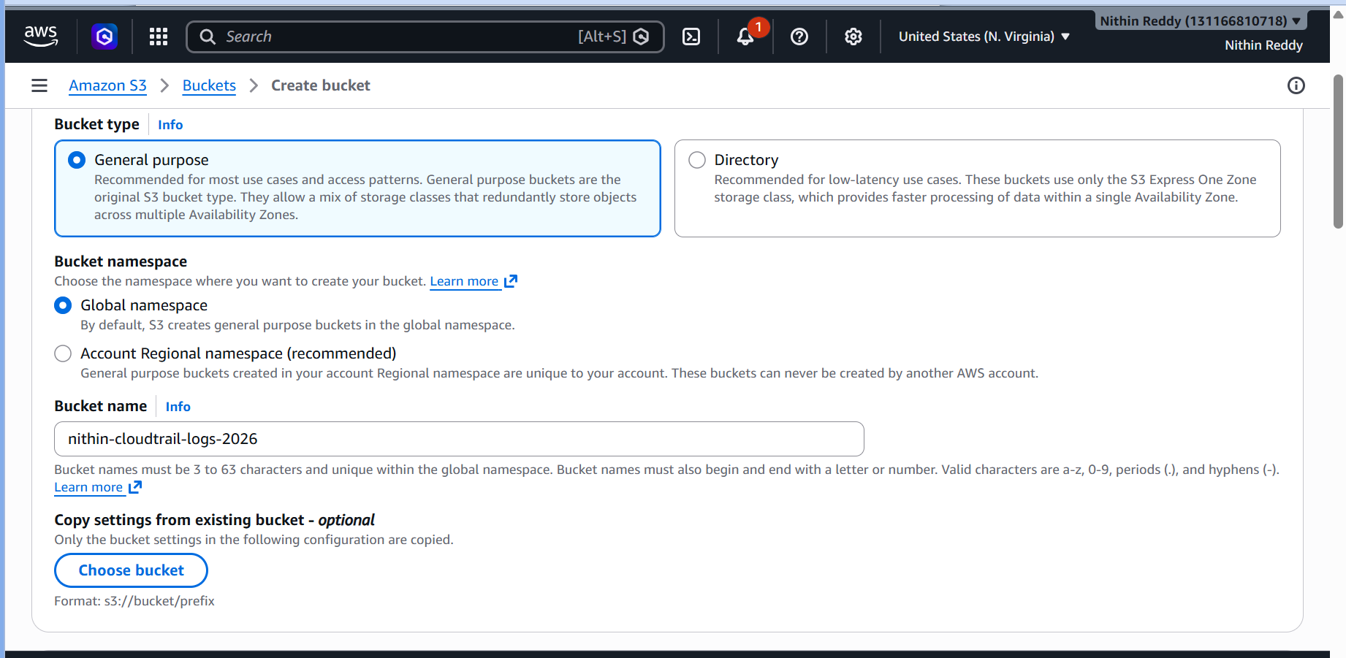
Step 2: Create a CloudWatch Log Group
- Open AWS Console.
- Navigate to CloudWatch.
- Select Logs → Log Groups.
- Click Create Log Group.
- Enter:
CloudTrailLogs
- Click Create.
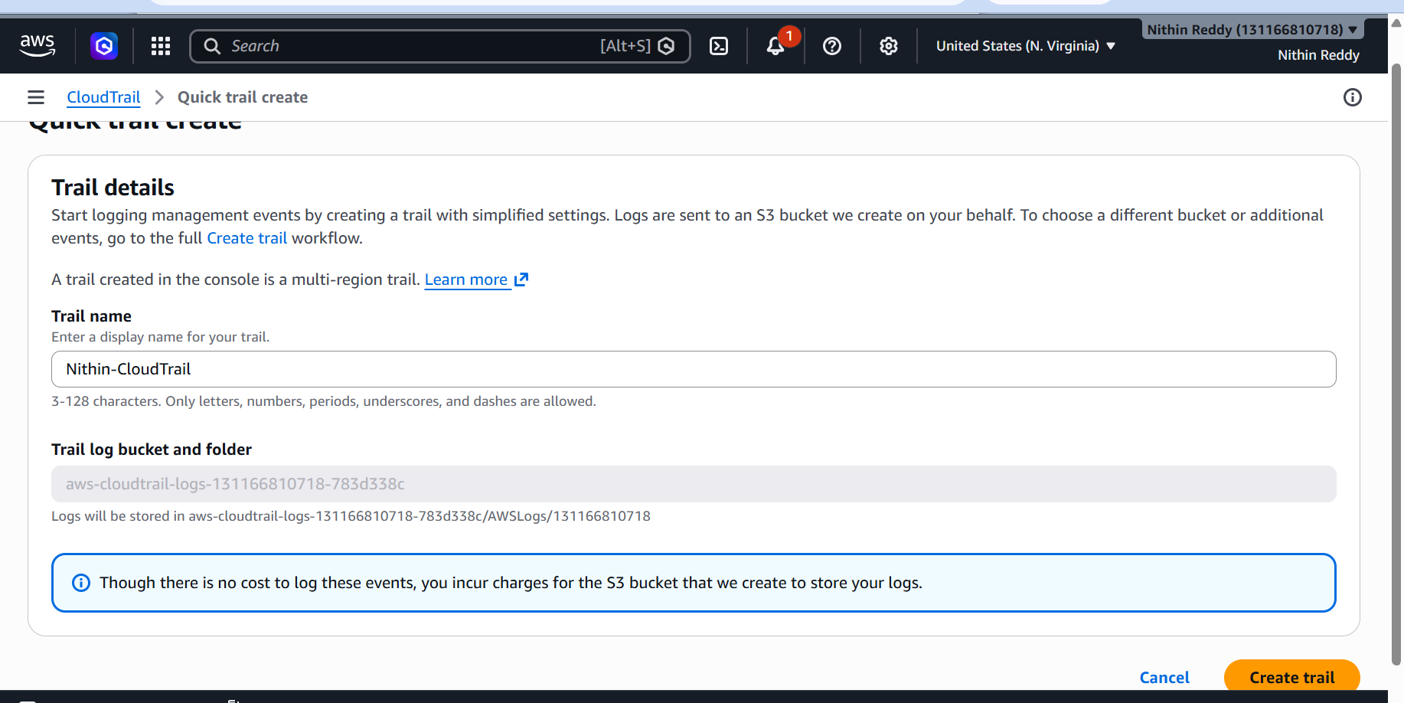
Step 3: Open CloudTrail Service
- Navigate to CloudTrail.
- Select Trails from left menu.
- Click Create Trail.

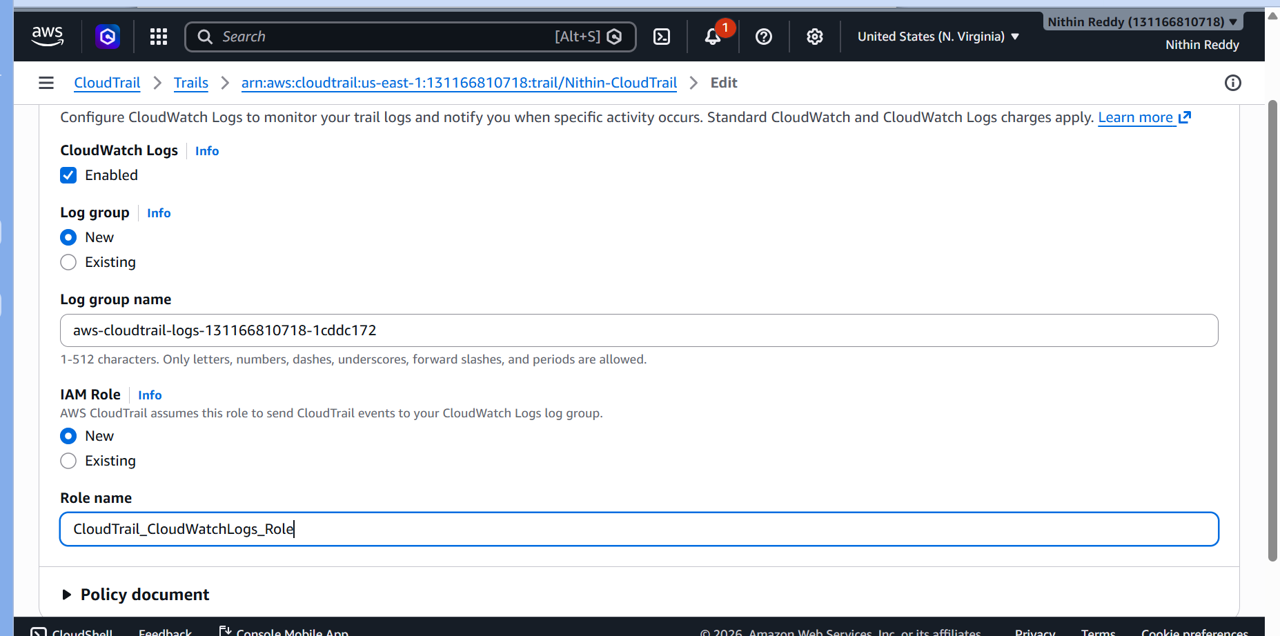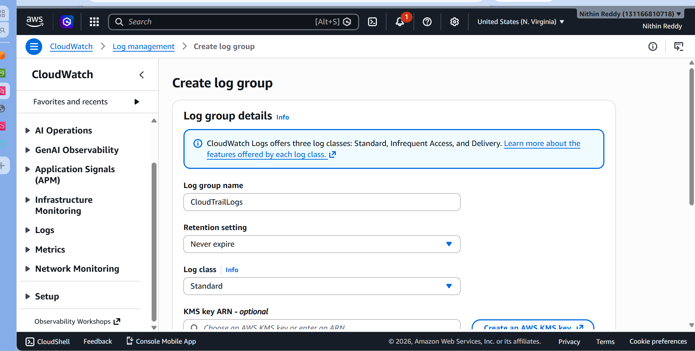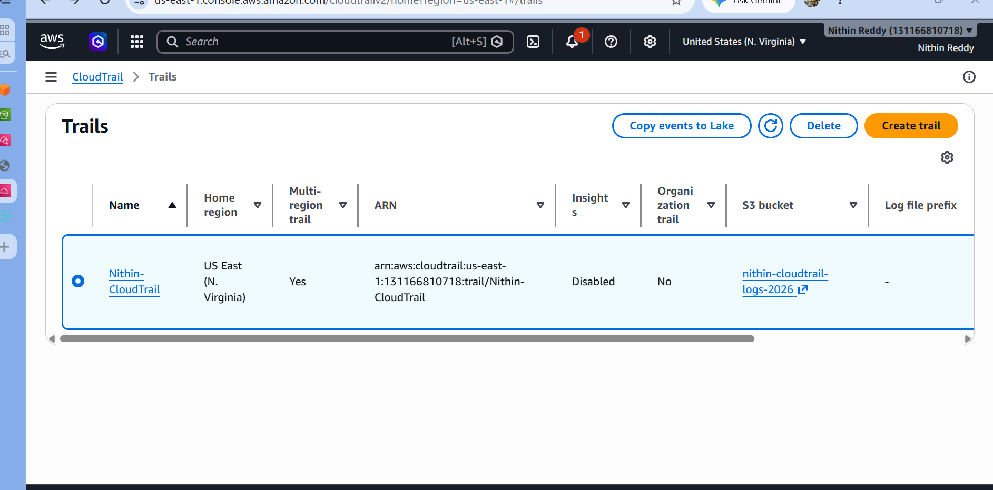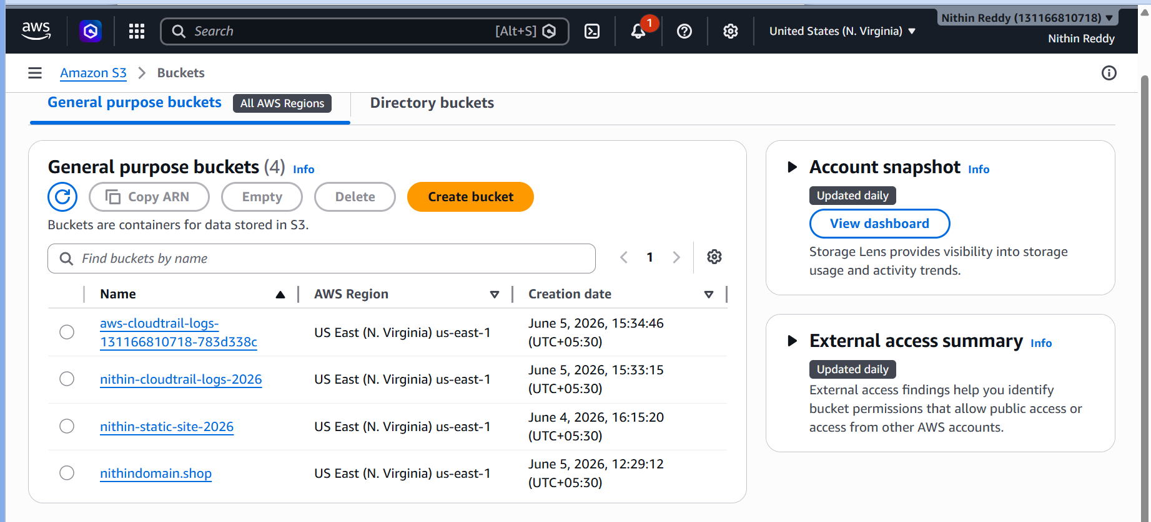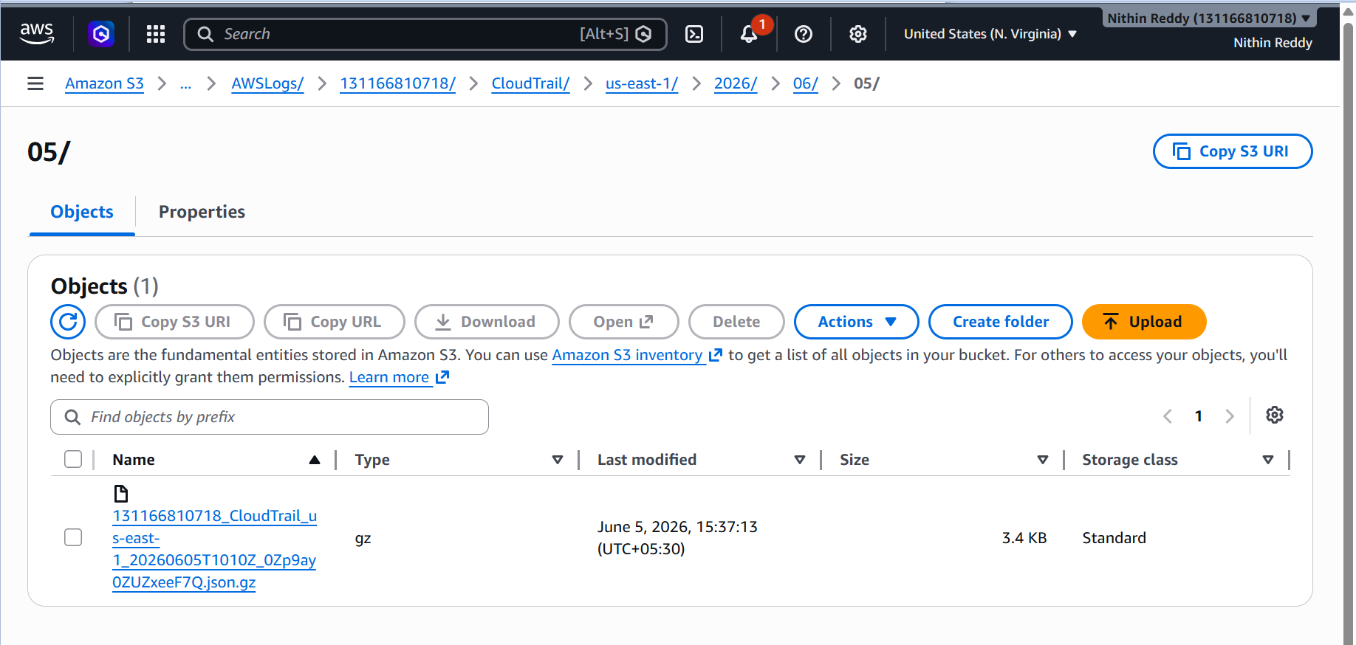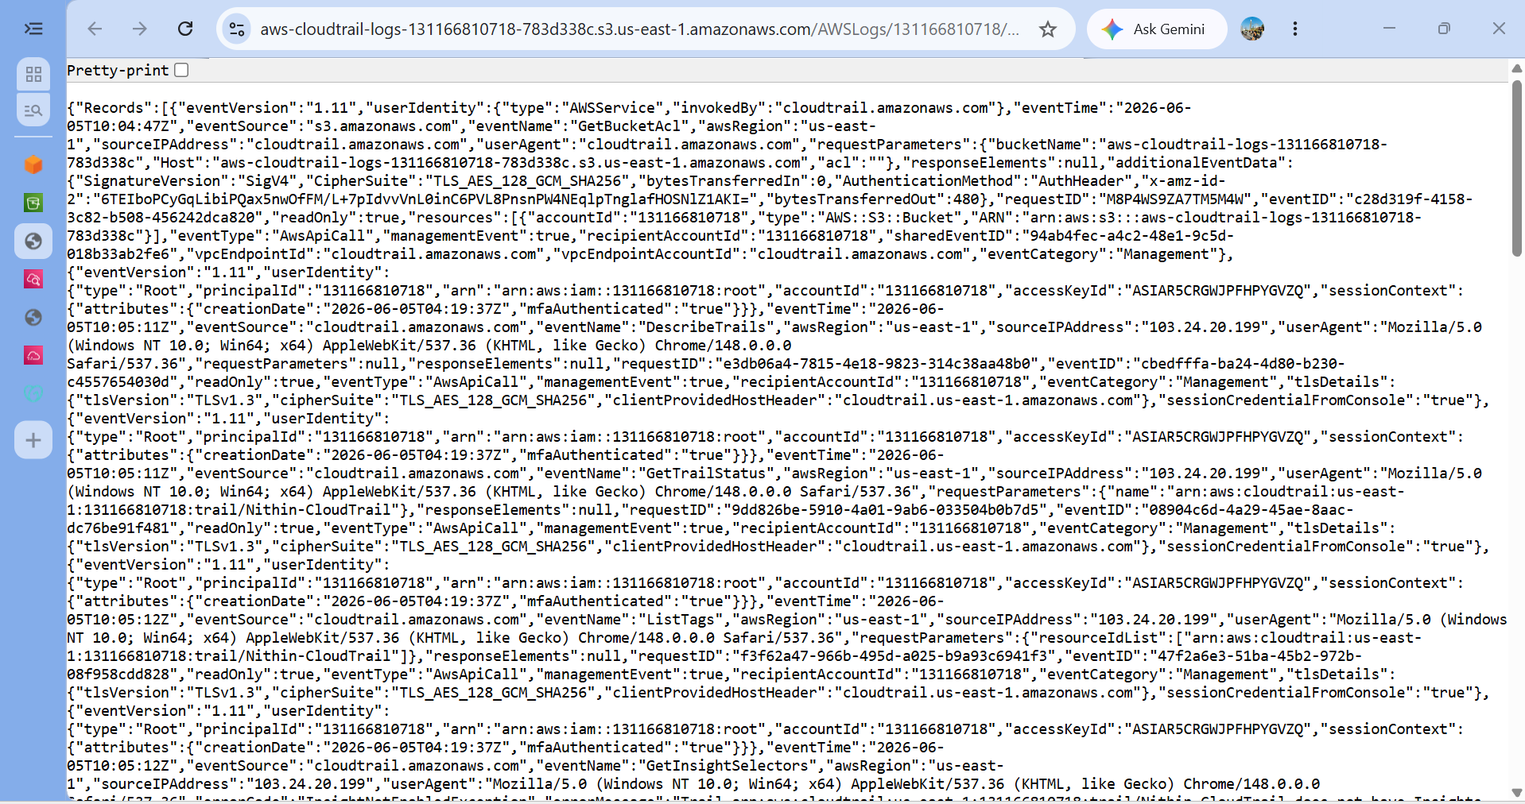

Validation
- Verified service/resource created successfully.
- Confirmed logs/metrics/events are being generated.
- Tested functionality by performing a sample action.
- Confirmed expected output received.
Errors Encountered & Resolution
Error 1
Issue:
- Brief description.
Resolution:
- How it was fixed.
Error 2
Issue:
- Brief description.
Resolution:
- How it was fixed.
Outcome
- Summarize the successful completion of the task.

Task 2: Enable SNS for CloudTrail to Send Alerts via Email
Objective
Configure Amazon SNS (Simple Notification Service) to send email notifications when CloudTrail detects specific AWS activities.
Prerequisites
- Task 1 completed
- CloudTrail logging enabled
- CloudWatch Log Group available
- Valid email address for alerts

Architecture
CloudTrail
↓
CloudWatch Logs
↓
EventBridge Rule
↓
SNS Topic
↓
Email Notification

Implementation Steps
Step 1: Create SNS Topic
- Open AWS Console.
- Navigate to SNS.
- Click Topics.
- Click Create Topic.
Select:
Type = Standard
Topic Name:
CloudWatch-Alerts
Click:
Create Topic
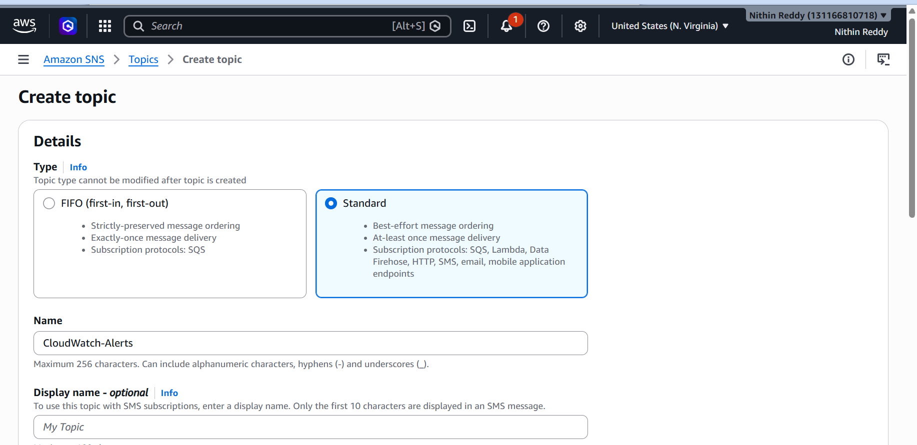

Step 2: Create Email Subscription
Inside the topic:
Click:
Create Subscription
Protocol:
Email
Endpoint:
your-email@example.com
Click:
Create Subscription
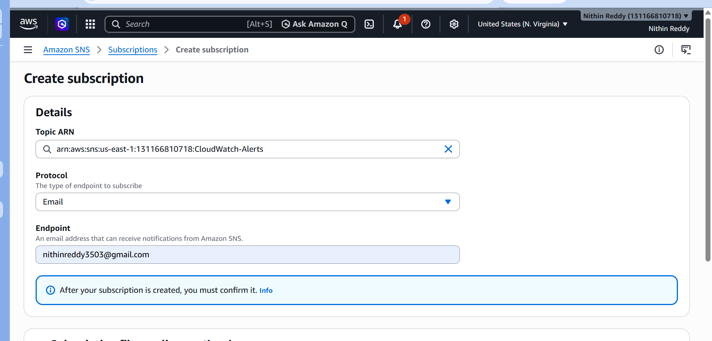
Step 3: Confirm Subscription
Check your inbox.
AWS sends:
AWS Notification - Subscription Confirmation
Open email.
Click:
Confirm Subscription
Return to SNS.
Status should change from:
Pending Confirmation
to
Confirmed
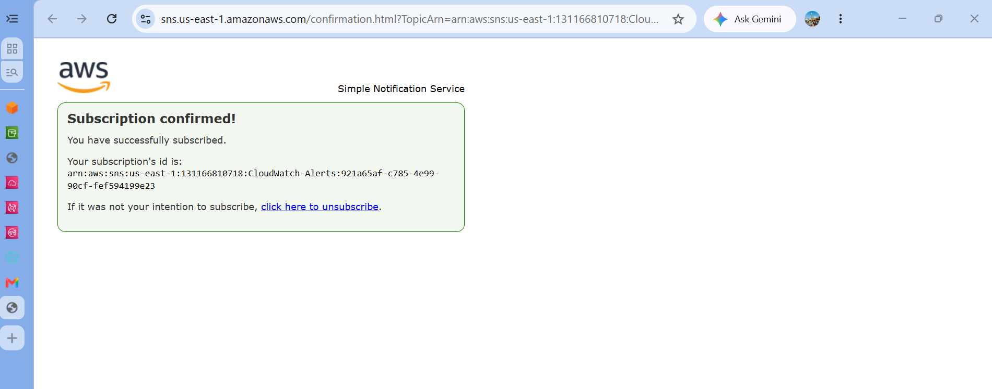
Step 4: Create EventBridge Rule
Navigate:
Amazon EventBridge
→ Rules
→ Create Rule
Rule Name:
CloudTrail-EC2-Alerts
Description:
Send email for EC2 CloudTrail events
Rule Type:
Rule with Event Pattern
Click Next.

Step 5: Configure Event Pattern
Select:
Event Source = AWS Events
Choose:
AWS Service = EC2
Event Type:
AWS API Call via CloudTrail
Specific Operation:
Add:
StartInstances
StopInstances
Click Next.

Step 6: Configure Target
Target Type:
AWS Service
Target:
SNS Topic
Select:
CloudWatch-Alerts
Click Next.

Step 7: Review and Create
Review configuration.
Click:
Create Rule

Step 8: Generate Test Event
Navigate:
EC2
Perform one action:
Start Instance
or
Stop Instance
CloudTrail records the event.
EventBridge matches it.
SNS sends email.
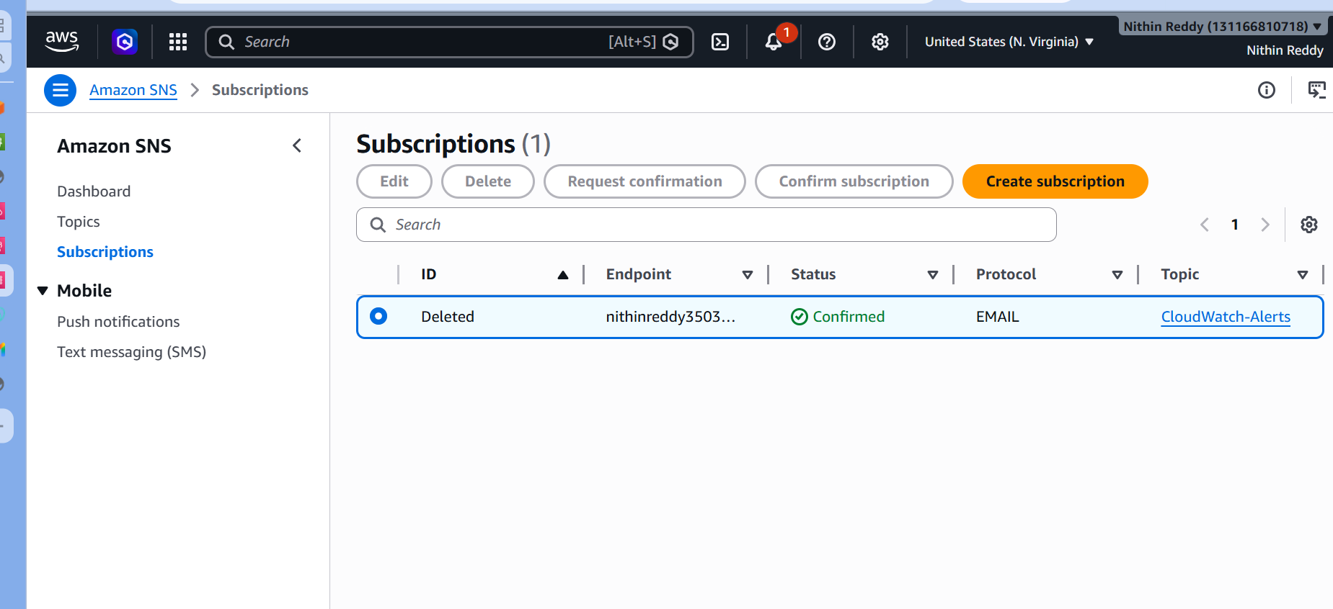
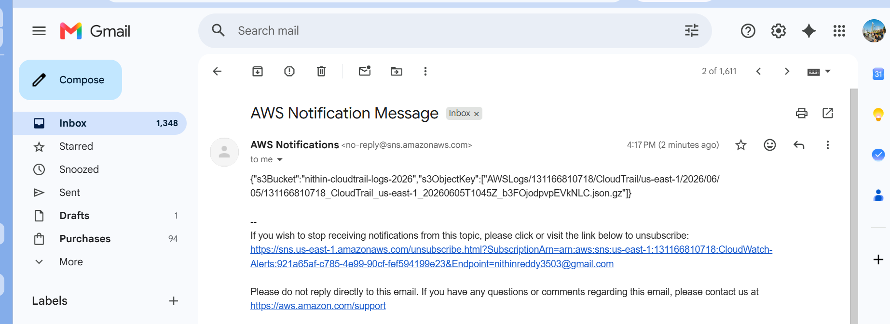
Common Errors and Resolution
Error 1: Subscription Still Pending
Issue
- SNS email not confirmed.
Resolution
- Open AWS confirmation email.
- Click Confirm Subscription.
- Refresh SNS page.

Task 3: Configure CloudWatch Monitoring and Record CPU Utilization and Other EC2 Metrics
Objective
Enable Amazon CloudWatch monitoring for your EC2 instance and collect performance metrics such as:
- CPU Utilization
- Network In
- Network Out
- Disk Read Bytes
- Disk Write Bytes
- Status Check Failed
These metrics will be used later for Task 4 (CPU Alarm) and dashboards.
Prerequisites
- EC2 Instance running
- CloudWatch access
- SNS Topic from Task 2 already created
- Administrator permissions

Architecture
EC2 Instance
↓
CloudWatch Metrics
↓
Monitoring Graphs
Implementation Steps
Step 1: Verify EC2 Instance is Running
Navigate:
EC2
→ Instances
Verify:
Instance State = Running
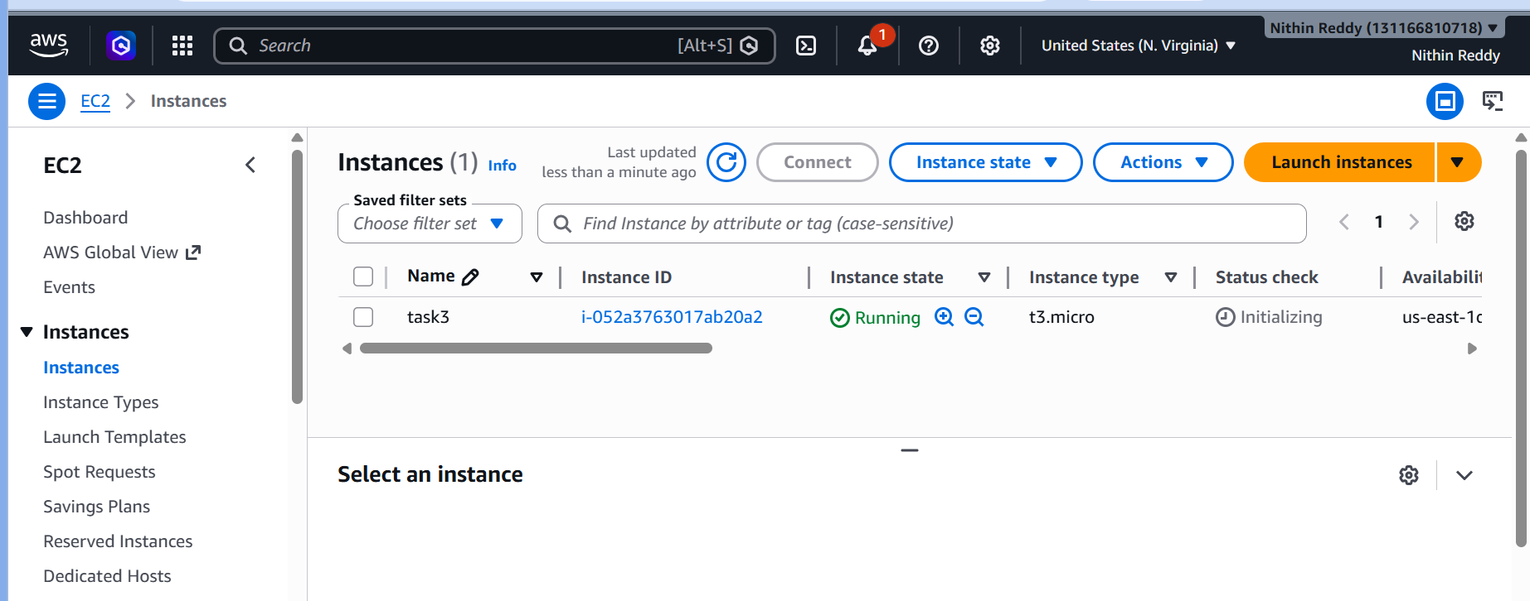
Step 2: Check Detailed Monitoring Status
Select your EC2 instance.
Go to:
Monitoring Tab
Check whether:
Detailed Monitoring
is enabled.
Step 3: Enable Detailed Monitoring
If disabled:
- Select Instance
- Click:
Actions
→ Monitor and troubleshoot
→ Manage detailed monitoring
Select:
Enable
Save changes.
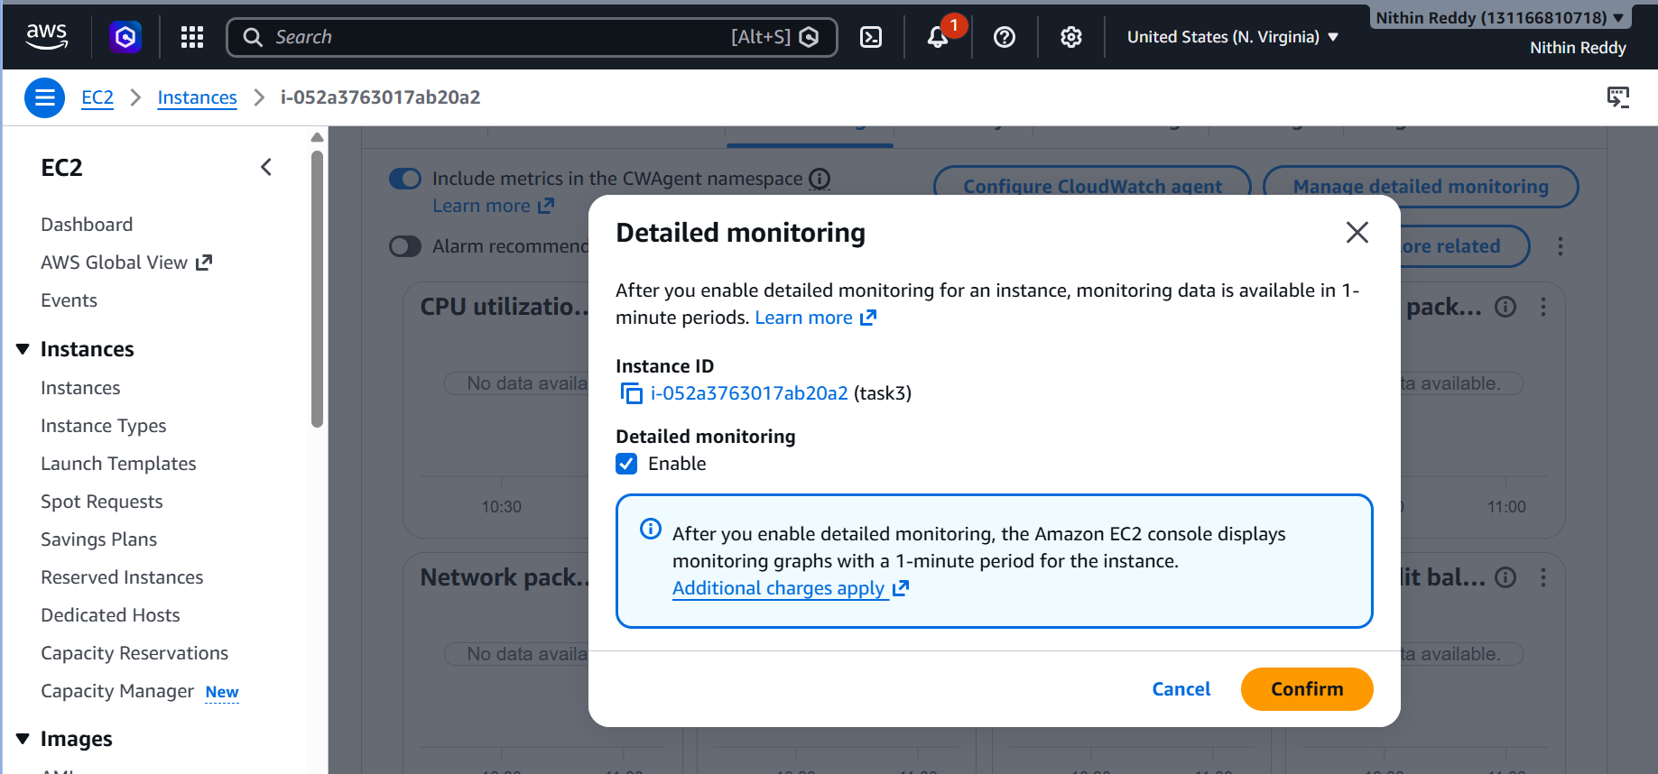

Why Enable Detailed Monitoring?
Without Detailed Monitoring:
Metrics every 5 minutes
With Detailed Monitoring:
Metrics every 1 minute
Better for alarms and dashboards.

Step 4: Open CloudWatch Metrics
Navigate:
CloudWatch
→ Metrics
Click:
All Metrics
Select:
EC2
Choose:
Per-Instance Metrics

Step 5: Verify CPU Utilization
Locate your Instance ID.
Select:
CPUUtilization
Expected:
Graph appears.
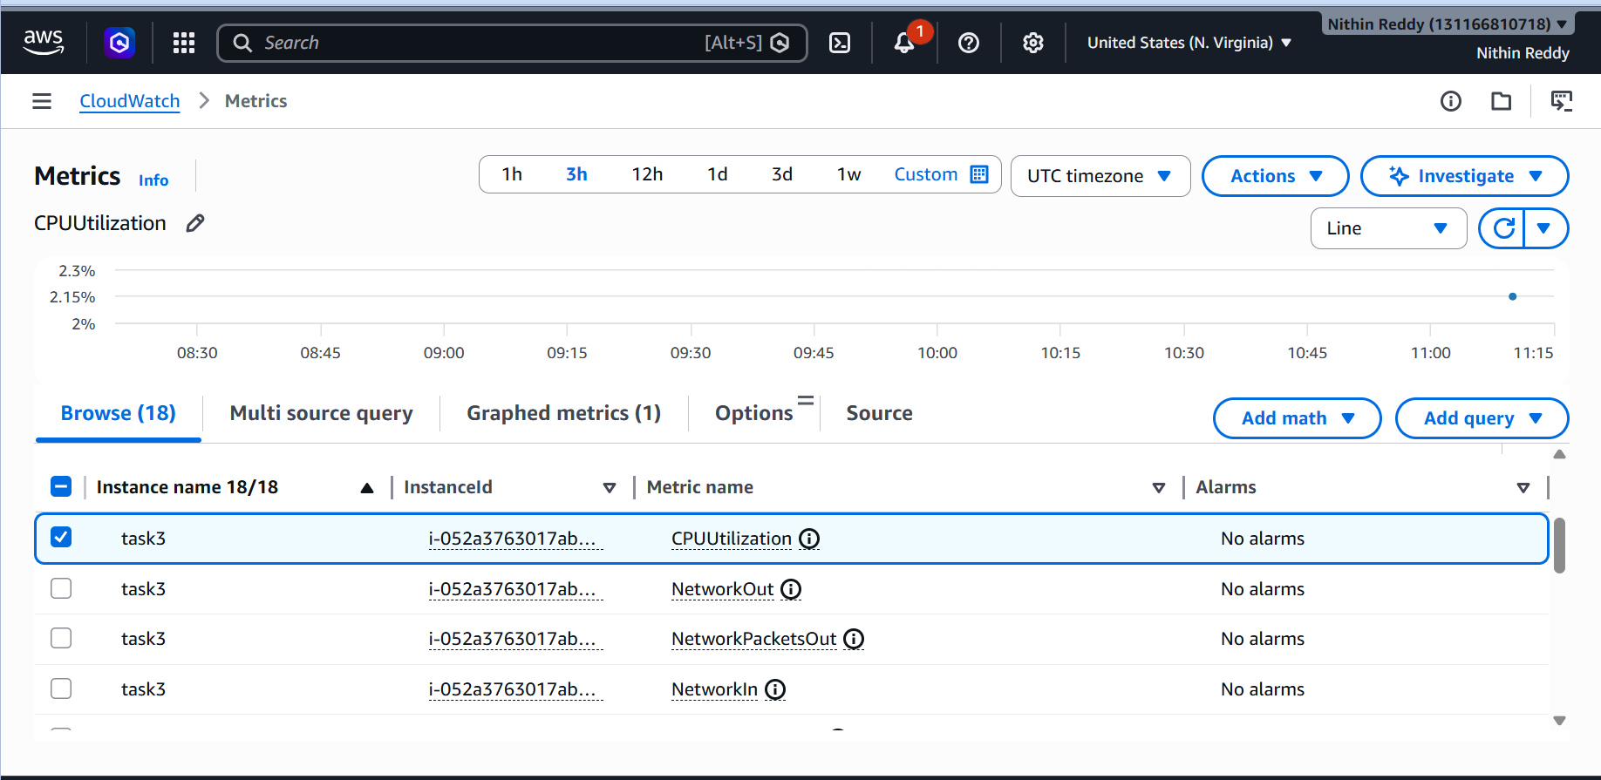
Step 6: Verify Additional Metrics
Select these metrics:
Network In
NetworkIn

Network Out
NetworkOut

Disk Read Bytes
DiskReadBytes

Disk Write Bytes
DiskWriteBytes

Status Check Failed
StatusCheckFailed
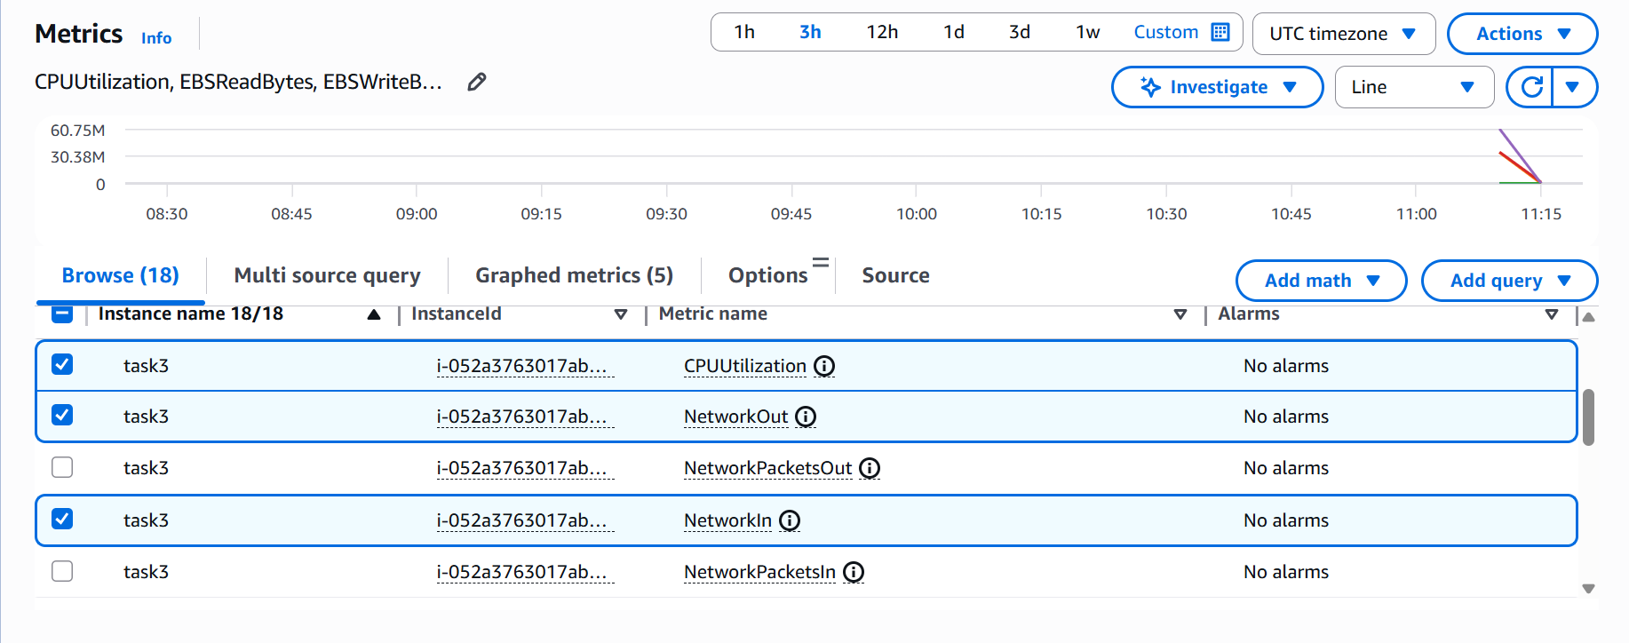
Step 7: Generate Load on EC2 (Optional)
Connect to EC2:
ssh -i key.pem ec2-user@PUBLIC-IP
Run:
yes > /dev/null &
Wait:
2–3 minutes
This increases CPU usage.
Return to CloudWatch.
Verify CPU graph changes.
Stop test:
pkill yes
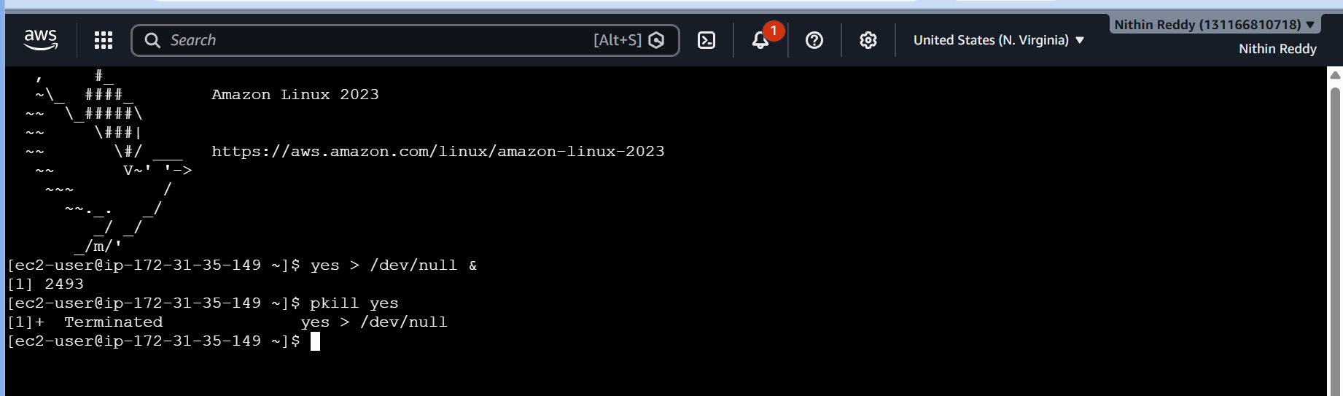
Error 3: Instance Not Listed
Issue
Wrong AWS region selected.
Resolution
Verify EC2 and CloudWatch are in the same region.
Error 4: Detailed Monitoring Disabled
Issue
Metrics updating every 5 minutes only.
Resolution
Enable Detailed Monitoring.
Outcome
- CloudWatch monitoring configured successfully.
- Detailed monitoring enabled.
- CPU utilization metric verified.
- Network metrics verified.
- Disk metrics verified.
- Instance health metrics verified.
- EC2 performance monitoring ready for alarm creation.
Task 4: Create a CloudWatch Alarm to Send Email Alert if CPU Utilization is More Than 70%
Objective
Create a CloudWatch Alarm that monitors EC2 CPU utilization and sends an email notification through SNS when CPU usage exceeds 70%.
Prerequisites
- Task 2 completed (SNS Topic created and email subscription confirmed)
- Task 3 completed (EC2 metrics visible)
- EC2 instance running
- CPUUtilization metric available

Architecture
EC2 Instance
↓
CPUUtilization Metric
↓
CloudWatch Alarm
↓
SNS Topic
↓
Email Alert

Implementation Steps
Step 1: Open CloudWatch Alarms
Navigate:
CloudWatch
→ Alarms
→ All Alarms
→ Create Alarm

Step 2: Select Metric
Click:
Select Metric
Navigate:
EC2
→ Per-Instance Metrics
Select your EC2 Instance.
Choose metric:
CPUUtilization
Click:
Select Metric

Step 3: Configure Alarm Conditions
Metric:
CPUUtilization
Statistic:
Average
Period:
1 Minute
Threshold Type:
Static
Condition:
Greater than
Threshold Value:
70
Meaning:
CPUUtilization > 70%

Step 4: Configure Alarm Actions
Choose:
In Alarm
Select:
Send notification to SNS topic
Choose SNS Topic:
CloudWatch-Alerts
(created in Task 2)

Step 5: Configure Alarm Name
Alarm Name:
EC2-CPU-Utilization-70
Description:
Send alert when CPU utilization exceeds 70%
Click:
Next
→ Create Alarm

Step 6: Verify Alarm Creation
Navigate:
CloudWatch
→ Alarms
Expected:
EC2-CPU-Utilization-70
State:
OK

Step 7: Generate CPU Load
Connect to EC2.
Amazon Linux / RHEL
Run:
yes > /dev/null &
yes > /dev/null &
yes > /dev/null &
yes > /dev/null &
OR
stress --cpu 4 --timeout 300
If stress not installed:
sudo yum install stress -y
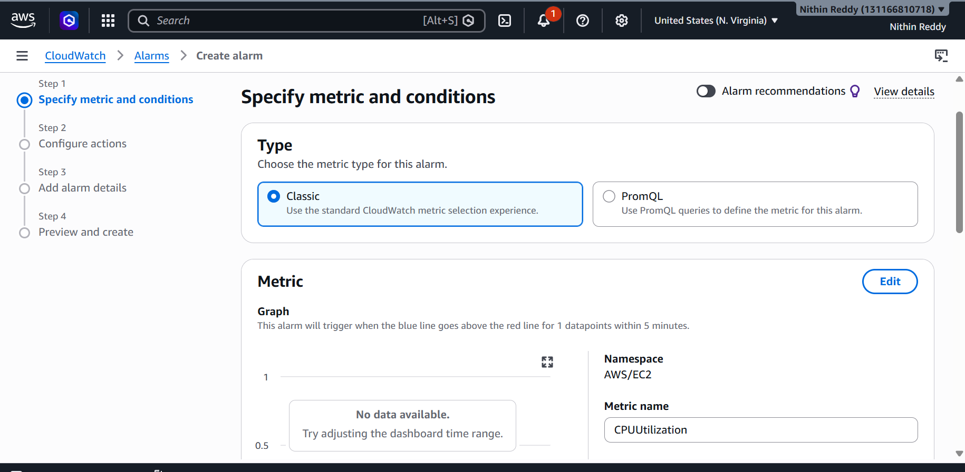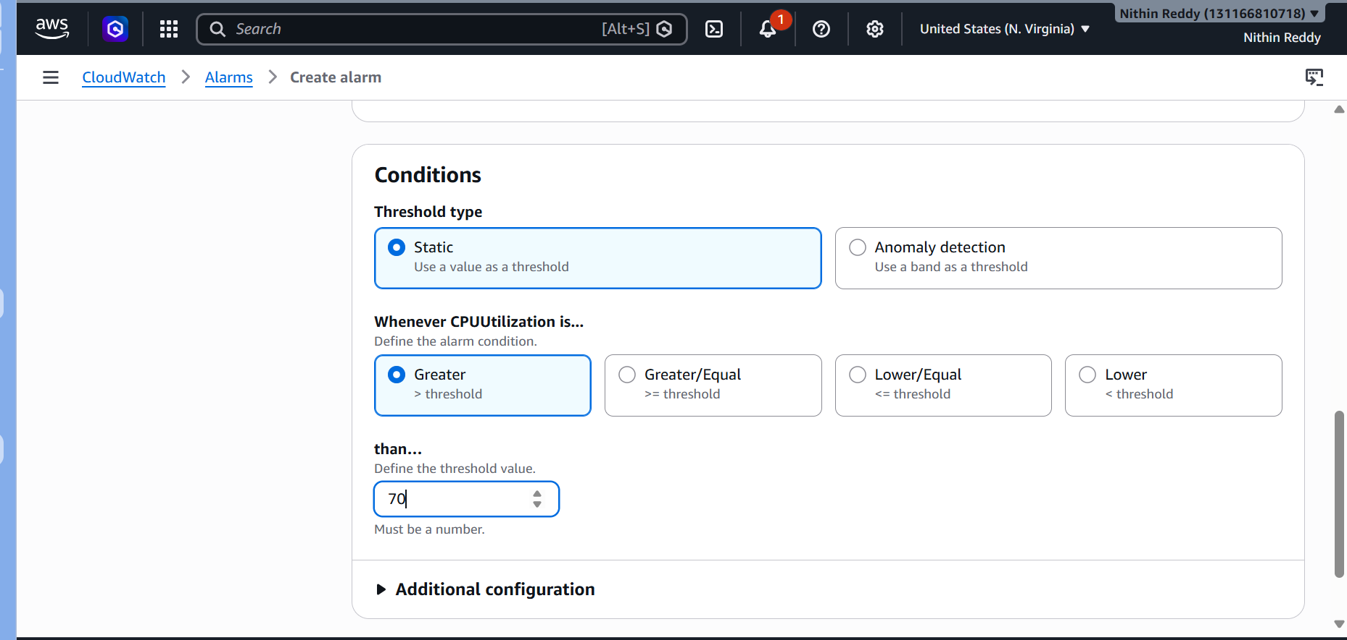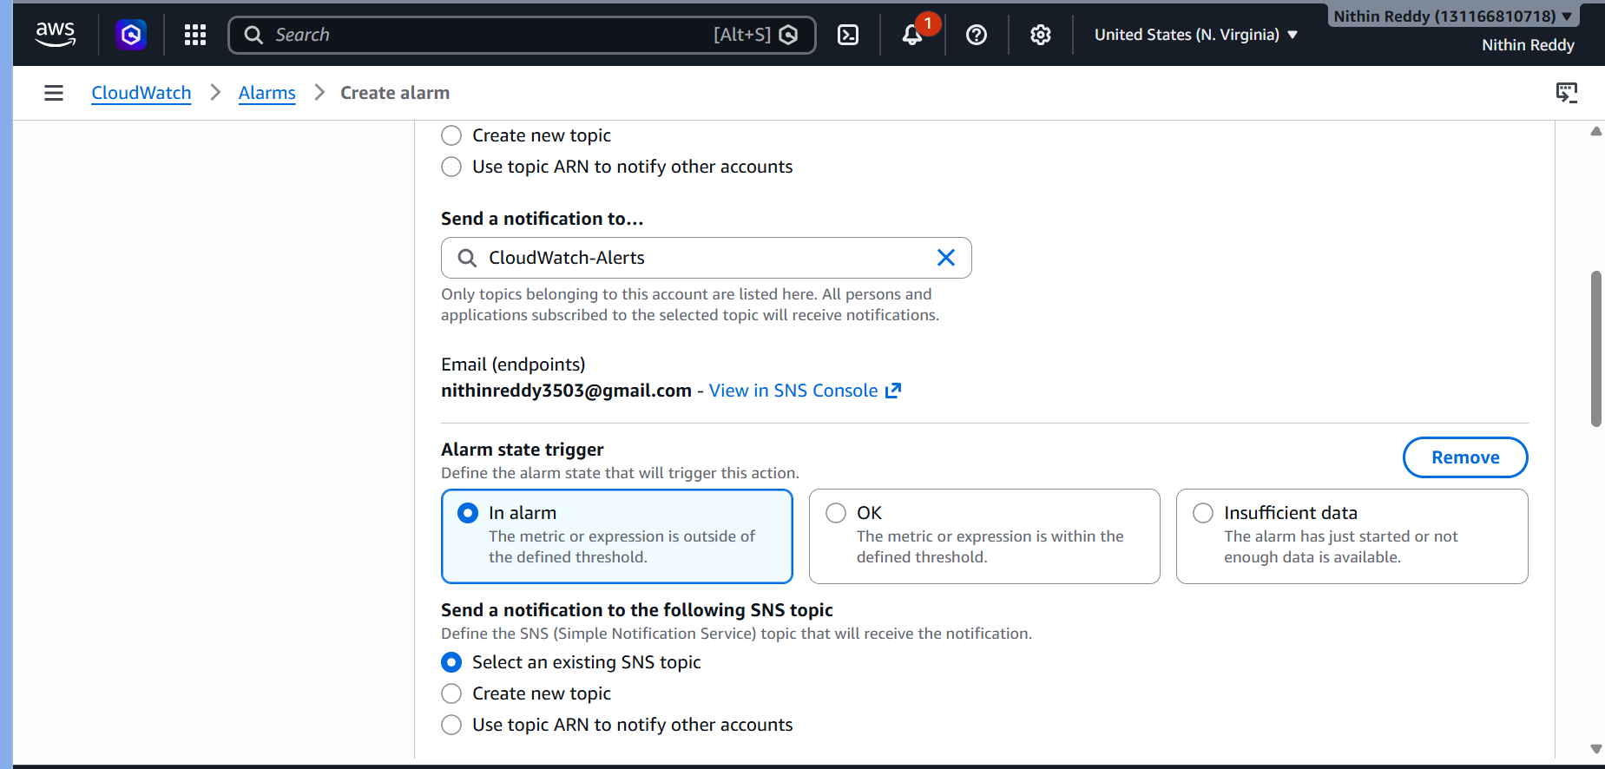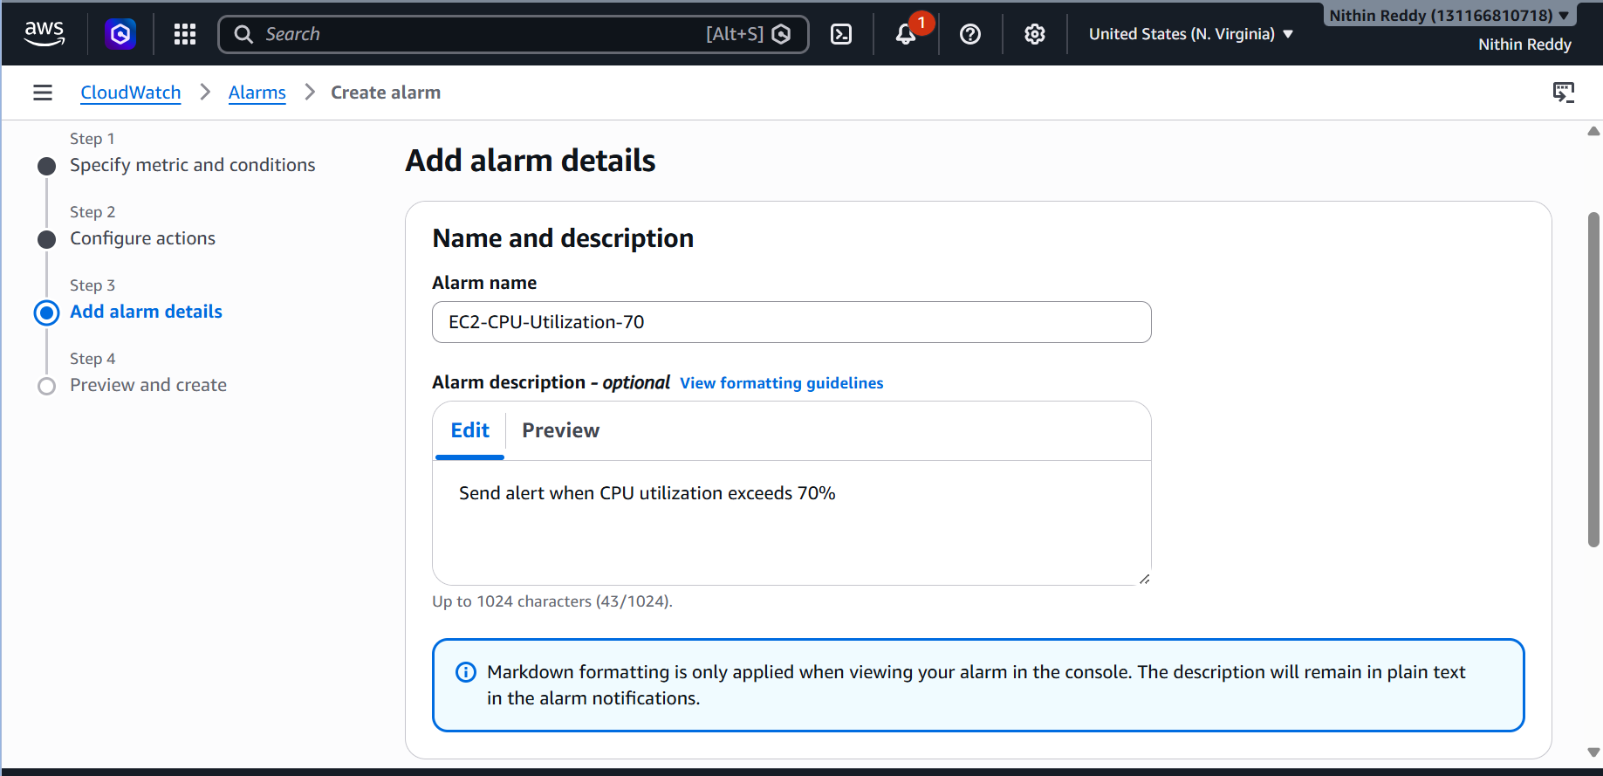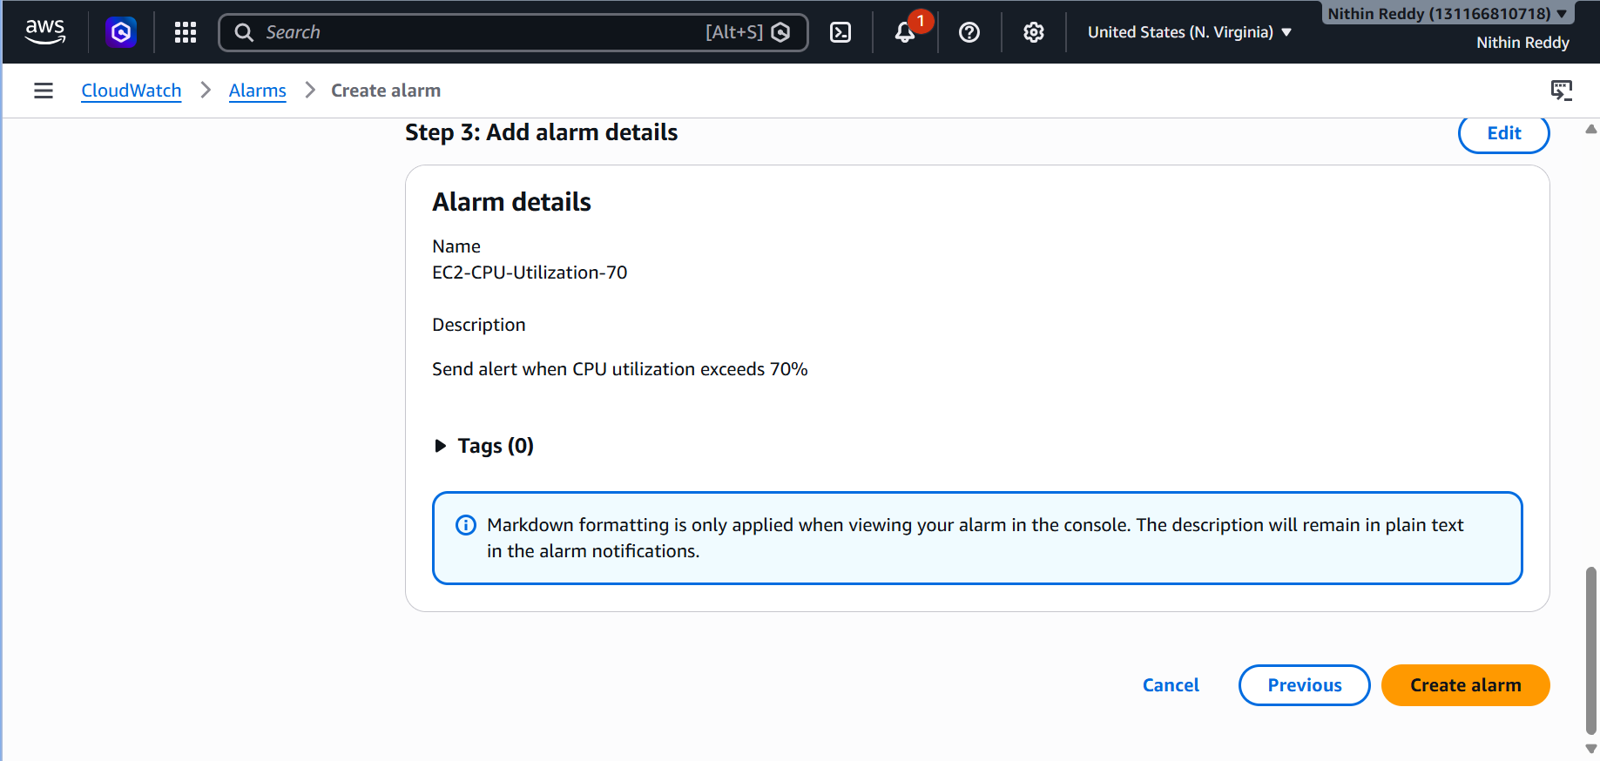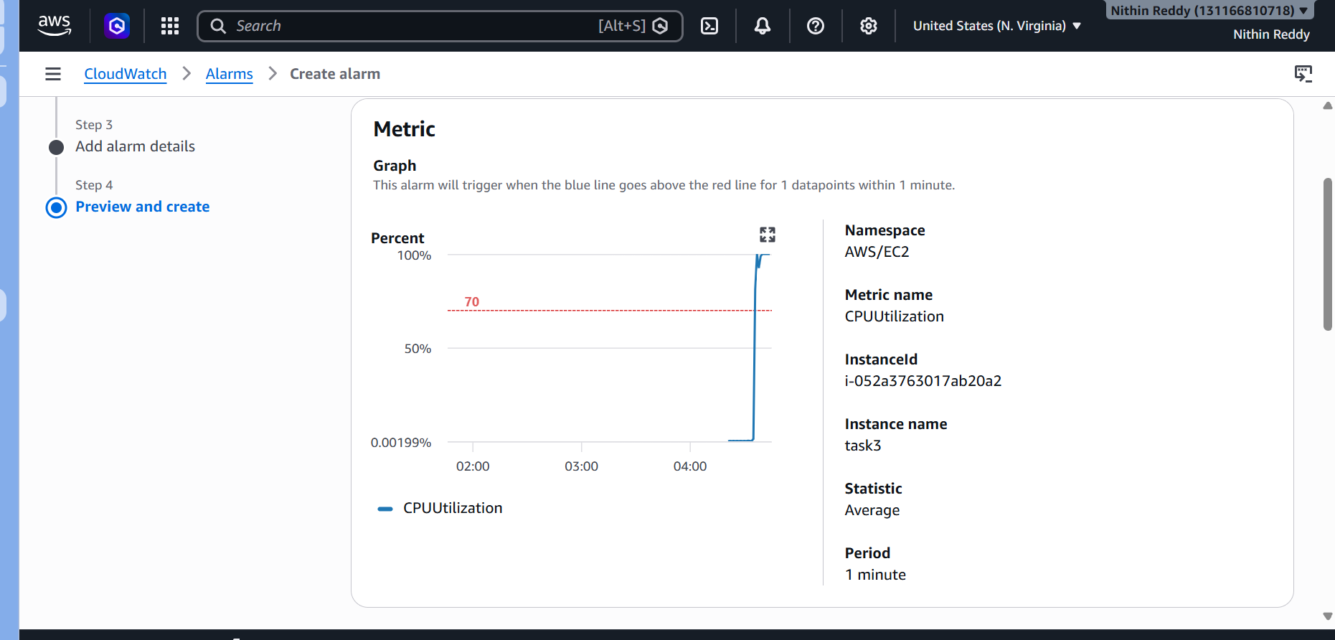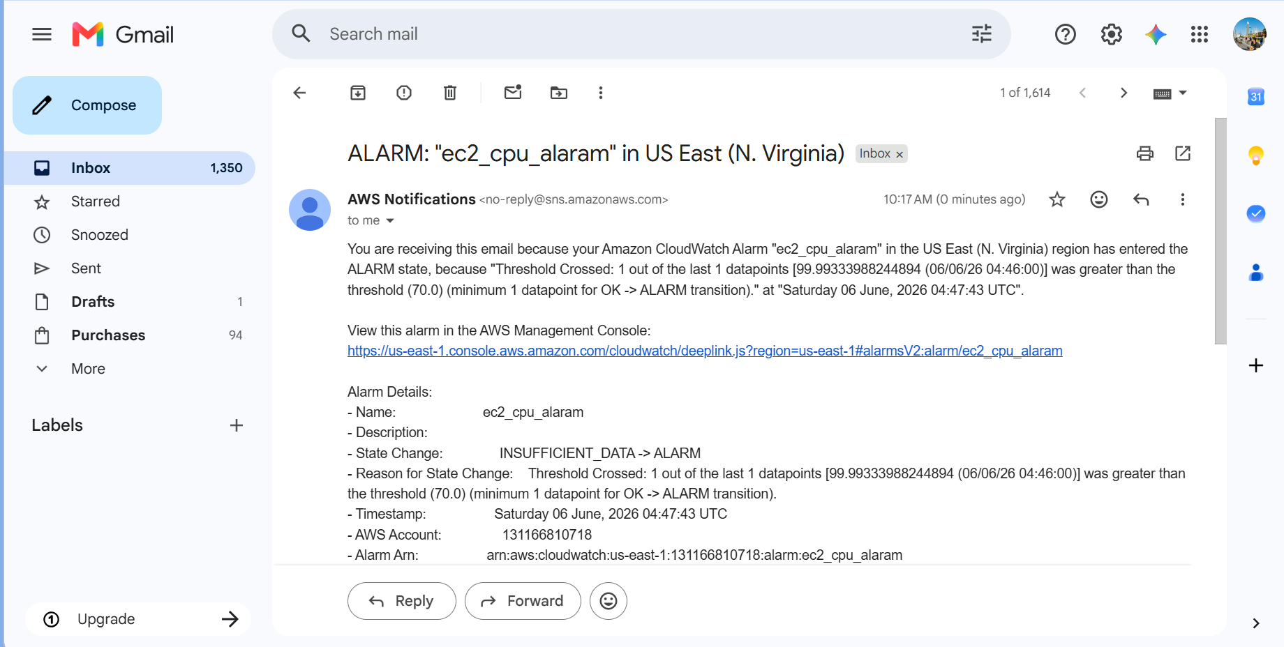

Error 4: CPU Graph Not Updating
Issue
- Detailed monitoring disabled.
Resolution
Enable Detailed Monitoring (Task 3).

Error 5: SNS Subscription Pending
Issue
- Email not confirmed.
Resolution
Confirm SNS subscription from email and retest.

Outcome
- CloudWatch Alarm successfully created.
- CPU utilization monitored continuously.
- SNS notifications configured.
- Email alert received when CPU exceeded 70%.
- Alarm returned to OK state after CPU usage normalized.
- Monitoring and alerting setup verified successfully.

Task 5: Create a Dashboard and Monitor the Tomcat Service Whether It Is Running or Not and Send an Alert
Objective
Monitor the Tomcat service running on your EC2 instance and receive an email alert if Tomcat stops running.
Prerequisites
- Task 2 completed (SNS Topic: CloudWatch-Alerts)
- EC2 instance running
- Tomcat 10.1.55 running
- Java 22 installed
- IAM Role attached to EC2 with CloudWatch permissions
Recommended IAM Policy:
CloudWatchAgentServerPolicy
Architecture
Tomcat Service
↓
CloudWatch Agent
↓
Custom Metric
↓
CloudWatch Dashboard
↓
CloudWatch Alarm
↓
SNS Topic
↓
Email Alert
Implementation Steps
- Verified that the Tomcat service was installed and running on the EC2 instance using systemctl commands.
- Installed and configured the Amazon CloudWatch Agent on the EC2 instance.
- Created a custom monitoring script to check the Tomcat service status periodically.
- Configured the script to publish Tomcat service status metrics to Amazon CloudWatch under a custom namespace.
- Scheduled the monitoring script using Cron to run every minute and continuously publish metrics.
- Verified that the custom metric (TomcatStatus) was successfully created and visible in CloudWatch Metrics.
- Created a CloudWatch Dashboard named Tomcat-Monitoring-Dashboard.
- Added the custom Tomcat status metric widget to the dashboard for real-time monitoring.
- Created a CloudWatch Alarm to monitor the TomcatStatus metric.
- Configured the alarm condition to trigger when the metric value becomes less than 1, indicating the Tomcat service is stopped.
- Associated the alarm with the existing SNS topic (CloudWatch-Alerts) to send email notifications.
- Stopped the Tomcat service to test the monitoring solution and verified that the alarm changed to the ALARM state.
- Confirmed that an email notification was received through SNS when the service stopped.
- Restarted the Tomcat service and verified that the alarm returned to the OK state.
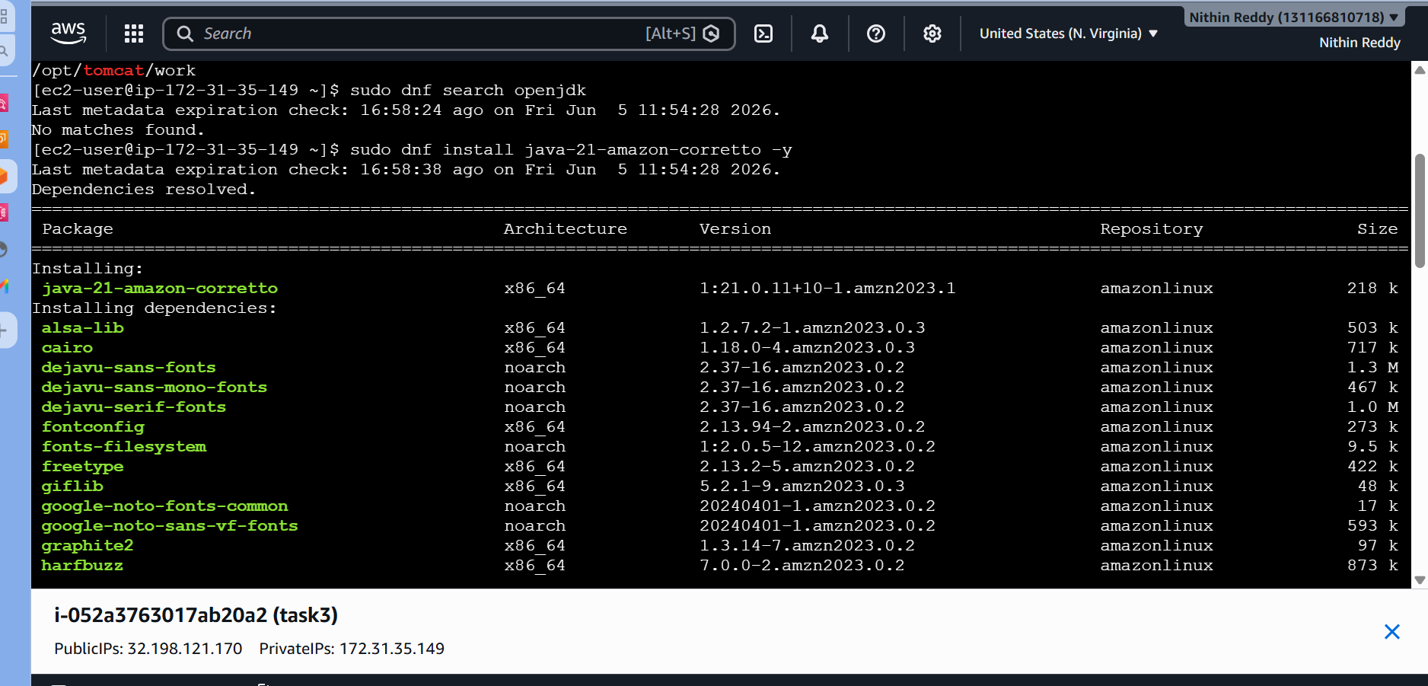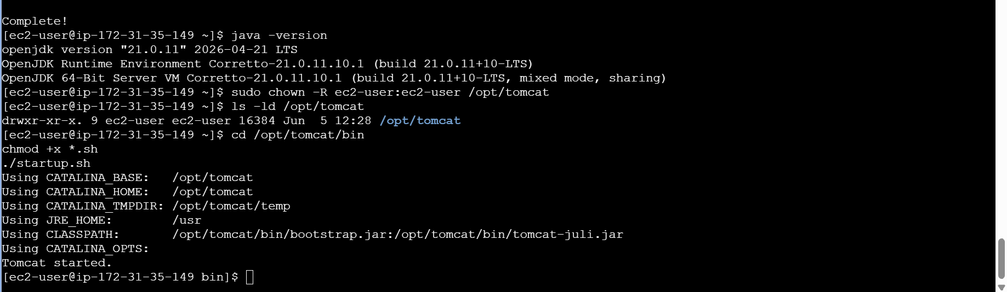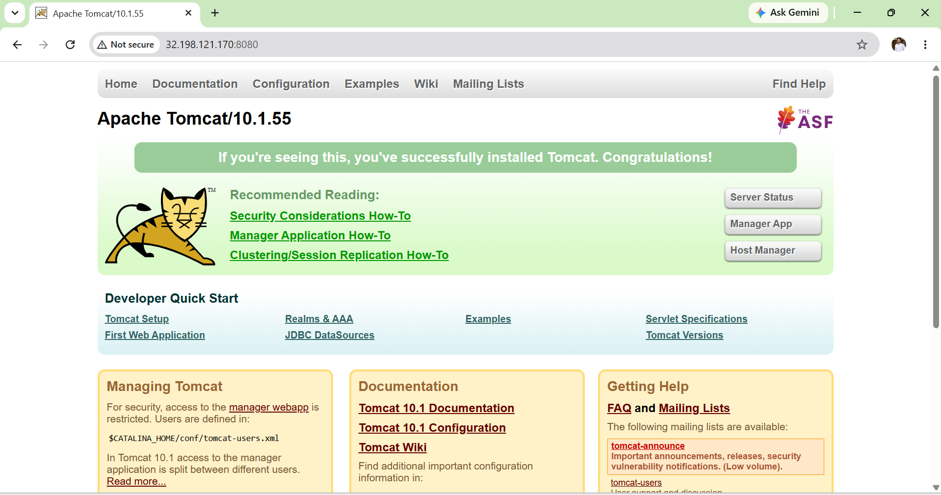

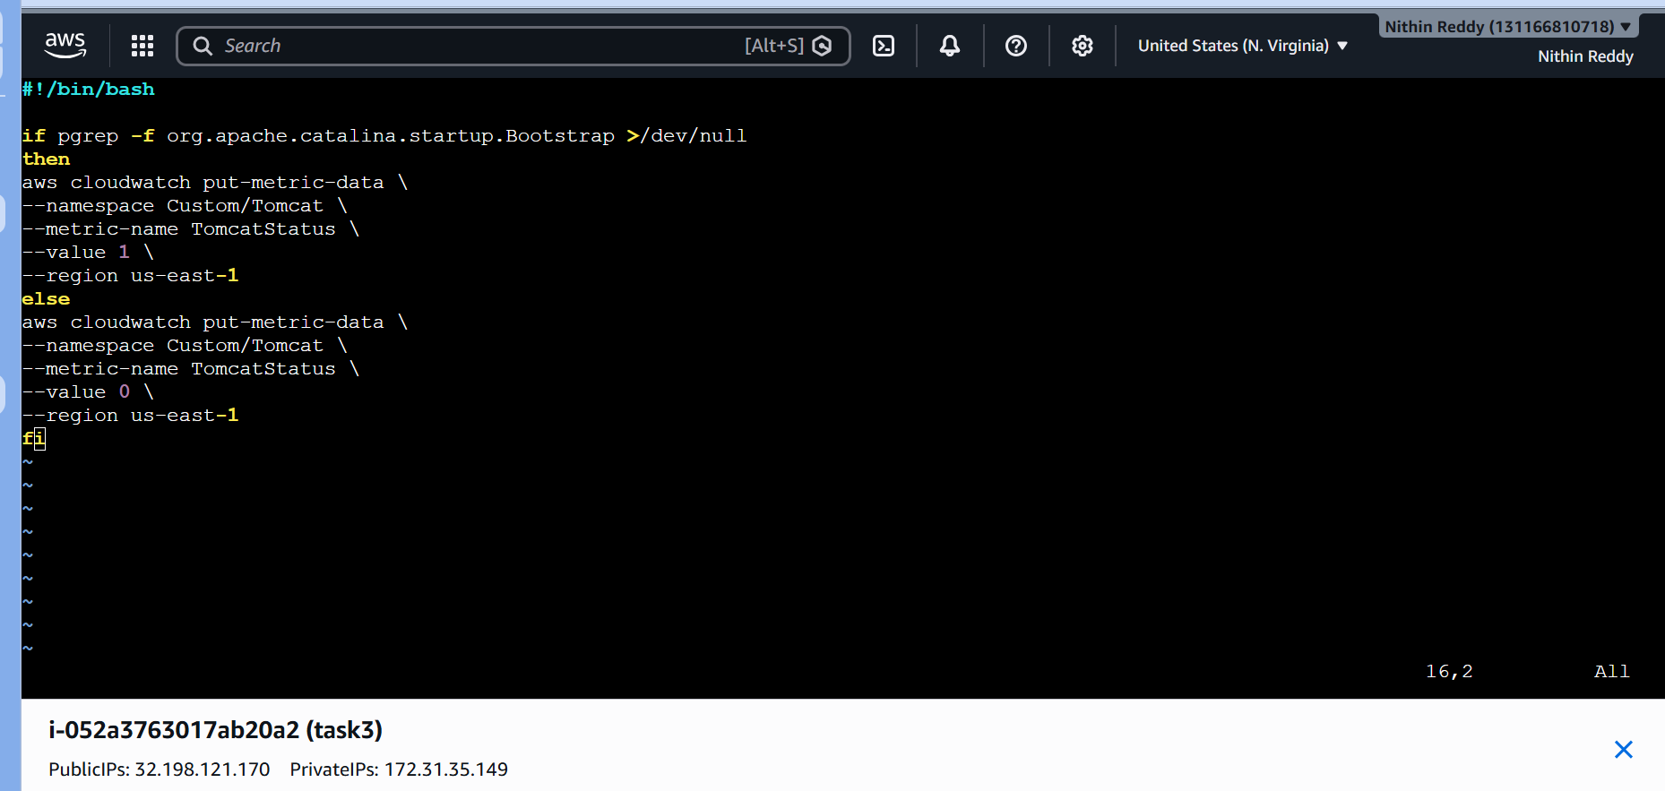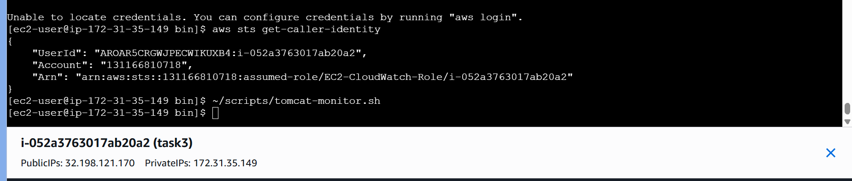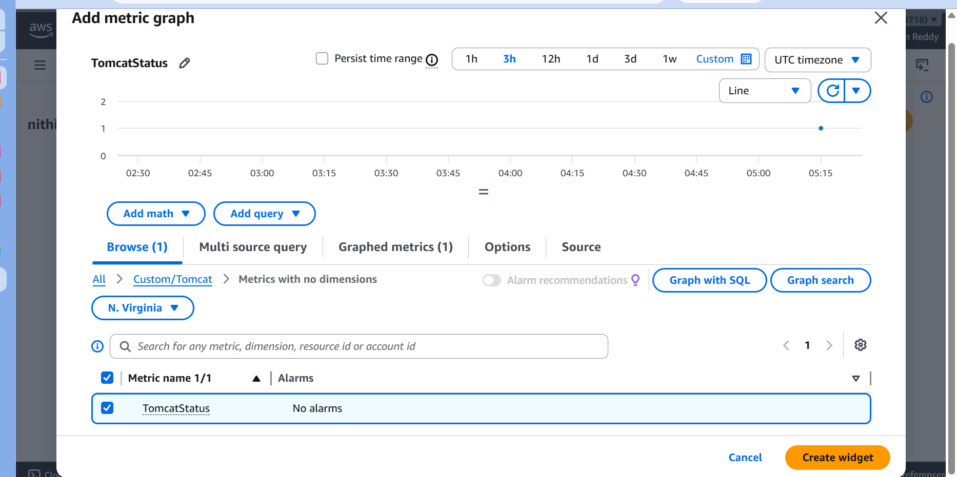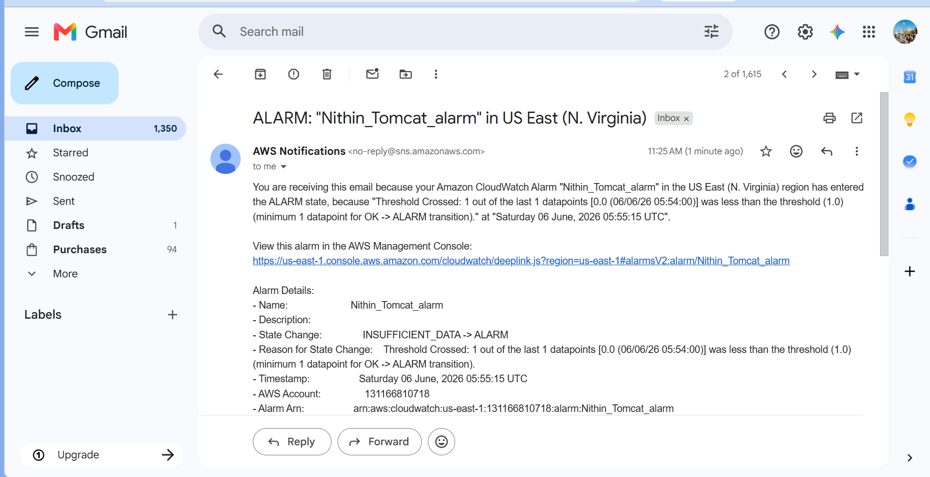
Validation
- Verified Tomcat service was running successfully.
- Verified custom CloudWatch metric TomcatStatus was generated.
- Verified metric data was visible in CloudWatch Metrics.
- Verified dashboard displayed Tomcat service status.
- Verified CloudWatch Alarm transitioned from OK to ALARM when Tomcat was stopped.
- Verified SNS email notification was received.
- Verified alarm returned to OK after restarting Tomcat.

Errors Encountered and Resolution
Error 1: CloudWatch metric not visible
Issue:
Custom metric did not appear in CloudWatch.
Resolution:
Executed the monitoring script manually and waited for CloudWatch metric ingestion.

Error 2: Unable to publish metric data
Issue:
EC2 instance lacked required IAM permissions.
Resolution:
Attached the CloudWatchAgentServerPolicy policy to the EC2 IAM role.

Task 6: Create a Dashboard and Monitor Nginx Service
Objective
To monitor the Nginx web service using Amazon CloudWatch, create a dashboard for service visibility, and configure email notifications through Amazon SNS when the Nginx service becomes unavailable.
Prerequisites:
• AWS Account with required permissions
• Running EC2 Instance
• IAM Role attached to EC2 with CloudWatchAgentServerPolicy
• Amazon SNS Topic already configured (CloudWatch-Alerts)
• CloudWatch access
• Amazon Linux EC2 instance
• AWS CLI installed and configured on EC2
Implementation Steps:
Step 1: Install Nginx
Command:
sudo dnf install nginx -y
Verification:
nginx -v
Expected Output:
nginx version displayed successfully.
Step 2: Start and Enable Nginx Service
Commands:
sudo systemctl start nginx
sudo systemctl enable nginx
Verification:
sudo systemctl status nginx
Expected Output:
active (running)
Step 3: Verify Nginx Web Page
Open Browser:
http://32.198.121.170
Expected Output:
Nginx Welcome Page displayed successfully.
Step 4: Create Nginx Monitoring Script
Created Script:
~/scripts/nginx-monitor.sh
Script Function:
• Checks whether Nginx service is running.
• Sends custom metric NginxStatus to CloudWatch.
• Sends value 1 when service is running.
• Sends value 0 when service is stopped.
Permission Command:
chmod +x ~/scripts/nginx-monitor.sh
Execution Command:
~/scripts/nginx-monitor.sh
Step 5: Configure Scheduled Monitoring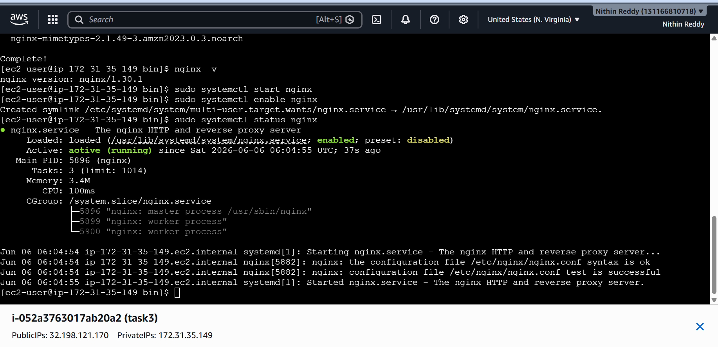
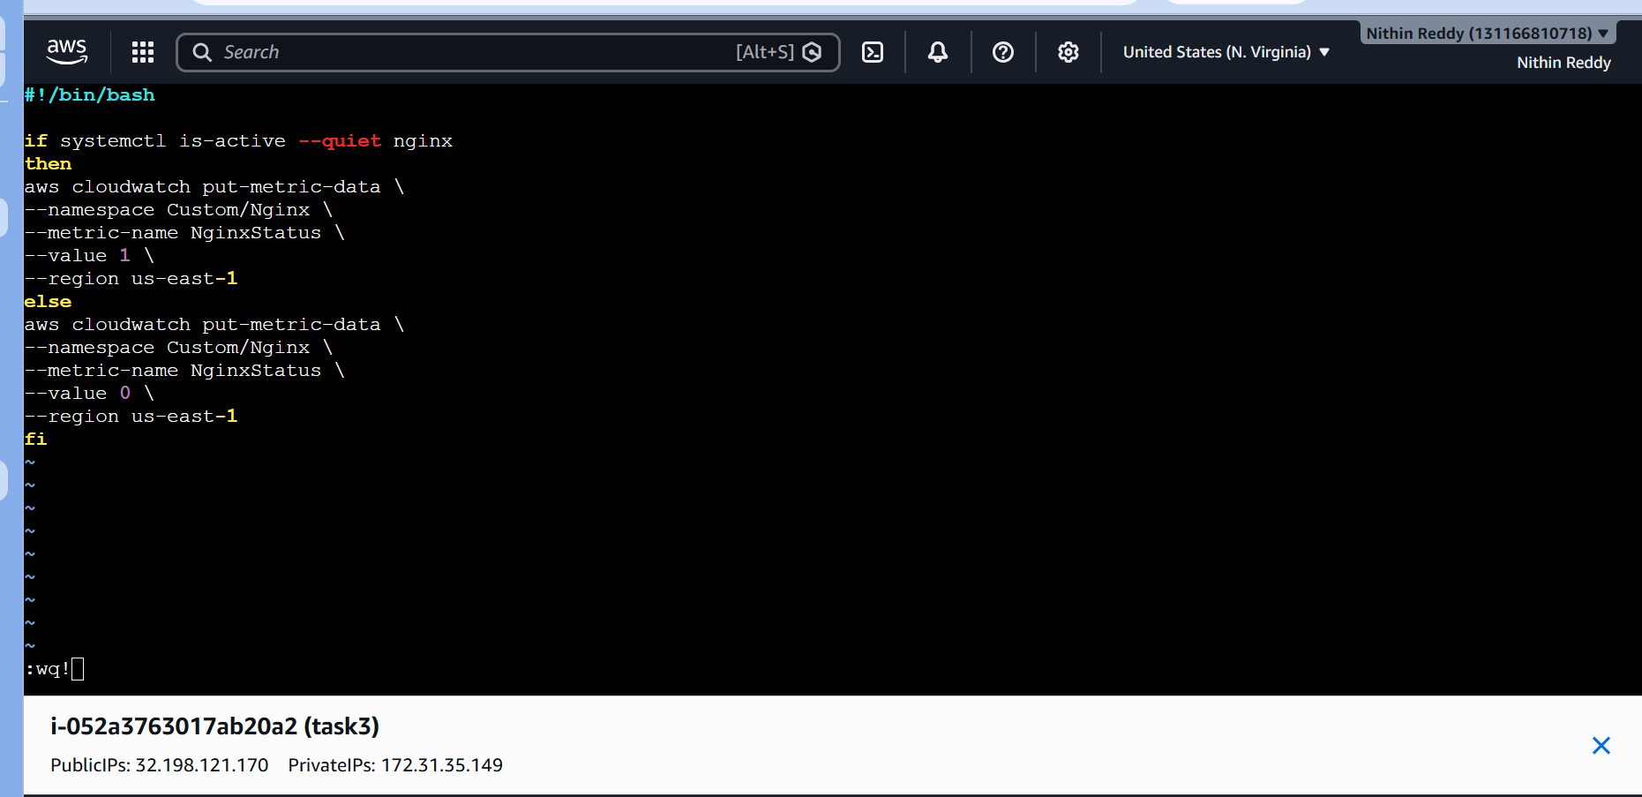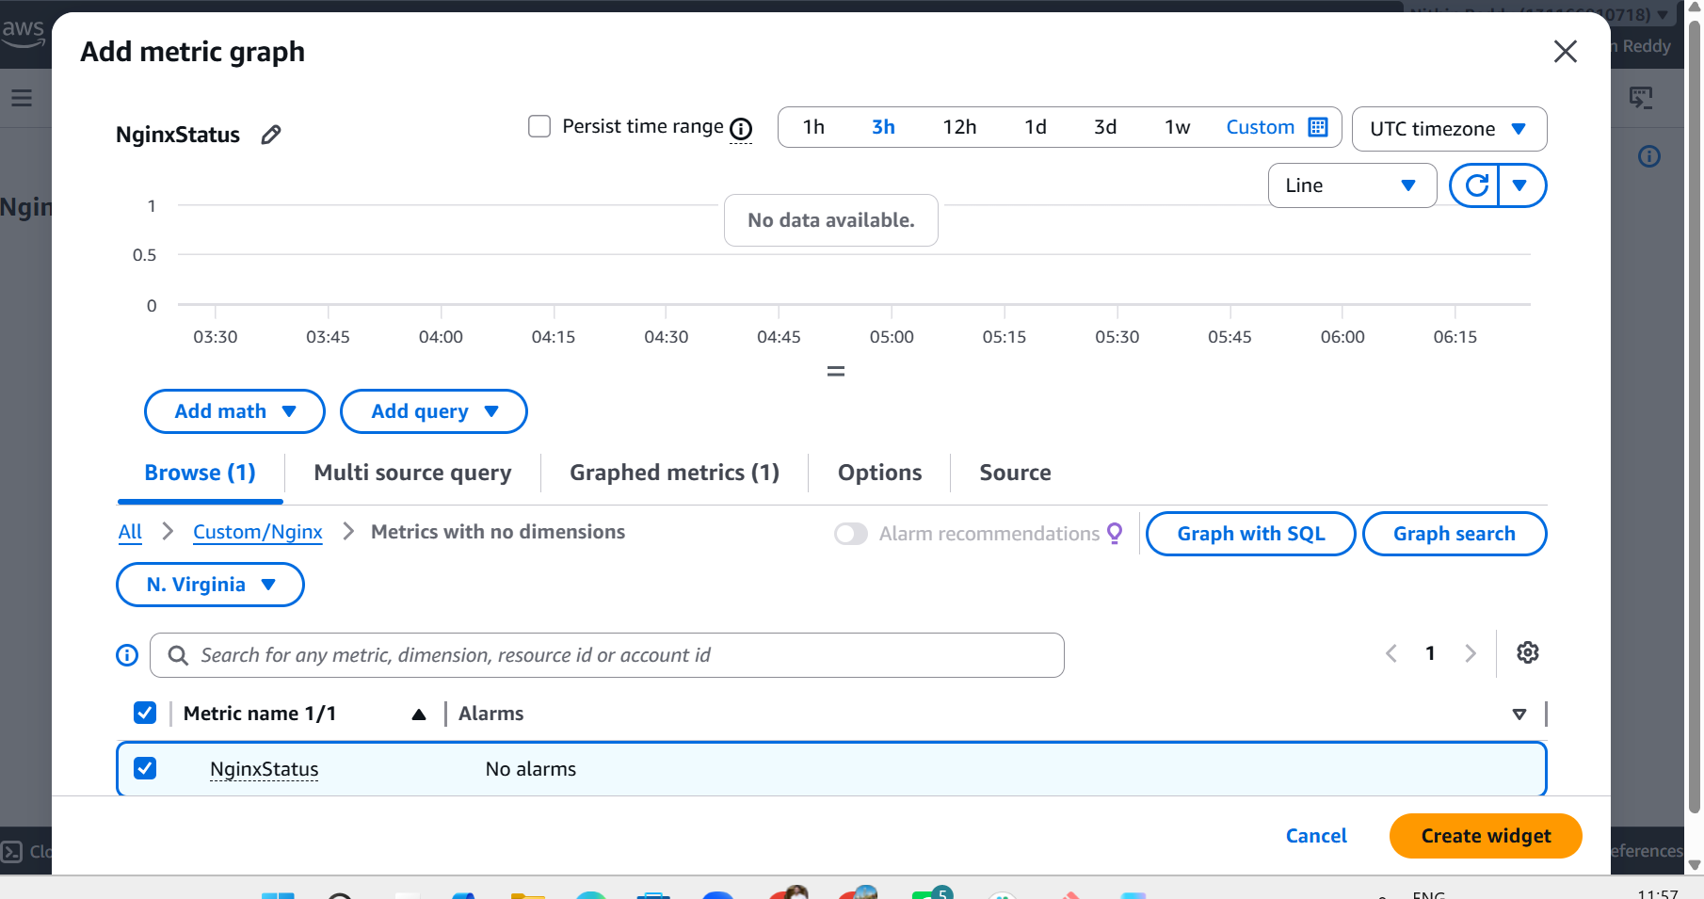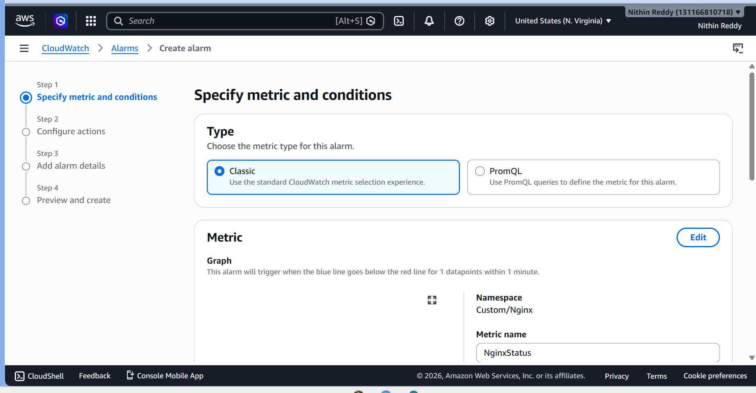
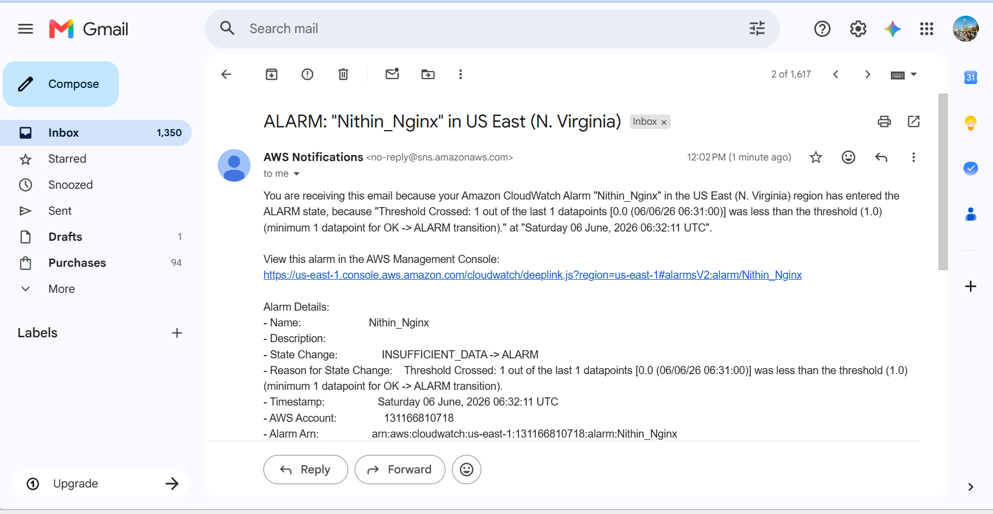
Validation Points:
• Nginx installed successfully.
• Nginx service running successfully.
• Nginx web page accessible.
• Custom CloudWatch metric NginxStatus created.
• CloudWatch Dashboard created successfully.
• CloudWatch Alarm created successfully.
• SNS email notification configured successfully.
• Alarm triggered when Nginx service stopped.
• Alarm recovered when Nginx service restarted.
• End-to-end monitoring validated successfully.
Errors Encountered and Resolution:
Error 1:
Unable to locate credentials.
Cause:
EC2 instance did not have an IAM role attached.

