Task 1: Configure Cross-Region VPC Peering
Objective
To establish private network connectivity between two VPCs located in different AWS regions using VPC Peering.
Prerequisites
- AWS account with VPC and EC2 permissions.
- Two VPCs created in different AWS regions.
- Non-overlapping CIDR ranges.
- Route tables associated with the VPCs.
- Security groups allowing ICMP traffic.
Implementation Steps
- Created a VPC named Mumbai-VPC in the ap-south-1 (Mumbai) region with CIDR block 10.0.0.0/16.
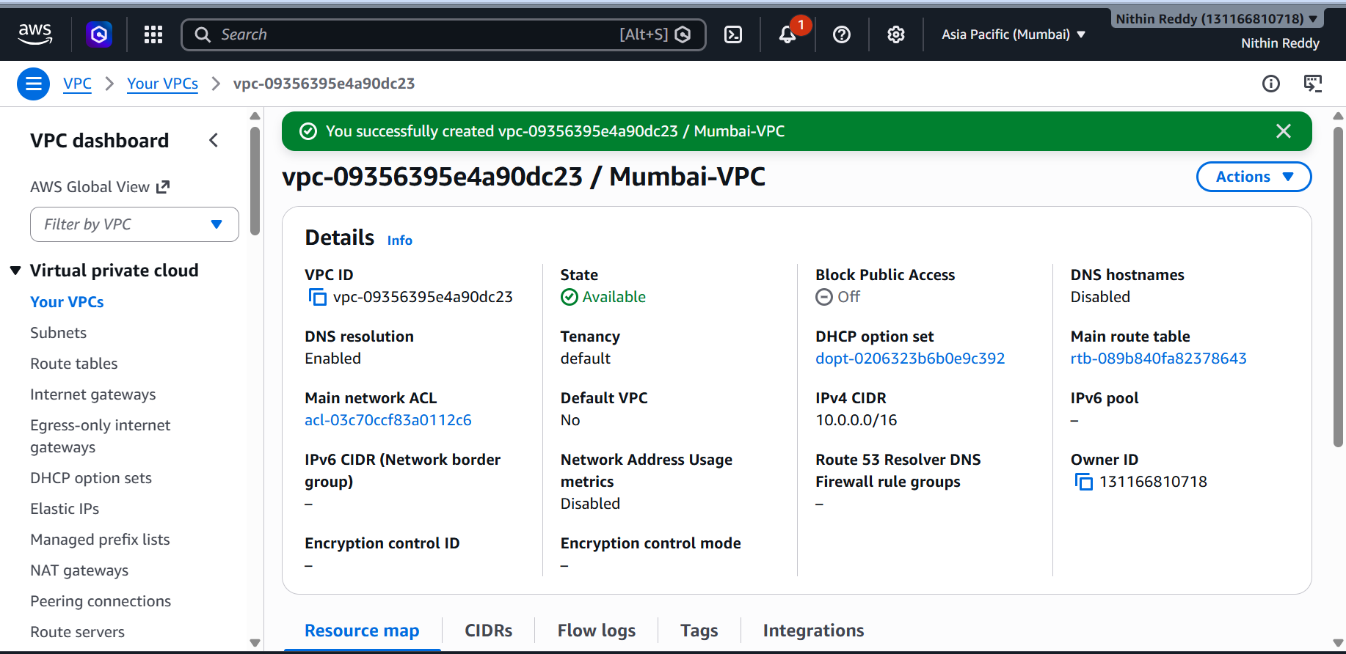

- Created a VPC named Virginia-VPC in the us-east-1 (N. Virginia) region with CIDR block 172.16.0.0/16.
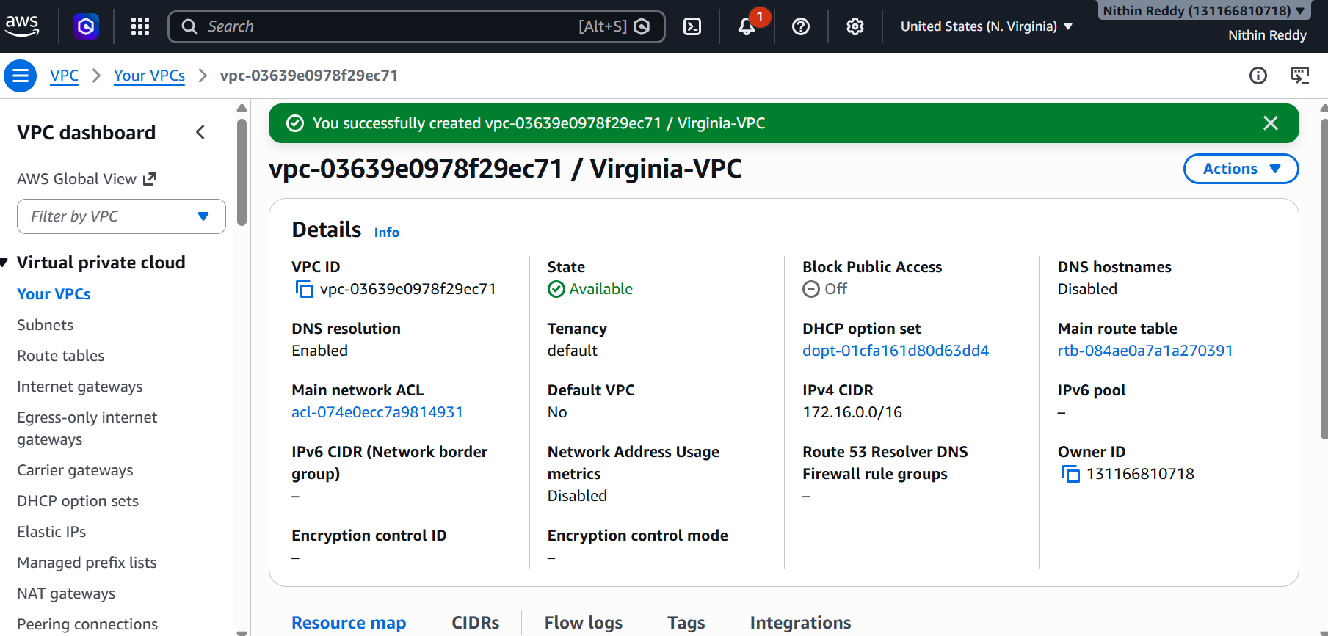
- Initiated a VPC peering connection from Mumbai-VPC to Virginia-VPC.
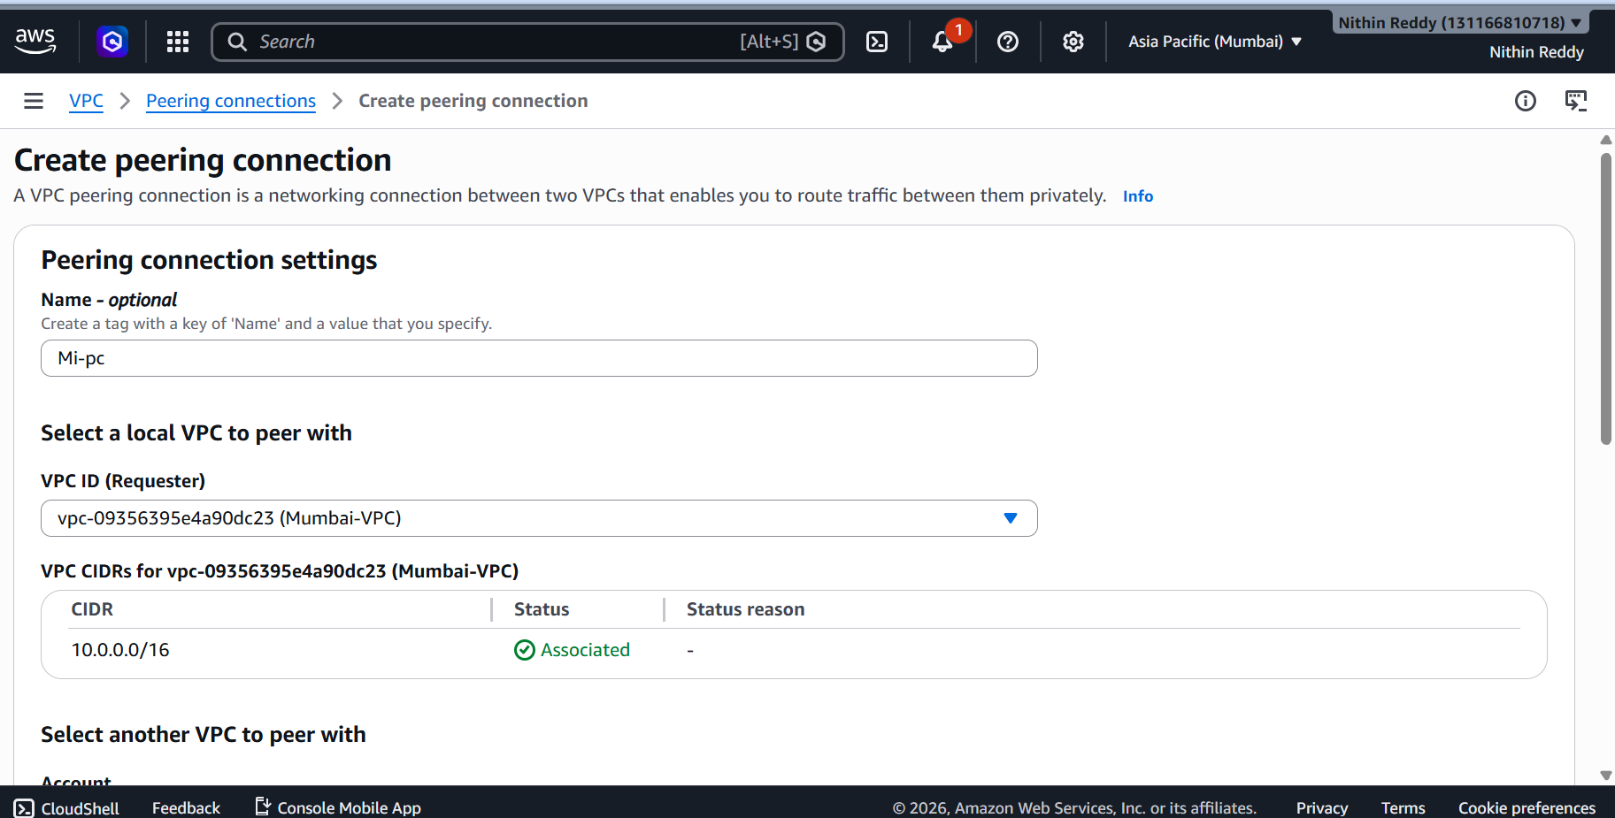

- Switched to the N. Virginia region and accepted the VPC peering request.
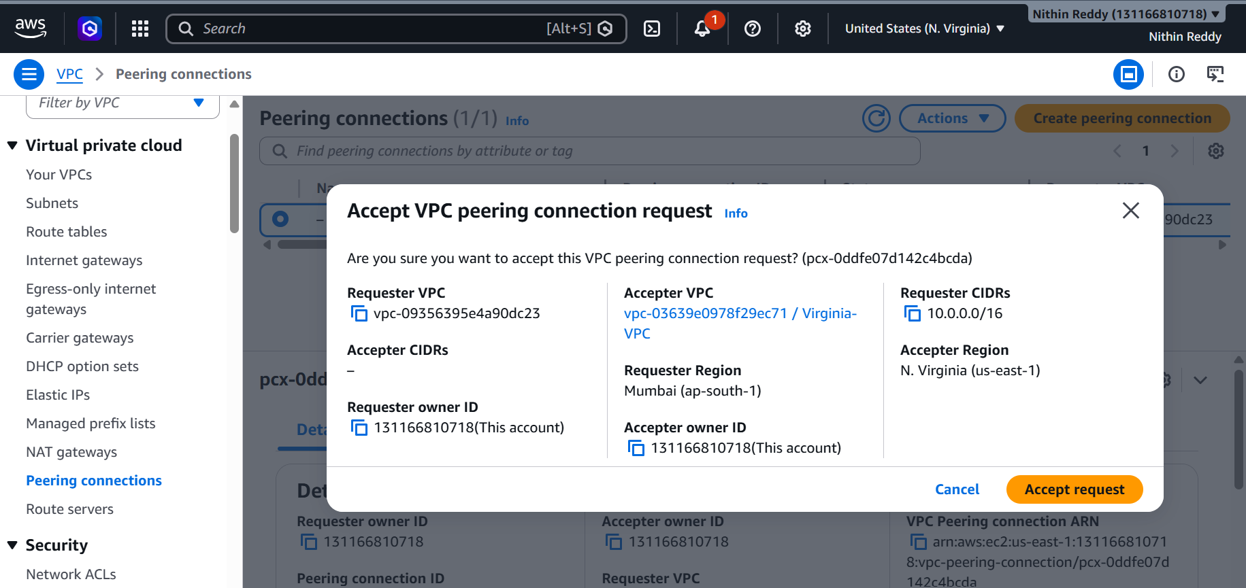
- Verified that the peering connection status changed to Active.
- Updated the Mumbai VPC route table by adding a route to 172.16.0.0/16 through the peering connection.
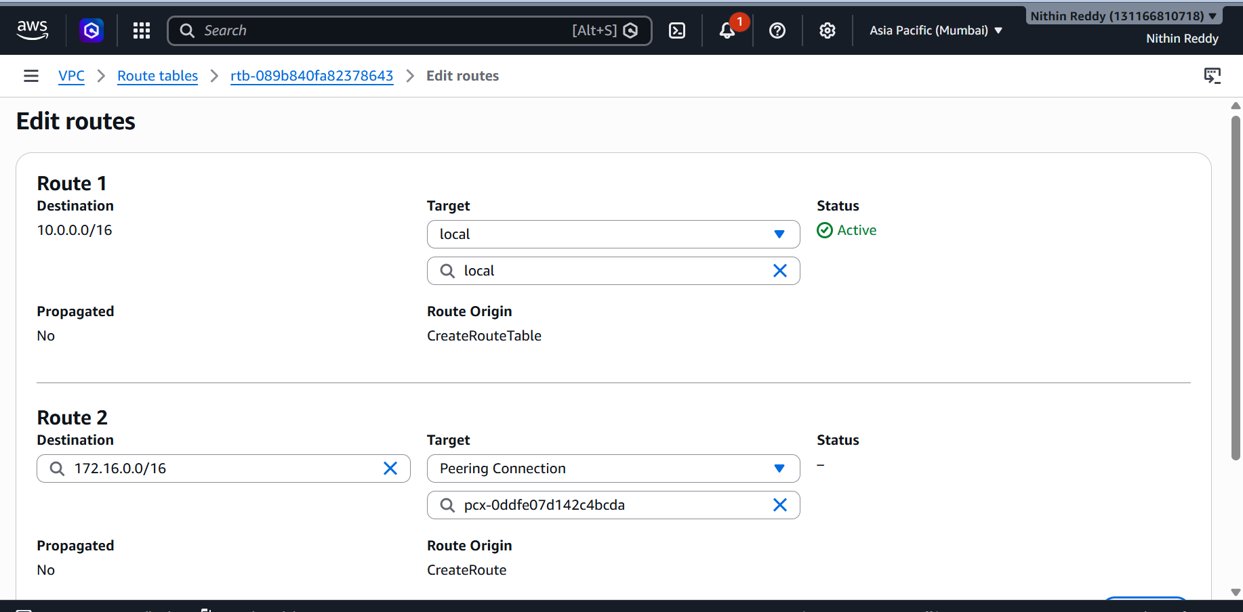
- Updated the Virginia VPC route table by adding a route to 10.0.0.0/16 through the peering connection.
- Modified security group inbound rules in both VPCs to allow ICMP traffic.
- Launched EC2 instances in both VPCs and tested connectivity using private IP addresses.
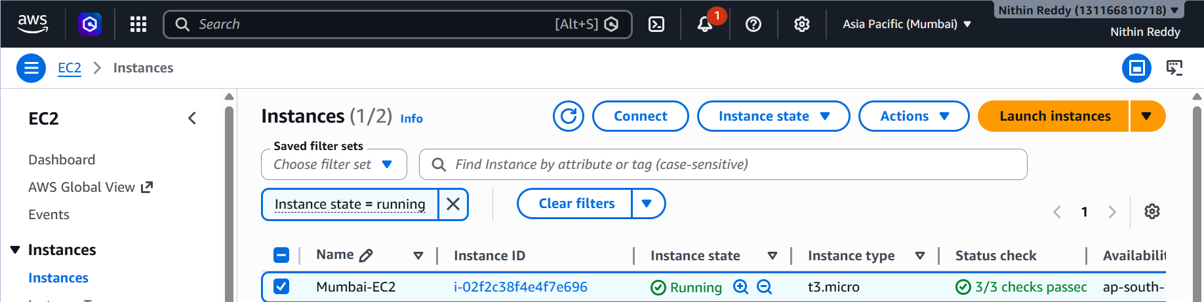
- Verified successful communication between the EC2 instances using the ping command.
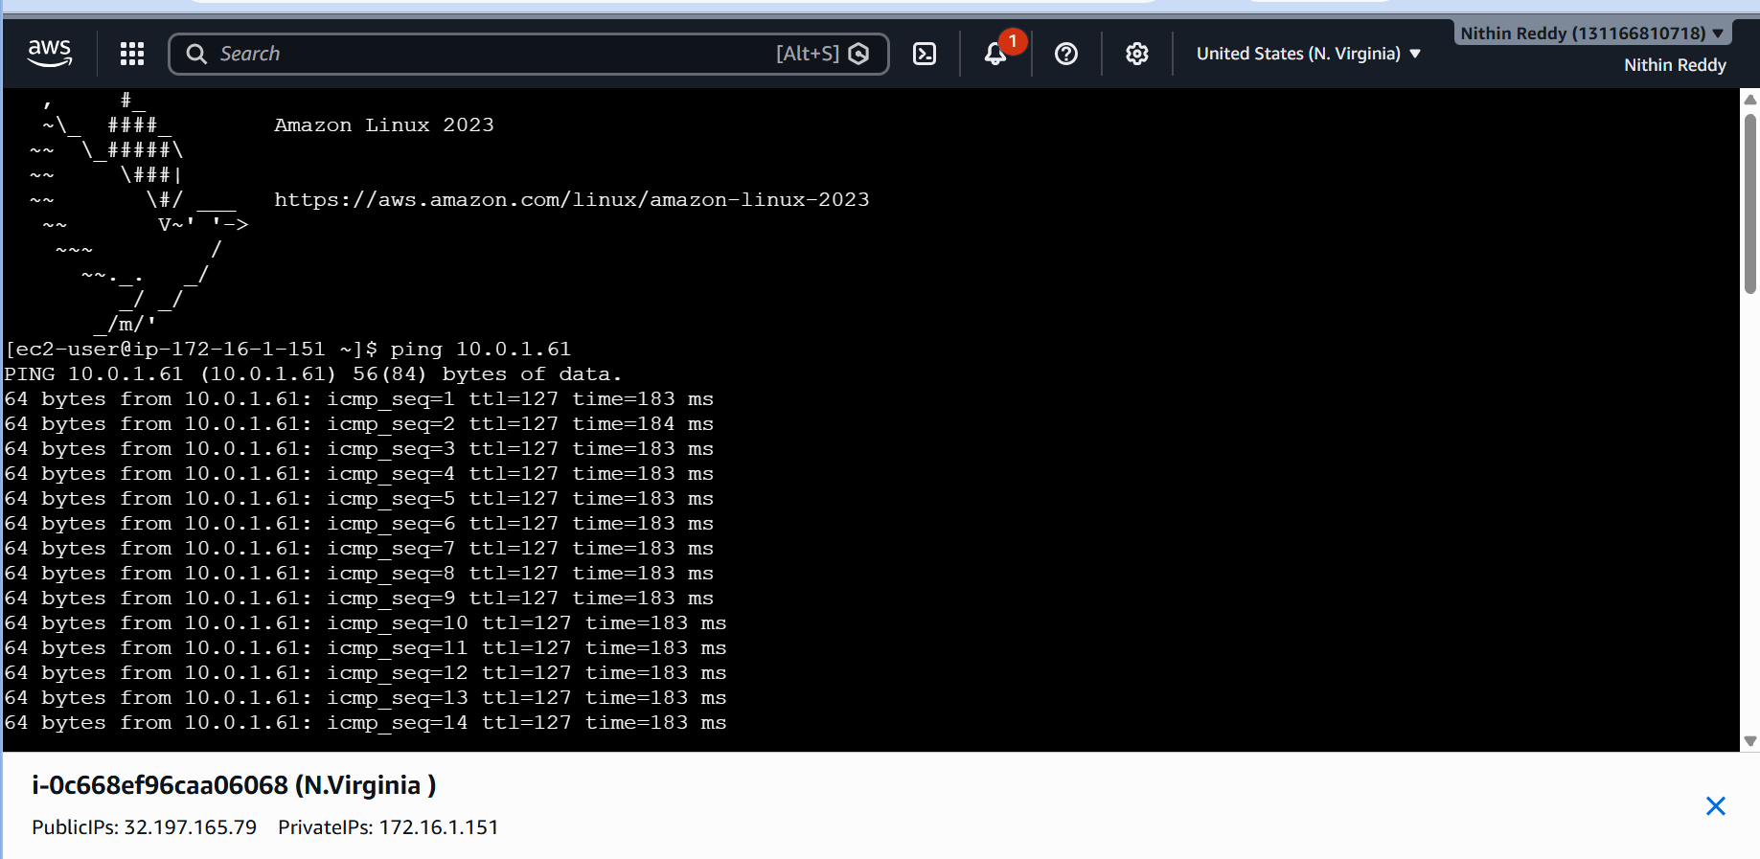

Validation
- VPC peering connection status displayed Active.
- Route tables contained the peer VPC CIDR entries.
- Security groups allowed ICMP traffic.
- Ping from one EC2 instance to the other succeeded.
- Network connectivity was established across AWS regions.
Troubleshooting / Errors Encountered
Issue 1: Peering Connection Remained Pending
Cause: Peering request was not accepted in the accepter region.
Resolution: Logged into the accepter region and accepted the peering request.
Issue 2: Ping Request Timed Out
Cause: ICMP traffic was blocked by the security group.
Resolution: Added inbound ICMP rules to the security groups.
Issue 3: Destination Host Unreachable
Cause: Route table entries were missing.
Resolution: Added routes pointing to the peering connection in both VPC route tables.
Issue 4: Peering Creation Failed
Cause: Overlapping CIDR ranges between VPCs.
Resolution: Created VPCs with non-overlapping CIDR blocks.
Outcome
Successfully established a cross-region VPC peering connection between Mumbai and N. Virginia regions. Private communication between EC2 instances in both VPCs was verified and functioning correctly.
Task 2: Purchase a Domain from GoDaddy
Objective
To purchase and register a public domain name that will be used for hosting the website through CloudFront and Route 53.

Prerequisites
- GoDaddy account.
- Valid payment method.
- Unique domain name not already registered.
- Access to the email account used for domain registration.
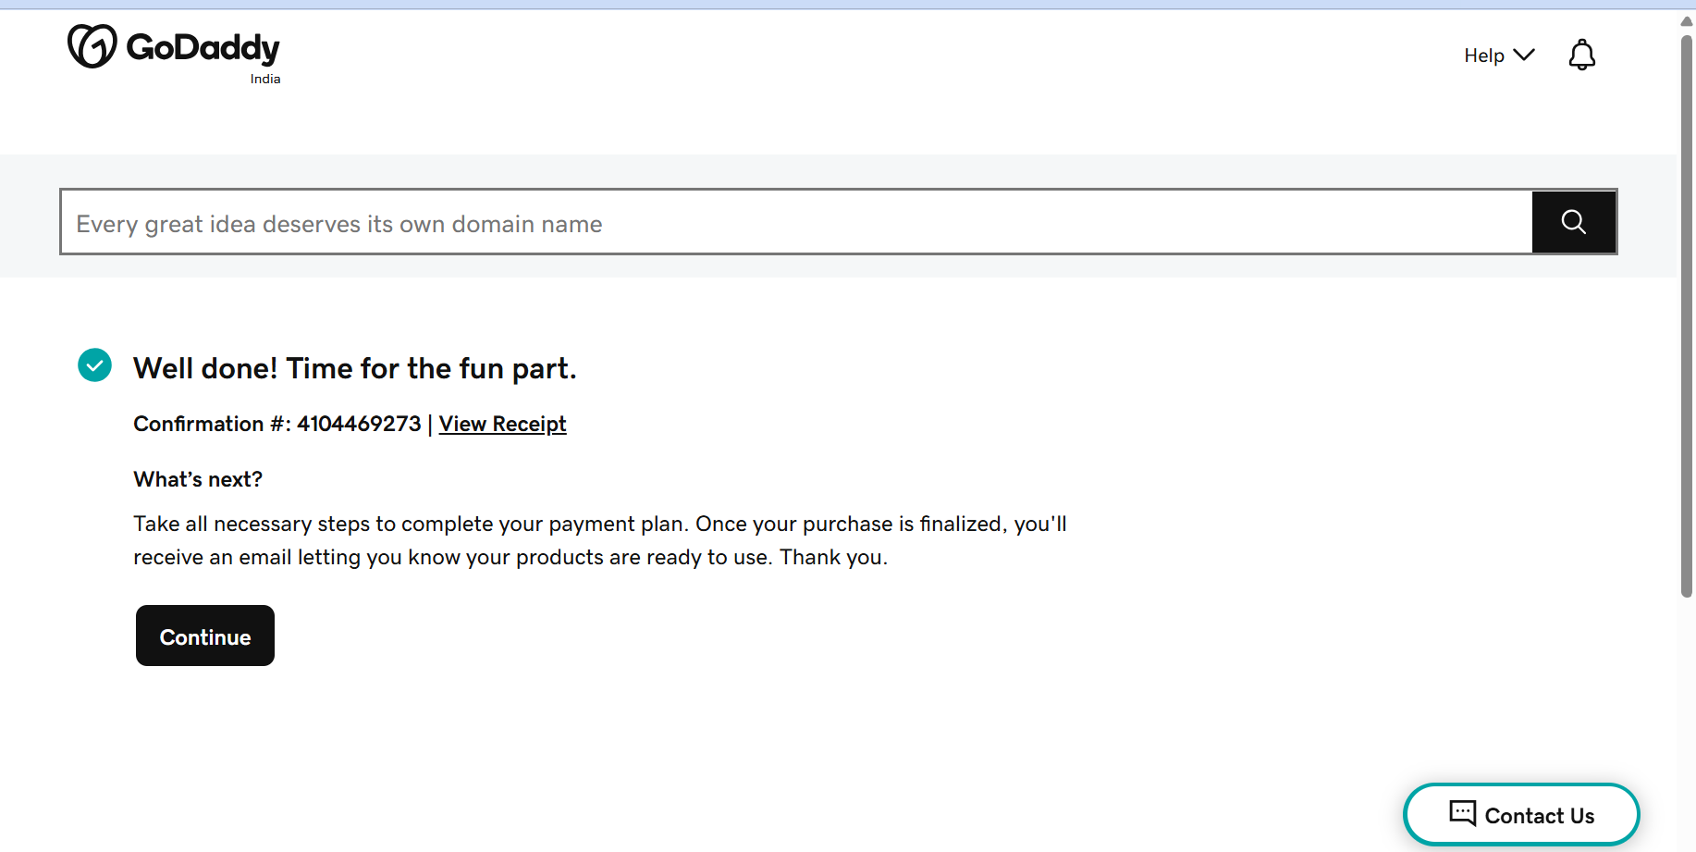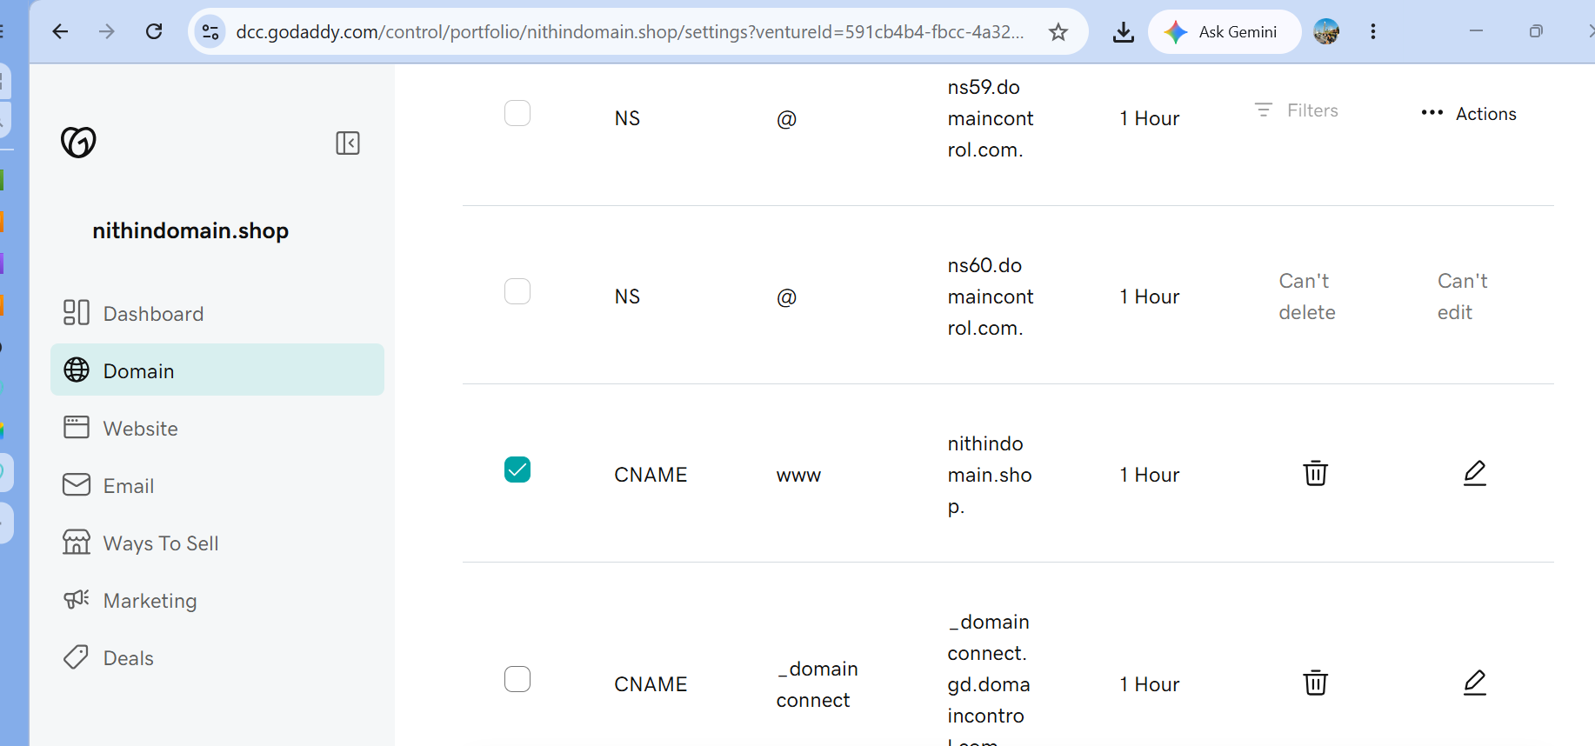

Outcome
Successfully purchased and registered a public domain through GoDaddy. The domain is active and ready to be integrated with Route 53 and CloudFront for website hosting.

Task 3: Deploy Static Website in Amazon S3
Objective
To host a static website using an Amazon S3 bucket and make it accessible over the internet.
Outcome
Successfully deployed a static website in Amazon S3 and made it accessible through the S3 website endpoint.
Prerequisites
- AWS Account
- IAM permissions for:
  - S3
  - CloudFront (later)
- HTML files ready:
  - index.html
  - error.html

Architecture
User
↓
S3 Static Website
Later in Task 4:
User
↓
CloudFront
↓
S3 Bucket
Implementation Steps
You can paste this into your report:
- Created an Amazon S3 bucket with a globally unique bucket name.
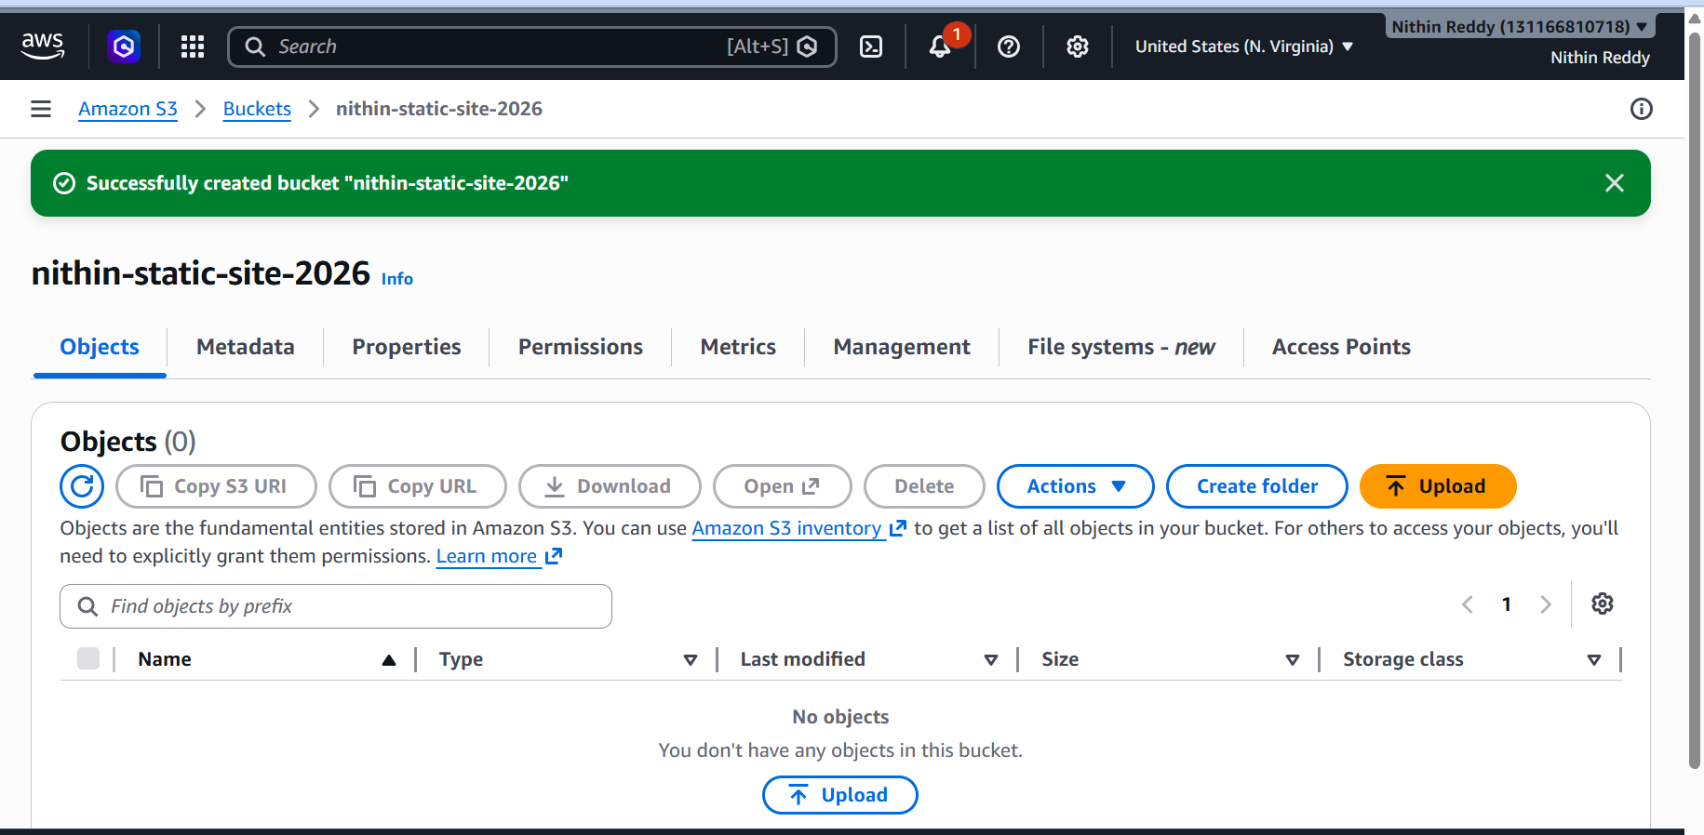
- Disabled Block Public Access settings to allow public website access.
- Uploaded the index.html and error.html files to the bucket.
- Enabled Static Website Hosting on the bucket.
- Configured index.html as the index document and error.html as the error document.
- Added a bucket policy to allow public read access to website files.
- Accessed the S3 website endpoint and verified that the website loaded successfully.
- Confirmed that the static website was publicly accessible through the generated endpoint.
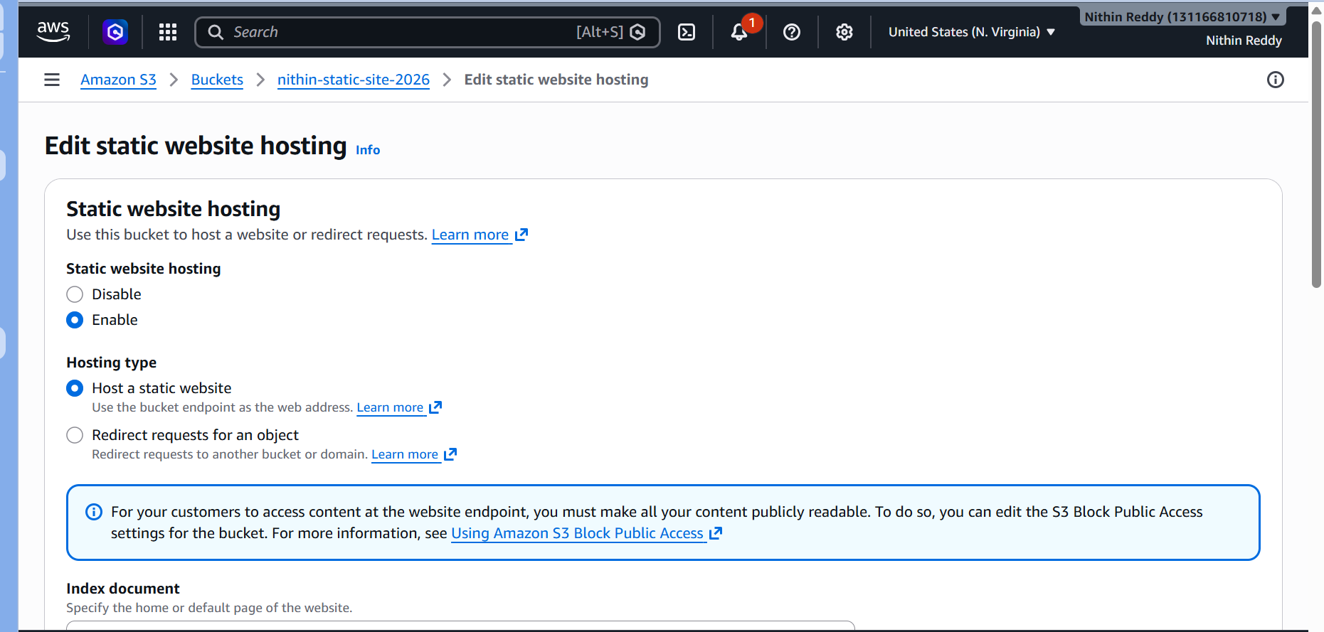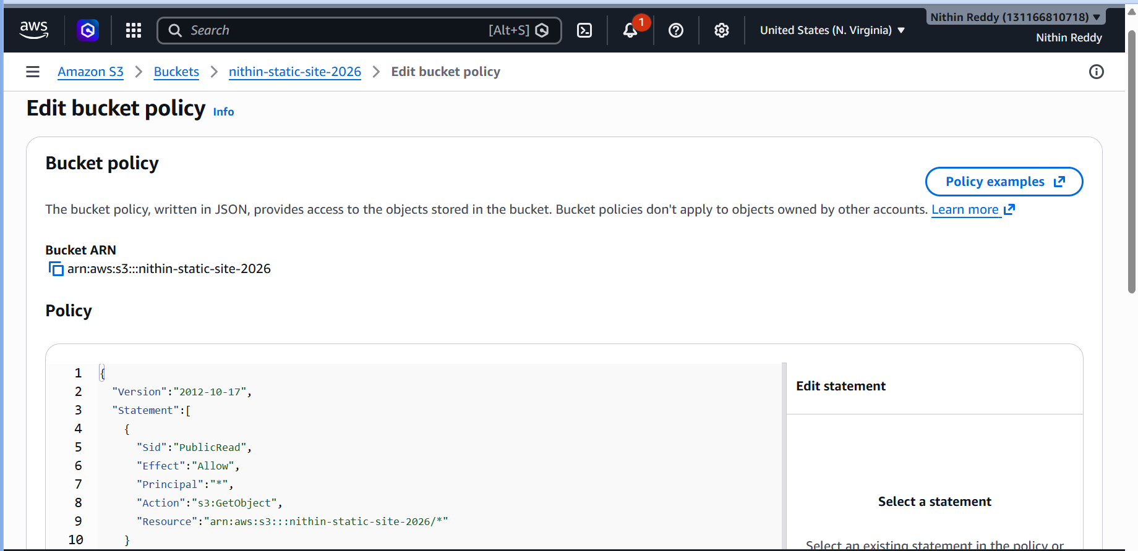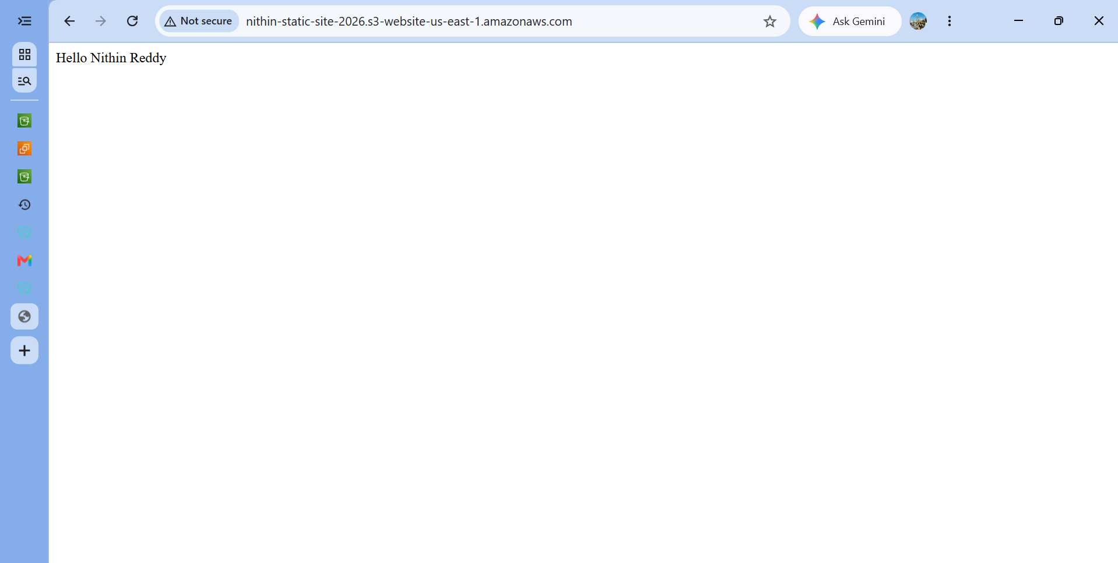
Validation
Verify:
✅ Bucket created successfully
✅ Files uploaded
✅ Static Website Hosting enabled
✅ Bucket Policy applied
✅ Website endpoint accessible
✅ index.html loads successfully
Troubleshooting / Errors
Error 1: Access Denied
Cause
Bucket policy missing
Resolution
Add public read bucket policy
Error 2: 403 Forbidden
Cause
Block Public Access enabled
Resolution
Disable Block Public Access

Error 3: 404 Not Found
Task 4: Create a CloudFront CDN and Attach an SSL Certificate
Objective
To improve website performance and security by placing Amazon CloudFront in front of the S3 website and configuring HTTPS using an AWS Certificate Manager (ACM) SSL certificate.
Outcome
Successfully created a CloudFront distribution, attached an ACM SSL certificate, enabled HTTPS, and served the S3-hosted website through CloudFront.

Prerequisites
Before starting, ensure:
✅ S3 static website is working.
✅ You have the S3 bucket name.
✅ You either:
- Already purchased a GoDaddy domain (recommended), OR
- Have a domain available for DNS validation.
Important: ACM certificates used with CloudFront must be created in US East (N. Virginia) – us-east-1.

Architecture
User
↓ HTTPS
CloudFront
↓
Implementation Steps
- Requested a public SSL certificate in AWS Certificate Manager in the us-east-1 region.
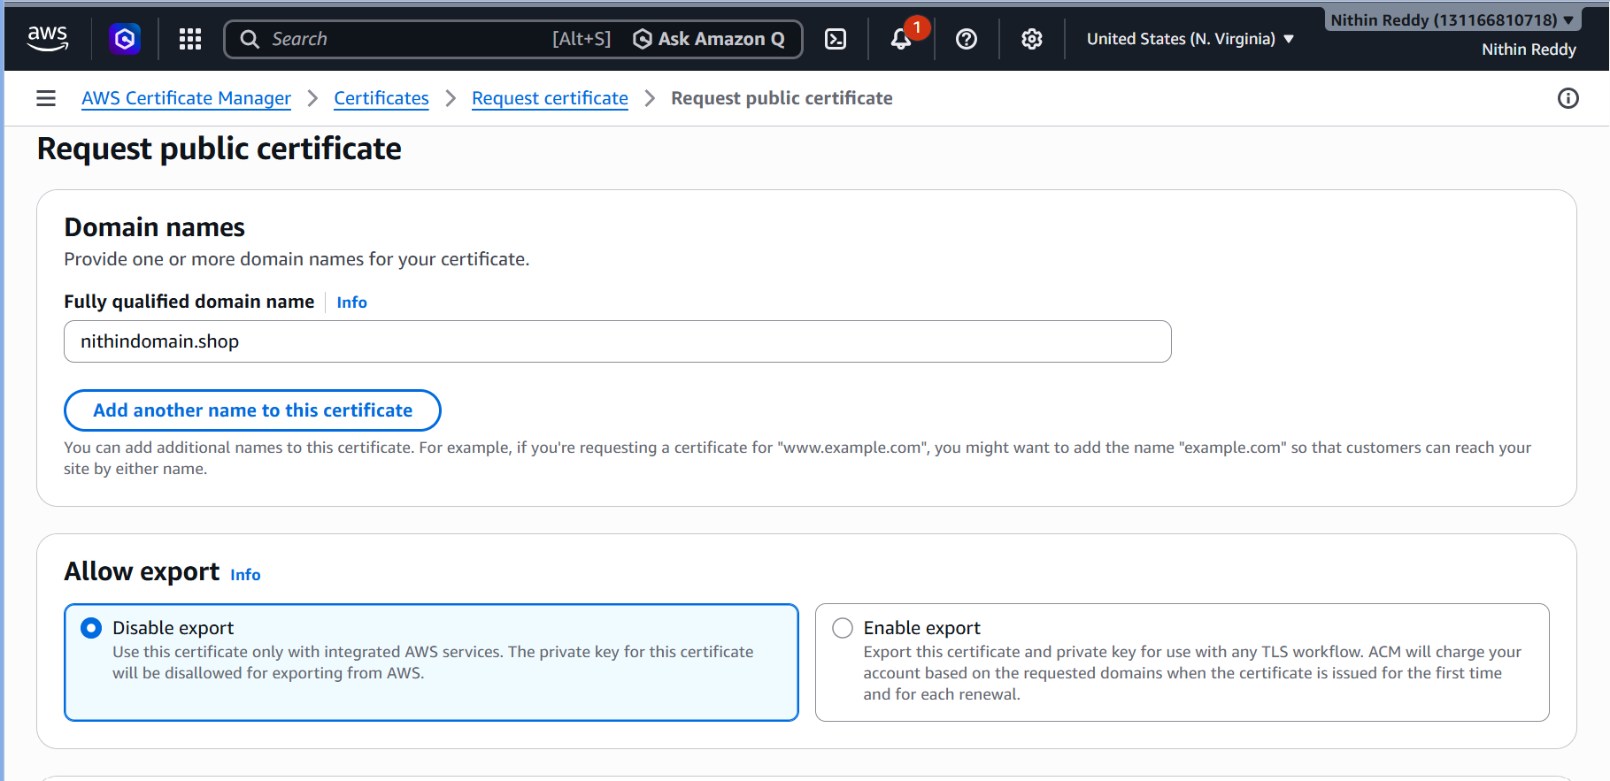
- Added the required DNS validation records in GoDaddy DNS management.
- Verified that the ACM certificate status changed to Issued.
- Created a CloudFront distribution with the S3 bucket as the origin.
- Configured CloudFront to redirect HTTP traffic to HTTPS.
- Added the custom domain name as an Alternate Domain Name (CNAME).
- Attached the ACM SSL certificate to the CloudFront distribution.
- Deployed the CloudFront distribution and verified successful deployment.
- Tested the CloudFront URL and confirmed that the website loaded securely over HTTPS.
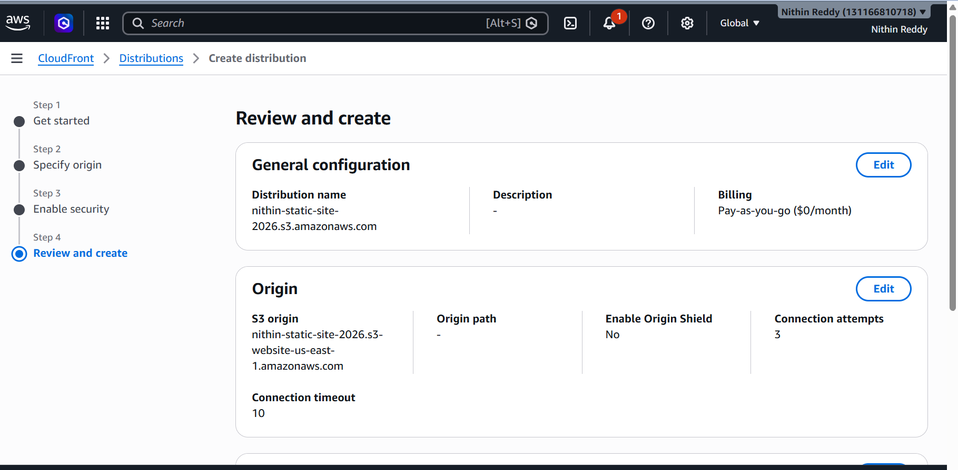
Validation
Verify:
✅ ACM certificate status = Issued
✅ CloudFront status = Deployed
✅ Alternate Domain Names configured
✅ HTTPS enabled
✅ CloudFront URL opens website
✅ SSL certificate is valid
Task 5: Create a Route 53 Hosted Zone and Map the Domain with CloudFront CDN
Objective
To create a Route 53 hosted zone for the purchased domain and route domain traffic to the CloudFront distribution hosting the static website.
Outcome
Successfully created a Route 53 hosted zone, delegated domain DNS management to Route 53, and mapped the domain name to the CloudFront distribution serving the static website.
Prerequisites
Ensure the following are completed:
✅ Domain purchased from GoDaddy
✅ S3 Static Website created
✅ ACM Certificate status = Issued
✅ CloudFront Distribution status = Deployed
✅ CloudFront Domain Name available
Example:
d123abcd.cloudfront.net

Architecture
User
↓
yourdomain.com
↓
Route 53
↓
CloudFront
↓
S3 Bucket
Document Version (Implementation Steps)
You can paste the following directly into your report:
- Created a public hosted zone in Amazon Route 53 for the purchased domain.
- Retrieved the Route 53 nameserver records generated for the hosted zone.
- Updated the domain nameservers in GoDaddy with the Route 53 nameservers.
- Waited for DNS propagation to complete.
- Created an Alias A record in Route 53 pointing the root domain to the CloudFront distribution.
- Created an additional Alias A record for the www subdomain.
- Verified that the Route 53 records resolved to the CloudFront distribution.
- Accessed the website using the custom domain name and confirmed successful connectivity over HTTPS.
- Verified that the SSL certificate was functioning correctly and the website loaded securely.
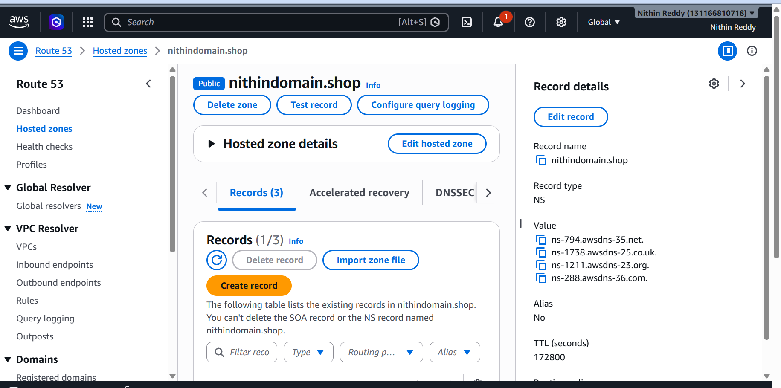
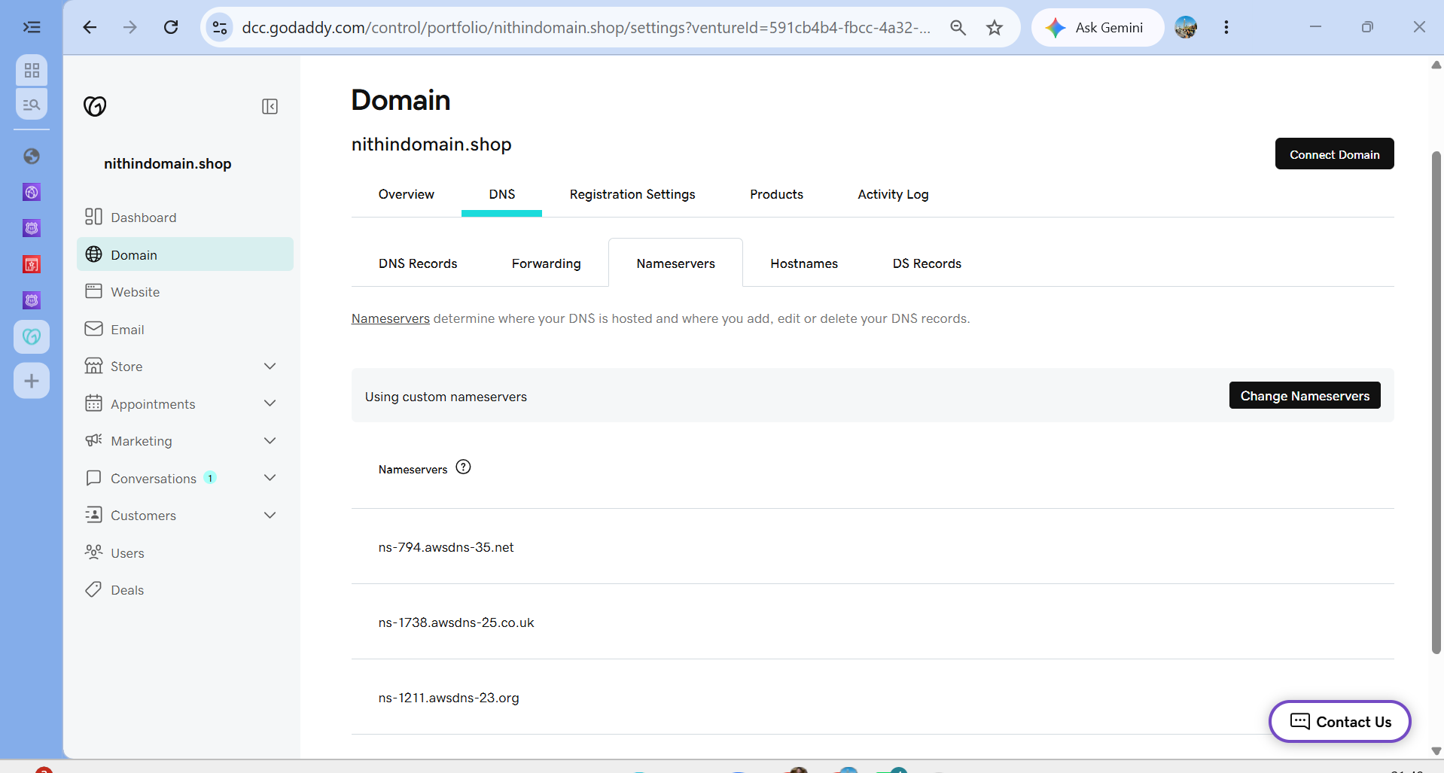
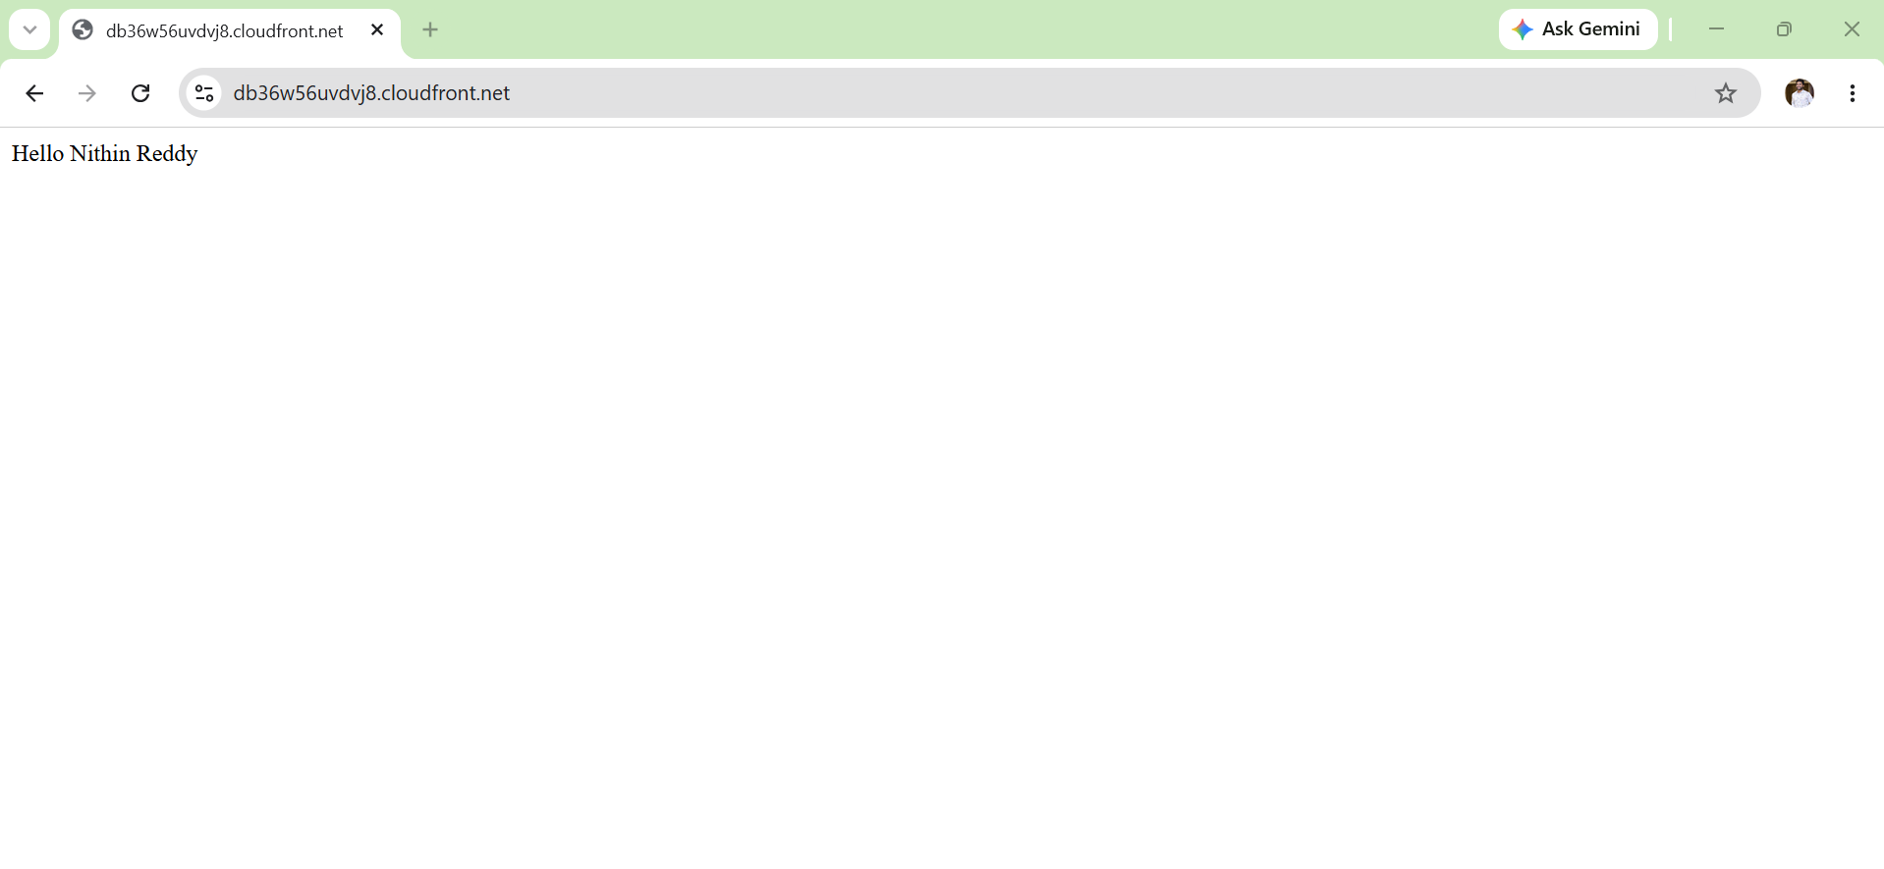
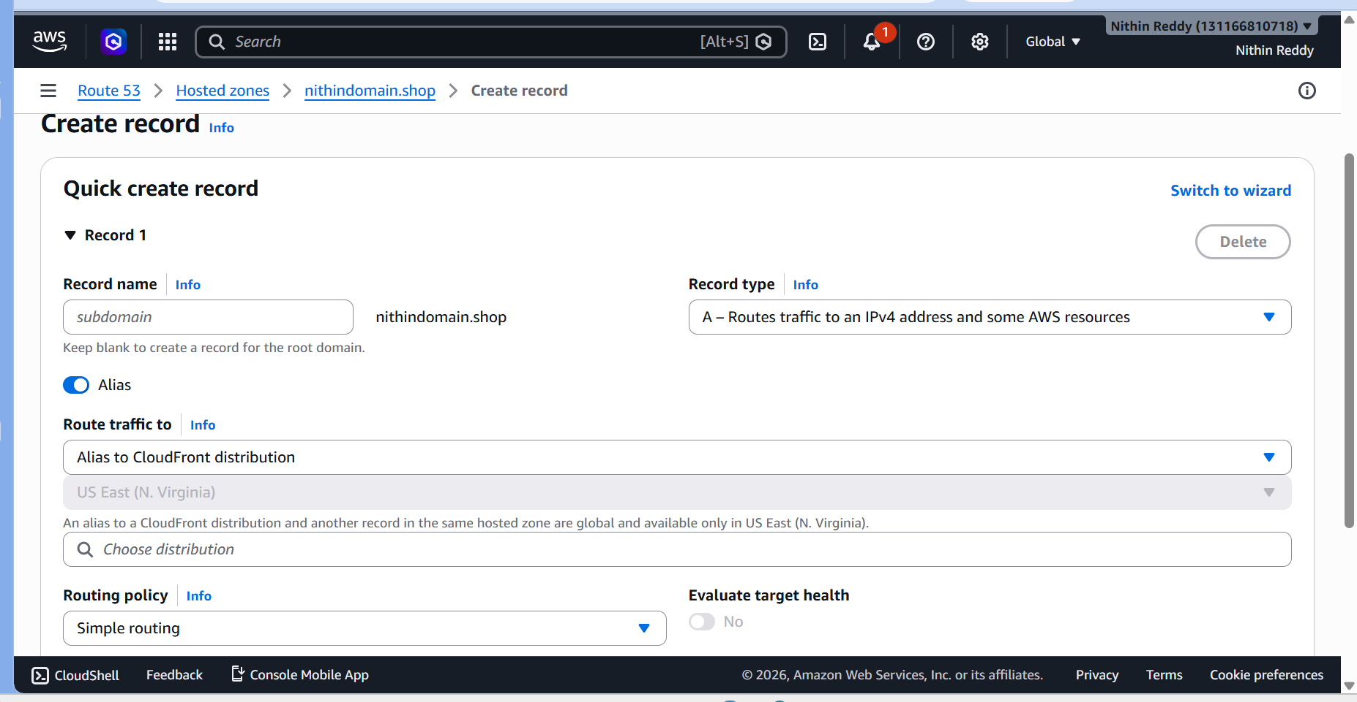
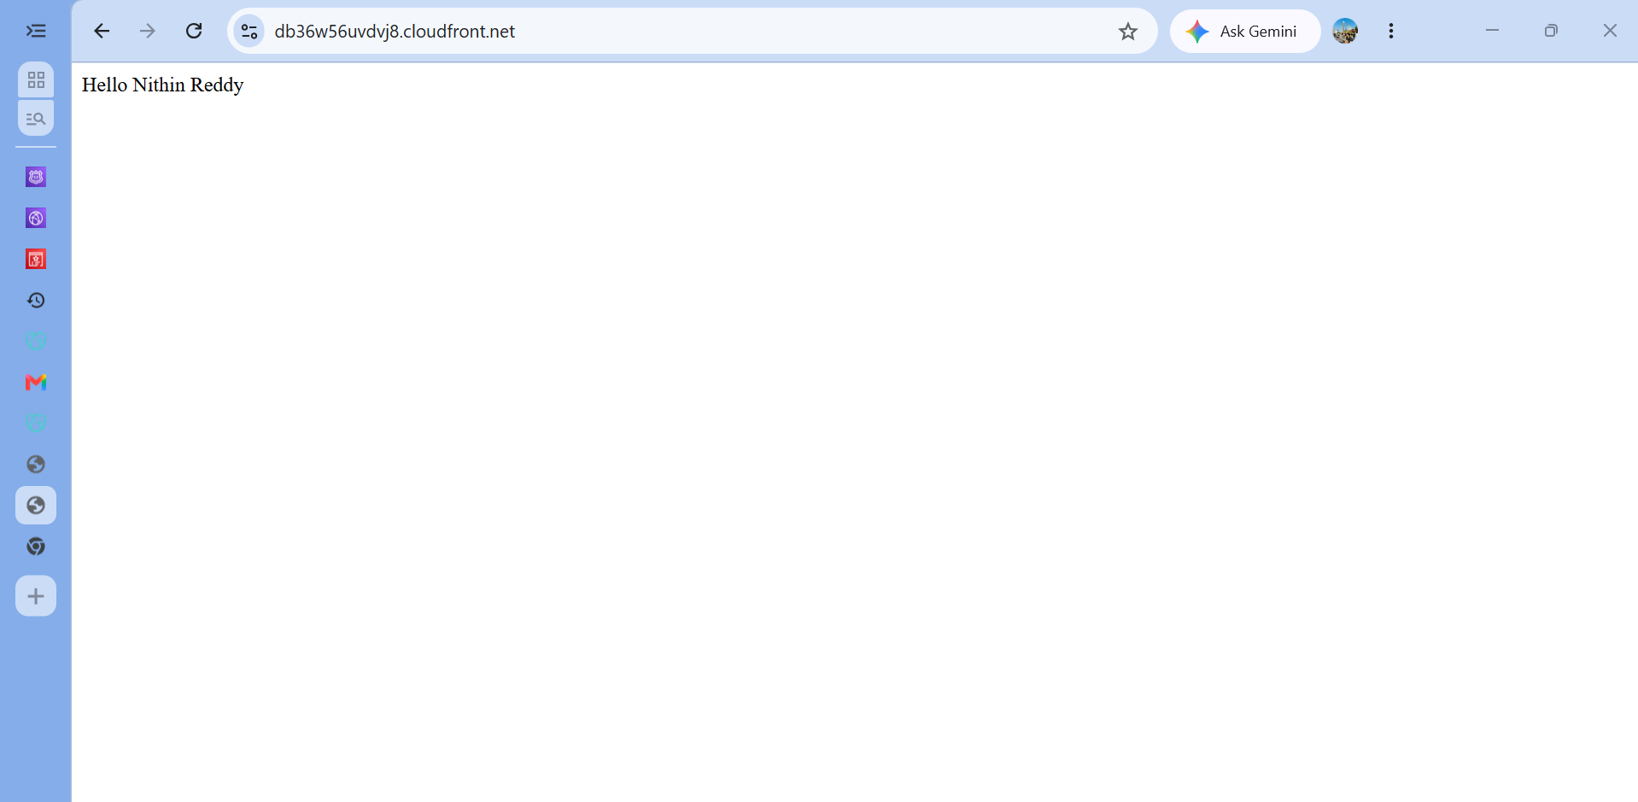
Validation
Verify:
✅ Hosted Zone created successfully
✅ GoDaddy nameservers updated
✅ Route 53 NS records propagated
✅ Alias record points to CloudFront
Troubleshooting / Errors
Error 1: Domain Not Opening
Cause
DNS propagation incomplete.
Resolution
Wait and test again after propagation.

Error 2: SSL Certificate Error
Cause
Domain not added as Alternate Domain Name in CloudFront.
Resolution
Add the domain under CloudFront Alternate Domain Names and redeploy.

Task 6: Update index.html and Verify Through Domain
Objective
Update website content in S3 and verify the changes through the custom domain.
Outcome
Successfully updated the S3-hosted website content and verified that the updated content was accessible through the CloudFront distribution and custom domain name.
Prerequisites
- S3 Static Website deployed successfully.
- CloudFront distribution status is Deployed.
- Route 53 domain mapping completed.
- Domain name is resolving correctly.
- Existing index.html file present in the S3 bucket.

Implementation Steps
- Opened the local index.html file and modified the website content.
- Saved the updated HTML file with the required changes.
- Logged in to the AWS Management Console and navigated to the S3 bucket.
- Uploaded the updated index.html file to replace the existing version.
- Navigated to the CloudFront distribution associated with the website.
- Created a CloudFront invalidation for /* to clear cached content.
- Waited for the invalidation process to complete successfully.
- Accessed the website using the custom domain name.
- Verified that the updated webpage content was displayed through the domain.
- Confirmed that HTTPS connectivity and SSL certificate functionality remained operational.

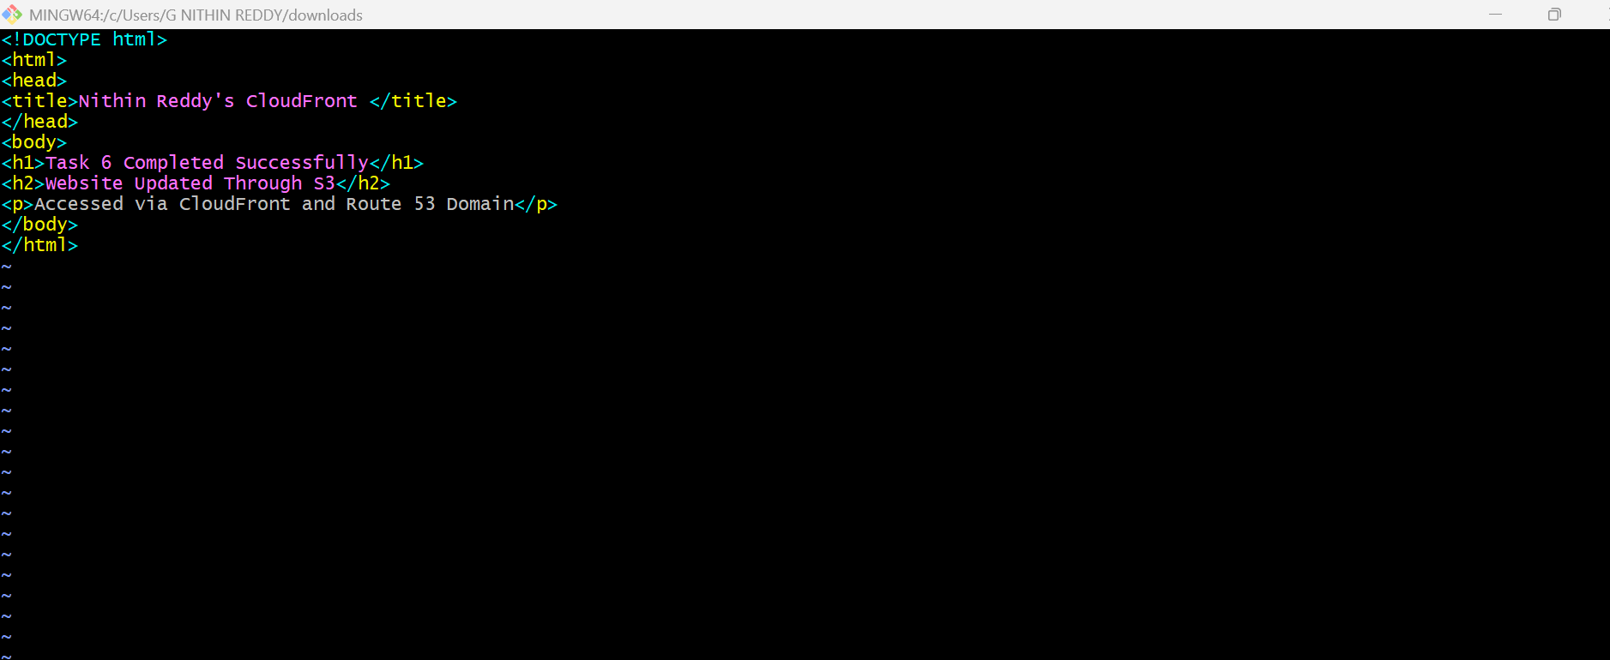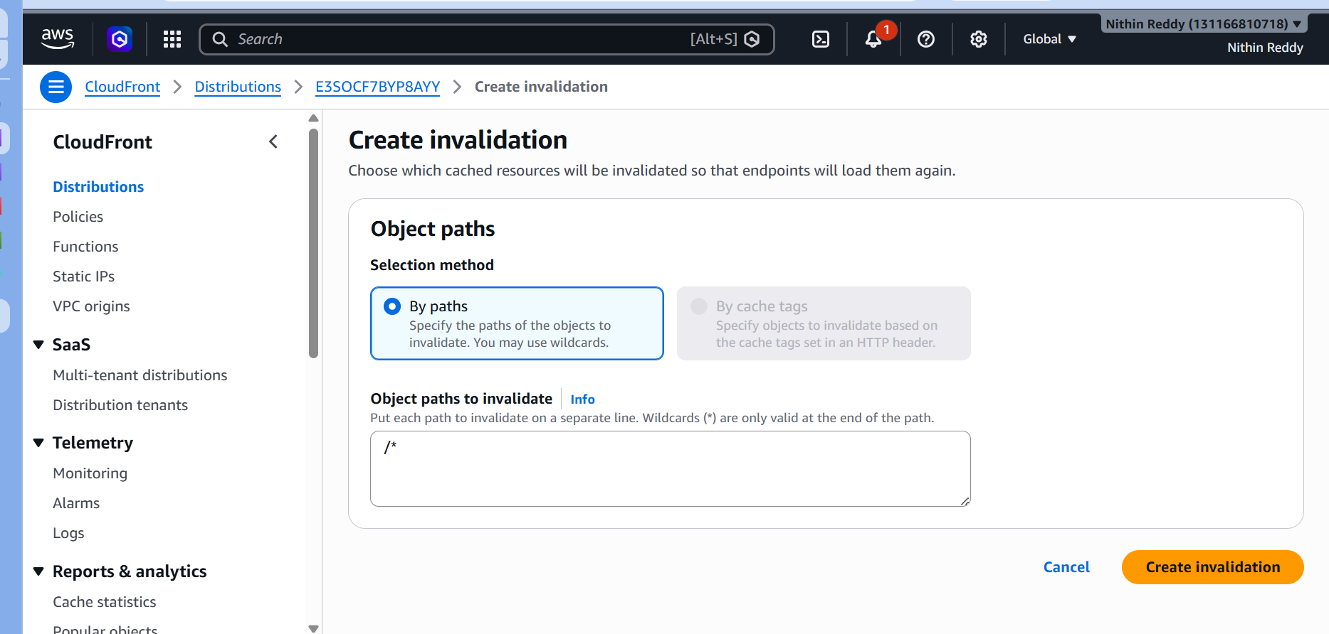
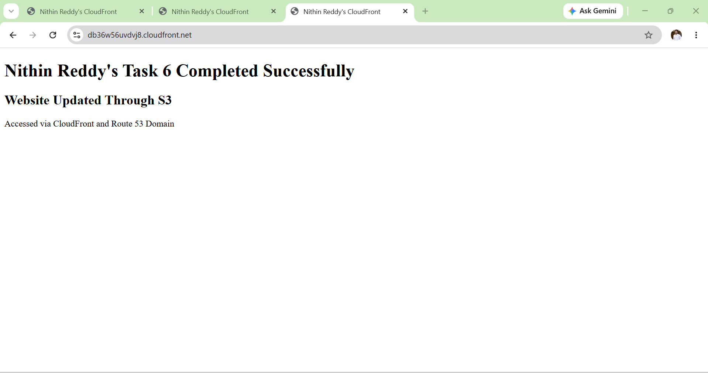

Validation Points
✅ Updated index.html file successfully uploaded to the S3 bucket.
✅ CloudFront invalidation status changed to Completed.
✅ Website displayed the newly updated content.
✅ Custom domain name resolved successfully.
✅ HTTPS protocol functioned correctly.
✅ SSL certificate displayed as valid in the browser.
✅ No CloudFront or S3 access errors were observed.
✅ Website remained accessible through the custom domain after the update.

Task 7: Share the Domain Name in Slack to Test Connectivity
Objective
To share the deployed website URL with team members through Slack and verify that the website is accessible from external networks.

Prerequisites
- Task 6 completed successfully.
- Website accessible using the custom domain.
- CloudFront distribution deployed.
- Route 53 DNS propagation completed.
- SSL certificate functioning correctly.

Implementation Steps
- Verified that the website was accessible using the custom domain name.
- Confirmed that the website loaded successfully over HTTPS.
- Copied the website URL.
- Logged in to the Slack workspace.
- Navigated to the assigned channel or group.
- Shared the website URL for connectivity testing.
- Requested team members to verify website accessibility.
- Collected feedback regarding successful website access.
- Confirmed that the website was reachable from external networks and devices.

Sample Slack Message
Website URL: https://db36w56uvdvj8.cloudfront.net/
https://nithindomain.shop
The static website has been successfully deployed using Amazon S3, CloudFront, ACM SSL Certificate, and Route 53.
Please verify the website accessibility and connectivity from your network and share your feedback.

Validation Points
✅ Domain URL shared successfully in Slack.
✅ Website opened successfully from different systems.
✅ HTTPS connection established.
✅ SSL certificate validated.
✅ Website content displayed correctly.
✅ No DNS resolution issues observed.
✅ External users were able to access the website.

