Task 1. Create one VPC in N. Virginia region.
Objective
Create a custom VPC to isolate and manage AWS resources.
Outcome
A VPC is available for deploying subnets, EC2 instances, ALB, NAT Gateway, and Auto Scaling resources.
Prerequisites
- AWS Account
- AWS Console Access
- Region: N. Virginia (us-east-1)
Dependencies
- Foundation task.
- Required for Tasks 2–12.
Steps
- Login to AWS Console.
- Open VPC Dashboard.
- Click Create VPC.
- Select VPC Only.
- Name: DevOps-VPC
- IPv4 CIDR:
10.0.0.0/16
- Create VPC.
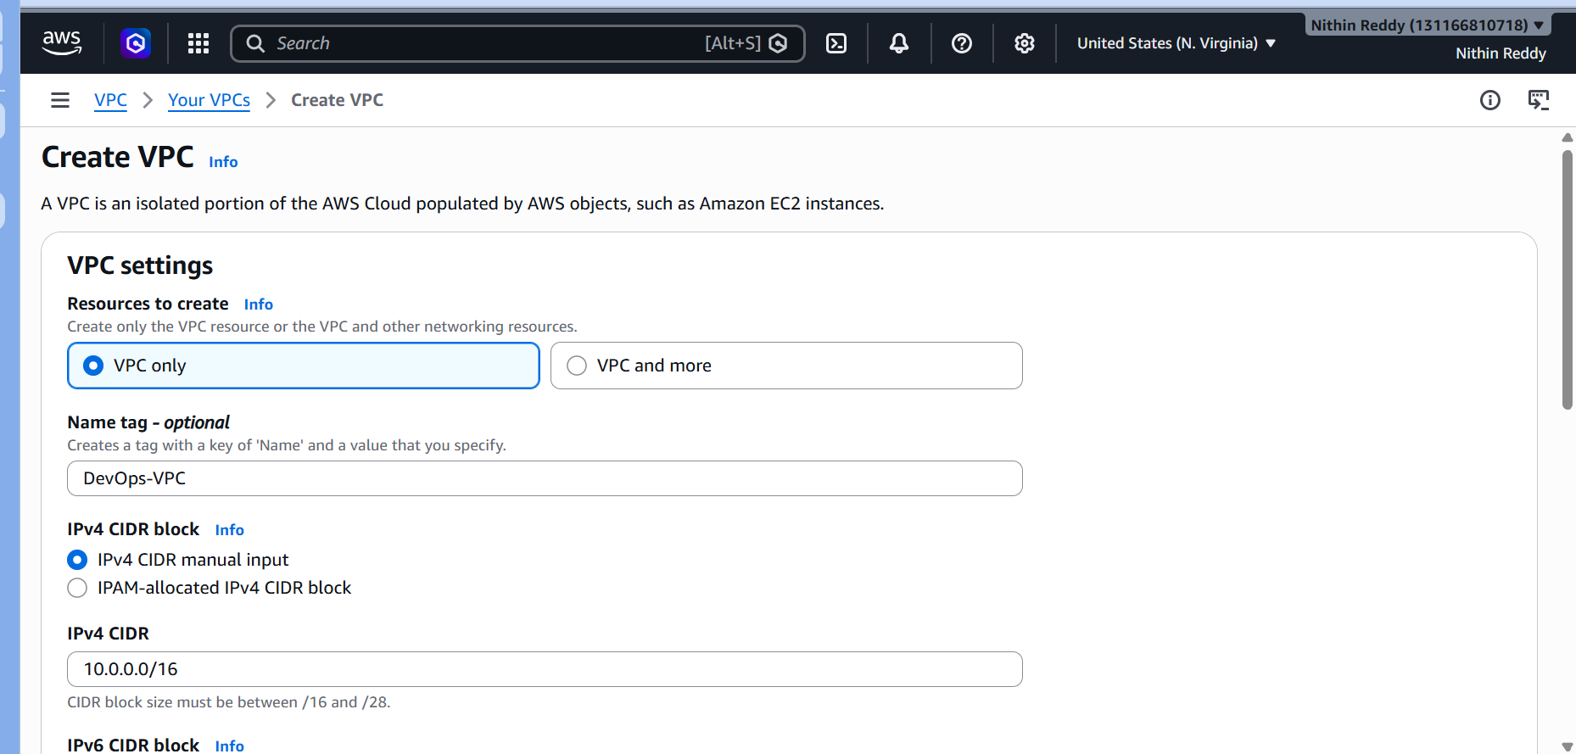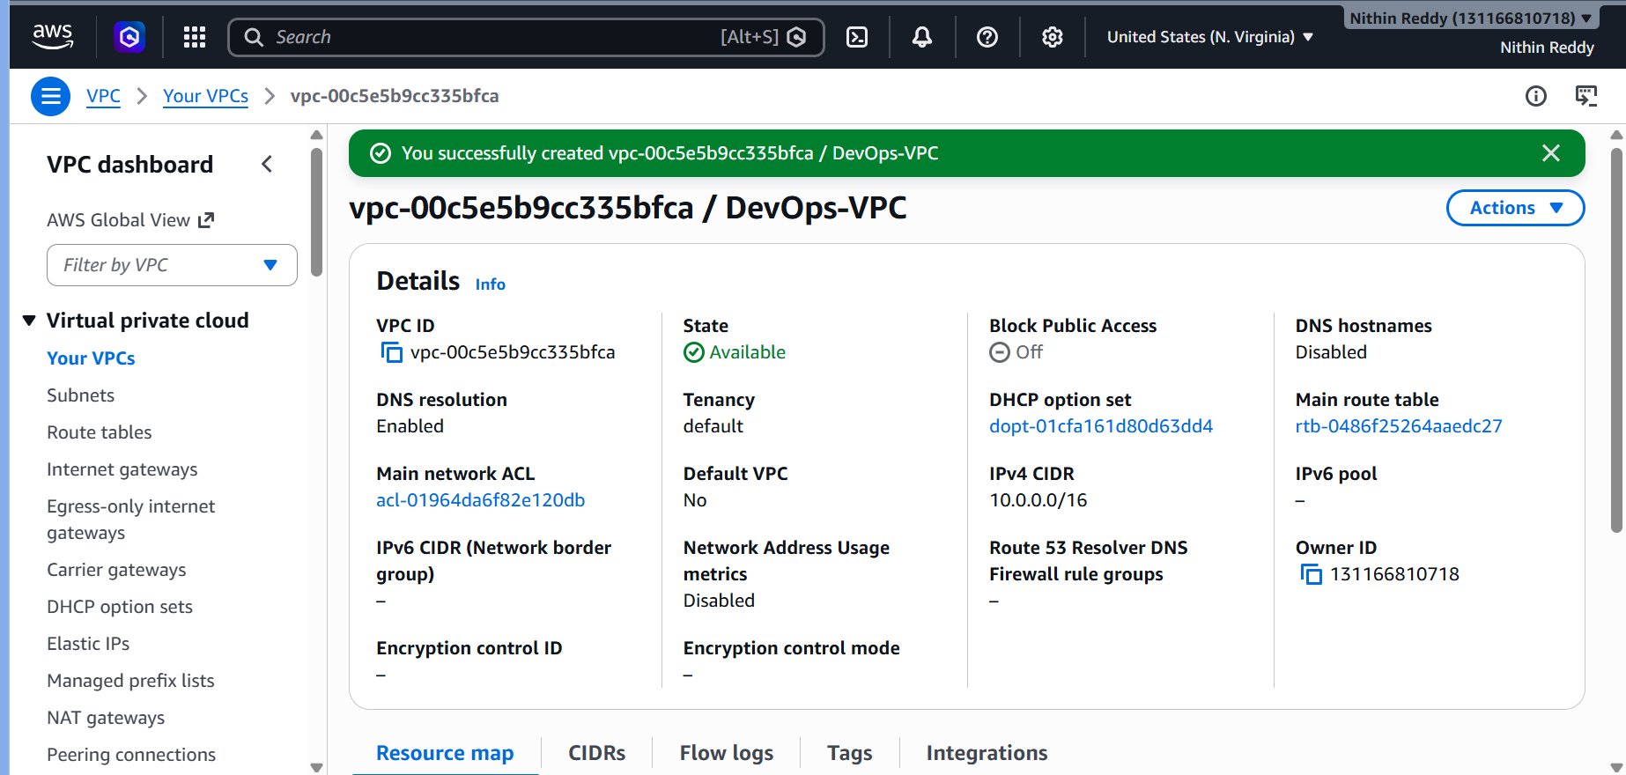
Validation
- VPC State = Available
- CIDR = 10.0.0.0/16
Troubleshooting
Error
CIDR overlap
Fix
Use another CIDR block. Exp 10.1.0.0/16
Task 2. Create two subnets: one public subnet and one private subnet.
Objective
Create network segmentation.
Outcome
- Public subnet
- Private subnet
Prerequisites
Task 1 completed.
Dependencies
Uses VPC from Task 1.
Steps
Public Subnet
Name:
Public-Subnet
CIDR:
10.0.1.0/24
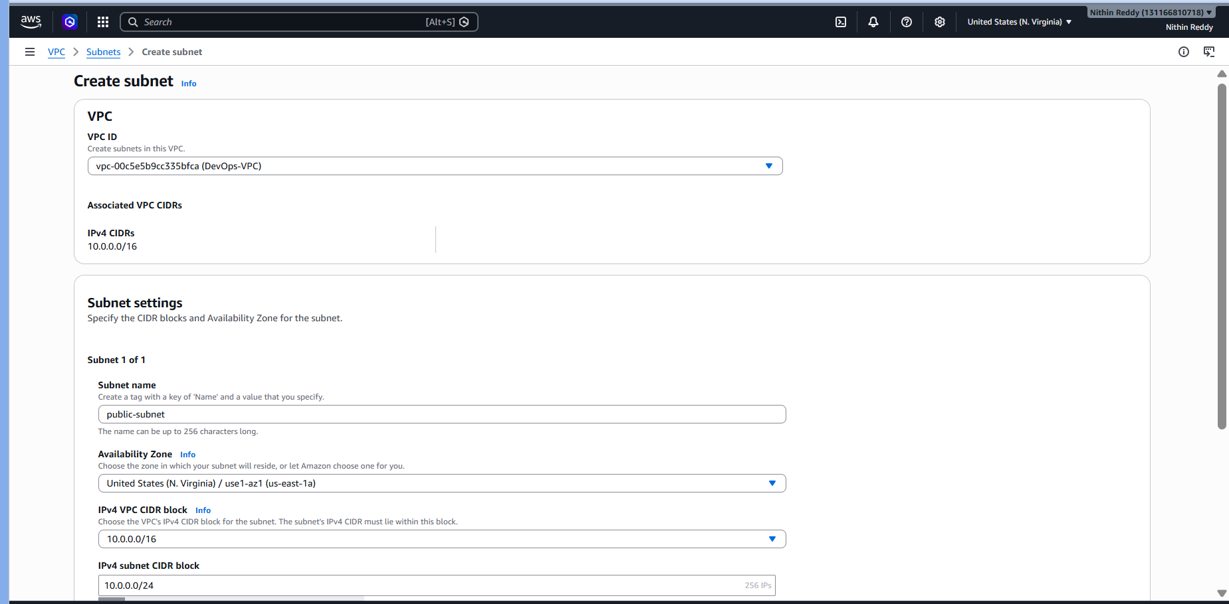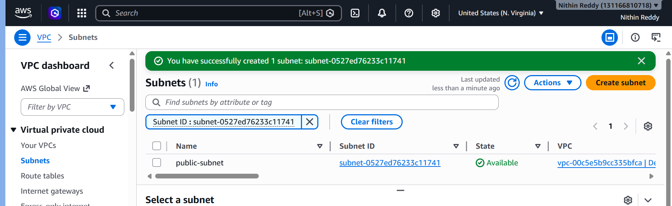
Private Subnet
Name:
Private-Subnet
CIDR:
10.0.2.0/24
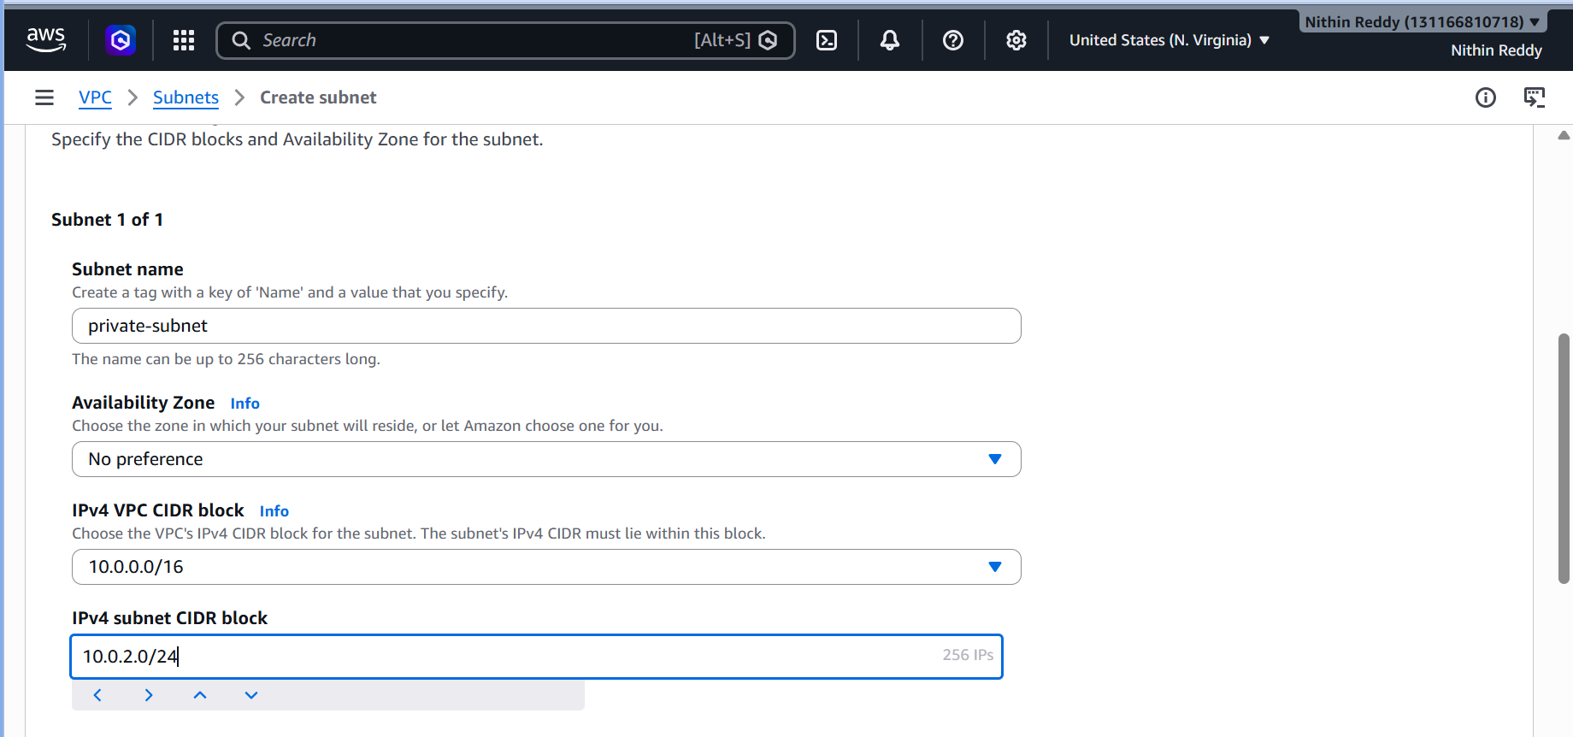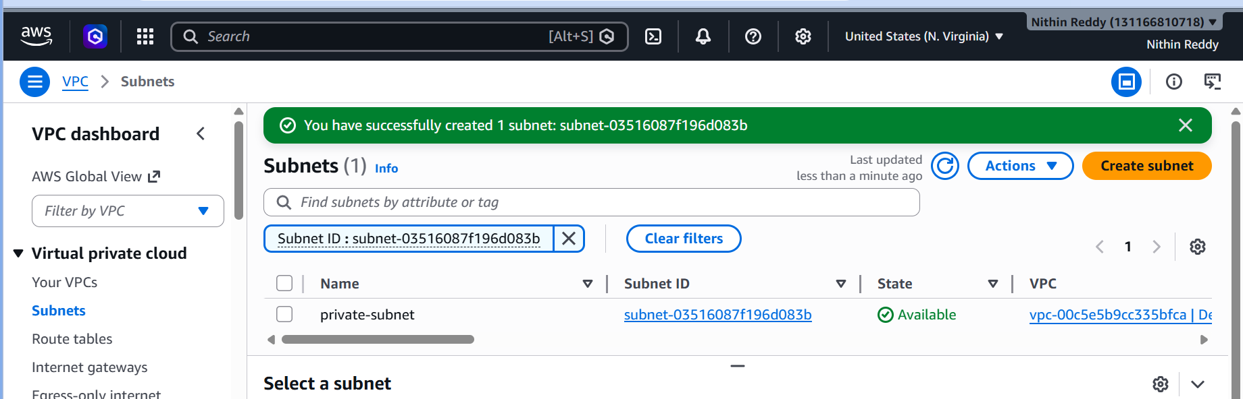
Validation
Verify both subnets created.
Troubleshooting
Error
CIDR overlap
Fix
Use unique ranges.

TASK 3: Attach Internet Gateway
Objective
Allow internet access to public resources.
Outcome
Public subnet instances can access internet.
Prerequisites
Task 1
Dependencies
Uses VPC from Task 1.
Steps
- Create IGW.
- Name:
DevOps-IGW
- Attach to VPC.
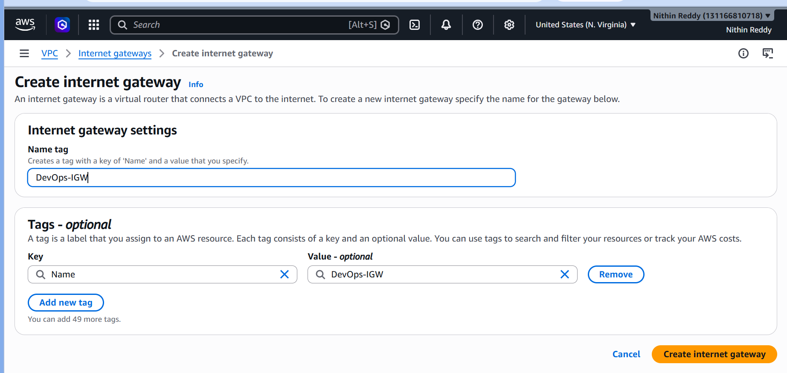

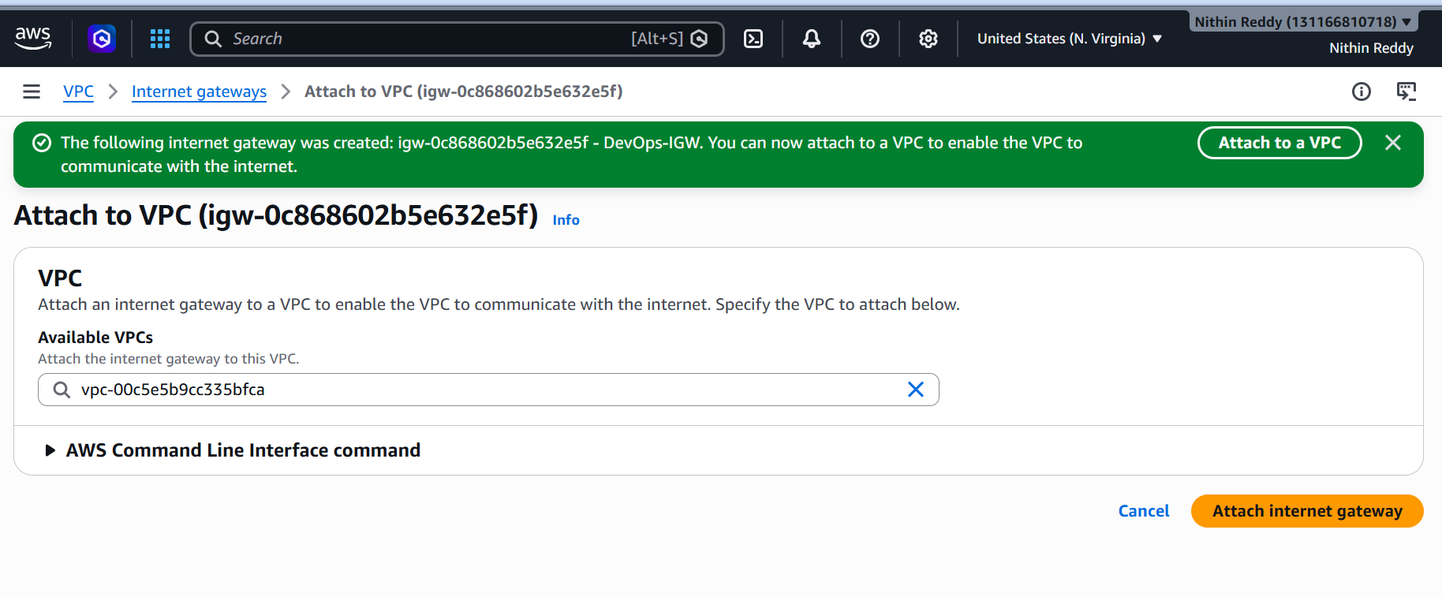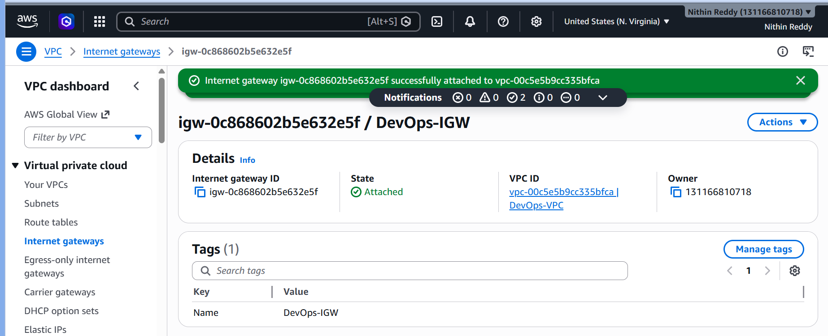
Validation
IGW State:
Attached
Troubleshooting
Error
No internet access
Fix
Verify IGW attached to correct VPC.

TASK 4: Create one public route table (RT) and one private route table.
Objective
Control traffic routing.
Outcome
Separate public/private routing.
Prerequisites
Tasks 1–3
Dependencies
Uses:
- VPC
- IGW
Steps
Public RT
Add route:
0.0.0.0/0 → Internet Gateway
Associate:
Public Subnet
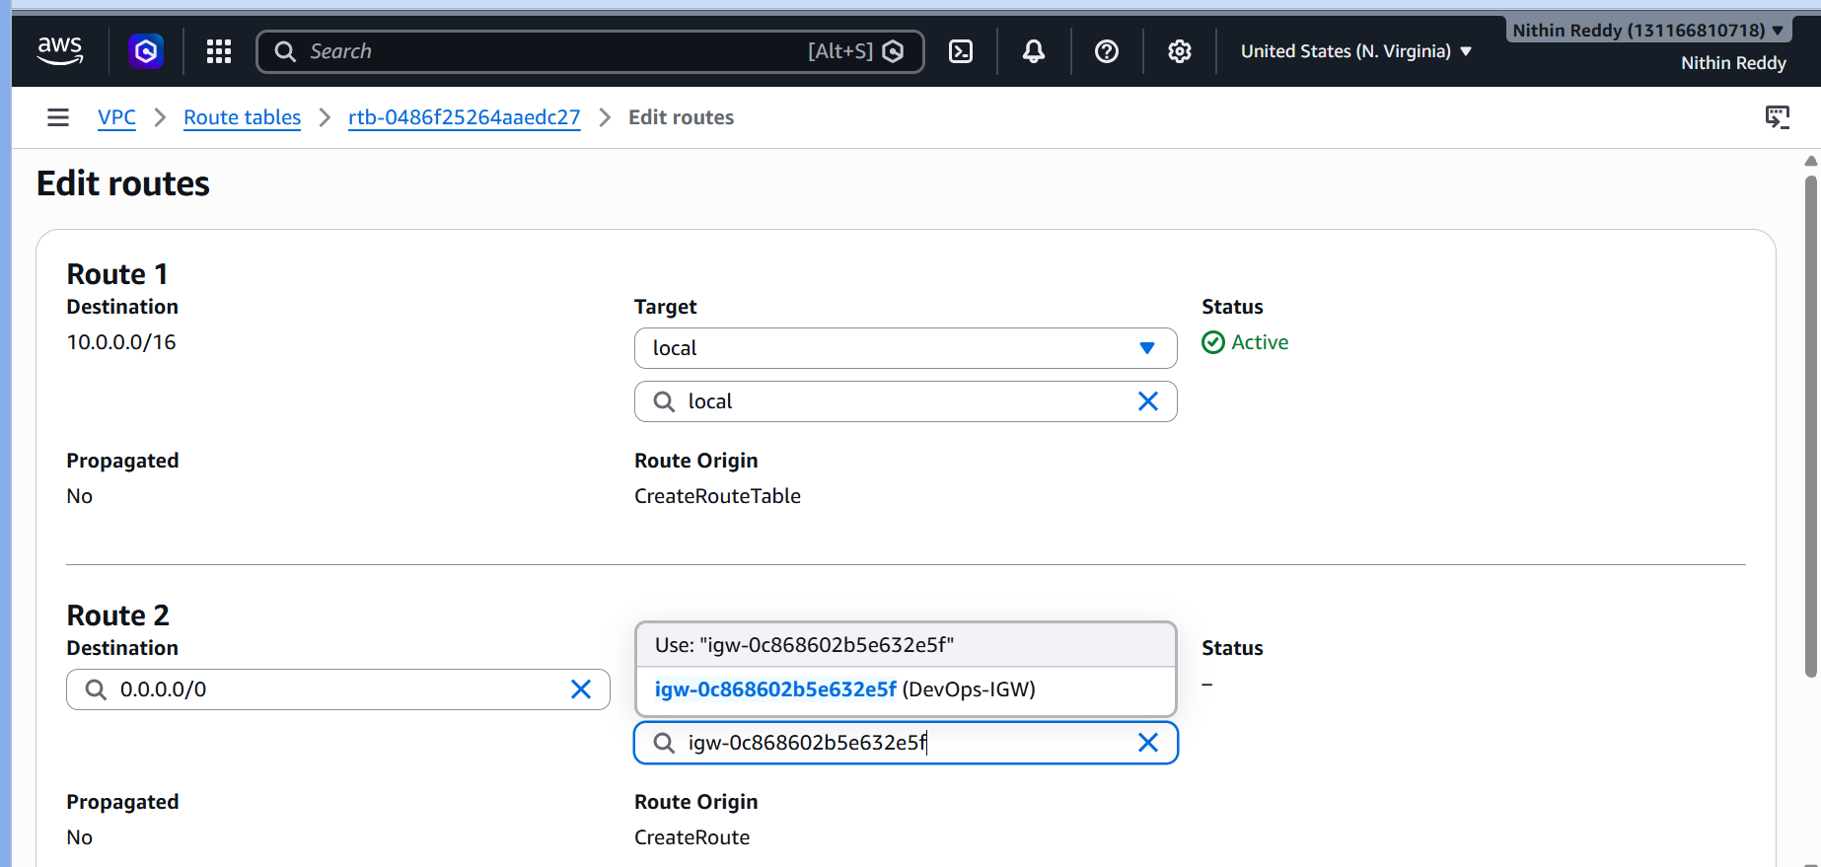
Private RT
Keep local route.
Associate:
Private Subnet
Validation
Public RT contains IGW route.
Troubleshooting
Error
Instance cannot access internet.
Fix
Check subnet association.

TASK 5: Deploy a NAT gateway in the public subnet and attach the NAT gateway to the private subnet
Objective
Allow private subnet outbound internet access.
Outcome
Private EC2 can install packages.
Prerequisites
Tasks 1–4
Dependencies
Uses:
- Public Subnet
- IGW
- Route Tables
Steps
- Allocate Elastic IP.
- Create NAT Gateway.
- Place NAT Gateway in Public Subnet.
- Edit Private RT.
- Add route:
0.0.0.0/0 → NAT Gateway
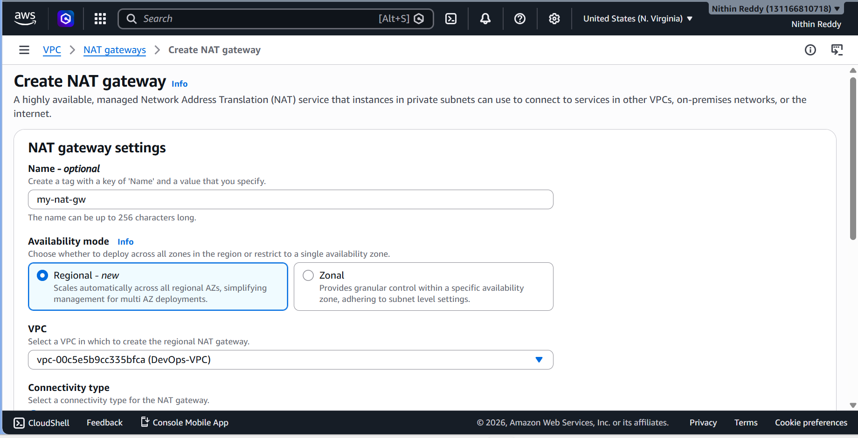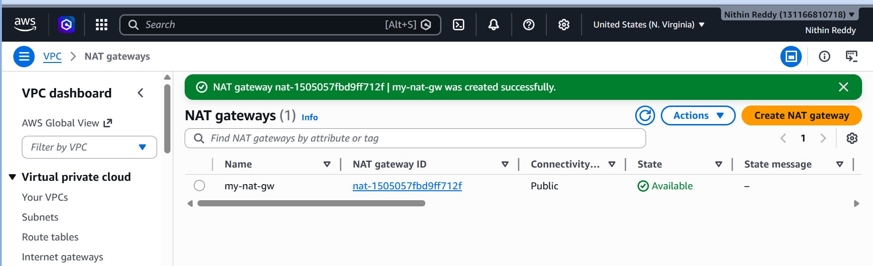
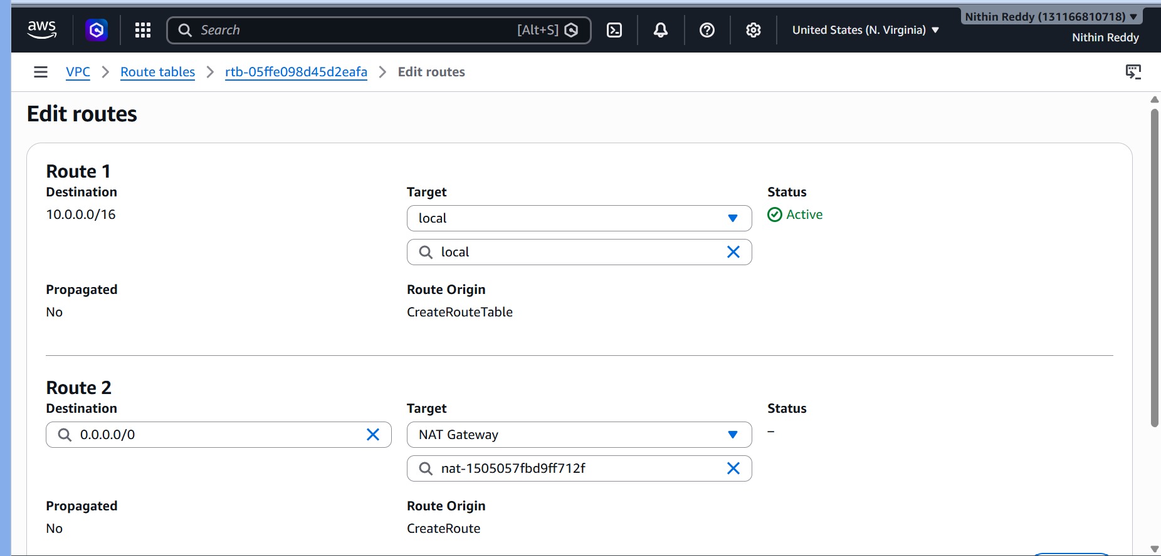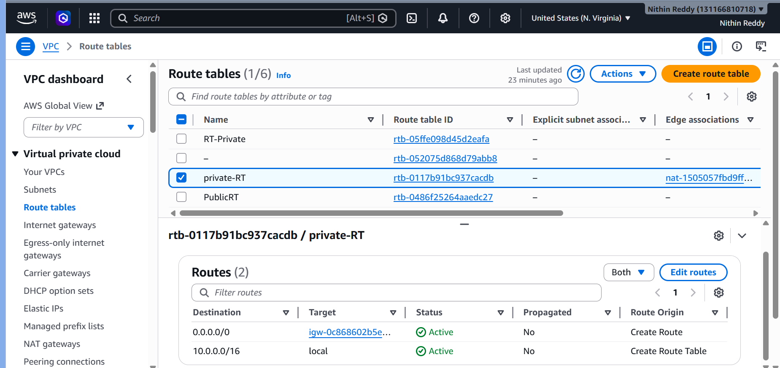
Validation
Private EC2 can:
sudo yum update -y
Troubleshooting
Error
Private EC2 no internet
Fix
Verify:
Task 6: Create Two EC2 Instances (One Public and One Private)
Objective
Deploy two EC2 instances inside your VPC:
- Public EC2 → Accessible from the internet via SSH.
- Private EC2 → No public IP; accessible only through the Public EC2 (bastion host).
Outcome
DevOps-VPC
│
├── Public Subnet (10.0.1.0/24)
│ └── Public-EC2
│
└── Private Subnet (10.0.2.0/24)
└── Private-EC2
Steps
Public EC2
Subnet:
Public-Subnet
Public IP:
Enable
Private EC2
Subnet:
Private-Subnet
Public IP:
Disable
Security Group:
22
80
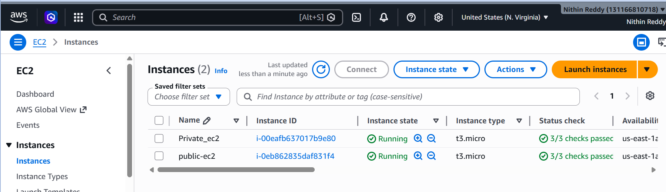
Validation
Public EC2 reachable.
Private EC2 reachable via:
ssh -i key.pem ec2-user@private-ip
from public EC2.
Troubleshooting
Error
SSH fails
Fix
Check:
- SG rules
- Key pair
- Route tables
Task 7. Deploy Apache server on both EC2 instances with a sample index.html file.
Objective
Host web application.
Outcome
Apache running on both servers.
Prerequisites
Task 6
Dependencies
Uses EC2 from Task 6.
Steps
sudo yum update -y
sudo yum install httpd -y
sudo systemctl start httpd
sudo systemctl enable httpd
Create page:
sudo nano /var/www/html/index.html
Public:
<h1>Public Server</h1>
Private:
<h1>Private Server</h1>
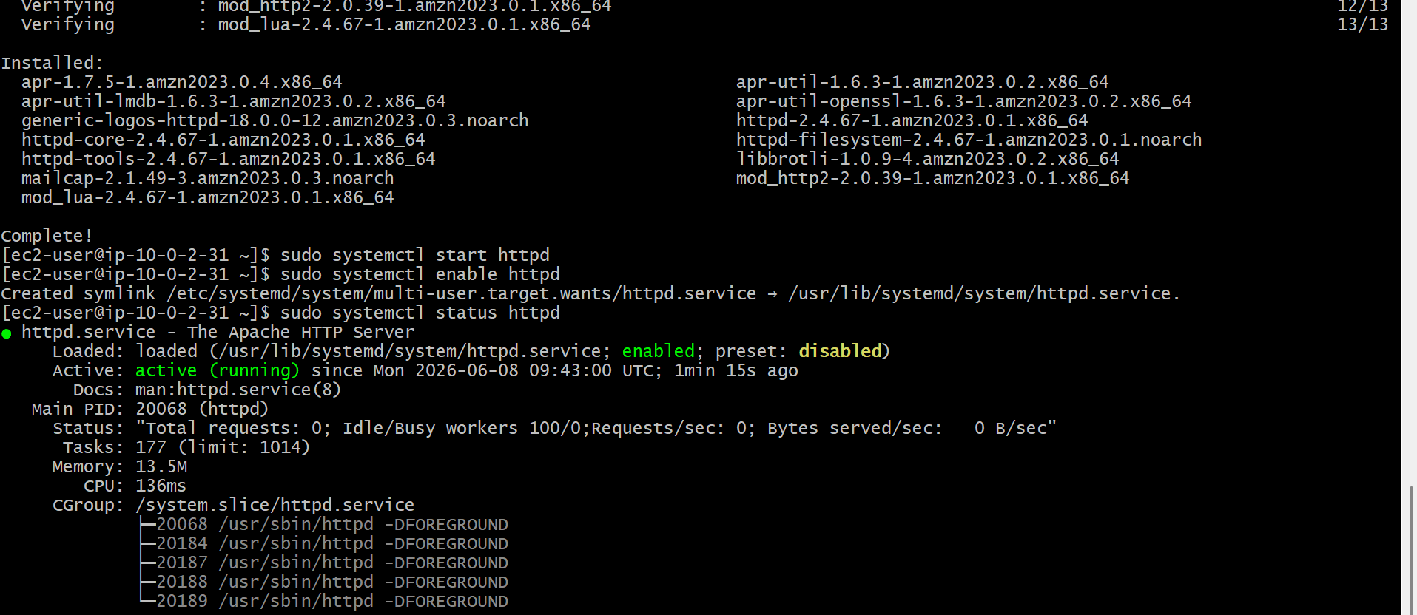
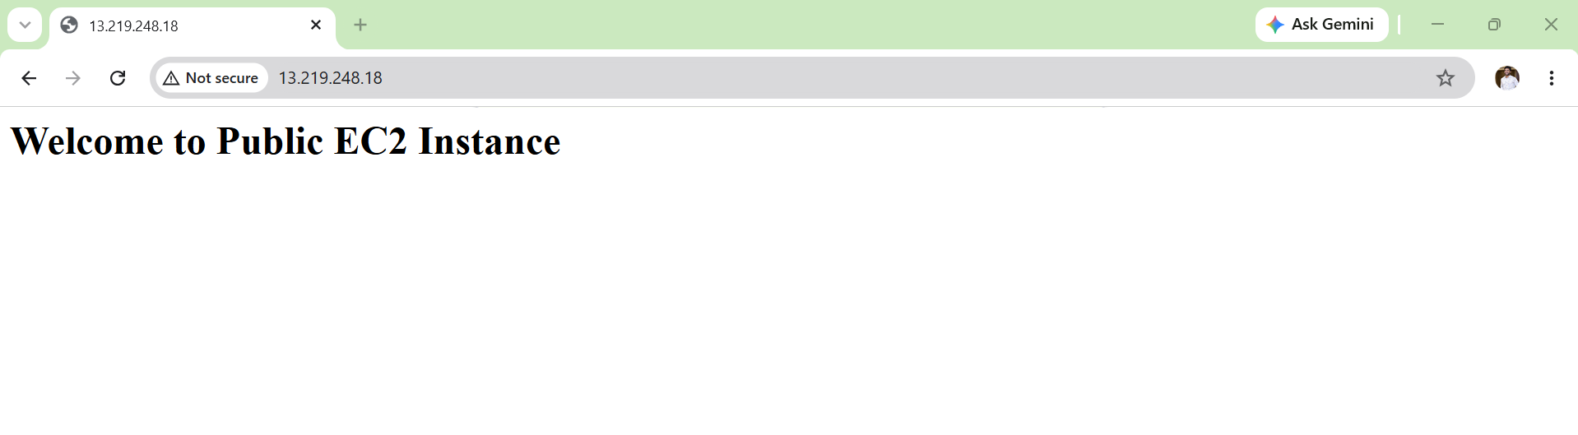
Validation
systemctl status httpd
Active (running)
Troubleshooting
Error
Apache not starting
Fix
sudo journalctl -xe

Task 8: Create Application Load Balancer (ALB) and Attach Both EC2 Instances
Objective
Create an Application Load Balancer (ALB) that distributes incoming HTTP traffic across:
- Public EC2
- Private EC2
Outcome
Internet
|
|
Application Load Balancer
|
-------------------------
| |
Public EC2 Private EC2
Apache Apache
When users access the ALB DNS URL, requests are forwarded to your EC2 instances.
Prerequisites
Tasks 6 and 7
Dependencies
Uses:
- Public Subnet
- EC2 Instances
Steps
- Create Target Group.
- Register both instances.
- Create ALB.
- Internet Facing.
- Select Public Subnet.
- Attach Target Group.
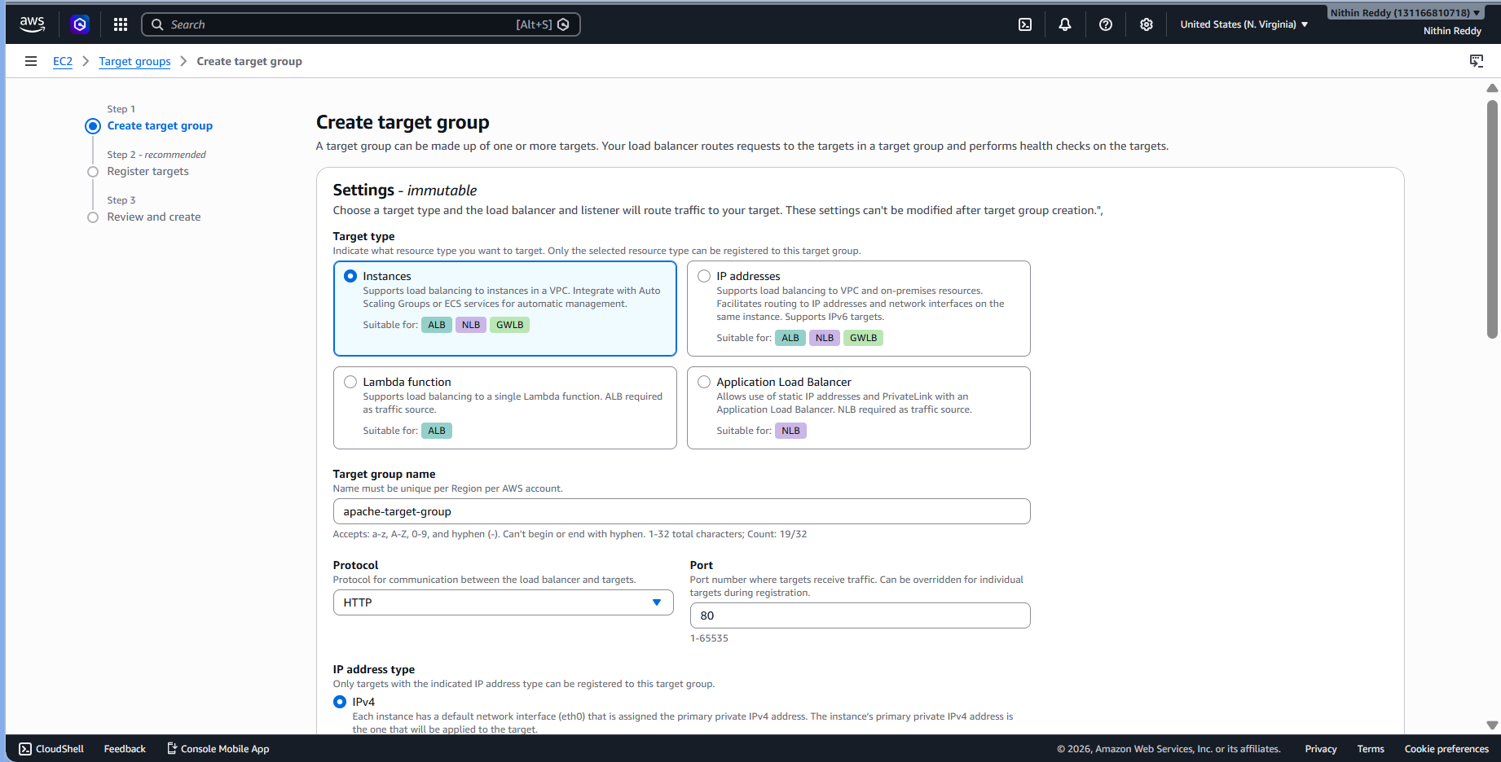
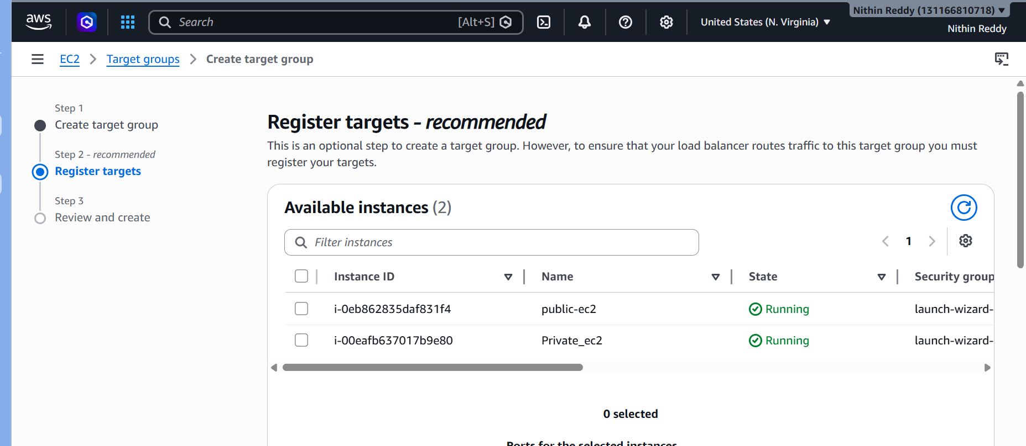

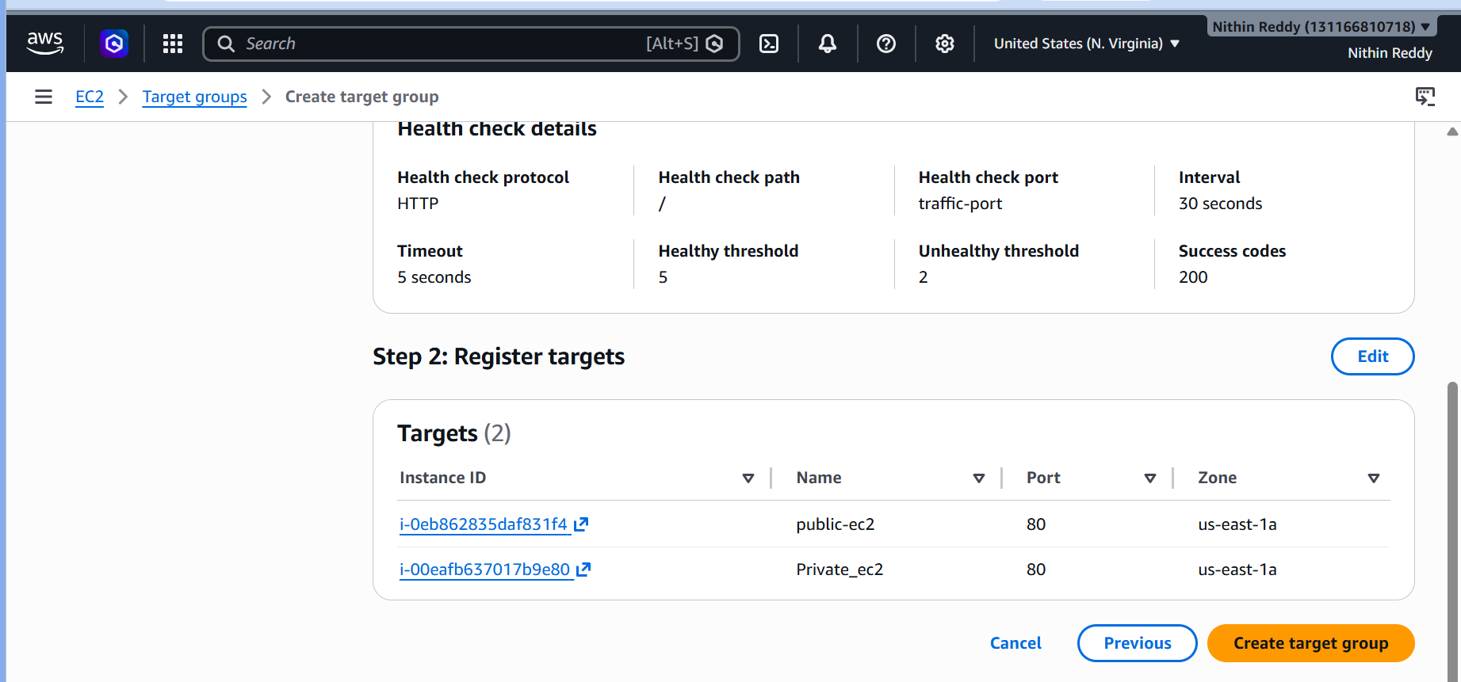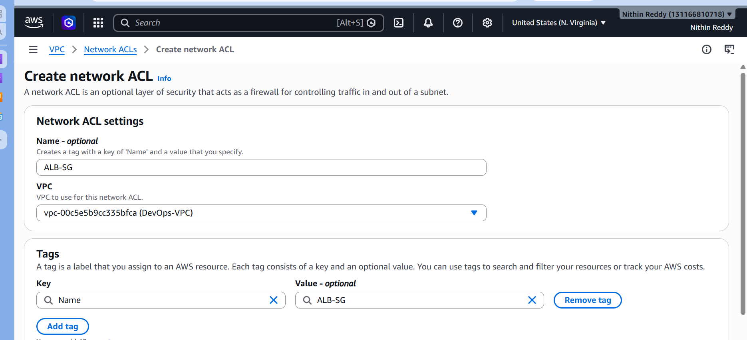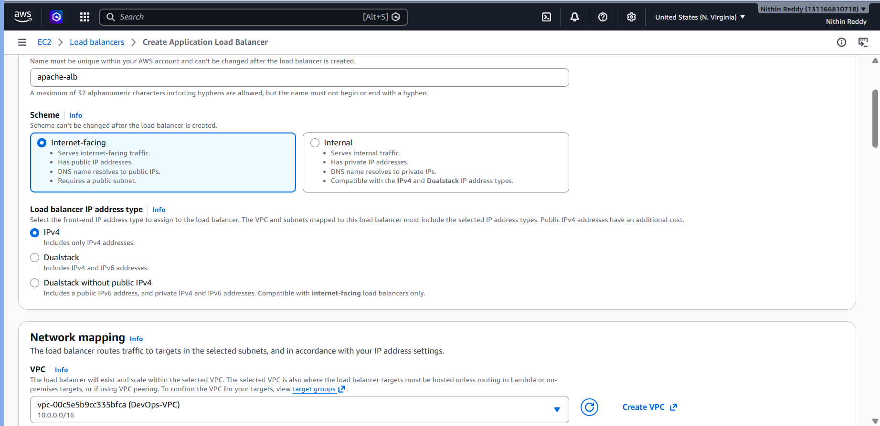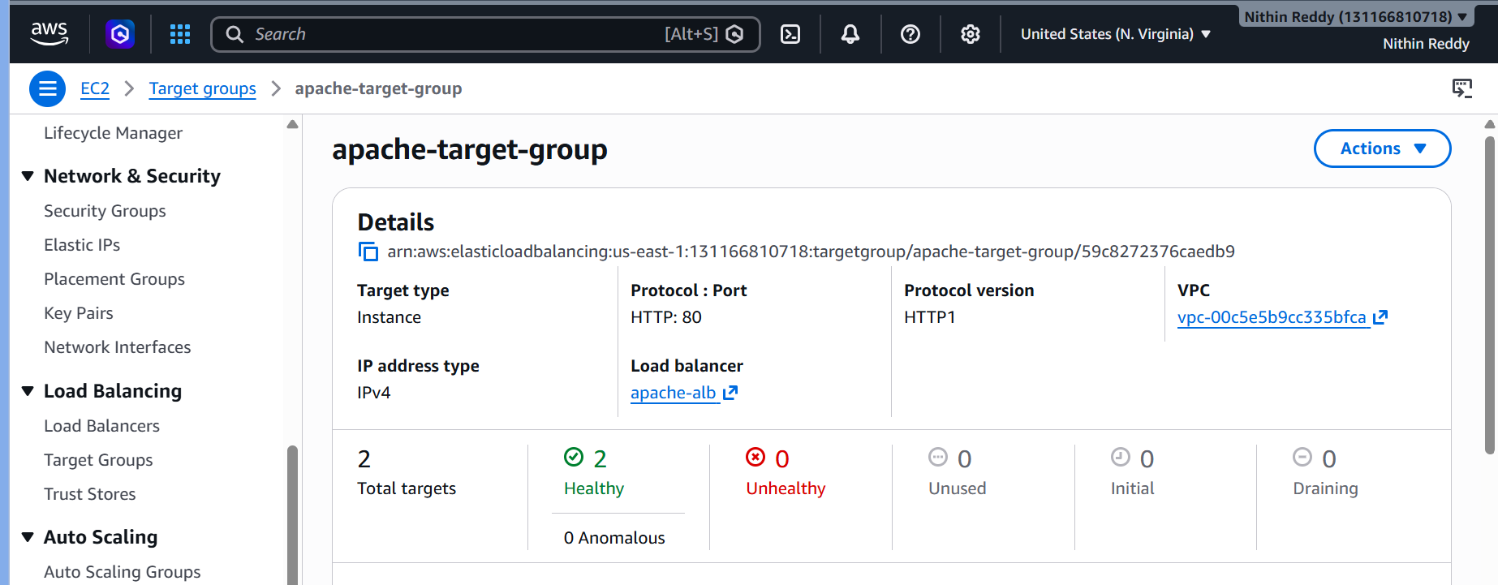

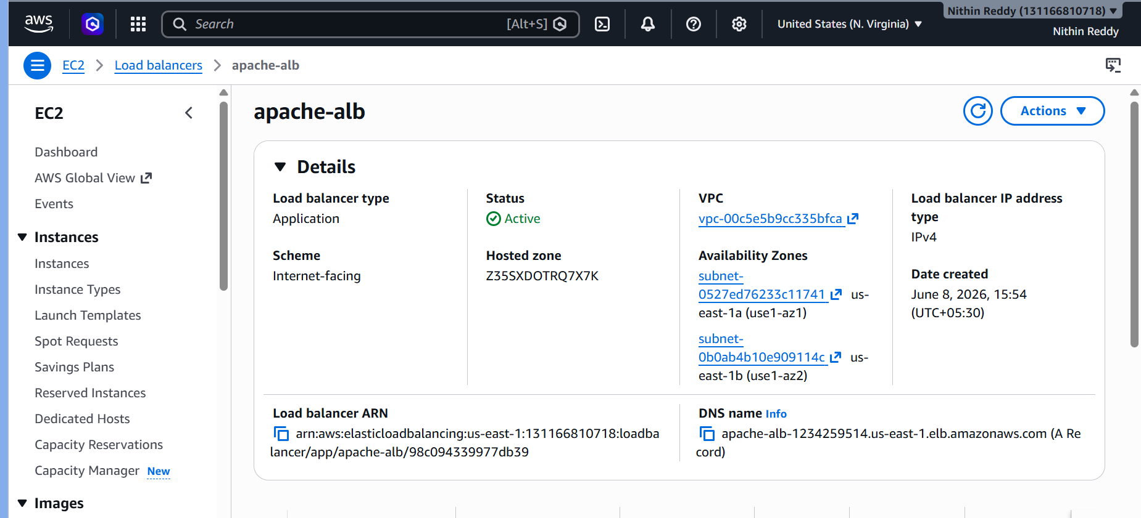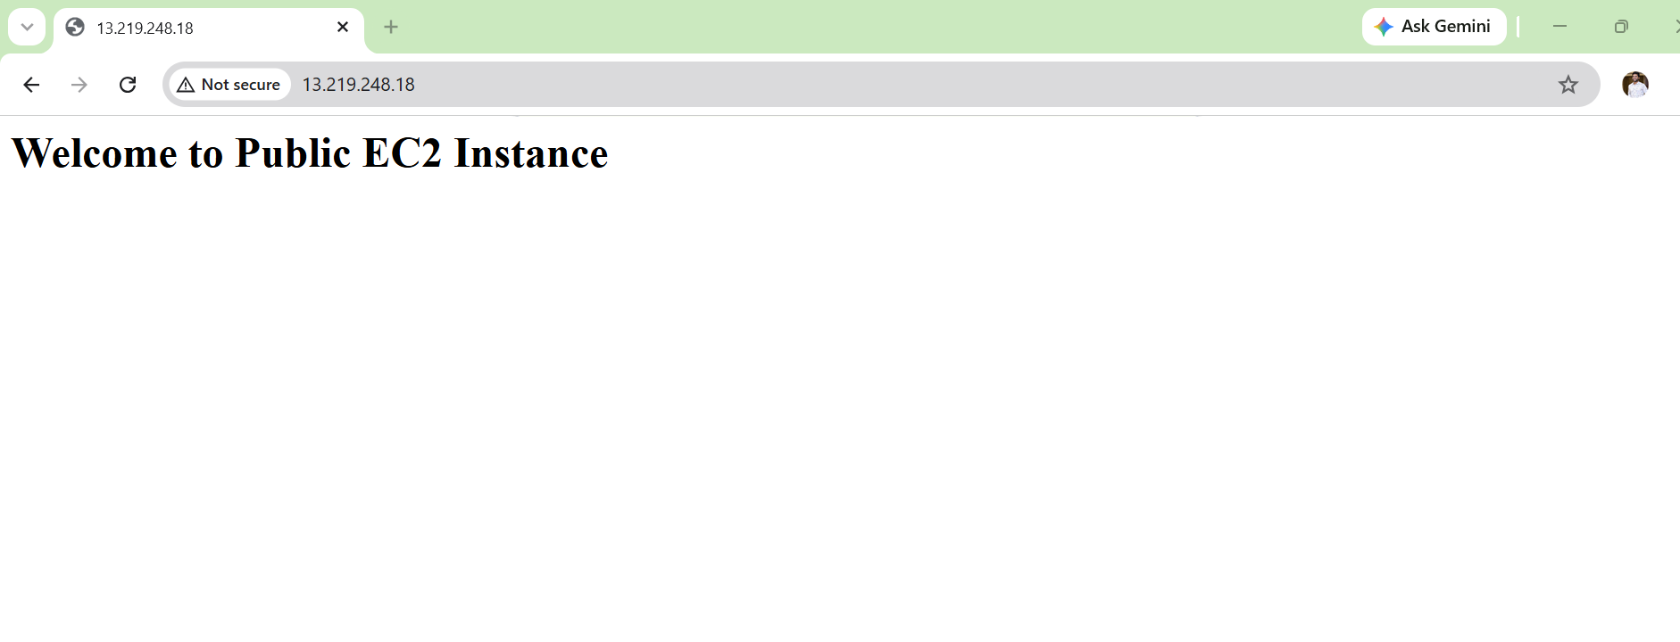
Validation
Open:
http://ALB-DNS
Page alternates between servers.
Troubleshooting
Error
Targets unhealthy
Fix
Check:
- Port 80 open
Task 9: Store Application Load Balancer (ALB) Logs in S3
Objective
Enable Access Logs on the Application Load Balancer and store all request logs in an S3 bucket.
Outcome
User Request
|
v
Application Load Balancer
|
v
S3 Bucket (ALB Logs)
Every request reaching the ALB will be logged and stored in S3.
Prerequisites
Task 8
Dependencies
Uses ALB.
Steps
- Create S3 bucket.
- Add ALB logging policy.
- Enable ALB Access Logs.
- Select bucket.

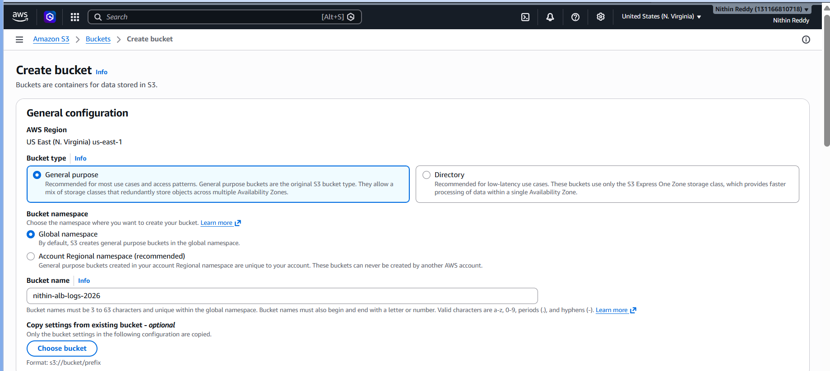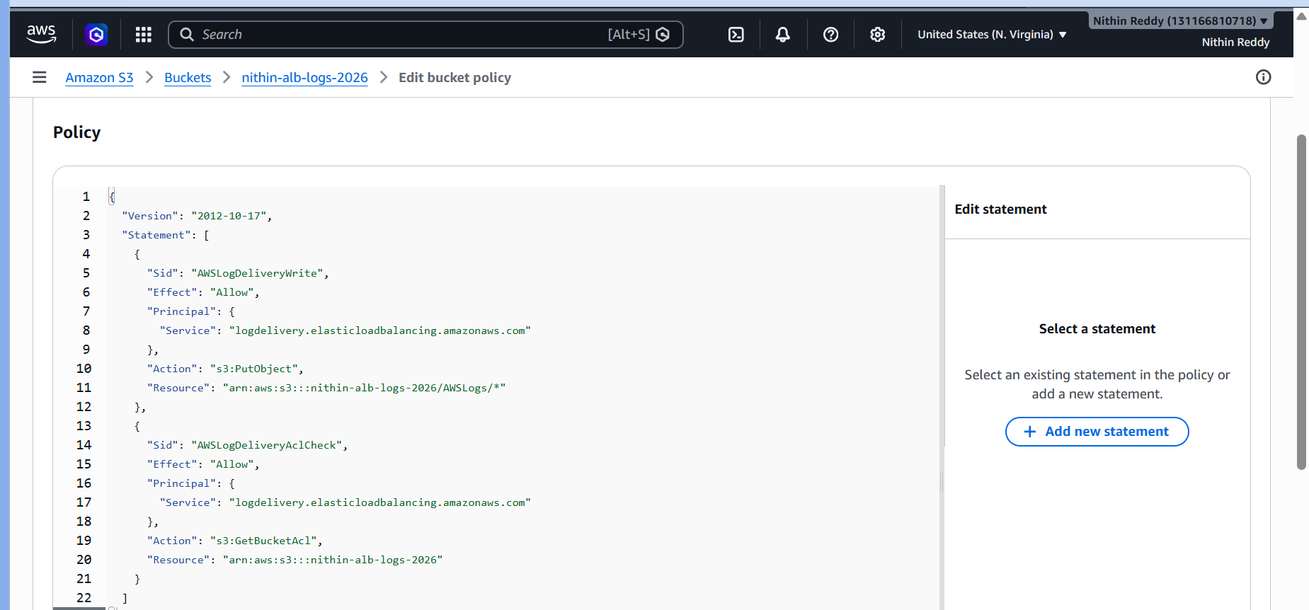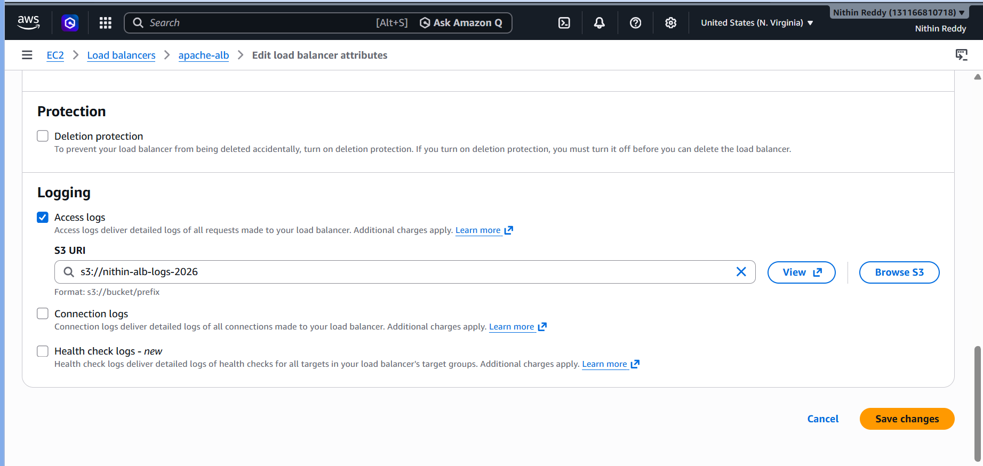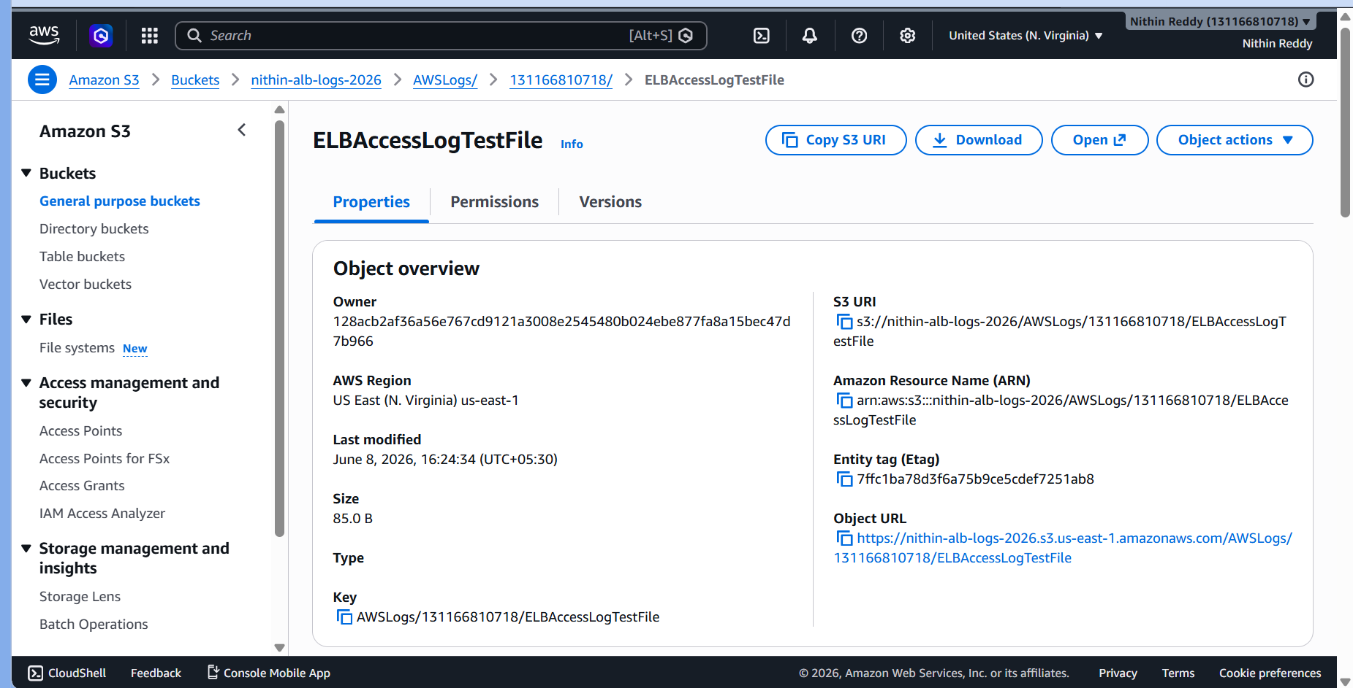
Validation
After traffic:
AWSLogs/
folder appears.
Troubleshooting
Error
Logs not generated
Task 10: Store VPC Flow Logs in CloudWatch Log Group
Objective
Enable VPC Flow Logs to capture network traffic information and send the logs to a CloudWatch Log Group.
Outcome
VPC
│
│ Flow Logs
▼
CloudWatch Log Group
│
▼
Network Traffic Records
You will be able to monitor accepted and rejected traffic in your VPC.
Dependencies
Uses VPC.
Steps
- Select VPC.
- Create Flow Log.
- Destination:
CloudWatch Logs
- Create Log Group.
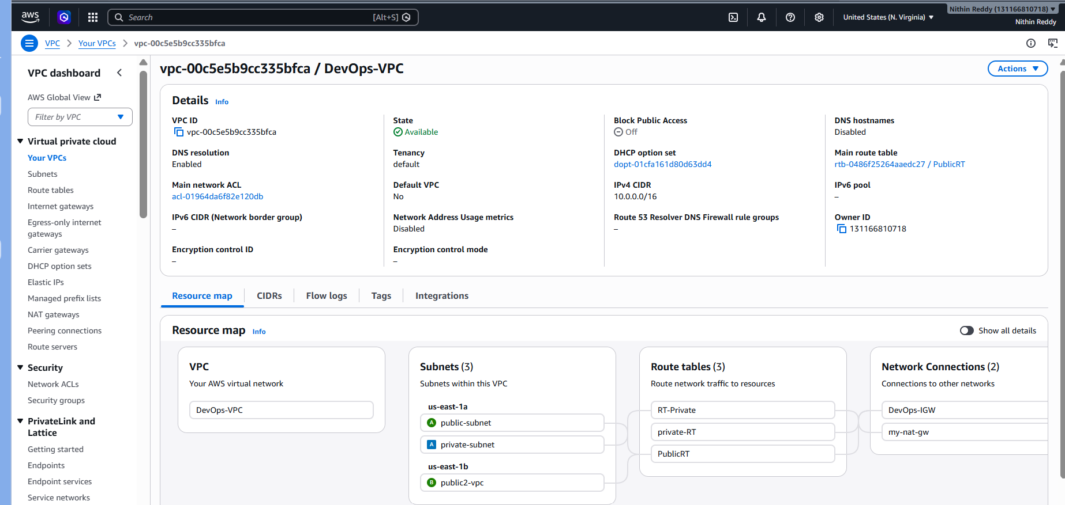
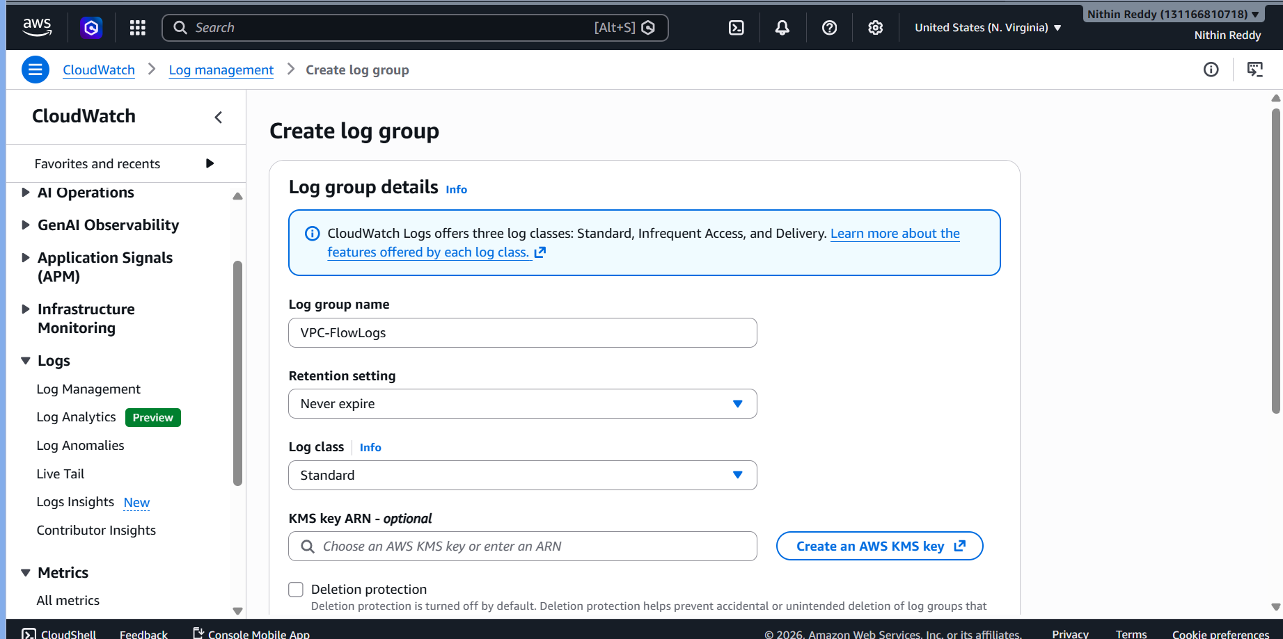
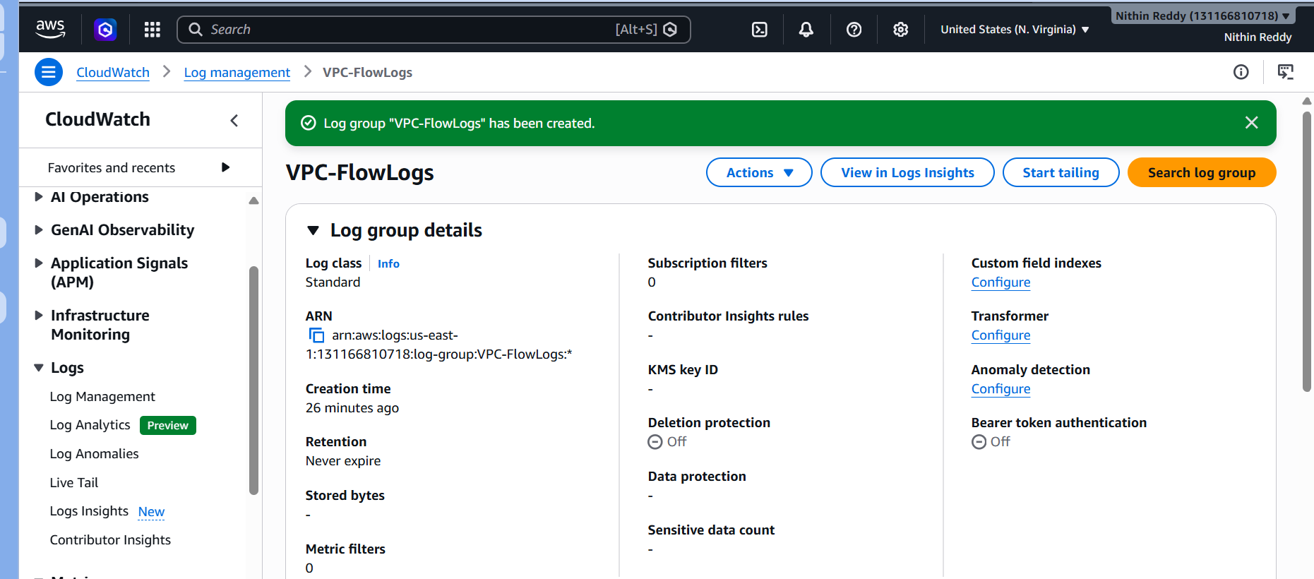
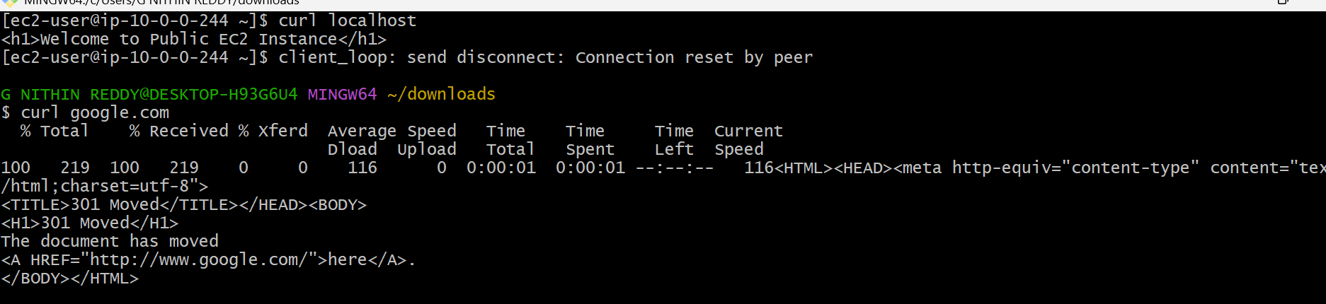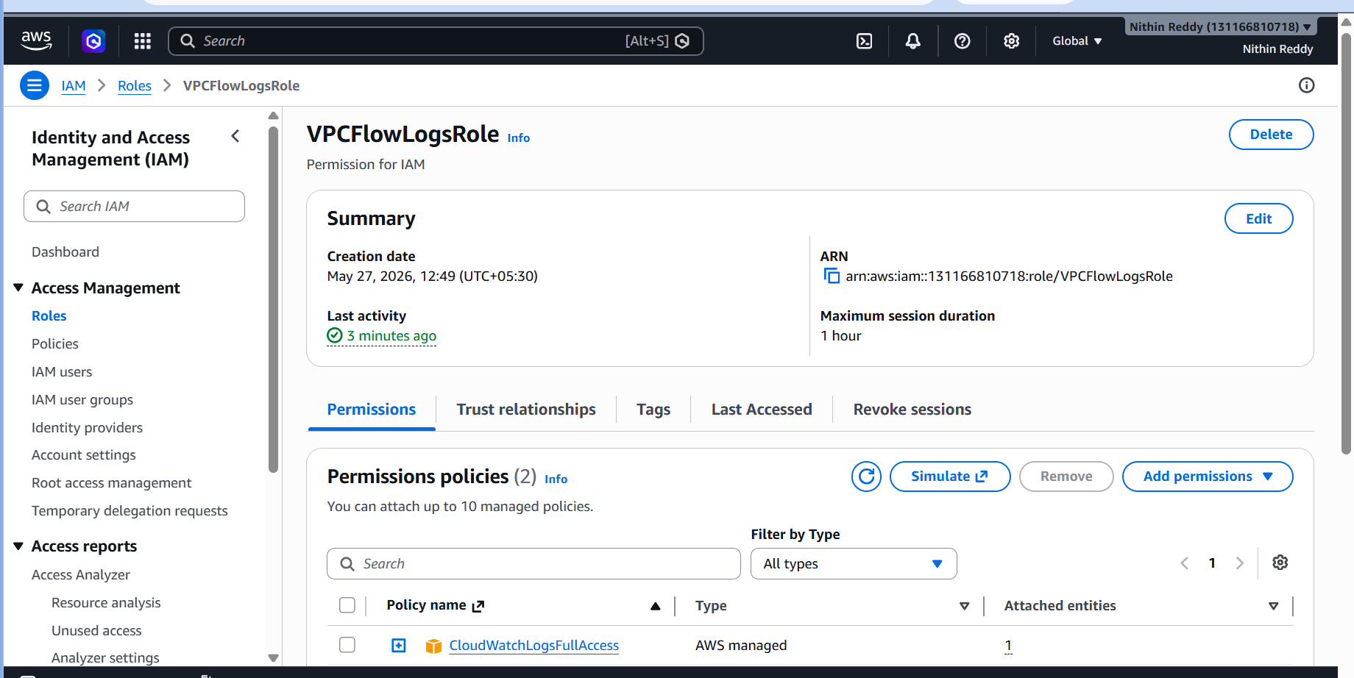
Validation
CloudWatch → Log Groups.
Entries visible.
Troubleshooting
Error
No logs
Fix
Verify IAM role attached.

Task 11: Create CloudWatch Dashboards to Monitor CPU Utilization and Apache Service
Objective
Create a CloudWatch Dashboard to monitor:
- EC2 CPU Utilization
- Apache (httpd) Service Status
Outcome
CloudWatch Dashboard
|
|-- CPU Utilization
|
|-- Apache Service Monitoring
Prerequisites
Tasks 6 and 7
Dependencies
Uses EC2.
Steps
Install CloudWatch Agent:
sudo yum install amazon-cloudwatch-agent -y
Create dashboard.
Add widgets:
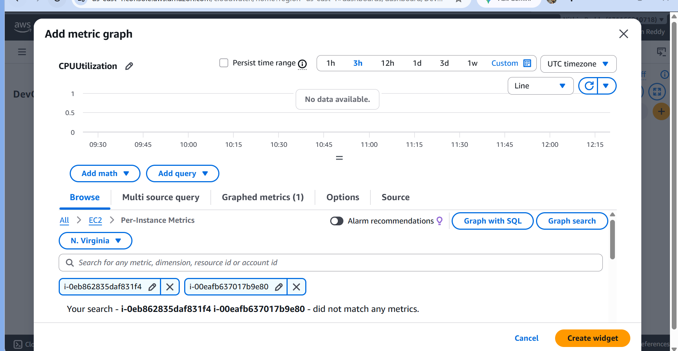
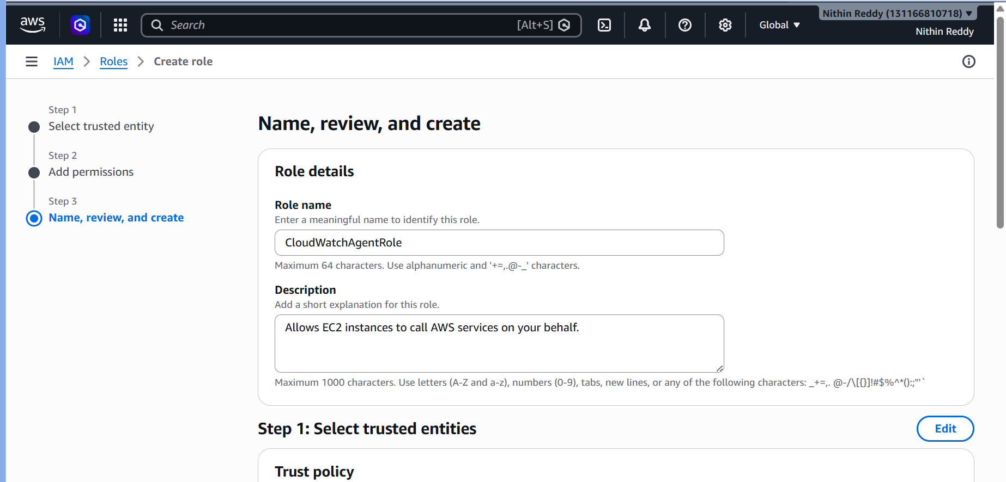
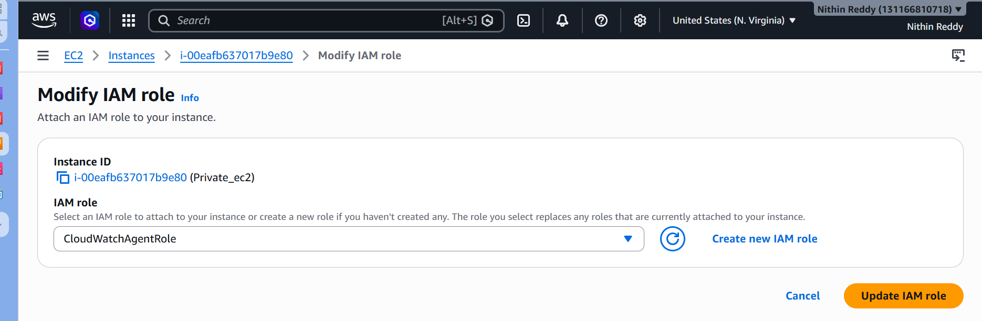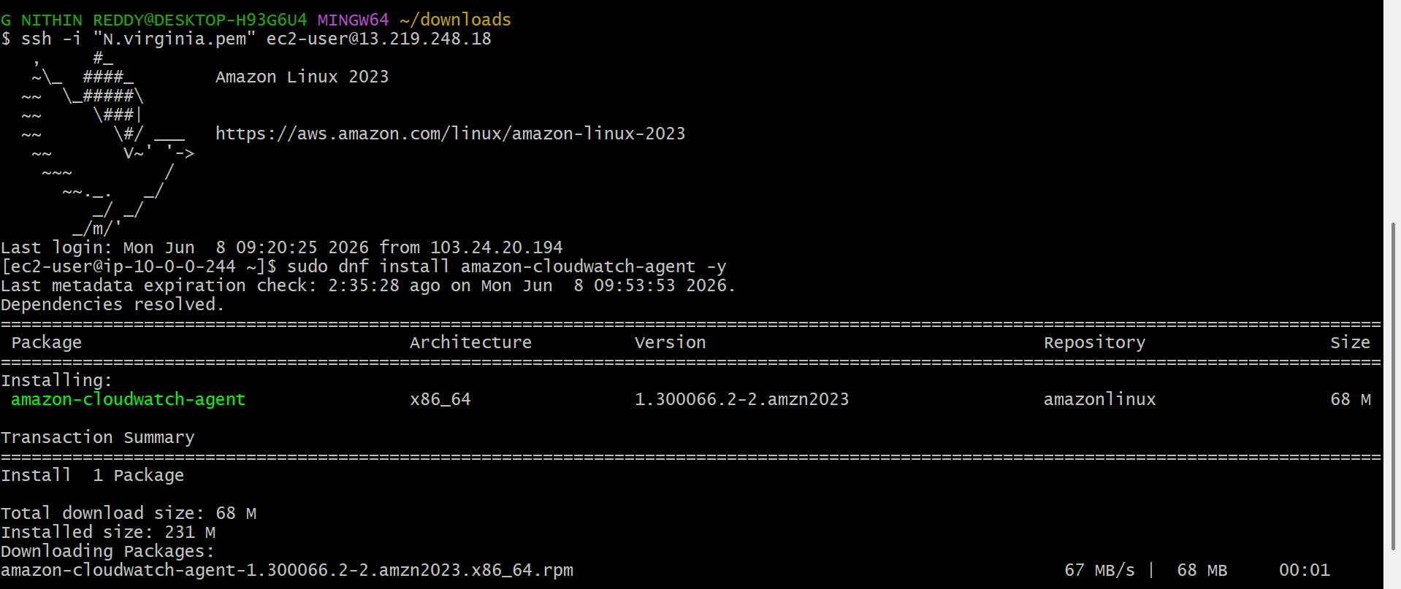
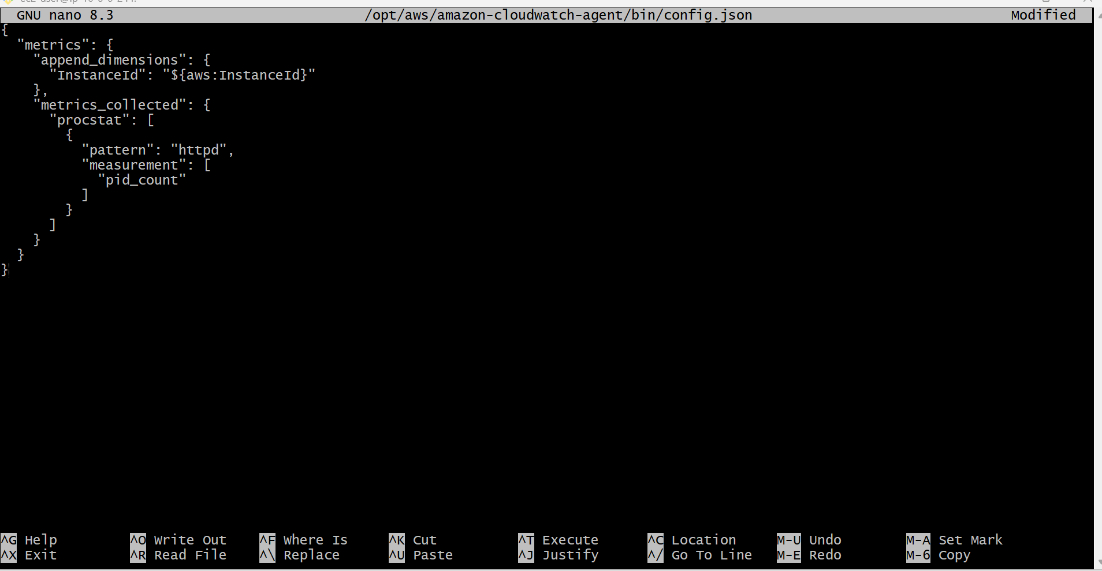
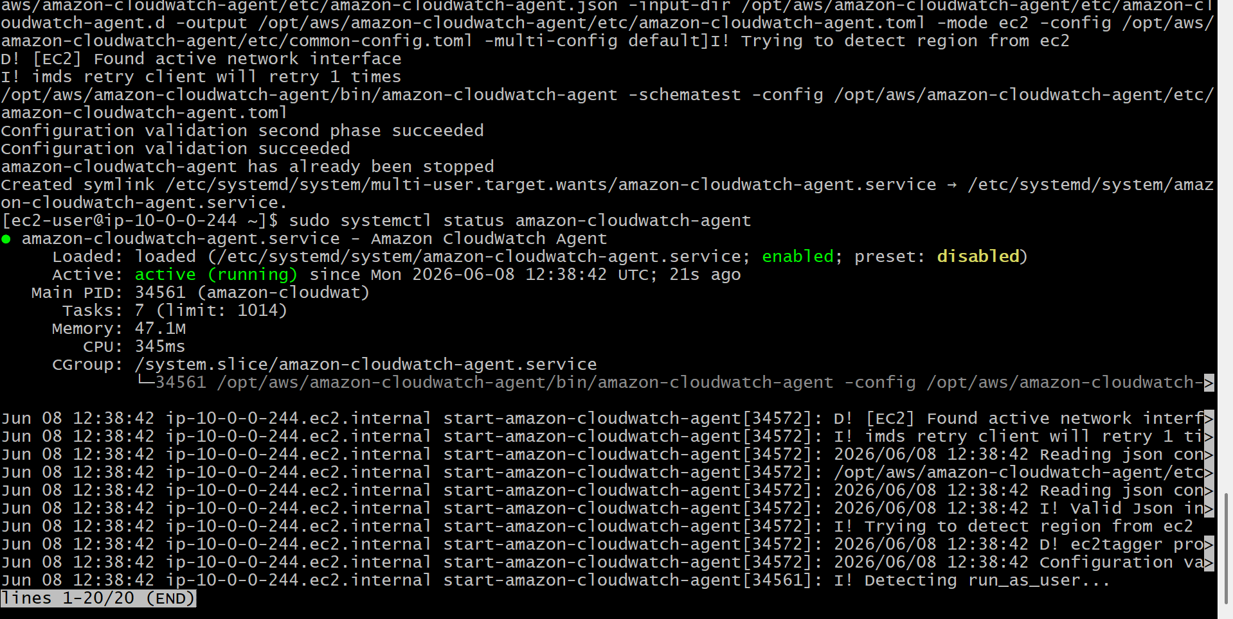

CPU
EC2 → CPUUtilization
Apache
StatusCheckFailed
or custom metric from CloudWatch Agent.
Validation
Graphs display data.
Troubleshooting
Error
No metrics
Fix
Verify CloudWatch Agent running.

Task 12: Auto Scaling When CPU Utilization Exceeds 70%
Objective
Automatically launch a new EC2 instance when CPU utilization exceeds 70%.
Outcome
Users
|
v
Application Load Balancer
|
Auto Scaling Group
|
----------------------
| | |
EC2-1 EC2-2 EC2-3
When CPU usage goes above 70%, AWS automatically adds instances.
Prerequisites
Tasks 6–11
Dependencies
Uses:
- Launch Template
- Target Group
- ALB

Steps
Create Launch Template
Select:
- AMI
- Security Group
- User Data
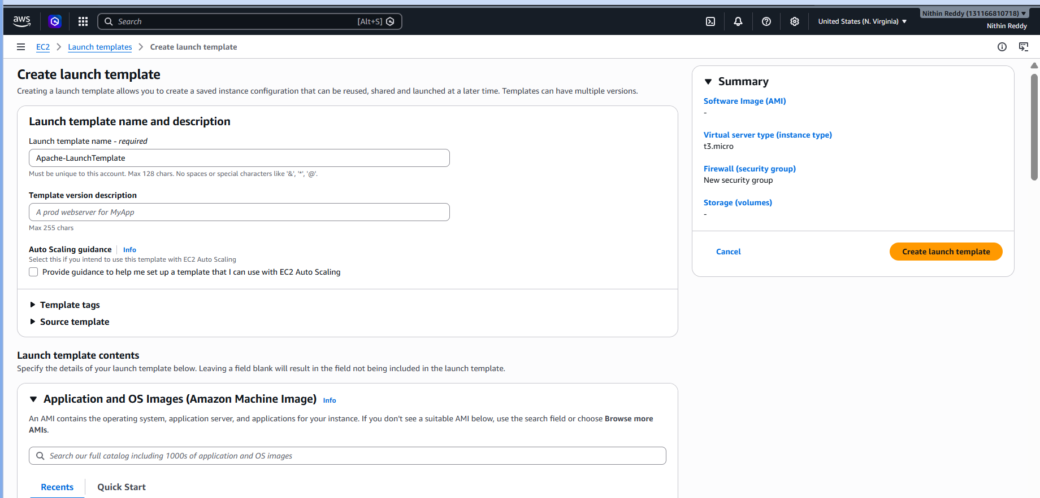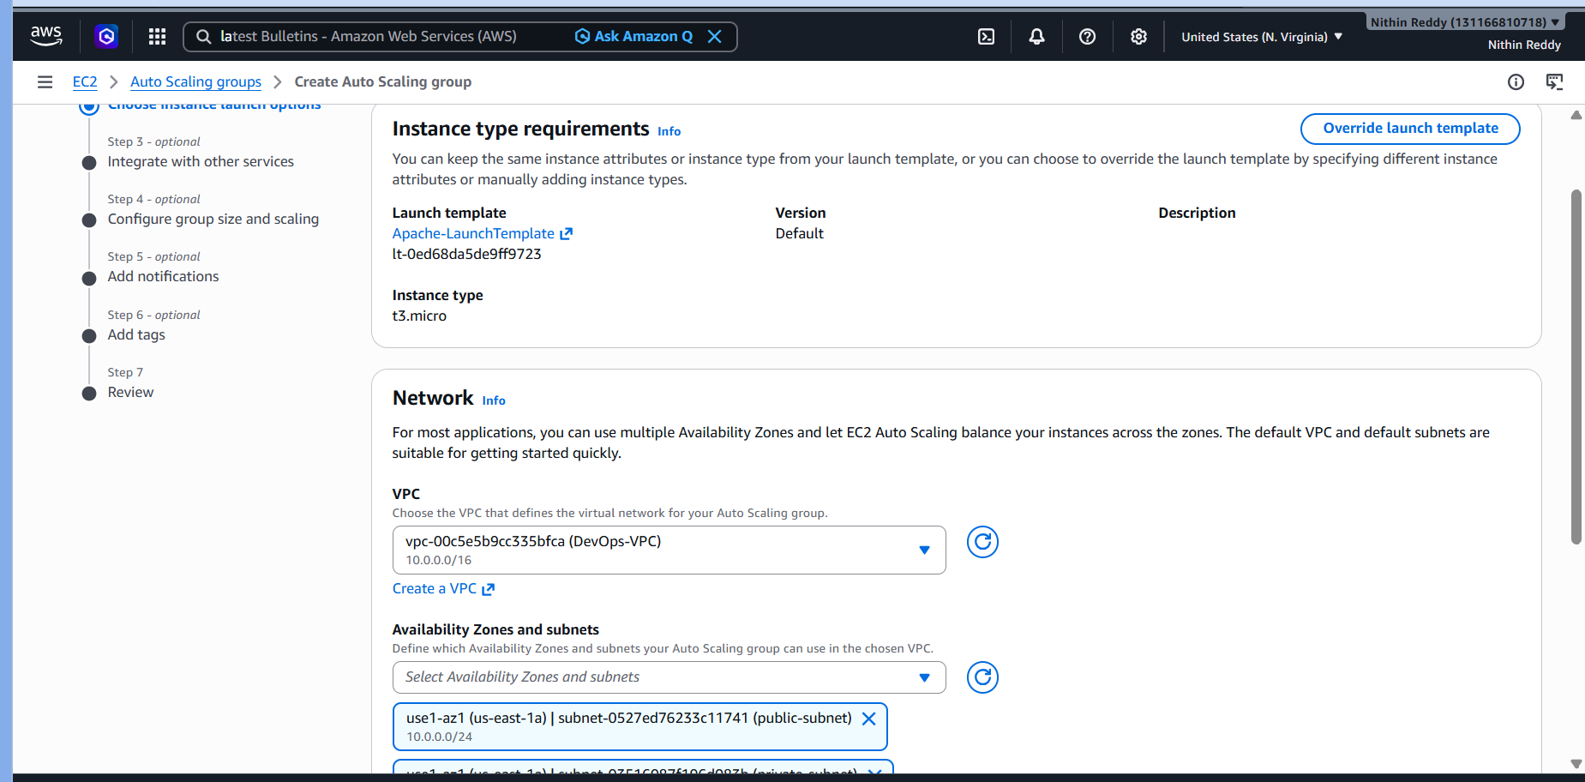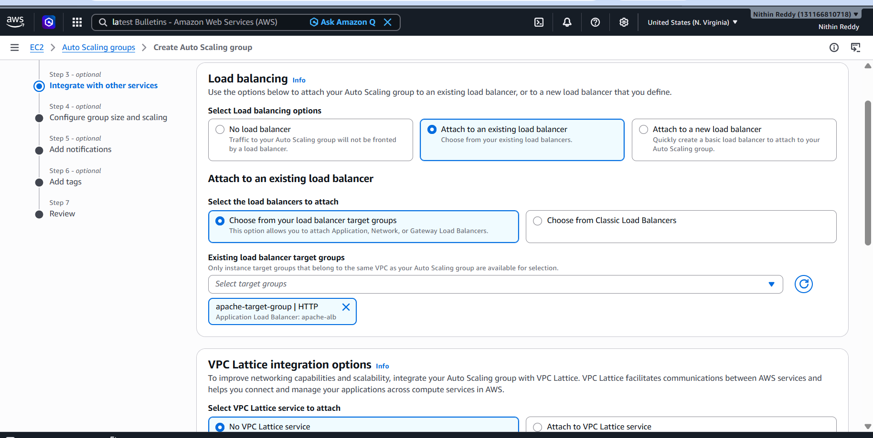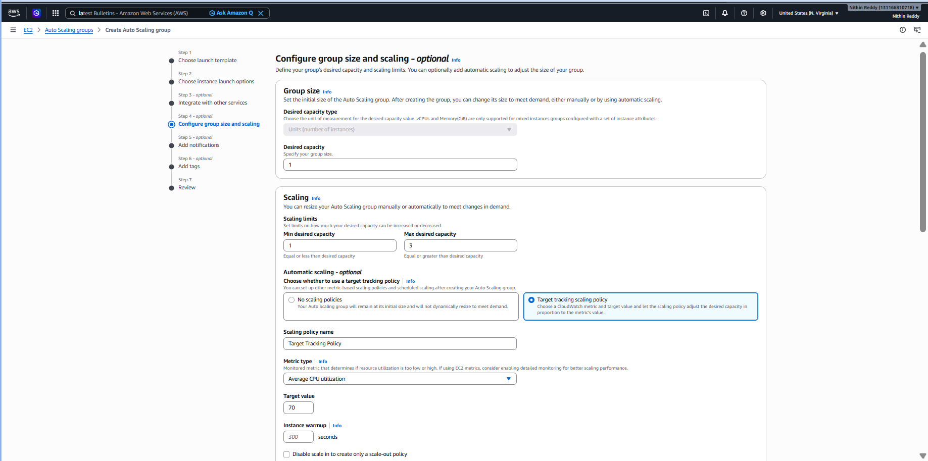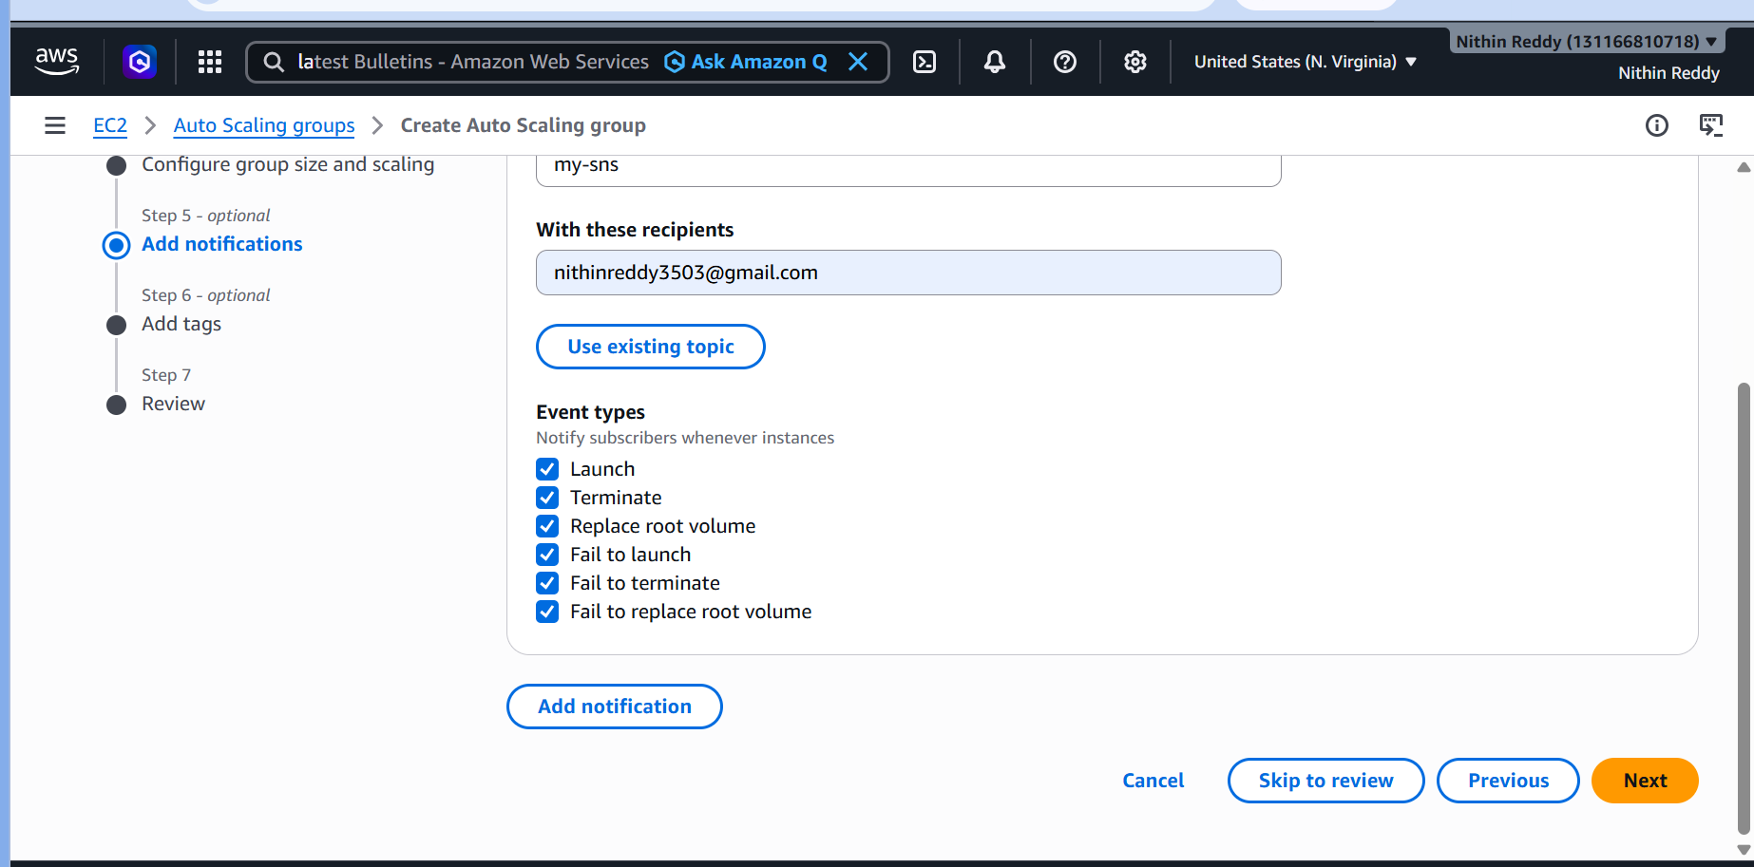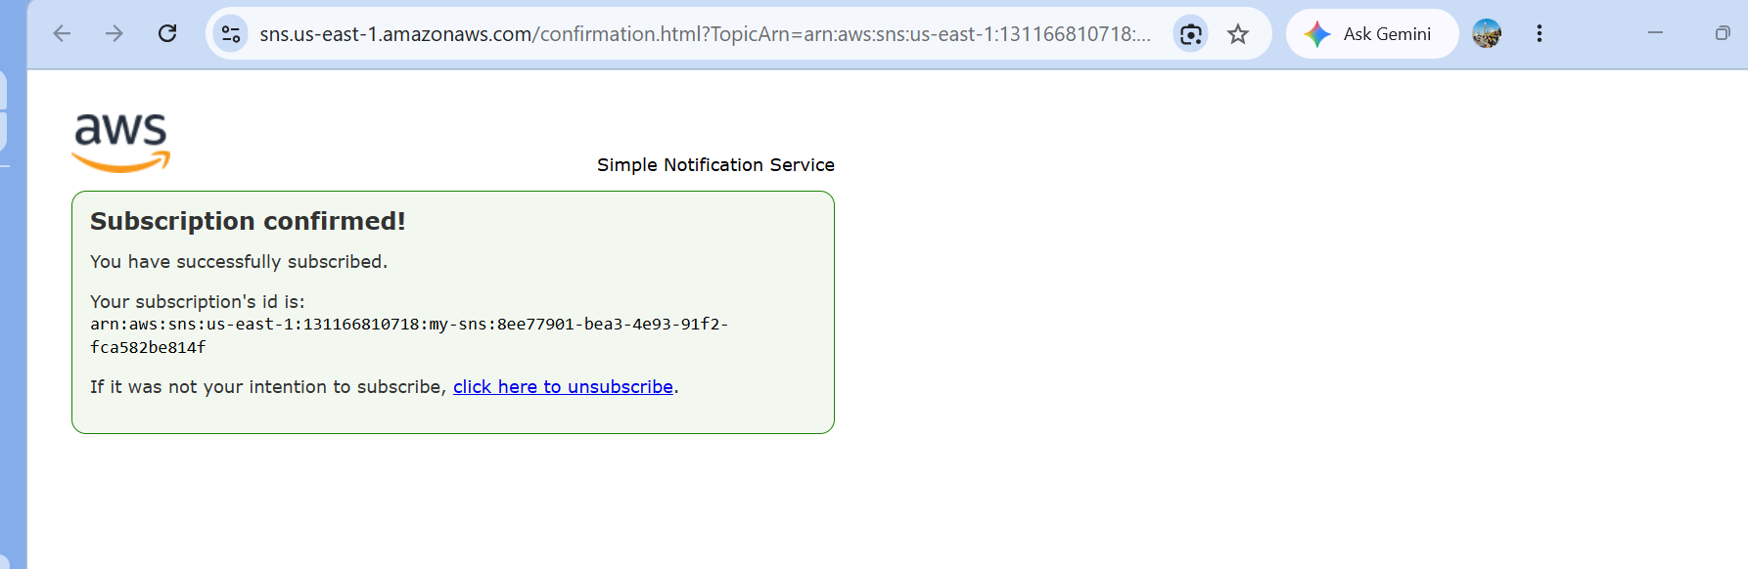
User Data:
#!/bin/bash
yum update -y
yum install httpd -y
systemctl start httpd
systemctl enable httpd
echo "<h1>Auto Scaling Server</h1>" > /var/www/html/index.html
Create ASG
Min:
1
Desired:
1
Max:
3
Attach Target Group.
Scaling Policy
Metric:
CPUUtilization
Threshold:
70%
Validation
Generate load:
sudo yum install stress -y
stress --cpu 4 --timeout 300
New instance launches.
Troubleshooting
Error
ASG not scaling
Fix
Verify:
- CloudWatch alarms
- Launch template
- ASG policy

