Kubernetes-01

K8S-01 Task 1: Setup Minikube on Your Local Machine (Windows)
Since I’m using Windows 11, l installed:
- ✅ Chocolatey (optional)
- ✅ Docker Desktop
- ✅ kubectl
- ✅ Minikube
- ✅ Start Kubernetes Cluster
- ✅ Verify Installation
Prerequisites
Your system should have:
Requirement | Status
Windows 10/11 64-bit | ✅
8 GB RAM (Minimum) | Recommended
Virtualization Enabled | Required
Docker Desktop Installed | Required
Internet Connection | Required
Task
Setup Minikube on the local machine.
Steps Performed
- Installed Docker Desktop.
- Installed Minikube.
- Installed kubectl.
- Started Minikube using the Docker driver.
- Created a local Kubernetes cluster.
- Verified the control-plane node.
- Verified cluster status and Kubernetes services.
Install minikube
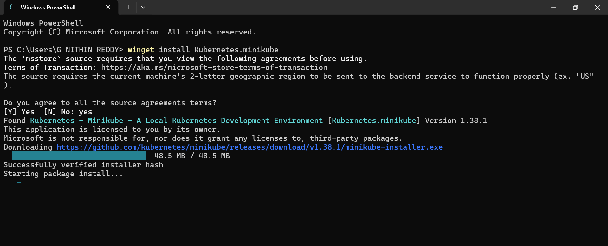
Verify
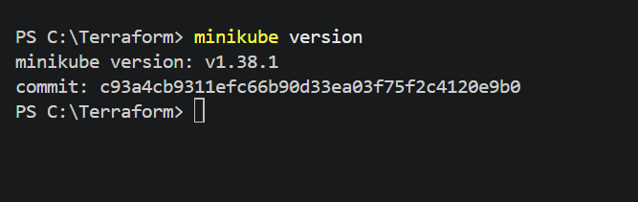
Minikube start
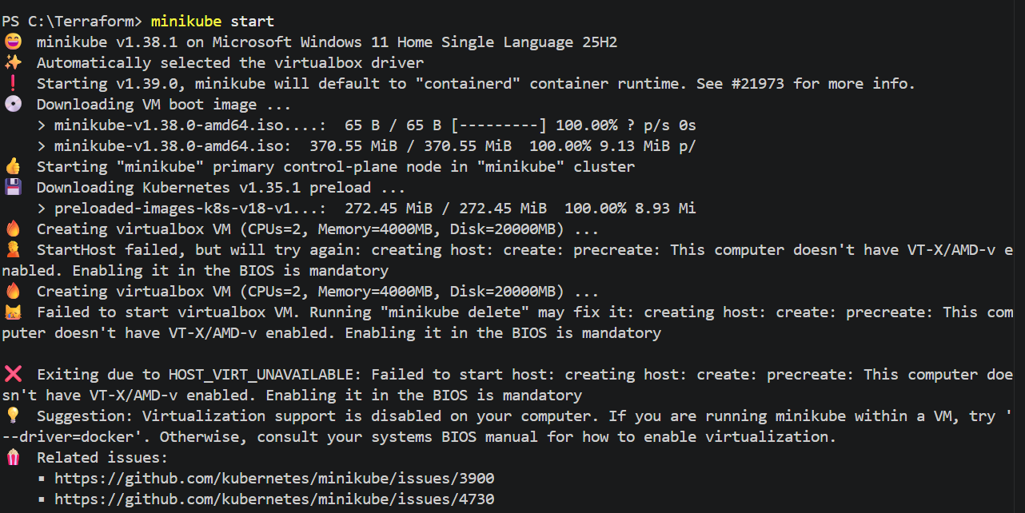
Install kubectl
Open PowerShell as Administrator
Run
winget install Kubernetes.kubectl
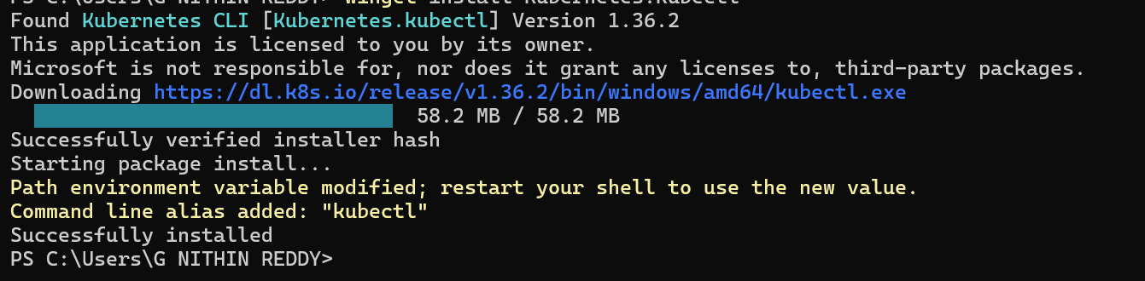
Verify kubectl
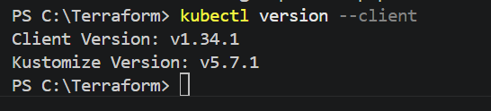

Now start minikube cluster
minikube start --driver=docker
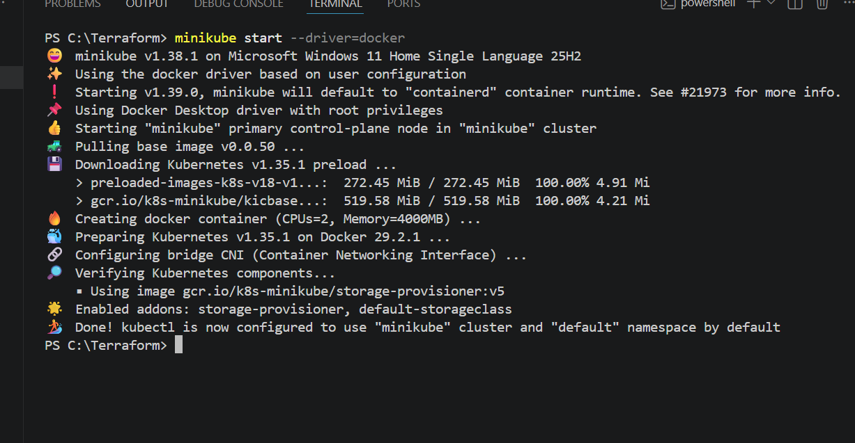
Verify using
kubectl get nodes
kubectl cluster-info
minikube status

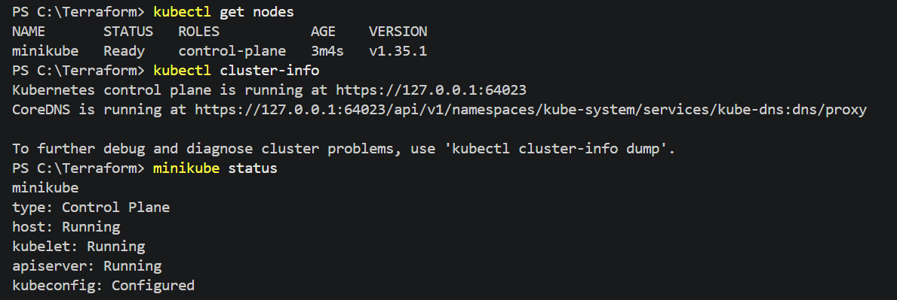

Validation
- Docker Engine is running.
- Minikube cluster is running.
- Kubernetes API Server is accessible.
- Control-plane node is in the Ready state.
- kubectl is successfully communicating with the cluster.

Outcome
A local single-node Kubernetes cluster was successfully created using Minikube and Docker. The Kubernetes control plane is operational, and the environment is ready for deploying pods, services, and other Kubernetes resources.

Task 2: Setup Kubernetes Master and Two Worker Nodes on Ubuntu
Architecture
Kubernetes Cluster

+-------------------------+
| Master Node |
| Control Plane Components|
+-----------+-------------+
|
-----------------------------
| |
+--------------------+ +--------------------+
| Worker Node-1 | | Worker Node-2 |
| kubelet/containerd | | kubelet/containerd |
+--------------------+ +--------------------+
Prerequisites
You'll need 3 Ubuntu machines.
Option 1 (Recommended)
AWS EC2
- Master
- Worker-1
- Worker-2
Option 2
Three Ubuntu Virtual Machines using VMware or VirtualBox.

Which platform should you use?
I recommend AWS EC2 because:
- Production-like environment
- Easy networking
- Common interview setup
- Easy to access via SSH
Steps Performed
- Launched 3 Amazon Linux 2023 EC2 instances.
  - 1 Master Node (k8s-master)
  - 2 Worker Nodes (k8s-worker1, k8s-worker2)
- Connected to all three nodes using SSH.
- Updated the operating system packages.
- Configured hostnames for each node.
- Disabled swap temporarily and permanently.
- Enabled required kernel modules:
  - overlay
  - br_netfilter
- Configured kernel parameters (sysctl) for Kubernetes networking.
- Installed containerd on all three nodes.
- Generated the default containerd configuration.
- Enabled SystemdCgroup=true in the containerd configuration.
- Started and enabled the containerd service.
- Added the Kubernetes package repository.
- Installed Kubernetes components on all three nodes:
  - kubeadm
  - kubelet
  - kubectl
- Enabled the kubelet service.
- Initialized the Kubernetes Control Plane on the master node using kubeadm init.
- Configured kubectl by copying the admin.conf file to the user's kubeconfig directory.
- Installed the Calico CNI plugin for cluster networking.
- Joined Worker-1 to the cluster using the kubeadm join command.
- Joined Worker-2 to the cluster using the kubeadm join command.
- Verified that the master and both worker nodes successfully joined the cluster.

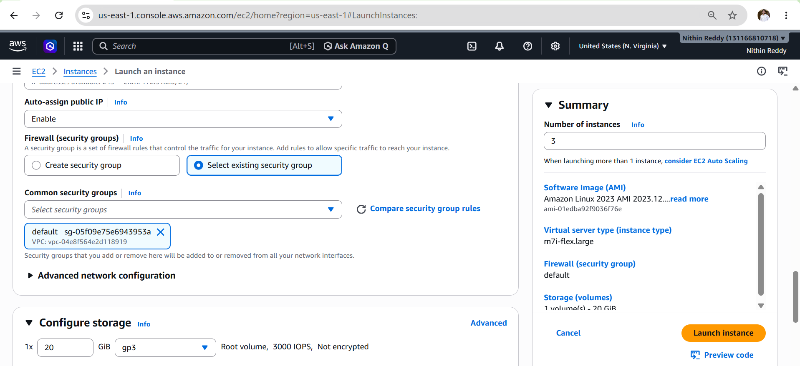
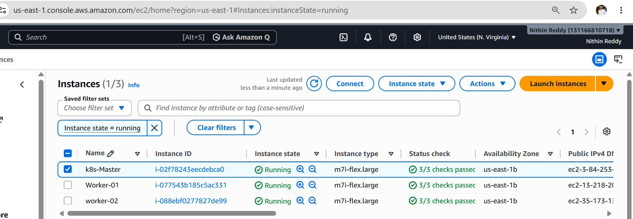
STEP 1: Set Hostnames (ALL NODES)
sudo hostnamectl set-hostname k8s-master # on master
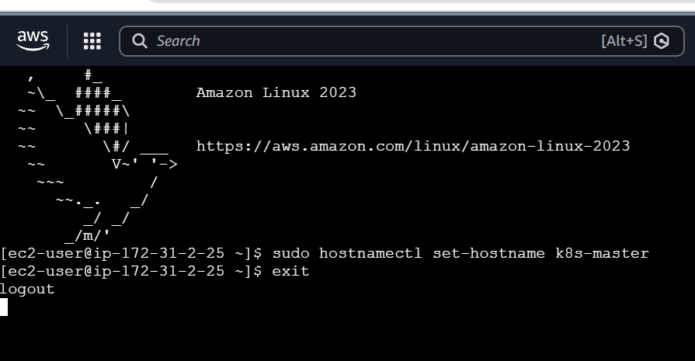
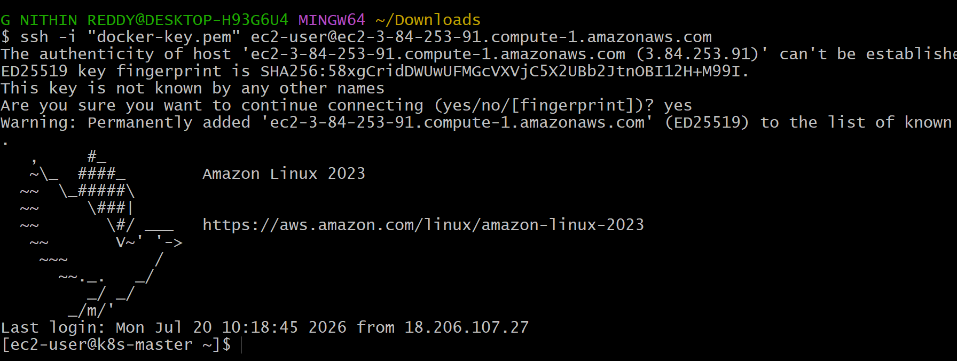
Now same for woker 1
sudo hostnamectl set-hostname k8s-worker1 # worker1
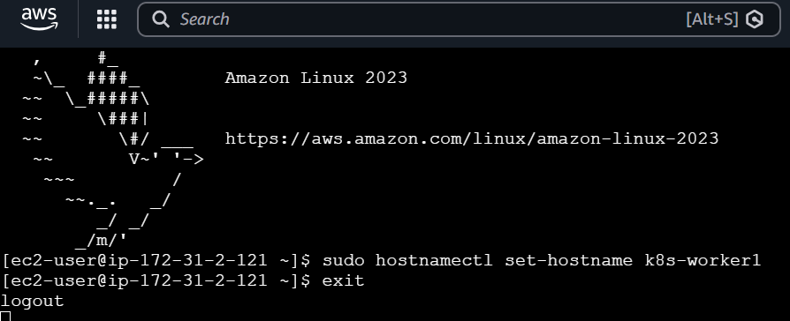
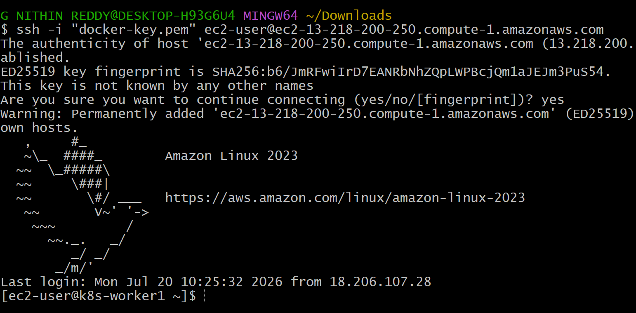
Now same for woker 2
sudo hostnamectl set-hostname k8s-worker2 # worker2
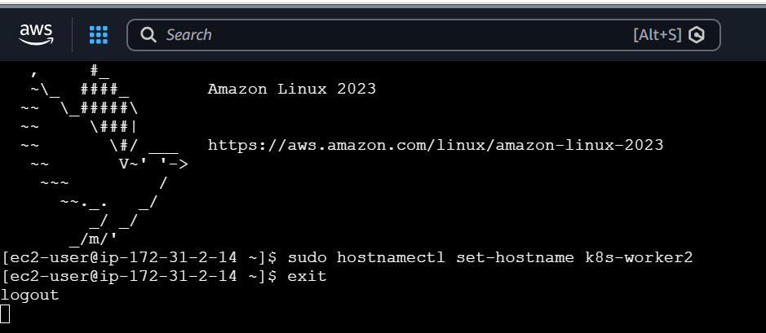
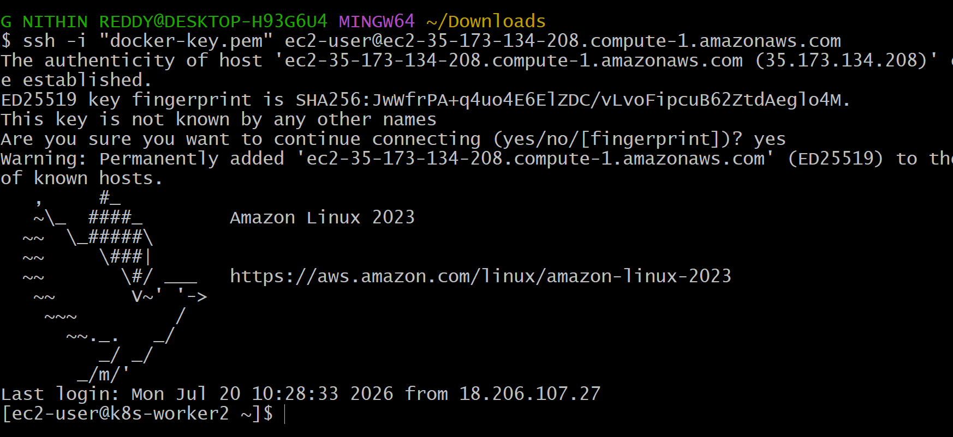
STEP 2: Update /etc/hosts (ALL NODES)
Edit:
sudo nano /etc/hosts
Add:
<MASTER-IP> k8s-master
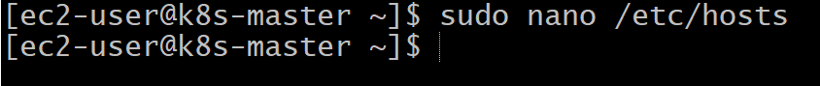
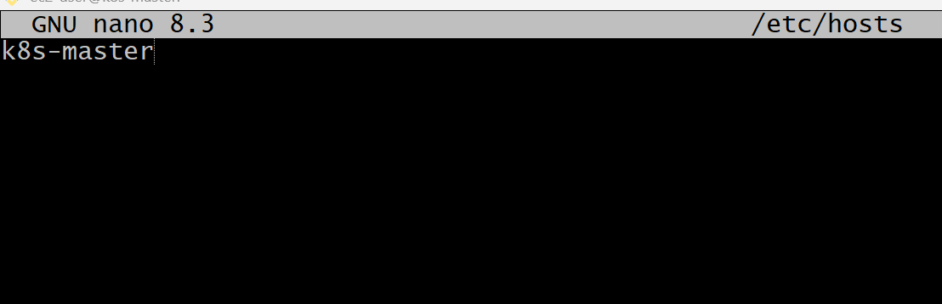
sudo nano /etc/hosts
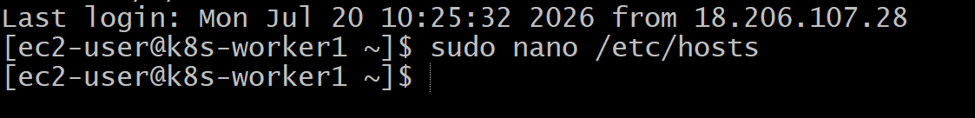
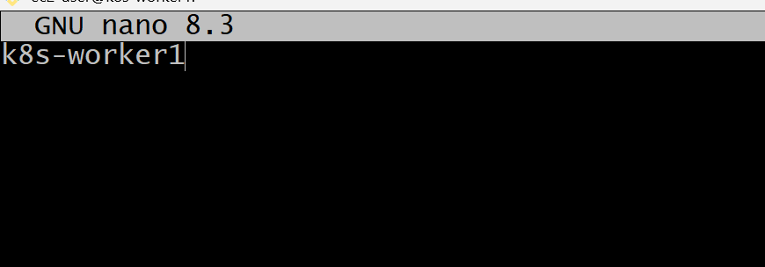
sudo nano /etc/hosts
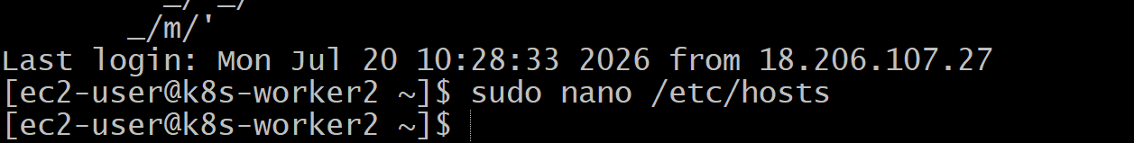
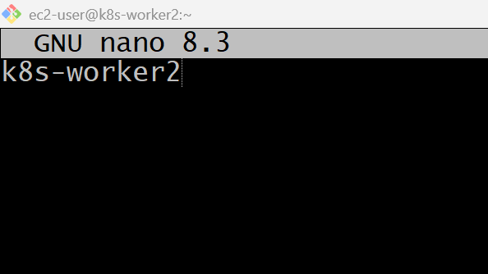
Enable Kernel Modules
cat <<EOF | sudo tee /etc/modules-load.d/k8s.conf
overlay
br_netfilter
EOF
Load them:
sudo modprobe overlay
sudo modprobe br_netfilter

Configure Networking
cat <<EOF | sudo tee /etc/sysctl.d/k8s.conf
net.bridge.bridge-nf-call-iptables = 1
net.bridge.bridge-nf-call-ip6tables = 1
net.ipv4.ip_forward = 1
EOF
Apply:
sudo sysctl --system
master
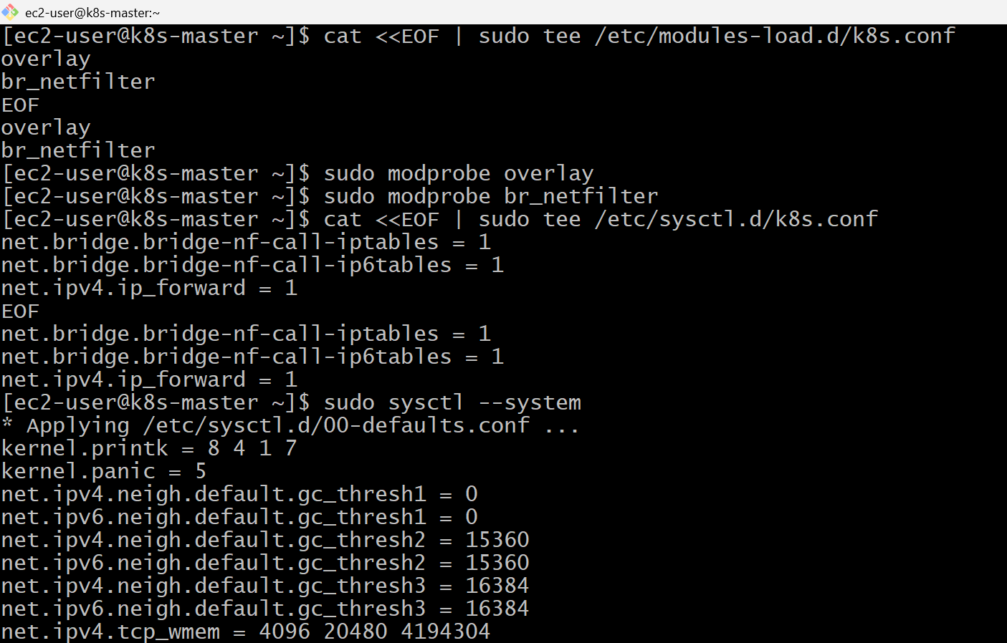
worker-01
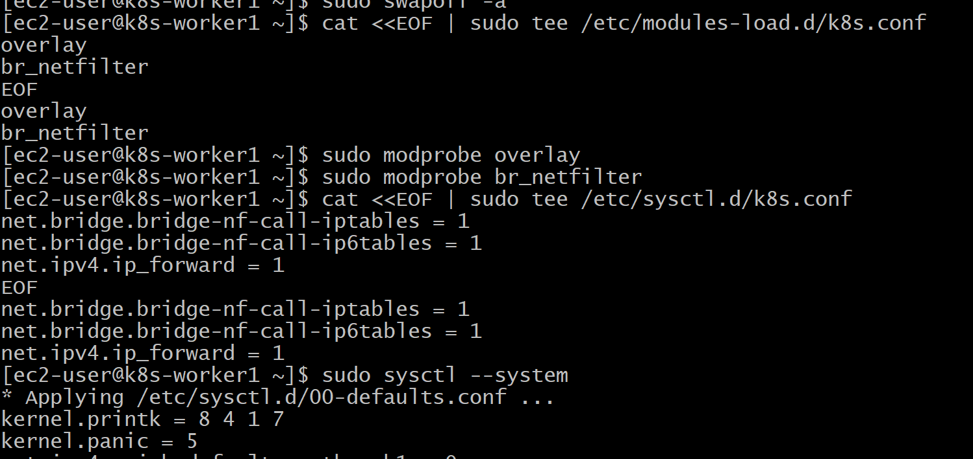
worker-02
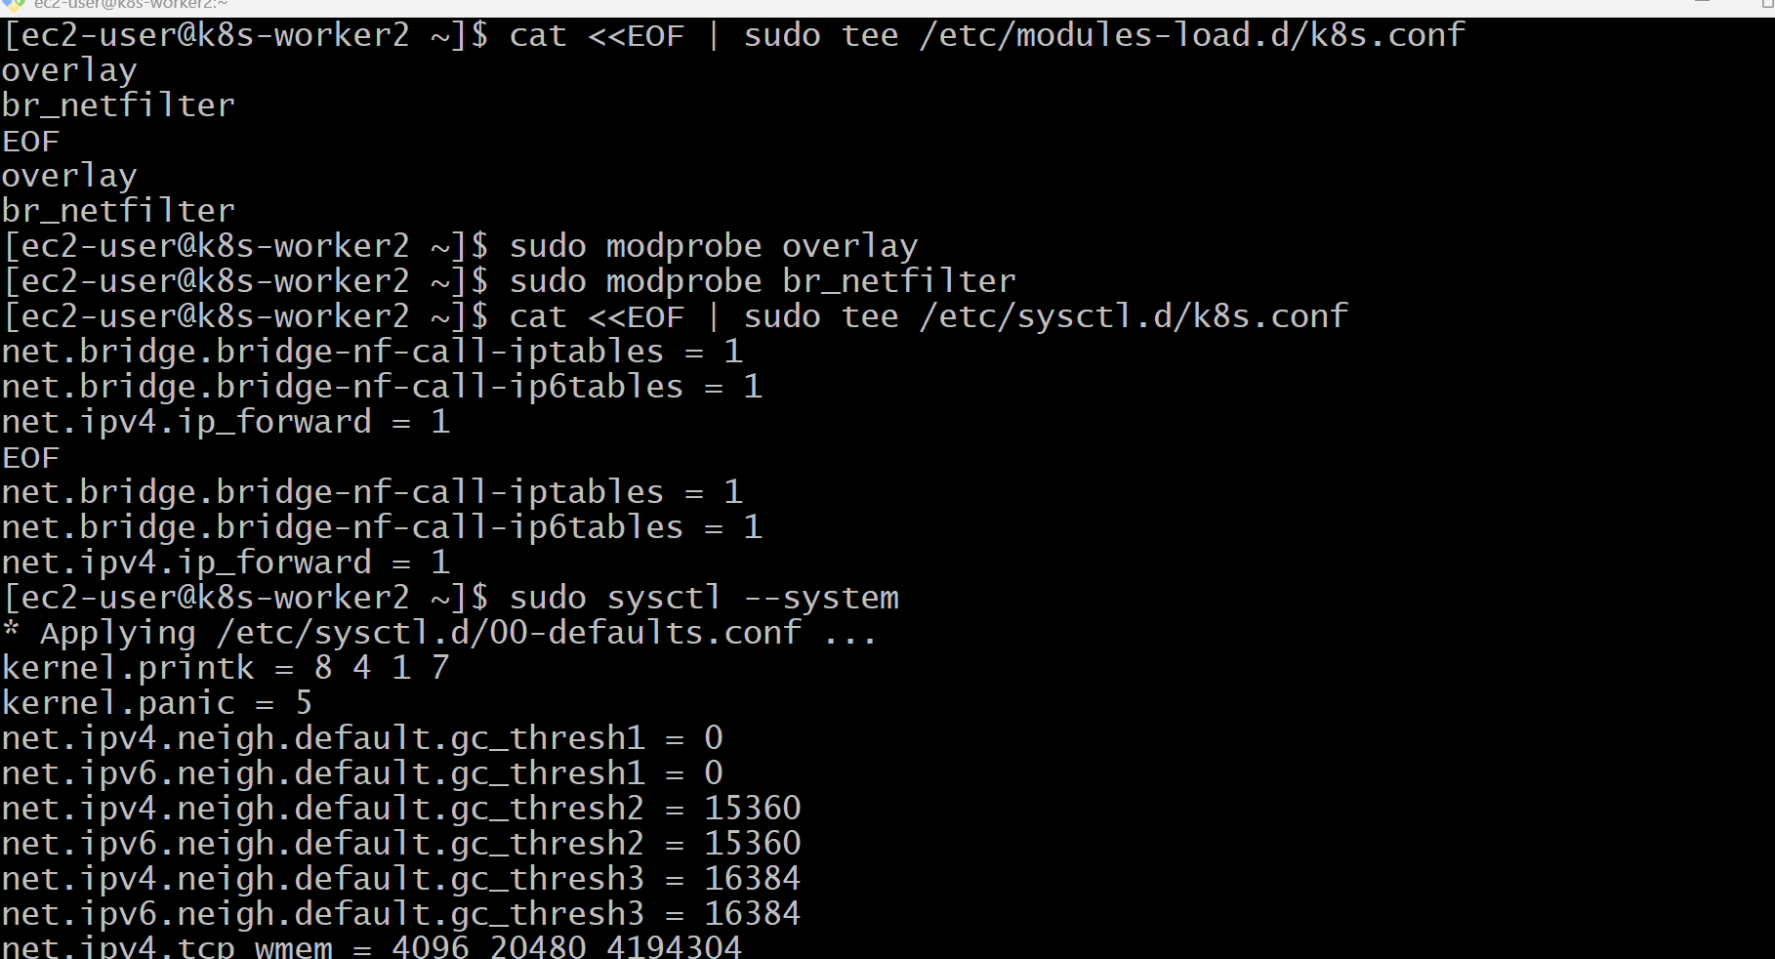
Next Step: Install containerd
This is where Amazon Linux differs from Ubuntu.
On Amazon Linux 2023, install it with:
sudo dnf install -y containerd
Then configure it:
sudo mkdir -p /etc/containerd
containerd config default | sudo tee /etc/containerd/config.toml
Enable systemd cgroups:
sudo sed -i 's/SystemdCgroup = false/SystemdCgroup = true/' /etc/containerd/config.toml
Restart and enable the service:
sudo systemctl enable --now containerd
Verify:
sudo systemctl status containerd
It should show active (running).
Master
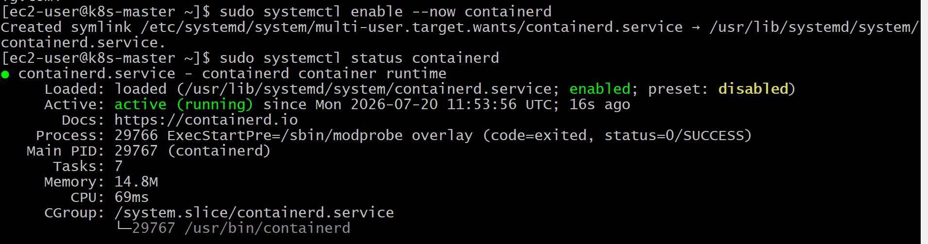
Worker-01
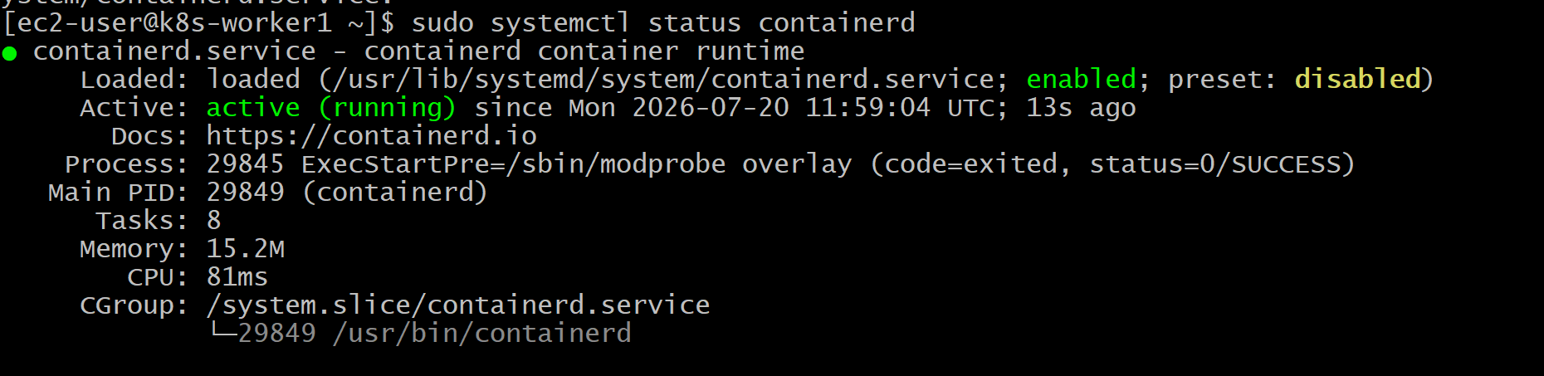worker-02
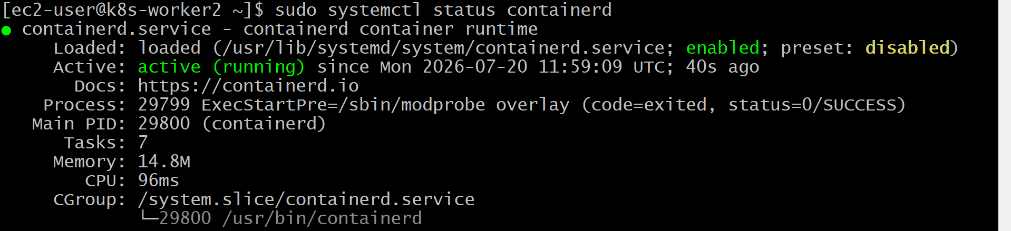

Install Kubernetes Components (Amazon Linux 2023)
Since you're using Amazon Linux 2023, the process differs from Ubuntu.
Step 7.1: Add the Kubernetes repository (All 3 Nodes)
Create the repository file:
cat <<EOF | sudo tee /etc/yum.repos.d/kubernetes.repo
[kubernetes]
name=Kubernetes
baseurl=https://pkgs.k8s.io/core:/stable:/v1.35/rpm/
enabled=1
gpgcheck=1
gpgkey=https://pkgs.k8s.io/core:/stable:/v1.35/rpm/repodata/repomd.xml.key
exclude=kubelet kubeadm kubectl cri-tools kubernetes-cni
EOF
Step 7.2: Install the packages (All 3 Nodes)
sudo dnf install -y kubelet kubeadm kubectl --disableexcludes=kubernetes
Step 7.3: Enable kubelet (All 3 Nodes)
sudo systemctl enable --now kubelet
Check the status:
sudo systemctl status kubelet
Master
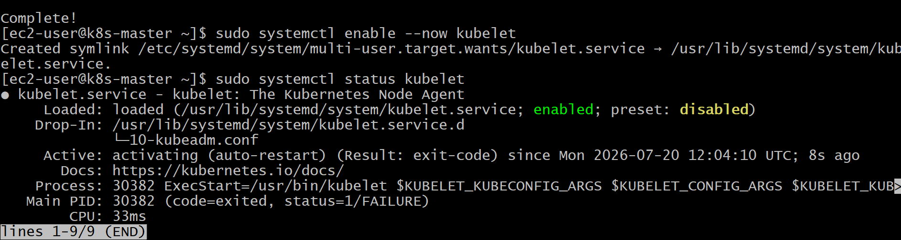
worker1
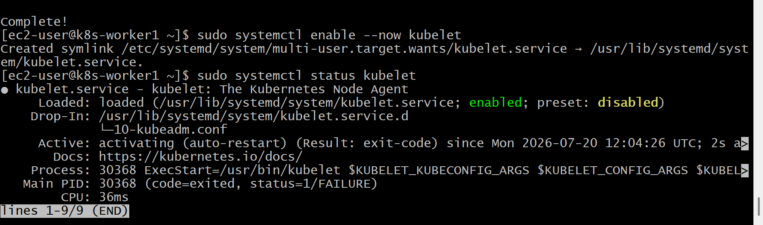
worker-02
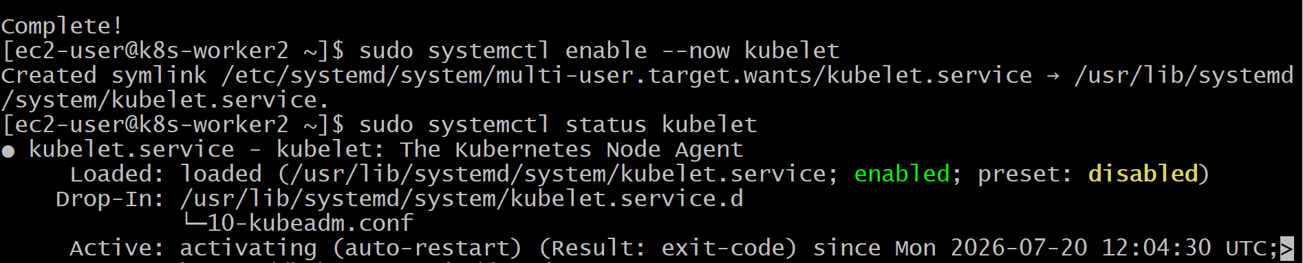
Configure kubectl (Master Only)
Run these commands on the master:
mkdir -p $HOME/.kube
sudo cp -i /etc/kubernetes/admin.conf $HOME/.kube/config
sudo chown $(id -u):$(id -g) $HOME/.kube/config
Verify
Run:
kubectl get nodes
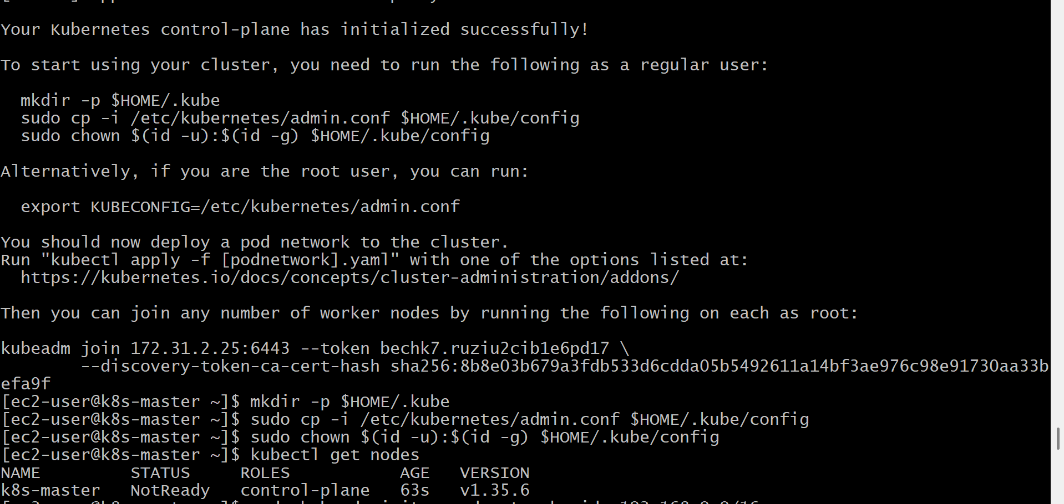
Master got ready
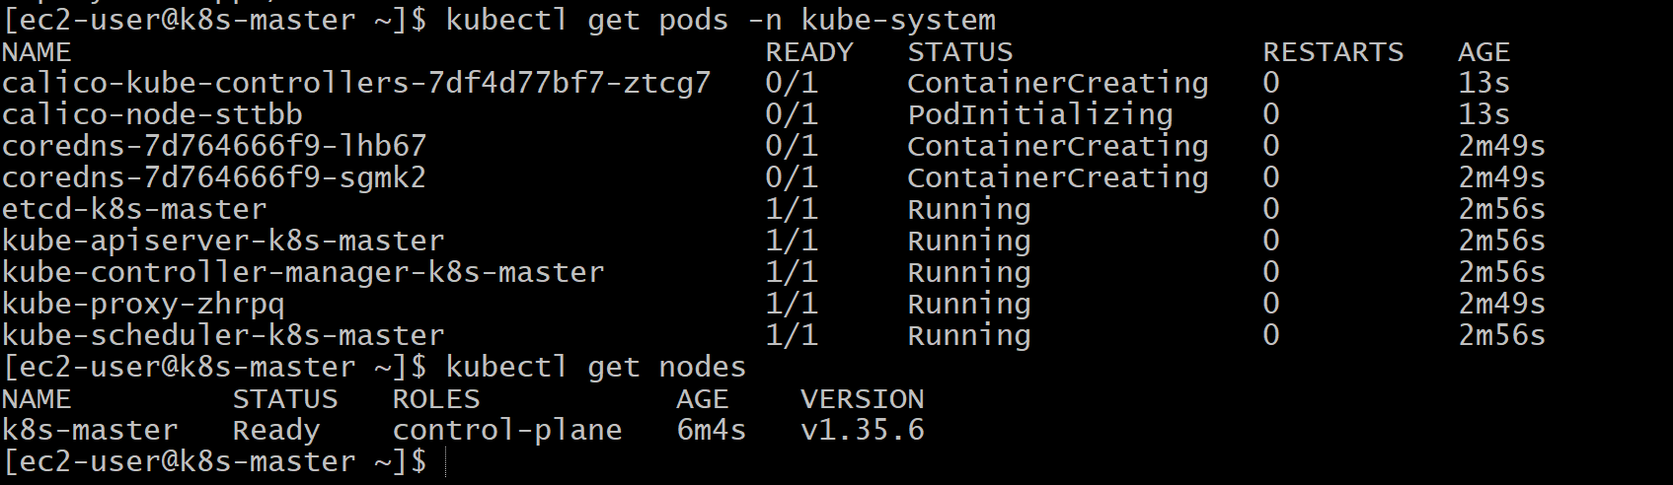
Worker 1 & worker 2
updated

Final outcome
in my master
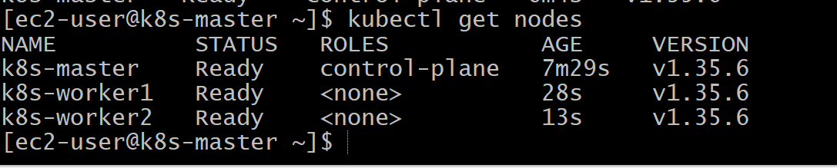

Validation Points
- Verified all three EC2 instances were up and accessible via SSH.
- Verified the hostnames of the Master and Worker nodes.
- Verified swap was disabled on all nodes.
- Verified the required kernel modules (overlay and br_netfilter) were loaded.
- Verified kernel parameters (sysctl) were applied successfully.
- Verified the containerd service was active and running.
- Verified both worker nodes joined the Kubernetes cluster successfully.
- Verified all nodes were in the Ready state using kubectl get nodes.
- Verified Kubernetes system Pods were in the Running state using kubectl get pods -n kube-system.
- Verified the cluster information using kubectl cluster-info.

Outcome
- Successfully built a Kubernetes cluster with 1 Control Plane (Master) and 2 Worker Nodes.
- Configured containerd as the container runtime on all nodes.
- Installed and configured kubeadm, kubelet, and kubectl.
- Initialized the Kubernetes Control Plane.
- Installed the Calico Container Network Interface (CNI) plugin for Pod networking.
- Successfully joined both worker nodes to the cluster.
- Verified that all nodes were in the Ready state and the cluster was ready to deploy and manage containerized applications.

Task 3: Run One Nginx Pod
Objective
Deploy a single Nginx Pod in your Minikube Kubernetes cluster and verify that it is running successfully.
Steps Performed
- Verified the Kubernetes cluster.
- Created an Nginx Pod using the official Nginx image.
- Verified the Pod reached the Running state.
- Retrieved Pod details and IP address.
- Accessed the Pod shell and verified the Nginx installation.
- Exposed the Pod using a NodePort Service.
- Accessed the Nginx welcome page through Minikube.

Commands used
kubectl get nodes
kubectl get pods
kubectl run nginx –image=nginx
kubectl get pod
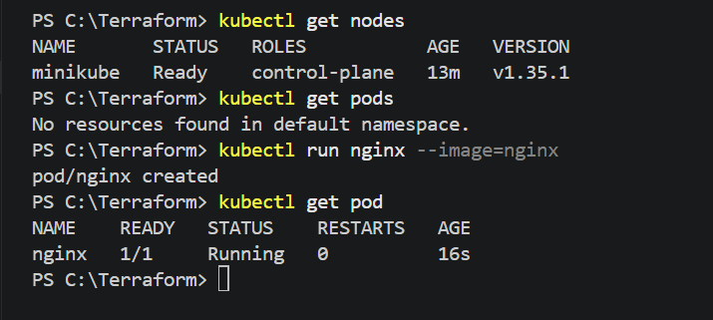

Get Detailed Pod Information
Run:
kubectl describe pod nginx
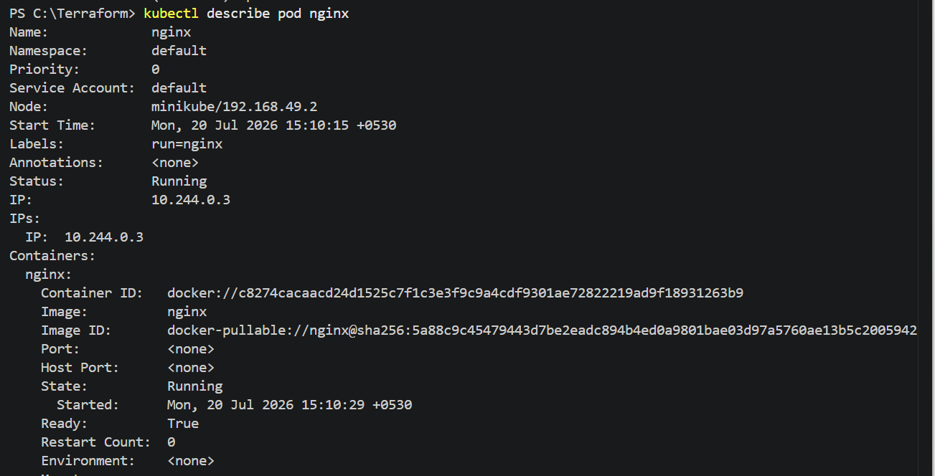
Check Pod Logs
Run:
kubectl logs nginx
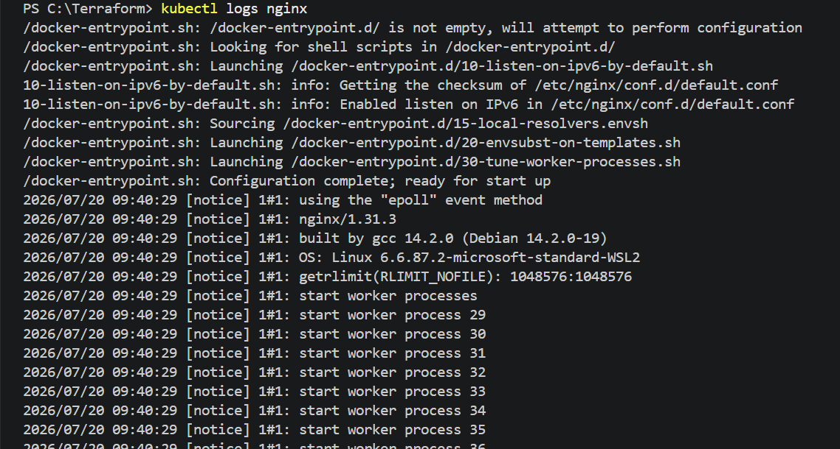

Get the Pod IP Address
Run:
kubectl get pods -o wide
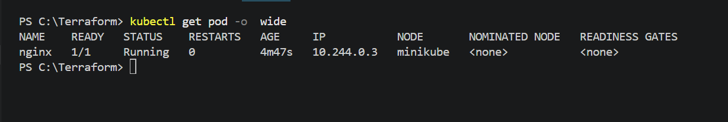
Execute Commands Inside the Pod
Open a shell inside the Nginx container:
kubectl exec -it nginx -- /bin/bash
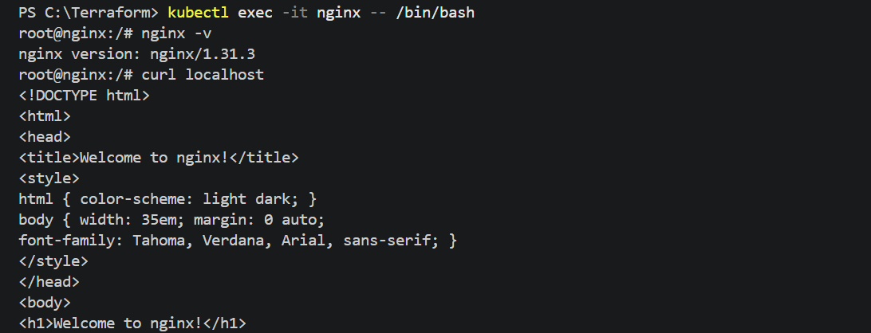

Expose the Pod
Create a NodePort Service:
kubectl expose pod nginx --type=NodePort --port=80
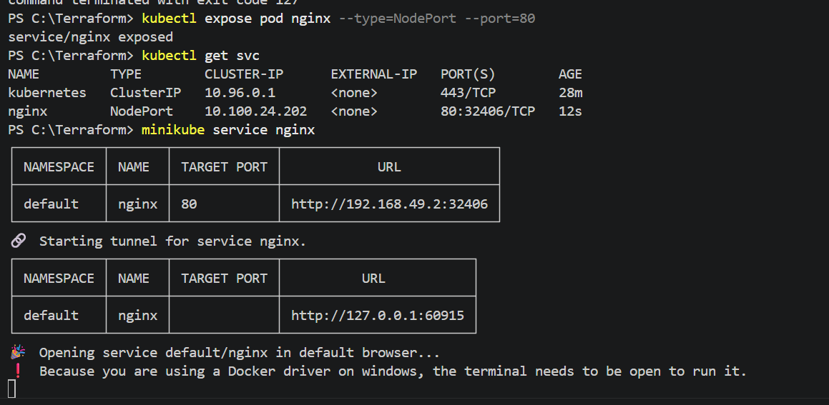

Open Nginx in the Browser
Run:
minikube service nginx
This opens the Nginx welcome page in your default browser.

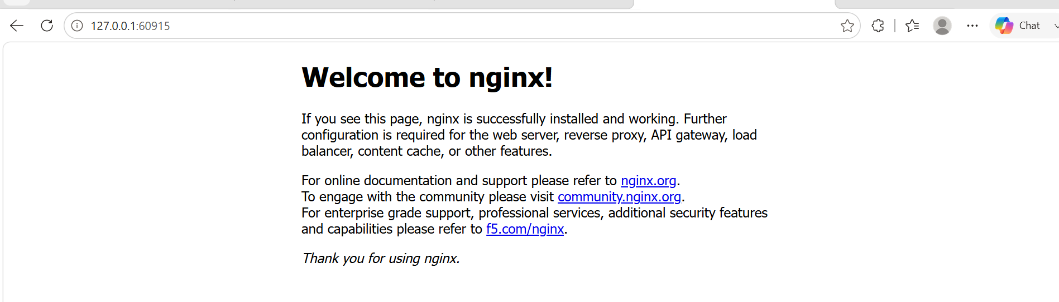

Validation
- Pod status is Running.
- Service is created successfully.
- Nginx is reachable in a web browser.
- kubectl commands execute without errors.
Outcome
A single Nginx Pod was successfully deployed on the Minikube Kubernetes cluster. The Pod is running, accessible through a NodePort Service, and serves the default Nginx web page, demonstrating successful application deployment on Kubernetes.

Task 4: Kubernetes Master and Worker Components
Kubernetes Architecture
Kubernetes Cluster

+----------------------+
| Master Node |
| (Control Plane) |
+----------+-----------+
|
--------------------------------------------------
| |
+------------------------+ +------------------------+
| Worker Node 1 | | Worker Node 2 |
+------------------------+ +------------------------+
| kubelet | | kubelet |
| kube-proxy | | kube-proxy |
| containerd | | containerd |
| Pods | | Pods |

Kubernetes Master (Control Plane)
The Master Node manages the entire Kubernetes cluster. It schedules Pods, maintains the cluster state, and communicates with worker nodes.
Components
1. kube-apiserver
Purpose:
- Entry point to the Kubernetes cluster.
- Receives all requests from kubectl, users, and applications.
Responsibilities:
- Accepts API requests.
- Authenticates users.
- Validates requests.
- Stores cluster information in etcd.
Port:
6443

2. etcd
Purpose:
- Distributed key-value database.
Responsibilities:
- Stores cluster configuration.
- Stores Pod information.
- Stores Service information.
- Stores Secrets and ConfigMaps.
Port:
2379
2380

3. kube-scheduler
Purpose:
- Decides where Pods should run.
Responsibilities:
- Checks CPU.
- Checks Memory.
- Checks Labels.
- Checks Taints/Tolerations.
- Chooses the best worker node.

4. kube-controller-manager
Purpose:
- Runs controllers that maintain the desired state of the cluster.
Examples:
- Node Controller
- Deployment Controller
- ReplicaSet Controller
- Job Controller
- Namespace Controller
Example:
If a Deployment requires 3 Pods and one Pod fails, the controller creates a new Pod automatically.

5. Cloud Controller Manager (Optional)
Used in cloud environments such as AWS, Azure, and GCP.
Responsibilities:
- Creates Load Balancers.
- Manages cloud storage.
- Manages cloud networking.
- Integrates Kubernetes with cloud services.

Worker Node
The Worker Node is where application Pods actually run.
Each worker contains these components.

1. kubelet
Purpose:
- Node agent.
Responsibilities:
- Receives instructions from the API Server.
- Creates Pods.
- Starts containers.
- Monitors Pod health.
- Reports node status to the Master.

2. kube-proxy
Purpose:
- Networking component.
Responsibilities:
- Manages Service networking.
- Routes traffic to Pods.
- Maintains iptables/IPVS rules.
- Provides load balancing between Pods.

3. Container Runtime
Examples:
- containerd
- CRI-O
(Older clusters used Docker.)
Responsibilities:
- Pulls container images.
- Starts containers.
- Stops containers.
- Deletes containers.

4. Pods
Pods are the smallest deployable unit in Kubernetes.
A Pod contains:
- One or more containers
- Shared network
- Shared storage
Example:
Pod
├── nginx container
└── sidecar container

Communication Flow
User
|
kubectl
|
API Server
|
Scheduler
|
Worker Node
|
kubelet
|
containerd
|
Pod
Outcome
Gained a clear understanding of Kubernetes architecture, including the responsibilities of the Master (Control Plane) and Worker nodes, how workloads are scheduled, and how Kubernetes components interact to manage and run containerized applications.
This topic is one of the most frequently asked in Kubernetes and DevOps interviews, so understanding these components and their interactions will help both in hands-on work and technical discussions.

