Terraform-01
Task 1: Install Terraform on Your PC
Objective
The objective of this task is to install Terraform on a local Windows machine and verify that it is functioning correctly. Terraform is an Infrastructure as Code (IaC) tool that allows infrastructure to be created, modified, and managed using configuration files instead of manually creating resources through cloud consoles. Installing Terraform is the first step before writing or executing any infrastructure templates.
What is Terraform?
Terraform is an open-source Infrastructure as Code (IaC) tool developed by HashiCorp.
Instead of manually creating AWS resources like EC2 instances, VPCs, or S3 buckets through the AWS Management Console, Terraform allows you to define the infrastructure in code using HCL (HashiCorp Configuration Language).
Example:
Instead of clicking
AWS Console
→ EC2
→ Launch Instance
→ Configure
→ Review
→ Launch
You simply write

resource "aws_instance" "web" {
ami = "ami-xxxxxxxx"
instance_type = "t2.micro"
}
Then run
terraform apply
Terraform automatically creates the EC2 instance.
Install Terraform on Windows PC – Steps
Step 1: Download Terraform
Official
- Open a web browser and visit the official HashiCorp Terraform download page.
- Select Windows → AMD64 → Version 1.15.7 (latest stable version).
- Download the file terraform_1.15.7_windows_amd64.zip.

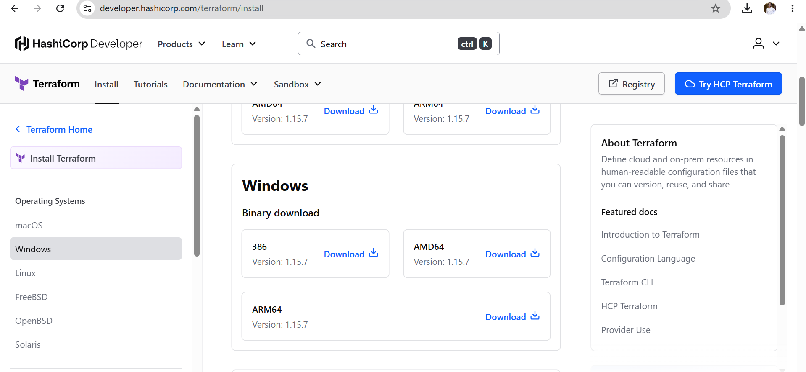

Step 2: Extract the ZIP File
Required
- Locate the downloaded ZIP file in the Downloads folder.
- Right-click the ZIP file and select Extract All.
- Verify that the extracted folder contains terraform.exe.

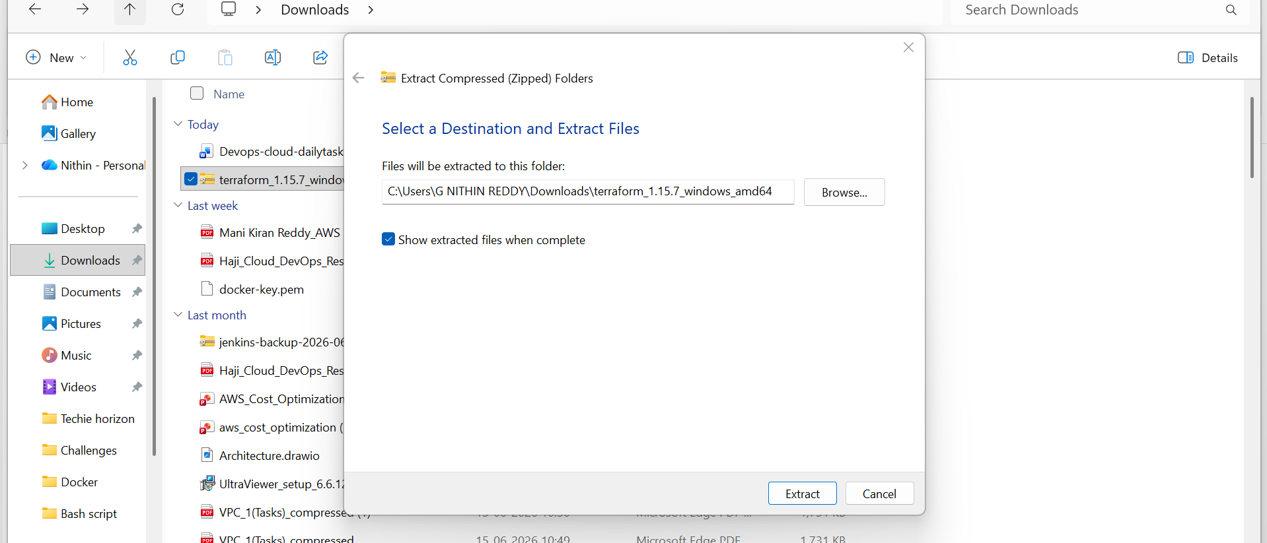
Step 3: Create Terraform Directory
Recommended
- Create a folder C:\Terraform.
- Copy terraform.exe into this folder.
- Confirm the final path is C:\Terraform erraform.exe.

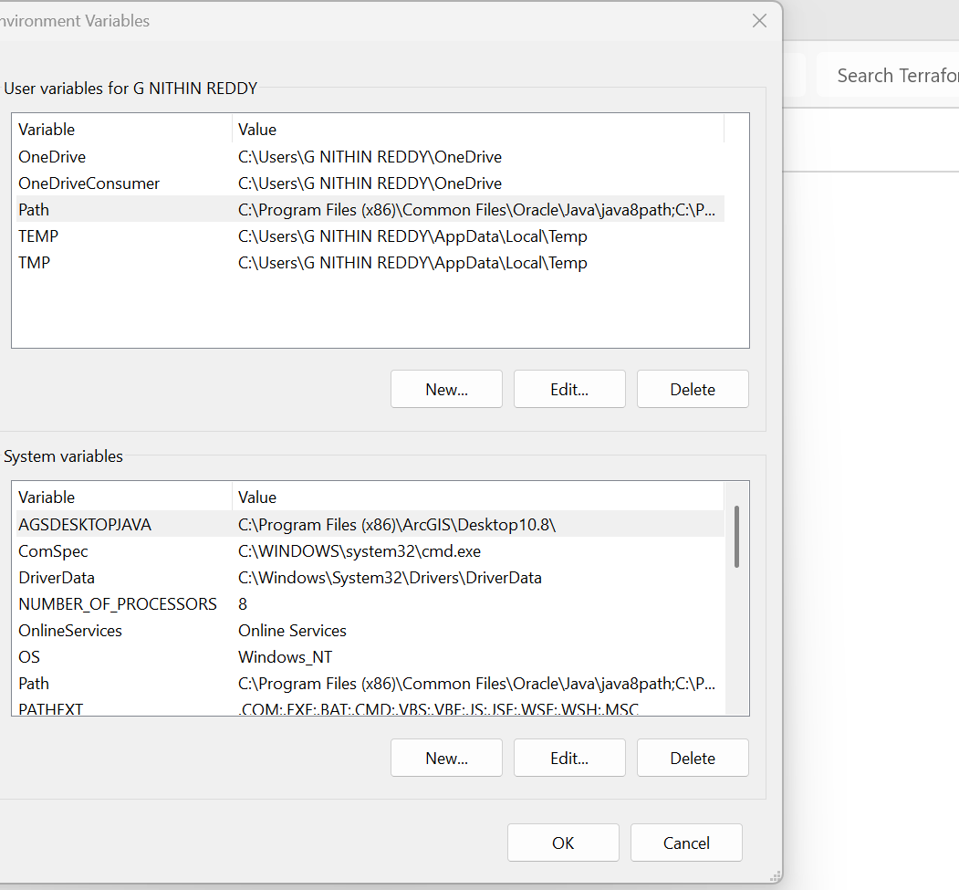
Step 4: Configure PATH Variable
Important
- Open Edit the system environment variables from Windows Search.
- Click Environment Variables.
- Select Path under System Variables and click Edit.
- Click New and add C:\Terraform.
- Click OK to save all changes.
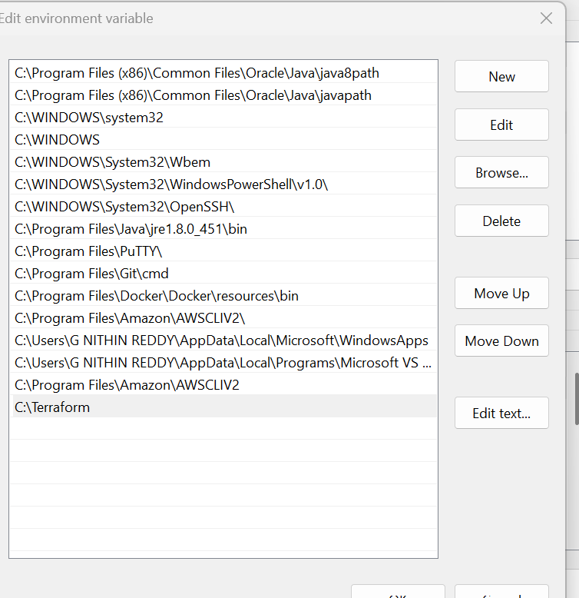
Step 5: Open Command Prompt
CLI
- Close any previously opened Command Prompt windows.
- Open a new Command Prompt or PowerShell window.
- Run the Terraform command from the terminal (do not double-click terraform.exe).
Validation Checklist
Verify the following:
✅ Terraform executable downloaded successfully.
✅ terraform.exe copied to the designated folder.
✅ PATH environment variable configured correctly.
✅ Command Prompt recognizes the terraform command.
✅ terraform version displays the installed version.
✅ where terraform shows the correct executable path.
✅ terraform -help lists all available commands.

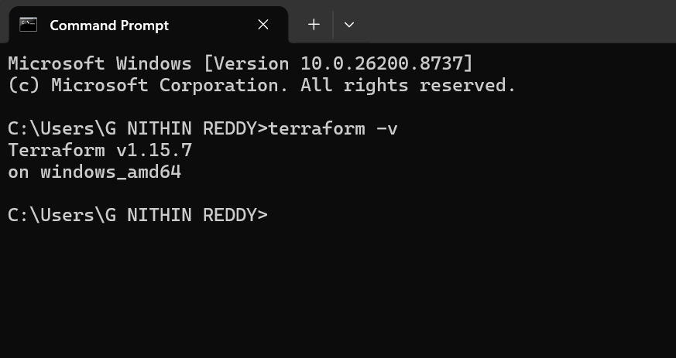
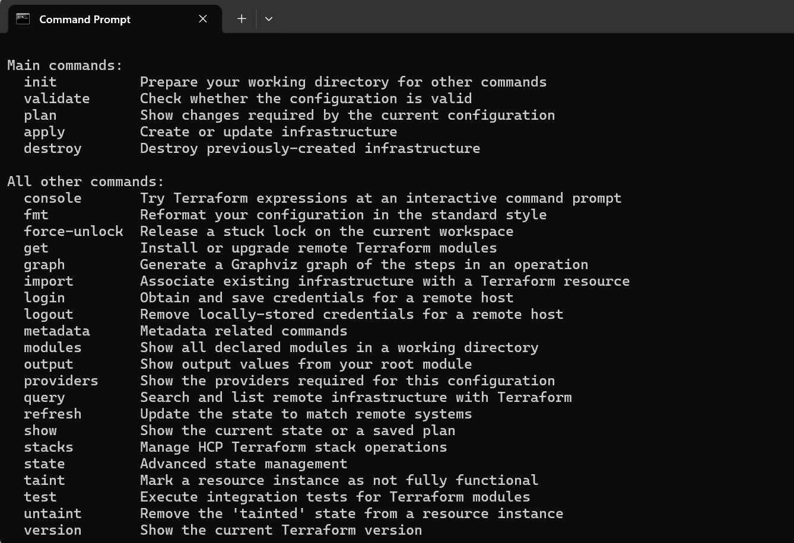
Expected Outcome
After completing this task:
- Terraform is installed successfully on the Windows machine.
- The Terraform executable is accessible from any Command Prompt or PowerShell session.
- The PATH environment variable is configured correctly.
- Terraform commands execute without errors.
- The local system is ready to create, validate, and deploy Infrastructure as Code (IaC) templates.
- The environment is prepared for subsequent tasks, including executing Terraform templates and integrating Terraform with Jenkins.

Common Errors & Fixes
Error:
terraform is not recognized
Fix:
PATH variable not added correctly.
Restart:
· CMD
· VS Code
· Or restart PC
---
Recommended Tools
Install VS Code Visual Studio Code
Install Terraform Extension
Open VS Code → Extensions → Search:
Terraform
Install extension by HashiCorp.
---
First Useful Commands
terraform init terraform plan terraform apply terraform destroy
---
Example Workflow
terraform init terraform plan terraform apply

Task 2: Execute Terraform Templates
Objective
The objective of this task is to execute Terraform templates to understand how Terraform provisions infrastructure using Infrastructure as Code (IaC). This task covers the complete Terraform workflow, including initializing the working directory, validating the configuration, generating an execution plan, applying the configuration, verifying the created resources, and destroying them when no longer required.
Prerequisites
Before executing Terraform templates, ensure the following prerequisites are met:
- Terraform is installed successfully on the local machine.
- Visual Studio Code (or any code editor) is installed.
- AWS account is available.
- AWS CLI is installed and configured (if deploying AWS resources).
- Internet connection is available.
- Sample Terraform template files are available.
- A working directory is created for the Terraform project.
Implementation Steps
Step 1: Create a Project Directory
- Create a new folder for the Terraform project.
- Open the folder using Visual Studio Code.
- Keep all Terraform configuration files inside this directory.

Step 2: Create Terraform Configuration File
- Create a file named main.tf.
- Add the Terraform configuration provided in the training video.
- Save the file.
Step 3: Open Terminal
- Open the integrated terminal in Visual Studio Code or Command Prompt.
- Navigate to the Terraform project directory.
Example:
cd C:\Terraform\Project
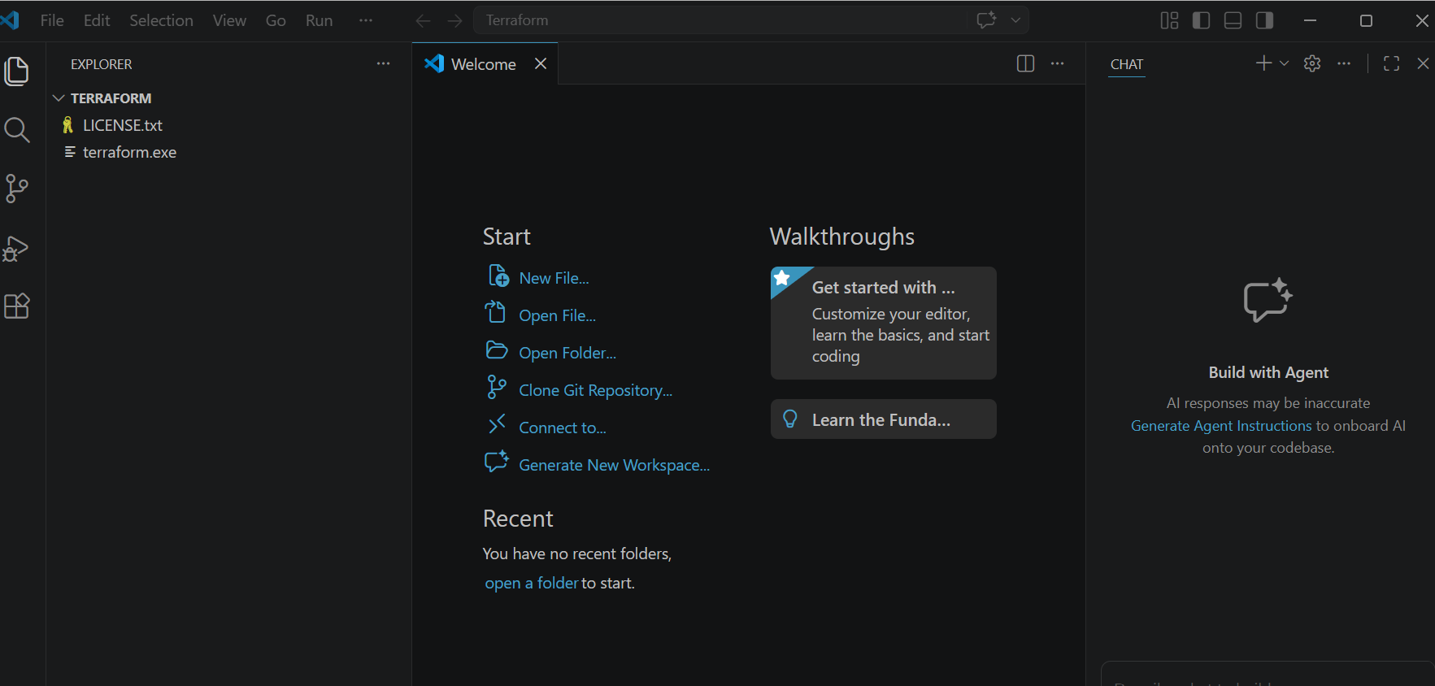
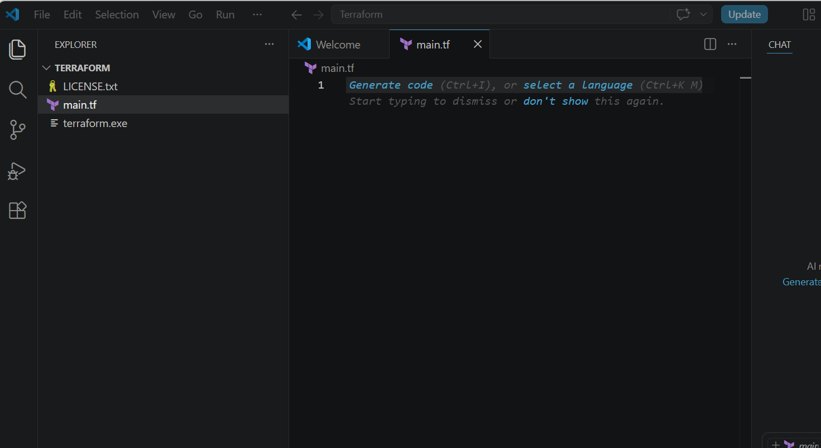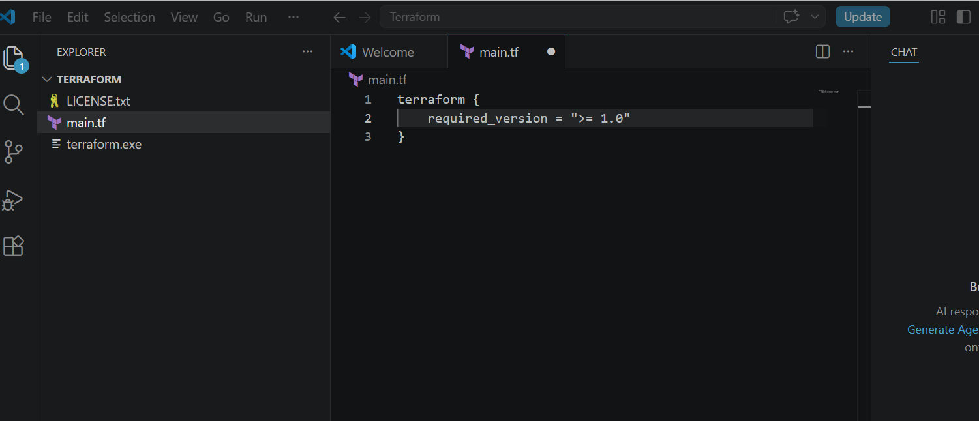
Step 4: Initialize Terraform
- Execute the initialization command.
terraform init
- Terraform downloads the required provider plugins.
- Creates the .terraform directory.
- Prepares the working directory for execution.
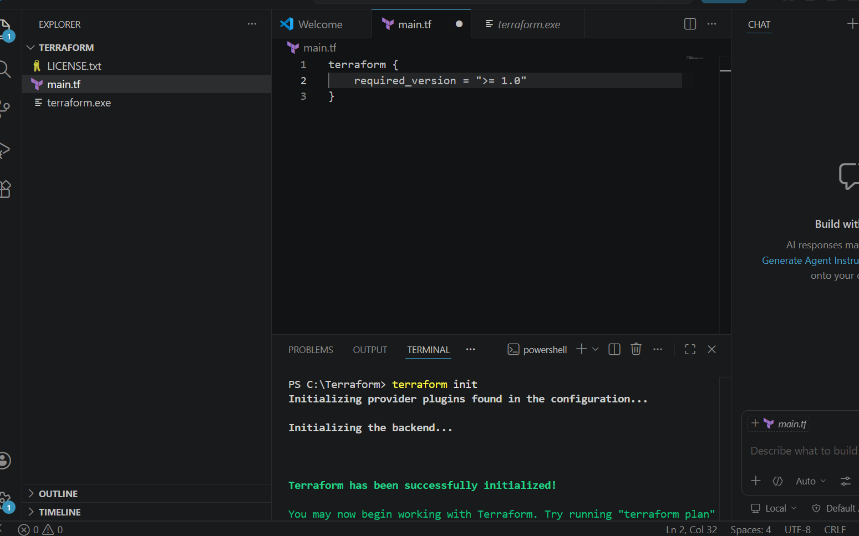
Step 5 : See Execution Plan
Run:
terraform plan
Terraform shows what it will create.
Example:
+ create local_file.pet
STEP 6 — Apply Changes
Run:
terraform apply
It will ask:
Do you want to perform these actions?
Type:
yes
Press Enter.

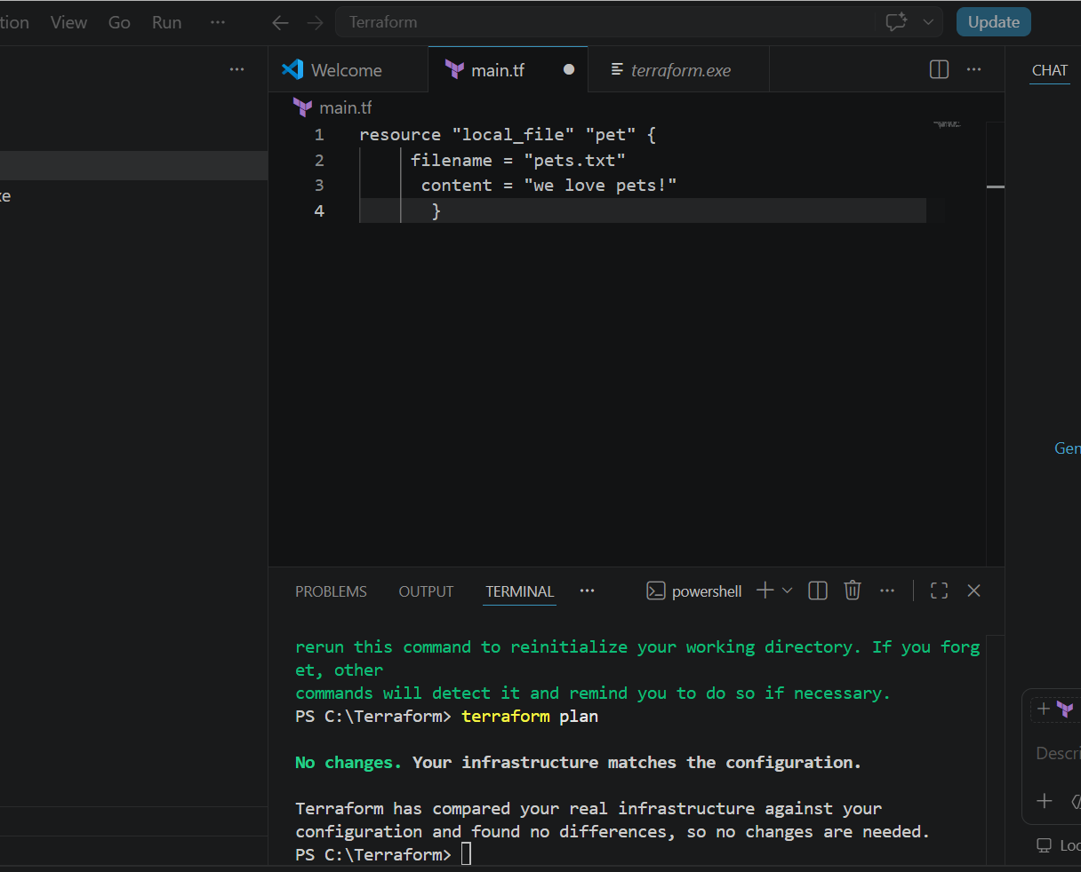
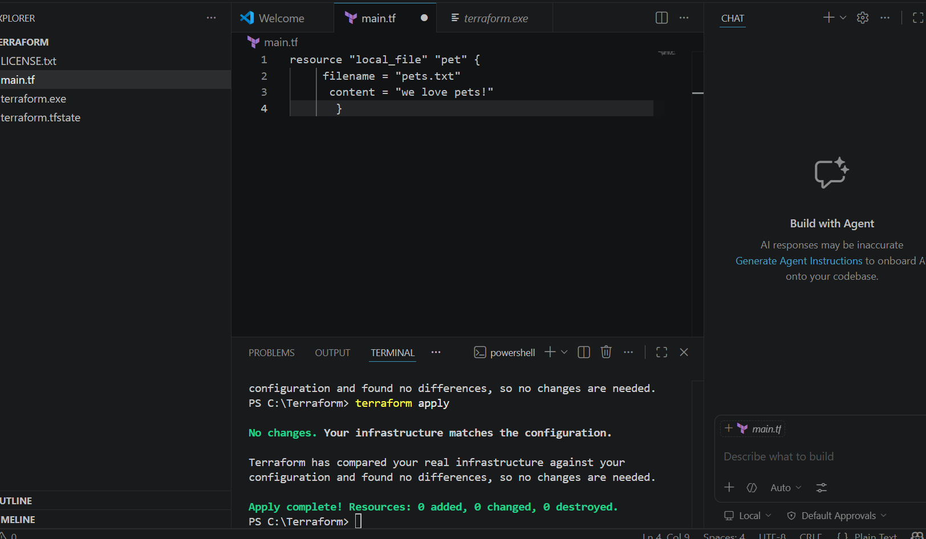
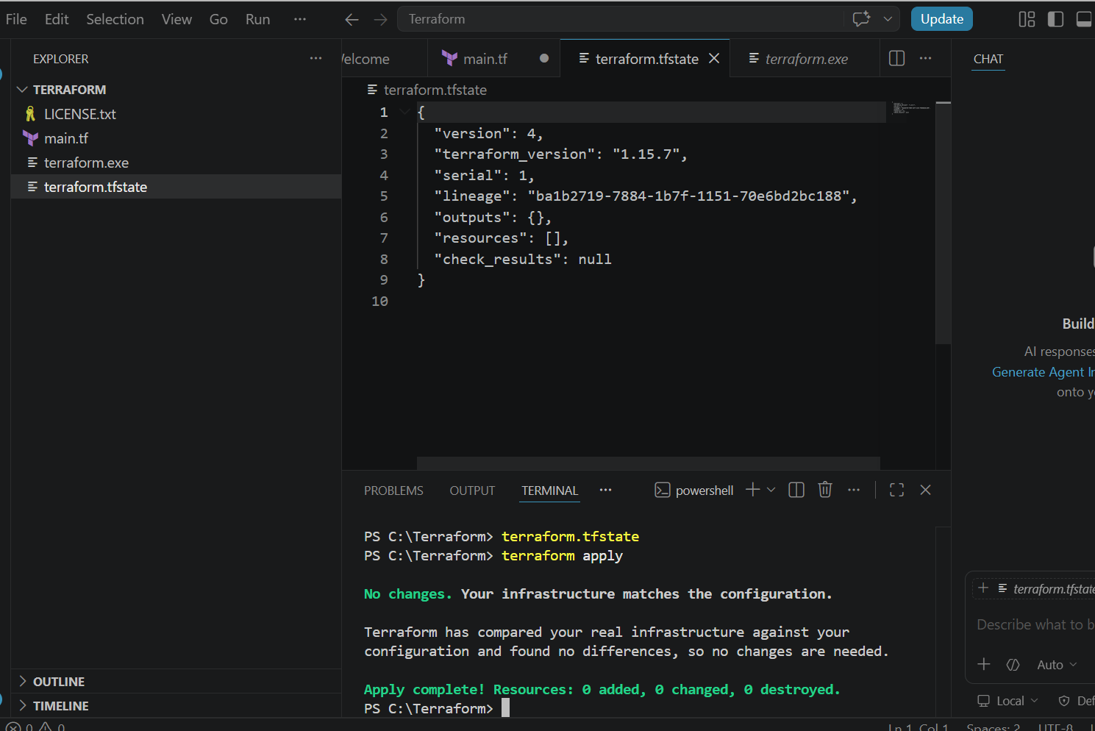

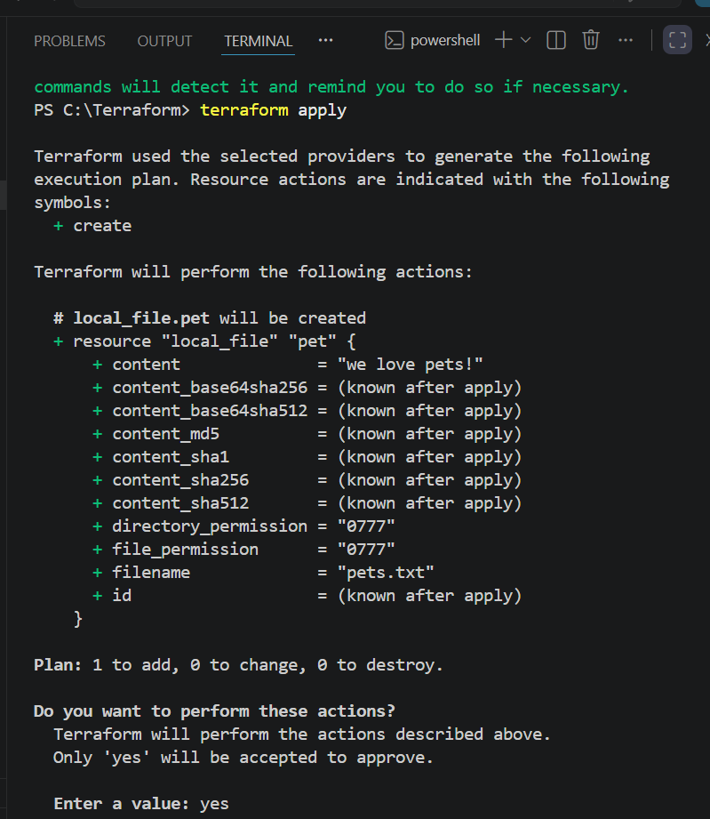
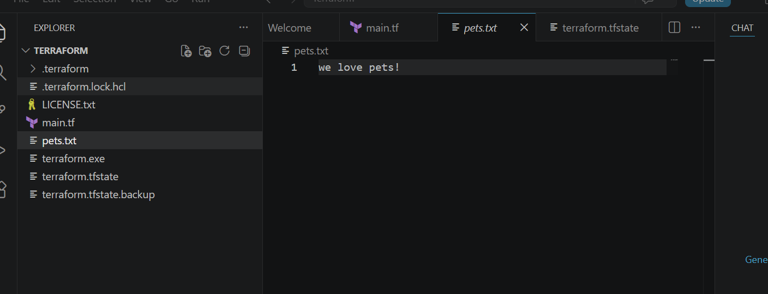
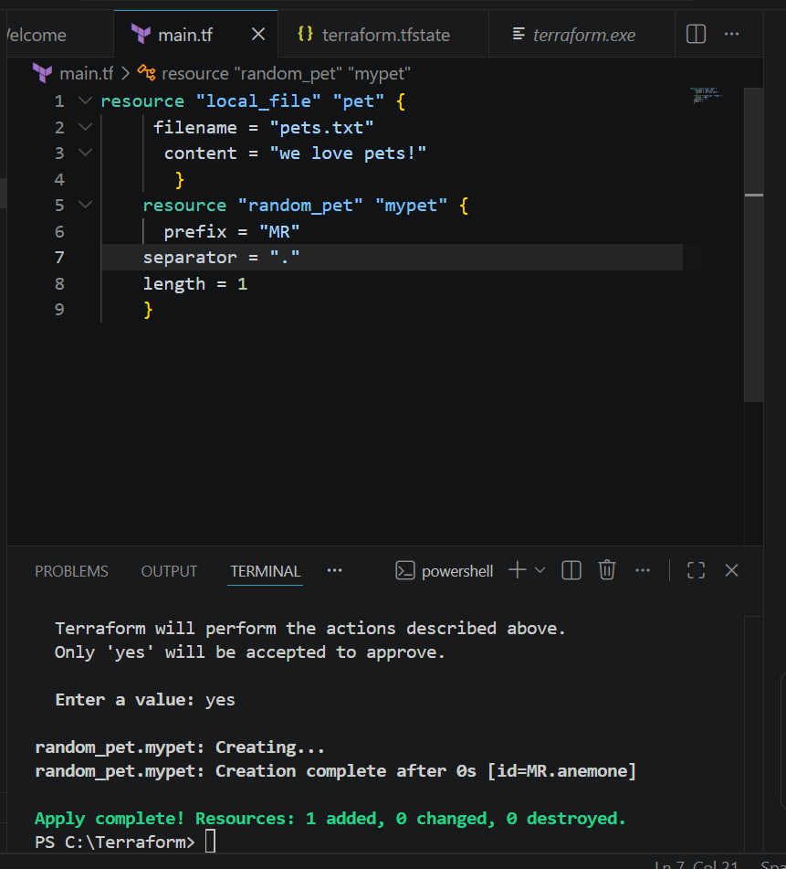
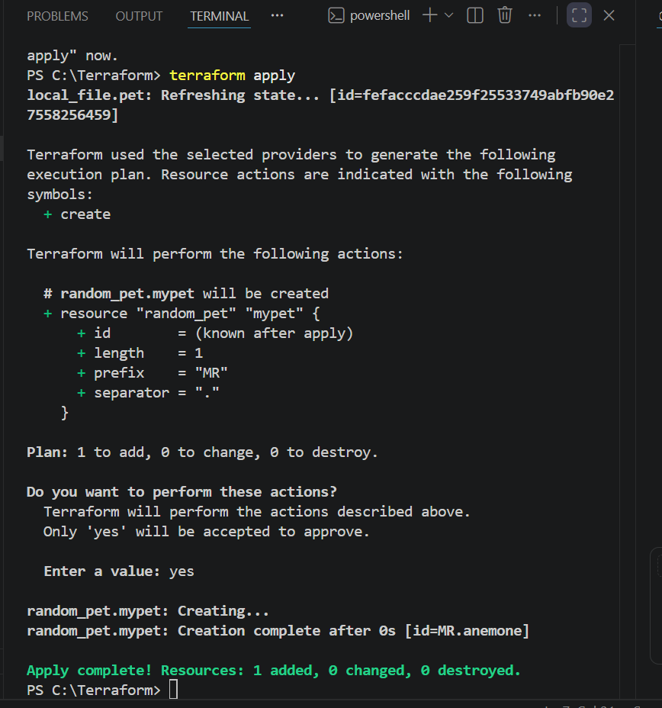
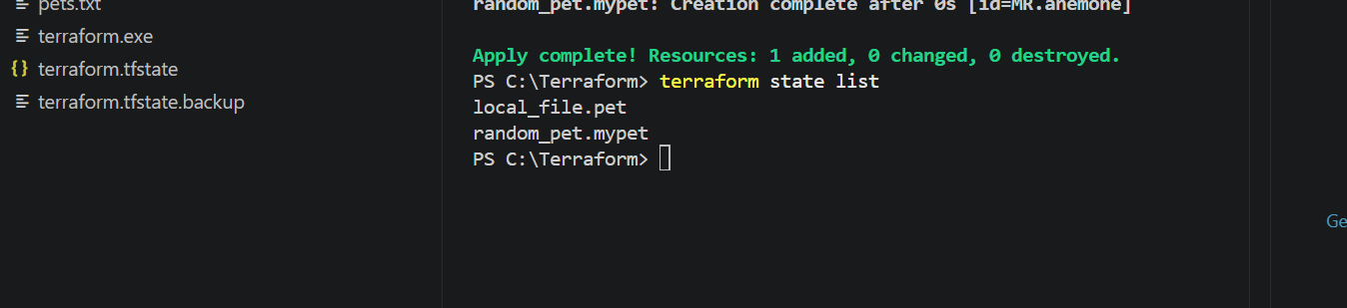
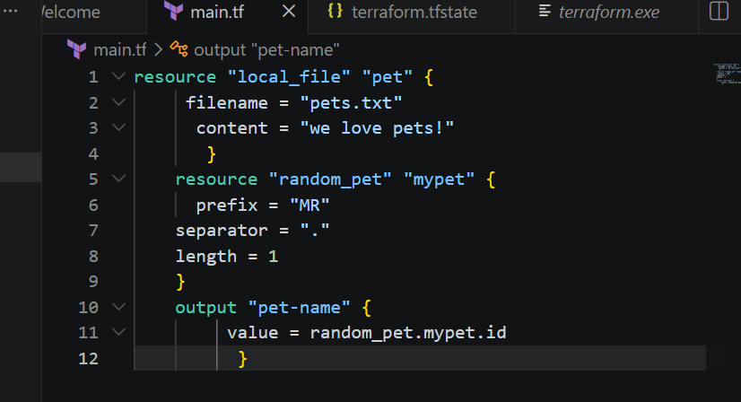
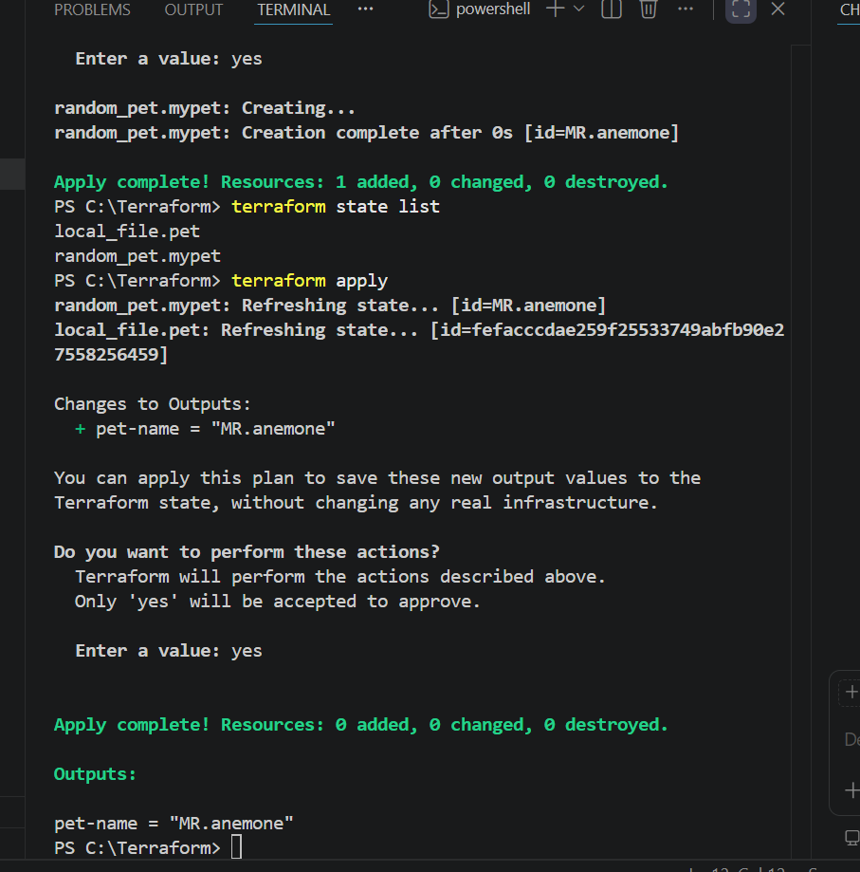
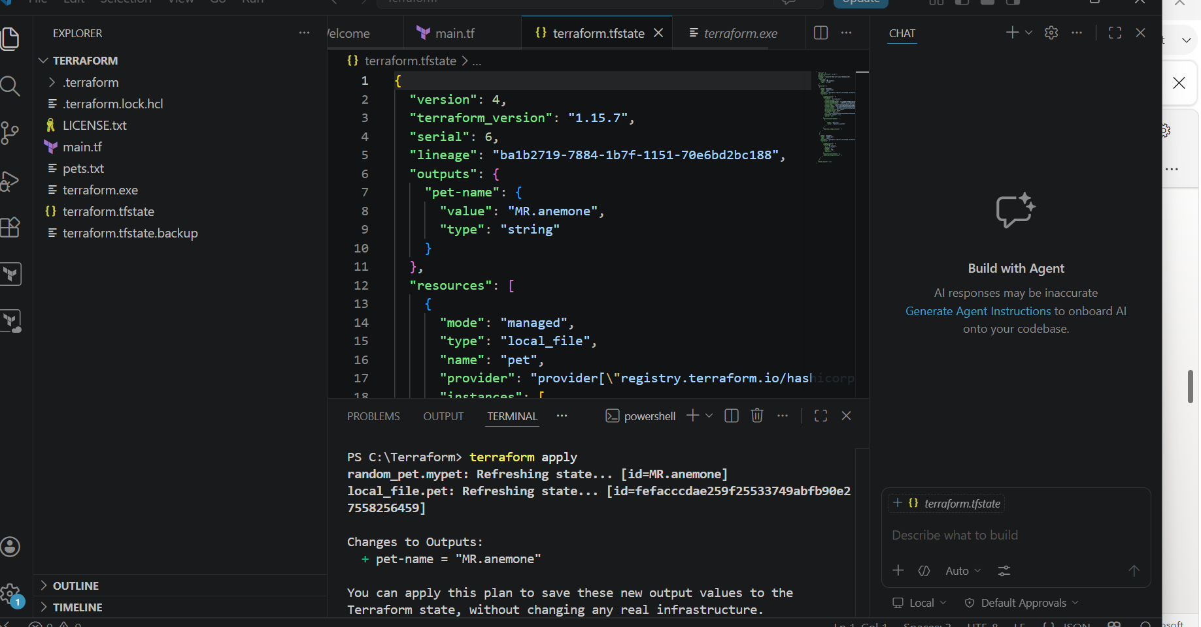
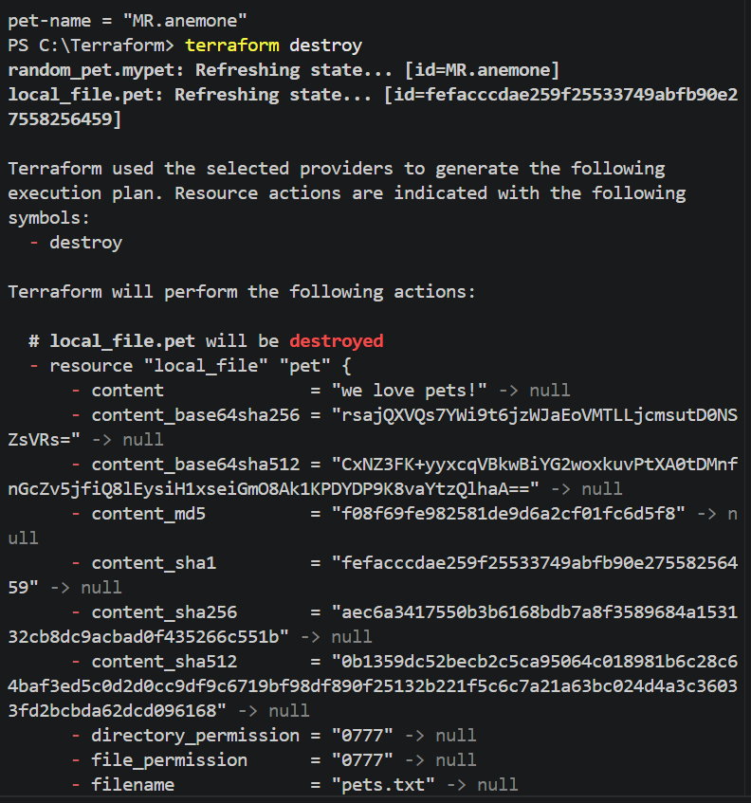
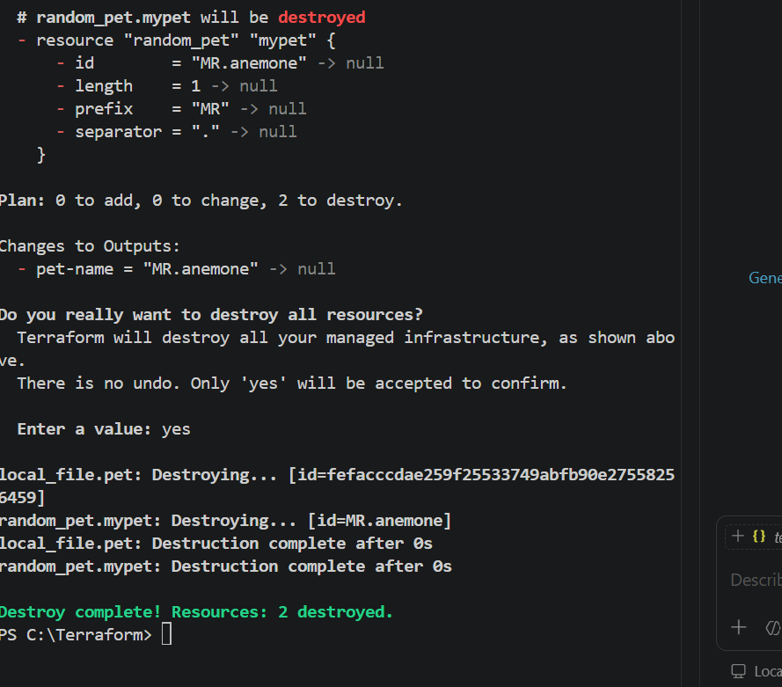
Validation
Verify the following after execution:
- Terraform initializes successfully.
- Provider plugins are downloaded.
- Configuration passes validation.
- Code is formatted correctly.
- Execution plan displays the expected resource changes.
- Infrastructure is created successfully.
- Resources are visible in the cloud provider console (if applicable).
- Terraform state file is generated.
- Resources are destroyed successfully after testing
Outcome
After completing this task:
- Terraform templates are executed successfully.
- The complete Terraform workflow (init, plan, apply, show, and destroy) is understood.
- Infrastructure is provisioned using Infrastructure as Code (IaC).
- The deployment process is validated before execution using terraform plan.
- Infrastructure is managed consistently and reproducibly using Terraform.
- All test resources are cleaned up successfully after verification.

Task 3: Study and Document Terraform Commands (Init, Plan, Apply, Provider)
Objective
The objective of this task is to understand the core Terraform commands and concepts used in the Infrastructure as Code (IaC) workflow. This includes learning the purpose and usage of Terraform Init, Terraform Plan, Terraform Apply, and Terraform Provider, which are essential for initializing a project, previewing infrastructure changes, deploying resources, and communicating with cloud platforms.
Prerequisites
Before performing this task, ensure the following prerequisites are met:
- Terraform is installed successfully on the local machine.
- Visual Studio Code or another code editor is installed.
- A sample Terraform project with .tf configuration files is available.
- Internet connection is available.
- AWS CLI is configured (if using AWS resources).
- Basic understanding of Infrastructure as Code (IaC).
Implementation Steps
Step 1: Prepare the Terraform Project
- Open the Terraform project folder.
- Verify that the required Terraform configuration files (main.tf, provider.tf, etc.) are present.
- Open the terminal in the project directory.

Step 2: Execute Terraform Init
- Run the initialization command.
terraform init
- Observe that Terraform:
  - Initializes the working directory.
  - Downloads the required provider plugins.
  - Creates the .terraform directory.
  - Generates the dependency lock file (.terraform.lock.hcl).
Step 3: Execute Terraform Plan
- Run the planning command.
terraform plan
- Review the execution plan.
- Verify the resources that Terraform intends to create, update, or destroy.
- Confirm there are no unexpected changes before deployment.
Step 4: Execute Terraform Apply
- Run the apply command.
terraform apply
- Review the proposed changes.
- Type yes when prompted.
- Wait for Terraform to provision the infrastructure.
- Confirm the deployment completes successfully.

Step 5: Study the Terraform Provider
- Open the Terraform configuration file.
- Identify the provider block.
- Observe how the provider specifies the target platform (e.g., AWS, Azure, GCP).
- Understand that Terraform uses providers to communicate with cloud services and manage resources.
Example:
provider "aws" {
region = "us-east-1"
}
Step 6: Record Observations
- Note the purpose of each command.
- Record the command syntax.
- Observe the output generated by each command.
- Document the role of providers in Terraform.
Validation
Verify the following after completing the task:
- terraform init completes successfully without errors.
- Provider plugins are downloaded.
- .terraform directory is created.
- terraform plan displays the expected infrastructure changes.
- terraform apply provisions resources successfully.
- The provider configuration is correctly defined.
- The purpose and usage of each command are documented.

Expected Outcome
After completing this task:
- The purpose of Terraform Init, Terraform Plan, Terraform Apply, and Terraform Provider is understood.
- The Terraform workflow for provisioning infrastructure is clearly documented.
- The provider configuration is recognized as the interface between Terraform and the cloud platform.
- Infrastructure changes can be reviewed before deployment using terraform plan.
- Resources can be deployed consistently using terraform apply.
- The user gains a solid understanding of the core Terraform lifecycle and command sequence.

Task 4: Integrate a Sample Terraform Template in Jenkins
Objective
The objective of this task is to integrate a sample Terraform template with Jenkins to automate Infrastructure as Code (IaC) deployment. This enables Jenkins to execute Terraform commands such as init, plan, and apply, allowing infrastructure to be provisioned automatically as part of a Continuous Integration/Continuous Deployment (CI/CD) pipeline.

Prerequisites
Before performing this task, ensure the following prerequisites are met:
- Jenkins is installed and running.
- Terraform is installed on the Jenkins server.
- Git is installed on the Jenkins server.
- AWS CLI is installed and configured (if deploying AWS resources).
- AWS IAM user with required permissions is available.
- Sample Terraform project is stored in a Git repository.
- Jenkins has access to the Git repository.
- Required Jenkins plugins (Git, Pipeline, Credentials) are installed.
- Terraform executable is added to the system PATH.
Implementation Steps
Step 1: Prepare the Terraform Project
- Create a sample Terraform project.
- Verify the project contains Terraform configuration files (main.tf, provider.tf, variables.tf, etc.).
- Push the project to a Git repository.
Step 2: Configure Jenkins
- Log in to the Jenkins dashboard.
- Verify Jenkins is running successfully.
- Install required plugins if they are not already installed.
- Configure Git and Terraform under Global Tool Configuration (if applicable).
Step 3: Configure AWS Credentials
- Create or verify AWS credentials.
- Add the credentials to Jenkins using Manage Jenkins → Credentials.
- Ensure Jenkins can authenticate with AWS during pipeline execution.
Step 4: Create a Pipeline Job
- Click New Item.
- Enter a project name.
- Select Pipeline.
- Click OK.

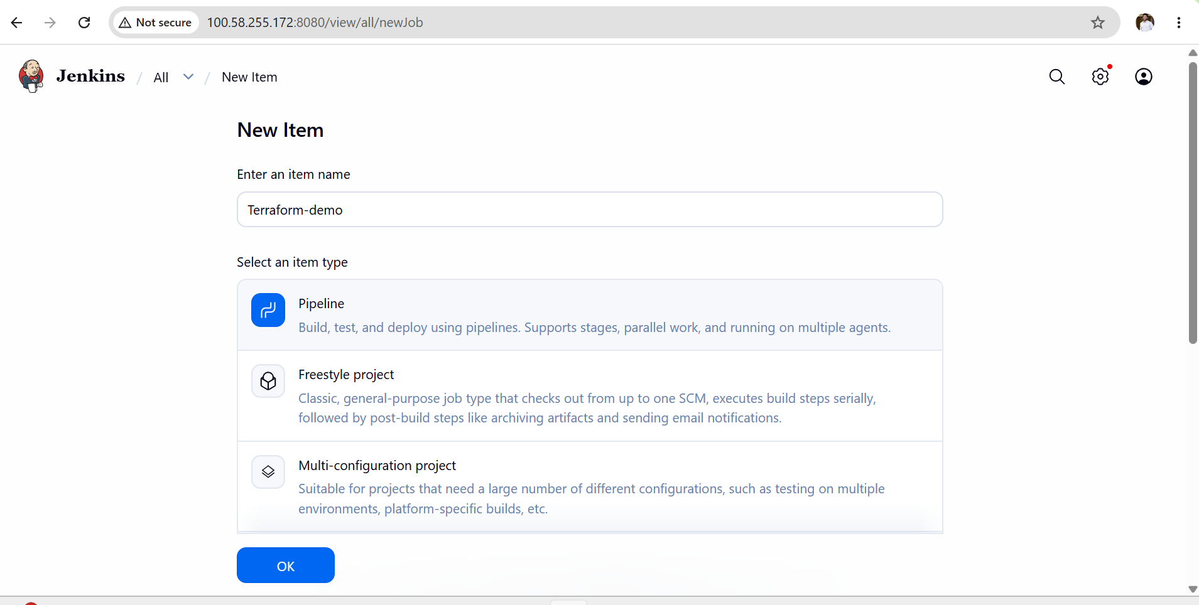
Step 6: Create Jenkins Pipeline
Create a Jenkinsfile in the repository that executes the Terraform workflow.
Example stages:
- Checkout Source Code
- Terraform Init
- Terraform Validate
- Terraform Plan
- Terraform Apply
Step 7: Build the Pipeline
- Click Build Now.
- Monitor the build progress.
- Verify each pipeline stage executes successfully.
Step 8: Review Console Output
- Open Console Output.
- Verify that:
  - Source code is cloned successfully.
  - Terraform initializes successfully.
  - Configuration validation passes.
  - Execution plan is generated.
  - Infrastructure is deployed successfully.
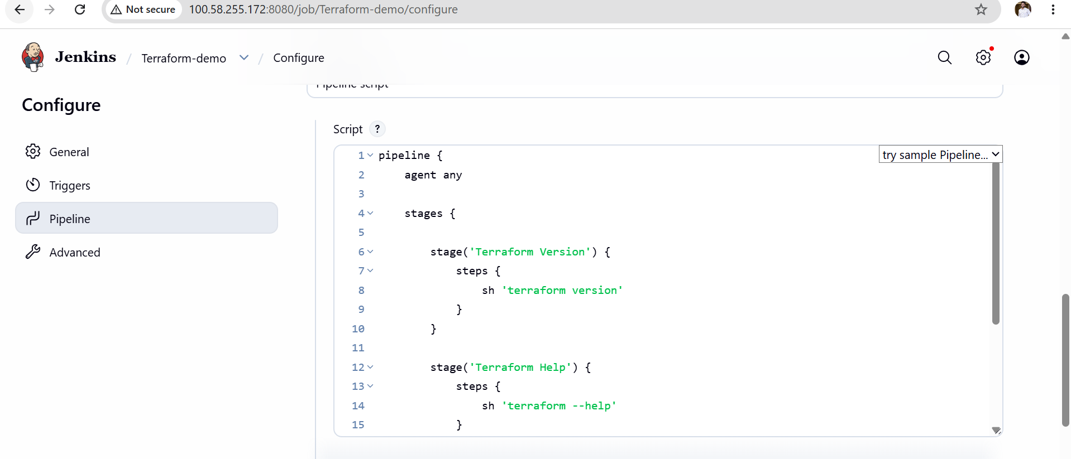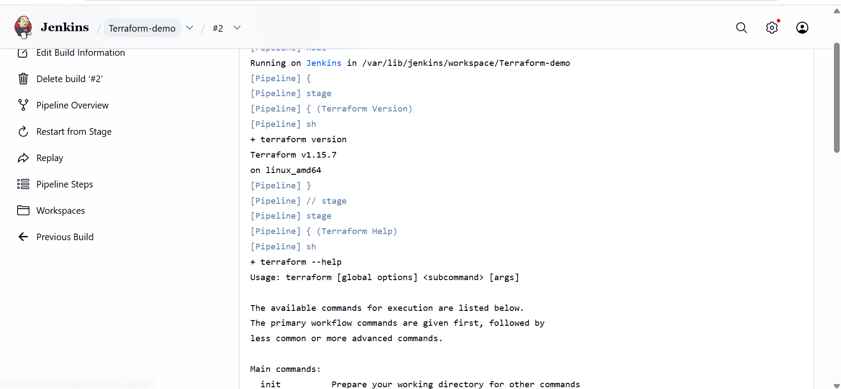

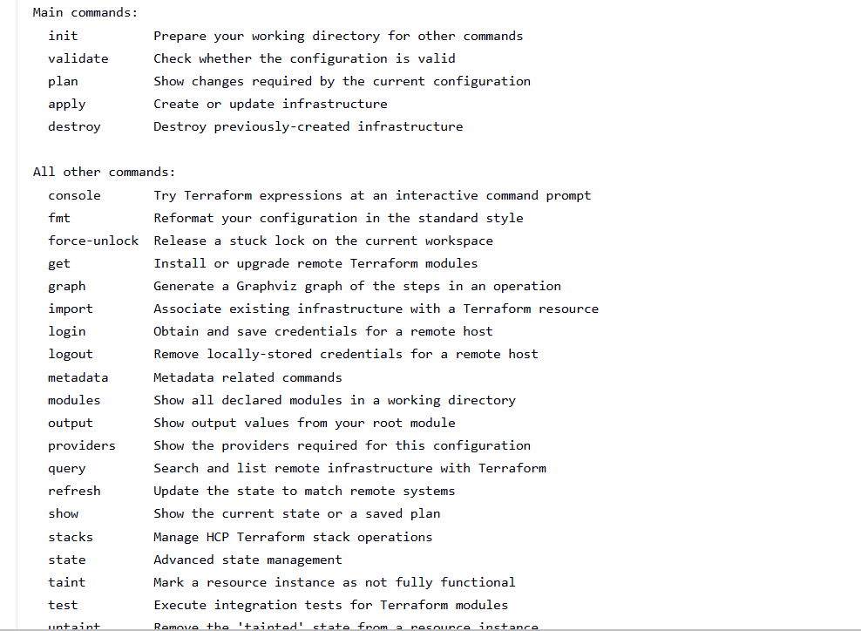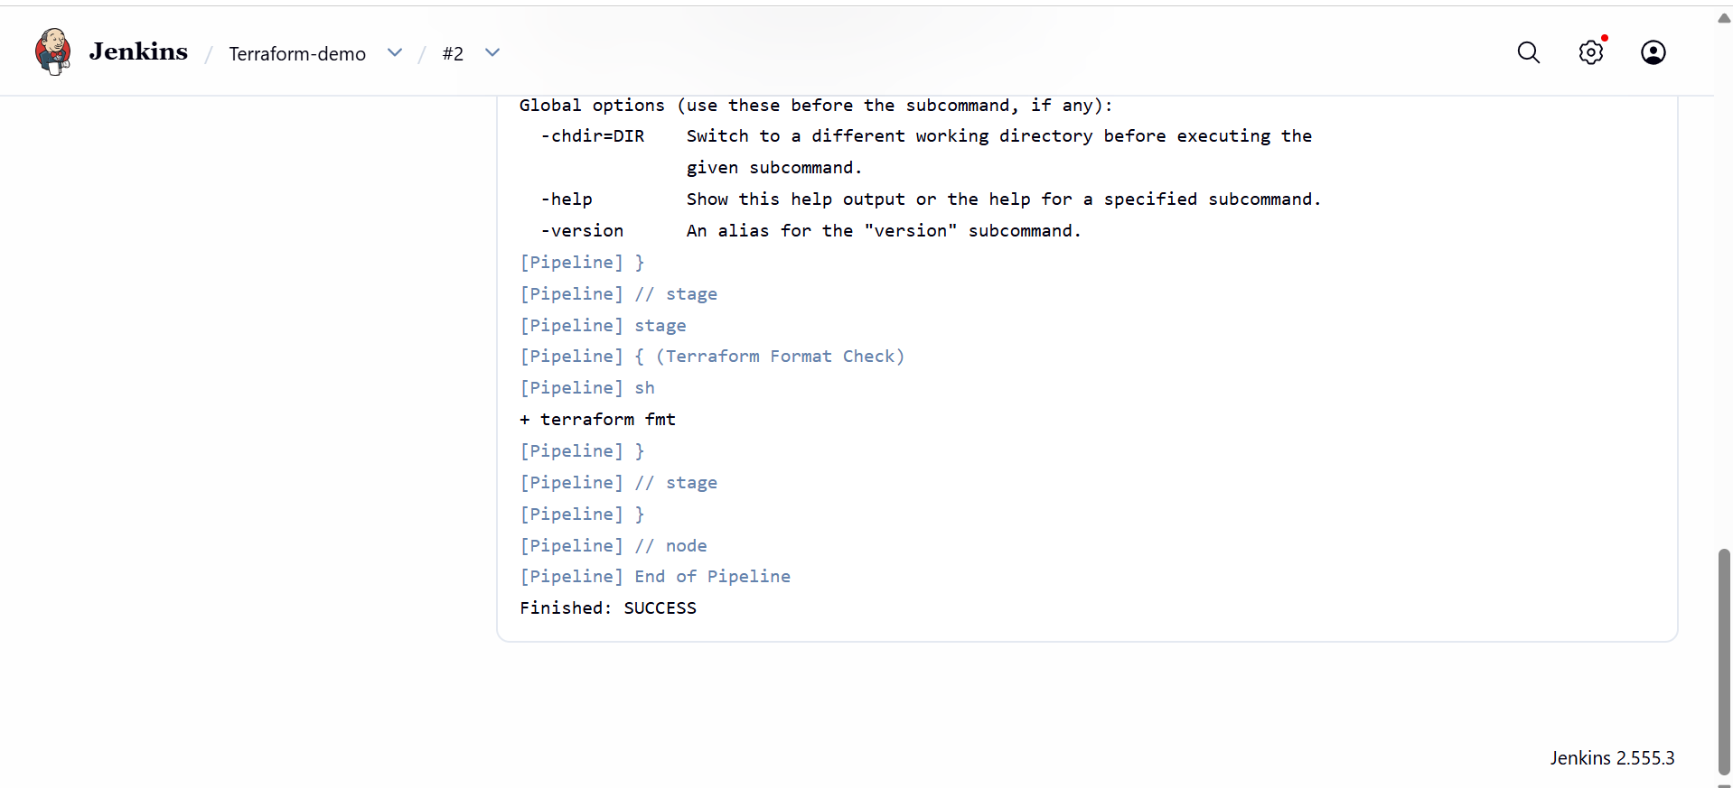
Validation
Verify the following after completing the task:
- Jenkins successfully clones the Git repository.
- Terraform initializes without errors.
- Configuration validation passes successfully.
- Terraform execution plan is generated.
- Infrastructure is provisioned successfully.
- Jenkins pipeline completes with SUCCESS status.
- Resources are visible in the AWS Management Console.
- Console output contains no critical errors

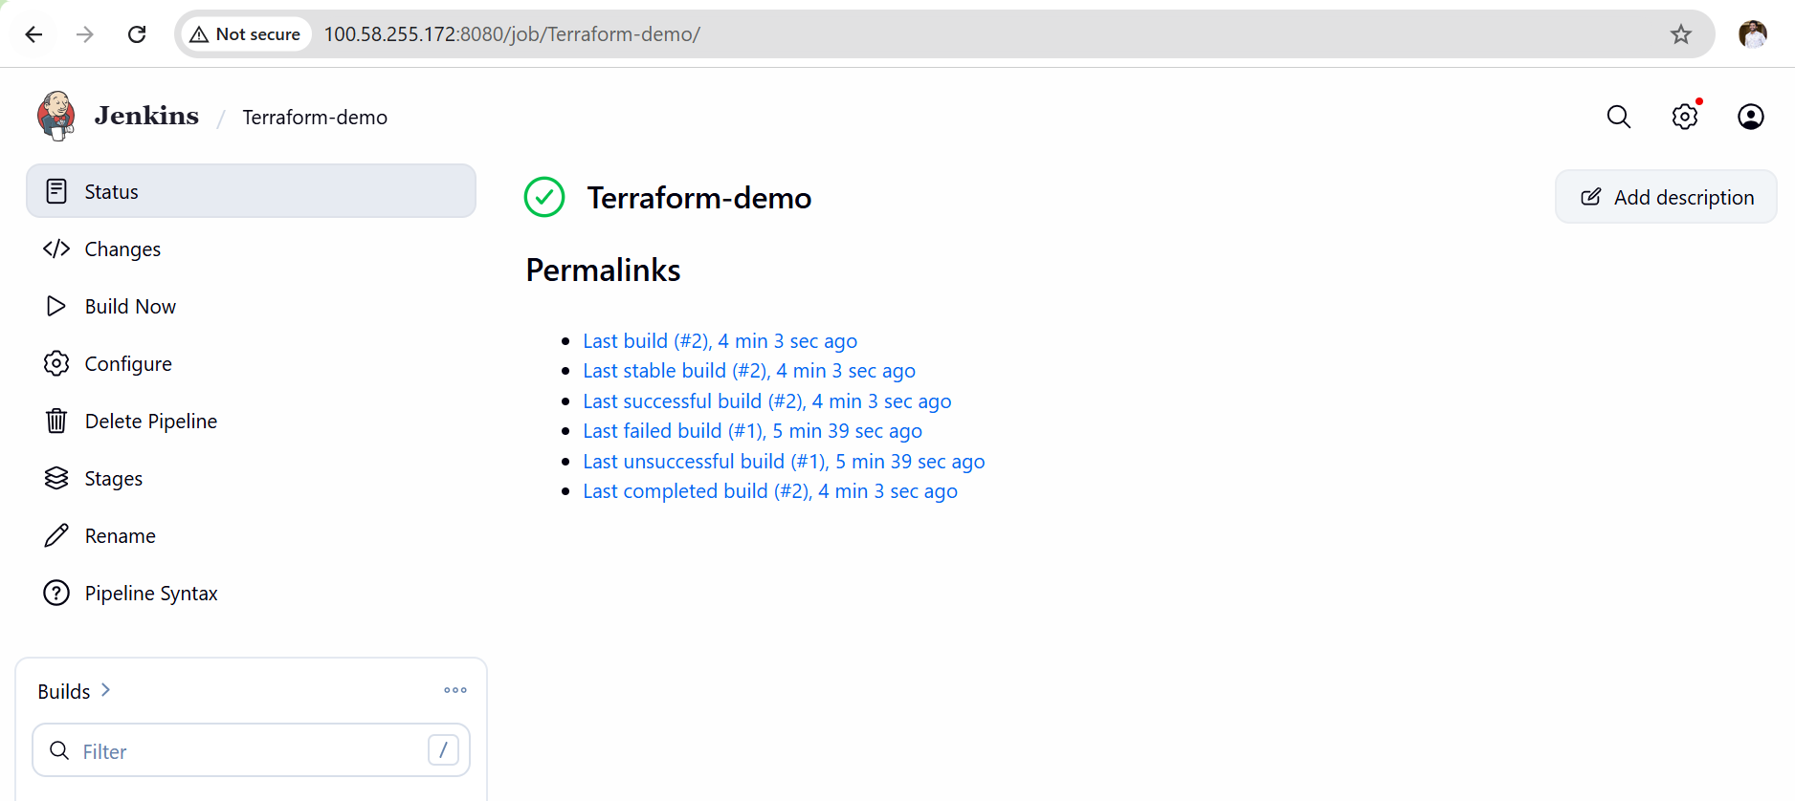
Outcome
After completing this task:
- Jenkins is successfully integrated with Terraform.
- Terraform templates are executed automatically through a Jenkins pipeline.
- Infrastructure provisioning is automated using CI/CD practices.
- Manual deployment effort is reduced.
- Infrastructure deployments become consistent, repeatable, and version-controlled.
- The complete Infrastructure as Code workflow is integrated into the DevOps pipeline.

