Ansible-02

Task-1: Install Apache Using Ansible Playbook (Handlers & Notifiers)
Objective
Install the Apache web server on all Worker nodes using an Ansible Playbook and automatically start/restart the Apache service using Handlers and Notifiers.
Prerequisites
- Task-01 completed successfully.
- One Ansible Master.
- Two Worker nodes.
- Passwordless SSH configured.
- Inventory file configured.
- ansible all -m ping returns pong.
- ansadm has sudo privileges.
Implementation Steps (Single-Line Points)
- Verified connectivity between the Ansible Master and Worker nodes using the ping module.
- Created a dedicated directory to store Ansible playbooks.
- Created a new Ansible playbook file named install_apache.yml.
- Configured the playbook to target all Worker nodes defined in the inventory.
- Enabled privilege escalation using become: yes.
- Added a task to install the Apache (apache2) package on all Worker nodes.
- Configured update_cache: yes to refresh the APT package repository.
- Added a Notifier to trigger the Apache service after package installation.
- Created a Handler to start and enable the Apache service.
- Verified the playbook syntax using the Ansible syntax check command.
- Performed a dry run to validate the execution without making changes.
- Executed the Ansible playbook on all Worker nodes.
- Verified successful installation of the Apache package on all Worker nodes.
- Verified the Apache service is running on all Worker nodes.
- Verified the Apache service is enabled to start automatically on system boot.
- Verified the Apache web server by accessing the default web page through the Worker node public IP addresses.
- Confirmed successful automation of Apache installation using Ansible Playbooks, Handlers, and Notifiers.

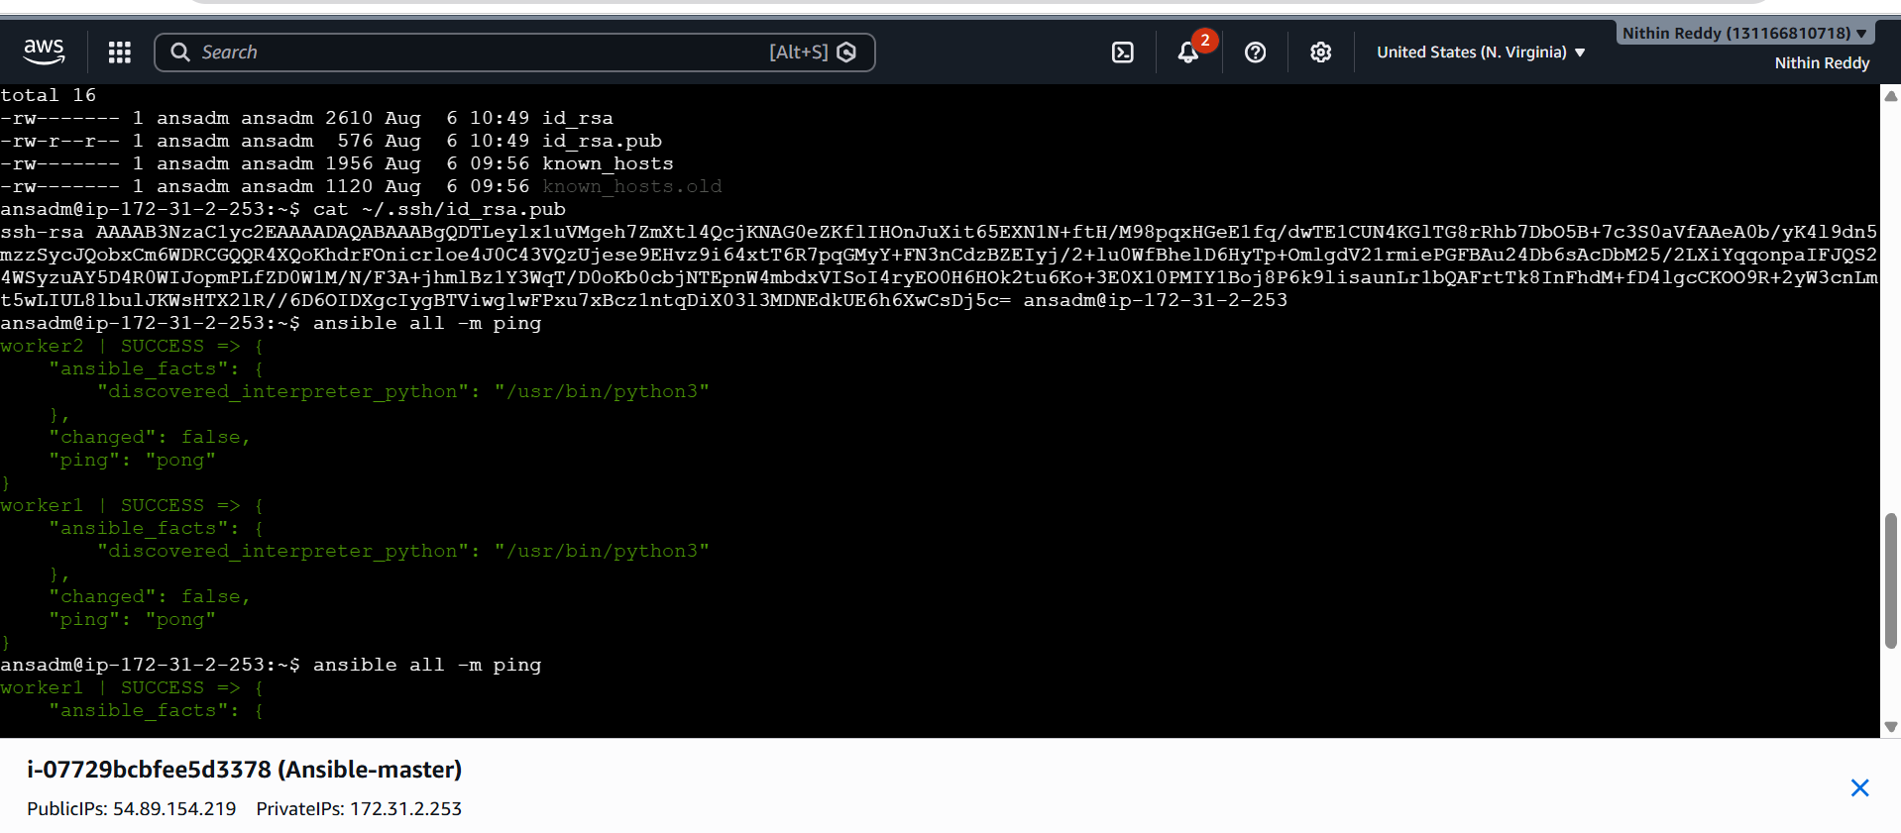
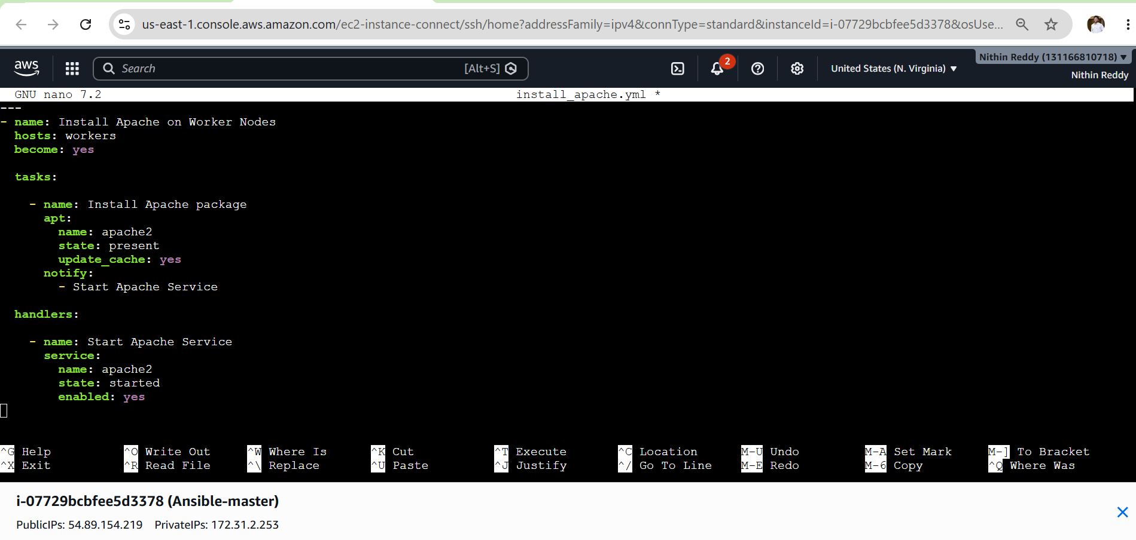
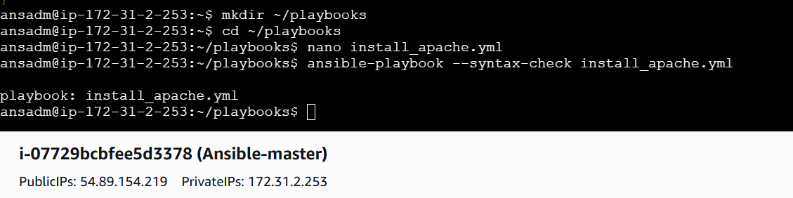
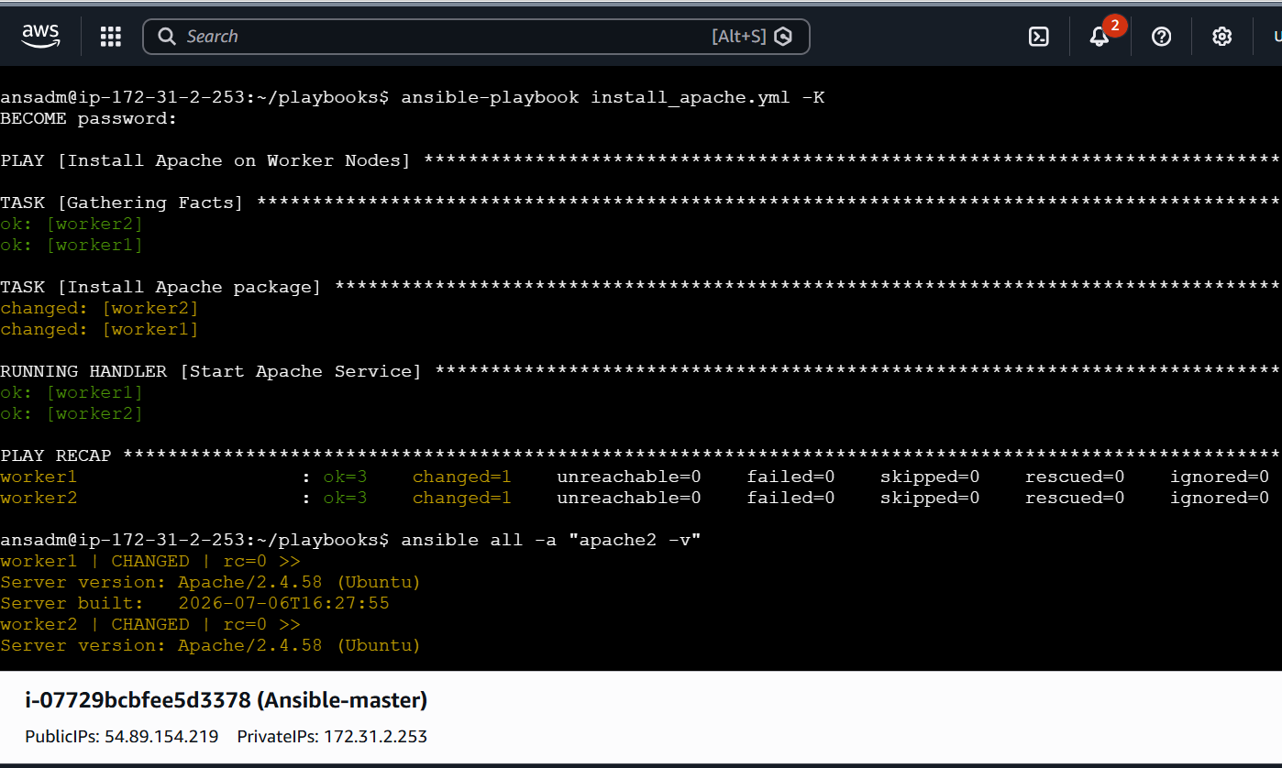

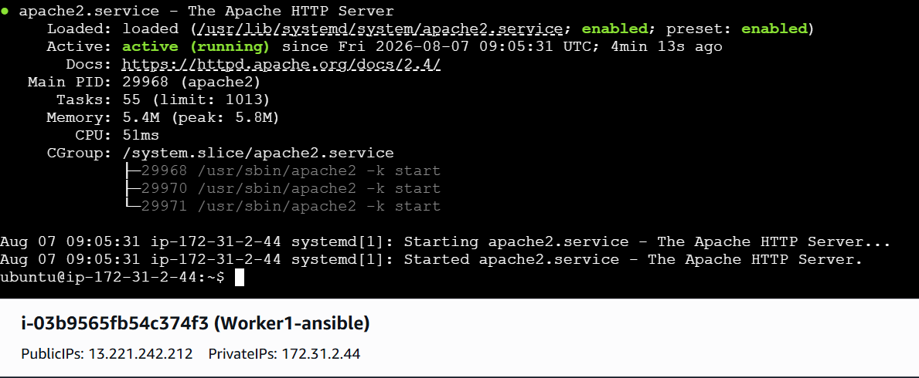
Validation
- Verify the playbook syntax is correct.
- Verify the playbook executes successfully without failures.
- Verify Apache is installed on both Worker nodes.
- Verify the Apache service is started and enabled.
- Verify the handler runs only when the installation task changes the system.
- Verify Apache responds on port 80.

Expected Outcome
- Apache is successfully installed on all Worker nodes using an Ansible Playbook.
- The Apache service is automatically started using a Handler.
- The Handler is triggered through a Notifier only when the installation task makes a change.
- The playbook demonstrates Ansible's event-driven execution model using Tasks, Notifiers, and Handlers.
- The environment is ready for Task-2: Install Apache Tomcat using an Ansible Playbook.
Task-2: Install Apache Tomcat Using Ansible Playbook
Since I’m using Ubuntu, we'll install:
- Java 21 (OpenJDK) (required for Tomcat)
- Apache Tomcat 10.1.x
- Configure Tomcat as a systemd service
- Start and enable the Tomcat service
Objective
Install and configure Apache Tomcat on all Worker nodes using an Ansible Playbook.
Prerequisites
- Task-1 completed successfully.
- Ansible Master and Worker nodes are running.
- Passwordless SSH configured.
- ansible all -m ping returns pong.
- ansadm has sudo privileges.
- Internet connectivity is available on Worker nodes.
Implementation Steps (Single-Line Points)
- Verified connectivity between the Ansible Master and Worker nodes.
- Created the install_tomcat.yml Ansible playbook.
- Updated the APT package repository on all Worker nodes.
- Installed OpenJDK 21 required for Tomcat.
- Created a dedicated tomcat group.
- Created a dedicated tomcat user.
- Created the /opt/tomcat installation directory.
- Downloaded the Apache Tomcat package from the Apache archive.
- Extracted the Tomcat package into the installation directory.
- Assigned the correct ownership and permissions to the Tomcat files.
- Created the tomcat.service systemd service file.
- Configured a Handler to restart the Tomcat service after deployment.
- Verified the playbook syntax before execution.
- Executed the playbook successfully on all Worker nodes.
- Verified Java installation on all Worker nodes.
- Verified the Tomcat service is running and enabled.
- Verified Tomcat deployment by accessing the application on port 8080.

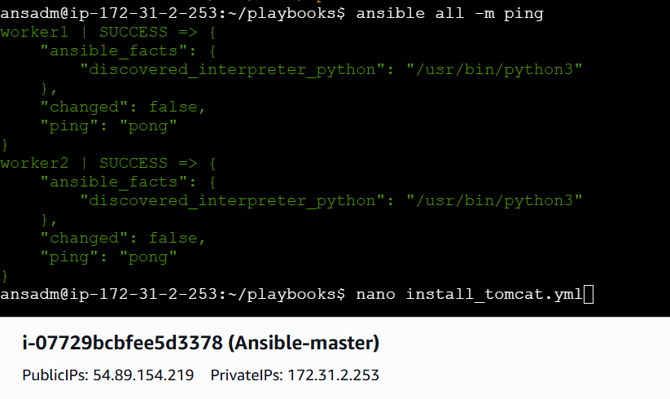
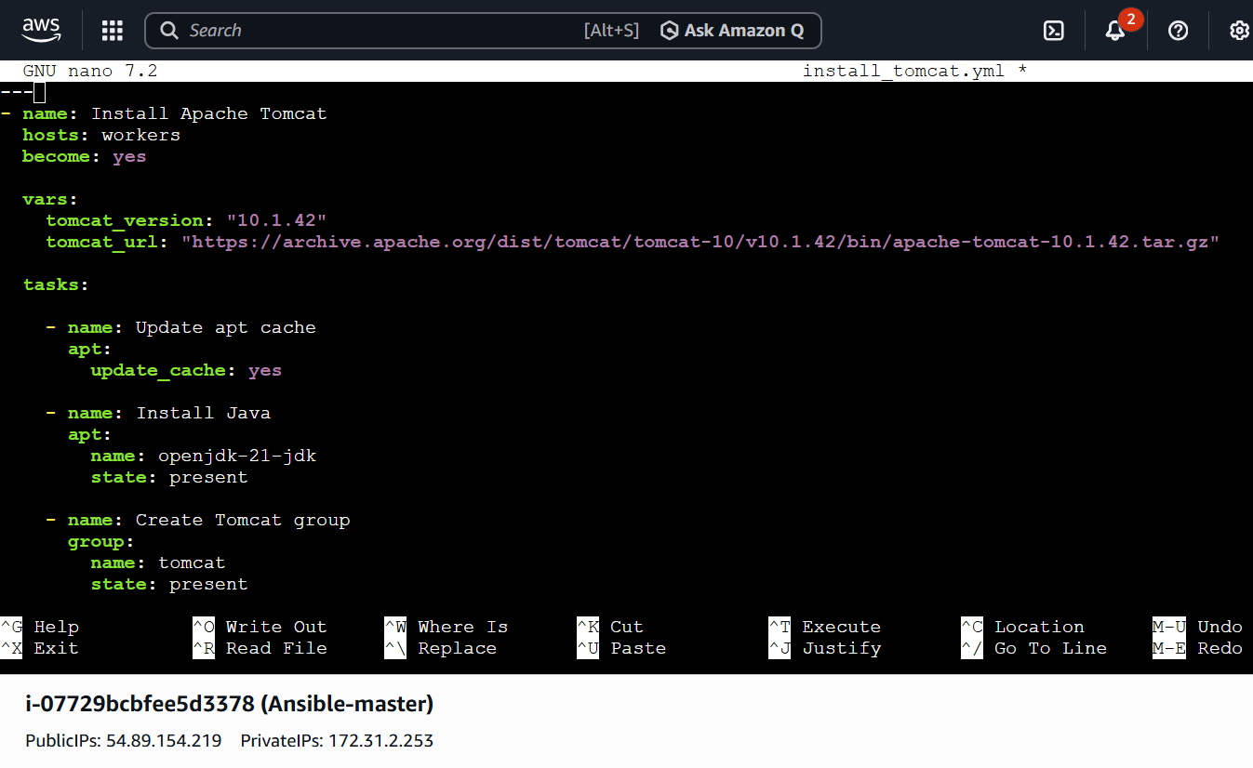
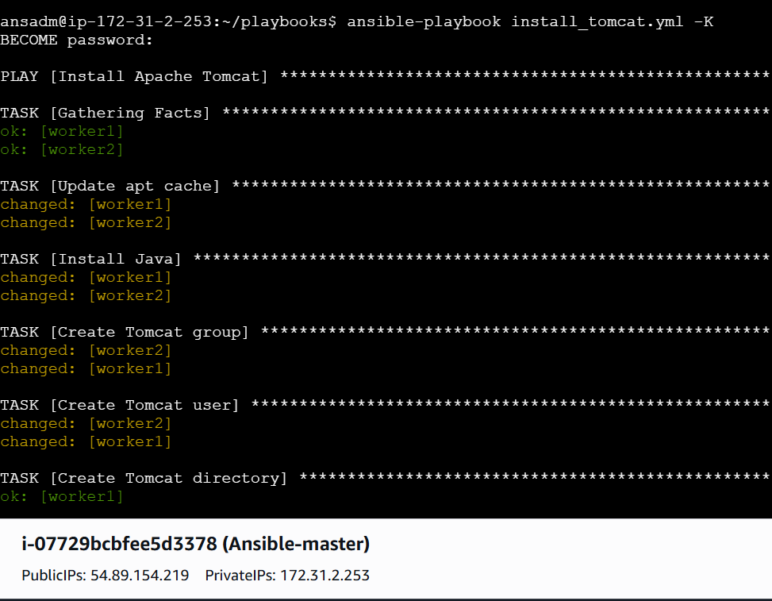
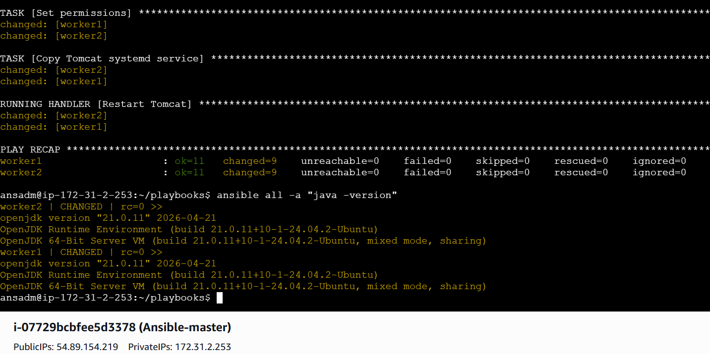
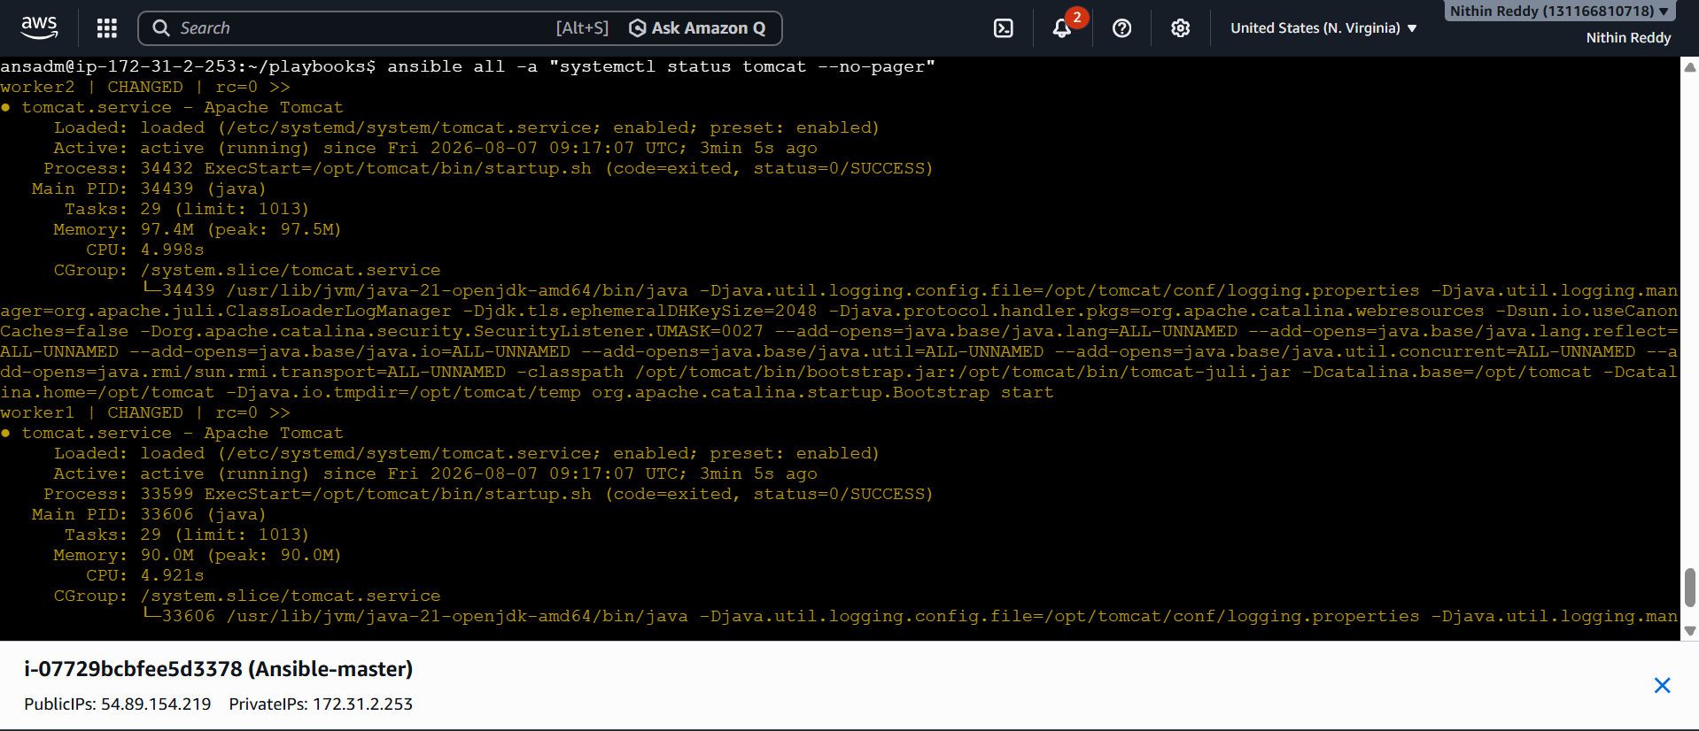
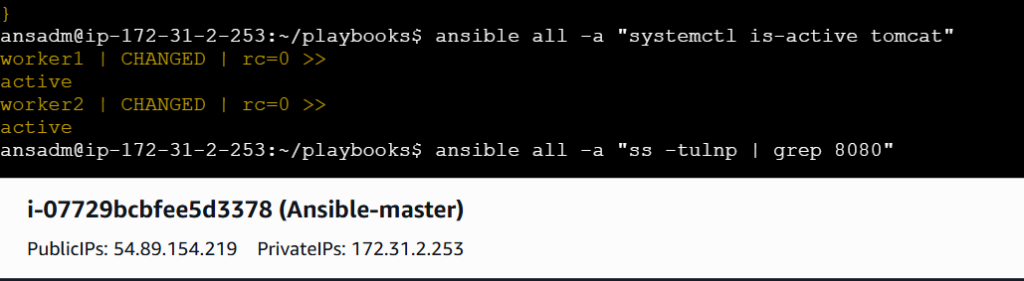

Worker-01 Apache tomcat
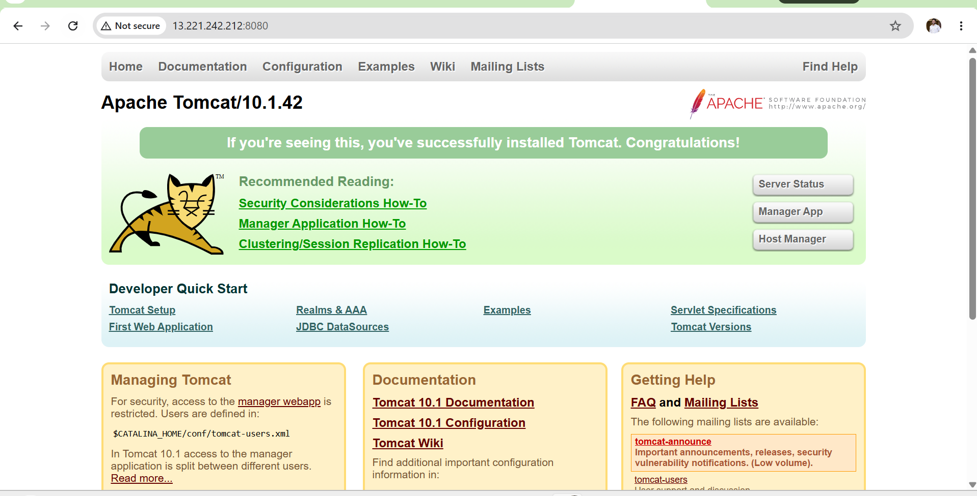

Worker-2 Apache Tomcat
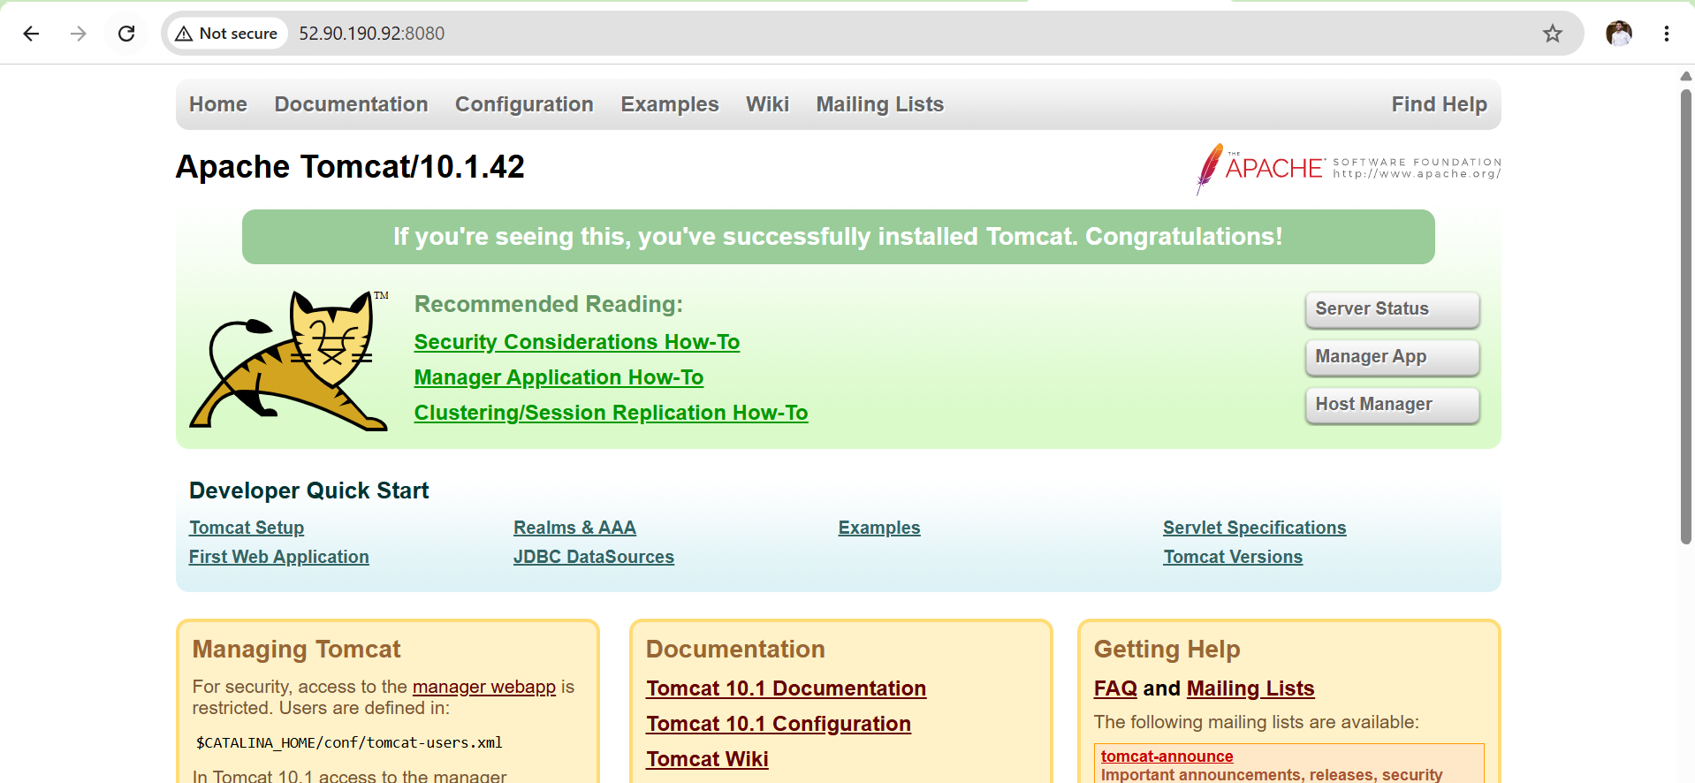

Validation Points
- Verified successful execution of the Tomcat installation playbook.
- Verified Java installation on all Worker nodes.
- Verified Apache Tomcat installation on all Worker nodes.
- Verified the Tomcat service is active and running.
- Verified the Tomcat service is enabled to start automatically on system boot.
- Verified Tomcat is listening on port 8080.
- Verified the Tomcat application is accessible through the browser.

Expected Outcome
- Apache Tomcat is successfully installed and configured on all Worker nodes.
- Tomcat runs as a managed systemd service.
- Java and Tomcat are deployed automatically using an Ansible Playbook.
- The Tomcat application is ready to host Java web applications.

Task-3: Provision One EC2 Instance on AWS Using an Ansible Playbook
Objective
Provision an Amazon EC2 instance automatically using an Ansible Playbook by leveraging AWS modules and AWS credentials
Prerequisites
- AWS account with permissions to create EC2 instances.
- Ansible installed on the Master node.
- Python 3 installed.
- AWS CLI installed and configured.
- Boto3 and Botocore Python libraries installed.
- Existing EC2 Key Pair.
- Existing Security Group.
- Existing VPC and Subnet.
- Ubuntu AMI ID available for your AWS Region.
Implementation Steps (Single-Line Points)
- Verified AWS CLI installation on the Ansible Master.
- Configured AWS CLI with IAM credentials.
- Installed the required Python libraries (boto3 and botocore).
- Installed the amazon.aws Ansible collection.
- Created an Ansible playbook to provision an EC2 instance.
- Configured the EC2 instance parameters, including AMI, instance type, key pair, subnet, and security group.
- Verified the playbook syntax before execution.
- Executed the playbook to provision the EC2 instance.
- Verified the EC2 instance reached the Running state.
- Verified the instance details in the AWS Management Console and using the AWS CLI.

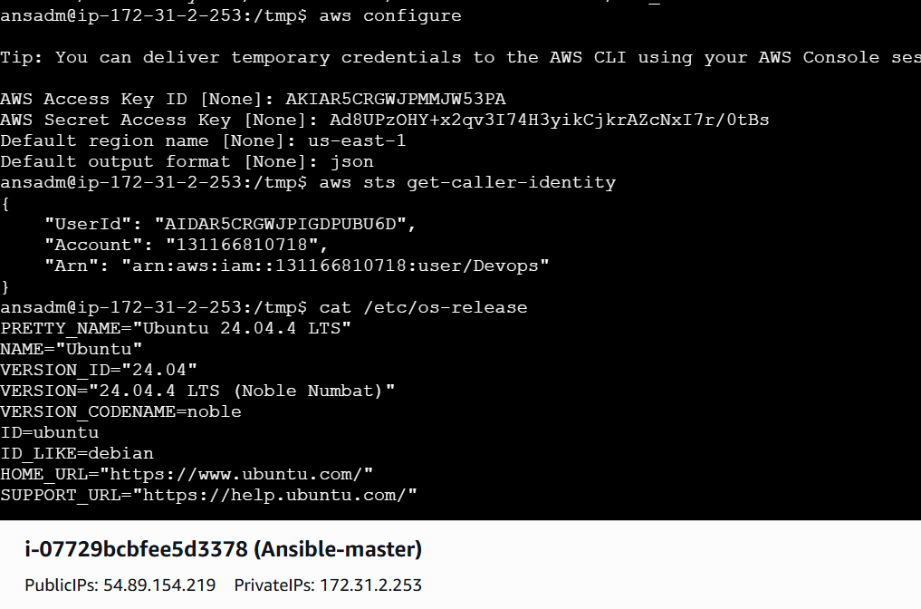
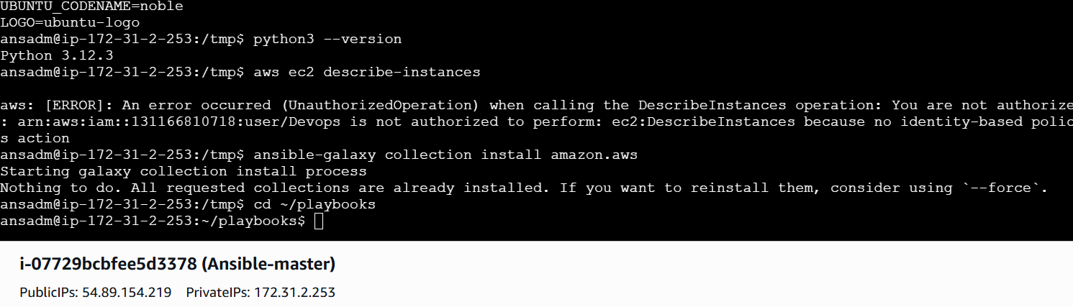
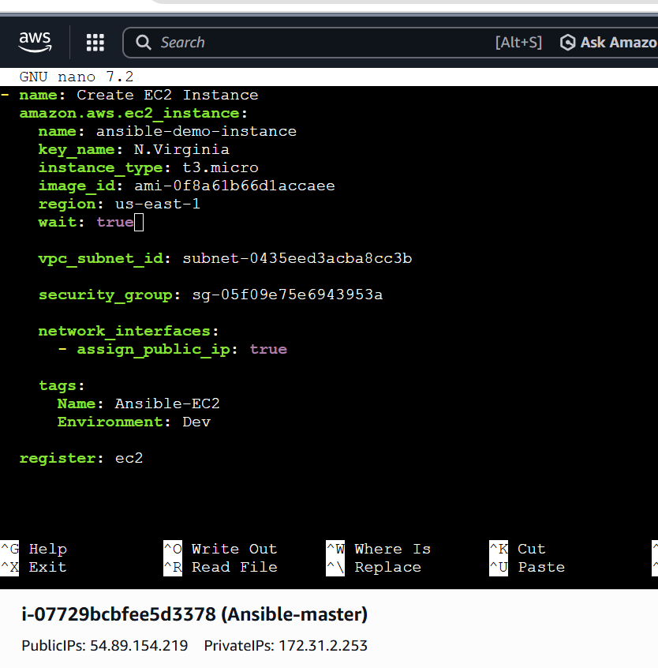
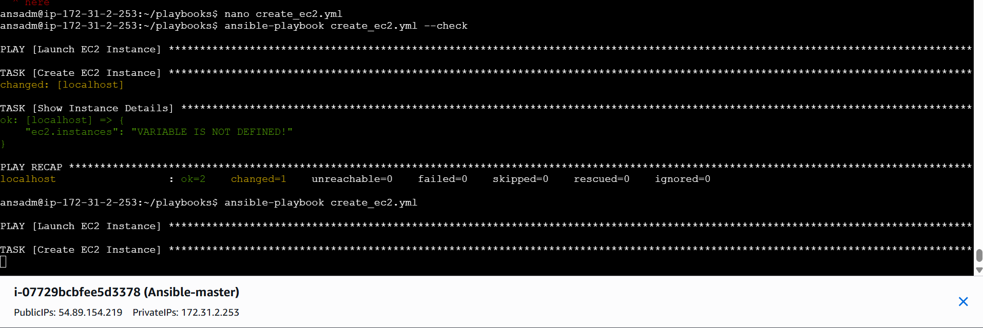
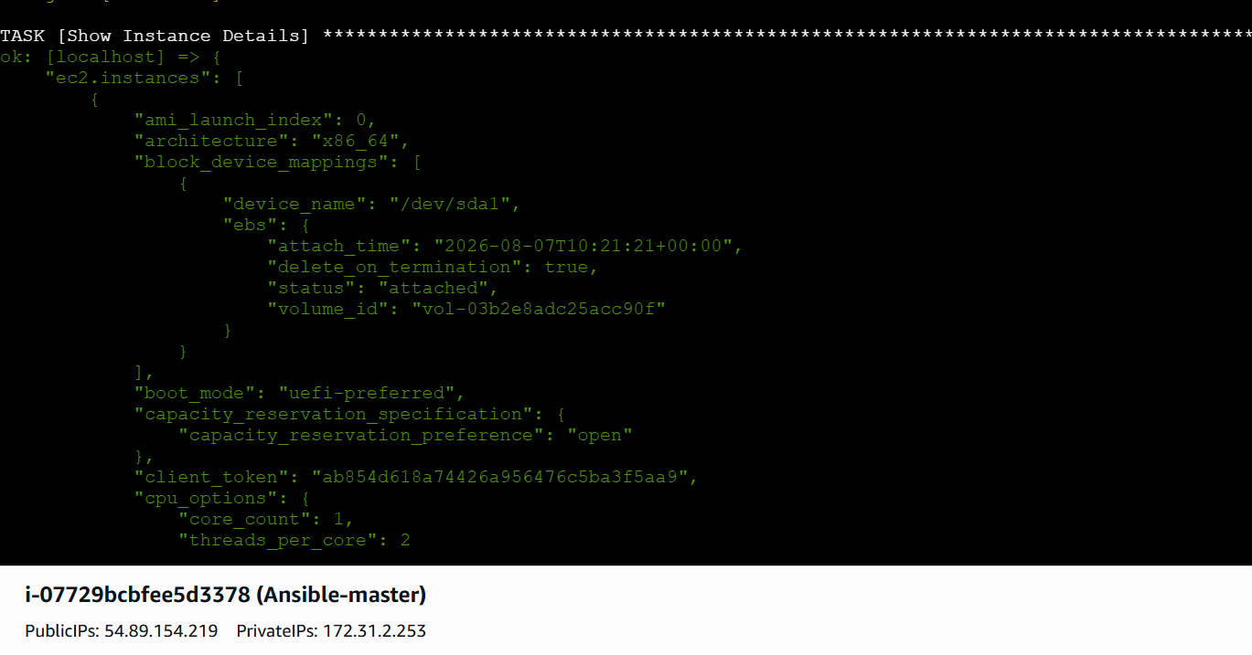
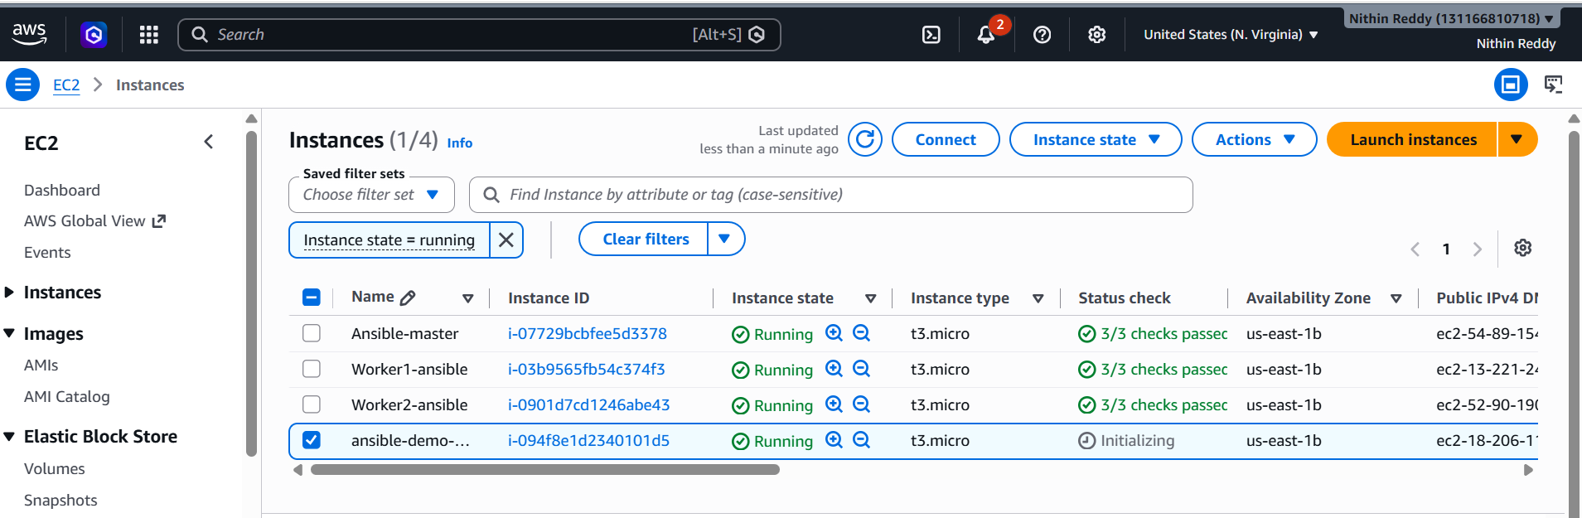
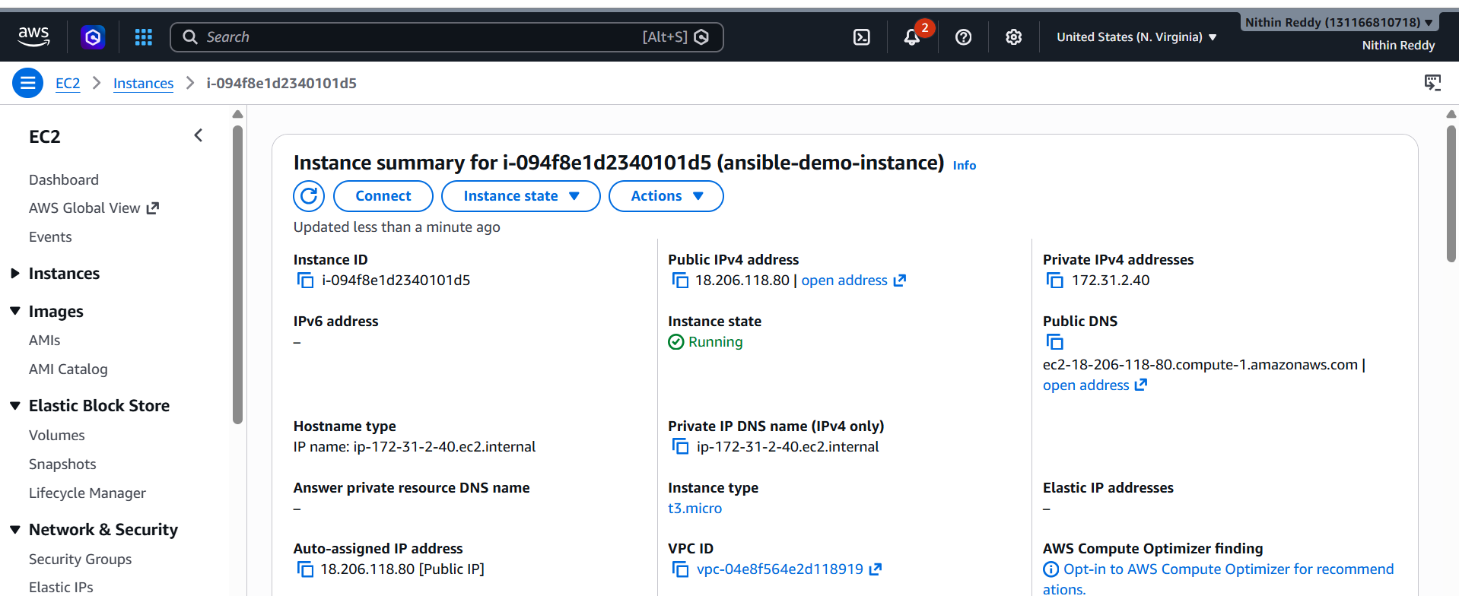

Validation
- Verified AWS CLI configuration.
- Verified AWS credentials are configured correctly.
- Verified the Amazon AWS Ansible collection is installed.
- Verified the playbook syntax successfully.
- Verified the EC2 instance is created successfully.
- Verified the EC2 instance reaches the Running state.
- Verified the instance details are displayed after provisioning.
- Verified the instance is visible in the AWS Management Console.

Expected Outcome
- Successfully provisioned an EC2 instance using an Ansible Playbook.
- Automated AWS infrastructure creation without manual intervention.
- Verified successful communication between Ansible and AWS APIs.
- Demonstrated Infrastructure as Code (IaC) using Ansible.

Task 4: Write an Ansible Playbook to Copy One File from Node-1 to Node-2 (Detailed Guide)
Objective
Copy a file from Worker-1 (Node-1) to Worker-2 (Node-2) using an Ansible playbook
Prerequisites
- Ansible Master configured.
- Worker-1 and Worker-2 reachable.
- Passwordless SSH working.
- ansible all -m ping should return pong.
- ansadm user exists on both workers.

Implementation Steps (Single-Line Points for Documentation)
- Created a sample file on Worker-1.
- Created an Ansible playbook on the Master node.
- Used the fetch module to retrieve the file from Worker-1.
- Stored the fetched file temporarily on the Ansible Master.
- Used the copy module to transfer the file to Worker-2.
- Set the file owner, group, and permissions on Worker-2.
- Verified playbook syntax before execution.
- Executed the playbook successfully.
- Validated the copied file and its contents on Worker-2.
- Confirmed successful file transfer between the worker nodes through the Ansible Master.

SSH worker-01
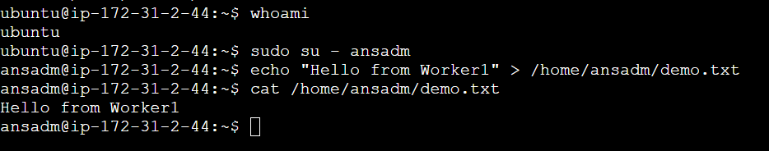
Back to master
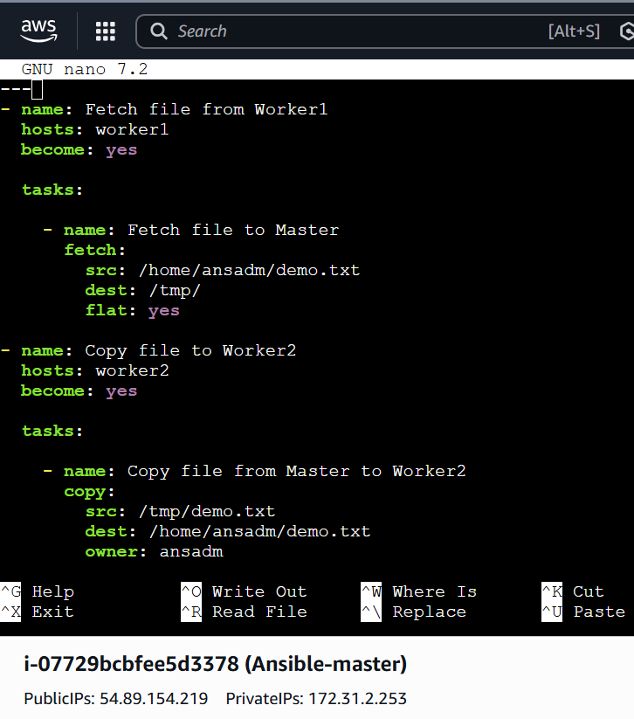

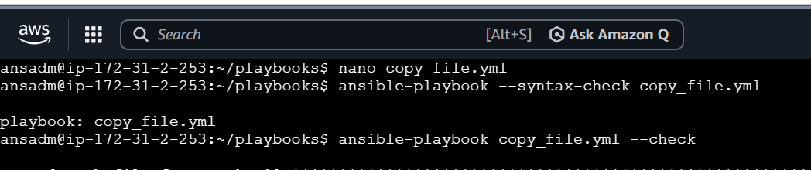
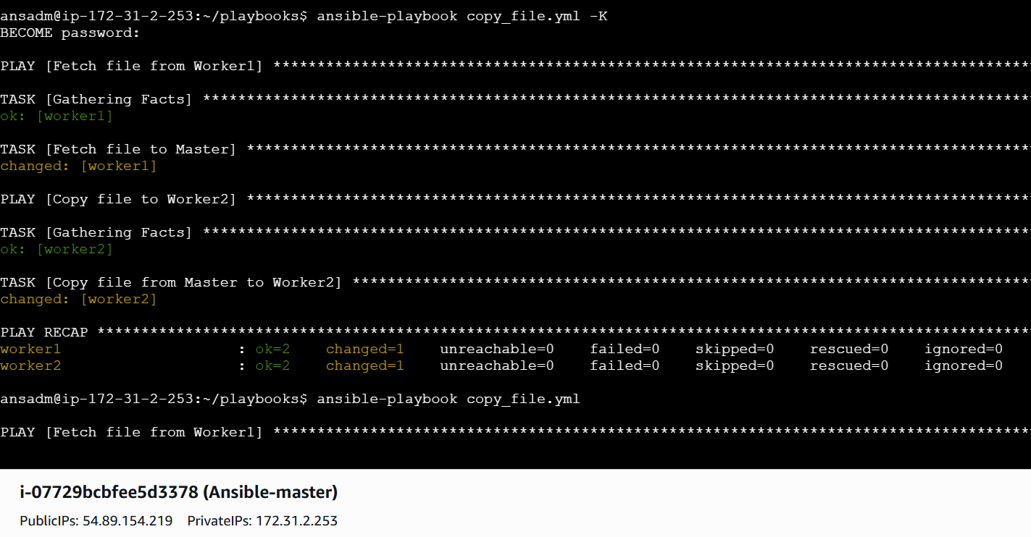
Validation Points (Single-Line)
- Successfully fetched the file from Worker-1 to the Ansible Master.
- Successfully copied the file from the Ansible Master to Worker-2.
- Verified the playbook executed without errors using -K.
- Validated the file content on Worker-2.
- Confirmed the copied file permissions and ownership.

Expected Outcome
- File fetched from Worker-1 to Ansible Master.
- File copied successfully from Master to Worker-2.
- File permissions preserved.
- Same content available on Worker-2.
- Playbook completed without errors.

Task 5: Write an Ansible Playbook to Create Different Files with Different Names Using a Single Playbook
Objective
Create multiple files with different names on the worker nodes using a single Ansible playbook.
Prerequisites
- Ansible Master configured.
- Worker-1 and Worker-2 reachable.
- Passwordless SSH configured.
- ansible all -m ping returns pong.
- ansadm user exists on all worker nodes.
Task 5 – Implementation Steps (Single-Line Points)
- Created a new Ansible playbook named create_files.yml.
- Defined the target hosts as the workers inventory group.
- Enabled privilege escalation using become: yes.
- Declared a variable containing the list of file names.
- Used the Ansible file module to create files.
- Set state: touch to create empty files.
- Used the loop keyword to iterate through all file names.
- Specified the destination path as /home/ansadm/.
- Assigned ansadm as the file owner and group.
- Set file permissions to 0644.
- Saved the playbook.
- Validated the playbook syntax using ansible-playbook --syntax-check.
- Performed a dry run using ansible-playbook create_files.yml --check -K.
- Executed the playbook using ansible-playbook create_files.yml -K.
- Verified the created files on all worker nodes using Ansible ad-hoc commands.
- Confirmed successful creation of all files on both worker nodes.

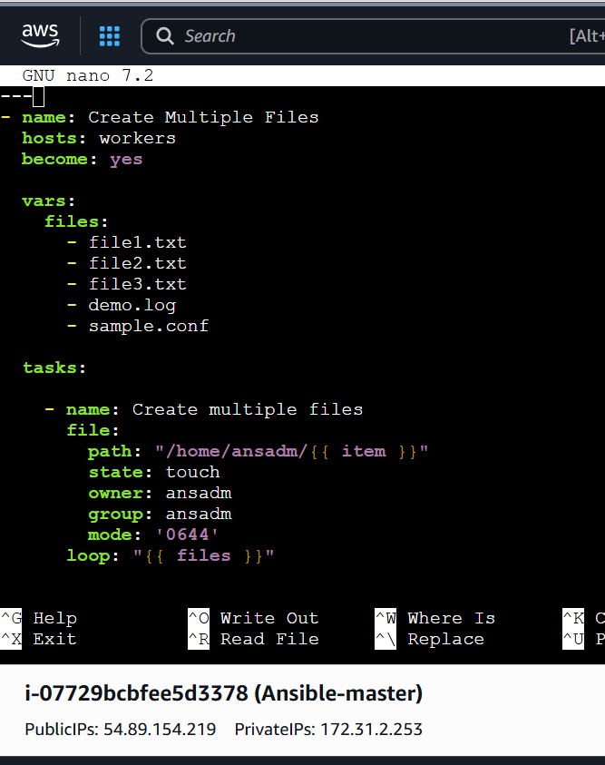

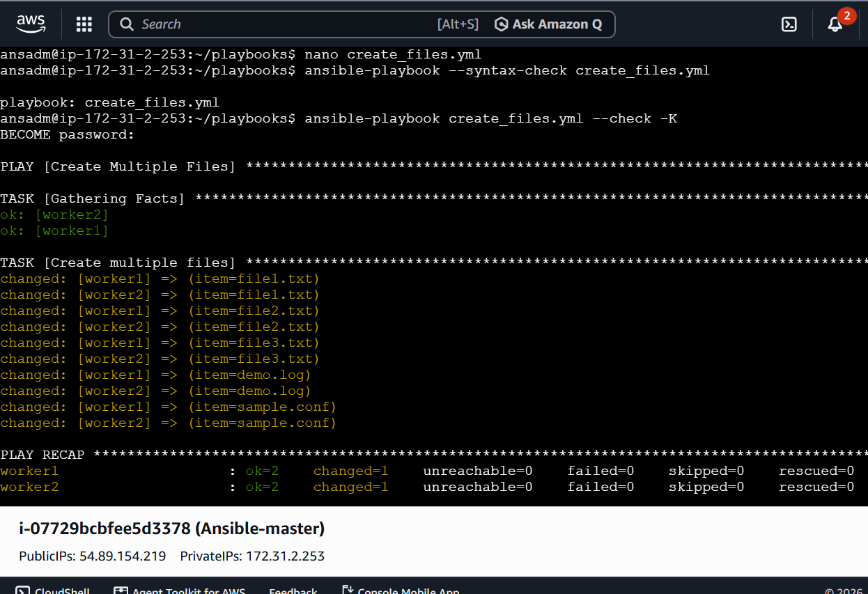
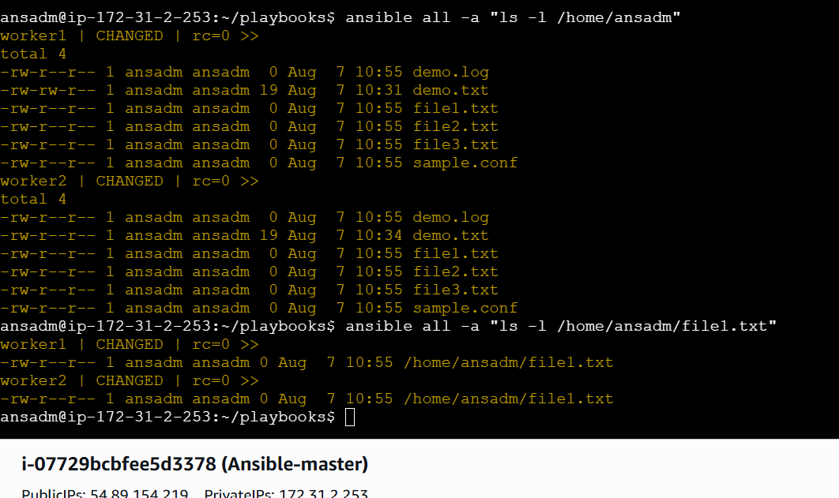

Validation Points
- Playbook executed without errors.
- Files were created on Worker1.
- Files were created on Worker2.
- File ownership is ansadm:ansadm.
- File permissions are correctly applied.
- All files are present in /home/ansadm/.
- Verification completed using Ansible ad-hoc commands.

Outcome
- Successfully automated the creation of multiple files using a single Ansible playbook.
- Learned to use the file module with state: touch.
- Learned to use loop to avoid repetitive tasks.
- Verified consistent file creation across multiple managed nodes.
- Reduced manual effort by automating file provisioning on all worker nodes.

