TASK 1: Create a VPC with 1 Public Subnet & 1 Private Subnet
Objective
Build the foundational network infrastructure in AWS — a custom VPC with isolated public and private network layers.
Why This Task?
Every cloud architecture starts with a VPC. The public subnet hosts internet-facing resources (like a bastion/NAT), while the private subnet protects backend resources (databases, app servers) from direct internet access. This is the base for all remaining tasks.
Steps
Step 1 — Create the VPC
- Go to AWS Console → VPC → Your VPCs → Create VPC
- Select "VPC only"
- Fill in:
  - Name tag: my-custom-vpc
  - IPv4 CIDR block: 10.0.0.0/16
  - Tenancy: Default
- Click Create VPC
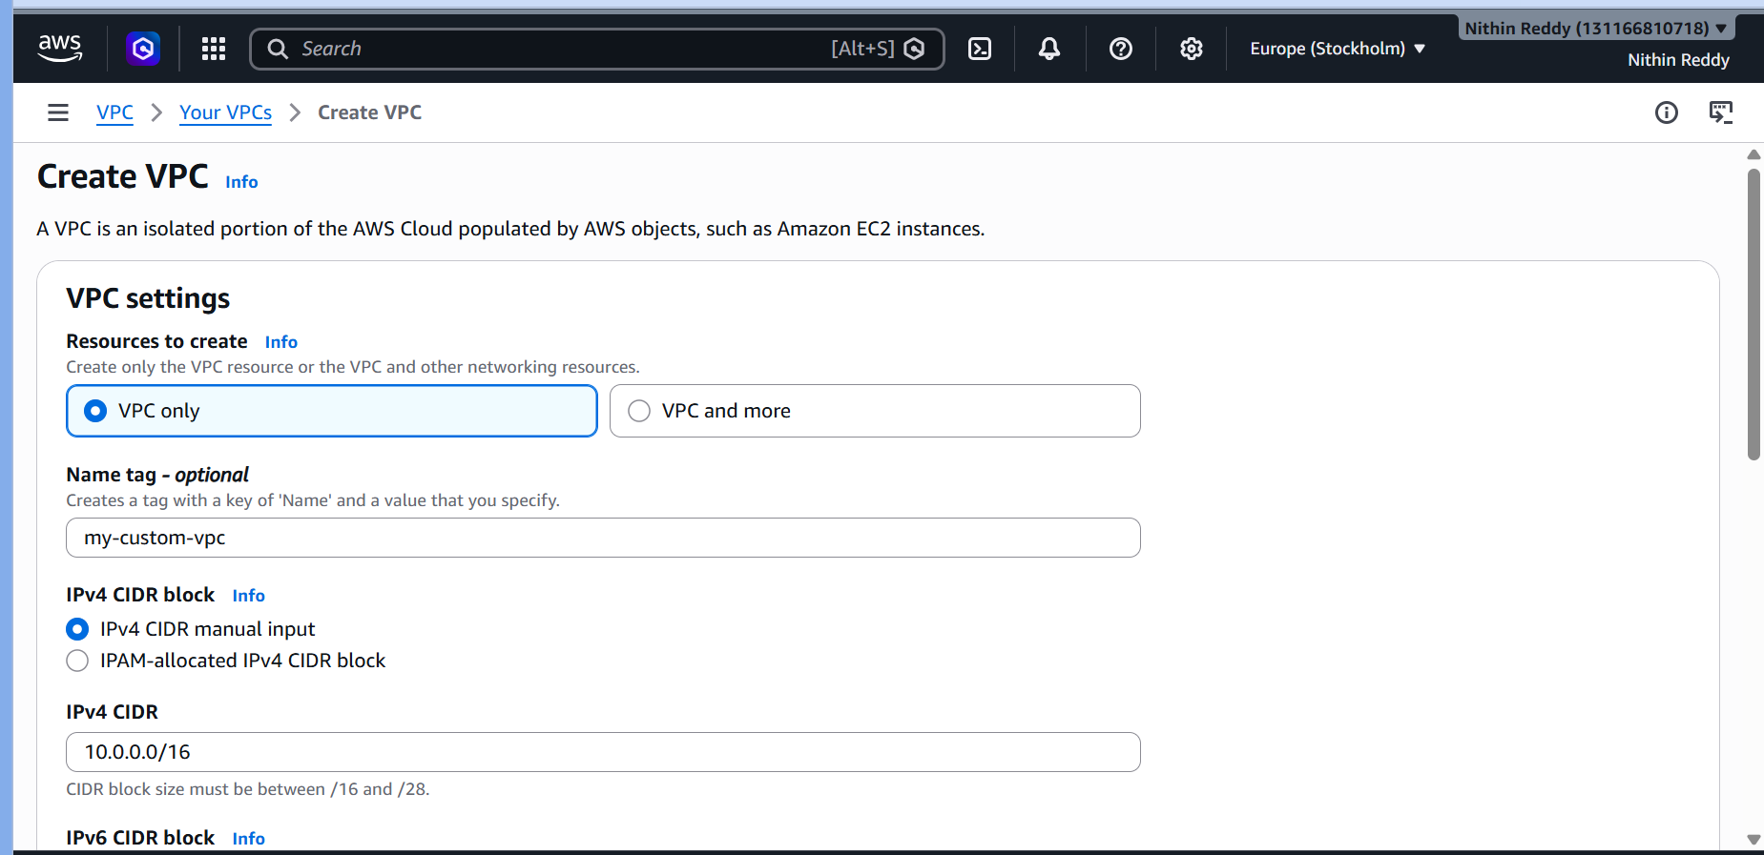
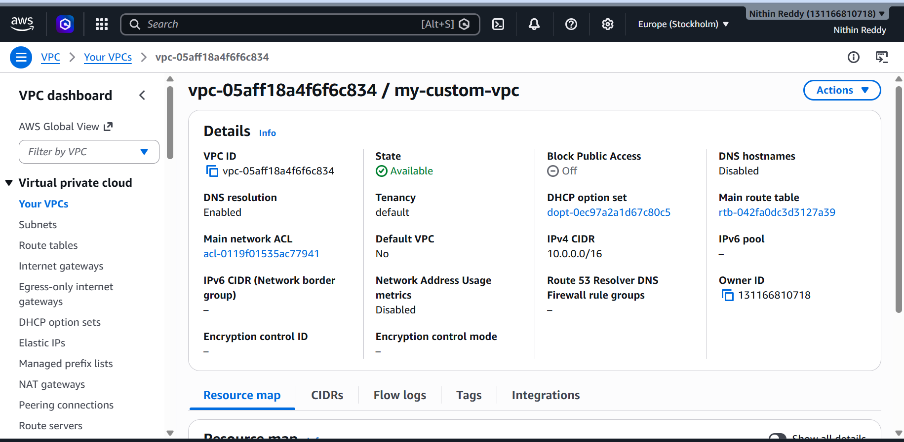
Step 2 — Create the Public Subnet
- Go to Subnets → Create Subnet
- Select your VPC: my-custom-vpc
- Fill in:
  - Subnet name: public-subnet-1
  - Availability Zone: ap-north-1a (or your region's AZ)
  - IPv4 CIDR: 10.0.1.0/24
- Click Create Subnet
- After creation → Select the subnet → Actions → Edit subnet settings
- ✅ Enable "Auto-assign public IPv4 address" → Save
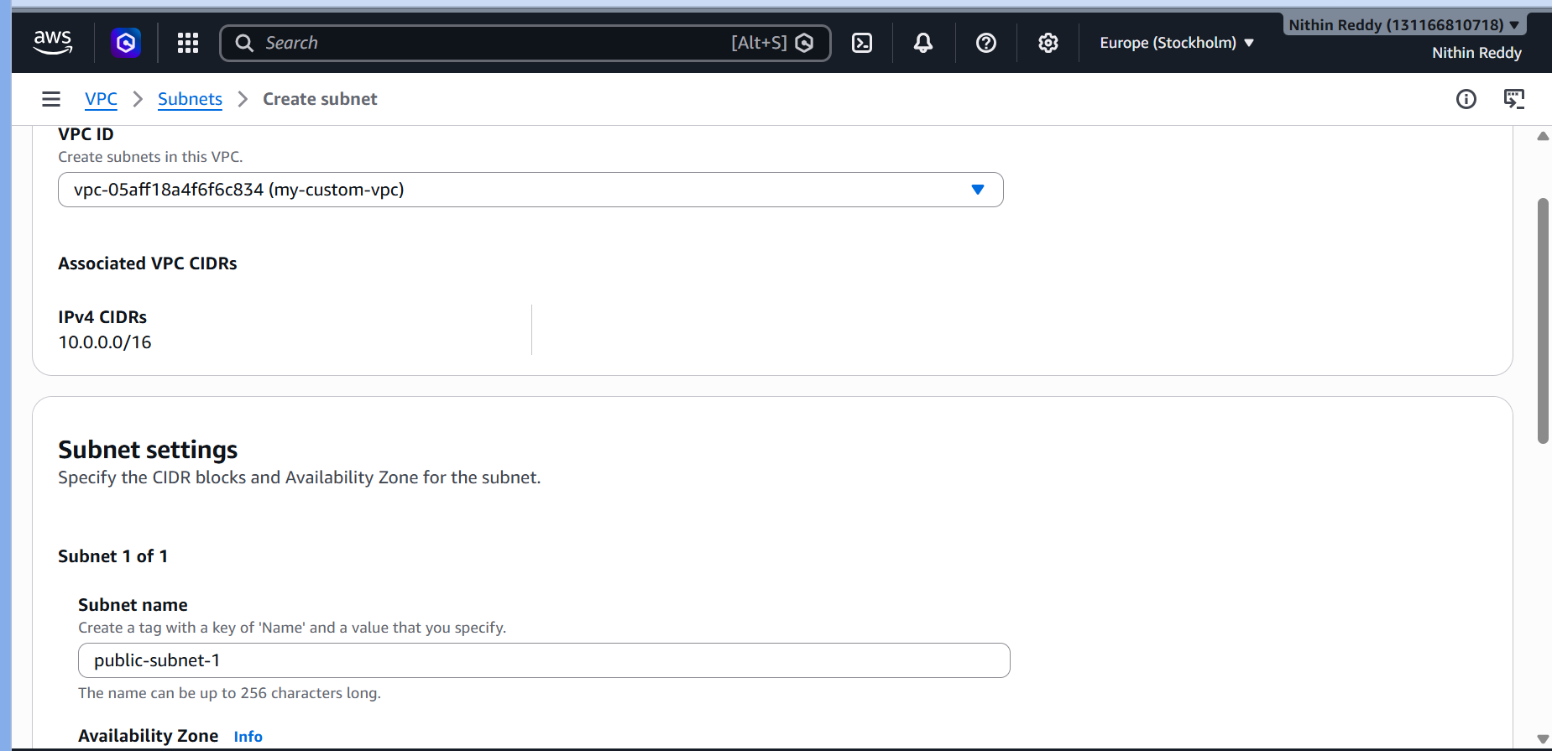
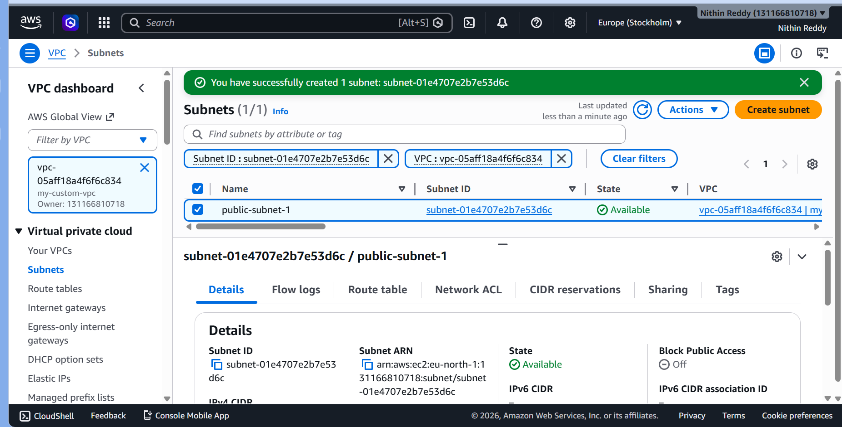
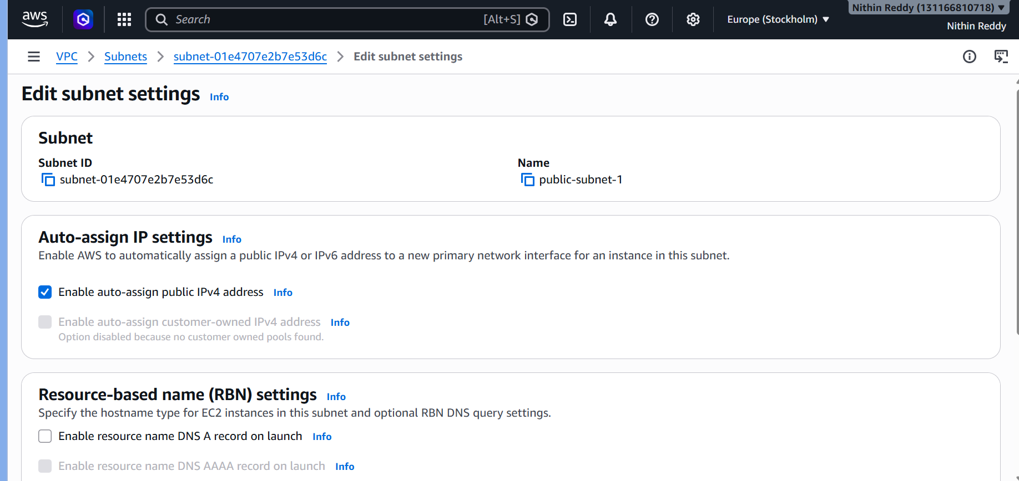
Step 3 — Create the Private Subnet
- Create another subnet in same VPC
- Fill in:
  - Subnet name: private-subnet-1
  - AZ: ap-north-1b
  - IPv4 CIDR: 10.0.2.0/24
- Click Create Subnet
- ❌ Do NOT enable auto-assign public IP here
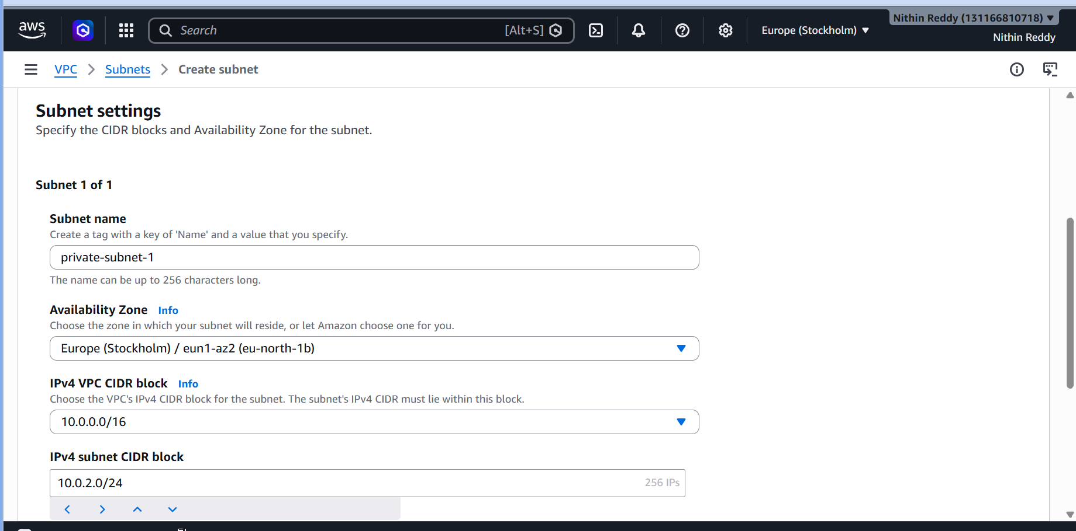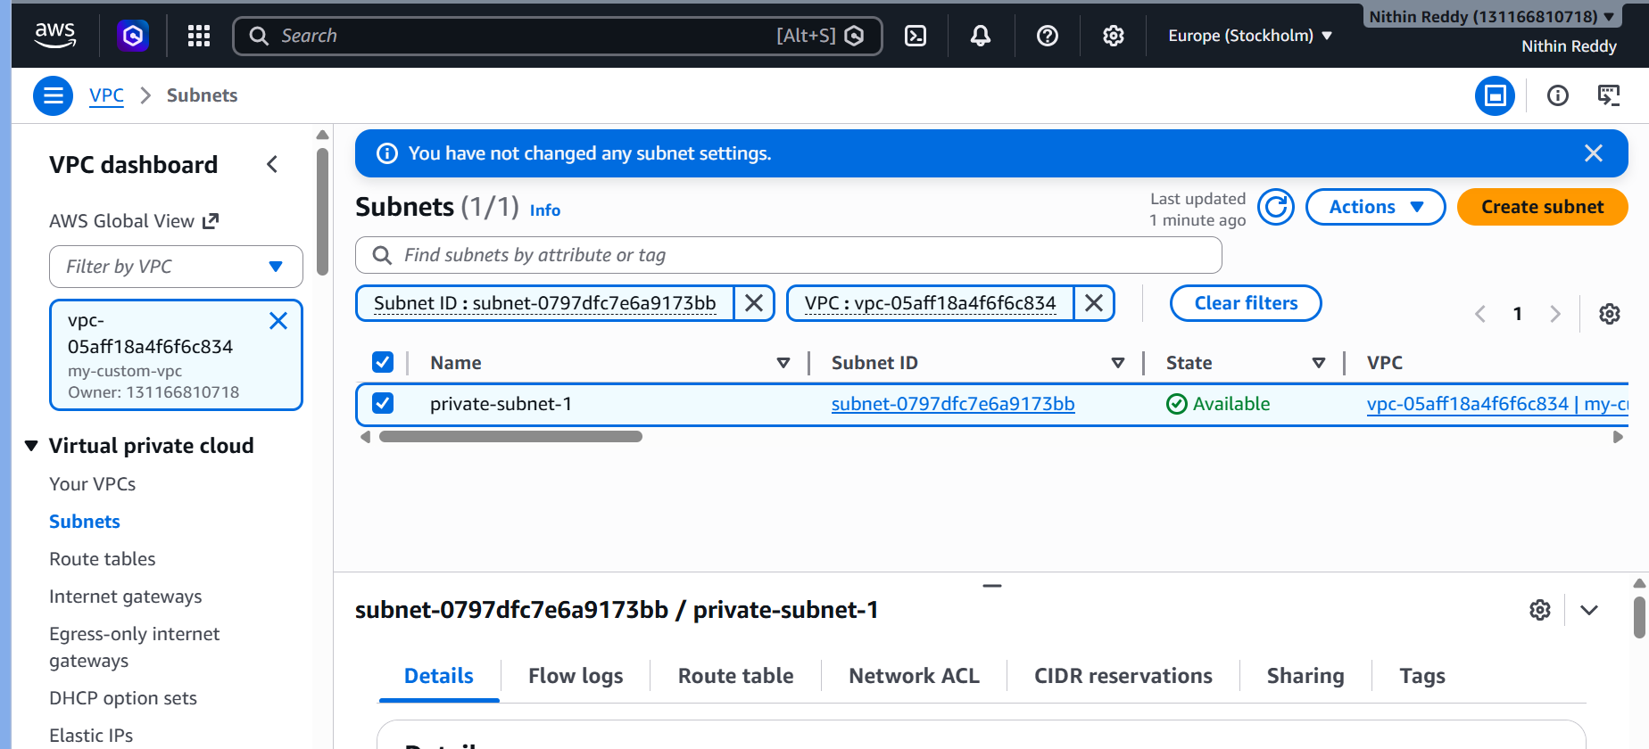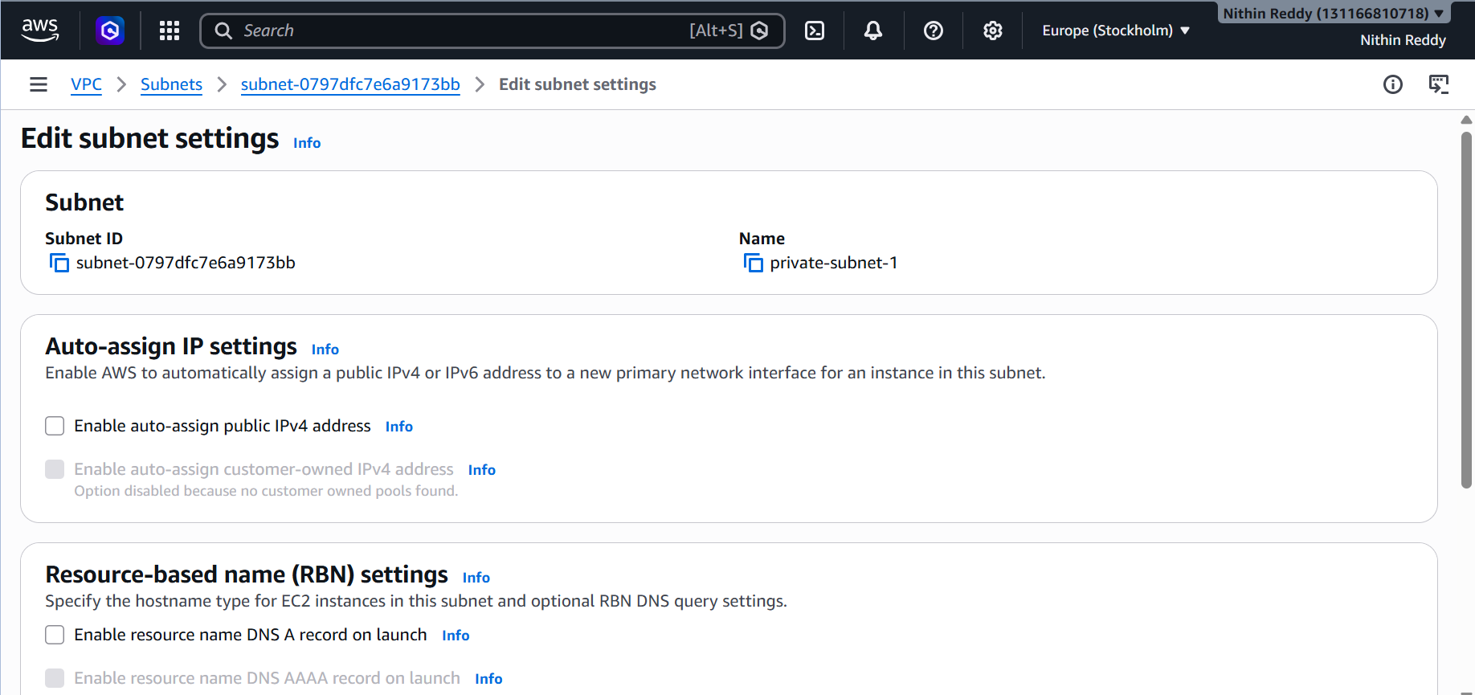
Step 4 — Create an Internet Gateway
- Go to Internet Gateways → Create Internet Gateway
- Name: my-igw
- After creation → Actions → Attach to VPC → select my-custom-vpc
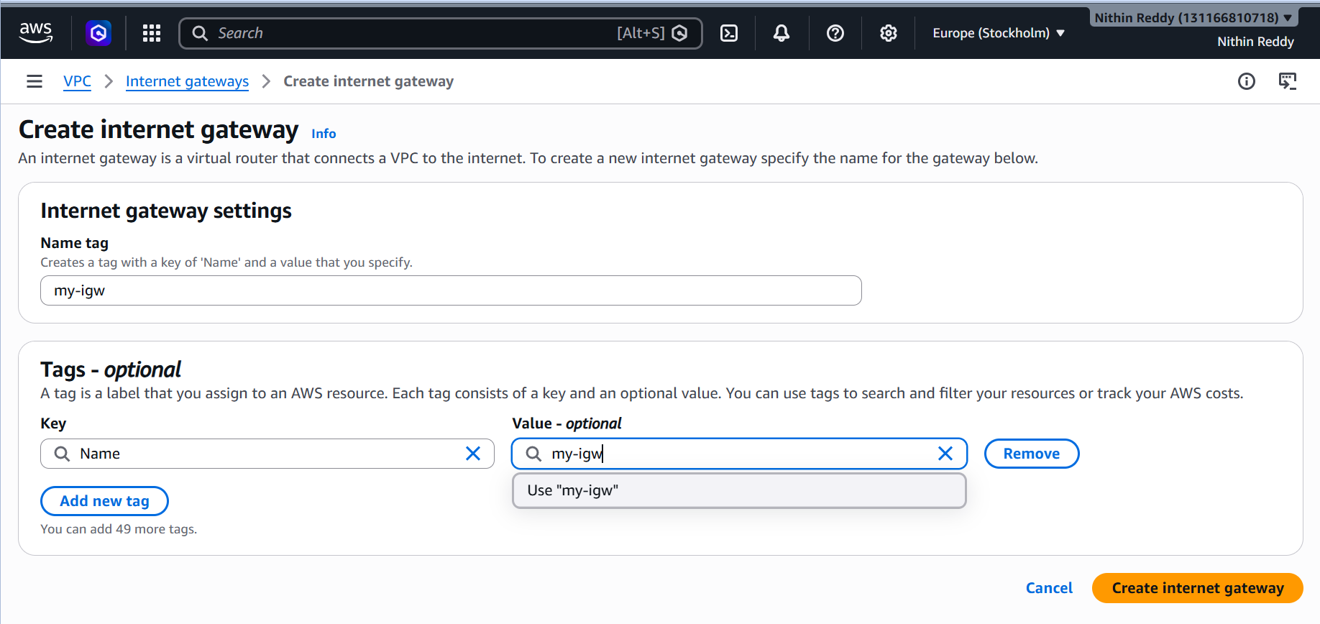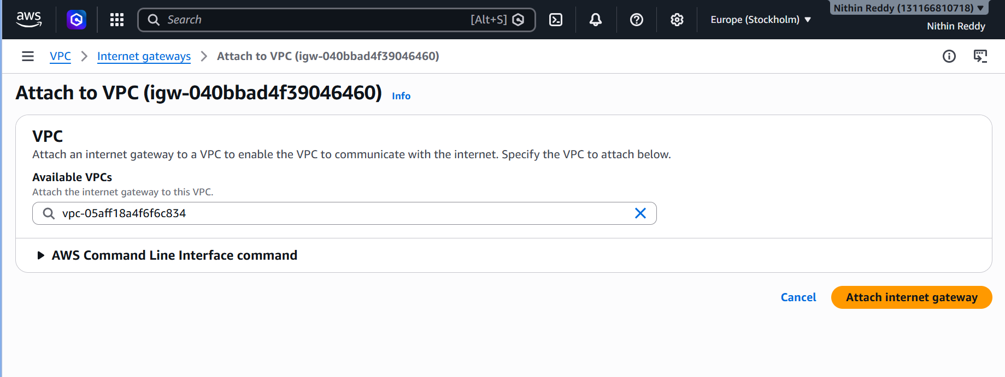
Validation
- Public EC2 should be reachable from your browser/SSH via public IP
- Private EC2 has no public IP and is not directly reachable from the internet
- Both instances can communicate with each other (same VPC)
Troubleshooting
Error | Fix
Can't SSH into public EC2 | Check Security Group — allow port 22 from your IP
Public EC2 has no public IP | Verify auto-assign public IP is enabled on the subnet
TASK 2: VPC Peering — Cross-Region
Objective
Connect two VPCs in different AWS regions so resources can communicate privately without going over the public internet.
Why This Task?
Cross-region VPC peering is used in multi-region architectures for disaster recovery, latency optimization, and data replication — all over AWS's private backbone network.
Steps
Step 1 — Create a Second VPC in a Different Region
- Switch your AWS Console region to us-east-1 (N. Virginia)
- Go to VPC → Create VPC
- Fill in:
  - Name: vpc-region-2
  - CIDR: 10.1.0.0/16 ← Must NOT overlap with 10.0.0.0/16
- Create a subnet 10.1.1.0/24 in this VPC as well
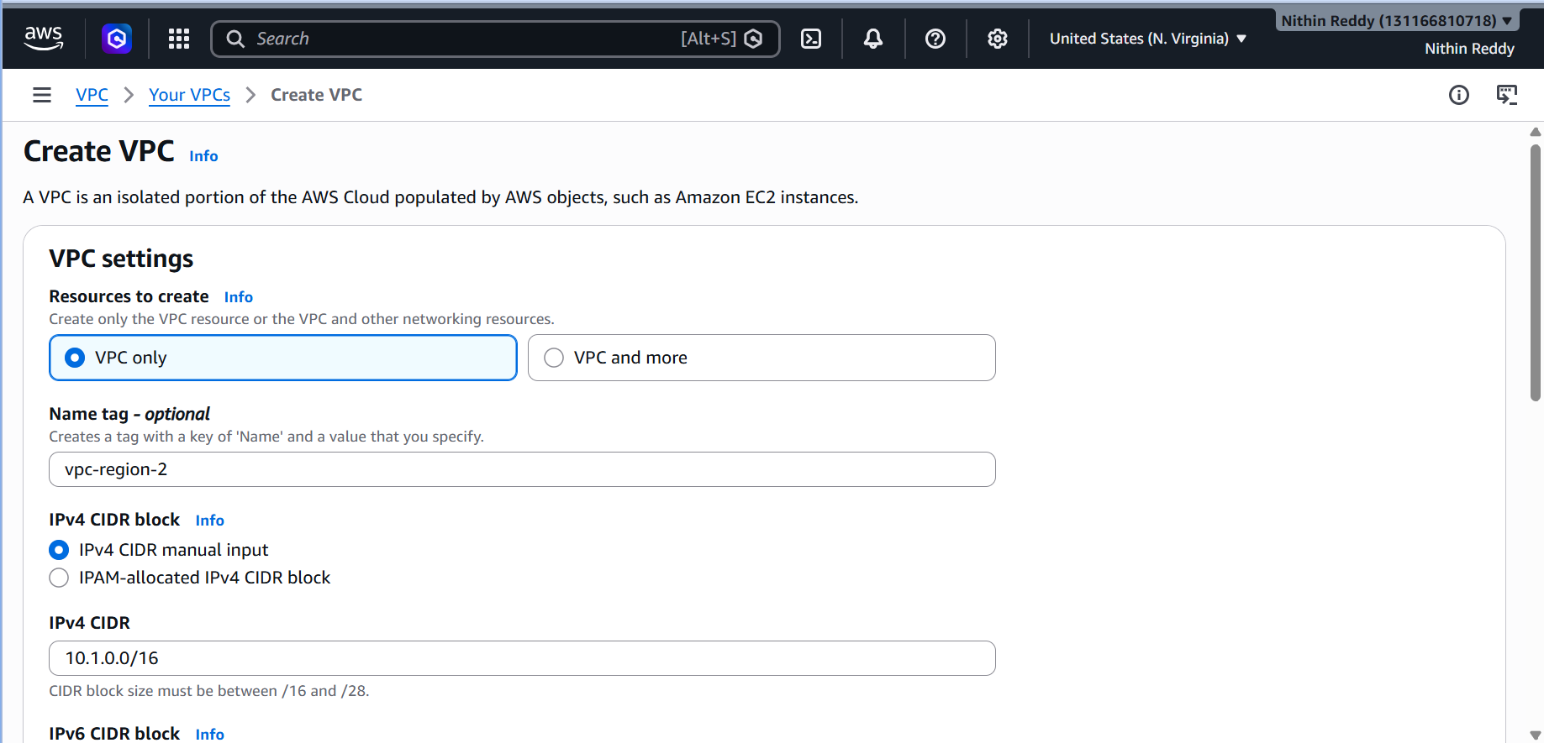
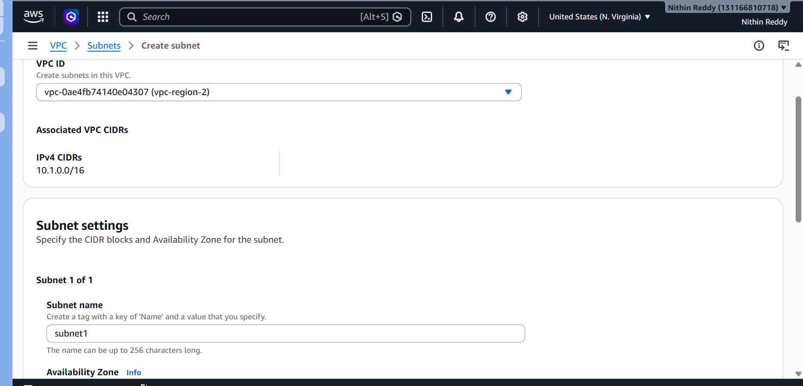
Step 2 — Initiate the Peering Request (from Region 1)
- Switch back to your original region (ap-south-1)
- Go to VPC → Peering Connections → Create Peering Connection
- Fill in:
  - Name: cross-region-peering
  - Local VPC (Requester): my-custom-vpc (10.0.0.0/16)
  - Account: My Account
  - Region: us-east-1
  - VPC ID (Accepter): paste the VPC ID of vpc-region-2
- Click Create Peering Connection
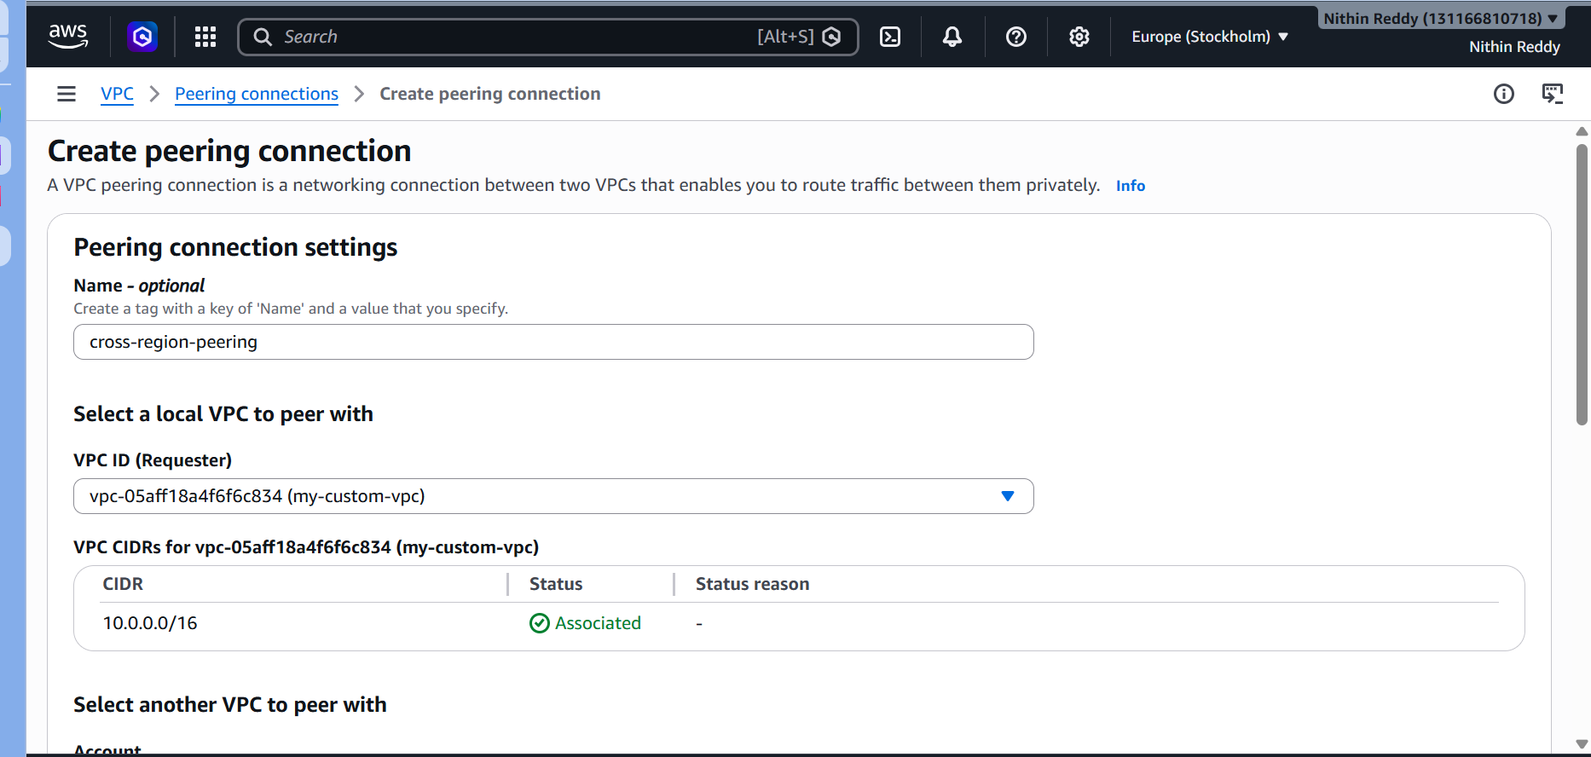
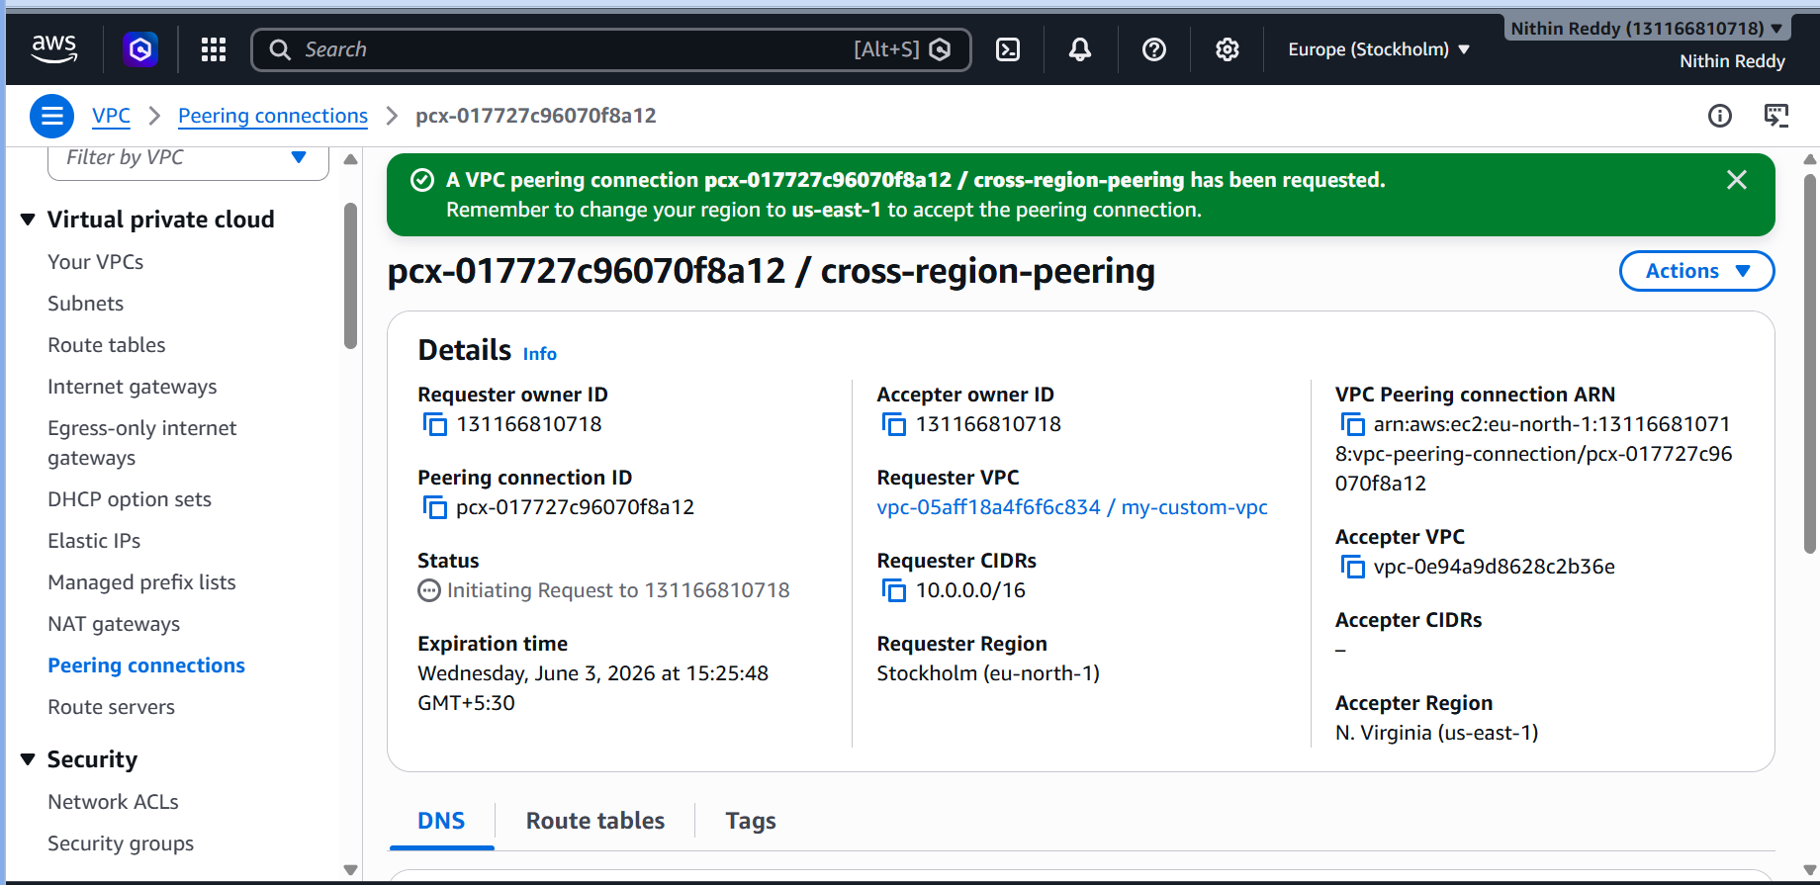
Step 4 — Update Route Tables in BOTH Regions
In Region 1 (ap-south-1):
- Open the route table for public-subnet-1
- Add Route:
  - Destination: 10.1.0.0/16 (Region 2's CIDR)
  - Target: Select the Peering Connection ID (pcx-xxxxxx)
In Region 2 (us-east-1):
- Open the route table for its subnet
- Add Route:
  - Destination: 10.0.0.0/16 (Region 1's CIDR)
  - Target: The same Peering Connection
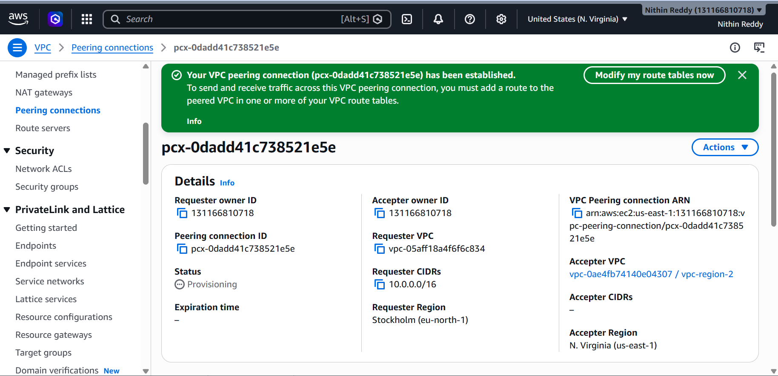
Step 5 — Update Security Groups
- In both regions, update Security Groups to allow ICMP (ping) or port 22 from the other VPC's CIDR
  - Example: Allow all traffic from 10.1.0.0/16 in Region 1's SG
Step 6 — Test Connectivity
- Launch an EC2 in each region
- SSH into Region 1's EC2
- Ping the private IP of Region 2's EC2
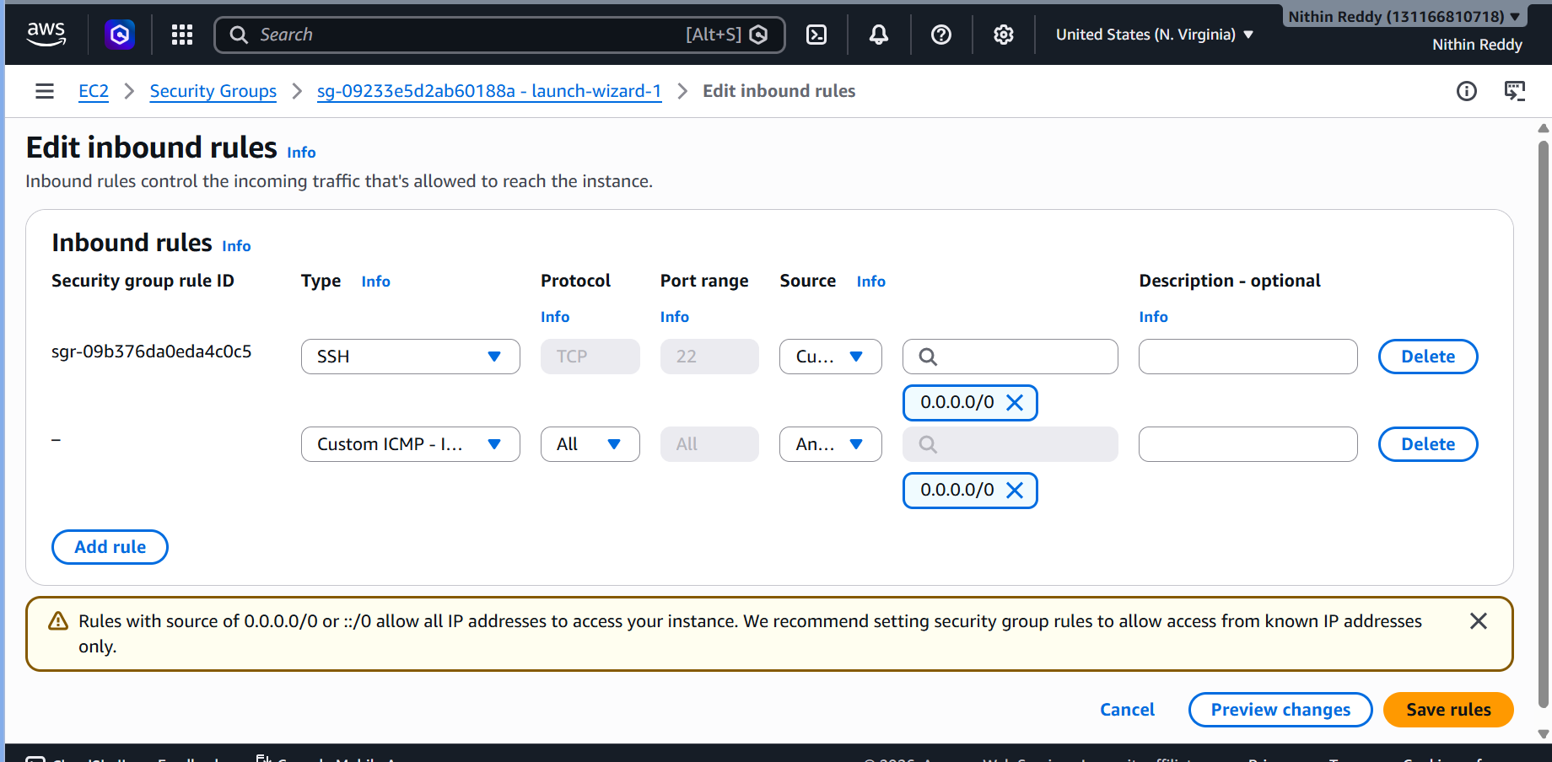
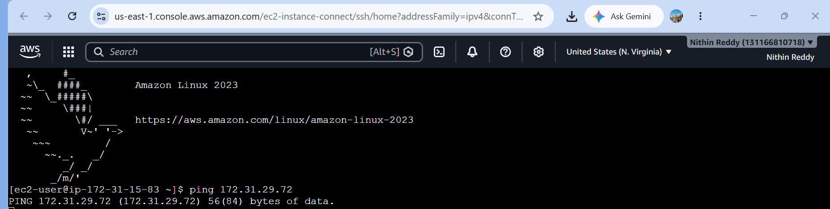
Validation
- Ping succeeds between EC2s in different regions using private IPs
- No public IPs needed — all traffic flows through AWS backbone
Troubleshooting
Error | Fix
Peering stuck in Pending | Must accept from the correct region's console
Ping fails | Check both route tables AND both security groups
CIDR conflict error | Make sure CIDRs don't overlap — use 10.0.x vs 10.1.x
DNS resolution fails | Enable DNS hostnames on both VPCs and turn on DNS resolution in peering options

TASK 3: VPC Peering — Cross-Account
Objective
Establish a VPC peering connection between two different AWS accounts — simulating real enterprise setups where teams/projects own separate accounts.
Why This Task?
In real organizations, different departments or clients have separate AWS accounts. Cross-account VPC peering allows secure private communication between them without merging accounts or using public internet.
Prerequisite
- You (Account A) + a friend/teammate (Account B)
- Exchange AWS Account IDs and VPC IDs
- Both VPCs must have non-overlapping CIDRs
  - Your VPC: 10.0.0.0/16
  - Friend's VPC: 10.2.0.0/16

Steps
Step 1 — Get Account B's Details (Your Friend) Ask your friend to share:
- Their AWS Account ID (12-digit number)
- Their VPC ID (e.g., vpc-0abc123)
- Their VPC CIDR (e.g., 10.2.0.0/16)
- Their Region (e.g., ap-south-1)
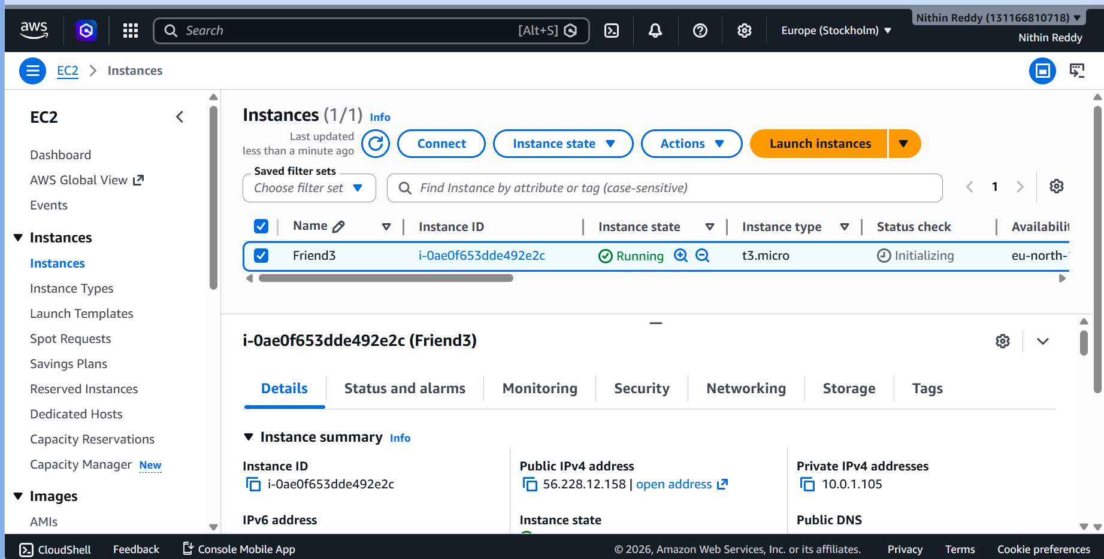
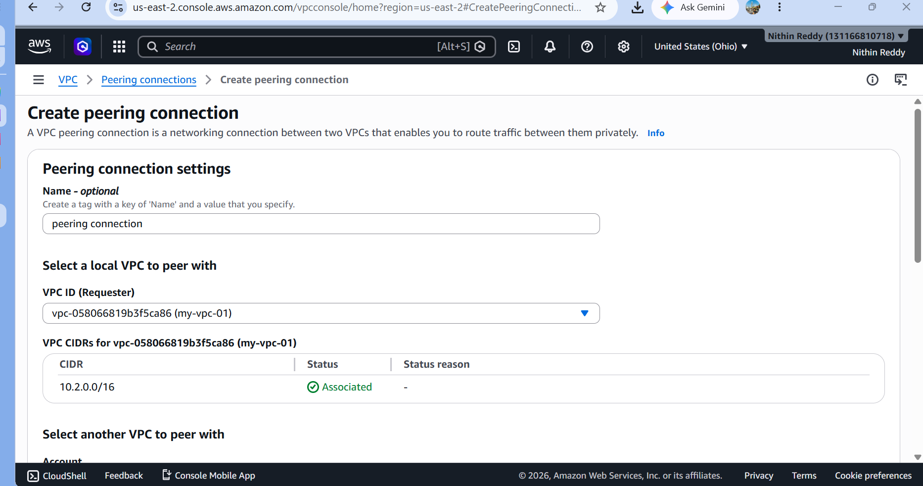
Step 2 — Initiate Peering from Account A (You)
- AWS Console → VPC → Peering Connections → Create Peering Connection
- Fill in:
  - Name: cross-account-peering
  - Requester VPC: your my-custom-vpc
  - Account: Another Account
  - Account ID: (paste friend's 12-digit account ID)
  - Region: (friend's region)
  - VPC ID: (friend's VPC ID)
- Click Create Peering Connection
- Copy the Peering Connection ID (pcx-xxxxxxxx) and send it to your friend
Step 3 — Accept from Account B (Friend's Side) Your friend logs into their AWS Console:
- Go to VPC → Peering Connections
- Find the pending request (verify the Account ID matches yours)
- Actions → Accept Request
Step 4 — Update Route Tables (Both Accounts)
In Account A — add route:
- Destination: 10.2.0.0/16 (Friend's CIDR)
- Target: pcx-xxxxxxxx (the peering connection)
In Account B — add route:
- Destination: 10.0.0.0/16 (Your CIDR)
- Target: Same peering connection ID
Step 5 — Update Security Groups (Both Accounts)
- Account A: Allow inbound from 10.2.0.0/16
- Account B: Allow inbound from 10.0.0.0/16

Step 6 — Test
bash
- # From your EC2 (Account A), ping friend's private EC2 IP
- ping 10.2.1.x
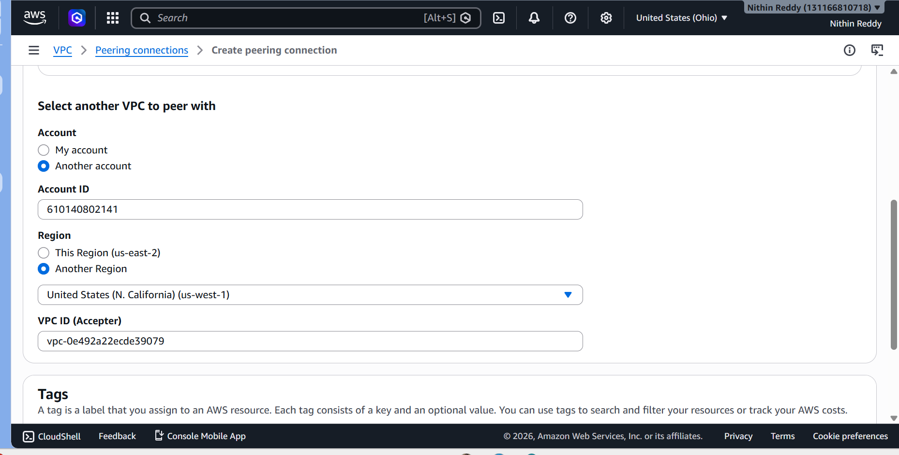
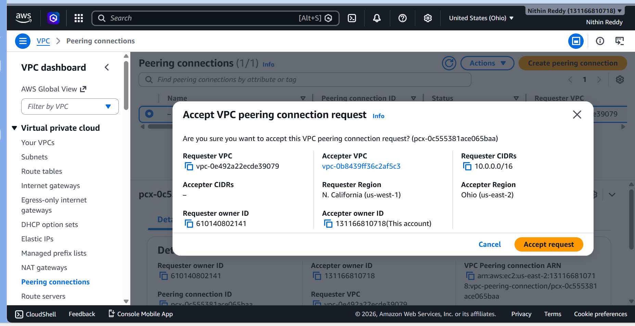
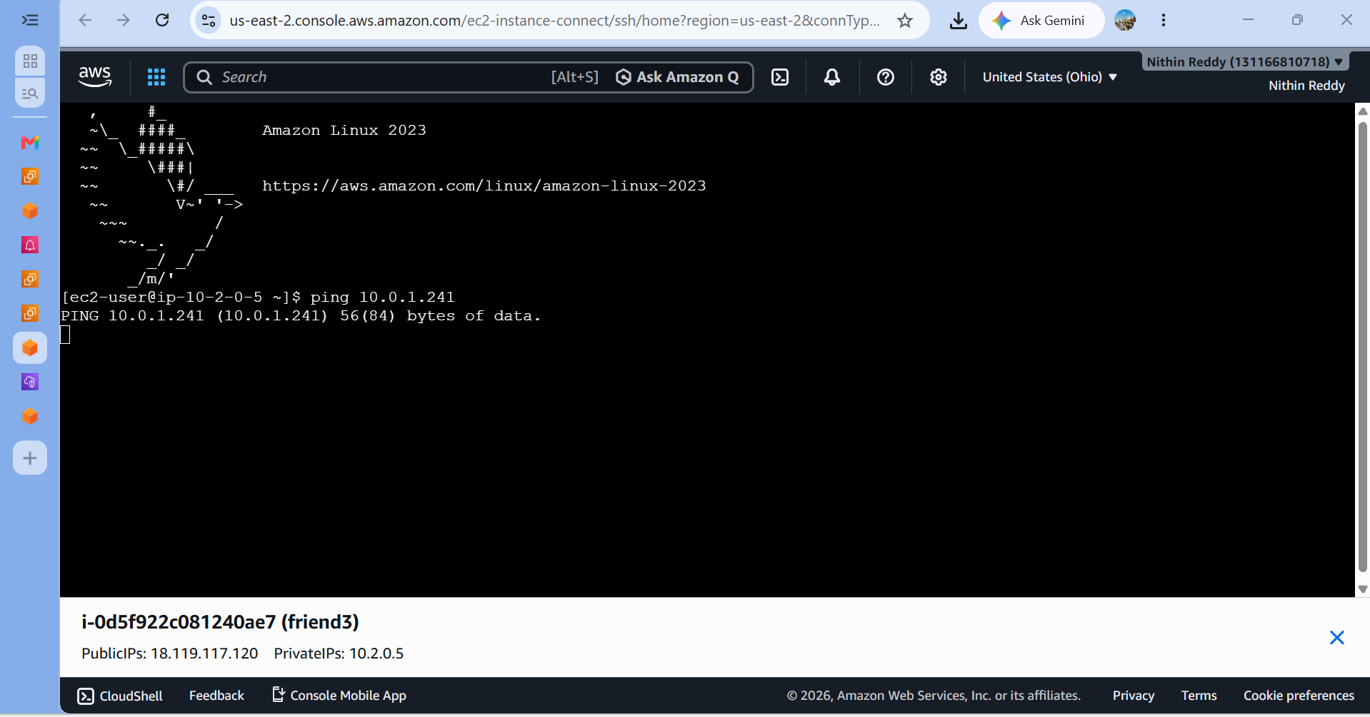 Validation
- Ping or SSH works between the two account's EC2s using private IPs
- No traffic leaves AWS's internal network
- Each party controls their own Security Groups independently
Troubleshooting
Error | Fix
Friend doesn't see the request | Verify Account ID and region are correct
Connection shows "Expired" | Peering requests expire after 7 days — recreate it
Route table error | Each account must update their OWN route table
Security group blocking | Must allow other account's CIDR in both SGs
TASK 4: Set Up a VPC Transit Gateway
Objective
Create a Transit Gateway (TGW) — a central network hub that connects multiple VPCs and on-prem networks through a single gateway, replacing complex full-mesh VPC peering.
Why This Task?
With VPC peering, connecting 5 VPCs requires 10 individual peering links. A Transit Gateway acts like a cloud router — you just attach each VPC to it and routing is centralized. This is the modern scalable approach for large multi-VPC architectures.
STEP-BY-STEP EXECUTION

PHASE 1 — Create a Second VPC (for TGW to connect)
You need 2 VPCs to demonstrate Transit Gateway working. You already have VPC-1 from Task 1. Let's create VPC-2 fresh.

Step 1 — Create VPC-2
- AWS Console → Search bar → type VPC → open VPC Dashboard
- Left panel → Your VPCs → Click Create VPC
- Select "VPC only" (not VPC and more)
- Fill in:
Field | Value
Name tag | vpc-2-tgw
IPv4 CIDR | 10.3.0.0/16
IPv6 | No IPv6
Tenancy | Default
- Click Create VPC
- You'll see a green success banner — note down the VPC ID (looks like vpc-0abc1234)

Step 2 — Create a Subnet inside VPC-2
- Left panel → Subnets → Create Subnet
- Fill in:
Field | Value
VPC ID | Select vpc-2-tgw
Subnet name | subnet-vpc2
Availability Zone | Pick any (e.g., ap-south-1a)
IPv4 CIDR | 10.3.1.0/24
- Click Create Subnet

Step 3 — Create a Route Table for VPC-2
- Left panel → Route Tables → Create Route Table
- Fill in:
Field | Value
Name | rt-vpc2
VPC | vpc-2-tgw
- Click Create Route Table
- After creation → Subnet Associations tab → Edit Subnet Associations
- Check subnet-vpc2 → Save

Step 4 — Launch EC2 in VPC-1 (your original VPC)
- Go to EC2 → Instances → Launch Instance
- Fill in:
Field | Value
Name | ec2-vpc1
AMI | Amazon Linux 2023 (free tier)
Instance type | t2.micro
Key pair | Create new → name it tgw-keypair → download the .pem file
Network | my-custom-vpc
Subnet | public-subnet-1
Auto-assign public IP | Enable
Security Group | Create new → name sg-vpc1
- In Security Group rules, add:
Type | Protocol | Port | Source
SSH | TCP | 22 | My IP
All ICMP - IPv4 | ICMP | All | 10.3.0.0/16
- Click Launch Instance

Step 5 — Launch EC2 in VPC-2
- EC2 → Launch Instance
- Fill in:
Field | Value
Name | ec2-vpc2
AMI | Amazon Linux 2023
Instance type | t2.micro
Key pair | Use same tgw-keypair
Network | vpc-2-tgw
Subnet | subnet-vpc2
Auto-assign public IP | Disable (private only — TGW will connect it)
Security Group | Create new → name sg-vpc2
- Security Group rules:
Type | Protocol | Port | Source
All ICMP - IPv4 | ICMP | All | 10.0.0.0/16
SSH | TCP | 22 | 10.0.0.0/16
- Click Launch Instance
ec2-vpc2 has NO public IP — that's intentional. We'll test connectivity TO it through the Transit Gateway from ec2-vpc1.

PHASE 2 — Create the Transit Gateway

Step 6 — Create Transit Gateway
- AWS Console → VPC → Left panel scroll down → Transit Gateways → Create Transit Gateway
- Fill in:
Field | Value
Name | my-transit-gateway
Description | Central hub connecting VPC1 and VPC2
Amazon side ASN | 64512 (leave default)
DNS support | ✅ Enabled
VPN ECMP support | ✅ Enabled
Default route table association | ✅ Enabled
Default route table propagation | ✅ Enabled
Multicast support | ❌ Disabled
- Click Create Transit Gateway
- ⏳ Wait 3–5 minutes — Status will show pending then change to available
- Keep refreshing until you see State = available ✅
- Note down the Transit Gateway ID (looks like tgw-0abc12345)
Do NOT proceed to next step until TGW state is available

PHASE 3 — Attach Both VPCs to the Transit Gateway

Step 7 — Create Attachment for VPC-1
- Left panel → Transit Gateway Attachments → Create Transit Gateway Attachment
- Fill in:
Field | Value
Name | attachment-vpc1
Transit Gateway ID | Select my-transit-gateway
Attachment type | VPC
VPC ID | my-custom-vpc (10.0.0.0/16)
Subnet | Select public-subnet-1
- Click Create Transit Gateway Attachment
- Status will show pending — note the Attachment ID

Step 8 — Create Attachment for VPC-2
- Create Transit Gateway Attachment again
- Fill in:
Field | Value
Name | attachment-vpc2
Transit Gateway ID | Select my-transit-gateway
Attachment type | VPC
VPC ID | vpc-2-tgw (10.3.0.0/16)
Subnet | Select subnet-vpc2
- Click Create Transit Gateway Attachment
- Wait until BOTH attachments show state = available (3–5 mins each)
Go to Transit Gateway Attachments list and refresh. Both must show available before next step.

PHASE 4 — Verify Transit Gateway Route Tables

Step 9 — Check TGW Route Table
- Left panel → Transit Gateway Route Tables
- Select the default route table (there's one created automatically)
- Click on it → go to Routes tab
- You should see two routes auto-propagated:
CIDR | Attachment | Type
10.0.0.0/16 | attachment-vpc1 | propagated
10.3.0.0/16 | attachment-vpc2 | propagated
✅ If you see both routes — TGW routing is working automatically!
❌ If routes are missing → go to Propagations tab → Create Propagation → select each attachment one by one

Step 10 — Check Associations tab
- Still on the same TGW Route Table → Associations tab
- You should see both attachments listed here
- If missing → Create Association for each attachment

PHASE 5 — Update VPC Route Tables to Use TGW
This is the most critical step — you tell each VPC how to reach the other VPC through TGW.

Step 11 — Update Route Table of VPC-1
- Left panel → Route Tables
- Find the route table associated with public-subnet-1 (from Task 1 — named public-rt)
- Click on it → Routes tab → Edit Routes
- Click Add Route:
Field | Value
Destination | 10.3.0.0/16
Target | Transit Gateway → select my-transit-gateway
- Click Save Changes

Step 12 — Update Route Table of VPC-2
- Find route table rt-vpc2 (the one you created for VPC-2)
- Routes tab → Edit Routes → Add Route:
Field | Value
Destination | 10.0.0.0/16
Target | Transit Gateway → select my-transit-gateway
- Click Save Changes

PHASE 6 — Test the Transit Gateway

Step 13 — Get the Private IP of ec2-vpc2
- Go to EC2 → Instances → ec2-vpc2
- Copy the Private IPv4 address (something like 10.3.1.x)

Step 14 — SSH into ec2-vpc1 and Test
- Open your terminal (or use EC2 Instance Connect for ec2-vpc1)
Using EC2 Instance Connect (easiest — no key needed):
- Select ec2-vpc1 → Click Connect
- Choose EC2 Instance Connect → Click Connect
- A browser terminal opens
Now run the ping test:
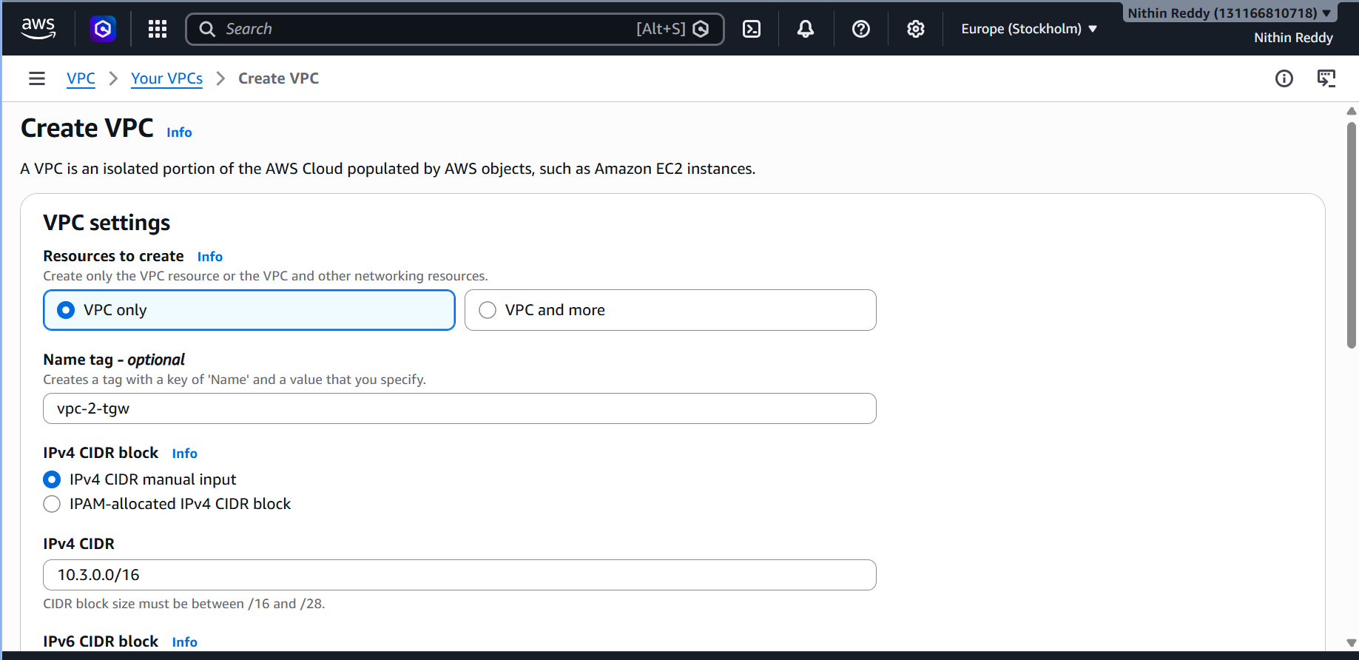
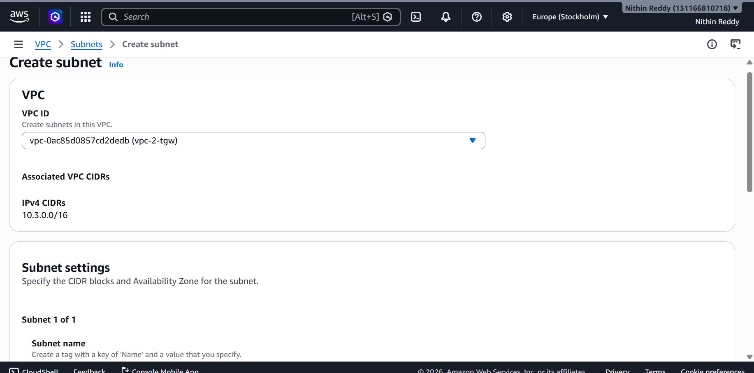
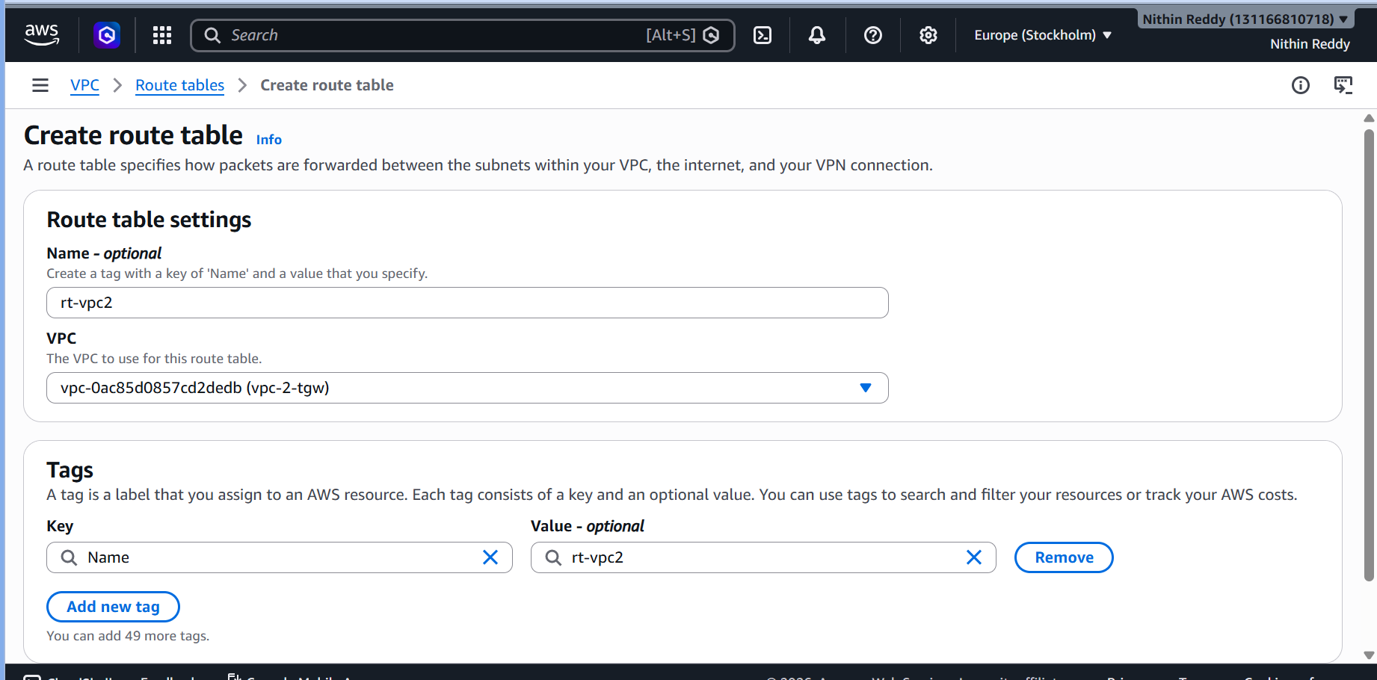
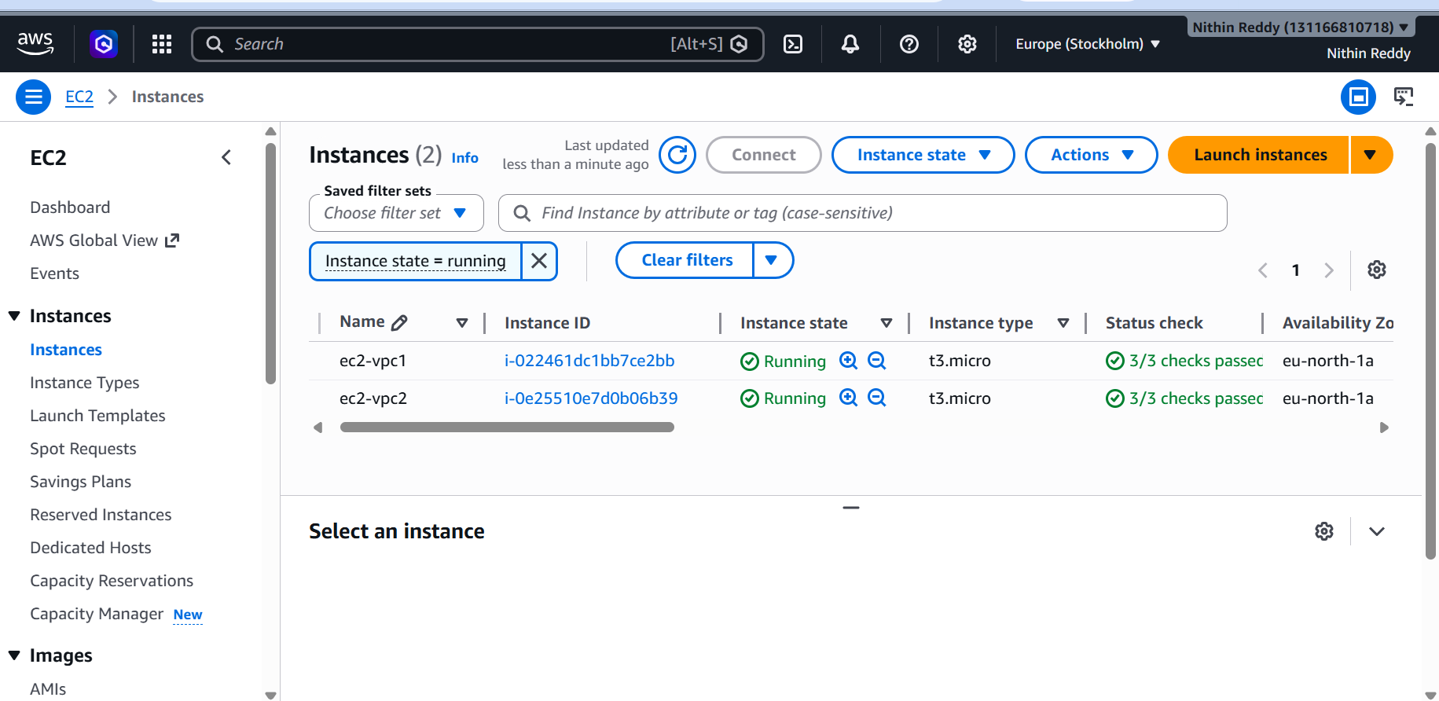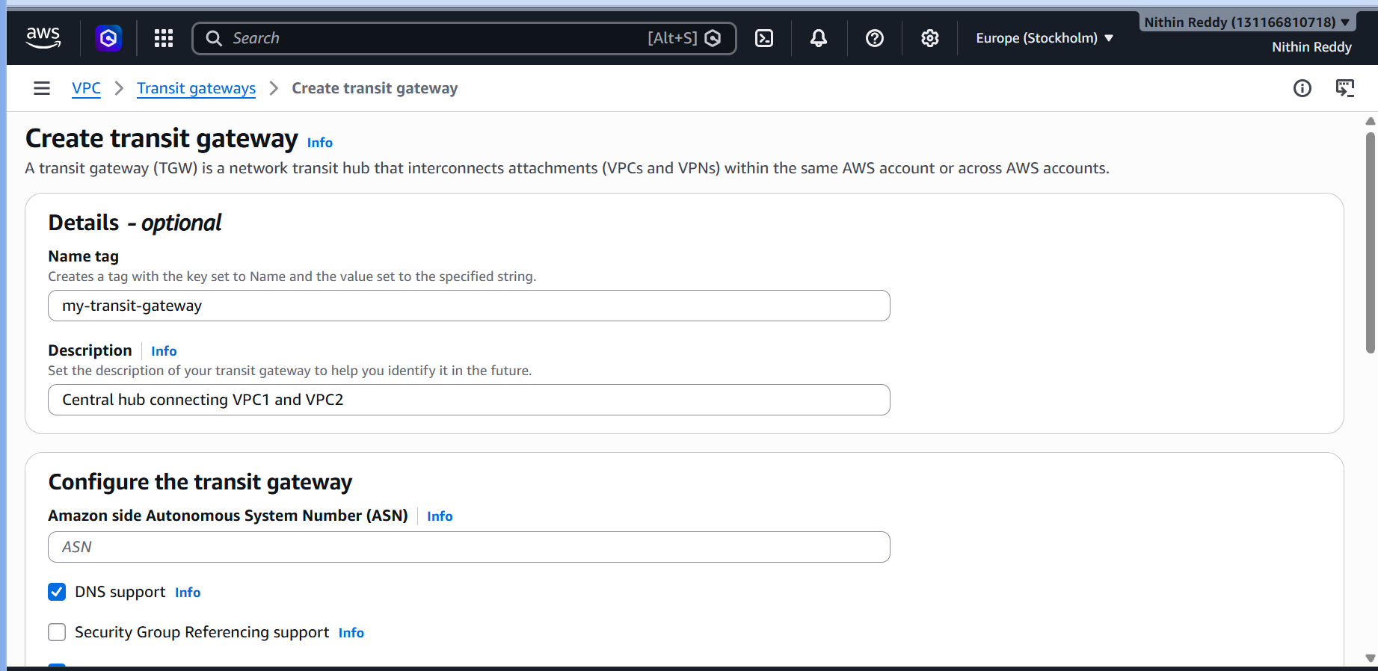
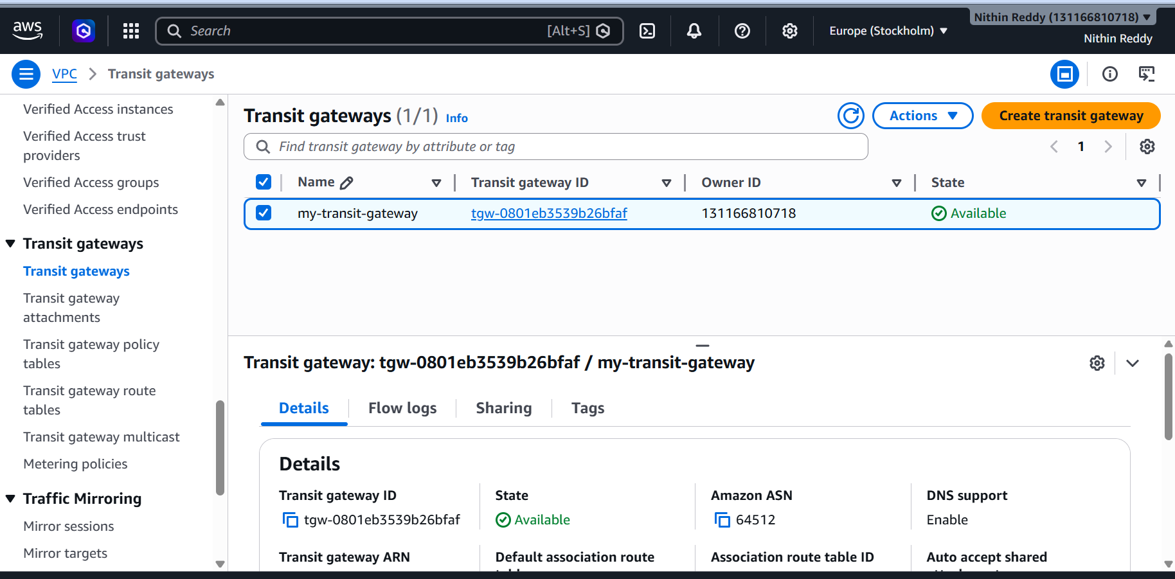
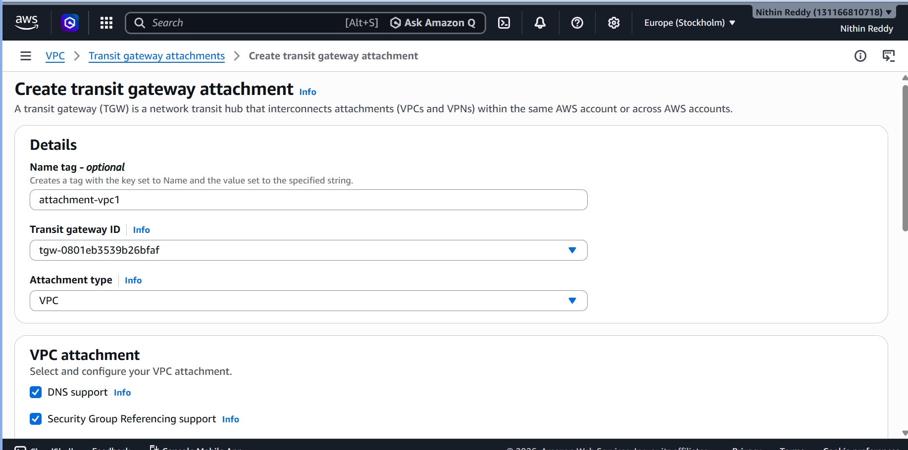
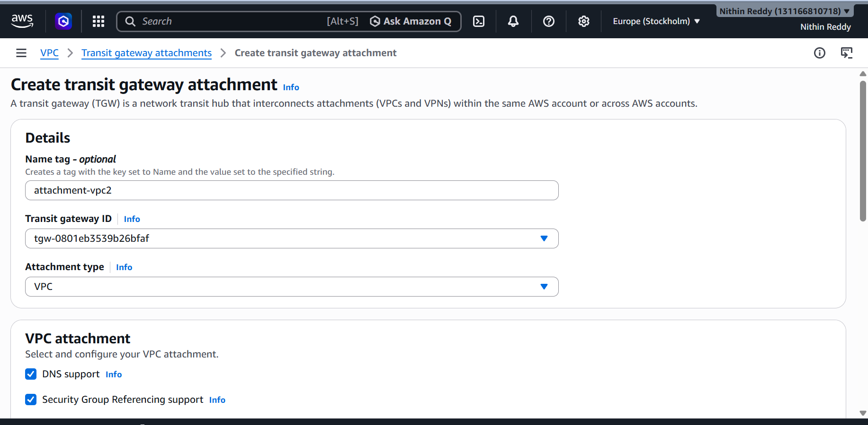
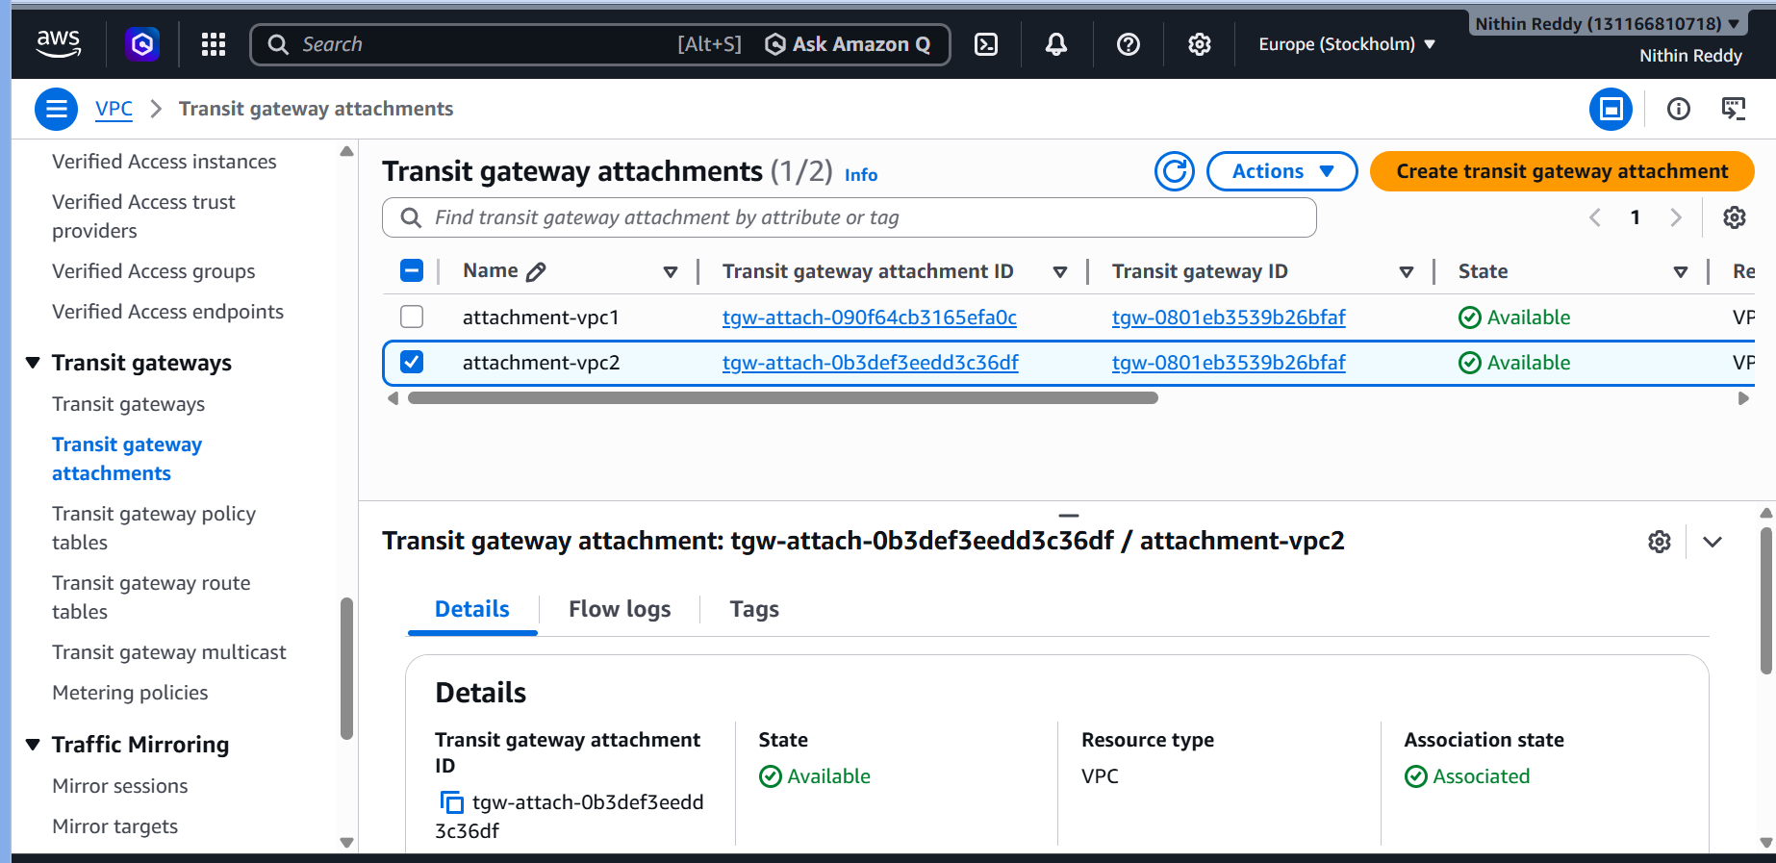
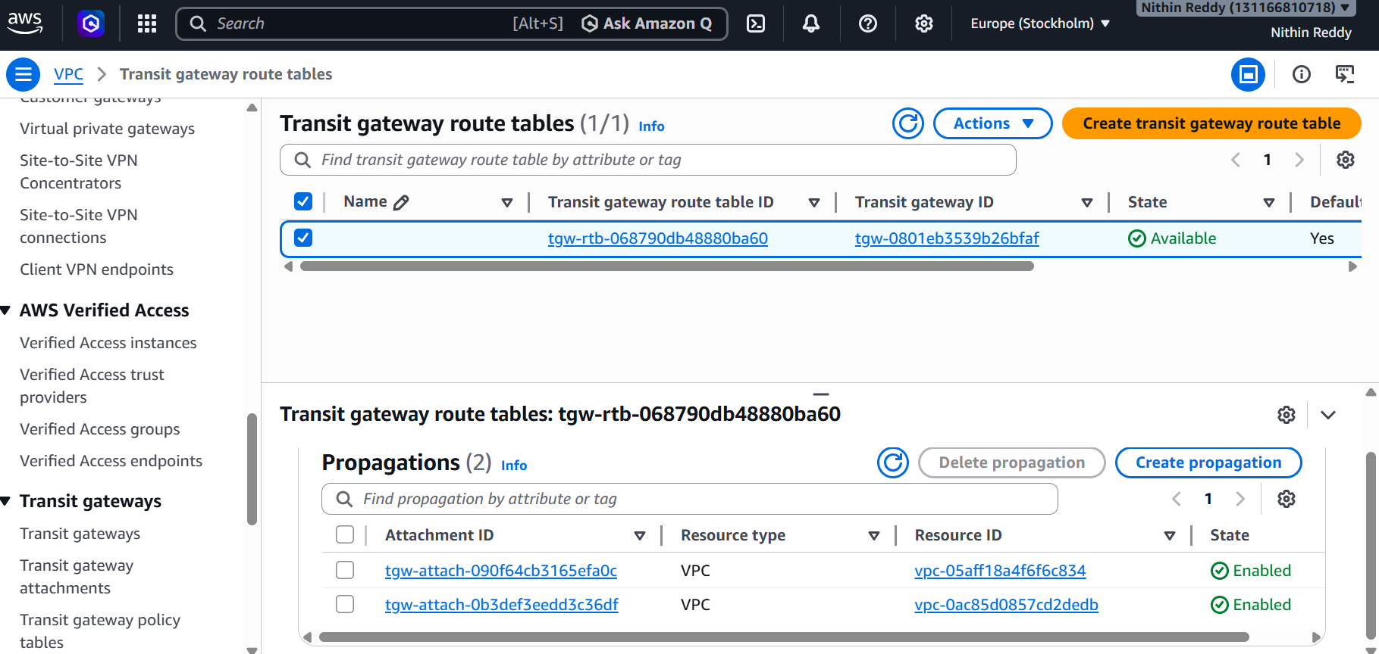
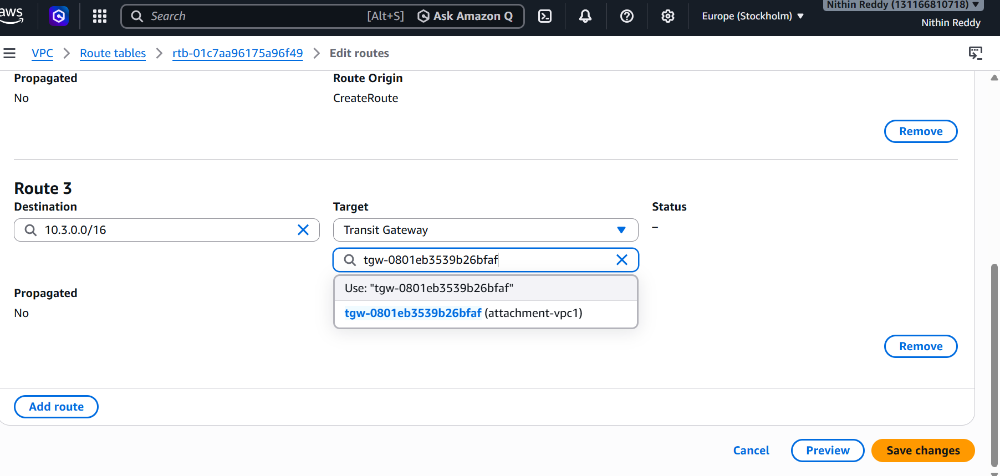
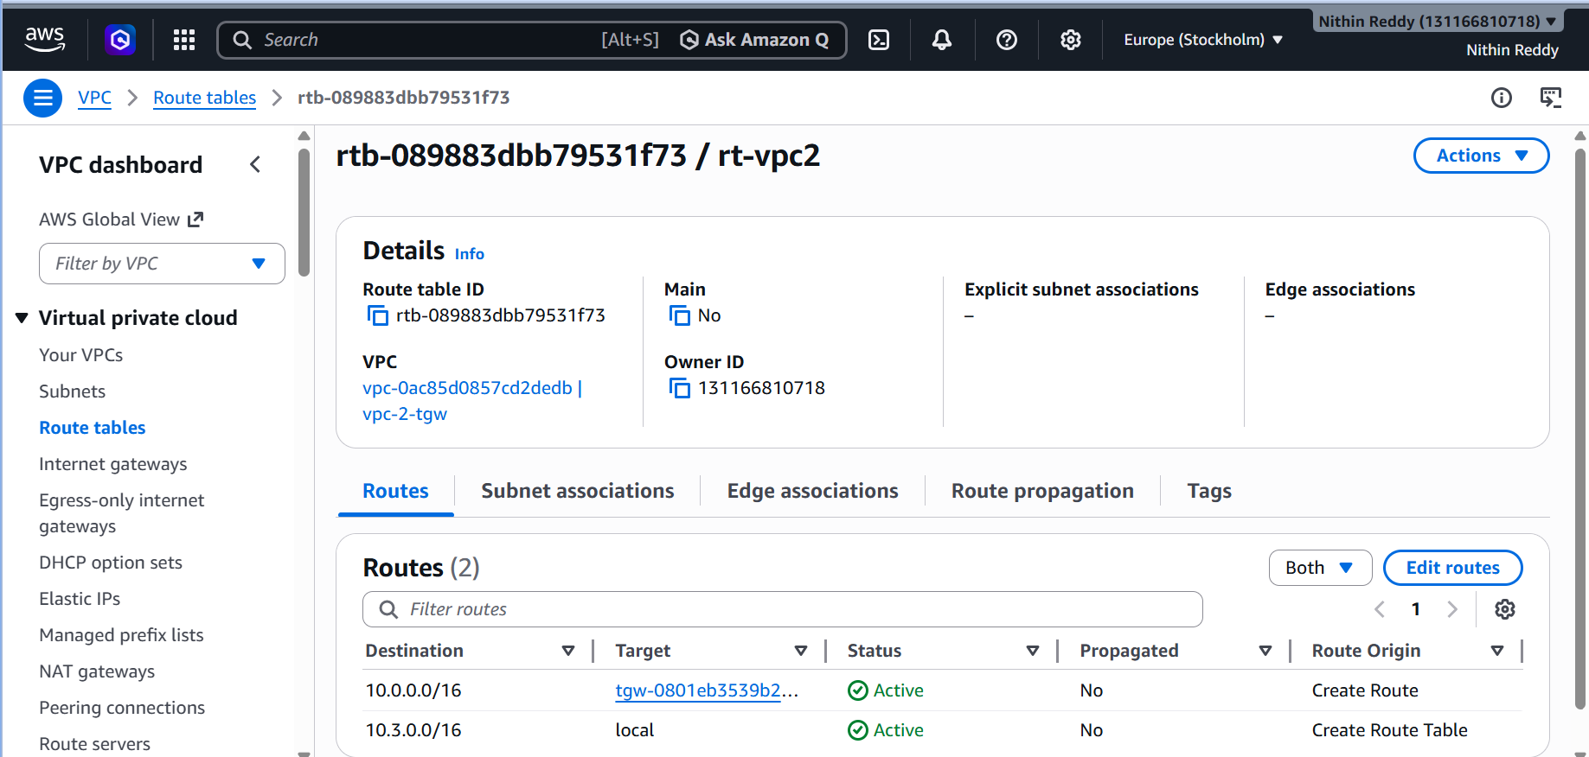
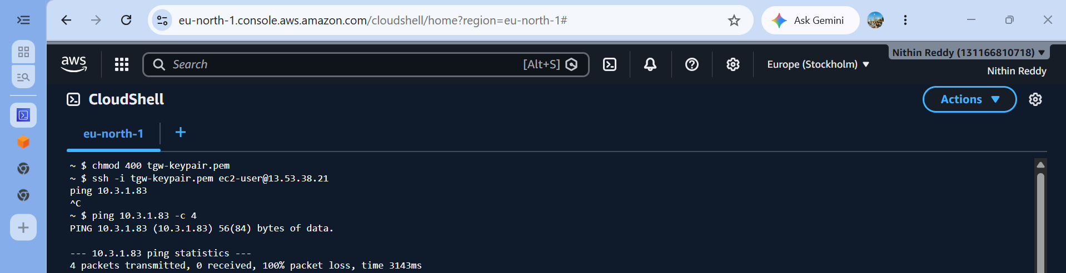
Validation
- Both VPCs communicate through the Transit Gateway (not direct peering)
- TGW Route Table shows both CIDRs as propagated routes
- Ping works between the two VPCs' private EC2 instances
Troubleshooting
Error | Fix
Attachment stuck in "pending" | Wait — TGW attachments take 3–5 min to become available
Routes not propagating | Manually create propagation in TGW route table
Ping fails despite routes | Check VPC route tables — both must point to TGW
"No routes found" in TGW | Ensure attachment is in "available" state first

TASK 5: Set Up a VPC Endpoint
Objective
Create a VPC Endpoint so that resources inside your private subnet can access AWS services (like S3, DynamoDB) without going through the internet — staying entirely within AWS's private network.
Why This Task?
Without a VPC Endpoint, your private EC2 must go through a NAT Gateway → Internet → AWS service (costly and exposed). A VPC Endpoint creates a private tunnel directly to AWS services, improving security, performance, and cost.
There are two types:
- Gateway Endpoint → for S3 and DynamoDB (free)
- Interface Endpoint → for all other AWS services (uses ENI + small cost)
We'll set up a Gateway Endpoint for S3 (most common, free).
Architecture
Private EC2 (10.0.2.x)
│
▼
Private Route Table
│ (pl-xxxxxx → vpce-xxxxxx)
▼
VPC Gateway Endpoint
│
▼
Amazon S3 (AWS Internal Network — no internet!)

Steps
Step 1 — Create an IAM Role for EC2 (to access S3)
- Go to IAM → Roles → Create Role
- Trusted entity: EC2
- Attach policy: AmazonS3ReadOnlyAccess
- Name: ec2-s3-role
- Create Role
Step 2 — Attach the Role to your Private EC2
- Go to EC2 → Instances → Select your private EC2
- Actions → Security → Modify IAM Role
- Attach ec2-s3-role
Step 3 — Create the VPC Endpoint (Gateway for S3)
- Go to VPC → Endpoints → Create Endpoint
- Fill in:
  - Name: s3-gateway-endpoint
  - Service category: AWS Services
  - Search for: s3
  - Select: com.amazonaws.ap-south-1.s3 (Gateway type)
  - VPC: my-custom-vpc
  - Route Tables: ✅ Select BOTH public-rt and private-rt
  - Policy: Full Access (default)
- Click Create Endpoint
Step 4 — Verify Route Table Updated Automatically
- Go to VPC → Route Tables → open private-rt
- Check the Routes tab
- You should now see a new route:
  - Destination: pl-xxxxxx (S3 prefix list)
  - Target: vpce-xxxxxxxx (your endpoint)
This was added automatically by AWS — that's the power of Gateway endpoints.
Step 5 — Test from Private EC2 (No Internet Needed)
SSH into your public EC2 first, then hop into private EC2:
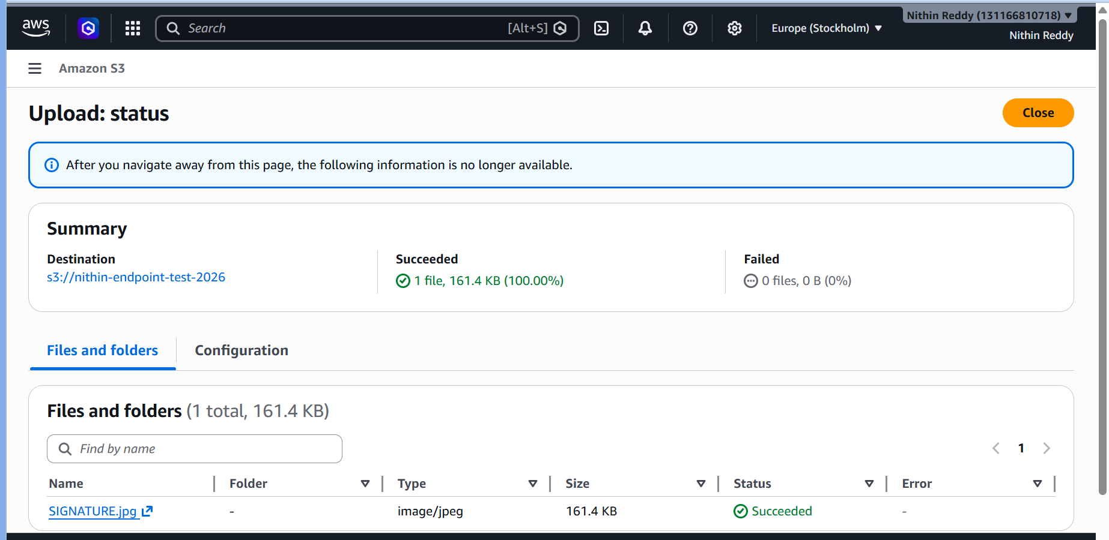
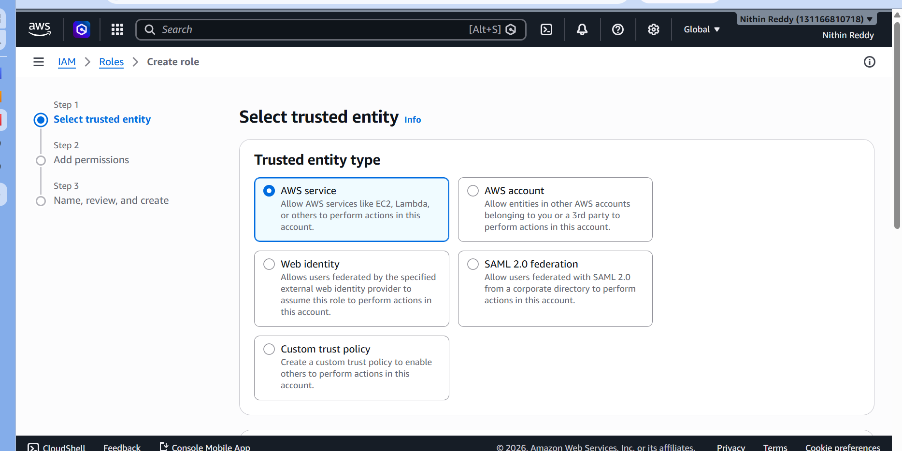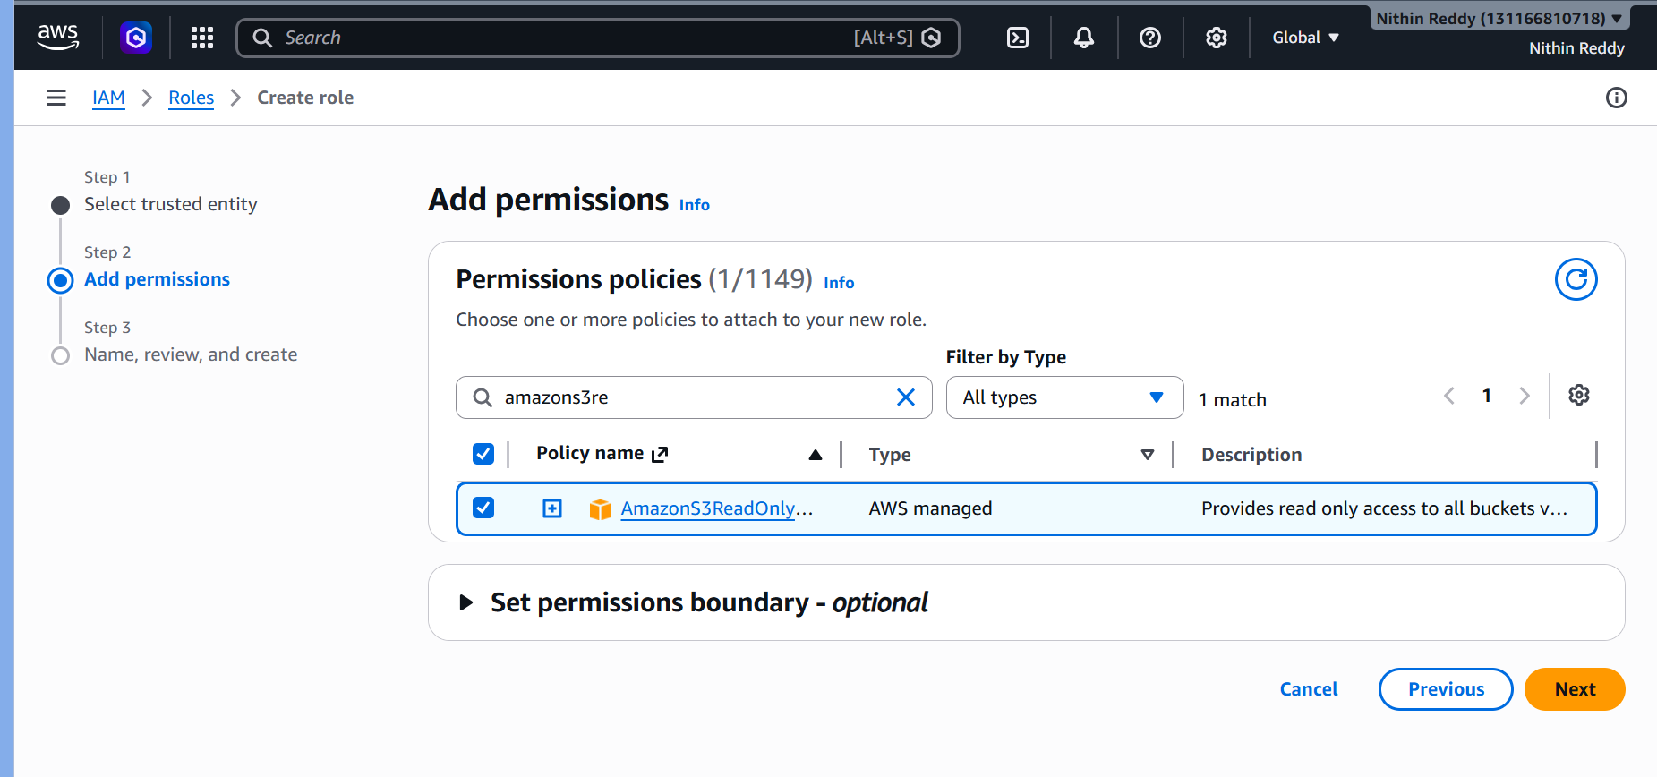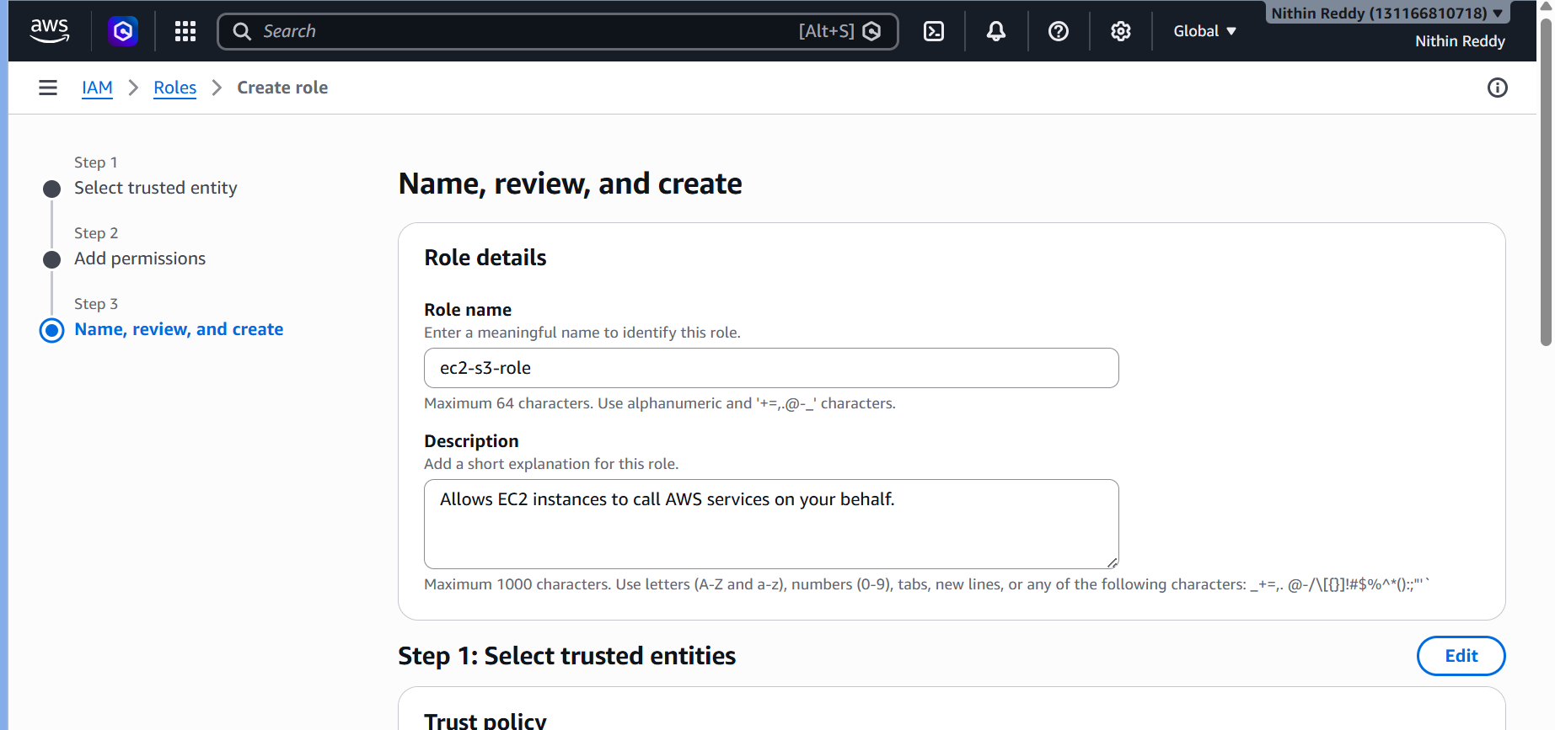
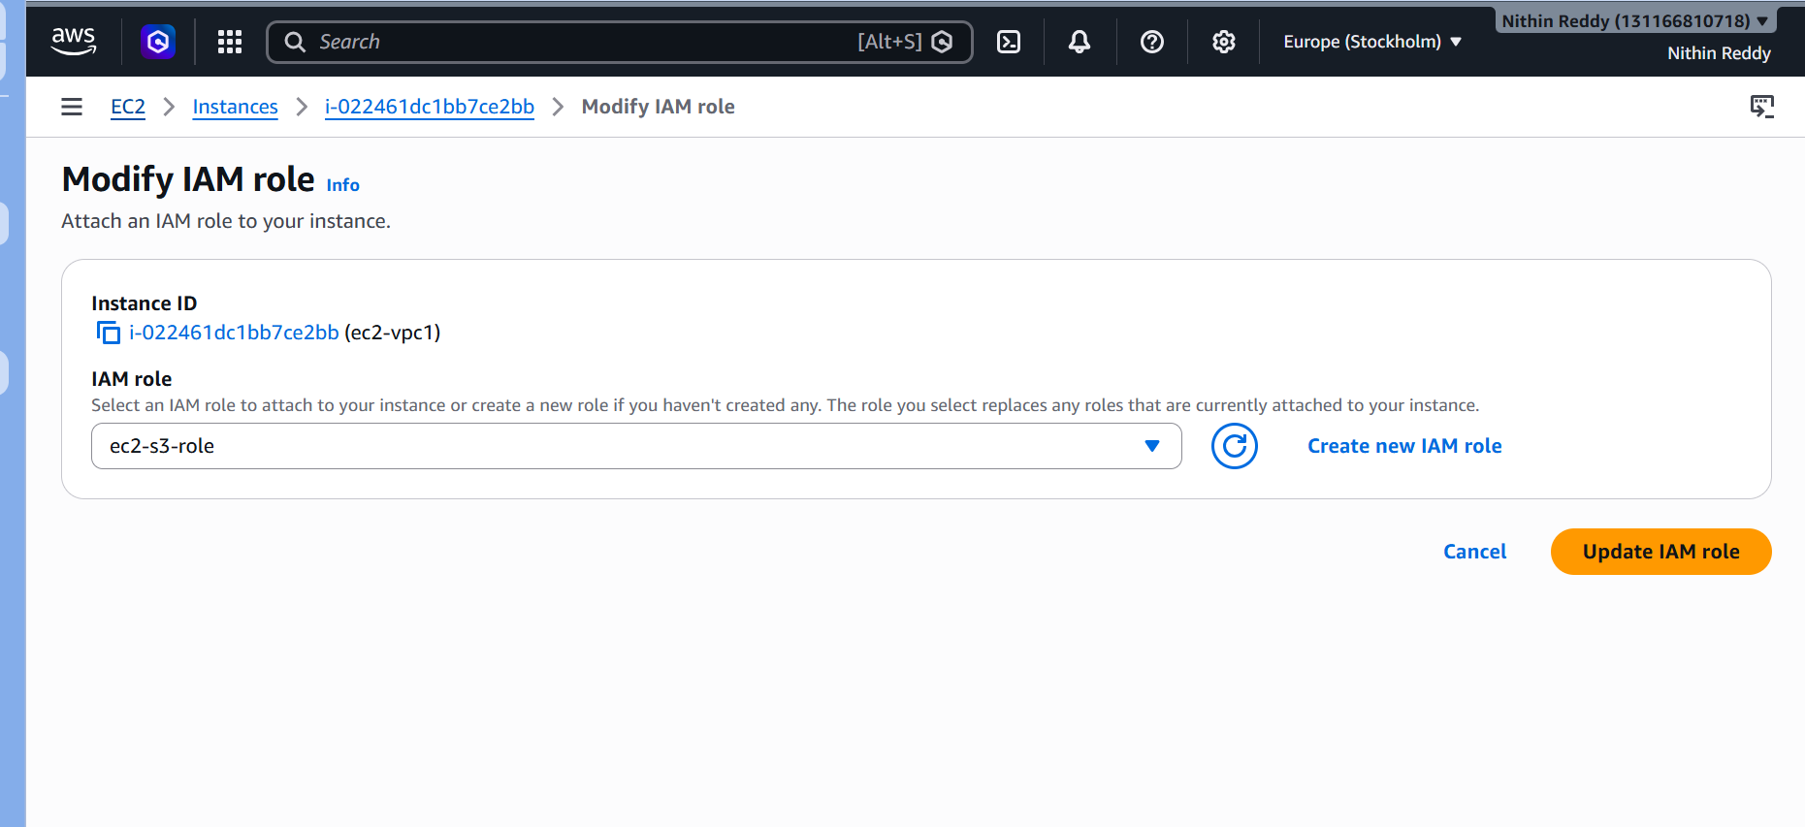
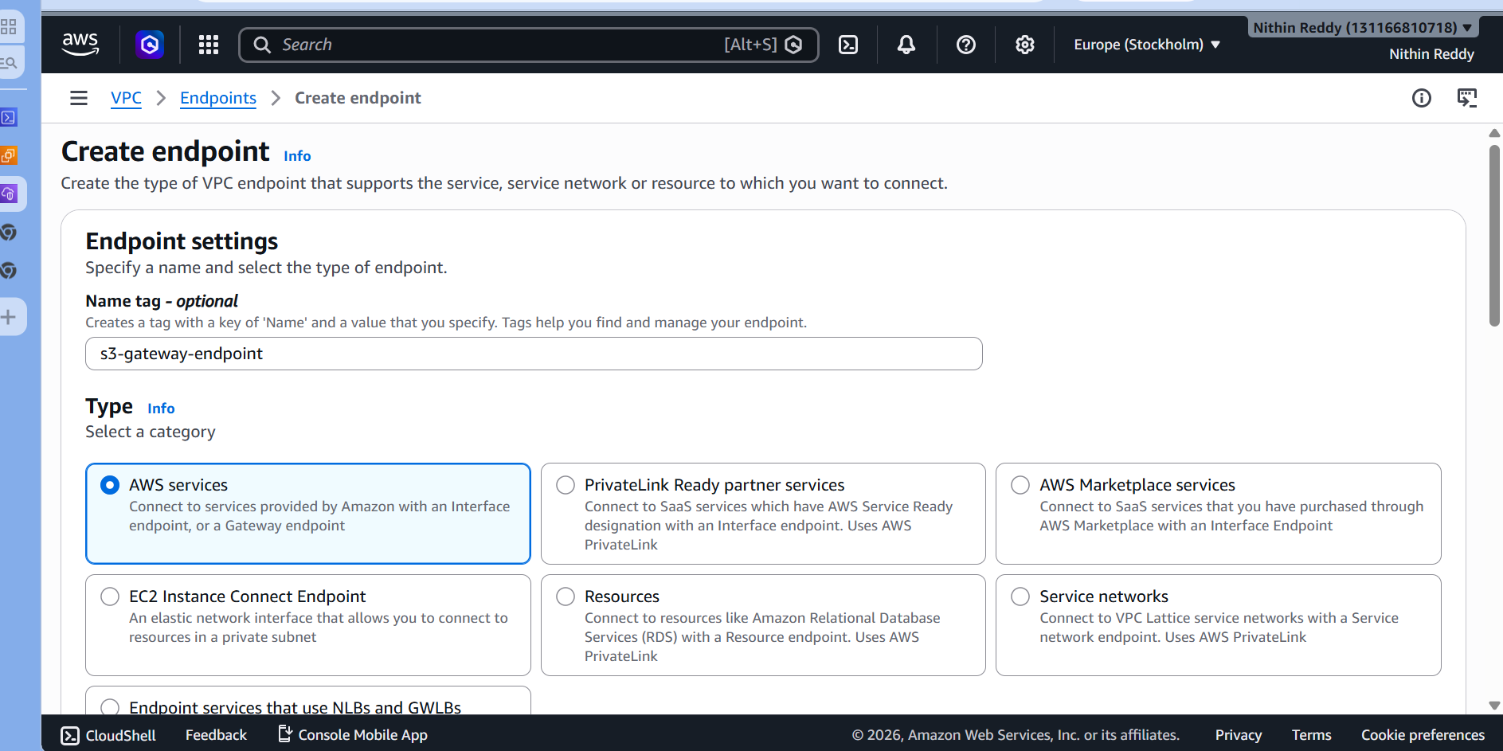
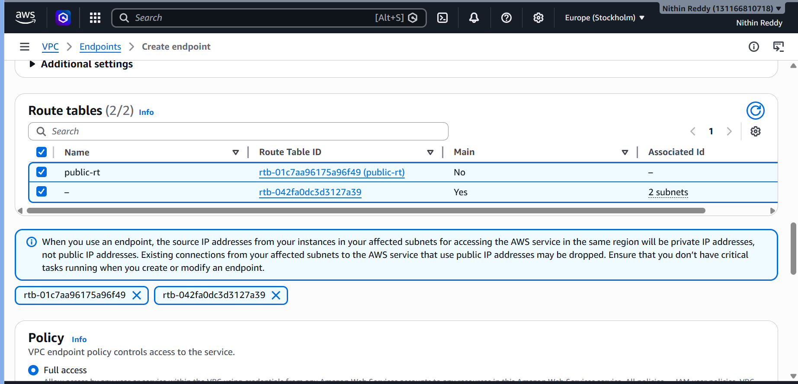
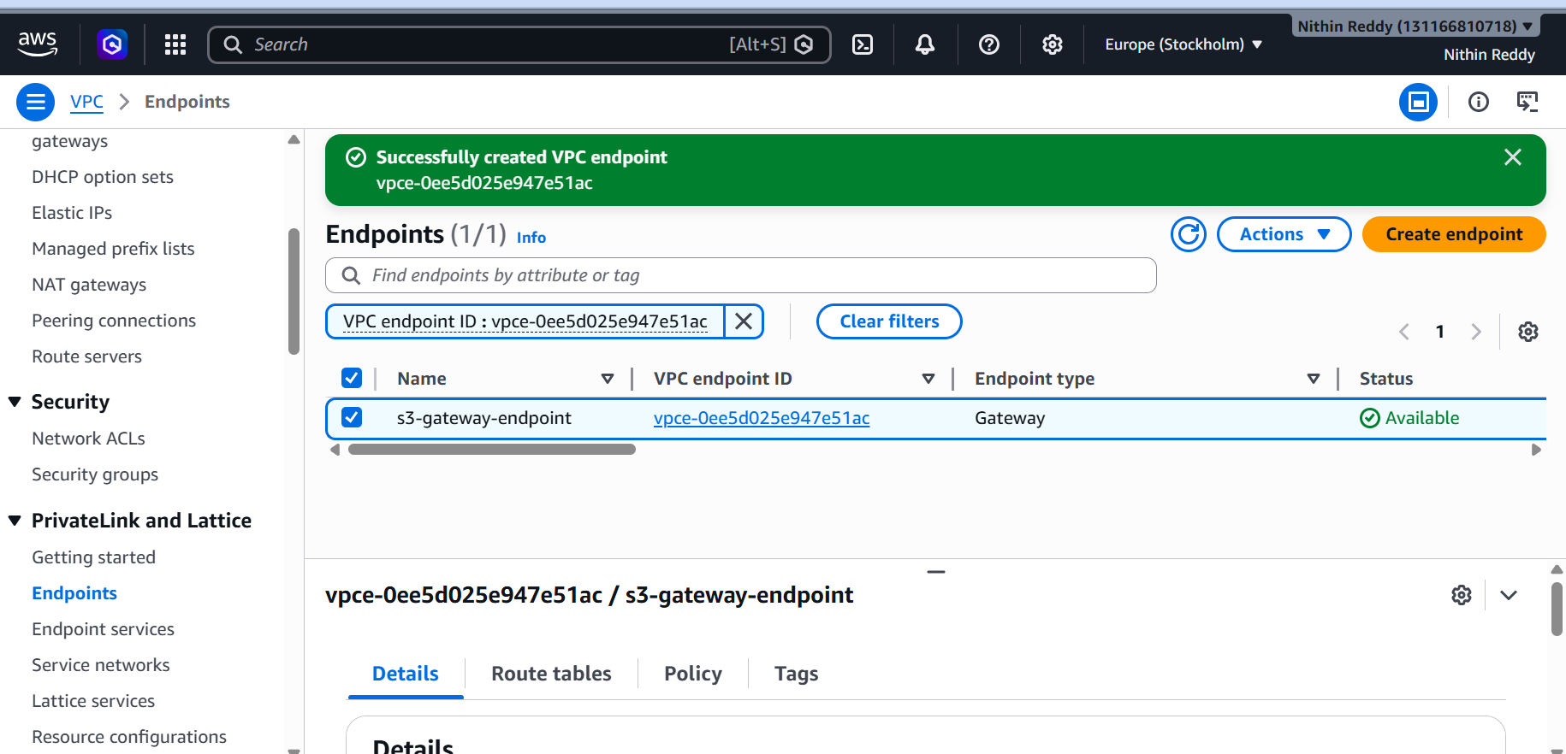
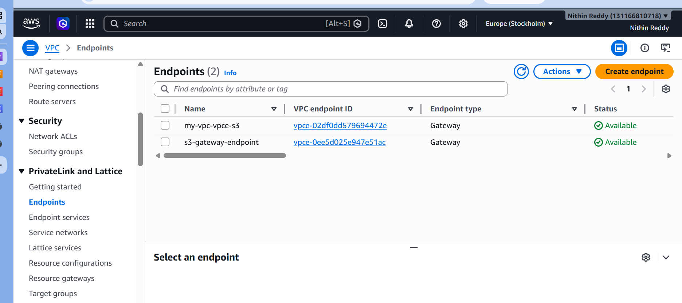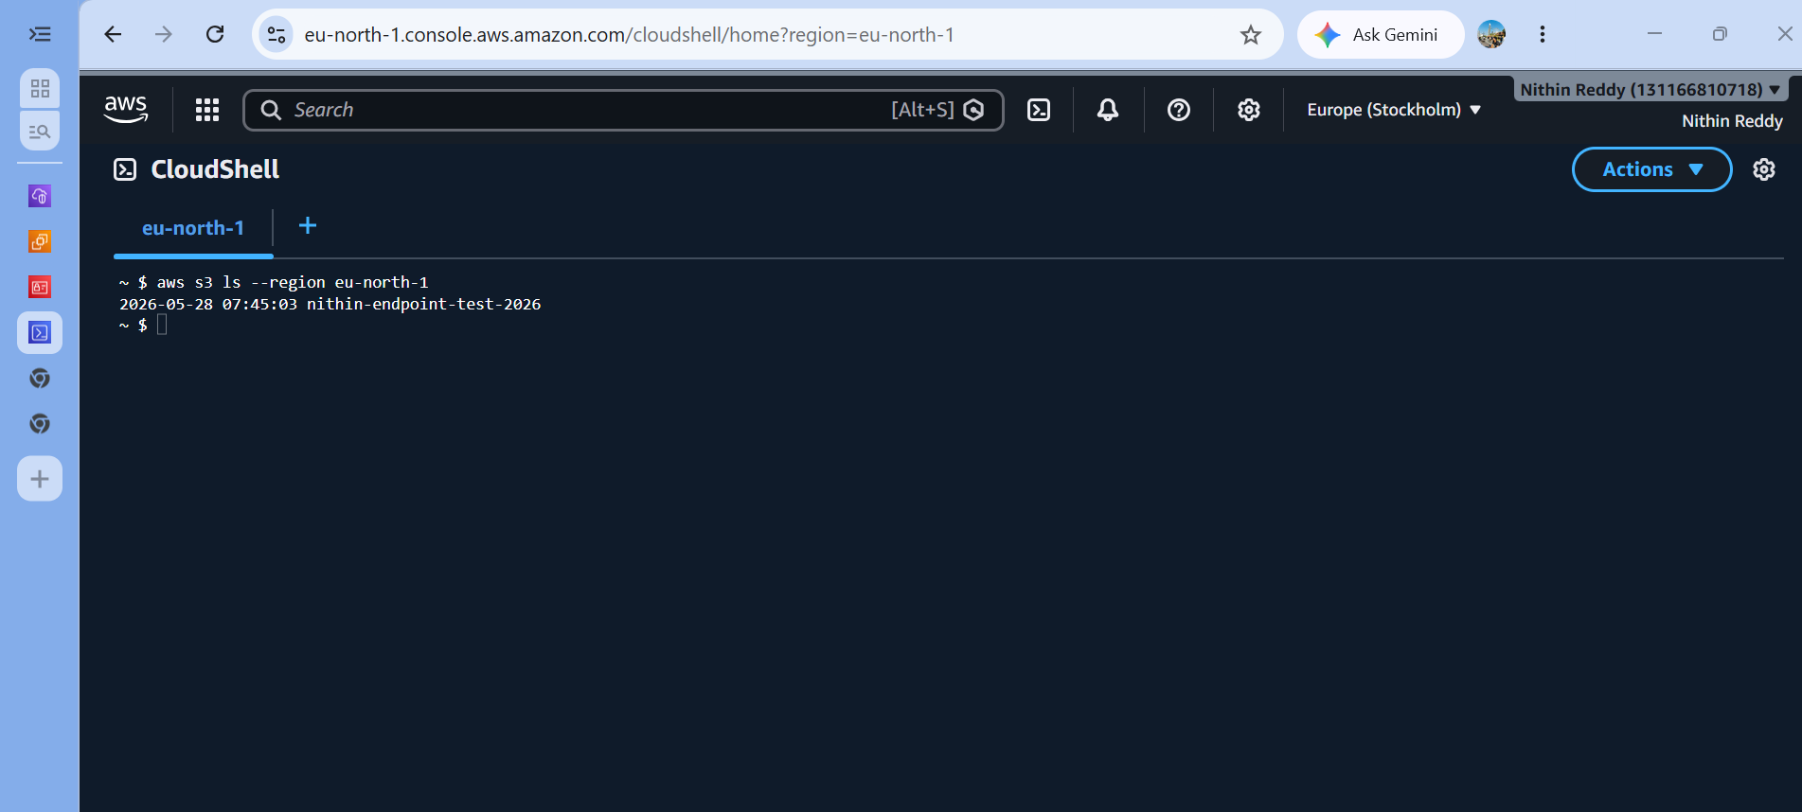
Validation Checklist
□ VPC Endpoint created — state = available
□ Endpoint type = Gateway, service = s3
□ Private route table shows auto-added S3 prefix list route
□ Private EC2 has NO public IP
□ Private EC2 has IAM role with S3 access
□ aws s3 ls works from private EC2
□ curl google.com FAILS from private EC2 (no internet)

Troubleshooting
Problem | Cause | Fix
aws s3 ls shows nothing | IAM role not attached | EC2 → Actions → Security → Modify IAM Role
Unable to locate credentials | No IAM role on EC2 | Attach ec2-s3-endpoint-role to the instance
Access Denied on S3 | Bucket policy or IAM | Use a bucket you own, check IAM role has S3ReadOnly
Can't reach private EC2 | No route or SG | TGW route must exist; SG must allow SSH from 10.0.0.0/16
Route table doesn't show S3 route | Wrong route table selected | Edit endpoint → change route table associations
EndpointRequestTimeout | Region mismatch | Always use --region ap-south-1 in AWS CLI commands
Endpoint shows service not found | Searched wrong service name | Look for com.amazonaws.ap-south-1.s3 Type=Gateway exactly

