Kubernetes-04

Task 1: Deploy an Application Using a Deployment with 3 Replicas and a Rolling Update Strategy
Objective
- Create a Deployment.
- Deploy an Nginx application.
- Configure 3 replicas.
- Use the RollingUpdate strategy.
- Verify Pods and Deployment.
- Understand how rolling updates work.

What is a Deployment?
A Deployment is the most commonly used Kubernetes controller for managing applications.
It provides:
- Pod creation
- Scaling
- Self-healing
- Rolling updates
- Rollbacks
Unlike a Replica Set, a Deployment can update Pods without downtime.

Architecture
Deployment
│
Rolling Update Strategy
│
ReplicaSet
│
┌─────────────┼─────────────┐
▼ ▼ ▼
Nginx Pod1 Nginx Pod2 Nginx Pod3

Prerequisites
kubectl get nodes
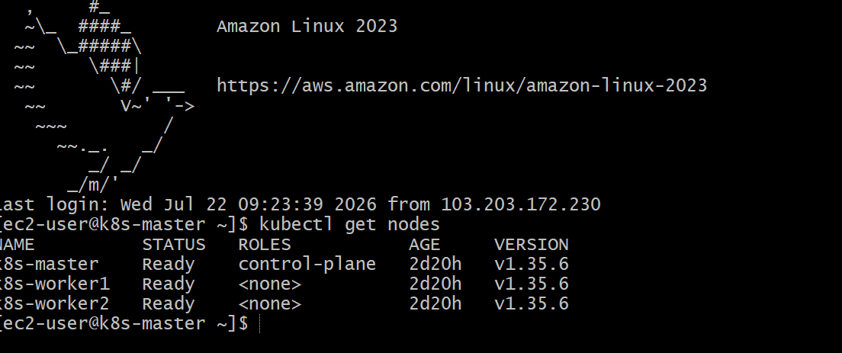
Implementation Steps (Documentation)
- Created a Deployment YAML file.
- Configured 3 replicas.
- Set the update strategy to RollingUpdate.
- Configured maxSurge and maxUnavailable.
- Applied the Deployment.
- Verified the Deployment, ReplicaSet, and Pods.
- Checked rollout status and history.
- Tested self-healing by deleting a Pod.
vi nginx-deployment.yaml
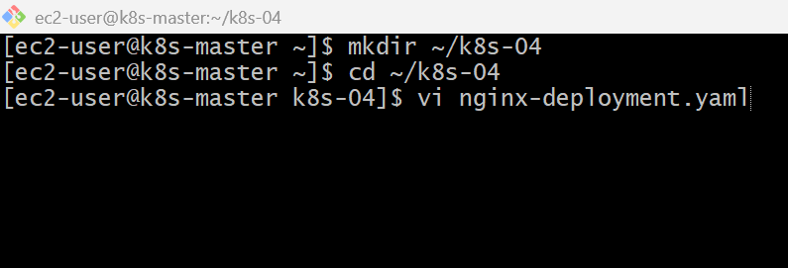

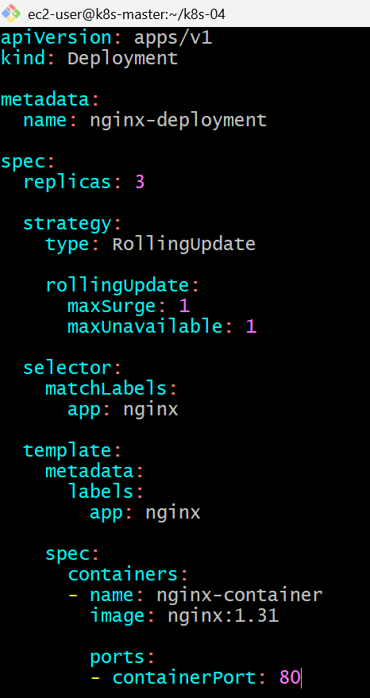
kubectl apply -f nginx-deployment.yaml
kubectl get deployments
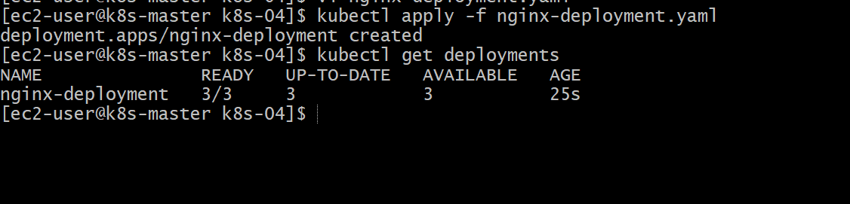

Kubectl get rc
Kubectl get pods -o wide
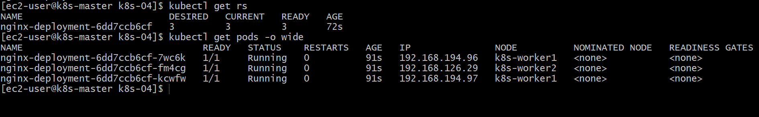
kubectl describe deployment nginx-deployment
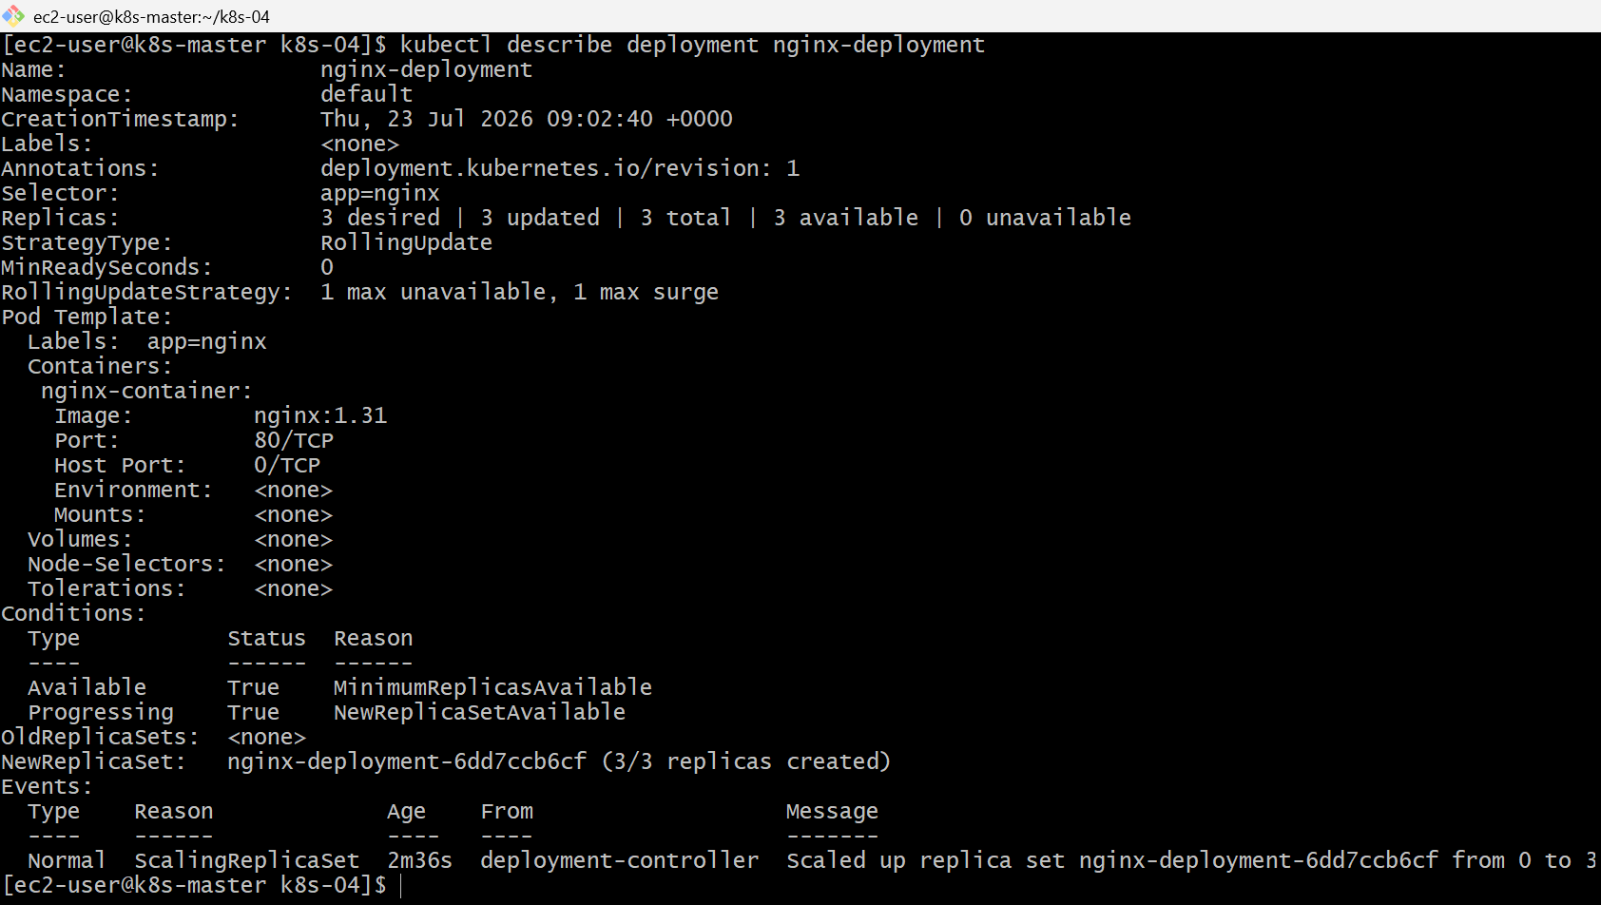
kubectl rollout status deployment/nginx-deployment
kubectl rollout history deployment/nginx-deployment
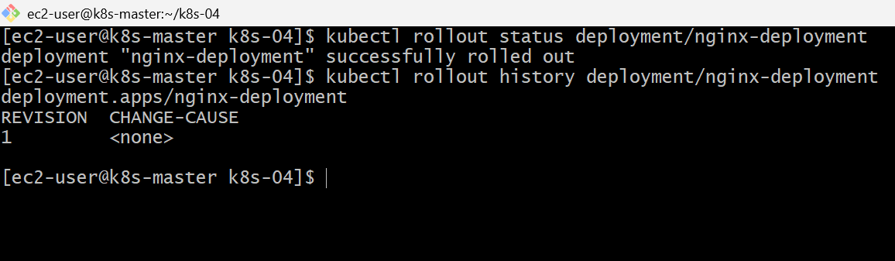

Kubectl get pods
kubectl delete pod nginx-deployment-6dd7ccb6cf-7wc6k
it got deleted and created new one
nginx-deployment-6dd7ccb6cf-4qfnz
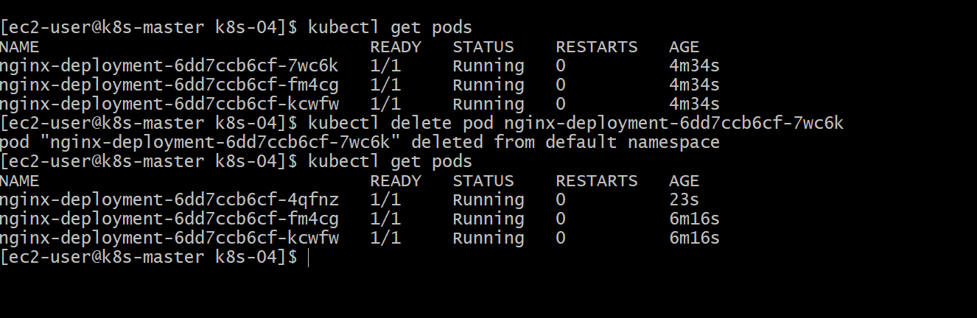
Validation Points
- Created a Deployment using a YAML file.
- Configured 3 replicas.
- Configured the RollingUpdate strategy.
- Verified the Deployment using kubectl get deployments.
- Verified the ReplicaSet using kubectl get rs.
- Verified that 3 Pods were running.
- Checked the rollout status and rollout history.
- Verified self-healing by deleting a Pod.

Outcome
- Successfully deployed an Nginx application using a Kubernetes Deployment.
- Configured three replicas with a RollingUpdate strategy.
- Verified that the Deployment created and managed a ReplicaSet.
- Confirmed automatic Pod recreation and rollout management.
Task 2: Configure a Deployment with a Recreate Strategy and Observe the Downtime
Objective
- Create a Deployment with 3 replicas.
- Use the Recreate strategy instead of RollingUpdate.
- Observe that the old Pods are terminated before the new Pods are created, causing temporary downtime.

What is the Recreate Strategy?
With the Recreate strategy, Kubernetes:
- Stops all existing Pods.
- Waits for them to terminate.
- Creates new Pods with the updated version.
Unlike RollingUpdate, there will be a brief period when no Pods are running, resulting in downtime.
Implementation Steps
- Created a Deployment YAML file named recreate-deployment.yaml.
- Configured the Deployment with 3 replicas.
- Set the deployment strategy to Recreate.
- Specified the Nginx container image and exposed container port 80.
- Applied the Deployment using kubectl apply -f recreate-deployment.yaml.
- Verified the Deployment status using kubectl get deployment.
- Verified that all three Pods were created and running using kubectl get pods -o wide.
- Modified the Deployment by updating the container image version.
- Reapplied the updated YAML using kubectl apply.
- Monitored the Pods during the update using kubectl get pods -w.
- Observed that all existing Pods were terminated before new Pods were created, resulting in temporary downtime.
- Verified the rollout status using kubectl rollout status deployment/recreate-deployment.
- Confirmed the deployment strategy was Recreate using kubectl describe deployment recreate-deployment.

vi recreate-deployment.yaml
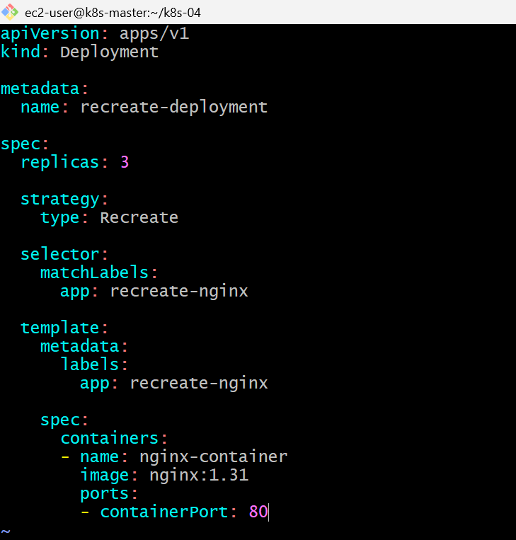

kubectl apply -f recreate-deployment.yaml
kubectl get deployment
kubectl get pods -o wide
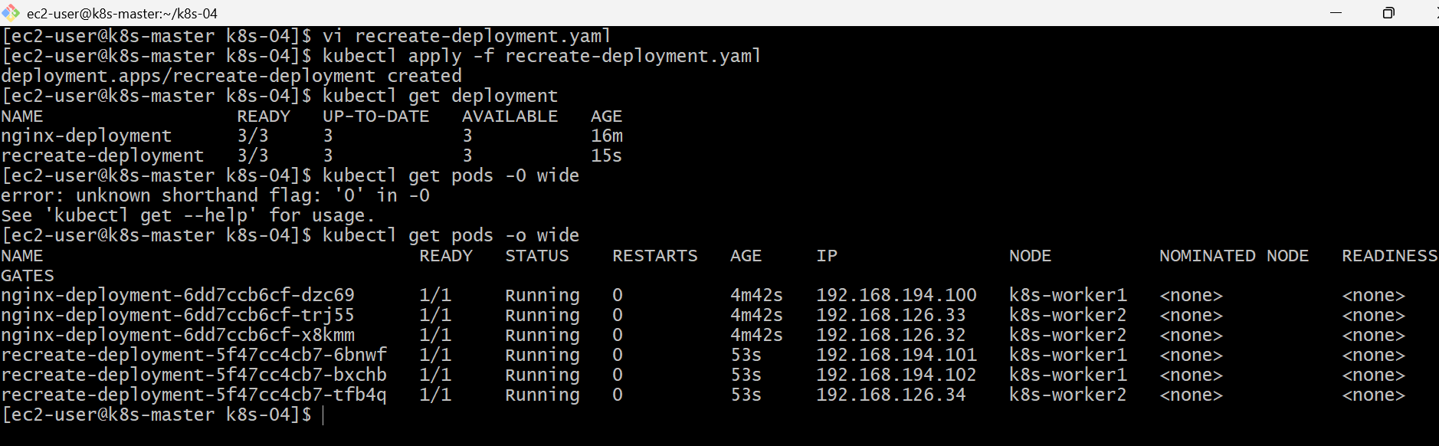
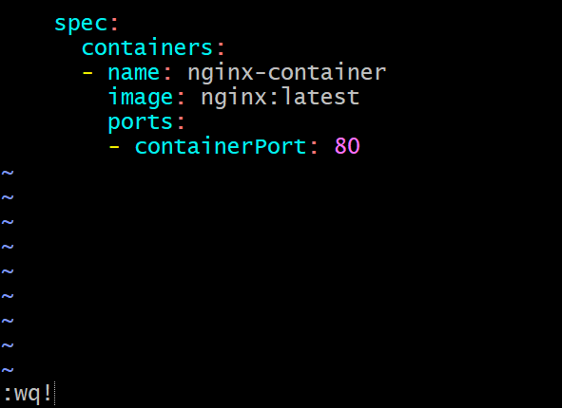
kubectl apply -f recreate-deployment.yaml
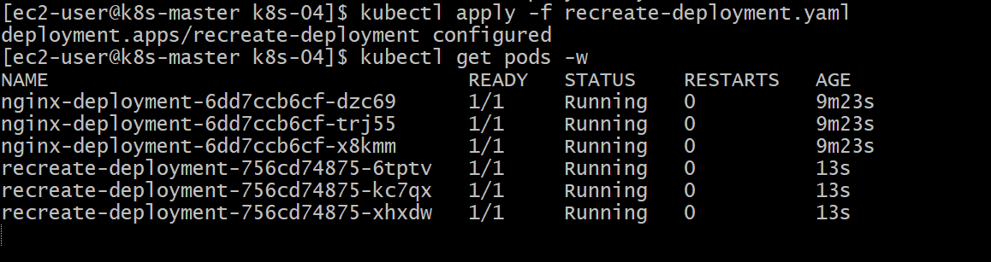

kubectl rollout status deployment/recreate-deployment
kubectl describe deployment recreate-deployment
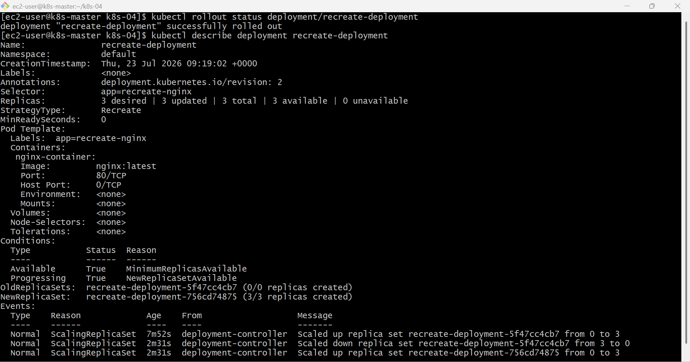
kubectl rollout history deployment recreate-deployment
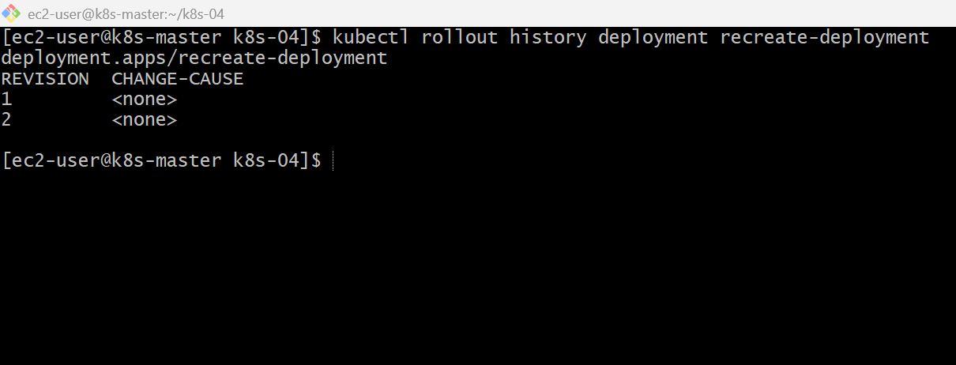

Validation Points
- Created a Deployment with the Recreate strategy.
- Verified that 3 Pods were running.
- Updated the Deployment image.
- Observed all old Pods terminating before new Pods were created.
- Verified the rollout status.
- Confirmed the Deployment strategy using kubectl describe.

Outcome
- Successfully deployed an application using the Recreate strategy.
- Observed temporary downtime during the update process.
- Understood the difference between Recreate and RollingUpdate strategies.
- Verified the Deployment update and rollout history.

Task 3: Update an Existing Deployment and Perform a Rollback to the Previous Version
Objective
- Update an existing Deployment.
- Verify the new version is deployed.
- Check rollout history.
- Roll back to the previous version if required.

Real-World Scenario
Suppose your application is running with:
nginx:1.31
A new version is released:
nginx:latest
After deployment, users report issues. Instead of creating a new Deployment, Kubernetes lets you roll back to the previous working version.
Implementation Steps (for Documentation)
- Verified the existing Deployment.
- Checked the current container image.
- Updated the Deployment image using kubectl set image.
- Monitored the rollout status.
- Verified the updated image version.
- Viewed the rollout revision history.
- Rolled back the Deployment using kubectl rollout undo.
- Verified the rollback was successful.
- Confirmed the previous image version was restored.
Kubectl get deployment
kubectl describe deployment nginx-deployment
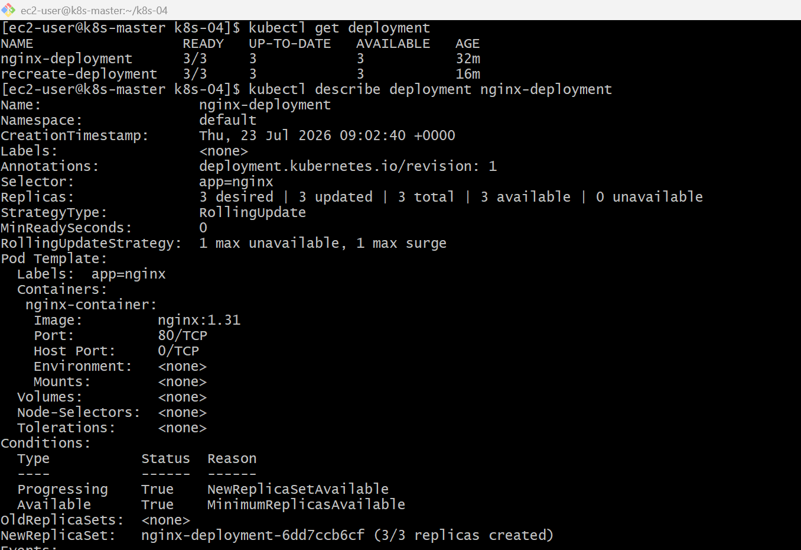
kubectl set image deployment/nginx-deployment nginx-container=nginx:latest
kubectl rollout status deployment/nginx-deployment
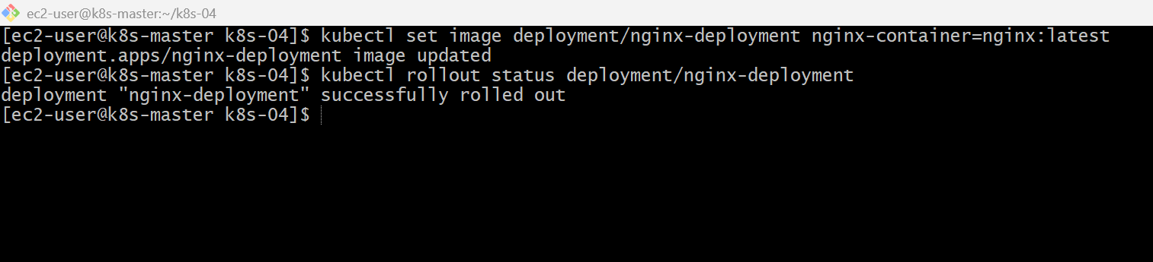

kubectl describe deployment nginx-deployment
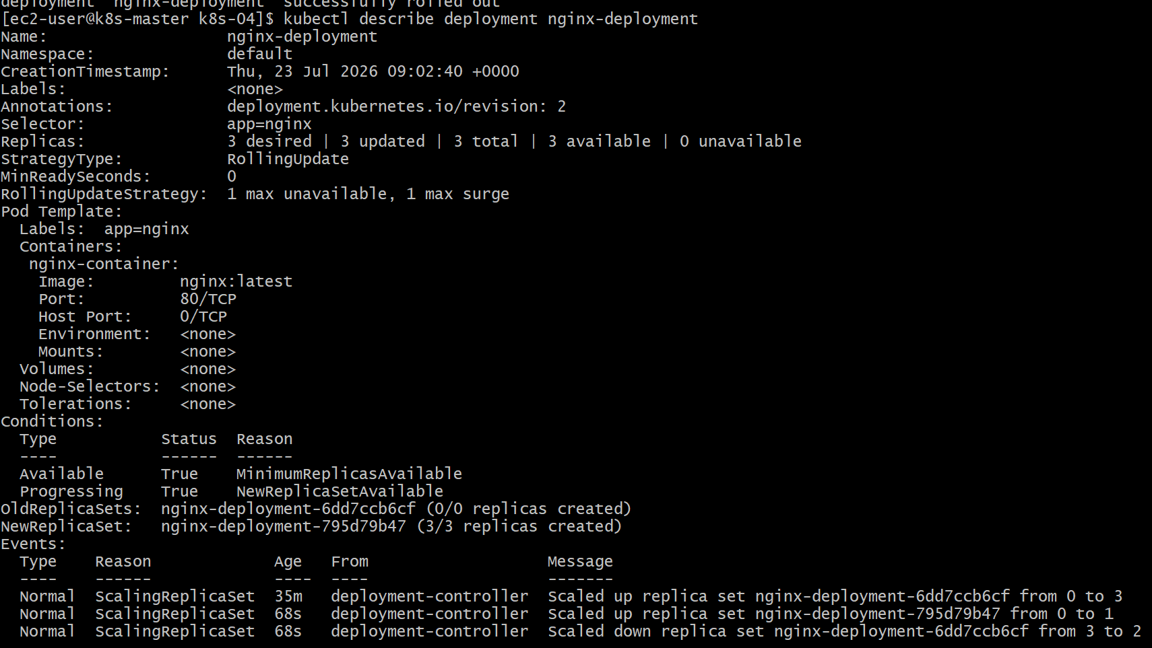
kubectl rollout history deployment/nginx-deployment
kubectl rollout undo deployment/nginx-deployment
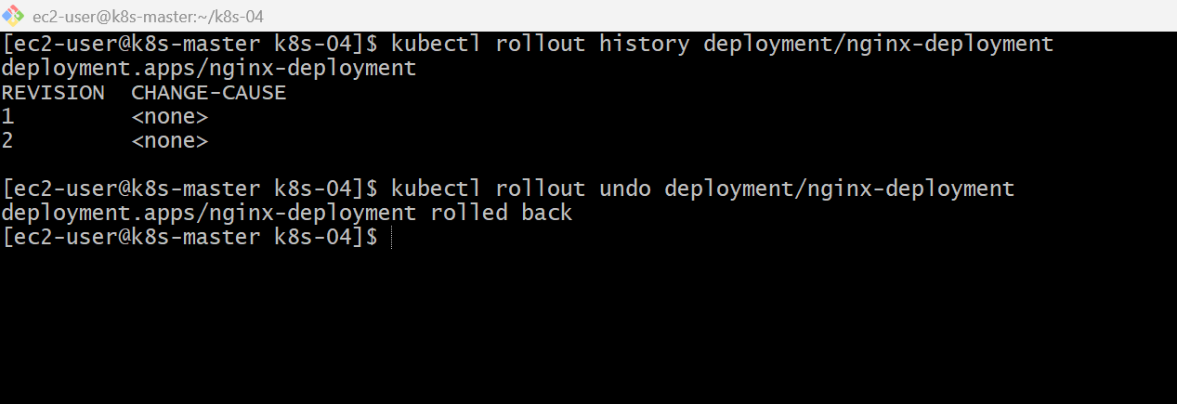
kubectl rollout status deployment/nginx-deployment
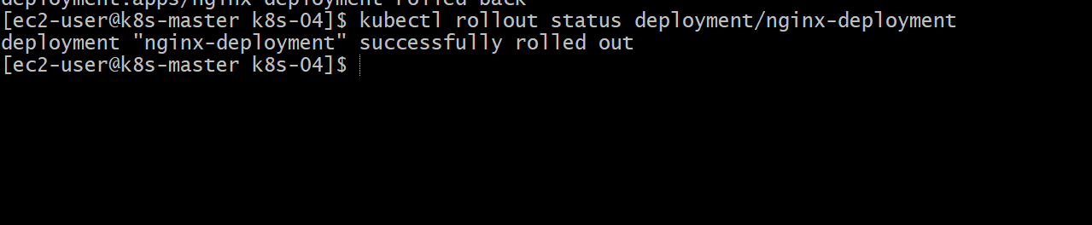
kubectl describe deployment nginx-deployment
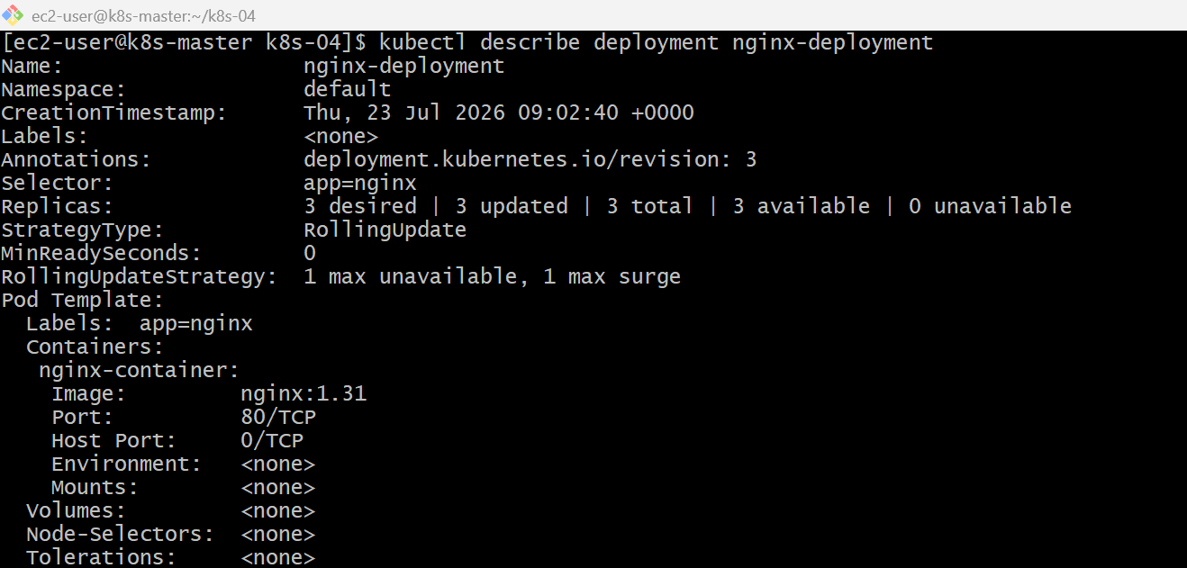
kubectl rollout history deployment/nginx-deployment
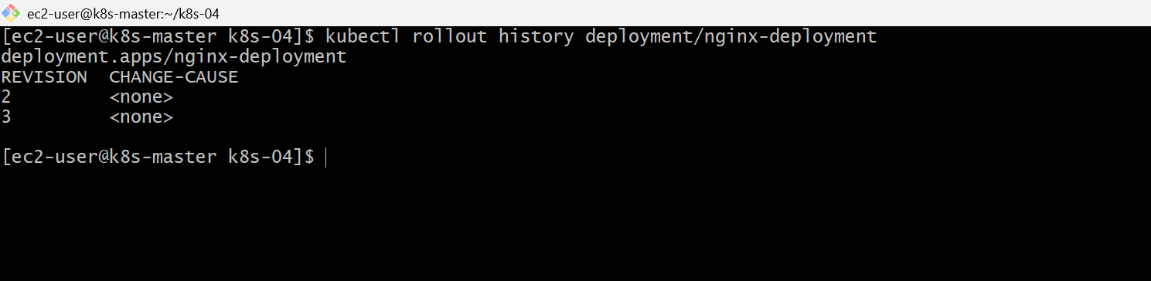
Validation Points
- Verified the existing Deployment. Updated the container image.
- Confirmed the rollout completed successfully.
- Verified the updated image version. Checked the rollout history.
- Performed a rollback to the previous version. Confirmed the original image was restored.
Outcome
- Successfully updated a Deployment with a new container image. Verified the rollout process.
- Performed a rollback to restore the previous stable version.
- Understood how Deployment revisions help recover quickly from failed releases.
Task 4: Modify a Deployment to Add Resource Requests and Limits for CPU and Memory
Objective
- Add CPU and Memory Requests.
- Add CPU and Memory Limits.
- Apply the Deployment.
- Verify the resource configuration.
What are Requests and Limits?
Resource Requests
The minimum resources guaranteed to a container.
Architecture
Deployment
│
ReplicaSet
│
┌──────────────┐
│ Nginx Pod │
│ CPU Request │
│ CPU Limit │
│ MEM Request │
│ MEM Limit │
└──────────────┘

Implementation Steps (Documentation)
- Opened the existing Deployment configuration.
- Added CPU and memory resource requests.
- Added CPU and memory resource limits.
- Saved and applied the updated Deployment.
- Verified the Deployment status.
- Verified the Pods were recreated successfully.
- Confirmed the resource configuration using kubectl describe pod.
kubectl edit deployment nginx-deployment
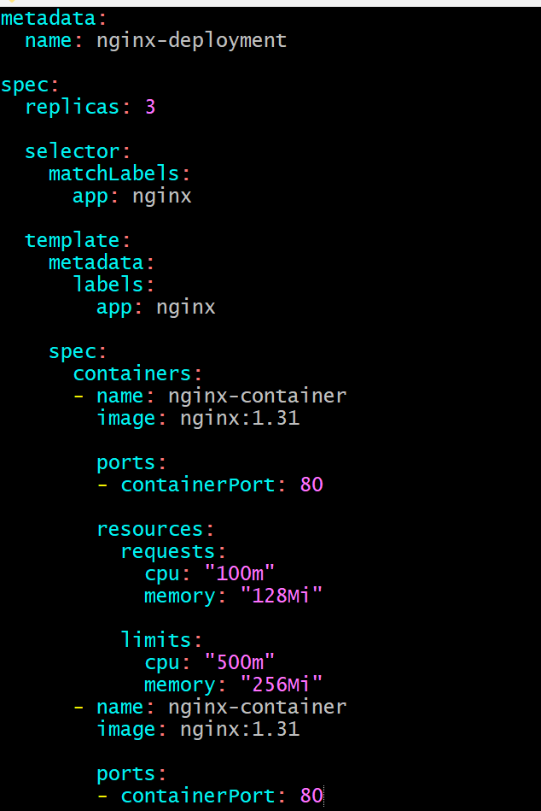

kubectl apply -f nginx-deployment.yaml
kubectl get deployments
kubectl get pods
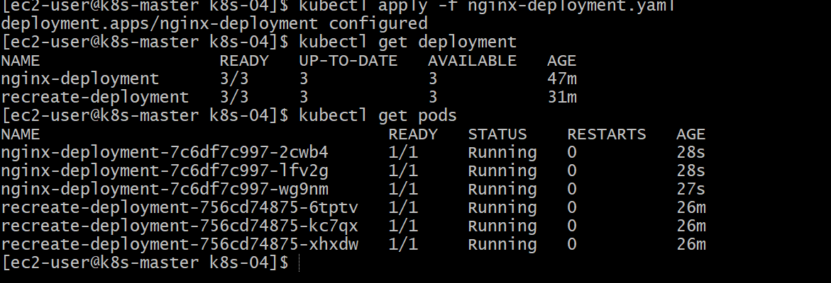
Kubectl describe pod podname
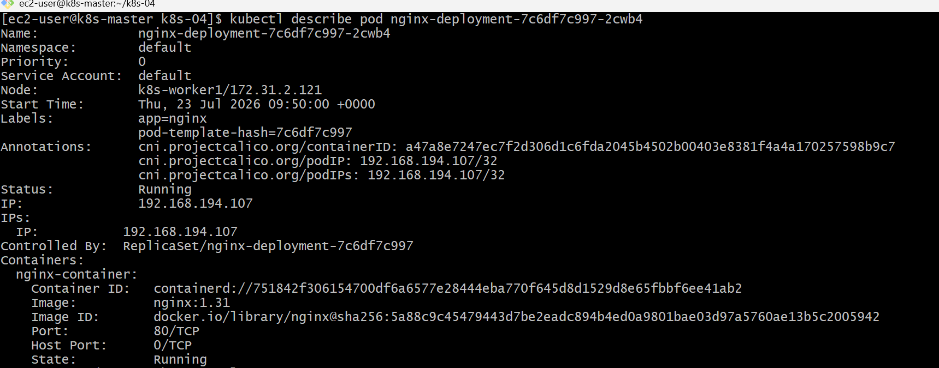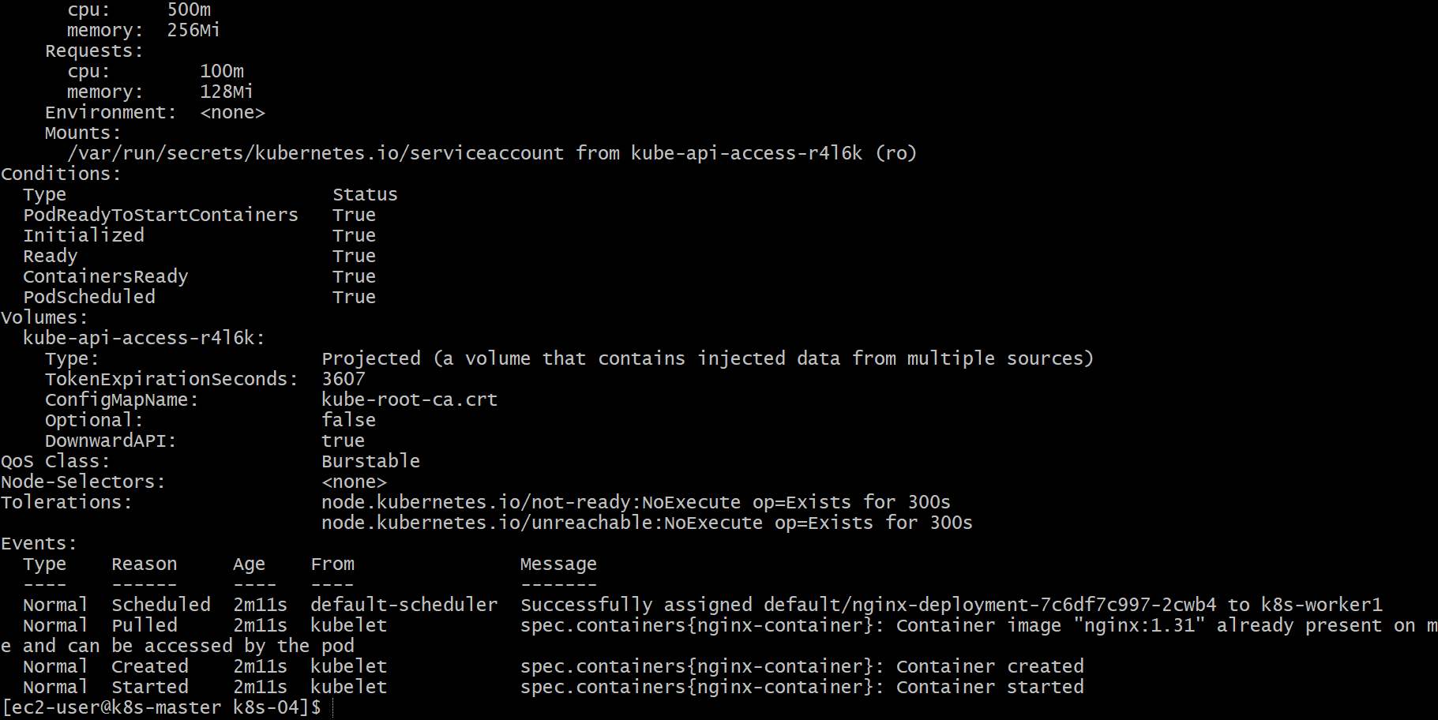

Kubectl get pods
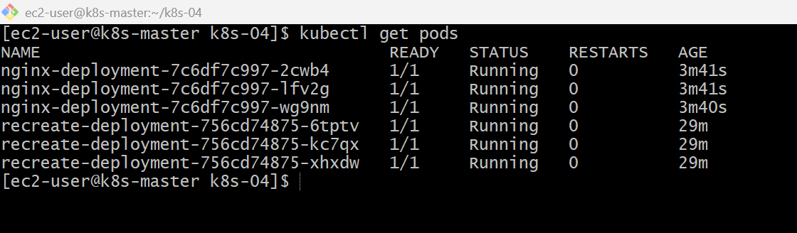
Validation Points
- Added CPU requests and limits.
- Added memory requests and limits.
- Applied the updated Deployment.
- Verified the Deployment was running successfully.
- Verified resource settings using kubectl describe pod.
Outcome
- Successfully configured CPU and memory requests and limits for a Deployment.
- Verified that Kubernetes applied the resource configuration.
- Understood how requests influence scheduling and limits control resource consumption.

Task 5: Create a Deployment with Max Surge and Max Unavailable Configurations
Objective
- Create a Deployment with 3 replicas.
- Configure Rolling Update strategy.
- Set max Surge and max Unavailable values.
- Update the Deployment and observe the rolling update behavior.
What are Max Surge and Max Unavailable?
During a rolling update, Kubernetes updates Pods gradually.
Max Surge
Specifies the maximum number of extra Pods that can be created above the desired replicas during an update.
Implementation Steps (Documentation)
- Created a Deployment YAML file.
- Configured 3 replicas.
- Set the Deployment strategy to RollingUpdate.
- Configured maxSurge: 1.
- Configured maxUnavailable: 1.
- Applied the Deployment using kubectl apply.
- Verified the Deployment and Pods.
- Updated the container image version.
- Monitored the rolling update using kubectl get pods -w.
- Verified the rollout status and Deployment strategy.

vi surge-deployment.yaml
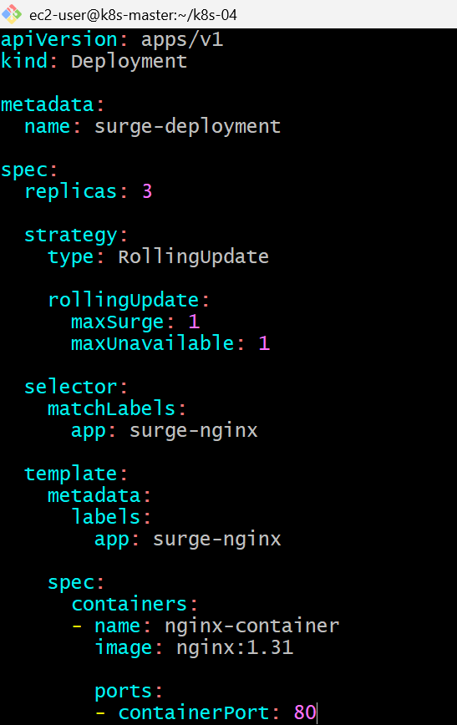
kubectl apply -f surge-deployment.yaml
kubectl get deployment
kubectl get pods -o wide
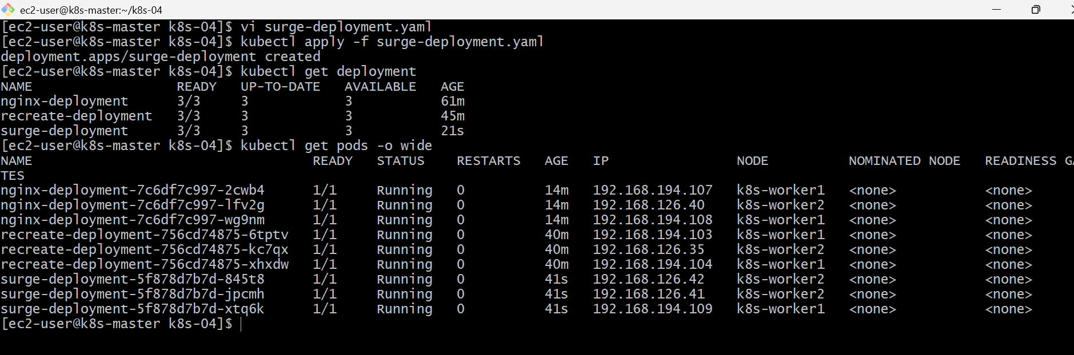
vi surge-deployment.yaml
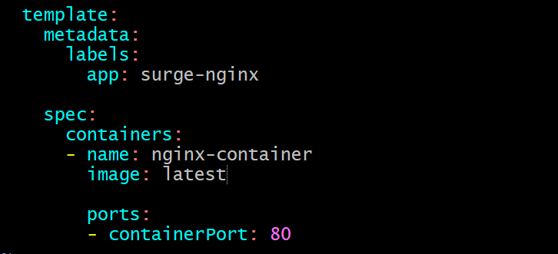
kubectl apply -f surge-deployment.yaml
kubectl get pods -w
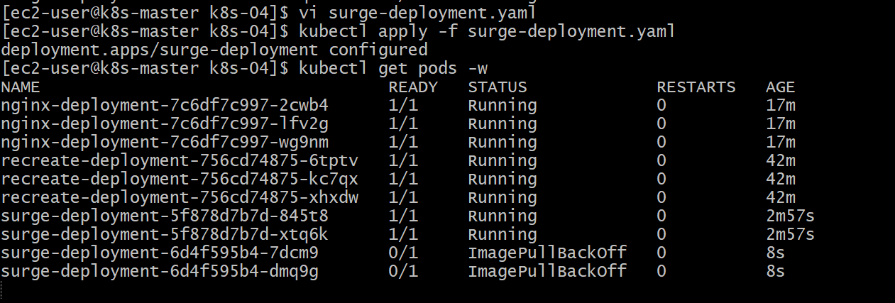

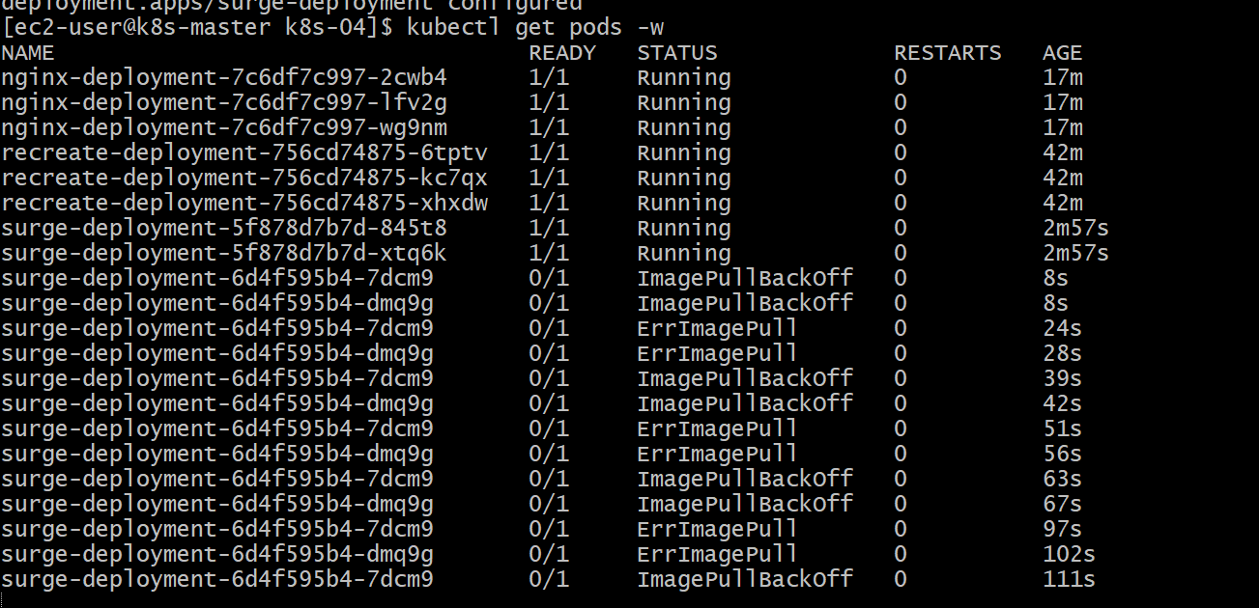

Validation Points
- Created a Deployment with 3 replicas.
- Configured the RollingUpdate strategy.
- Set maxSurge to 1.
- Set maxUnavailable to 1.
- Updated the container image.
- Observed the rolling update process.
- Verified the Deployment strategy using kubectl describe.

Outcome
- Successfully configured a Deployment with RollingUpdate strategy.
- Controlled the rolling update process using maxSurge and maxUnavailable.
- Verified that Pods were updated gradually with minimal disruption.
- Understood how Kubernetes performs zero-downtime deployments.

Task 6: Set Up a Deployment with a Custom Revision History Limit
Objective
- Create a Deployment.
- Configure a custom revisionHistoryLimit.
- Perform multiple updates.
- Verify that Kubernetes retains only the specified number of Deployment revisions.
What is revisionHistoryLimit?
Every time you update a Deployment, Kubernetes creates a new ReplicaSet (revision).
By default, Kubernetes keeps several old ReplicaSets so you can roll back.
The revisionHistoryLimit field controls how many old ReplicaSets are retained.
Implementation Steps (Documentation)
- Created a Deployment YAML file.
- Configured revisionHistoryLimit: 3.
- Applied the Deployment using kubectl apply.
- Verified the Deployment status.
- Updated the Deployment multiple times to generate new revisions.
- Verified the rollout history.
- Confirmed that older ReplicaSets were automatically removed after the limit was exceeded.
- Verified the revision history limit using kubectl describe deployment.

vi revision-deployment.yaml
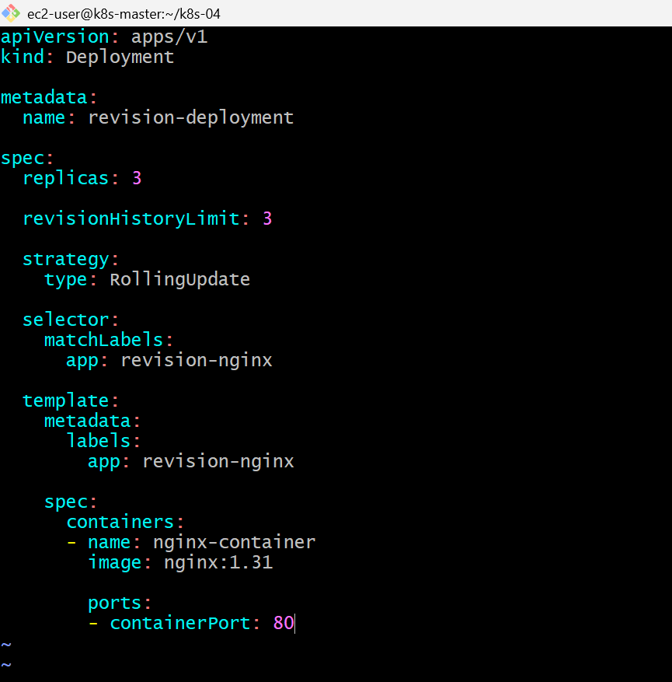

kubectl apply -f revision-deployment.yaml
kubectl get deployment
kubectl get rs
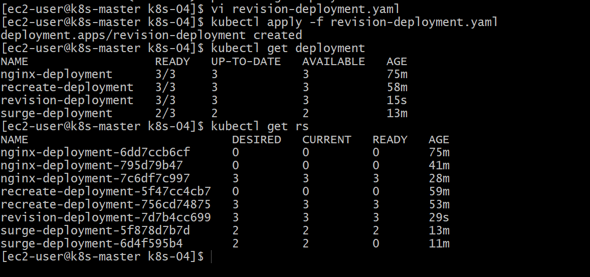
vi revision-deployment.yaml
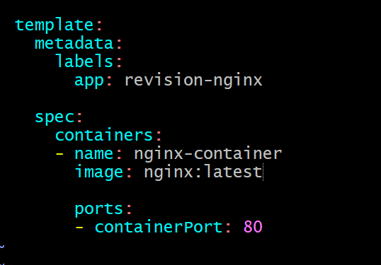
kubectl apply -f revision-deployment.yaml
kubectl rollout history deployment revision-deployment
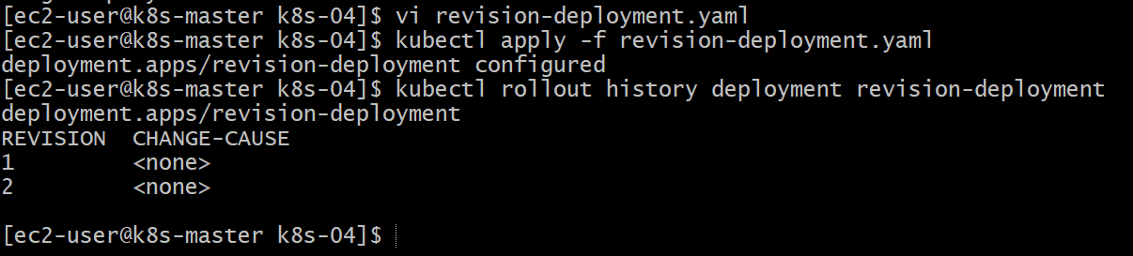
kubectl get rs
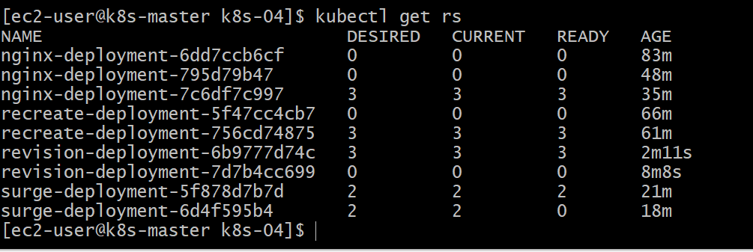
kubectl describe deployment revision-deployment
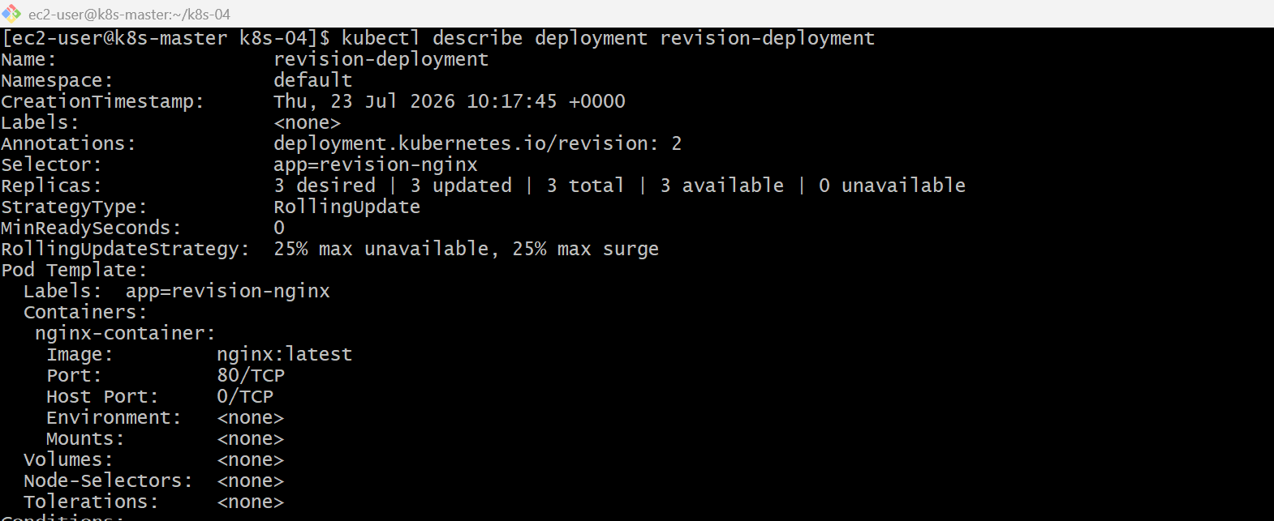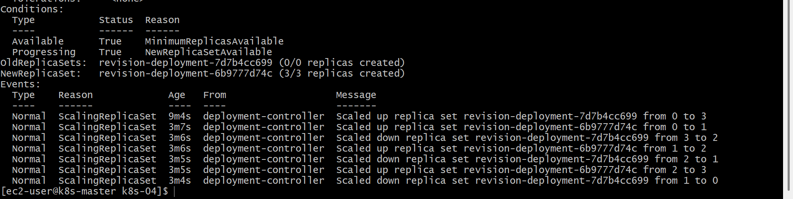

Validation Points
- Created a Deployment with revisionHistoryLimit.
- Configured the revision history limit to 3.
- Performed multiple Deployment updates.
- Verified rollout history.
- Confirmed that old ReplicaSets were automatically removed after exceeding the configured limit.

Outcome
- Successfully configured a custom revision history limit for a Deployment.
- Verified that Kubernetes retained only the configured number of Deployment revisions.
- Learned how revision history helps balance rollback capability and resource cleanup.

Task 7: Pause a Deployment During an Update, and Then Resume It
Objective
- Pause a Deployment before completing an update.
- Make changes while the Deployment is paused.
- Verify that no rollout occurs during the pause.
- Resume the Deployment and complete the rollout.
What is a Paused Deployment?
Normally, when you update a Deployment, Kubernetes immediately starts a rolling update.
If you pause the Deployment:
- Changes are accepted and stored.
- Kubernetes does not create new Pods.
- The rollout starts only after you resume the Deployment.
This is useful when you want to make multiple changes and deploy them together.
Implementation Steps (Documentation)
- Verified the existing Deployment.
- Paused the Deployment using kubectl rollout pause.
- Confirmed the Deployment entered the paused state.
- Updated the Deployment image while it was paused.
- Verified that no rollout occurred during the pause.
- Resumed the Deployment using kubectl rollout resume.
- Verified the rollout completed successfully.
- Confirmed the updated Pods were running.

kubectl get deployment
kubectl rollout pause deployment/nginx-deployment
kubectl describe deployment nginx-deployment
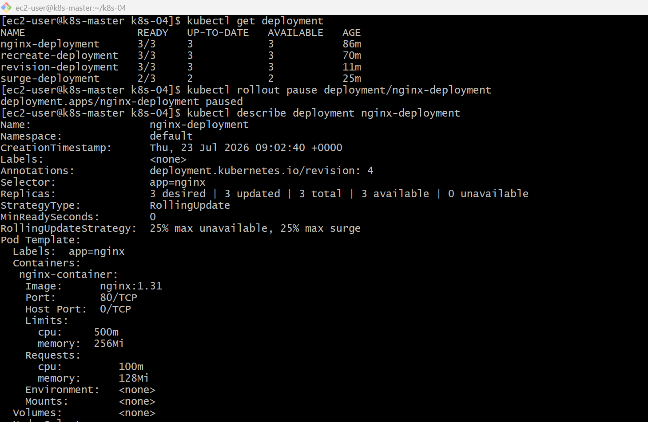
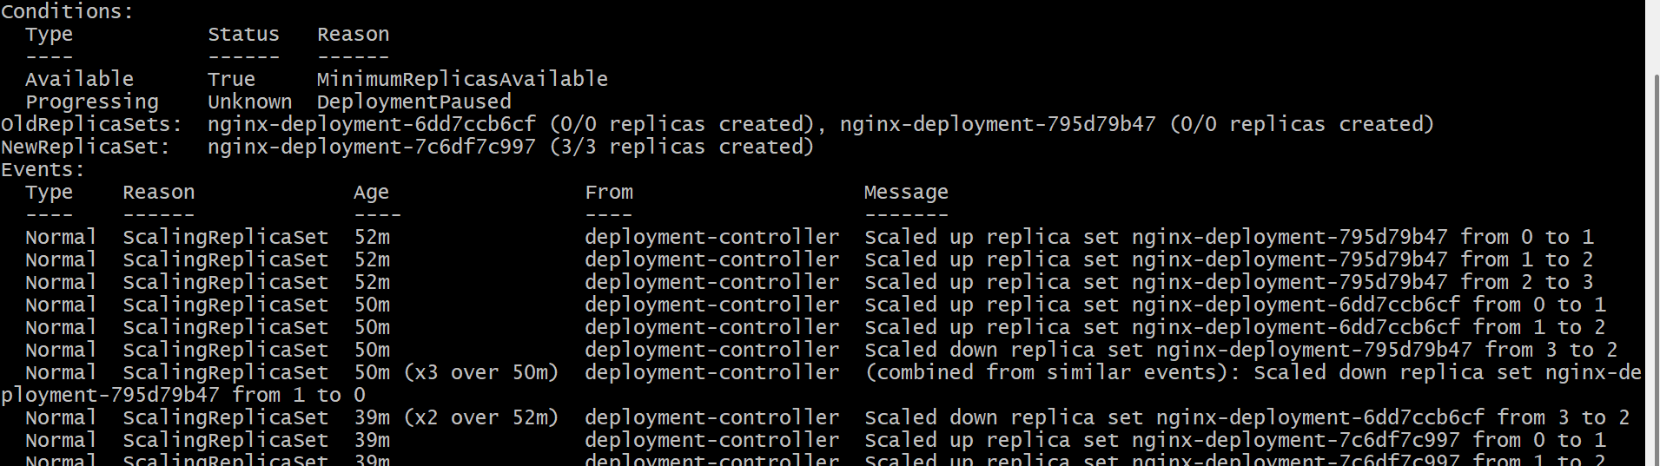

kubectl get pods
kubectl rollout status deployment/nginx-deployment
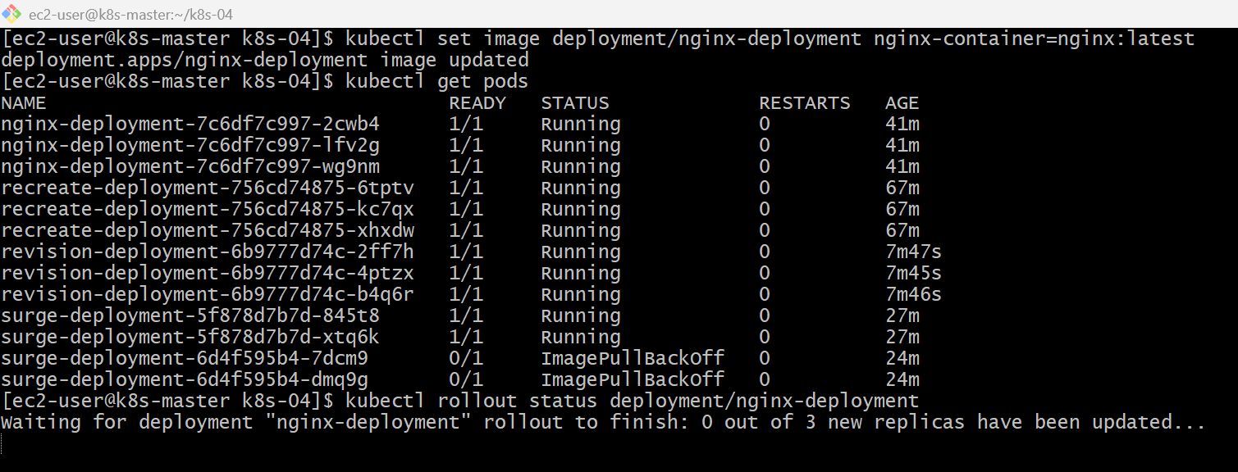
kubectl rollout status deployment/nginx-deployment
kubectl get pods
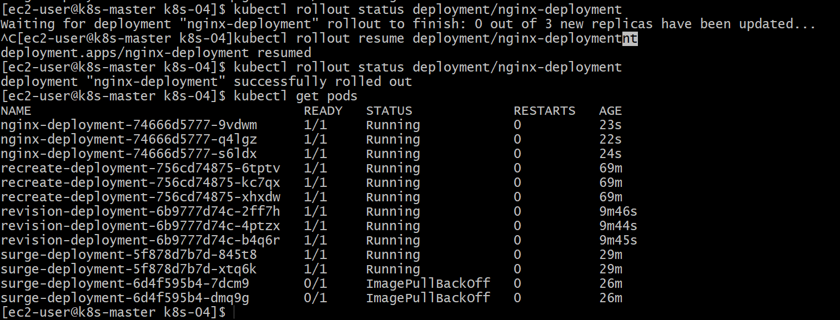

kubectl describe deployment nginx-deployment
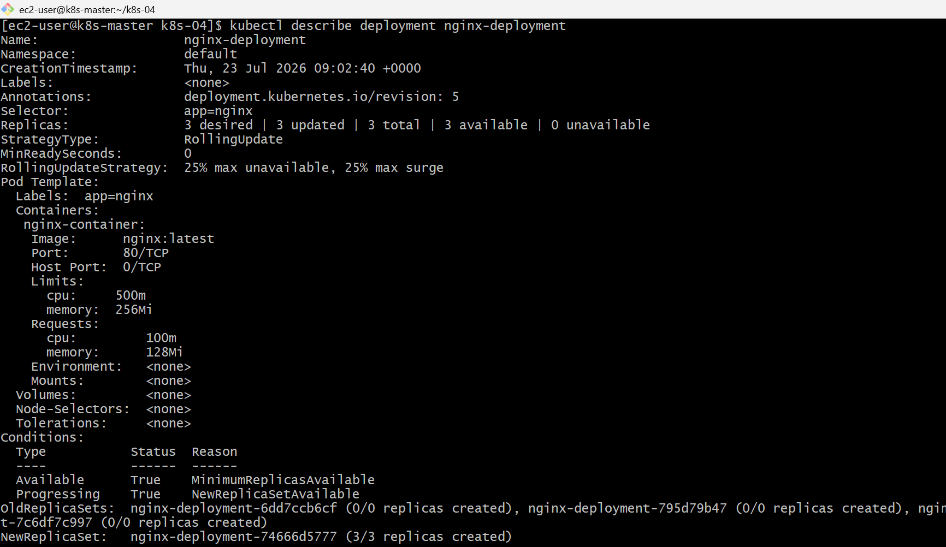
Validation Points
- Verified the Deployment.
- Paused the Deployment successfully.
- Updated the Deployment while it was paused.
- Verified that no Pods were recreated during the pause.
- Resumed the Deployment.
- Verified the rollout completed successfully.
- Confirmed the updated image was running.

Outcome
- Successfully paused a Deployment before updating it.
- Applied changes without triggering an immediate rollout.
- Resumed the Deployment to complete a single rolling update.
- Learned how pausing a Deployment helps batch multiple configuration changes efficiently.
Task 8: Create a Pod Using Resource Requests for Memory and CPU, and Observe How the Scheduler Assigns It to a Node
Objective
- Create a Pod with CPU and Memory requests.
- Apply the Pod.
- Verify the Pod is scheduled to a node.
- Observe how the Kubernetes scheduler uses resource requests to select a node.

What is Resource Scheduling?
When you create a Pod, the Kubernetes Scheduler checks:
- Available CPU on each node.
- Available Memory on each node.
- Resource requests specified in the Pod.
It schedules the Pod on a node that has enough free resources
Implementation Steps (Documentation)
- Created a Pod YAML file with CPU and memory requests.
- Configured CPU and memory limits.
- Applied the Pod configuration using kubectl apply.
- Verified the Pod status.
- Checked the node assigned to the Pod using kubectl get pods -o wide.
- Verified the configured resource requests and limits.
- Examined the selected node's allocated resources using kubectl describe node

vi resource-pod.yaml
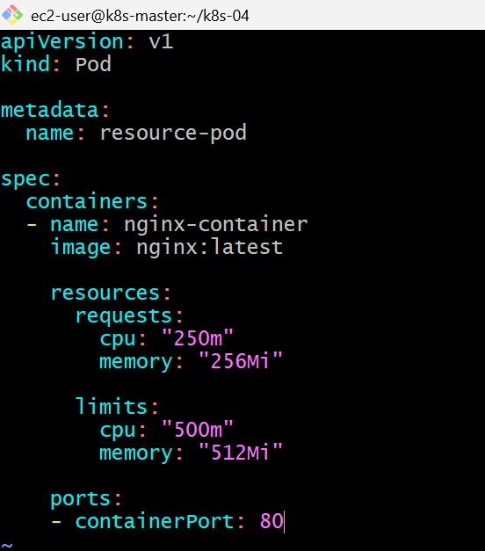
kubectl apply -f resource-pod.yaml
kubectl get pods
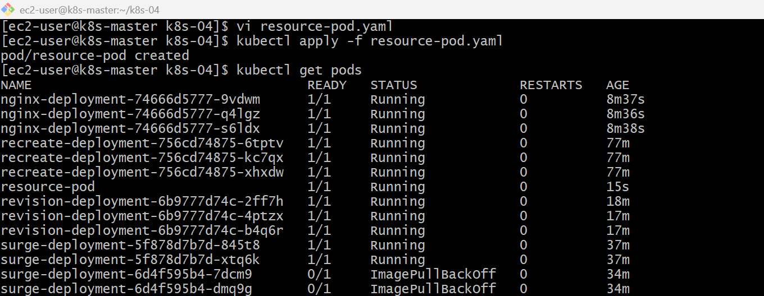

kubectl get pods -o wide
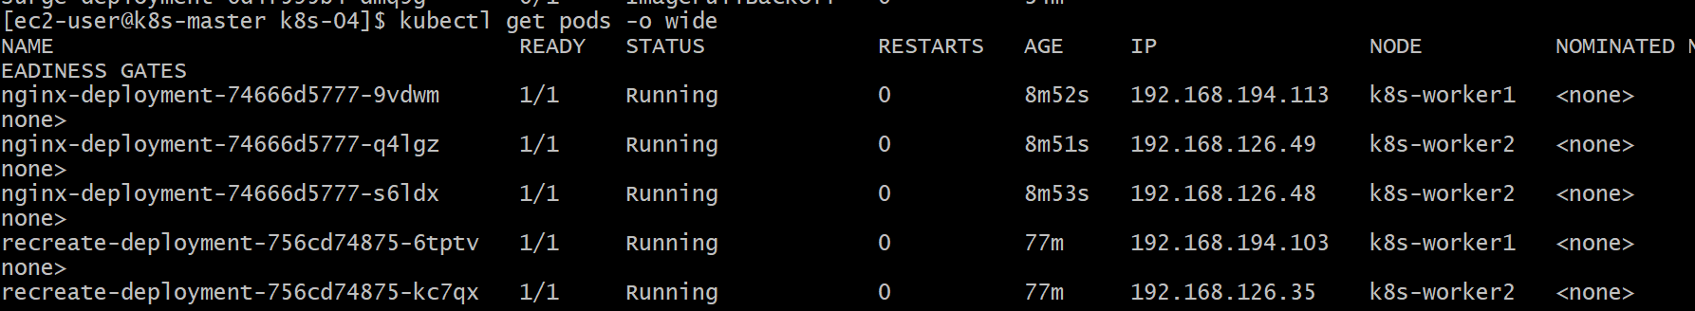
kubectl describe pod resource-pod
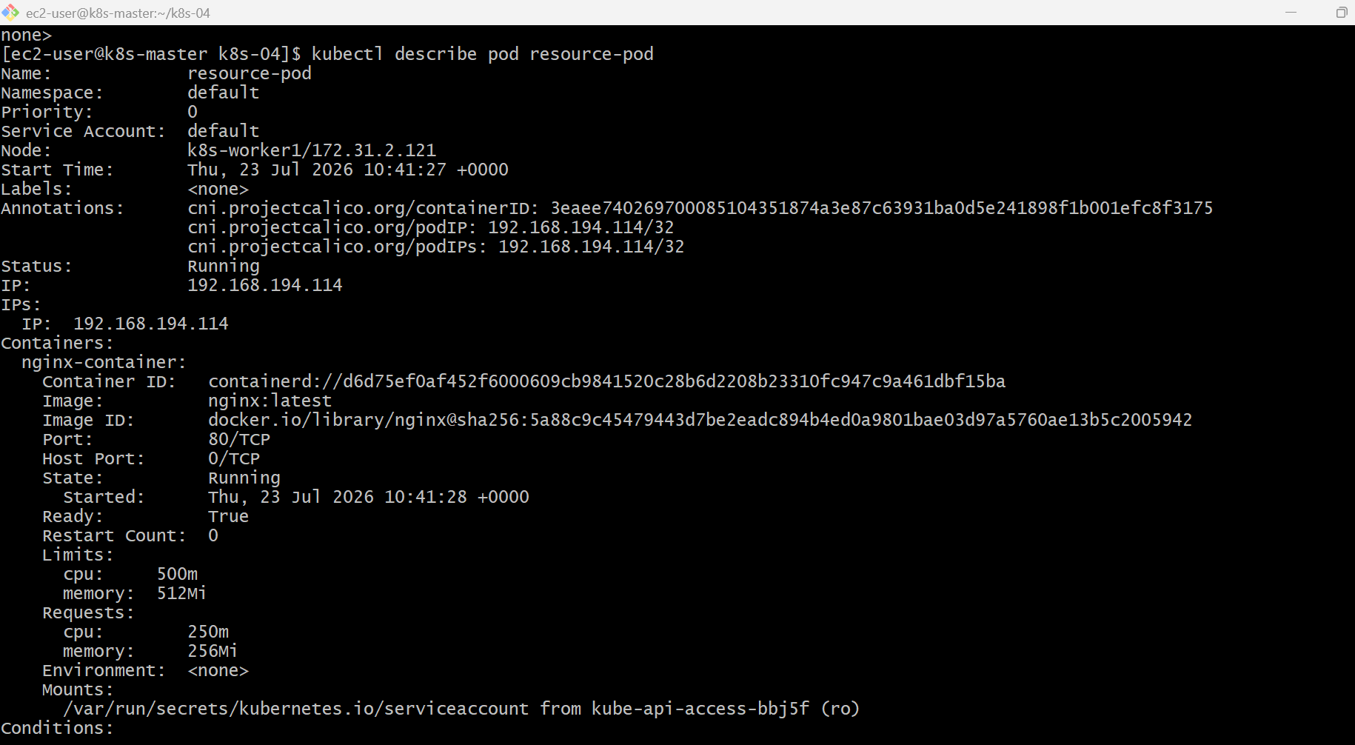
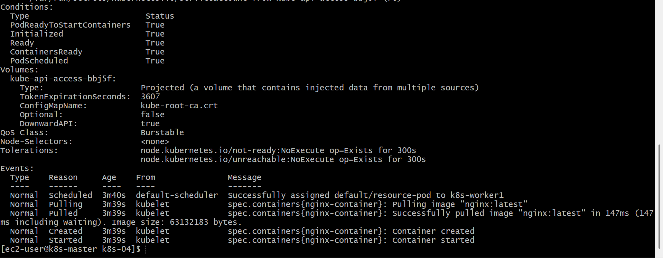

kubectl describe node k8s-worker1
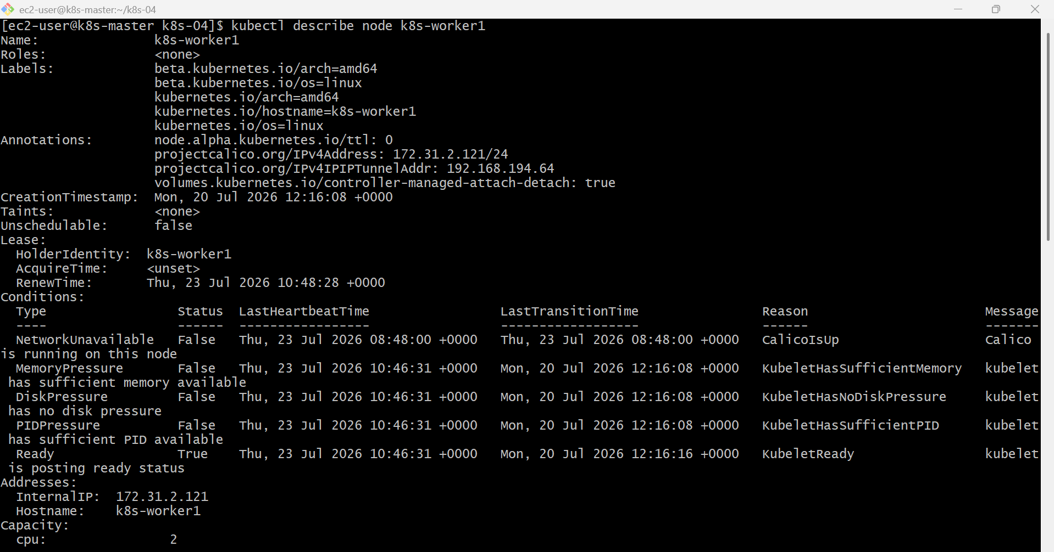
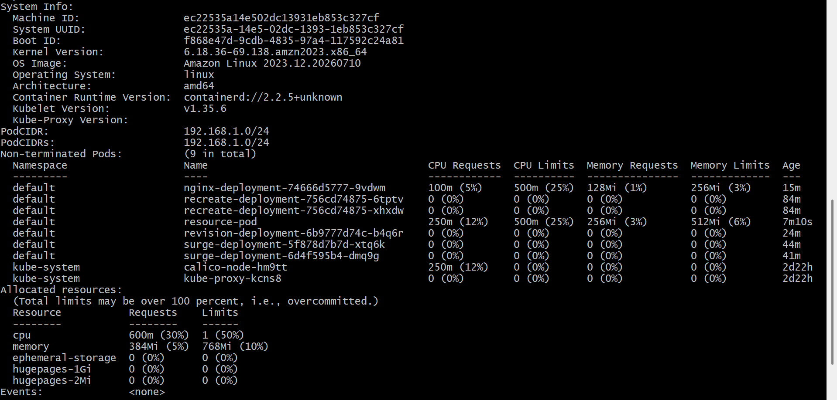
Kubectl get nodes
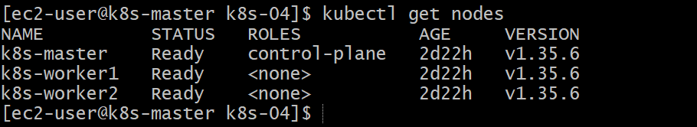

Validation Points
- Created a Pod with CPU and memory requests.
- Configured CPU and memory limits.
- Successfully deployed the Pod.
- Verified the Pod reached the Running state.
- Identified the node selected by the scheduler.
- Verified the resource requests and limits using kubectl describe pod.
- Verified allocated resources on the selected node.

Outcome
- Successfully created a Pod with CPU and memory requests.
- Verified that the Kubernetes scheduler assigned the Pod to a suitable node based on available resources.
- Confirmed the configured resource requests and limits.
- Understood how resource requests influence scheduling decisions.

