Kubernetes-05
Task 1: Create a Namespace dev-environment and Apply a Resource Quota
Objective
- Create a namespace named dev-environment.
- Apply a Resource Quota to:
  - Allow a maximum of 3 Pods
  - Allow a maximum of 2 Services
- Verify that the quota is enforced.
What is a Namespace?
A Namespace is used to logically separate Kubernetes resources within the same cluster.
Example:
Kubernetes Cluster

├── default
├── kube-system
├── dev-environment
├── prod-environment
└── staging-environment
Each namespace can have its own:
- Pods
- Services
- Deployments
- Resource Quotas
- LimitRanges

What is ResourceQuota?
A ResourceQuota limits the amount of resources that can be created in a namespace.
Example:
Namespace: dev-environment
Maximum Pods : 3
Maximum Services : 2
If a user tries to create a 4th Pod or a 3rd Service, Kubernetes rejects the request.
Architecture
Kubernetes Cluster
│
├───────────────
│
dev-environment Namespace
│
├── Pod 1
├── Pod 2
├── Pod 3
│
├── Service 1
└── Service 2

Implementation Steps (Documentation)
- Created the dev-environment namespace.
- Created a ResourceQuota YAML file.
- Configured limits for Pods and Services.
- Applied the ResourceQuota to the namespace.
- Verified the ResourceQuota configuration.
- Created Pods and Services within the allowed limits.
- Attempted to exceed the configured limits and verified that Kubernetes blocked the requests.
Prerequisites
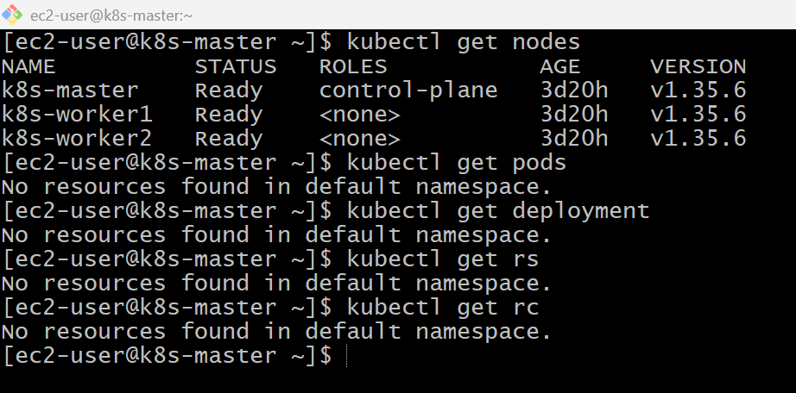
kubectl create namespace dev-environment
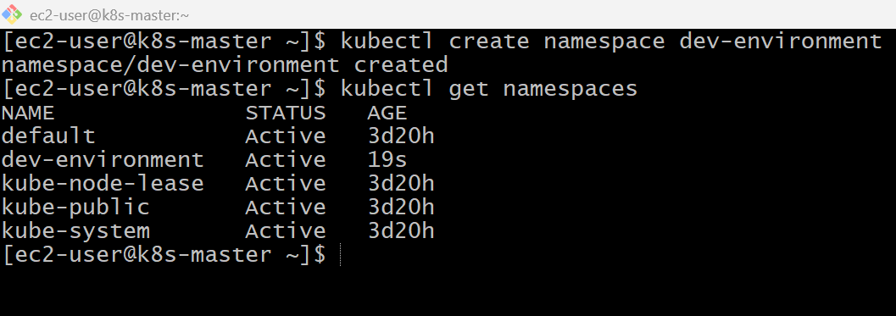
vi resourcequota.yaml
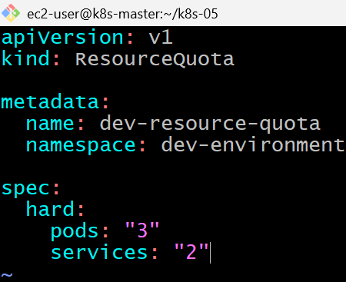
kubectl apply -f resourcequota.yaml
kubectl get resourcequota -n dev-environment
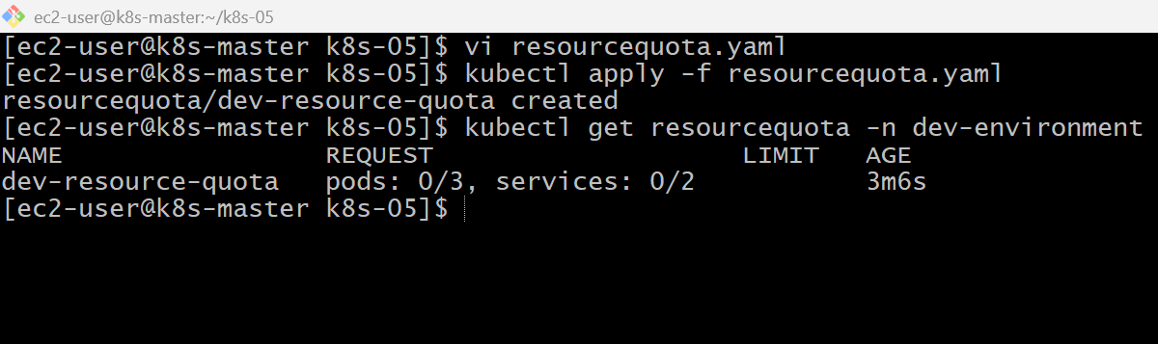
kubectl describe resourcequota dev-resource-quota -n dev-environment
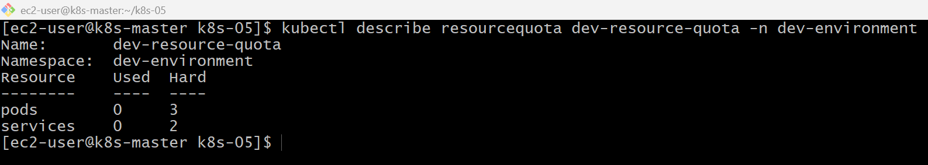
kubectl run pod1 --image=nginx -n dev-environment
kubectl run pod2 --image=nginx -n dev-environment
kubectl run pod3 --image=nginx -n dev-environment
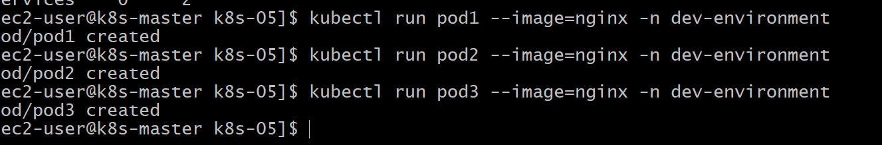
kubectl run pod4 --image=nginx -n dev-environment
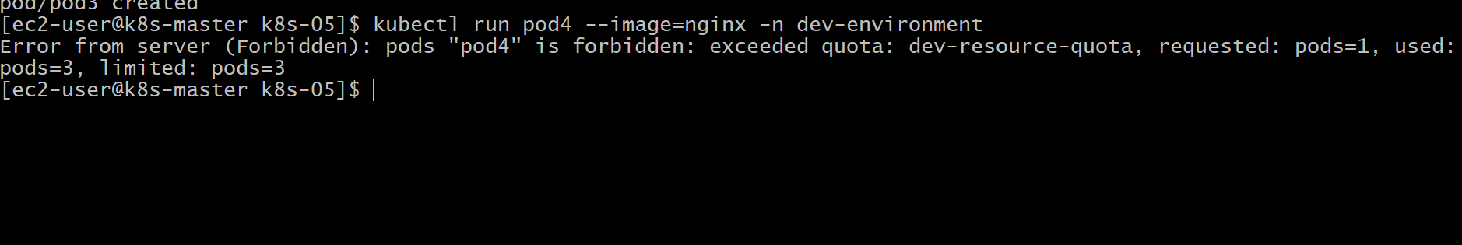
kubectl expose pod pod1 --port=80 --name=service1 -n dev-environment
kubectl get svc -n dev-environment
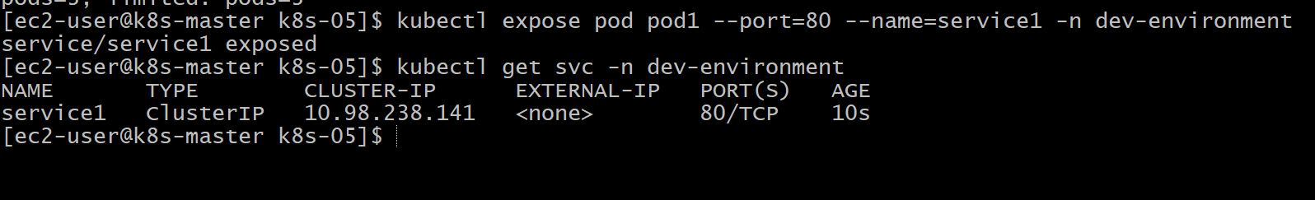
Validation Points
- Created the dev-environment namespace.
- Created and applied a ResourceQuota.
- Configured a maximum of 3 Pods.
- Configured a maximum of 2 Services.
- Verified the ResourceQuota.
- Successfully created 3 Pods.
- Successfully created 2 Services.
- Confirmed that creating additional Pods and Services was denied.

Outcome
- Successfully created a dedicated namespace for development.
- Applied a ResourceQuota to control resource creation.
- Verified that Kubernetes enforced the Pod and Service limits.
- Learned how ResourceQuota helps prevent excessive resource usage within a namespace.

Task 2: Create a Pod in the prod-environment Namespace with CPU and Memory Requests/Limits
Objective
- Create a namespace named prod-environment.
- Create a Pod in that namespace.
- Configure:
  - CPU Request: 200m (0.2 CPU)
  - Memory Request: 200Mi
  - CPU Limit: 500m (0.5 CPU)
  - Memory Limit: 500Mi
- Verify the resource configuration.
What are Requests and Limits?
Resource Requests
The minimum resources reserved for the Pod. The scheduler uses these values when choosing a node.
CPU Request : 200m (0.2 CPU)
Memory Request : 200Mi

Resource Limits
The maximum resources the Pod can consume.
CPU Limit : 500m (0.5 CPU)
Memory Limit : 500Mi

Architecture
Kubernetes Cluster
│
│
prod-environment Namespace
│
│
nginx Pod
│
┌───────────────────────┐
│ CPU Request : 200m │
│ CPU Limit : 500m │
│ Memory Req : 200Mi │
│ Memory Limit: 500Mi │
└───────────────────────┘
Implementation Steps (Documentation)
- Created the prod-environment namespace.
- Created a Pod YAML file with CPU and memory requests/limits.
- Applied the YAML using kubectl apply.
- Verified the Pod status.
- Verified the configured CPU and memory requests/limits.
- Checked the node assigned by the scheduler.
- Confirmed the resource allocation using kubectl describe pod.

kubectl create namespace prod-environment
kubectl get ns
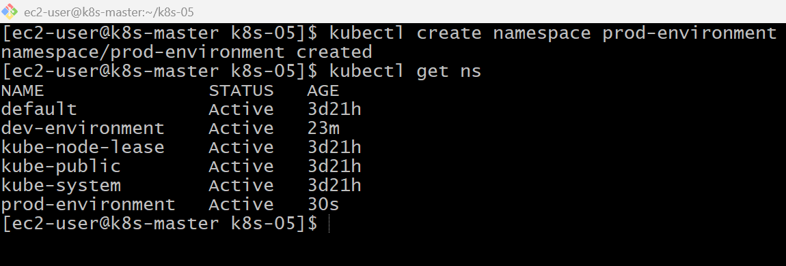
vi prod-pod.yaml
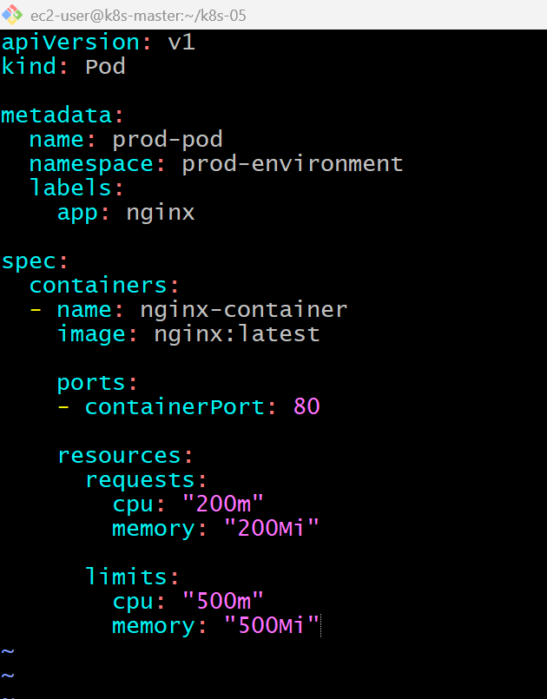

kubectl apply -f prod-pod.yaml
kubectl get pods -n prod-environment
kubectl describe pod prod-pod -n prod-environment
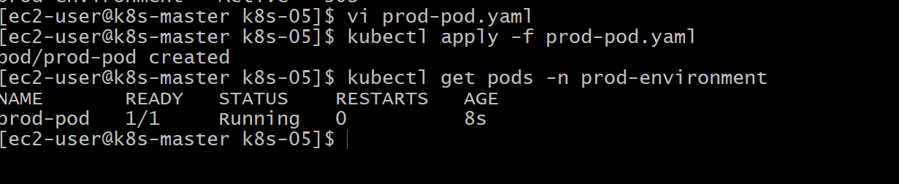
kubectl describe pod prod-pod -n prod-environment
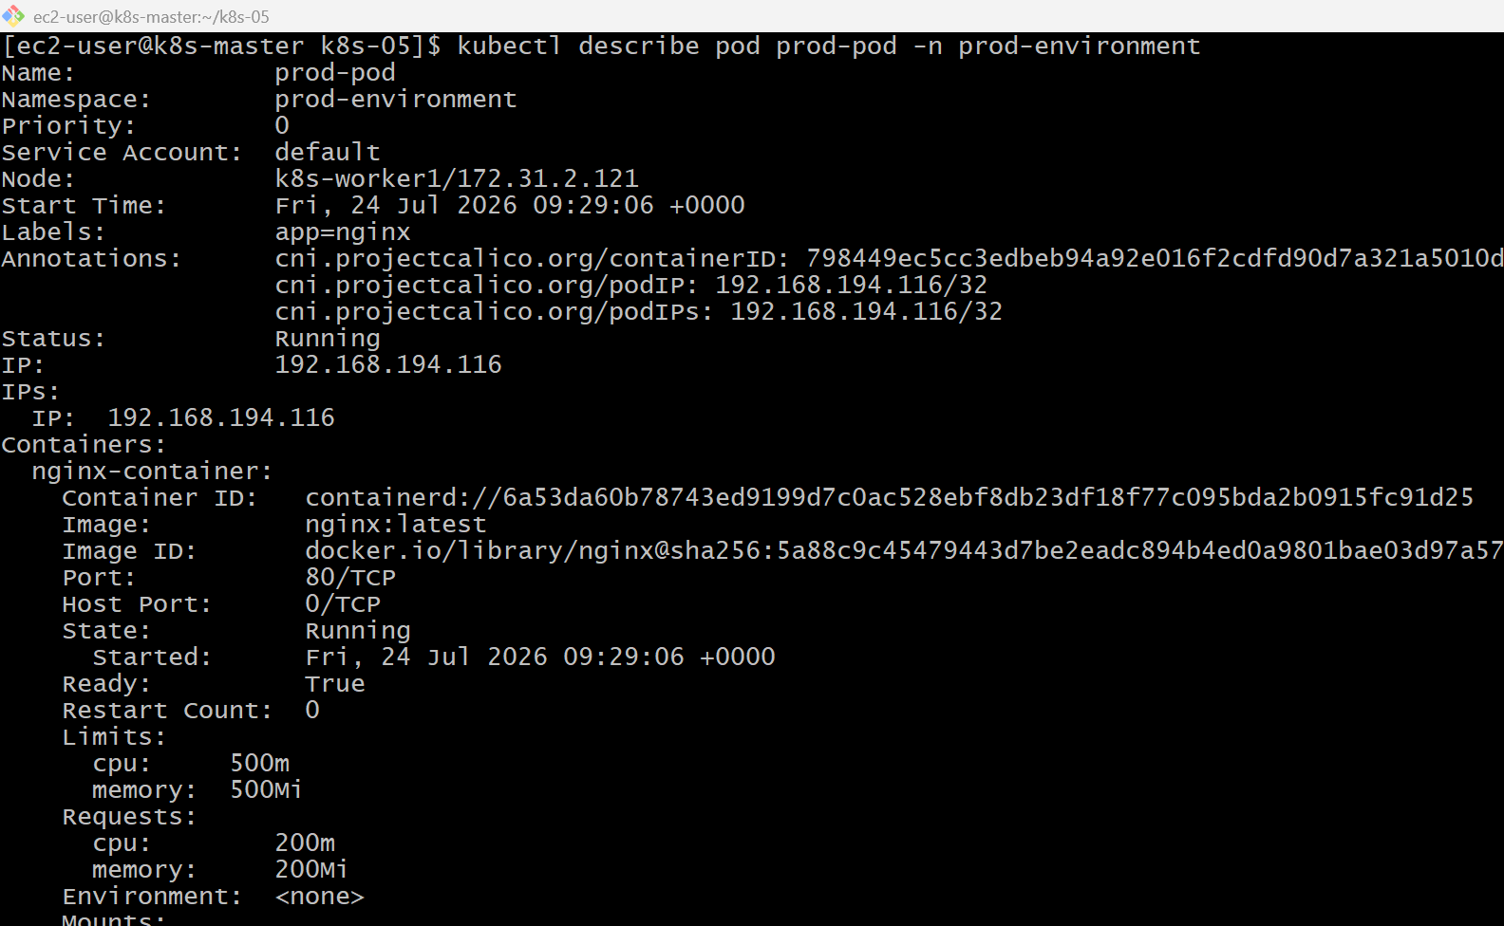
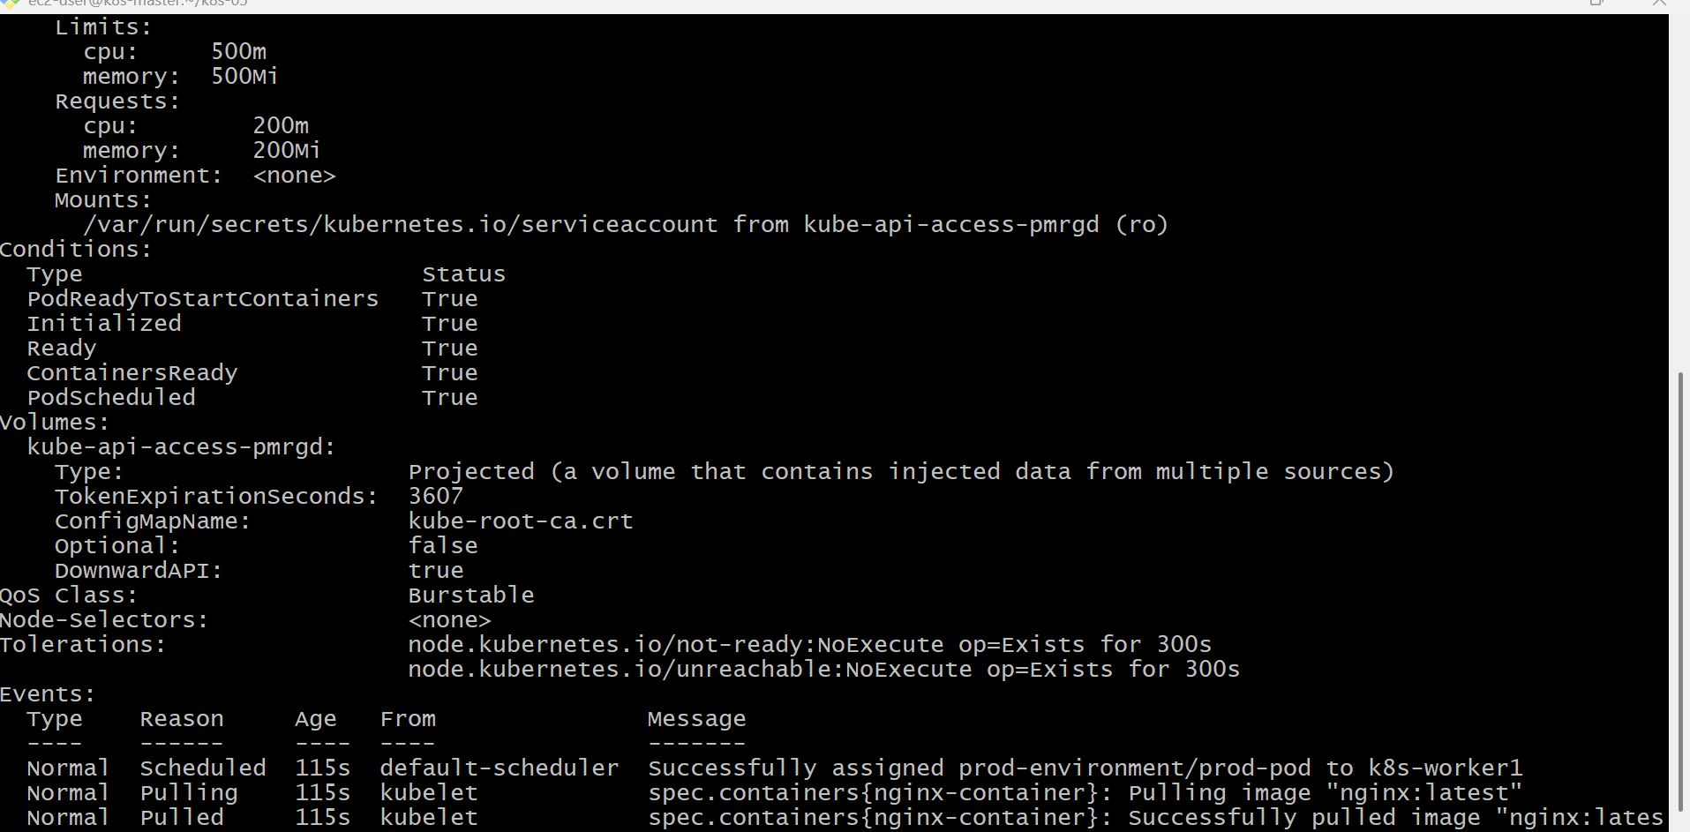
kubectl get pods -n prod-environment -o wide
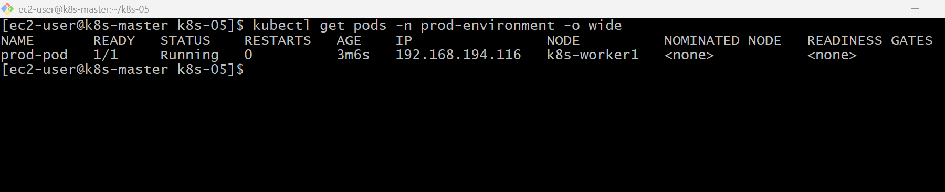
kubectl describe node k8s-worker1
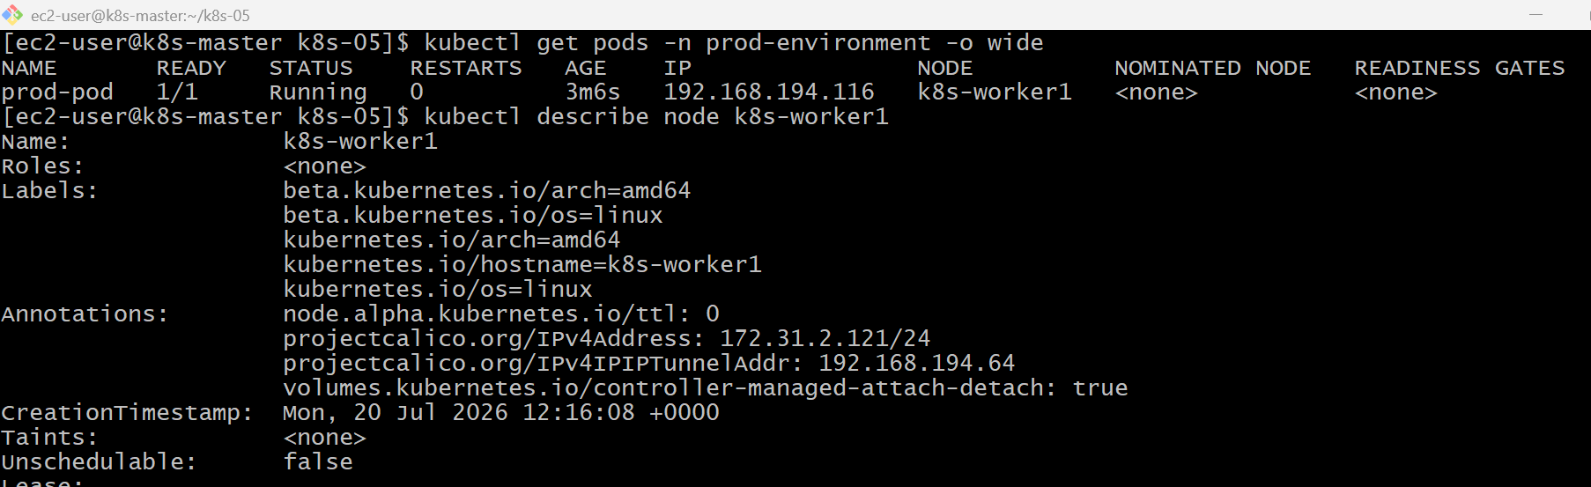
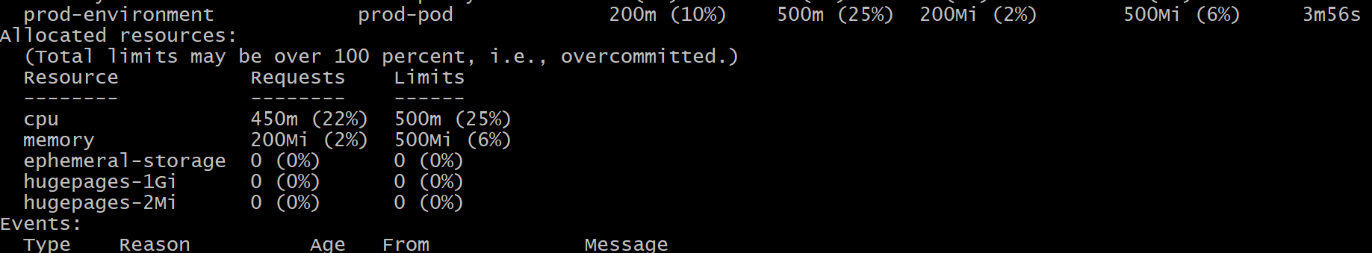

Validation Points
- Created the prod-environment namespace.
- Created a Pod in the namespace.
- Configured CPU request as 200m.
- Configured memory request as 200Mi.
- Configured CPU limit as 500m.
- Configured memory limit as 500Mi.
- Verified the Pod was in the Running state.
- Verified the resource configuration using kubectl describe pod.

Outcome
- Successfully created a Pod with CPU and memory requests and limits.
- Verified that the scheduler placed the Pod on a suitable node.
- Confirmed the configured resource values were applied correctly.
- Understood how resource requests and limits control resource allocation and usage.

Task 3: In the staging-environment Namespace, Set a Limit Range with Default CPU and Memory Limits and Minimum/Maximum CPU
Objective
- Create a namespace called staging-environment.
- Create a Limit Range that:
  - Sets default CPU limit to 300m
  - Sets default memory limit to 600Mi
  - Sets a minimum CPU
  - Sets a maximum CPU
- Create a Pod without specifying resources.
- Verify that the default limits are automatically applied.

What is a Limit Range?
A Limit Range is a Kubernetes policy that sets default, minimum, and maximum resource values for Pods and Containers in a namespace.
Unlike a Resource Quota, which limits the total resources used in a namespace, a Limit Range controls the resource configuration of each individual Pod or Container.

Difference Between Resource Quota and Limit Range
Resource Quota | Limit Range
Controls total resources in a namespace | Controls resources for individual Pods/Containers
Example: Maximum 10 Pods | Example: Default CPU = 300m
Prevents overuse of namespace resources | Ensures Pods have valid resource settings

Architecture
Kubernetes Cluster
│
│
staging-environment
│
│
Limit Range
│
┌─────────────────────────────┐
│ Default CPU : 300m │
│ Default Memory : 600Mi │
│ Minimum CPU : 100m │
│ Maximum CPU : 500m │
└─────────────────────────────┘
│
│
New Pod (No Resources)
│
Automatically gets:
CPU = 300m
Memory = 600Mi

Implementation Steps (Documentation)
- Created the staging-environment namespace.
- Created a LimitRange YAML file.
- Configured default CPU and memory limits.
- Configured default CPU and memory requests.
- Configured minimum and maximum CPU values.
- Applied the LimitRange.
- Verified the LimitRange configuration.
- Created a Pod without specifying resources.
- Verified that default resources were automatically assigned.
- Tested and confirmed enforcement of the minimum and maximum CPU constraints.

kubectl create namespace staging-environment
kubectl get ns
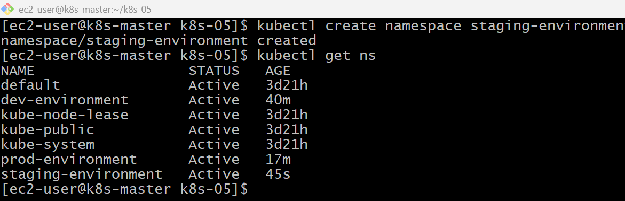

vi limitrange.yaml
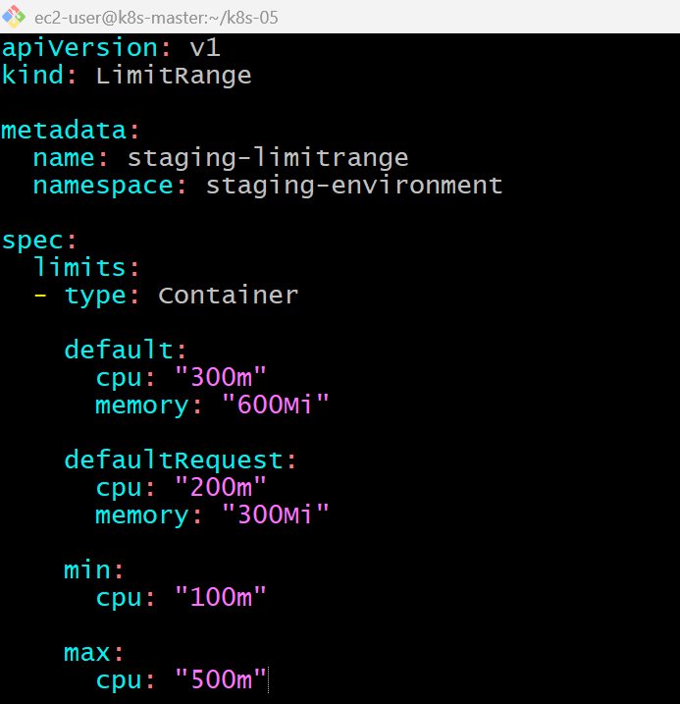

kubectl apply -f limitrange.yaml
kubectl get limitrange -n staging-environment
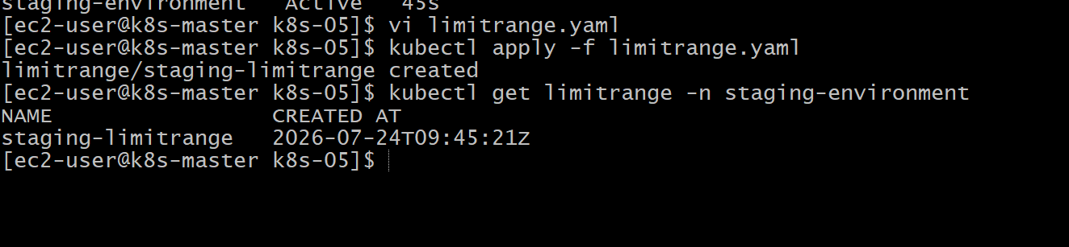

kubectl describe limitrange staging-limitrange -n staging-environment
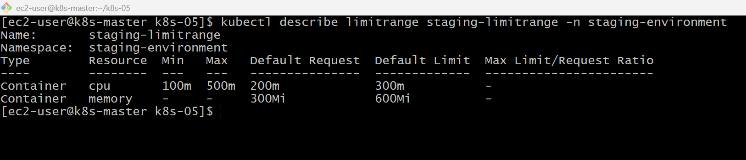
vi staging-pod.yaml
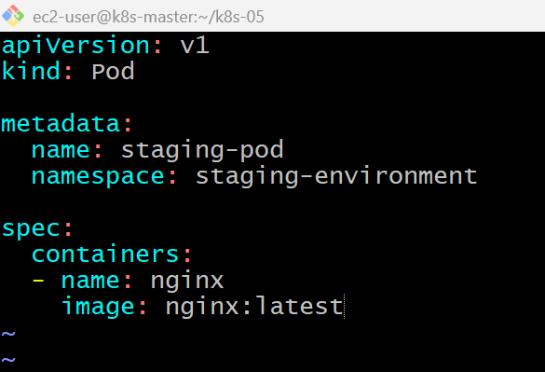
kubectl apply -f staging-pod.yaml
kubectl get pods -n staging-environment
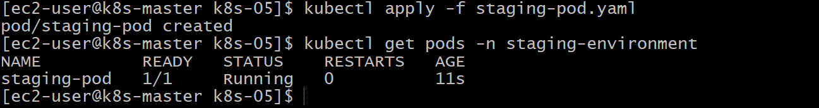

kubectl describe pod staging-pod -n staging-environment
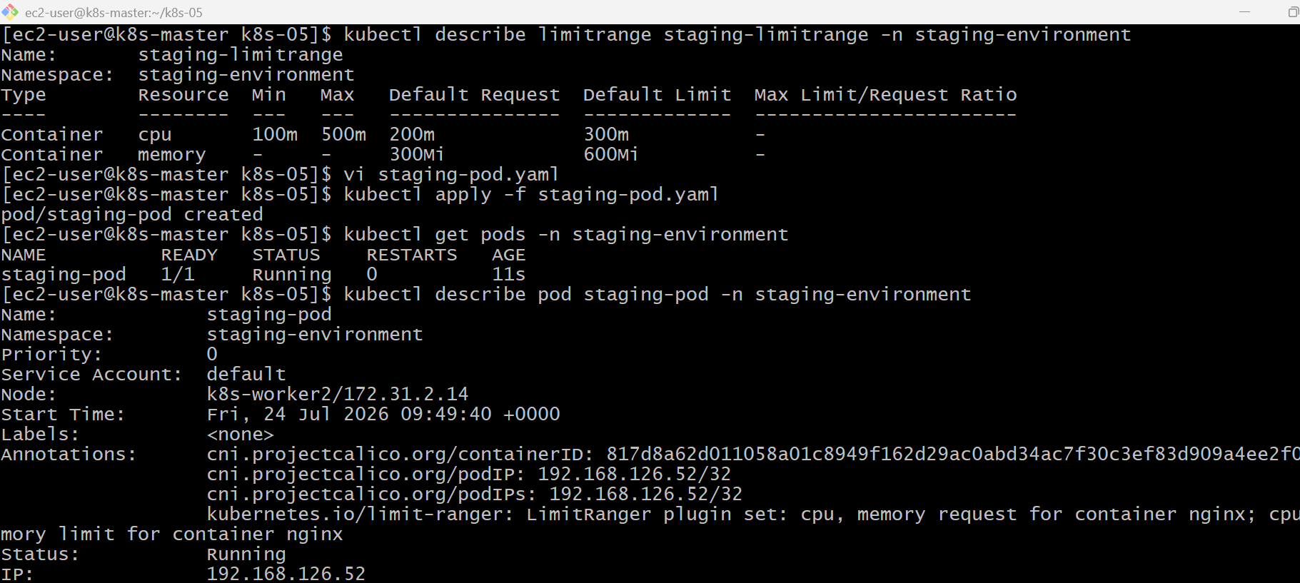
Requests
limits
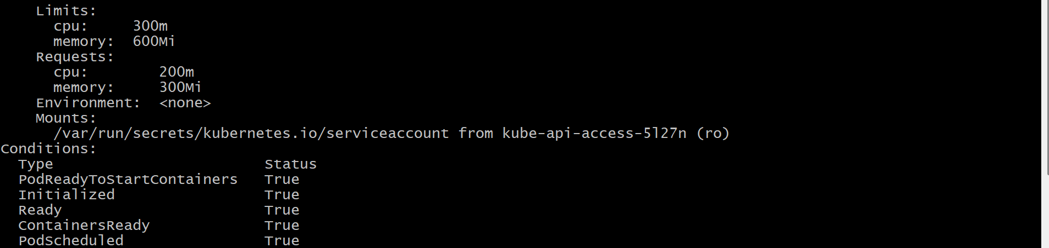

Validation Points
- Created the staging-environment namespace.
- Created and applied a Limit Range.
- Configured default CPU limit as 300m.
- Configured default memory limit as 600Mi.
- Configured minimum CPU as 100m.
- Configured maximum CPU as 500m.
- Created a Pod without specifying resources.
- Verified that default requests and limits were automatically applied.
- Verified that Pods violating the minimum or maximum CPU constraints were rejected.

Outcome
- Successfully configured a Limit Range for the staging-environment namespace.
- Verified automatic application of default resource requests and limits.
- Confirmed that Kubernetes enforced the configured minimum and maximum CPU values.
- Understood how Limit Range helps standardize resource settings within a namespace.

Task 4: Create a Pod and a NodePort Service in the Default Namespace, Then Create Another Pod in the test Namespace and Communicate Between Them Using Service DNS
Objective
- Create a Pod in the default namespace.
- Expose it using a NodePort Service.
- Create a new namespace called test.
- Create another Pod in the test namespace.
- Verify communication using the Service DNS.
Architecture
Kubernetes Cluster
│
┌────────────────────┴────────────────────┐
│ │
Default Namespace test Namespace
│ │
nginx-pod client-pod
│ │
NodePort Service curl DNS
│ │
nginx-service.default.svc.cluster.local

Implementation Steps (Documentation)
- Created an Nginx Pod in the default namespace.
- Created a NodePort Service for the Pod.
- Verified the Service.
- Created the test namespace.
- Created a BusyBox client Pod in the test namespace.
- Connected to the client Pod.
- Verified Service DNS resolution.
- Accessed the Nginx Service using its DNS name.
- Confirmed successful communication between namespaces.

vi nginx-pod.yaml
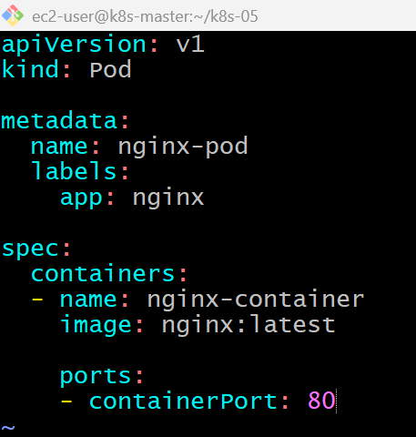

kubectl apply -f nginx-pod.yaml
kubectl apply -f nginx-pod.yaml
kubectl get pods
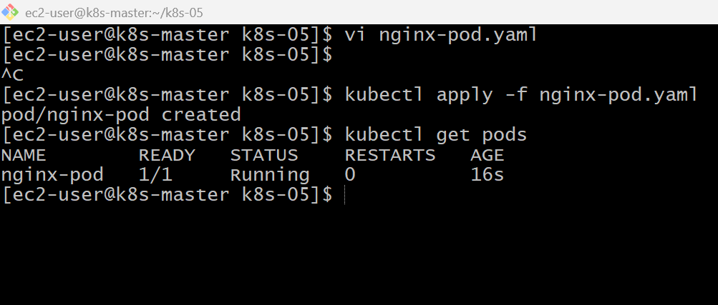
vi nginx-nodeport-service.yaml
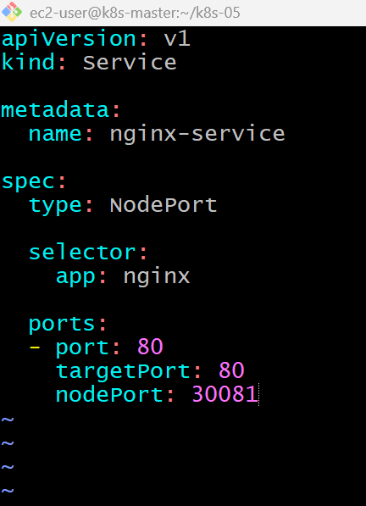

kubectl apply -f nginx-nodeport-service.yaml
kubectl get svc
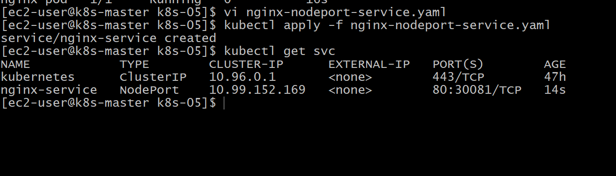
52.90.241.207:30081
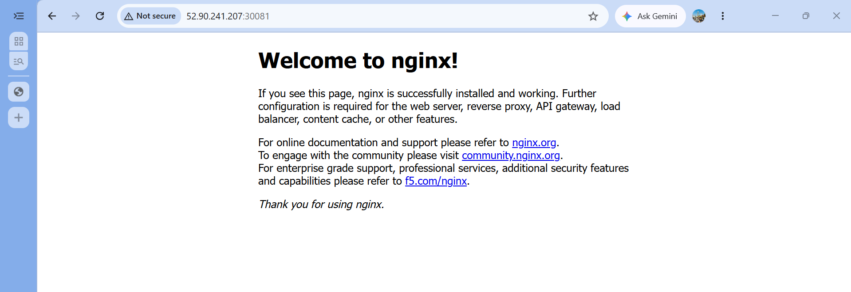
kubectl create namespace test
kubectl get ns
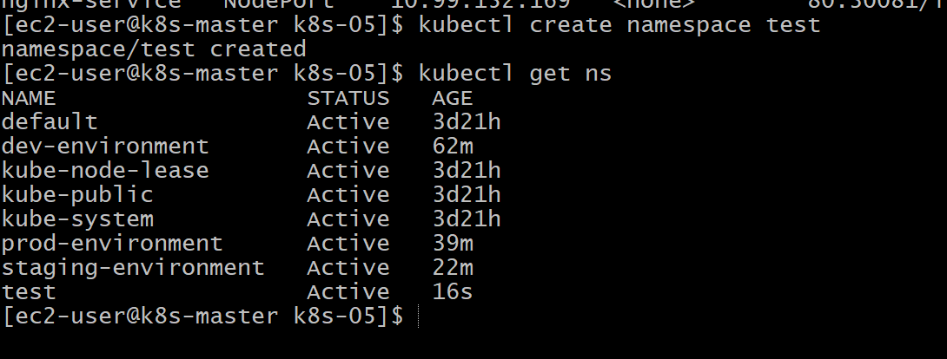

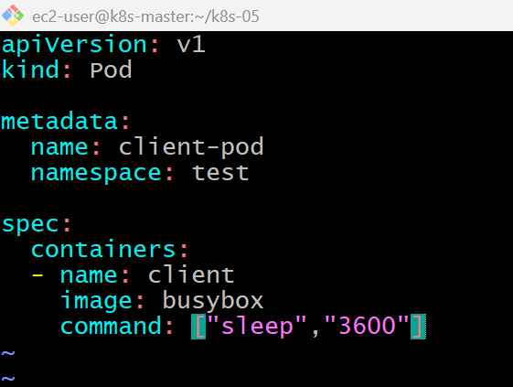
kubectl apply -f client-pod.yaml
kubectl get pods -n test
kubectl exec -it client-pod -n test -- sh
nslookup nginx-service.default.svc.cluster.local
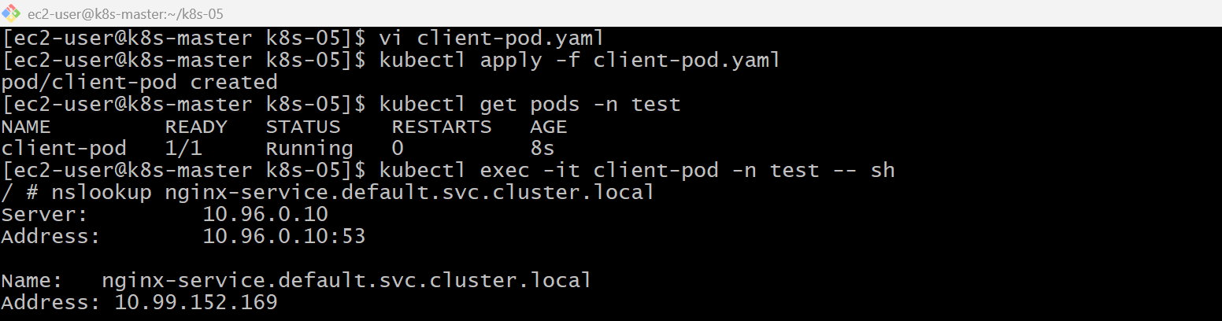
wget -qO- http://nginx-service.default.svc.cluster.local
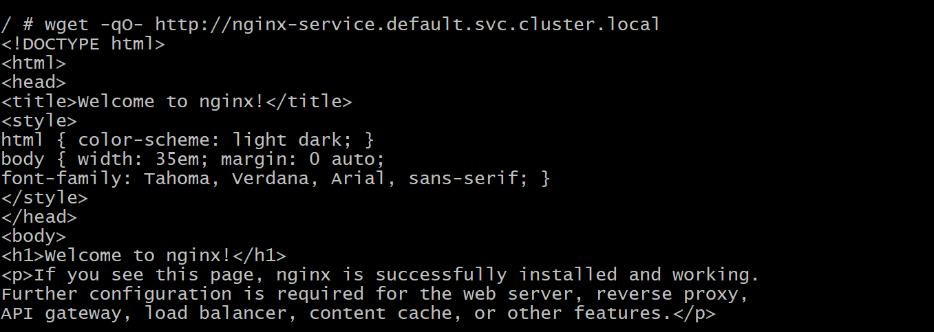

Validation Points
- Created an Nginx Pod in the default namespace.
- Exposed the Pod using a NodePort Service.
- Created the test namespace.
- Created a client Pod in the test namespace.
- Verified DNS resolution for the Service.
- Verified communication using the Service DNS.
- Confirmed successful access to the Nginx application.

Outcome
- Successfully created a Pod and exposed it using a NodePort Service.
- Verified cross-namespace communication using Kubernetes Service DNS.
- Understood how Kubernetes DNS enables service discovery across namespaces.

Task 5: Apply a LimitRange with a Max Limit/Request Ratio of 2 for Memory in the performance-environment Namespace and Test It
Objective
- Create a namespace named performance-environment.
- Create a LimitRange.
- Configure the maximum limit/request ratio for memory as 2.
- Create a Pod with an invalid memory request/limit ratio and verify that Kubernetes rejects it.

What is Max Limit/Request Ratio?
The maxLimitRequestRatio defines the maximum allowed ratio between a container's resource limit and request.
Implementation Steps (Documentation)
- Created the performance-environment namespace.
- Created a LimitRange YAML file.
- Configured maxLimitRequestRatio for memory.
- Applied the LimitRange.
- Verified the LimitRange configuration.
- Created a Pod with an invalid memory ratio and confirmed it was rejected.
- Created a Pod with a valid memory ratio and confirmed it was deployed successfully

kubectl create namespace performance-environment
kubectl get ns
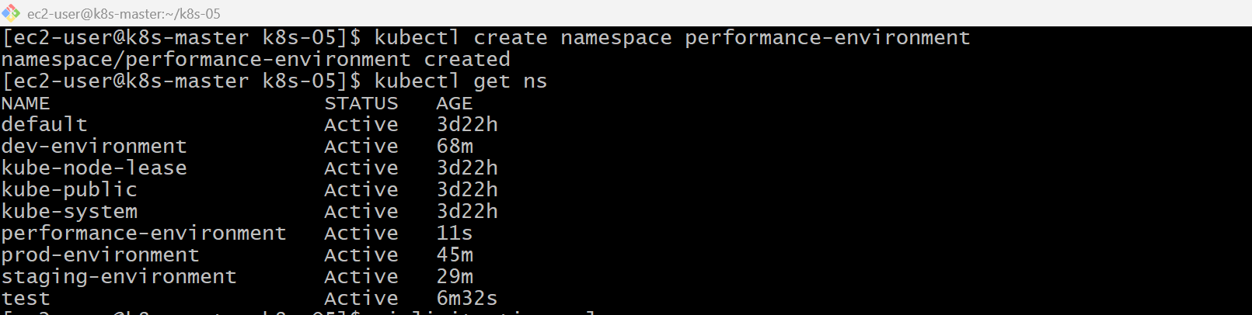
vi limitratio.yaml
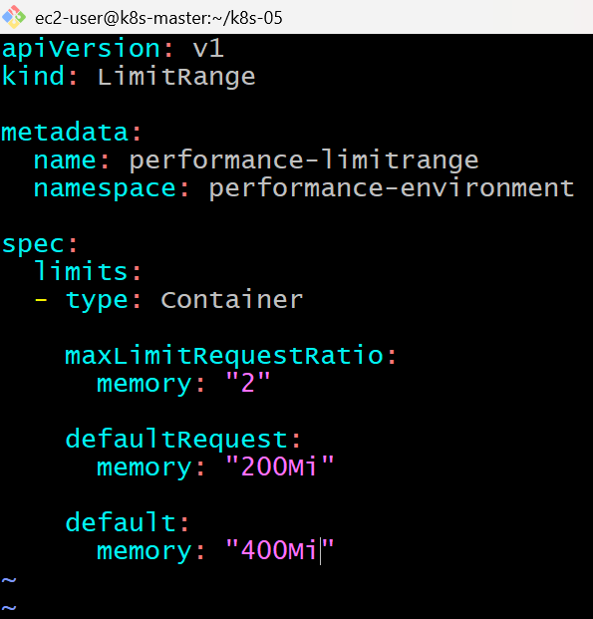
kubectl apply -f limitratio.yaml
kubectl describe limitrange performance-limitrange -n performance-environment
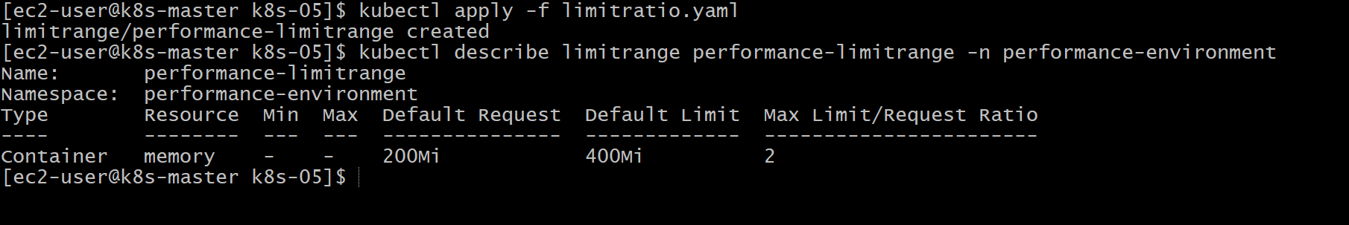
vi bad-pod.yaml
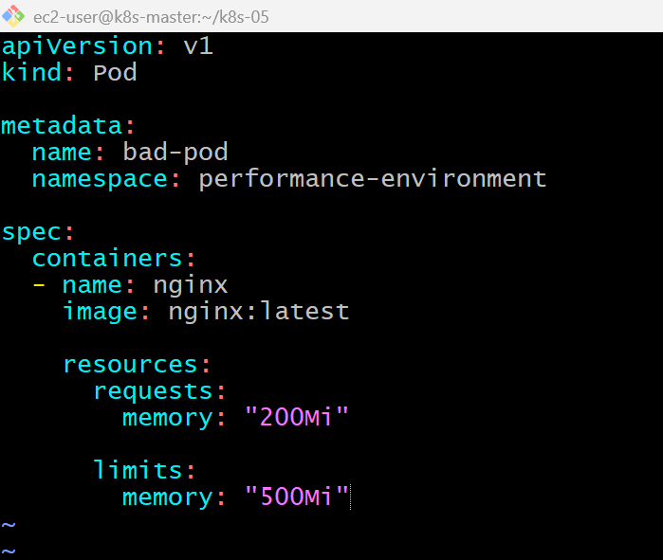
kubectl apply -f bad-pod.yaml
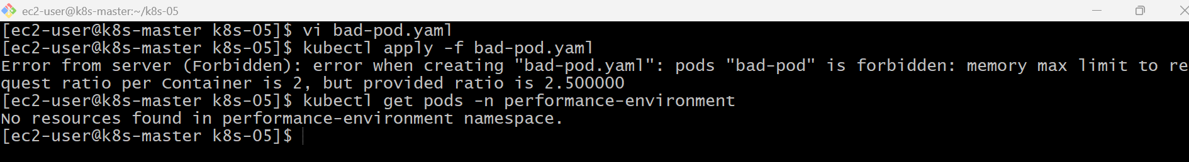

vi good-pod.yaml
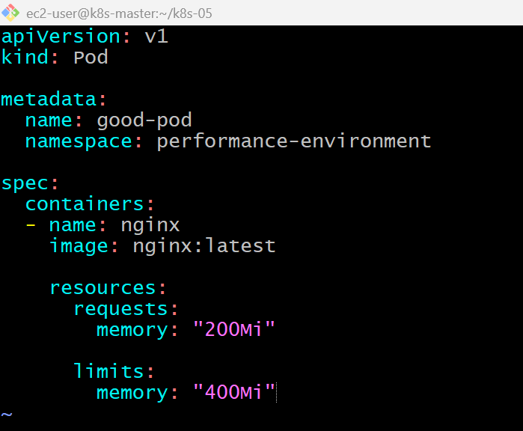
kubectl apply -f good-pod.yaml
kubectl get pods -n performance-environment
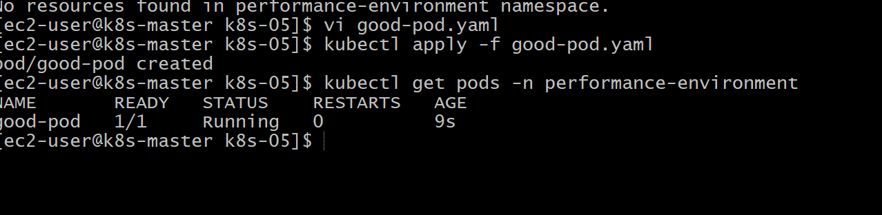

Validation Points
- Created the performance-environment namespace.
- Created and applied a LimitRange.
- Configured maxLimitRequestRatio for memory as 2.
- Verified the LimitRange configuration.
- Created a Pod with an invalid memory ratio and confirmed it was rejected.
- Created a Pod with a valid memory ratio and confirmed it started successfully.

Outcome
- Successfully configured a LimitRange with a maximum memory limit/request ratio.
- Verified that Kubernetes enforced the configured ratio.
- Understood how maxLimitRequestRatio helps prevent containers from requesting too little memory while setting excessively high limits.

