Jenkins Pipelines

Task 1 : Create one Declarative pipeline job
Objective
- Understand the structure and syntax of a Declarative Jenkins pipeline
- Create a Jenkins pipeline job using Declarative syntax for the hiring-app project
- Integrate SonarQube analysis, Maven build, Nexus upload, and Slack notification in Declarative style
Prerequisites
- Jenkins is installed and running
- Maven tool configured in Jenkins Global Tool Configuration with name mavan
- SonarQube server configured in Jenkins Configure System with name sonarqube
- SonarQube Scanner tool configured with name sonar-scanner
- Nexus Repository Manager running with maven-releases repository created
- Following credentials added in Jenkins Credentials:
  - sonar-token → Secret text (SonarQube token)
  - nexus → Username and Password (Nexus login)
  - slack → Secret text (Slack Webhook URL)
- Source code available at https://github.com/betawins/hiring-app.git

Steps
- Open Jenkins Dashboard → Click New Item
- Enter job name hiring-app-declarative → Select Pipeline → Click OK
- Scroll down to Pipeline section → Select Pipeline script
- Paste the Declarative pipeline code → Click Save
- Click Build Now and monitor the Stage View
- Verify all 5 stages complete: Pipeline Info, Git Clone, SonarQube Analysis, Maven Build, Nexus Upload
- Check Slack channel for SUCCESS notification
- Check Nexus for uploaded WAR file

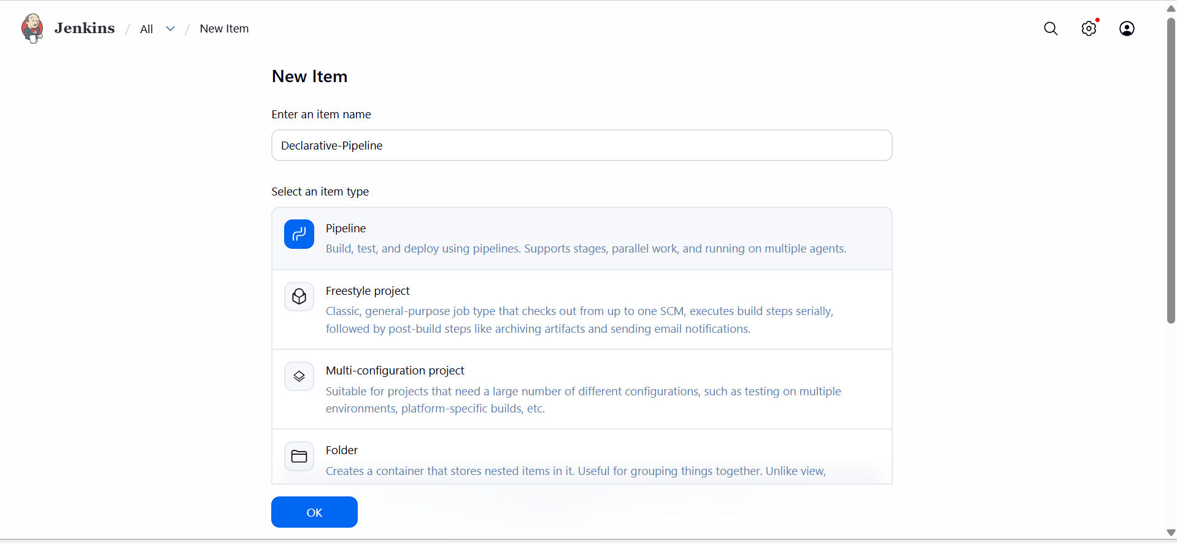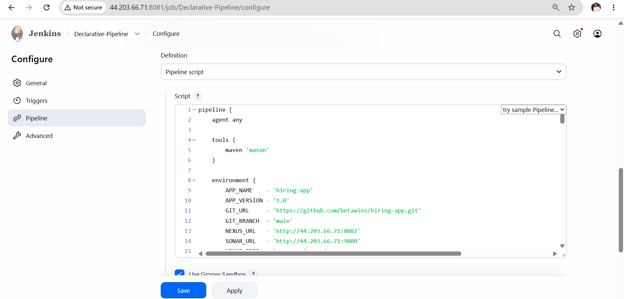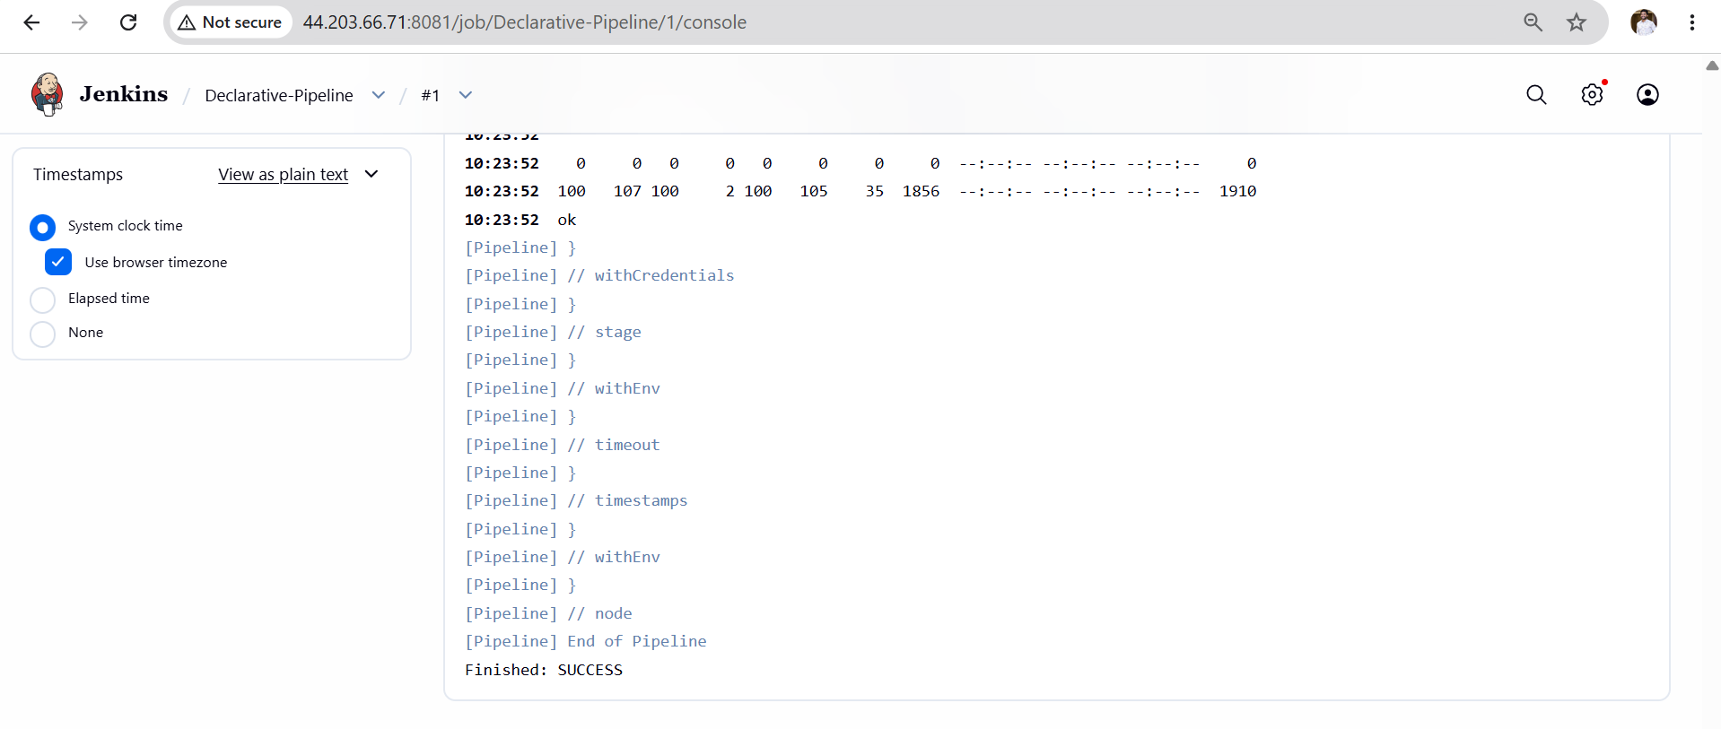

Validation Points
- Jenkins build shows success for hiring-app-declarative job
- All 5 stages visible and green in Stage View
- SonarQube dashboard shows project hiring-app-declarative with analysis report
- Nexus maven-releases repository contains uploaded WAR file
- Slack channel received SUCCESS message with correct build number and job name
- Workspace cleaned after build via cleanWs() in post { always } block
- Pipeline code uses pipeline {} block — confirming Declarative syntax
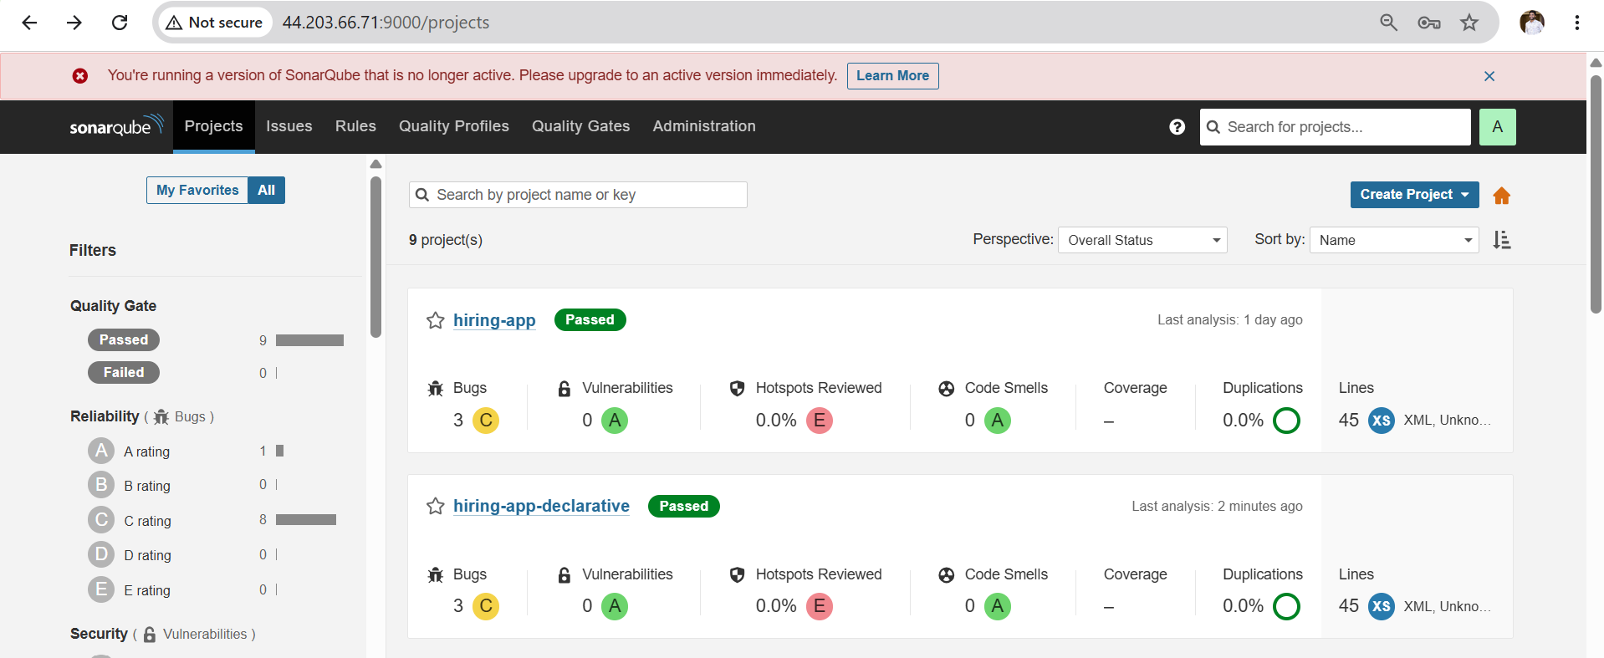
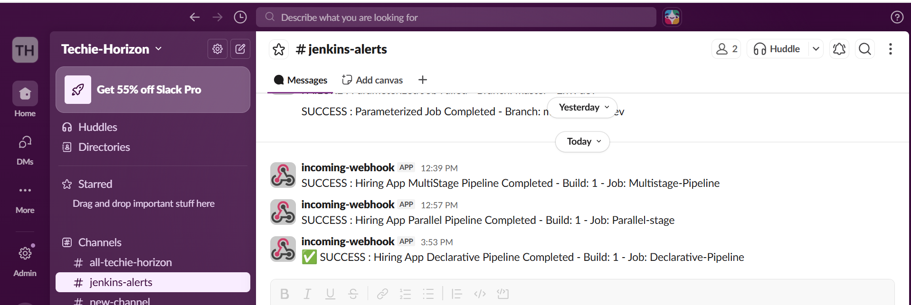

Outcome
- Successfully created a Declarative pipeline job in Jenkins
- Pipeline executed all stages in order: Pipeline Info → Git Clone → SonarQube Analysis → Maven Build → Nexus Upload
- WAR file built by Maven was uploaded to Nexus maven-releases repository
- Slack channel received SUCCESS or FAILURE notification after build
- Understood Declarative pipeline structure using pipeline {}, stages {}, post {} blocks

Task 02 : Create one Scripted pipeline job
Objective
- Understand the structure and syntax of a Scripted Jenkins pipeline
- Create a Jenkins pipeline job using Scripted Groovy syntax for the hiring-app project
- Integrate SonarQube analysis, Maven build, Nexus upload, and Slack notification in Scripted style
- Understand the difference between Declarative and Scripted pipeline error handling
Prerequisites
- Jenkins is installed and running
- Maven tool configured in Jenkins Global Tool Configuration with name mavan
- SonarQube server configured in Jenkins Configure System with name sonarqube
- SonarQube Scanner tool configured with name sonar-scanner
- Nexus Repository Manager running with maven-releases repository created
- Following credentials added in Jenkins Credentials:
  - sonar-token → Secret text (SonarQube token)
  - nexus → Username and Password (Nexus login)
  - slack → Secret text (Slack Webhook URL)
- Source code available at https://github.com/betawins/hiring-app.git
- Challenge 2 Declarative pipeline completed successfully

Steps
- Open Jenkins Dashboard → Click New Item
- Enter job name hiring-app-scripted → Select Pipeline → Click OK
- Scroll down to Pipeline section → Select Pipeline script
- Paste the Scripted pipeline code starting from node { → Click Save
- Click Build Now and monitor the Stage View
- Verify all 5 stages complete: Pipeline Info, Git Clone, SonarQube Analysis, Maven Build, Nexus Upload
- Check Slack channel for SUCCESS notification
- Check Nexus for uploaded WAR file

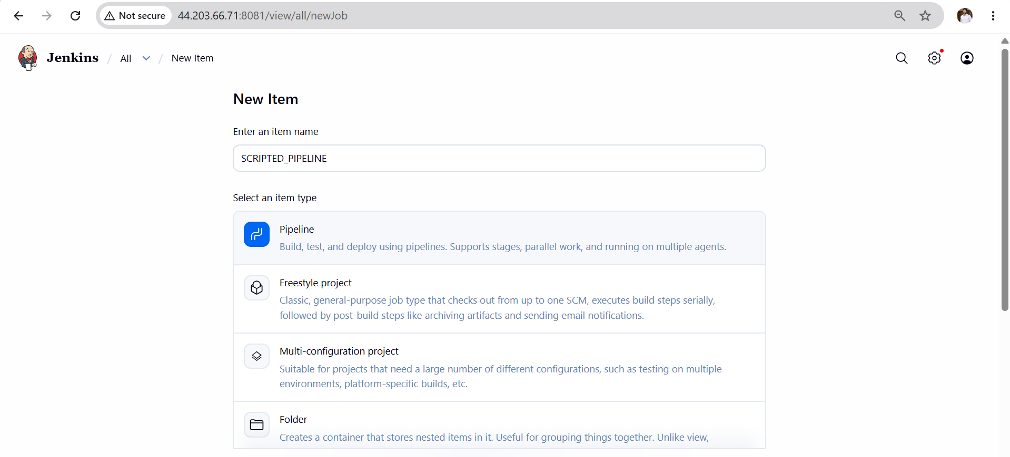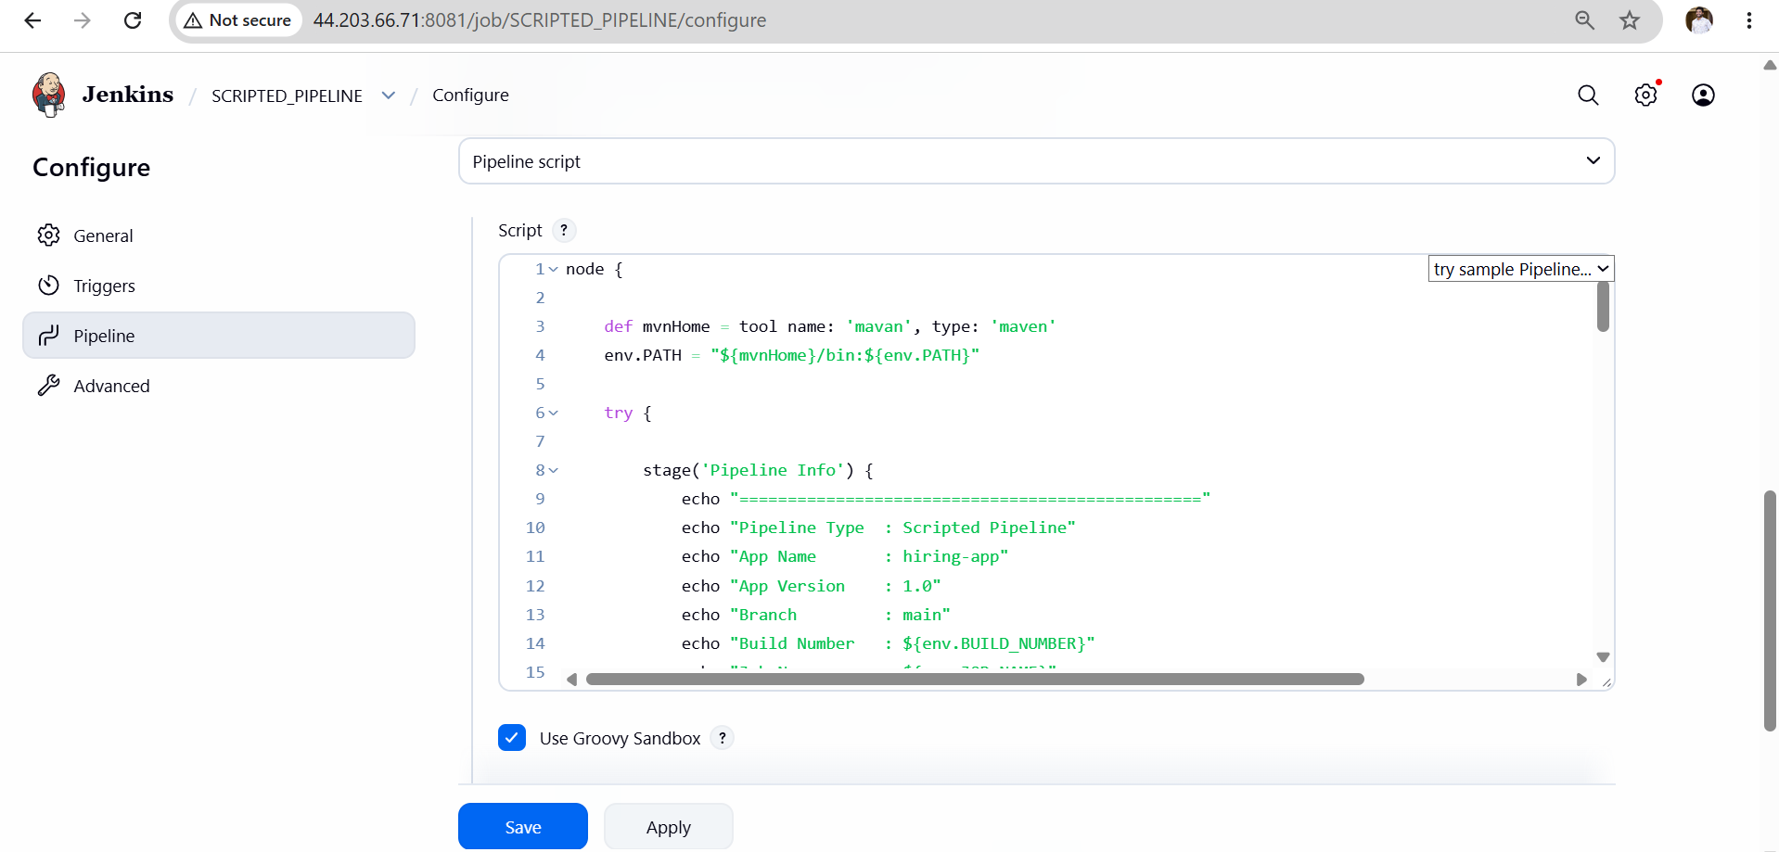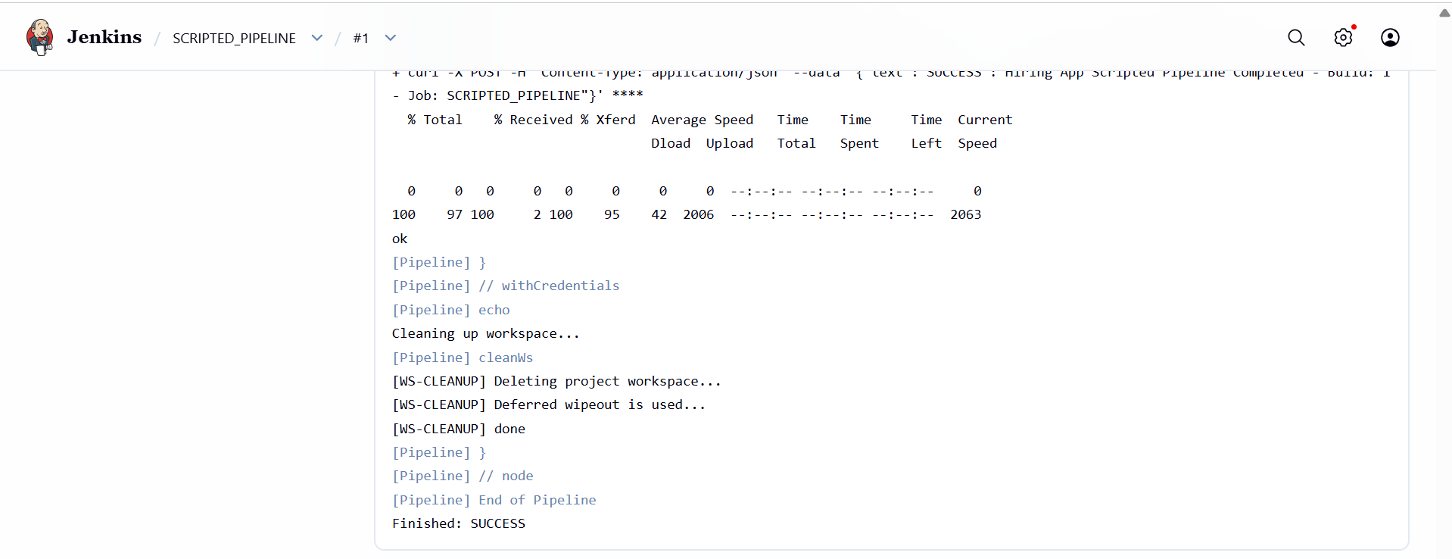

Validation Points
- Jenkins build shows success for hiring-app-scripted job
- All 5 stages visible and green in Stage View
- SonarQube dashboard shows project hiring-app-scripted with analysis report
- Nexus maven-releases repository contains uploaded WAR file
- Slack channel received SUCCESS message with correct build number and job name
- Workspace cleaned after build via cleanWs() in finally block
- Pipeline code uses node {} block — confirming Scripted syntax
- Error handling done via try/catch/finally instead of post {} block
- currentBuild.result manually set to SUCCESS or FAILURE confirming Scripted style
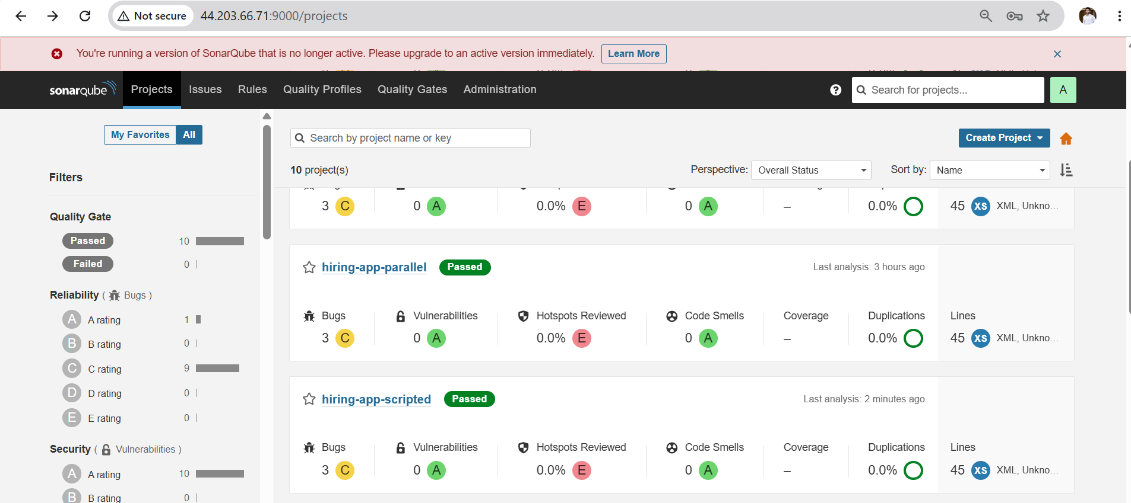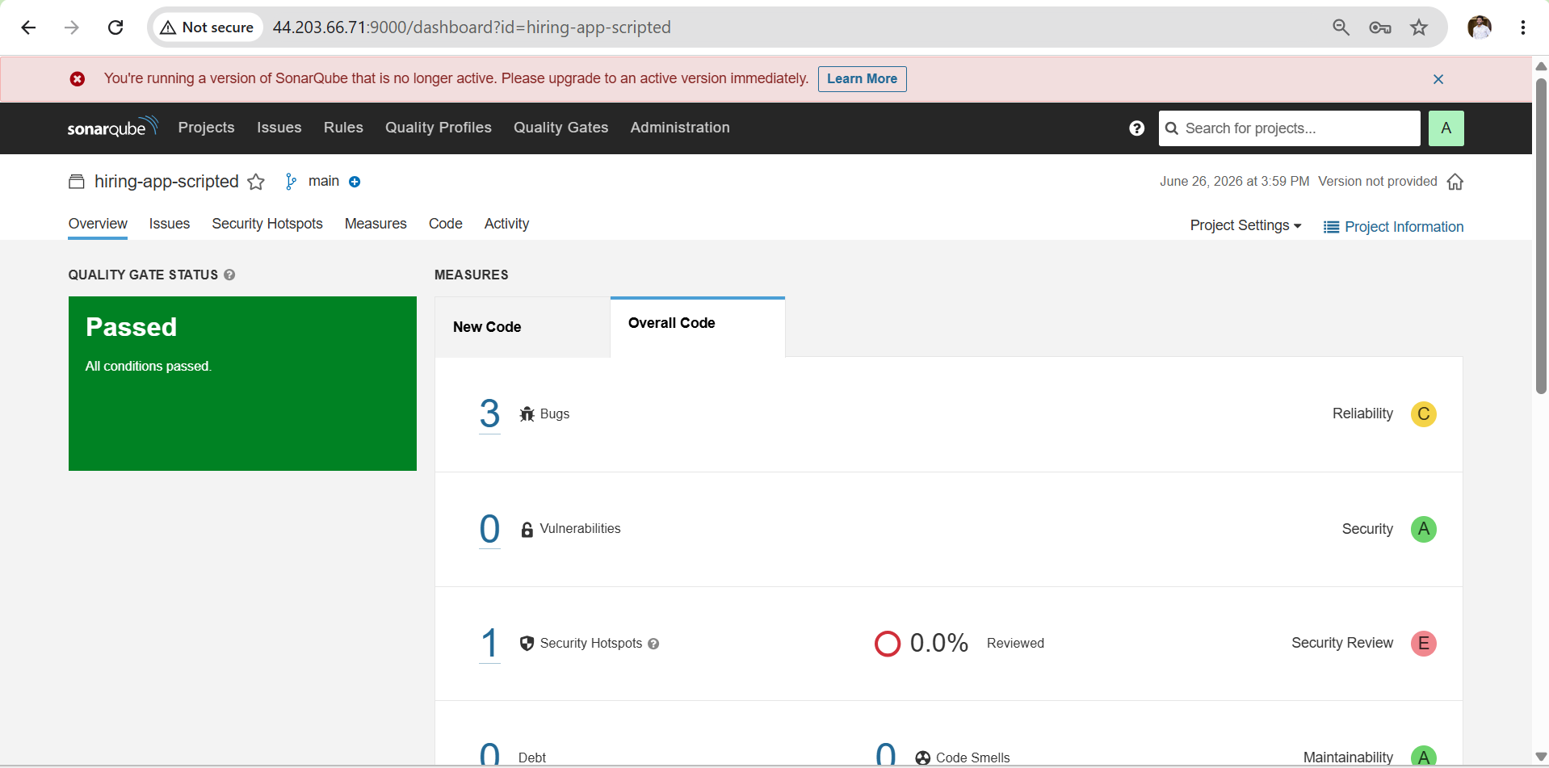

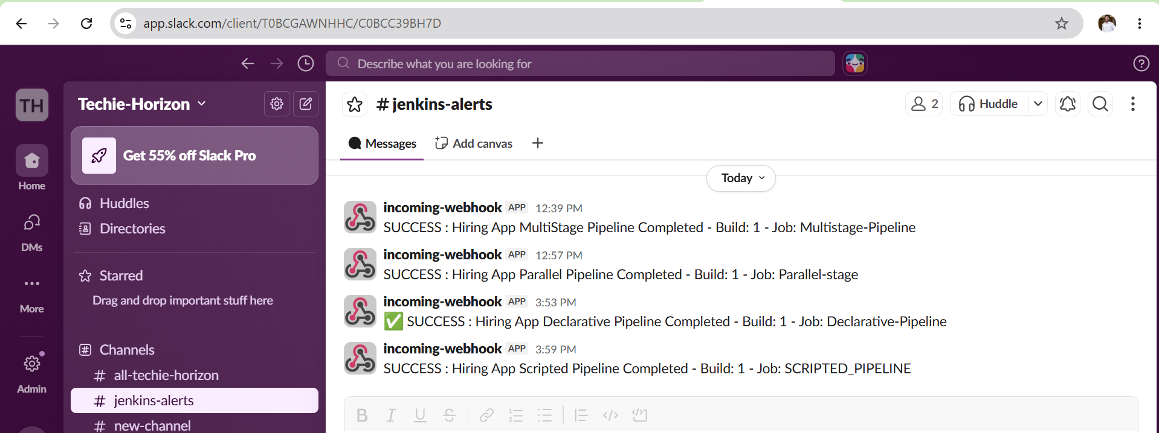

Outcome
- Successfully created a Scripted pipeline job in Jenkins
- Pipeline executed all stages in order: Pipeline Info → Git Clone → SonarQube Analysis → Maven Build → Nexus Upload
- WAR file built by Maven was uploaded to Nexus maven-releases repository
- Slack channel received SUCCESS or FAILURE notification after build
- Understood Scripted pipeline structure using node {}, stage(), try/catch/finally blocks

Task 3: Create a Parameterized Job in Jenkins
Objective
Learn how to create a Jenkins parameterized pipeline job that accepts dynamic inputs at build time, allowing flexible and reusable CI/CD pipelines.

Outcome
- A Jenkins parameterized job created
- Job accepts parameters like branch name, version, environment
- Pipeline uses parameters dynamically during build
- Application built and deployed based on parameter values
- Understanding of different parameter types in Jenkins

Prerequisites
Server Requirements
- Jenkins running at http://35.170.182.61:8080
- Maven configured in Jenkins tools as mavan
- SonarQube running at http://35.170.182.61:9000
- Nexus running at http://35.170.182.61:8082
- Tomcat running at http://35.170.182.61:8080
Jenkins Credentials Required
- sonar-token — SonarQube token
- nexus — Nexus username and password
- slack — Slack webhook URL
Steps Implementations
- Login to Jenkins Dashboard.
- Click New Item → Enter name Parameterized-SpringMVC.
- Select Freestyle Project → Click OK.
- Scroll to This project is parameterized and enable it.
- Click Add Parameter → Select String Parameter.
- Parameter Name = BRANCH_NAME.
- Default Value = master.
- Description = Git Branch Name.
- Under Source Code Management select Git.
- Repository URL = https://github.com/betawins/spring3-mvc-maven-xml-hello-world-1.git.
- Branch Specifier = */${BRANCH_NAME}.
- Under Build Steps click Invoke Top-level Maven Targets.
- Goals = clean package.
- Click Apply → Save.
- Click Build with Parameters.
- Enter branch name (master).
- Click Build.
- Monitor build from Console Output.
- Verify Maven build success.
- Verify WAR/JAR generated under workspace target folder.

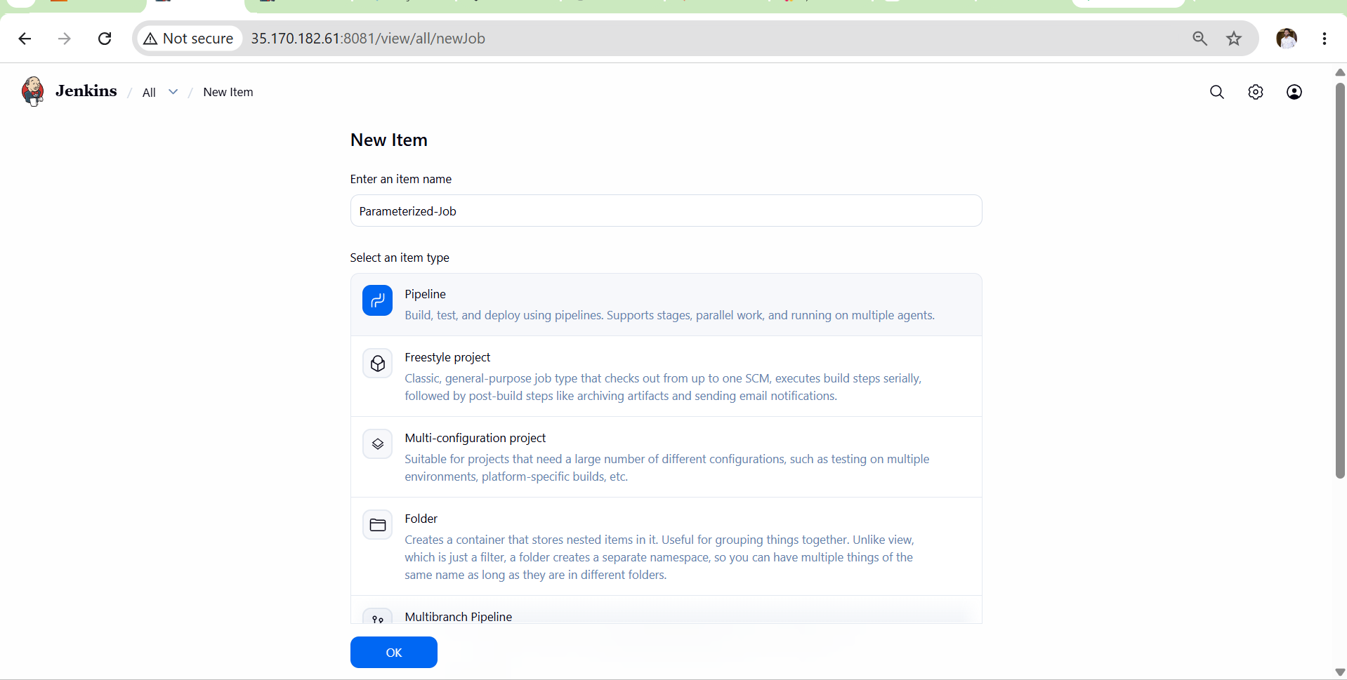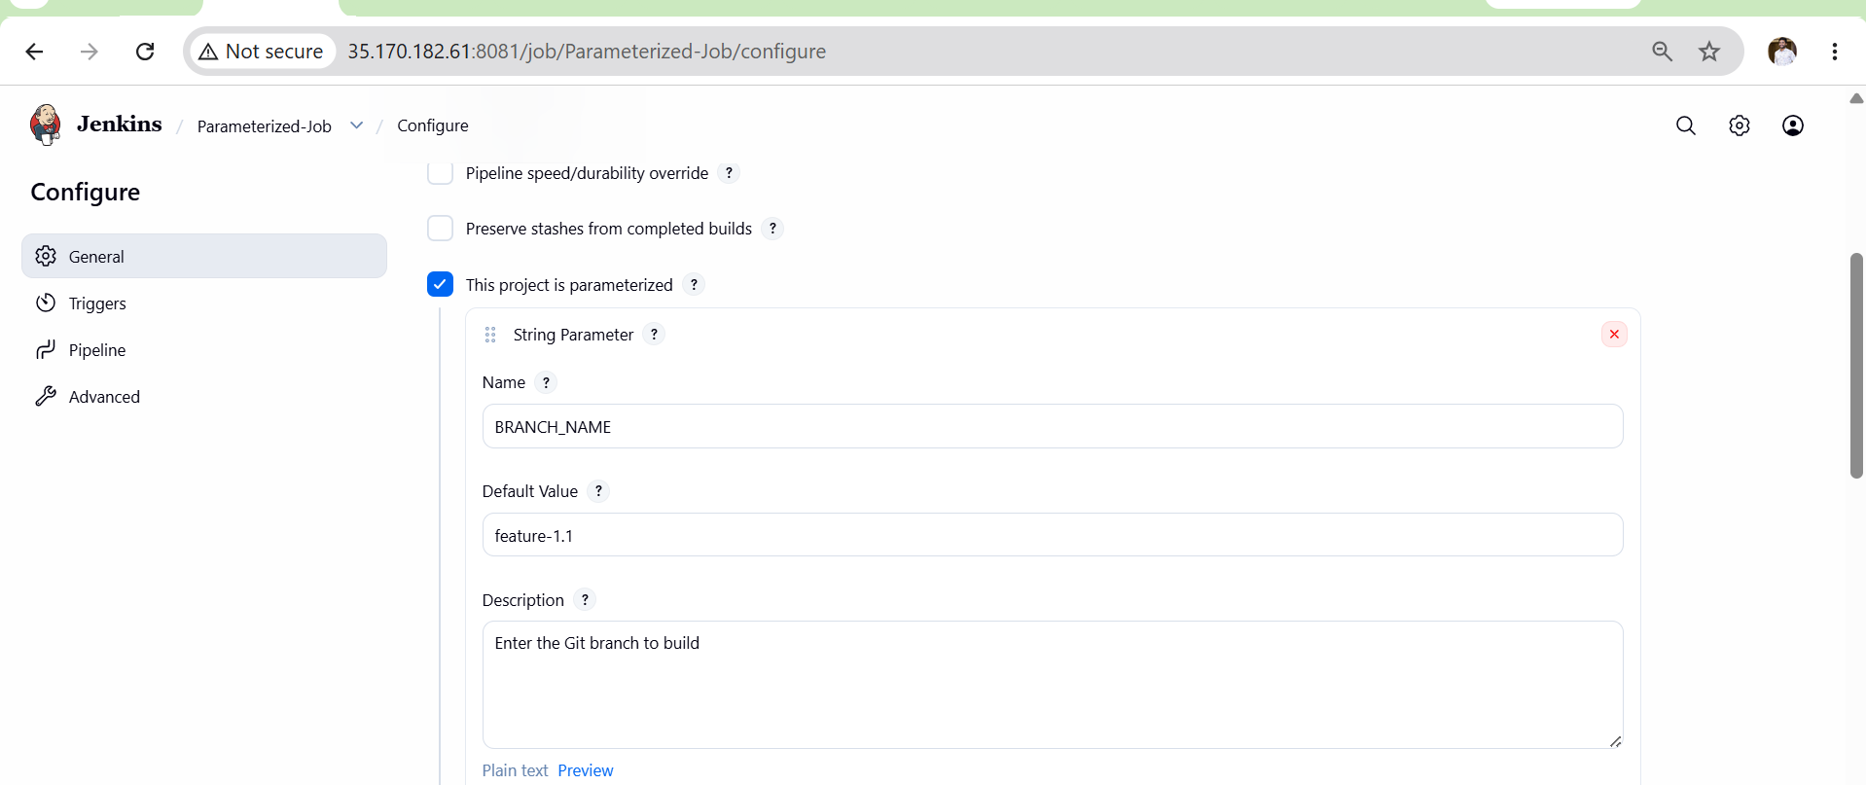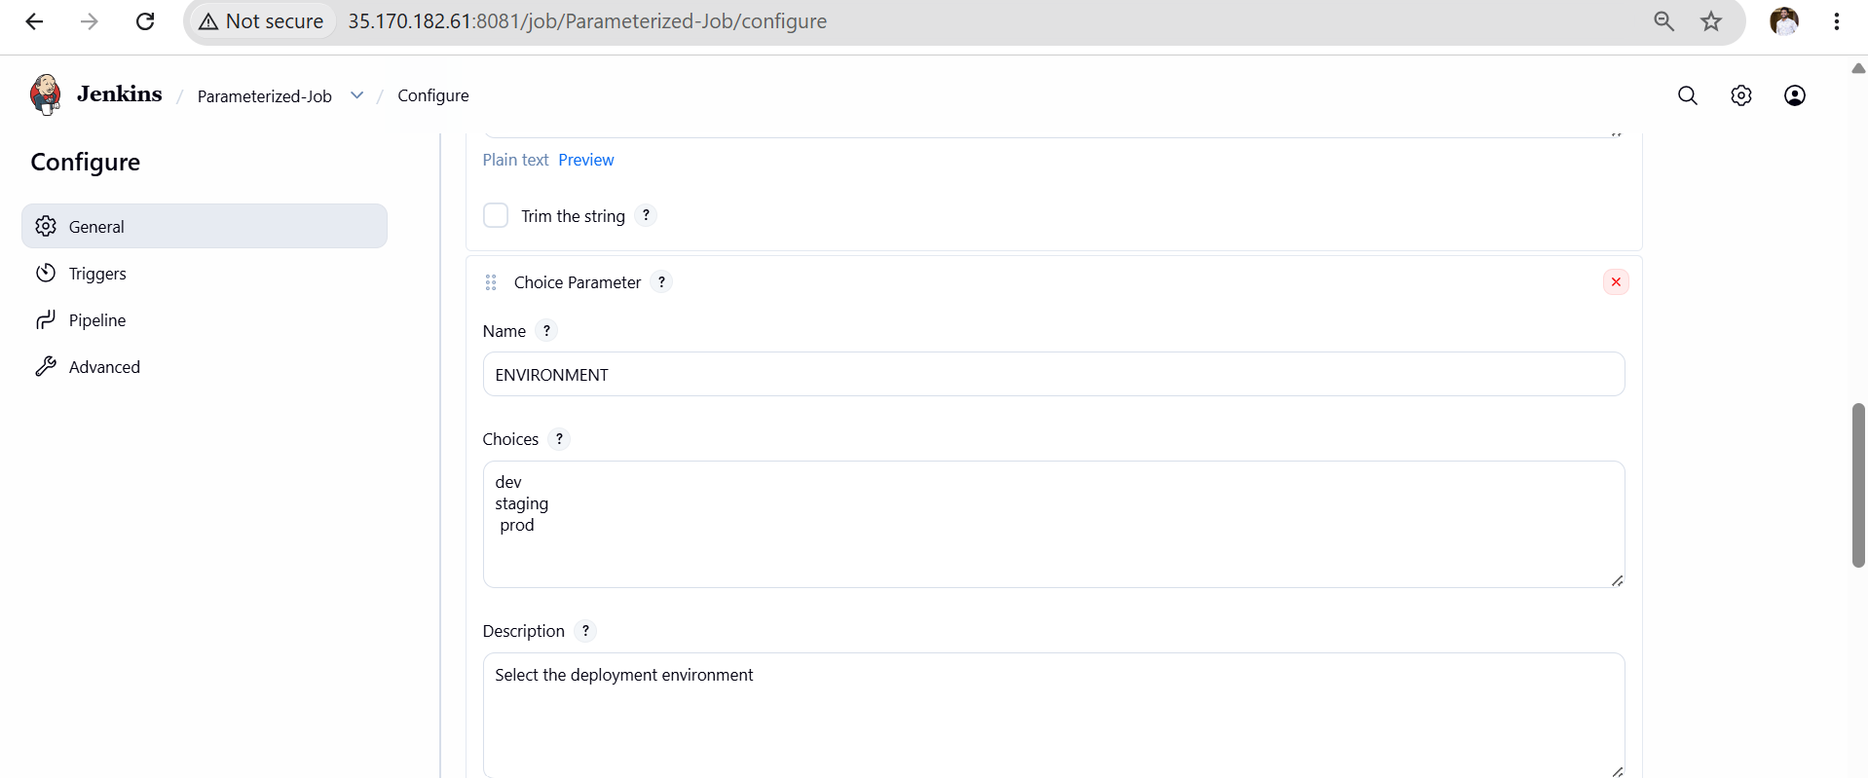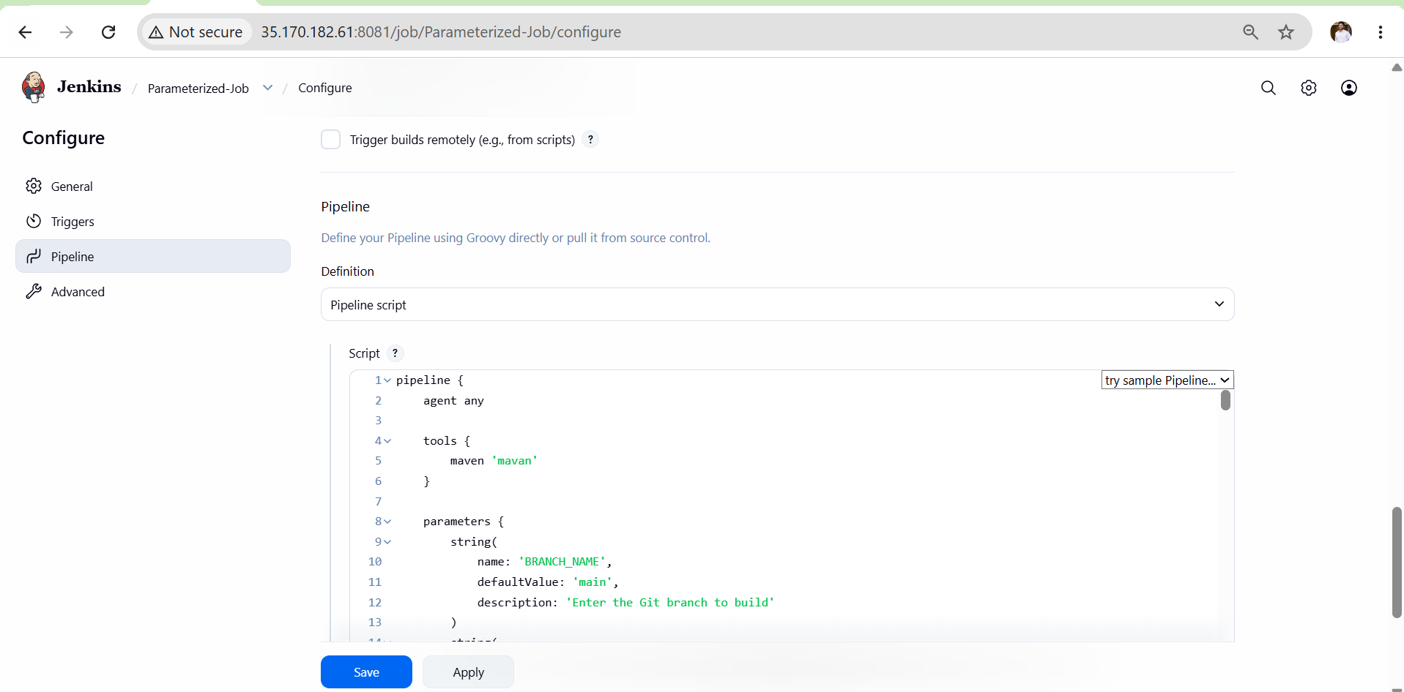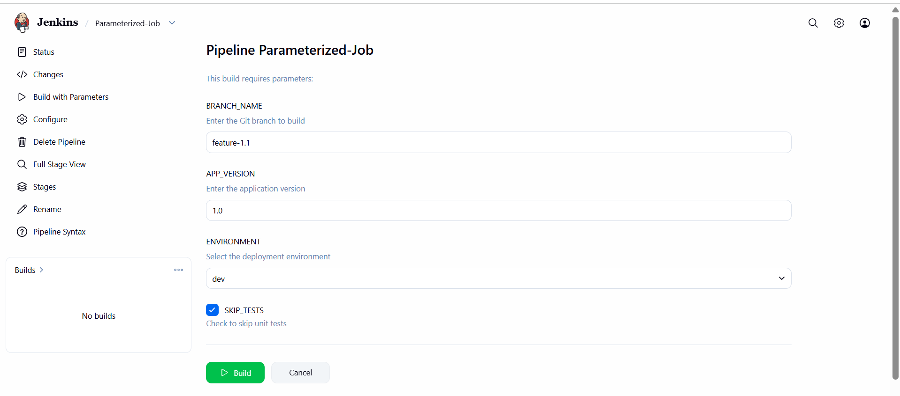
Validation Points
- Build with Parameters option visible.
- Parameter value accepted during build.
- Git checkout uses selected branch.
- Maven clean package executes successfully.
- Build status shows SUCCESS.
- Target artifact generated successfully.
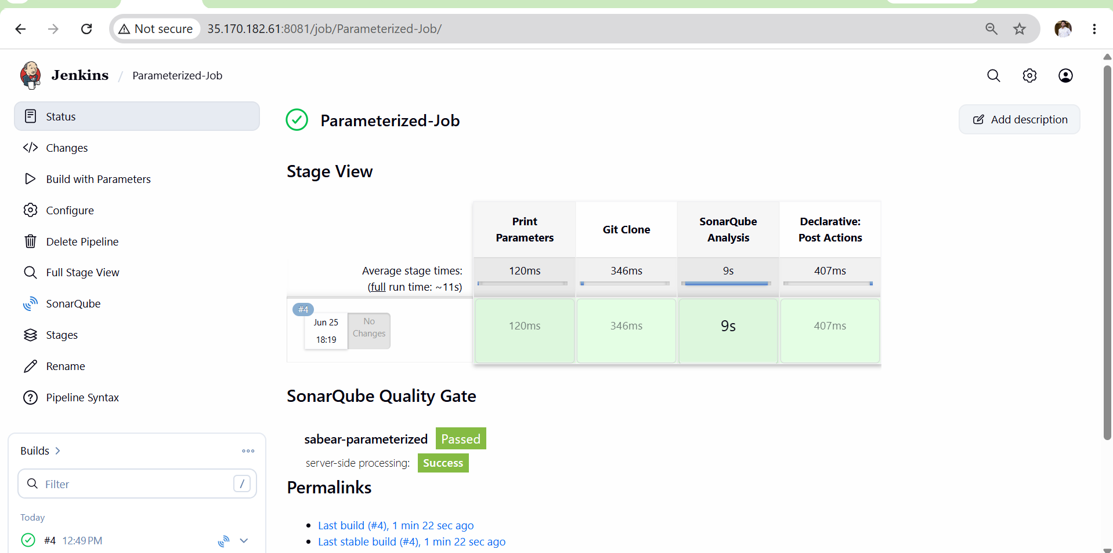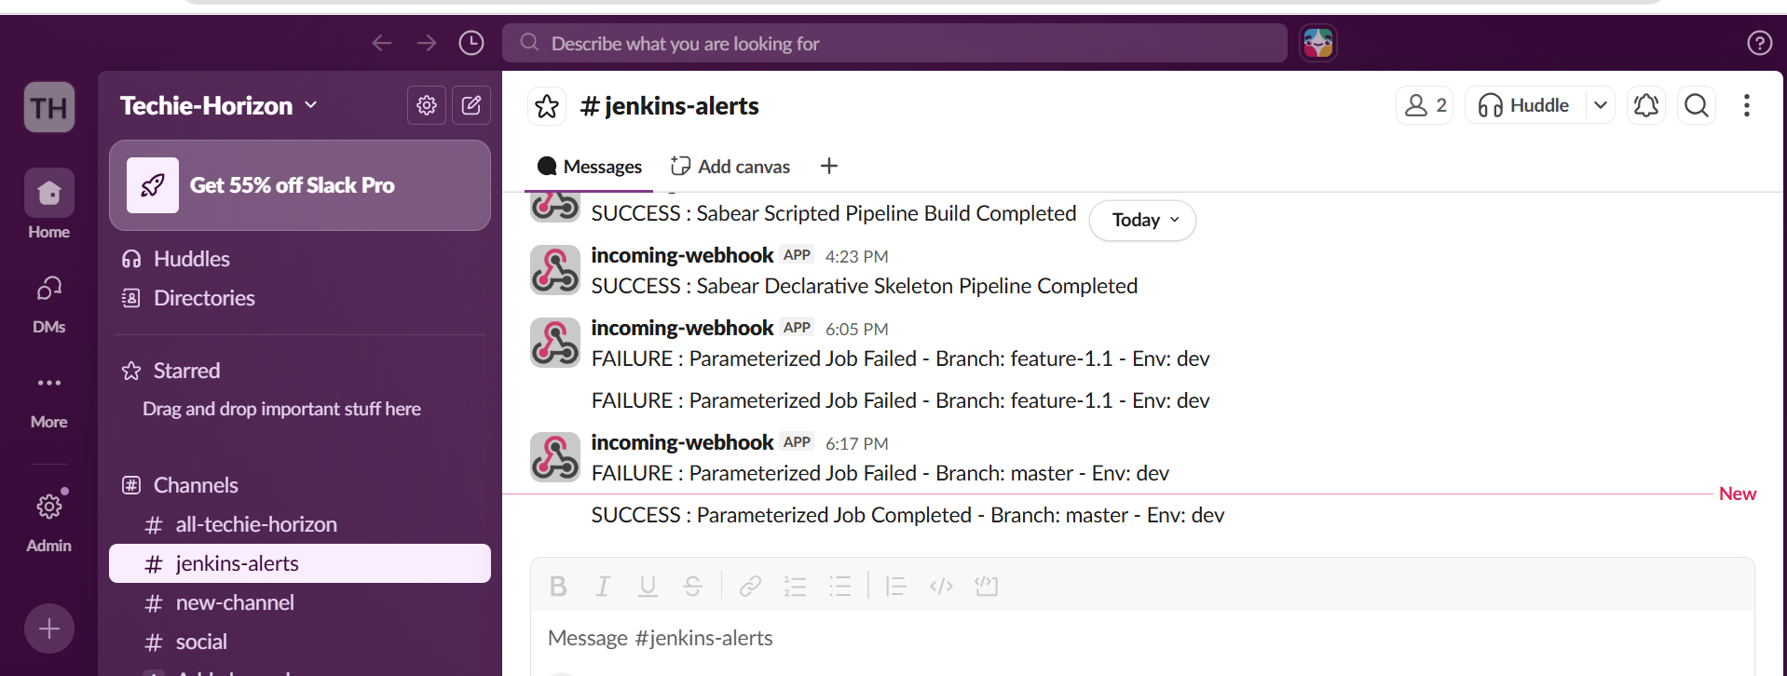
Outcome
- Created a Jenkins Parameterized Job.
- User can build different branches dynamically.
- Git branch selection automated using parameters.
- Maven build completed successfully.
- Artifact generated based on selected branch.
- Demonstrated dynamic build execution using Jenkins Parameters.

Task 4: Write sample skeleton for Declarative and Scripted pipelines
Declarative Pipeline Skeleton
pipeline {
agent any

environment {
APP_NAME = "DemoApp"
}

tools {
maven 'Maven-3.9'
}

stages {

stage('Checkout') {
steps {
echo 'Checkout Source Code'
}
}

stage('Build') {
steps {
echo 'Build Application'
}
}

stage('Test') {
steps {
echo 'Run Tests'
}
}

stage('Deploy') {
steps {
echo 'Deploy Application'
}
}
}

post {
success {
echo 'Pipeline Completed Successfully'
}

failure {
echo 'Pipeline Failed'
}

always {
echo 'Cleaning Workspace'
}
}
}
Structure
pipeline
├── agent
├── environment
├── tools
├── stages
│ ├── Checkout
│ ├── Build
│ ├── Test
│ └── Deploy
└── post

Scripted Pipeline Skeleton
node {

stage('Checkout') {
echo 'Checkout Source Code'
}

stage('Build') {
echo 'Build Application'
}

stage('Test') {
echo 'Run Tests'
}

stage('Deploy') {
echo 'Deploy Application'
}

echo 'Pipeline Completed'
}

Structure
node
├── Checkout
├── Build
├── Test
└── Deploy

Declarative vs Scripted
Declarative Pipeline | Scripted Pipeline
pipeline {} | node {}
Uses agent any | Uses node
Uses stages and steps | Uses Groovy code directly
Easier to read and maintain | More flexible for complex logic
Recommended for most CI/CD pipelines | Best for advanced/custom workflows

Task 5: Create one Declarative job
- Source
Code:https://github.com/betawins/sabear_simplecutomerapp/tree/feature-1.1
Objective
Create a Declarative Pipeline using:
Repository:
https://github.com/betawins/sabear_simplecutomerapp.git
Branch:
feature-1.1
Stages
1. Git Clone
2. SonarQube Integration
3. Maven Compilation
4. Nexus Artifactory Upload
5. Slack Notification
6. Deploy on Tomcat
Implementation Steps
- Created Jenkins Pipeline job Sabear-Declarative-Pipeline.
- Configured Git repository URL and feature-1.1 branch.
- Verified JDK-21, Maven, Sonar Scanner, Nexus, Slack, and SonarQube configurations.
- Added SonarQube token credential (sonar-token) in Jenkins.
- Added Nexus username/password credential (nexus) in Jenkins.
- Added Slack webhook credential (slack) in Jenkins.
- Configured SonarQube server integration in Jenkins.
- Configured Nexus repository for artifact storage.
- Added Declarative Pipeline script in Jenkins job.
- Executed Git Clone stage to pull source code from GitHub.
- Executed SonarQube Analysis stage for code quality scanning.
- Executed Maven Compilation stage using mvn clean package.
- Generated deployable application artifact successfully.
- Uploaded build artifact to Nexus Repository Manager.
- Sent build success notification to Slack channel.
- Deployed generated artifact to Apache Tomcat server.
- Restarted Tomcat after deployment.
- Verified successful application deployment from browser.
- Verified artifact availability in Nexus Repository.
- Verified SonarQube analysis report generation.
- Verified Slack notification delivery.
- Confirmed all six pipeline stages executed successfully.
- Validated end-to-end Declarative CI/CD pipeline workflow.
- Build completed with SUCCESS status in Jenkins.
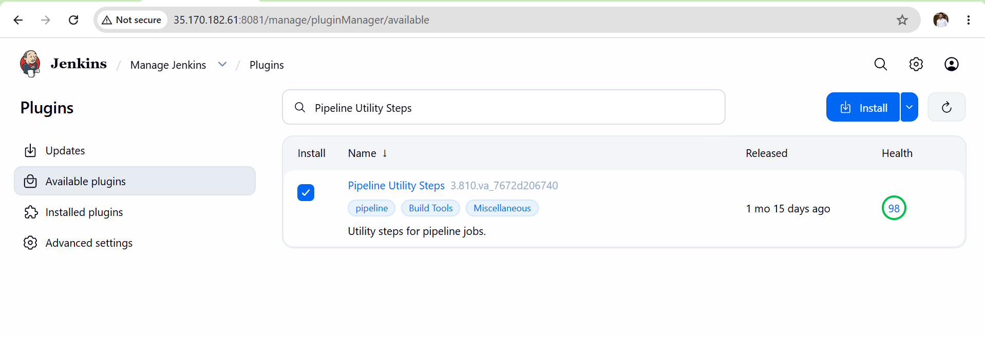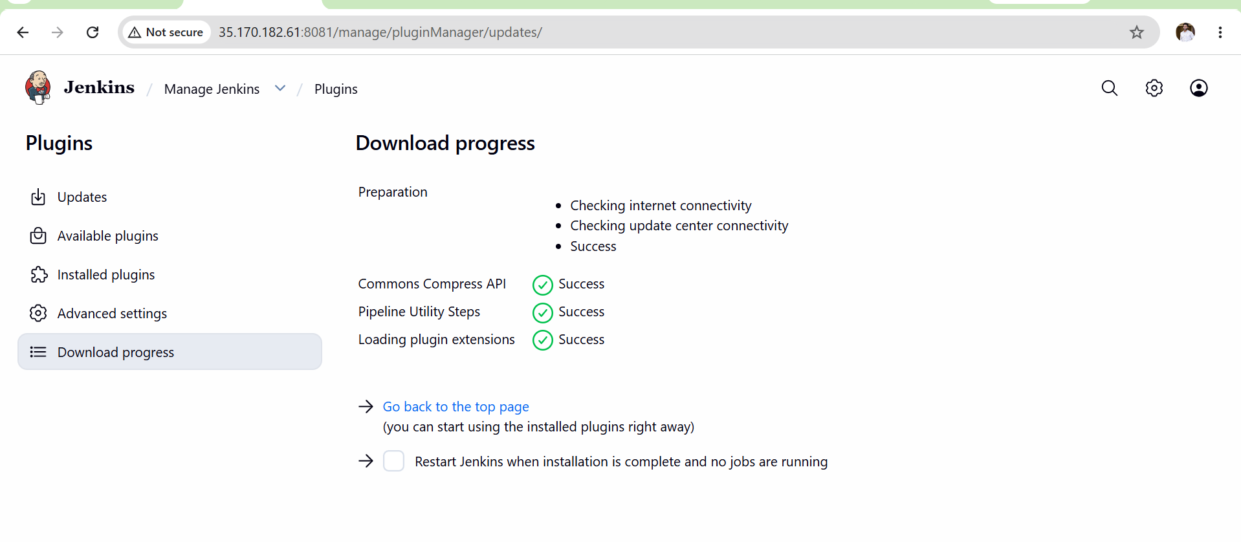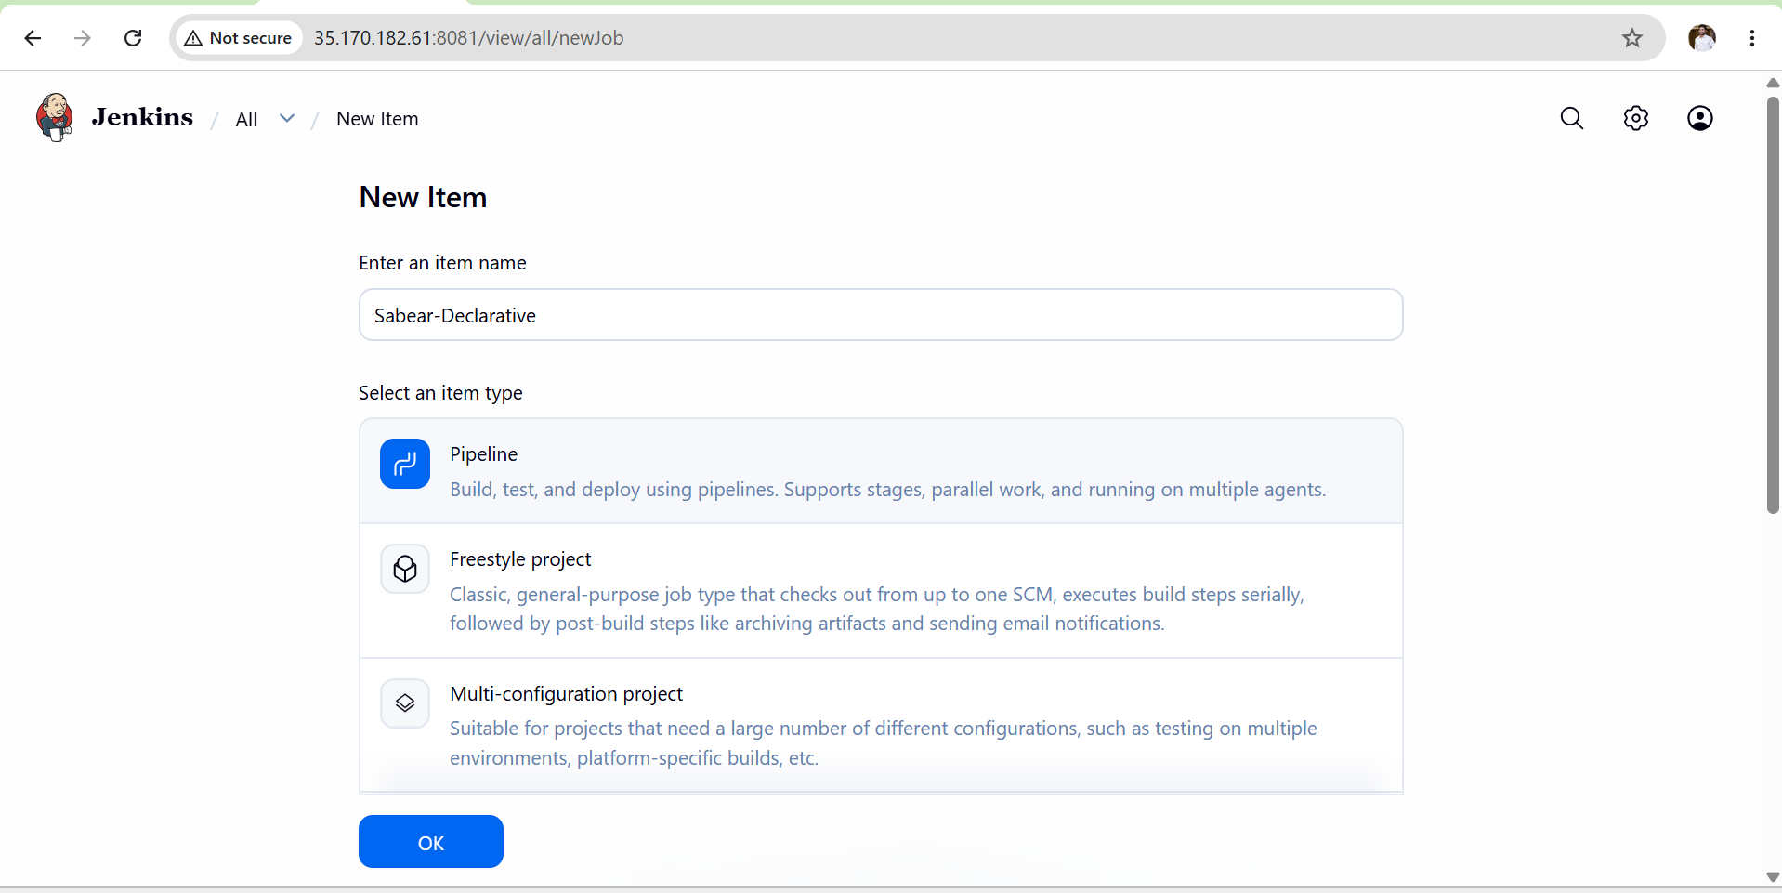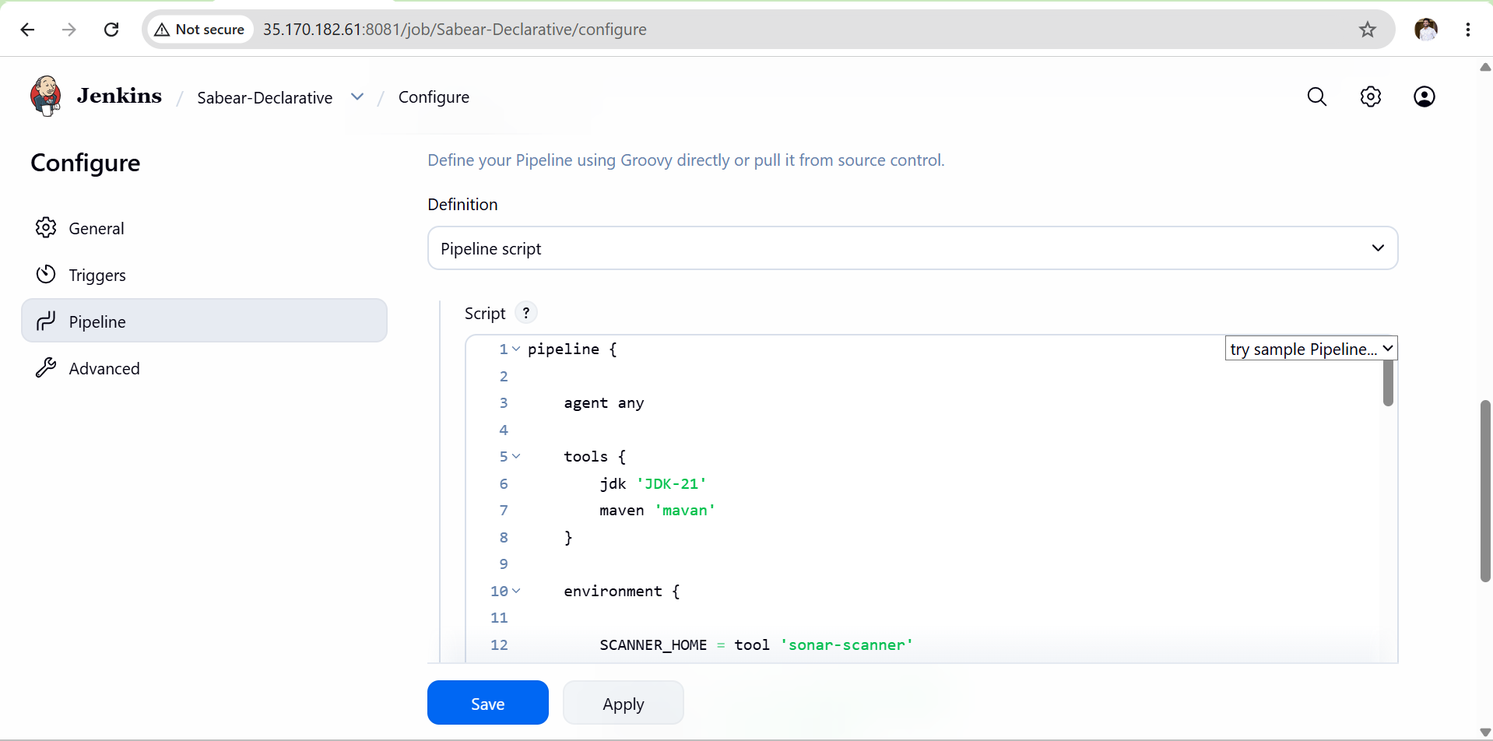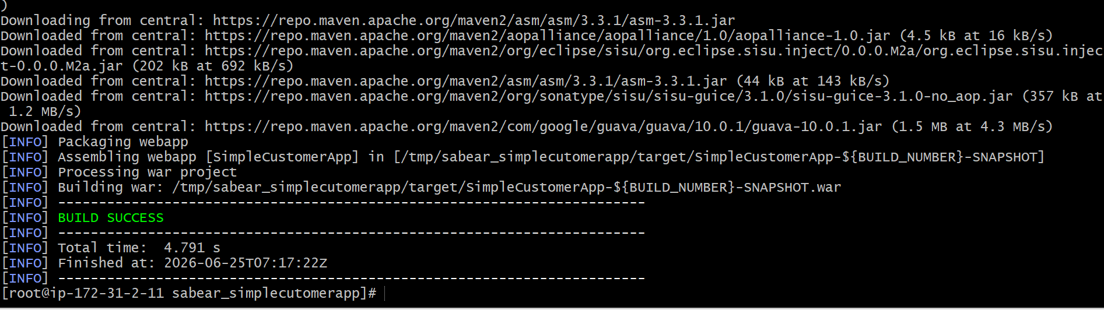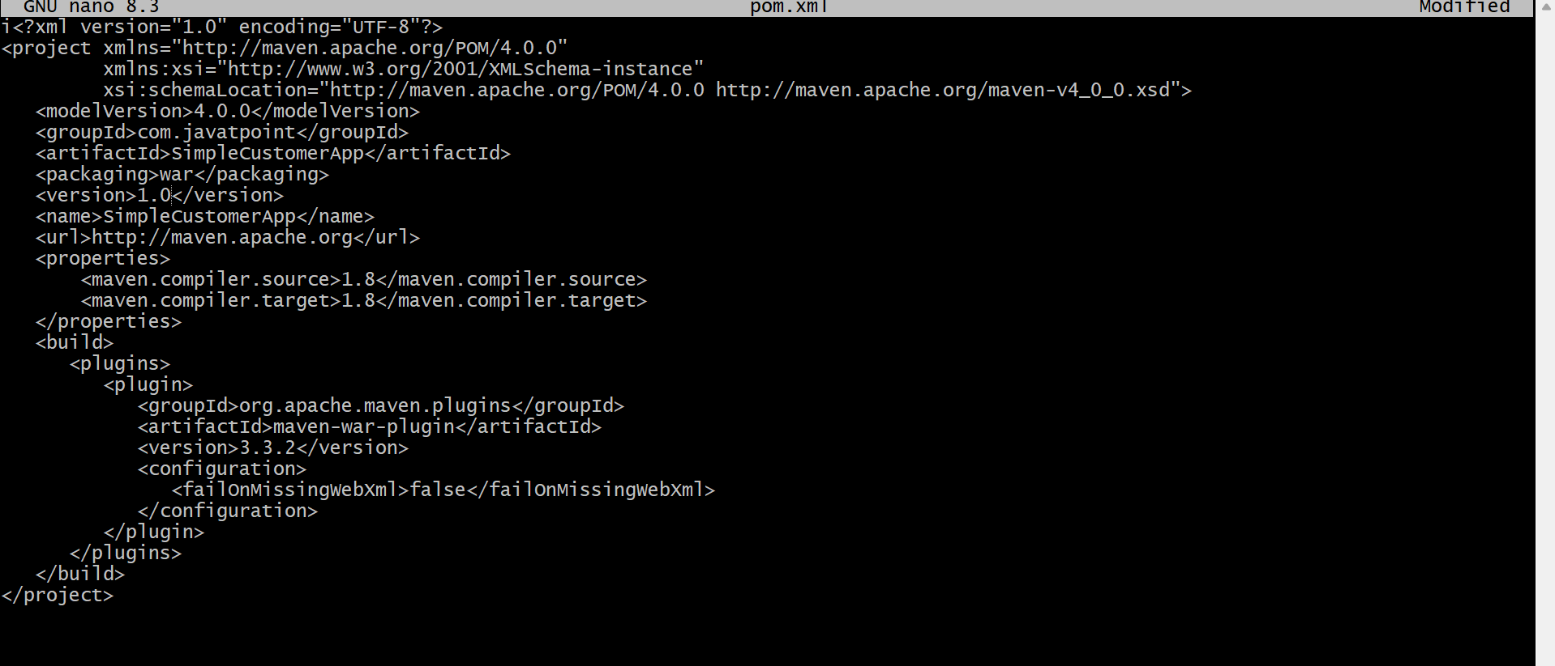

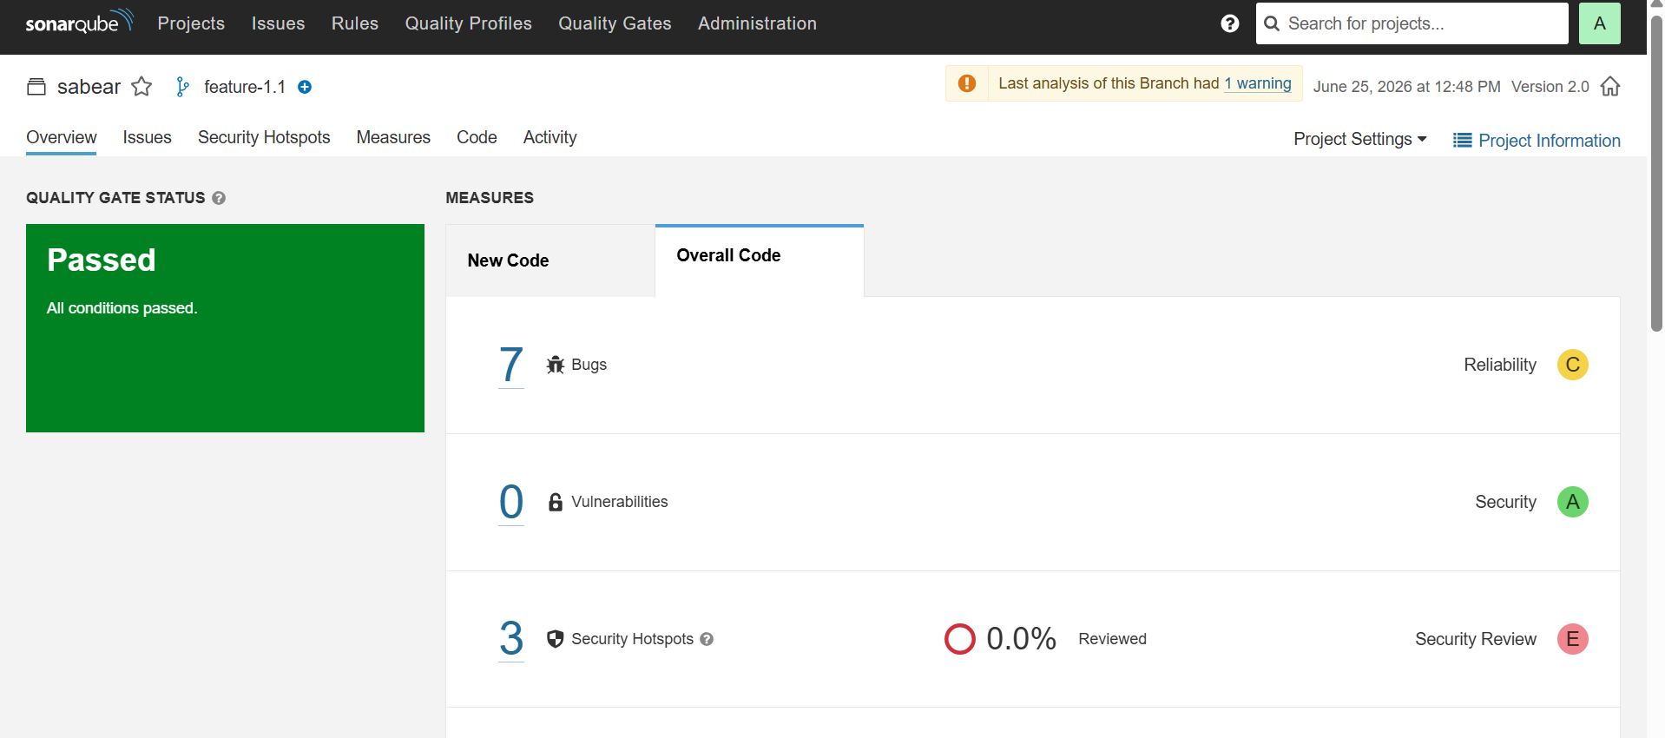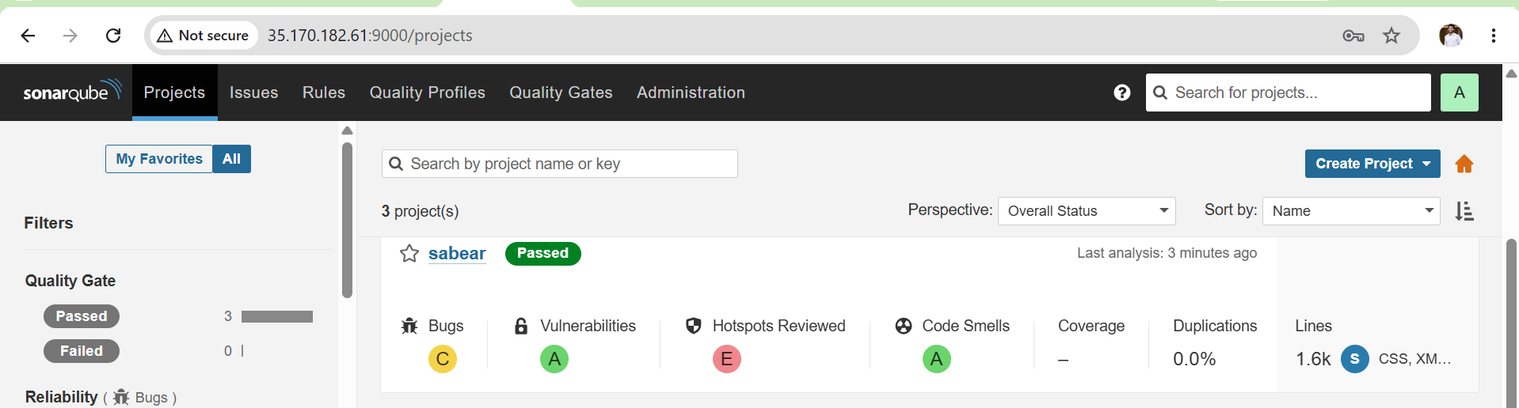
Validation
- Git repository cloned successfully from feature-1.1 branch.
- SonarQube code analysis completed successfully.
- Maven build completed without errors.
- WAR/JAR artifact generated successfully.
- Artifact uploaded successfully to Nexus Repository.
- Slack notification received in configured channel.
- Application deployed successfully on Tomcat server.
- Jenkins pipeline status displayed SUCCESS. 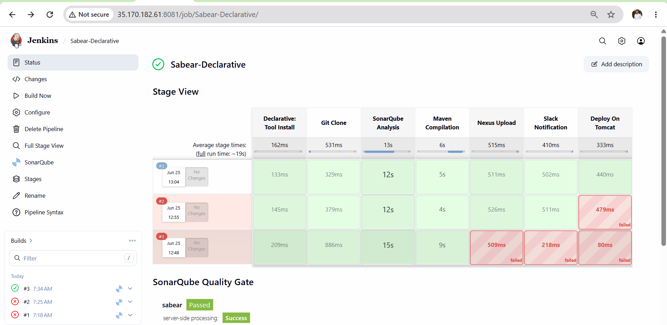

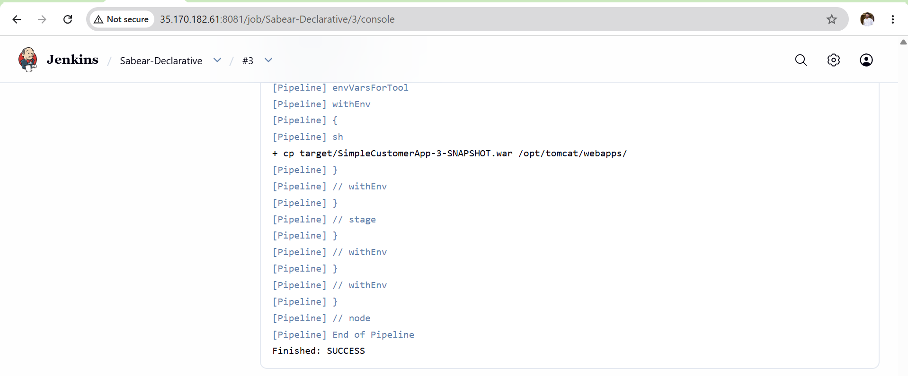
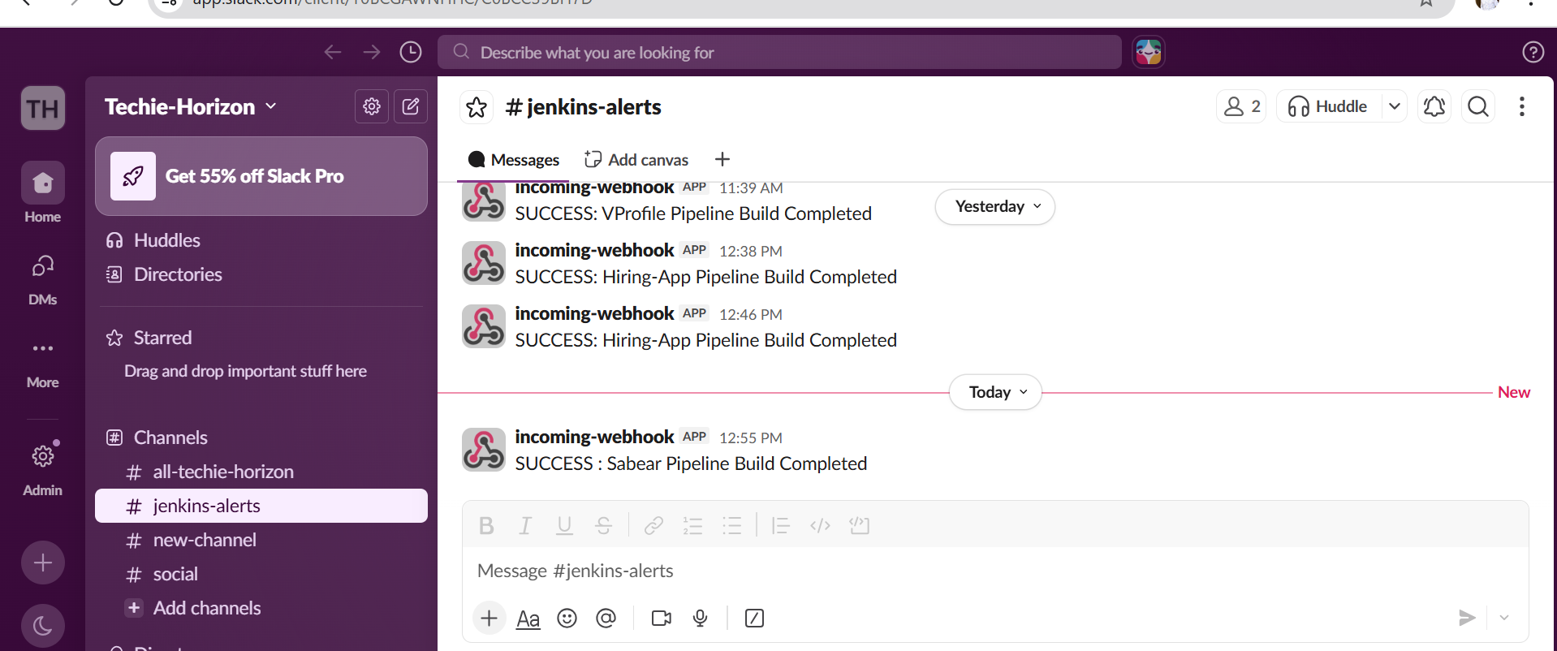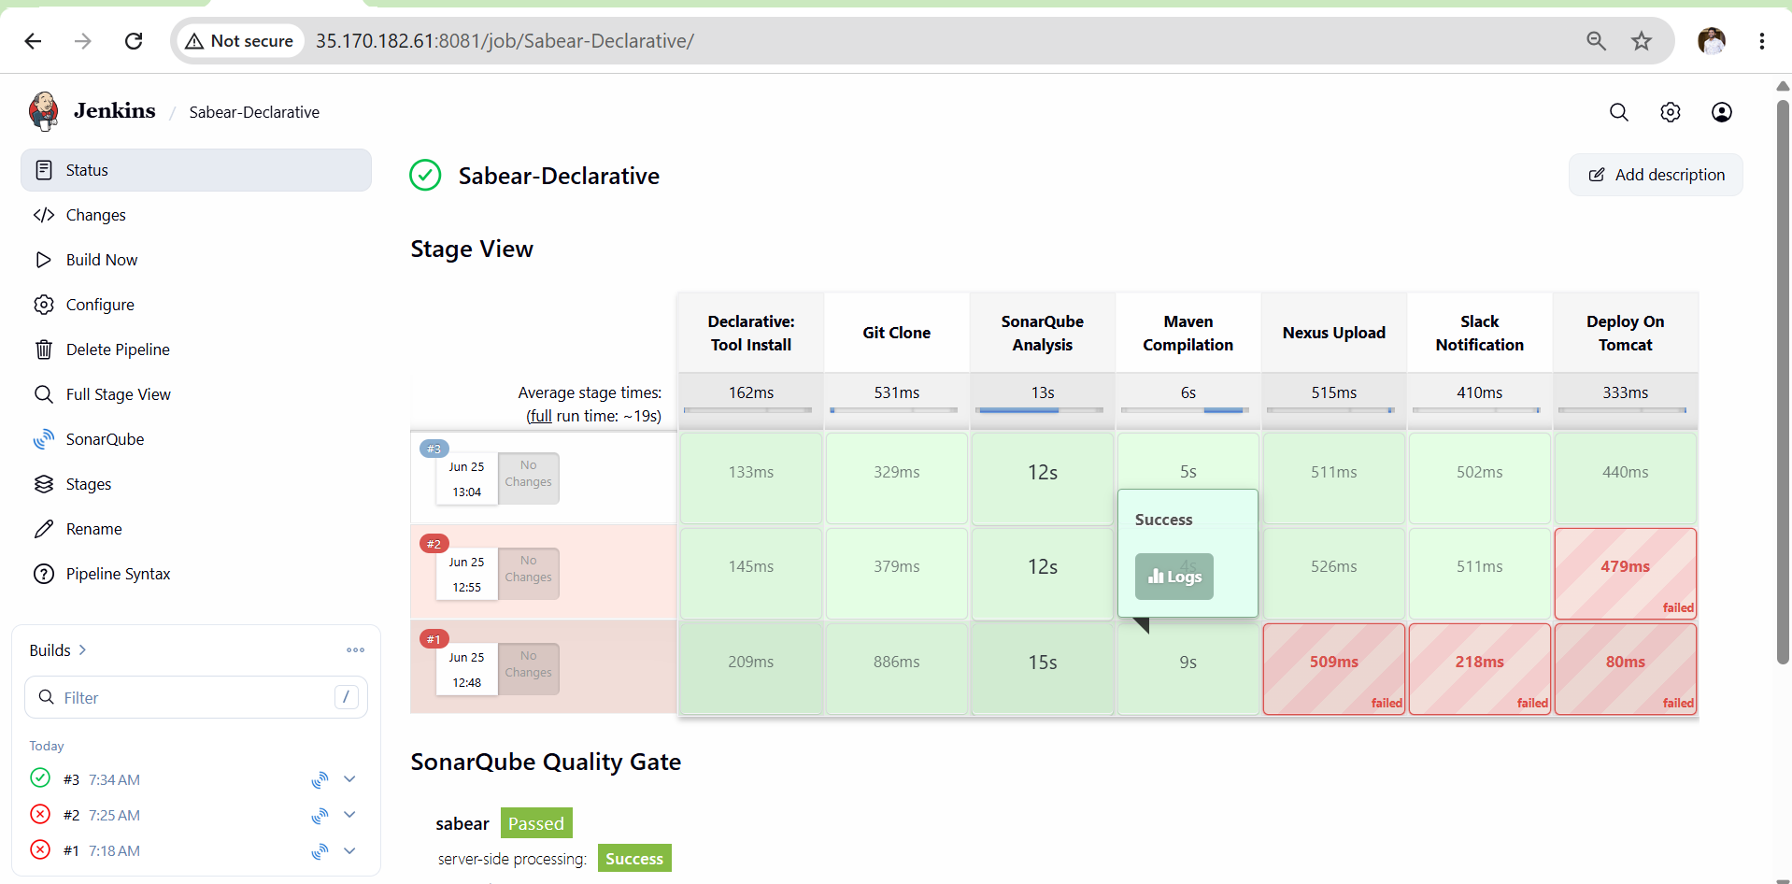

Outcome
- End-to-end Declarative CI/CD pipeline implemented successfully.
- Automated code quality checks using SonarQube.
- Automated artifact management using Nexus.
- Automated deployment to Tomcat.
- Automated build notifications through Slack.
- Successful integration of Git, SonarQube, Maven, Nexus, Slack, and Tomcat in Jenkins

Task 06: Create one Declarative job
Source Code:
https://github.com/betawins/Trading-UI.git

Objective
- Understand the structure and syntax of a Declarative Jenkins pipeline
- Create a Jenkins pipeline job using Declarative job.
- Integrate SonarQube analysis, Maven build, Nexus upload, and Slack notification in Declarative style
Prerequisites
- Jenkins is installed and running
- Maven tool configured in Jenkins Global Tool Configuration with name mavan
- SonarQube server configured in Jenkins Configure System with name sonarqube
- SonarQube Scanner tool configured with name sonar-scanner
- Nexus Repository Manager running with maven-releases repository created
- Following credentials added in Jenkins Credentials:
  - sonar-token → Secret text (SonarQube token)
  - nexus → Username and Password (Nexus login)
  - slack → Secret text (Slack Webhook URL)
- Source code available at Source Code:https://github.com/betawins/Trading-UI.git
Steps
- Open Jenkins Dashboard → Click New Item
- Enter job name hiring-app-declarative → Select Pipeline → Click OK
- Scroll down to Pipeline section → Select Pipeline script
- Paste the Declarative pipeline code → Click Save
- Click Build Now and monitor the Stage View
- Verify all 5 stages complete: Pipeline Info, Git Clone, SonarQube Analysis, Maven Build, Nexus Upload
- Check Slack channel for SUCCESS notification
- Check Nexus for uploaded WAR file



Validation Points
- Jenkins build shows success for hiring-app-declarative job
- All 5 stages visible and green in Stage View
- SonarQube dashboard shows project hiring-app-declarative with analysis report
- Nexus maven-releases repository contains uploaded WAR file
- Slack channel received SUCCESS message with correct build number and job name
- Workspace cleaned after build via cleanWs() in post { always } block
- Pipeline code uses pipeline {} block — confirming Declarative syntax
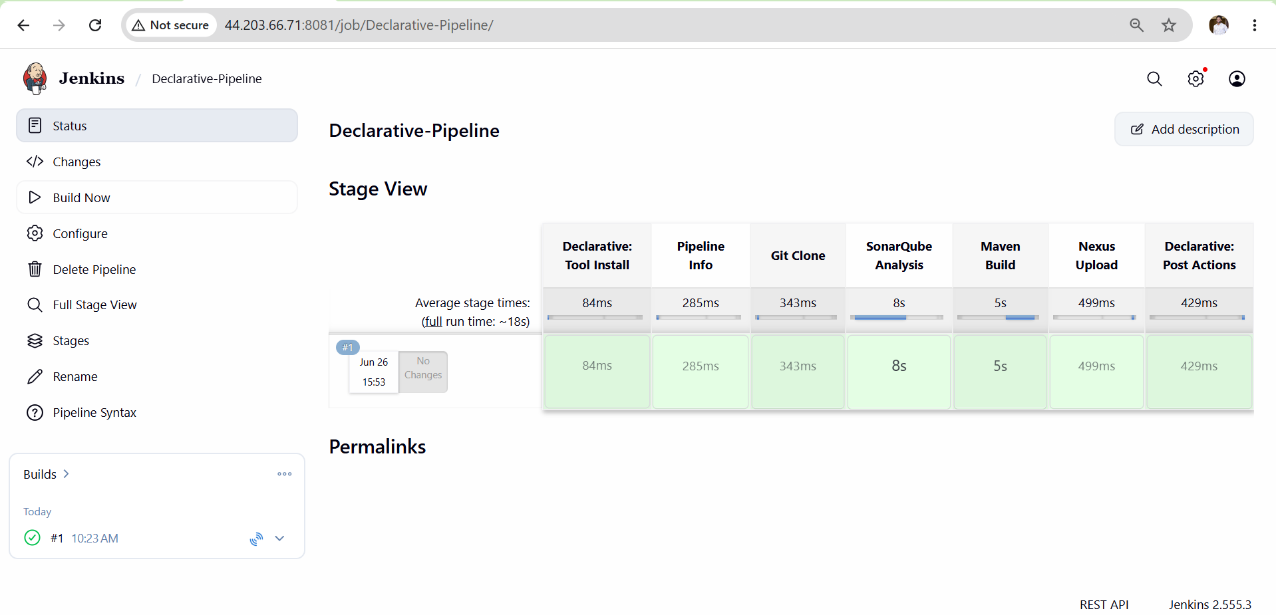

Outcome
- Successfully created a Declarative pipeline job in Jenkins
- Pipeline executed all stages in order: Pipeline Info → Git Clone → SonarQube Analysis → Maven Build → Nexus Upload
- WAR file built by Maven was uploaded to Nexus maven-releases repository
- Slack channel received SUCCESS or FAILURE notification after build
- Understood Declarative pipeline structure using pipeline {}, stages {}, post {} blocks

Task 7: Parallel Stage Pipeline Job
Objective
Create a Jenkins Parallel Stage Pipeline for the hiring-app where multiple stages run simultaneously at the same time, reducing overall build time.
Prerequisites
Server Requirements
- Jenkins running at http://44.203.66.71:8080
- SonarQube running at http://44.203.66.71:9000
- Nexus running at http://44.203.66.71:8082
Jenkins Tools Configured
- Maven installed in Jenkins Tools with name mavan
- SonarQube Scanner configured with name sonar-scanner
Jenkins Credentials Required
- sonar-token — SonarQube authentication token
- nexus — Nexus username and password
- slack — Slack webhook URL
Plugins Required
- Pipeline
- Git
- SonarQube Scanner
- Workspace Cleanup

Steps
- SSH into server and verify all tools are running
- Verify Jenkins credentials exist for sonar-token, nexus and slack
- Go to Jenkins → New Item → Enter name Hiring-App-MultiStage-Pipeline
- Select Pipeline → Click OK
- Scroll to Pipeline section → Select Pipeline script
- Paste the complete pipeline script
- Click Save
- Click Build Now
- Watch Stage View — verify all stages go green
- Check SonarQube dashboard for analysis report
- Check Nexus repository for uploaded WAR file
- Check Slack channel for success notification

Validation Points
Jenkins
- Job Hiring-App-MultiStage-Pipeline created successfully
- All 5 stages visible in Stage View
- All stages show green on successful run
- Console output shows BUILD SUCCESS
- Console output shows Running on Jenkins node

Git Clone
- Console shows commit message from main branch
- Workspace contains hiring-app source code
Maven Build
- Console shows BUILD SUCCESS
- WAR file created in target folder
- Console shows WAR file listed after build
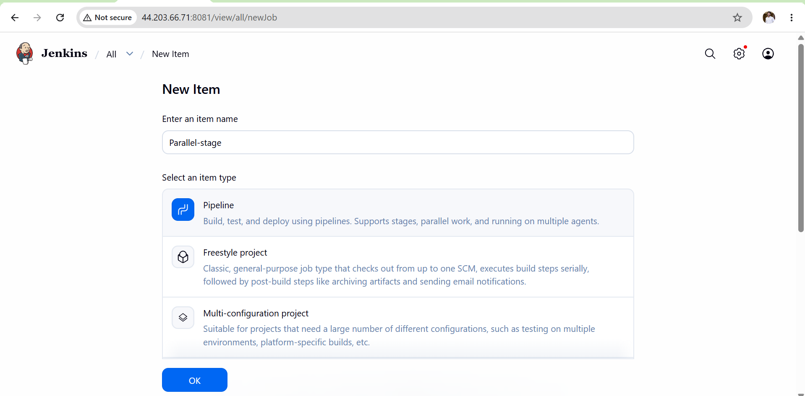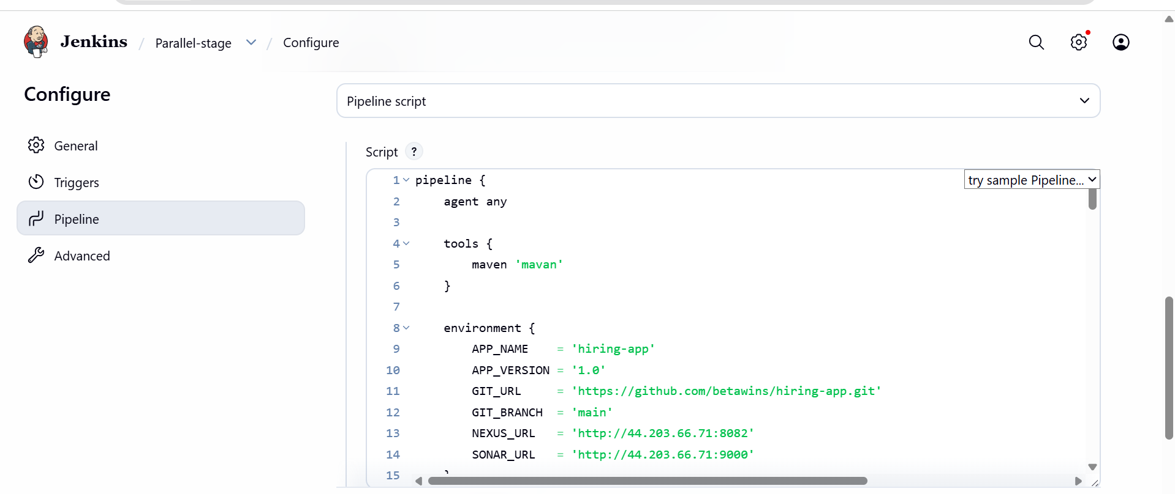

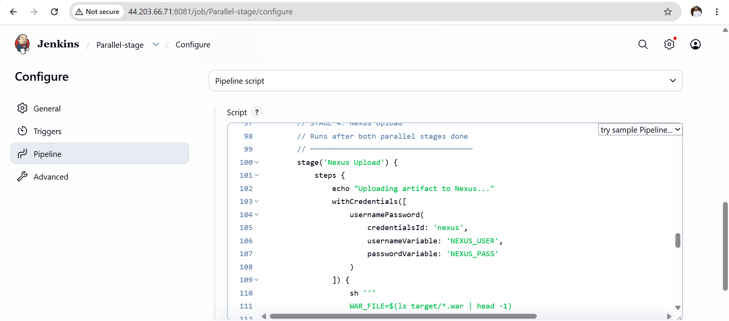
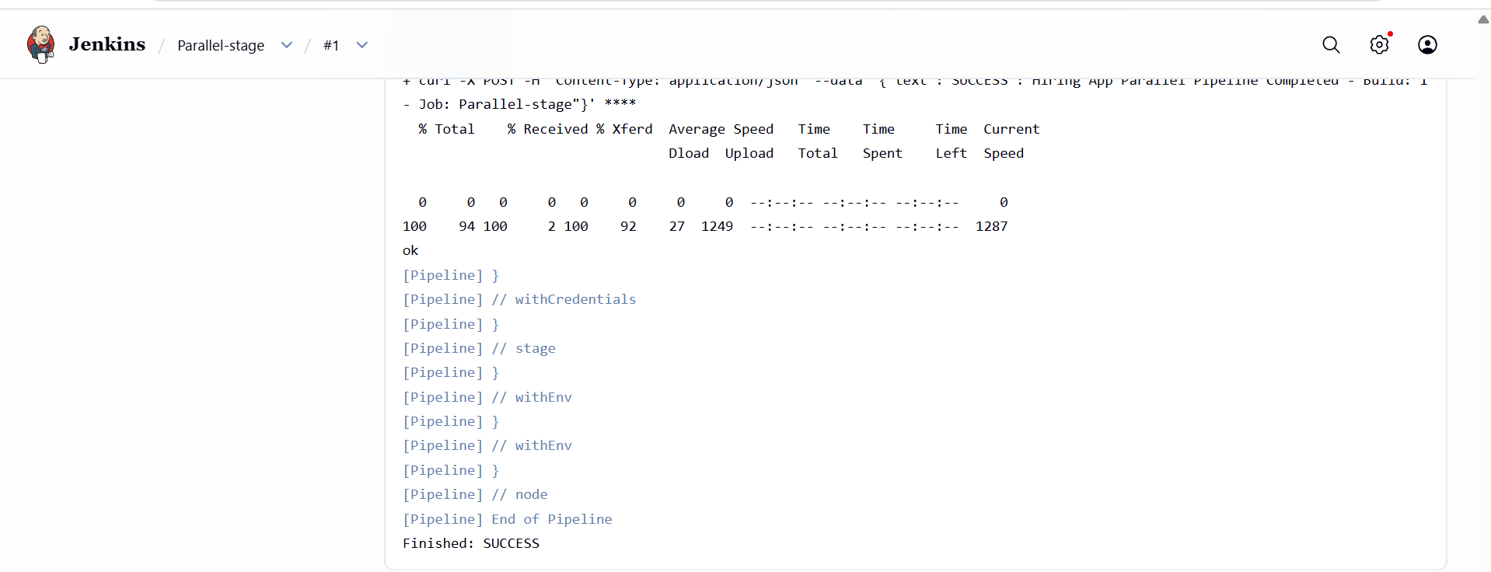
SonarQube
- Analysis report visible at:
http://44.203.66.71:9000/dashboard?id=hiring-app-multistage

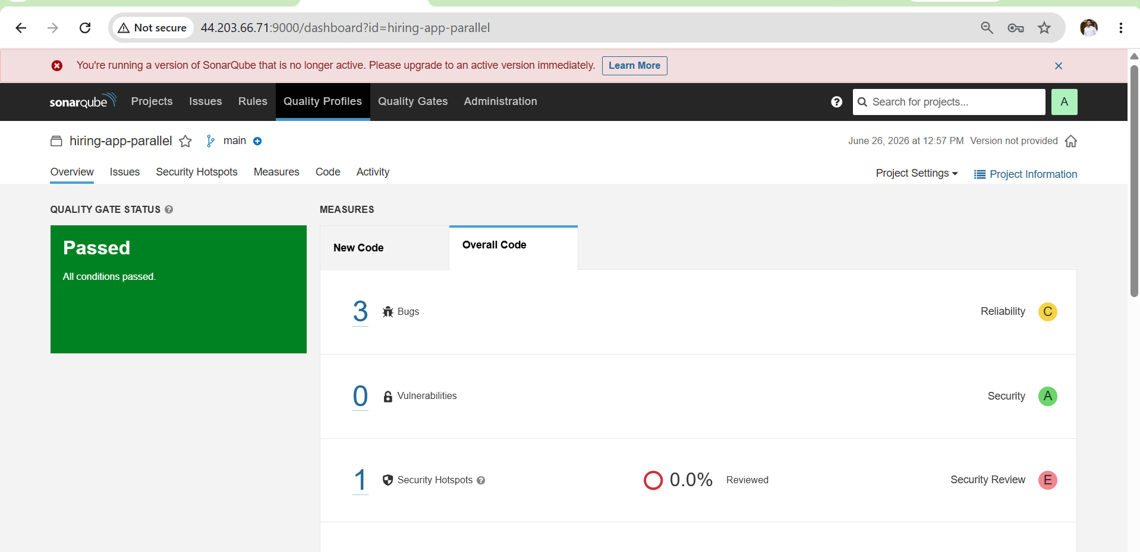
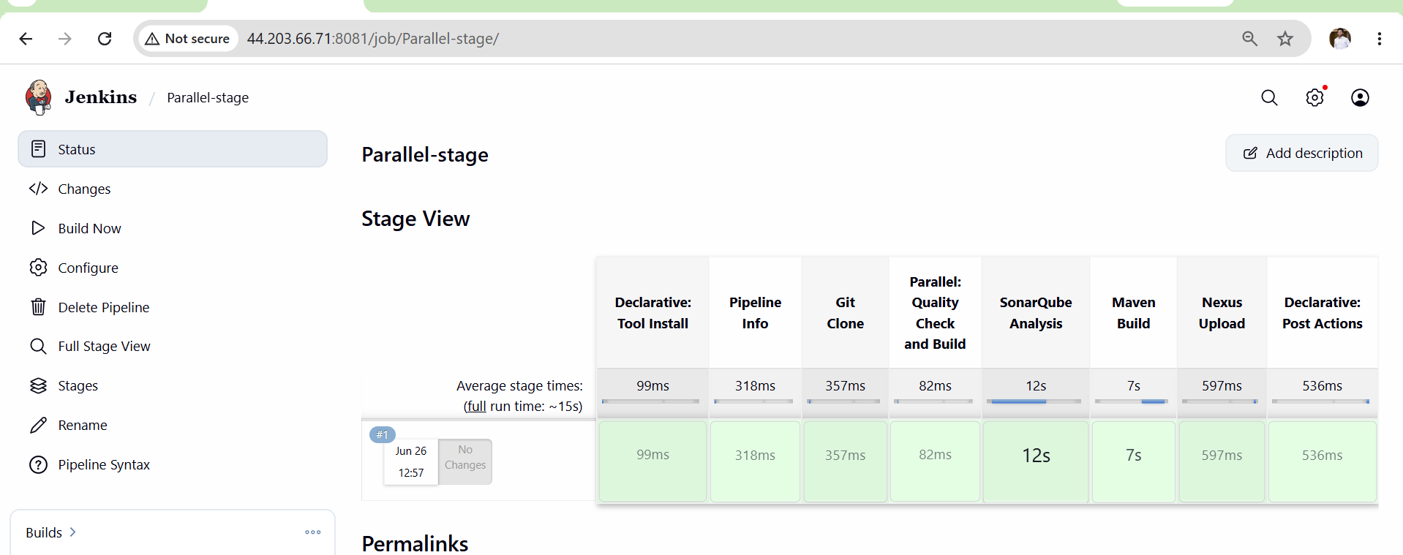

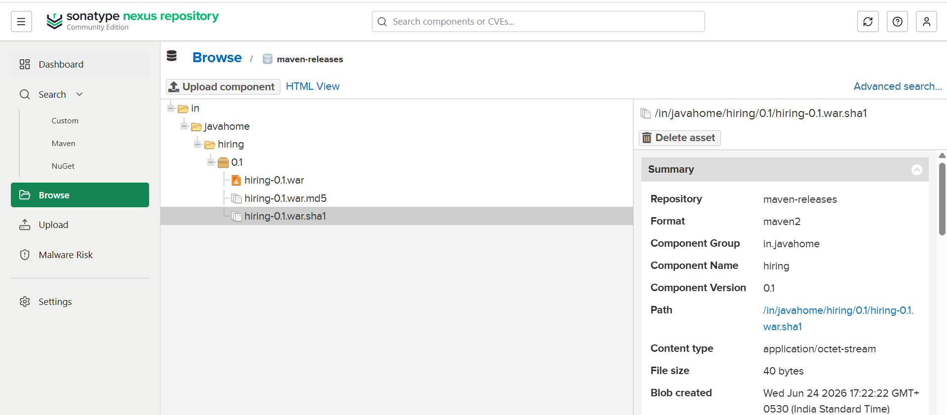
Slack
- Success message received in Slack channel:
SUCCESS : Hiring App MultiStage Pipeline Completed
Build: #1 - Job: Hiring-App-MultiStage-Pipeline

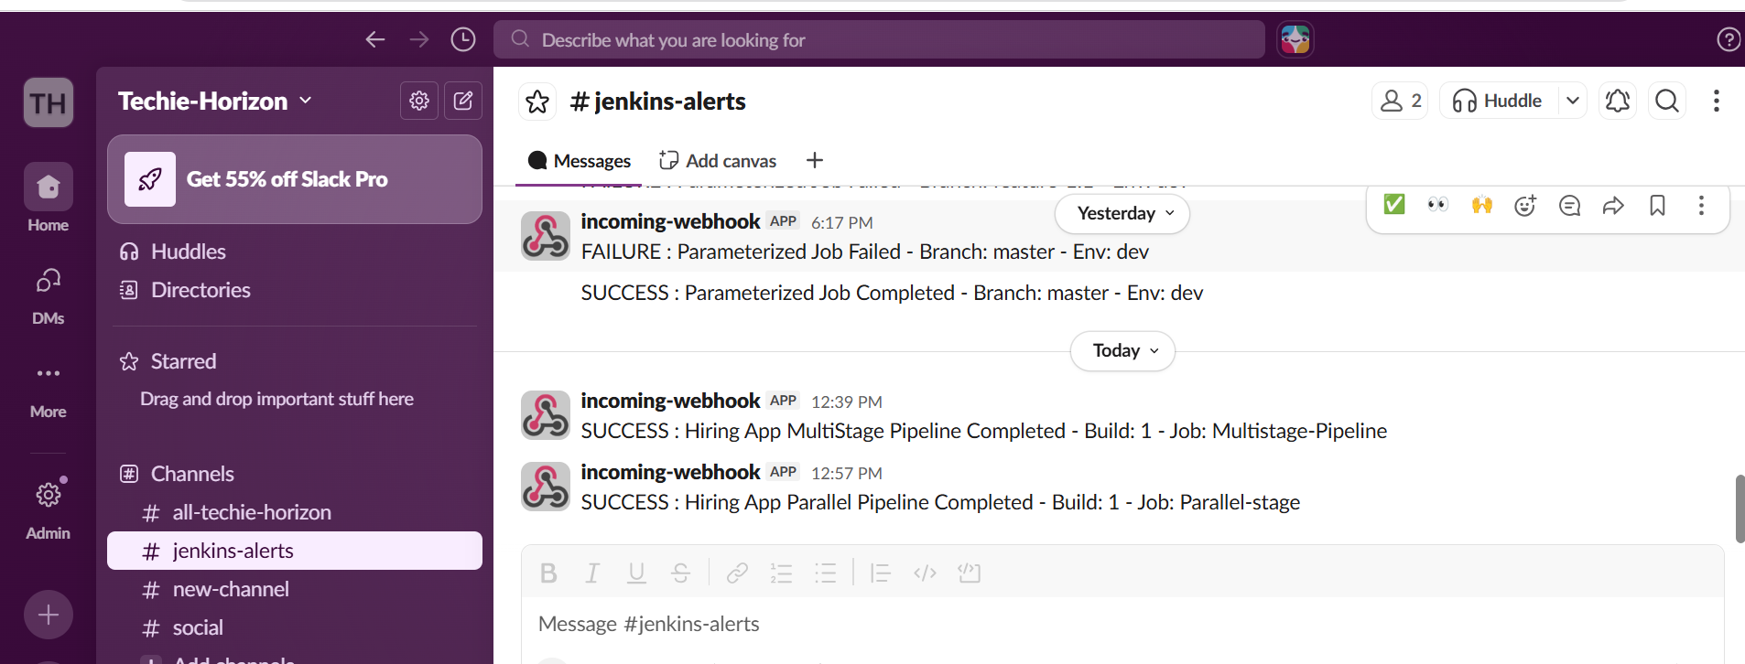

Outcome
- A Jenkins Multi Stage Pipeline job created and running successfully
- All 5 stages visible and green in Jenkins Stage View
- Code cloned from main branch of hiring-app repository
- SonarQube analysis report generated and visible on dashboard
- WAR artifact built by Maven and uploaded to Nexus repository
- Slack success notification received on pipeline completion

Task 8: Execute Jenkins Pipeline Stages Using Shared Libraries
A Jenkins Shared Library is a collection of reusable Groovy scripts stored in a Git repository. Instead of writing the same pipeline code in every Jenkinsfile, you write it once in a shared library and reuse it across multiple pipelines. This keeps pipelines clean, reusable, and easier to maintain.

Architecture
GitHub (Shared Library Repository)
│
├── vars/
│ ├── buildApp.groovy
│ ├── testApp.groovy
│ └── deployApp.groovy
│
└── README.md
│
▼
Jenkins Global Pipeline Library
│
▼
Jenkins Pipeline (Jenkinsfile)
│
▼
Execute Shared Library Functions
Implementation Steps
1. Verify Jenkins is Running
sudo systemctl status jenkins

2. Install Git (if not installed)
sudo dnf install git -y
Verify:
git --version

3. Create a GitHub Repository
- Create a new repository named jenkins-shared-library.

4. Create Shared Library Structure
jenkins-shared-library/
│
├── vars/
│ └── hello.groovy
└── README.md

5. Create Shared Library Function
File: vars/hello.groovy
def call() {
echo "Hello from Shared Library!"
}

6. Initialize Git Repository
git init
git add .
git commit -m "Initial Shared Library"

7. Push Repository to GitHub
git remote add origin <GitHub Repository URL>
git branch -M main
git push -u origin main

8. Configure Global Shared Library in Jenkins
Navigate to:
Manage Jenkins
↓
System (Configure System)
↓
Global Pipeline Libraries
Configure:
- Library Name: shared-lib
- Default Version: main
- Retrieval Method: Modern SCM
- Source Code Management: Git
- Repository URL: GitHub repository URL
Click Save.

9. Create a Pipeline Job
- Create a new Jenkins Pipeline project.
- Paste the following Jenkinsfile:
@Library('shared-lib') _

pipeline {
agent any

stages {
stage('Shared Library Demo') {
steps {
hello()
}
}
}
}

10. Build the Pipeline
- Click Build Now.
- Open Console Output.

Create a GitHub Repository
Create a repository named:
jenkins-shared-library

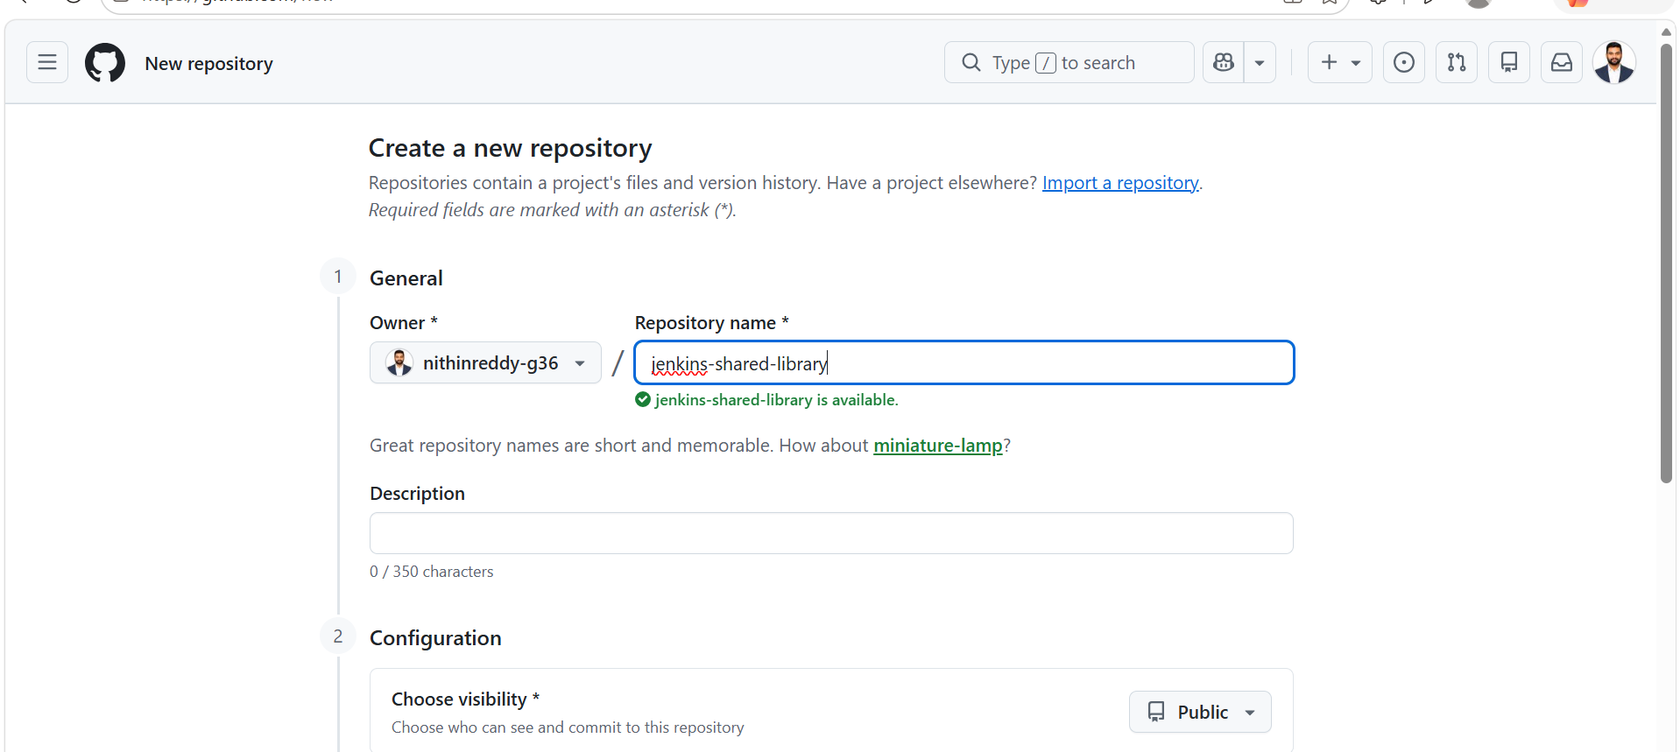

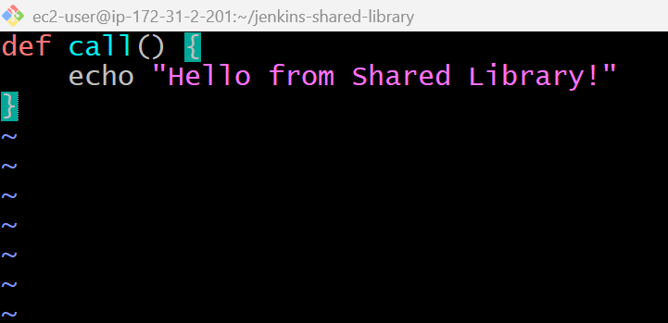
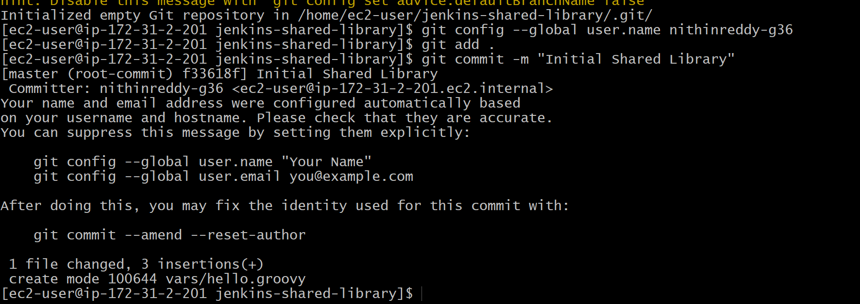
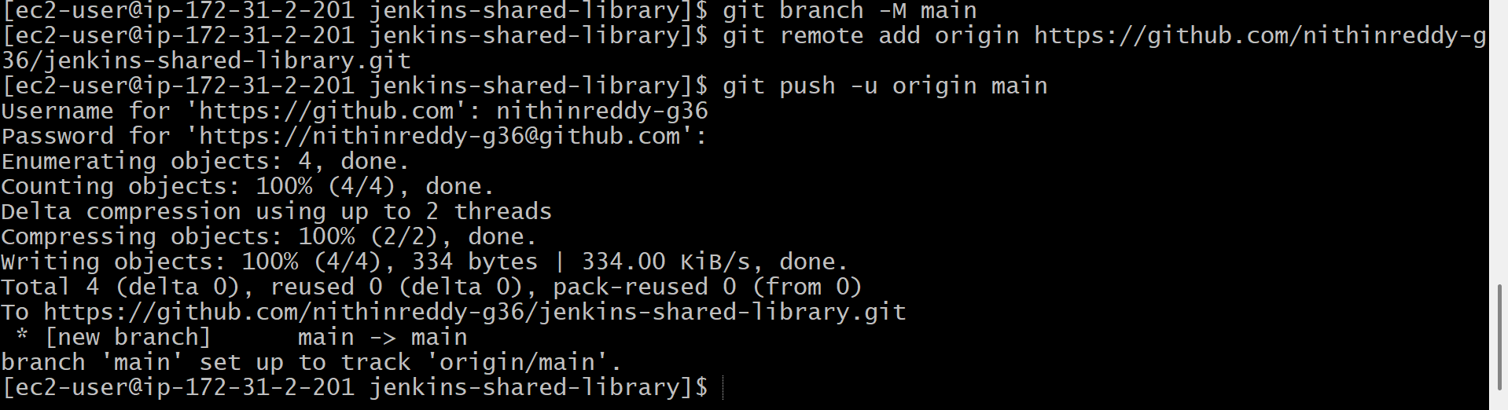
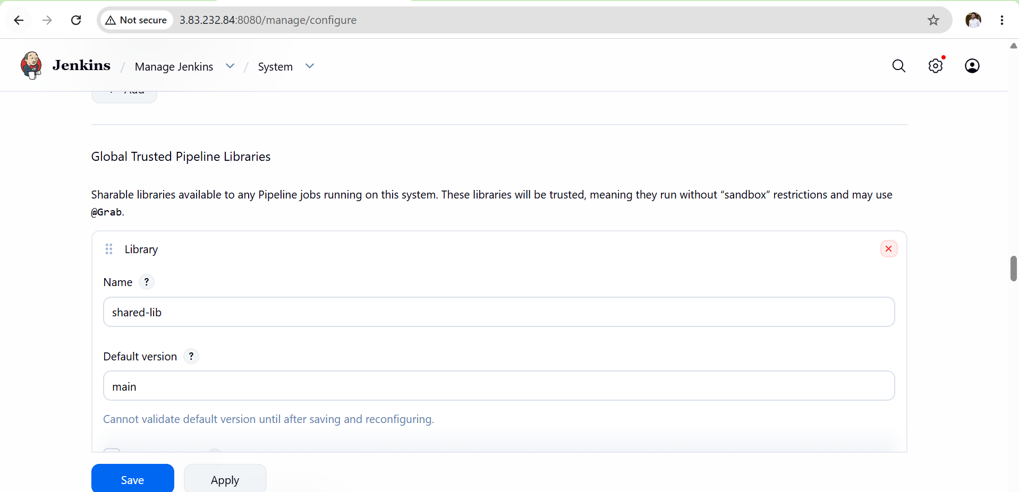
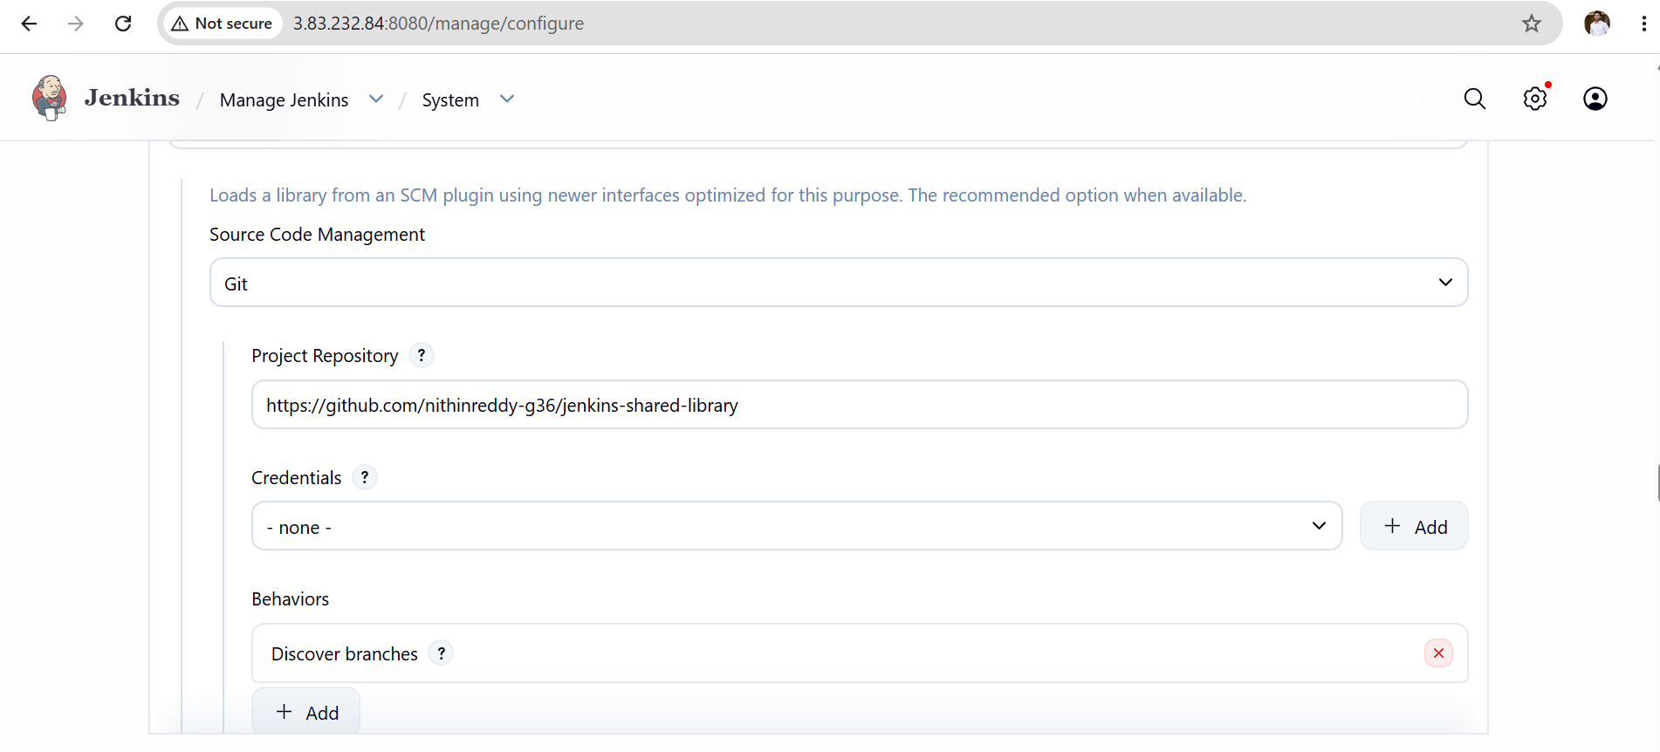
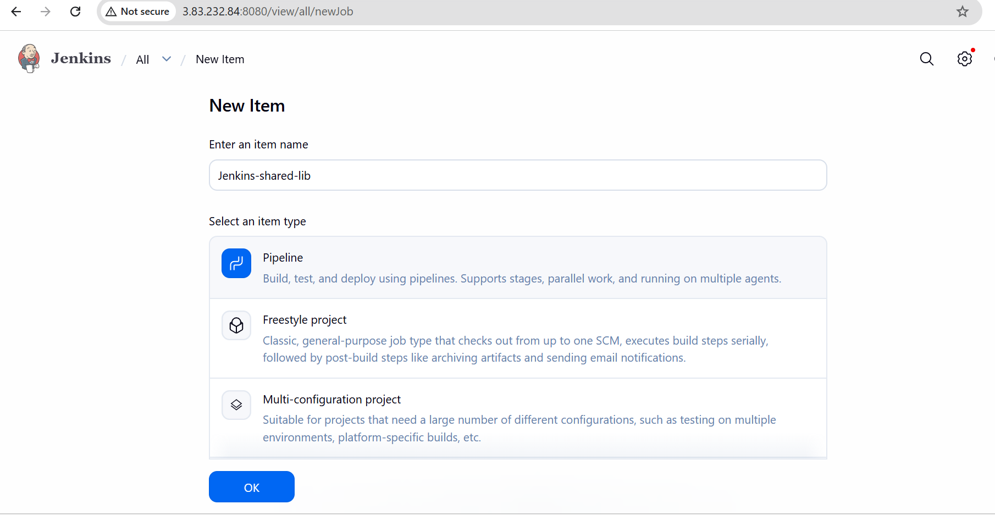
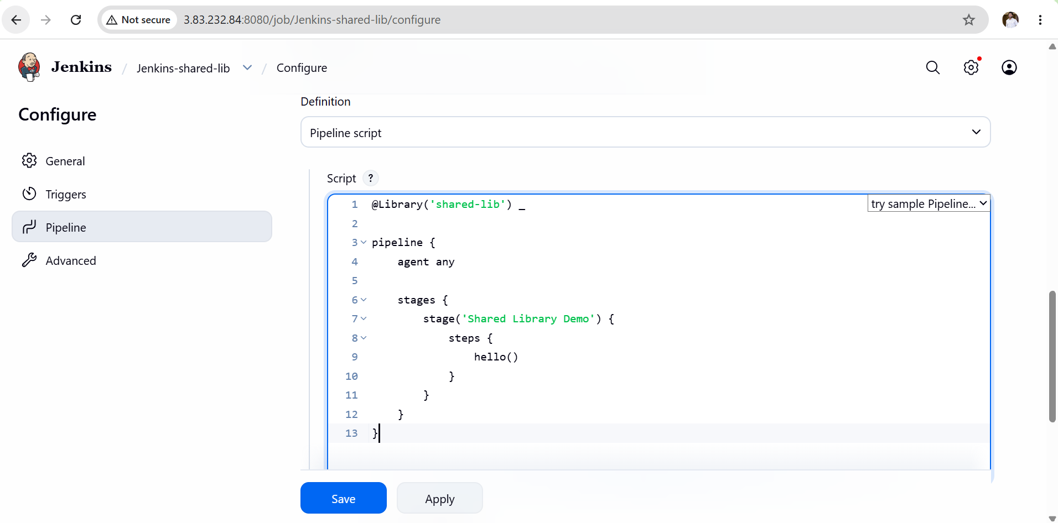
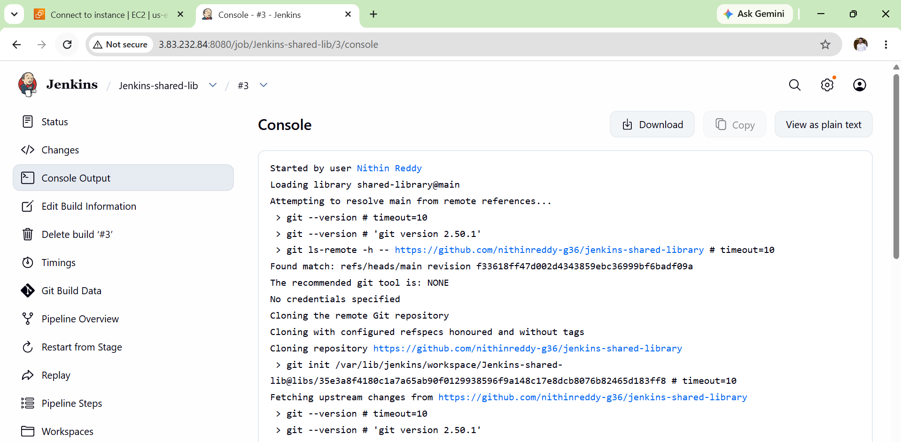
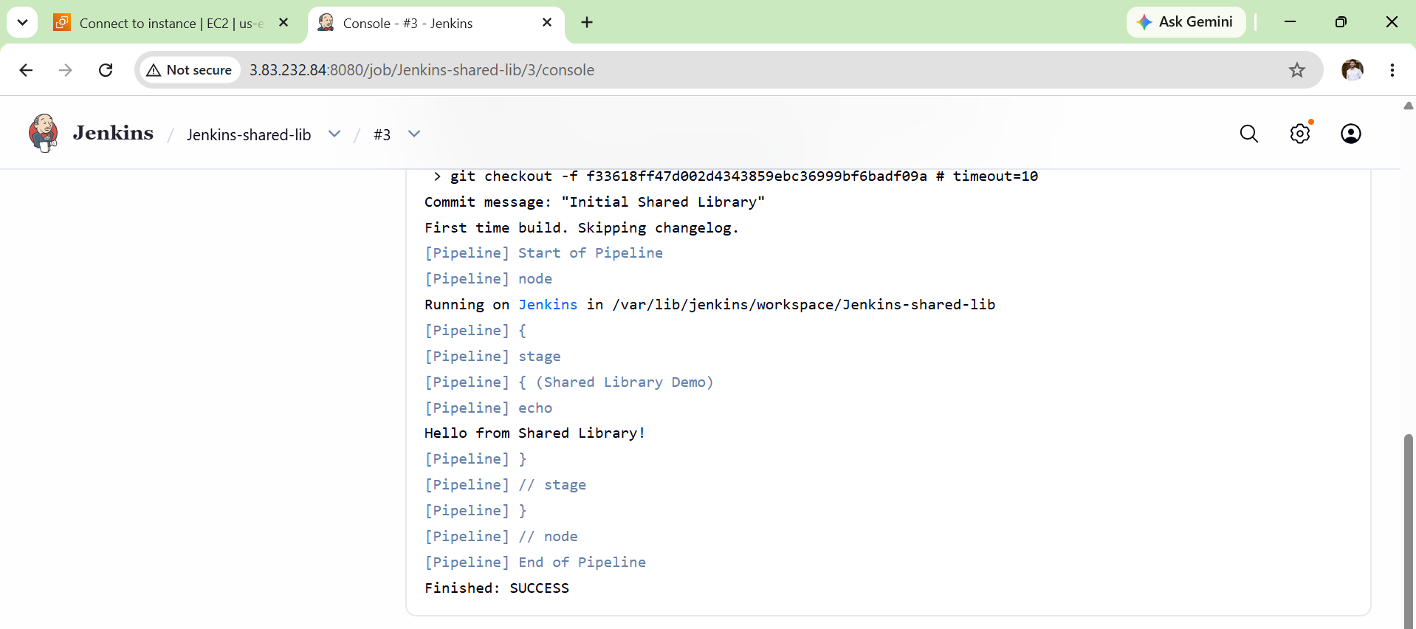
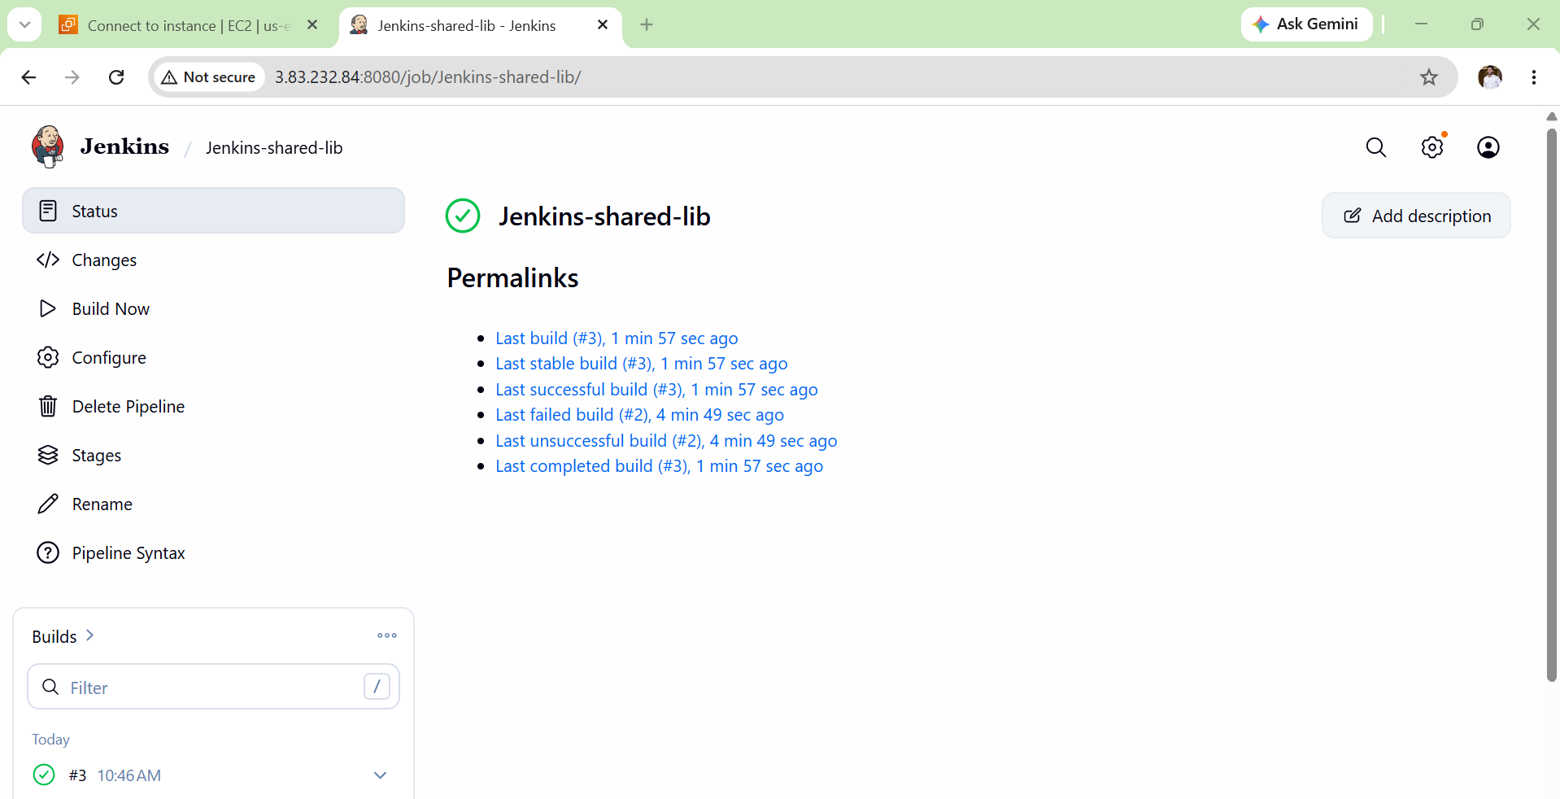
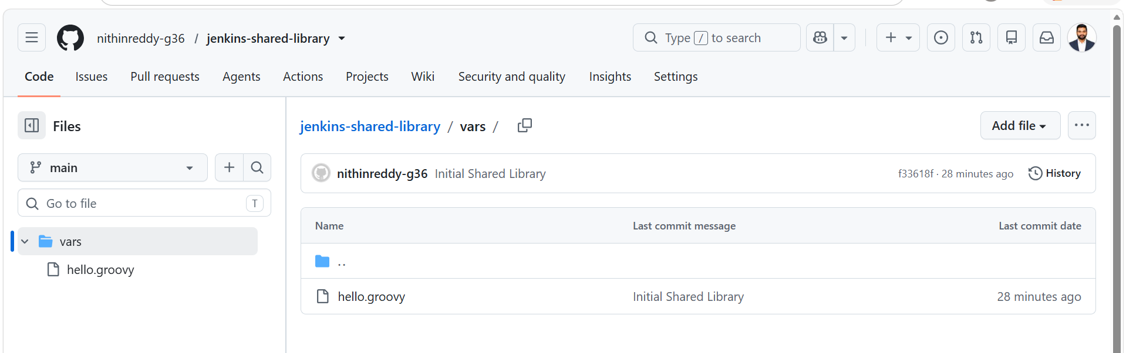
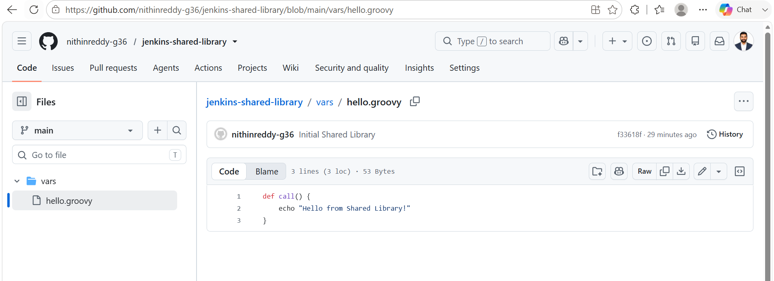

Validation Points
- Jenkins service is running successfully.
- Git is installed on the Jenkins server.
- Shared Library repository is created in GitHub.
- vars/hello.groovy exists in the repository.
- Global Shared Library is configured correctly in Jenkins.
- Library name in Jenkins matches the @Library annotation.
- Pipeline executes successfully without errors.
- Console output displays:
Hello from Shared Library!
- Build status is SUCCESS.

Outcome
- Successfully created and configured a Jenkins Shared Library.
- Reused common pipeline logic through the shared library.
- Executed pipeline stages using a reusable function (hello()).
- Reduced duplicate pipeline code and improved maintainability.
- Verified successful execution with a SUCCESS build status and expected console output.

