Kubernetes-02
Task 1: Create a Simple Pod Using YAML
Objective
Create a Pod named firstpod using a YAML manifest with an Nginx container, then verify it and view its logs.
Prerequisites
I have launched master ec2 instance and connected
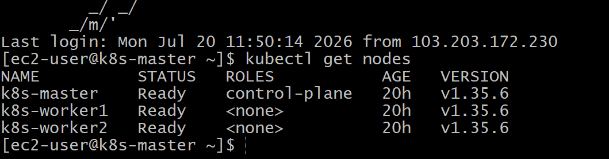
Step 1: Create a Working Directory (Master Only)
mkdir -p ~/k8s-02
cd ~/k8s-02
Step 2: Create the YAML File
nano firstpod.yaml
apiVersion: v1
kind: Pod

metadata:
name: firstpod
labels:
app: nginx

spec:
containers:
- name: nginx-container
image: nginx:latest
ports:
- containerPort: 80
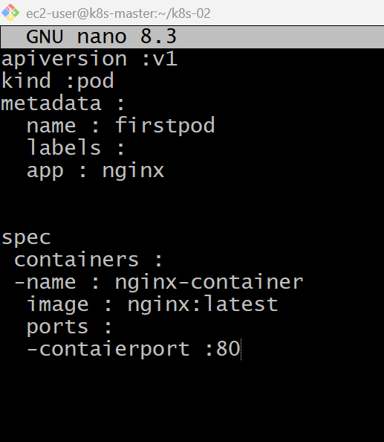
Step 3: Validate the YAML (Optional)
cat firstpod.yaml
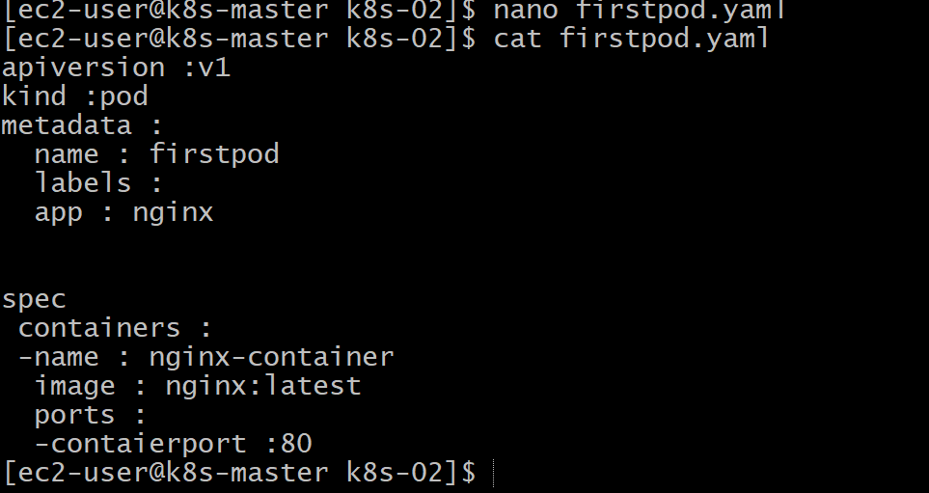
Step 4: Create the Pod
kubectl apply -f firstpod.yaml
Step 5: Verify the Pod
kubectl get pods
Step 6: Get Detailed Information
kubectl describe pod firstpod
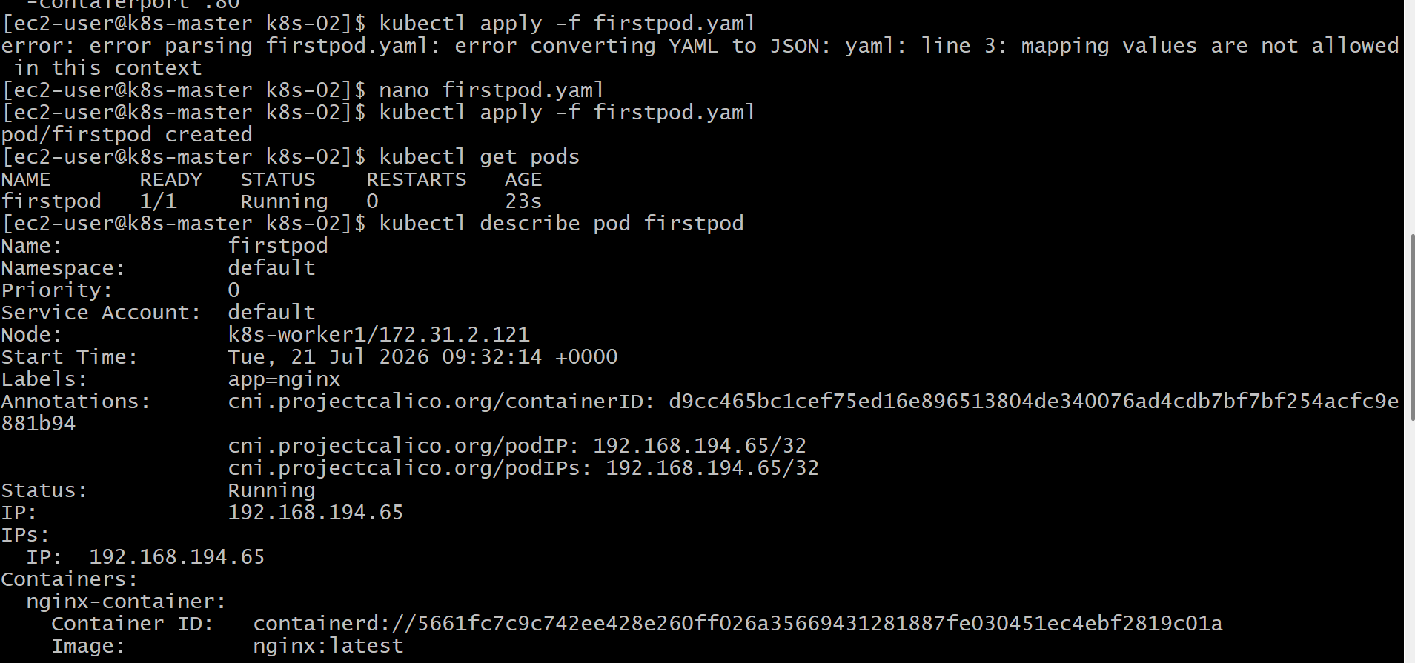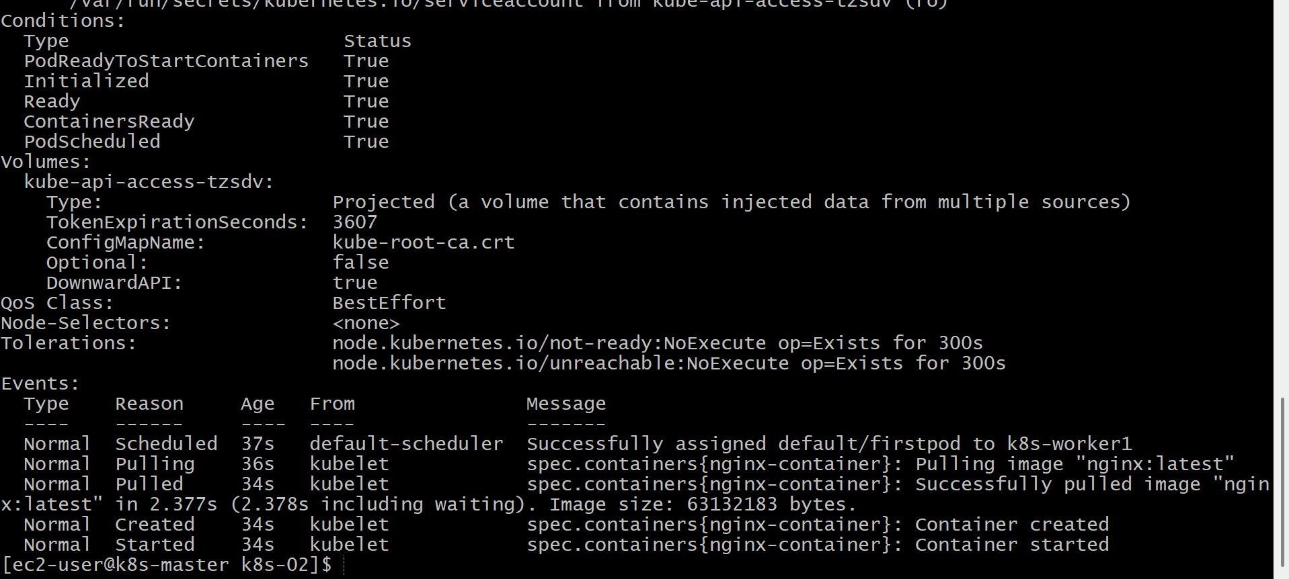
Step 7: View Container Logs
kubectl logs firstpod
Step 8: Verify the Nginx Process
kubectl exec -it firstpod -- /bin/bash
Inside the container:
nginx -v
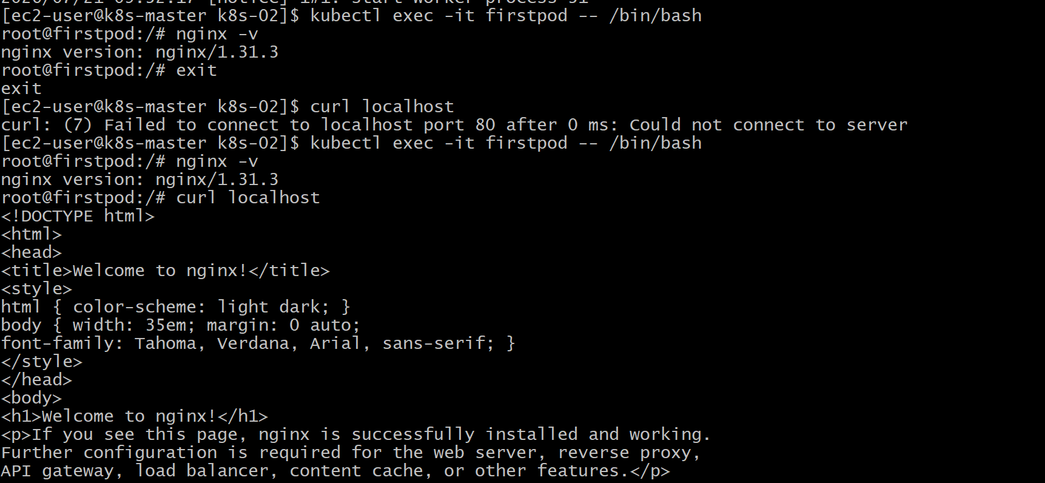
Validation
- Verified the YAML file was created successfully.
- Verified the Pod was created using kubectl apply.
- Verified the Pod status is Running using kubectl get pods.
- Verified Pod details using kubectl describe pod firstpod.
- Verified the container logs using kubectl logs firstpod.
- Verified the Nginx web server from inside the container using curl localhost.
Outcome
- Successfully created an Nginx Pod using a YAML manifest.
- Verified the Pod is running correctly.
- Learned how to create, inspect, and troubleshoot Pods using kubectl.

Task 2: Set Environment Variables in a Pod
Objective
Modify the Pod YAML to include the following environment variables:
- myname=sabair
- City=Hyderabad
Deploy the Pod and verify the variables using:
kubectl exec <pod_name> -- env
Delete the Existing Pod
Since Pods cannot be updated to add environment variables after creation, delete the existing Pod first.
kubectl delete pod firstpod
Verify:
kubectl get pods
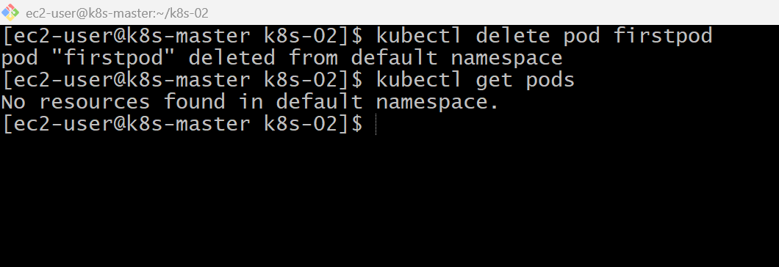

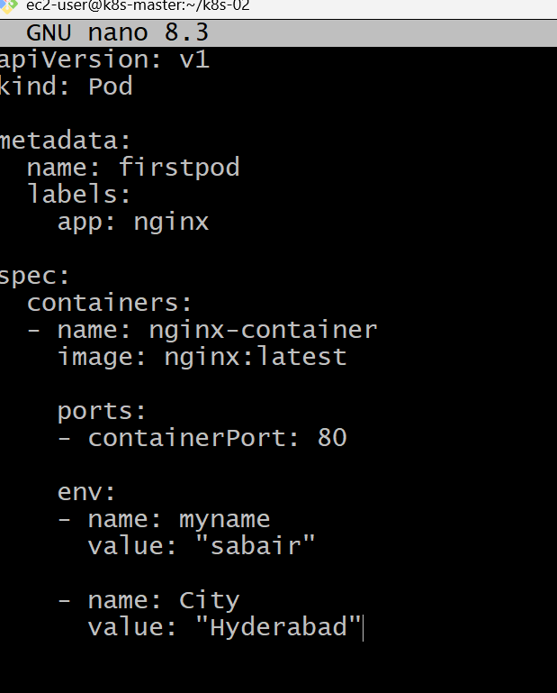
Implementation Steps
- Deleted the existing firstpod.
- Opened the existing Pod YAML file (firstpod.yaml).
- Added the env section under the container specification.
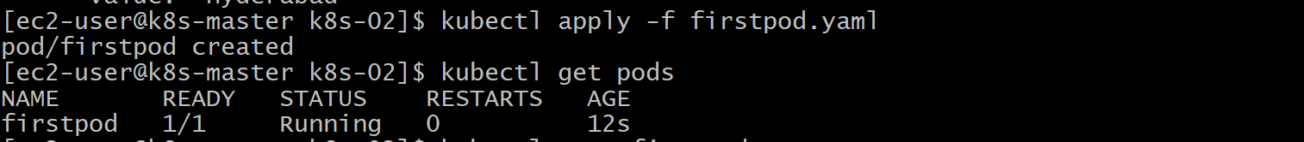
- Configured the environment variable myname with the value sabair.
- Configured the environment variable City with the value Hyderabad.
- Saved the updated YAML file.
- Applied the YAML file using kubectl apply -f firstpod.yaml.
- Verified that the Pod was created successfully.
- Checked the configured environment variables using kubectl exec firstpod -- env.
- Logged into the container using kubectl exec -it firstpod -- /bin/bash.
- Verified the environment variables using echo $myname and echo $City.
- Verified the environment variable configuration using kubectl describe pod firstpod.
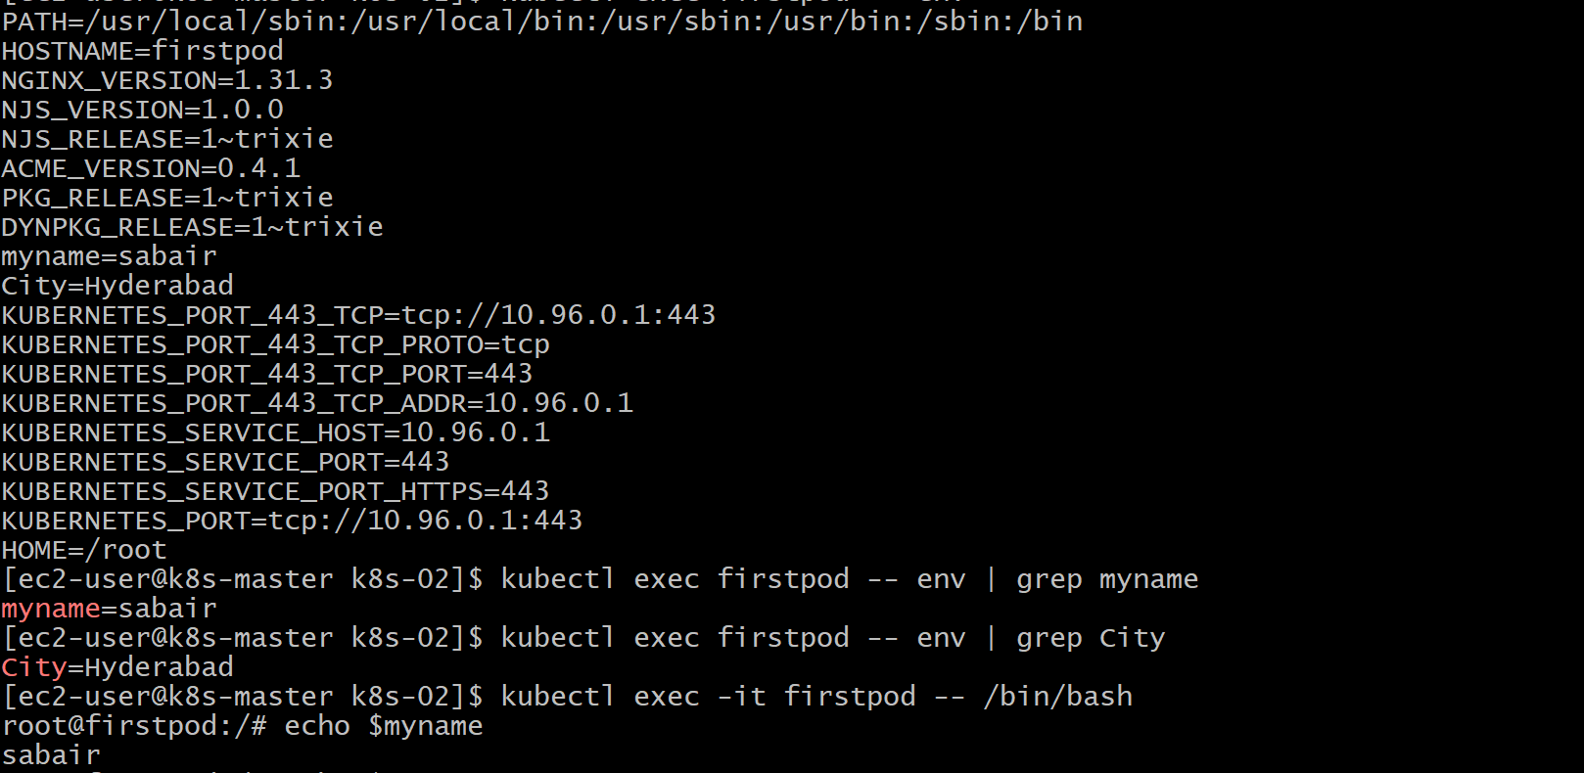
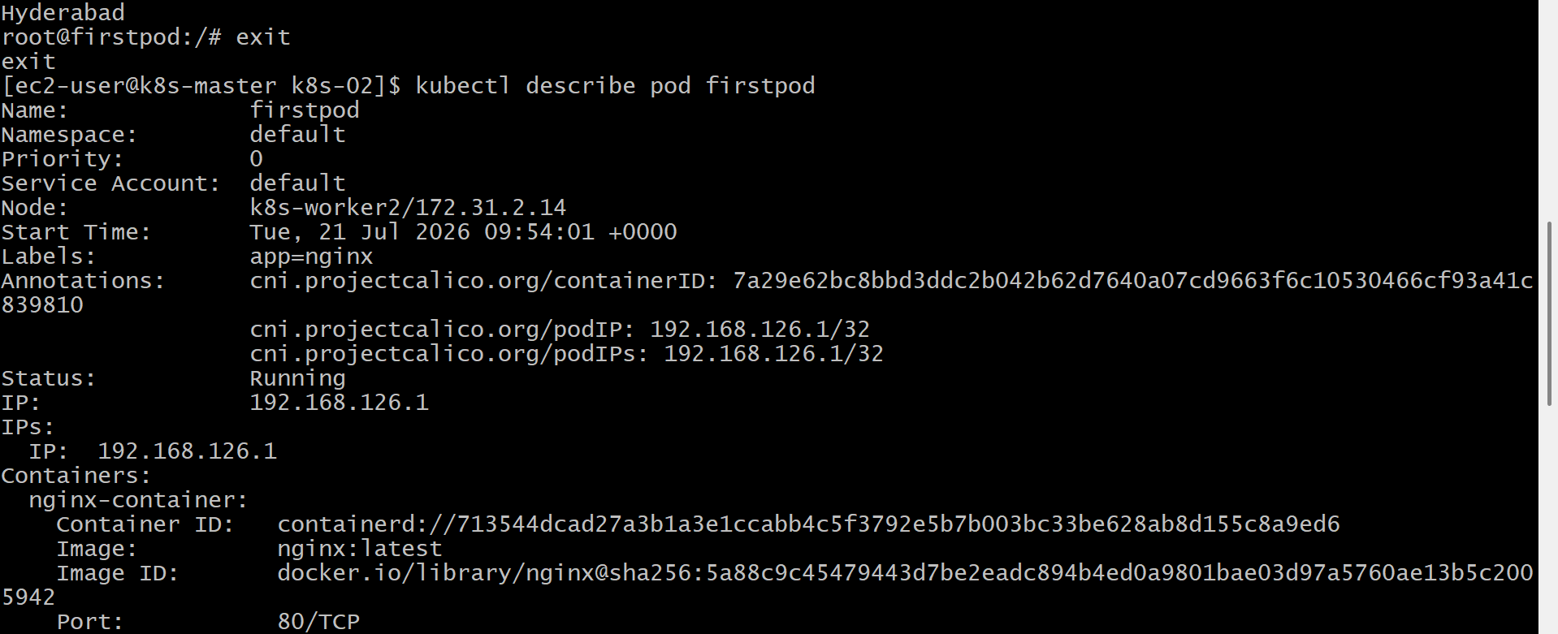
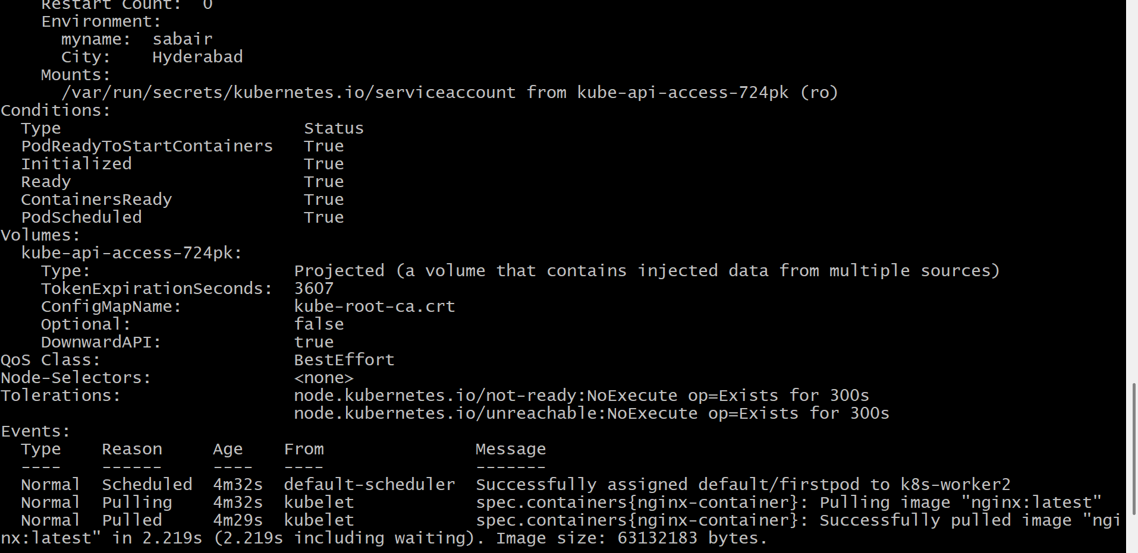
Validation
- Verified the Pod was recreated successfully.
- Verified the Pod reached the Running state.
- Verified the custom environment variables using kubectl exec firstpod -- env.
- Verified the variables inside the container using echo $myname and echo $City.
- Verified the environment variables in kubectl describe pod firstpod.

Outcome
- Successfully configured custom environment variables in a Kubernetes Pod using a YAML manifest.
- Verified the variables were available inside the running container.
- Learned how applications can receive configuration through environment variables instead of hardcoding values.

Task 3: Deploy a Pod with Commands (Args) in YAML
Objective
Create a Pod that executes the following command:
sleep 50
This means the container will run for 50 seconds and then exit.
Implementation Steps (for your documentation)
- Deleted the existing firstpod.
- Opened the Pod YAML file (firstpod.yaml).
- Added the command field with the value sleep.
- Added the args field with the value 50.
- Saved the updated YAML file.
- Deployed the Pod using kubectl apply -f firstpod.yaml.
- Verified the Pod creation using kubectl get pods.
- Verified the configured command and arguments using kubectl describe pod firstpod.
- Verified that the container executed the command and exited after 50 seconds.

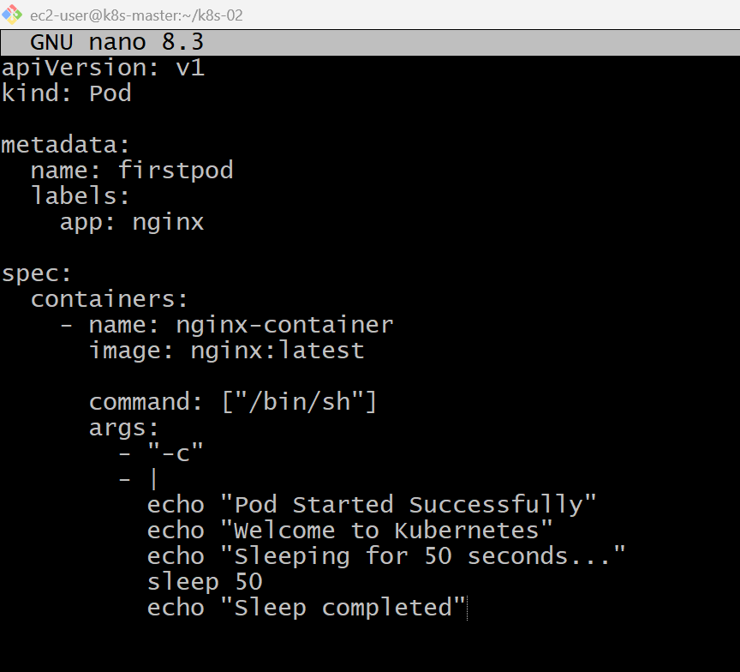

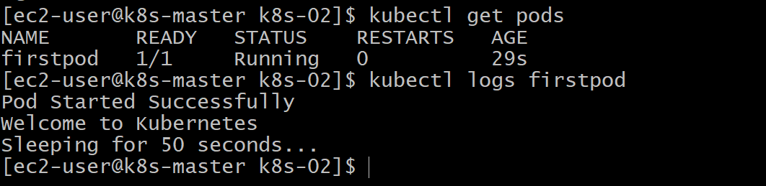
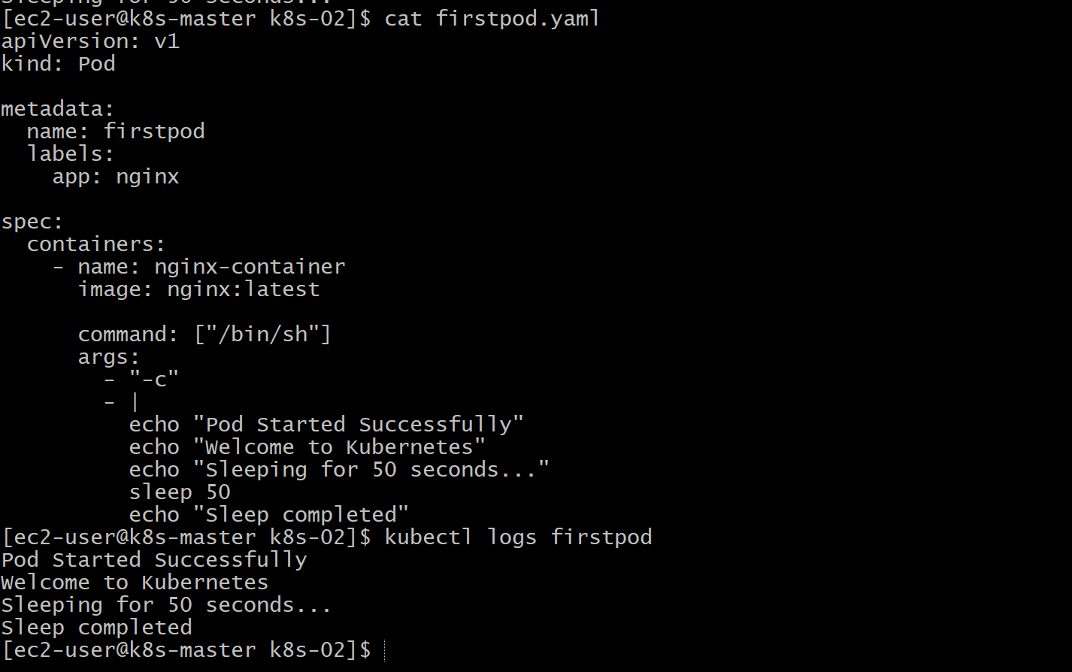
Validation
- Verified the existing Pod was deleted.
- Modified the Pod YAML to include the command and args fields.
- Deployed the updated Pod successfully.
- Verified the Pod execution using kubectl get pods.
- Verified the configured command and arguments using kubectl describe pod firstpod.
- Verified that the container completed execution after approximately 50 seconds.
Outcome
- Successfully deployed a Pod using custom command and args.
- Learned how Kubernetes overrides a container's default startup behavior.
- Verified that command-line arguments were correctly passed to the container.

Task 4: Create a Pod with Two Containers
Objective
Create a single Pod containing two Nginx containers.
Then:
- Verify both containers are running.
- Access each container using kubectl exec.
- Verify they share the same Pod network (same IP address).
- Demonstrate communication within the Pod.
Implementation Steps
- Deleted the existing Pod (if present).
- Created a new YAML file named twocontainerpod.yaml.
- Defined a Pod with two containers:
  - nginx-container-1 (Nginx image)
  - busybox-container (BusyBox image)
- Configured the BusyBox container to stay running using the command:
sh -c "sleep 3600"
- Saved the YAML file.
- Deployed the Pod using:
kubectl apply -f twocontainerpod.yaml
- Verified that both containers were running using:
kubectl get pods
- Described the Pod to verify both container configurations:
kubectl describe pod twocontainerpod
- Accessed the Nginx container using:
kubectl exec -it twocontainerpod -c nginx-container-1 -- /bin/bash
- Verified the Nginx web server using:
curl localhost
- Accessed the BusyBox container using:
kubectl exec -it twocontainerpod -c busybox-container -- sh
- Verified that both containers shared the same Pod IP using:
hostname -i
- Verified communication with the Nginx container from the BusyBox container using:
wget -qO- http://localhost
- Confirmed that both containers shared the same network namespace and could communicate using localhost.

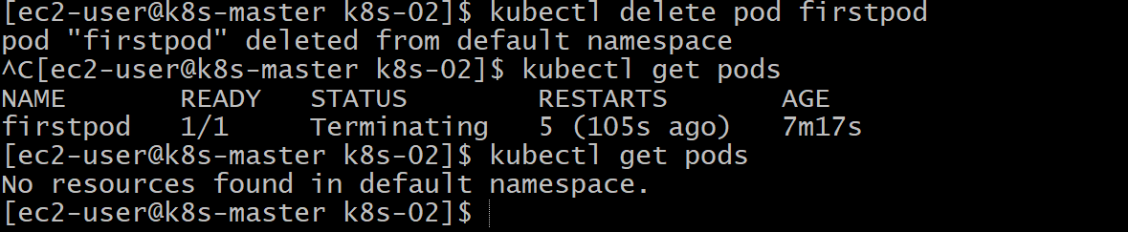

Cat twocontainerpod.yaml
kubectl apply -f twocontainer.yaml
kubectl get pods
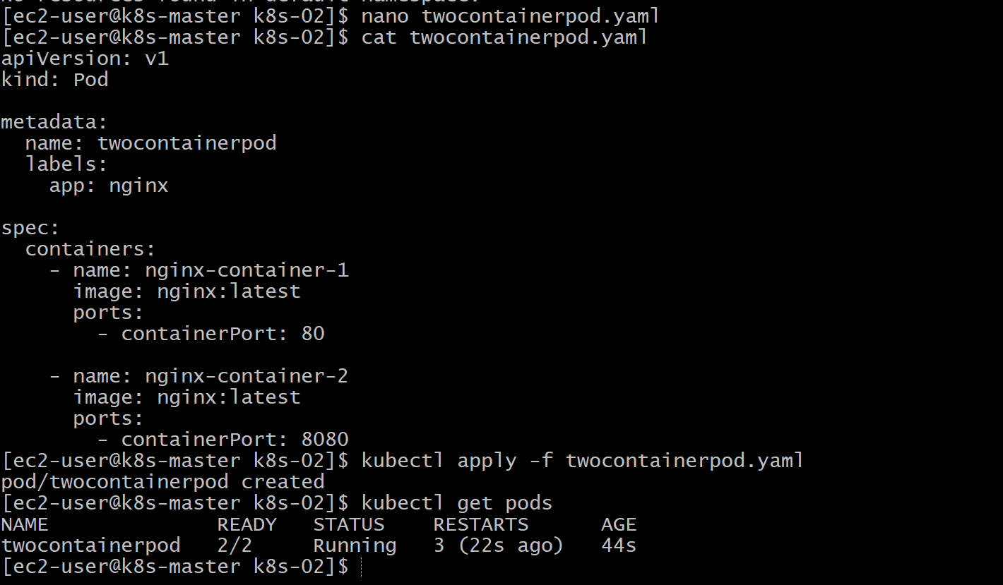
kubectl describe pod twocontainerpod
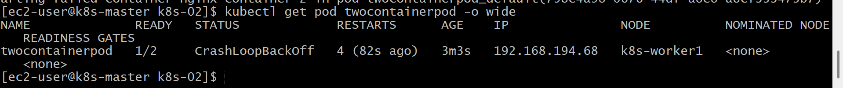
kubectl exec -it twocontainerpod -c nginx-container-1 -- /bin/bash
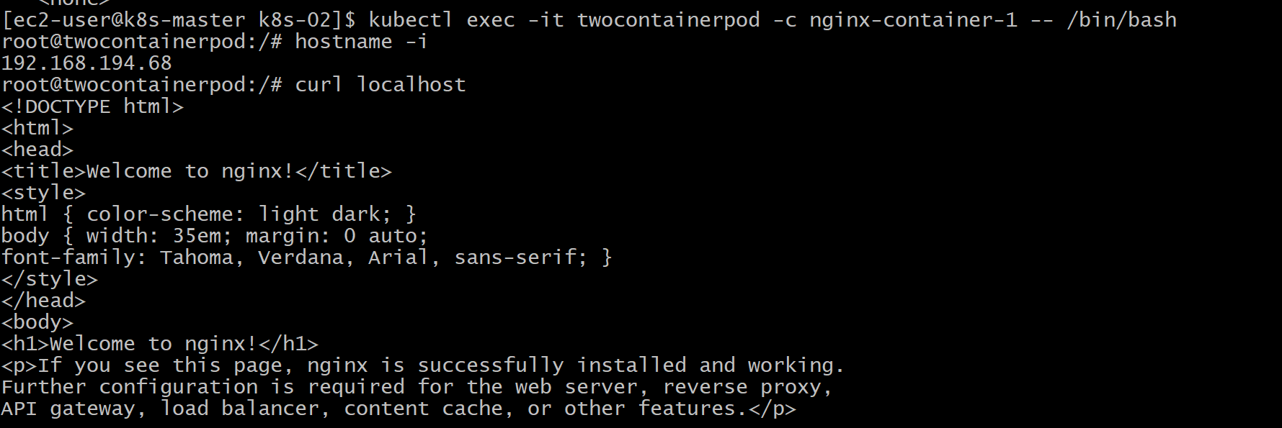
for container-2
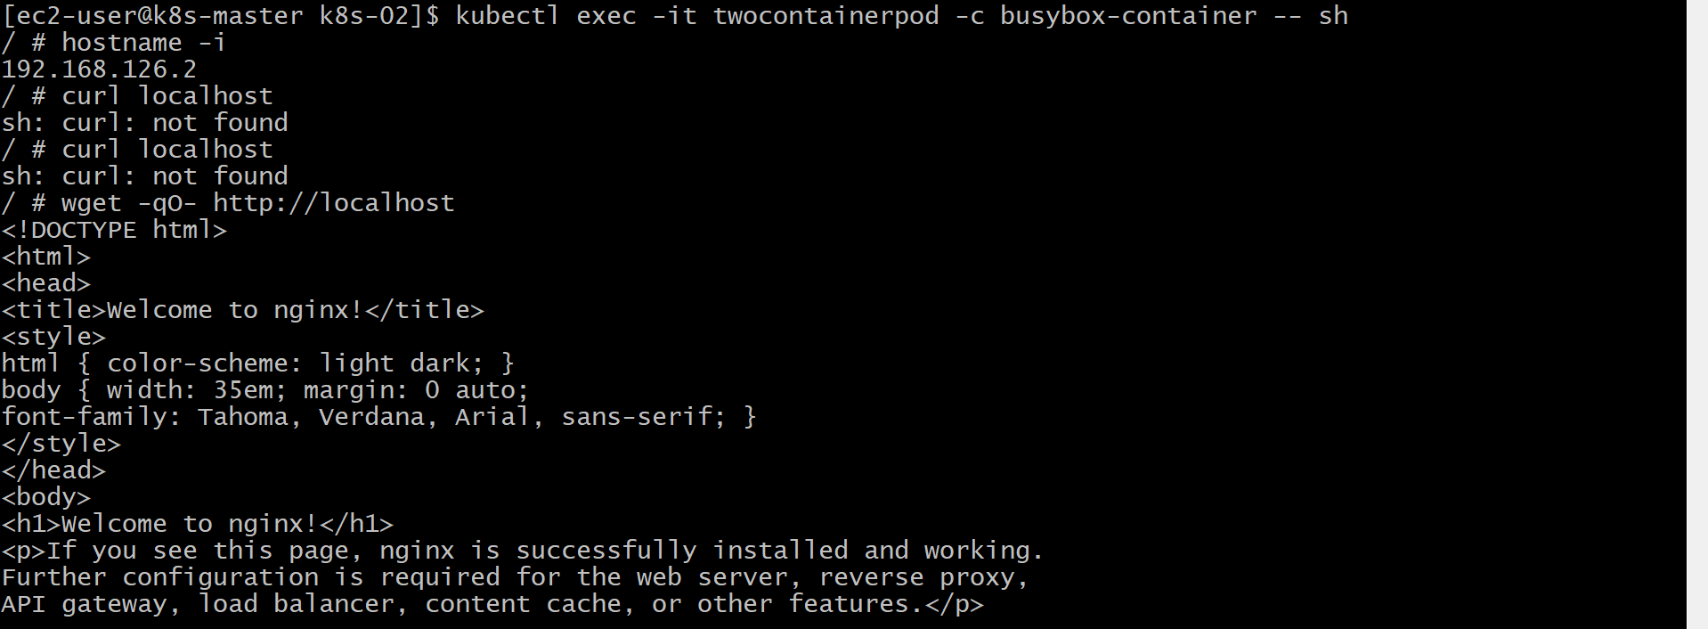
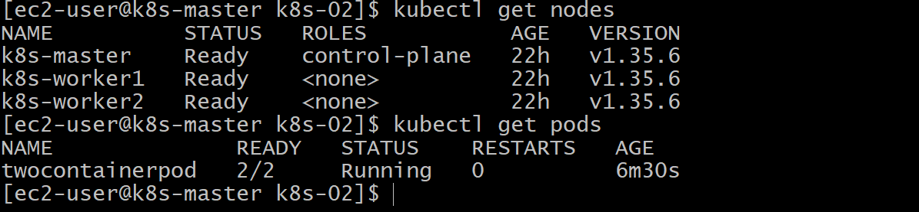
Validation
- Verified the Pod with two containers was created successfully.
- Verified both containers were in the Running state (2/2 Ready).
- Verified both containers were listed in kubectl describe pod.
- Verified access to each container using kubectl exec.
- Verified both containers shared the same Pod IP address.
- Verified Nginx was accessible inside each container using curl localhost.
Outcome
- Successfully created a multi-container Pod.
- Learned that multiple containers within the same Pod share the network namespace and IP address.
- Verified both containers were running and accessible.
- Understood how containers in the same Pod communicate using localhost.
Task 5: Set Up an Init Container in a Pod
Objective
Create a Pod that includes:
- 1 Init Container
- 1 Main Container (Nginx)
The Init Container should:
- Sleep for 30 seconds
- Complete successfully
Only after the Init Container finishes should the Nginx container start.
Finally, verify the Init Container using:
- kubectl describe pod
- kubectl logs
What is an Init Container?
An Init Container is a special container that runs before the application container.
It is commonly used for:
- Downloading files
- Waiting for a database
- Checking dependencies
- Creating directories
- Initializing configuration
Important: The main application container will not start until all Init Containers complete successfully.
Implementation Steps (for your documentation)
- Deleted the previous Pod.
- Created a new YAML file named initpod.yaml.
- Added an Init Container using the BusyBox image.
- Configured the Init Container to print messages and sleep for 30 seconds.
- Added the main Nginx container.
- Deployed the Pod using kubectl apply -f initpod.yaml.
- Verified the Init Container execution using kubectl get pods -w.
- Verified the Init Container completion using kubectl describe pod initpod.
- Verified the Init Container logs using kubectl logs initpod -c init-container.
- Verified the Nginx container started successfully after the Init Container completed.
- Verified the Nginx web server using curl localhost.
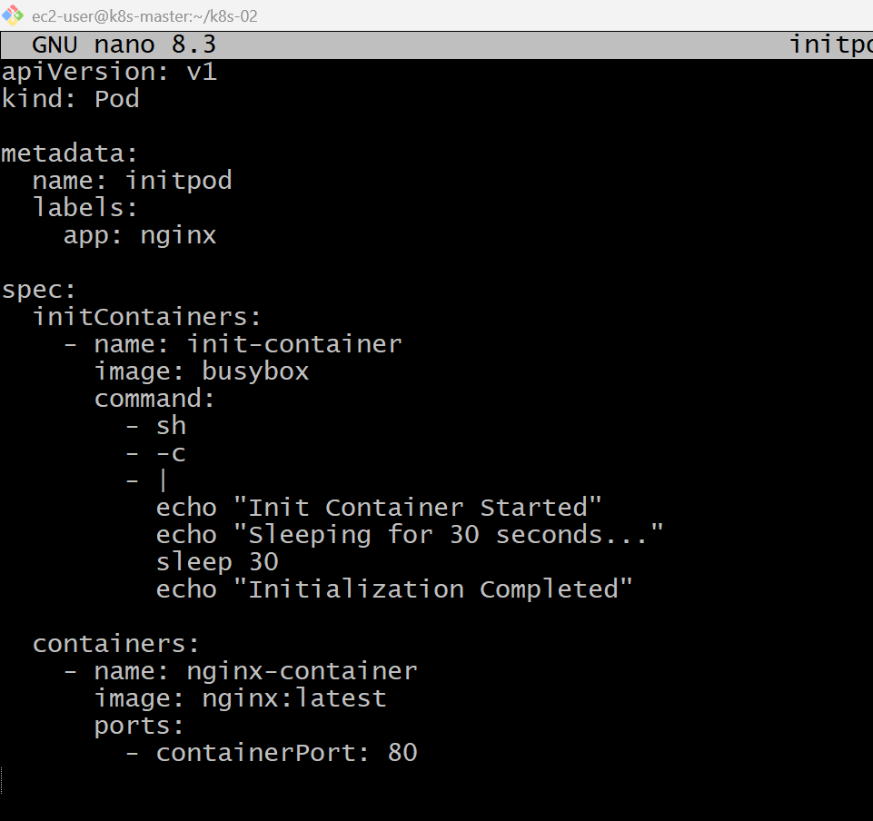
kubectl describe pod initpod
kubectl apply -f initpod.yaml
kubectl exec -it initpod -- /bin/bash
kubectl logs initpod -c init-container
kubectl logs initpod
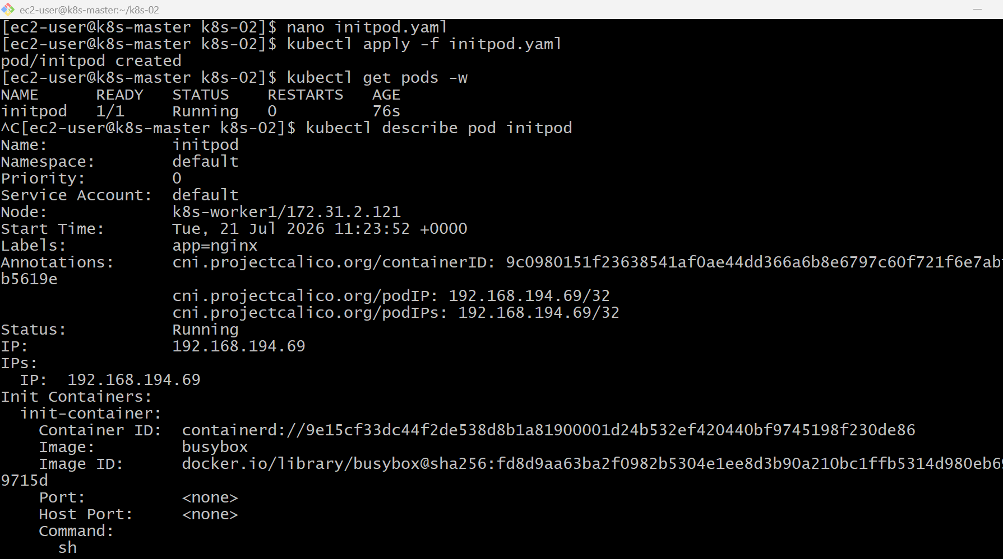
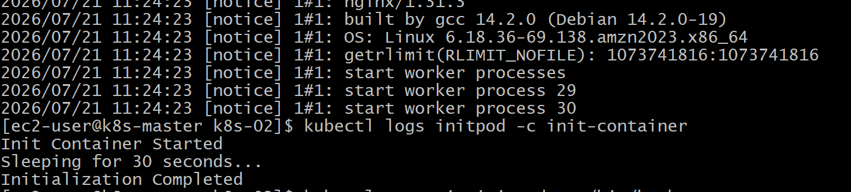
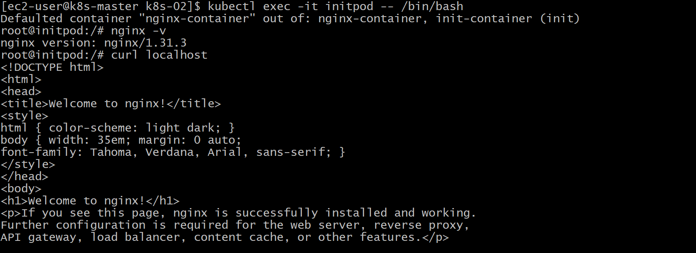

Validation
- Verified the Pod was created successfully.
- Verified the Pod remained in the Init:0/1 state while the Init Container was running.
- Verified the Init Container completed successfully using kubectl describe pod.
- Verified the Init Container logs using kubectl logs initpod -c init-container.
- Verified the Nginx container started only after the Init Container completed.
- Verified the Nginx web server using curl localhost.

Outcome
- Successfully configured an Init Container in a Kubernetes Pod.
- Verified that the Init Container executed before the application container.
- Learned that Init Containers are used to perform initialization tasks before the main application starts.

Task 6: Run a Dry Run Command to Generate YAML
Objective
- Generate a Pod YAML using kubectl run with --dry-run.
- Save the YAML to a file.
- Modify the YAML (labels, environment variables, etc.).
- Deploy the Pod.
- Verify the Pod.
What is --dry-run?
A dry run means Kubernetes does not create any resources. Instead, it validates the command and can generate the corresponding YAML.
This is useful because you can:
- Generate a starter YAML.
- Modify it as needed.
- Store it in Git.
- Deploy it later.
Generate the YAML
Run:
kubectl run nginx --image=nginx --dry-run=client -o yaml > dryrunpod.yaml
Implementation Steps (for your documentation)
- Generated a Pod YAML using the kubectl run command with the --dry-run=client option.
- Saved the generated YAML to dryrunpod.yaml.
- Reviewed the generated YAML.
- Modified the YAML by updating the Pod name.
- Added custom labels.
- Added environment variables.
- Applied the YAML using kubectl apply -f dryrunpod.yaml.
- Verified the Pod creation.
- Verified the labels and environment variables.
- Verified the Pod configuration using kubectl describe pod

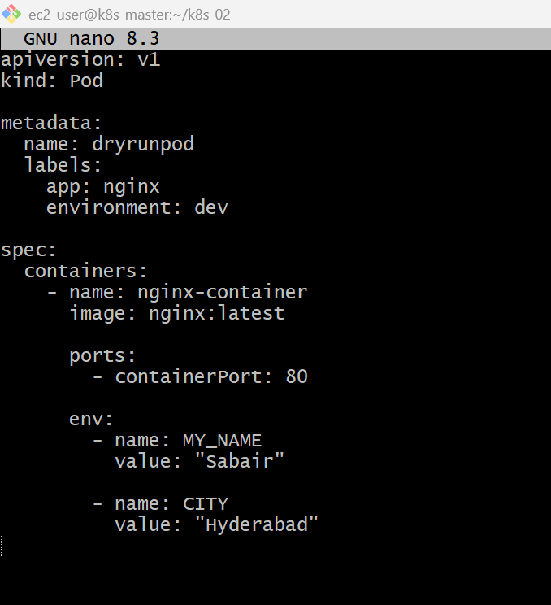
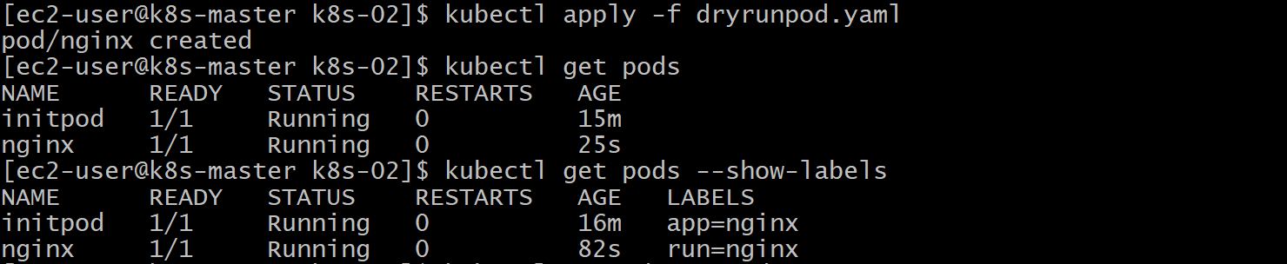

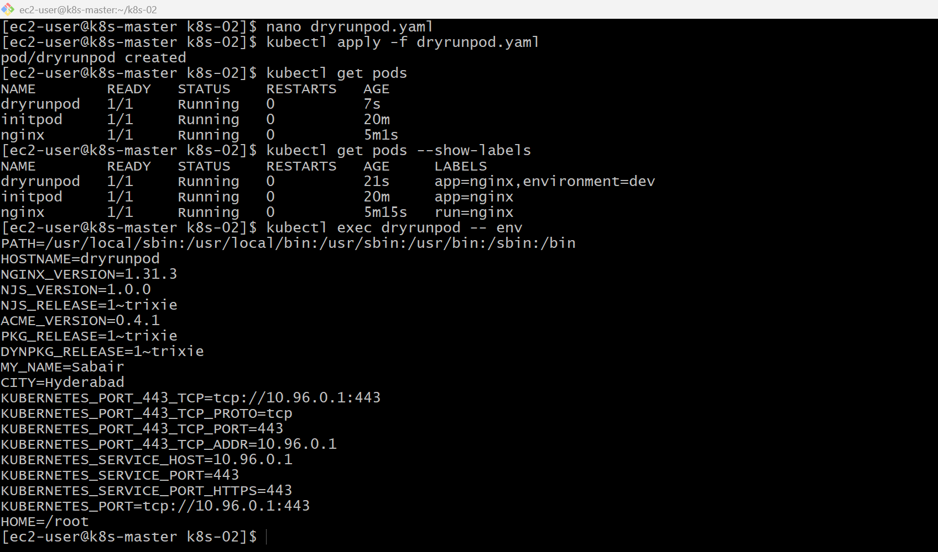
Validation
- Verified the Pod YAML was generated using kubectl run --dry-run.
- Verified the generated YAML was saved successfully.
- Modified the YAML by adding labels and environment variables.
- Deployed the Pod using kubectl apply.
- Verified the Pod reached the Running state.
- Verified the labels using kubectl get pods --show-labels.
- Verified the environment variables using kubectl exec.
- Verified the Pod configuration using kubectl describe pod.
Outcome
- Successfully generated a Pod YAML using the --dry-run option.
- Customized the generated YAML with labels and environment variables.
- Deployed the customized Pod successfully.
- Learned how to use kubectl run --dry-run to quickly create reusable YAML manifests.
Task 7: Use kubectl create vs kubectl apply
Objective
- Create a Pod using a YAML file.
- Deploy it using kubectl create.
- Modify the YAML (change the image version).
- Redeploy using kubectl apply.
- Understand the difference between create and apply.
Implementation Steps (for your documentation)
- Created a Pod YAML file named applypod.yaml.
- Defined an Nginx Pod in the YAML file.
- Deployed the Pod using kubectl create -f applypod.yaml.
- Verified the Pod creation and status.
- Modified the container image in the YAML file.
- Attempted to redeploy using kubectl create and observed the AlreadyExists error.
- Redeployed the updated YAML using kubectl apply.
- Verified the updated Pod configuration (or recreated the Pod if required due to immutable Pod fields).

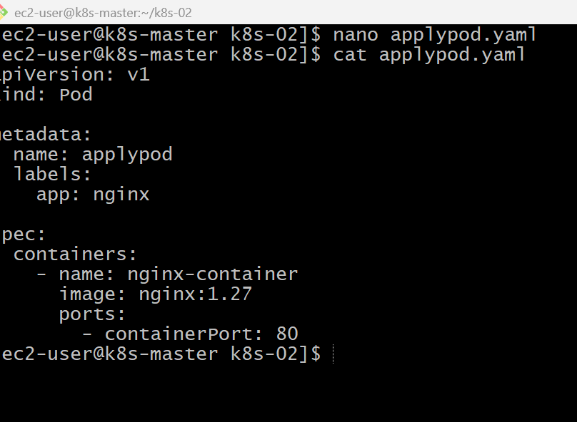
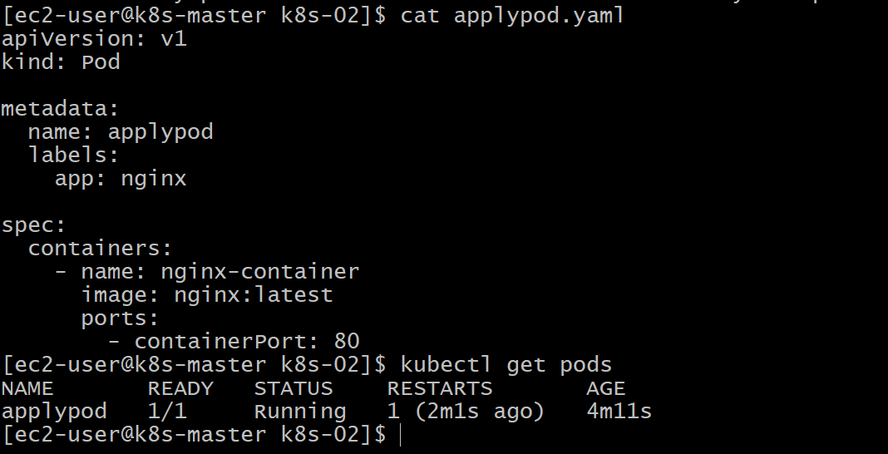
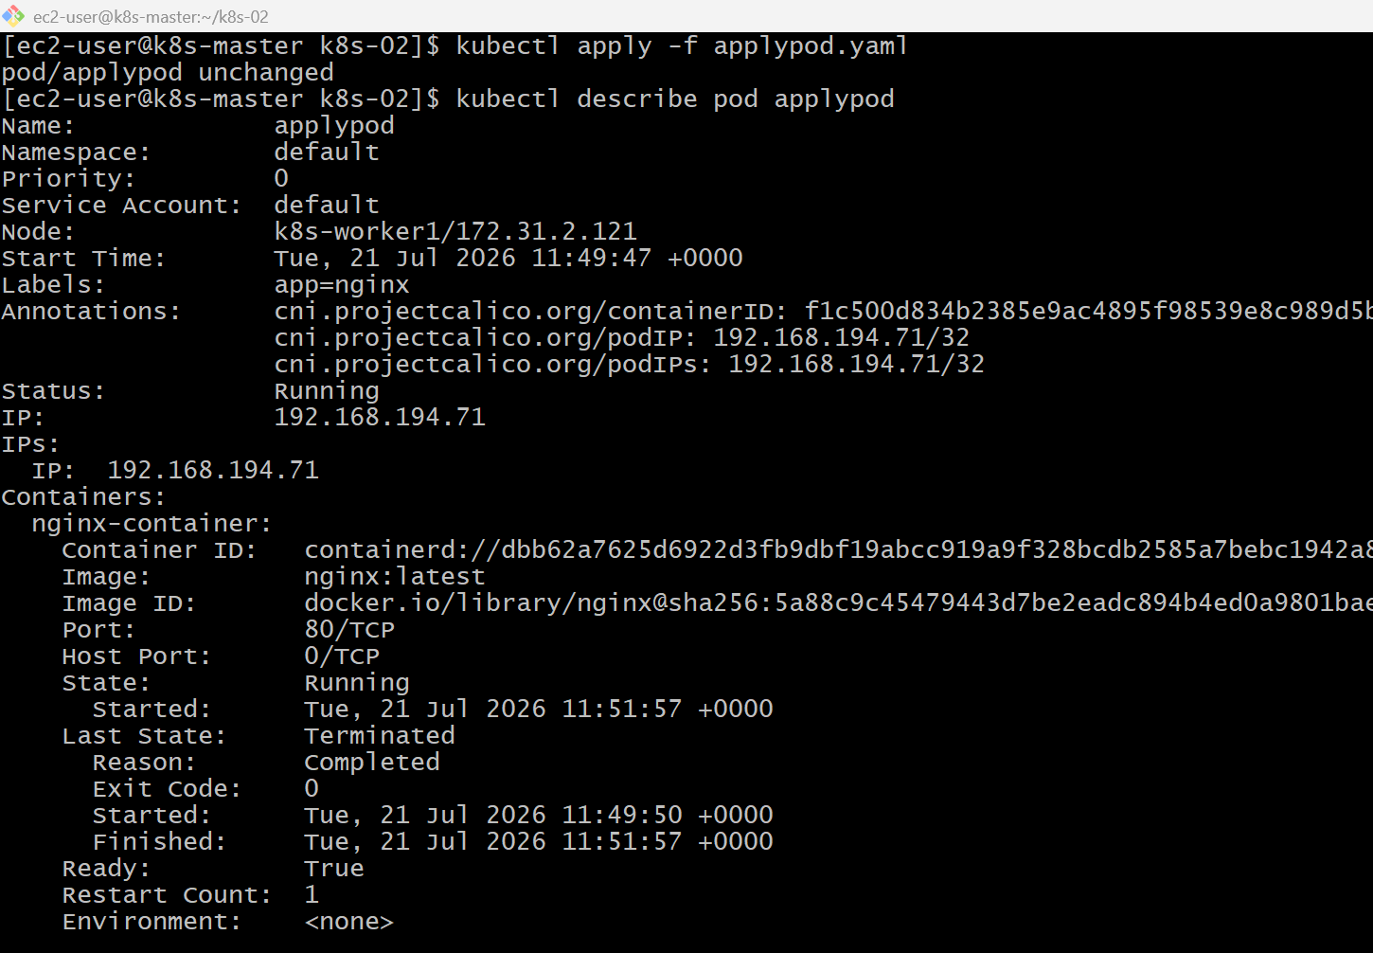
Validation
- Verified the Pod was created using kubectl create.
- Verified that kubectl create failed because the resource already existed.
- Updated the resource using kubectl apply (or recreated the Pod when the image field couldn't be updated).
- Verified the final Pod configuration.
Outcome
- Successfully created a Pod using kubectl create.
- Learned that kubectl create only creates new resources.
- Learned that kubectl apply is used to create or update Kubernetes resources.
- Understood why kubectl apply is preferred for Infrastructure as Code (IaC) and CI/CD pipelines.
Task 8 : Edit an Existing Pod Configuration
Objective
Use kubectl edit pod to edit the running Pod and observe what happens when you try to modify immutable fields.
Verify the Pod
kubectl get pods
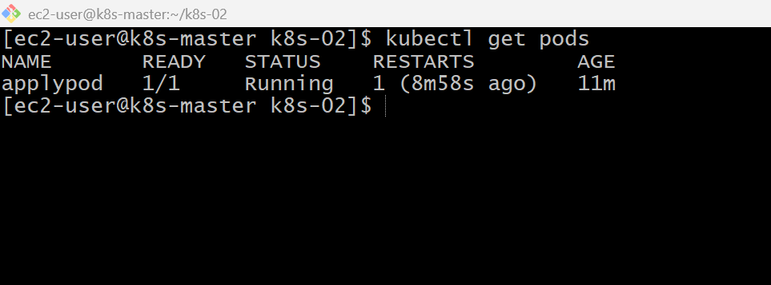
Implementation Steps (for your documentation)
- Listed the running Pods.
- Opened the Pod configuration using kubectl edit pod <pod_name>.
- Attempted to modify the container image.
- Saved the changes and observed the immutable field error.
- Verified the Pod configuration remained unchanged.
- Deleted the existing Pod.
- Updated the YAML manifest with the required changes.
- Recreated the Pod using kubectl apply -f.
- Verified the updated Pod configuration.
- Redeployed the updated YAML using kubectl apply.
- Verified the updated Pod configuration (or recreated the Pod if required due to immutable Pod fields).




Validation
- Attempted to edit the Pod using kubectl edit pod.
- Observed that immutable fields (image/environment variables) cannot be changed on a running Pod.
- Verified the original configuration remained unchanged.
- Deleted and recreated the Pod with the updated YAML to apply the changes.
Outcome
- Learned how kubectl edit pod works.
- Understood that most Pod specification fields are immutable.
- Learned that updates to images or environment variables require recreating the Pod or, in production, updating a Deployment.

Task 9: Expose a Pod Using a Service (ClusterIP)
Objective
Create a ClusterIP Service to expose applypod (or firstpod) on port80, then verify it using kubectl get svc.
Note: A ClusterIP Service is only accessible inside the Kubernetes cluster. You won't be able to open it directly in your laptop's browser. Browser access requires a NodePort, LoadBalancer, or kubectl port-forward.

What is a Service?
A Service provides a stable network endpoint for Pods.
Without a Service:
- Pod IPs can change when Pods are recreated.
With a Service:
- Applications use the Service name or ClusterIP, while Kubernetes forwards traffic to the matching Pods.
Implementation Steps (for your documentation)
- Verified the Pod labels using kubectl get pods --show-labels.
- Created a Service YAML file named applypod-service.yaml.
- Configured the Service type as ClusterIP.
- Added a selector matching the Pod labels.
- Configured the Service to expose port 80.
- Applied the YAML using kubectl apply -f applypod-service.yaml.
- Verified the Service using kubectl get svc.
- Verified the Service endpoints using kubectl describe svc.
- Tested connectivity from another Pod using the Service name.

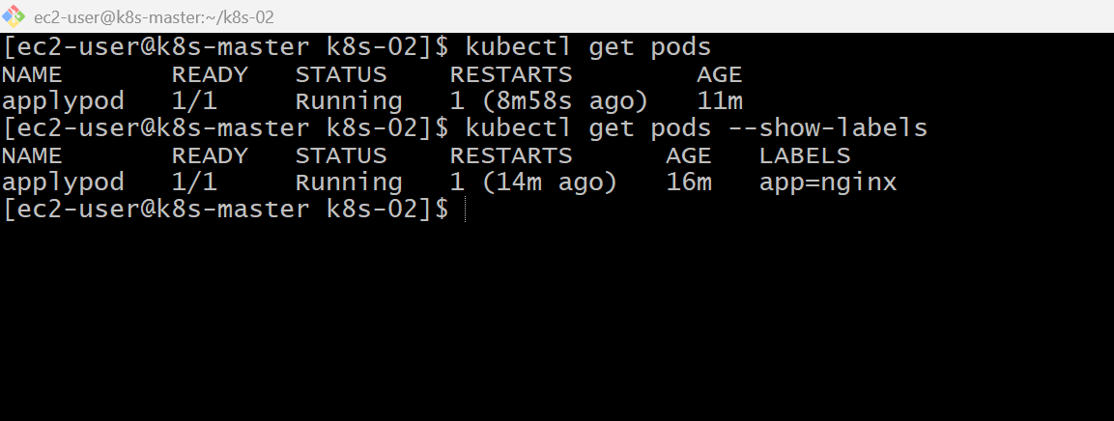
Nano applypod-service.yaml
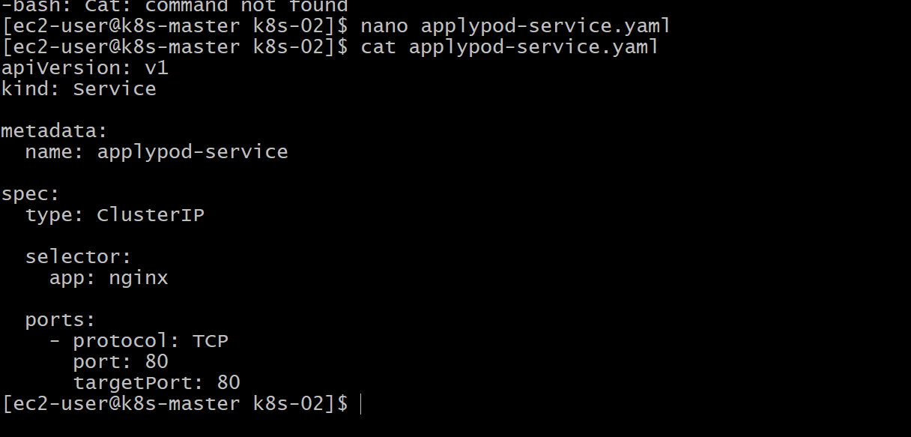
kubectl apply -f applypod-service.yaml
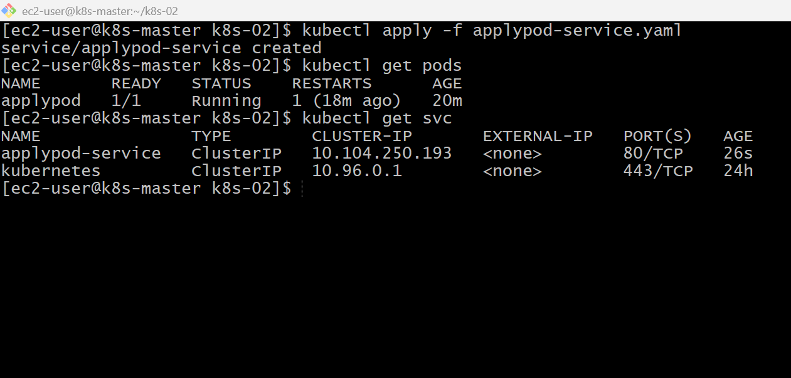

kubectl describe svc applypod-service
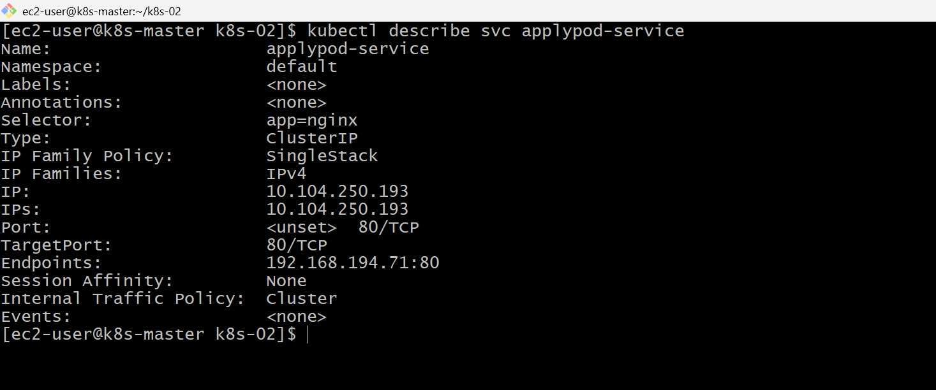
kubectl run testpod --image=busybox --restart=Never -it --rm – sh
wget -qO- http://applypod-service
kubectl port-forward service/applypod-service 8080:80
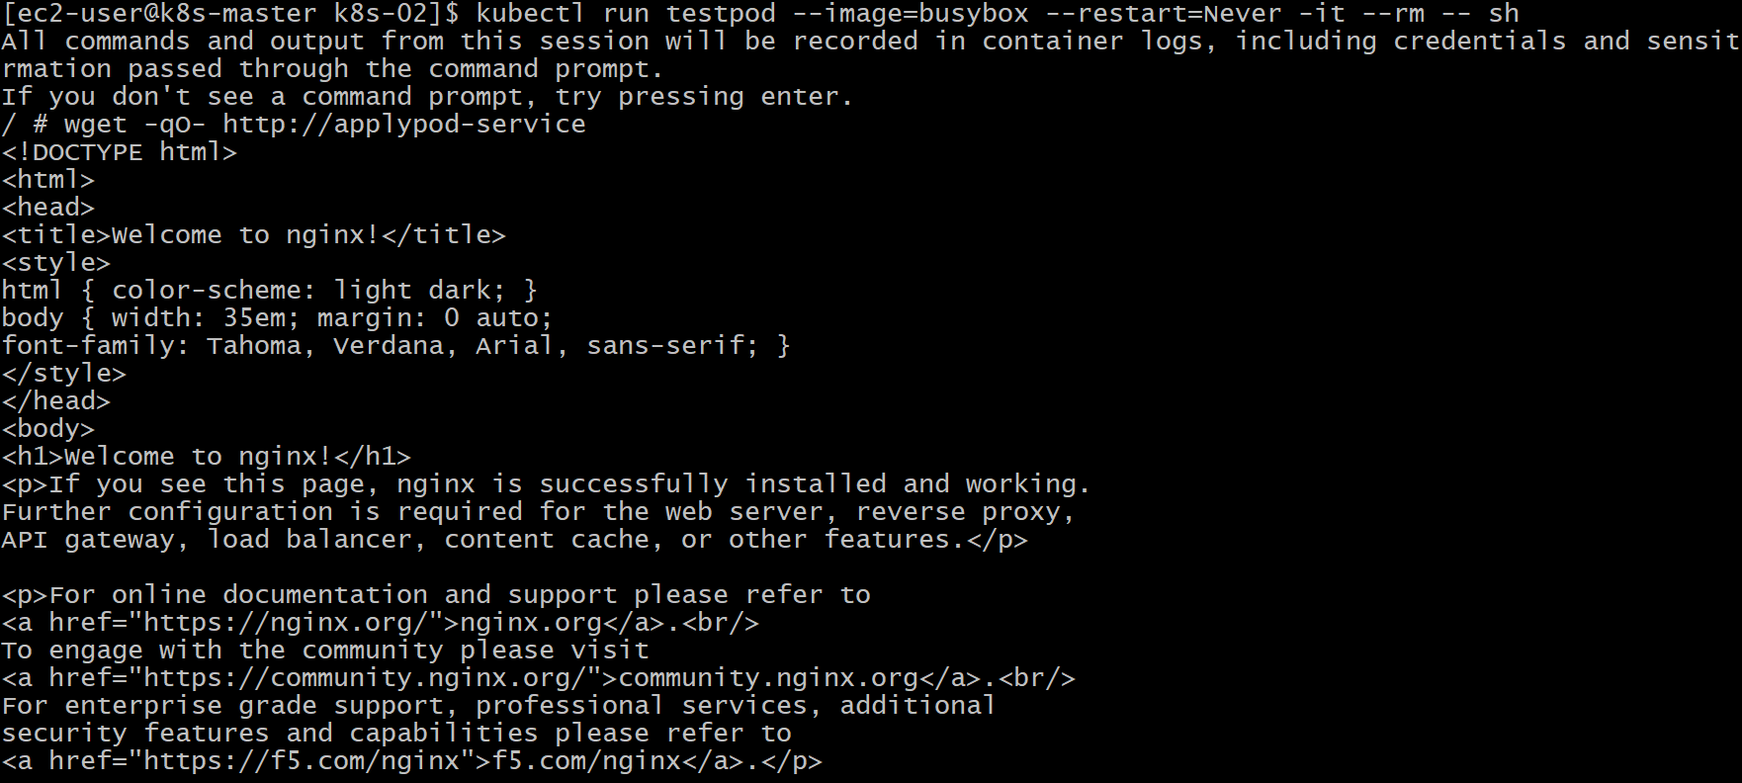

Validation
- Verified the Pod label.
- Created a ClusterIP Service using a YAML file.
- Deployed the Service using kubectl apply.
- Verified the Service using kubectl get svc.
- Verified the Service configuration using kubectl describe svc.
- Verified communication from inside the cluster using a temporary BusyBox Pod.

Outcome
- Successfully exposed a Pod using a ClusterIP Service.
- Learned that a ClusterIP Service provides stable internal networking for Pods.
- Verified that applications inside the cluster can access the Service by its name.

Task 10: Pod with Resource Requests and Limits
Objective
Create a Pod with CPU and Memory requests and limits, deploy it, and verify the configuration using kubectl describe pod.

What are Resource Requests and Limits?
Resource Request
A request is the minimum amount of CPU and memory Kubernetes reserves for a container.
Example:
- CPU Request = 250m (0.25 CPU)
- Memory Request = 128Mi
Resource Limit
A limit is the maximum CPU and memory a container can use.
Example:
- CPU Limit = 500m (0.5 CPU)
- Memory Limit = 256Mi
Implementation Steps (for your documentation)
- Created a YAML file named resourcepod.yaml.
- Defined an Nginx Pod.
- Configured CPU and memory requests.
- Configured CPU and memory limits.
- Applied the YAML using kubectl apply -f resourcepod.yaml.
- Verified the Pod status using kubectl get pods.
- Verified the resource configuration using kubectl describe pod.
- Verified the Nginx container using kubectl exec.
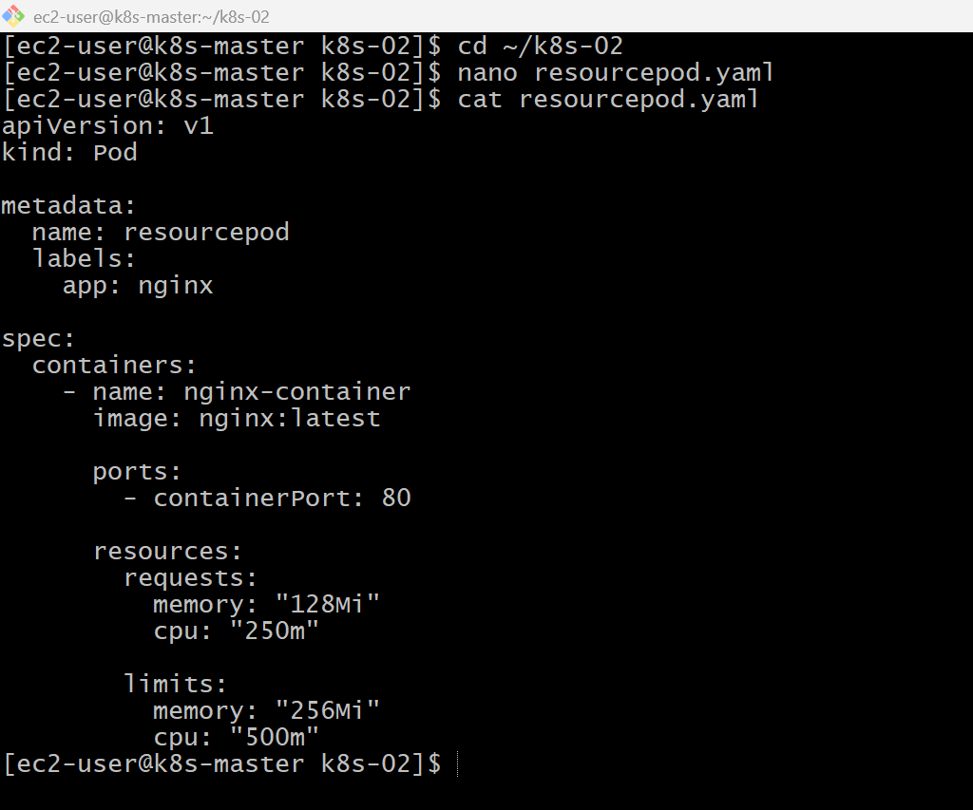
kubectl apply -f resourcepod.yaml
kubectl get pods
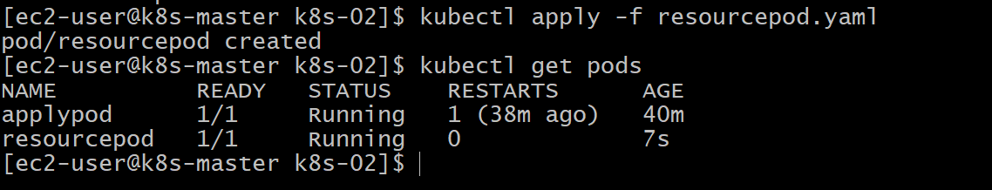
kubectl describe pod resourcepod
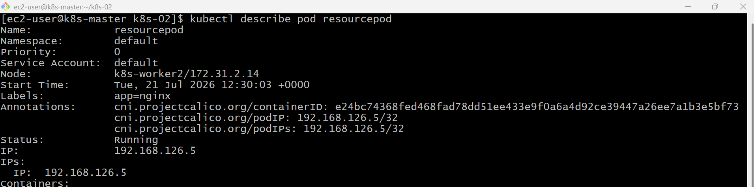

kubectl exec -it resourcepod -- /bin/bash
inside – nginx-v
curl localhost
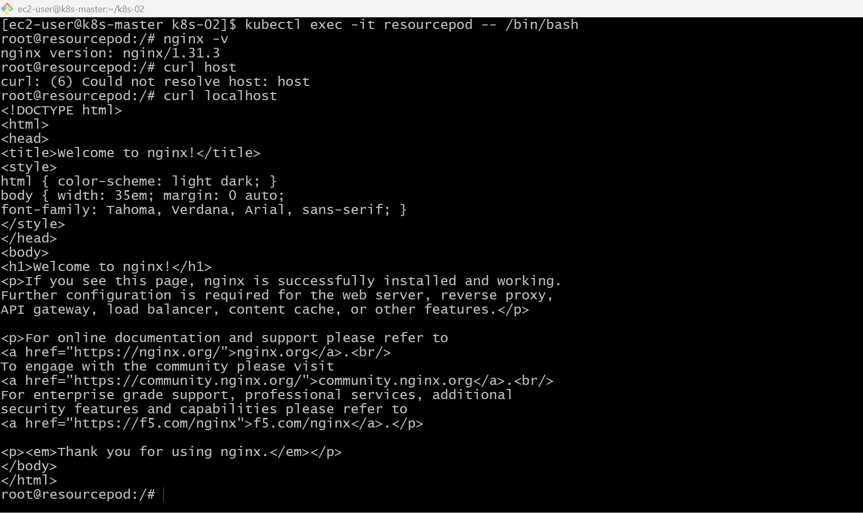
Validation Points
- Verified the Pod was created successfully.
- Verified the Pod reached the Running state.
- Verified CPU and memory requests using kubectl describe pod.
- Verified CPU and memory limits using kubectl describe pod.
- Verified the Nginx container was accessible using kubectl exec.

Outcome
- Successfully created a Pod with CPU and memory requests.
- Successfully configured CPU and memory limits.
- Verified the resource configuration using kubectl describe pod.
- Learned how Kubernetes reserves and restricts container resources.

