Docker-03

Task 1: Create an Image from a Running Container
Objective
Create a new Docker image from an existing running container using the docker commit command. This captures the current state of the container and saves it as a reusable image.
Prerequisites
Before starting, ensure:
- Ubuntu EC2 instance is running.
- Docker is installed and running.
- At least one container is running.
Implementation Steps
- Verified the existing Docker container using docker ps -a.
- Started the stopped container using the docker start command.
- Verified that the container was running successfully using docker ps.
- Accessed the running container using the docker exec -it command.
- Created a sample file (task1.html) inside the Nginx web root directory to simulate a change in the running container.
- Verified that the file was created successfully inside the container.
- Exited the container after making the required changes.
- Created a new Docker image from the running container using the docker commit command.
- Verified that the newly created Docker image was available locally using docker images.
- Created a new container from the newly committed image using the docker run command.
- Verified that the new container was running successfully using docker ps.
- Accessed the application through the browser and confirmed that the changes made in the original container were retained in the new image.

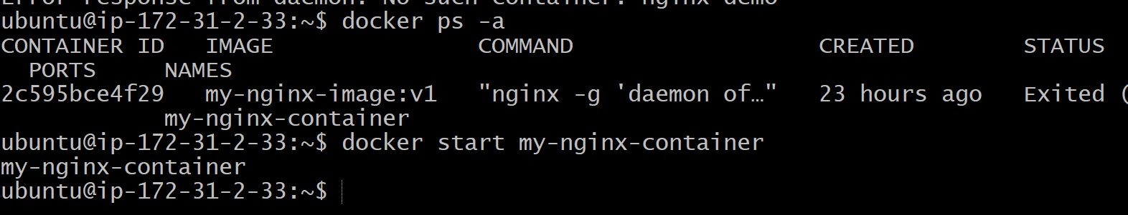
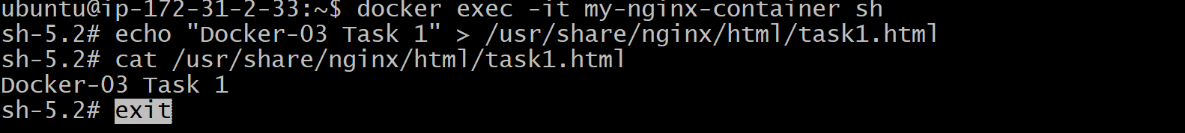
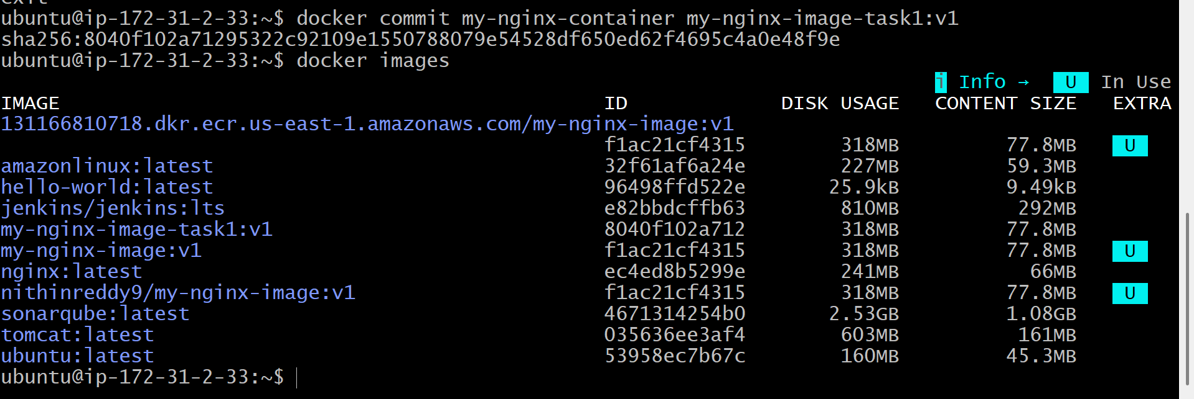
Validation Points
- Verified the source container was running.
- Confirmed the sample file was created successfully inside the running container.
- Verified that the new Docker image was created using docker commit.
- Confirmed the new image was listed in docker images.
- Verified the new container was created successfully from the committed image.
- Confirmed the application was accessible from the browser and reflected the committed changes.

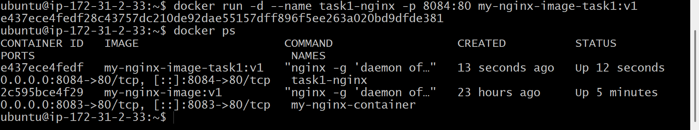
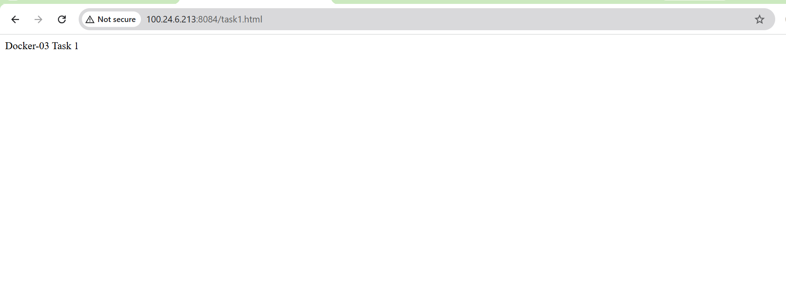
Outcome
Successfully created a new Docker image from a running container using the docker commit command. The committed image preserved all changes made inside the running container and was successfully used to launch a new container with the same configuration and application content.

Task 2: Copy Docker Image from Local Machine to Docker Server and Load the Image
Objective
Transfer a Docker image from one Docker host (local/source machine) to another Docker host (destination server) using the docker save and docker load commands.
In a real environment:
- Local Machine = Your laptop/workstation
- Docker Server = Remote Docker host (EC2)
Since you're already working on an EC2 instance, you can simulate this process by exporting the image to a .tar file and then loading it back. This demonstrates the same concept and is commonly accepted for lab exercises.
Prerequisites
Verify Docker:
docker --version
Verify the image exists:
docker images
You should have something similar to:
my-nginx-image-task1 v1
Implementation Steps
- Verified that the required Docker image was available on the source Docker host using docker images.
- Exported the Docker image into a TAR archive using the docker save command.
- Verified that the TAR file was created successfully in the local directory.
- Simulated the image transfer process from the local machine to the Docker server.
- Loaded the Docker image into the Docker server using the docker load command.
- Verified that the image was successfully loaded using docker images.
- Created and started a new Docker container from the loaded image using the docker run command.
- Accessed the running container and modified the default Nginx index.html page with custom content.
- Verified the updated web page by accessing the application through the browser.
- Confirmed that the image transfer, loading process, and application deployment were completed successfully.

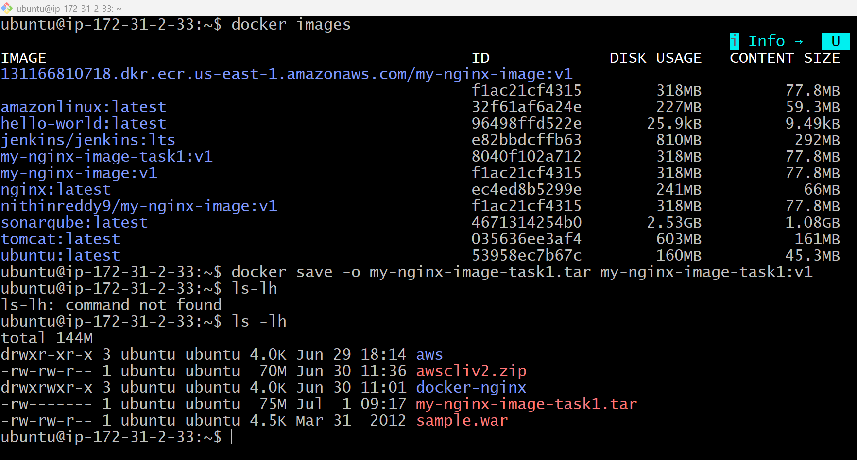
Validation Points
- Verified the Docker image existed locally.
- Successfully exported the Docker image into a TAR archive.
- Verified the TAR archive was created.
- Successfully loaded the Docker image from the TAR archive.
- Verified the restored image using docker images.
- Successfully created and started a new container from the loaded image.
- Verified the application was accessible through the browser.
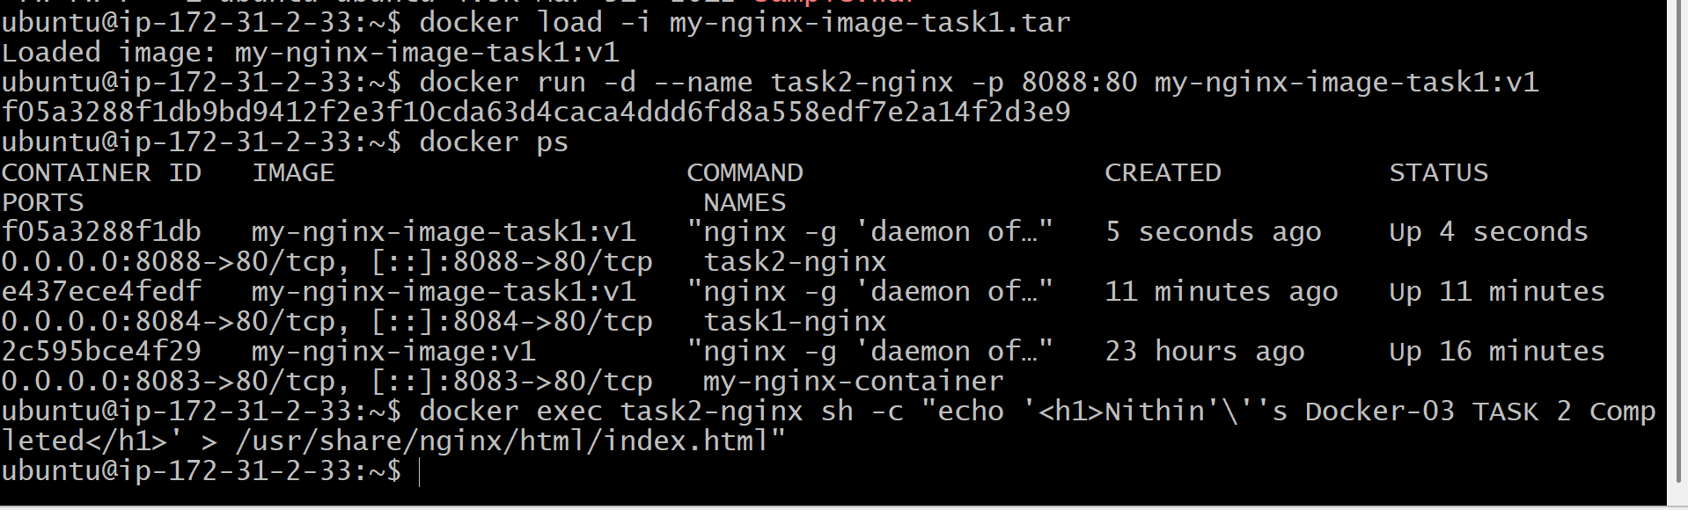

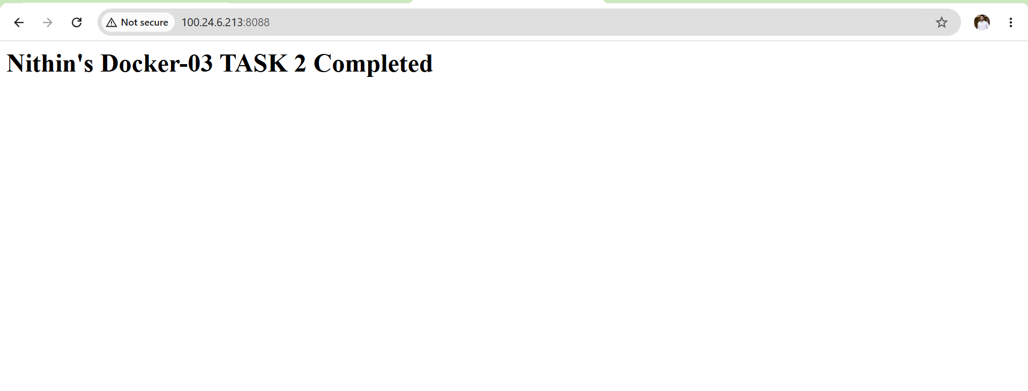
Outcome
Successfully exported a Docker image from the local Docker host into a TAR archive using docker save, restored the image using docker load, and deployed a new container from the restored image, demonstrating the process of transferring Docker images between Docker hosts.

Task 3: Create a Docker Image Using Alpine and Customize with Tomcat
Objective
Create a custom Docker image using Alpine Linux as the base image, install Tomcat, configure it, and run a Tomcat container.
Note: Tomcat is not available as a standard Alpine package, so the correct approach is to install Java, download the official Apache Tomcat distribution, extract it, and configure it. This is the proper way to complete this task.
Prerequisites
Verify Docker:
docker --version
Create a working directory:
mkdir ~/alpine-tomcat
cd ~/alpine-tomcat
Verify:
pwd
Expected:
/home/ubuntu/alpine-tomcat
Implementation Steps
- Created a new project directory for the Alpine Tomcat Docker image.
- Created a Dockerfile using alpine:latest as the base image.
- Added maintainer information using the LABEL instruction.
- Installed Java (OpenJDK), wget, and tar packages using the Alpine package manager (apk).
- Downloaded the Apache Tomcat binary package from the official Apache website.
- Extracted the Tomcat archive and configured it under the /opt/tomcat directory.
- Exposed Tomcat's default application port 8080 using the EXPOSE instruction.
- Configured the container startup command to launch the Tomcat server using catalina.sh run.
- Built the custom Docker image using the docker build command.
- Verified that the custom Docker image was created successfully using docker images.
- Created and started a Docker container from the custom Alpine Tomcat image using the docker run command.
- Verified that the Tomcat container was running successfully using docker ps.
- Accessed the Tomcat application through a web browser and confirmed that the server was running successfully.

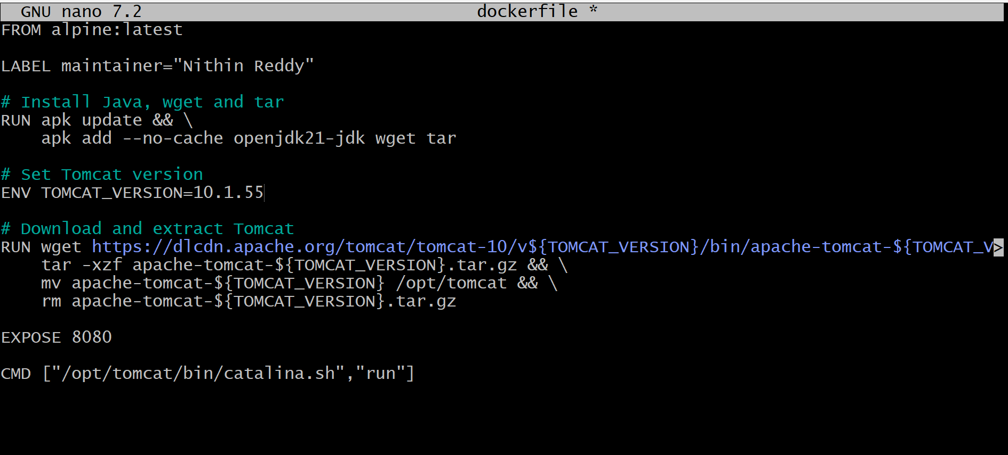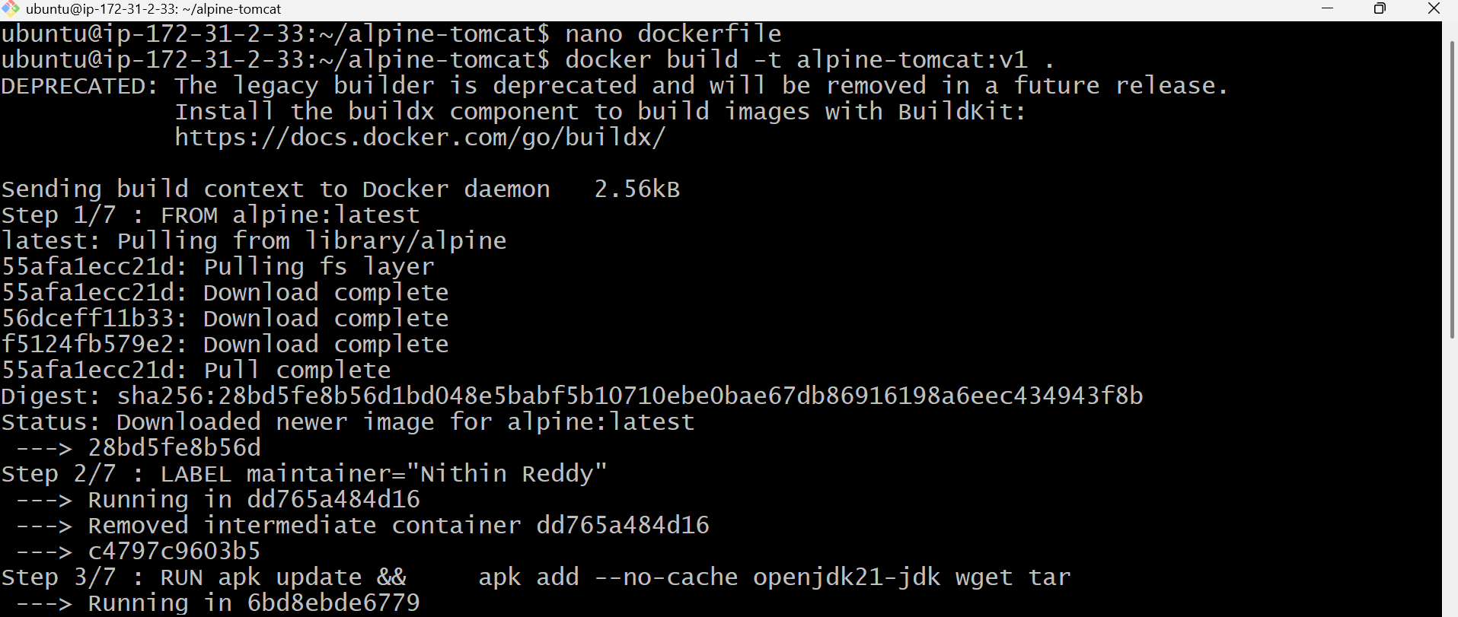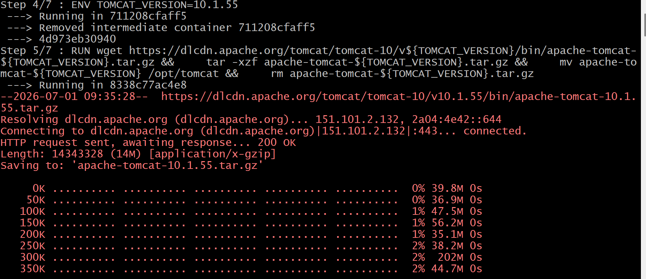
Validation Points
- Verified the Docker image was built successfully without errors.
- Confirmed the custom Alpine Tomcat image was listed in docker images.
- Verified the Tomcat container was running successfully using docker ps.
- Confirmed Tomcat startup logs using docker logs.
- Verified the Tomcat application was accessible through the browser on the configured port.
- (If customized) Confirmed the browser displayed the custom page "Nithin's Docker-03 Task 3 Completed".

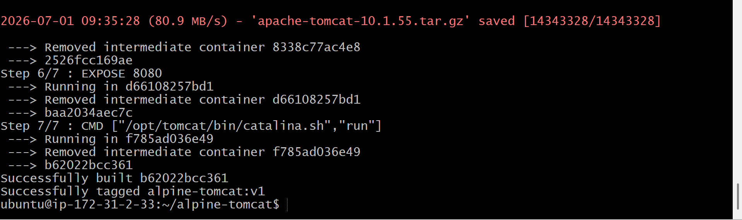
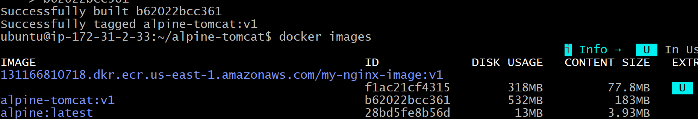
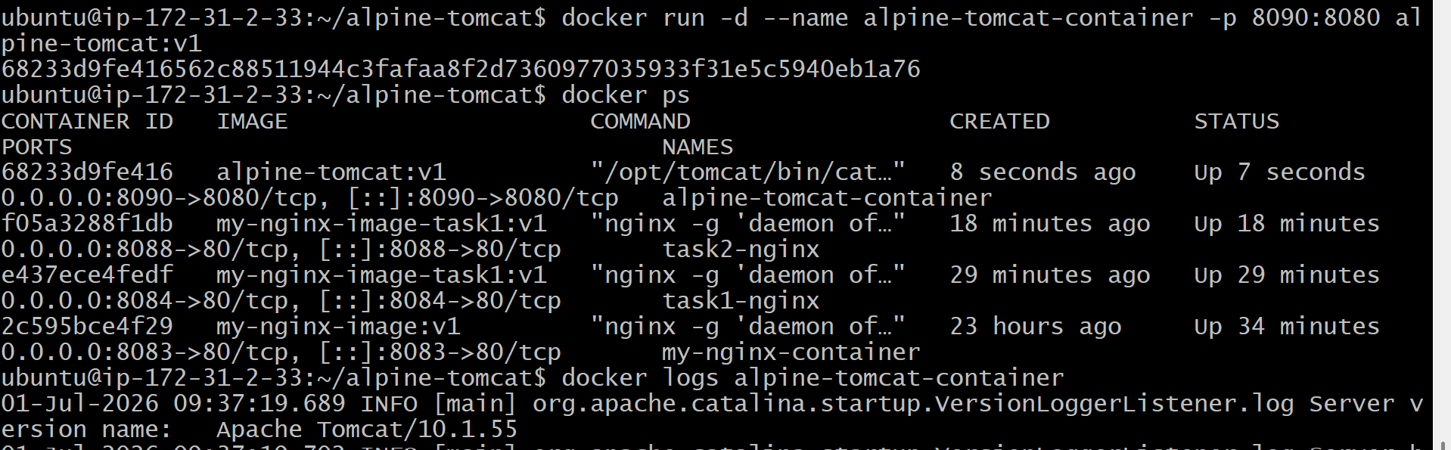
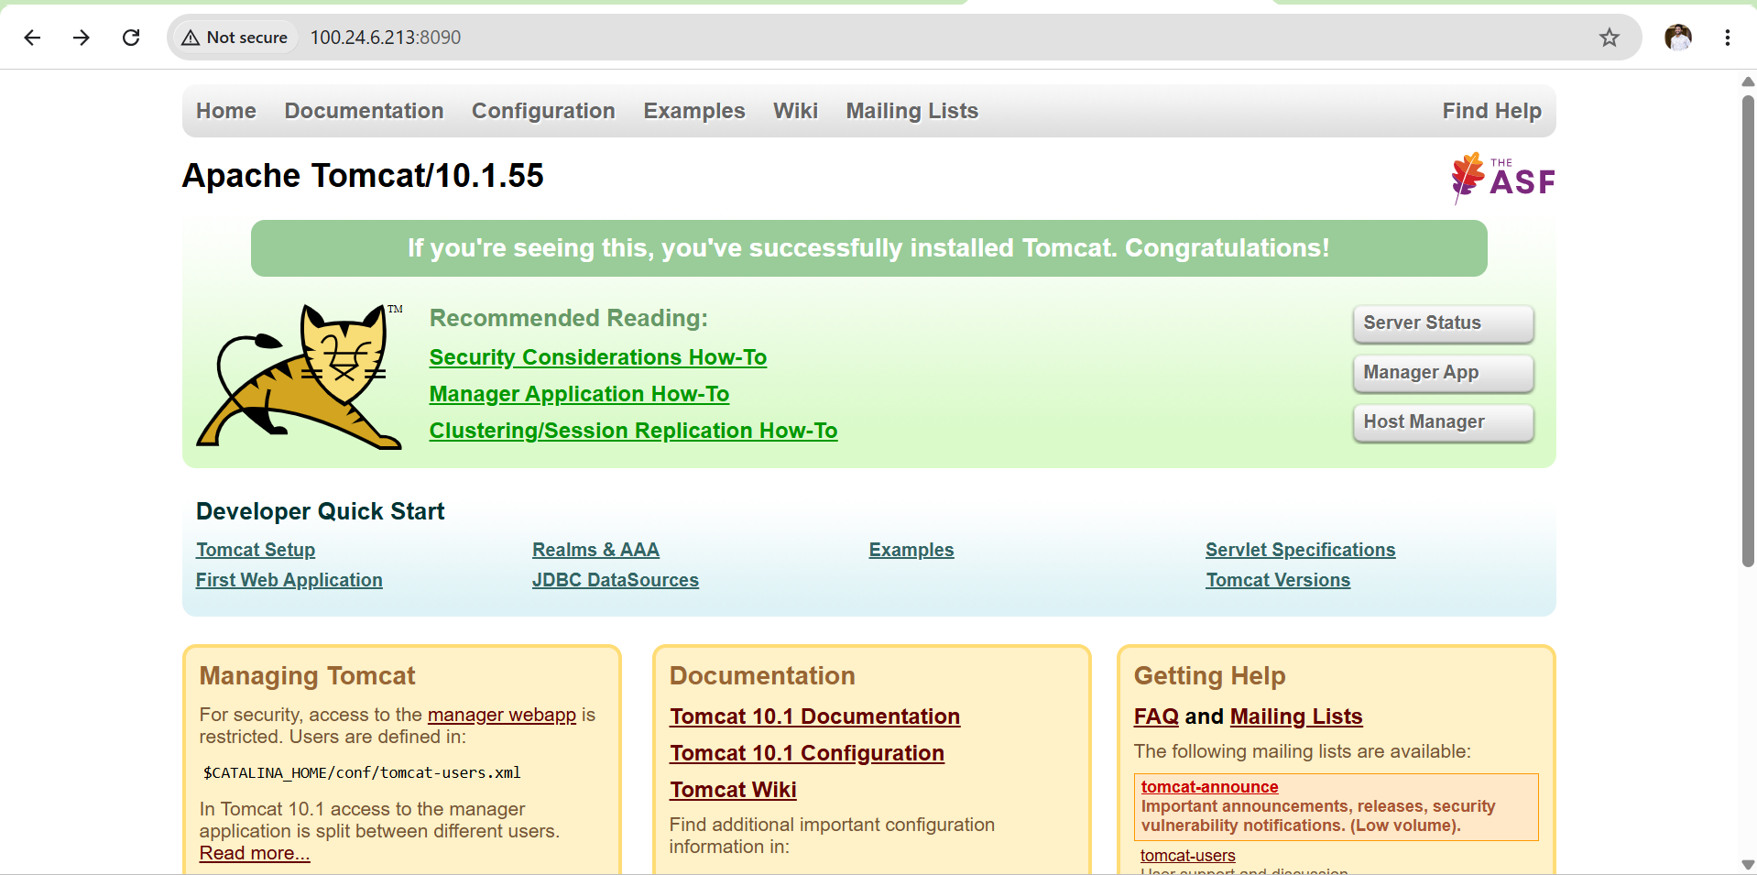
Outcome
Successfully created a custom Docker image using Alpine Linux as the base image, installed and configured Apache Tomcat, built the image, deployed a Tomcat container, and verified that the application was running successfully through the browser.

Task 4: Create Single Stage and Multi Stage Docker file
Source Code:
https://github.com/betawins/multi-stage-example.git?utm_source=chatgpt.com

Objective
Create:
- A Single Stage Docker file
- A Multi Stage Docker file
using the provided Java Maven application.
What is Single Stage Build?
A Single Stage Dockerfile performs build and runtime in the same image.
Characteristics:
- Build tools remain inside the image.
- Image size is larger.
- Less secure.
- Suitable for learning.
Example:
Source Code
↓
Docker Build
↓
Install Maven
Compile Code
Package WAR/JAR
Run Application
What is Multi Stage Build?
A Multi Stage Dockerfile separates:
- Build Environment
- Runtime Environment
Only the final application is copied to the runtime image.
Benefits:
- Smaller image
- Faster deployment
- More secure
- Production standard
Stage 1
Build using Maven
↓
Copy only JAR
↓
Stage 2
Run using JDK
Single Stage Dockerfile
- Create a project directory.
- Clone the source code repository.
- Create Dockerfile.single.
- Use the Maven base image.
- Copy the application source code.
- Build the application using mvn clean package -DskipTests.
- Build the Docker image (single-stage:v1).
- Run the container on port 8081.
- Verify the application and Docker logs.

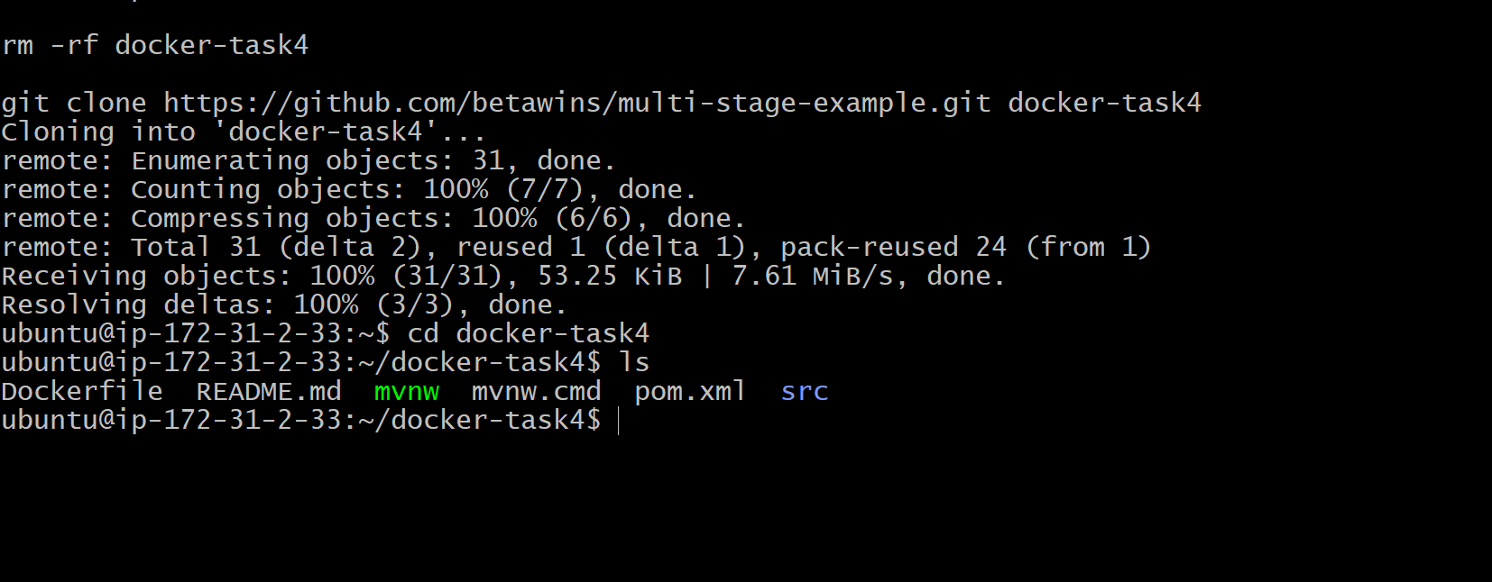
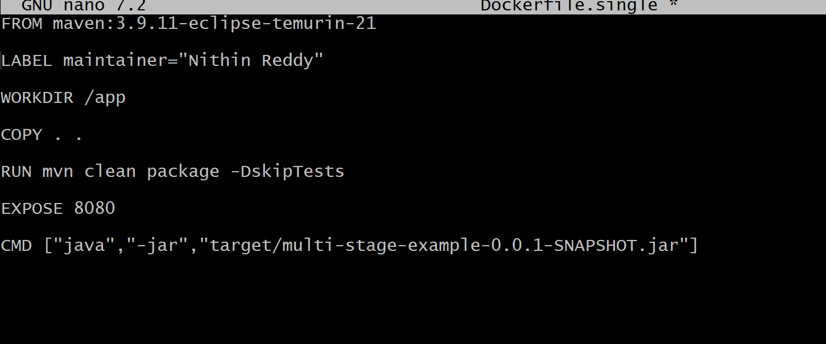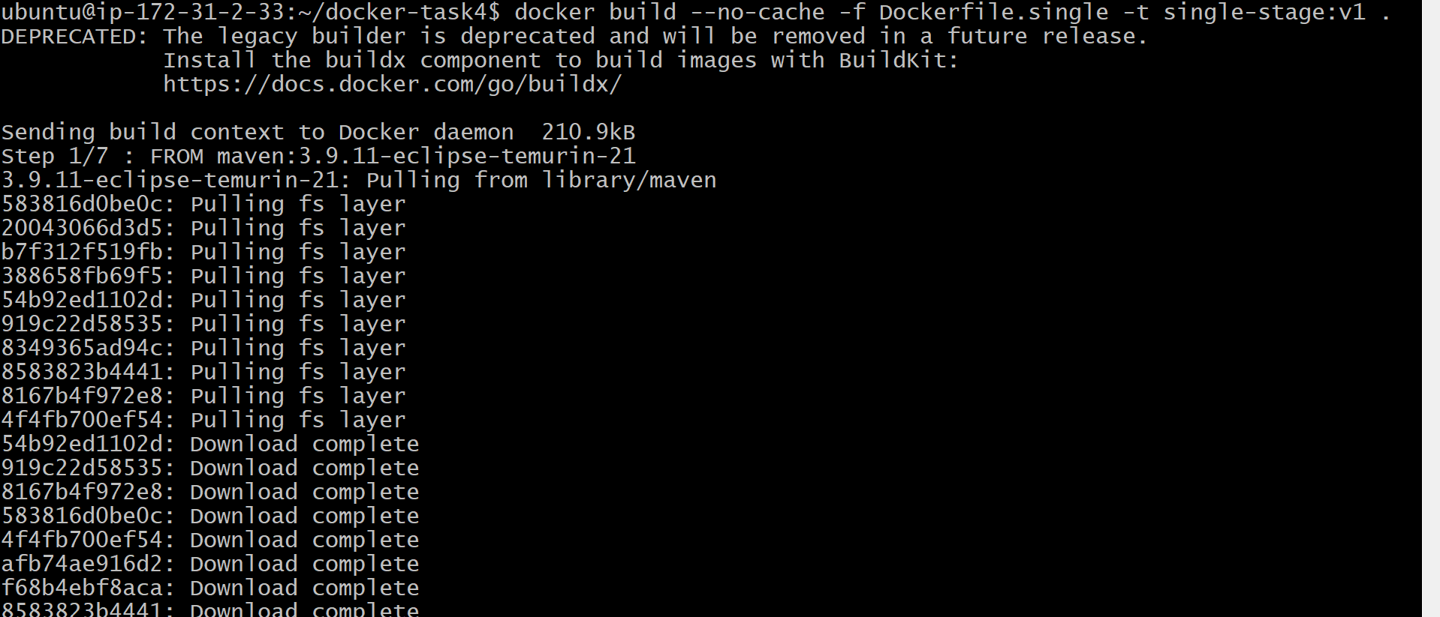
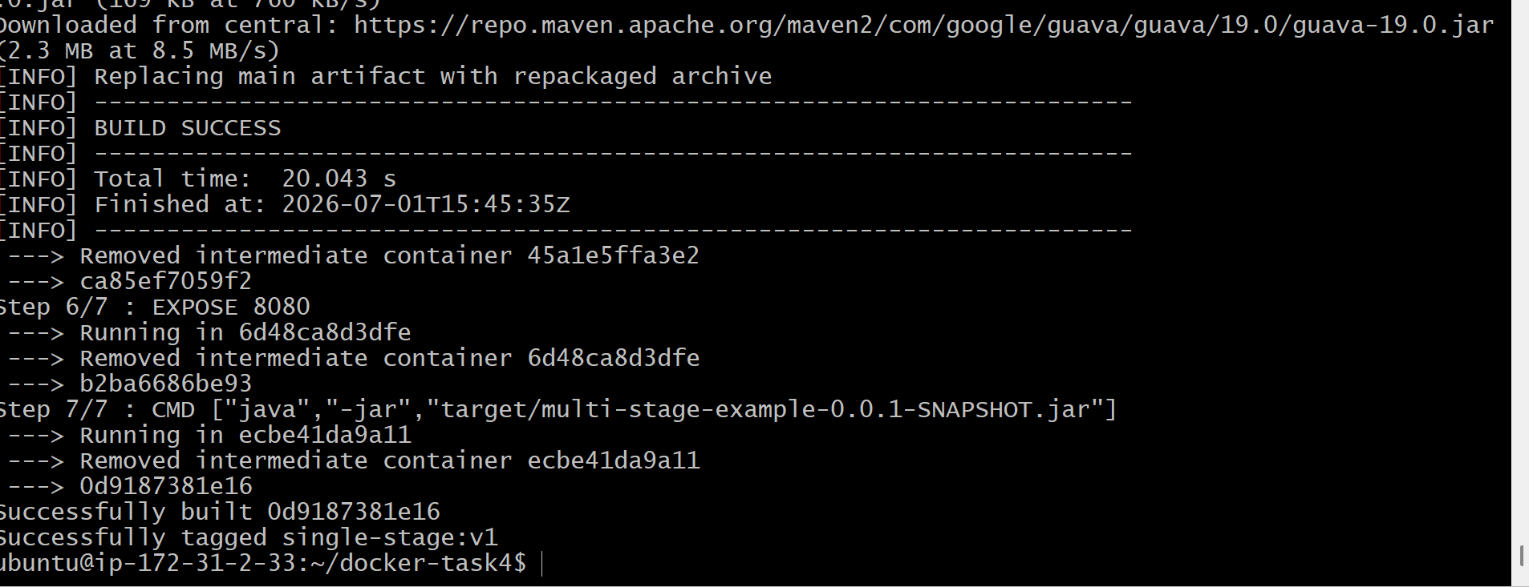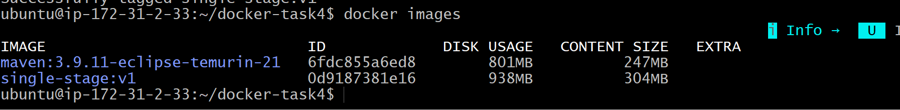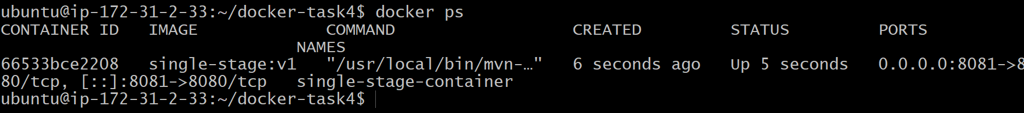
Multi Stage Dockerfile
- Create Dockerfile.multi.
- Use Maven as the build stage.
- Build the application and generate the JAR file.
- Use a lightweight Java runtime image for the final stage.
- Copy only the JAR file from the builder stage.
- Build the Docker image (multi-stage:v2).
- Run the container on port 8082.
- Verify the application and Docker logs.
- Compare the image sizes of single-stage and multi-stage builds.

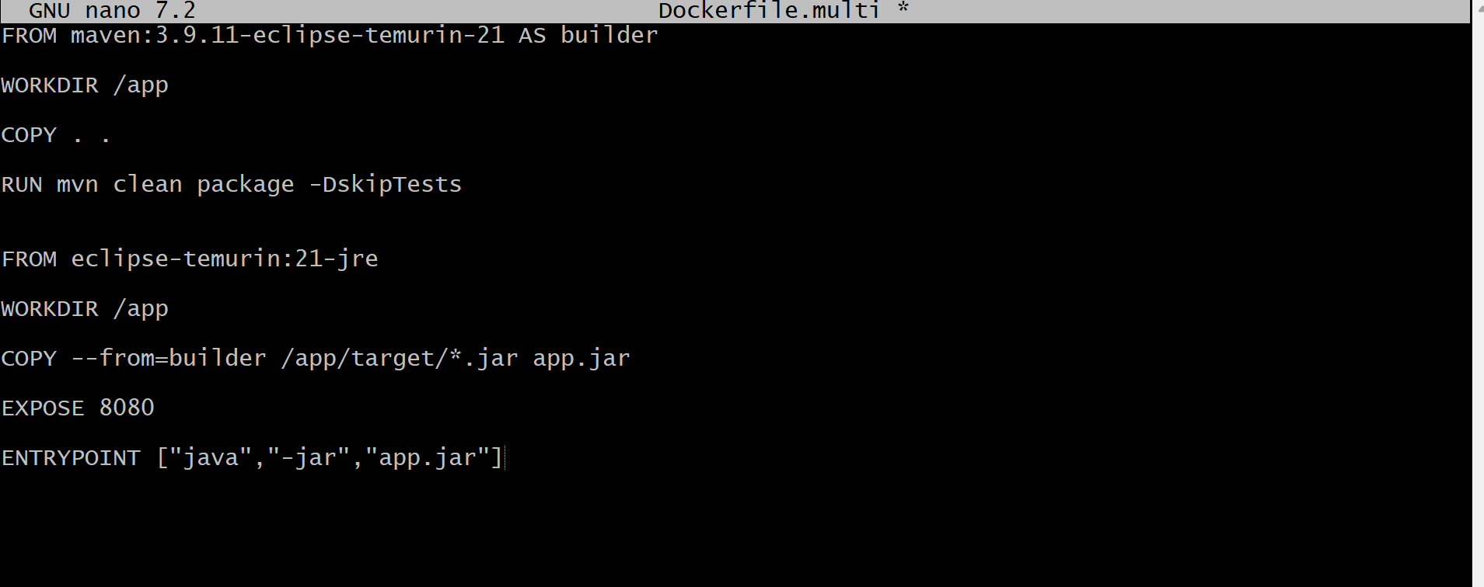
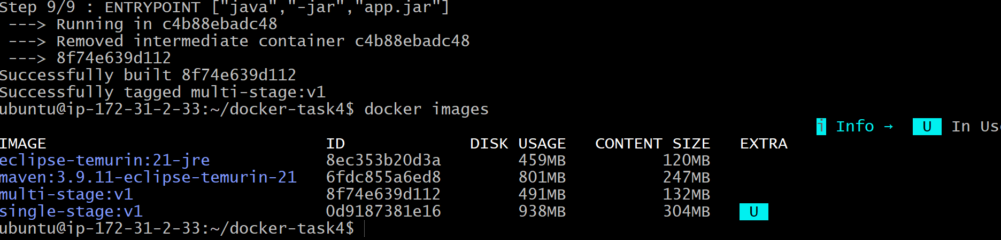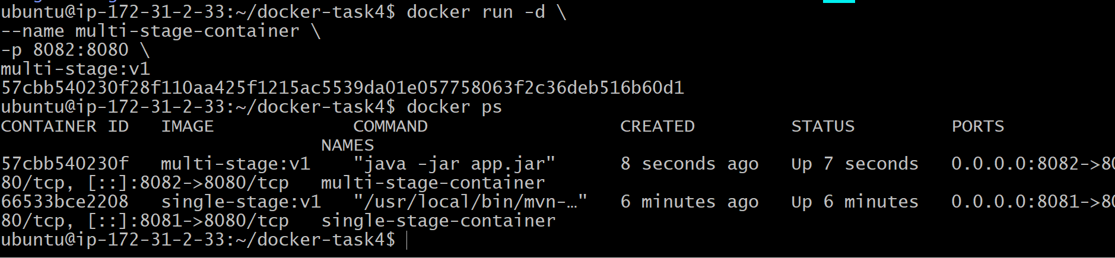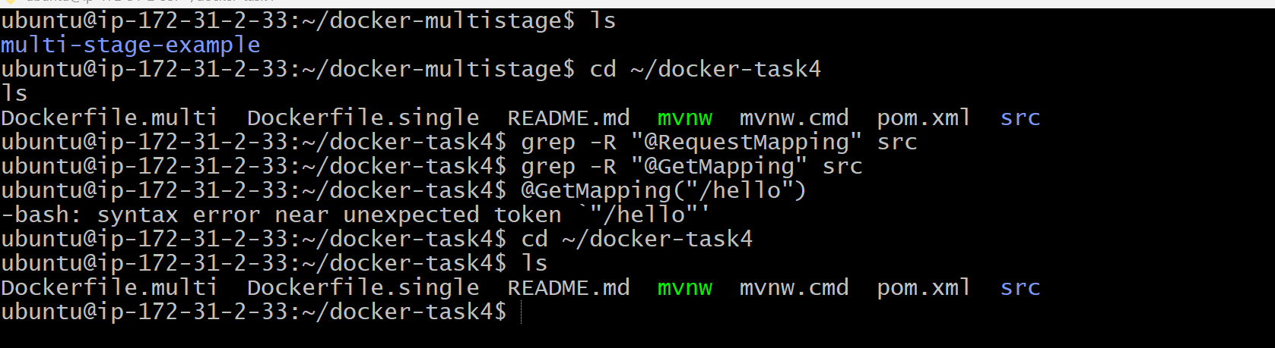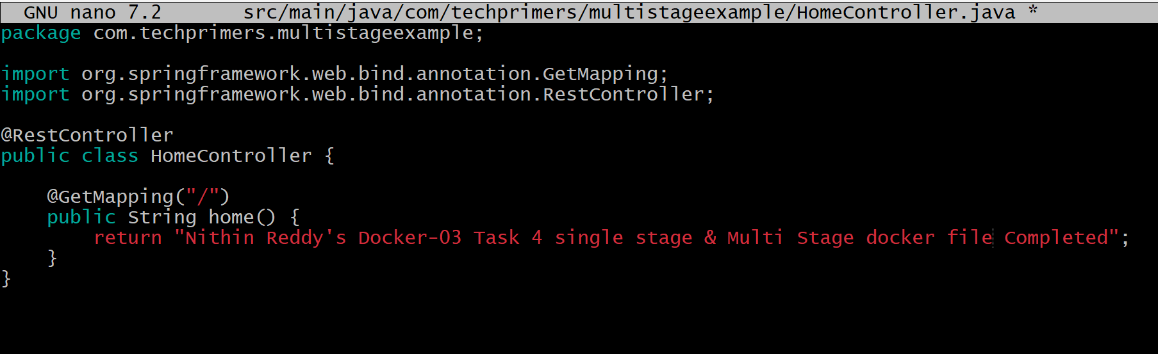
Validation
- docker images displays single-stage:v1 and multi-stage:v2.
- docker ps shows both containers in Up status.
- docker logs confirms the Spring Boot application started successfully.
- Application is accessible through the configured ports.
- Multi-stage image size is smaller than the single-stage image.

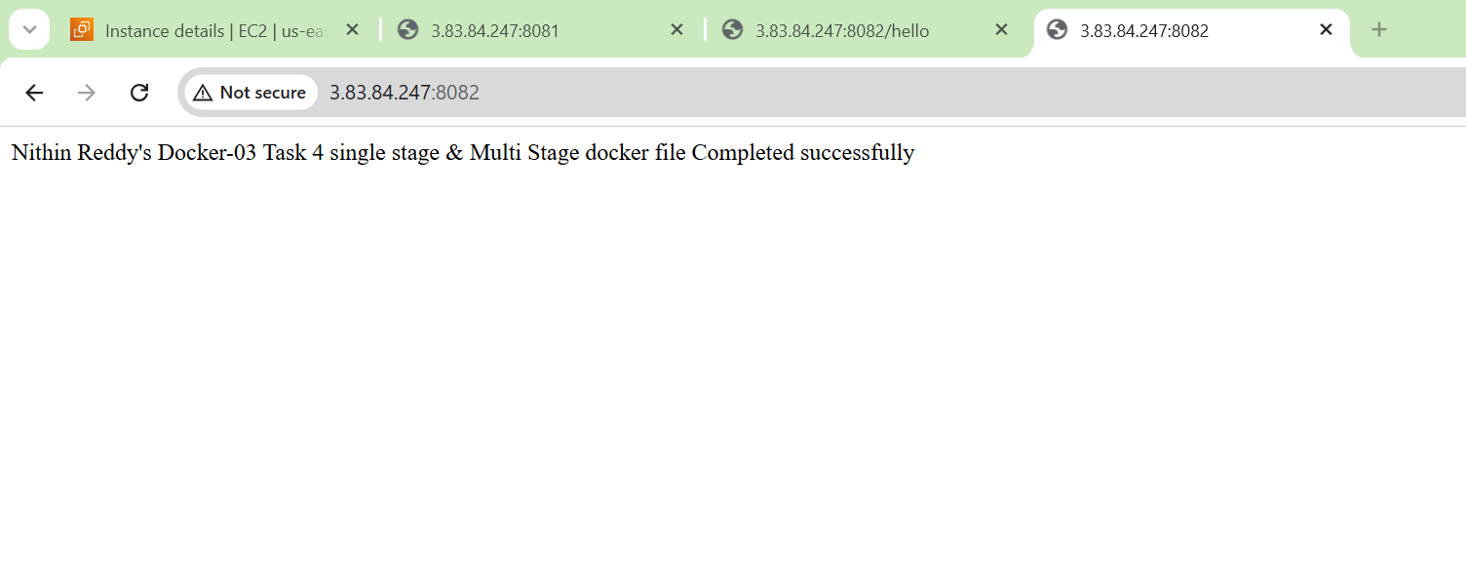

Outcome
- Successfully created a Single Stage Dockerfile using a Maven image for both build and runtime.
- Successfully created a Multi Stage Dockerfile using separate build and runtime stages.
- Built Docker images successfully.
- Launched containers successfully.

Task 5: Install Docker Compose and Execute a Sample Application
Objective
Install Docker Compose on the Ubuntu EC2 instance and deploy a sample multi-container application using a docker-compose.yml file.

What is Docker Compose?
Docker Compose is a tool used to define and manage multiple Docker containers using a single YAML file.
Instead of running multiple docker run commands, you define all services in a docker-compose.yml file and start them together.
Example:
docker-compose.yml
│
├── Nginx
├── Redis
├── MySQL
└── Application
Then simply run:
docker compose up -d

Prerequisites
Verify Docker:
docker --version
Check if Docker Compose is already installed:
docker compose version
or
docker-compose --version
If you get a version number, skip the installation section.
Implementation Steps
- Verified that Docker was installed and running on the Ubuntu EC2 instance.
- Checked whether Docker Compose was already installed using the version command.
- Installed the Docker Compose plugin on the EC2 instance.
- Verified the Docker Compose installation successfully.
- Created a new project directory for the Docker Compose application.
- Created a docker-compose.yml file to define the sample Nginx service.
- Validated the Docker Compose YAML configuration using the docker compose config command.
- Started the sample application using the docker compose up -d command.
- Verified that the Docker Compose service and container were running successfully using docker ps and docker compose ps.
- Accessed the Nginx application through the browser and verified that it was working correctly.
- Viewed the application logs using the docker compose logs command.
- Stopped and removed the Docker Compose application using the docker compose down command

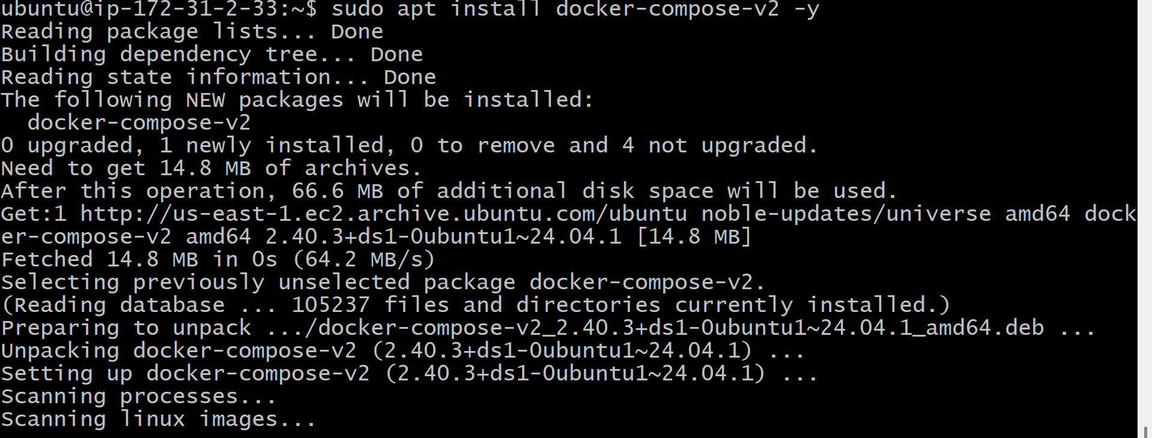
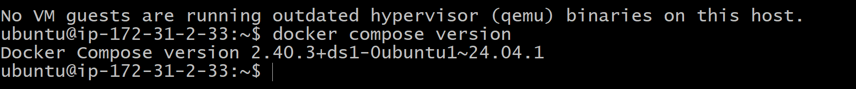
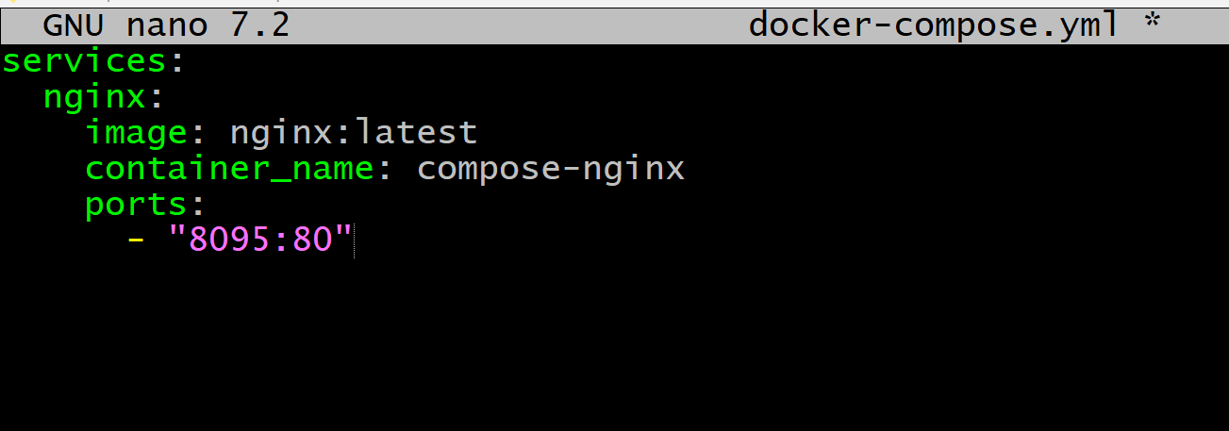
Validation Points
- Docker Compose installed successfully.
- Docker Compose version verified.
- docker-compose.yml file created successfully.
- YAML configuration validated without errors.
- Sample application deployed using Docker Compose.
- Nginx container running successfully.
- Application accessible through the browser.
- Docker Compose services managed using up and down commands.

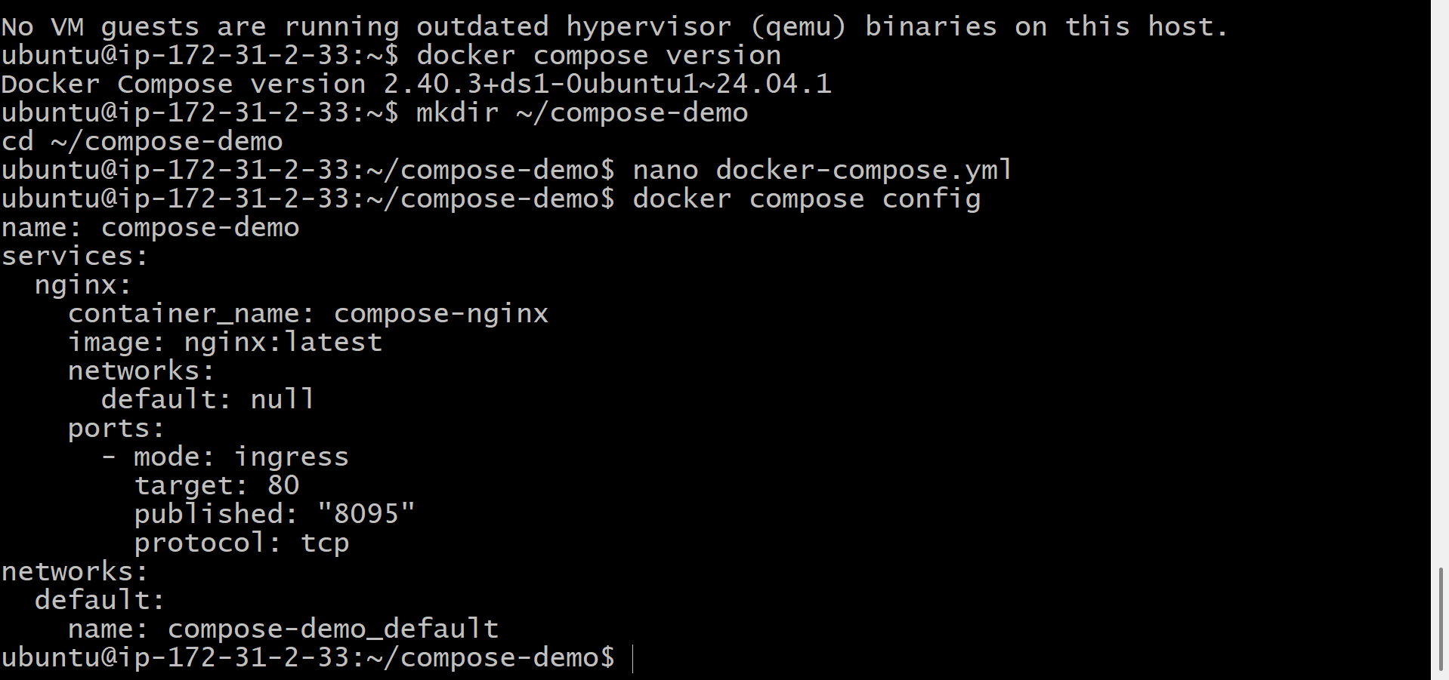
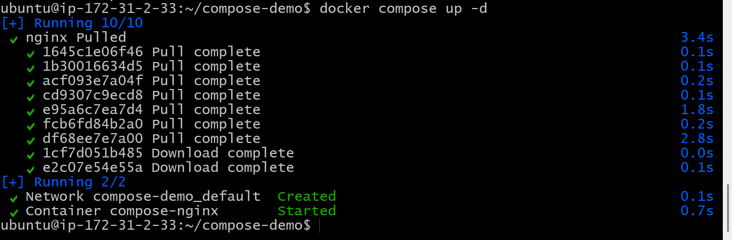
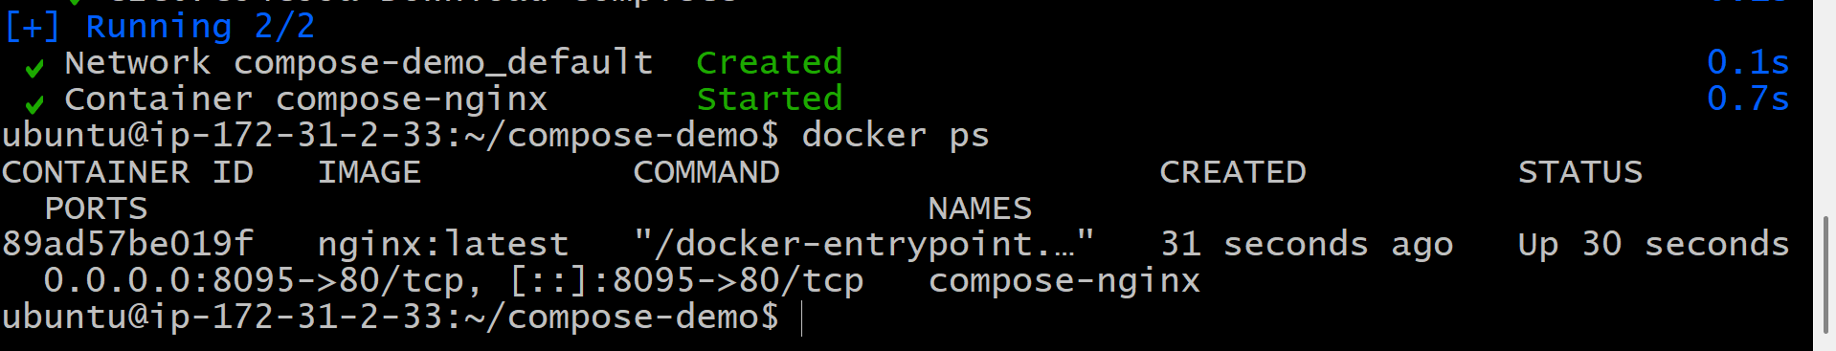
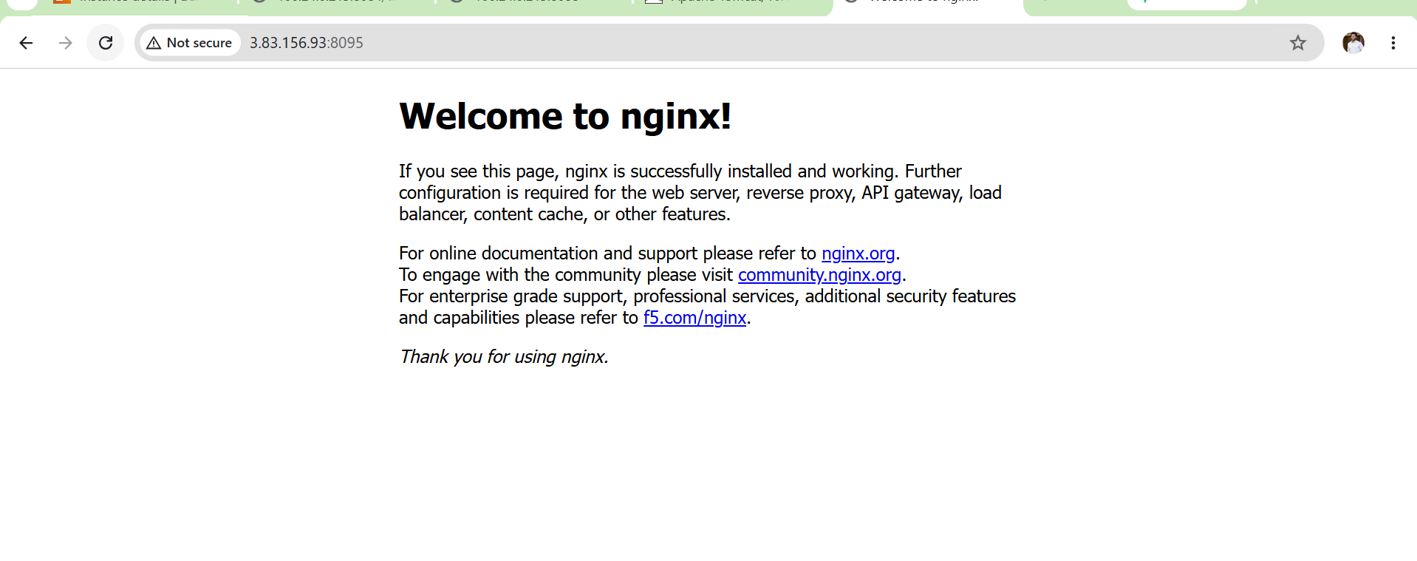
Outcome
Successfully installed Docker Compose, created a docker-compose.yml configuration file, deployed a sample Nginx application as a Docker Compose service, verified its functionality through the browser, and managed the application lifecycle using Docker Compose commands.

Task 6: Implement Solution to Scan Images When Pushed to Docker Registry
Objective
Configure an image scanning solution that automatically scans Docker images for vulnerabilities when images are pushed to a Docker registry.
For this task, we will use Docker Hub automated security scanning (common for this practical).
Flow:
Developer
|
Build Docker Image
|
Push Image
|
Docker Registry (Docker Hub)
|
Automatic Vulnerability Scan
|
Security Report

Prerequisites
- Docker installed
- Docker Hub account
- Docker image available locally
Check your images:
docker images
Example:
my-nginx-image:v1
Implementation Steps
- Verified Docker image availability in the local Docker environment.
- Logged into Docker Hub using Docker CLI authentication.
- Tagged the local Docker image with Docker Hub repository format.
- Verified the newly created Docker image tag.
- Pushed the Docker image to Docker Hub registry.
- Verified successful image upload and generated image digest.
- Opened Docker Hub repository and accessed the pushed image tag.
- Enabled image vulnerability scanning / Scan on Push feature in Docker Hub.
- Triggered image scanning after pushing the image to the registry.
- Verified vulnerability scan results from the Docker Hub repository.
- Confirmed that Docker images are scanned automatically after every push.

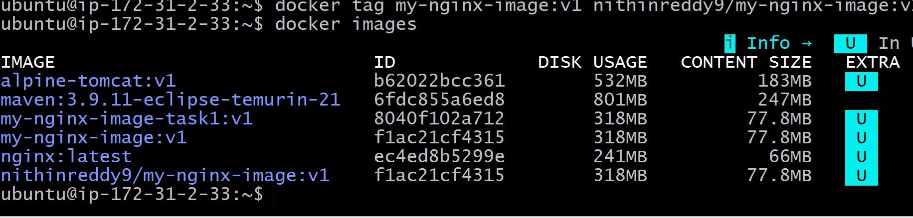
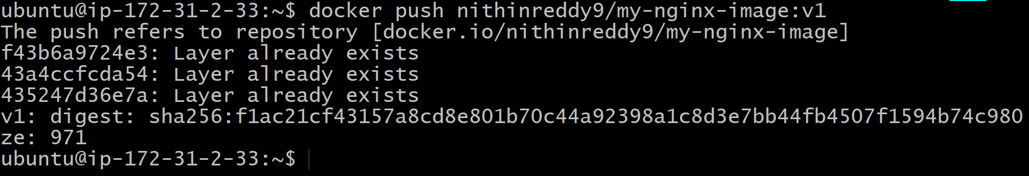
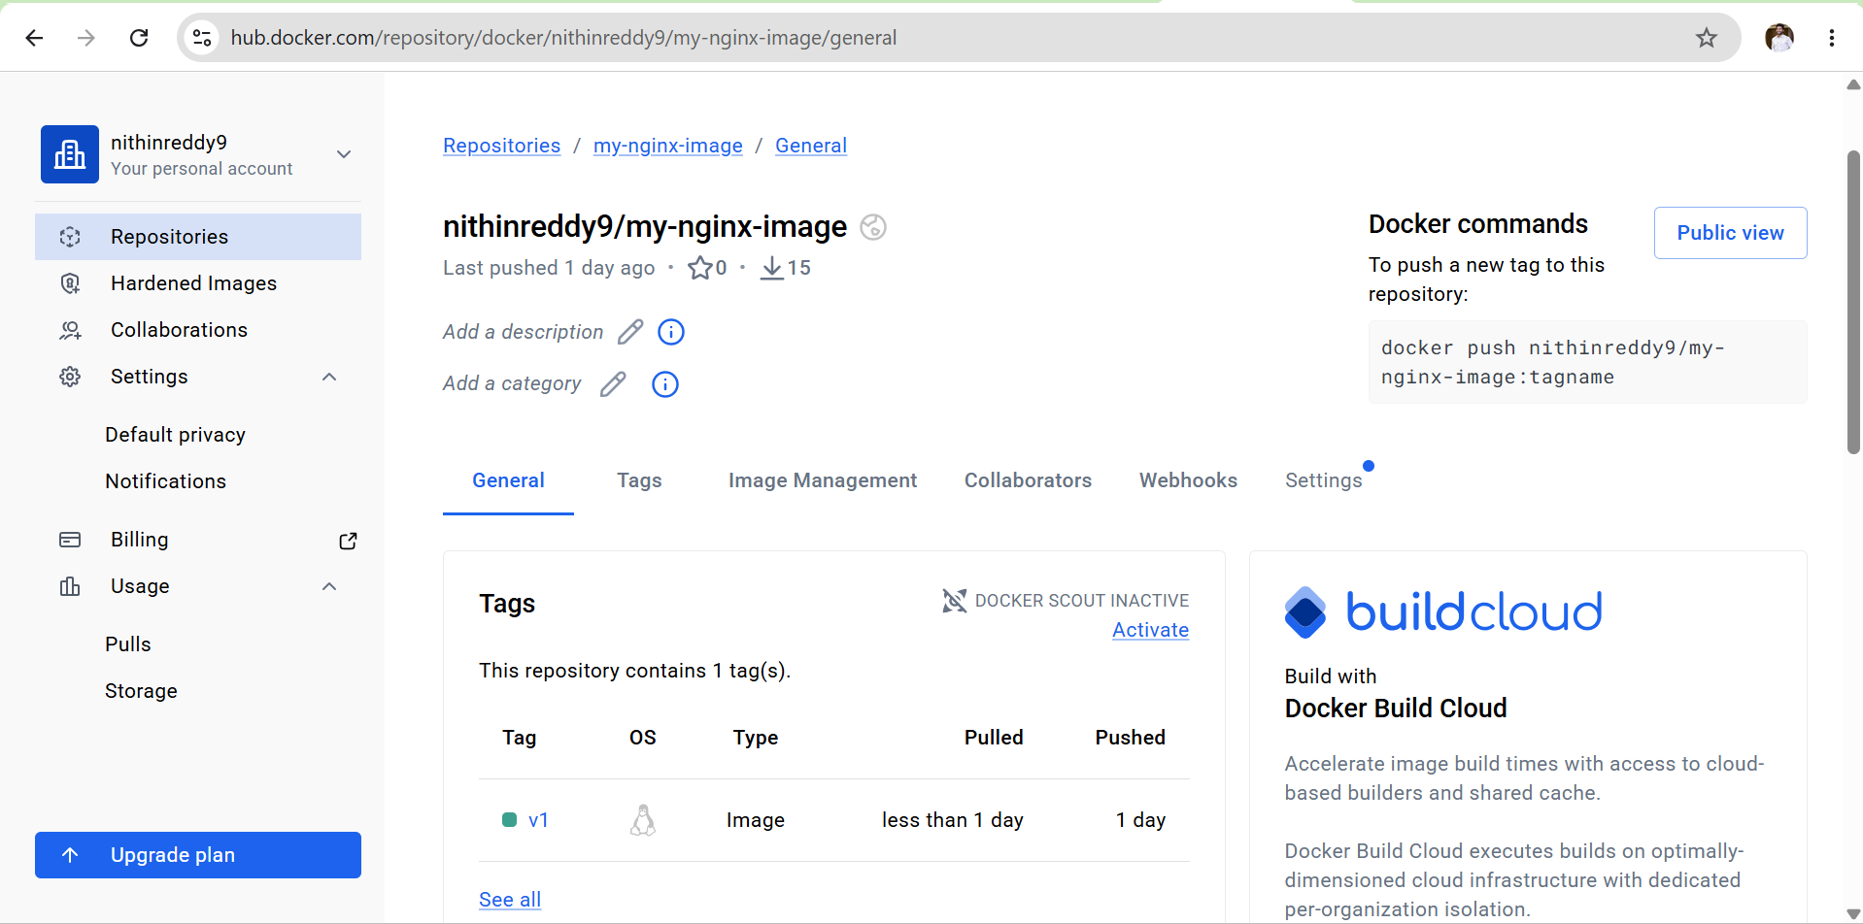
Validation:
- Verified Docker Hub authentication successfully.
- Tagged local Docker image with Docker Hub repository name.
- Successfully pushed Docker image to Docker Hub registry.
- Confirmed image digest generated after successful push.
- Enabled vulnerability scanning on Docker Hub repository.
- Verified security scan results from Docker Hub.
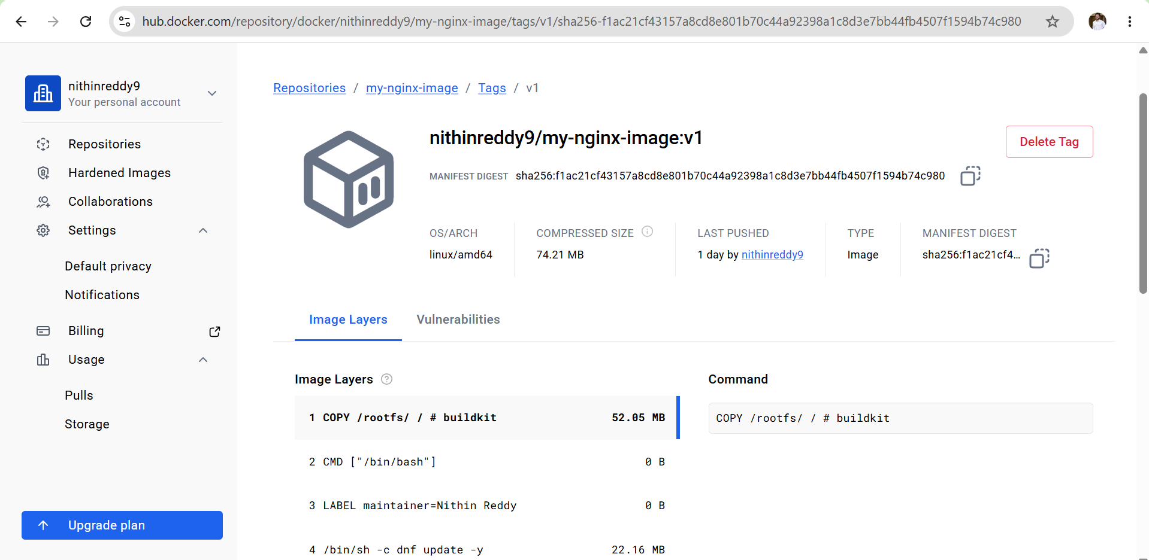
Outcome
Successfully implemented Docker image scanning solution by pushing the Docker image to Docker Hub registry. The image is automatically scanned for security vulnerabilities after upload, improving container security before deployment.

Task 7: Implement Solution to Scan Images When Pushed to AWS ECR
Objective
Configure AWS Elastic Container Registry (ECR) to automatically scan Docker images when they are pushed to the repository.
Flow:
Docker Image
|
↓
AWS ECR Repository
|
↓
Scan on Push Enabled
|
↓
Vulnerability Report
Prerequisites
You already have:
✅ AWS CLI installed
✅ Docker installed
✅ Docker image available:
my-nginx-image:v1
Check:
docker images

Implementation Steps
- Verified AWS CLI installation and AWS account access using aws sts get-caller-identity.
- Created an AWS ECR repository for storing Docker images.
- Enabled Scan on Push vulnerability scanning configuration in the ECR repository.
- Verified the ECR repository and scanning configuration.
- Authenticated Docker client with AWS ECR using aws ecr get-login-password.
- Tagged the existing Docker image with the AWS ECR repository URI.
- Verified the Docker image tag before pushing.
- Pushed the Docker image to AWS ECR repository.
- Verified successful image upload and generated image digest.
- Checked ECR image scan status after image push.
- Verified vulnerability scan findings using AWS CLI and AWS Console.
- Confirmed that future images pushed to ECR will be automatically scanned.

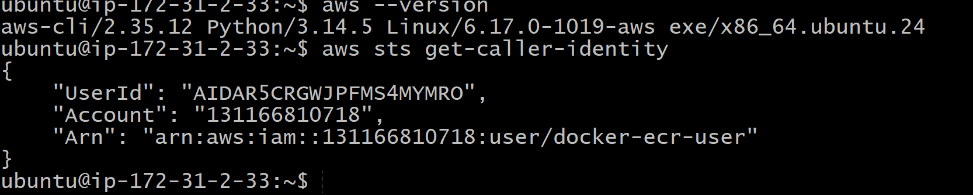
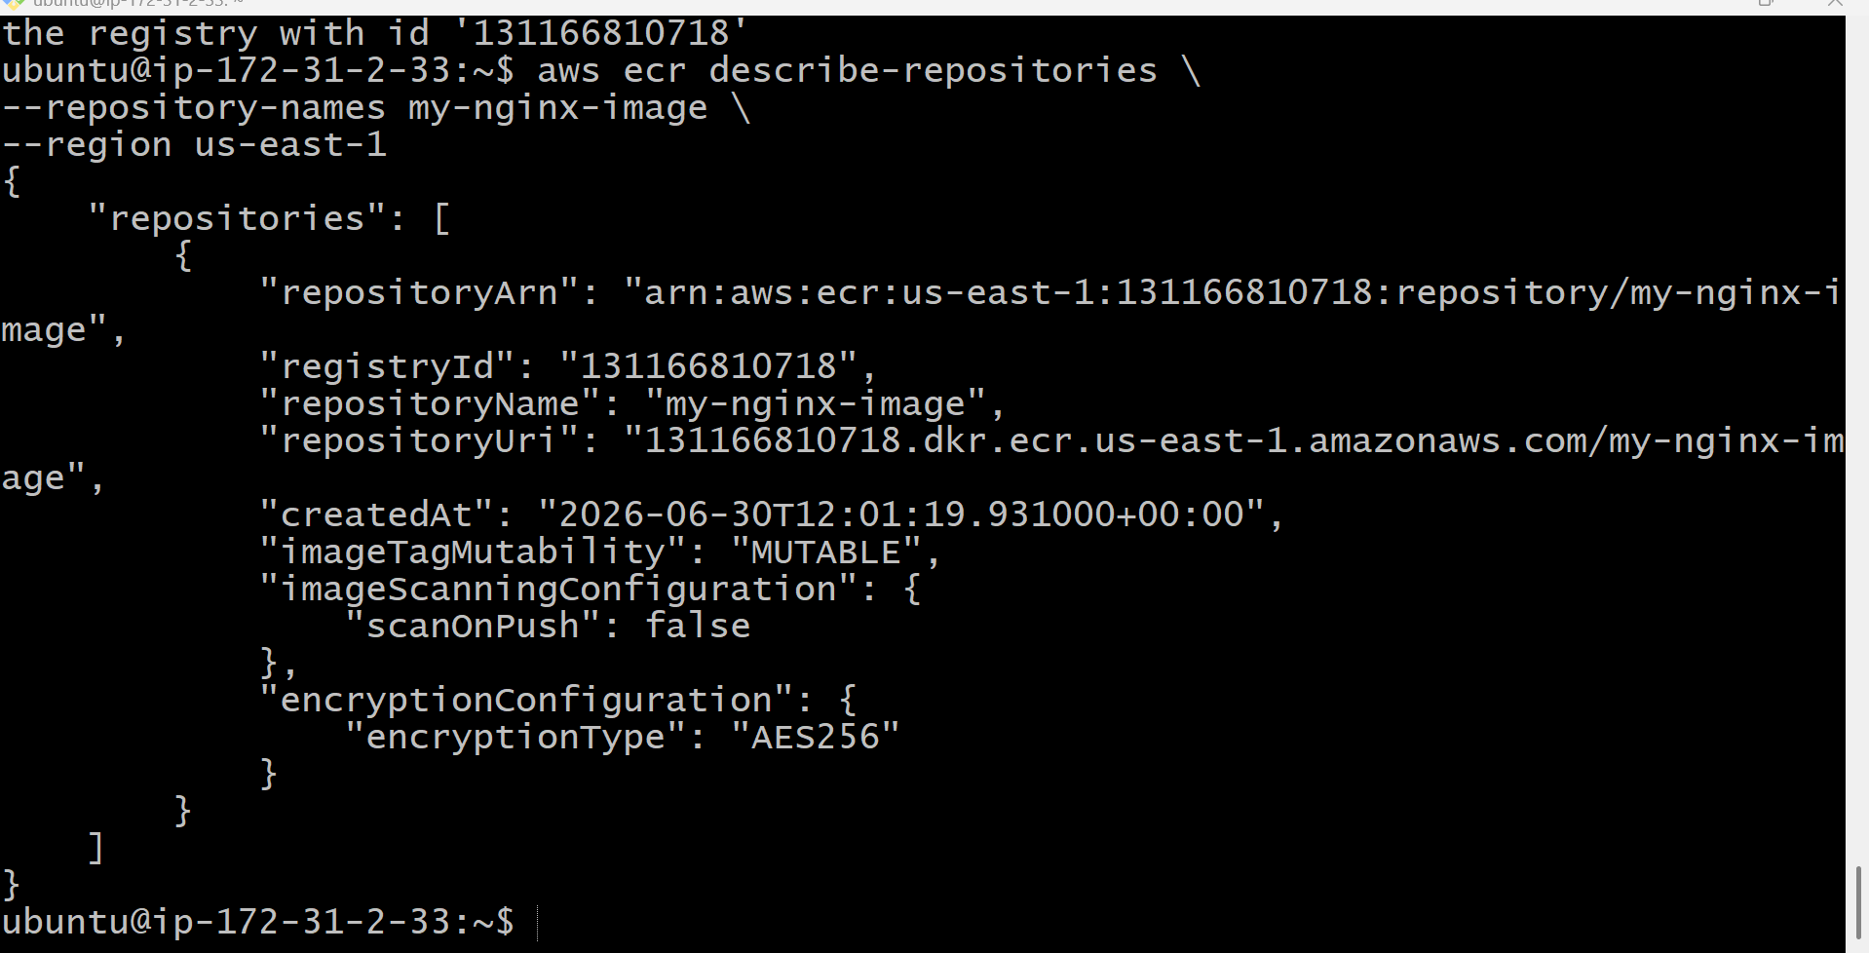
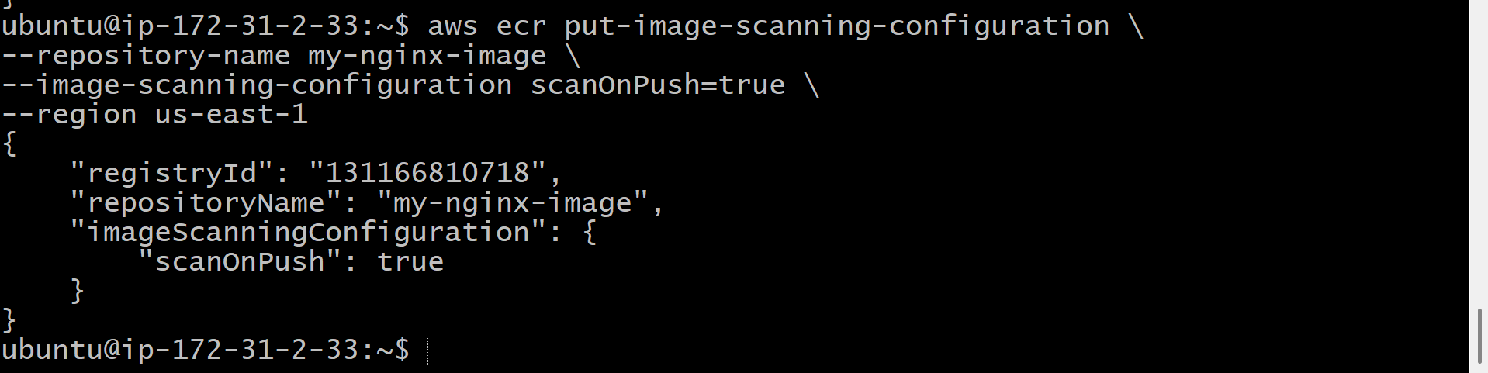
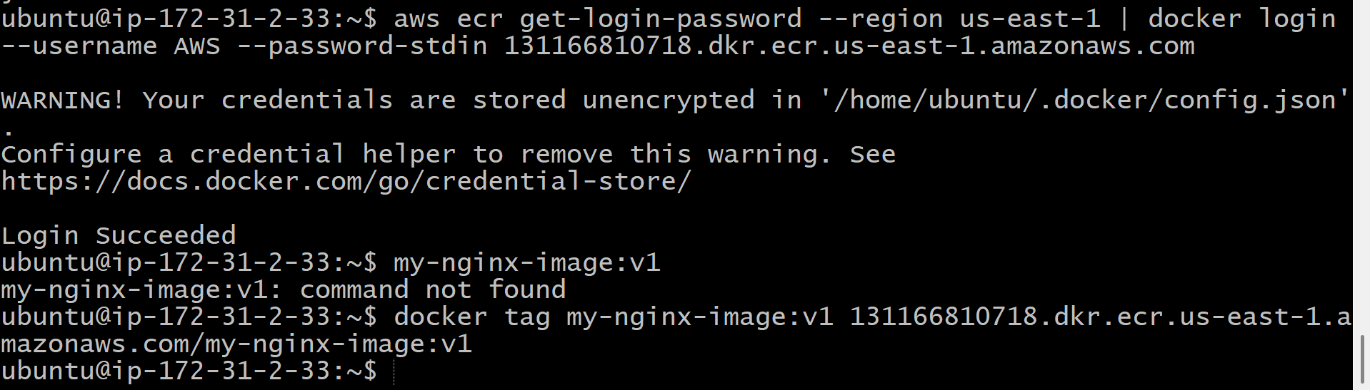
Validation Points
- Verified AWS CLI configuration and IAM access.
- Confirmed ECR repository availability.
- Enabled Scan on Push configuration.
- Authenticated Docker with AWS ECR.
- Tagged Docker image with ECR repository URI.
- Successfully pushed Docker image to AWS ECR.
- Verified automatic vulnerability scan execution.
- Checked image scan findings from AWS ECR.
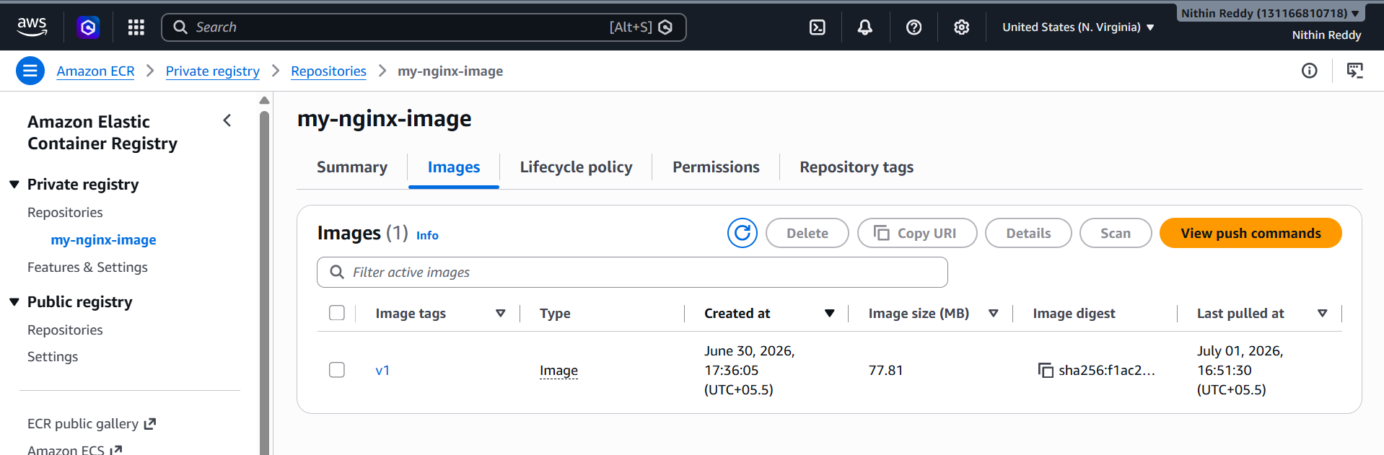
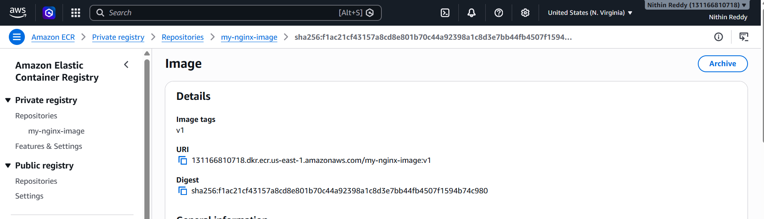
Outcome
Successfully implemented AWS ECR image vulnerability scanning by enabling Scan on Push. Docker images pushed to AWS ECR are automatically scanned for security vulnerabilities, and scan results can be reviewed through AWS ECR.

Task 8: Create a Jenkins Pipeline to Create Docker Image and Push Image to Docker Hub
Objective
Create a Jenkins CI/CD pipeline that:
- Gets source code from GitHub
- Builds a Docker image
- Tags the Docker image
- Pushes the image to Docker Hub automatically
Flow:
Developer Push Code
|
↓
Jenkins
|
↓
Git Clone
|
↓
Docker Build
|
↓
Docker Login
|
↓
Docker Push
|
↓
Docker Hub

Prerequisites
You already have:
✅ Jenkins installed
✅ Docker installed
✅ Docker Hub account (nithinreddy9)
✅ Docker image push tested manually
Check:
docker --version
docker login
Steps Important Points
- Launch the EC2 instance and ensure Jenkins and Docker are installed.
- Verify the Jenkins user has permission to run Docker commands.
- Create a simple application (index.html) and a Dockerfile.
- Copy the project files to the Jenkins workspace.
- Log in to Jenkins (http://<EC2-Public-IP>:8080).
- Create a new Pipeline job.
- Configure Docker Hub credentials in Jenkins (Username with Password / Personal Access Token).
- Write the Declarative Jenkins Pipeline to:
  - Build the Docker image.
  - Log in to Docker Hub.
  - Push the Docker image to Docker Hub.
- Save the pipeline configuration.
- Click Build Now to execute the pipeline.
- Monitor the build progress in Console Output.
- Verify the Docker image is available in the Docker Hub repository.

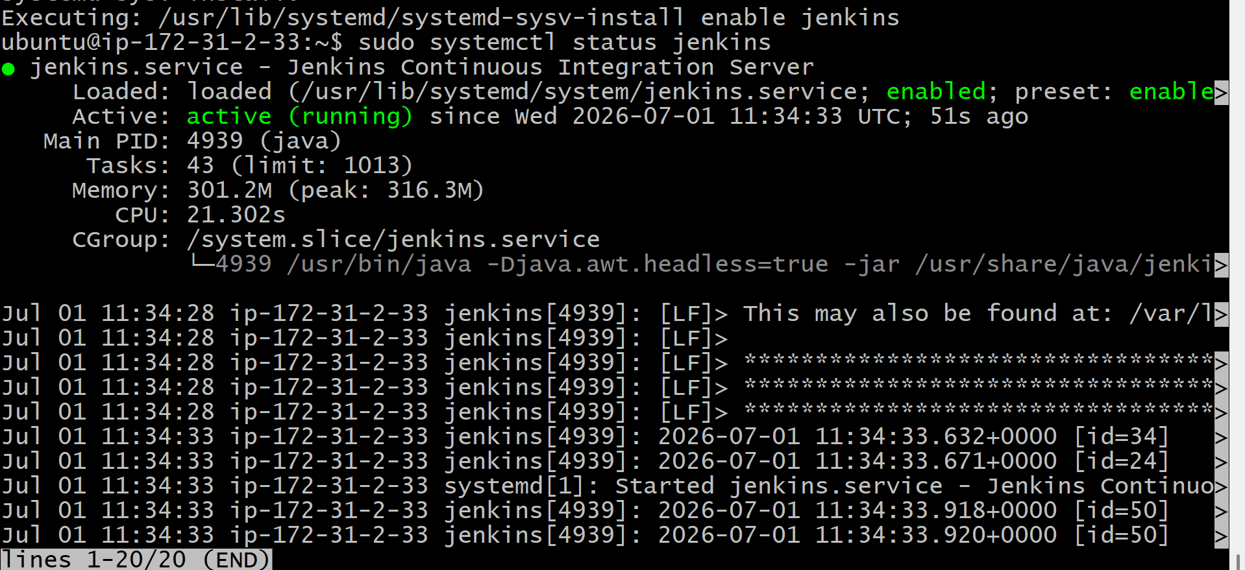
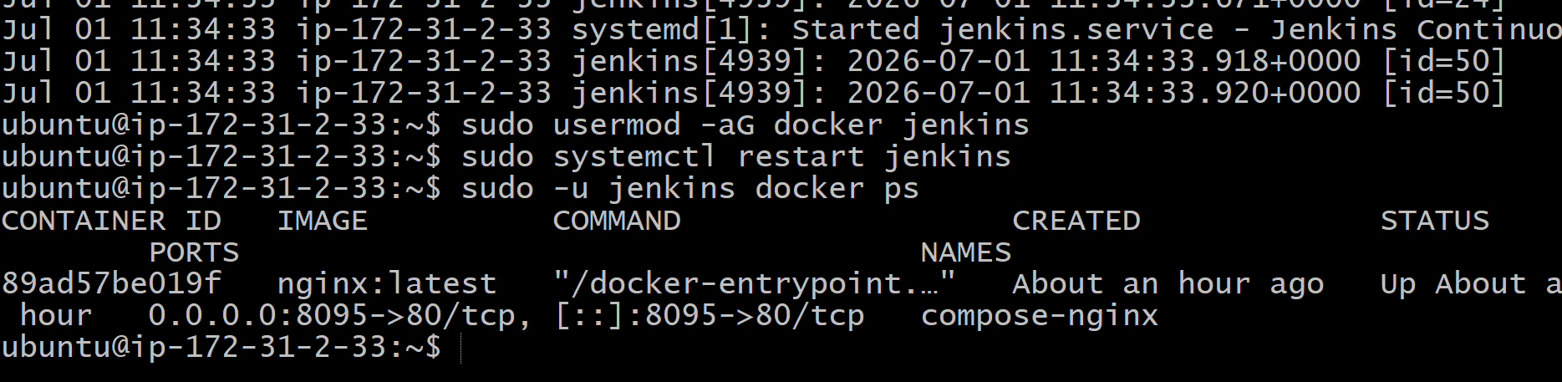
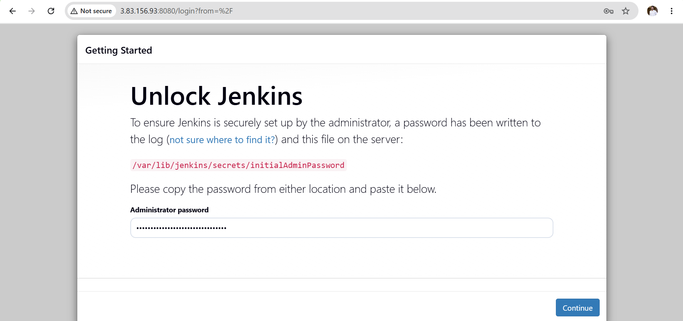
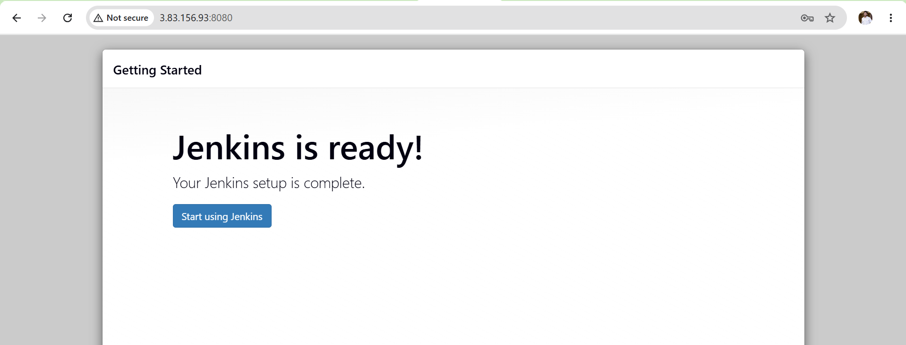
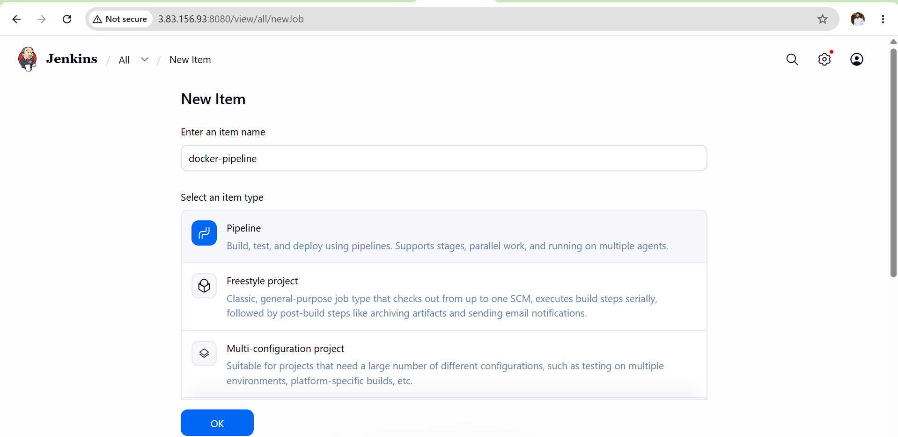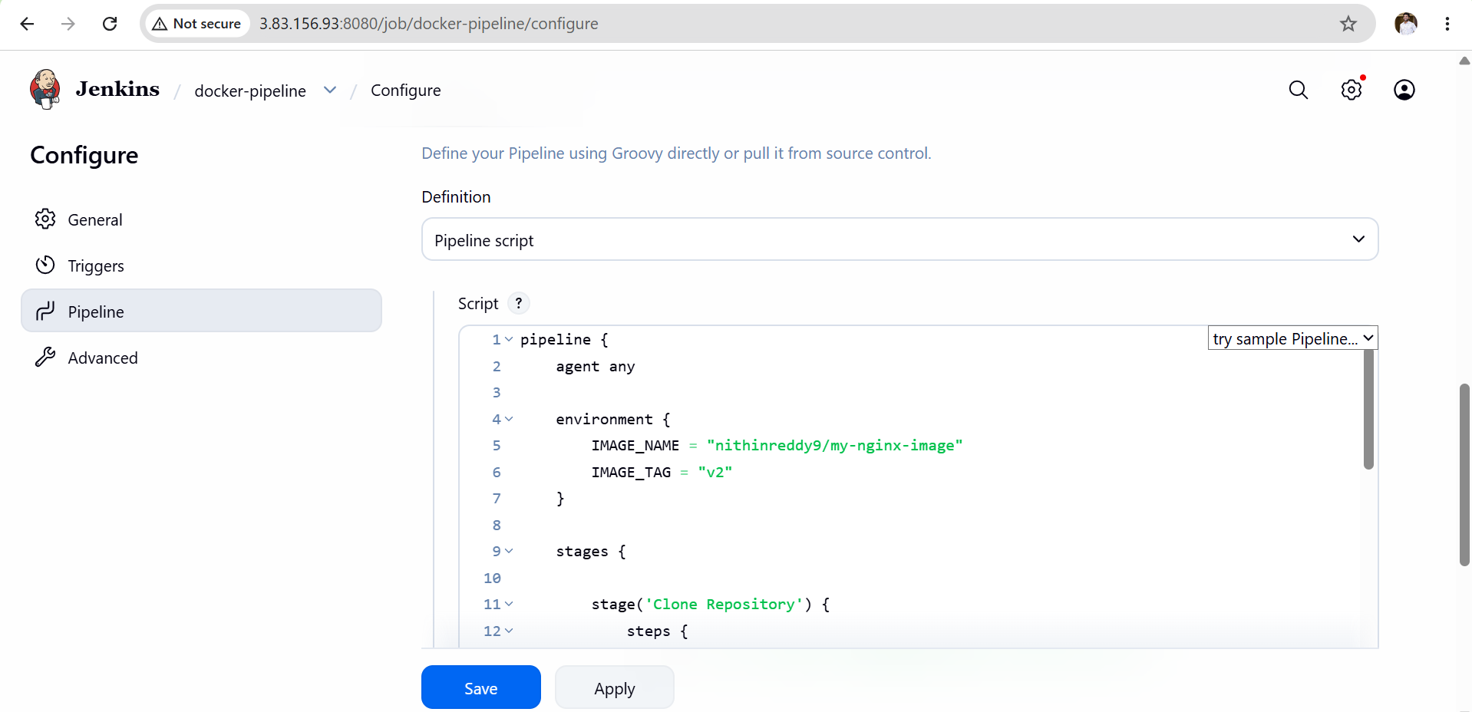

Validation
- ✅ Jenkins pipeline executed successfully.
- ✅ Docker image built without errors.
- ✅ Docker Hub authentication completed successfully.
- ✅ Docker image pushed to Docker Hub.
- ✅ Image and tag are visible in the Docker Hub repository.
- ✅ Jenkins build status shows:

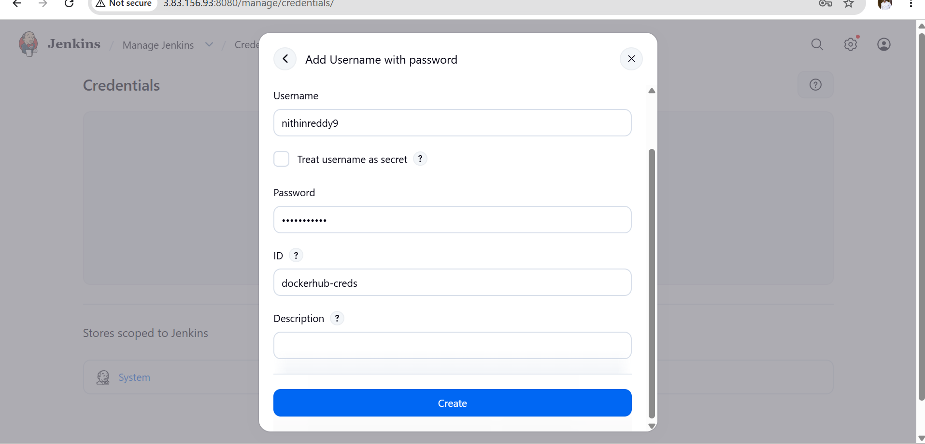

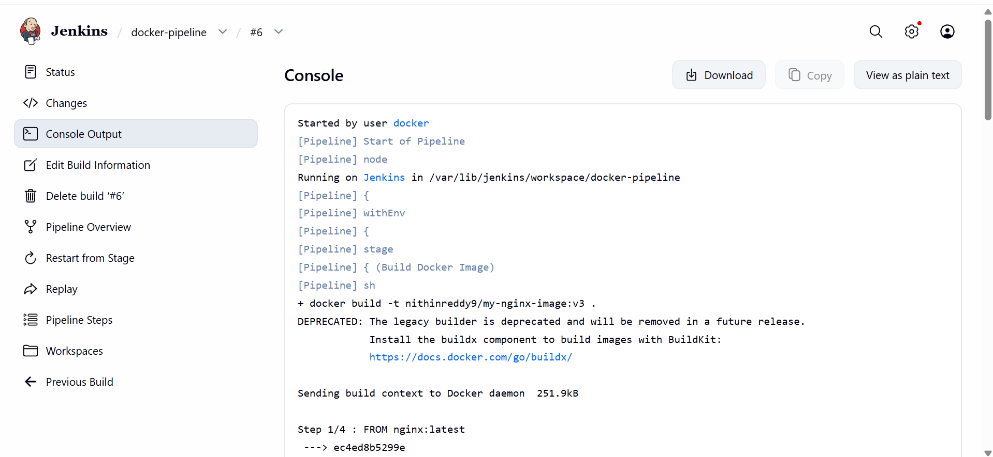
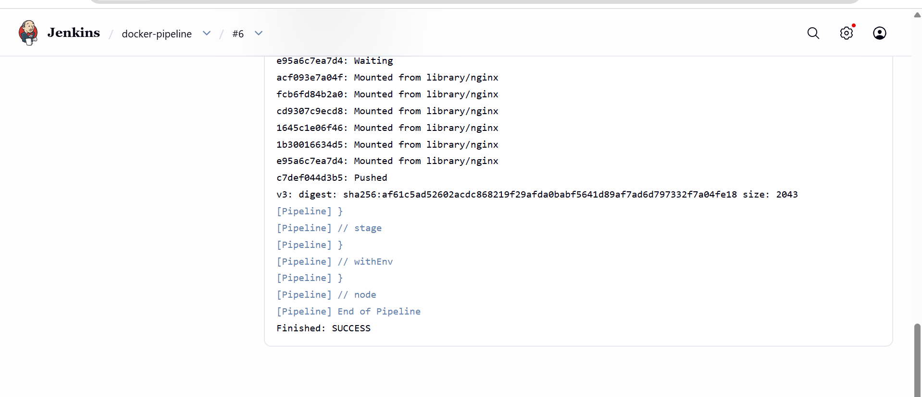
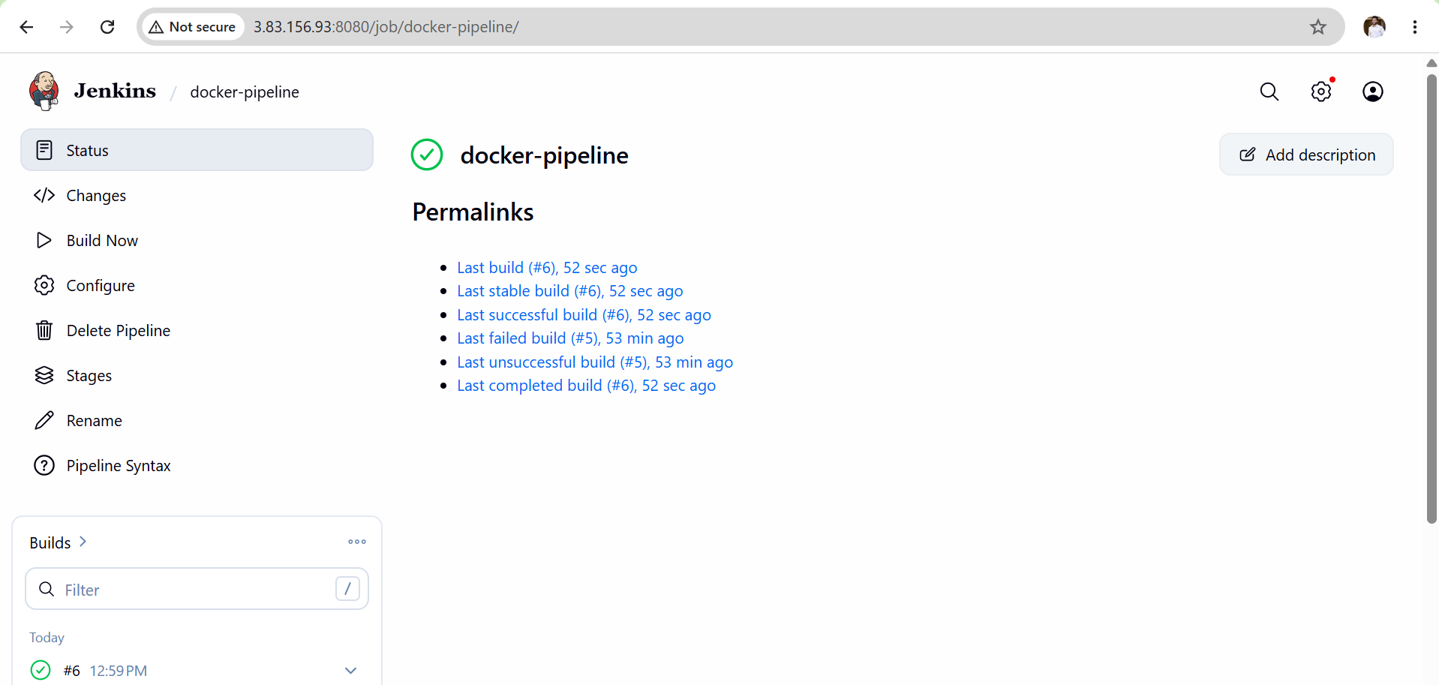
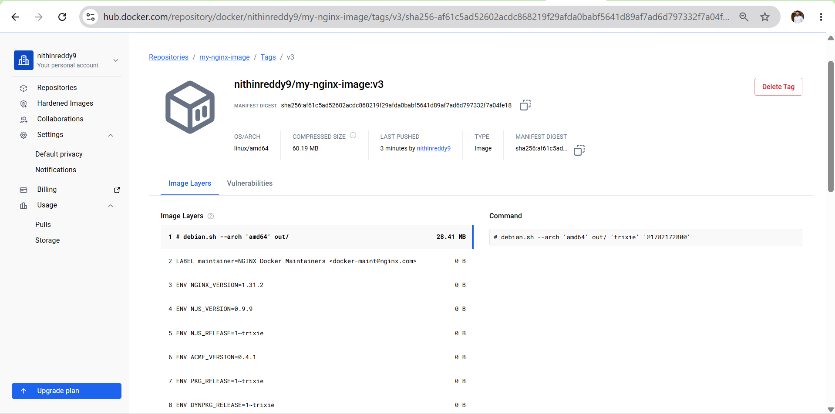
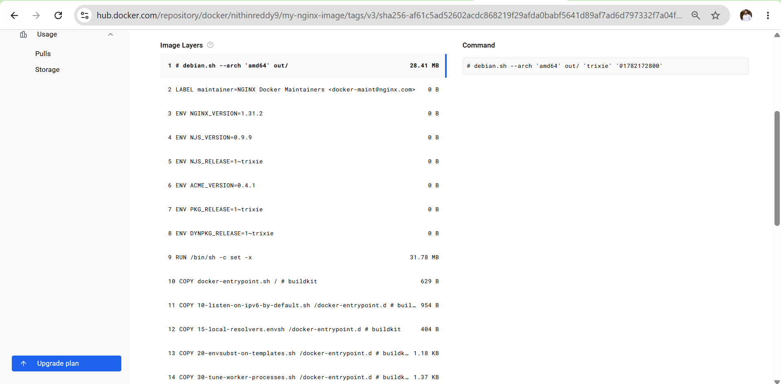
Outcome
- Successfully automated Docker image creation using a Jenkins Pipeline.
- Successfully authenticated Jenkins with Docker Hub.
- Successfully pushed the Docker image to Docker Hub.
- Verified the uploaded image in the Docker Hub repository.
- Demonstrated a complete CI workflow for Docker image build and deployment using Jenkins.

