Task related to ECS
- Setup a highly available ecs cluster with load balancer and dynamic port mapping.
NOTE: Your cluster should maintain atleast 6 tasks at any point of time and should be highly availble across multiple AZ's. Use the below image from deployment:
sabair0509/hiring-app:works
Task Objective
Deploy a highly available containerized application on Amazon ECS using AWS Fargate.
The application should:
- Run behind an Application Load Balancer
- Use Dynamic Port Mapping
- Be deployed across multiple Availability Zones
- Always maintain at least 6 running tasks
- Automatically replace unhealthy tasks
- Support load balancing across all running containers
Architecture
Users
|
|
Internet
|
Application Load Balancer
|
-------------------------------
| |
| |
AZ-1 AZ-2
| |
Private Subnet Private Subnet
| |
ECS Task 1 ECS Task 4
ECS Task 2 ECS Task 5
ECS Task 3 ECS Task 6
ECS Cluster (Fargate)
Services Used
Service | Purpose
ECS | Container Orchestration
Fargate | Serverless container runtime
ECR/Docker Hub | Image Repository
ALB | Load Balancer
Target Group | Registers ECS Tasks
IAM Role | ECS Permissions
CloudWatch | Logs
Security Groups | Firewall
VPC | Networking

Prerequisites
You should already have:
✅ AWS Account
✅ IAM User
✅ Existing VPC
Preferably
2 Public Subnets
2 Private Subnets
Across
ap-south-1a
ap-south-1b
Implementation Steps
Step 1: Create ECS Cluster
- Open Amazon ECS Console.
- Create a new ECS Cluster.
- Choose Amazon ECS with EC2 (or Fargate if instructed).
- Enable Container Insights (optional).
- Complete cluster creation.

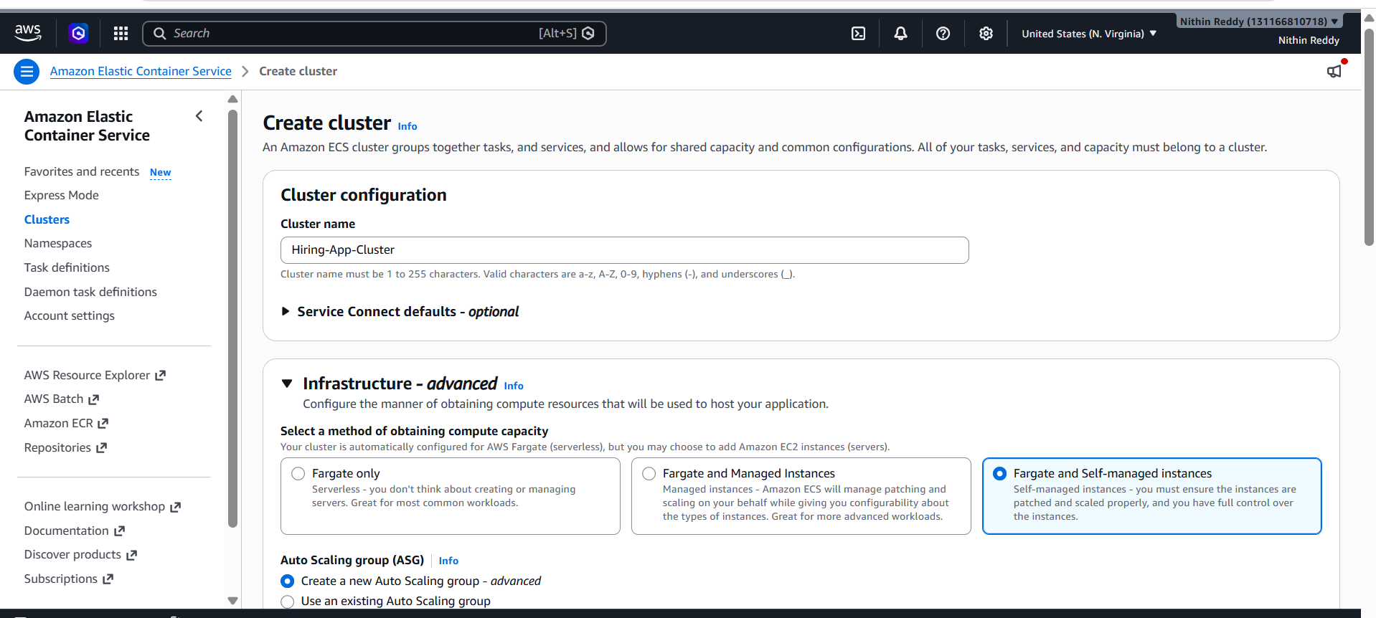
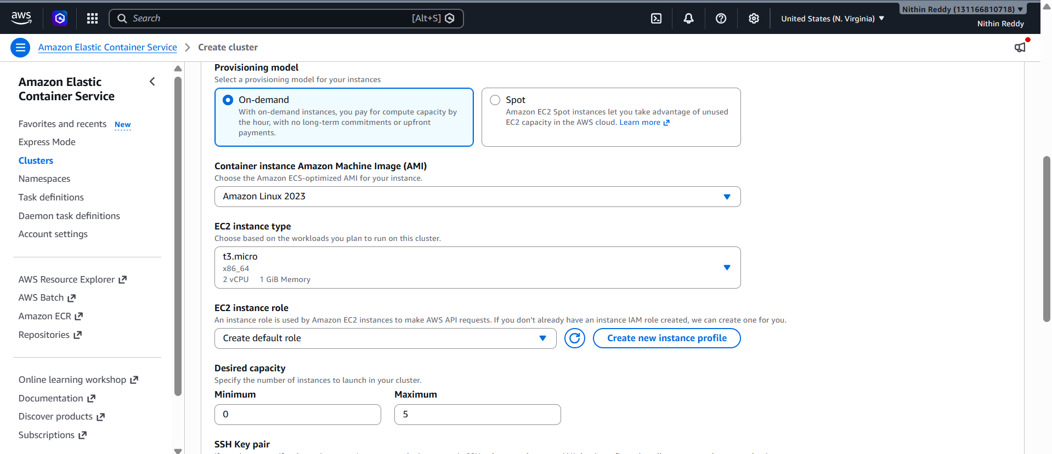

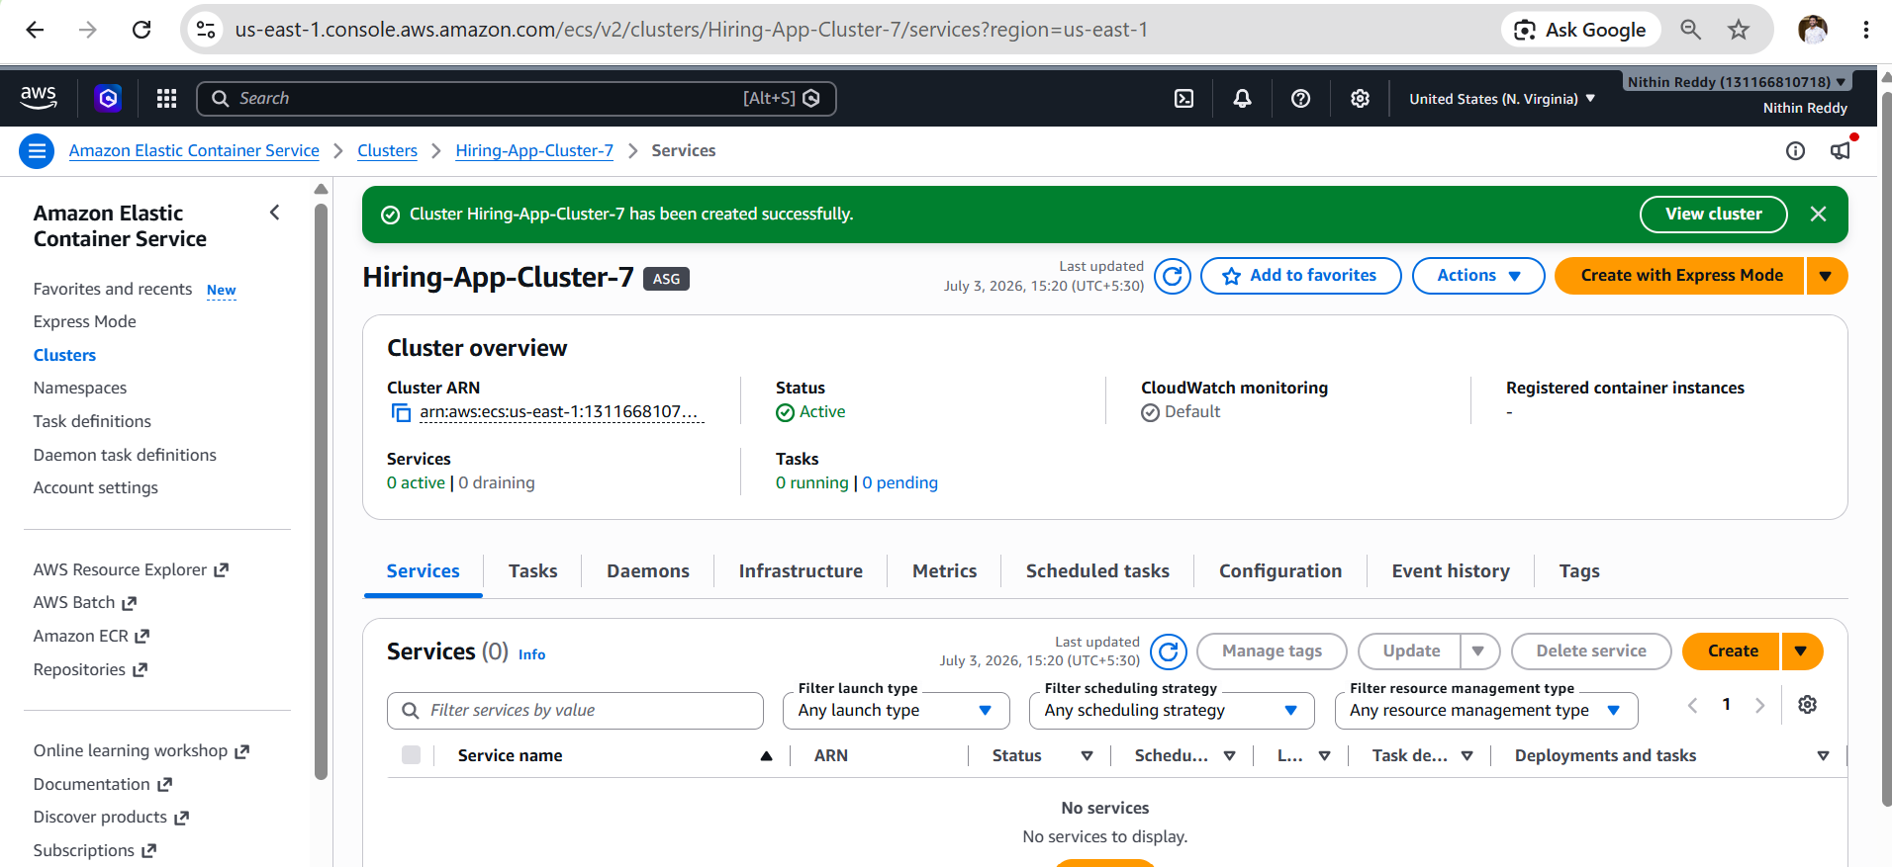
Step 2: Create Task Definition
- Create a new ECS Task Definition.
- Select Linux operating system.
- Configure CPU and Memory.
- Add container.
- Image:
sabair0509/hiring-app:works

- Configure container port.
- Enable CloudWatch Logs.
- Save the task definition.

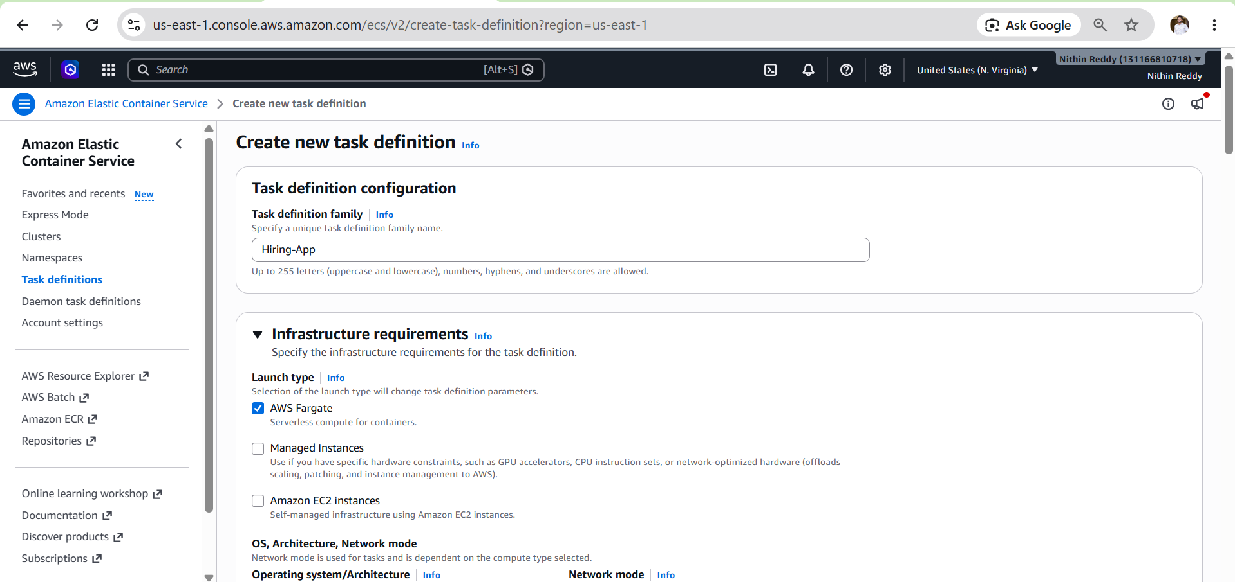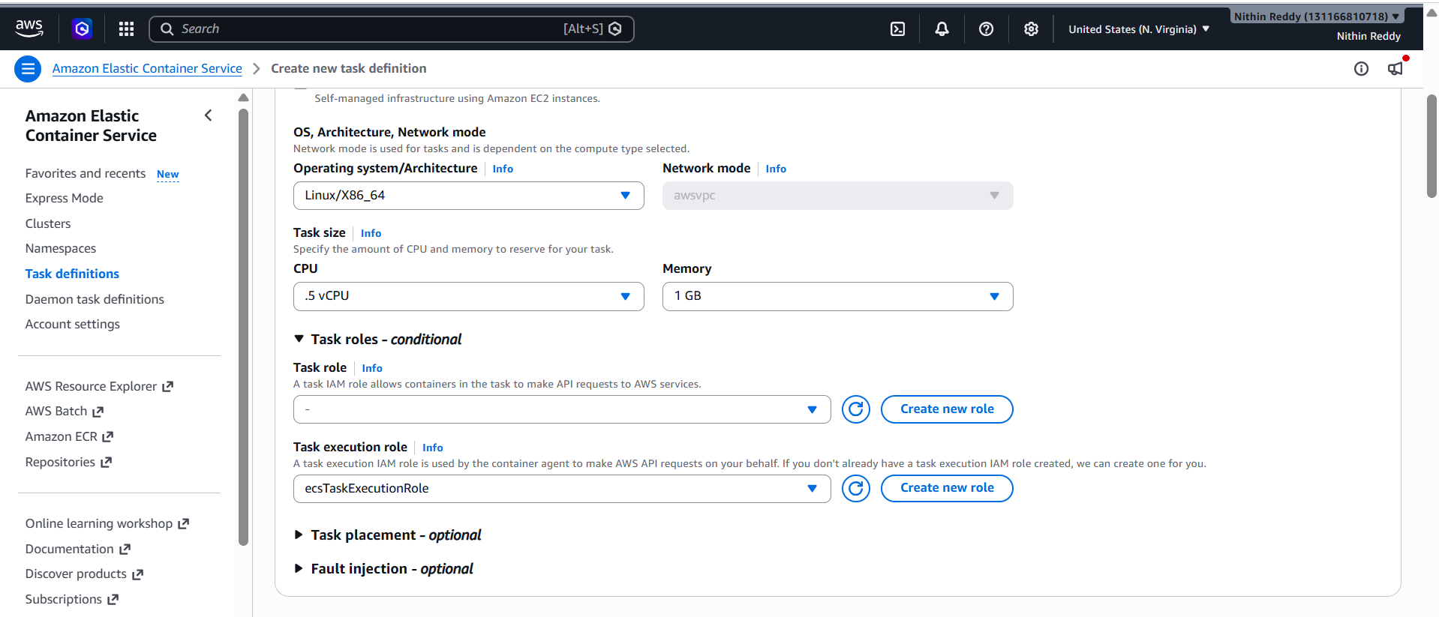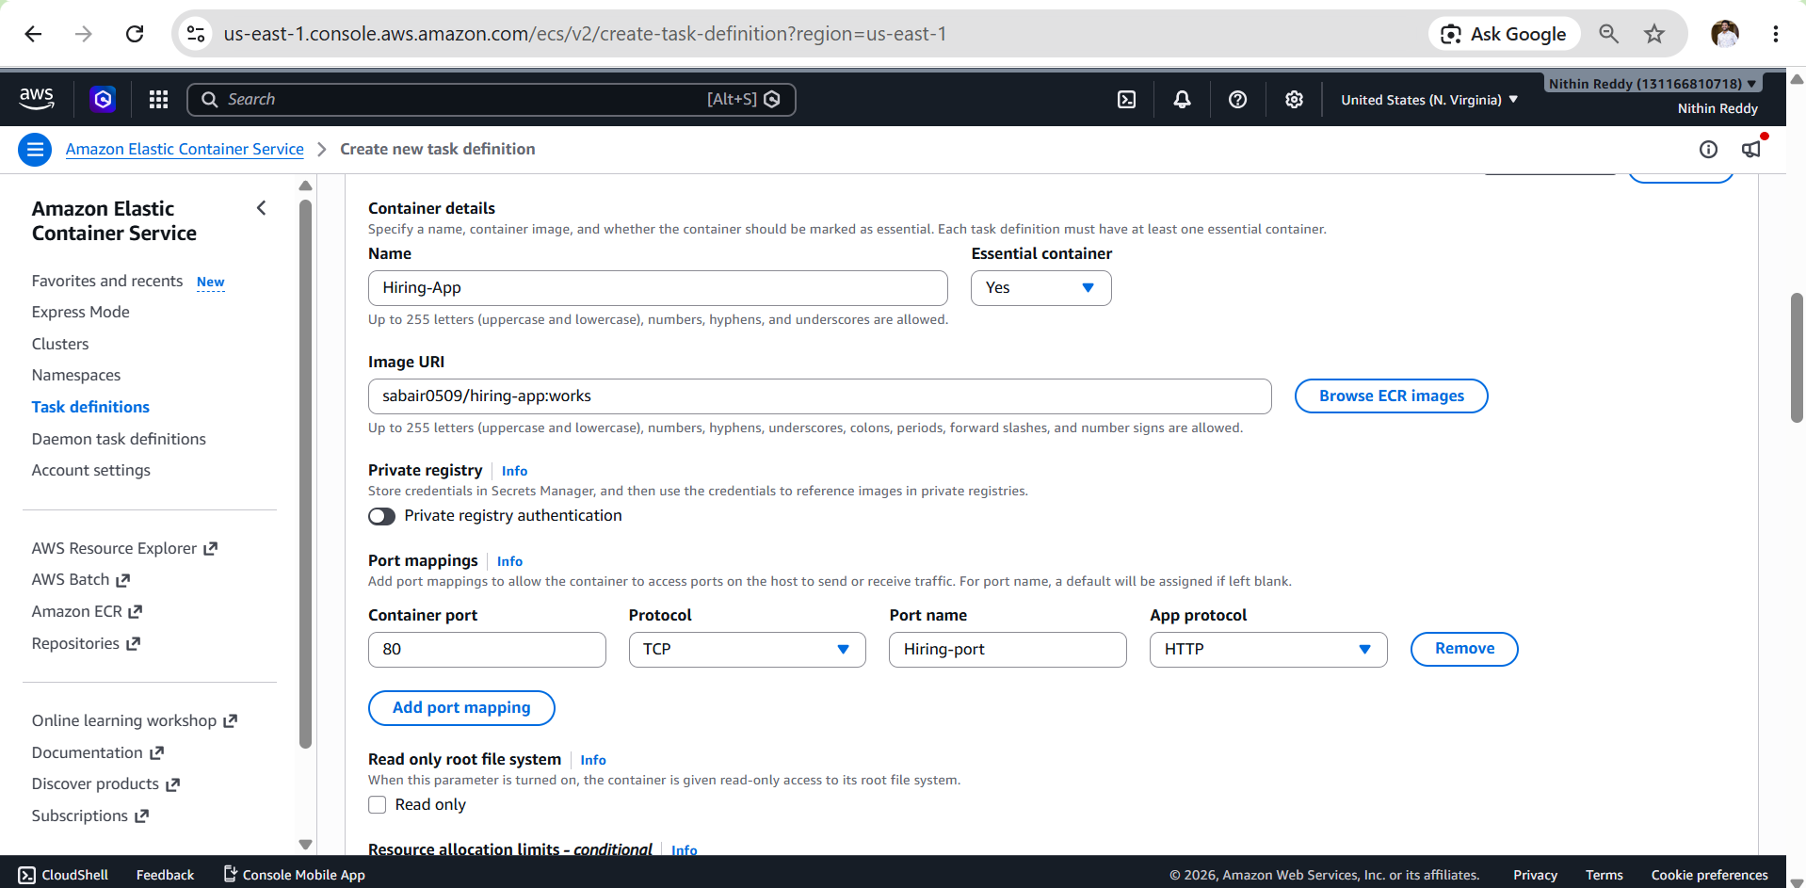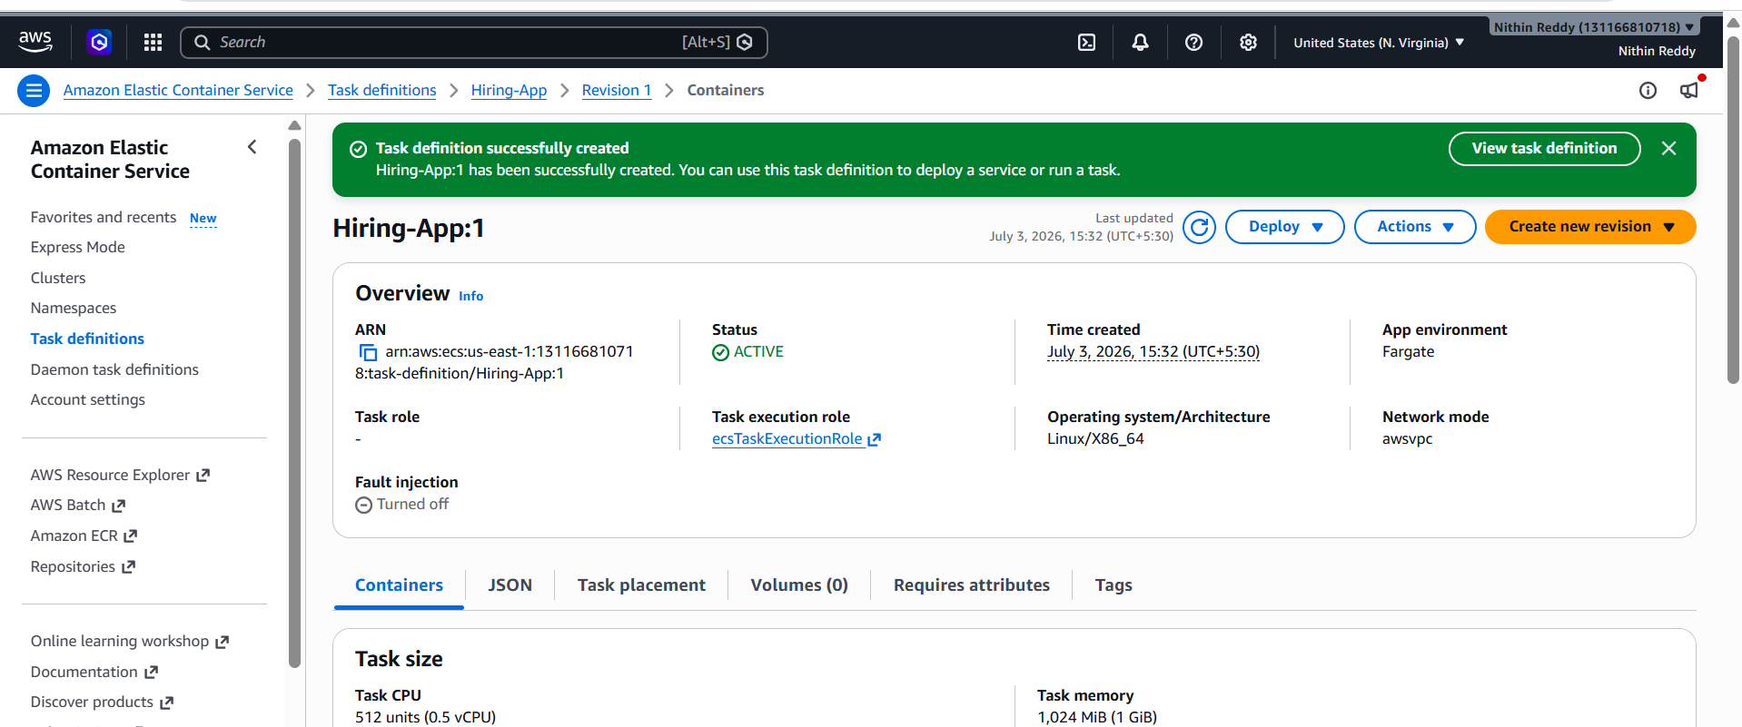
Step 3: Create Application Load Balancer
- Create an Internet-facing Application Load Balancer.
- Select at least two public subnets in different Availability Zones.
- Configure HTTP Listener (Port 80).
- Attach appropriate Security Group.

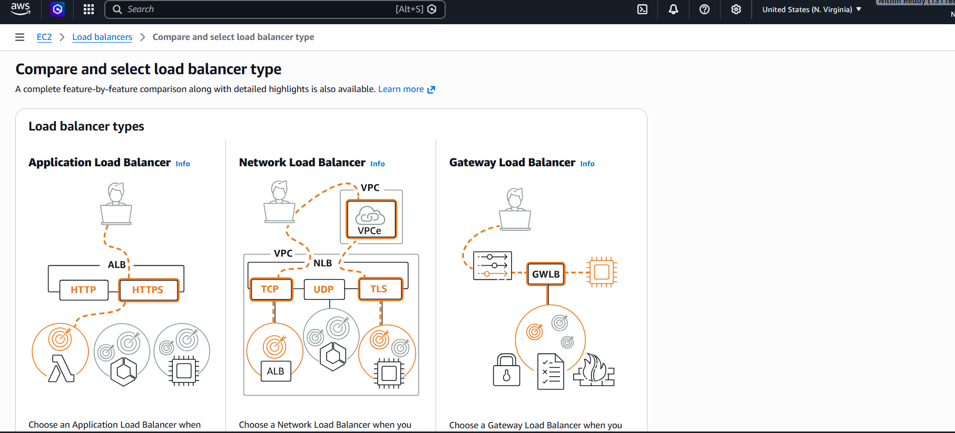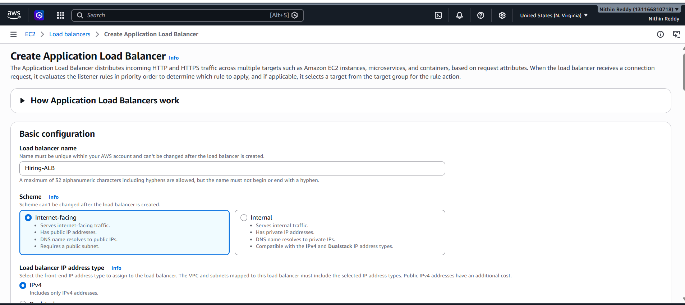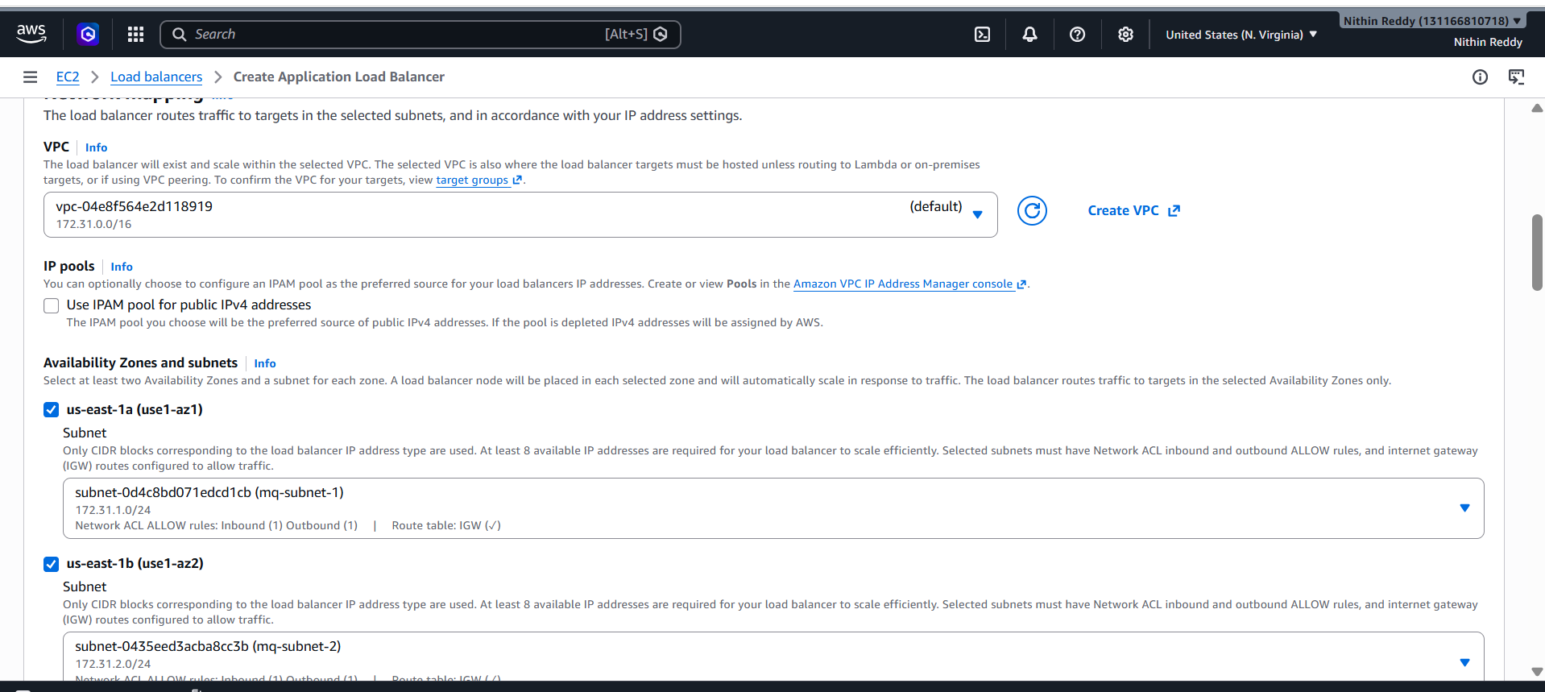

Step 4: Create Target Group
- Create a Target Group.
- Target Type:
  - IP (Fargate)
  - Instance (EC2)
- Protocol: HTTP
- Port: Application Port
- Health Check Path:
- Complete Target Group creation.
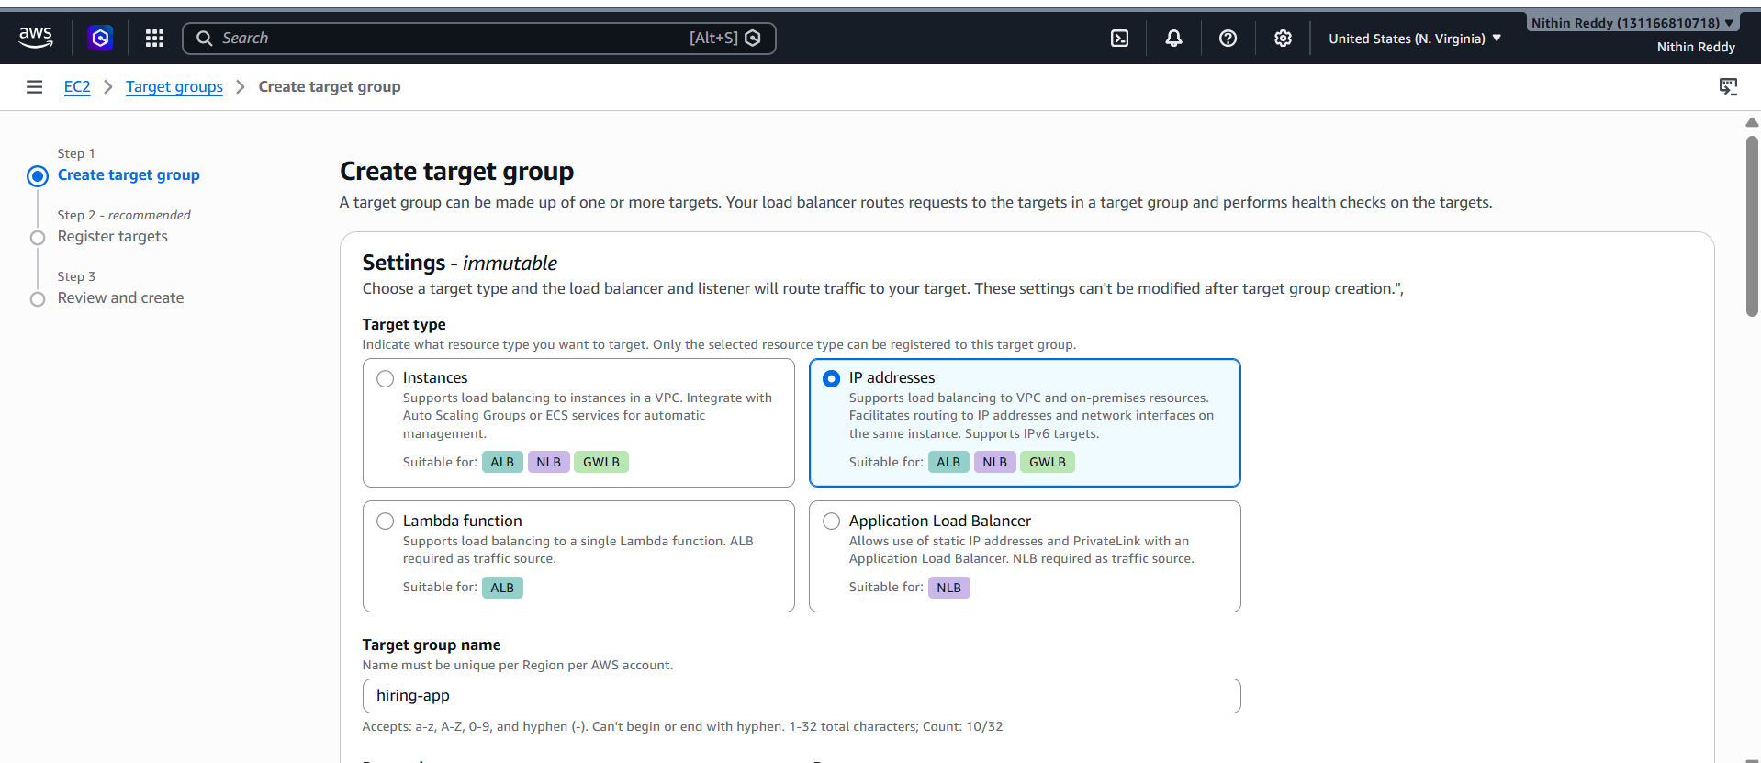
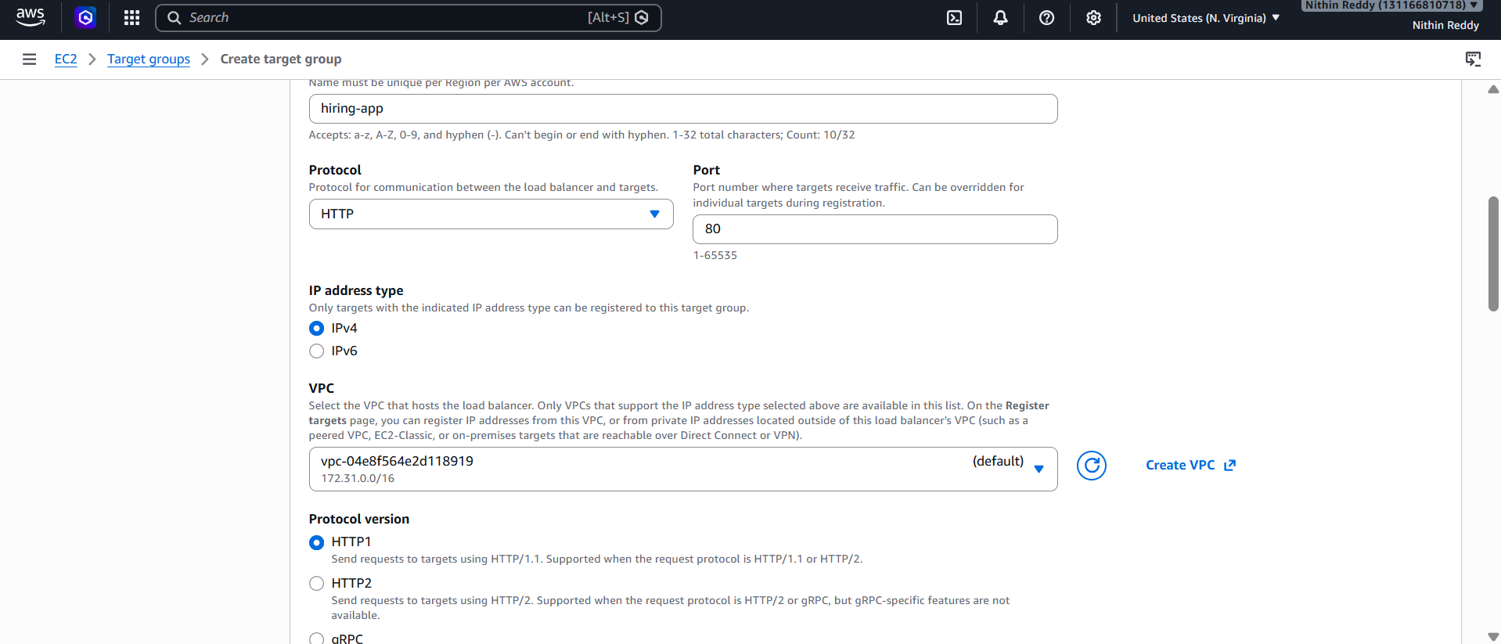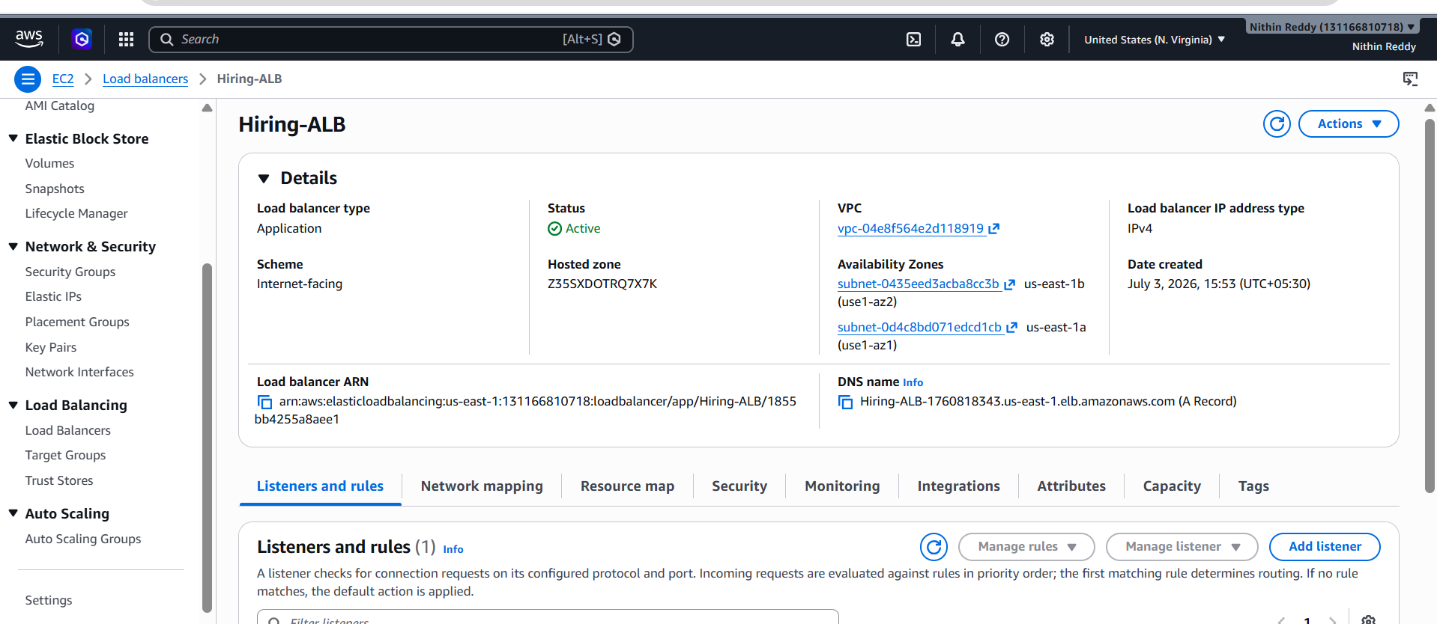

Step 5: Create ECS Service
- Open the created ECS Cluster.
- Create a new ECS Service.
- Select the Task Definition.
- Configure Desired Tasks: 06
- Attach the Application Load Balancer.
- Select the Target Group.
- Enable Dynamic Port Mapping.
- Choose subnets across multiple Availability Zones.
- Create the service.

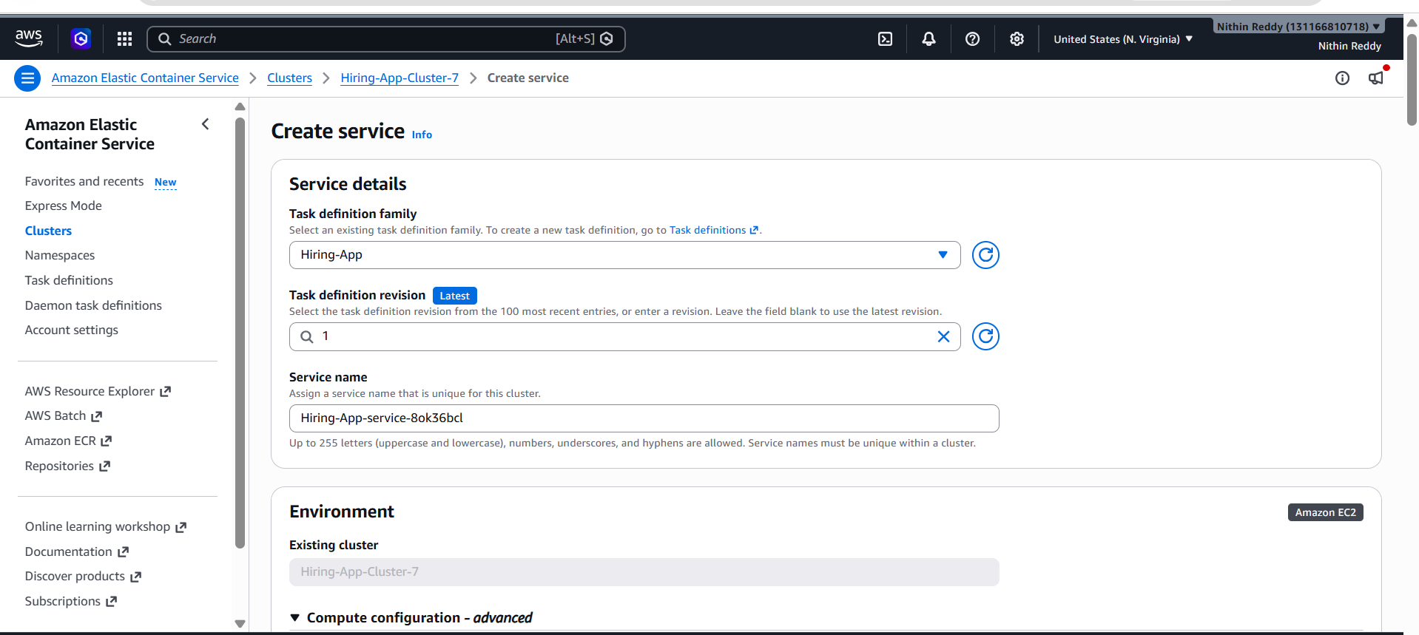

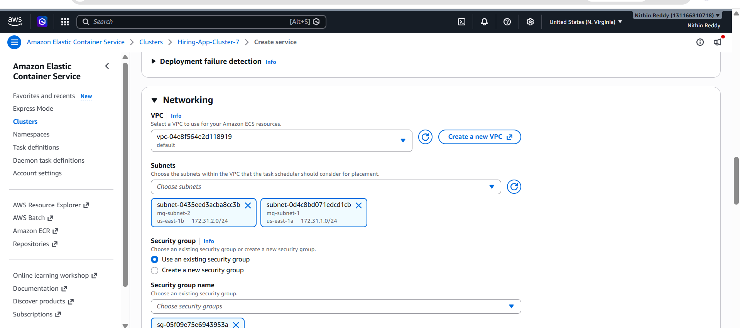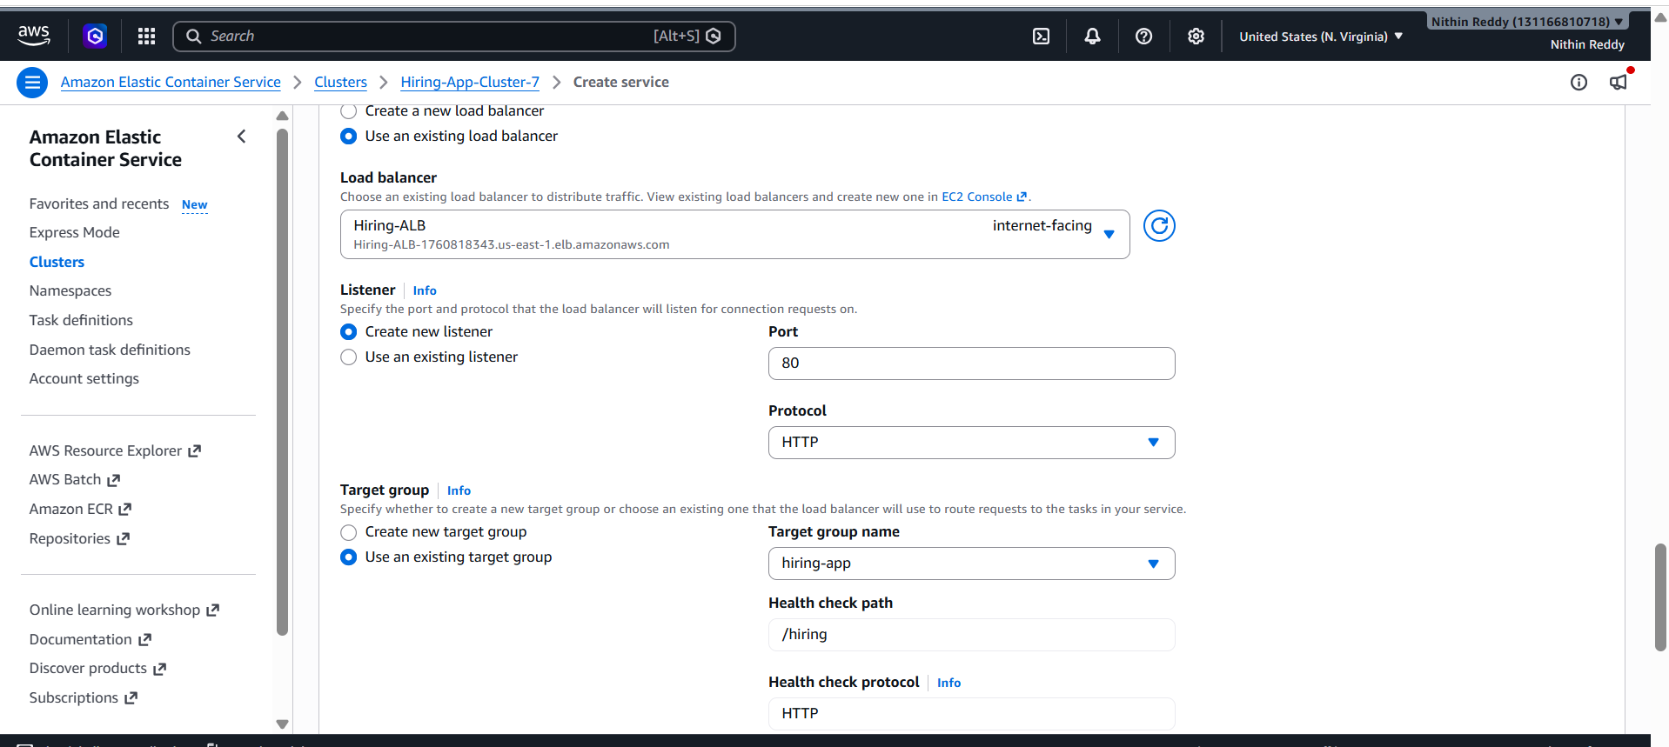
Step 6: Verify Deployment
- ECS launches 6 tasks.
- Tasks register automatically with Target Group.
- Load Balancer begins routing traffic.
- ECS maintains desired task count.

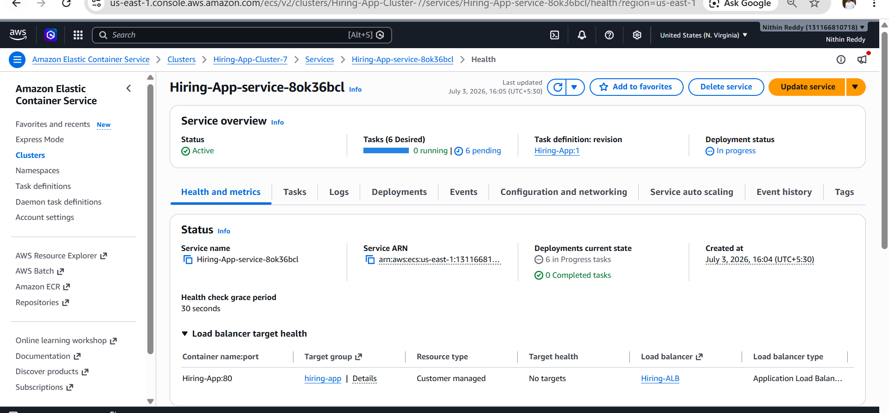
Validation
Validate the following:
- ECS Cluster status is Active.
- ECS Service status is Active.
- Desired Tasks = 6.
- Running Tasks = 6.
- Tasks are distributed across multiple Availability Zones.
- Target Group shows all registered targets.
- Health status becomes Healthy.
- Application is accessible using the ALB DNS Name.
- Dynamic Port Mapping is functioning correctly.
- Stopping a task automatically launches a replacement task.

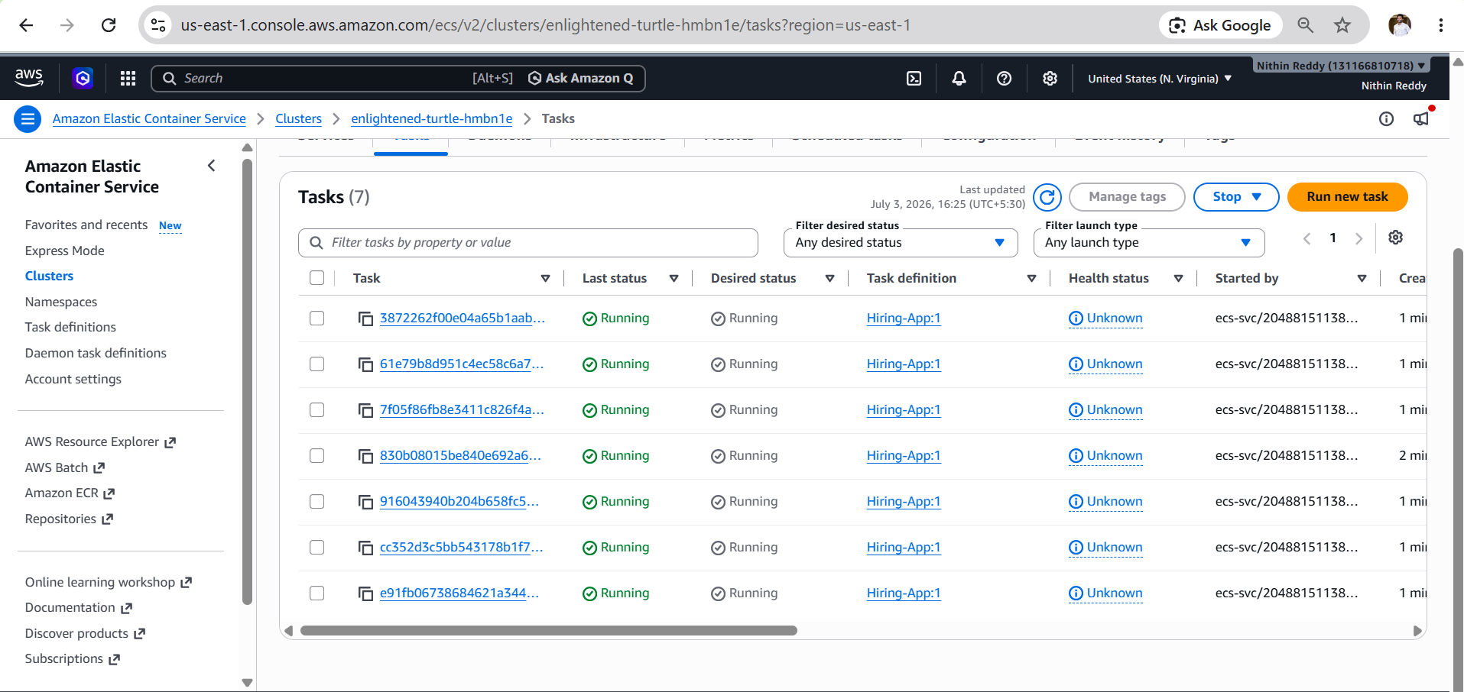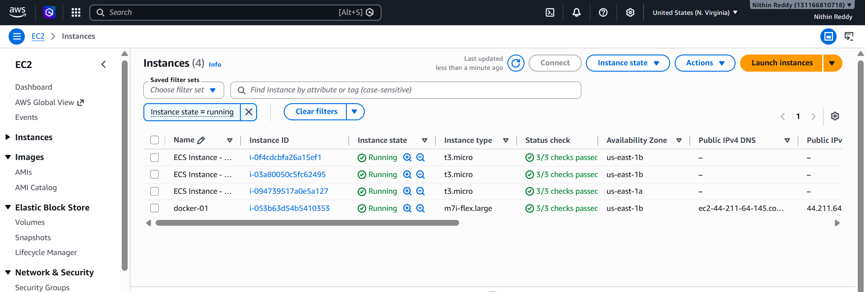
Expected Outcome
- Successfully created a Highly Available ECS Cluster.
- Deployed containerized application using Amazon ECS.
- Configured Application Load Balancer.
- Enabled Dynamic Port Mapping.
- Application distributed across multiple Availability Zones.
- ECS maintained six running tasks automatically.
- Load Balancer routed traffic only to healthy tasks.
- High Availability and automatic recovery were successfully verified.

Technical Errors Encountered (Points)
- ECS tasks remained in Pending/Provisioning state.
- 0 registered ECS container instances were available in the cluster.
- EC2 instances were created but did not initially register with the ECS cluster.
- ECS service was unable to place tasks due to unavailable container instances.
- Target Group initially showed 6 unhealthy targets.
- ALB health checks failed until the application became available.
- Container instances took time to join the ECS cluster after Auto Scaling launched them.
- ECS service deployment remained In Progress while tasks were being provisioned.
- Running task count did not match the desired task count during initial deployment.
- Target Group health status changed from Unhealthy → Initial → Healthy after successful application startup.
- Security Group and Target Group configurations were verified to ensure ALB could reach the ECS tasks.
- Verified that the Task Definition container port matched the Target Group health check port.
- Confirmed that the Application Load Balancer listener was correctly forwarding traffic to the Target Group.
- Waited for ECS service stabilization before validating the deployment.
- Verified successful access to the application using the ALB DNS endpoint after all targets became healthy.

