Terraform-03
Task 1: Execute the script shown in the video.
Step 1: Create Project Folder
Open VS Code → Create folder:
Terraform_basic
Inside it create:
main.tf
variables.tf

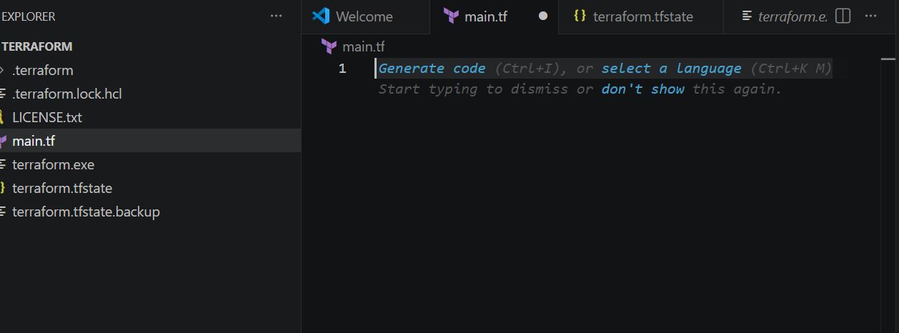
Step 2: Write main.tf
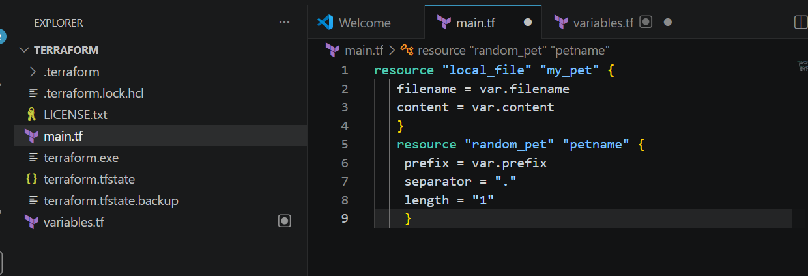
Step 3: write variable.tf
only variable deceleration
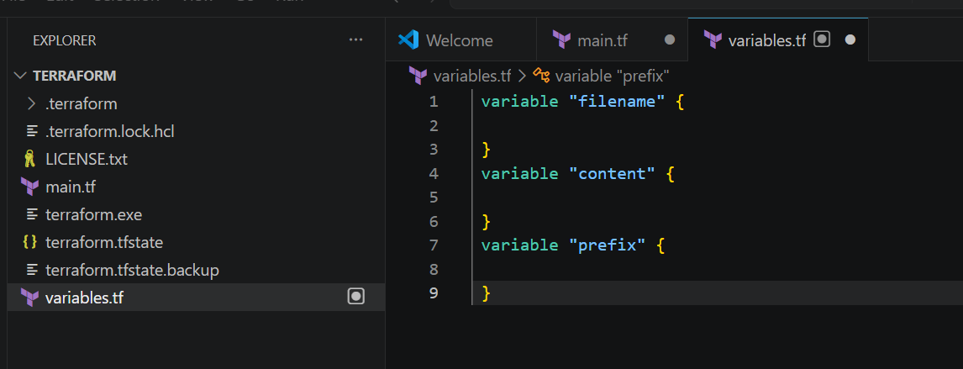
Step 4: Initialize Terraform
Open terminal inside VS Code:
terraform init
You will see:
Terraform has been successfully initialized!
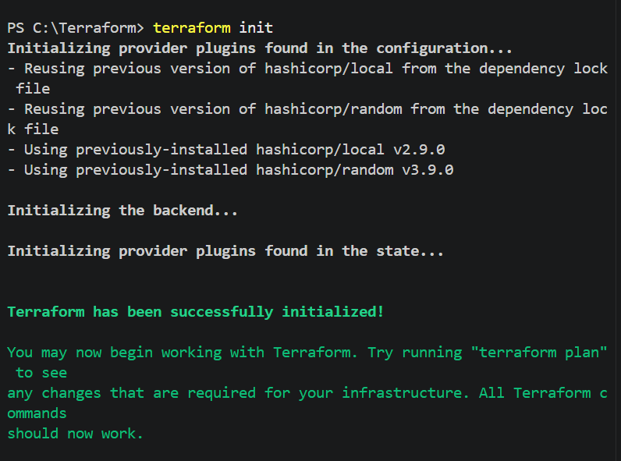

Step 5: Pass Values Using Environment Variables
Run:
Set-Item -Path env:TF_VAR_filename -Value 'wild.txt'
Set-Item -Path env:TF_VAR_content -Value 'I Love Dogs'
Set-Item -Path env:TF_VAR_prefix -Value 'MISS'

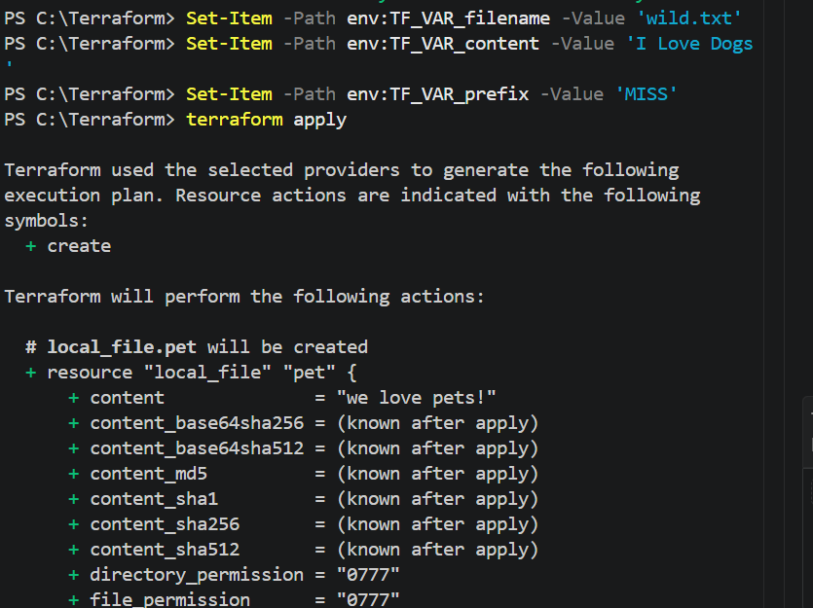
Now execute:
terraform apply
Type: YES
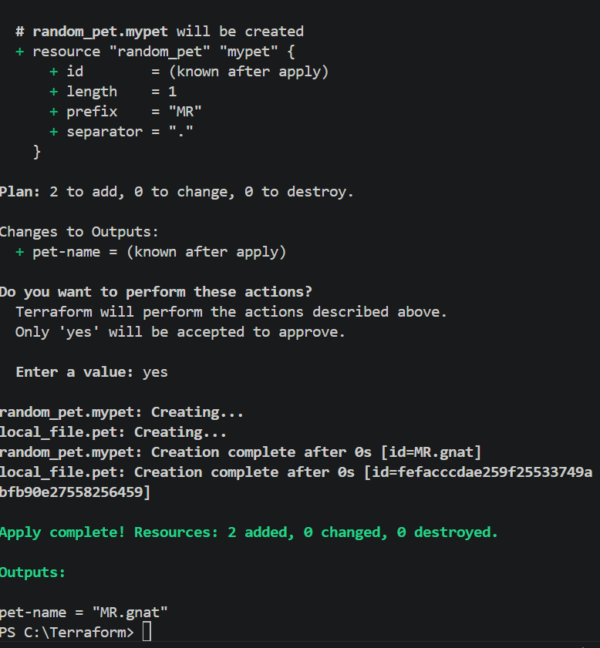
Step 6: Variable Default Values Method
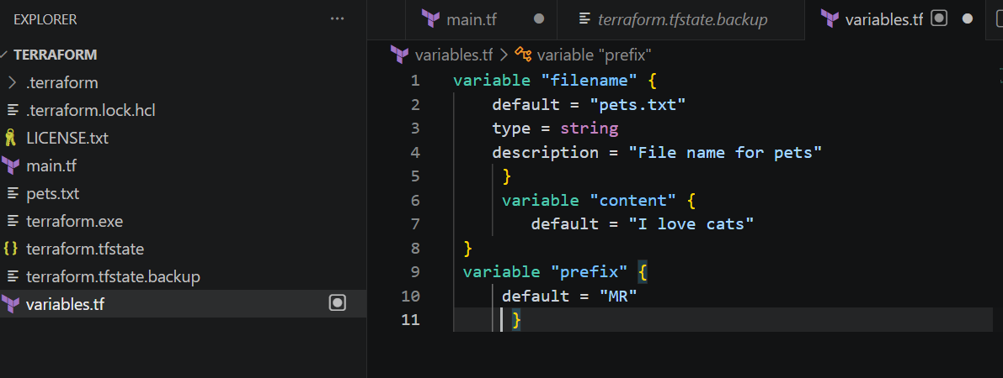

Terraform apply now
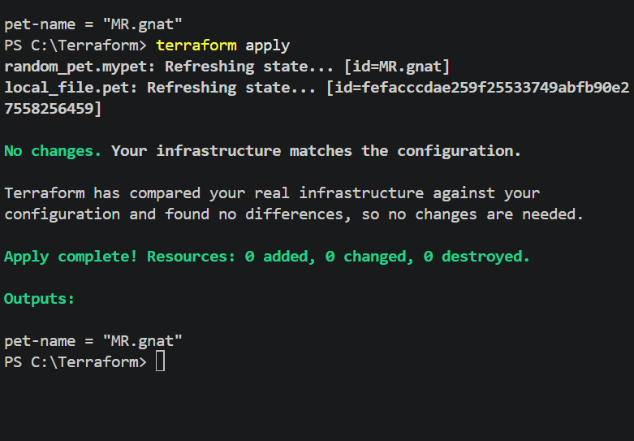
Step 7: Dynamic Random Pet Name Example
Replace main.tf with:
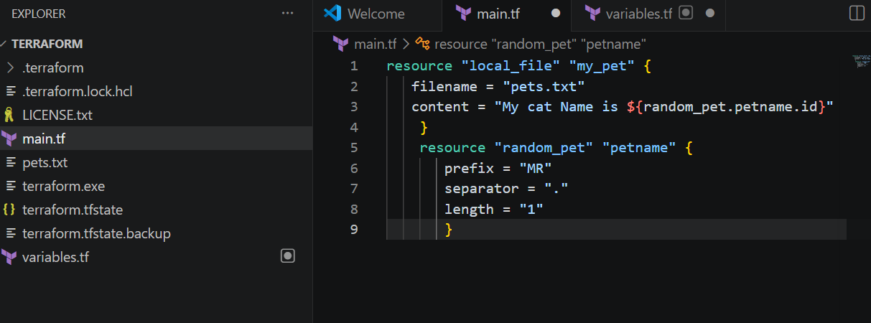
Now : Terraform apply
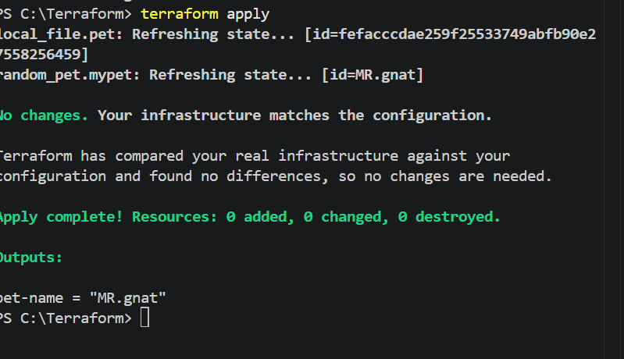
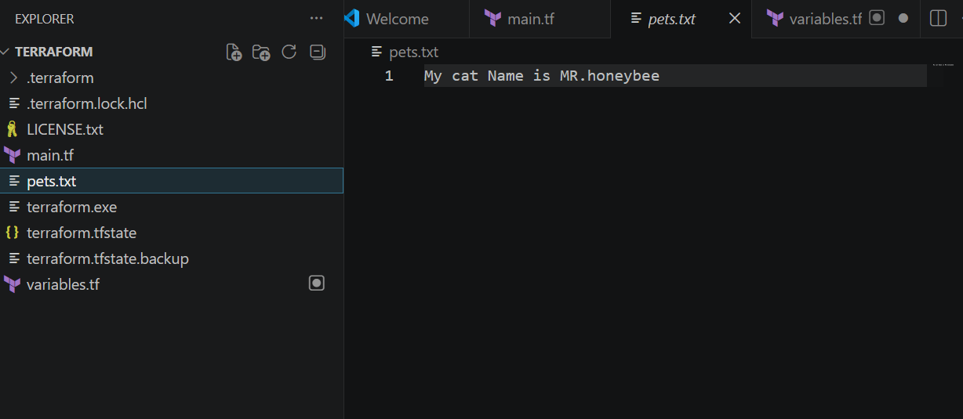
Step 8: Destroy Infrastructure
terraform destroy
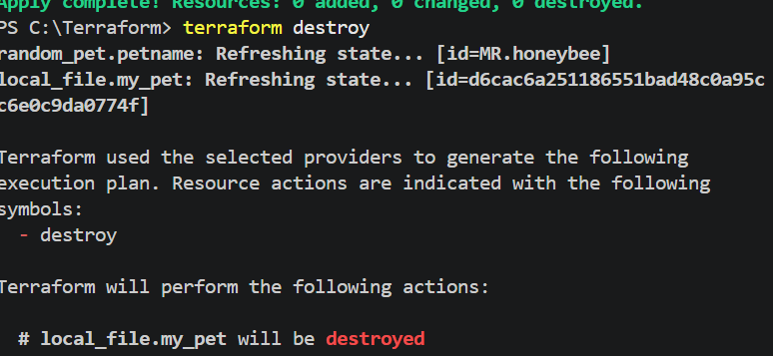
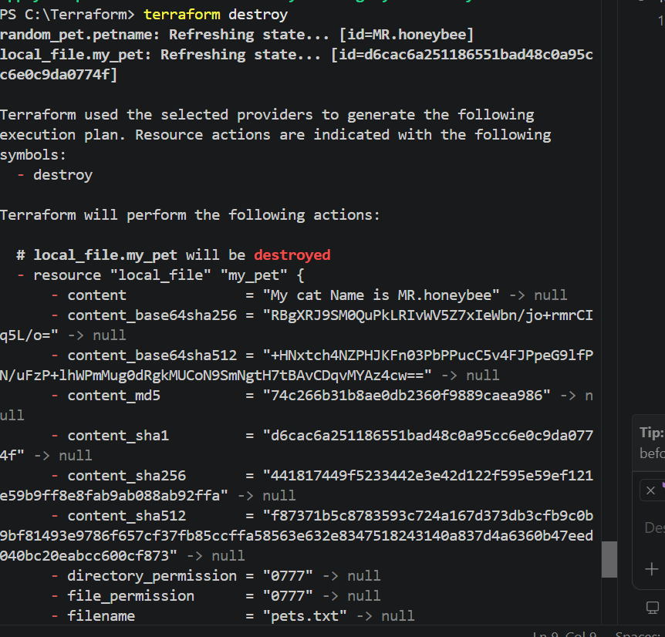
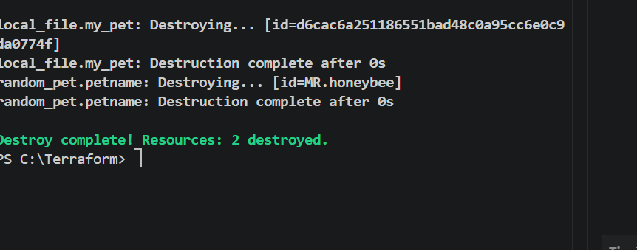

Task 2: Integrate Terraform in Jenkins using the Terraform Plugin
Objective
The objective of this task is to integrate Terraform with Jenkins using the Terraform Plugin. This integration allows Jenkins to execute Terraform commands (init, plan, apply, and destroy) through a CI/CD pipeline, enabling automated infrastructure provisioning and management using Infrastructure as Code (IaC).
What is the Terraform Plugin?
The Terraform Plugin is a Jenkins plugin that integrates Terraform with Jenkins. It allows Jenkins jobs and pipelines to use Terraform installations configured in Jenkins without manually specifying the Terraform executable path.
Benefits
- Integrates Terraform with Jenkins
- Supports multiple Terraform versions
- Simplifies pipeline configuration
- Uses centrally managed Terraform installations
- Automates Infrastructure as Code deployments
Prerequisites
Before starting, ensure the following requirements are met:
System Requirements
- Ubuntu/Linux Jenkins Server
- Jenkins installed and running
- Java installed
- Git installed
- Terraform installed
- Internet connection
Jenkins Requirements
- Administrator access
- Pipeline Plugin
- Git Plugin
- Terraform Plugin
- Credentials Plugin
Cloud Requirements
- AWS Account (if deploying AWS resources)
- AWS CLI configured (optional)
- IAM User with required permissions
Implementation Steps
Step 1: Verify Jenkins is Running
Open Jenkins in your browser.
http://<Jenkins-IP>:8080
Login using administrator credentials.
Step 2: Install Terraform Plugin
Navigate to
Manage Jenkins
↓
Plugins
↓
Available Plugins
Search
Terraform
Select
Terraform
Click
Install without restart
Wait until installation completes.
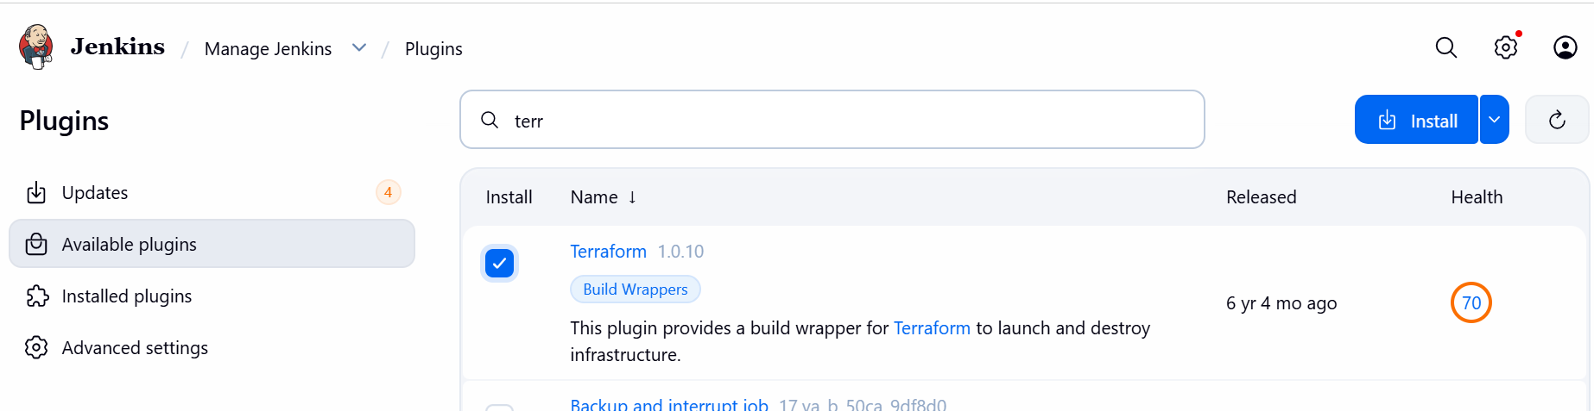
Step 3: Verify Plugin Installation
Go to
Manage Jenkins
↓
Plugins
↓
Installed Plugins
Verify that
Terraform Plugin
appears in the installed plugin list.
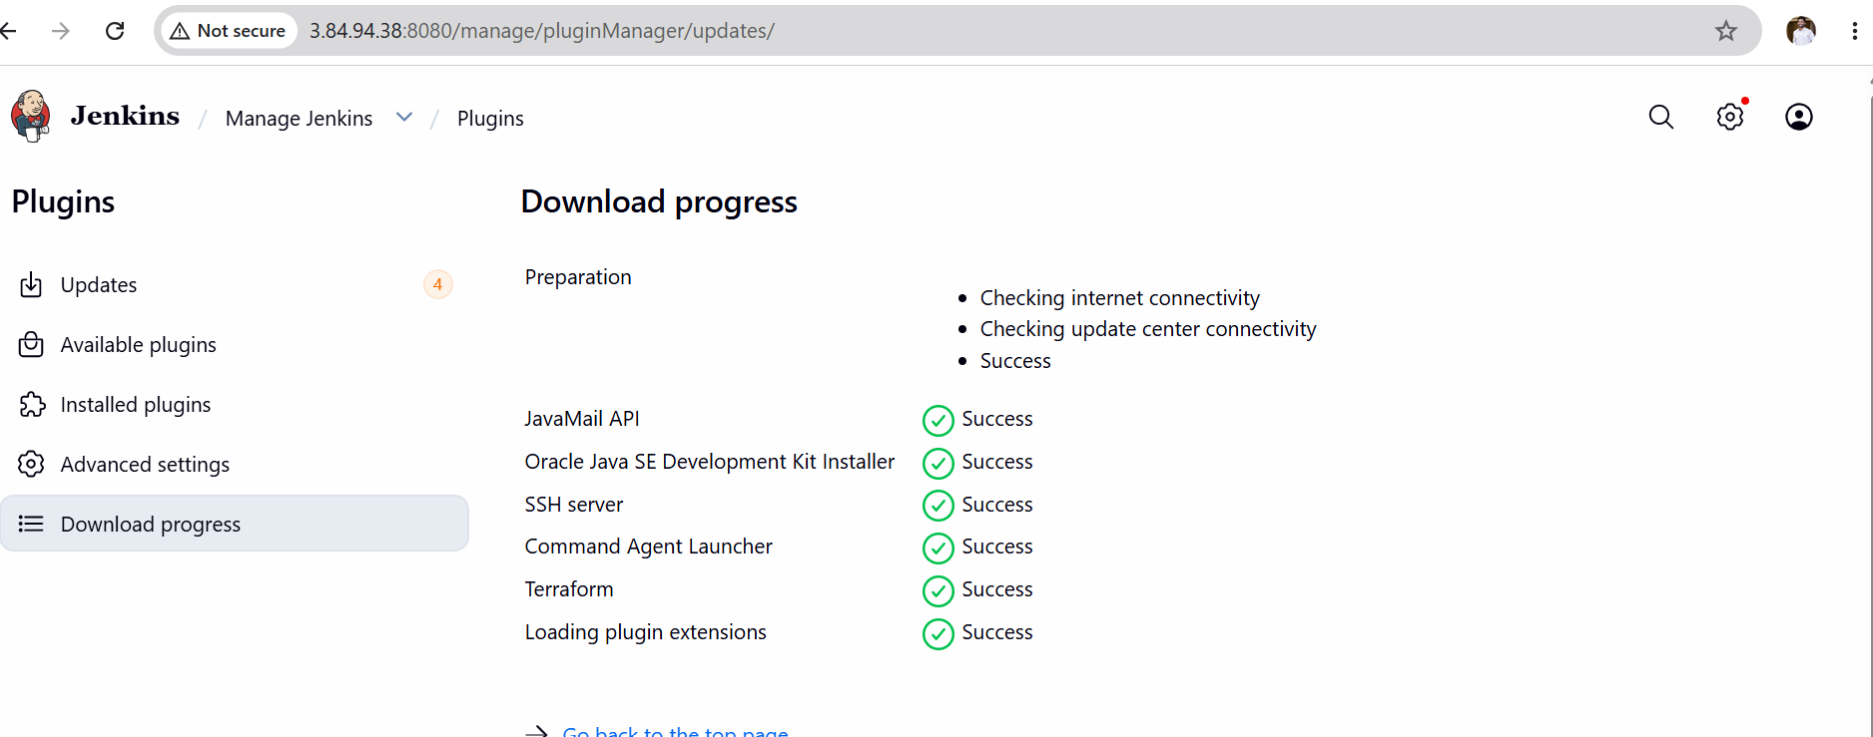
Step 4: Configure Terraform Installation
Navigate to
Manage Jenkins
↓
Tools
(or Global Tool Configuration, depending on the Jenkins version)
Scroll down to
Terraform Installations
Click
Add Terraform
Configure:
Name
Terraform-1.15.7
Uncheck
Install automatically
Enter the installation directory.
Example
/usr/local/bin/terraform
or
/usr/bin/terraform
(Use the output of which terraform on your Jenkins server.)
Click
Save
Step 5: Verify Terraform Path
Run on Jenkins server
which terraform
Example output
/usr/local/bin/terraform
Also verify
terraform version
Expected output
Terraform v1.15.7
Step 6: Create Pipeline Job
Dashboard
↓
New Item
Project Name
Terraform-Plugin-Demo
Select
Pipeline
Click
OK
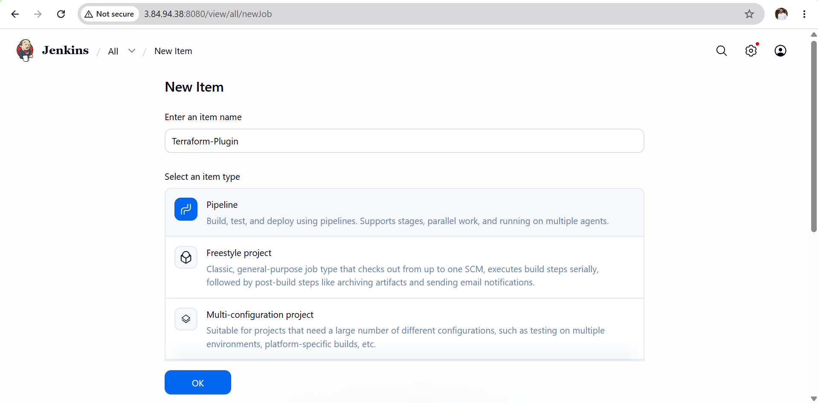
Declarative script
pipeline {
agent any

stages {

stage('Terraform Version') {
steps {
sh 'terraform version'
}
}

stage('Terraform Init') {
steps {
sh 'terraform init'
}
}

stage('Terraform Validate') {
steps {
sh 'terraform validate'
}
}
}
}
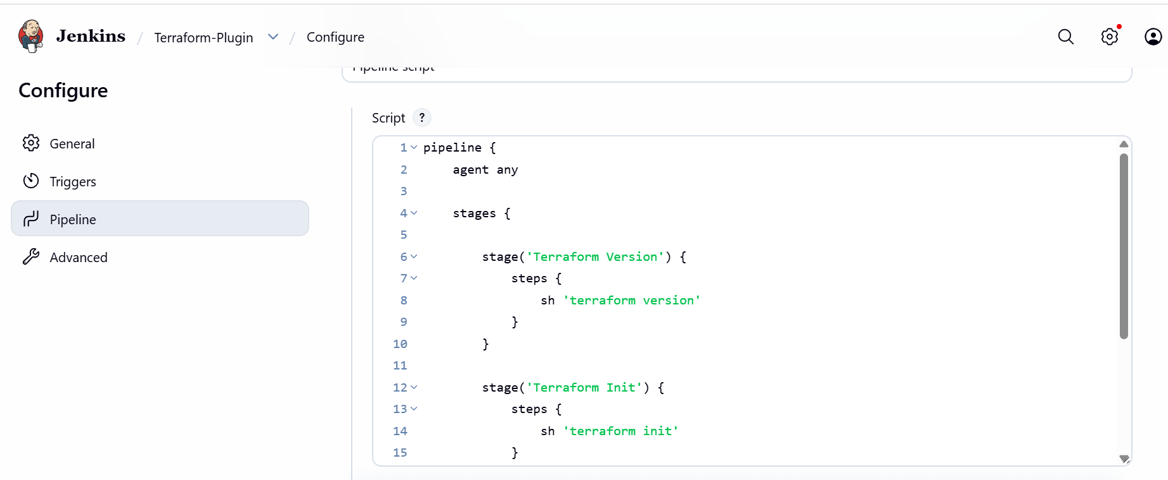
Step 8: Save Pipeline
Click
Save

Step 9: Build Pipeline
Click
Build Now
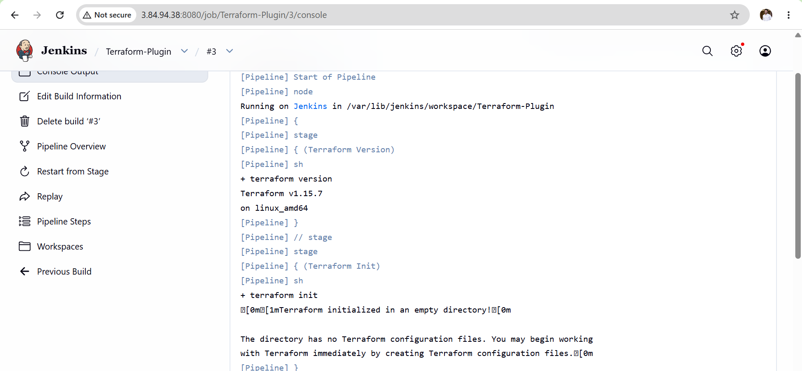
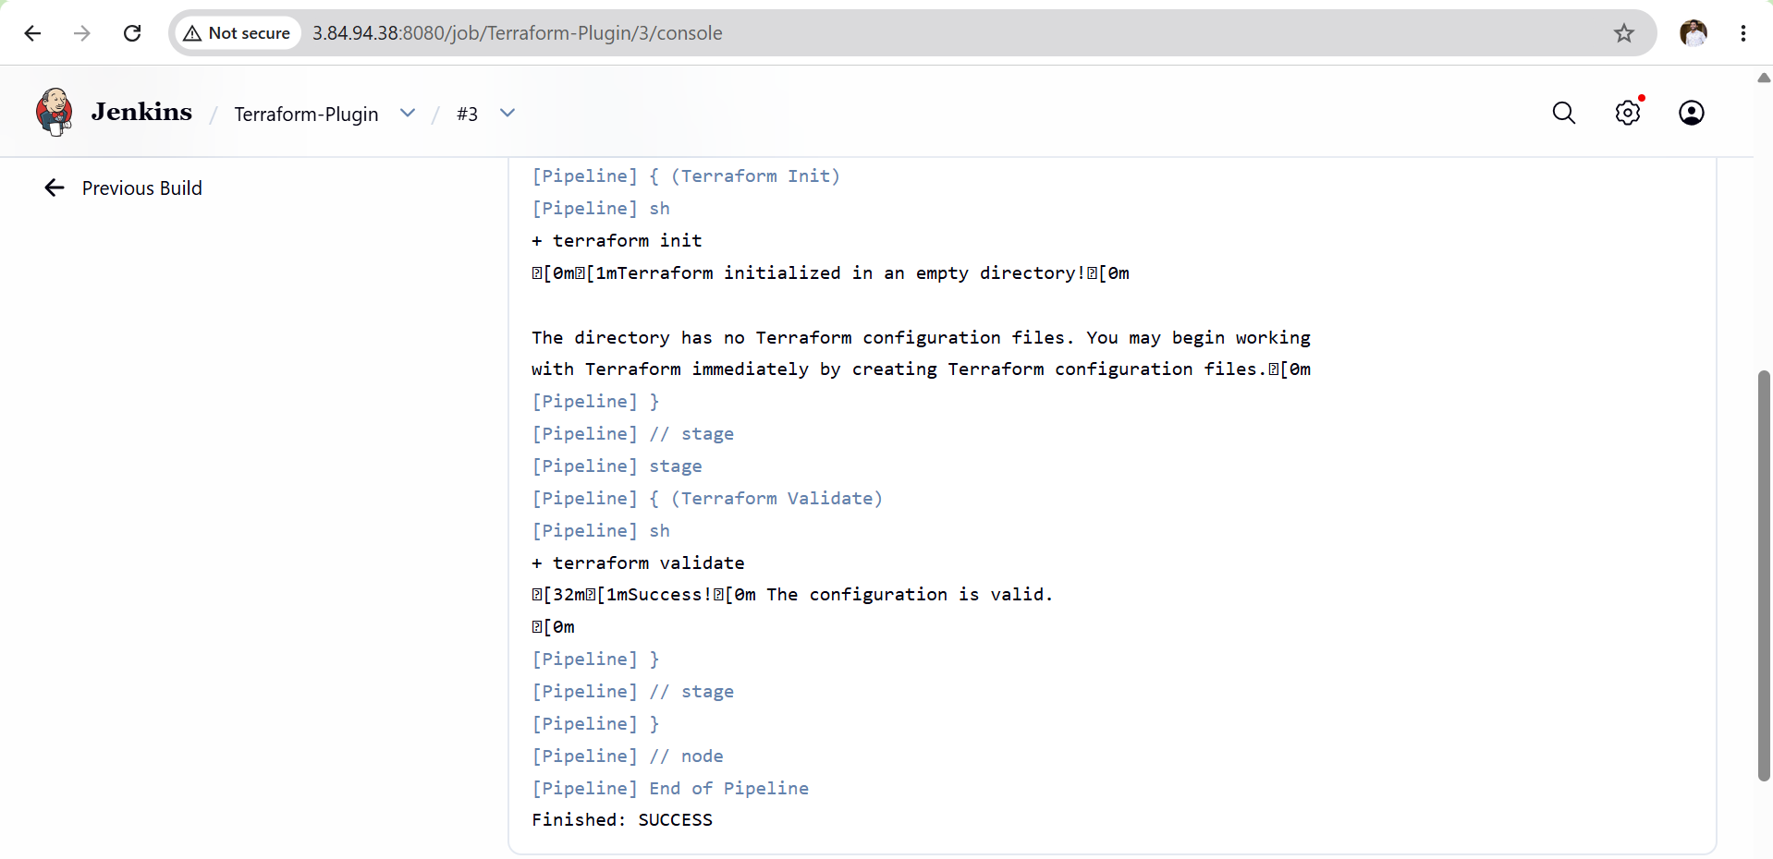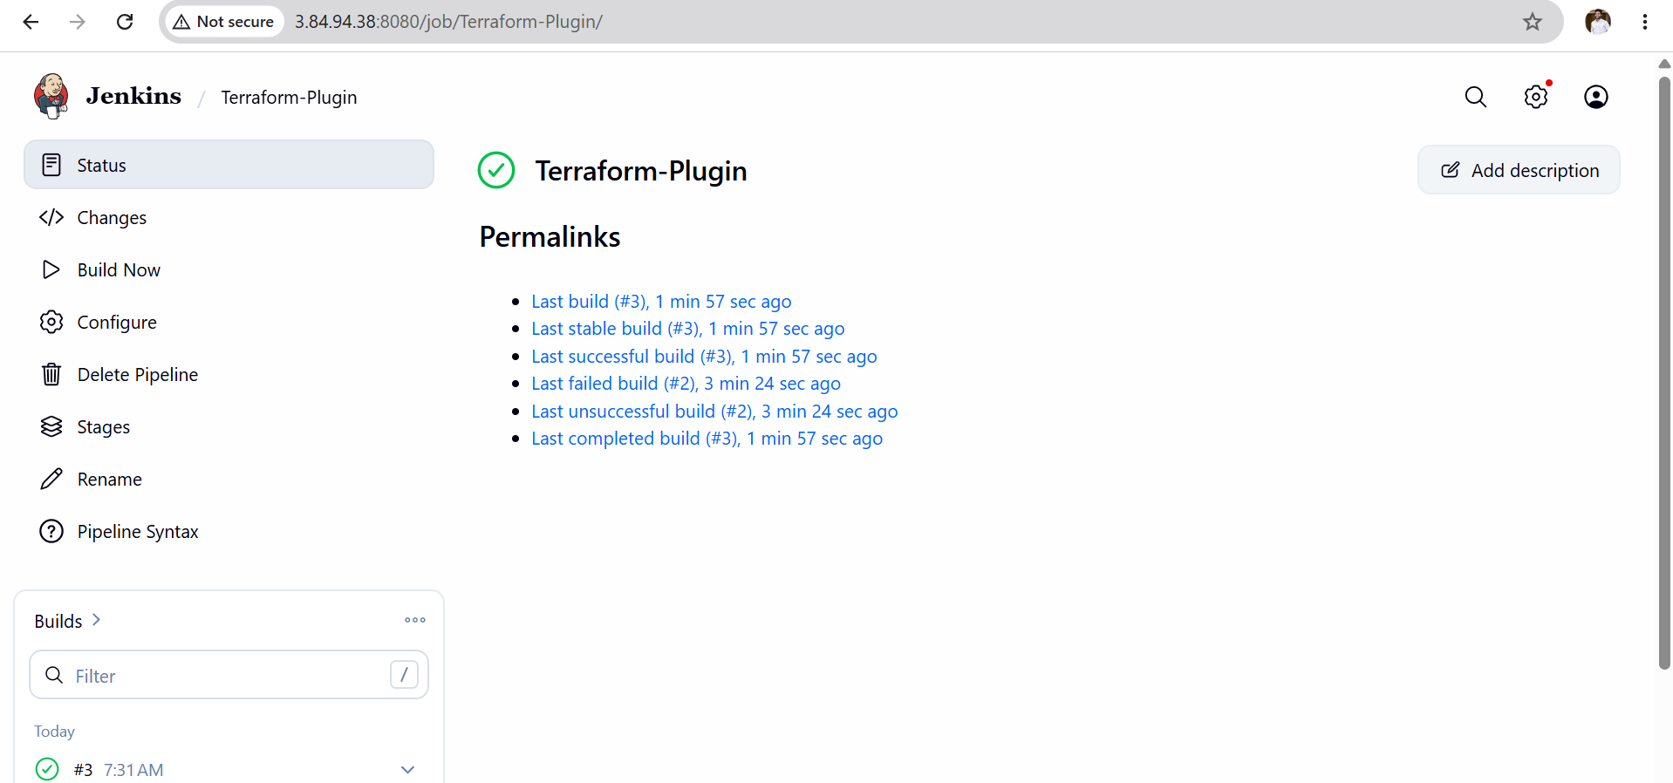
Validation Checklist
- Jenkins server is running.
- Terraform Plugin is installed.
- Terraform installation is configured in Jenkins.
- Terraform version is detected successfully.
- Pipeline executes without errors.
- Console output displays Terraform commands.
- Build completes with SUCCESS status.

Outcome
After completing this task:
- Terraform Plugin is successfully installed in Jenkins.
- Terraform is configured as a global tool.
- Jenkins can access the configured Terraform installation.
- A pipeline can execute Terraform commands without specifying the executable path manually.
- Infrastructure automation through Jenkins and Terraform is ready for future deployments.

Task 3: Create a Jenkins Maven Project with Git Clone and Maven Compilation
Source Code:
https://github.com/betawins/java-Working-app.git

Objective
The objective of this task is to create a Jenkins Maven Project that automatically clones a Java application from a GitHub repository and performs Maven compilation. This task demonstrates Continuous Integration (CI) by integrating GitHub with Jenkins and automating the build process using Maven.
Prerequisites
Before starting this task, ensure the following requirements are met:
- Jenkins is installed and running.
- Java (JDK 21) is installed.
- Maven is installed and configured in Jenkins.
- Git is installed on the Jenkins server.
- Internet connection is available.
- GitHub repository is accessible.
- Jenkins administrator access is available.
Implementation Steps
Step 1: Verify Jenkins Service
- Log in to the Jenkins dashboard.
- Ensure the Jenkins service is running successfully.
Example:
http://<Jenkins-IP>:8080

Step 2: Configure Global Tools
Navigate to:
Manage Jenkins
↓
Tools (Global Tool Configuration)
Configure:
- Git Installation
- JDK Installation
- Maven Installation
Save the configuration.
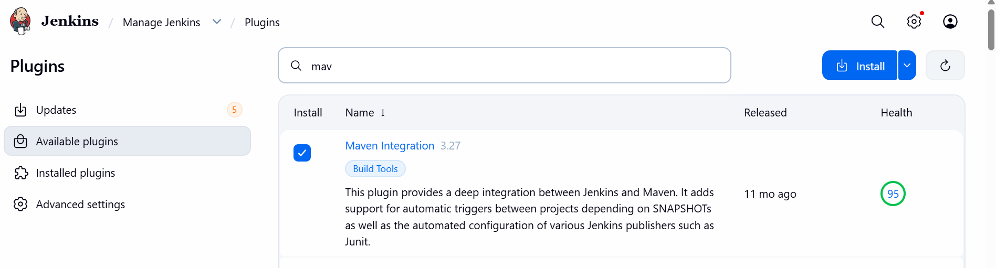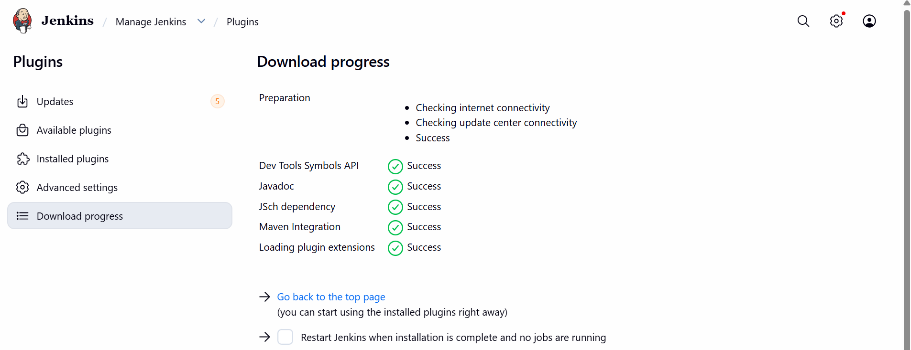
Step 3: Create a New Maven Project
- Click New Item.
- Enter the project name.
Example:
Java-Maven-Build
- Select Maven Project.
- Click OK.
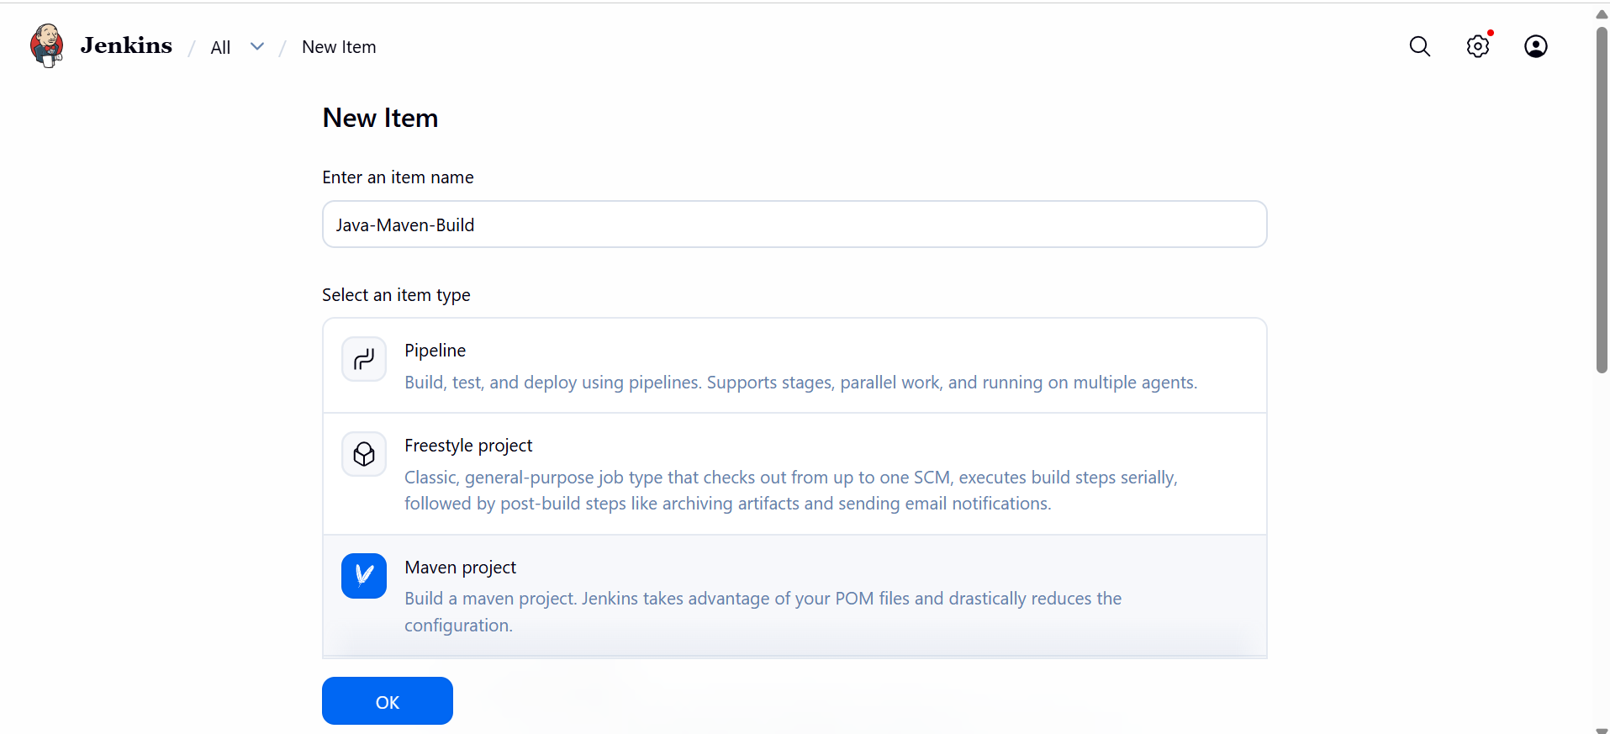
Step 4: Configure Source Code Management
Under Source Code Management:
- Select Git.
- Repository URL:
https://github.com/betawins/java-Working-app.git

- Branch:
*/main
(If main does not exist, use */master.)
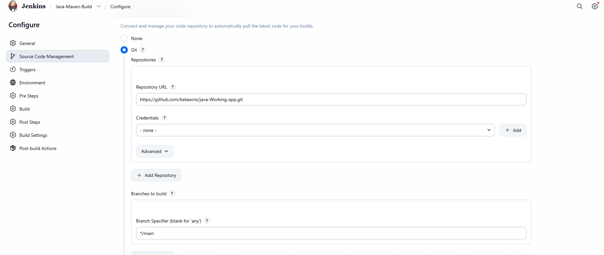
Step 5: Configure Build Triggers (Optional)
Choose one of the following:
- Build Now (Manual)
- Poll SCM
- GitHub Webhook
For this task, manual build is sufficient.

Step 6: Configure Build Environment
Leave the default settings unless specific options are required.

Step 7: Configure Build
Under Build:
Select
Invoke top-level Maven targets
Choose Maven version:
Maven3
Goals:
clean compile

Step 8: Save the Job
Click
Save
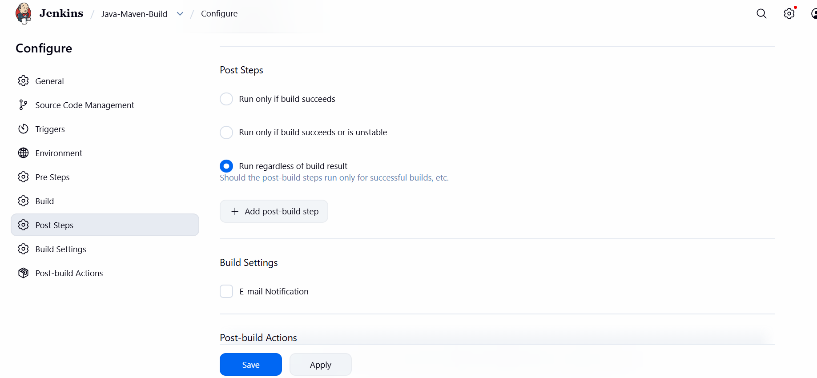
Step 9: Build the Project
Click
Build Now
Wait for the build to complete.

Step 10: Verify Console Output
Open
Console Output

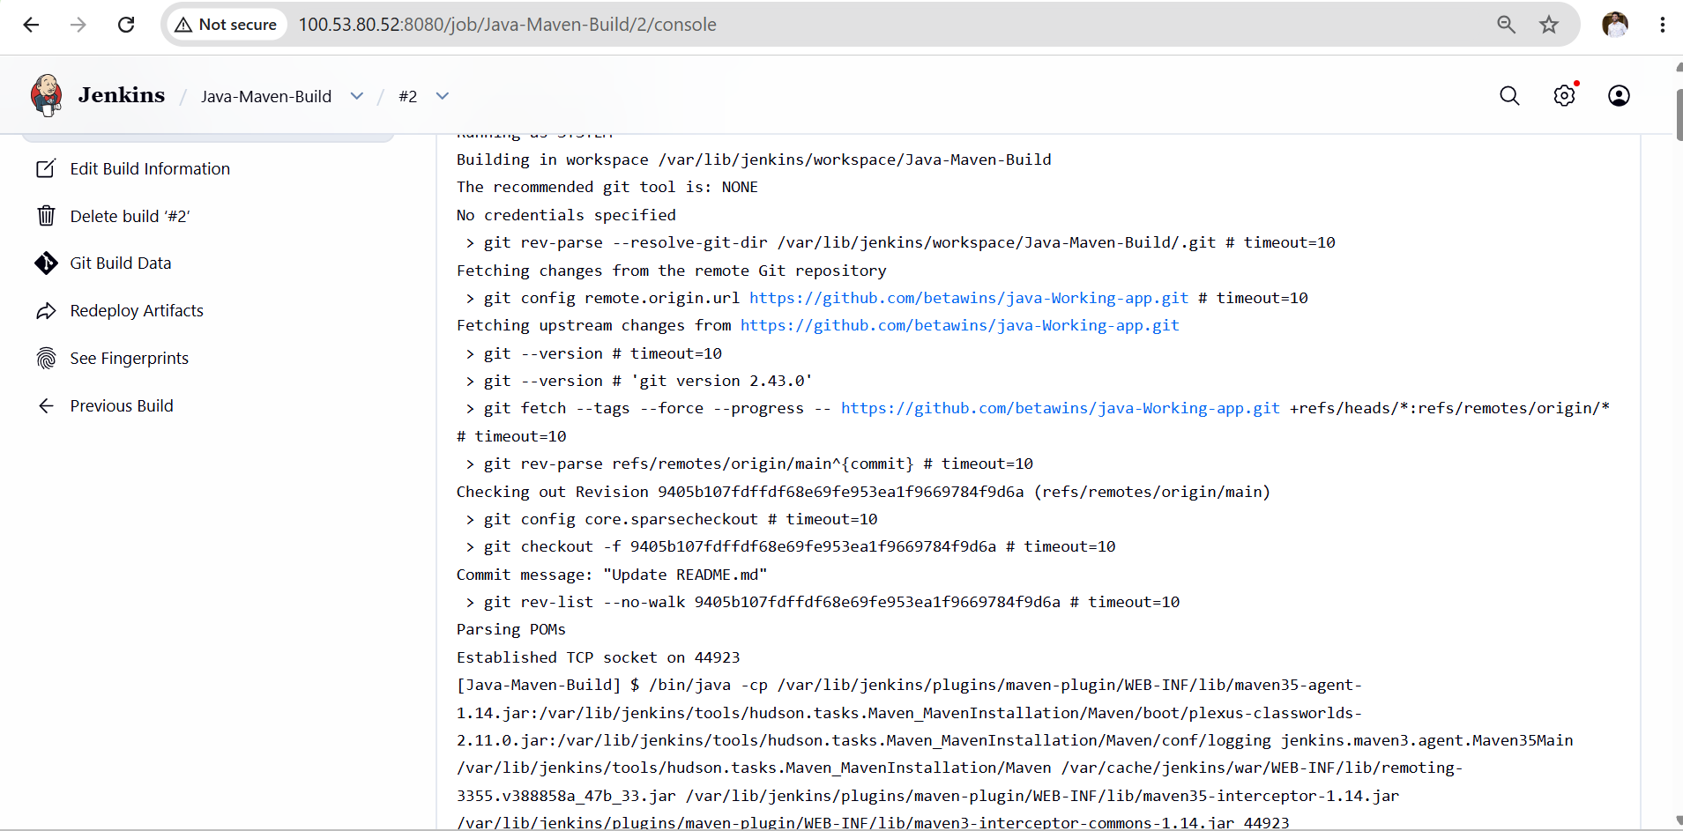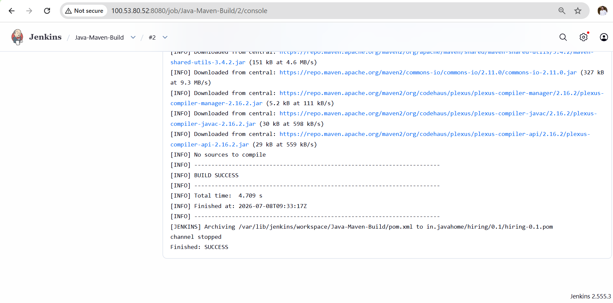

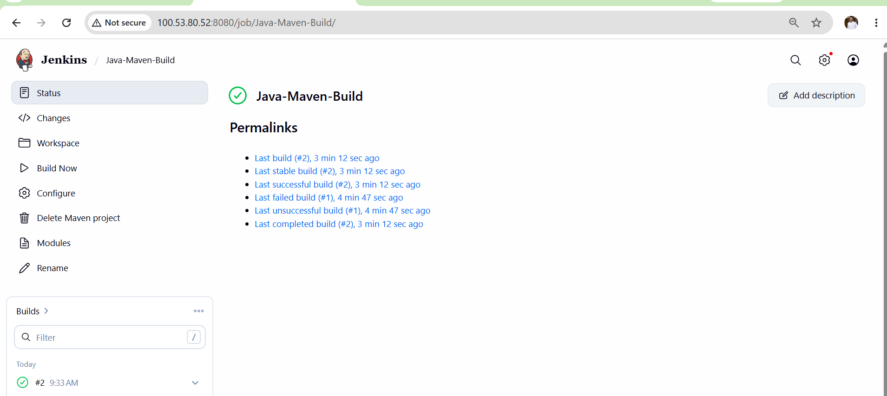
Validation
Verify the following:
- Jenkins job is created successfully.
- Git repository is cloned successfully.
- Maven downloads project dependencies.
- Java source files are compiled.
- Console output shows BUILD SUCCESS.
- Build status is SUCCESS (green).
Expected Outcome
After completing this task:
- Jenkins successfully connects to the GitHub repository.
- Source code is cloned automatically.
- Maven compiles the Java project successfully.
- The build completes without errors.
- Continuous Integration (CI) is achieved using Jenkins, Git, and Maven.

Task 4: Create a Parameterized Jenkins Job
Repository:
https://github.com/betawins/java-Working-app.git

Objective
The objective of this task is to create a Parameterized Jenkins Job that allows users to provide input parameters before starting the build. The job will clone the source code from GitHub and compile the Java application using Maven. Parameterized jobs improve flexibility by allowing different branches, environments, or build options to be selected without modifying the job configuration.
What is a Parameterized Job?
A parameterized job is a Jenkins job that prompts the user for input values before execution. These values are available as environment variables during the build.
Benefits
- Reuse the same job for different inputs.
- Select branches dynamically.
- Deploy to different environments.
- Reduce duplicate jobs.
- Improve CI/CD flexibility.
Prerequisites
Before starting, ensure the following:
- Jenkins is installed and running.
- Git is installed on the Jenkins server.
- Maven is configured in Jenkins.
- JDK is configured in Jenkins.
- Internet connection is available.
- GitHub repository is accessible.
- Jenkins administrator access.
Implementation Steps
Step 1: Create a New Jenkins Job
- Open the Jenkins Dashboard.
- Click New Item.
- Enter the job name.
Example:
Parameterized-Maven-Build
- Select Maven Project.
- Click OK.
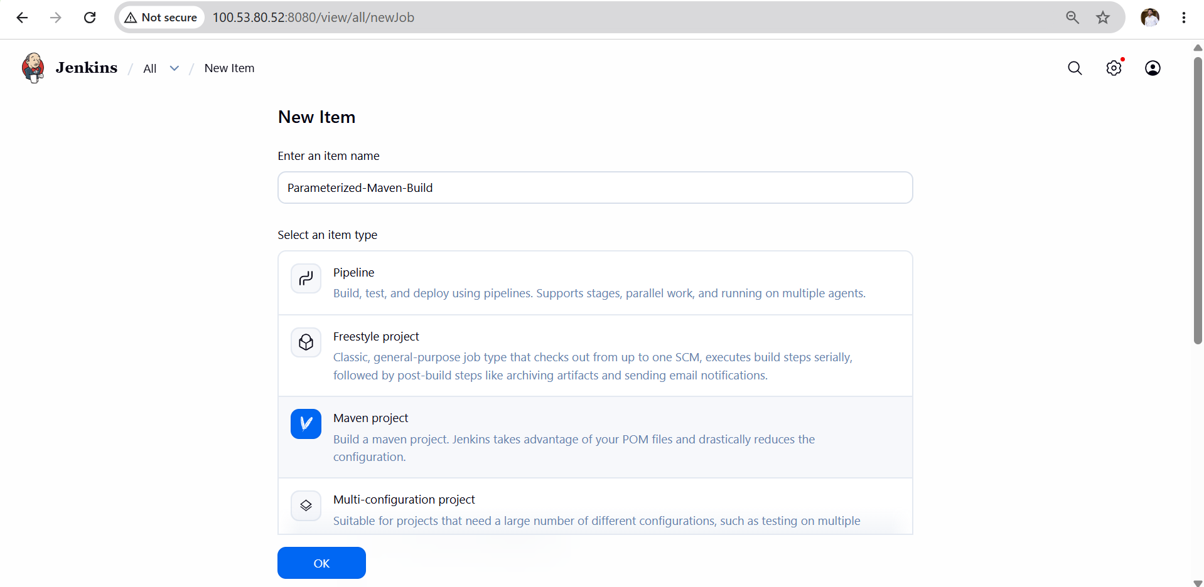
Step 2: Enable Parameterized Build
- In the job configuration, scroll to General.
- Check This project is parameterized.

Step 3: Add a String Parameter
Click Add Parameter → String Parameter.
Configure:
Name
BRANCH_NAME
Default Value
main
Description
Git branch to build
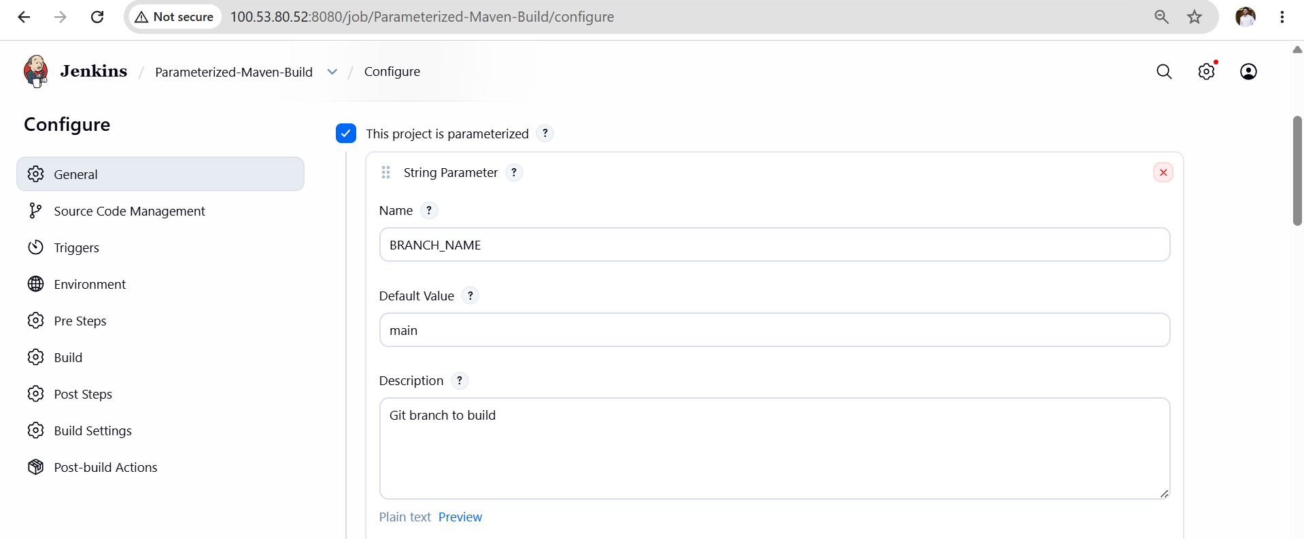
Step 4: Configure Git Repository
Under Source Code Management:
Select Git
Repository URL:
https://github.com/betawins/java-Working-app.git

Branch Specifier:
*/${BRANCH_NAME}
This allows Jenkins to build whichever branch the user enters.

Step 5: Configure Build
Under Build
Select:
Invoke top-level Maven targets
Maven Version:
Maven
Goals:
clean compile
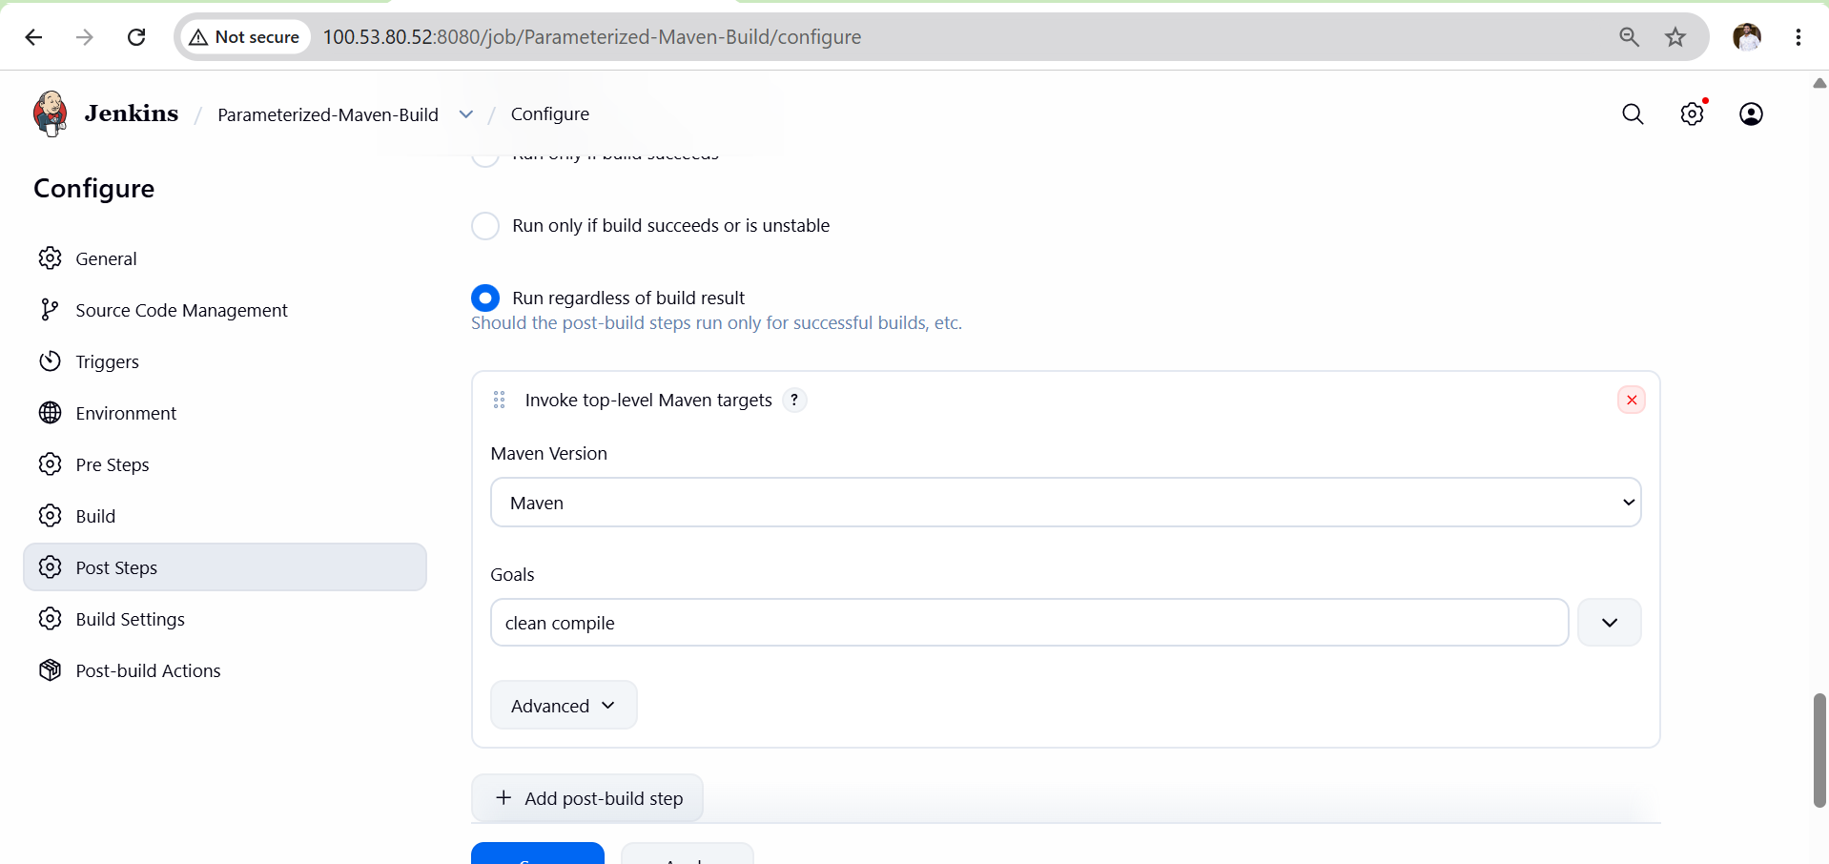
Step 6: Save the Job
Click Save.

Step 7: Build with Parameters
Instead of Build Now, click:
Build with Parameters
You will see:
BRANCH_NAME = main
Leave it as main (or enter another branch if it exists).
Click Build.
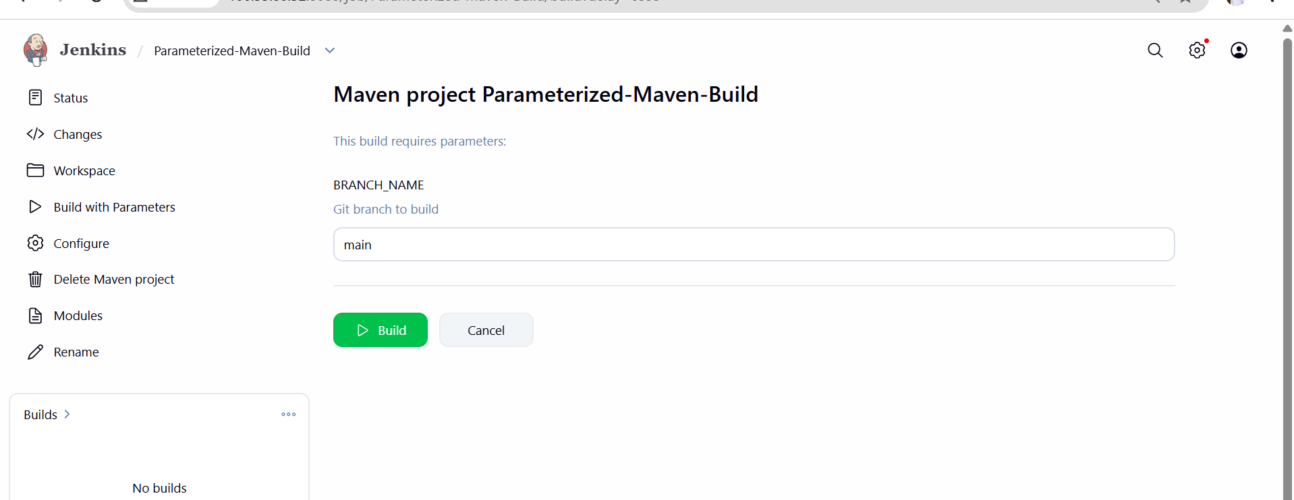
Step 8: Monitor the Build
Open Build History.
Click the latest build.
Open Console Output.
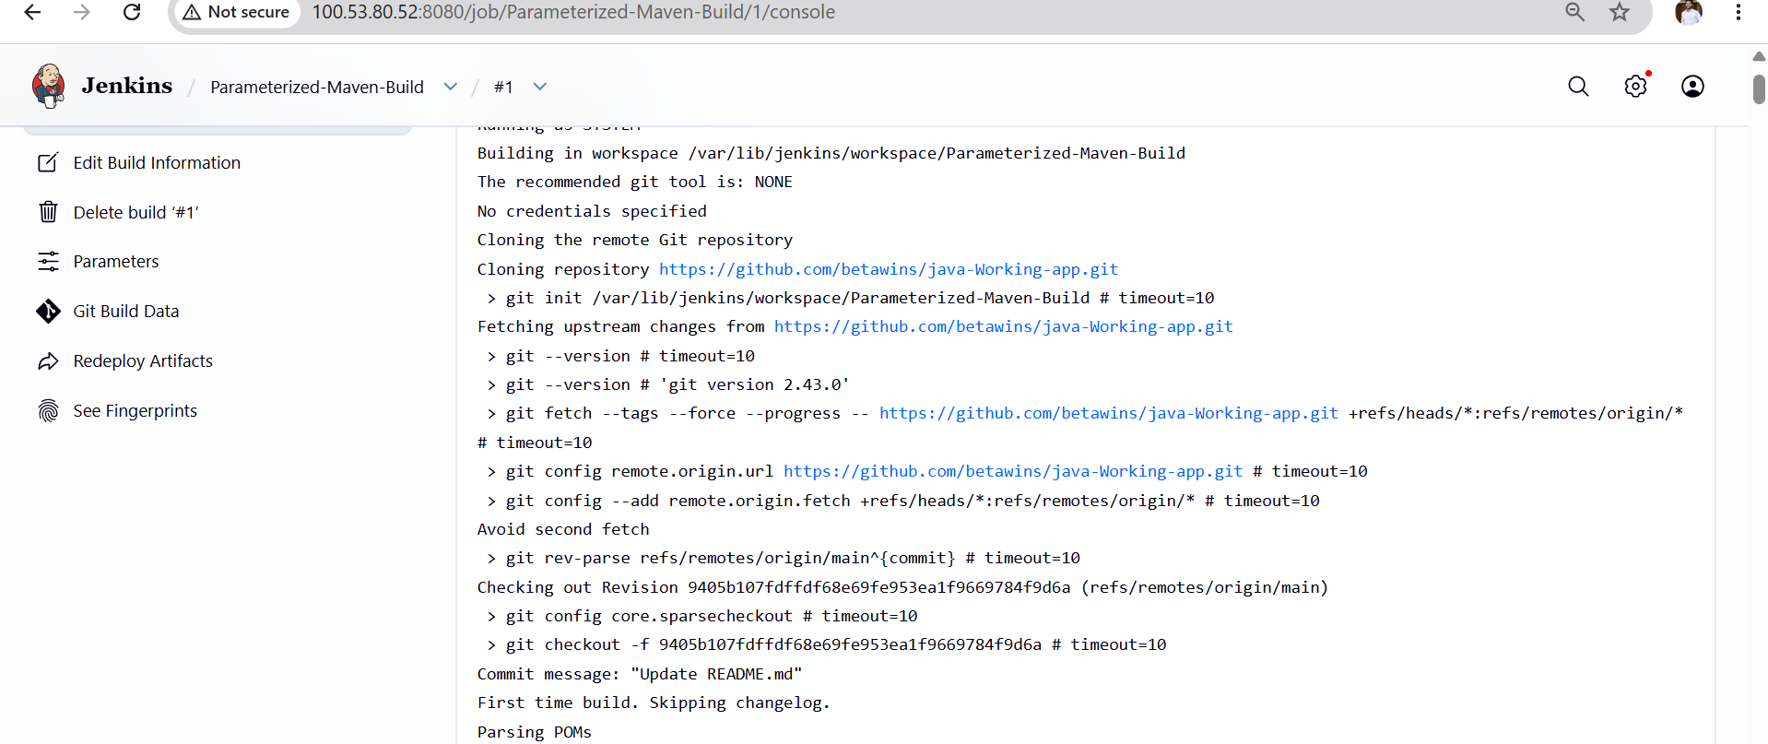
Validation
Verify the following:
- Parameterized job is created successfully.
- Build with Parameters option is visible.
- User can enter a branch name.
- Jenkins clones the specified branch.
- Maven compiles the project successfully.
- Console output shows BUILD SUCCESS.
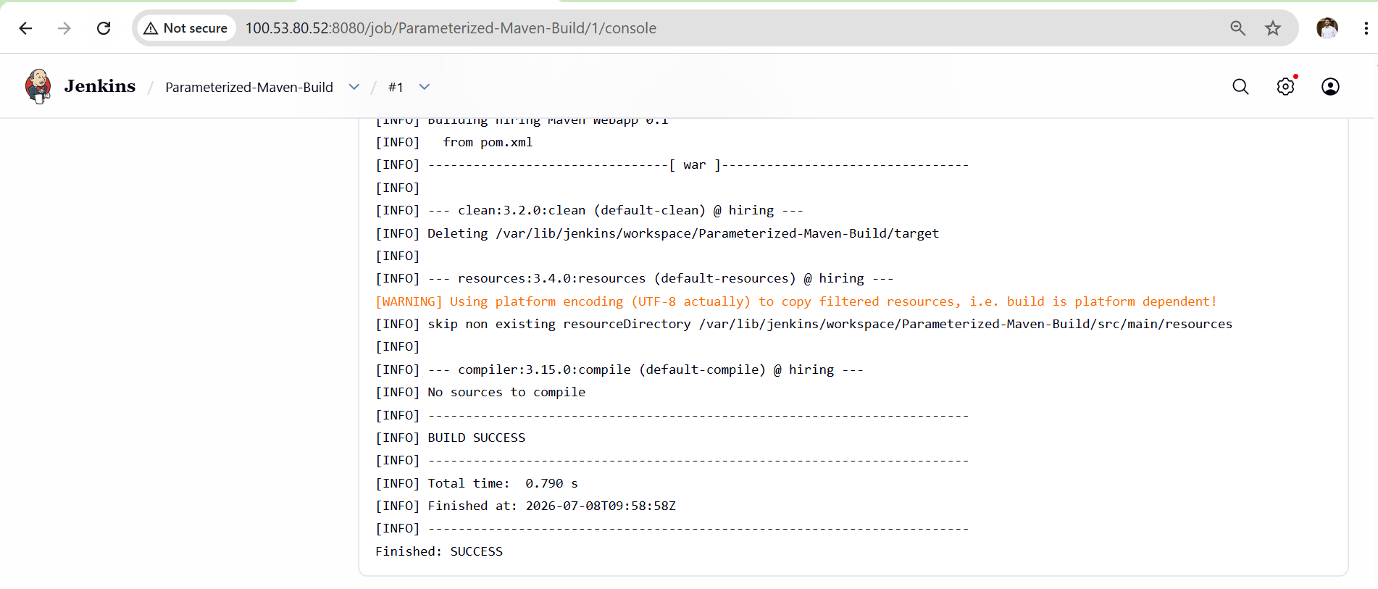
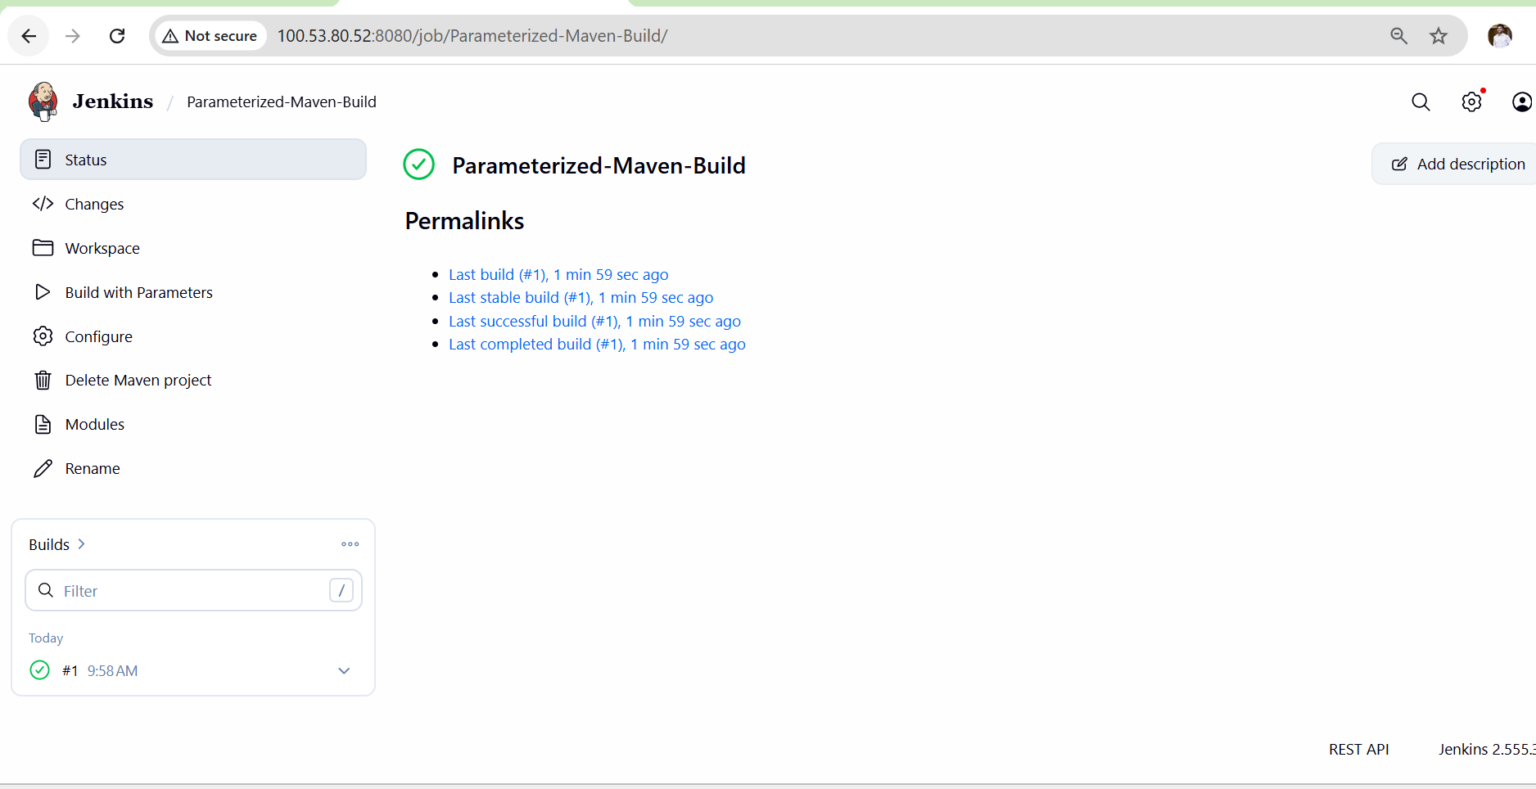
Outcome
- A parameterized Jenkins Maven job is created.
- Users can choose the Git branch before execution.
- The job clones the selected branch from GitHub.
- Maven compiles the Java application successfully.
- The build completes with SUCCESS status
Task 5: What are the Global Variables in Jenkins?

Objective
The objective of this task is to understand Global Variables in Jenkins, their purpose, and how they are used inside Jenkins pipelines. Global variables provide predefined information about the Jenkins environment, current build, workspace, job details, and source code repository, making pipeline scripts more dynamic and reusable.

What are Global Variables?
Global Variables are predefined environment variables that Jenkins automatically makes available during a build or pipeline. These variables can be accessed anywhere in the pipeline without manually defining them.
Example:
echo "${env.JOB_NAME}"
This prints the current Jenkins job name.

Why are Global Variables Used?
- Avoid hardcoding values.
- Access build and job information dynamically.
- Improve pipeline flexibility.
- Simplify scripting.
- Make pipelines reusable across multiple projects.

Common Jenkins Global Variables
Global Variable | Description | Example Value
BUILD_NUMBER | Current build number | 15
BUILD_ID | Unique build ID | 15
BUILD_TAG | Unique build tag | jenkins-Job-15
JOB_NAME | Name of the Jenkins job | Java-Maven-Build
JOB_BASE_NAME | Job name without folder path | Java-Maven-Build
BUILD_URL | URL of the current build | http://server:8080/job/...
JOB_URL | URL of the Jenkins job | http://server:8080/job/...
WORKSPACE | Workspace directory | /var/lib/jenkins/workspace/Java-Maven-Build
JENKINS_HOME | Jenkins home directory | /var/lib/jenkins
NODE_NAME | Name of the node running the build | Built-In Node
NODE_LABELS | Labels assigned to the node | linux docker
EXECUTOR_NUMBER | Executor handling the build | 0
GIT_BRANCH | Current Git branch | main
GIT_COMMIT | Latest Git commit ID | 9405b107...
GIT_URL | Git repository URL | https://github.com/...

Common Environment Variables Used in Pipelines
Variable | Purpose
env.BUILD_NUMBER | Displays the current build number.
env.JOB_NAME | Displays the Jenkins job name.
env.WORKSPACE | Displays the current workspace path.
env.BUILD_URL | Displays the URL of the current build.
env.NODE_NAME | Displays the Jenkins node name.
env.GIT_BRANCH | Displays the Git branch being built.

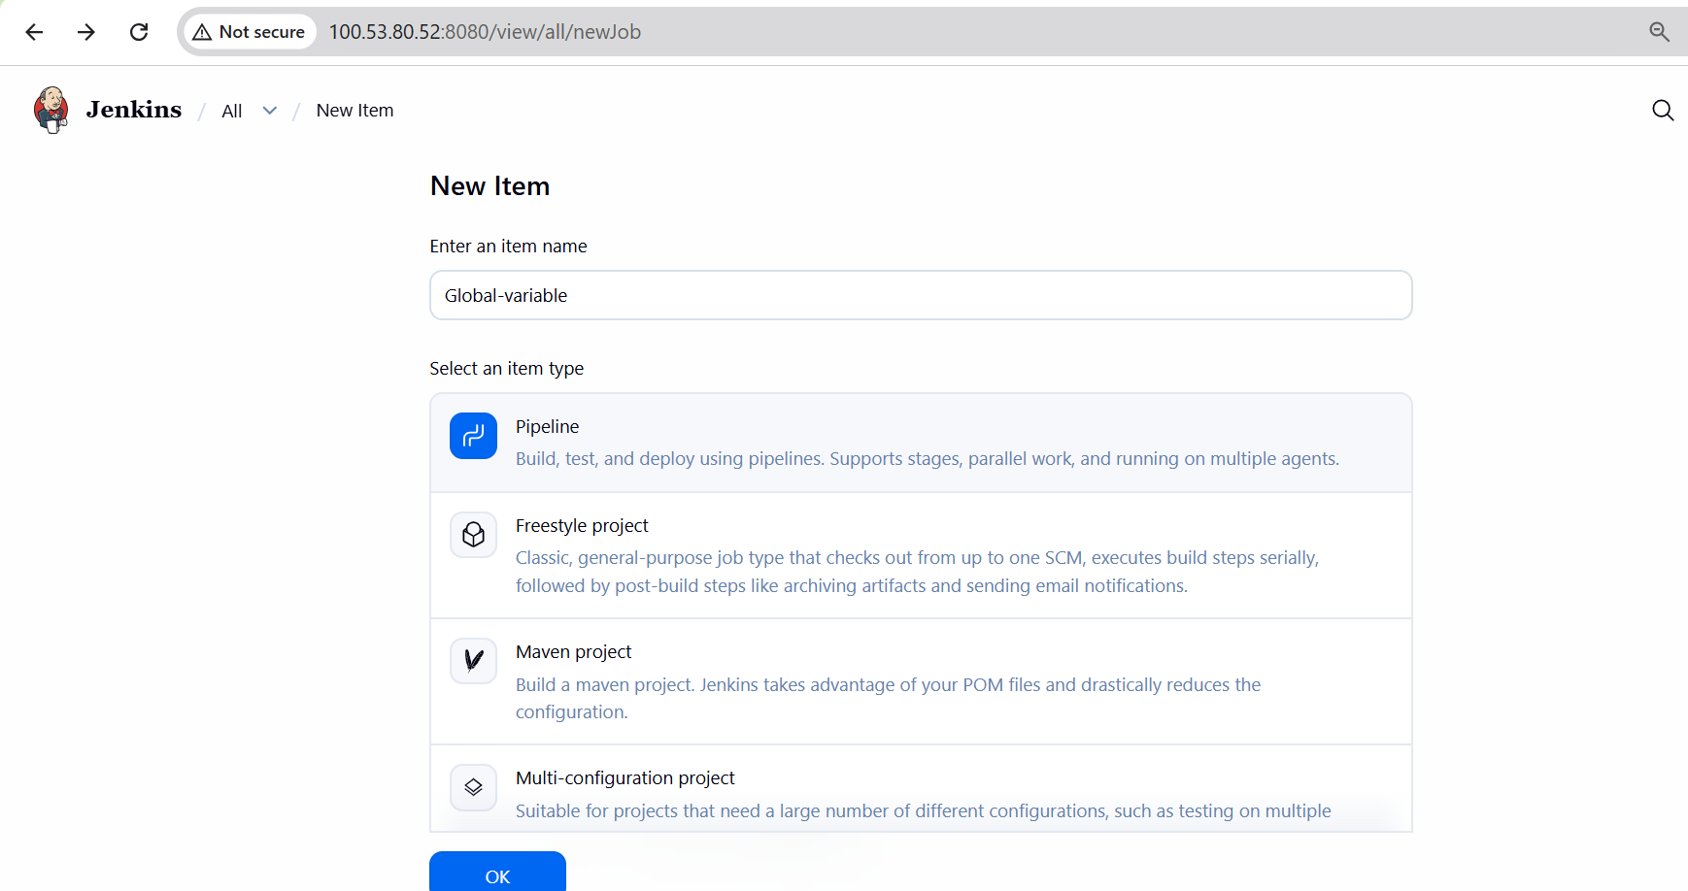
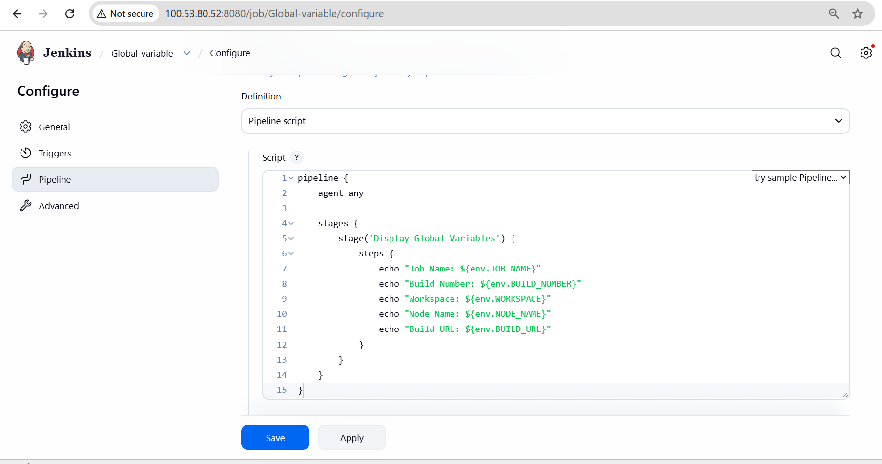
Validation
Verify the following:
- Jenkins displays the predefined environment variables.
- Pipeline successfully prints the variable values.
- Variables change automatically based on the current build.
- The workspace and build information are displayed correctly.

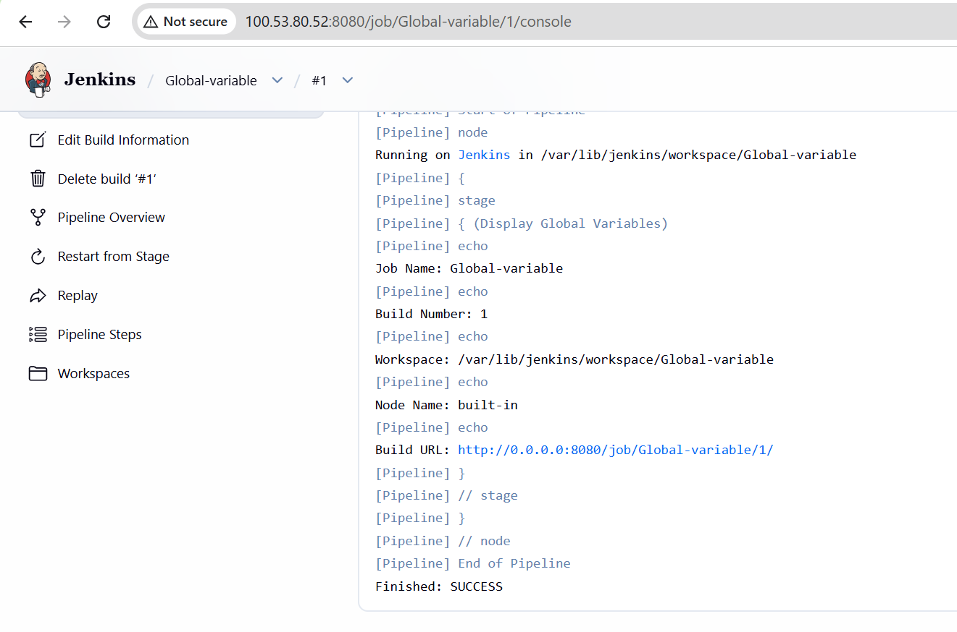
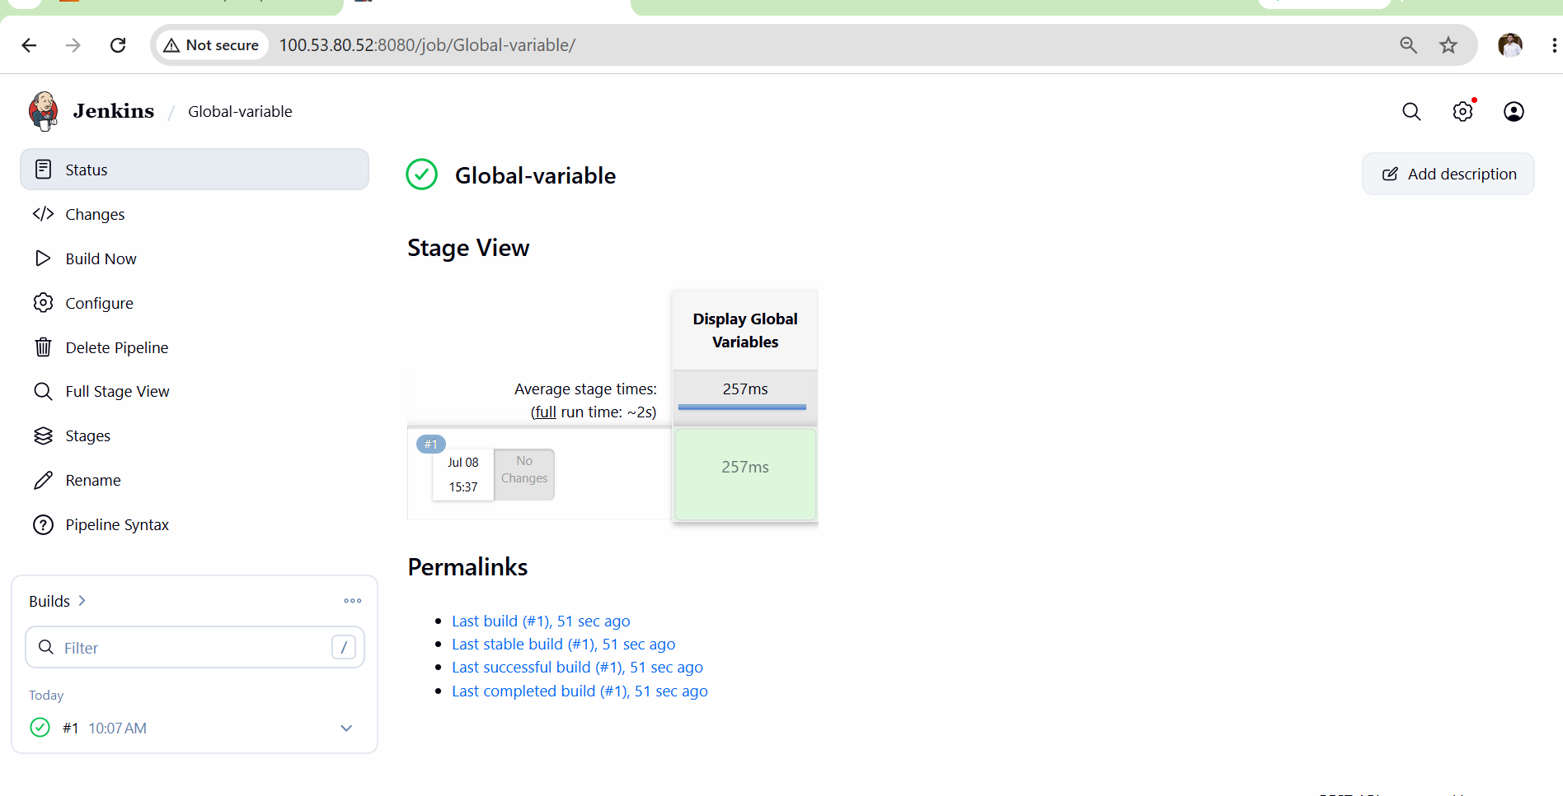
Outcome: I understand what Jenkins Global Variables are.
- You know how to use environment variables in Jenkins pipelines.
- You can access build, job, node, workspace, and Git information dynamically.
Pipelines become more reusable and easier to maintain by avoiding hardcoded values

