Docker-01
Task 1: Setup a Virtual Machine using Ubuntu Image (AWS EC2)
Objective
To create an Ubuntu Linux Virtual Machine (EC2 Instance) in AWS that will be used for all Docker hands-on tasks.
After completing this task, you will have:
- One Ubuntu Server running in AWS
- SSH access from your laptop
- A server ready for Docker installation
Architecture
Your Laptop
│
│ SSH (Port 22)
│
Internet
│
AWS
│
VPC
│
Public Subnet
│
Ubuntu EC2 Instance
Prerequisites
- AWS Account with EC2 access
- IAM user with required permissions
- Internet connection
- Git Bash / PowerShell / Terminal installed on the local system
- SSH Key Pair (.pem file)
Implementation Steps
- Logged in to the AWS Management Console.
- Opened the EC2 Dashboard.
- Clicked Launch Instance.
- Entered the instance name as Docker-01.
- Selected Ubuntu Server 22.04 LTS (64-bit x86) as the Amazon Machine Image (AMI).
- Chose the t2.micro instance type.
- Created a new key pair (docker-key.pem) and downloaded it securely.
- Created a new Security Group and configured the following inbound rules:
  - SSH (Port 22) – My IP
  - HTTP (Port 80) – Anywhere
  - Custom TCP (Port 81) – Anywhere
  - Custom TCP (Port 8080) – Anywhere
  - Custom TCP (Port 9000) – Anywhere
  - Custom TCP (Port 50000) – Anywhere
- Kept the default storage (10 GB gp3).
- Reviewed the instance configuration and clicked Launch Instance.
- Waited until the EC2 instance state changed to Running and the status checks displayed 2/2 Checks Passed.
- Copied the Public IPv4 address of the instance.
- Connected to the EC2 instance from the local machine using SSH:
chmod 400 docker-key.pem
ssh -i docker-key.pem ubuntu@<Public-IP>
- Verified successful login to the Ubuntu server.

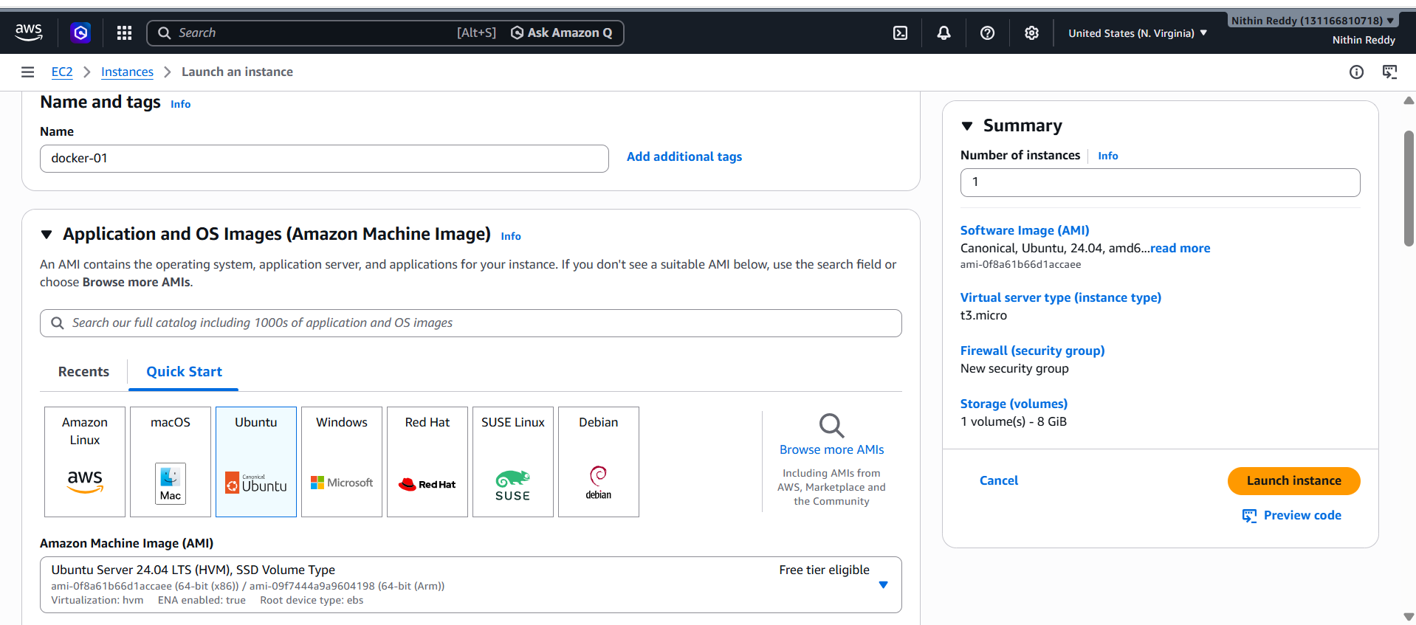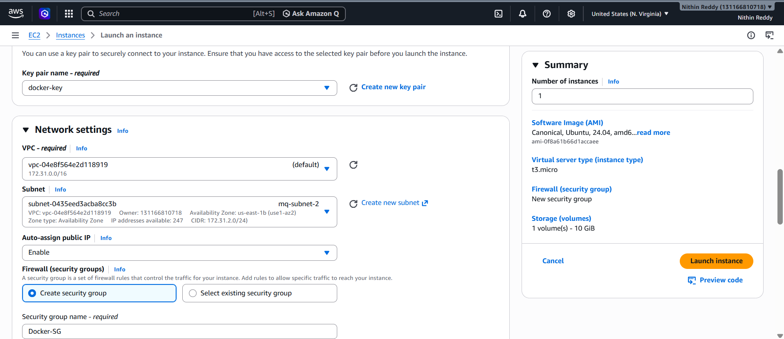

Validation
The following checks were performed to validate successful completion of the task:
- EC2 instance state is Running.
- Instance status checks show 2/2 Checks Passed.
- Public IPv4 address is assigned.
- SSH connection to the instance is successful.
- Successfully logged in as the ubuntu user.
- Ubuntu command prompt is displayed:
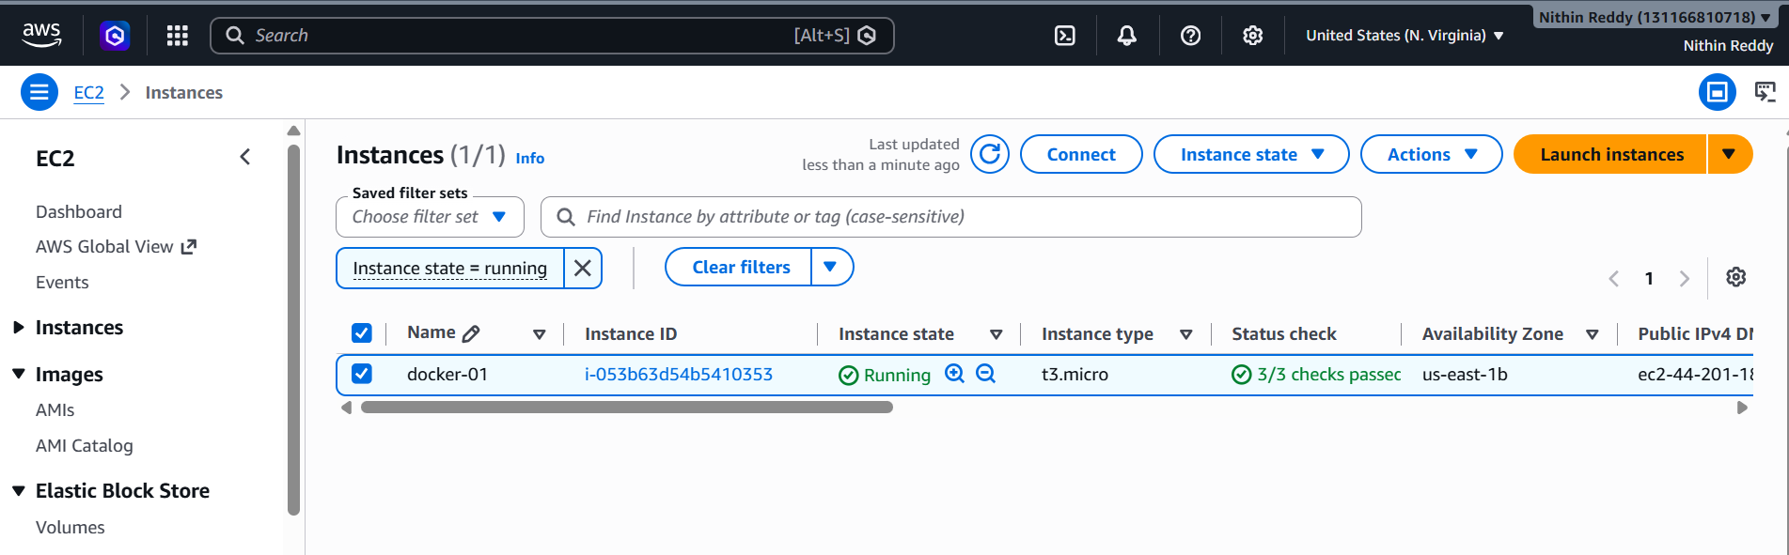

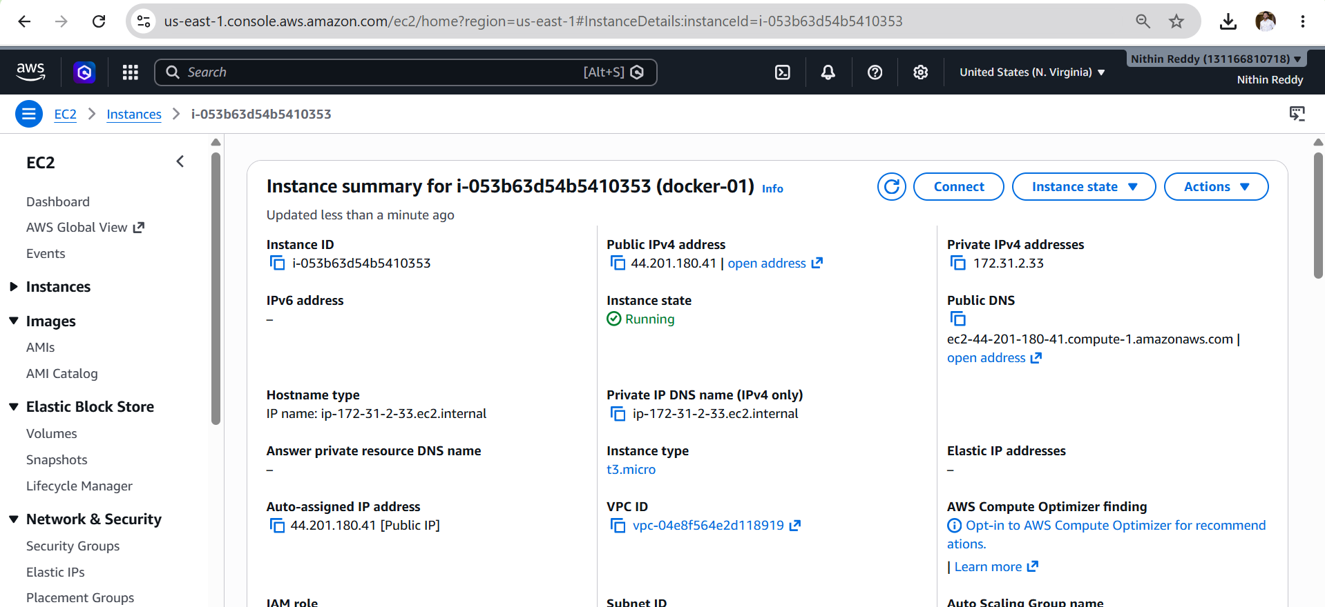
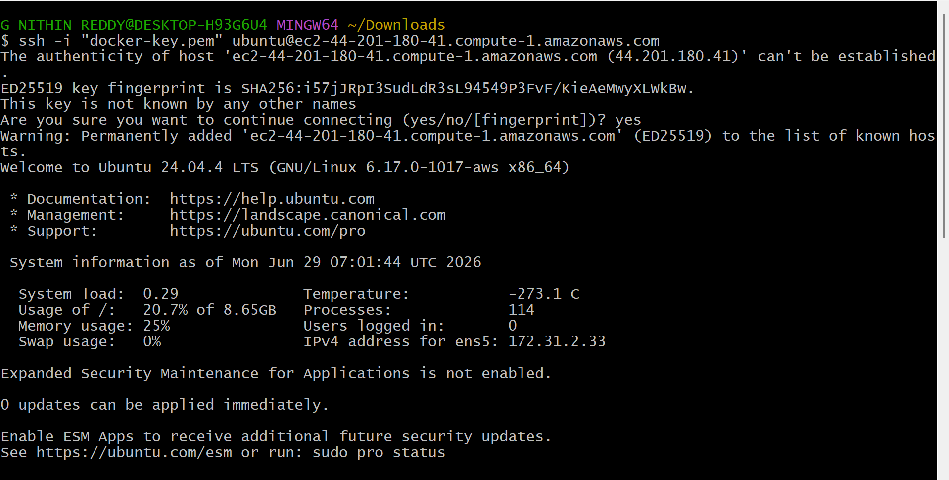

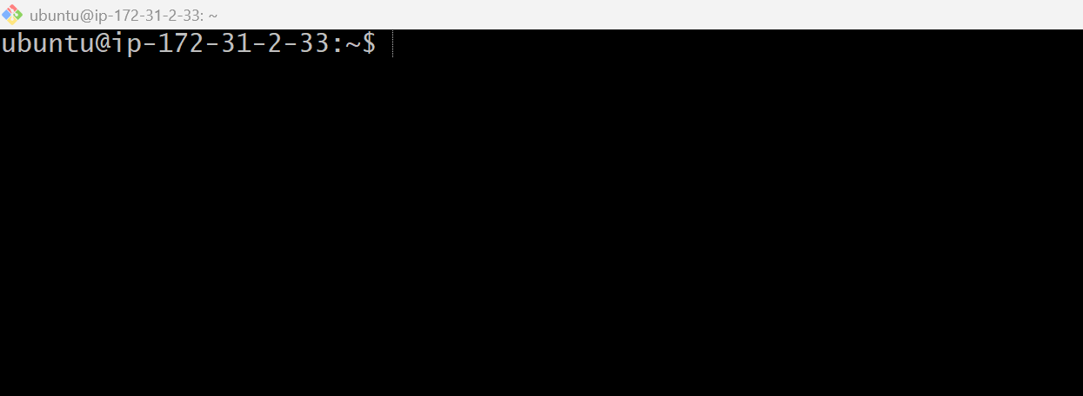

Outcome
- Successfully launched an Ubuntu EC2 virtual machine on AWS.
- Configured the required networking and security settings.
- Established SSH connectivity from the local machine to the EC2 instance.
- Prepared the Ubuntu server for Docker installation and the remaining Docker hands-on tasks.

Task 2: Install Docker on Ubuntu EC2 Instance
Objective
To install Docker Engine on the Ubuntu EC2 instance, start the Docker service, enable it to start automatically after every reboot, and verify that Docker is installed and functioning correctly.
What is Docker?
Docker is an open-source containerization platform that allows developers to package an application along with all its dependencies into a lightweight container. These containers can run consistently across different environments without compatibility issues.
Why Do We Install Docker?
- To create and manage containers.
- To run applications without installing software directly on the operating system.
- To ensure consistency across development, testing, and production environments.
- To isolate applications from one another.
- To simplify application deployment.
Prerequisites
- Ubuntu EC2 Instance is running.
- Successfully connected to the instance via SSH.
- Logged in as the ubuntu user.
- Internet connectivity is available.
Implementation Steps
- Connected to the Ubuntu EC2 instance using SSH.
- Updated the package repository using sudo apt update.
- Upgraded the installed packages using sudo apt upgrade -y.
- Installed Docker Engine using sudo apt install docker.io -y.
- Verified the Docker installation using docker --version.
- Checked the Docker service status using sudo systemctl status docker.
- Started the Docker service using sudo systemctl start docker (if not already running).
- Enabled the Docker service to start automatically on system boot using sudo systemctl enable docker.
- Verified that the Docker service is enabled using sudo systemctl is-enabled docker.
- Displayed Docker system information using sudo docker info.
- Added the ubuntu user to the Docker group using sudo usermod -aG docker ubuntu.
- Applied the new group membership using newgrp docker.
- Verified Docker group membership using the groups command.
- Confirmed Docker commands work without sudo by running docker --version.
- Tested the Docker installation successfully by running the docker run hello-world container.

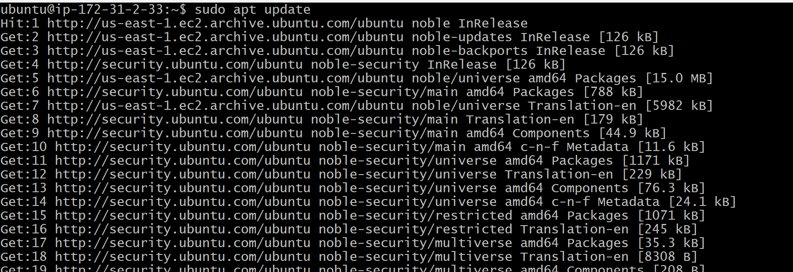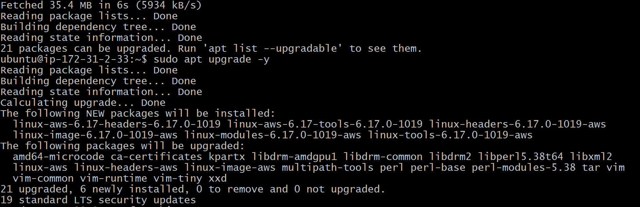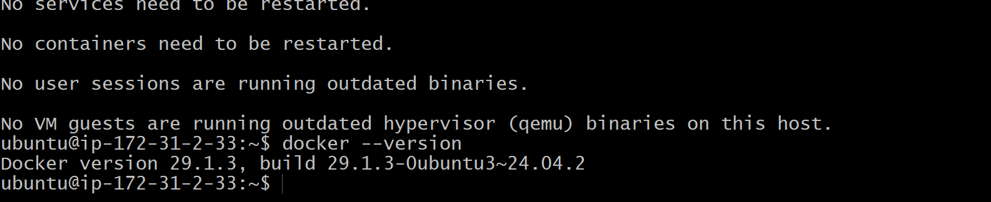
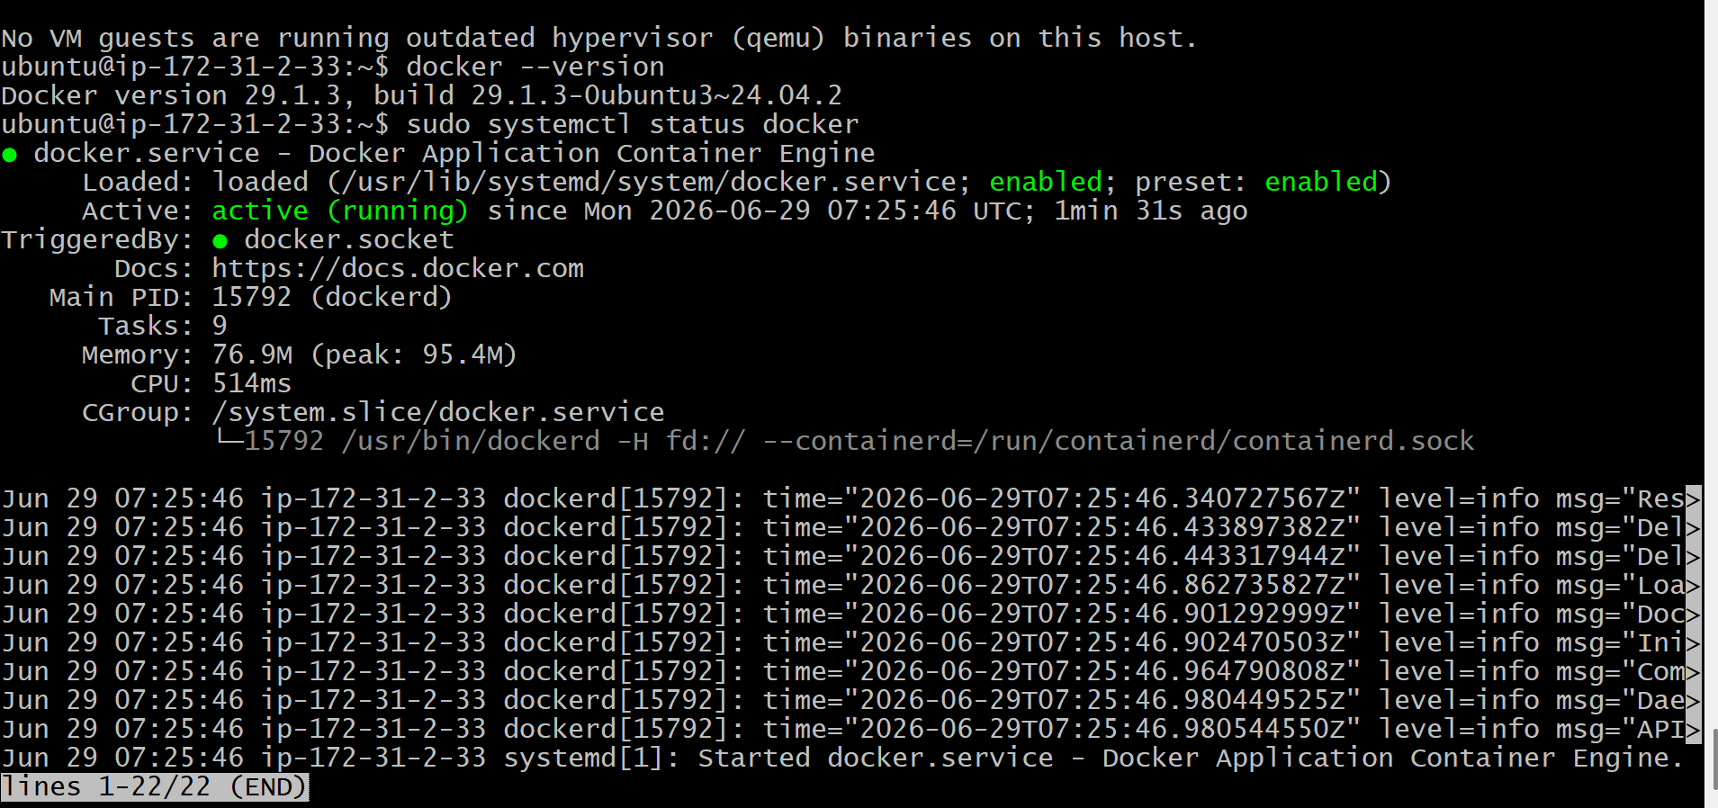

Validation Points
Verify the following:
- ✅ Package repository updated successfully.
- ✅ Docker installed without errors.
- ✅ docker --version displays the installed version.
- ✅ Docker service status is Active (running).
- ✅ Docker service is Enabled.
- ✅ docker info displays Docker server information.
- ✅ docker run hello-world executes successfully and prints the welcome message
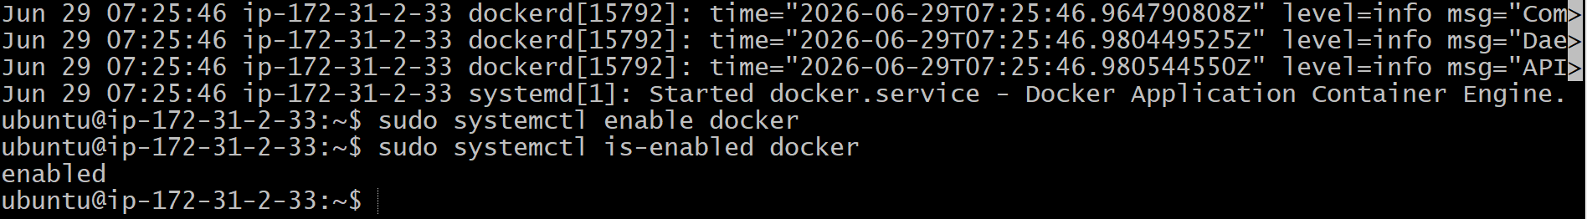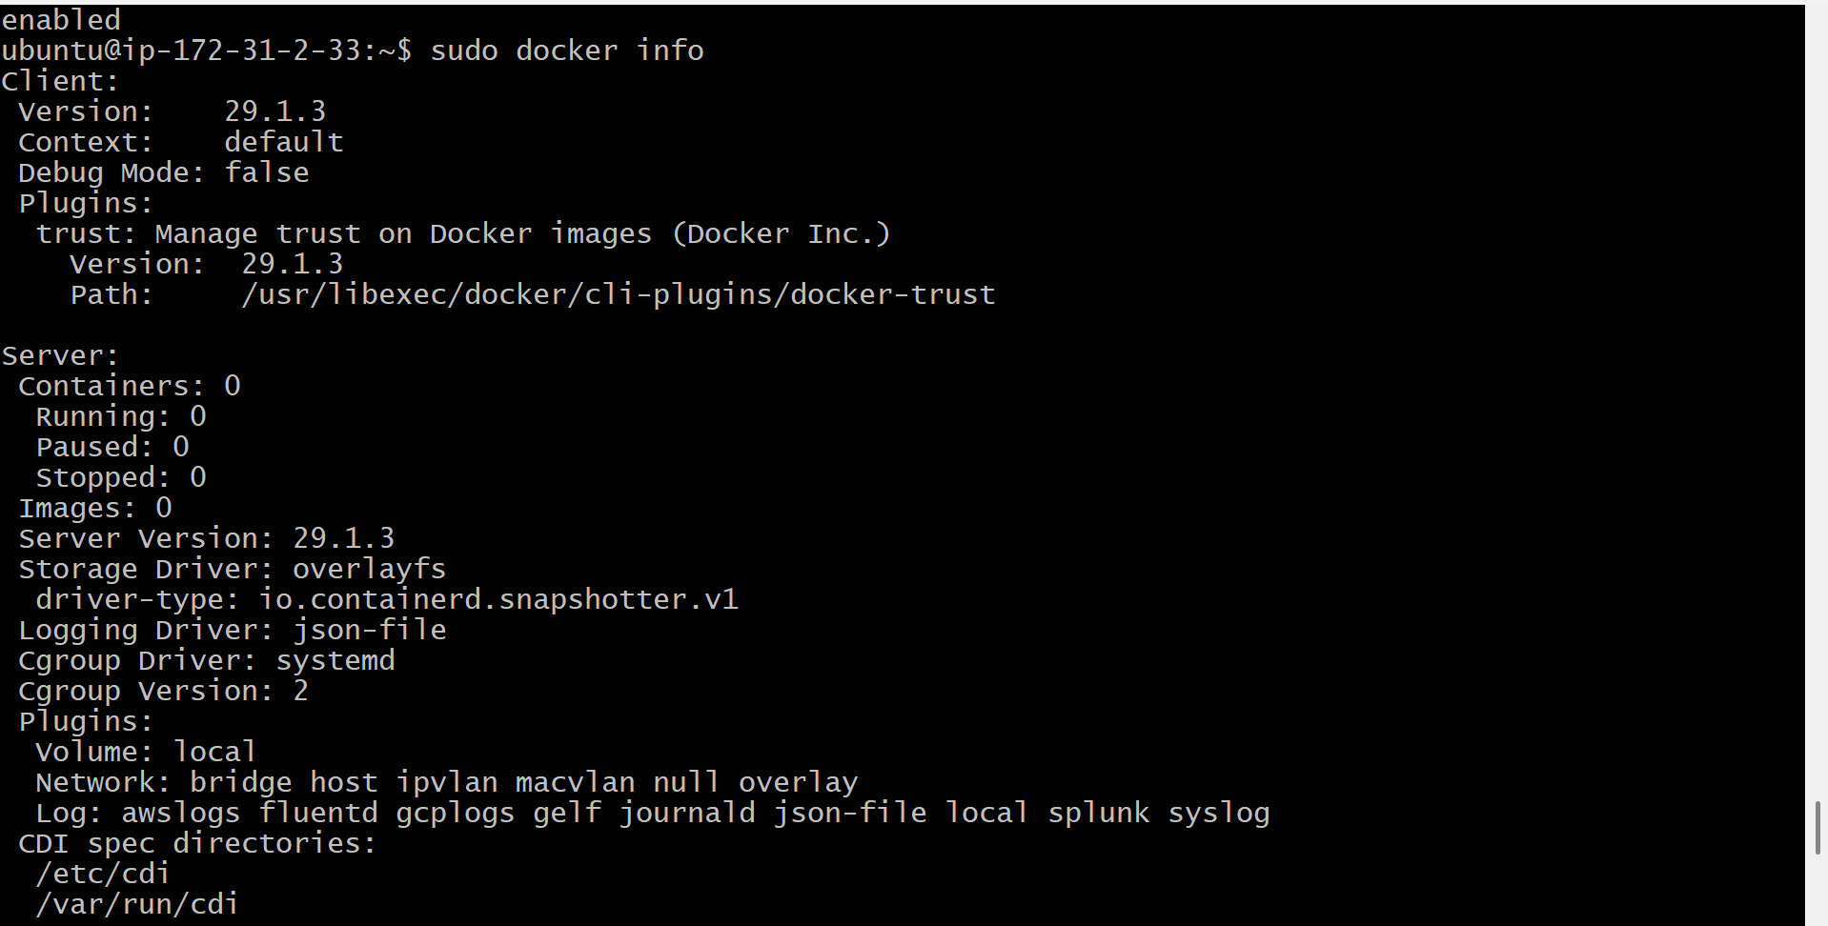
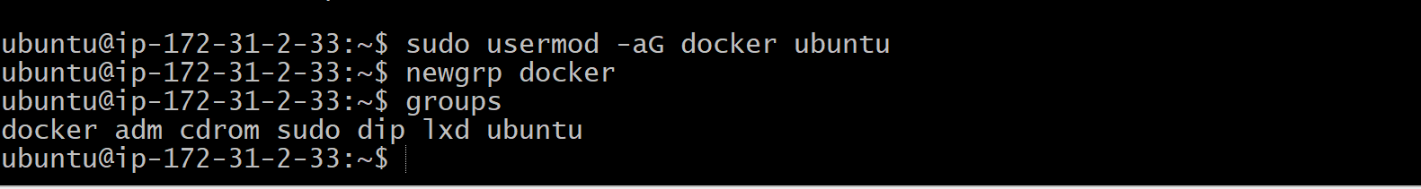
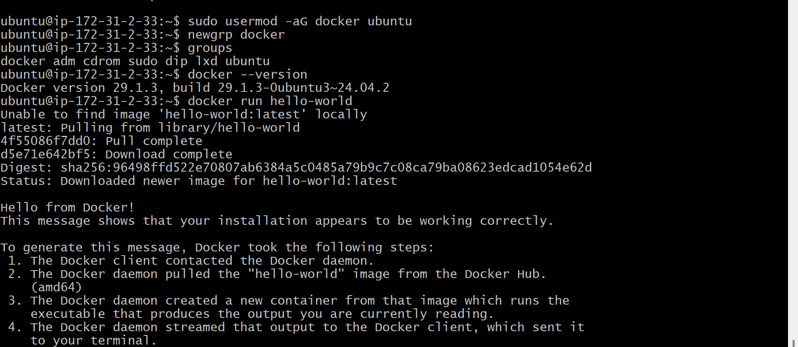
Outcome
After completing Task 2:
- Docker Engine is installed on the Ubuntu EC2 instance.
- Docker service is running.
- Docker starts automatically after every system reboot.
- The ubuntu user can execute Docker commands without sudo (after adding to the Docker group).
- The Docker installation has been validated using the hello-world container.
- The EC2 instance is now ready for pulling Docker images and creating containers

Task 3: Pull 5 Docker Images (nginx, Apache Tomcat, Ubuntu, Jenkins, SonarQube)
Objective
To download the required Docker images from Docker Hub to the local Docker host (Ubuntu EC2 instance). These images will be used in the next tasks to create and run containers.
What is a Docker Image?
A Docker image is a read-only template that contains everything required to run an application, including:
- Application code
- Runtime
- Libraries
- Dependencies
- Configuration files
An image acts as a blueprint for creating Docker containers.
Prerequisites
- Ubuntu EC2 instance is running.
- Docker is installed successfully.
- Docker service is active and running.
- Internet connection is available.
Implementation Steps
- Connected to the Ubuntu EC2 instance using SSH.
- Verified that the Docker service was running using sudo systemctl status docker.
- Checked the existing Docker images using docker images.
- Pulled the Nginx Docker image using docker pull nginx.
- Verified the Nginx image was downloaded successfully using docker images.
- Pulled the Apache Tomcat Docker image using docker pull tomcat.
- Verified the Apache Tomcat image was downloaded successfully using docker images.
- Pulled the Ubuntu Docker image using docker pull ubuntu.
- Verified the Ubuntu image was downloaded successfully using docker images.
- Pulled the Jenkins LTS Docker image using docker pull jenkins/jenkins:lts.
- Verified the Jenkins image was downloaded successfully using docker images.
- Pulled the SonarQube Docker image using docker pull sonarqube.
- Verified the SonarQube image was downloaded successfully using docker images.
- Displayed all downloaded Docker images using the docker images command.
- Confirmed that all five required Docker images were available in the local Docker image repository.

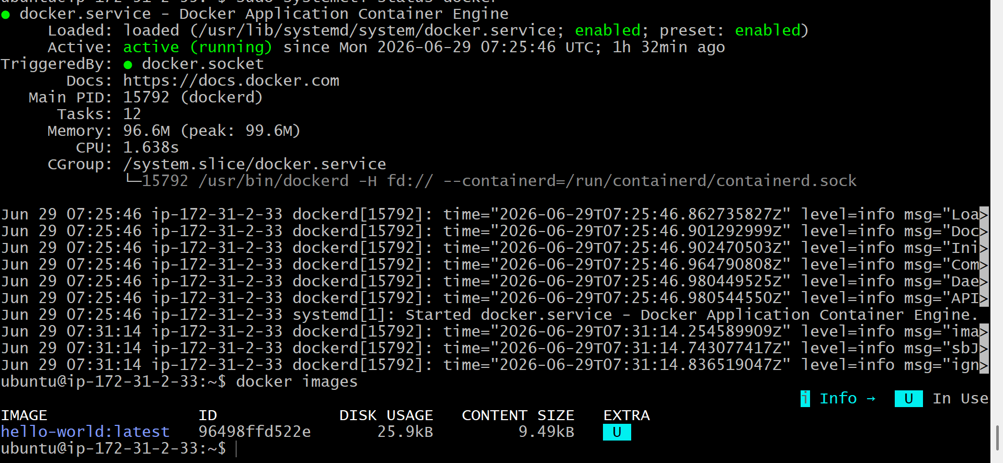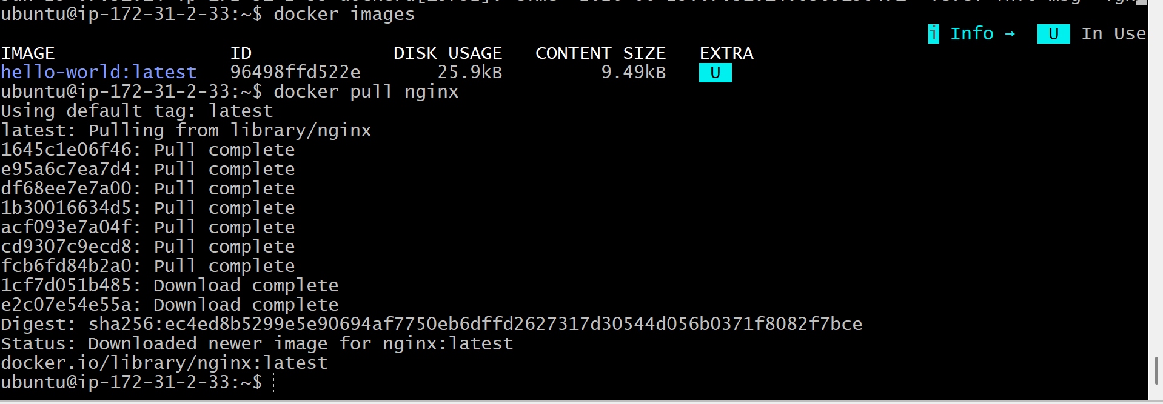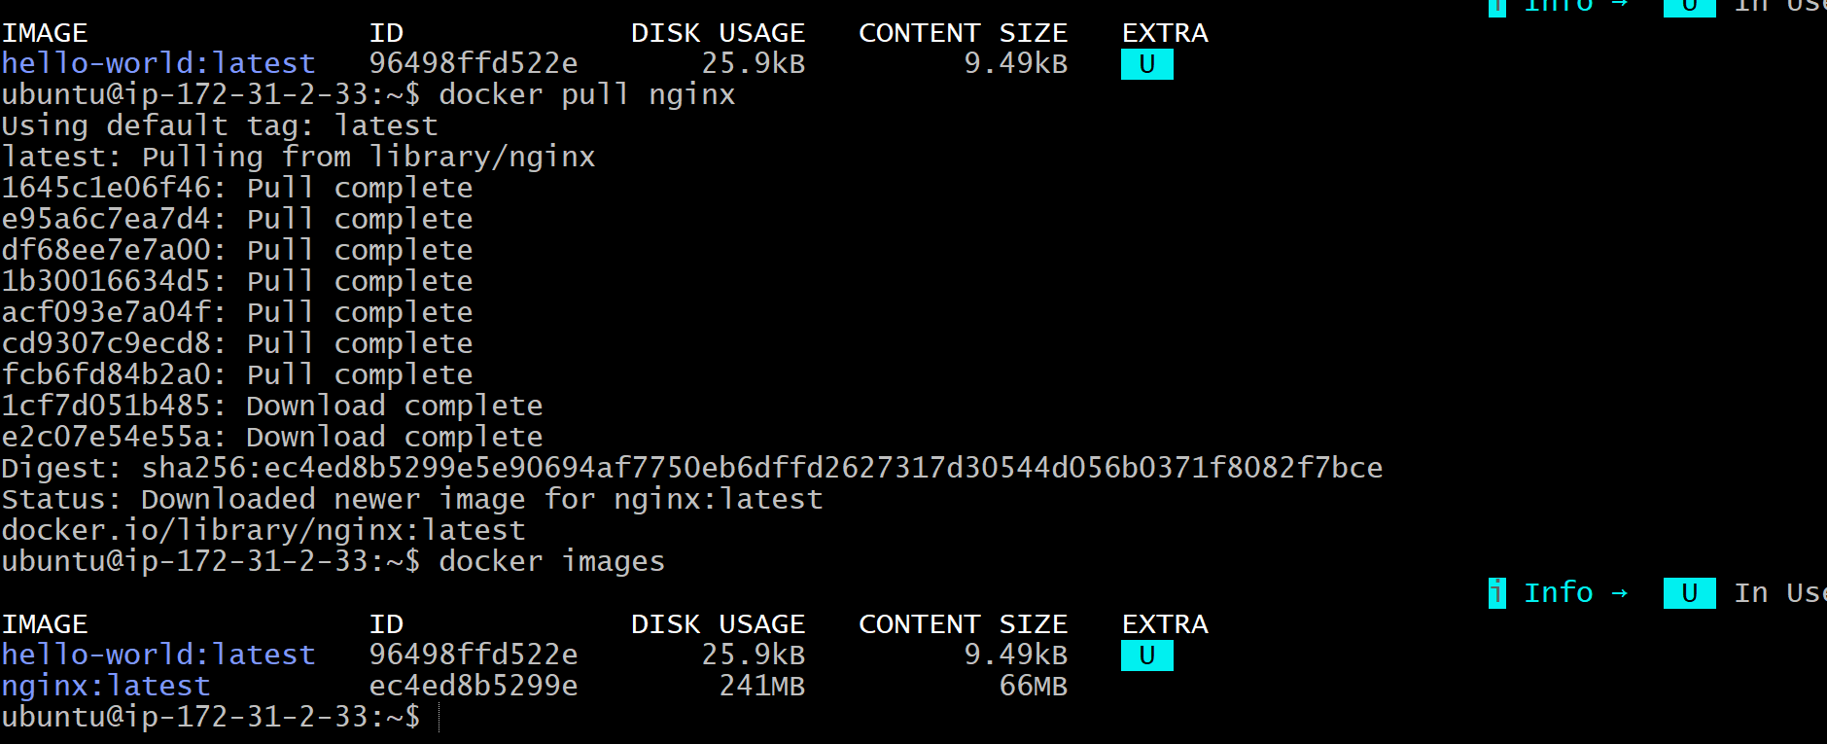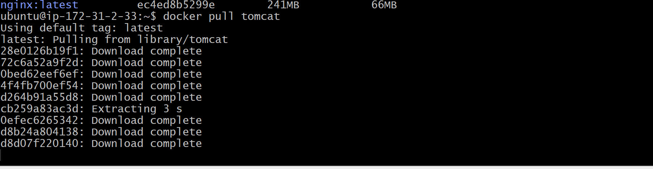
Validation Points
- Docker service is running.
- Nginx image downloaded successfully.
- Apache Tomcat image downloaded successfully.
- Ubuntu image downloaded successfully.
- Jenkins LTS image downloaded successfully.
- SonarQube image downloaded successfully.
- docker images displays all five required images.

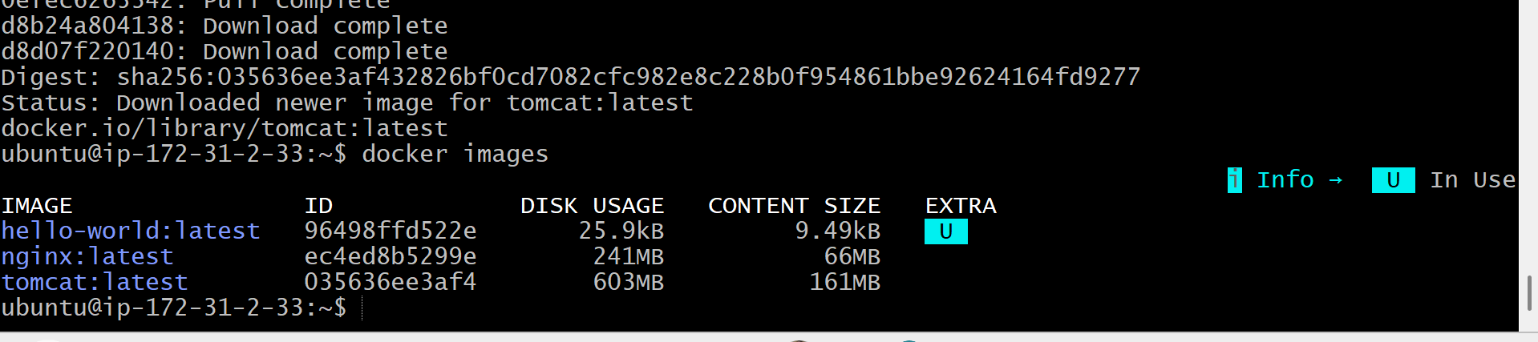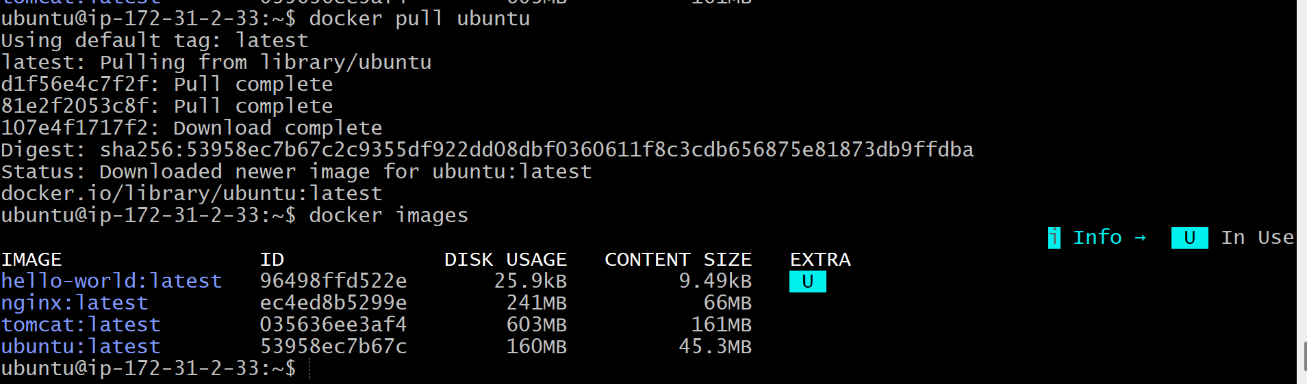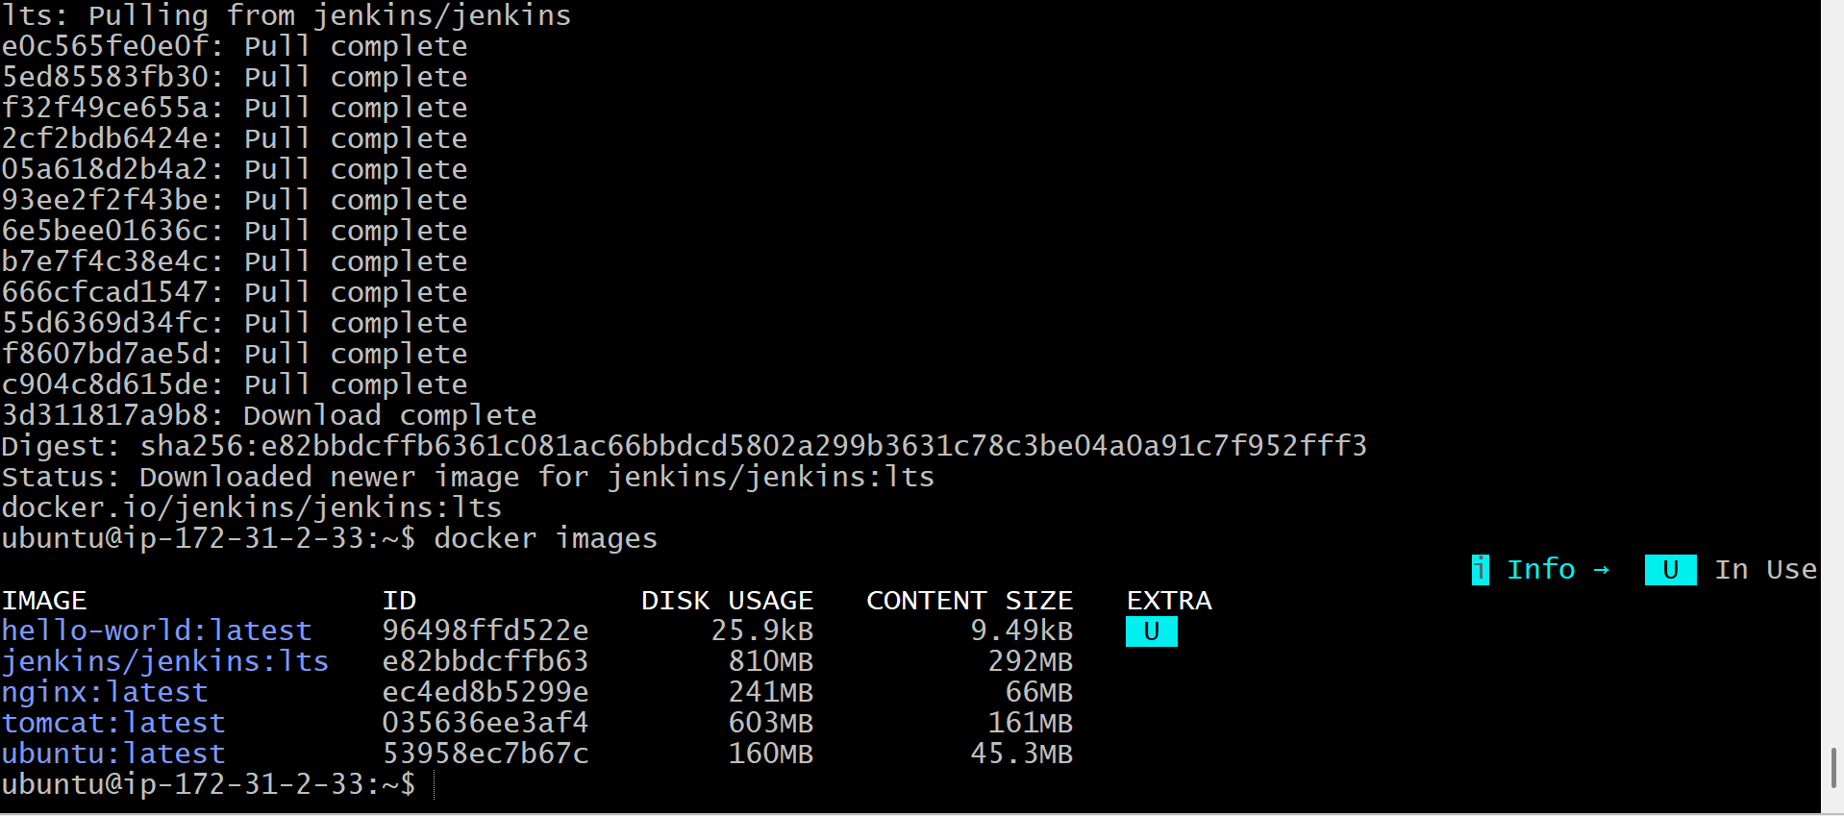

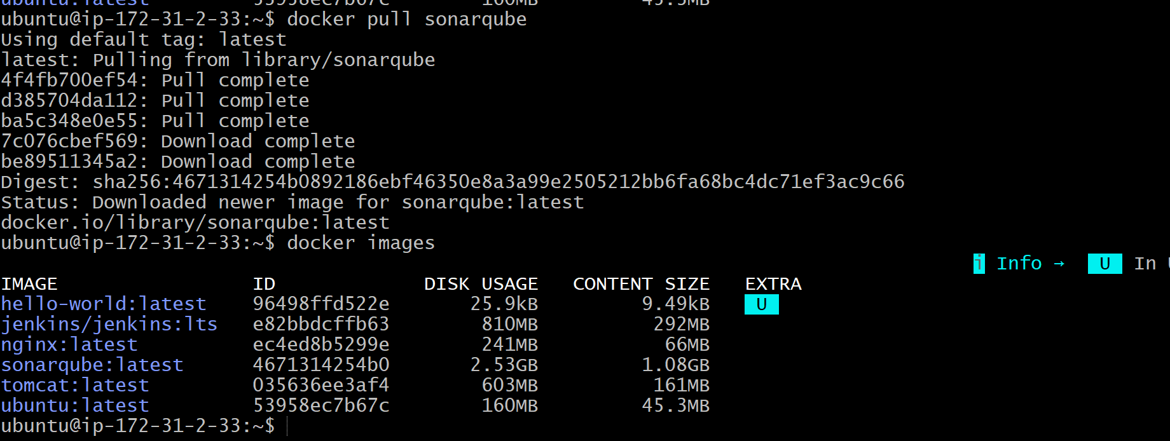

Outcome
After completing Task 3:
- Docker Hub connectivity was verified.
- Five required Docker images were successfully downloaded to the local Docker host.
- All images are available locally and ready to create containers in the upcoming tasks.
- The environment is prepared for running Nginx, Jenkins, SonarQube, Ubuntu, and Apache Tomcat containers.

Task 4: Run Nginx Container and Expose it on Port 81
Objective
To create and run an Nginx Docker container and expose it on port 81 of the EC2 instance so that the Nginx default web page can be accessed from a web browser.
What is a Nginx Container?
Nginx is a lightweight, high-performance web server. Running it inside a Docker container allows you to host web content without installing Nginx directly on the Ubuntu operating system.
Prerequisites
- Ubuntu EC2 instance is running.
- Docker is installed and running.
- Nginx Docker image has already been pulled (docker pull nginx).
- Security Group allows Custom TCP Port 81 from 0.0.0.0/0 (Anywhere).
Implementation Steps
- Connected to the Ubuntu EC2 instance using SSH.
- Verified that the Nginx Docker image was available using docker images.
- Checked for any running Docker containers using docker ps.
- Created and started the Nginx container using docker run -d --name nginx-container -p 81:80 nginx.
- Verified that the Nginx container was running using docker ps.
- Confirmed the port mapping (81:80) using docker port nginx-container.
- Viewed the Nginx container logs using docker logs nginx-container.
- Tested the Nginx web server locally using curl http://localhost:81.
- Verified that Custom TCP Port 81 was allowed in the EC2 Security Group.
- Accessed the Nginx web page from a browser using http://<EC2-Public-IP>:81.
- Confirmed that the Welcome to nginx! page was displayed successfully, indicating the container was running correctly.

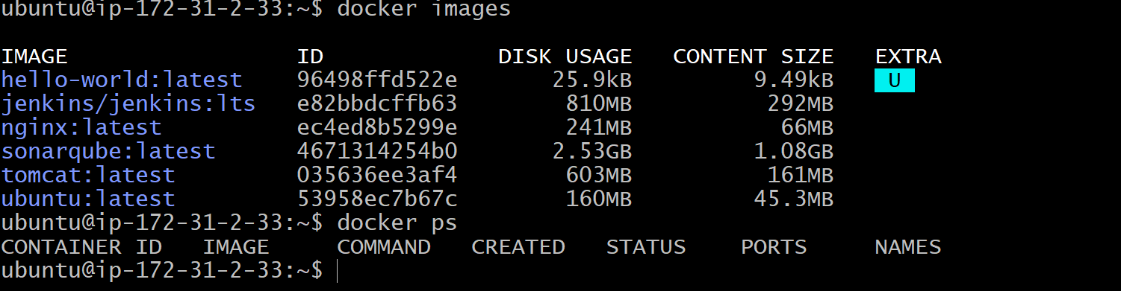
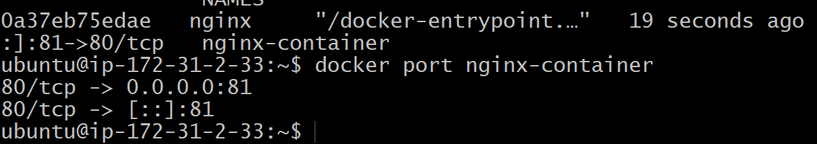

Validation Points
- Nginx image exists locally.
- Nginx container created successfully.
- Container status is Up.
- Port mapping shows 81:80.
- curl http://localhost:81 returns the Nginx HTML page.
- Browser displays the Welcome to nginx! page using the EC2 Public IP and port 81.
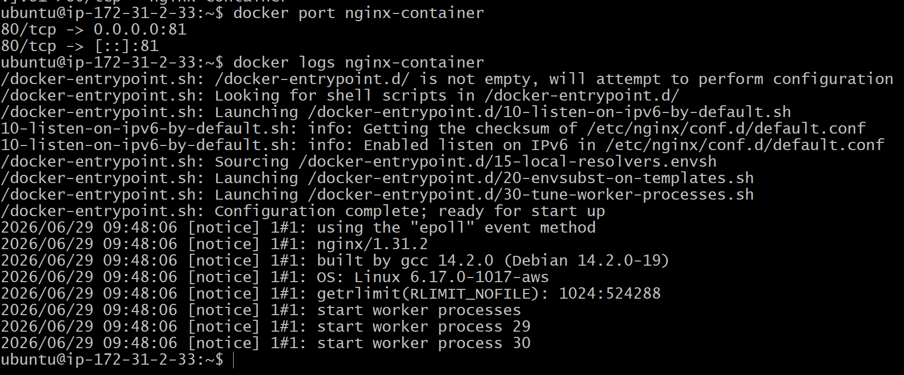
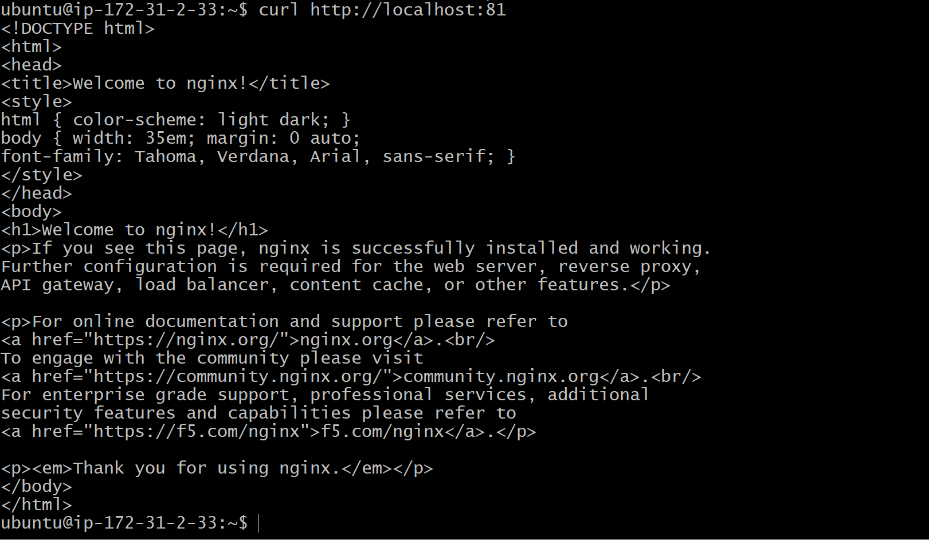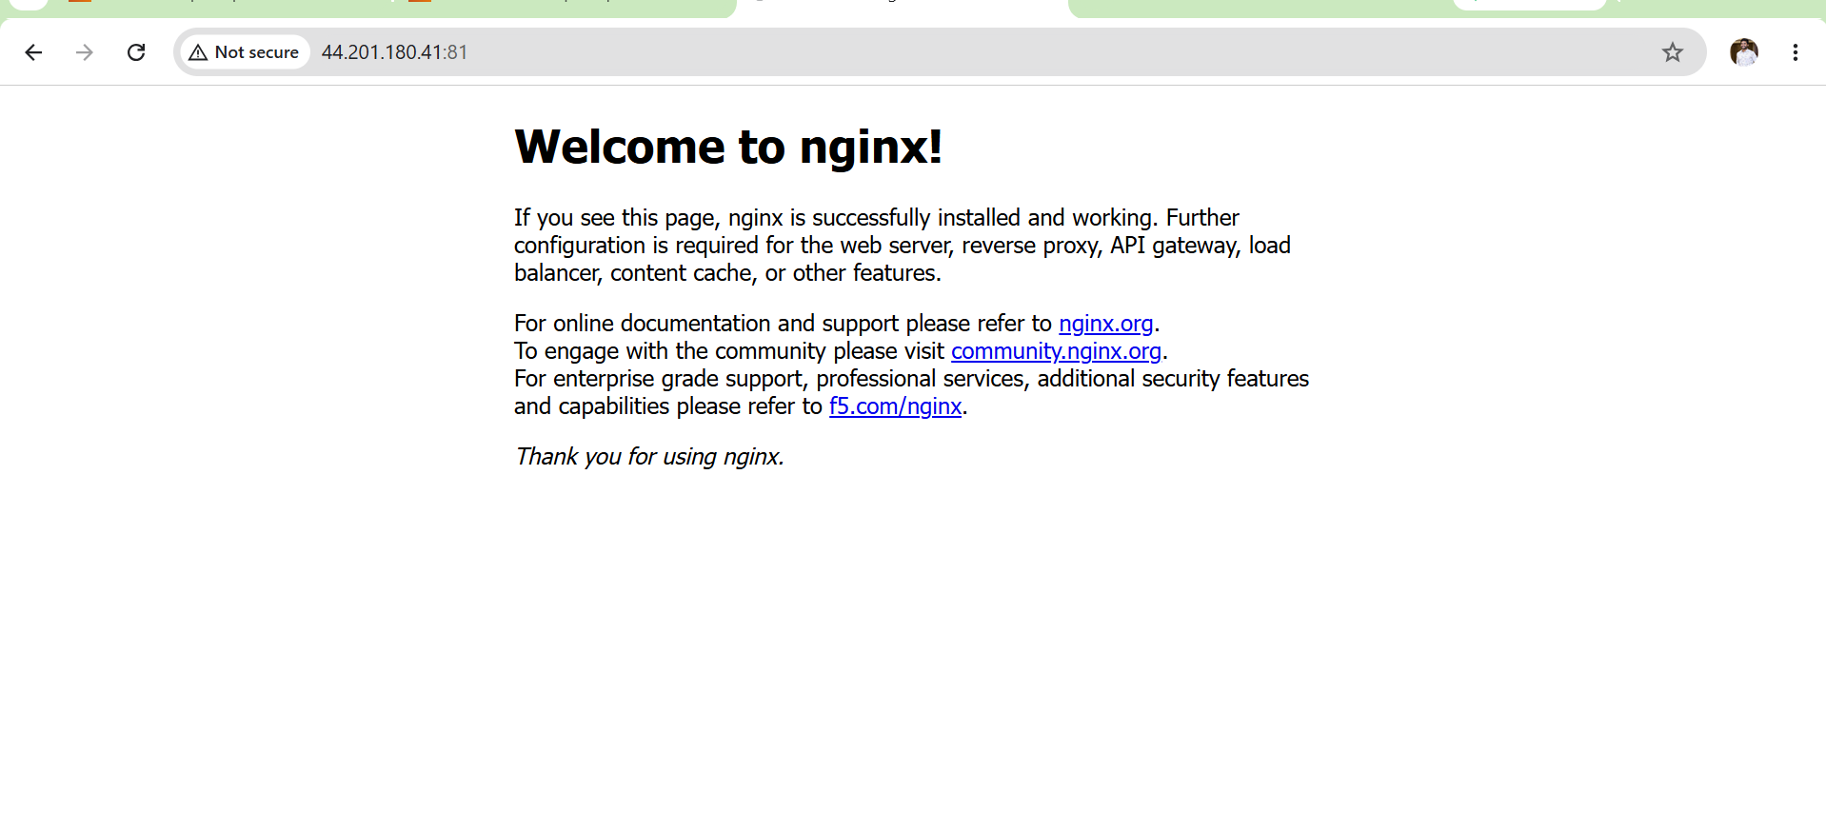

Outcome
After completing Task 4:
- Successfully created and started an Nginx Docker container.
- Exposed the Nginx service on EC2 port 81.
- Verified container status and port mapping.
- Successfully accessed the Nginx default web page from both the EC2 instance and an external web browser.
Task 5: Delete the Apache Tomcat Image from Local
Objective
To remove the Apache Tomcat Docker image from the local Docker image repository to understand how to manage and clean up unused Docker images.
What is docker rmi?
docker rmi stands for Docker Remove Image.
It removes Docker images that are stored locally on the Docker host.
Syntax
docker rmi <image-name>
or
docker image rm <image-name>
Both commands perform the same function.
Prerequisites
- Ubuntu EC2 instance is running.
- Docker is installed.
- Apache Tomcat image has already been downloaded.
- No running container is using the Tomcat image.
Implementation Steps
- Connected to the Ubuntu EC2 instance using SSH.
- Verified the available Docker images using docker images.
- Checked whether any running or stopped container was using the Tomcat image using docker ps -a.
- Removed the Apache Tomcat Docker image using docker rmi tomcat.
- Verified that the Tomcat image was successfully deleted by executing docker images.
- Confirmed that the remaining Docker images (Nginx, Ubuntu, Jenkins, and SonarQube) were still available in the local Docker image repository.

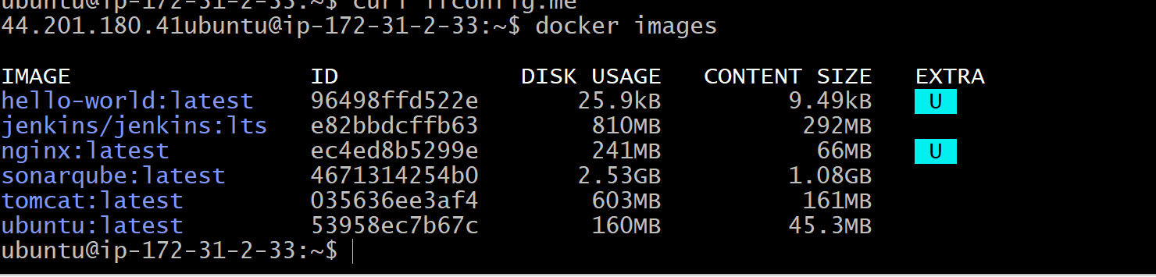
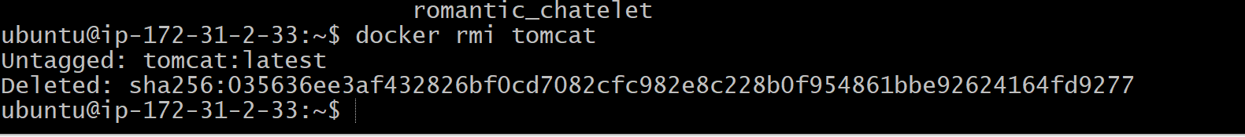
Validation Points
- Verified that the Tomcat image existed before deletion.
- Confirmed no running or stopped container was using the Tomcat image.
- Successfully removed the Tomcat Docker image.
- Verified that the Tomcat image no longer appeared in the output of docker images.

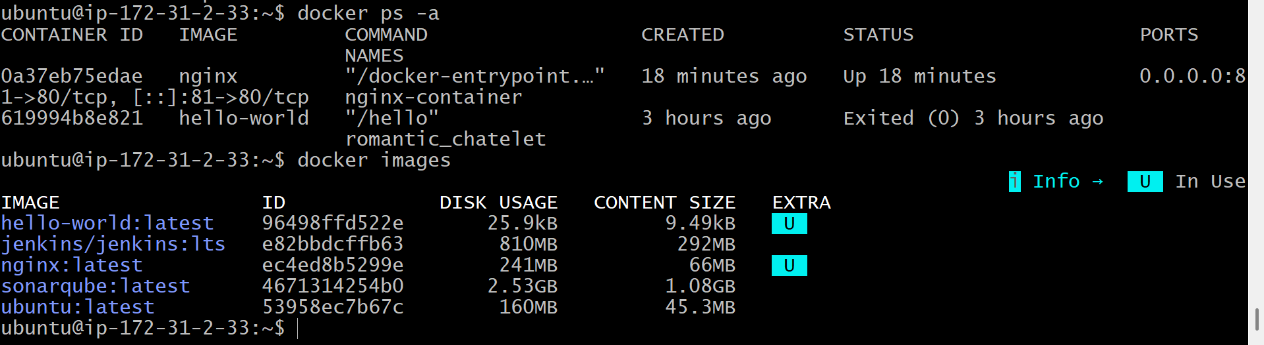
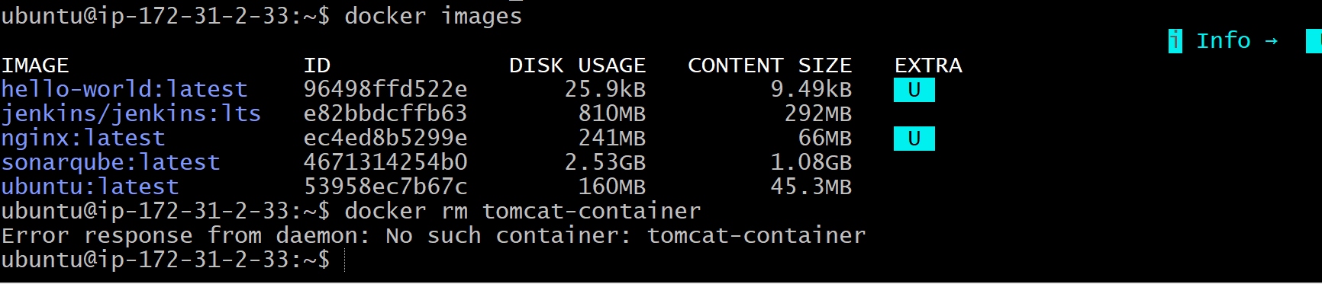
Outcome
After completing Task 5:
- Successfully removed the Apache Tomcat image from the local Docker image repository.
- Verified that only the required images (Nginx, Ubuntu, Jenkins, and SonarQube) remained.
- Learned how to safely delete Docker images and handle image dependency errors.

Task 6: Inspect the Jenkins Image and SonarQube Image
Objective
To inspect the Jenkins and SonarQube Docker images and view detailed metadata such as image ID, creation date, architecture, operating system, environment variables, default command, labels, layers, and other configuration details.
What is docker inspect?
The docker inspect command displays detailed information in JSON format about Docker objects such as:
- Images
- Containers
- Networks
- Volumes
For this task, we will inspect Docker images.
Why Use docker inspect?
It helps DevOps engineers to:
- Verify image configuration.
- View environment variables.
- Identify exposed ports.
- Check image architecture.
- Review Docker image metadata.
- Troubleshoot image-related issues.

Prerequisites
- Ubuntu EC2 instance is running.
- Docker service is active.
- Jenkins image has been pulled.
- SonarQube image has been pulled.
Implementation Steps
- Connected to the Ubuntu EC2 instance using SSH.
- Verified that the Jenkins and SonarQube Docker images were available using docker images.
- Inspected the Jenkins Docker image using docker inspect jenkins/jenkins:lts.
- Reviewed the Jenkins image metadata, including Image ID, Operating System, Architecture, Environment Variables, and Configuration.
- Inspected the SonarQube Docker image using docker inspect sonarqube.
- Reviewed the SonarQube image metadata, including Image ID, Operating System, Architecture, Environment Variables, and Configuration.
- Confirmed that detailed image information was successfully displayed in JSON format for both Docker images.

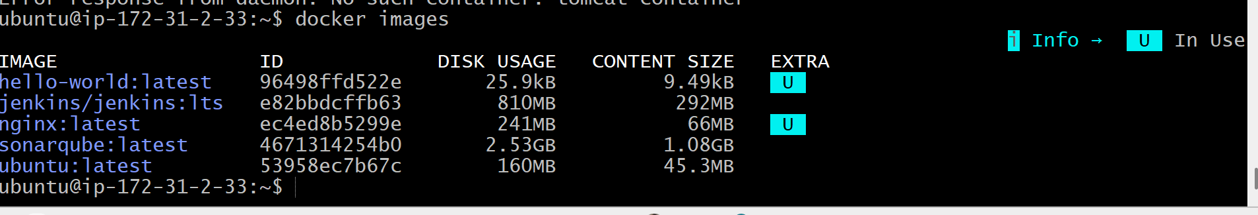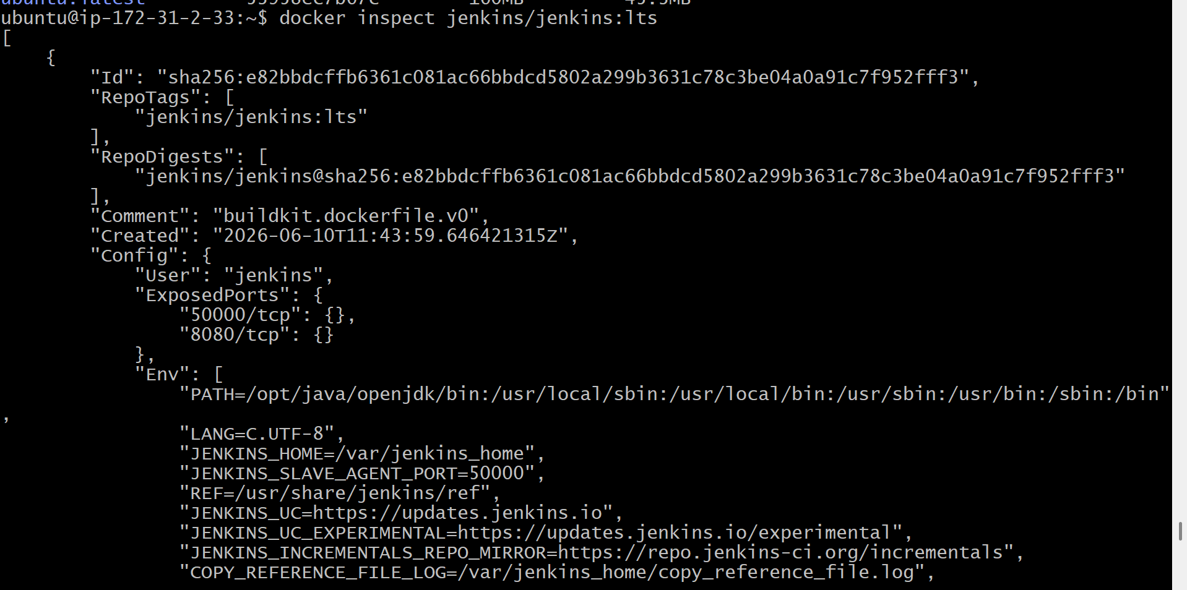
Validation Points
- Verified that the Jenkins image exists.
- Successfully inspected the Jenkins Docker image.
- Verified that the SonarQube image exists.
- Successfully inspected the SonarQube Docker image.
- Confirmed that image metadata such as Image ID, OS, Architecture, Configuration, and Environment Variables was displayed.

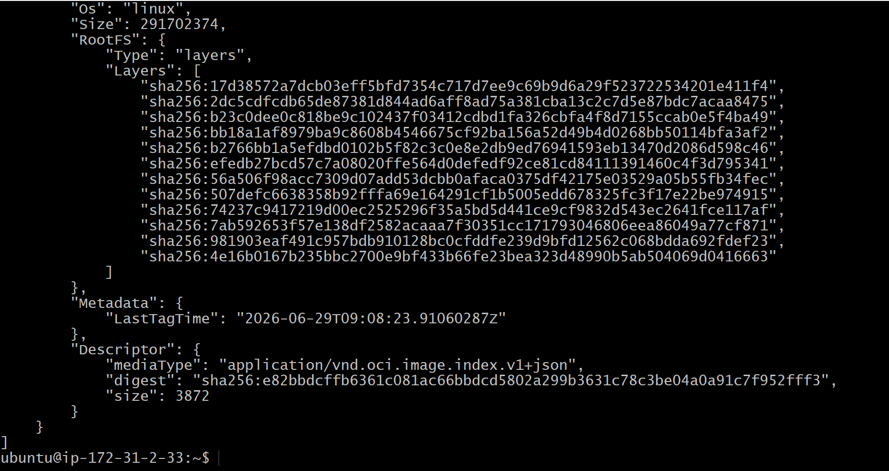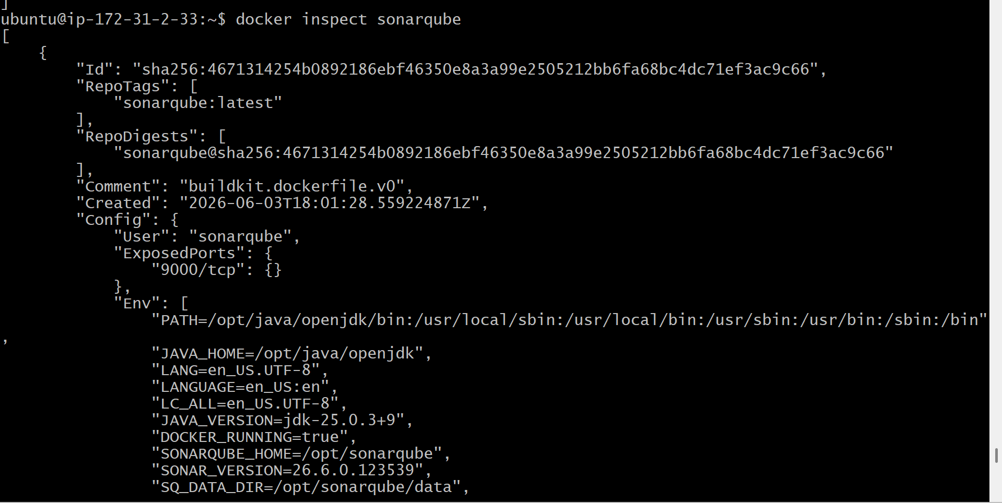
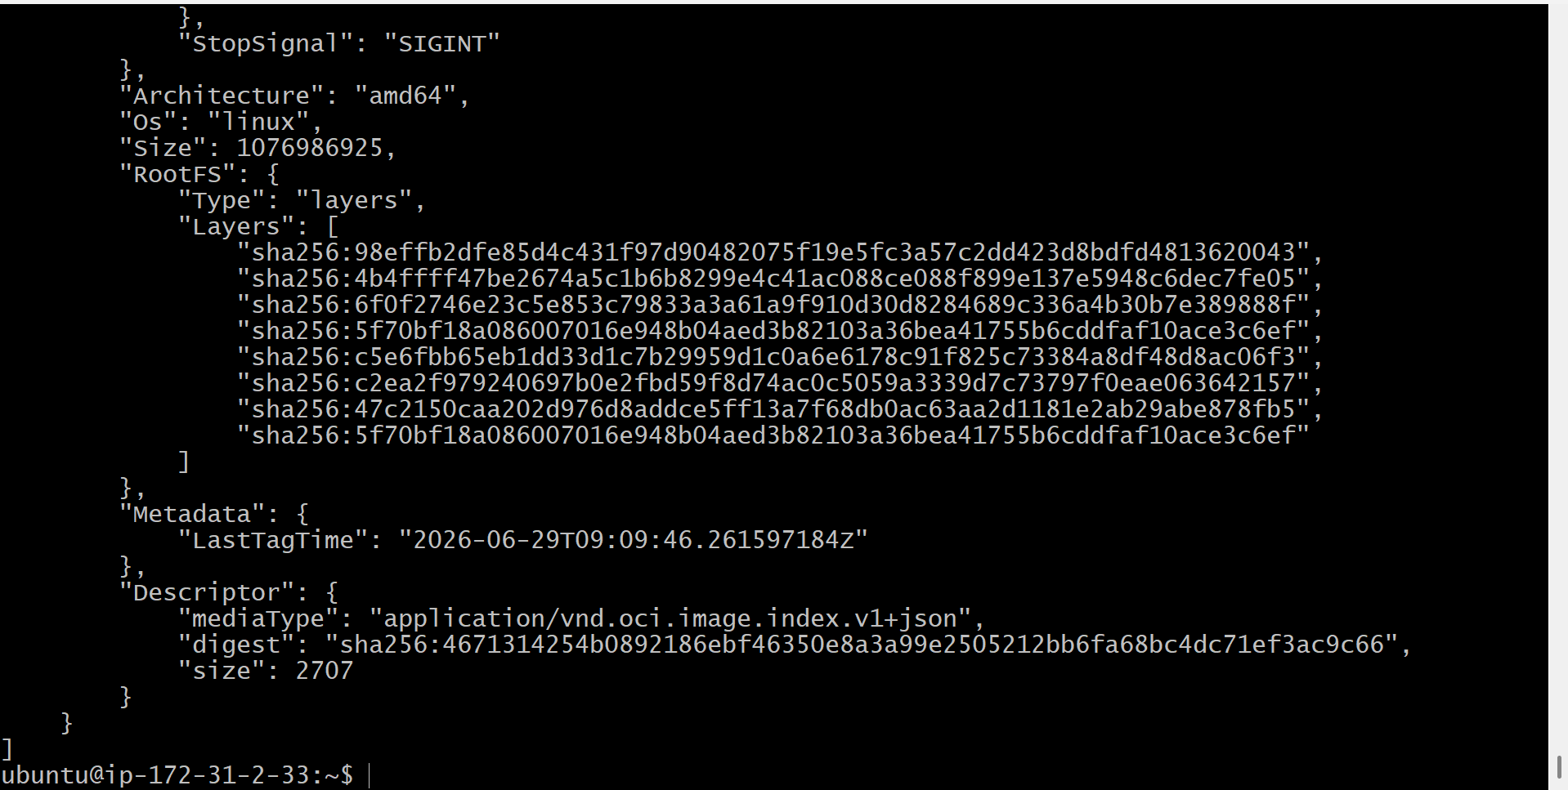

Outcome
After completing Task 6:
- Successfully inspected the Jenkins Docker image.
- Successfully inspected the SonarQube Docker image.
- Viewed detailed image metadata in JSON format.
- Learned how to examine Docker image configuration for troubleshooting and verification.

Task 7: Run Jenkins Container and Execute a Sample Job
Objective
To create and run a Jenkins Docker container, access the Jenkins web interface, complete the initial configuration, install the recommended plugins, create a sample Freestyle job, and execute the job successfully.
Prerequisites
- Ubuntu EC2 instance is running.
- Docker is installed and running.
- Jenkins Docker image (jenkins/jenkins:lts) has already been pulled.
- EC2 Security Group allows:
  - Port 8080 (Jenkins Web UI)
Implementation Steps
- Connected to the Ubuntu EC2 instance (or local Docker host) and verified that the Jenkins Docker image was available using docker images.
- Checked for any existing Jenkins container using docker ps -a.
- Removed the existing Jenkins container (if present) using docker rm -f jenkins.
- Created and started the Jenkins container using docker run -d --name jenkins -p 8080:8080 jenkins/jenkins:lts.
- Verified that the Jenkins container was running successfully using docker ps.
- Retrieved the Jenkins initial administrator password using docker exec jenkins cat /var/jenkins_home/secrets/initialAdminPassword.
- Opened the Jenkins web interface in a browser using http://localhost:8080 (or http://<EC2-Public-IP>:8080 if running on EC2).
- Unlocked Jenkins using the initial administrator password.
- Installed the suggested Jenkins plugins.
- Created the first Jenkins administrator user and completed the initial setup.
- Created a new Freestyle Project named Sample-Job.
- Added an Execute Shell build step with sample shell commands.
- Saved the job configuration and triggered the build using Build Now.
- Verified the build execution through the Console Output and confirmed the build completed with Finished: SUCCESS.

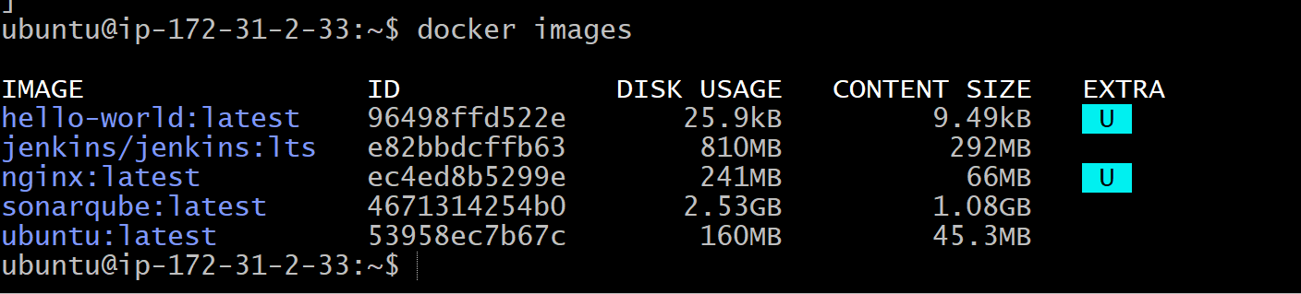

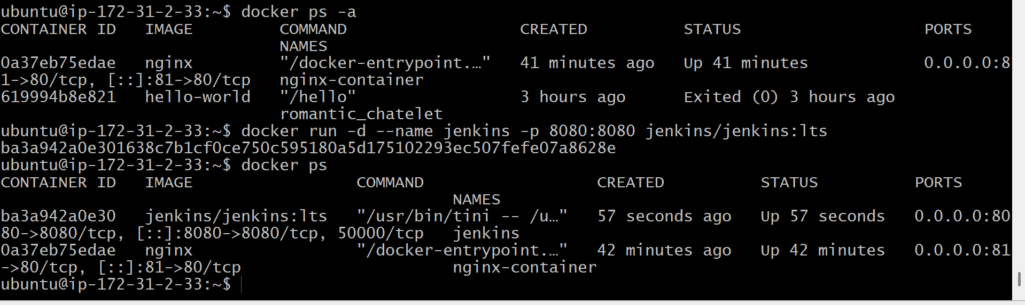
Validation Points
- Jenkins container created successfully.
- Jenkins container is running.
- Jenkins web interface is accessible.
- Initial administrator password retrieved successfully.
- Suggested plugins installed successfully.
- Administrator user created.
- Sample Freestyle job created.
- Job executed successfully.
- Console output displays Finished: SUCCESS.

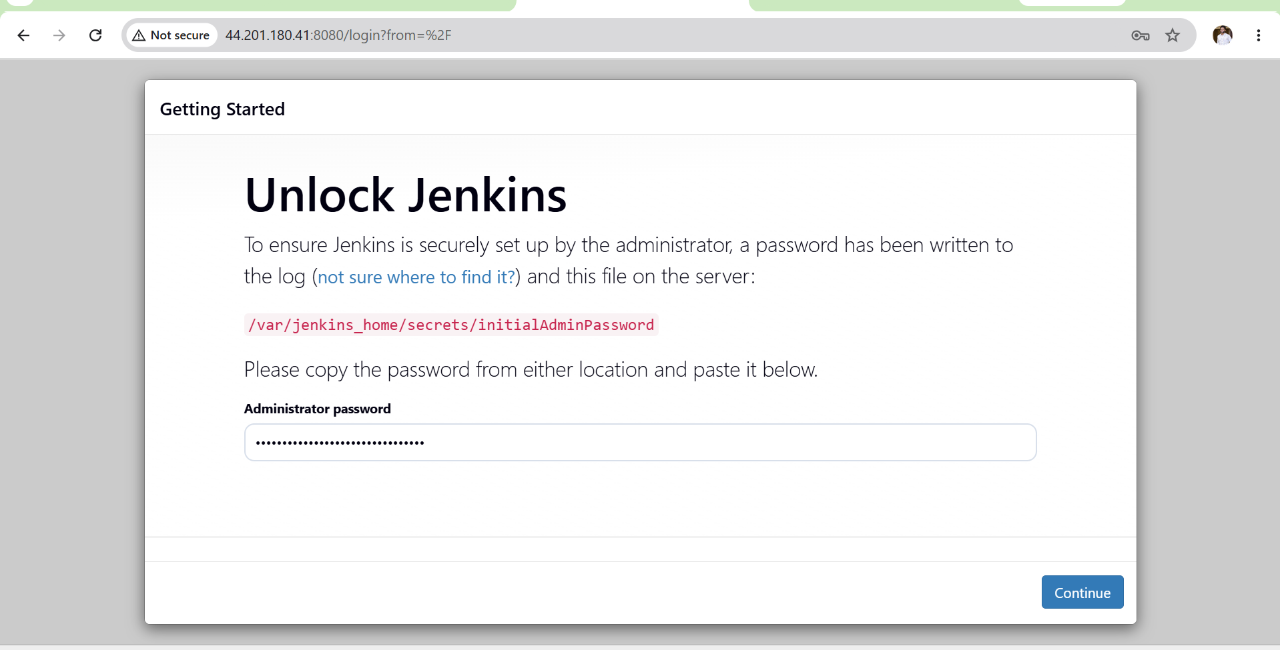
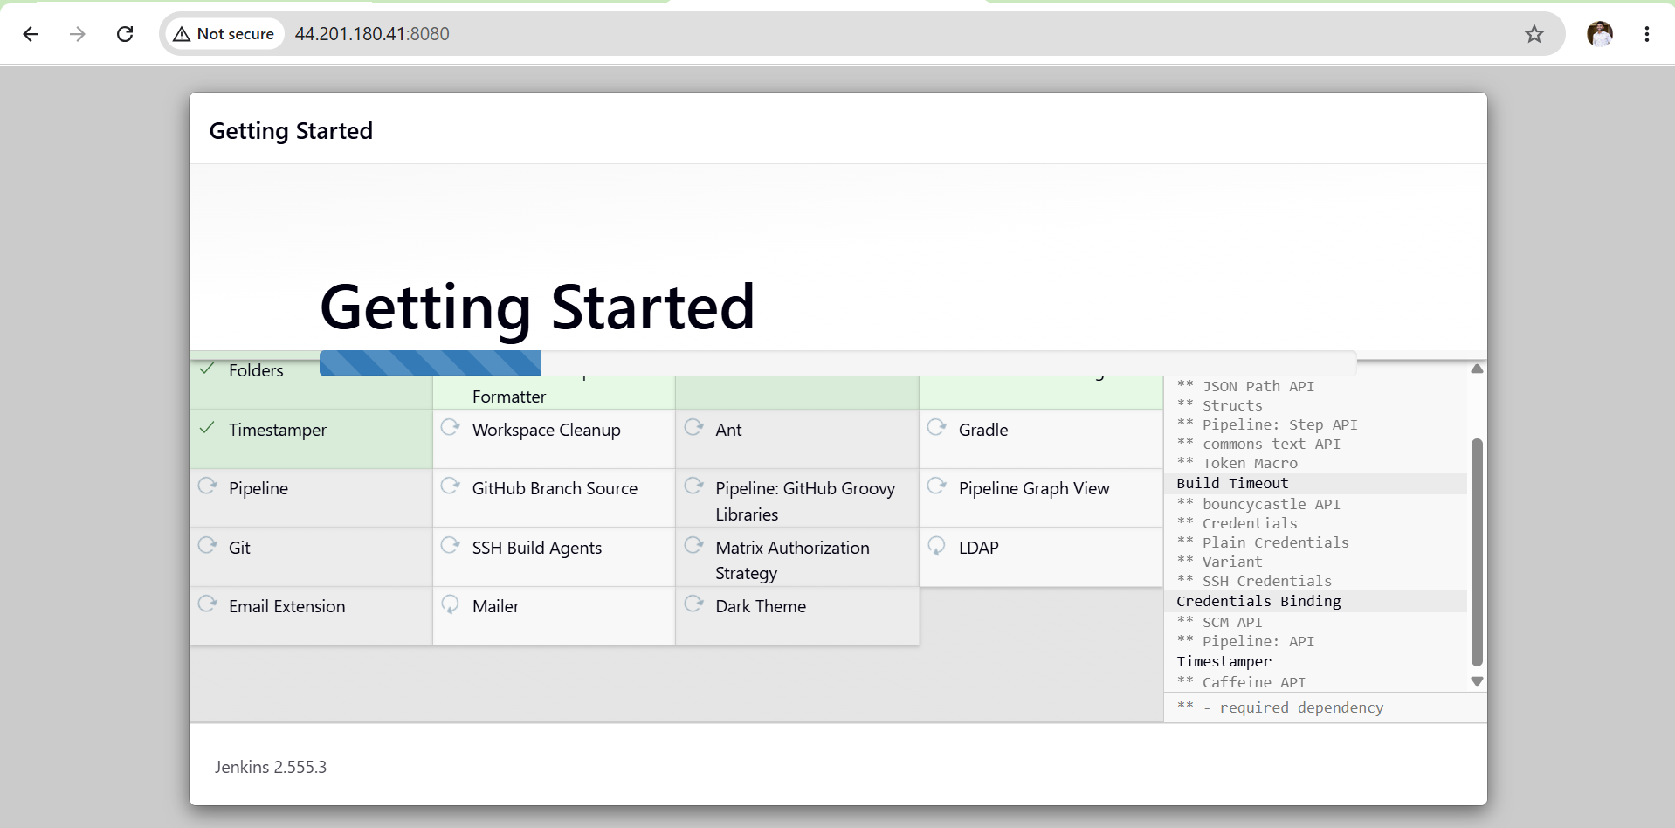
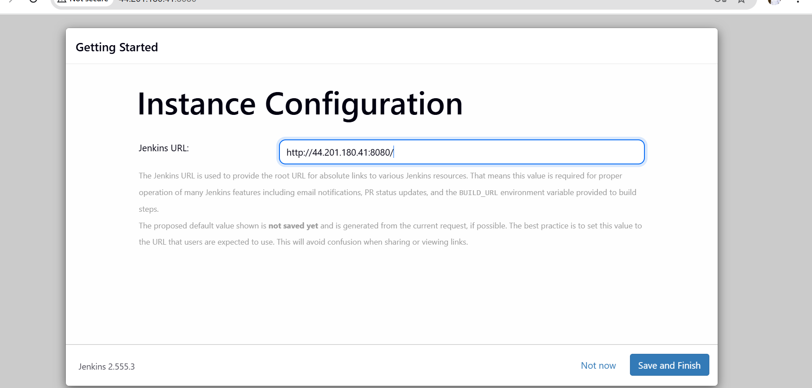
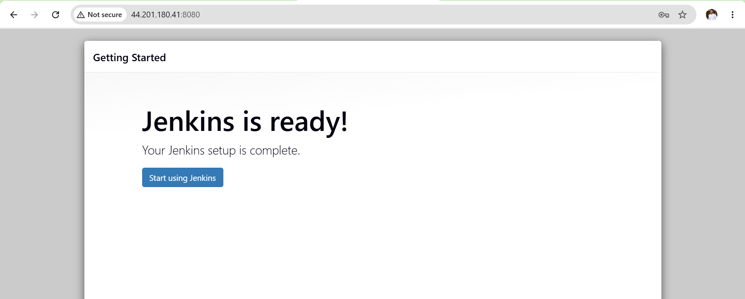
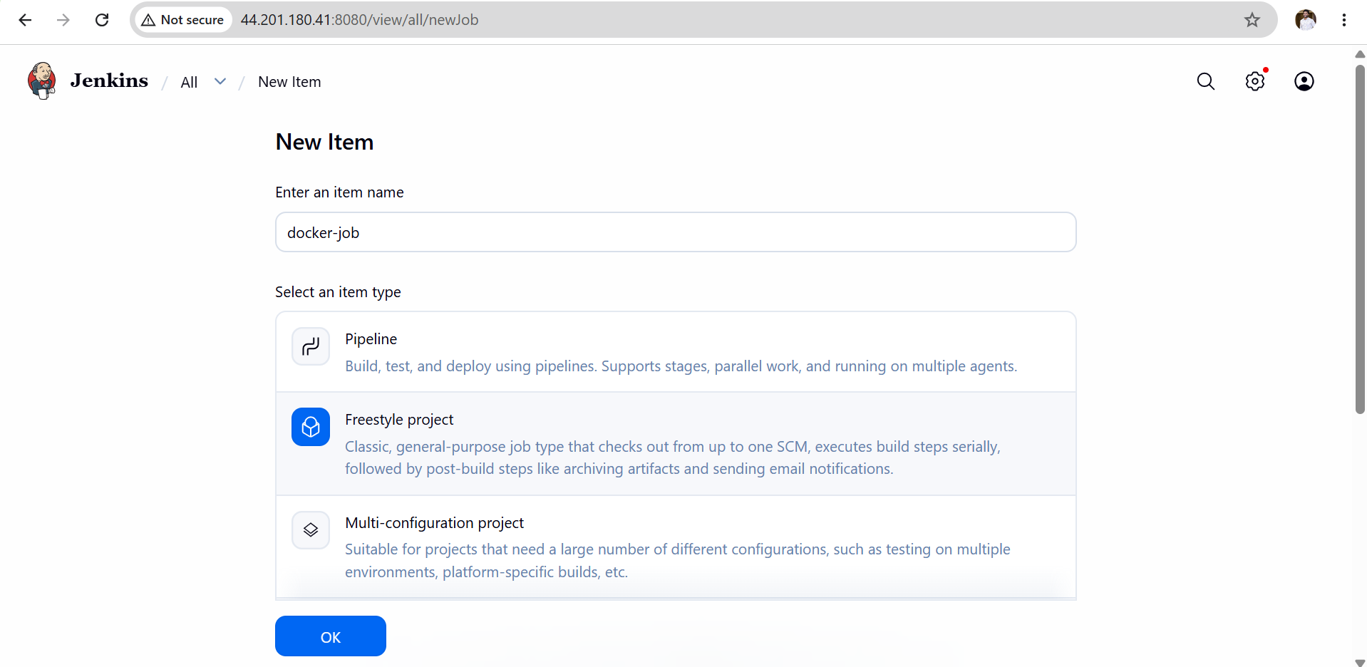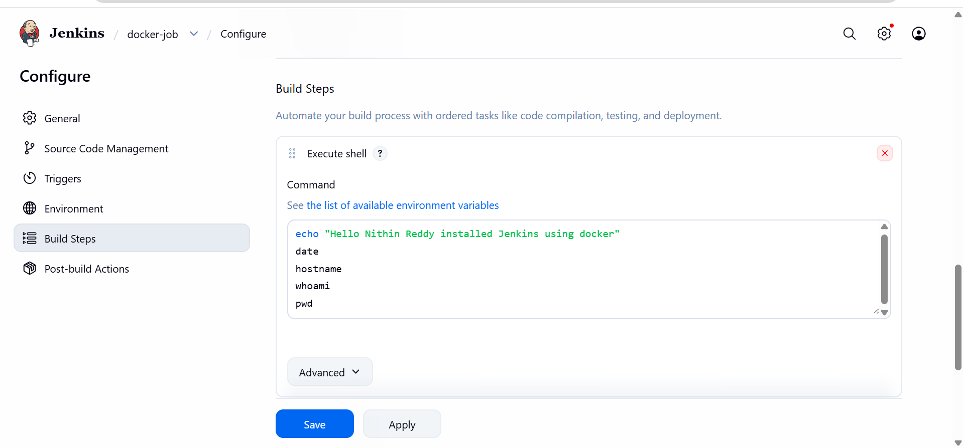

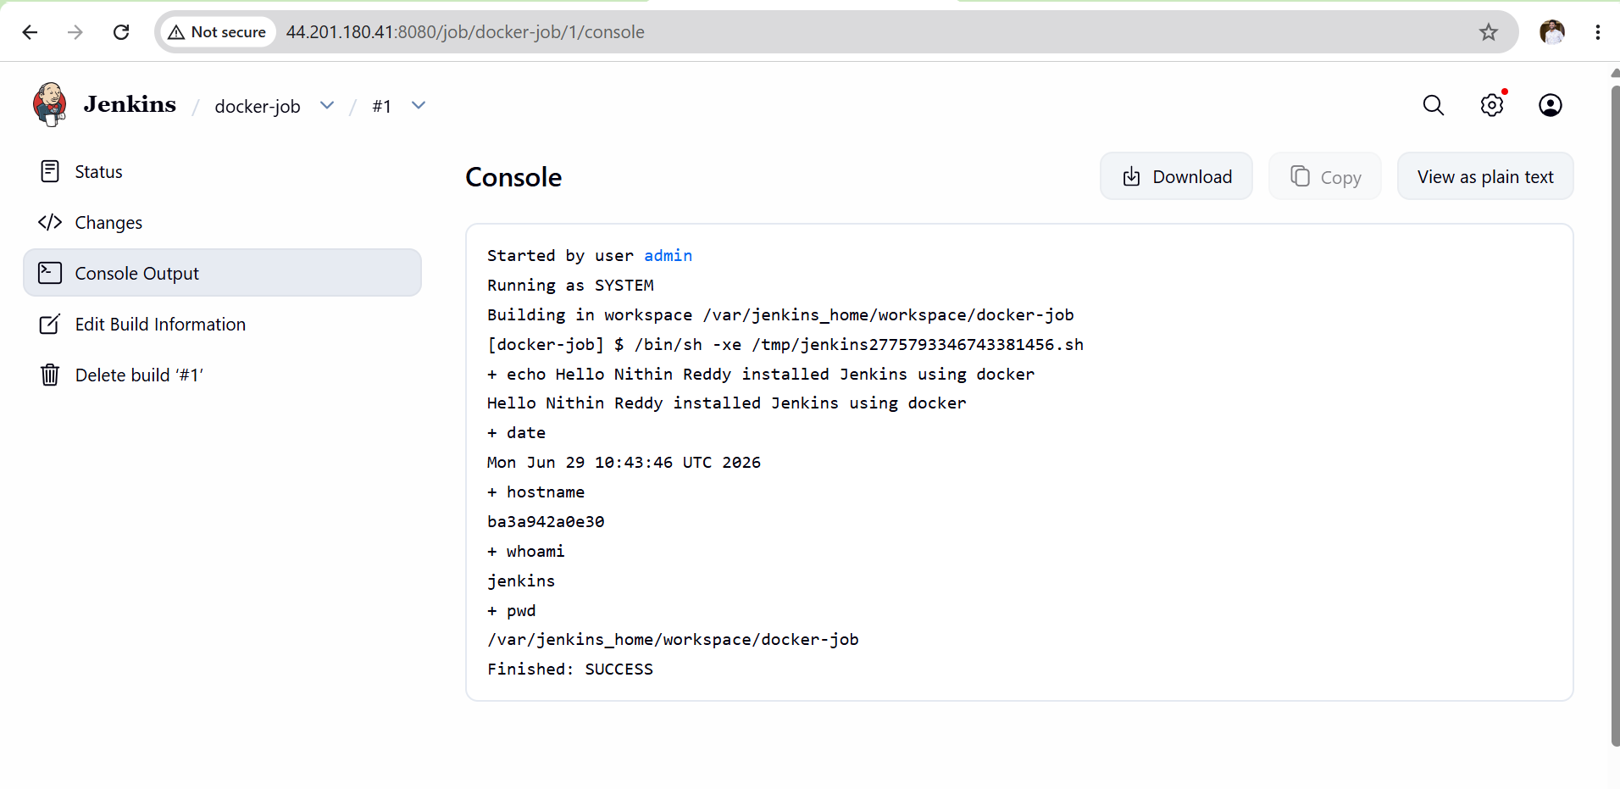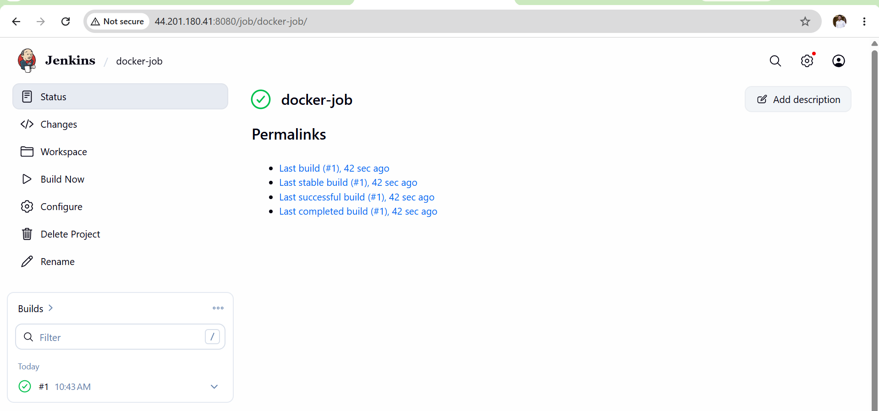
Outcome
After completing Task 7:
- Successfully deployed Jenkins in a Docker container.
- Accessed and configured the Jenkins web interface.
- Installed the recommended plugins.
- Created an administrator account.
- Created and executed a sample Freestyle job.
- Verified successful job execution through the Jenkins console output.

