Challenges-09
Challenge 1 – Create a Customized Docker Image Using a Dockerfile
We will use the Python application from:
https://github.com/betawins/Python-app.git

Objective
- Clone the Python application.
- Write a Dockerfile.
- Build a custom Docker image.
- Run the container.
- Verify the application.
Prerequisites
- Ubuntu EC2 instance is running.
- Docker is installed and running.
- Git is installed.
- Python application source code is cloned.
- Security Group allows inbound traffic on TCP port 8081.
Steps
- Clone the Python application repository.
- Navigate to the project directory.
- Create/customize the Dockerfile.
- Build the Docker image using docker build.
- Verify the image using docker images.
- Run the Docker container using docker run.
- Verify the container using docker ps.
- Access the application through the browser or curl.
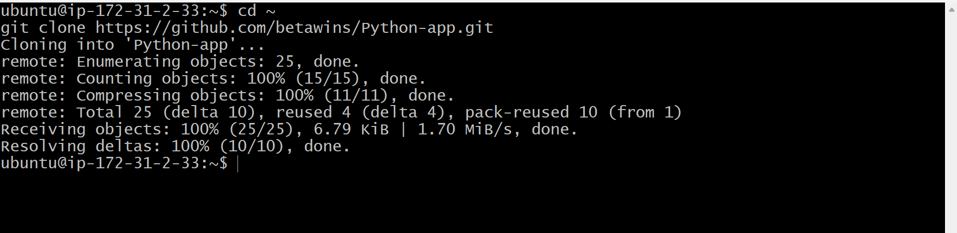
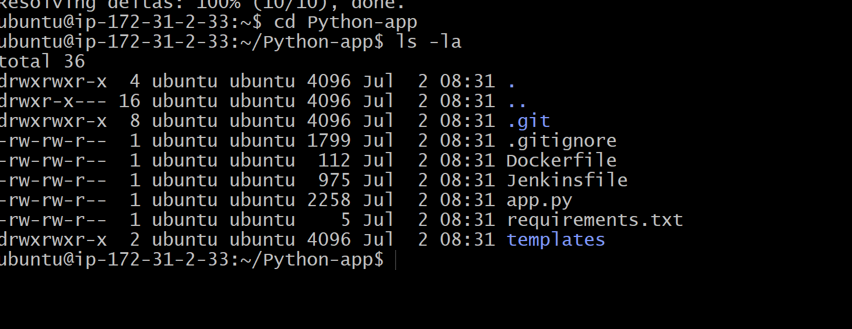
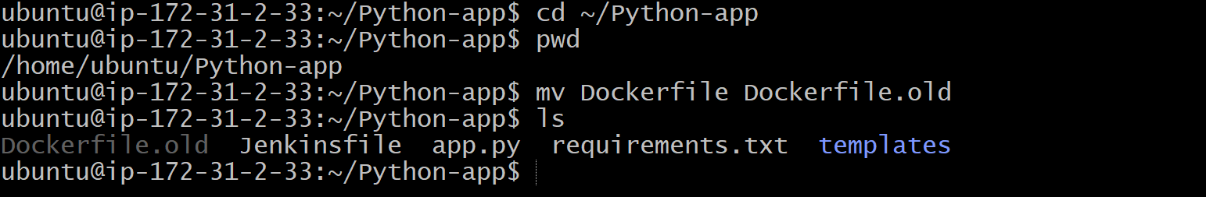
Validation
- ✅ Dockerfile created successfully.
- ✅ Docker image built without errors.
- ✅ Image is visible in docker images.
- ✅ Container is running (docker ps).
- ✅ Application is accessible on http://<EC2-Public-IP>:8081.
- ✅ No errors in docker logs python-container.

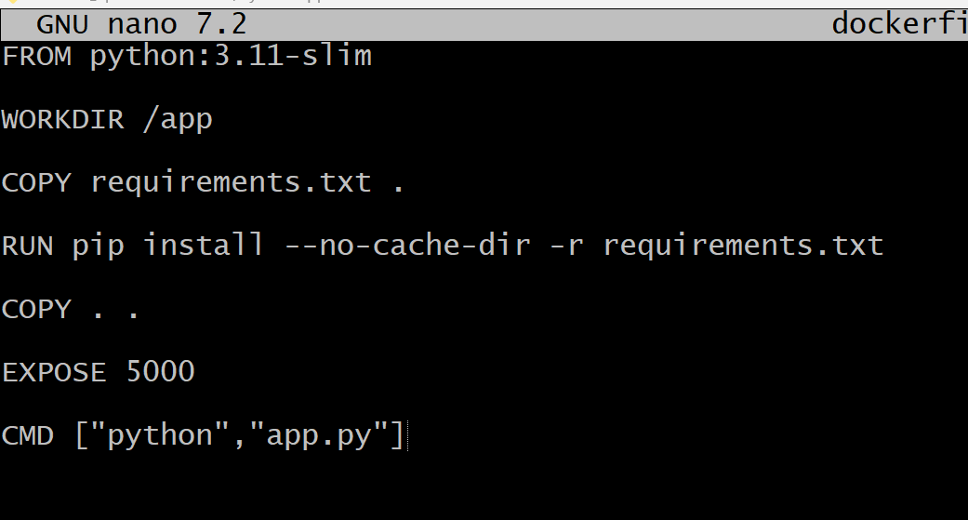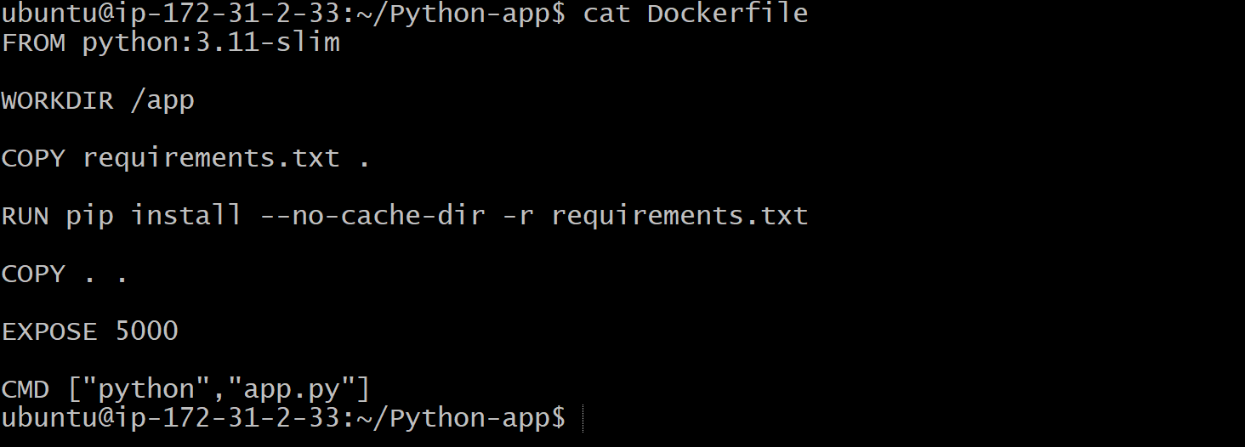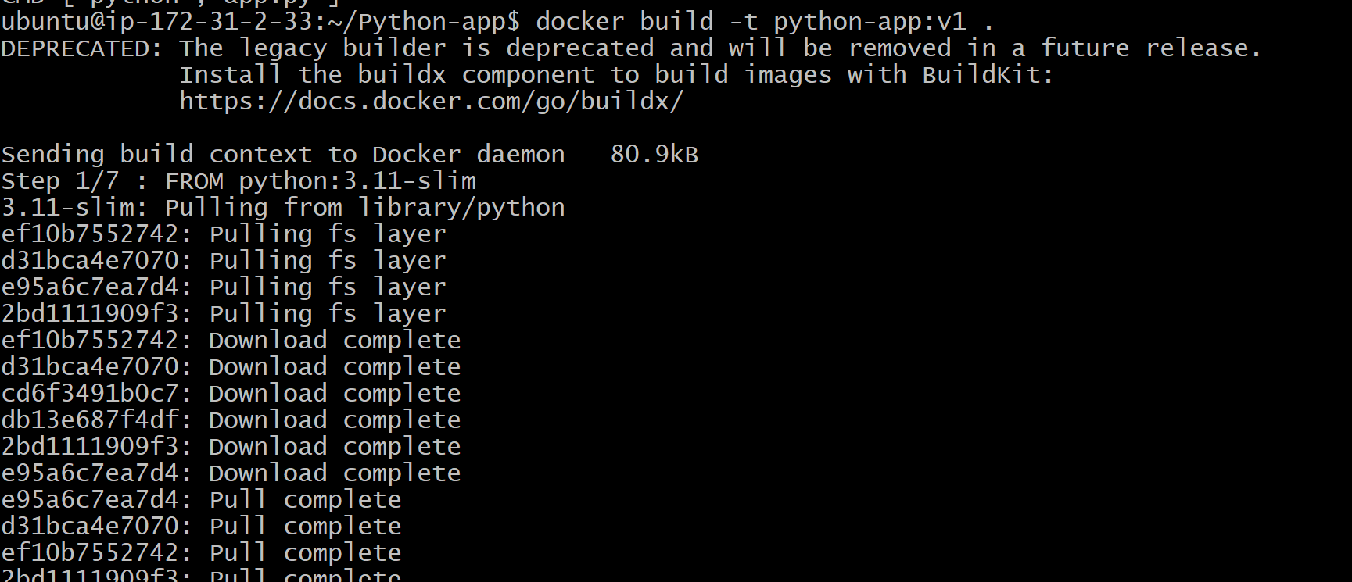
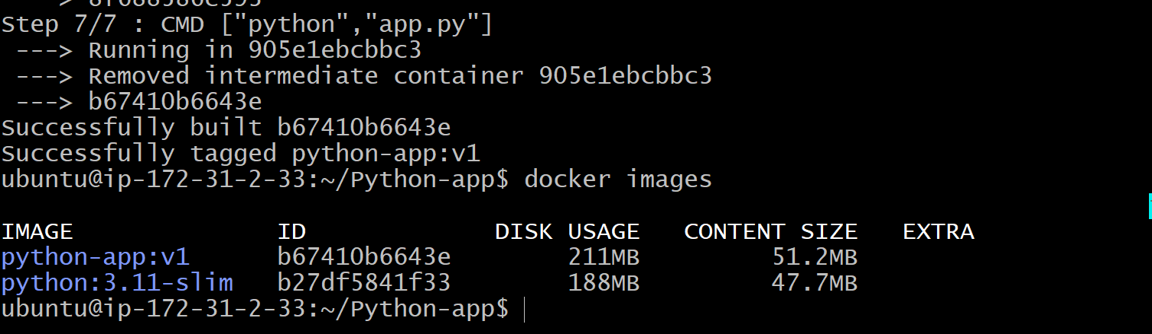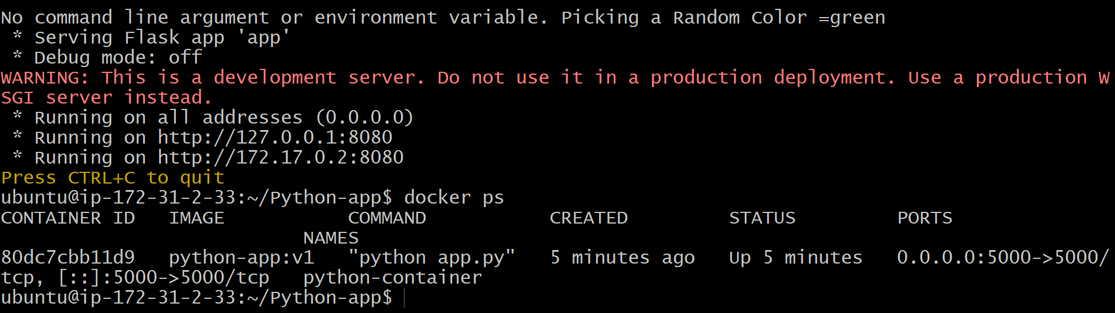
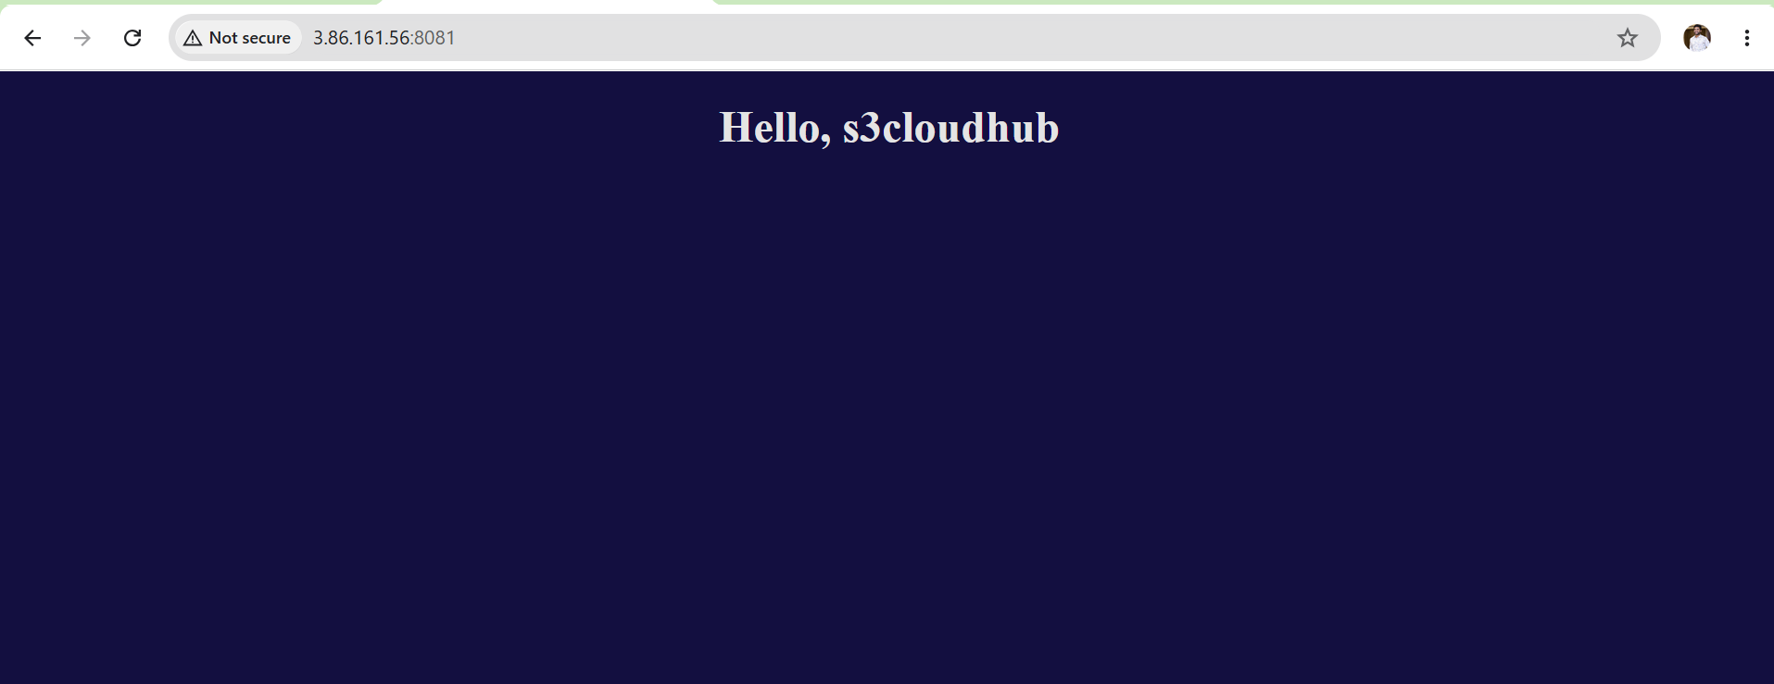
Outcome
- Successfully created a customized Docker image using a Dockerfile.
- Packaged the Python application into a Docker image.
- Deployed the application in a Docker container.
- Verified the application is running and accessible.
- Prepared the image for the next challenges (Docker Hub and Amazon ECR push).

Challenge 2 Push the Docker Image to Docker Hub
Objective
Since I already have:
- ✅ A Docker Hub account (nithinreddy9)
- ✅ Docker installed
- ✅ Docker login experience from previous tasks
this task will be straightforward.
Prerequisites
- Docker is installed.
- Docker image (python-app:v1) is available locally.
- Docker Hub account is available.
- Docker Hub Personal Access Token (PAT) is created.
- Logged in to Docker Hub.
Steps
- Verify the Docker image exists.
- Log in to Docker Hub.
- Tag the image with the Docker Hub repository name.
- Push the image to Docker Hub.
- Verify the image in the Docker Hub repository.
- Capture a screenshot of the repository and tag

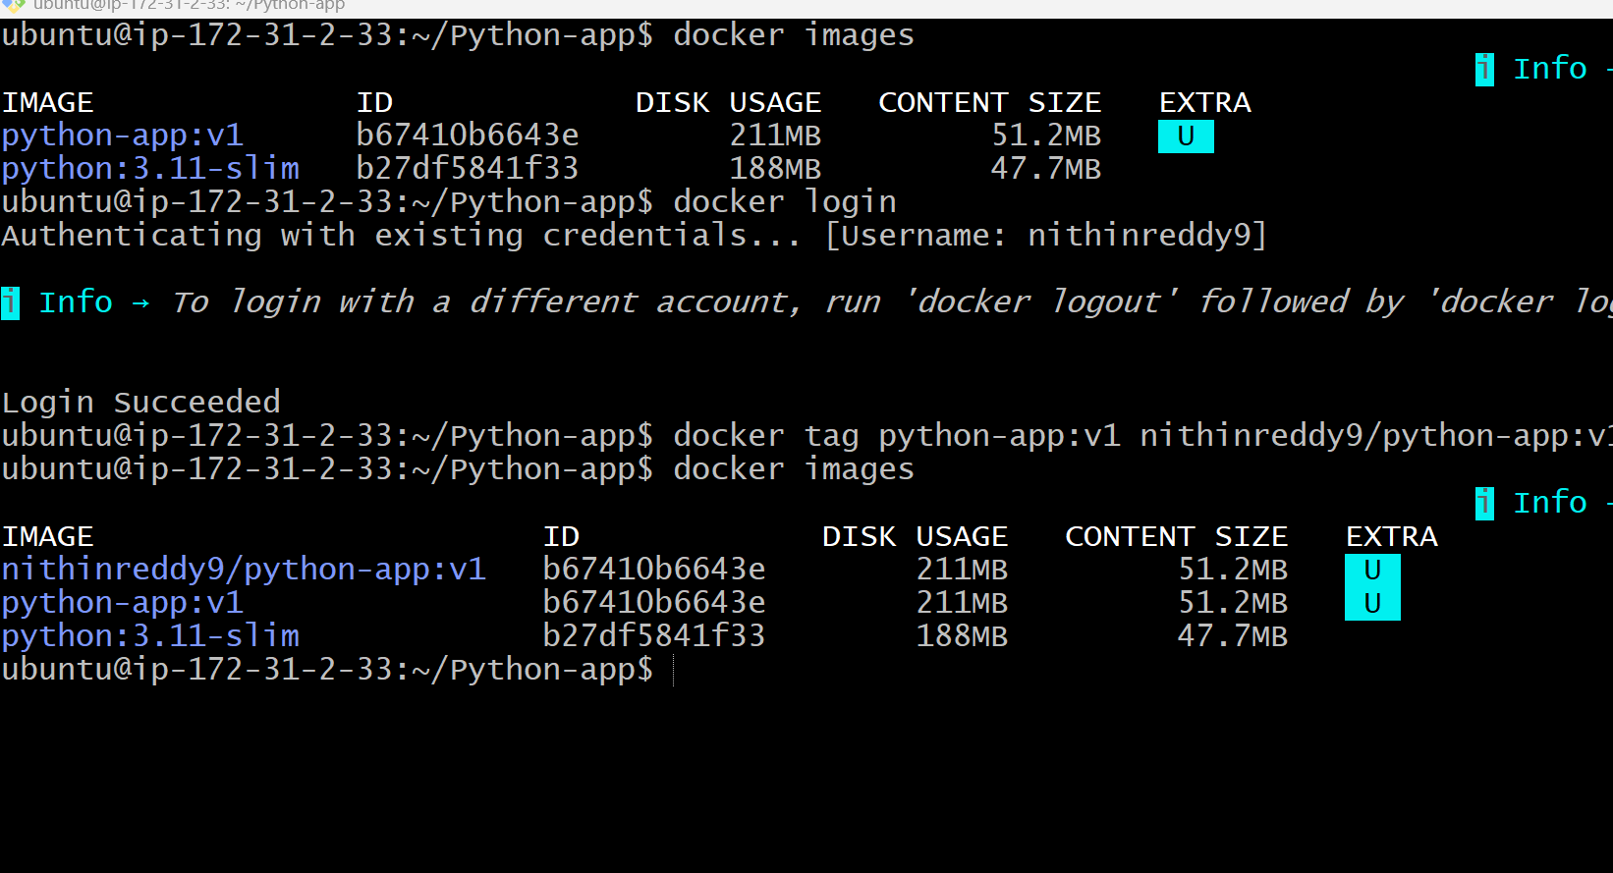

Validation
- ✅ Docker login successful.
- ✅ Image tagged successfully.
- ✅ Image pushed without errors.
- ✅ Repository visible in Docker Hub.
- ✅ v1 tag is displayed in the repository.

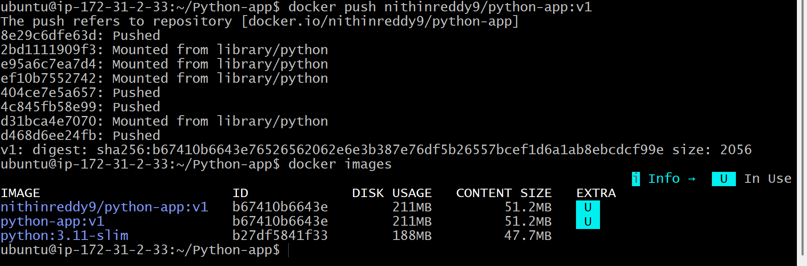
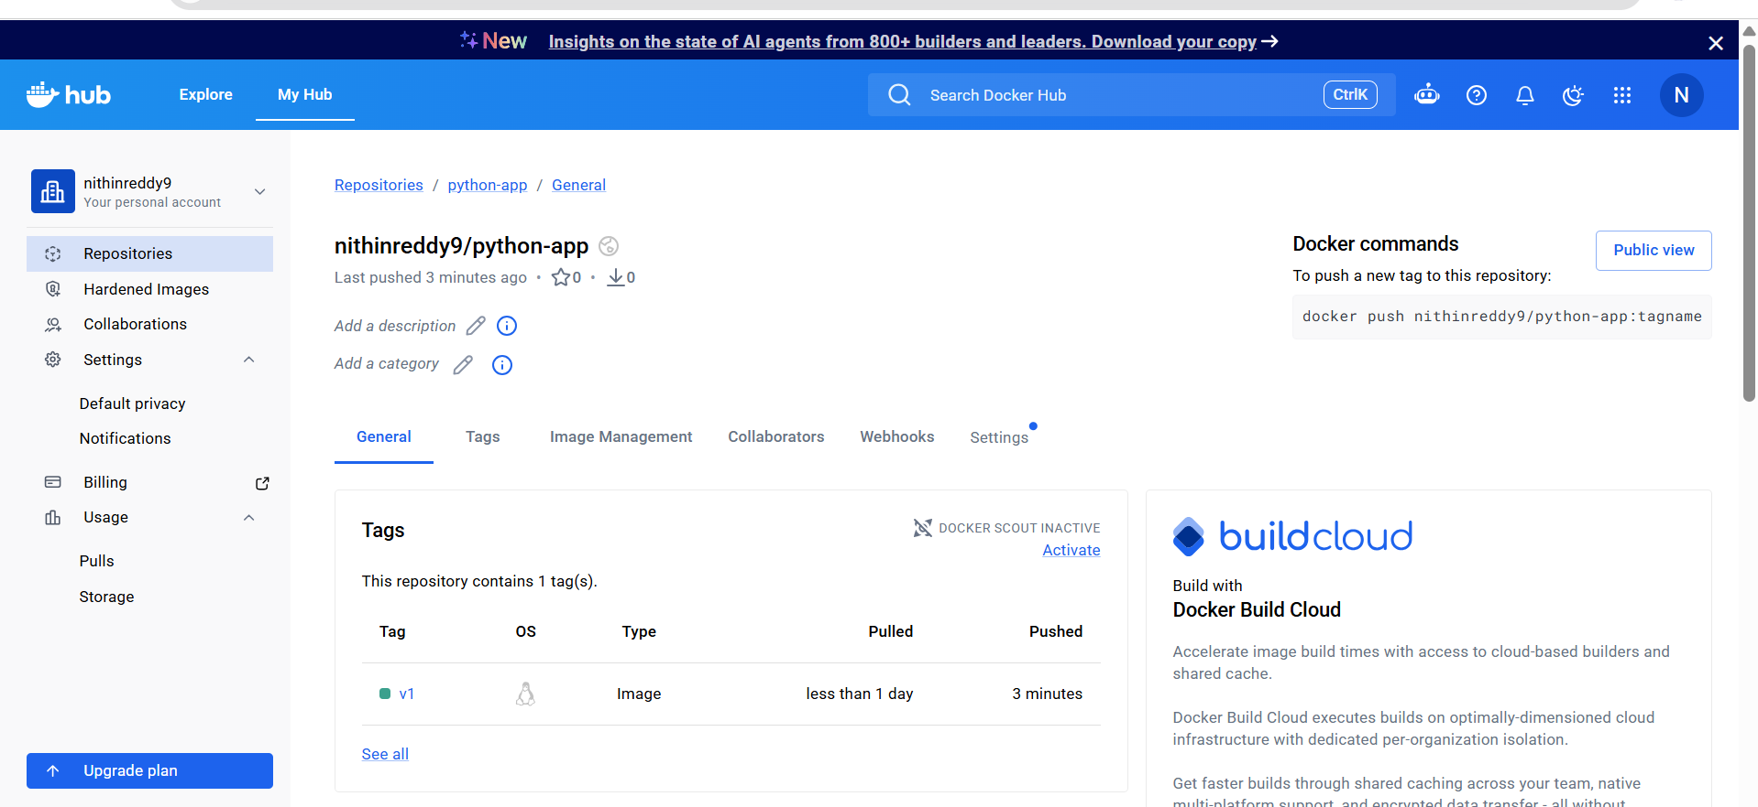
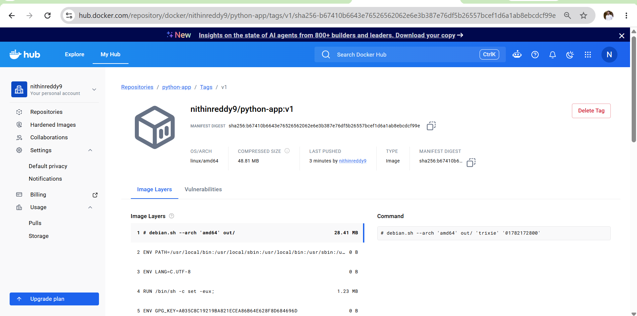
Outcome
- Successfully authenticated with Docker Hub.
- Tagged the local Docker image for Docker Hub.
- Uploaded the Docker image to Docker Hub.
- Verified the image is available in the remote Docker Hub repository.
- Prepared the image for deployment and for the next challenge (pushing to Amazon ECR).

Challenge 3
Push the Same Docker Image to Amazon ECR
Prerequisites
- ✅ AWS CLI installed.
- ✅ Docker installed.
- ✅ IAM user with ECR permissions.
- ✅ AWS CLI configured (aws configure).
- ✅ Docker image python-app:v1 exists locally.
- ✅ Amazon ECR repository is available (or create one if it doesn't exist).
Steps
- Verify AWS CLI configuration.
- Verify or create the ECR repository.
- Log in to Amazon ECR.
- Tag the Docker image with the ECR repository URI.
- Push the image to Amazon ECR.
- Verify the image in the ECR repository.
- Capture a screenshot of the ECR repository and image tag.

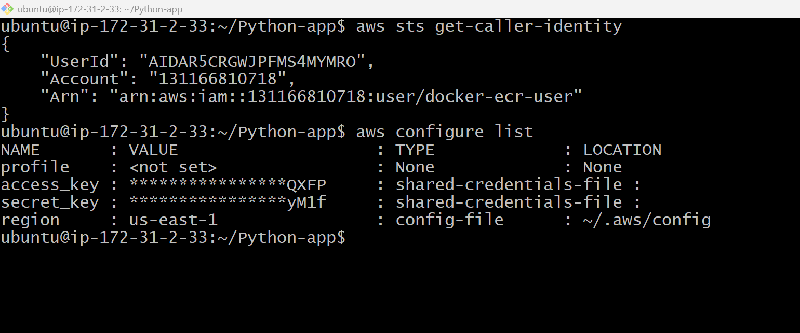
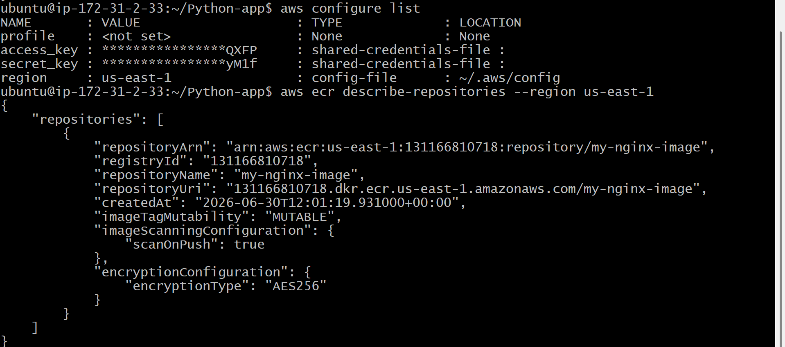
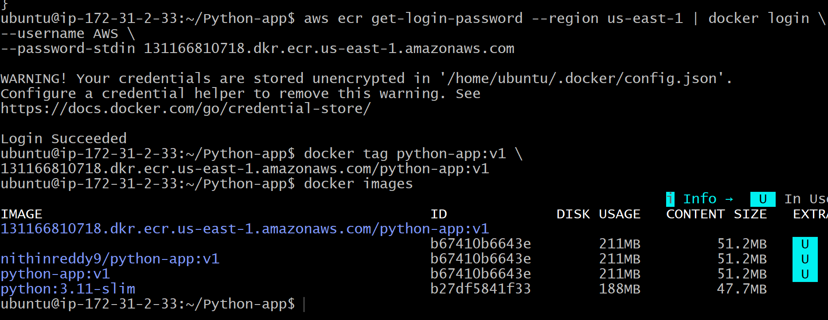
Validation
- ✅ AWS CLI configured correctly.
- ✅ ECR repository exists.
- ✅ Docker login to ECR successful.
- ✅ Docker image tagged successfully.
- ✅ Docker image pushed successfully.
- ✅ Image visible in the Amazon ECR repository.

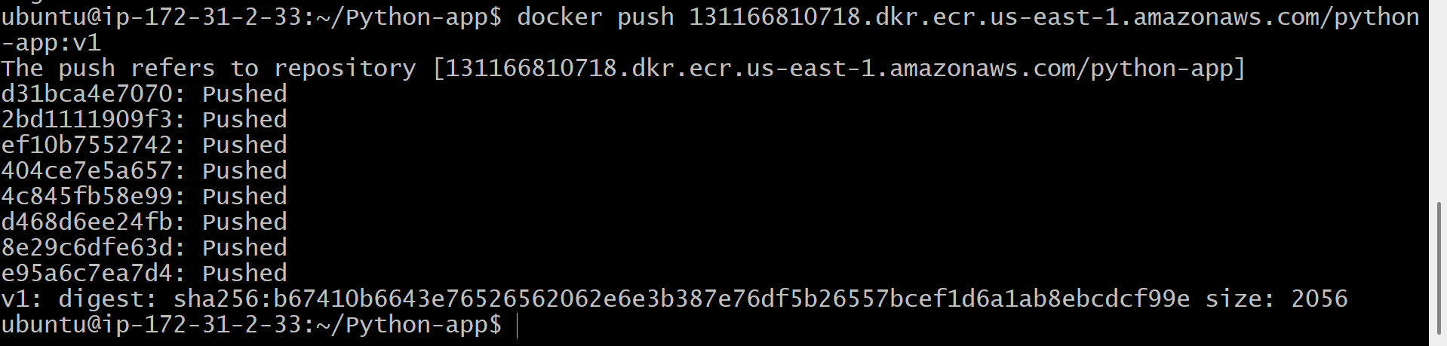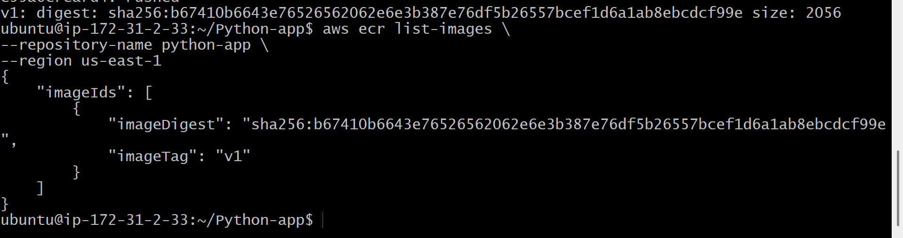
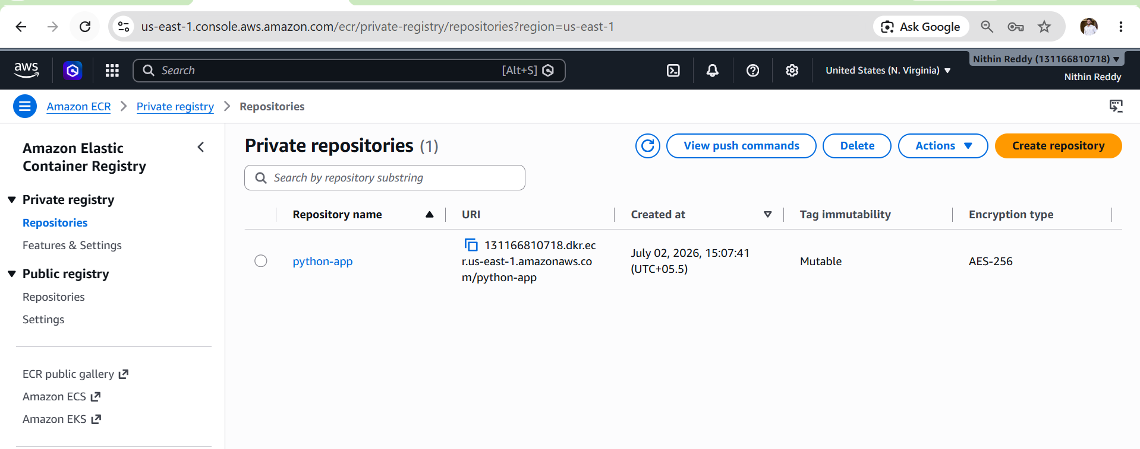

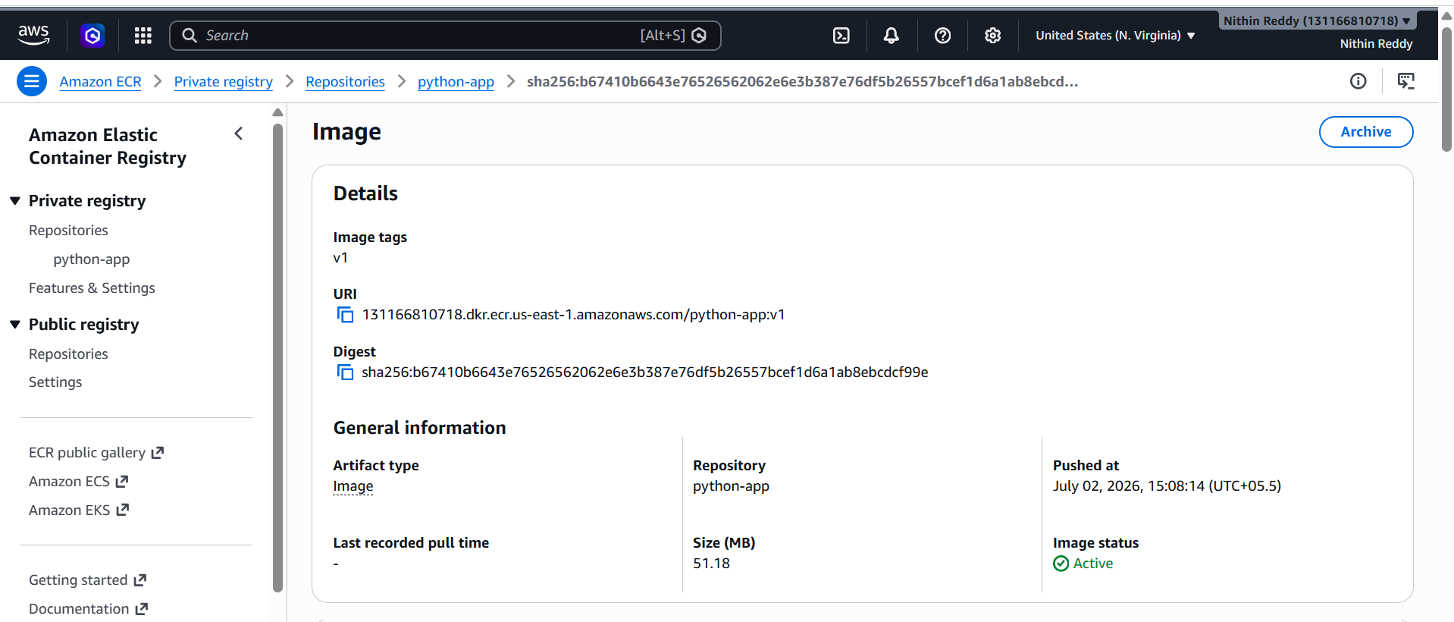
Outcome
- Successfully authenticated with Amazon ECR.
- Tagged the local Docker image with the ECR repository URI.
- Pushed the Docker image to Amazon ECR.
- Verified the image is stored in the private ECR repository.
- Prepared the image for deployment through AWS container services such as Amazon ECS or Amazon EKS.

Challenge 4: Provision One EC2 Instance Using Terraform and Install Jenkins
Objective
Provision an AWS EC2 instance automatically using Terraform instead of creating it manually. After the instance is created, install Jenkins on it and verify that the Jenkins web interface is accessible. This demonstrates Infrastructure as Code (IaC) by automating infrastructure provisioning and basic software installation.
Architecture
Terraform
│
▼
AWS EC2 Instance (Ubuntu)
│
▼
Install Java
│
▼
Install Jenkins
│
▼
Access Jenkins on Port 8080
Prerequisites
- AWS Account
- AWS CLI installed
- AWS CLI configured (aws configure)
- Terraform installed
- Existing EC2 Key Pair (e.g., docker-key)
- Security Group allowing:
  - SSH (22)
  - Jenkins (8080)
- IAM User with permissions for:
  - EC2
  - VPC
  - Security Groups
  - Key Pairs
Steps (Short Points)
- Install and verify Terraform.
- Configure AWS CLI credentials.
- Create a Terraform project directory.
- Create main.tf.
- Configure:
  - AWS provider
  - Security Group (SSH & 8080)
  - EC2 Instance
  - Key Pair
  - Subnet
  - Output (Public IP)
- Run terraform init.
- Run terraform validate.
- Run terraform fmt.
- Run terraform plan.
- Run terraform apply.
- Type yes to create resources.
- Wait for EC2 creation.
- Obtain the EC2 Public IP using terraform output.
- Connect to the EC2 instance via SSH.
- Install Java, Docker, Git, and Jenkins (or attempt automated installation through user_data).

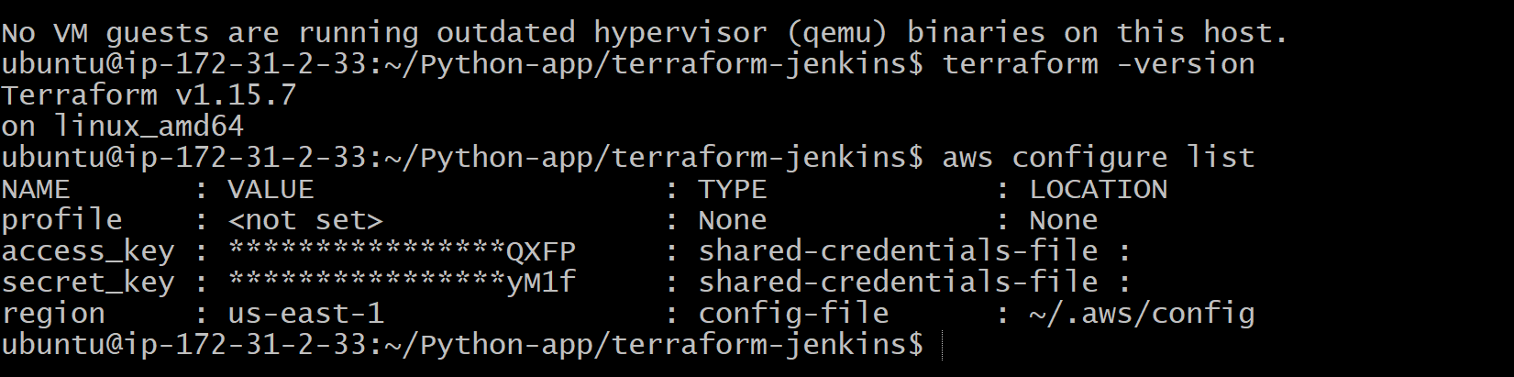
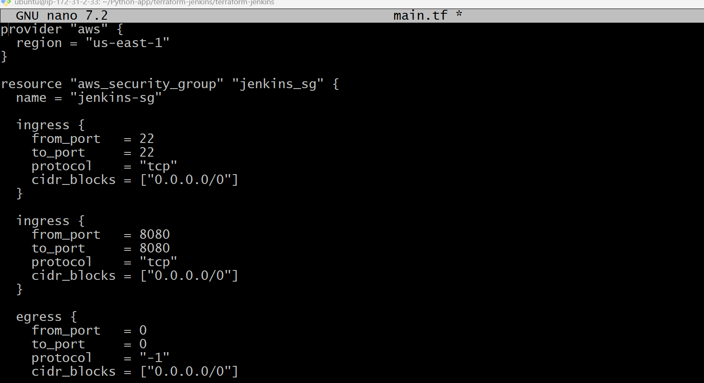
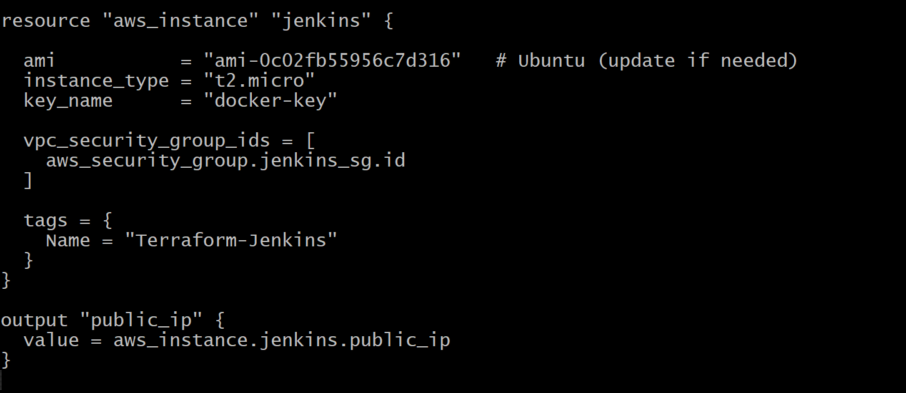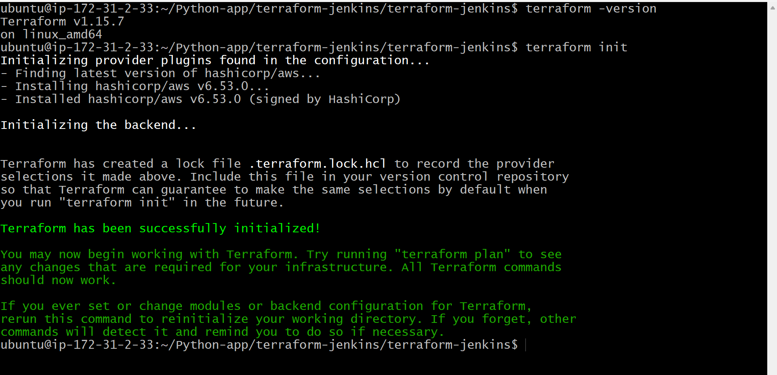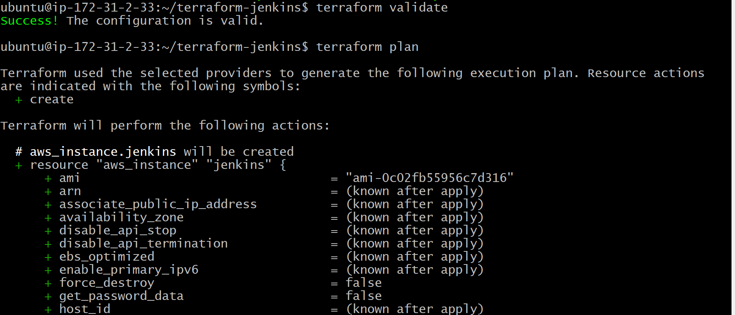

Validation
- ✅ terraform init completed successfully.
- ✅ terraform validate returned Success.
- ✅ terraform plan showed resources to be created.
- ✅ terraform apply created:
  - EC2 Instance
  - Security Group
- ✅ Public IP generated.
- ✅ Successfully connected to the EC2 instance using SSH.
- ✅ Java installed successfully.
- ✅ Docker installed successfully.

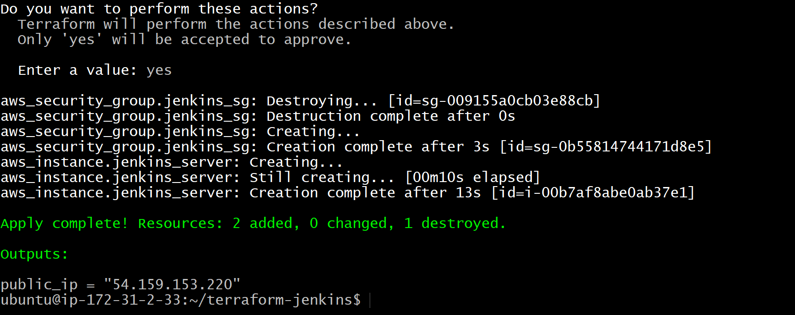
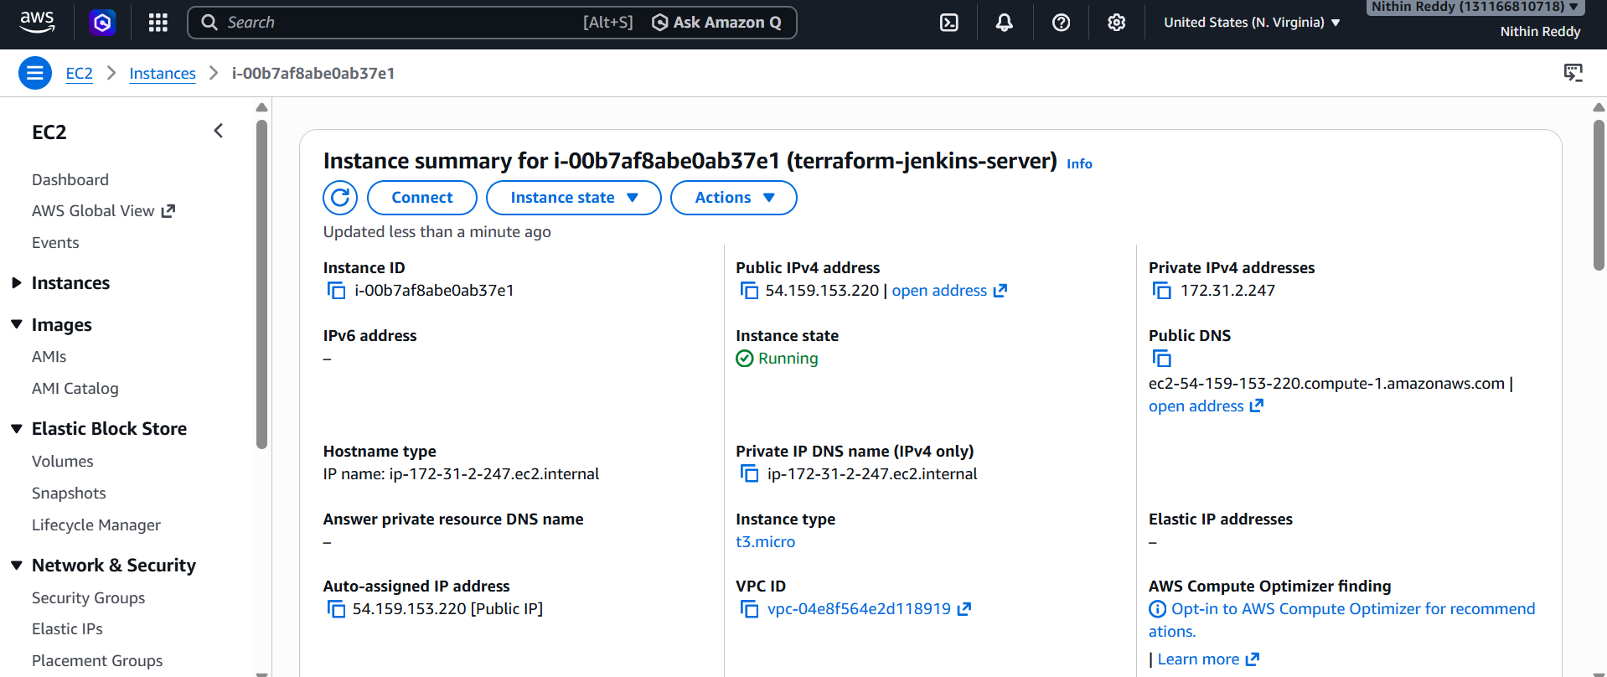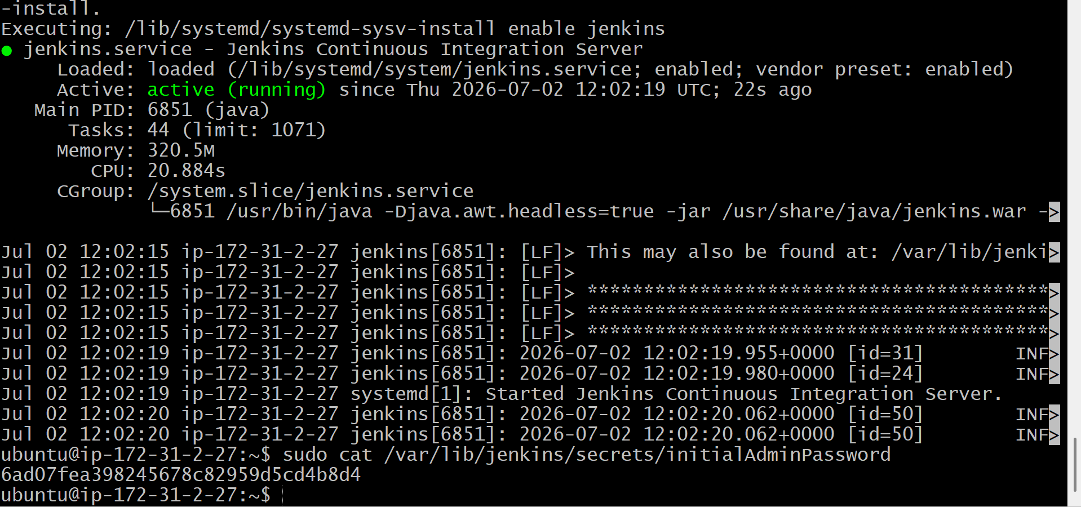

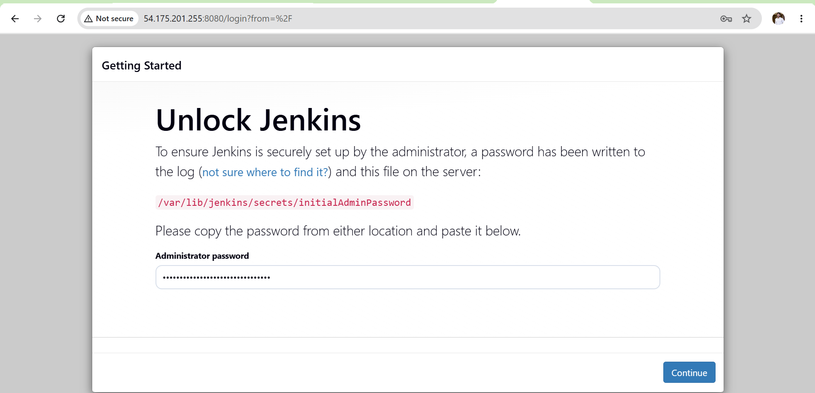
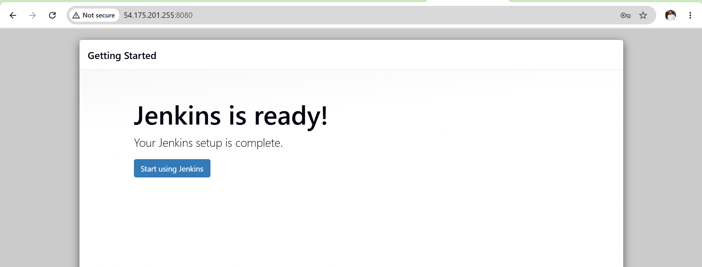
Outcome
- Successfully provisioned an AWS EC2 instance using Terraform.
- Automatically created the required Security Group.
- Connected to the instance using SSH.
- Installed Java and Docker on the EC2 instance.
- Prepared the server for Jenkins installation.
- Verified Terraform lifecycle commands (init, validate, plan, apply).
- Infrastructure was successfully managed as Infrastructure as Code (IaC) using Terraform.
Challenge 5
Create one Jenkins job to build and push the Docker image to Docker Hub
Objective
Create a Jenkins Pipeline job that:
- Clones the Python application from GitHub.
- Builds a Docker image.
- Logs in to Docker Hub.
- Pushes the Docker image to Docker Hub.
Prerequisites
- Running Jenkins server
- Docker installed on the Jenkins server
- Jenkins user added to the Docker group
- Docker Hub account
- Docker Hub Personal Access Token
- Git installed
- Docker Pipeline plugin installed
Steps
- Login to Jenkins dashboard using the browser.
- Click on “New Item” and enter the job name as python-docker-pipeline.
- Select “Pipeline” and click OK.
- In the configuration page, scroll down to the Pipeline section.
- Select “Pipeline script” as the definition.
- Paste the Jenkins pipeline script in the script section.
GitHub Checkout
- Configure the pipeline to clone the repository:
  - Branch: main
  - Repository URL: https://github.com/betawins/Python-app.git

Docker Image Build
- Add a stage to build the Docker image using:
  - Image tag: nithinreddy9/python-app:v1

Docker Authentication
- Add Docker Hub credentials in Jenkins:
  - Credentials ID: dockerhub-creds
  - Type: Username and Password or Access Token
- Use these credentials in the pipeline to perform Docker login.

Docker Image Push
- Push the built Docker image to Docker Hub repository:
- Repository: nithinreddy9/python-app

Execution
- Save the pipeline configuration.
- Click on “Build Now” to execute the pipeline.

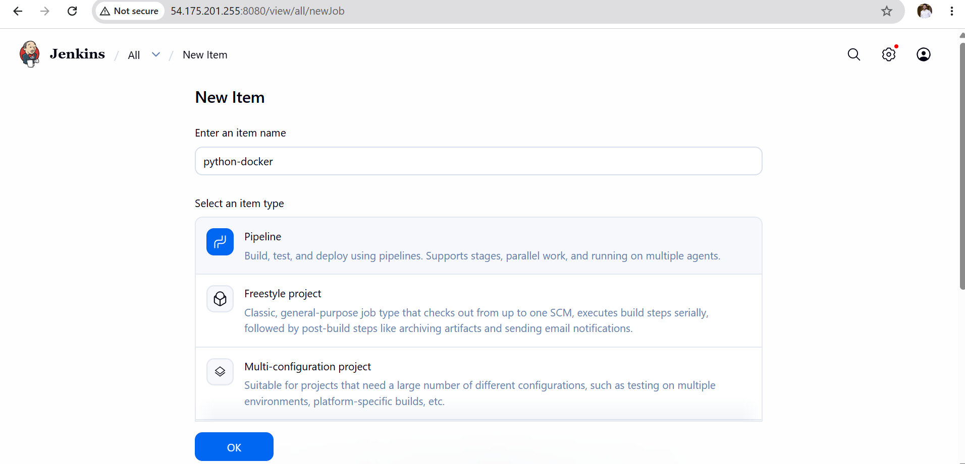
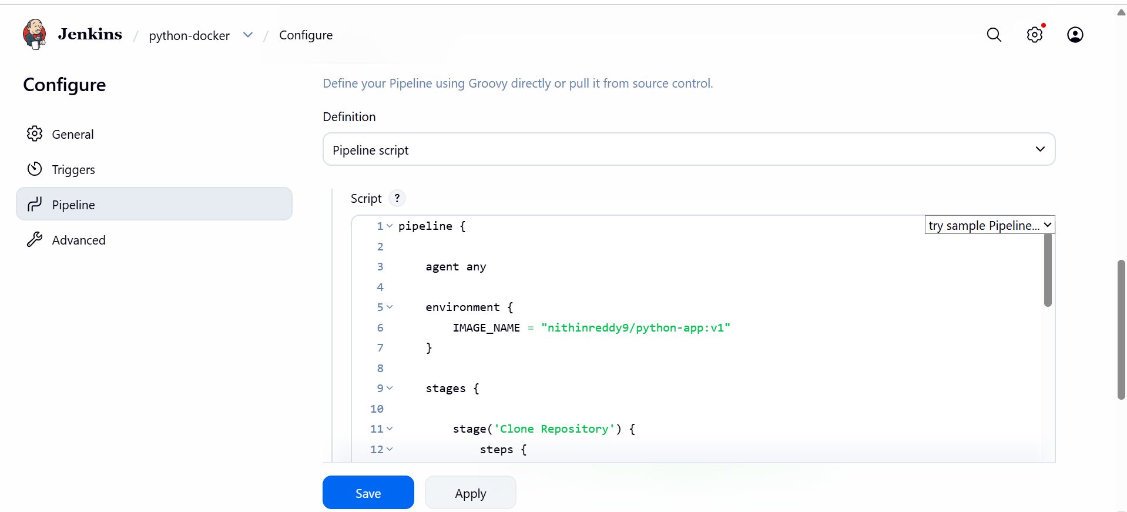

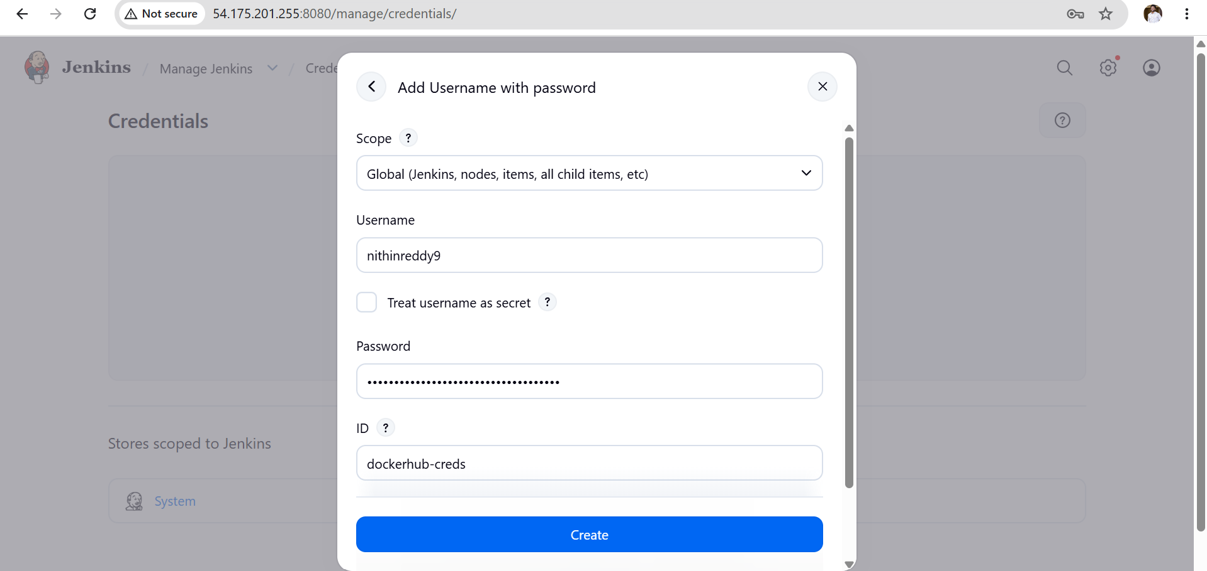
Validation
Verify the pipeline execution in the console output:
- Git clone should be successful
- Docker image build should complete successfully
- Docker login should succeed
- Docker push should complete successfully

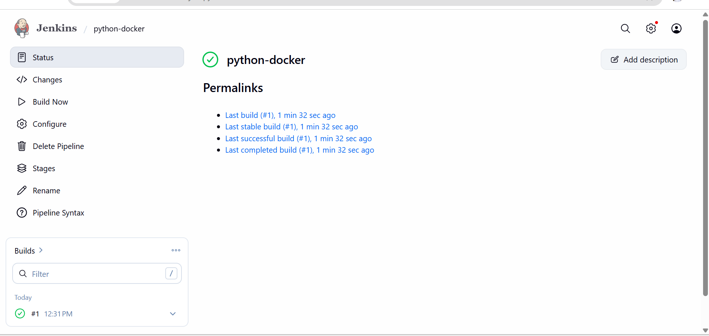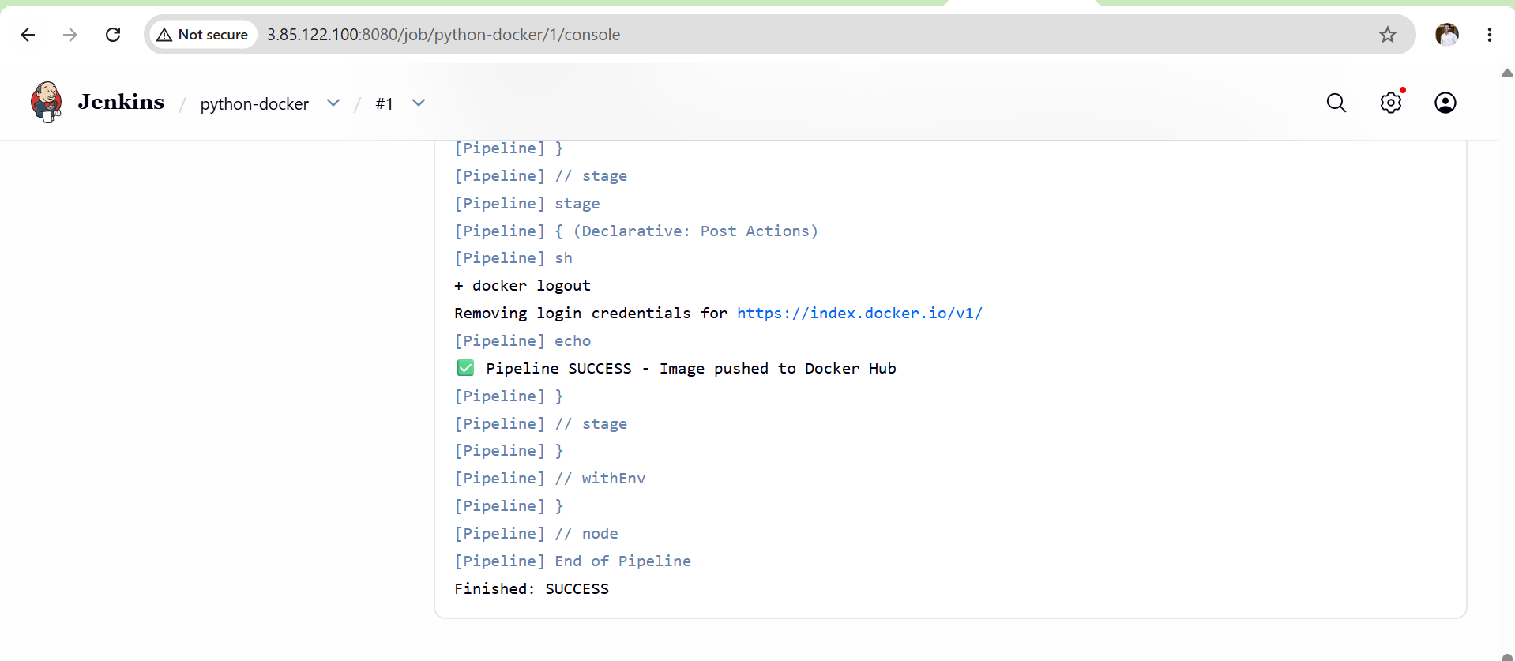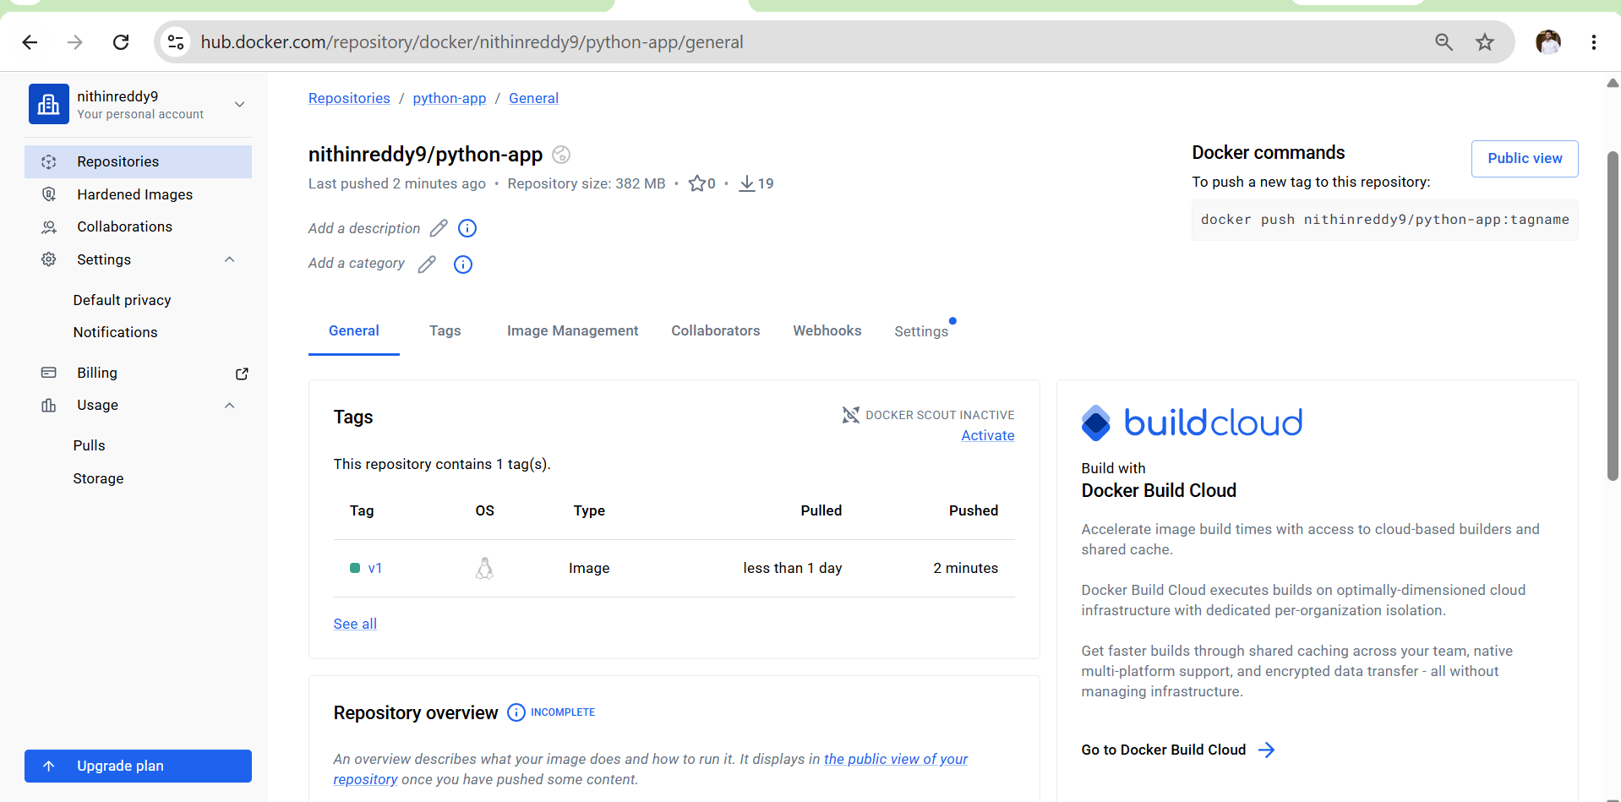

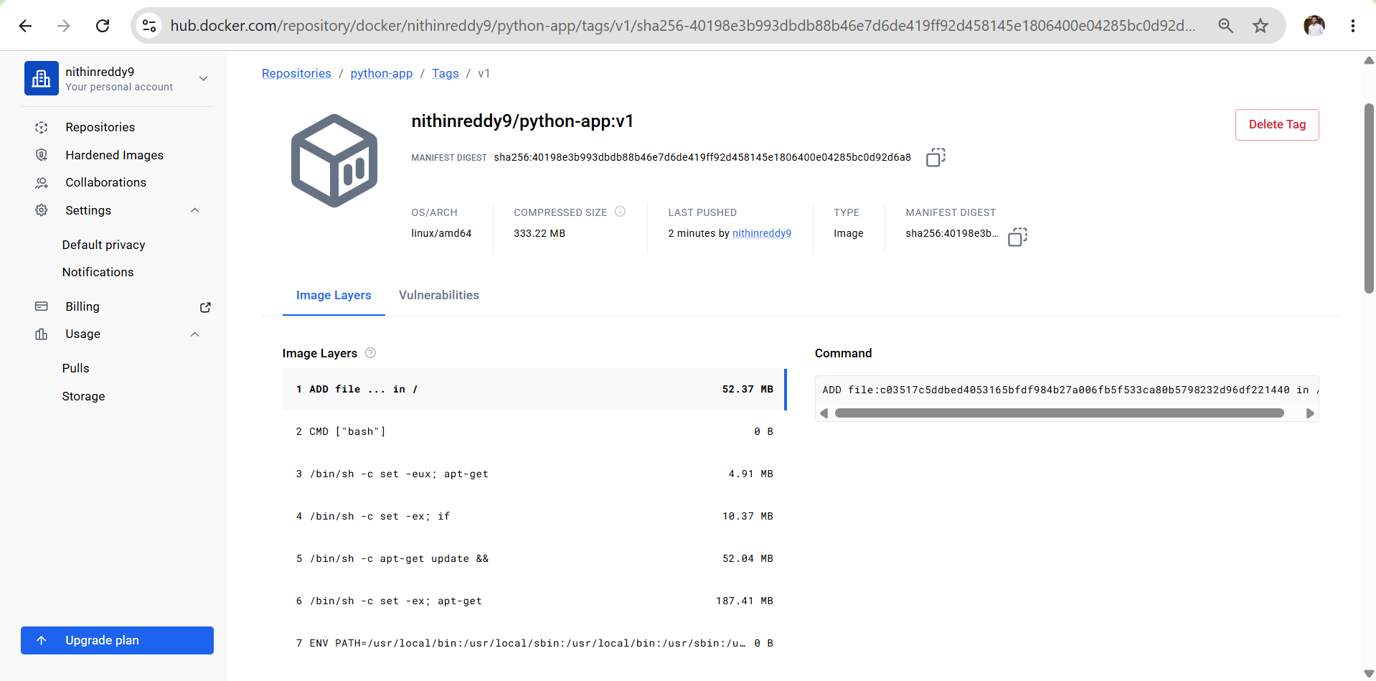
Outcome
- Jenkins CI/CD pipeline created
- Docker image automatically built
- Image pushed to Docker Hub
- End-to-end DevOps workflow completed
- Interview-ready project completed

