Ansible-03

Task 1 — Install Apache + Nginx using variables from separate file
Objective
Install Apache and Nginx on the worker nodes without hardcoding package names inside the playbook.
Ansible's package module can work across different package managers, but package names can differ between distributions, so we'll keep those names in a separate variables file.
Documentation points
- Created a separate variables file containing Apache and Nginx package/service names.
- Used vars_files to load external variables into the playbook.
- Used the package module to install Apache and Nginx.
- Used variables instead of hardcoding package names.
- Used the service module to manage web services.
- Validated package installation on all worker nodes.

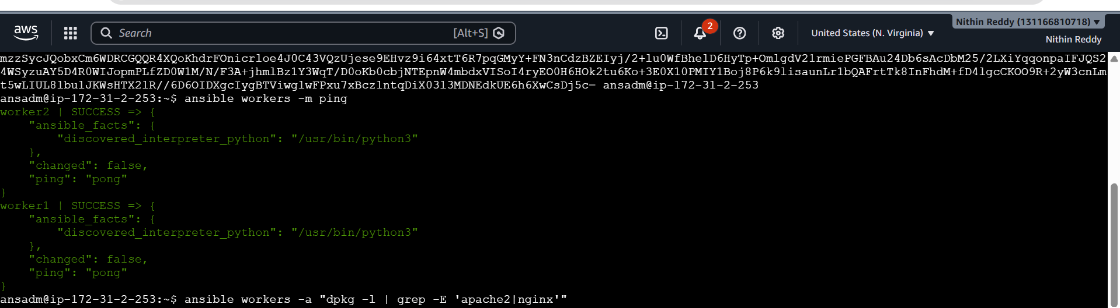
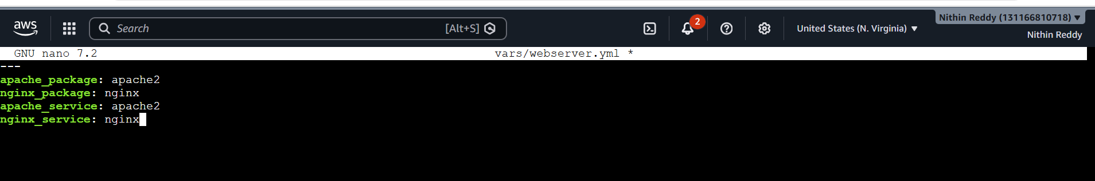
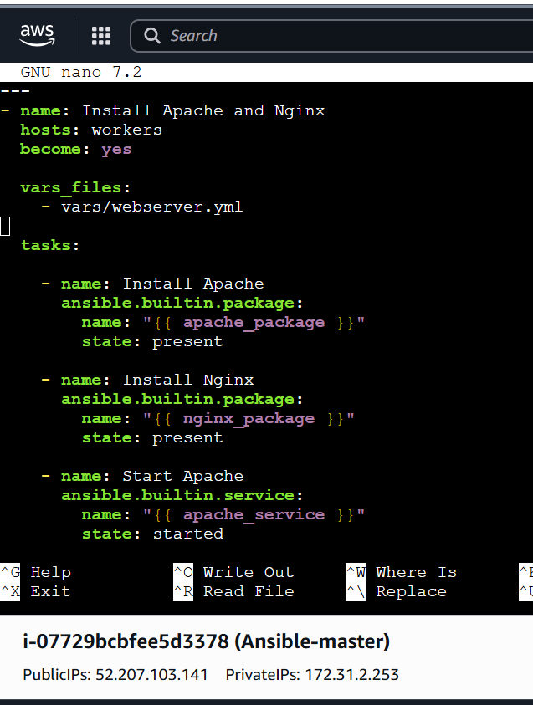

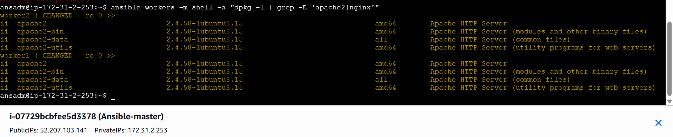

Task 2 — Create 10 directories using minimal code
Step 1
cd ~/playbooks
nano create_directories.yml
Documentation points
- Created a list variable containing 10 directory names.
- Used a single file task instead of writing 10 separate tasks.
- Used loop to iterate through the directory names.
- Created directories under /home/ansadm/.
- Set ownership and permissions using the file module.
- Validated all 10 directories on both worker nodes

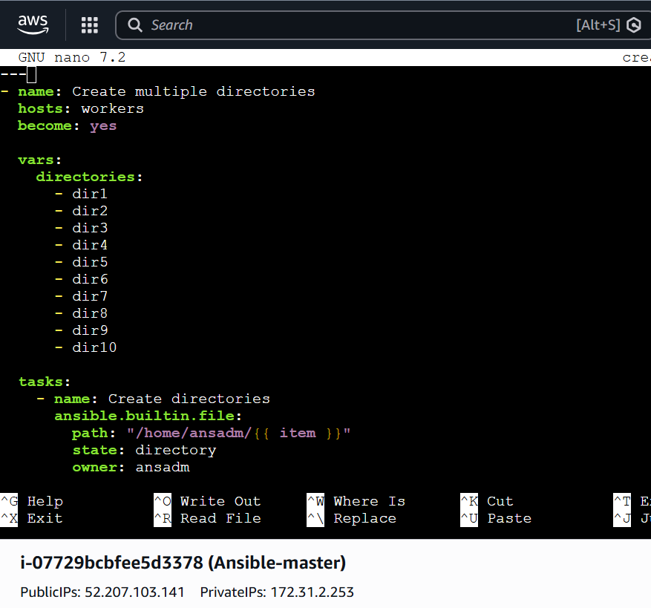
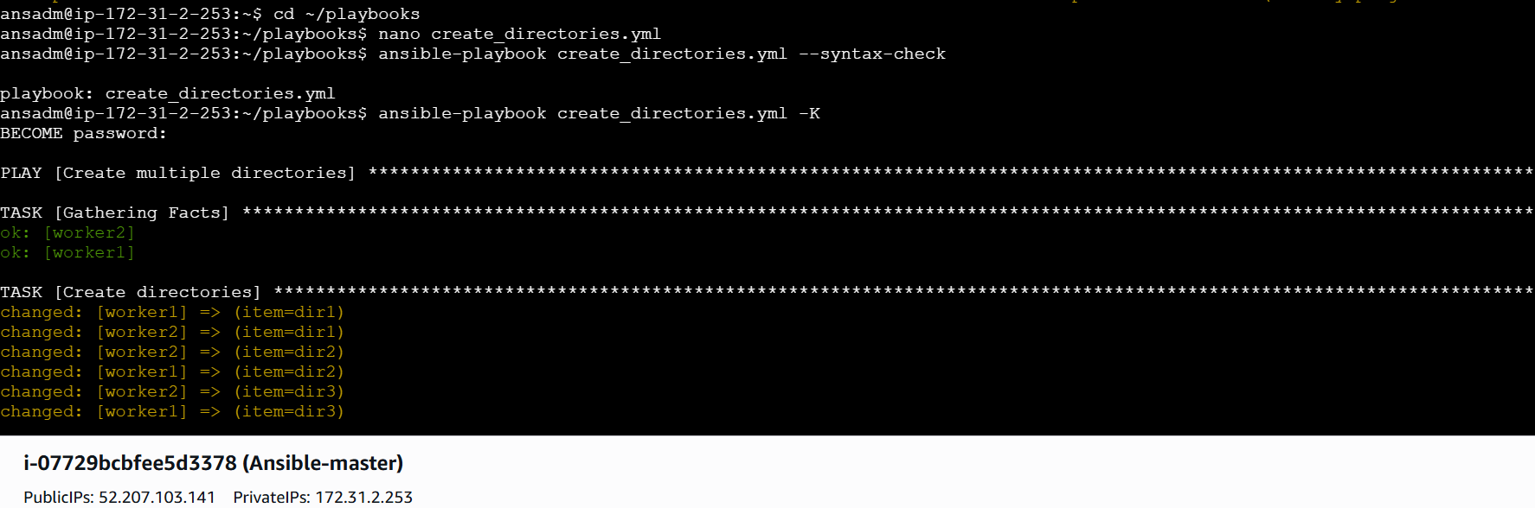
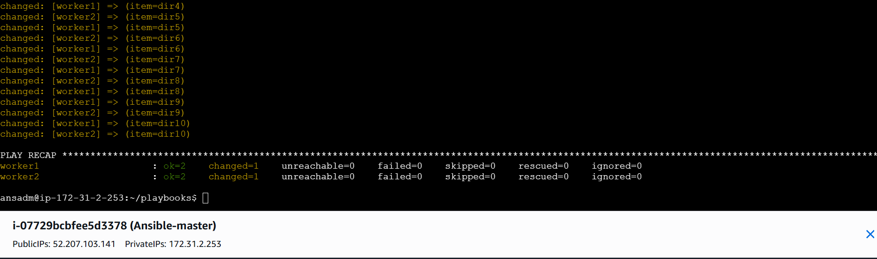

Task 3 — Passwordless SSH key authentication
This task has two parts:
- Provision 1 master + 2 workers.
- Create ansadm on all three.
- Create SSH key on master.
- Copy public key to workers.
Important
Do NOT copy your private key.
You copy:
id_rsa.pub
to:
~/.ssh/authorized_keys
The private key:
id_rsa
must remain on the master.
Documentation points
- Provisioned one Ansible master and two worker EC2 instances.
- Created the common ansadm user on all three instances.
- Added ansadm to the sudo group.
- Configured passwordless sudo for Ansible automation.
- Generated an RSA SSH key pair on the Ansible master.
- Copied only the master's public key to worker nodes.
- Added the public key to authorized_keys.
- Configured worker private IPs in the Ansible inventory.
- Verified passwordless SSH connectivity.
- Verified Ansible connectivity using the ping module

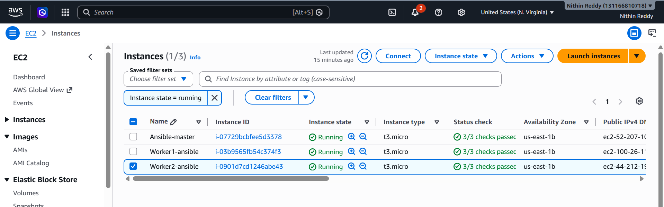
Configure Passwordless SSH
- Login as the Ansible user on the Master.
- Generate an RSA SSH key pair using ssh-keygen.
- Display the generated public key.
- Login to Worker-1.
- Create the .ssh directory for the Ansible user.
- Set the correct ownership of the .ssh directory.
- Set appropriate permissions on the .ssh directory.
- Create the authorized_keys file.
- Paste the Master's public key into authorized_keys.
- Set the correct permissions on authorized_keys.
- Repeat the same steps on Worker-2.
- Test SSH connectivity from Master to Worker-1.
- Test SSH connectivity from Master to Worker-2.
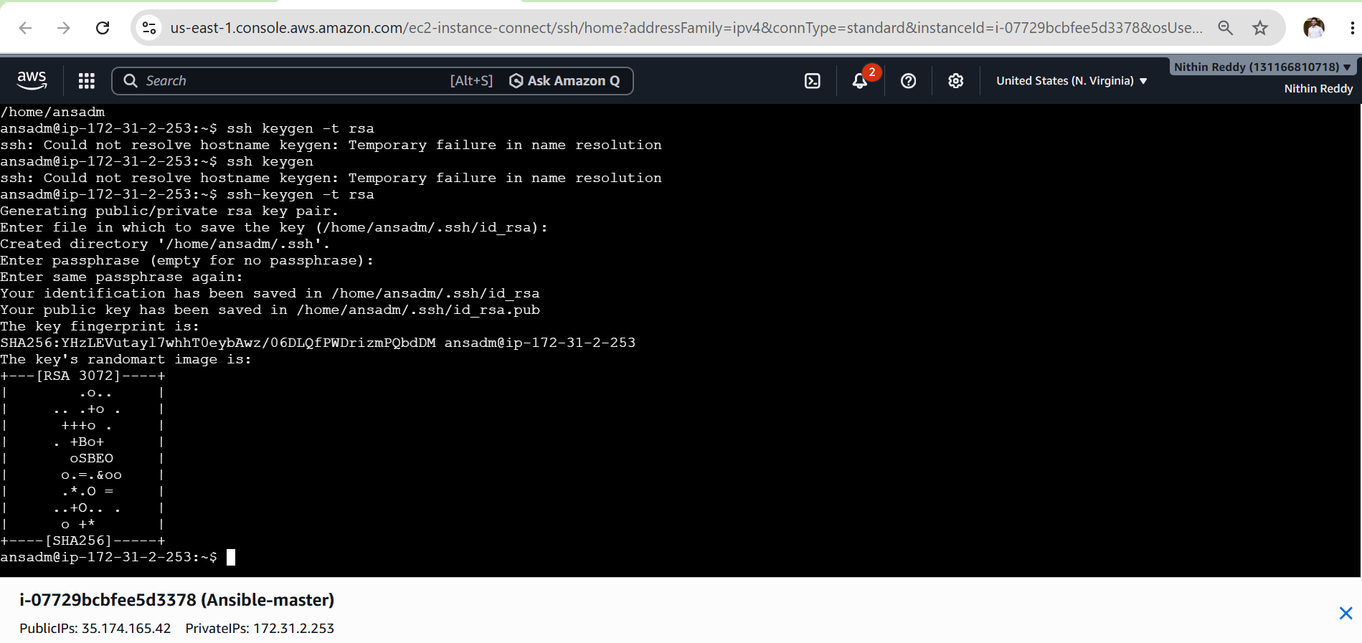
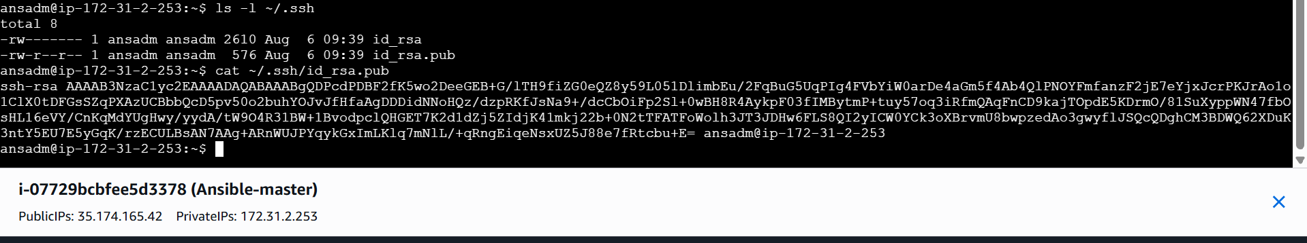Now go to worker-01 and paste key
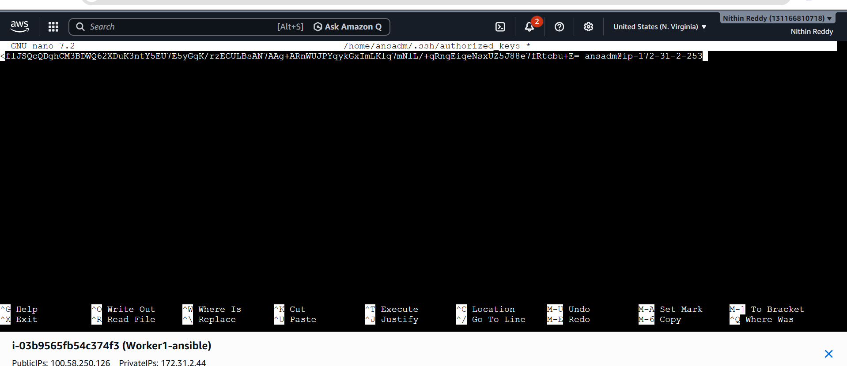
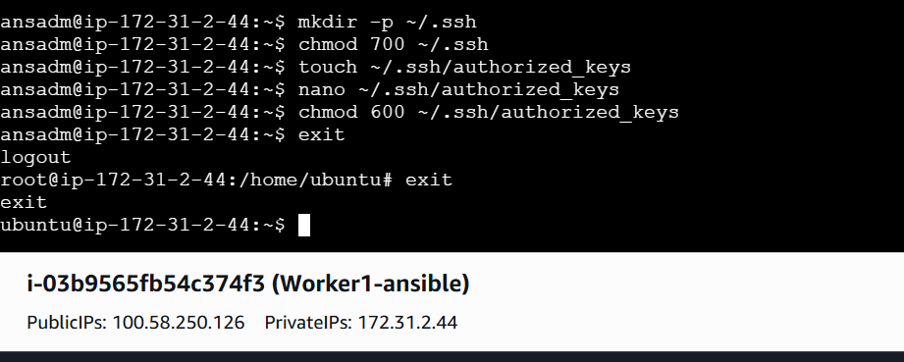
Repeat same in Worker-02
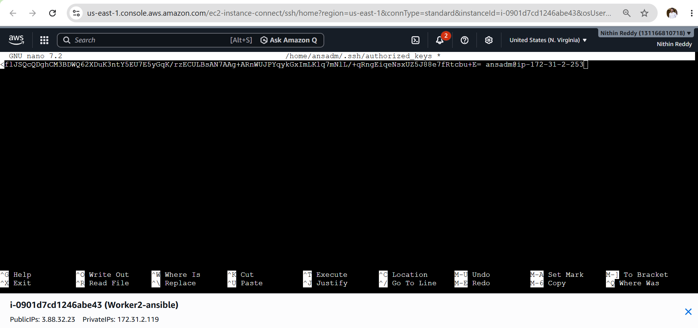
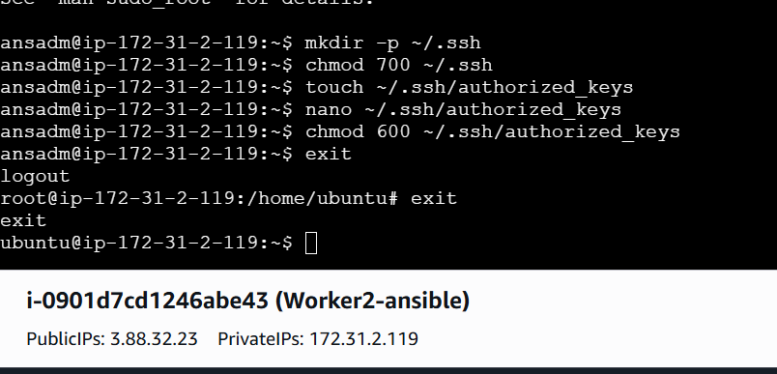

Test Passwordless SSH
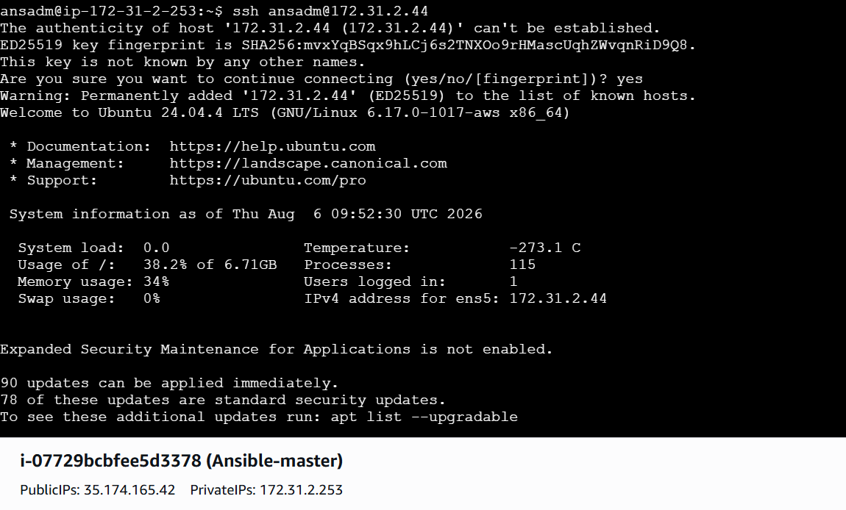
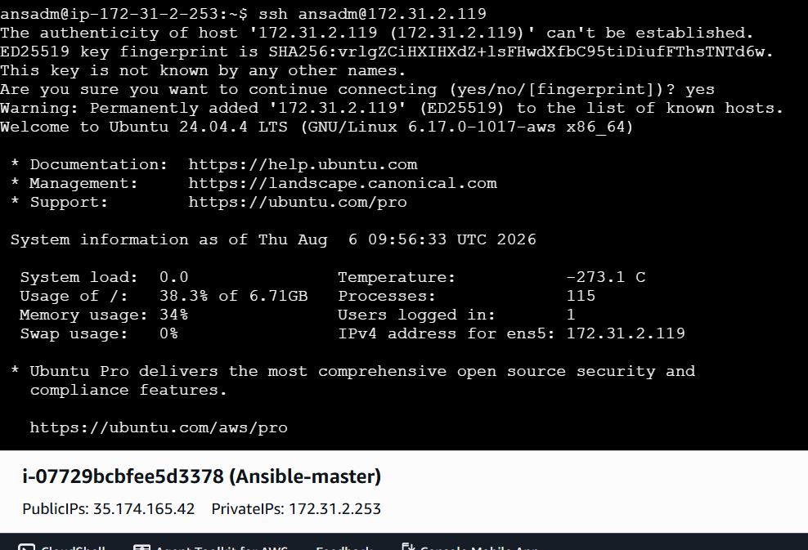

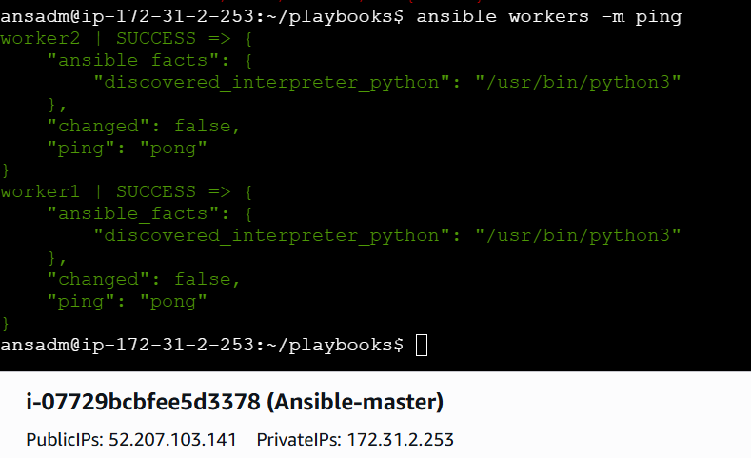

Task 4 — Inject Ansible Vault variables
This is where you learn to keep passwords/secrets encrypted.
Ansible Vault encrypts variables/files so sensitive data isn't stored as plaintext.
Step 1 — Create vault file
cd ~/playbooks
ansible-vault create secrets.yml
Documentation points
- Created an encrypted Ansible Vault file.
- Stored database credentials as Vault variables.
- Loaded encrypted variables using vars_files.
- Executed the playbook with --ask-vault-pass.
- Verified that encrypted variables were successfully injected into the playbook.

