Ansible-04
Task 1 — Create ansible playbook to create ansible vault
This task is simpler than Ansible-03 Task 4.
Create Vault
cd ~/playbooks
ansible-vault create credentials.yml
Enter Vault password.
Add:
---
username: ansadm
password: Welcome123
Save.
Documentation points
- Created an encrypted Ansible Vault file using ansible-vault create.
- Stored sensitive username and password variables inside the Vault.
- Verified encrypted content using cat.
- Used ansible-vault view to securely view decrypted content.
- Used ansible-vault edit to modify encrypted variables.

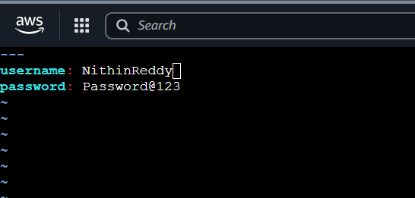
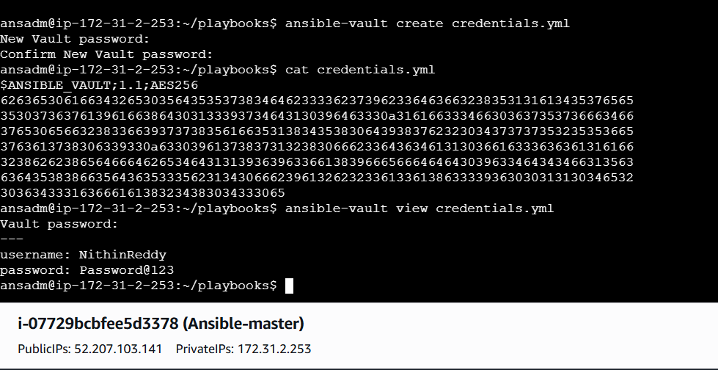

Task-2: Write a ansible playbook to install apache in linux and ubuntu machine by using when condition.
Documentation points
- Gathered OS facts from managed nodes.
- Used when conditions based on OS family.
- Installed httpd on RedHat-based systems.
- Installed apache2 on Debian/Ubuntu systems.
- Started and enabled the appropriate Apache service.
- Validated Apache installation across different operating systems.

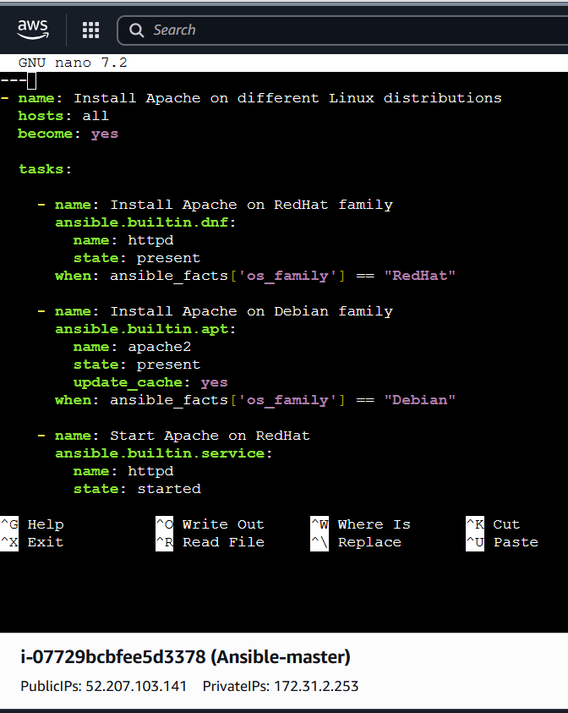
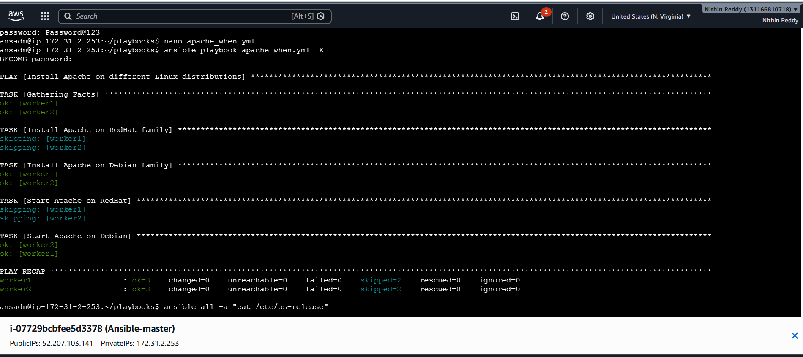

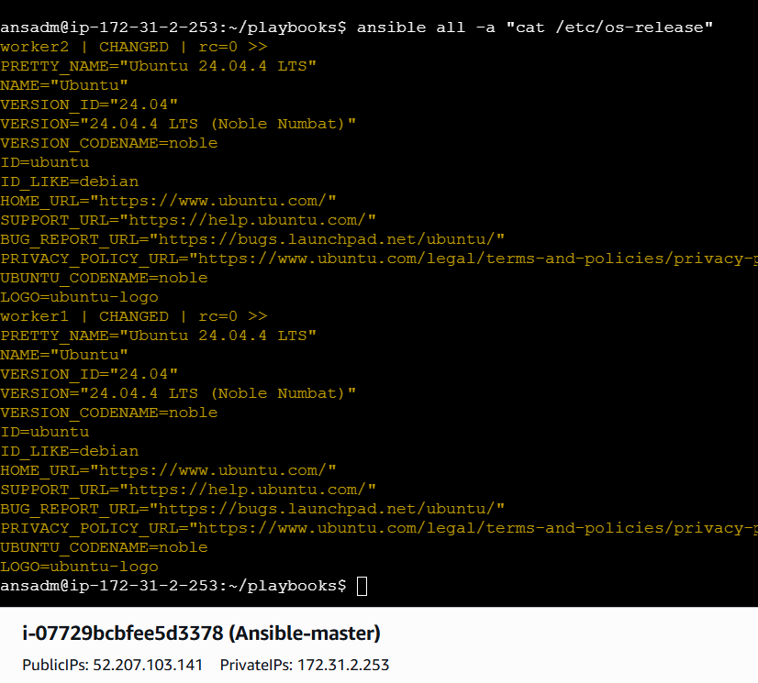
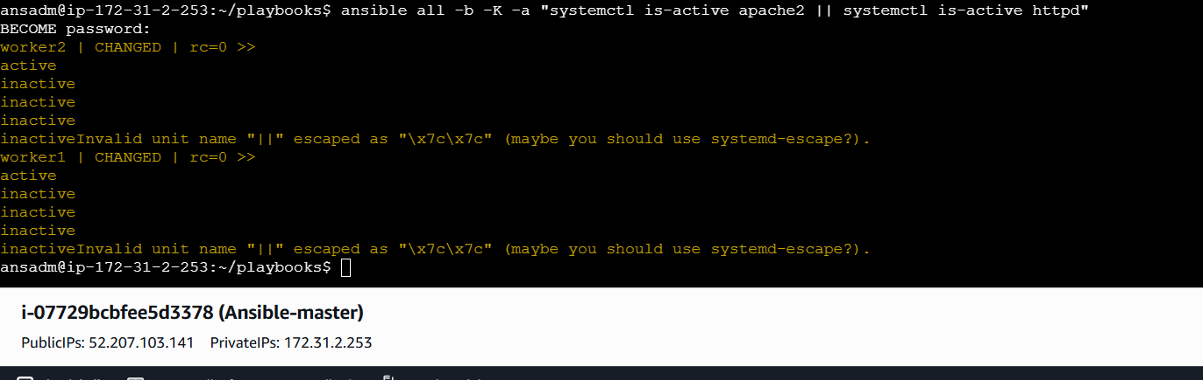

Task3: Create ansible playbook using roles to configure LAMP stack
Documentation points
- Created separate Ansible roles for Apache, MariaDB and PHP.
- Used role-based directory structure for reusable automation.
- Added installation and service configuration tasks inside each role.
- Created a main playbook to call all LAMP roles.
- Executed the playbook against worker nodes.
- Validated Apache, MariaDB and PHP installation successfully.

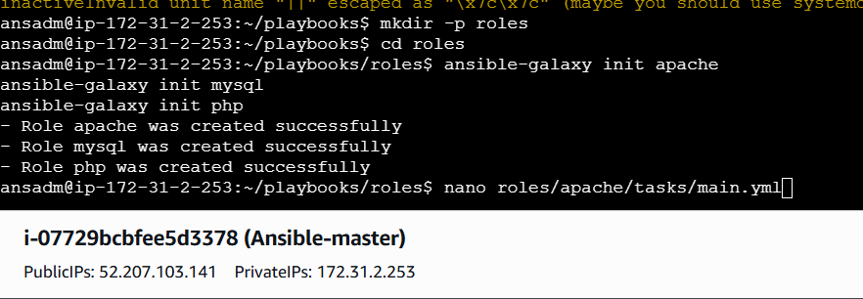
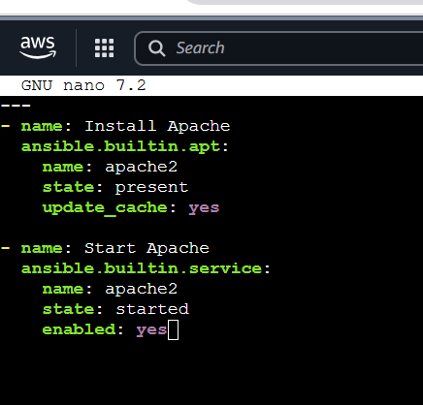

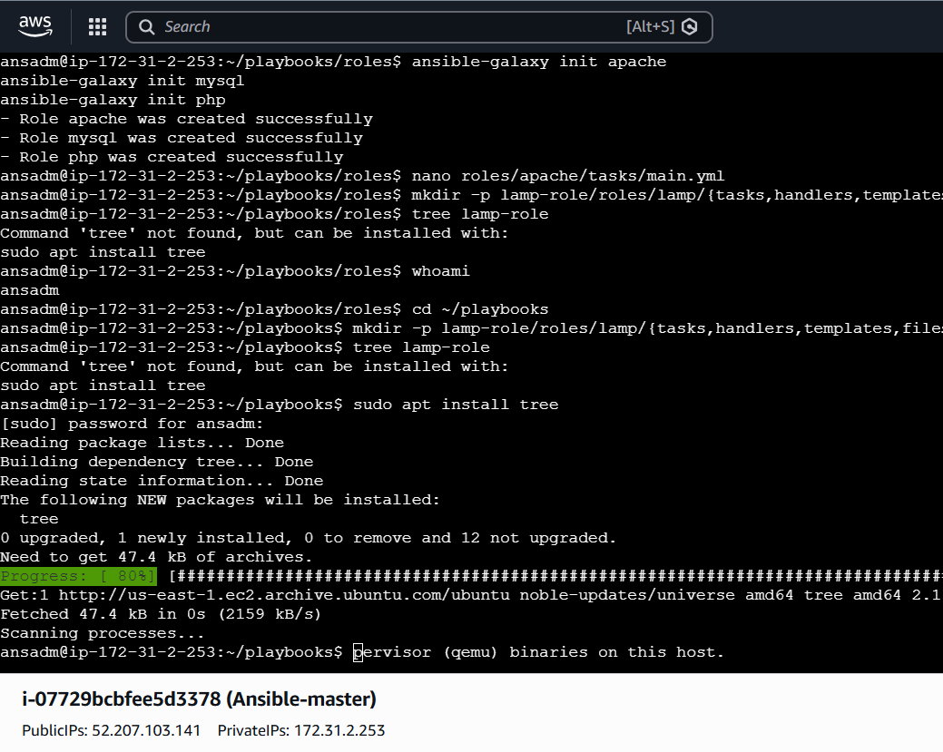
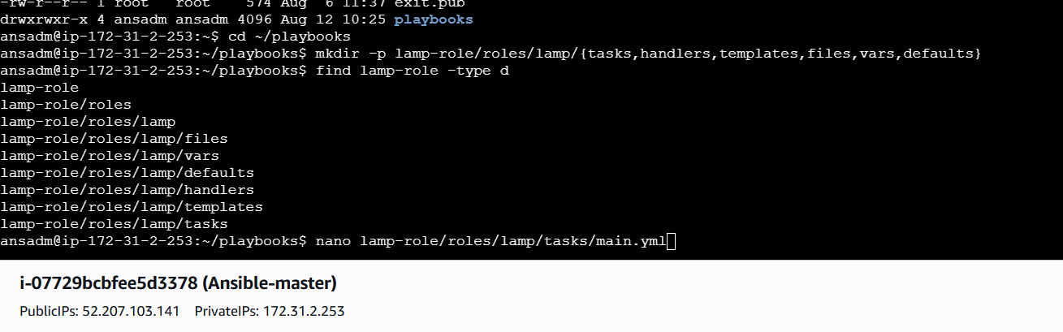
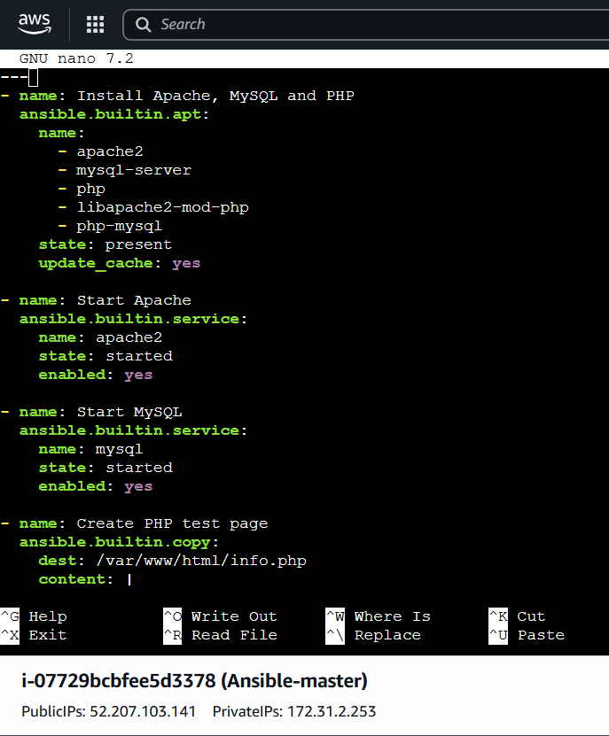

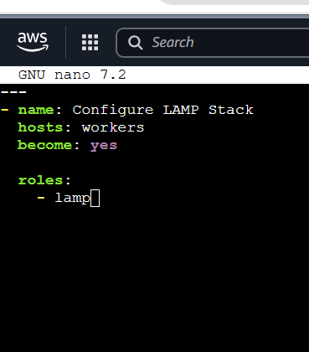

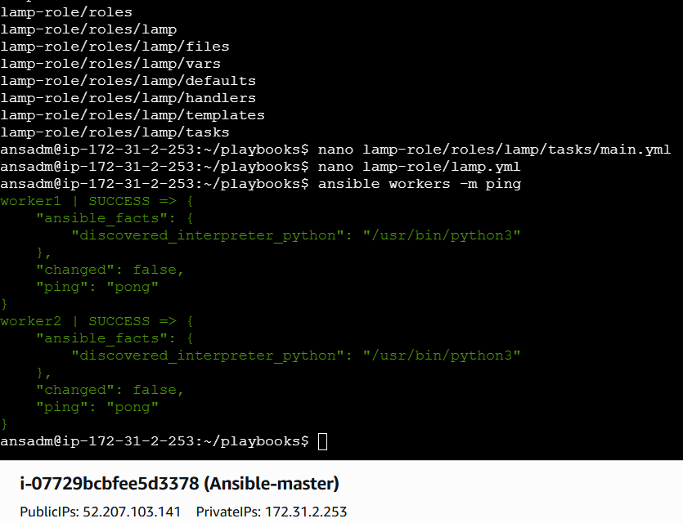

Task 4 — Install and Explore Ansible AWX
Implementation steps:
- Installed K3s Kubernetes cluster and verified the node was in Ready state.
- Installed AWX Operator version 2.19.1 on the K3s cluster.
- Created the awx namespace and deployed the AWX instance.
- Verified AWX PostgreSQL, task, web, and migration pods were running/completed successfully.
- Exposed AWX using a Kubernetes NodePort service on port 31744.
- Retrieved the AWX admin password from the Kubernetes secret and accessed the AWX web UI.
- Created an AWX Organization and configured the Ansible-Labs project with Git source control.
- Explored AWX Dashboard, Projects, Inventories, Credentials, Templates, Jobs, Schedules, Workflows, Users, Teams, and Execution Environments.

1. Prepare the EC2
On your Ubuntu server:
whoami
hostname
free -h
df -h
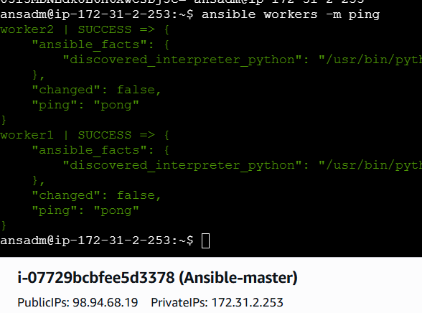
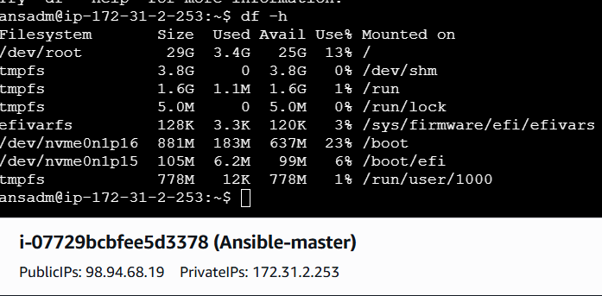

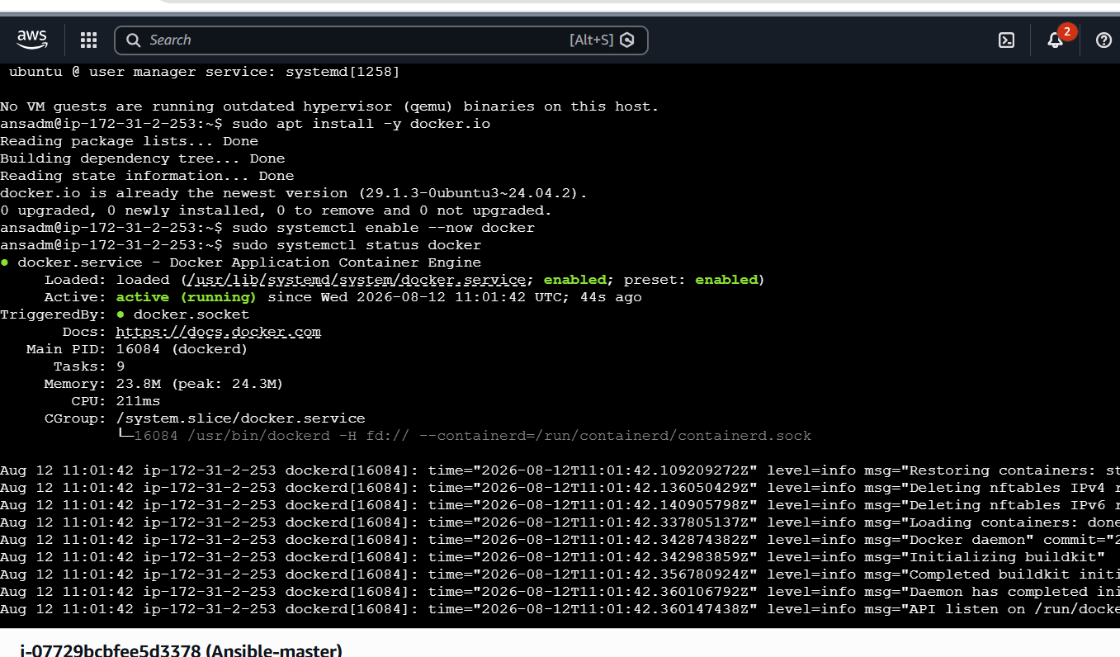
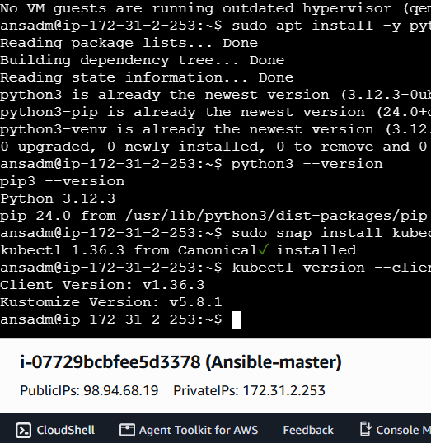

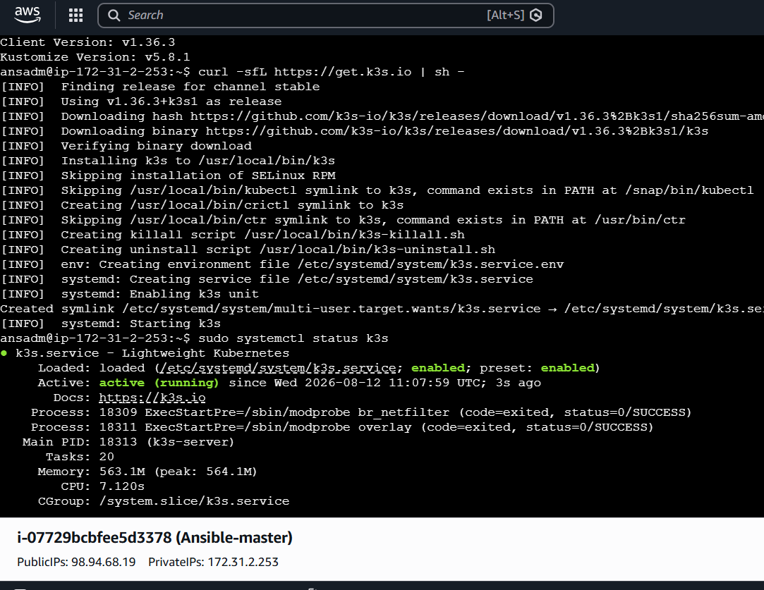
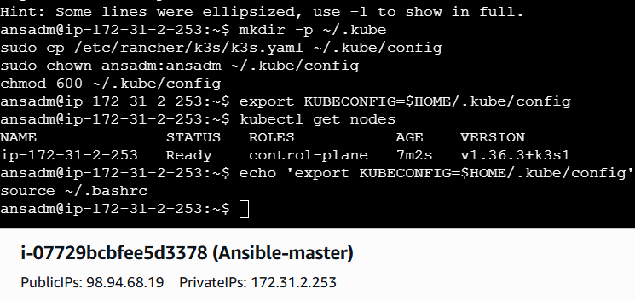
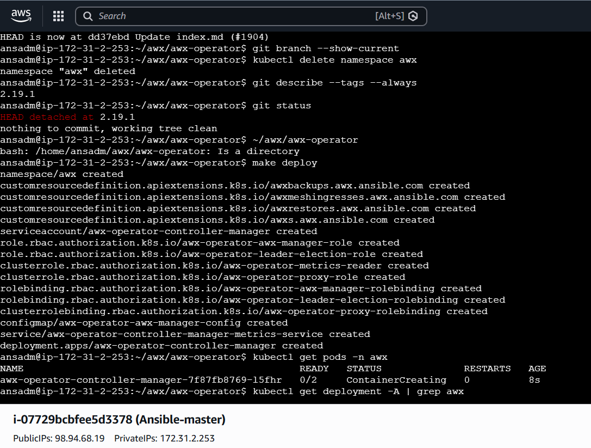
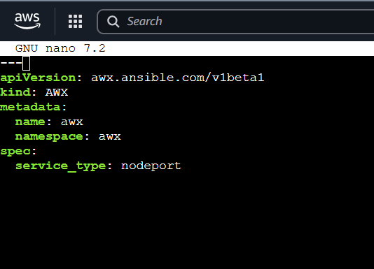
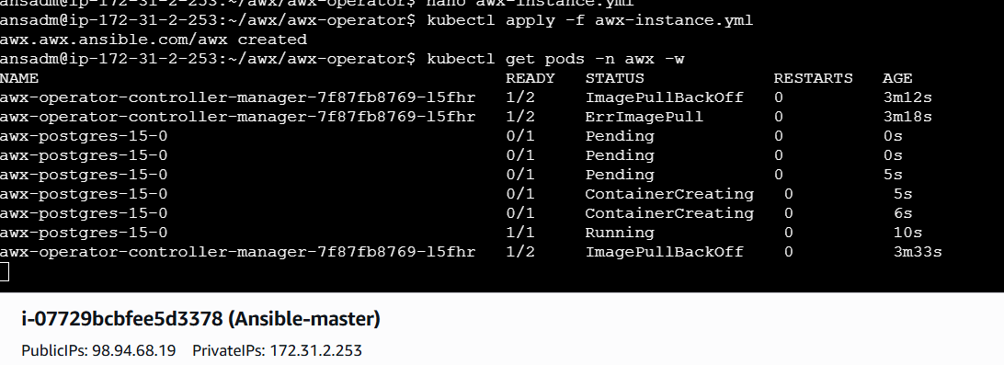
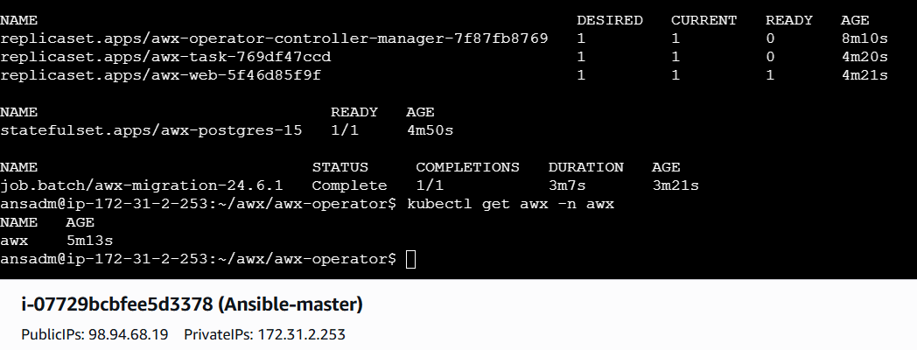
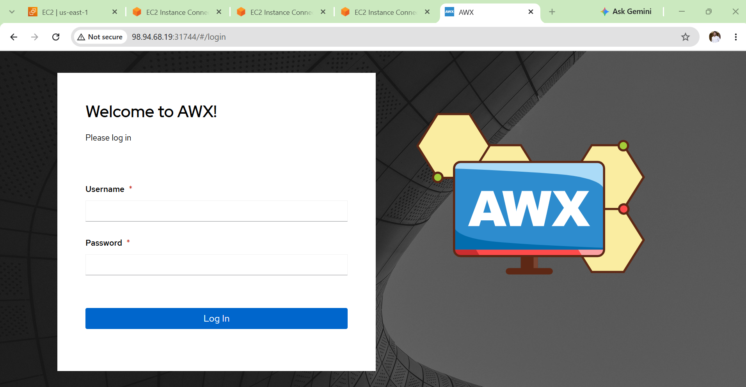
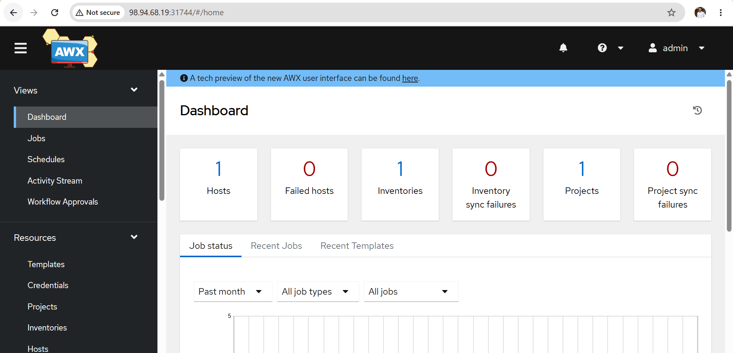
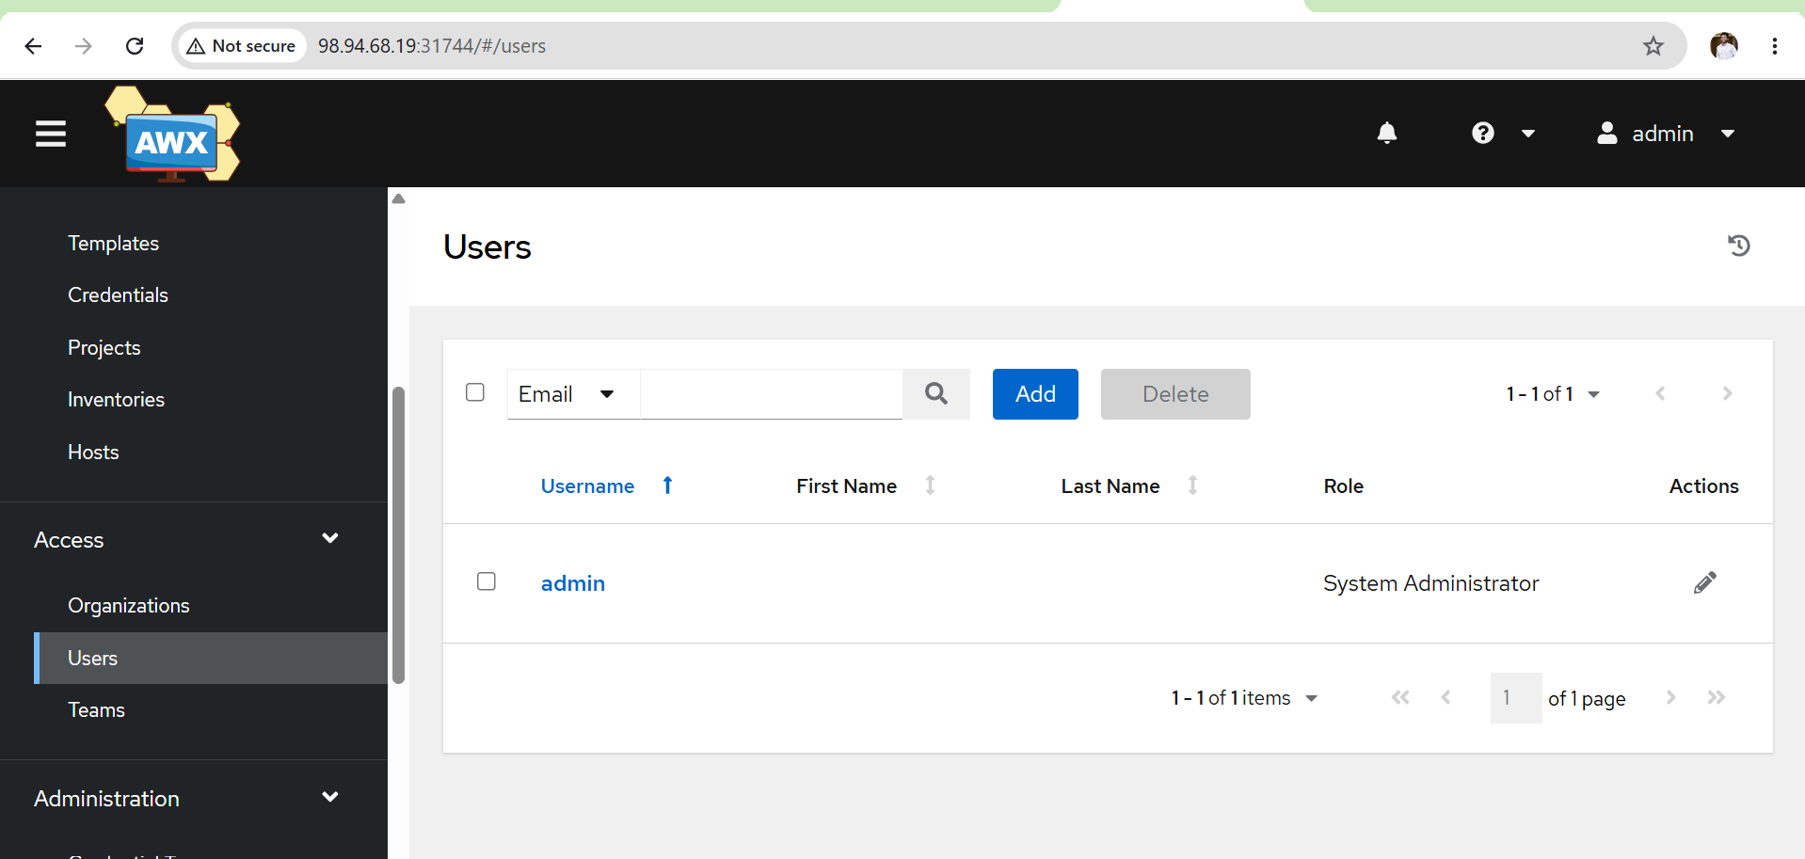
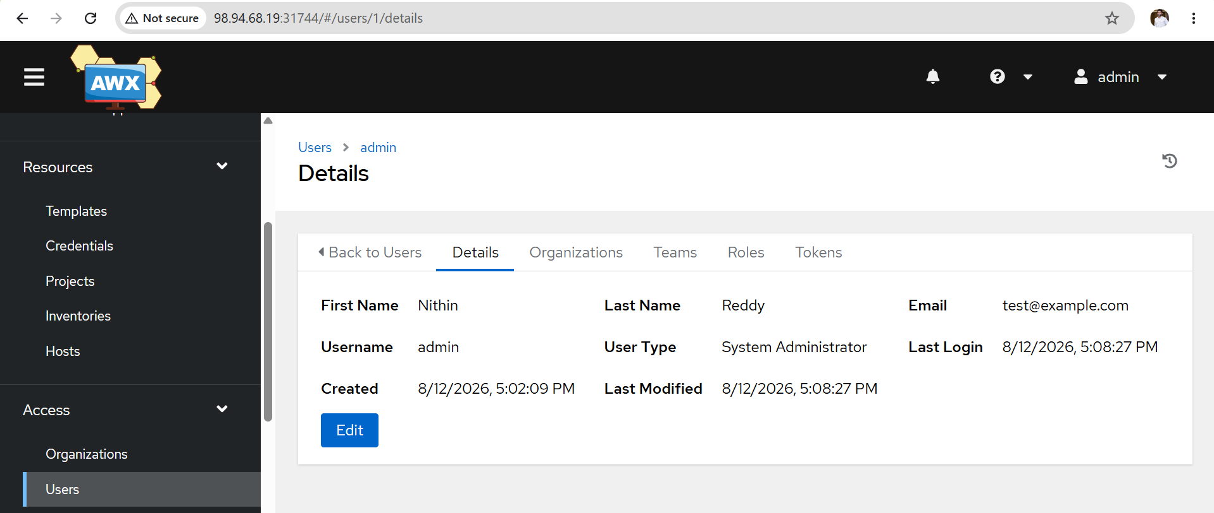

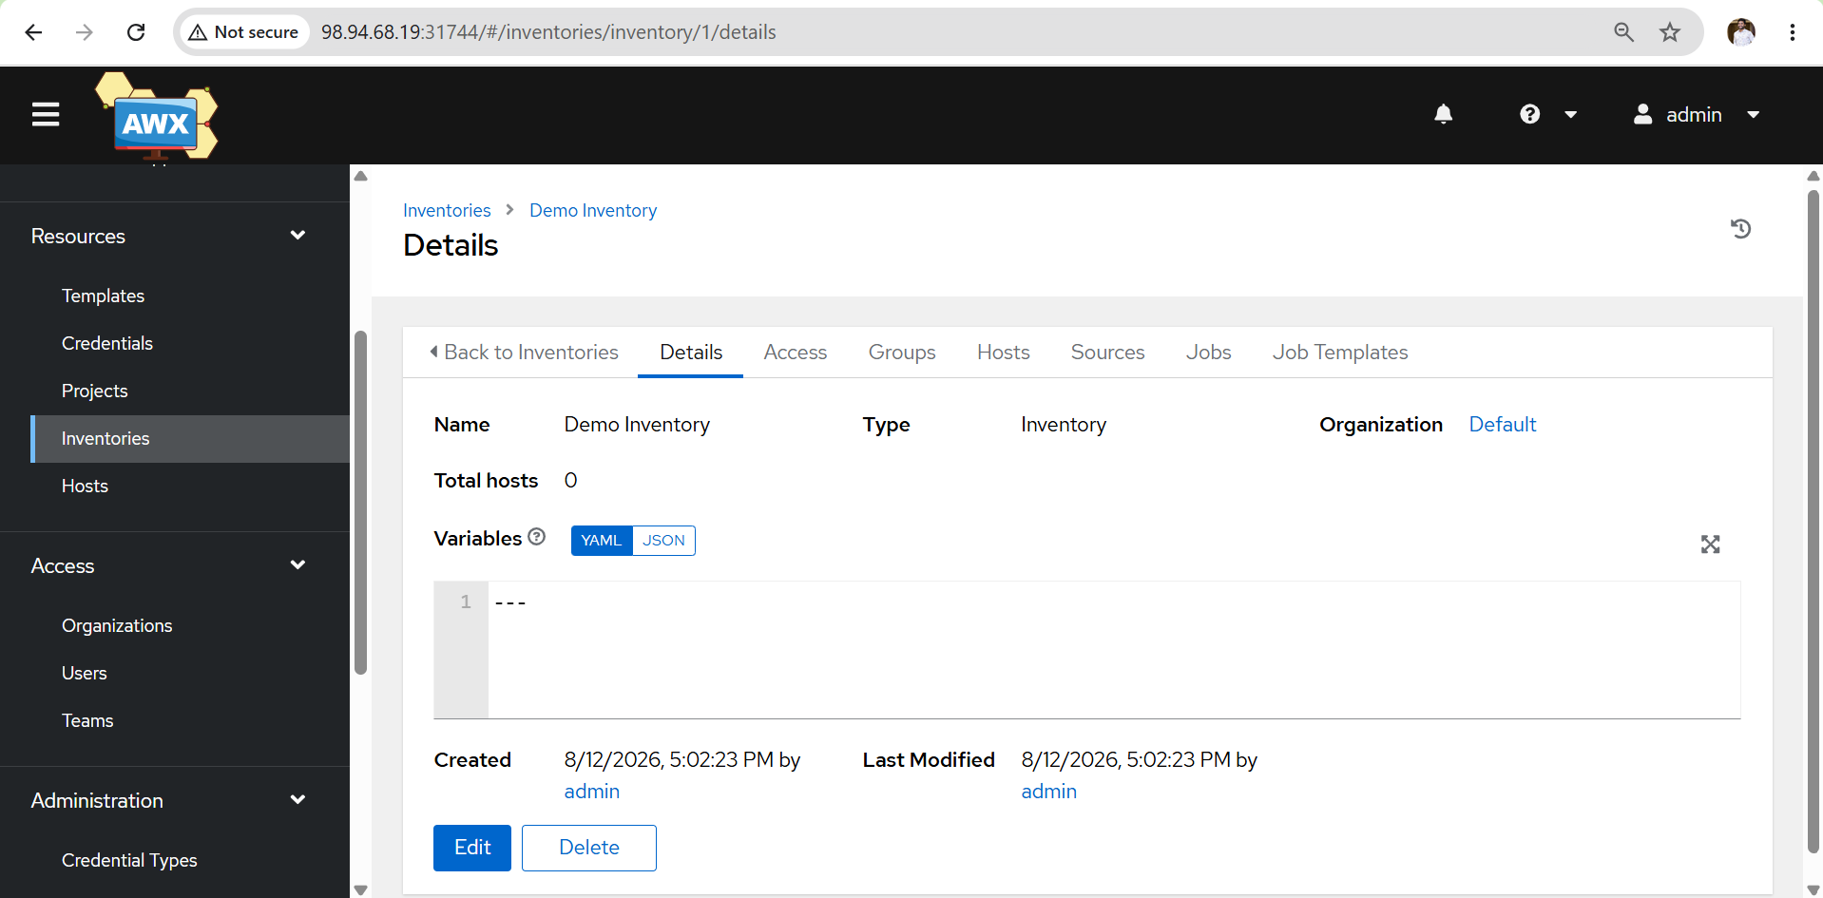
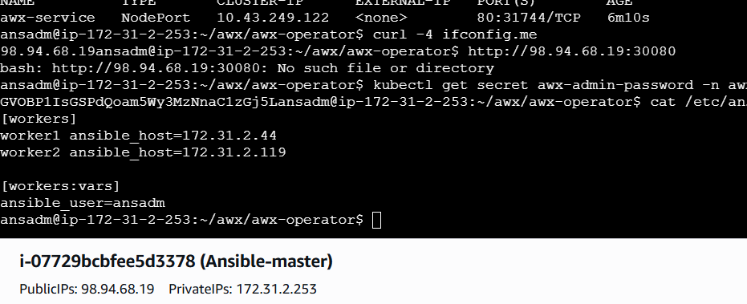
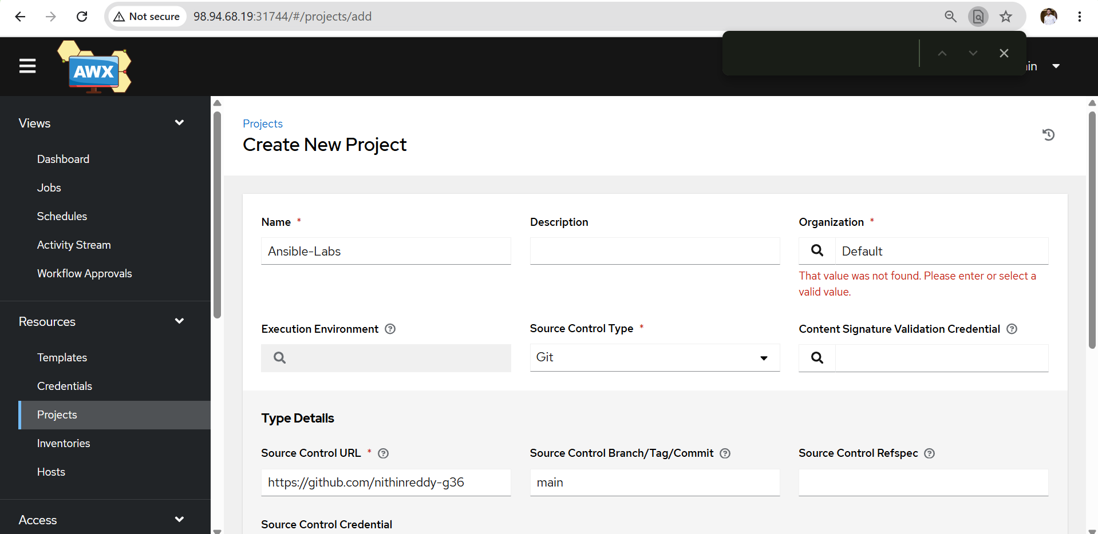
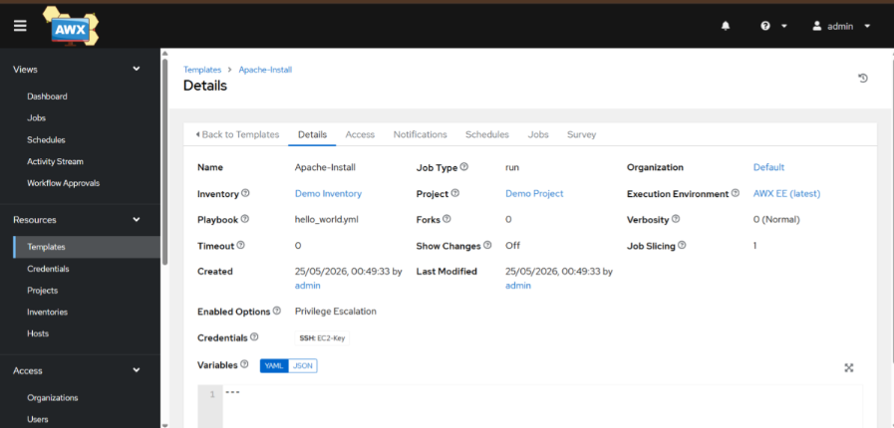
Output
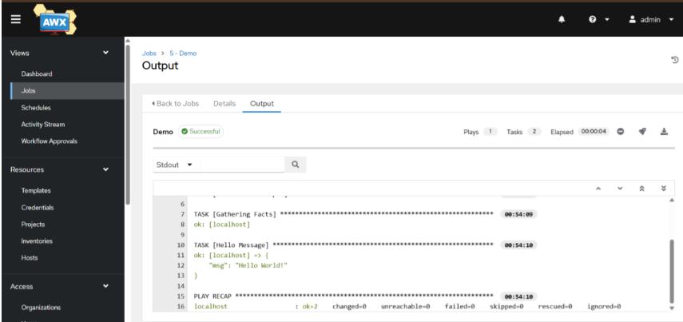
Outcome
- AWX successfully deployed and accessed through the web UI.
- AWX Operator and AWX application components were verified.
- Git-based Ansible project was configured in AWX.
- Learned the basic AWX workflow: Organization → Project → Inventory → Credentials → Job Template → Job.

