Architecture
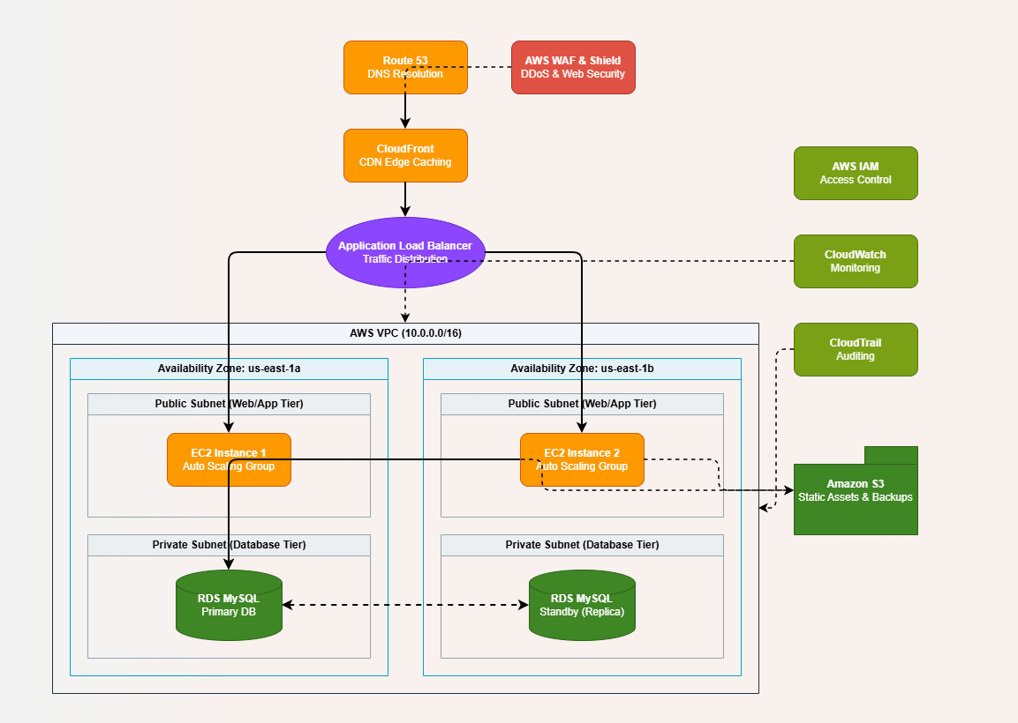

Architecture Summary
- Designed a 3-Tier AWS Architecture to ensure High Availability, Security, Performance, and Cost Optimization.
- Users access the application through Amazon Route 53, which provides DNS resolution.
- Amazon CloudFront delivers content through edge locations, reducing latency and improving application performance.
- AWS WAF protects the application from common web attacks such as SQL Injection and Cross-Site Scripting (XSS).
- AWS Shield provides protection against DDoS attacks.
- An Application Load Balancer (ALB) distributes incoming traffic across multiple EC2 instances.
- The application servers run on Amazon EC2 Instances deployed across multiple Availability Zones.
- Auto Scaling Group (ASG) automatically adds or removes EC2 instances based on traffic demand.
- Deploying resources across multiple Availability Zones ensures High Availability and eliminates a single point of failure.
- Application data is stored in Amazon RDS MySQL with Multi-AZ deployment for automatic failover and database redundancy.
- Amazon S3 is used to store static content, images, logs, and backups.
- Amazon CloudWatch monitors infrastructure and application performance and generates alerts when required.
- AWS CloudTrail records user activities and API calls for auditing and compliance purposes.
- AWS IAM controls user access through roles and policies, following the principle of least privilege.
- The architecture achieves:
  - High Availability through Multi-AZ deployment, ALB, and Auto Scaling.
  - Performance Excellence through CloudFront, Load Balancing, and Auto Scaling.
  - Security through WAF, Shield, IAM, Security Groups, and Private Subnets.
  - Cost Optimization through Auto Scaling, S3 storage, CloudFront caching, and pay-as-you-go AWS services.
Conclusion
This architecture provides a scalable, secure, highly available, and cost-effective solution capable of handling application growth while maintaining optimal performance and reliability.

