Jenkins-03
Task 1
Create One Jenkins Pipeline Job with 3 Stages
Source Code: VProfile-1 GitHub Repository

Objective
Create a Jenkins Pipeline Job that performs:
Stage 1
- Clone source code from GitHub
Stage 2
- Perform SonarQube code quality analysis
Stage 3
- Send build notifications to Slack

Architecture
GitHub Repository
|
V
Jenkins Pipeline
|
+---- Stage 1: Git Clone
|
+---- Stage 2: SonarQube Analysis
|
+---- Stage 3: Slack Notification

Execution Steps
Stage 1: Git Clone
- Create a new Pipeline Job in Jenkins.
- Open Pipeline configuration.
- Add GitHub repository URL:
https://github.com/betawins/VProfile-1.git
- Execute git clone stage.
- Verify repository is downloaded into Jenkins workspace.

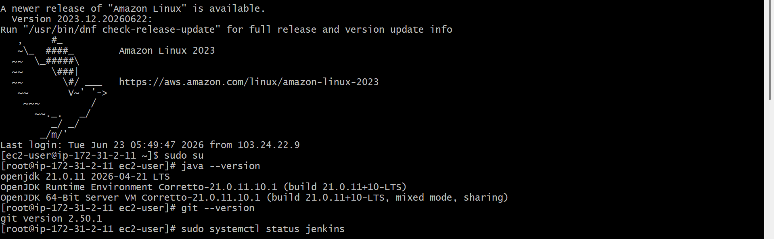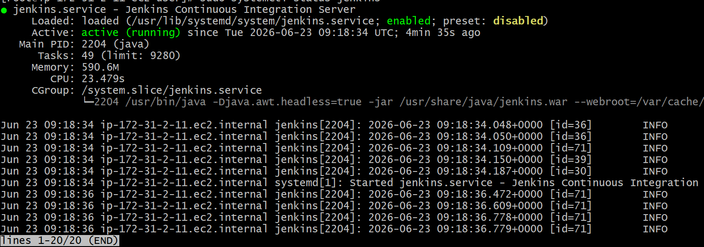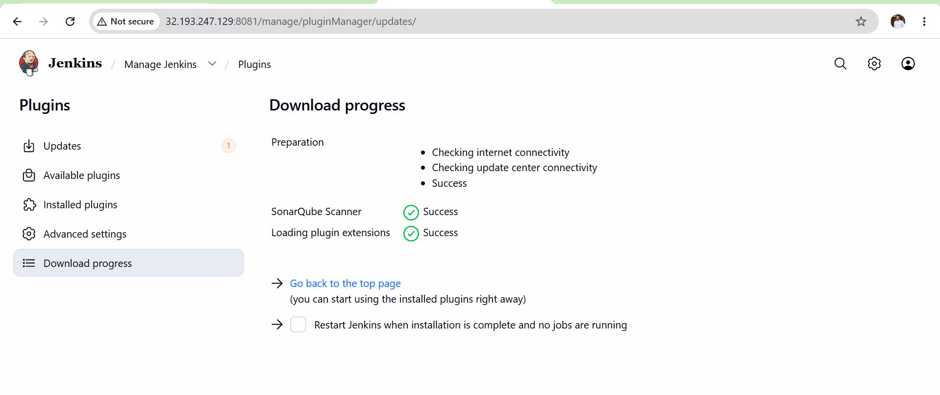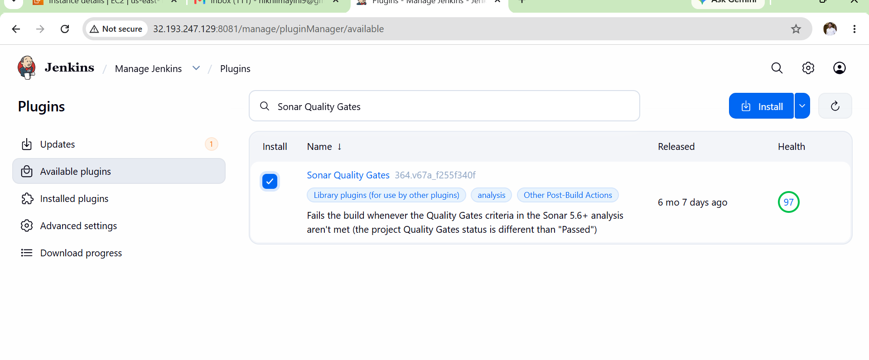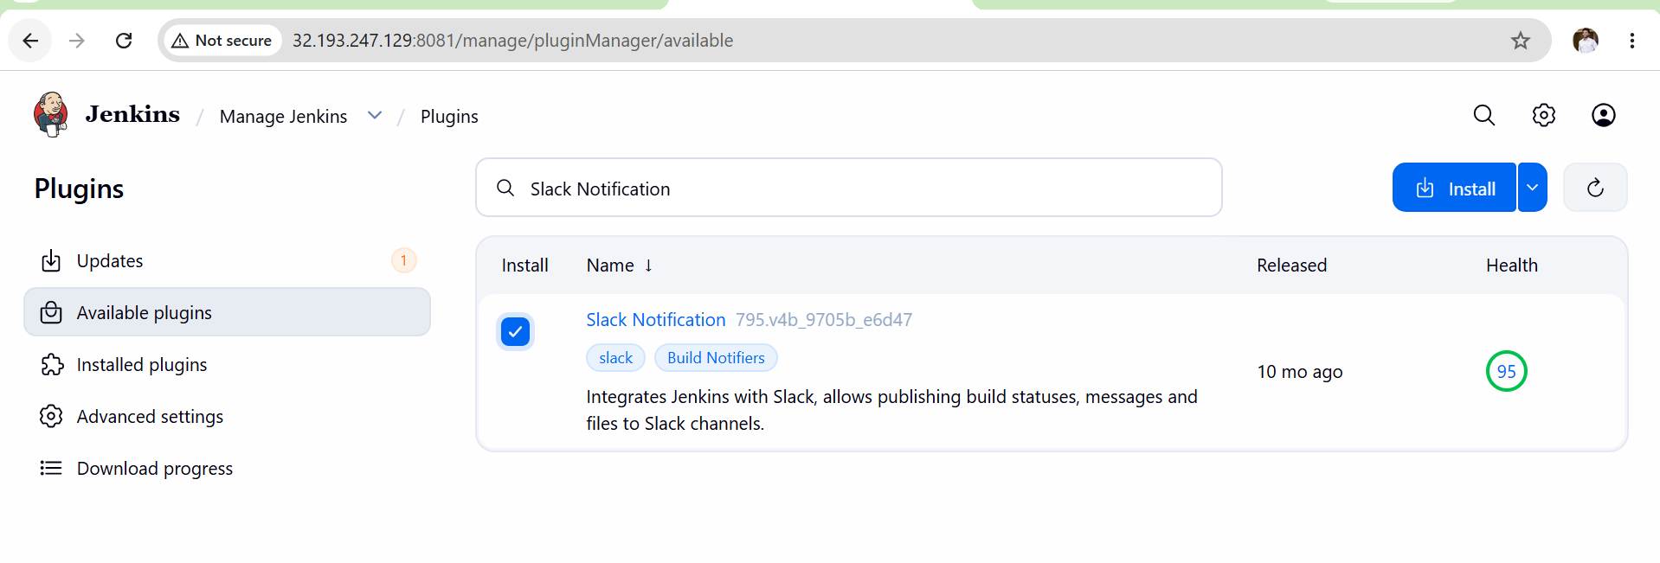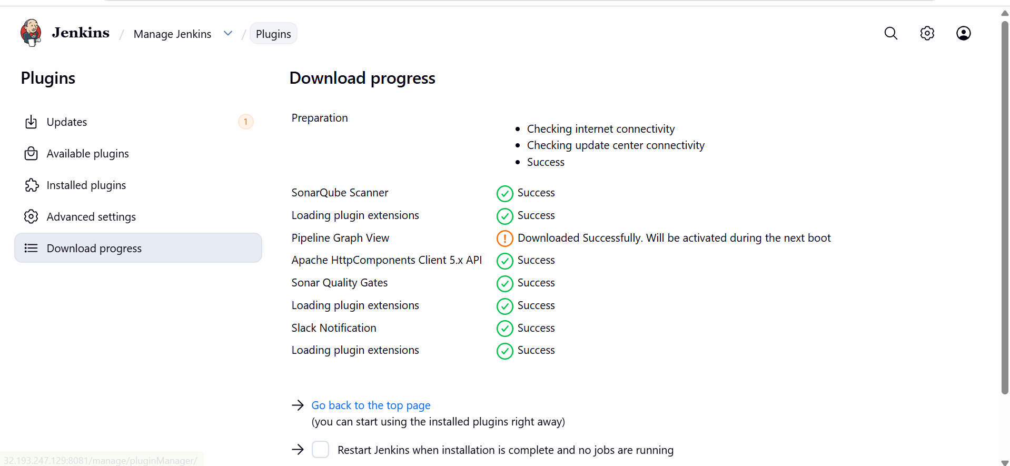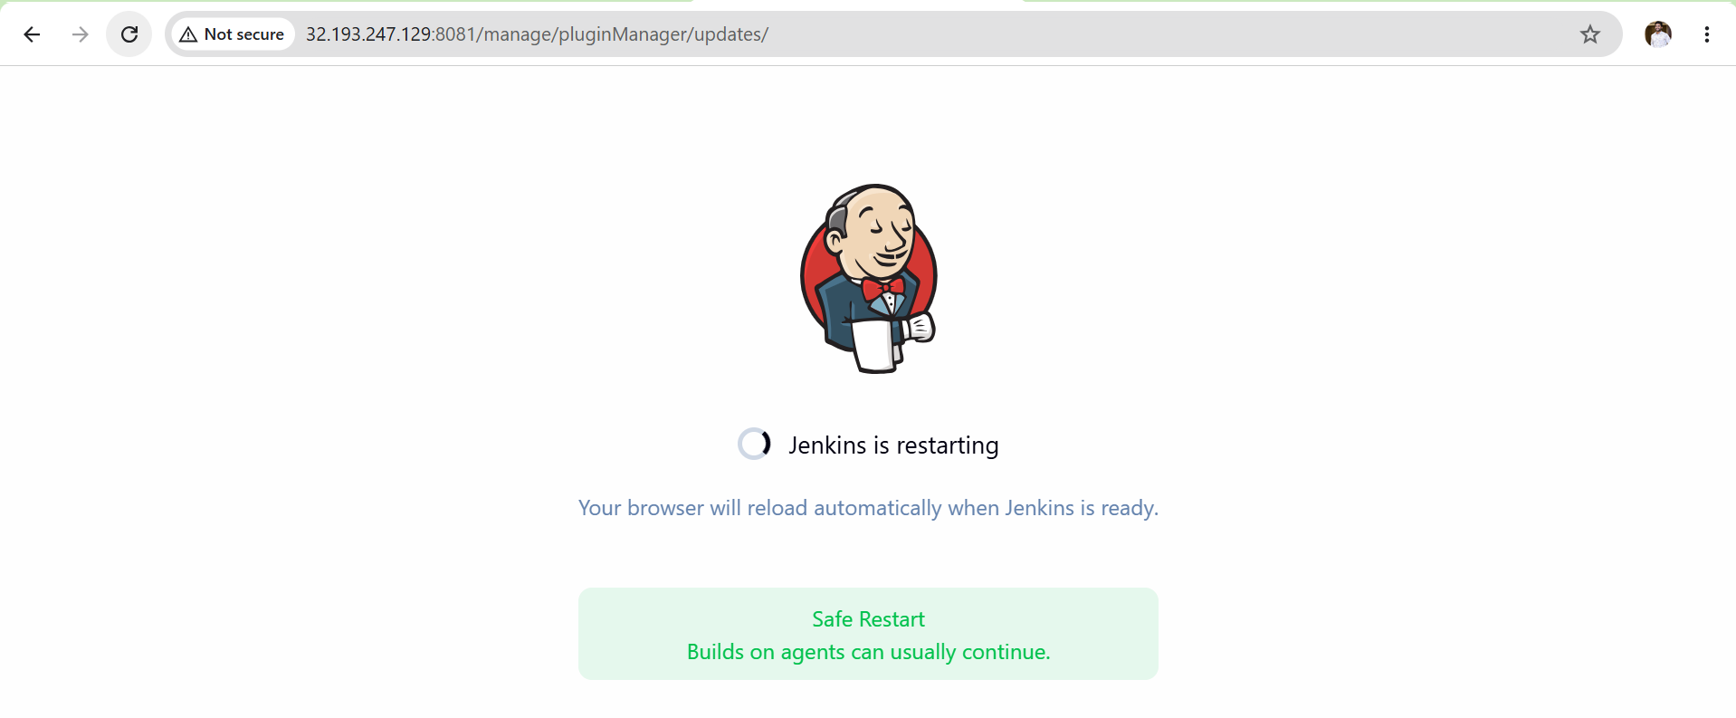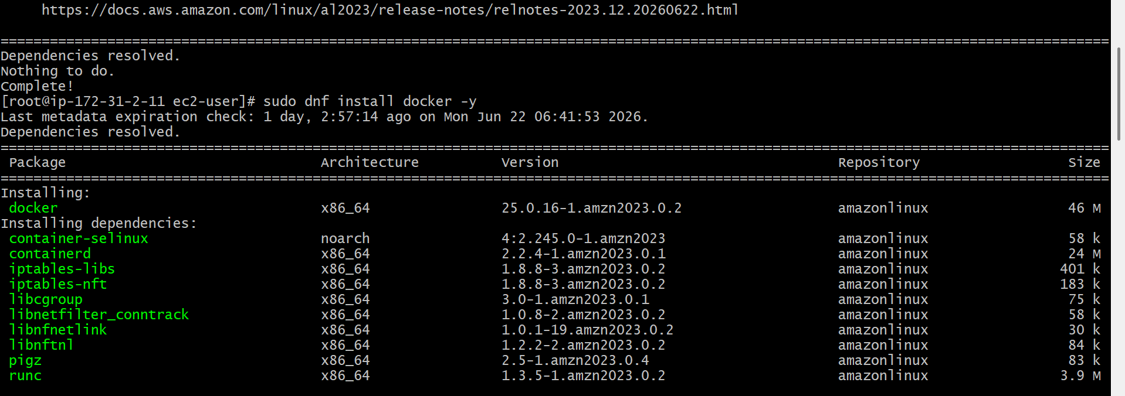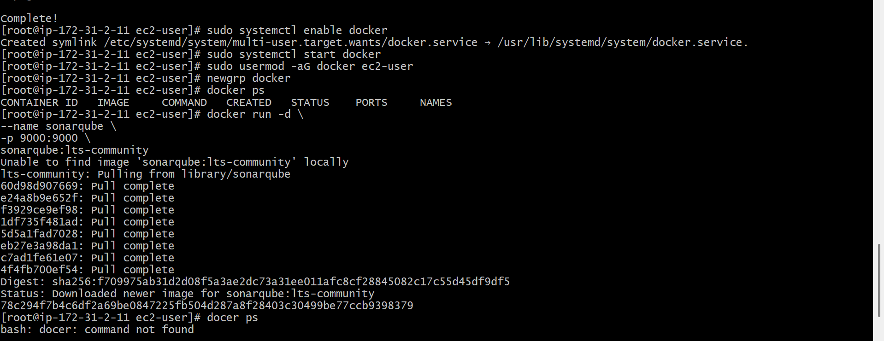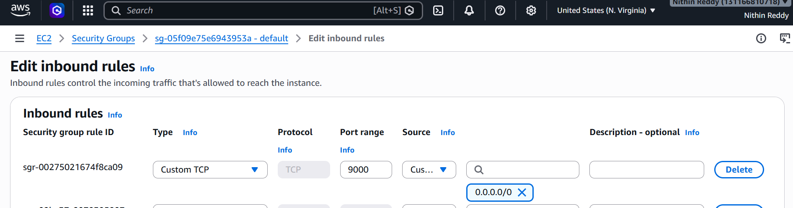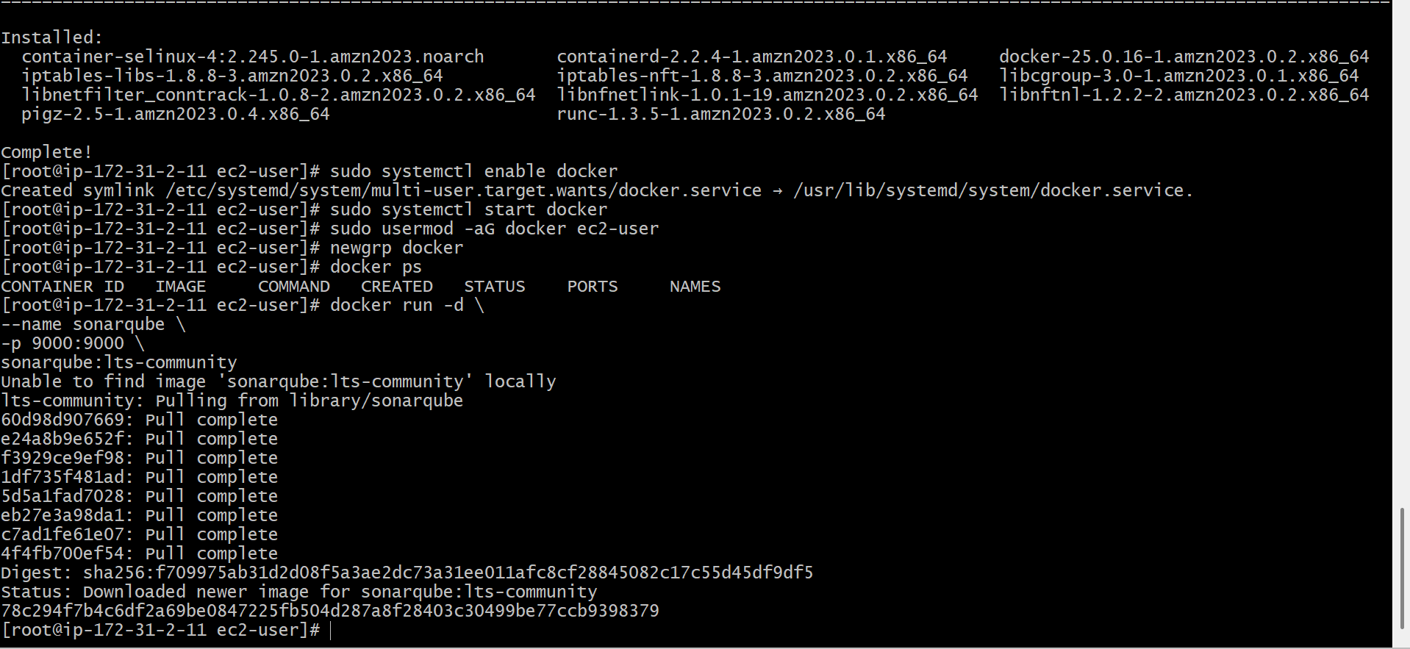
Stage 2: SonarQube Analysis
- Install SonarQube Scanner plugin.
- Configure SonarQube server in Jenkins.
- Generate SonarQube authentication token.
- Store token in Jenkins Credentials.
- Configure SonarQube Scanner tool.
- Add SonarQube analysis stage in Pipeline.
- Execute sonar-scanner command.
- Verify project appears in SonarQube Dashboard.
- Review Bugs, Vulnerabilities, Code Smells, and Quality Gate results.
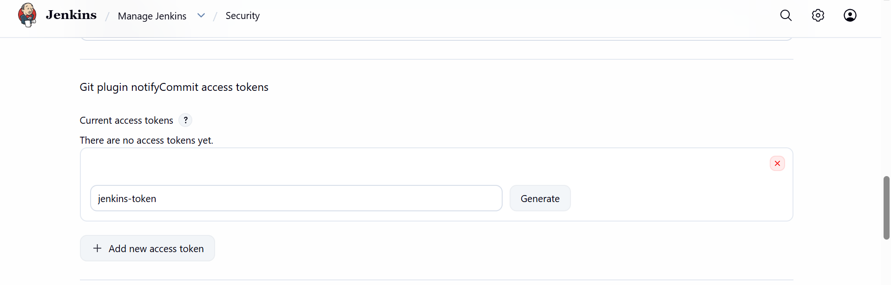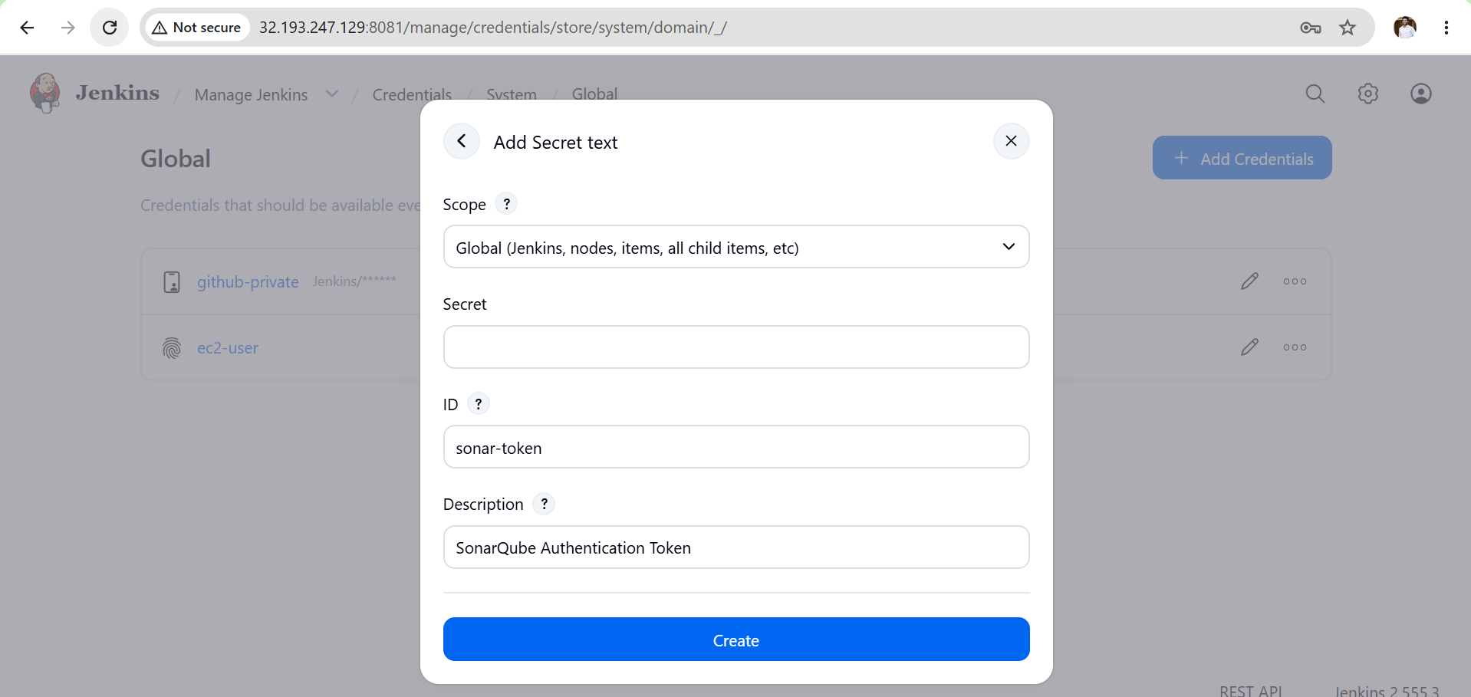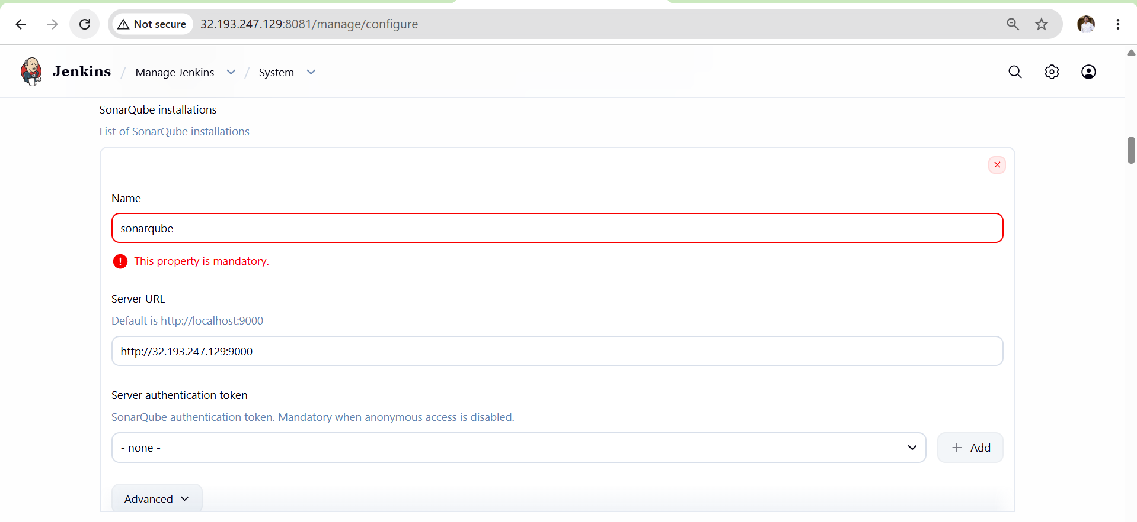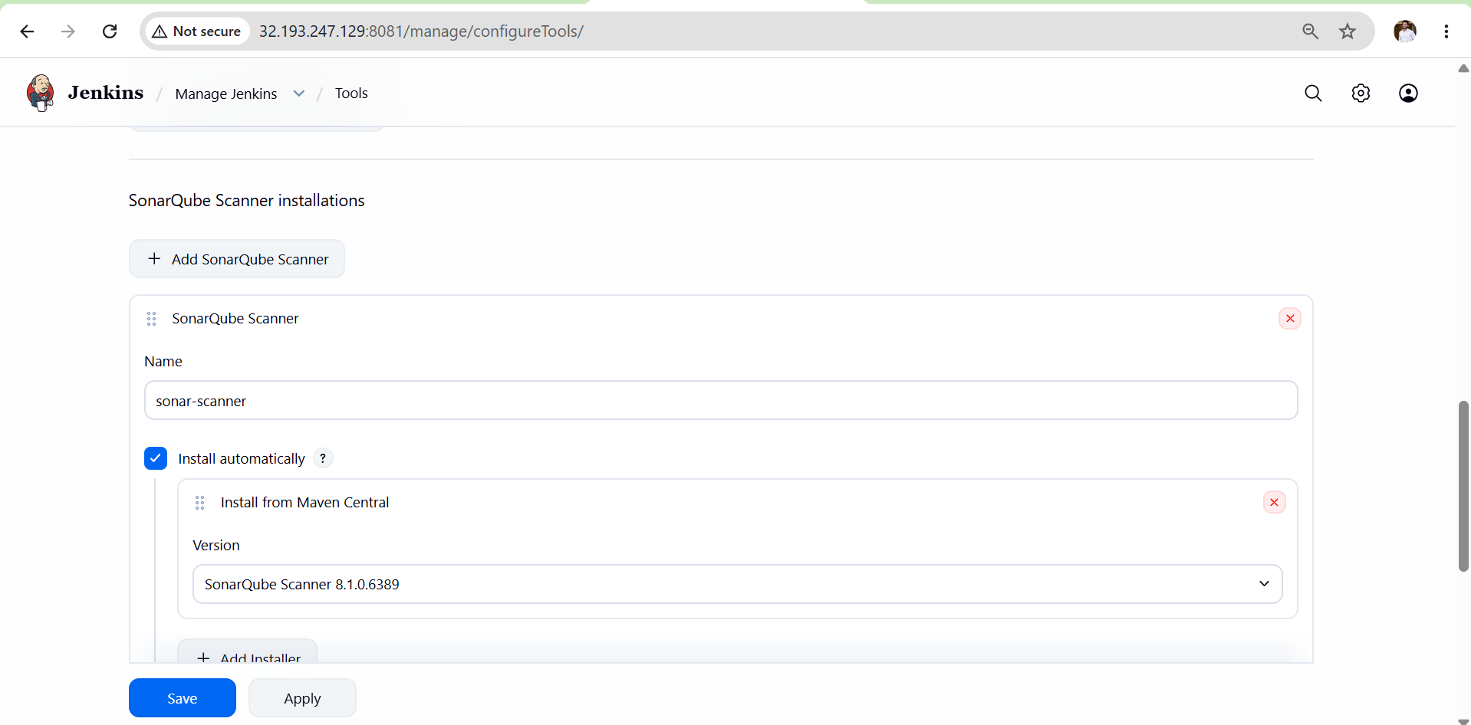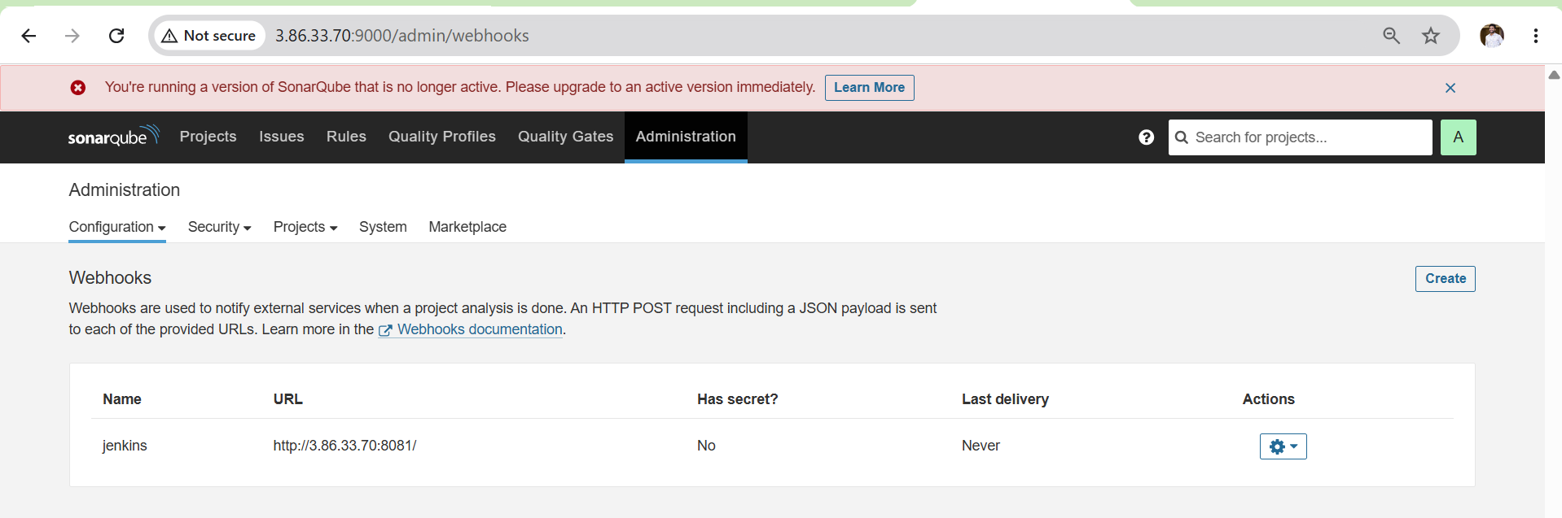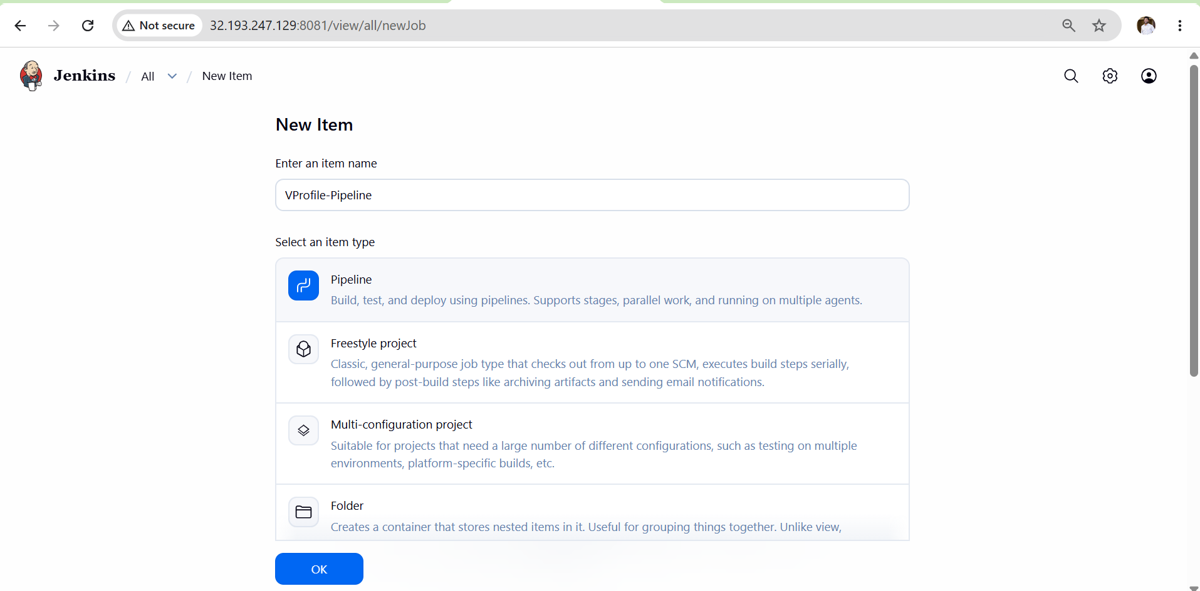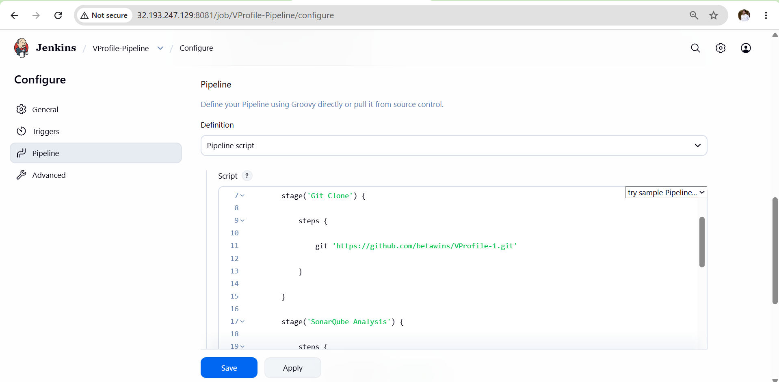

Stage 3: Slack Notification
- Create Slack channel named jenkins-alerts.
- Install Incoming Webhooks App in Slack.
- Generate Webhook URL.
- Store Webhook URL as Secret Text Credential in Jenkins.
- Add Slack notification stage in Pipeline.
- Configure curl command to send notification.
- Execute Pipeline.
Verify notification received in Slack channel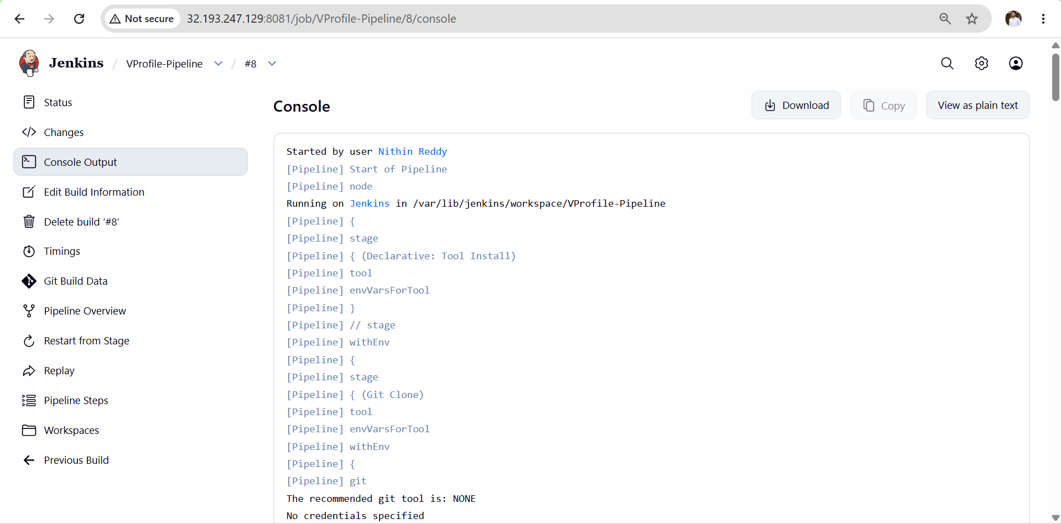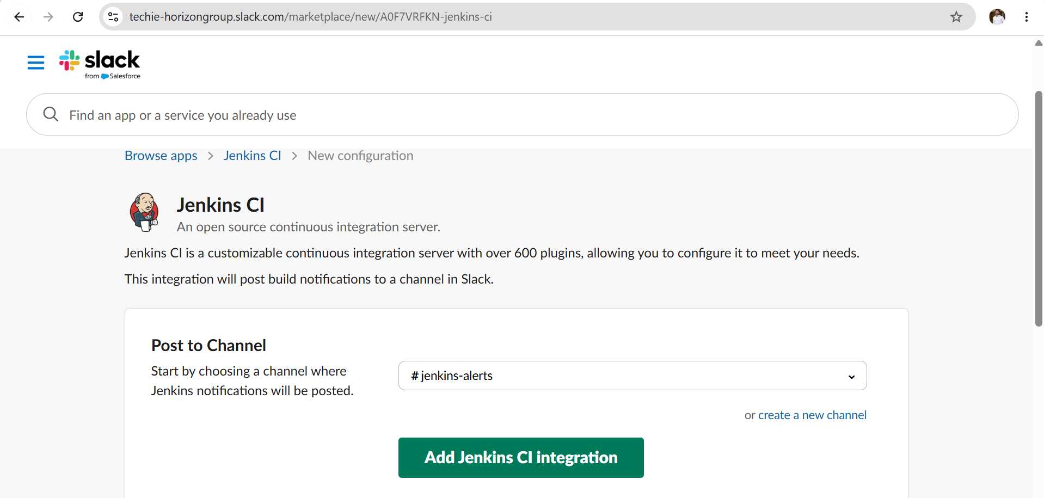
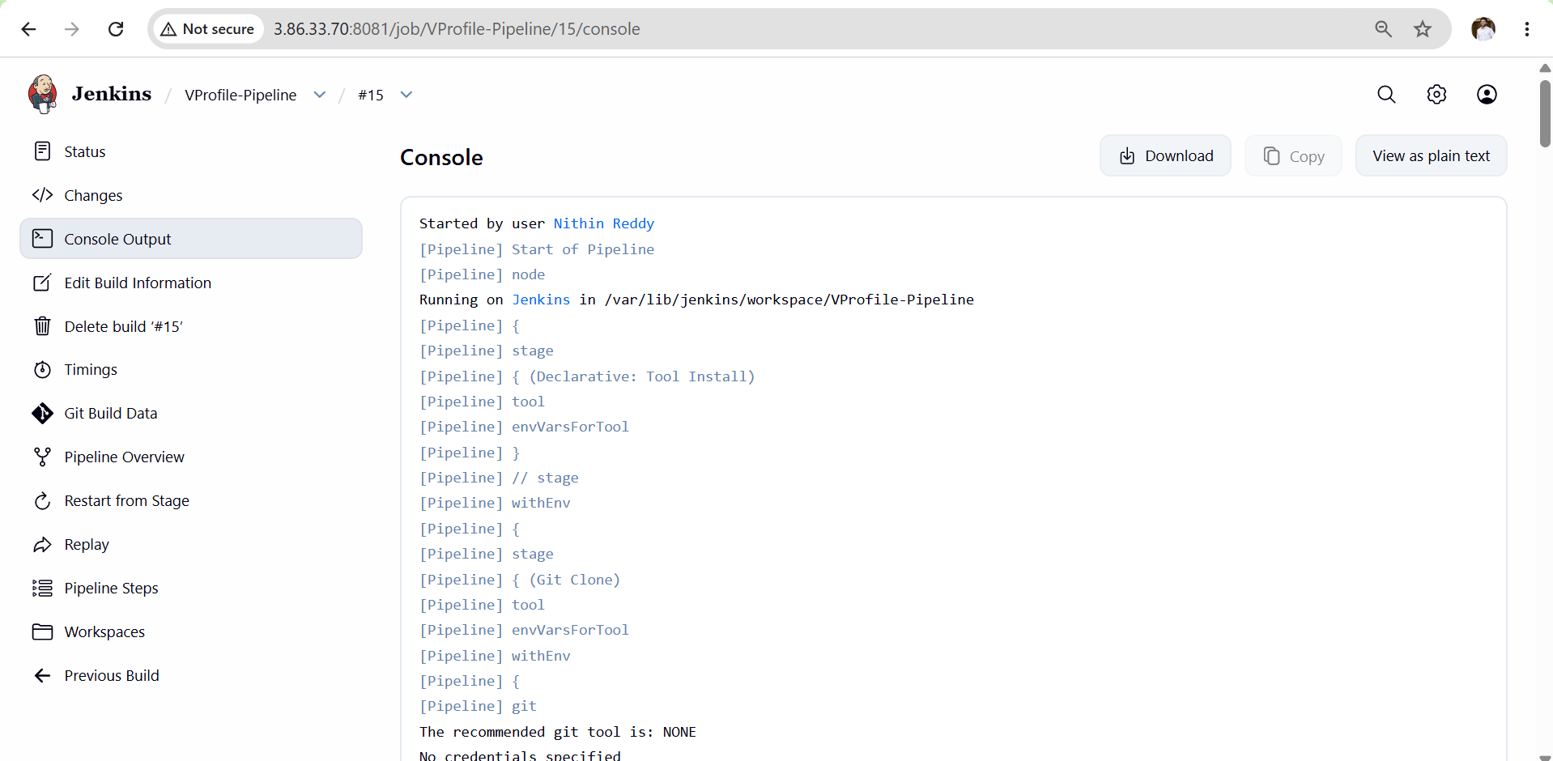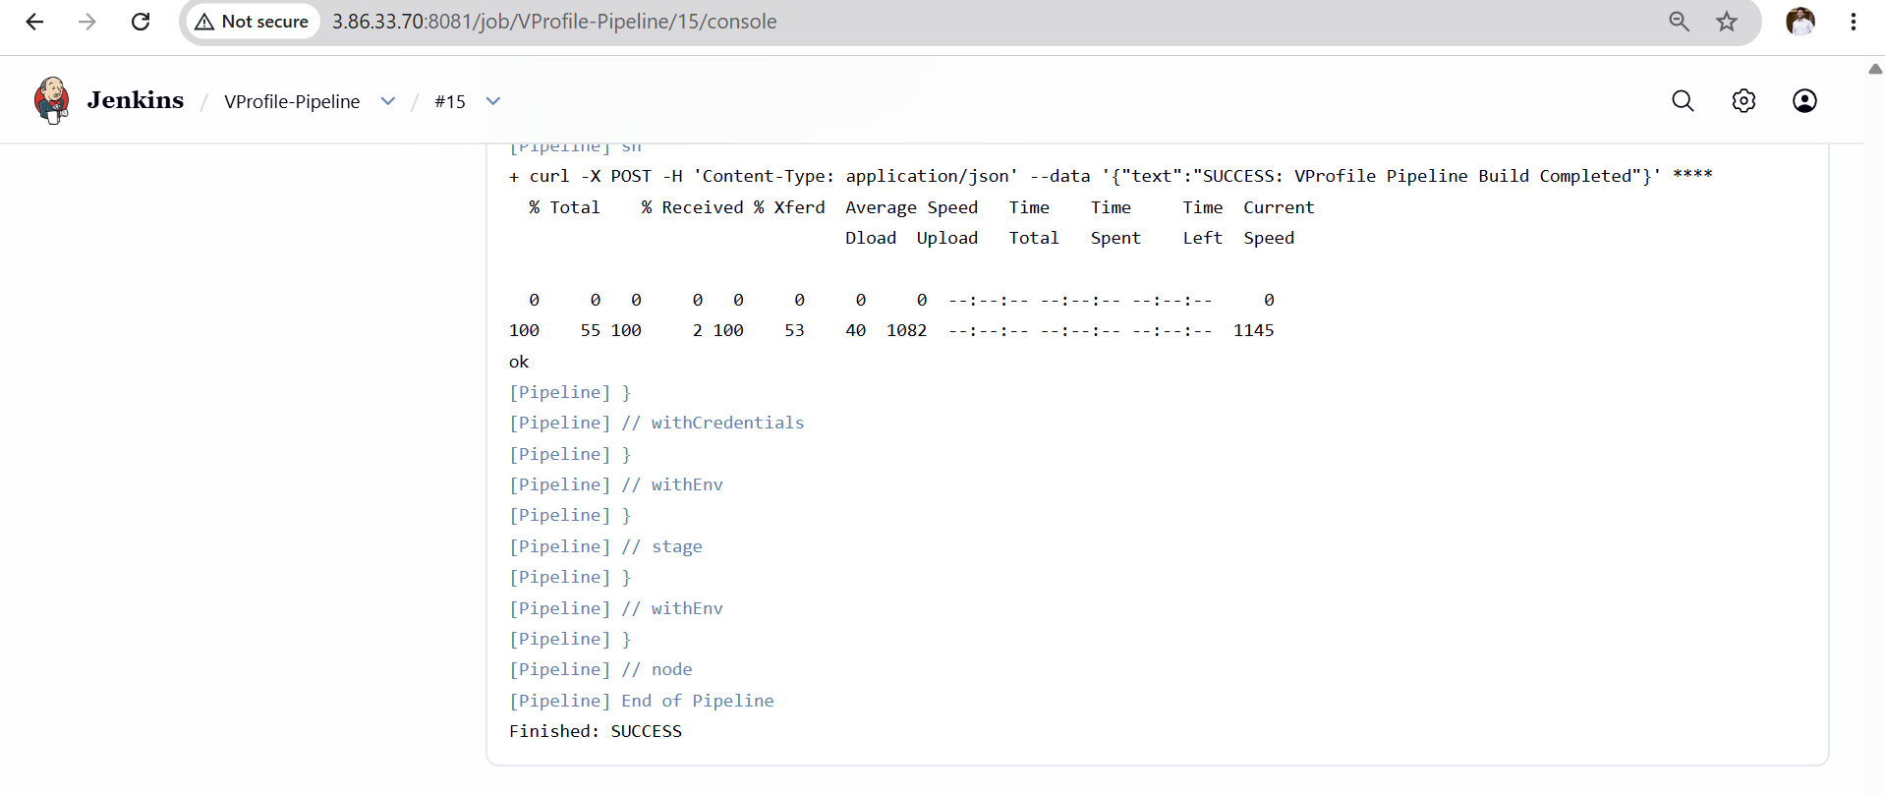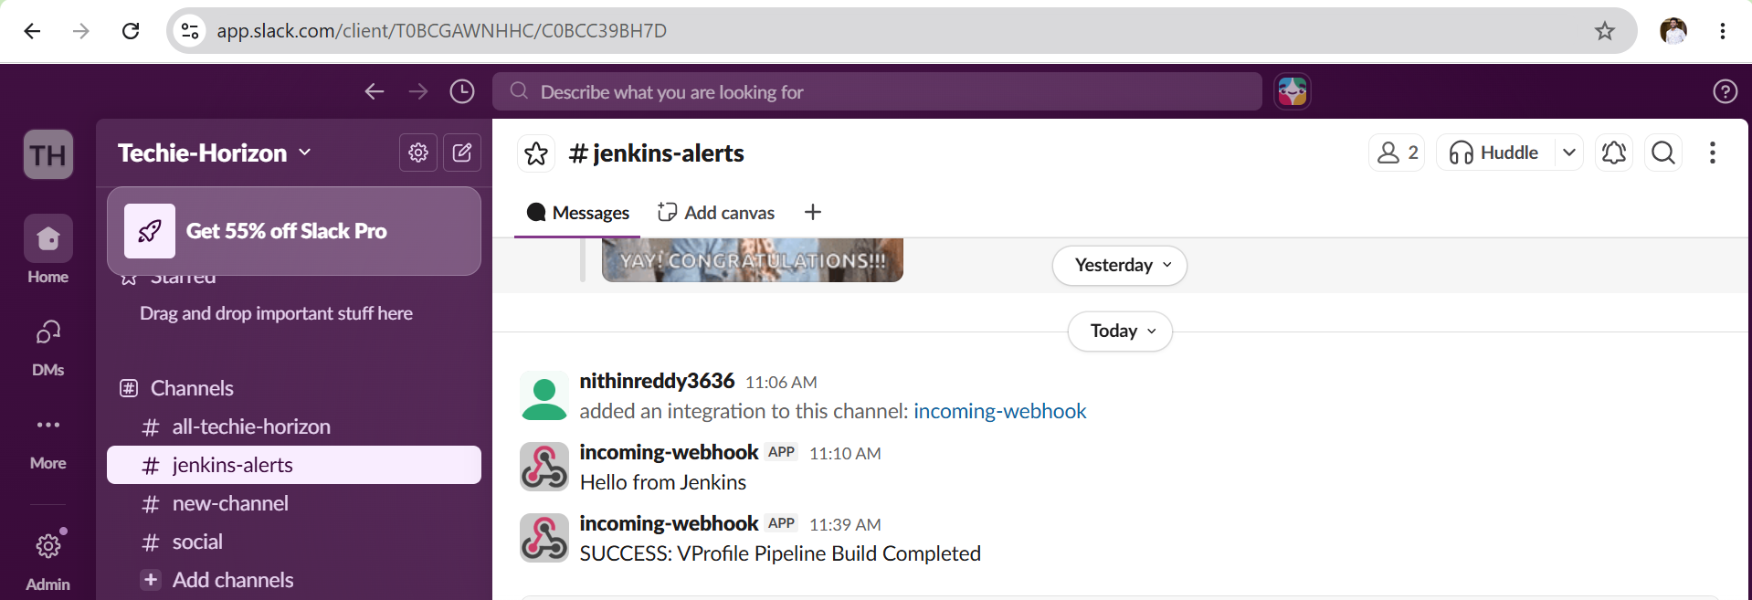
Validation Steps
Git Validation
- Repository successfully cloned.
- Source code available in Jenkins workspace.
- Build log shows successful checkout.
SonarQube Validation
- Analysis completed successfully.
- Project visible in SonarQube Dashboard.
- Quality metrics generated.
- No authentication errors.
Slack Validation
- Notification received in Slack channel.
- Build status displayed correctly.
- No webhook connectivity errors.

Outcome
- Source code successfully cloned from GitHub.
- Code quality analysis completed through SonarQube.
- Build notifications successfully sent to Slack.
- CI pipeline automation implemented with three stages.
- Real-time build monitoring enabled through Slack alerts.

Jenkins-03
Task 2 Create one Jenkins job using the below code and create three stages.
Objective
Create a Jenkins Pipeline Job with:
Stage 1
Git Clone
Stage 2
SonarQube Analysis
Stage 3
Slack Notification
Repository:
https://github.com/betawins/hiring-app.git
Prerequisites
- Jenkins Server up and running
- Java 21 configured as JDK-21
- SonarQube Server running on port 9000
- SonarQube token stored in Jenkins as sonar-token
- Sonar Scanner configured in Jenkins as sonar-scanner
- Slack Incoming Webhook URL stored in Jenkins Credentials as slack
- Slack channel created (jenkins-alerts)
- Required plugins installed:
  - Git Plugin
  - Pipeline Plugin
  - SonarQube Scanner Plugin
  - Slack Plugin (optional)
  - Credentials Plugin
Execution Steps
Stage 1: Create Pipeline Job
- Login to Jenkins.
- Click New Item.
- Enter Job Name:
Hiring-App-Pipeline
- Select Pipeline.
- Click OK.
Stage 2: Configure Pipeline
- Scroll to Pipeline section.
- Select:
Pipeline Script
- Paste Pipeline Code.
- Save.
Stage 3: Git Clone
- Jenkins connects to GitHub repository.
- Repository cloned:
https://github.com/betawins/hiring-app.git
- Correct branch configured (main/master).

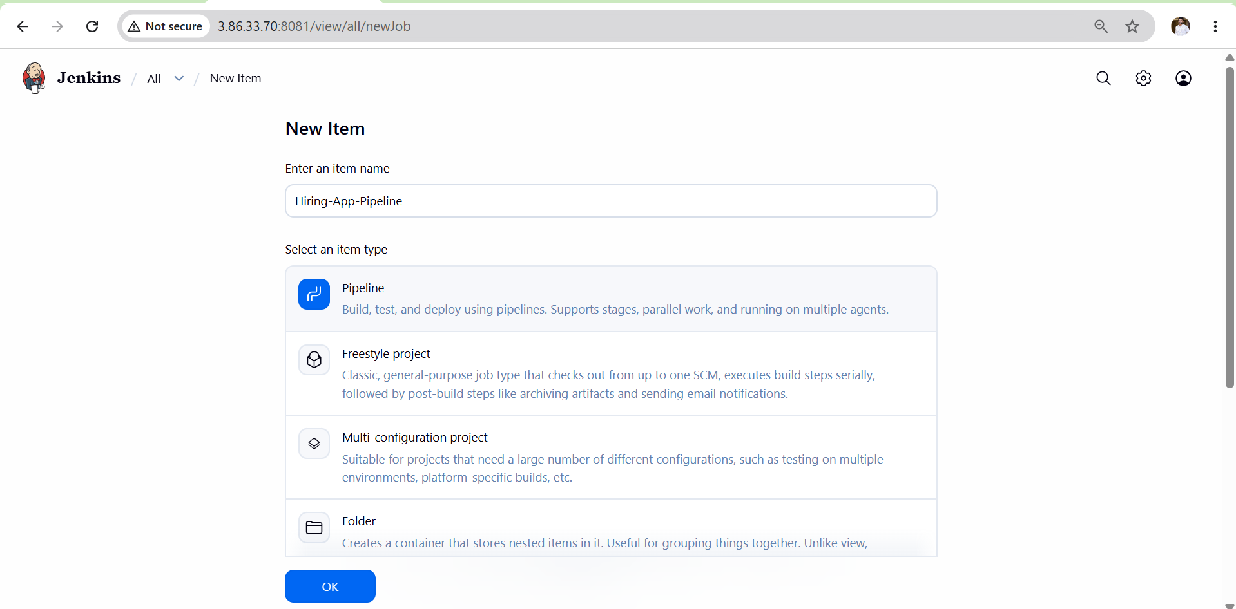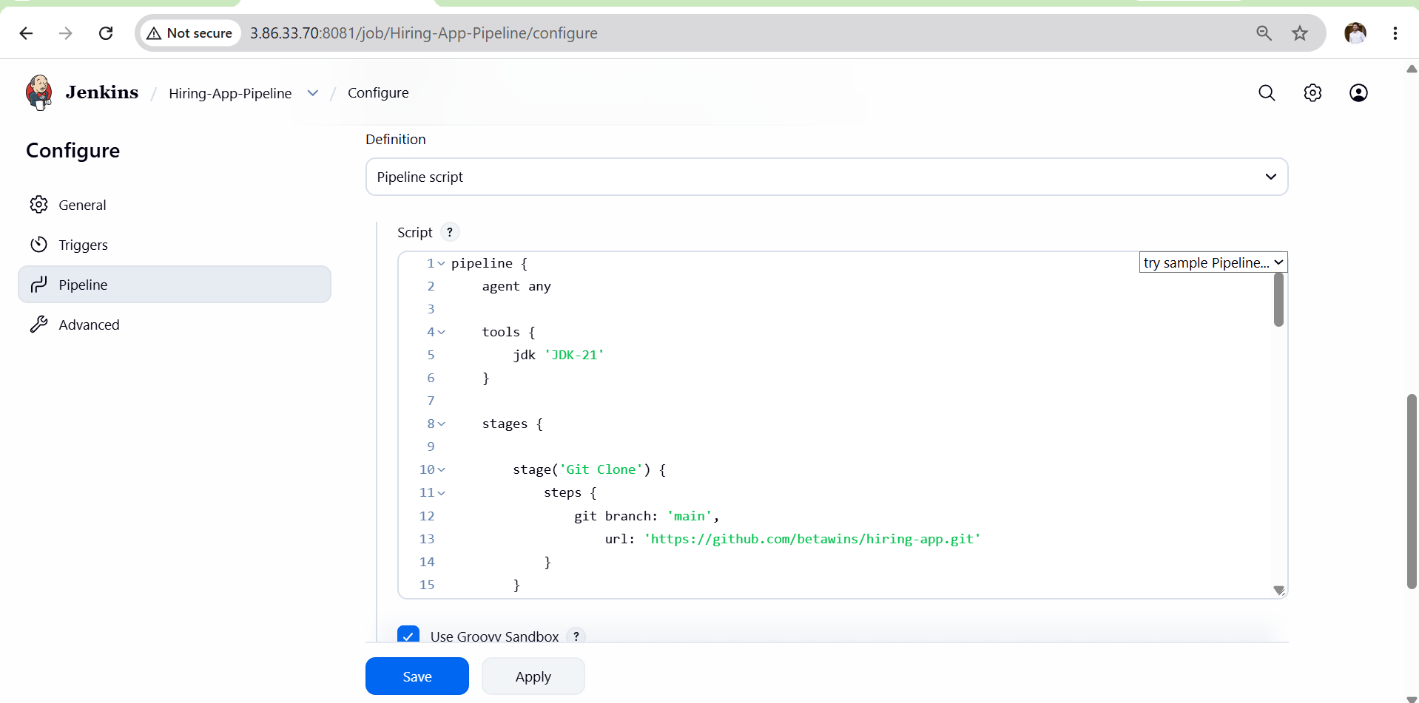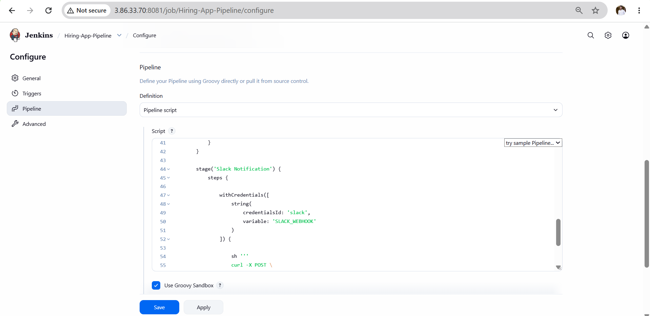
Stage 4: SonarQube Analysis
- Jenkins loads Sonar Scanner.
- Connects to SonarQube Server.
- Uses Jenkins credential:
sonar-token
- Creates project:
hiring-app
- Performs code quality scan.
- Uploads analysis report to SonarQube.
Stage 5: Slack Notification
- Jenkins reads Slack Webhook URL.
- Sends Success message.
- Message received in:
#jenkins-alerts

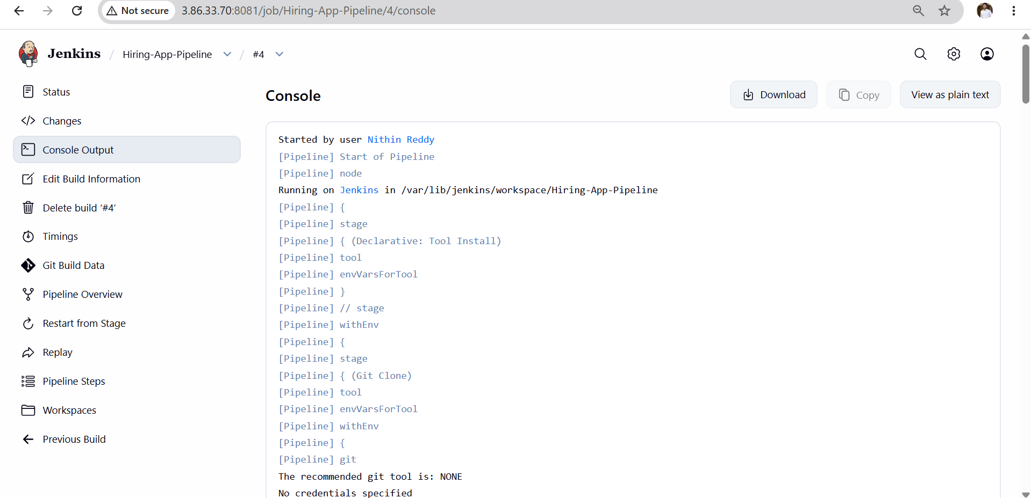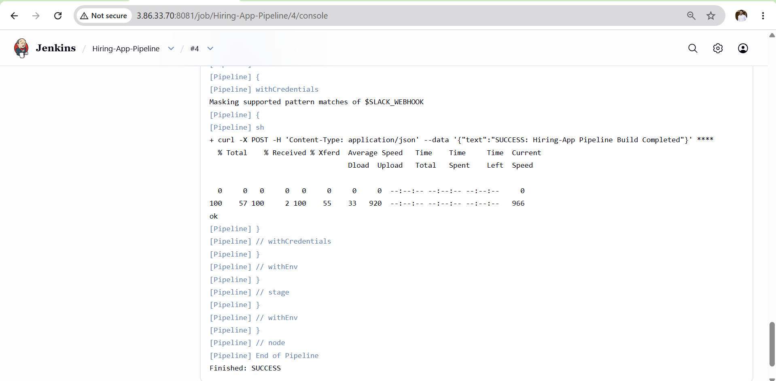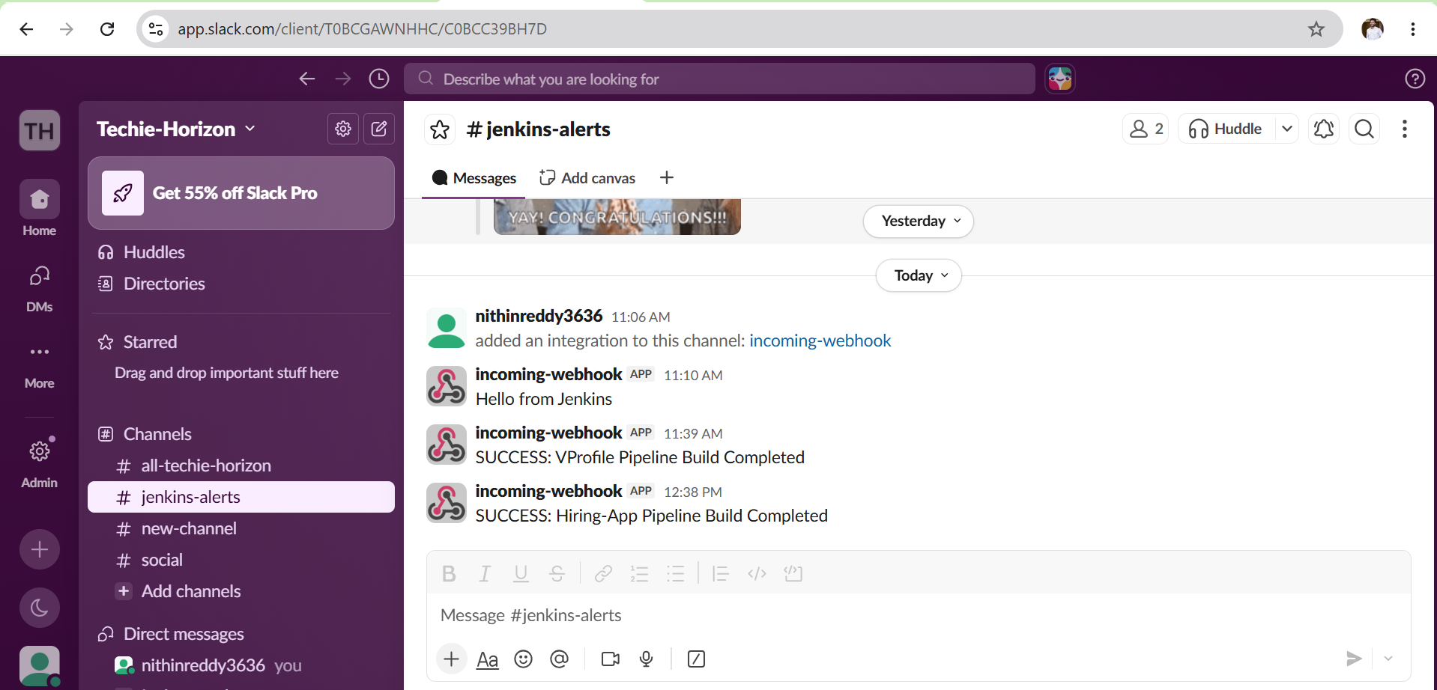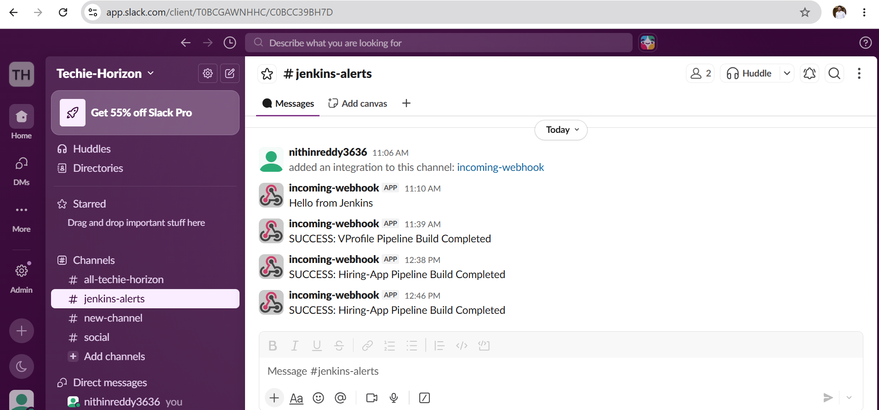
Validation Steps
Git Validation
Build Console Output should show:
Cloning repository https://github.com/betawins/hiring-app.git
Status:
SUCCESS

SonarQube Validation
Open:
http://<SonarQube-IP>:9000
Verify:
- Project Name:
hiring-app
- Analysis completed.
- Code metrics visible.

Slack Validation
Open Slack Channel:
#jenkins-alerts
Verify message:
SUCCESS: Hiring-App Pipeline Build Completed

