Task 1: Freestyle CI/CD Pipeline
Project: Hiring-App
Repository: https://github.com/betawins/hiring-app.git
Stages Required:
- Git Clone
- SonarQube Analysis
- Maven Build
- Nexus Upload
- Slack Notification
- Deploy to Tomcat
Objective
Create a Jenkins Freestyle Job with the following stages:
- Git Clone
- SonarQube Integration
- Maven Compilation
- Nexus Artifactory Upload
- Slack Notification
- Deploy on Tomcat

Prerequisites
- Jenkins Server running on Port 8081
- Java 21 Installed
- Git Installed
- Maven Installed
- Docker Installed
- SonarQube Container Running on Port 9000
- Nexus Container Running on Port 8082
- Tomcat 10 Installed on Port 8080
- Slack Webhook Configured
- SonarQube Token Created
- Nexus Repository Created
Execution Steps
- Started SonarQube Docker container and verified access on Port 9000.
- Started Nexus Docker container and verified access on Port 8082.
- Installed and configured Apache Tomcat 10 on Port 8080.
- Created Maven Hosted Repository (maven-releases) in Nexus Repository Manager.
- Added SonarQube token, Nexus credentials, and Slack webhook credentials in Jenkins.
- Created a Jenkins Freestyle Job named Hiring-App-Freestyle.
- Configured Git SCM with repository https://github.com/betawins/hiring-app.git.
- Configured SonarQube Scanner for code quality analysis.
- Configured Maven build with goal clean package.
- Generated WAR artifact successfully using Maven.
- Uploaded WAR artifact to Nexus Repository Manager.
- Configured Slack integration for build notifications.
- Verified successful notifications in #jenkins-alerts Slack channel.
- Configured Tomcat deployment for generated WAR artifact.
- Deployed application successfully on Tomcat server.
- Validated Git Clone, SonarQube Analysis, Maven Build, Nexus Upload, Slack Notification, and Tomcat Deployment stages.
- Successfully implemented end-to-end CI/CD pipeline using Jenkins Freestyle Job, SonarQube, Maven, Nexus, Slack, and Tomcat.
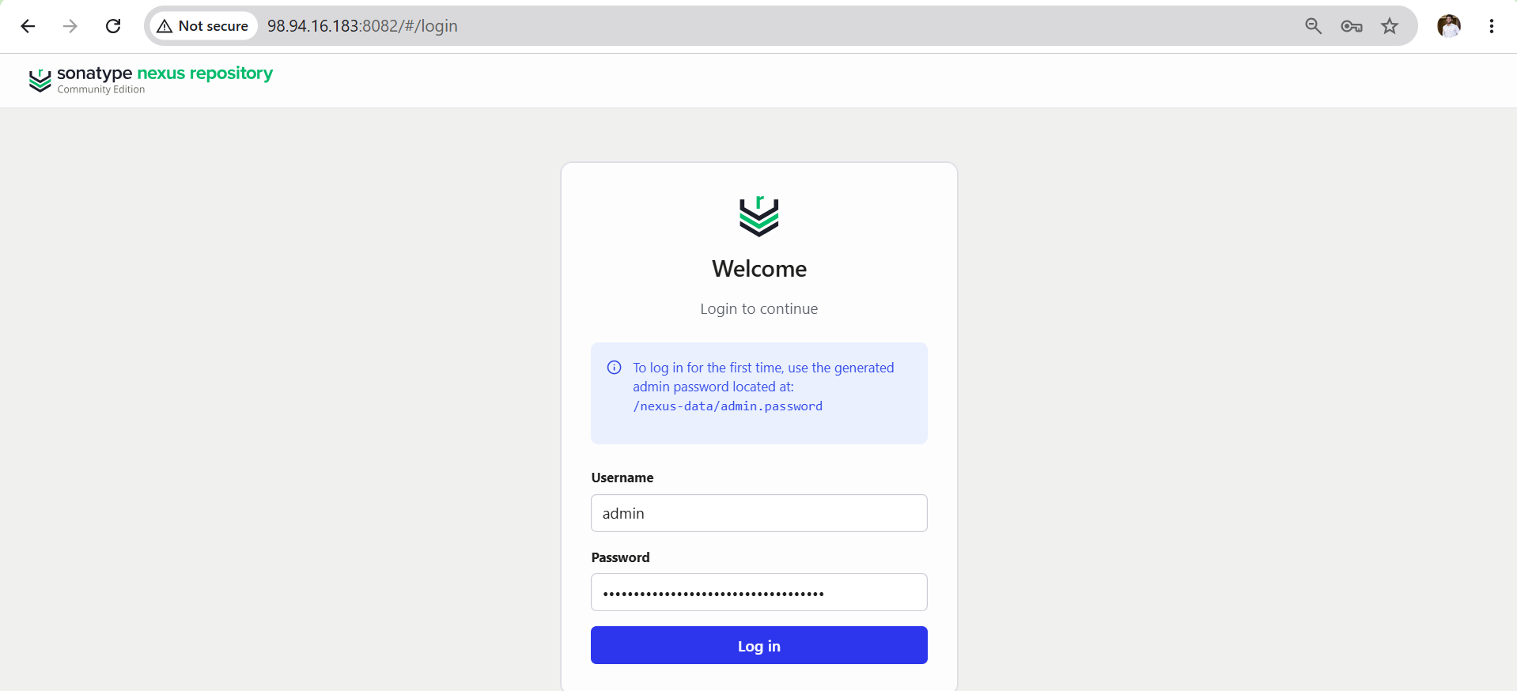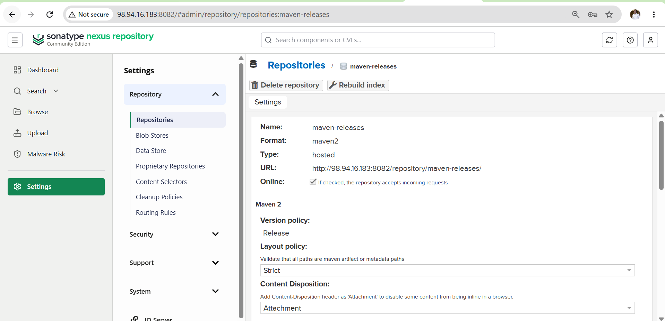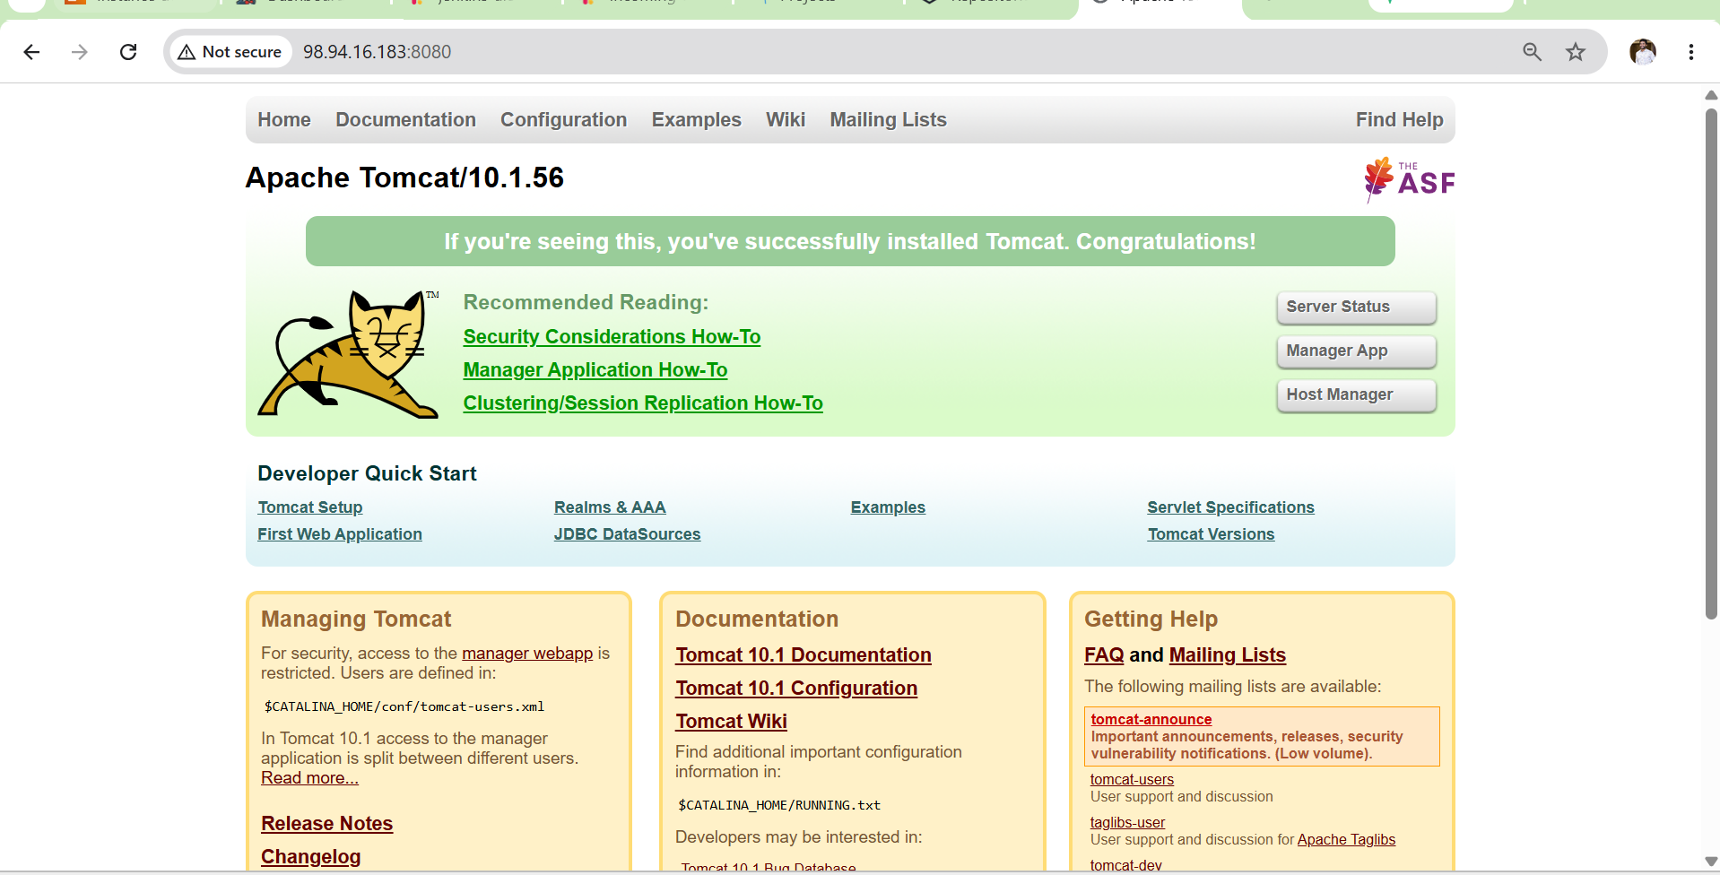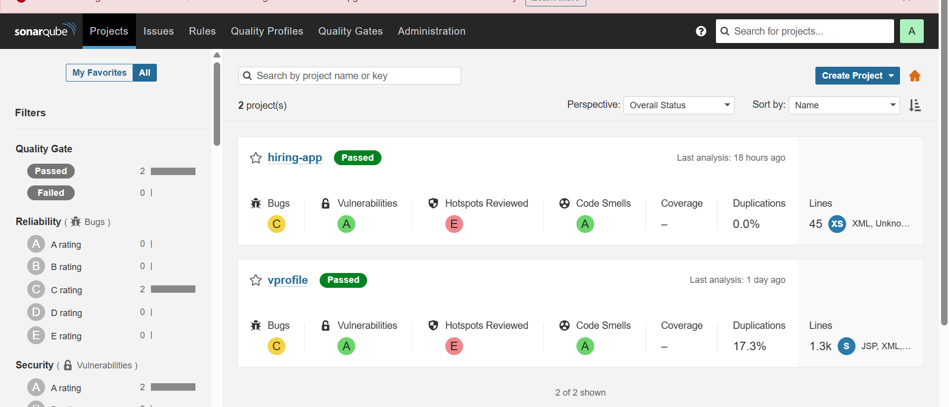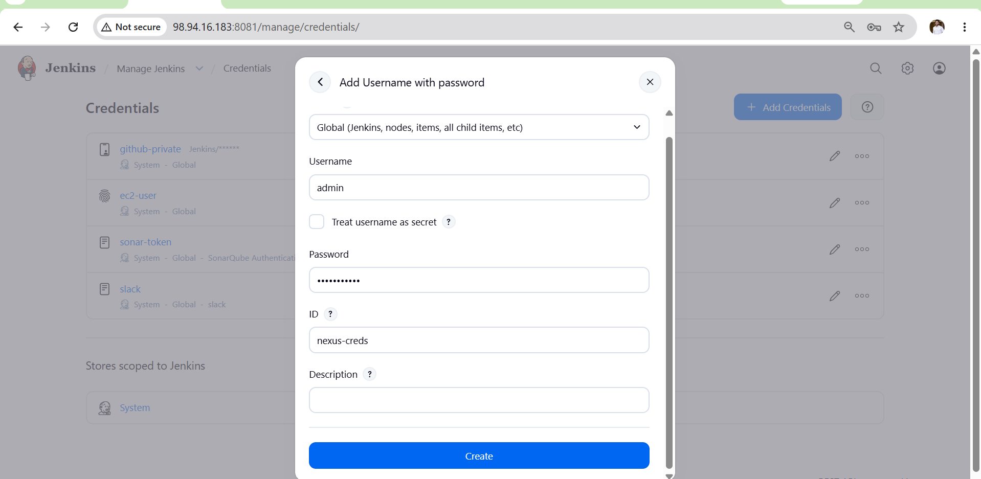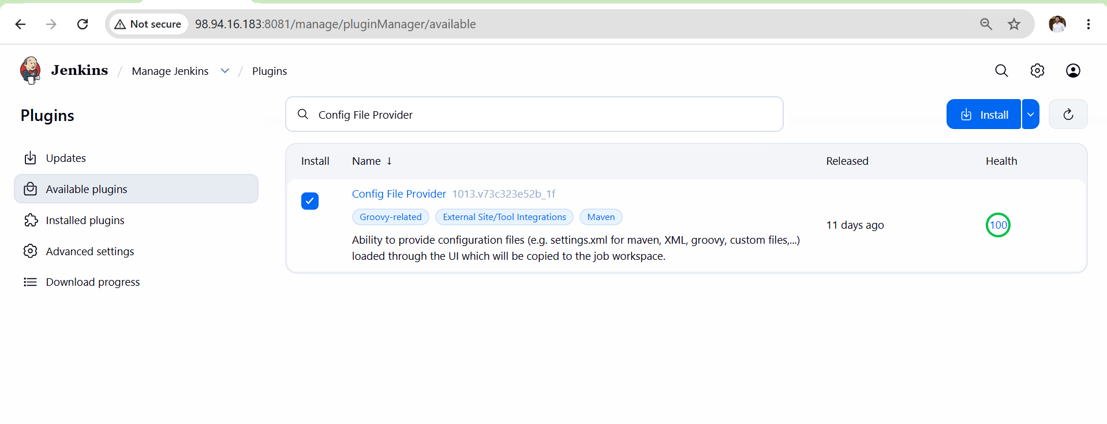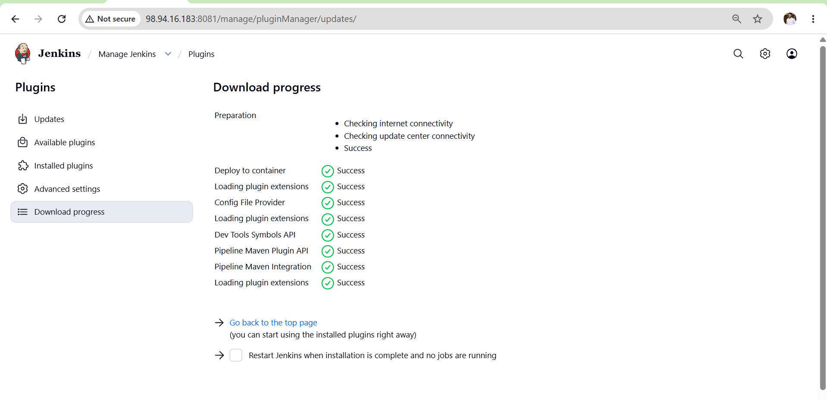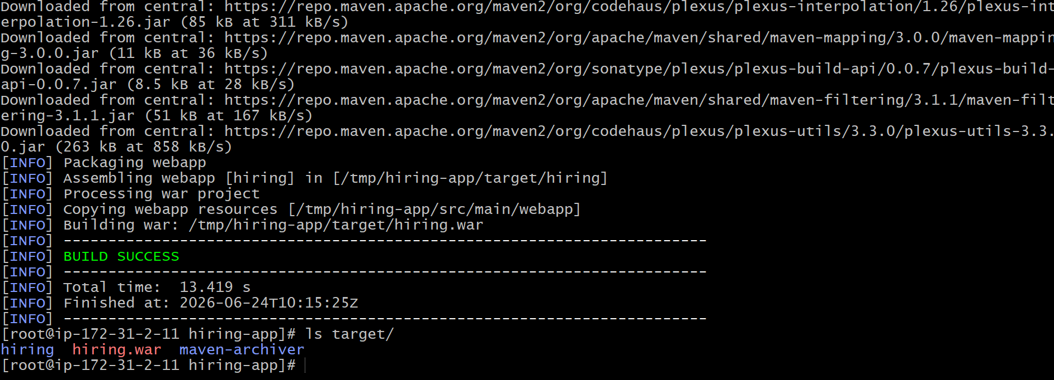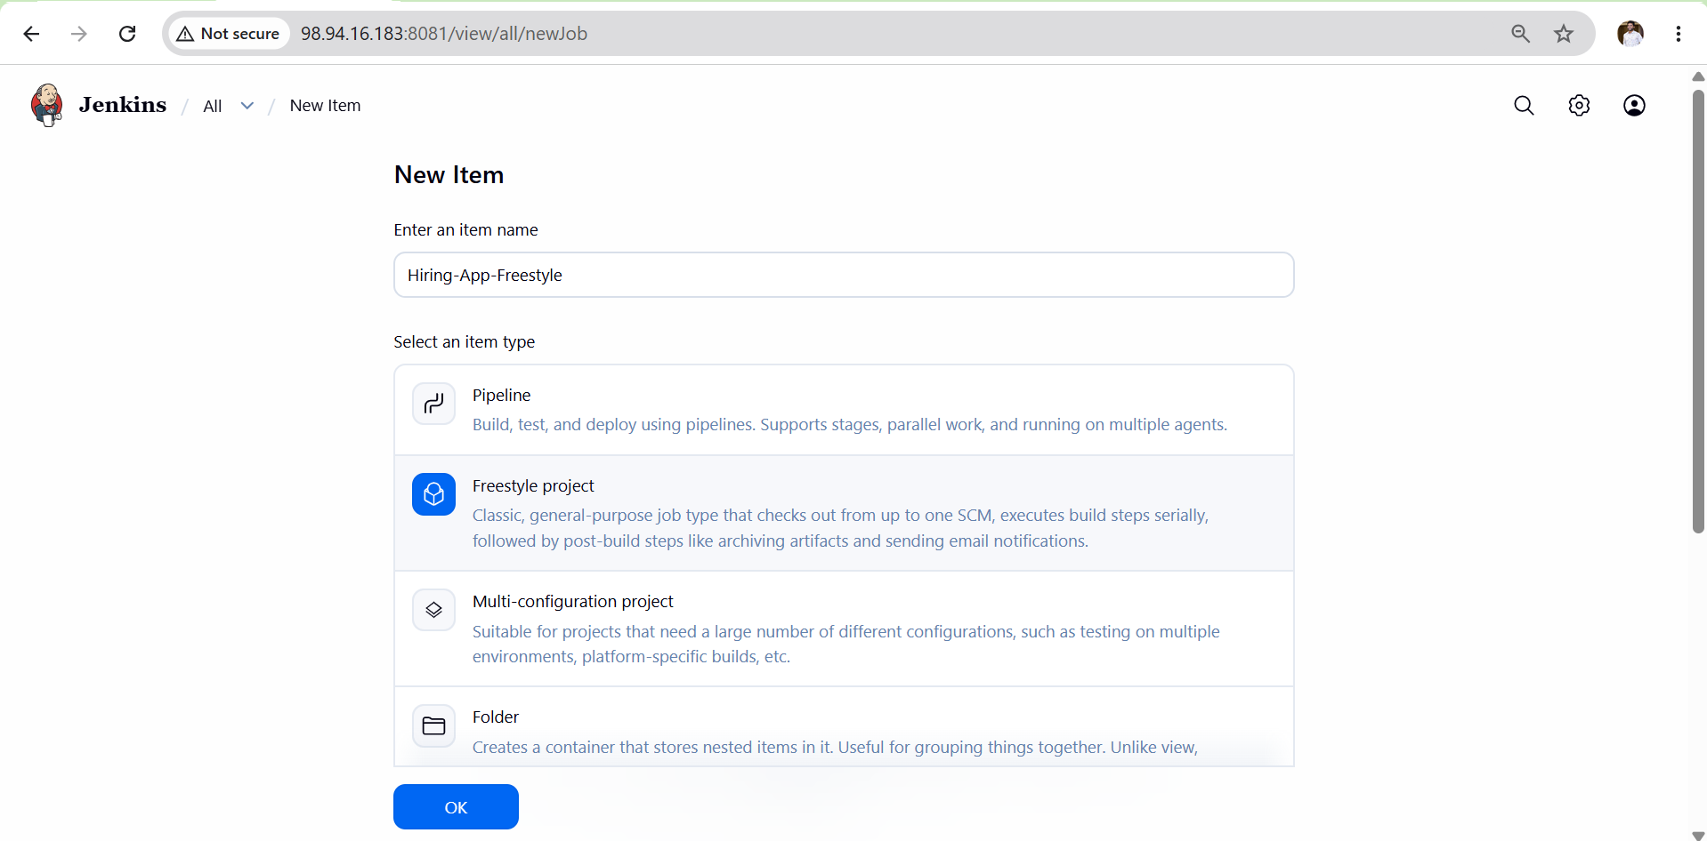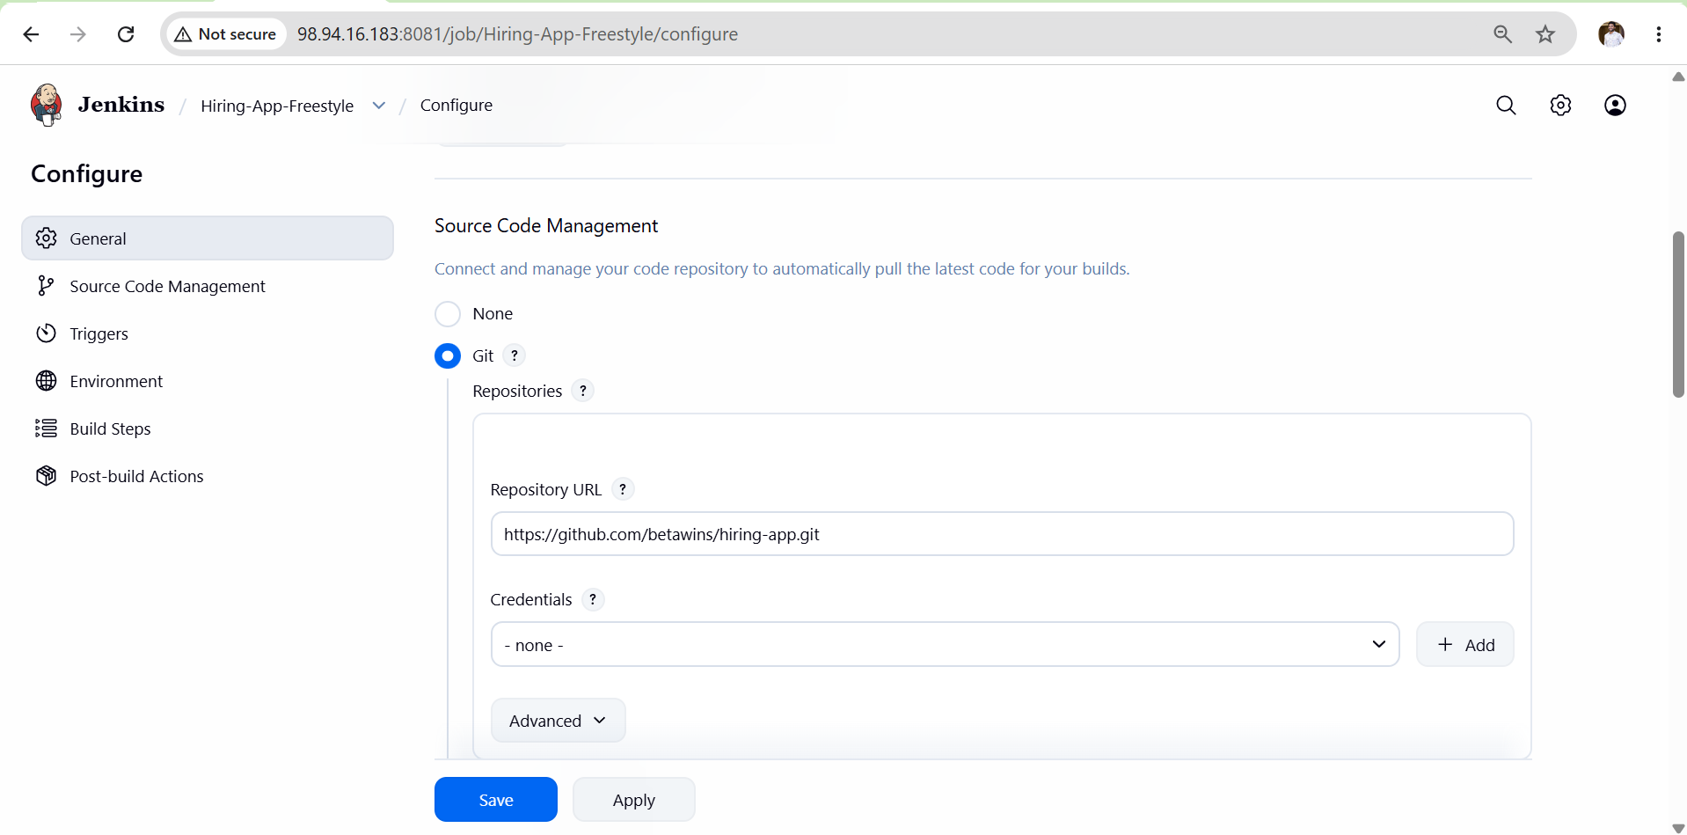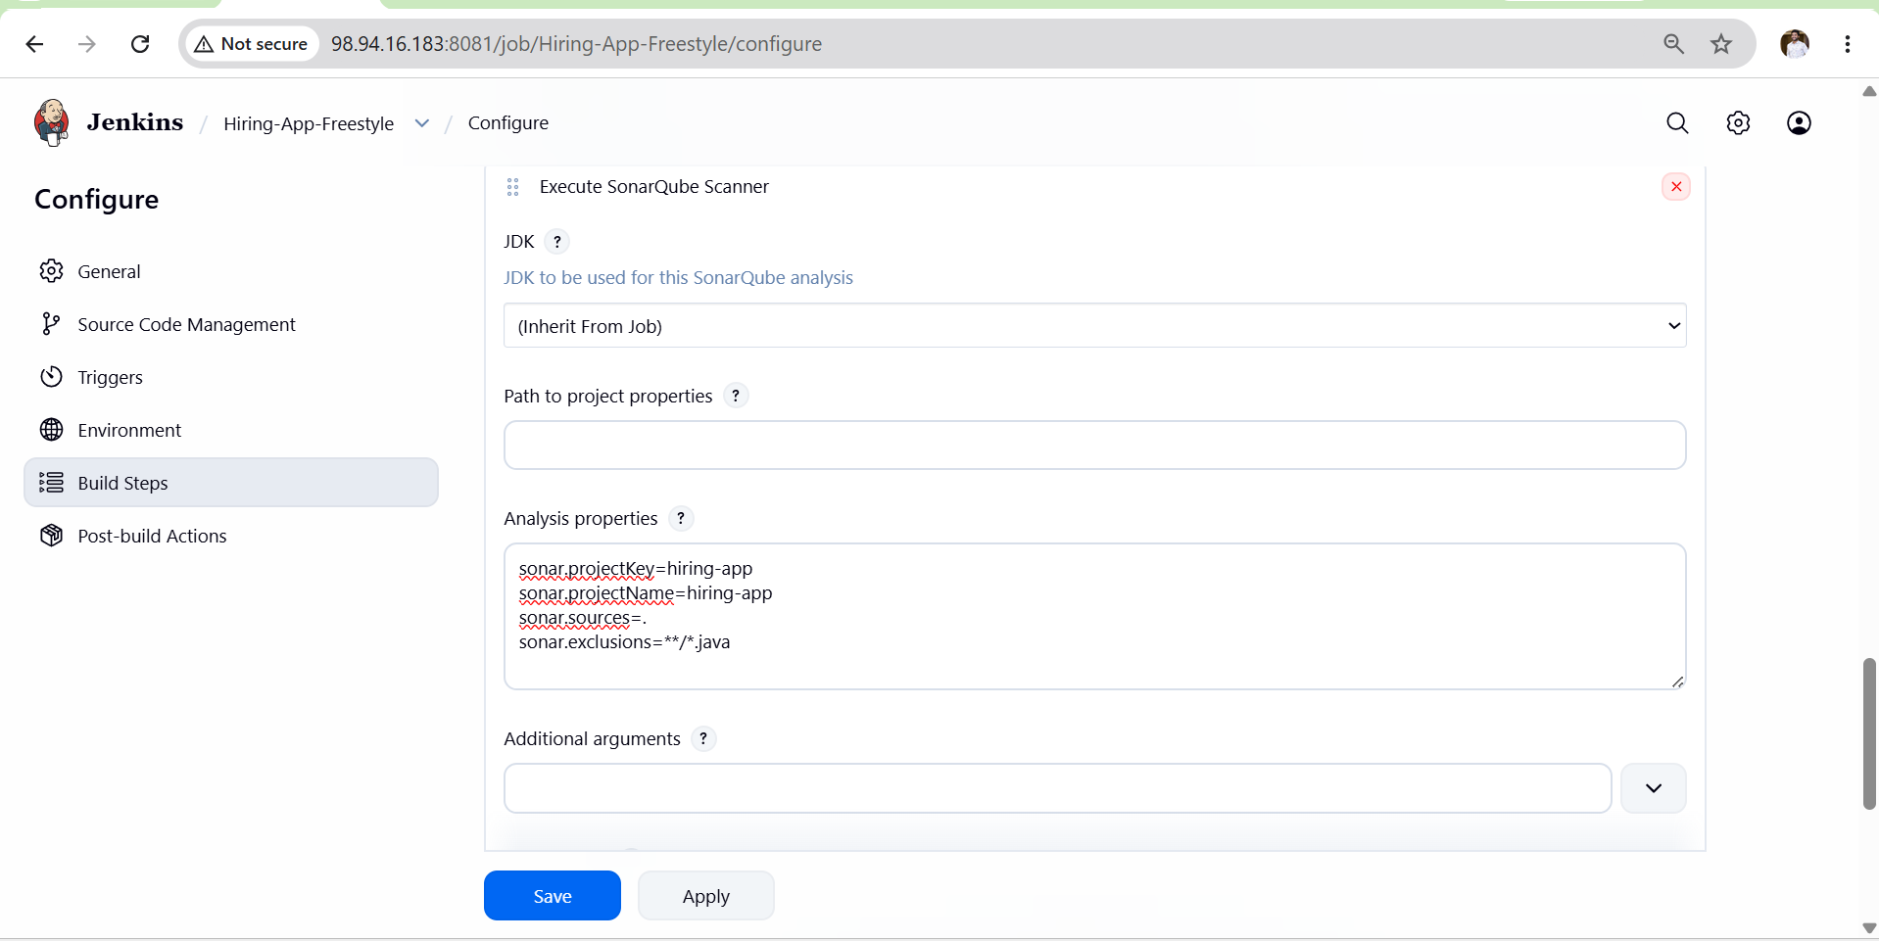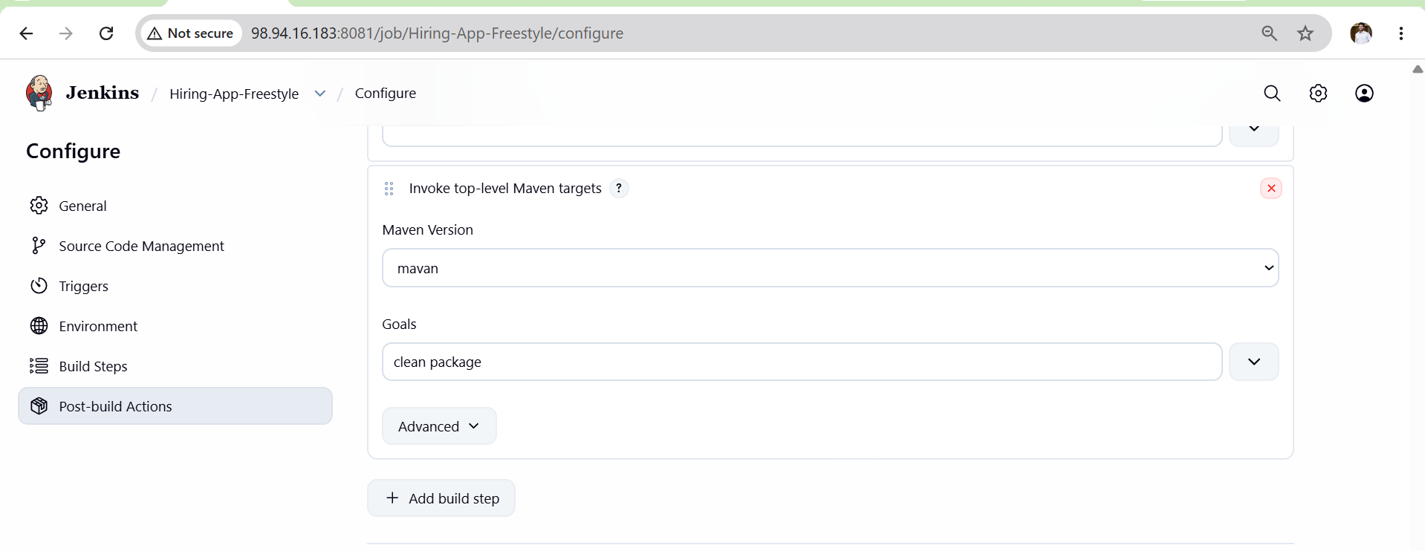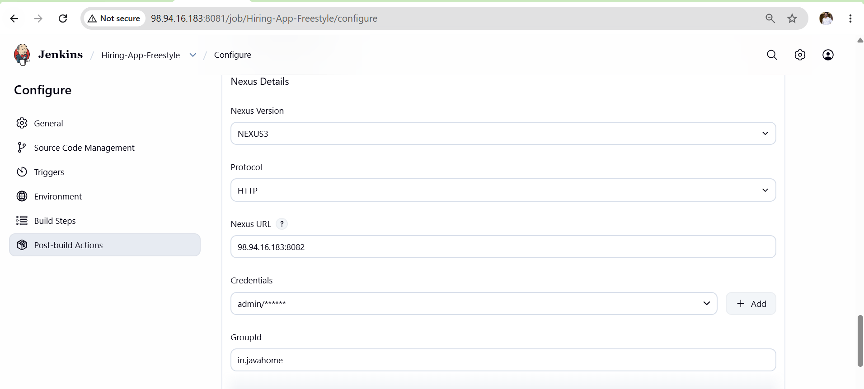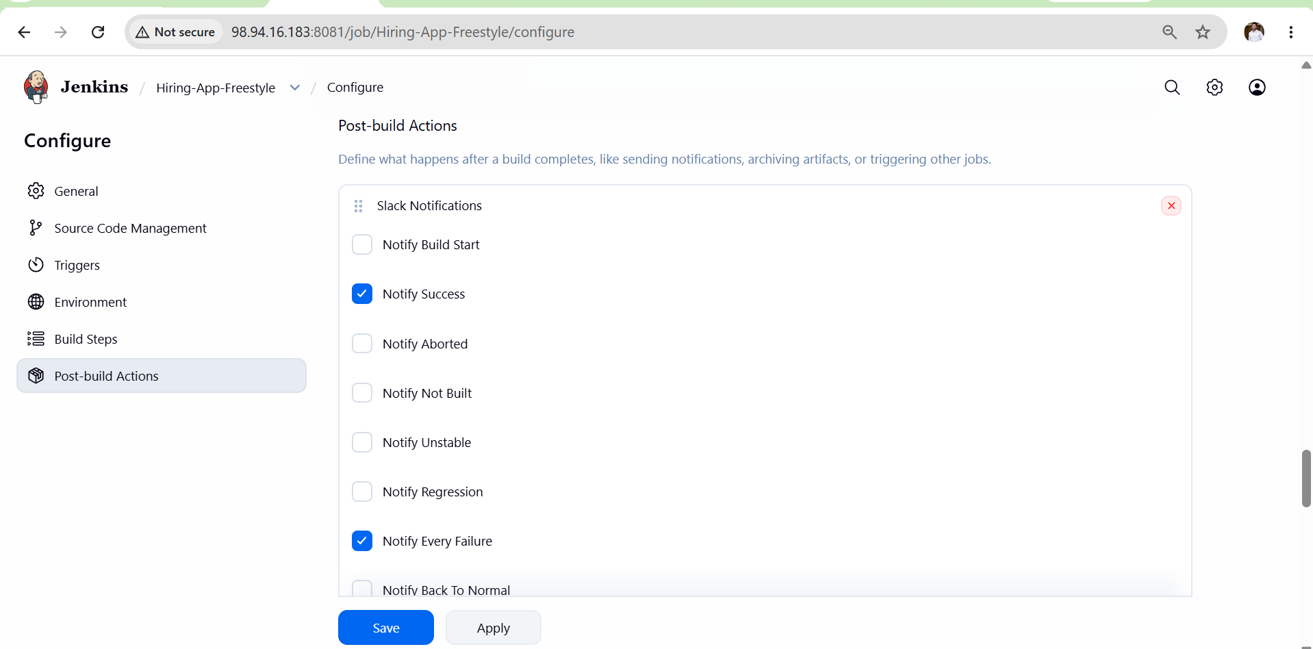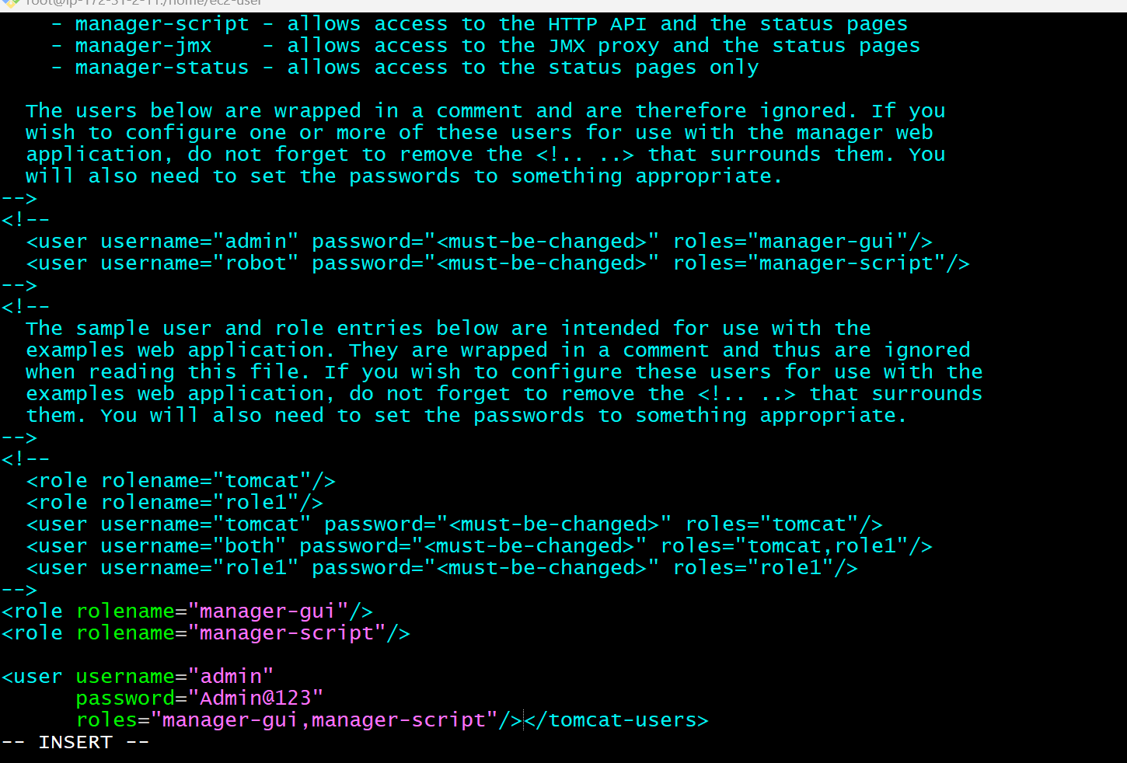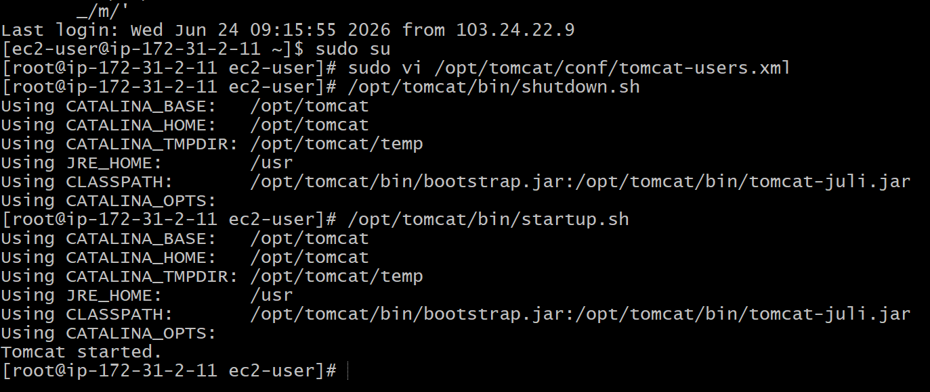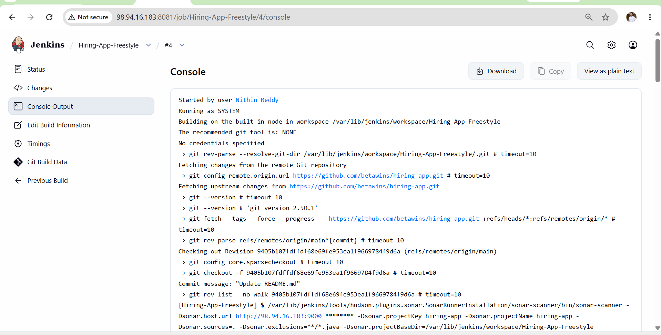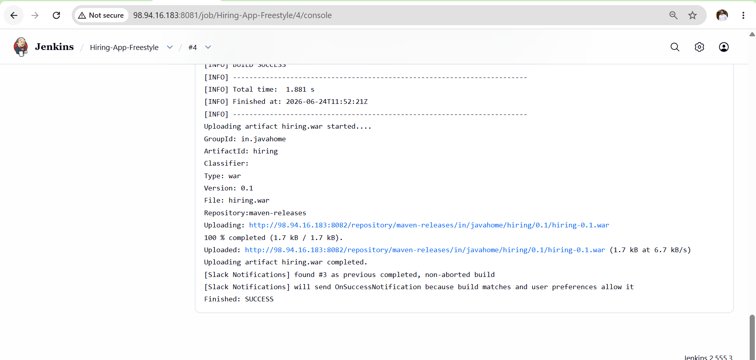

Jenkins-04 Task-2
Objective
Create a Declarative Pipeline using:
Repository:
https://github.com/betawins/sabear_simplecutomerapp.git
Branch:
feature-1.1
Stages
1. Git Clone
2. SonarQube Integration
3. Maven Compilation
4. Nexus Artifactory Upload
5. Slack Notification
6. Deploy on Tomcat
Implementation Steps
- Created Jenkins Pipeline job Sabear-Declarative-Pipeline.
- Configured Git repository URL and feature-1.1 branch.
- Verified JDK-21, Maven, Sonar Scanner, Nexus, Slack, and SonarQube configurations.
- Added SonarQube token credential (sonar-token) in Jenkins.
- Added Nexus username/password credential (nexus) in Jenkins.
- Added Slack webhook credential (slack) in Jenkins.
- Configured SonarQube server integration in Jenkins.
- Configured Nexus repository for artifact storage.
- Added Declarative Pipeline script in Jenkins job.
- Executed Git Clone stage to pull source code from GitHub.
- Executed SonarQube Analysis stage for code quality scanning.
- Executed Maven Compilation stage using mvn clean package.
- Generated deployable application artifact successfully.
- Uploaded build artifact to Nexus Repository Manager.
- Sent build success notification to Slack channel.
- Deployed generated artifact to Apache Tomcat server.
- Restarted Tomcat after deployment.
- Verified successful application deployment from browser.
- Verified artifact availability in Nexus Repository.
- Verified SonarQube analysis report generation.
- Verified Slack notification delivery.
- Confirmed all six pipeline stages executed successfully.
- Validated end-to-end Declarative CI/CD pipeline workflow.
- Build completed with SUCCESS status in Jenkins.
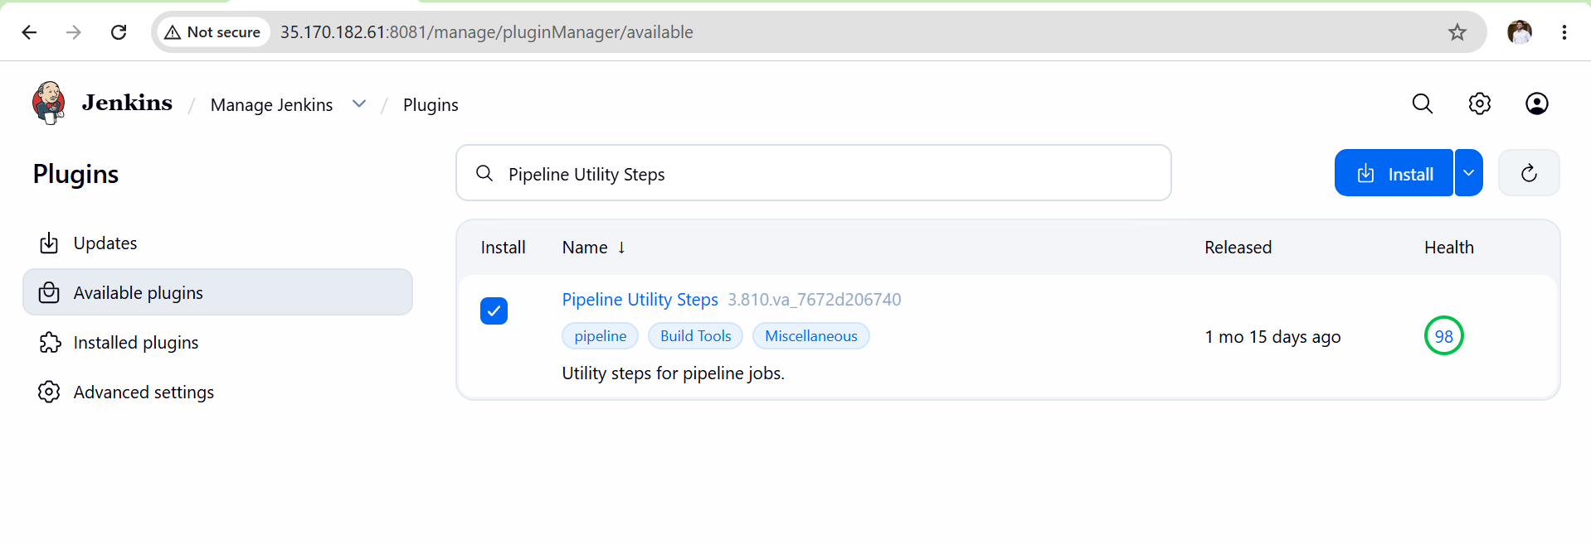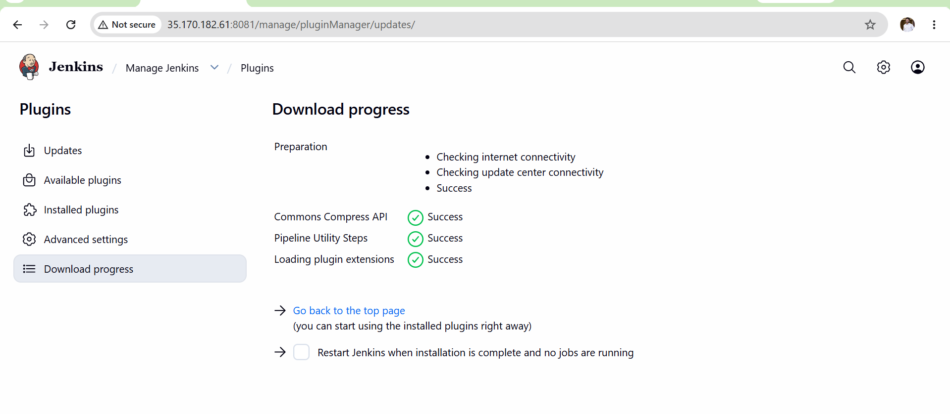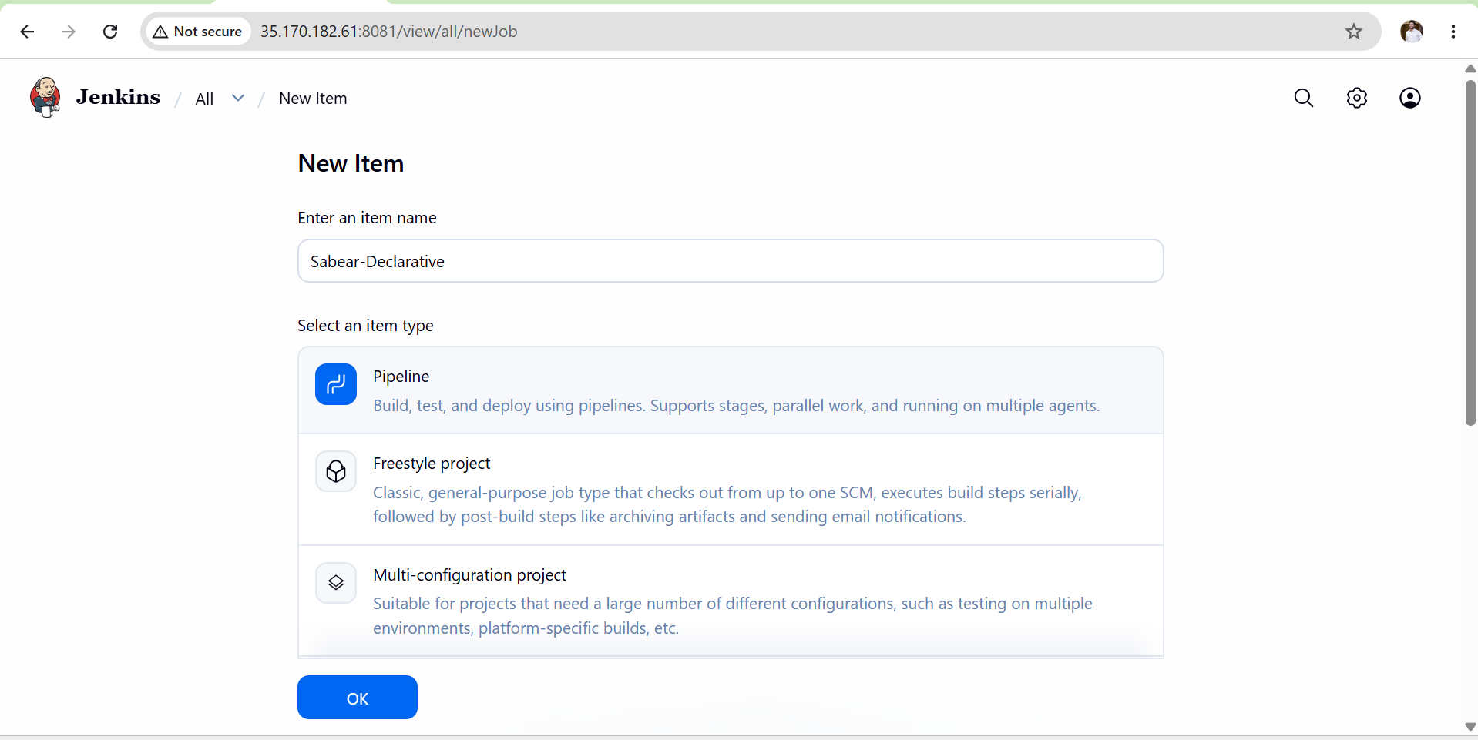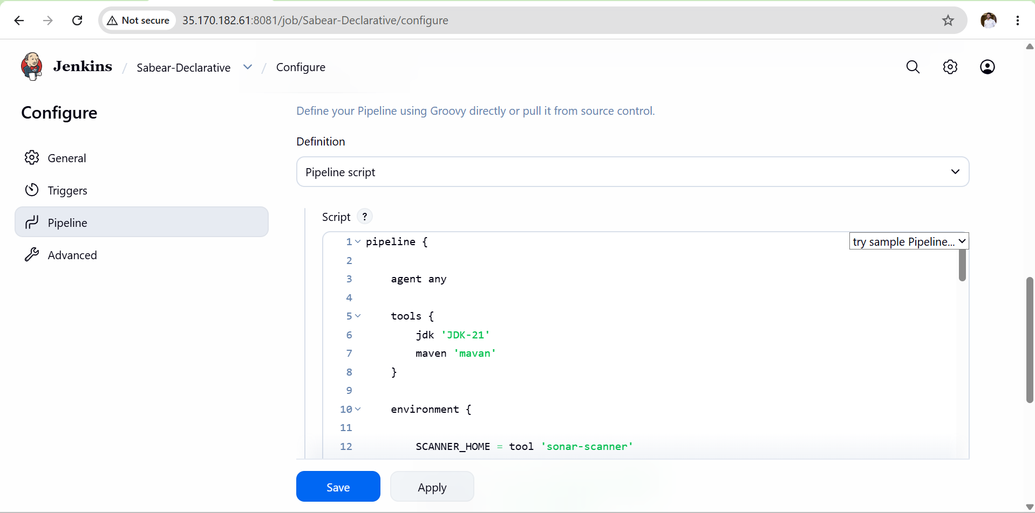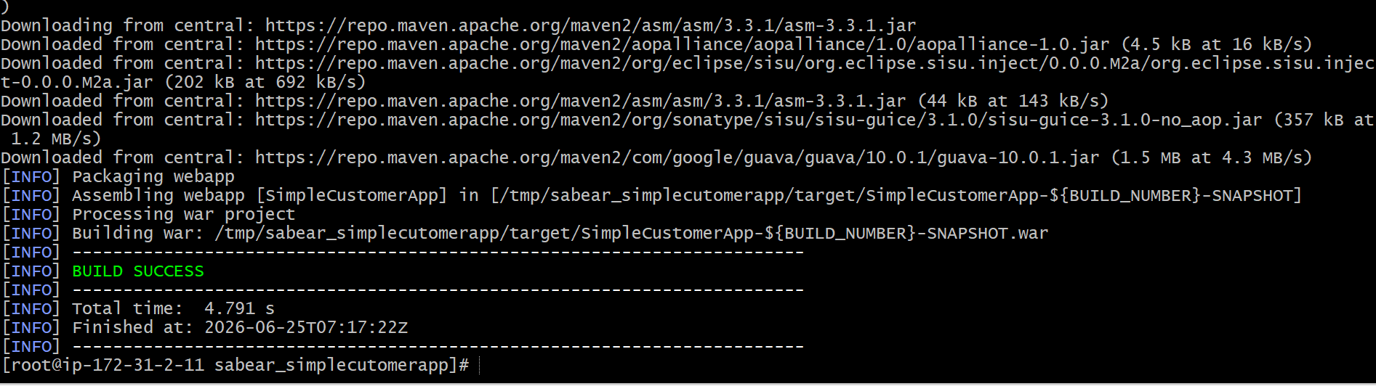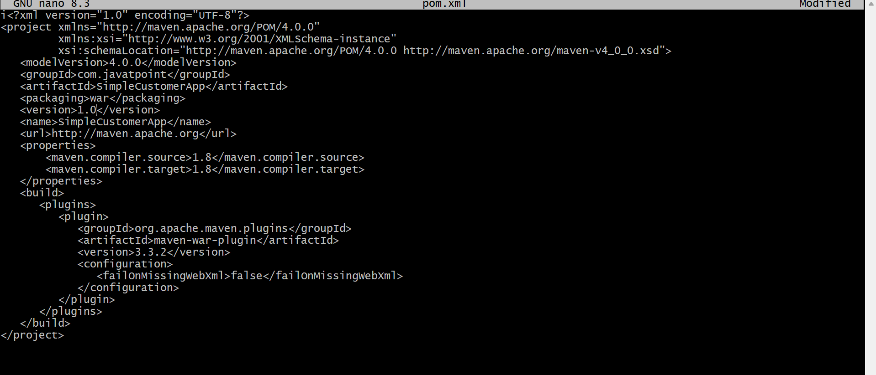

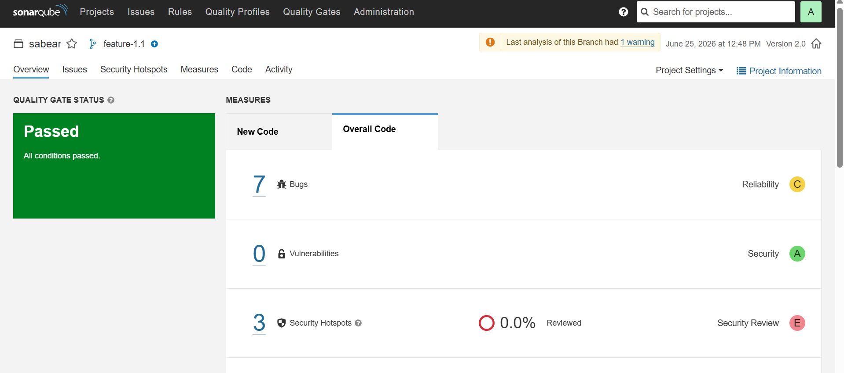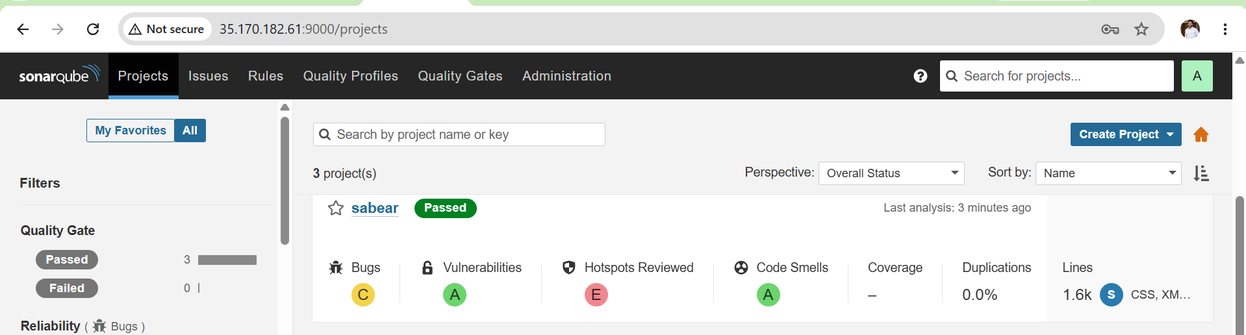
Validation
- Git repository cloned successfully from feature-1.1 branch.
- SonarQube code analysis completed successfully.
- Maven build completed without errors.
- WAR/JAR artifact generated successfully.
- Artifact uploaded successfully to Nexus Repository.
- Slack notification received in configured channel.
- Application deployed successfully on Tomcat server.
- Jenkins pipeline status displayed SUCCESS. 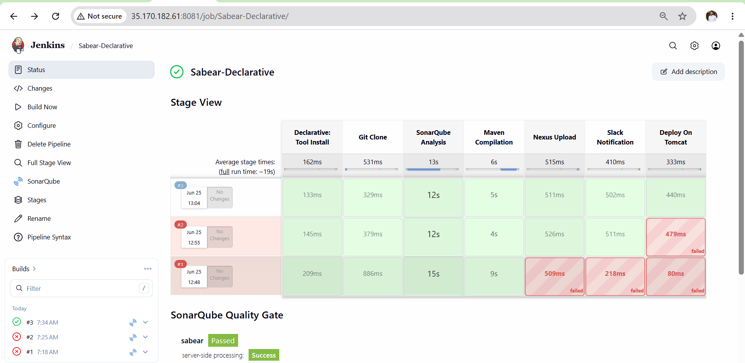

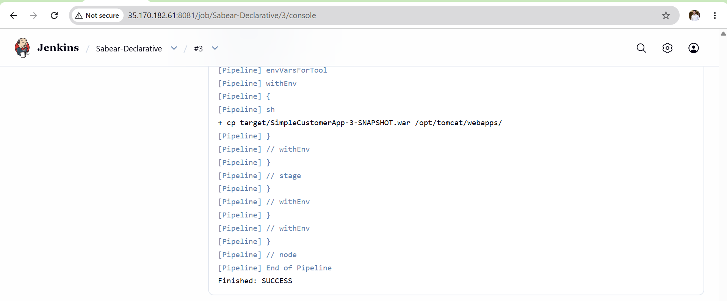
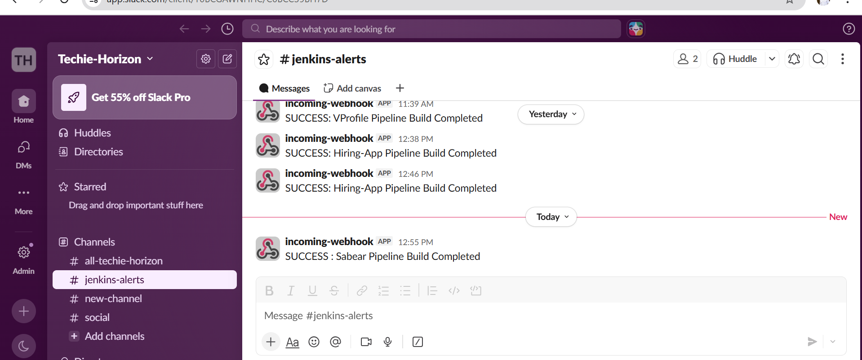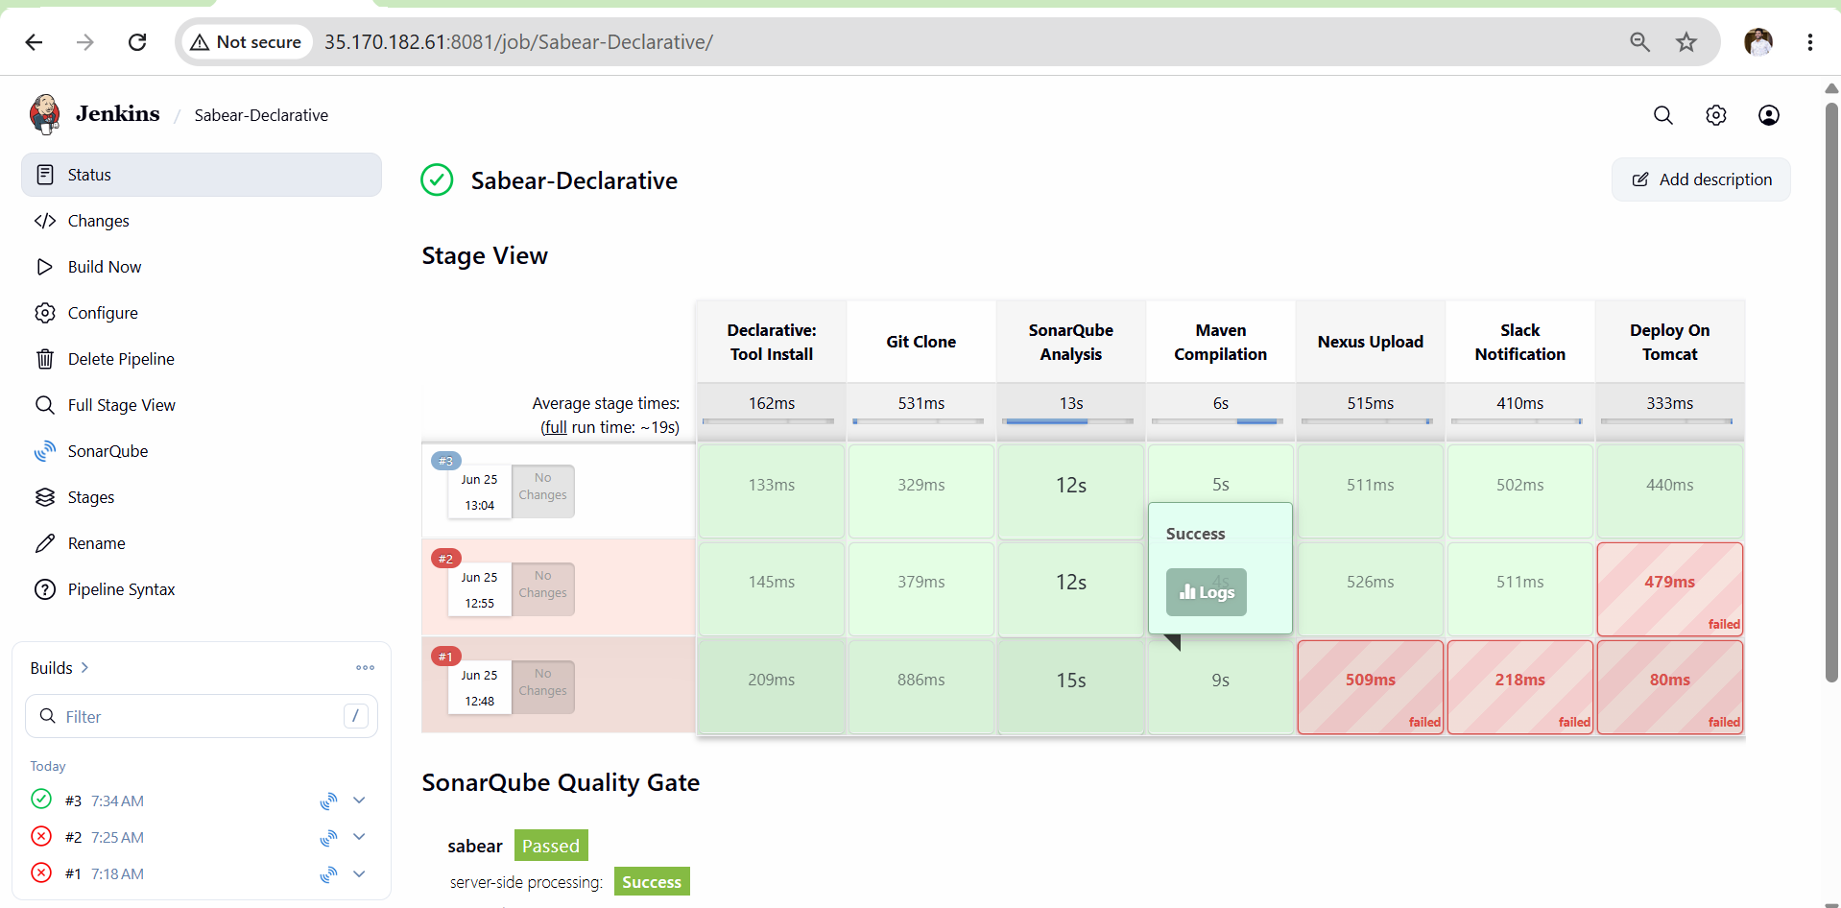

Outcome
- End-to-end Declarative CI/CD pipeline implemented successfully.
- Automated code quality checks using SonarQube.
- Automated artifact management using Nexus.
- Automated deployment to Tomcat.
- Automated build notifications through Slack.
- Successful integration of Git, SonarQube, Maven, Nexus, Slack, and Tomcat in Jenkins

TASK 3: Setup a Jenkins CICD pipeline using Scripted pipeline using feature-1.1 branch.
Objective
Set up a complete CI/CD pipeline using Jenkins Scripted Pipeline for the feature-1.1 branch that automates code checkout, code quality analysis, build, artifact storage, notification and deployment.
Source Code: https://github.com/betawins/sabear_simplecutomerapp/tree/feature-1.1
stages:
- Git Clone
- SonarQube Integration
- Maven Compilation
- Nexus Artifactory
- Slack Notification
- Deploy On tomcat
Prerequisites
- Jenkins installed and running at http://35.170.182.61:8080
- SonarQube installed and running at http://35.170.182.61:9000
- Nexus installed and running at http://35.170.182.61:8082
- Tomcat installed and running at http://35.170.182.61:8080
- Maven installed and configured in Jenkins
- Following plugins installed in Jenkins:
  - Pipeline
  - Git
  - SonarQube Scanner
  - Slack Notification
- Following credentials added in Jenkins:
  - sonar-token — SonarQube token
  - nexus — Nexus username and password
  - slack — Slack webhook URL
- Jenkins user has sudo permission for cp command
- Jenkins user owns /opt/tomcat/webapps/
- pom.xml version set to 1.0 in GitHub
Steps
Step 1: Prerequisites Setup on Server
- Fix pom.xml version
- Fix Tomcat permissions
- Fix sudo permissions for Jenkins
Step 2: Configure Jenkins Credentials
- Add SonarQube token
- Add Nexus credentials
- Add Slack webhook
Step 3: Create Jenkins Job
- Create new Pipeline job
- Paste Scripted pipeline script
- Save and run
Step 4: Validate Each Stage
- Verify Git Clone
- Verify SonarQube
- Verify Maven build
- Verify Nexus upload
- Verify Slack notification
- Verify Tomcat deployment

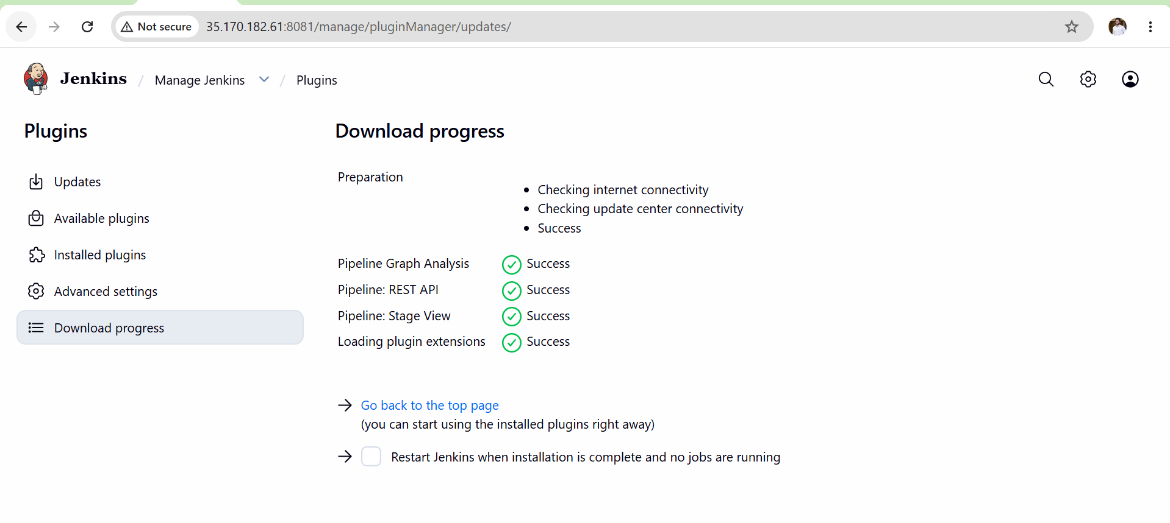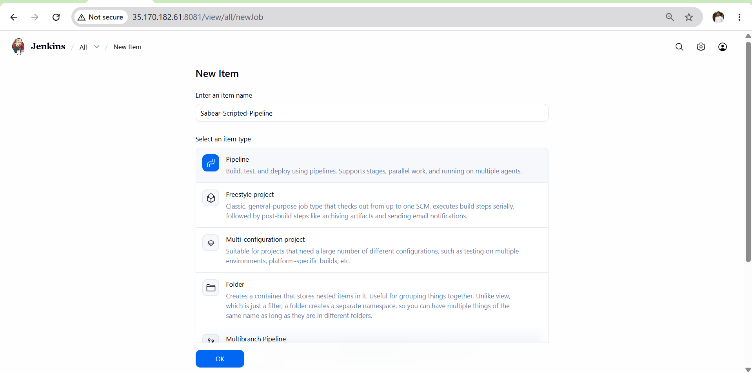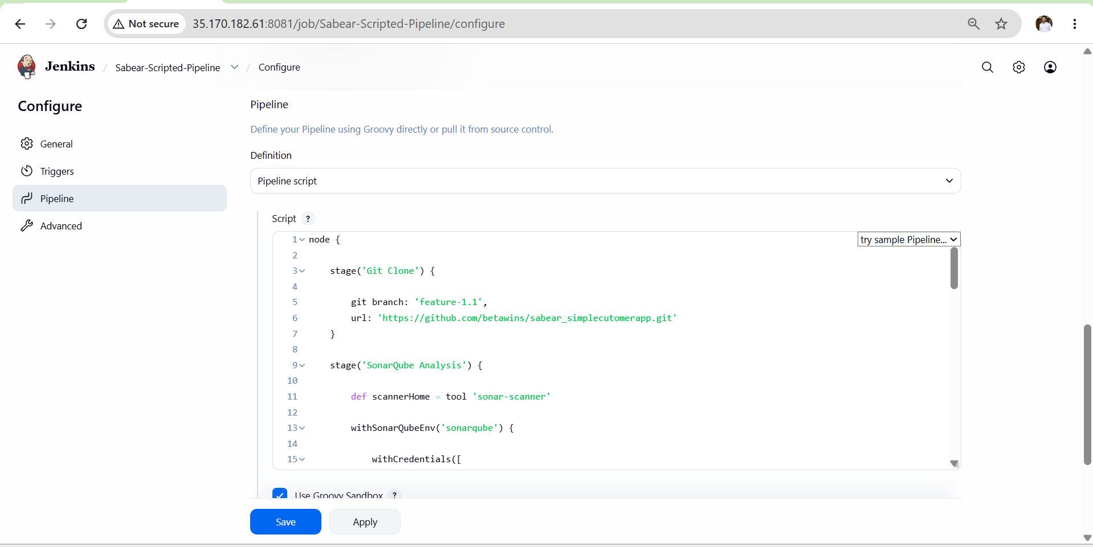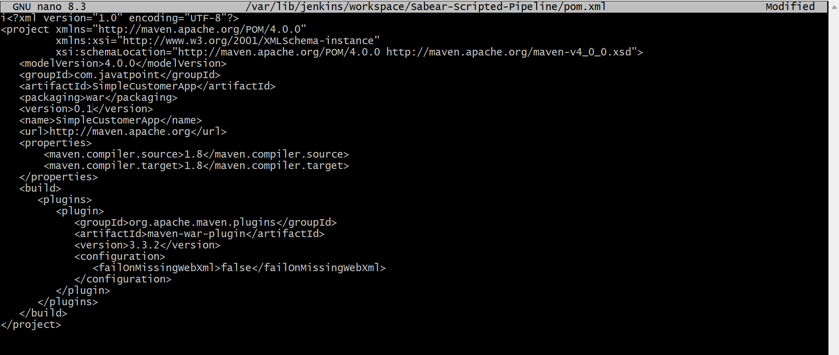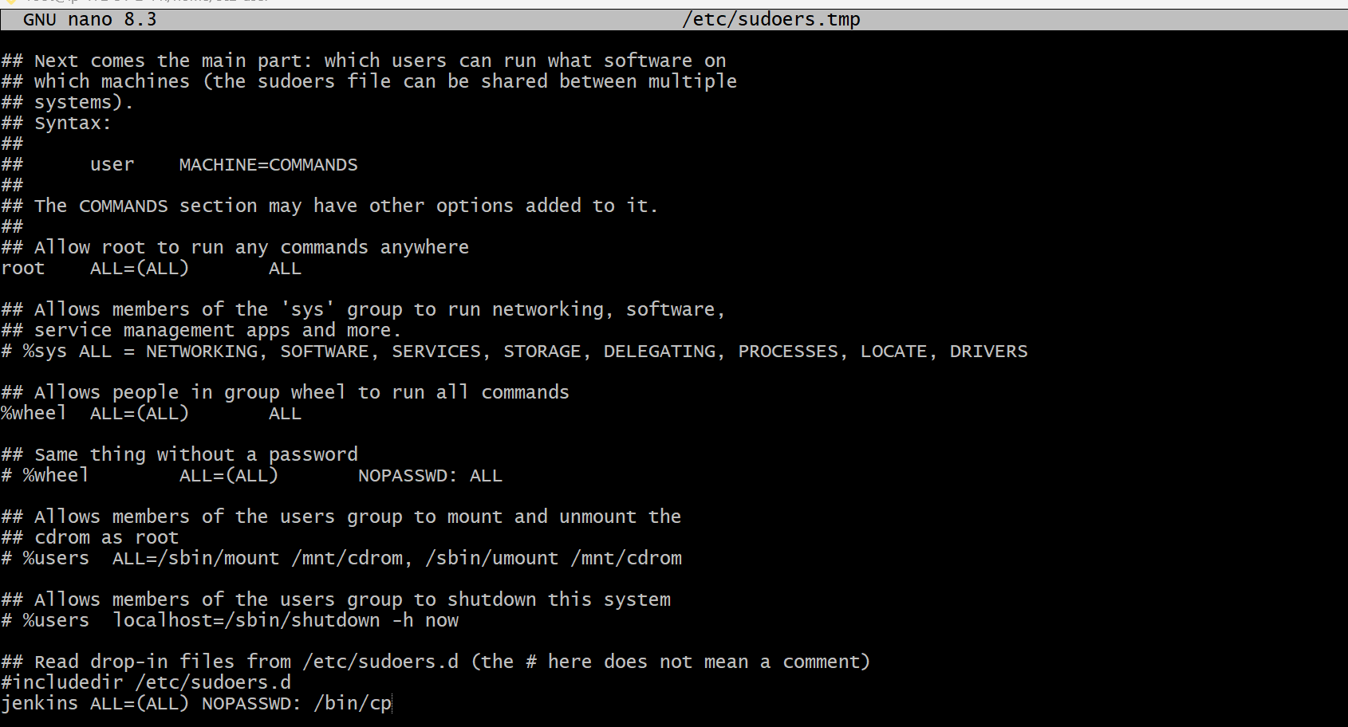

Validation Points
- Jenkins job created as Scripted Pipeline
- All 6 stages visible and green in Stage View
- SonarQube dashboard shows analysis at http://35.170.182.61:9000
- WAR file uploaded to Nexus repository
- Slack message received on success and failure
- WAR deployed and folder created in /opt/tomcat/webapps/
- Application accessible in browser at http://35.170.182.61:8080/SimpleCustomerApp-1.0/

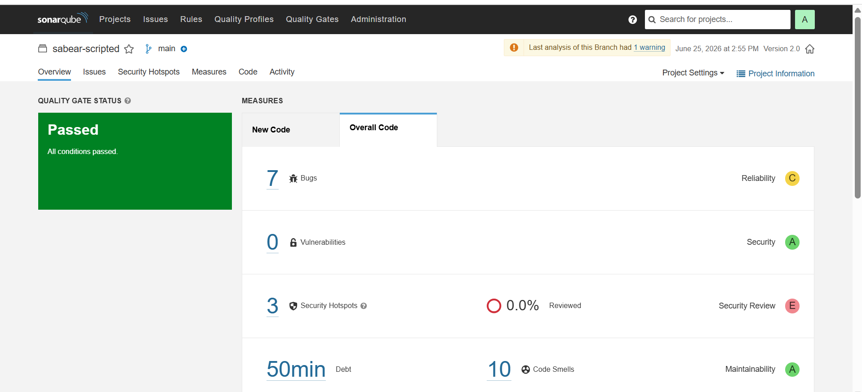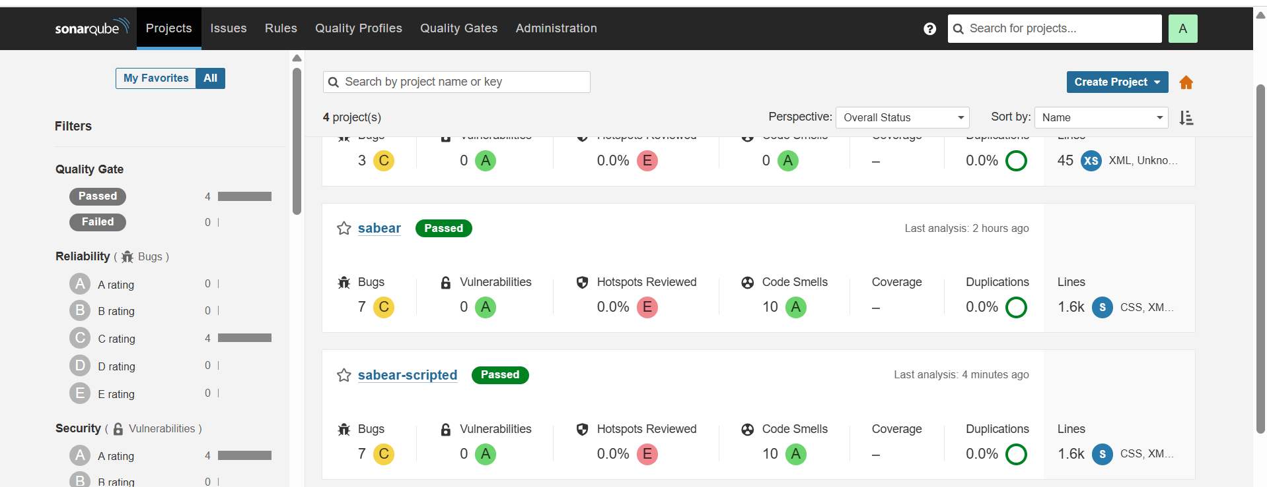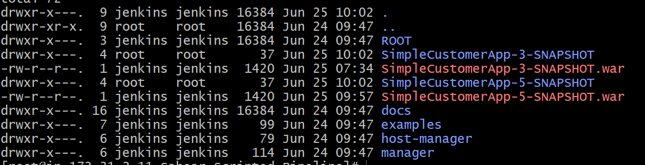
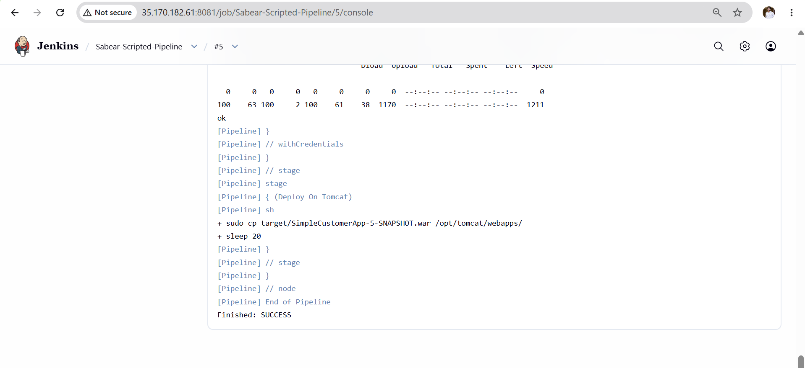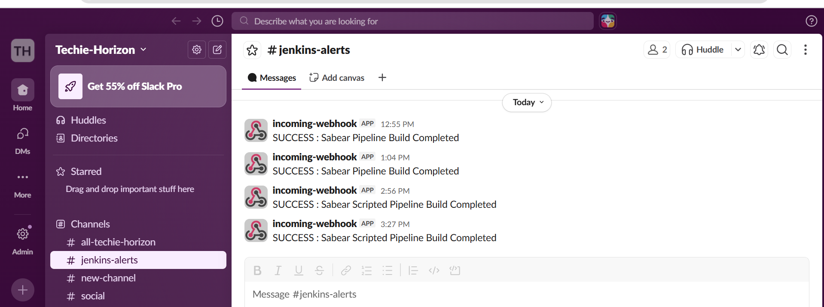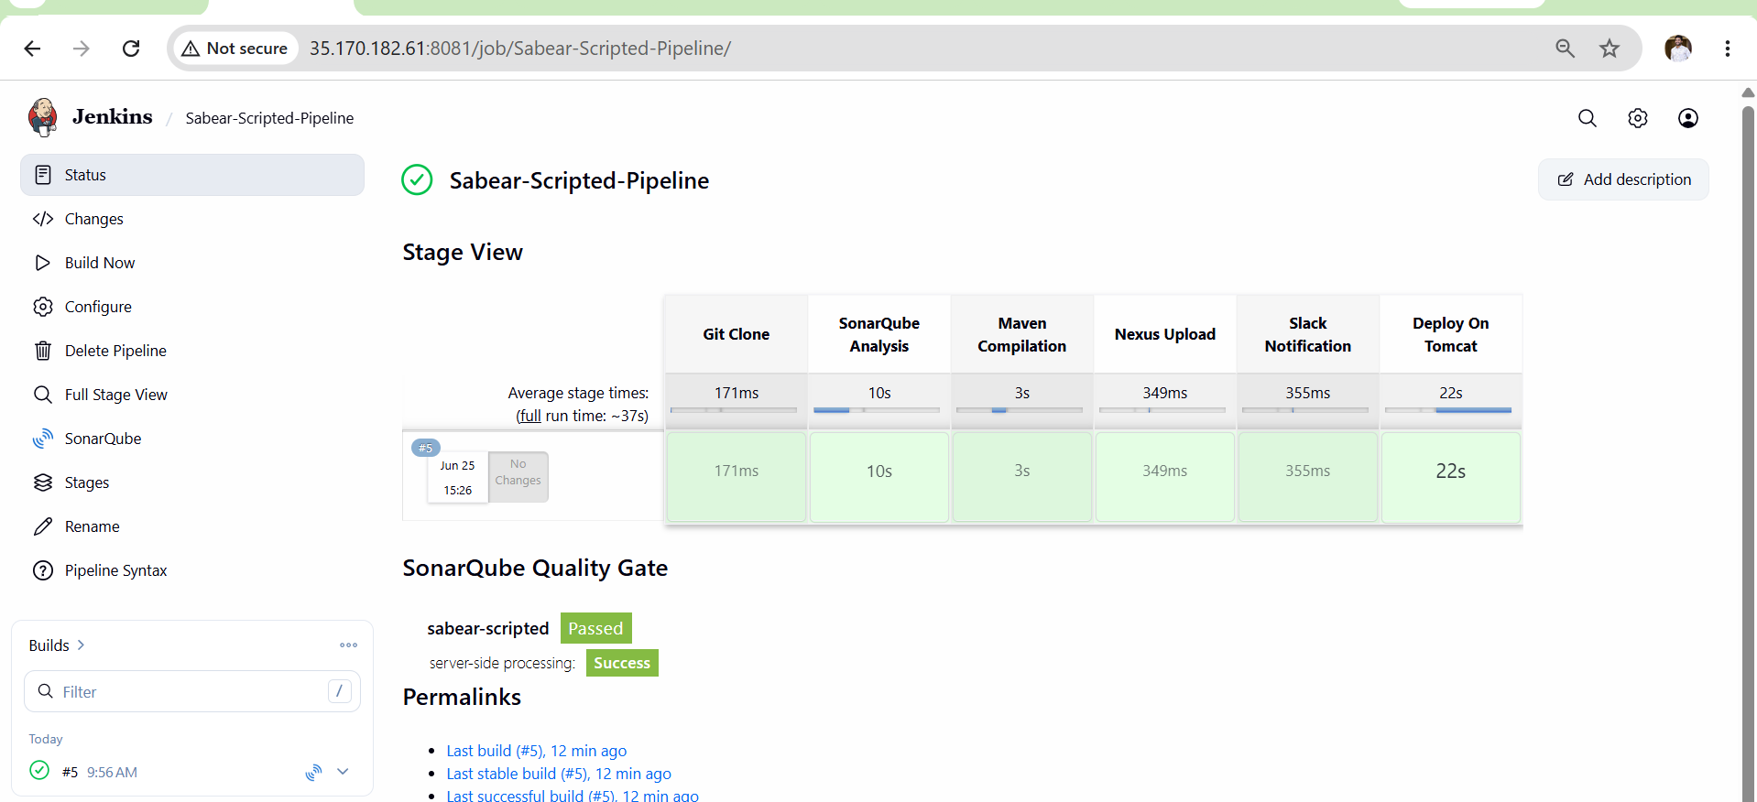

Outcome
By the end of this task you will have:
- A fully working Jenkins Scripted Pipeline
- Code automatically cloned from GitHub feature-1.1 branch
- SonarQube code quality analysis running on every build
- Maven WAR file built and packaged
- WAR artifact uploaded to Nexus repository
- Slack notification sent on build success/failure
- Application deployed and accessible on Tomcat

Task 4: Write Sample Skeleton of Pipelines

Objective
Learn and understand the structure of Jenkins Declarative and Scripted pipelines by writing skeleton templates that can be reused as a base for any CI/CD project.

Outcome
By the end of this task you will have:
- A working Declarative pipeline skeleton
- A working Scripted pipeline skeleton
- Understanding of difference between both pipeline types
- Both pipelines successfully running in Jenkins

Prerequisites
- Jenkins is installed and running
- Jenkins URL accessible at http://35.170.182.61:8080
- Following plugins installed in Jenkins:
  - Pipeline plugin
  - Git plugin
  - Maven plugin
  - SonarQube Scanner plugin
  - Nexus Artifact Uploader plugin
  - Slack Notification plugin

Validation Points
- Both pipeline jobs created in Jenkins
- Both pipelines run without errors
- All stages visible in Jenkins Stage View
- Console output shows SUCCESS for each stage
- Pipeline syntax is valid (use Jenkins snippet generator)

Steps Overview
- Understand pipeline structure
- Create Declarative pipeline skeleton
- Create Scripted pipeline skeleton
- Create Jenkins jobs for both
- Run and validate both pipelines

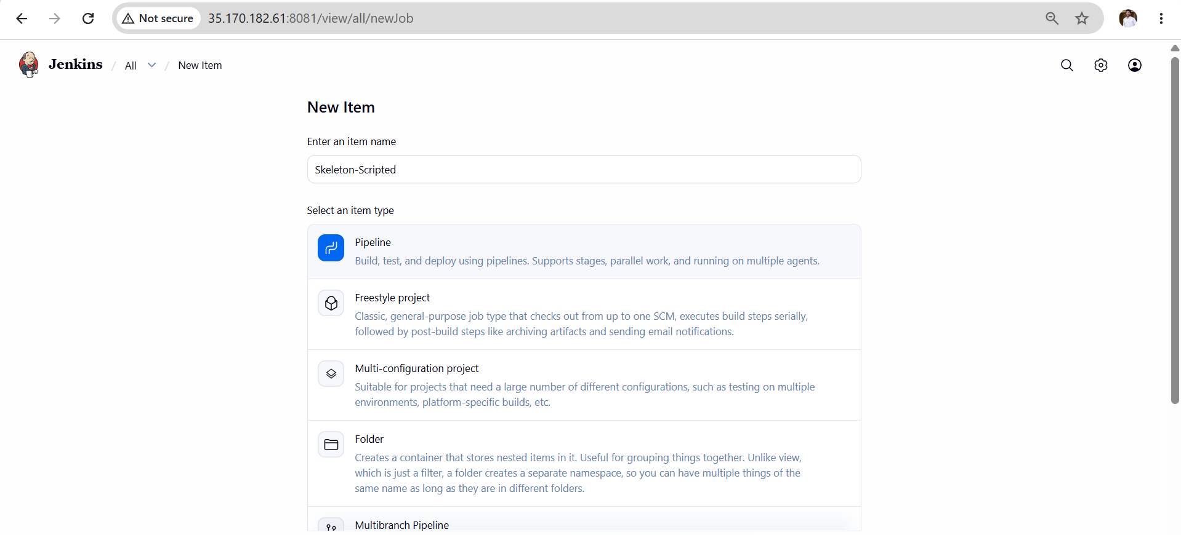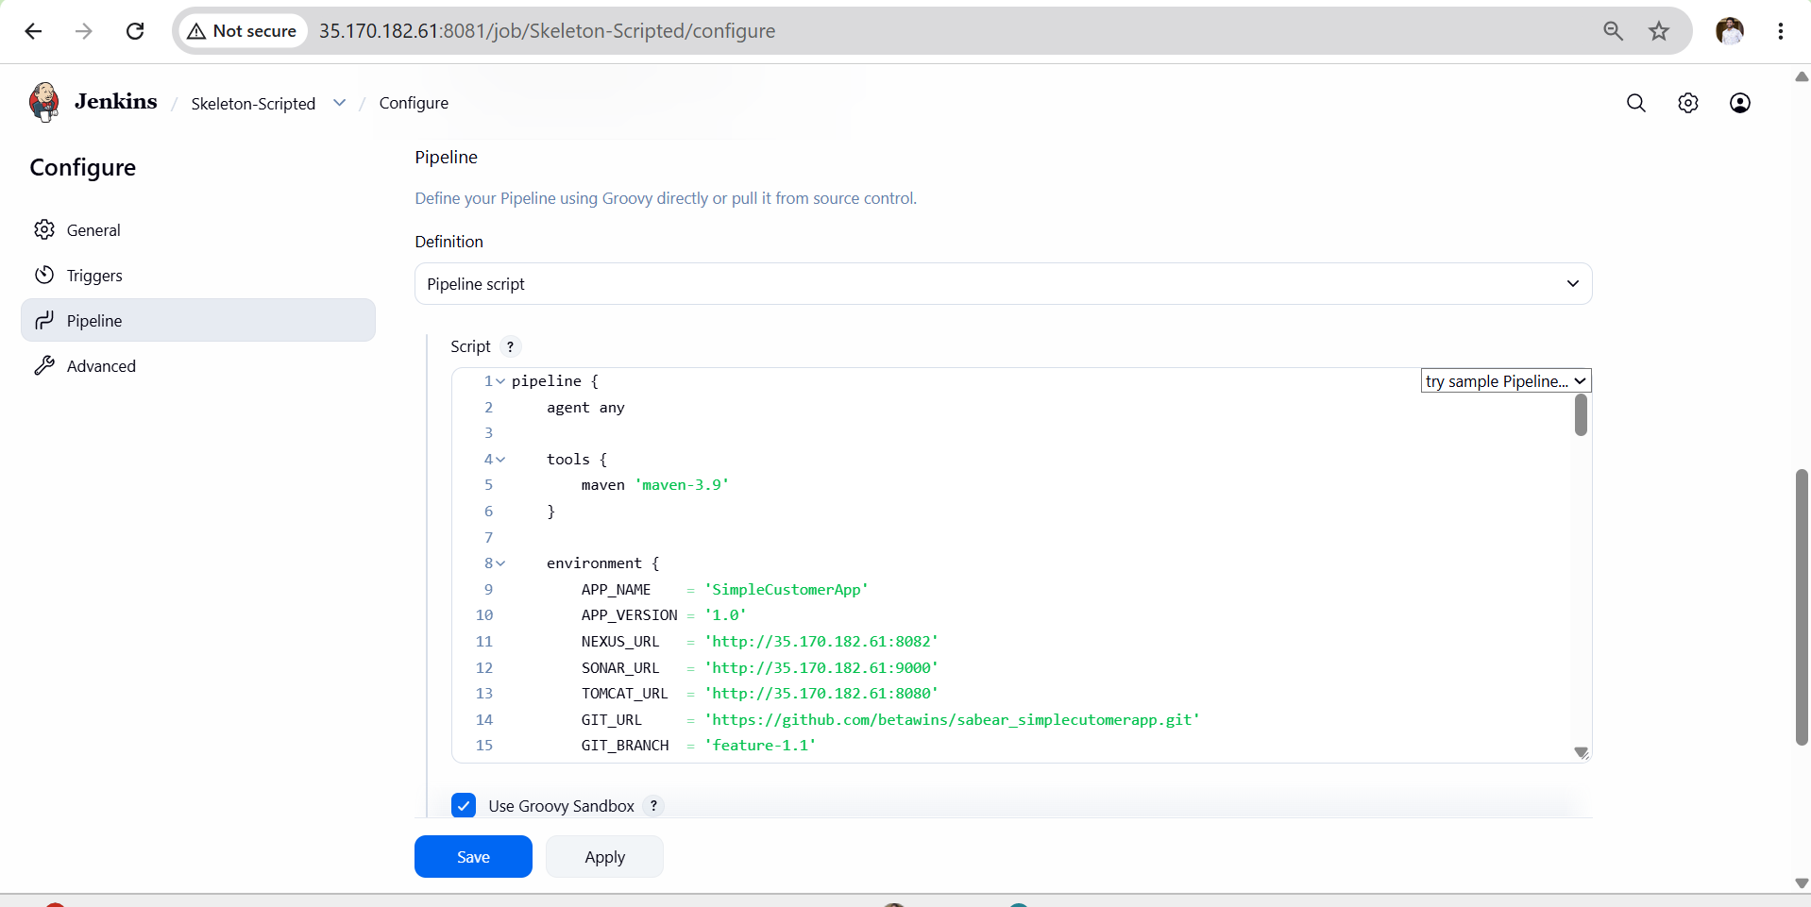
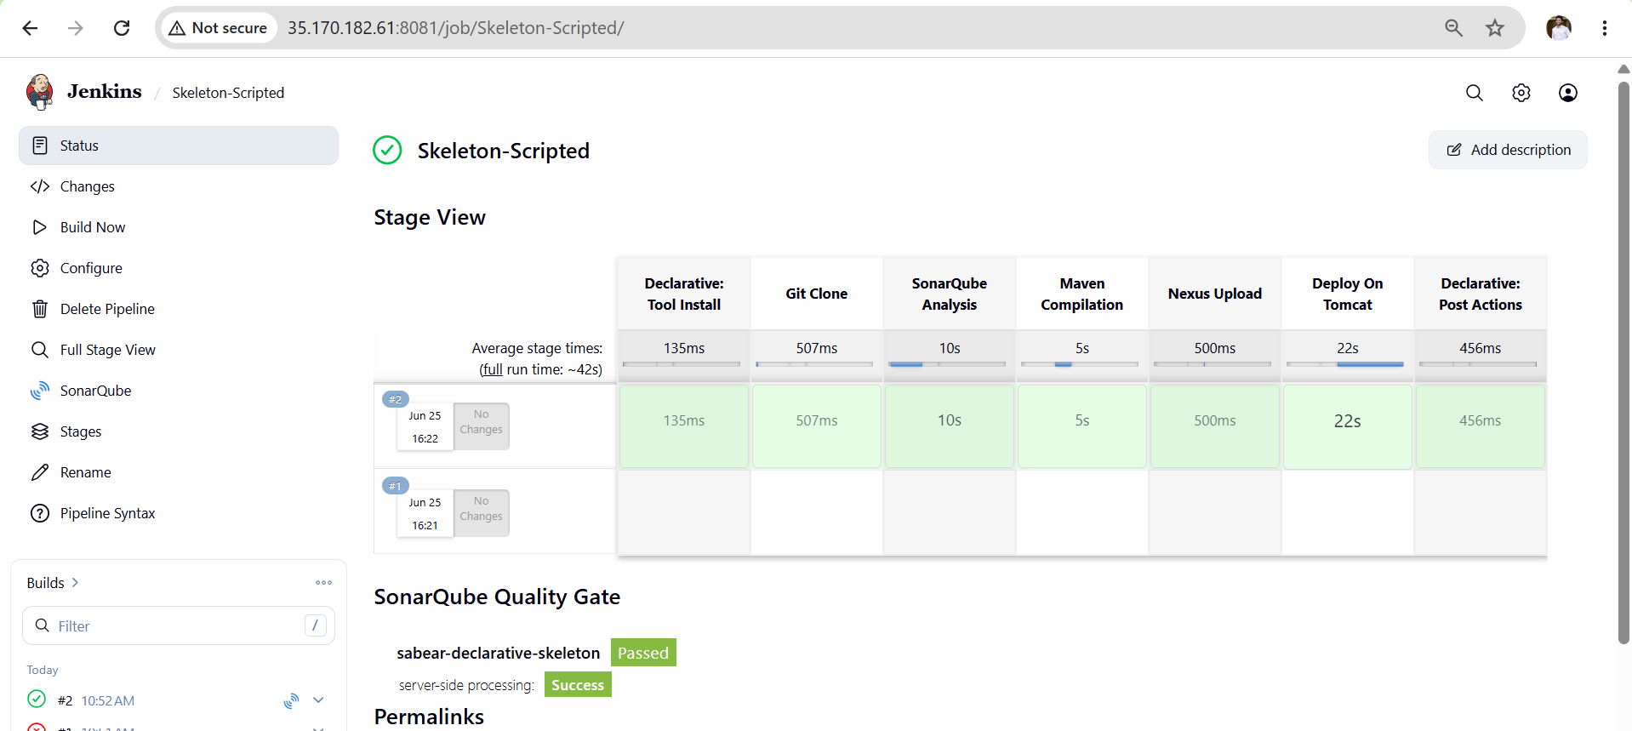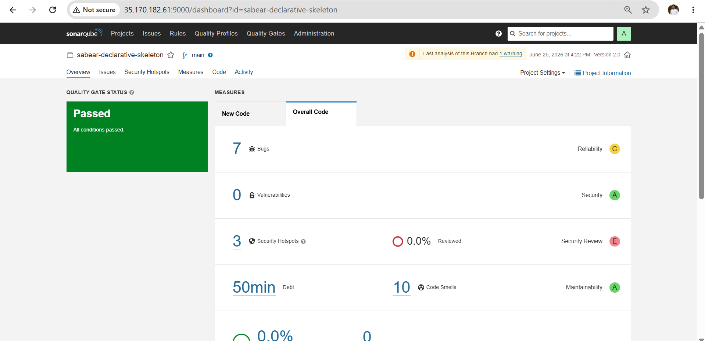
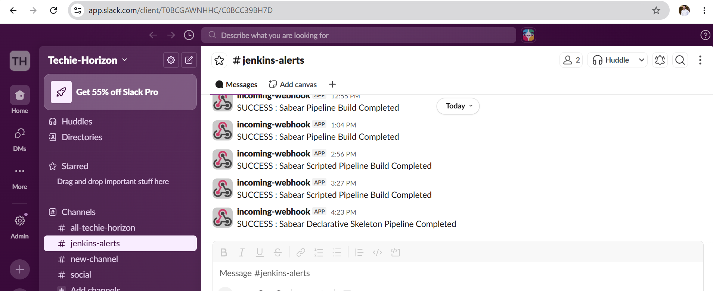

Outcome
By the end of this task you will have:
- A working Declarative pipeline skeleton
- A working Scripted pipeline skeleton
- Understanding of difference between both pipeline types
- Both pipelines successfully running in Jenkins

Task 5: Create a Parameterized Job in Jenkins
Objective
Learn how to create a Jenkins parameterized pipeline job that accepts dynamic inputs at build time, allowing flexible and reusable CI/CD pipelines.

Outcome
- A Jenkins parameterized job created
- Job accepts parameters like branch name, version, environment
- Pipeline uses parameters dynamically during build
- Application built and deployed based on parameter values
- Understanding of different parameter types in Jenkins

Prerequisites
Server Requirements
- Jenkins running at http://35.170.182.61:8080
- Maven configured in Jenkins tools as mavan
- SonarQube running at http://35.170.182.61:9000
- Nexus running at http://35.170.182.61:8082
- Tomcat running at http://35.170.182.61:8080
Jenkins Credentials Required
- sonar-token — SonarQube token
- nexus — Nexus username and password
- slack — Slack webhook URL
Steps Implementations
- Login to Jenkins Dashboard.
- Click New Item → Enter name Parameterized-SpringMVC.
- Select Freestyle Project → Click OK.
- Scroll to This project is parameterized and enable it.
- Click Add Parameter → Select String Parameter.
- Parameter Name = BRANCH_NAME.
- Default Value = master.
- Description = Git Branch Name.
- Under Source Code Management select Git.
- Repository URL = https://github.com/betawins/spring3-mvc-maven-xml-hello-world-1.git.
- Branch Specifier = */${BRANCH_NAME}.
- Under Build Steps click Invoke Top-level Maven Targets.
- Goals = clean package.
- Click Apply → Save.
- Click Build with Parameters.
- Enter branch name (master).
- Click Build.
- Monitor build from Console Output.
- Verify Maven build success.
- Verify WAR/JAR generated under workspace target folder.

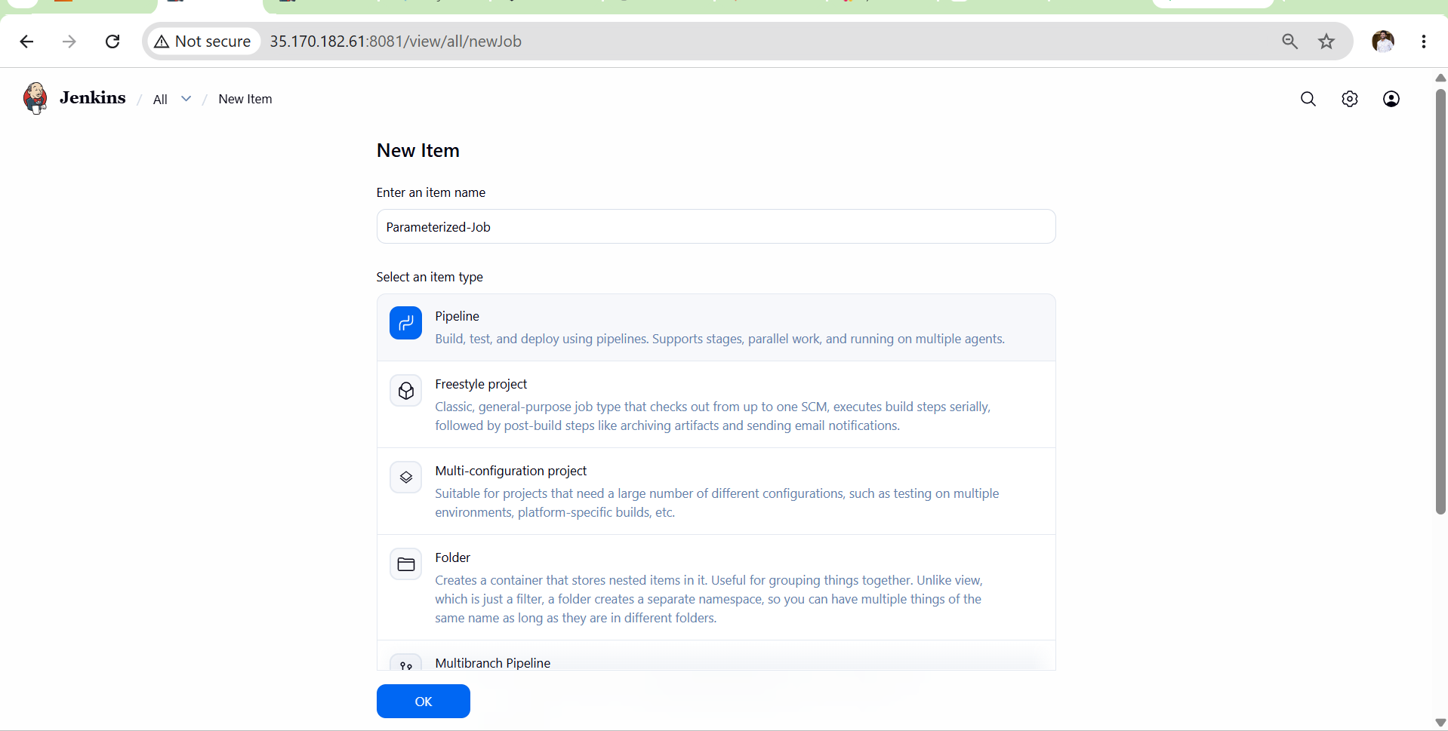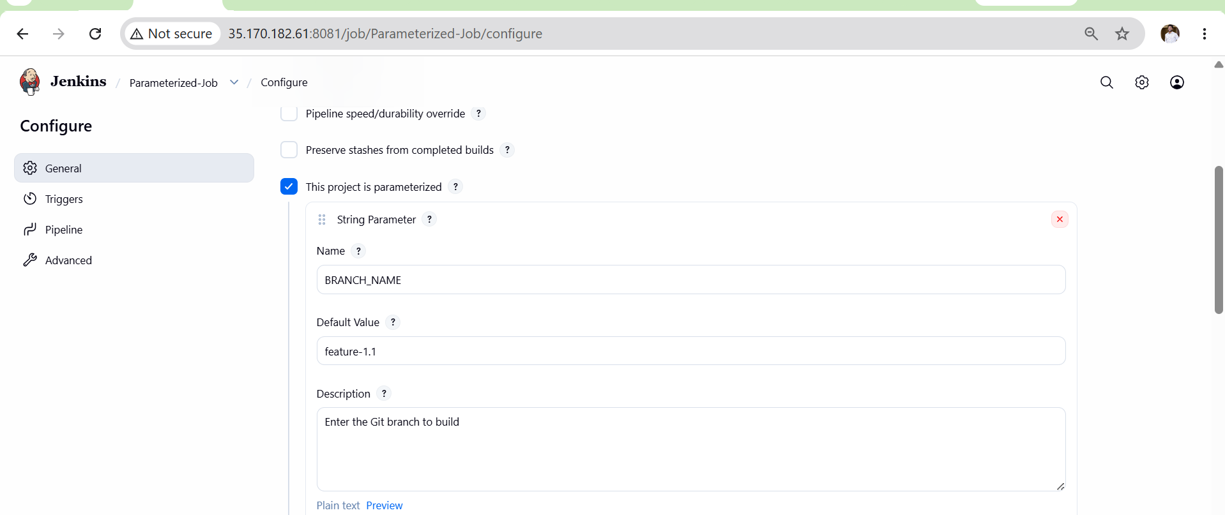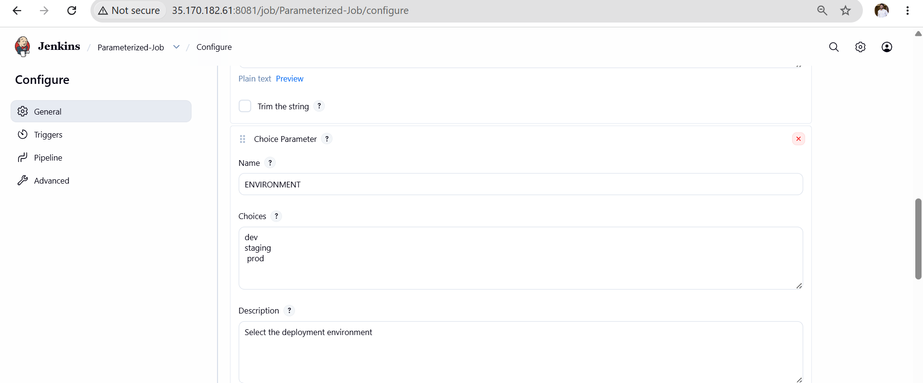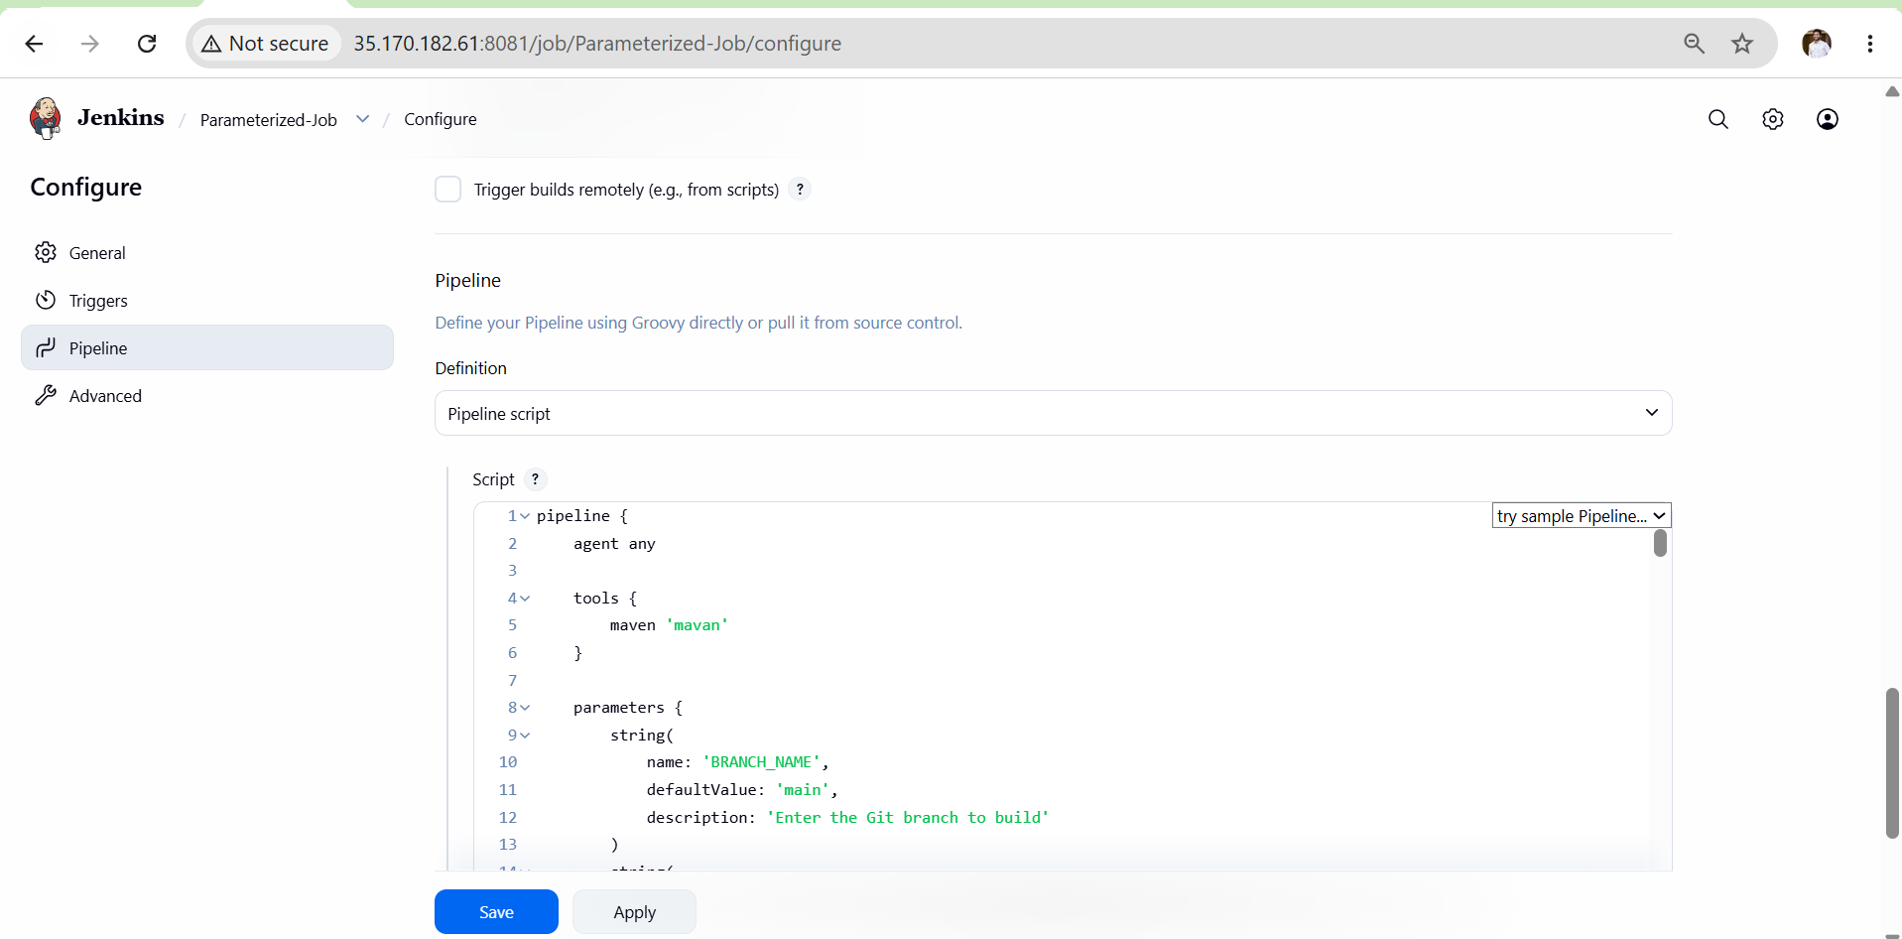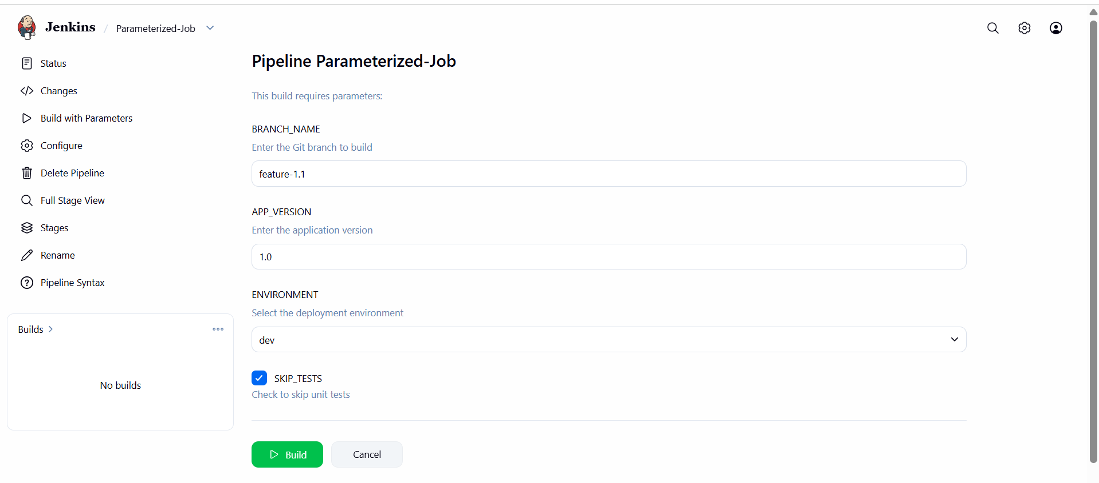
Validation Points
- Build with Parameters option visible.
- Parameter value accepted during build.
- Git checkout uses selected branch.
- Maven clean package executes successfully.
- Build status shows SUCCESS.
- Target artifact generated successfully.
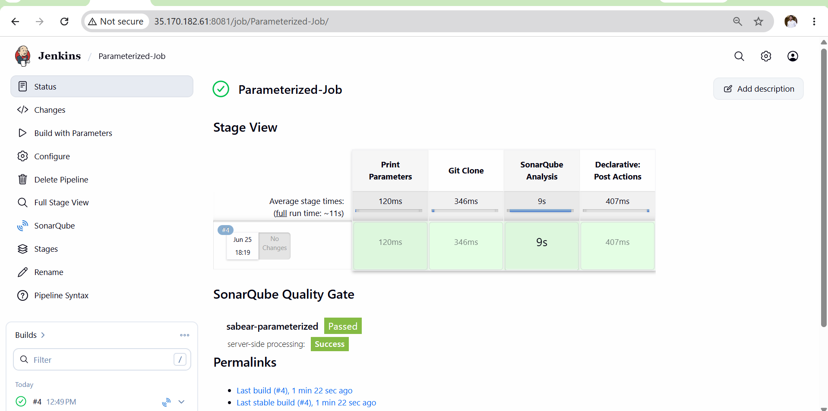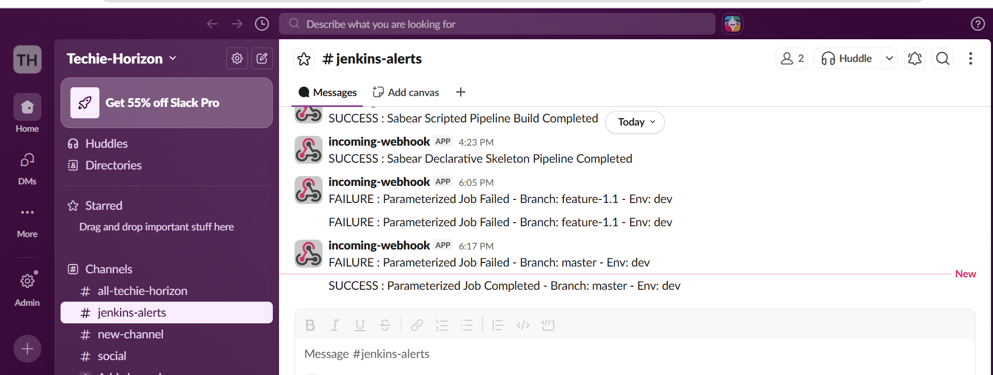
Outcome
- Created a Jenkins Parameterized Job.
- User can build different branches dynamically.
- Git branch selection automated using parameters.
- Maven build completed successfully.
- Artifact generated based on selected branch.
- Demonstrated dynamic build execution using Jenkins Parameters.

Task 6: Setup Slave Machine for Jenkins
Objective
Configure a Jenkins Master-Slave (Agent) architecture where the Master delegates build jobs to a Slave node, following Jenkins official documentation recommendations.
Outcome
- A slave EC2 instance configured and connected to Jenkins master
- Jenkins pipeline running on slave node instead of master
- Proper Master-Slave architecture established
- Build jobs executed on slave agent

Architecture Overview
Developer → Push Code → GitHub
↓
Jenkins Master
(35.170.182.61:8080)
↓
Jenkins Slave
(New EC2 Instance)
↓
Build/Deploy

Prerequisites
Master Node (Already Running)
IP: 35.170.182.61
Port: 8080
OS: Amazon Linux 2023
Slave Node (New EC2 Instance Required)
OS: Amazon Linux 2023
Instance: t2.micro
Port: 22 (SSH)
Same Region: as Master
Steps
- Launch a new EC2 instance (Amazon Linux 2023) to act as Jenkins Agent.
- Configure Security Group to allow SSH (Port 22) from Jenkins Master EC2.
- Install Java 21 on Agent machine.
- Install Git on Agent machine.
- Install Maven on Agent machine.
- Generate SSH key pair on Jenkins Master using ssh-keygen.
- Copy Master public key (id_rsa.pub) to Agent ~/.ssh/authorized_keys.
- Verify SSH connectivity from Master to Agent using ssh ec2-user@<Agent-IP>.
- Login to Jenkins Master UI.
- Navigate to Manage Jenkins → Nodes → New Node.
- Create node name as agent1.
- Select Permanent Agent and click Create.
- Configure Remote Root Directory as /home/ec2-user/jenkins.
- Add Labels as agent1.
- Set Usage as Use this node as much as possible.
- Select Launch Method as Launch agents via SSH.
- Enter Agent Private IP address.
- Add SSH credentials using Jenkins private key.
- Save the node configuration.
- Click Launch Agent.
- Verify Agent status becomes Connected/Online.
- Create a test Freestyle Job.
- Restrict the job to run on label agent1.
- Build the job and confirm execution on Agent node.
- Validate workspace creation under /home/ec2-user/jenkins/workspace.
Validation Points
- SSH connection successful from Master to Agent.
- Agent status shows Online in Jenkins Nodes.
- Jenkins automatically creates remote workspace on Agent.
- Test build executes on Agent instead of Master.
- Build logs display Agent node name.

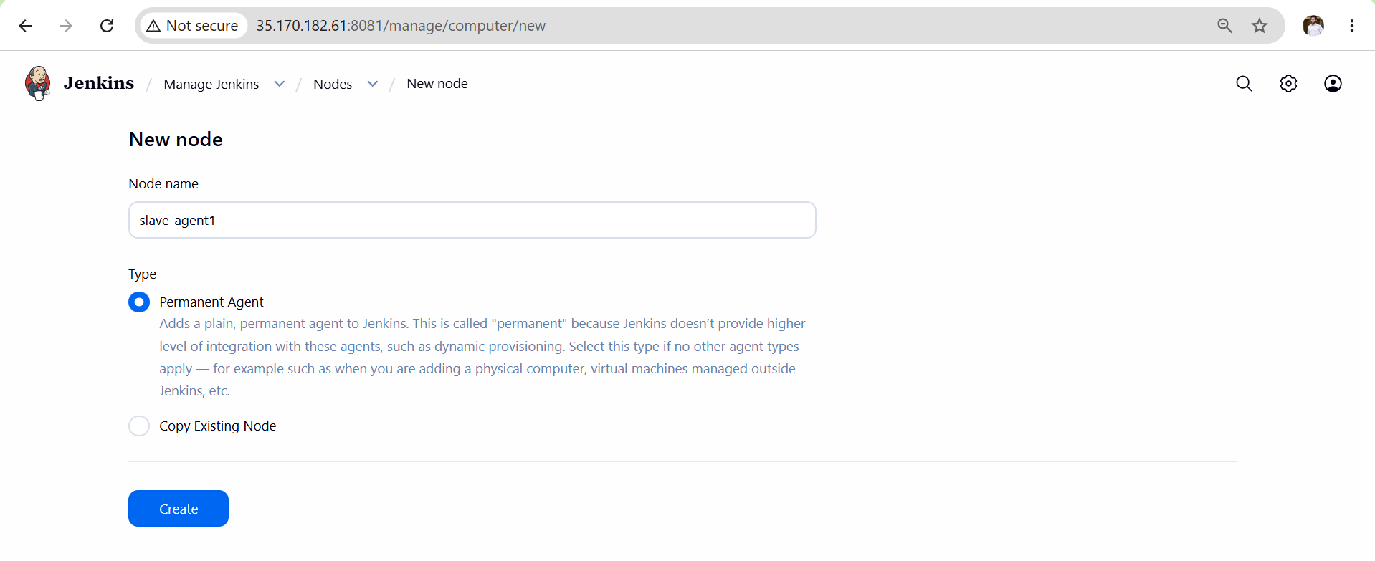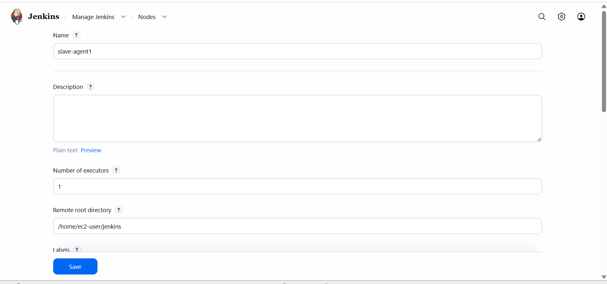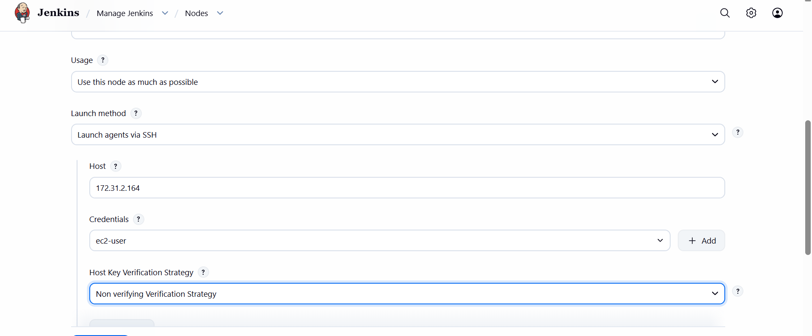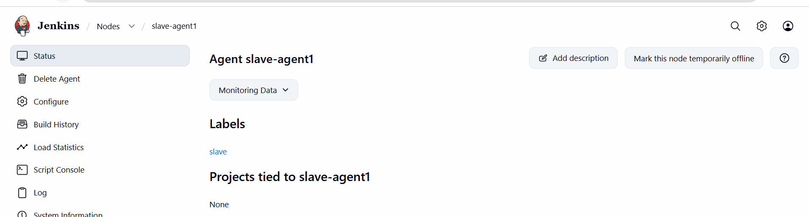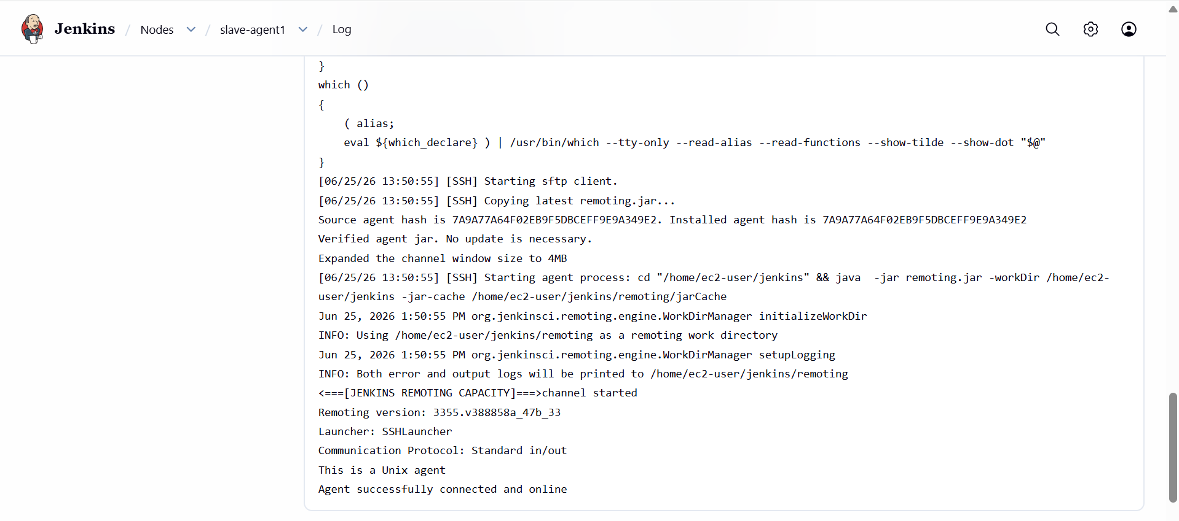
Outcome
- ✅ Jenkins Master-Agent architecture configured successfully.
- ✅ Jenkins Master delegates build execution to Agent node.
- ✅ Distributed builds improve scalability and resource utilization.
- ✅ Agent ready for running CI/CD pipelines independently of Master.

