Task 1&2 : Install Jenkins and Run Jenkins on Port 8081 & Secure Jenkins Server
Objective
Install Jenkins on an AWS EC2 instance with:
- Java 21
- Jenkins LTS
- Jenkins running on port 8081
- Jenkins accessible through browser

Expected Outcome
After completing this task:
✅ EC2 Instance Created
✅ Java 21 Installed
✅ Jenkins Installed
✅ Jenkins Running
✅ Jenkins Port Changed from 8080 → 8081
✅ Jenkins Accessible via Browser

Architecture
Your Laptop
|
|
Public IP
|
AWS Security Group
|
EC2 Instance
|
Jenkins Service
|
Port 8081

Prerequisites
AWS Account
• EC2 Instance (Amazon Linux 2023)
• Security Group allowing ports 22 and 8081
• Internet Connectivity
• SSH Key Pair
Implementation Steps:
- Launch an EC2 Instance
  - Create an EC2 instance named Jenkins-Server.
  - Select Amazon Linux 2023 AMI.
  - Choose t2.medium instance type.
  - Configure Security Group:
• SSH (22) – My IP
• Custom TCP (8081) – Anywhere
  - Launch the instance.
- Connect to the EC2 Instance
  - Connect using SSH from local machine.
  - Verify successful login.
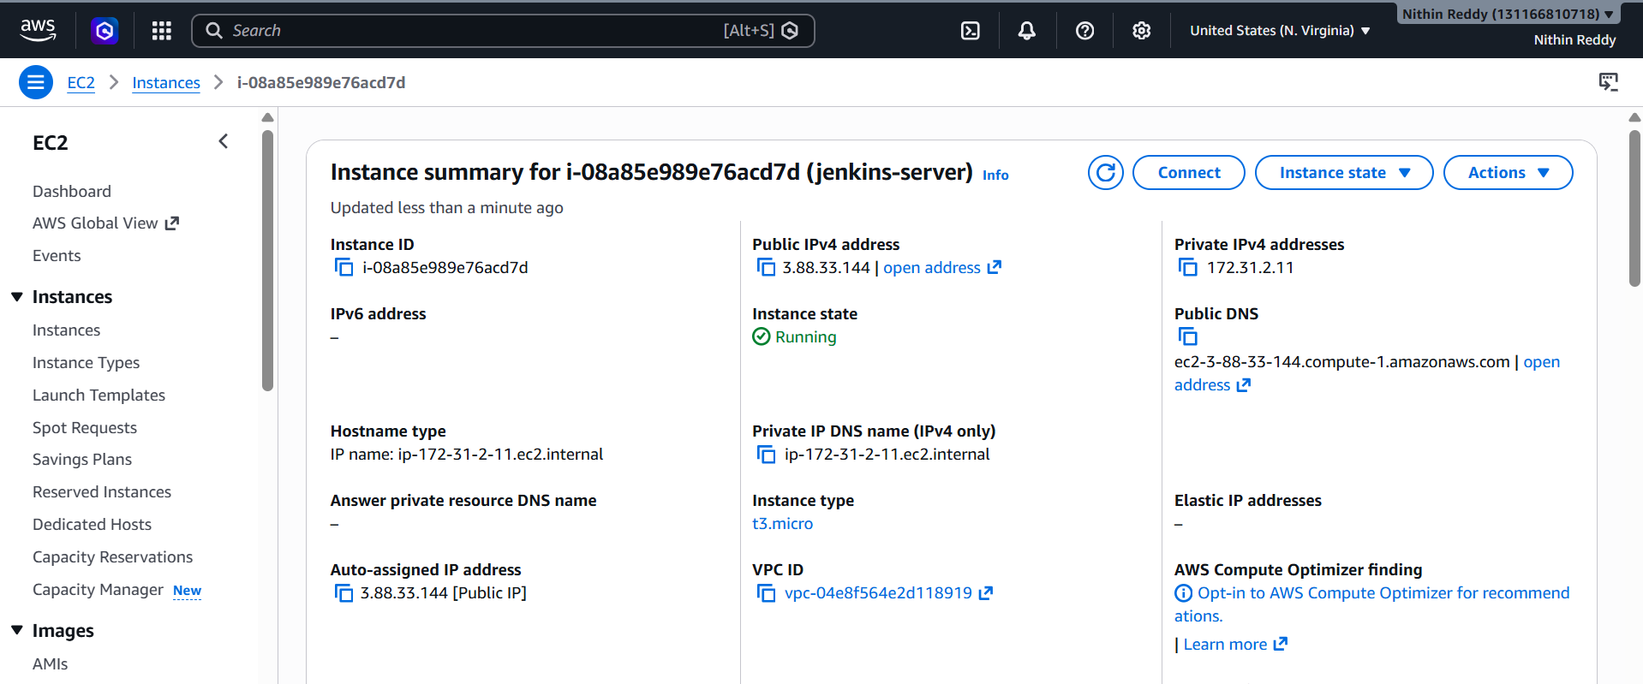
- Update the Server
  - Update all existing packages using DNF package manager.
  - Ensure the system is up to date before installing software.
- Install Java 21
  - Install Amazon Corretto Java 21.
  - Verify Java installation using java -version command.
- Configure JAVA_HOME
  - Identify Java installation path.
  - Configure JAVA_HOME environment variable.
  - Update system profile and reload environment variables.
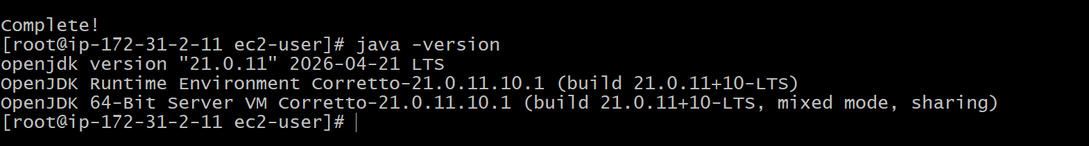
- Add Jenkins Repository
  - Download Jenkins repository configuration file.
  - Import Jenkins GPG security key.
- Install Jenkins
  - Install Jenkins package from Jenkins repository.
  - Verify successful installation.
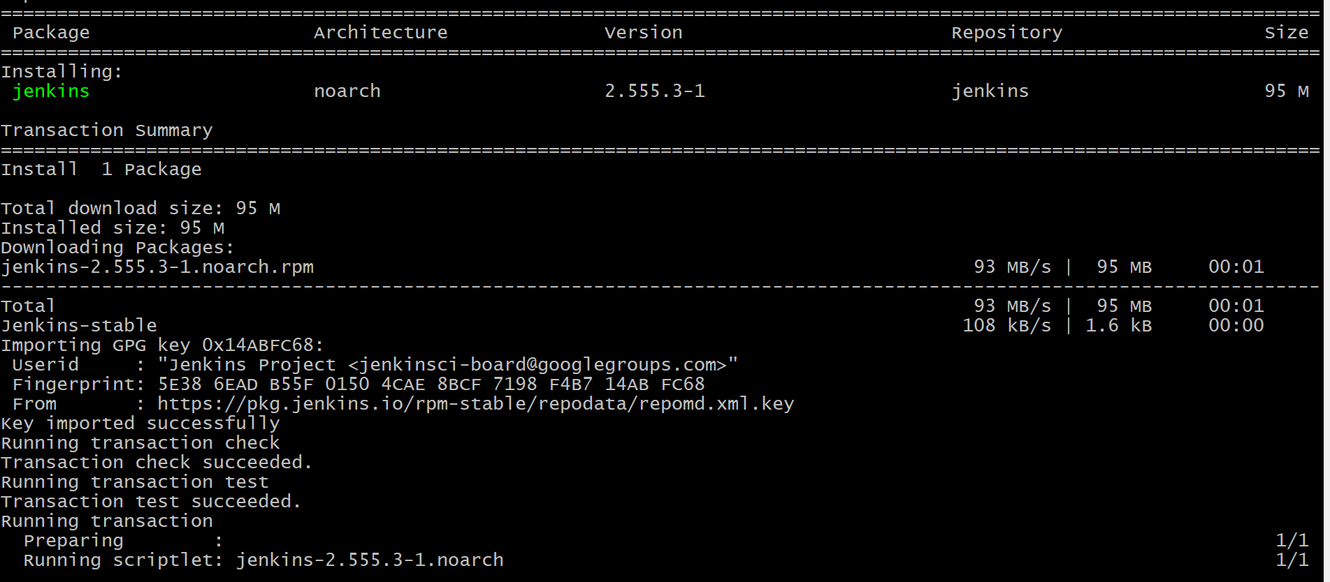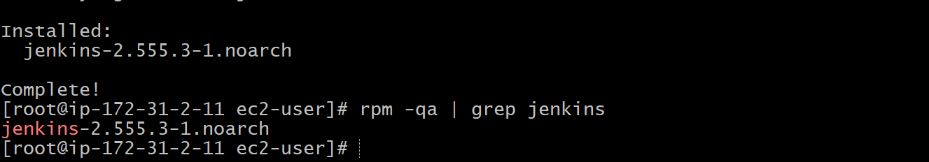
- Change Jenkins Default Port
  - Open Jenkins service configuration file.
  - Modify Jenkins port from 8080 to 8081.
  - Save the configuration.
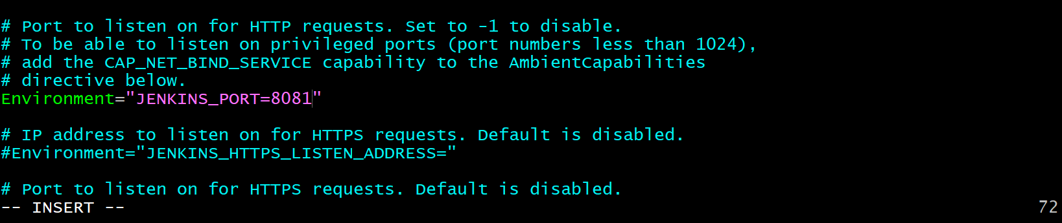
- Reload System Services
  - Reload systemd daemon to apply Jenkins configuration changes.
- Start Jenkins Service
  - Start Jenkins service.
  - Enable Jenkins service to start automatically during system boot.
- Verify Jenkins Service Status
  - Check Jenkins service status.
  - Ensure service is running successfully
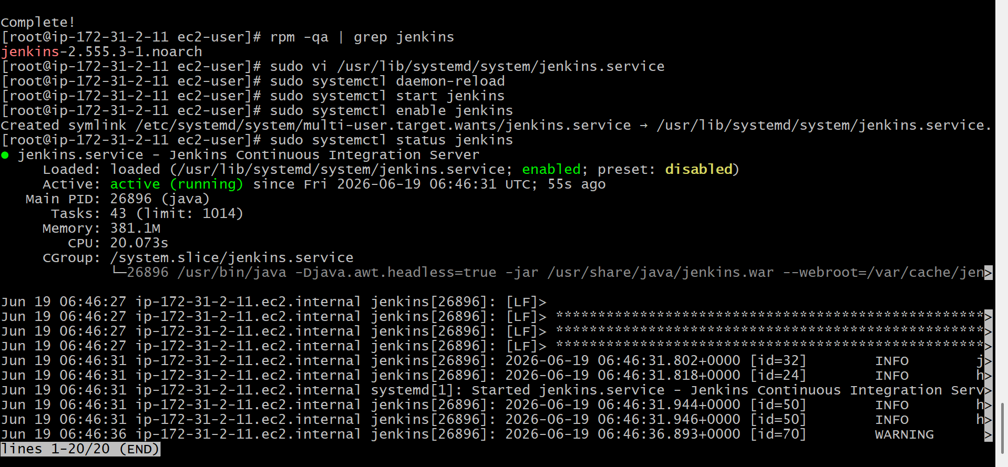
- Verify Jenkins Listening Port
  - Confirm Jenkins is listening on port 8081.
  - Validate that the port is active
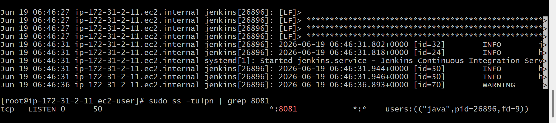
- Access Jenkins from Browser
  - Open browser and access:
http://:8081
  - Verify Jenkins Unlock screen appears
- Unlock Jenkins
  - Retrieve initial administrator password from Jenkins server.
  - Enter the password in Jenkins web interface.
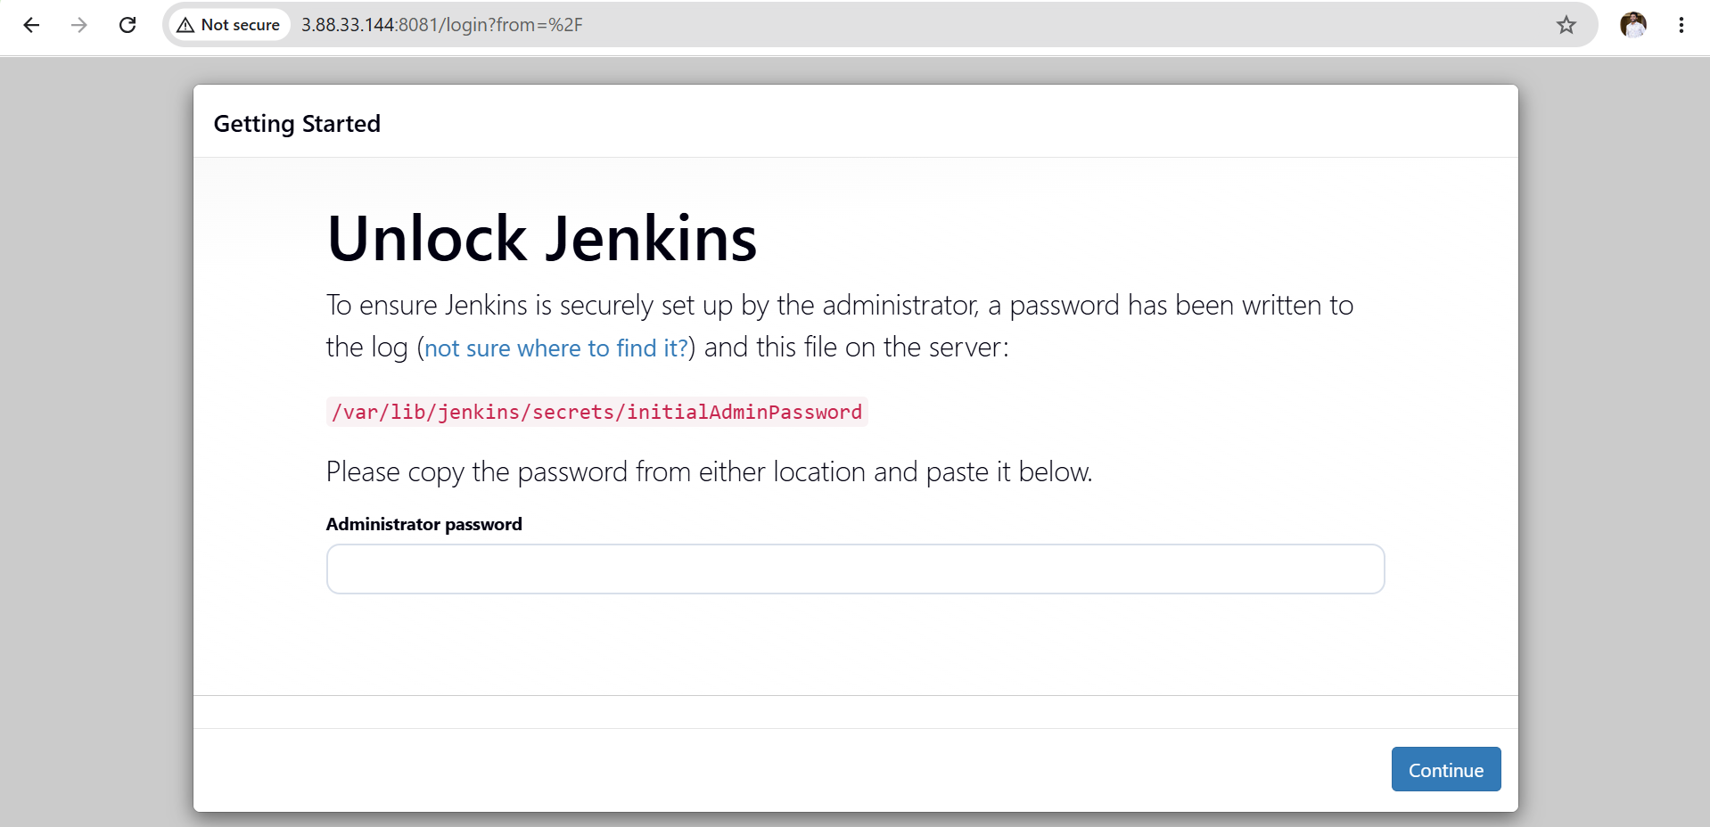
- Install Suggested Plugins
  - Select “Install Suggested Plugins”.
  - Wait for plugin installation to complete.
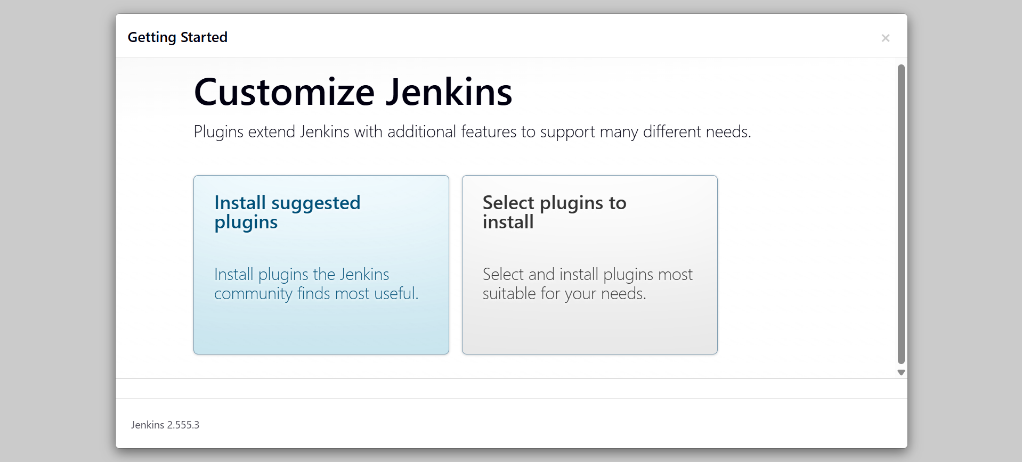
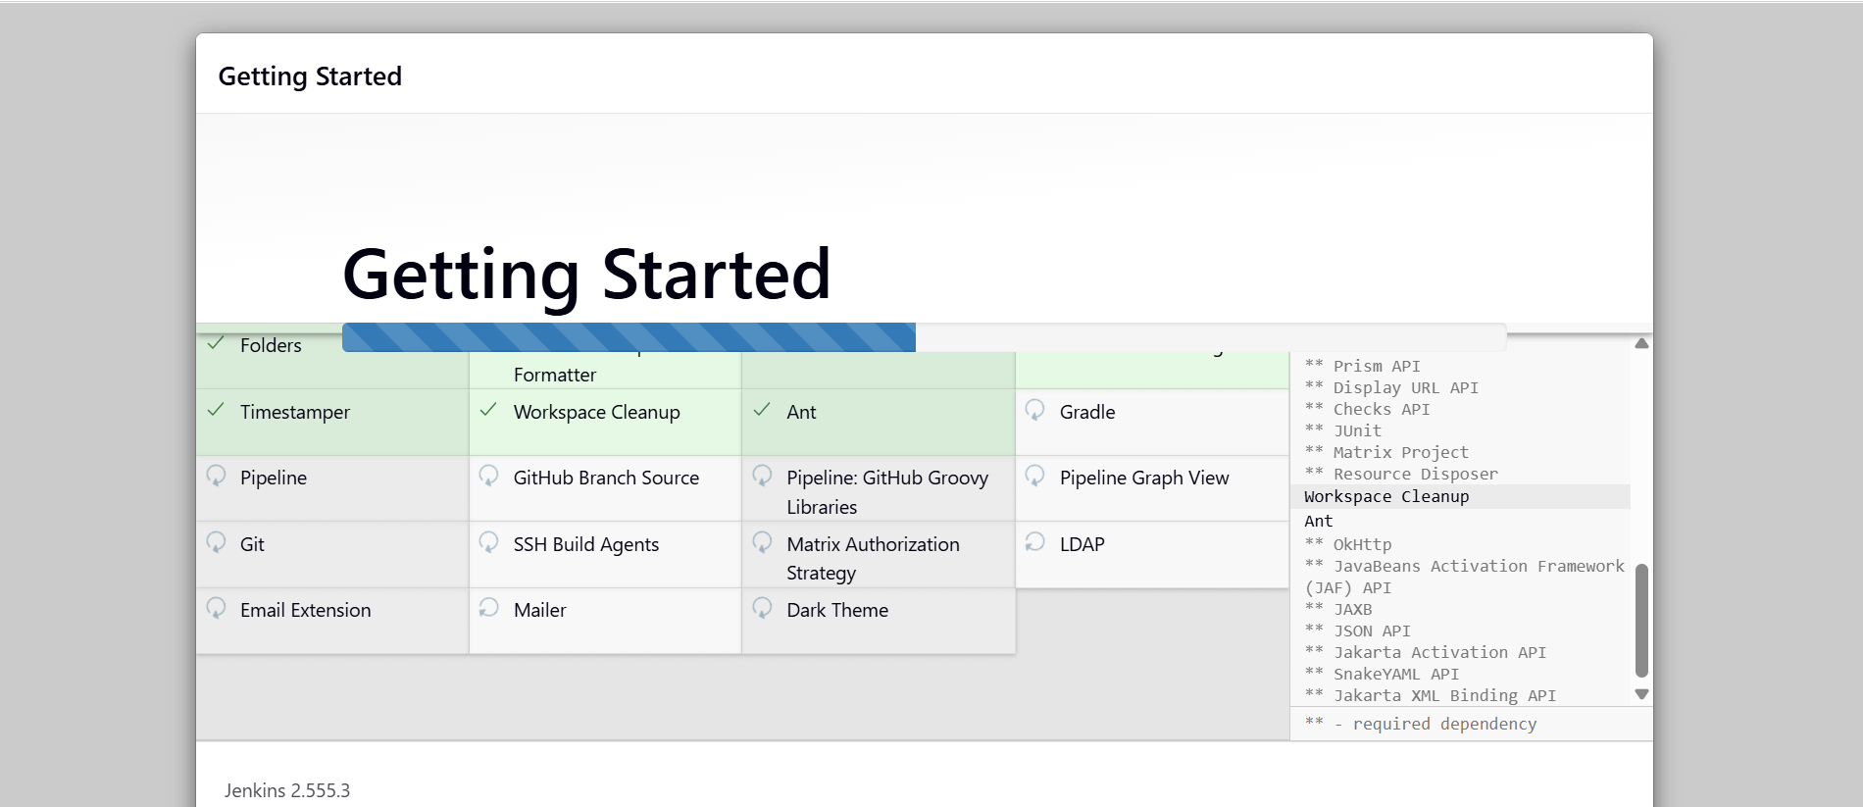
- Create Jenkins Administrator User
  - Create admin username and password.
  - Save Jenkins configuration.
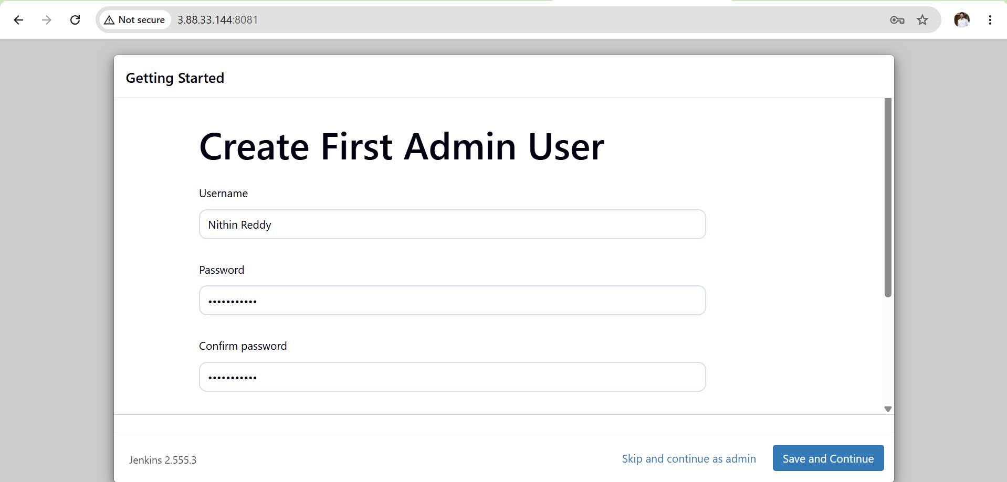
- Complete Jenkins Setup
  - Verify Jenkins Dashboard is accessible.
  - Confirm Jenkins is running successfully on port 8081.
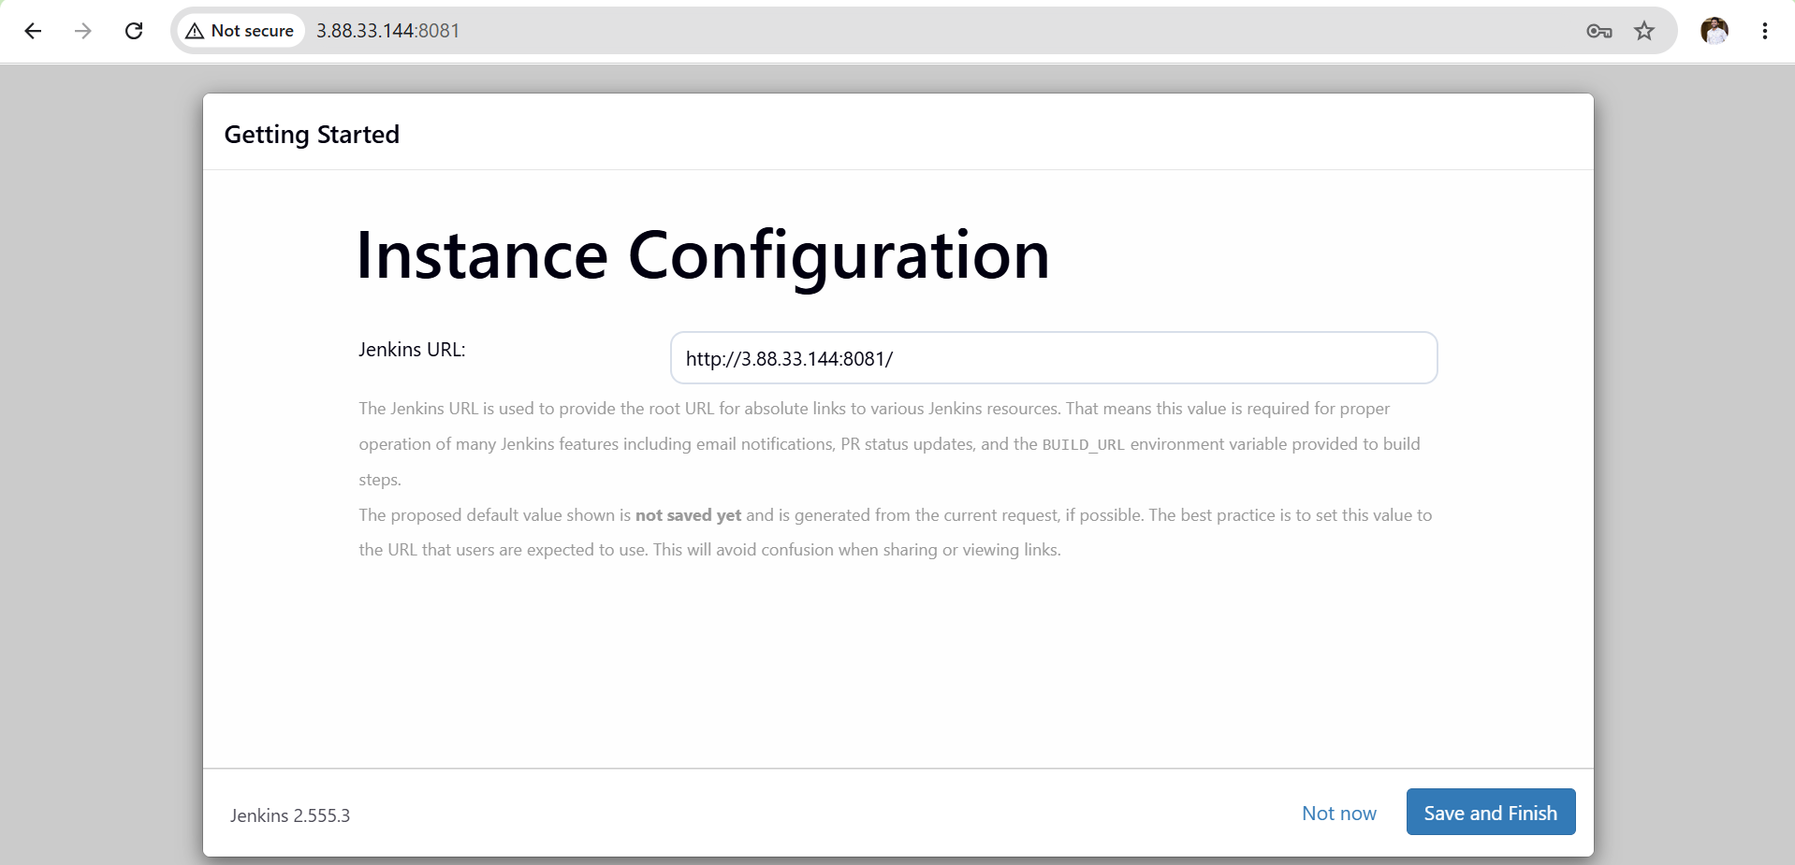
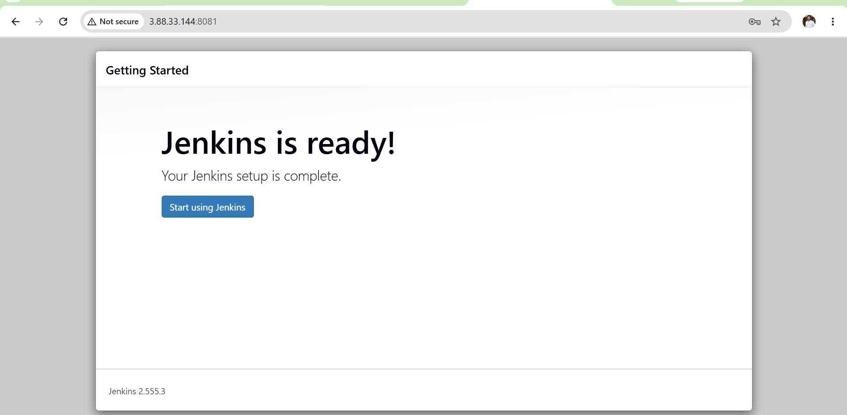
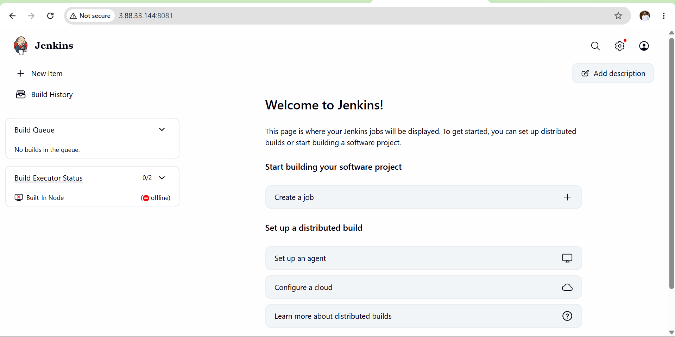
Outcome:
• Java 21 Installed Successfully
• Jenkins Installed Successfully
• Jenkins Running on Port 8081
• Jenkins Dashboard Accessible
• Administrator Account Created
• Jenkins Ready for Job Creation

Common Errors & Troubleshooting
Error 1
java: command not found
Fix:
sudo dnf install java-21-amazon-corretto -y

Error 2
Job for jenkins.service failed
Check:
sudo journalctl -u jenkins -xe

Error 3
This site can't be reached
Check:
Security Group contains:
TCP 8081
0.0.0.0/0

Error 4
Port already in use
Check:
sudo lsof -i :8081
Kill process if required.

• Port 8081 Not Accessible
- Verify Security Group rules.
- Confirm Jenkins is listening on port 8081.
• Jenkins Dashboard Not Loading
- Verify public IP address.
- Check Jenkins service status.
Conclusion:
Jenkins was successfully installed on Amazon Linux 2023 with Java 21 and configured to run on port 8081. The Jenkins dashboard is accessible and ready for further CI/CD activities.

Task 3: CREATE USERS DEVOPS AND TESTING WITH LIMITED ACCESS
Objective
To create multiple Jenkins users and assign limited permissions based on their responsibilities. This ensures secure access control and follows the principle of least privilege.
Expected Outcome
Different users have different permissions.
Prerequisites:
• Jenkins Installed and Running
• Administrator Account Available
• Jenkins Security Enabled
• Matrix-Based Security Configured
Implementation Steps:
Step 1: Login as Administrator
• Open Jenkins Dashboard.
• Login using the administrator account.
• Verify you have administrative privileges.
Step 2: Navigate to User Management
• Go to:
Manage Jenkins → Security → Users
• Click on Create User.
Step 3: Create DevOps User
Enter the following details:
Username: DevOps
Password: DevOps@123
Confirm Password: DevOps@123
Full Name: DevOps User
Email Address: nitginreddy3503@gmail.com
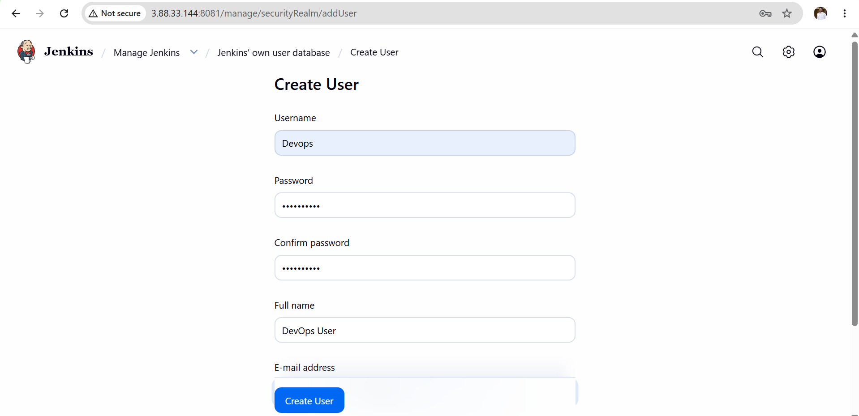
• Click Create User.
• Verify the DevOps user appears in the user list.
Step 4: Create Testing User
Enter the following details:
Username: Testing
Password: Testing@123
Confirm Password: Testing@123
Full Name: Testing User
Email Address: testing@example.com
• Click Create User.
• Verify the Testing user appears in the user list.
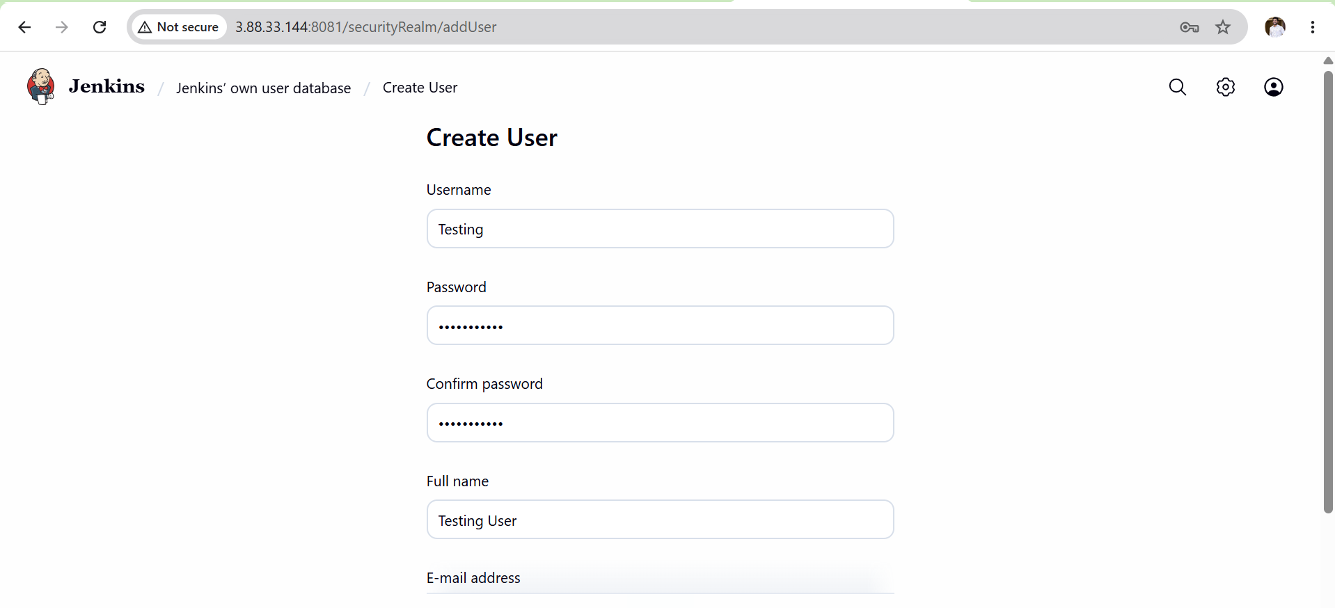
Step 5: Open Global Security Settings
Navigate to:
Manage Jenkins
→ Configure Global Security
Locate the Authorization section.
Step 6: Configure Matrix-Based Security
• Ensure Matrix-Based Security is enabled.
• Add the following users:
- admin
- DevOps
- Testing
Step 7: Assign Permissions to Admin User
Grant all permissions:

Configure Permissions
Manage Jenkins
Configure Global Security
Matrix Authorization
DevOps
Give:
Read
Build
Job Create
Job Configure
Testing
Give:
Read
Build
Workspace
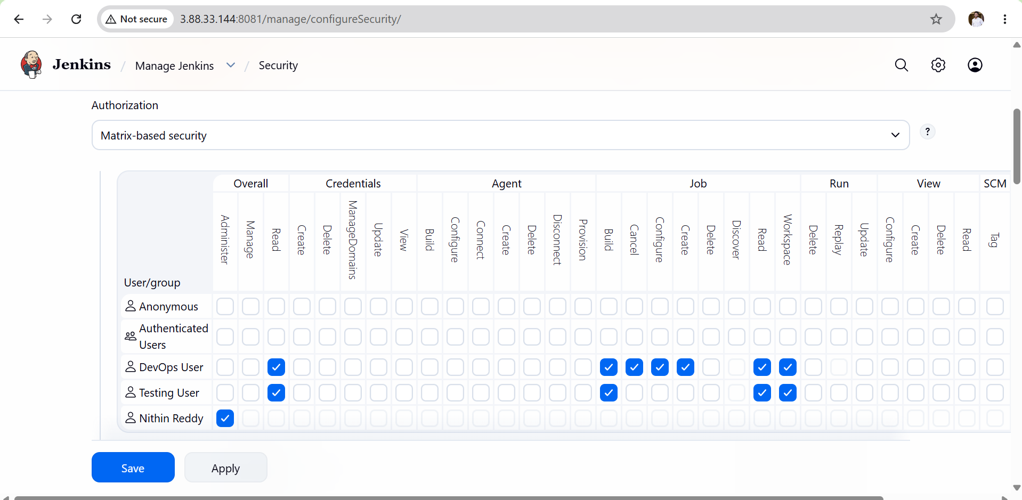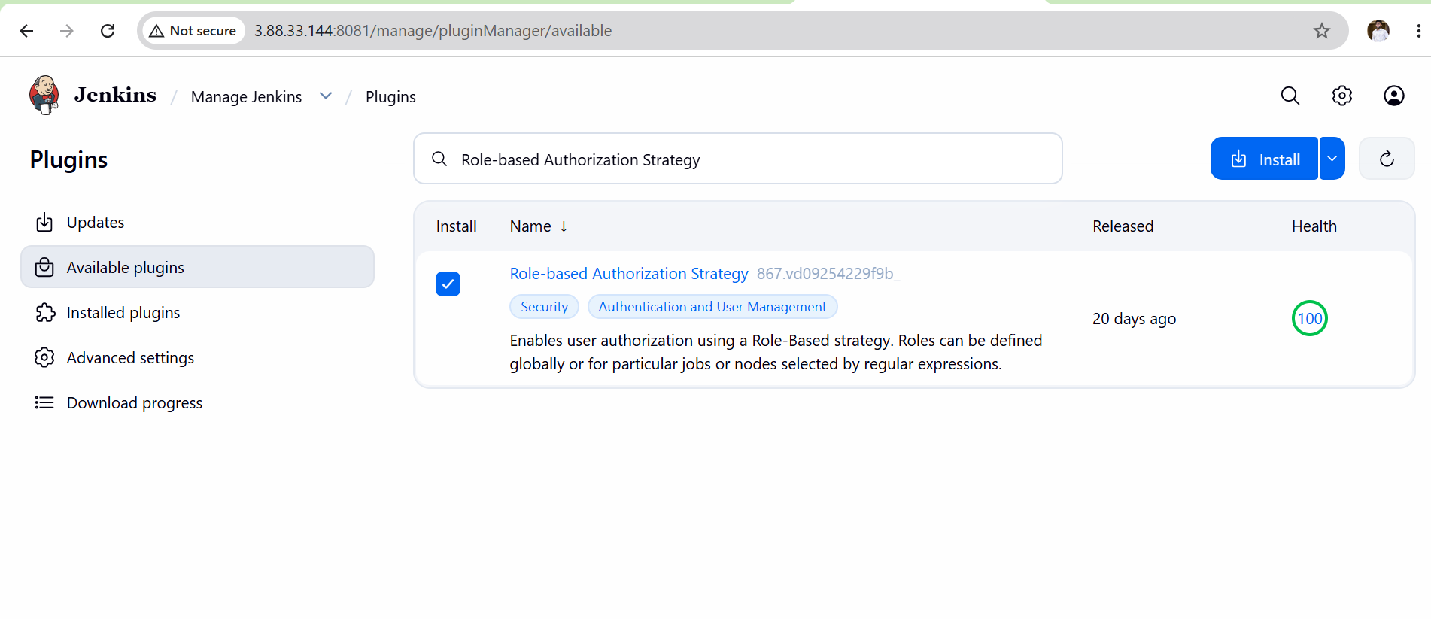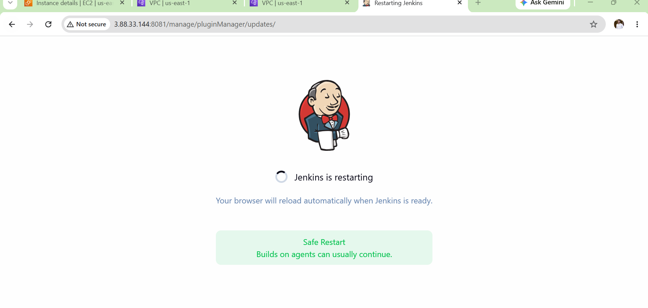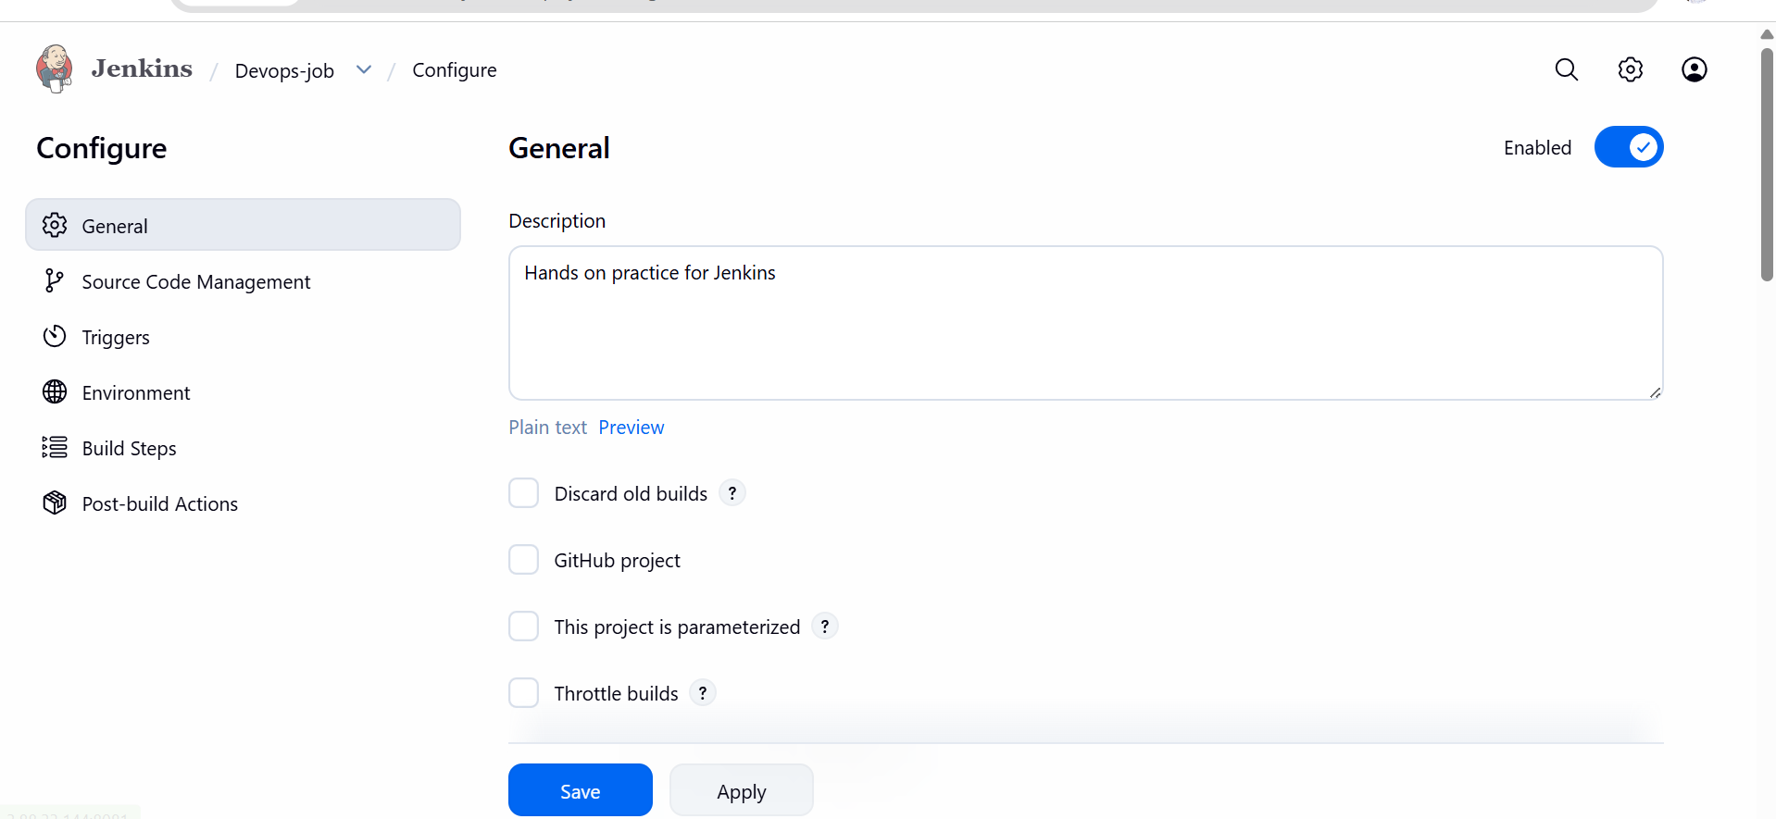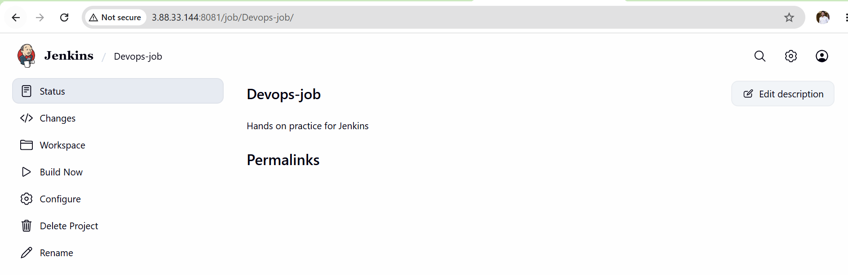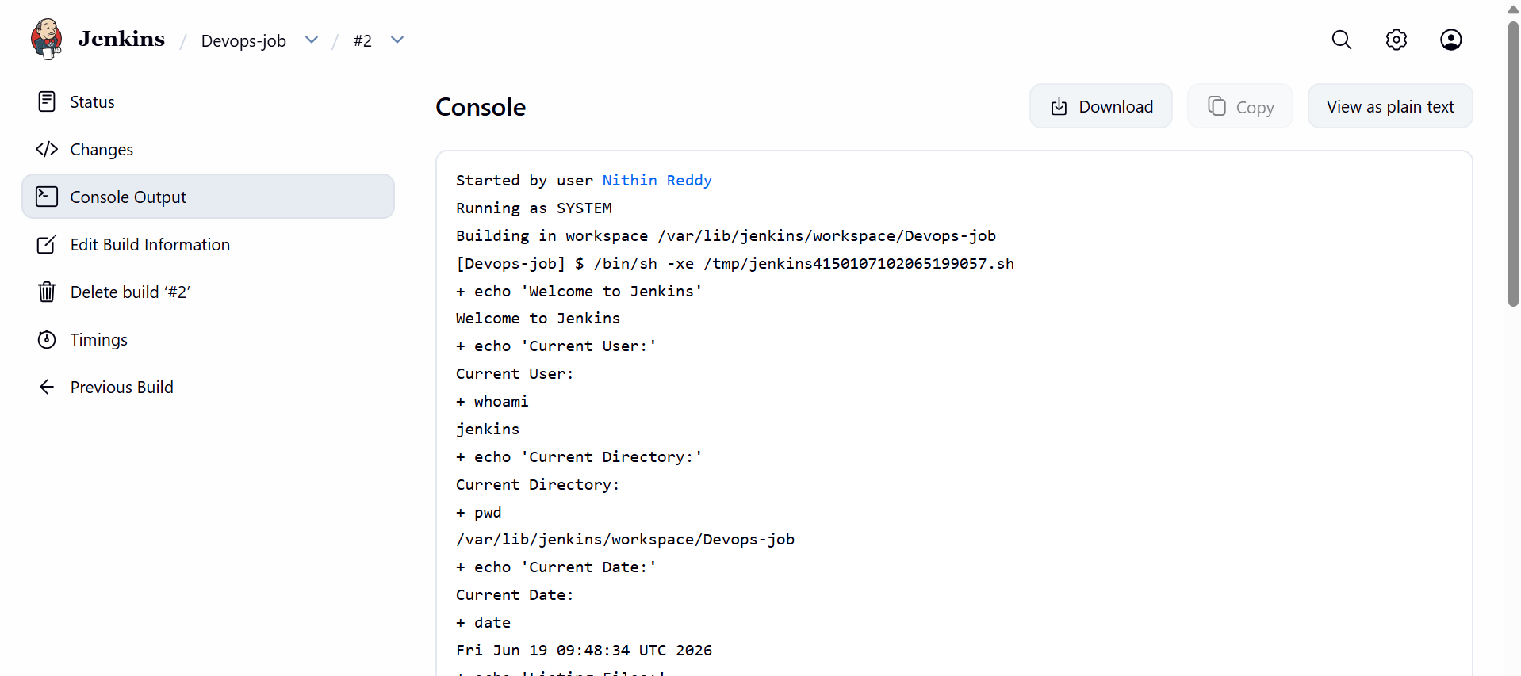
Expected Outcome:
• DevOps User Created
• Testing User Created
• Role-Based Access Control Implemented
• Administrative Functions Restricted
• Secure User Management Configured
Validation Checks:
• DevOps can create and build jobs.
• Testing can only run and monitor jobs.
• Admin retains full control.
• Unauthorized actions are blocked.
Troubleshooting:
Issue: User Cannot Login
Solution:
• Verify username and password.
• Check user creation status.
Issue: Permission Denied
Solution:
• Review Matrix-Based Security permissions.
• Ensure required permissions are granted.
Issue: User Can Access Restricted Areas
Solution:
• Remove unnecessary permissions.
• Recheck authorization matrix.
Conclusion:
Multiple Jenkins users were successfully created and assigned role-based permissions. DevOps users can manage and execute jobs, while Testing users can run and monitor builds. Administrative access remains restricted to the administrator account, improving Jenkins security and access control.

Task 4: Configure Labels and Restrict Jobs to Execute Based on Label Only
Objective
Create Jenkins Nodes (Agents), assign labels to them, and configure jobs so they run only on specific labeled nodes.

What is a Label?
A label is simply a tag assigned to a Jenkins node.
Example:
Node | Label
Jenkins Master | master
DevOps Agent | devops
Testing Agent | testing
When a job has label:
devops
it will run only on the node having the label devops.
Architecture for Task 4
Jenkins Controller (Master)
|
----------------
| |
DevOps Agent Testing Agent
Label:devops Label:testing
Prerequisites:
• Jenkins Installed and Running
• Administrator Access to Jenkins
• At Least One Jenkins Node Available
• Java Installed on Agent Nodes (if using agents)
• SSH Connectivity Configured (if using remote agents)
Implementation Steps:
- Login to Jenkins
  - Access Jenkins Dashboard.
  - Login using administrator credentials.
- Create or Configure Jenkins Nodes
  - Navigate to:
Manage Jenkins → Nodes
  - Create new nodes or use existing nodes.
  - Configure node details such as executors and remote workspace.
- Assign Labels to Nodes
  - Open node configuration.
  - Add labels to each node.
  - Example:
• DevOps-Agent → devops
• Testing-Agent → testing
  - Save the configuration.
- Verify Node Status
  - Ensure nodes are online and connected.
  - Confirm labels are displayed correctly.
- Create a Jenkins Job
  - Navigate to:
New Item
  - Create a Freestyle Project.
  - Provide a job name.
  - Save the initial configuration.
- Restrict Job Execution Based on Label
  - Open Job Configuration.
  - Under General section:
Enable "Restrict where this project can be run".
  - Enter the required label.
  - Example:
devops
- Configure Build Steps
  - Add build commands.
  - Save the job configuration.
- Execute the Job
  - Click Build Now.
  - Monitor build execution.
- Verify Label-Based Execution
  - Open Console Output.
  - Confirm the job executed on the correct labeled node.
  - Example:
Running on DevOps-Agent
- Repeat for Additional Labels
  - Create another job.
  - Assign testing label.
  - Execute and validate job placement.
- Validate Job Restrictions
  - Confirm jobs execute only on matching nodes.
  - Ensure jobs do not run on unrelated nodes.
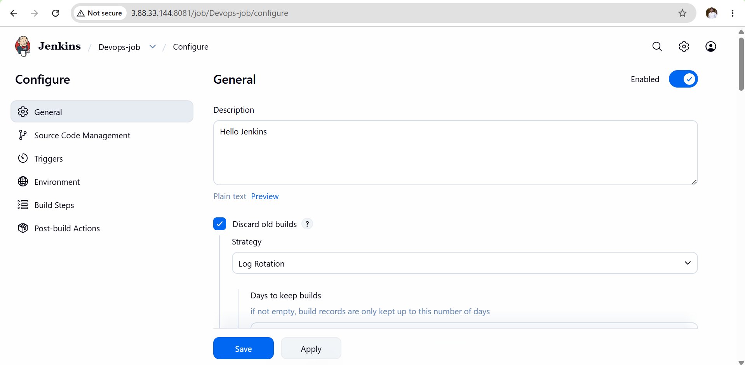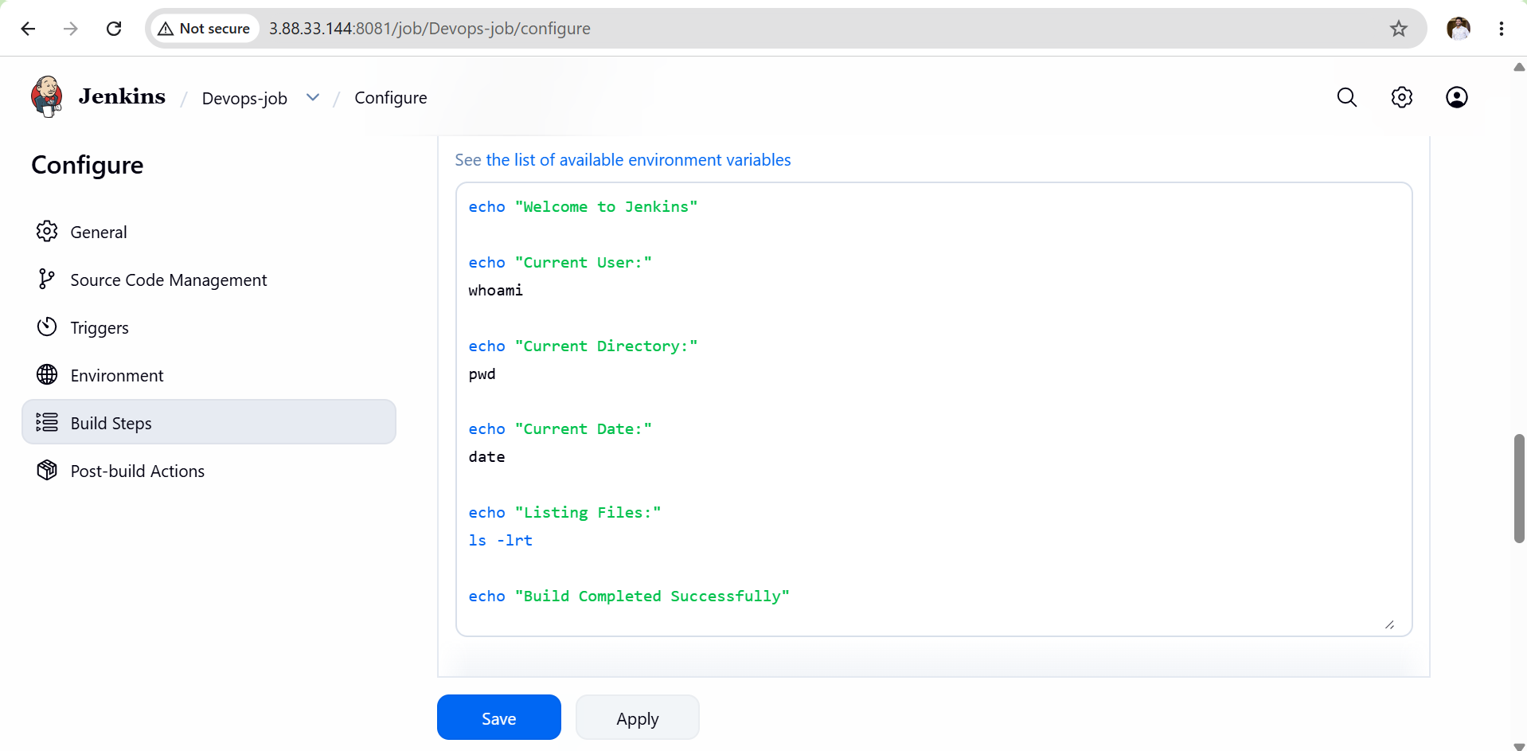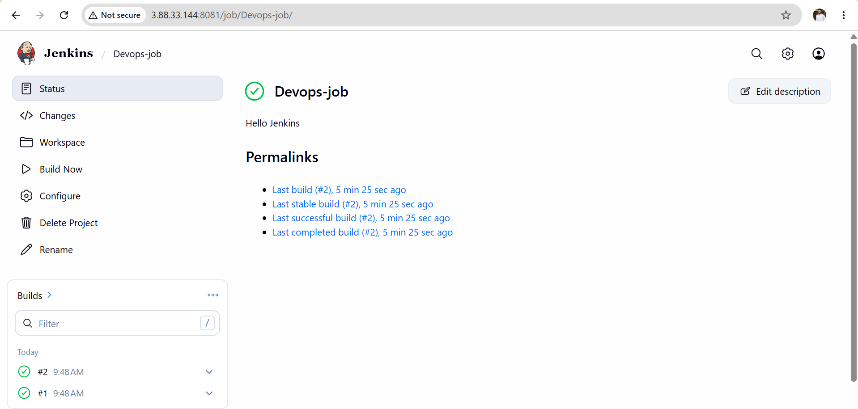
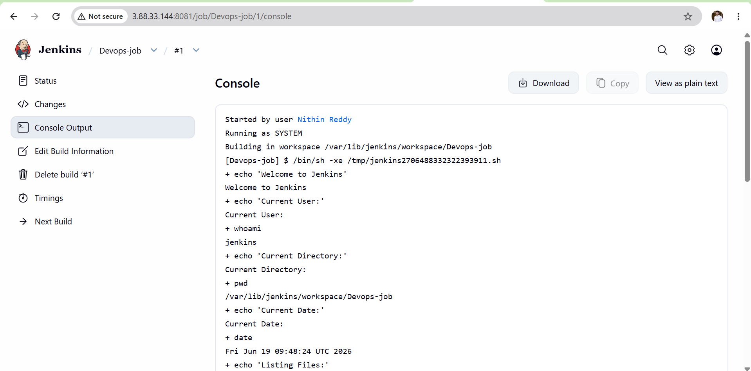
Expected Outcome:
• Labels Successfully Configured
• Nodes Properly Categorized
• Jobs Restricted to Specific Labels
• Builds Executed on Intended Nodes
• Improved Resource Management
• Controlled Job Execution Environment
Validation Checks:
• Labels visible in node configuration.
• Nodes show Online status.
• Jobs contain label restrictions.
• Console output displays correct execution node.
• Jobs run only on matching labeled nodes.
Troubleshooting:
Issue: Node Offline
Solution:
• Verify node connectivity.
• Check Java installation on agent.
• Restart agent connection.
Issue: Label Does Not Match Any Nodes
Solution:
• Verify label spelling.
• Ensure job label matches node label exactly.
Issue: Job Stuck in Queue
Solution:
• Check if labeled node is online.
• Verify available executors.
• Confirm node can accept tasks.
Issue: SSH Connection Failed
Solution:
• Verify SSH credentials.
• Check security group rules.
• Confirm port 22 accessibility.
Issue: Permission Denied (Public Key)
Solution:
• Verify private key configuration.
• Reconfigure Jenkins credentials.
Issue: Job Running on Wrong Node
Solution:
• Verify label restriction settings.
• Check node labels.
• Confirm job configuration is saved.
Conclusion:
Labels were successfully configured on Jenkins nodes and jobs were restricted to execute only on matching labeled nodes. This ensures controlled execution, better resource utilization, and improved CI/CD management.

Task 5: Create Three Sample Jobs Using GitHub Repository
Prerequisites:
• Jenkins Installed and Running
• Git Plugin Installed in Jenkins
• Git Installed on Jenkins Server
• Maven Installed on Jenkins Server (if required)
• Internet Connectivity
• Access to GitHub Repository
Objective
Create 3 Jenkins jobs using the GitHub repository:
- Clone-Code
- Build-App
- Test-App
Repository URL:
https://github.com/betawins/Techie_horizon_Login_app.git
Implementation Steps:
Job 1: Clone-Code
- Login to Jenkins Dashboard.
- Click New Item.
- Enter Job Name:
Clone-Code
- Select Freestyle Project.
- Click OK.
- Under General:
  - Add job description.
- Under Source Code Management:
  - Select Git.
  - Enter Repository URL:
https://github.com/betawins/Techie_horizon_Login_app.git
- Under Build Triggers:
  - Leave default settings.
- Under Environment:
  - Leave default settings.
- Under Build Steps:
  - Add Execute Shell.
  - Add commands to verify repository checkout.
- Save the job.
- Click Build Now.
- Verify repository is successfully cloned through Console Output.
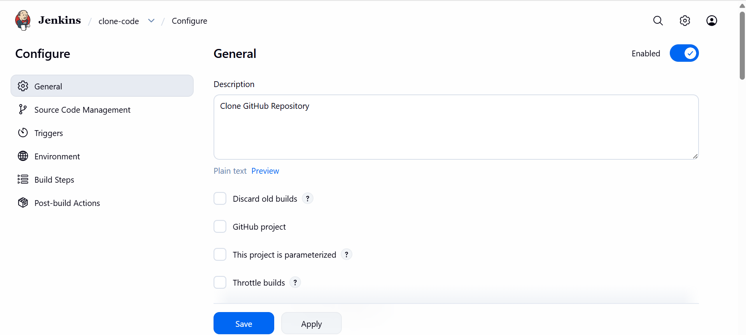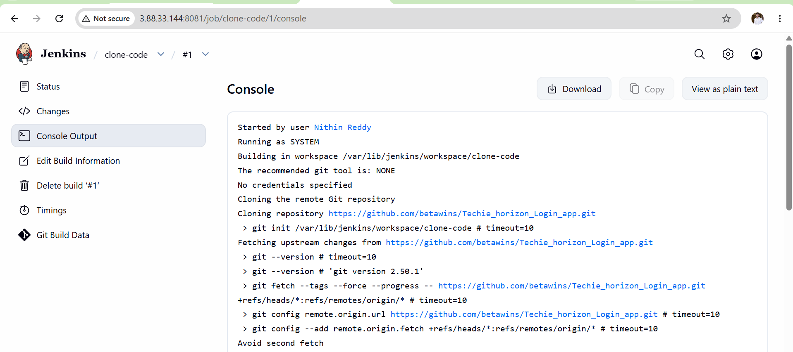
Job 2: Build-App
- Click New Item.
- Enter Job Name:
Build-App
- Select Freestyle Project.
- Click OK.
- Configure Git Repository URL.
- Under Build Steps:
  - Add build command.
  - Example:
mvn clean package
- Save the job.
- Click Build Now.
- Verify successful build execution through Console Output.
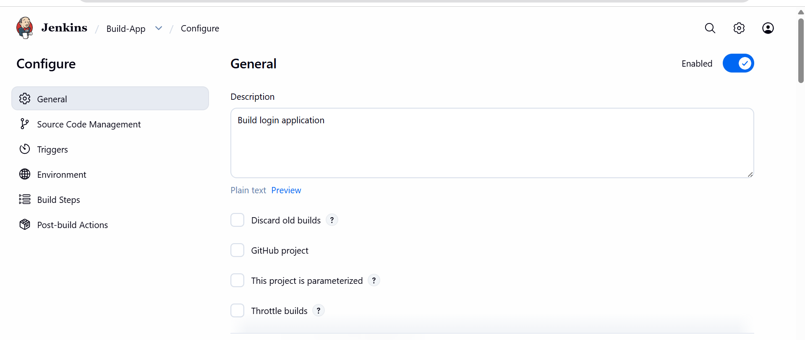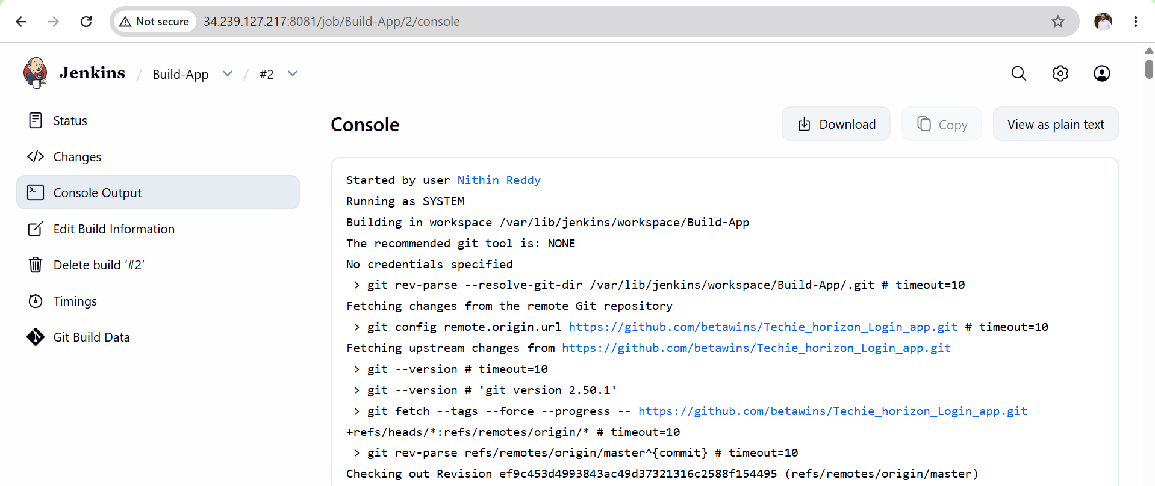
Job 3: Test-App
- Click New Item.
- Enter Job Name:
Test-App
- Select Freestyle Project.
- Click OK.
- Configure Git Repository URL.
- Under Build Steps:
  - Add test execution command.
  - Example:
mvn test
- Save the job.
- Click Build Now.
- Verify successful test execution through Console Output
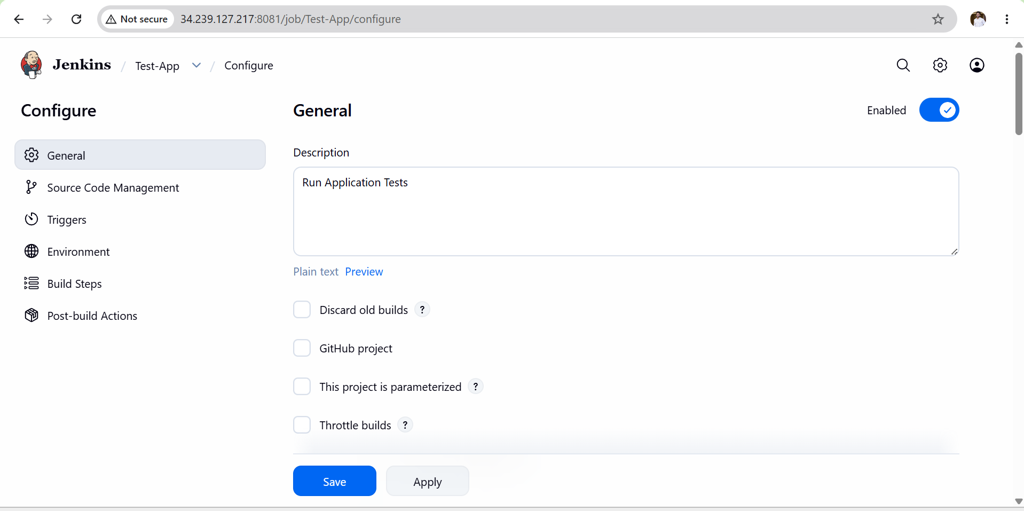 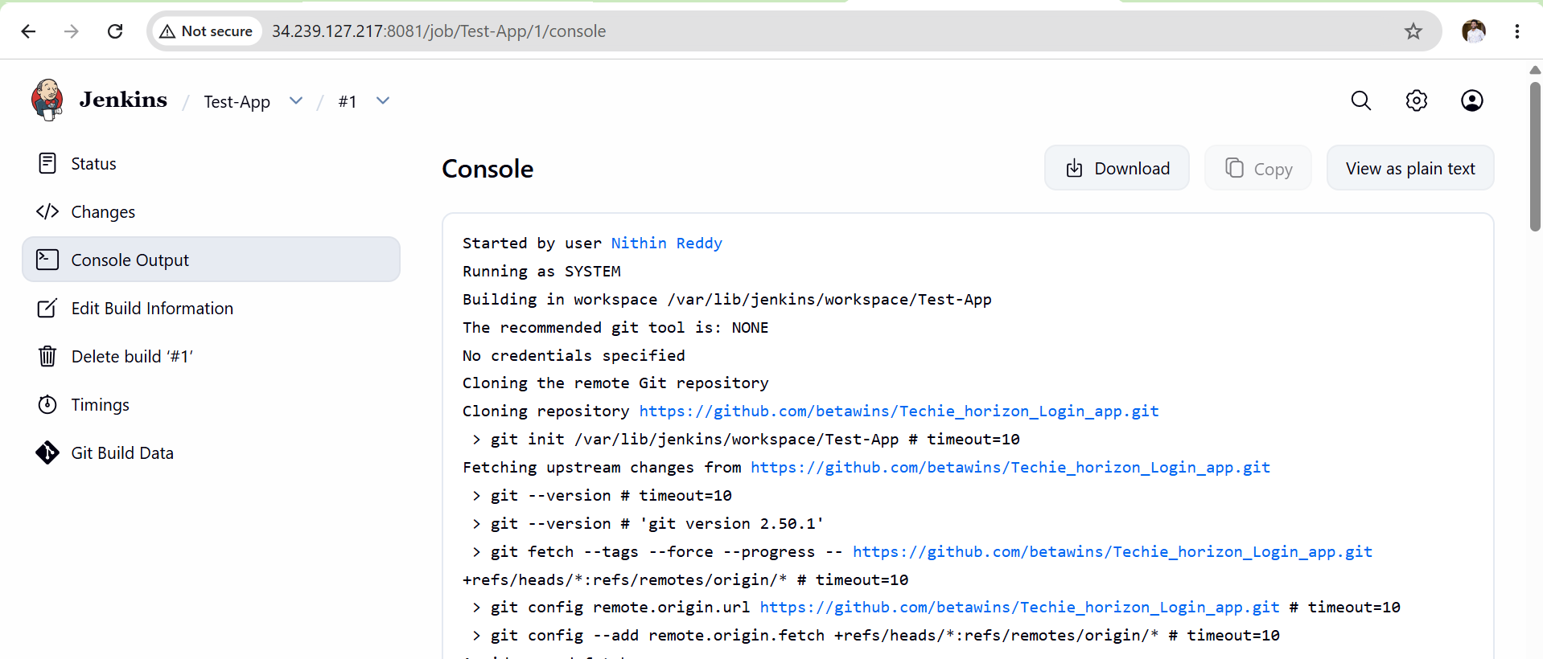
Validation Steps:
- Verify all three jobs are visible on Jenkins Dashboard.
- Verify each job executes successfully.
- Verify Git repository checkout is successful.
- Verify build output is generated.
- Verify test execution completes successfully.
- Confirm build status shows SUCCESS.

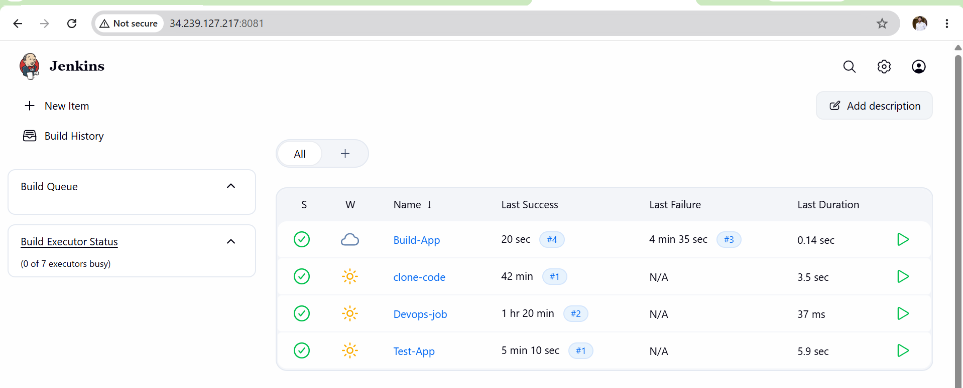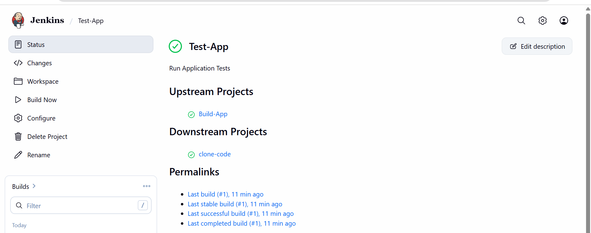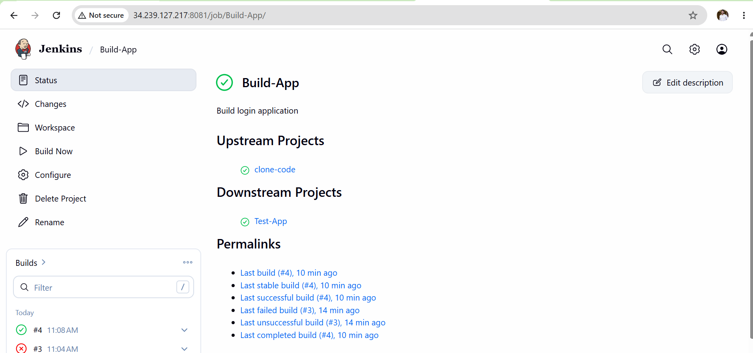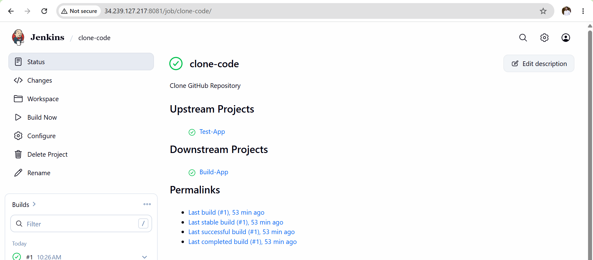
Expected Outcome:
• Clone-Code Job Created Successfully
• Build-App Job Created Successfully
• Test-App Job Created Successfully
• GitHub Repository Integrated with Jenkins
• Repository Successfully Cloned
• Application Successfully Built
• Tests Successfully Executed
• Jenkins Jobs Executed Without Errors

Troubleshooting:
Issue: Git Command Not Found
Cause:
• Git not installed on Jenkins server.
Solution:
• Install Git package.
• Verify using git --version.

Issue: Maven Command Not Found
Cause:
• Maven not installed.
Solution:
• Install Maven package.
• Verify using mvn --version.

Issue: Failed to Connect to Repository
Cause:
• Incorrect repository URL.
• Internet connectivity issue.
Solution:
• Verify GitHub URL.
• Check network connectivity.
• Confirm repository accessibility.

Issue: Authentication Failed
Cause:
• Invalid credentials.
• Private repository access issue.
Solution:
• Configure Jenkins credentials.
• Verify GitHub Personal Access Token.

Issue: Couldn't Find Any Revision to Build
Cause:
• Incorrect branch name.
Solution:
• Verify repository default branch.
• Update branch name to main or master accordingly.

Issue: pom.xml Not Found
Cause:
• Repository is not a Maven project.
Solution:
• Verify project structure.
• Use alternative build commands if Maven project files are unavailable.

Issue: Build Failed
Cause:
• Compilation errors.
• Dependency issues.
Solution:
• Review Console Output.
• Resolve code or dependency errors.

Issue: Test Execution Failed
Cause:
• Failed test cases.
• Missing dependencies.
Solution:
• Review test reports.
• Fix failed test cases.
• Rebuild and retest.
Conclusion:
Three Jenkins Freestyle jobs were successfully created and integrated with the GitHub repository. Jenkins successfully performed source code checkout, build operations, and test execution, demonstrating basic CI/CD workflow implementation.

Task 6: Create One Jenkins Job Using a GitHub Private Repository
Objective
Configure Jenkins to securely access a private GitHub repository using credentials and create a Jenkins job that can clone and build code from the private repository.
Prerequisites
- Jenkins Server installed and running.
- Git installed on Jenkins server.
- GitHub account available.
- Private GitHub repository created.
- GitHub Personal Access Token (PAT) generated.
- Jenkins administrator access available.
- Internet connectivity enabled.
Implementation Steps
- Create a private repository in GitHub.
- Upload sample code or a README file to the repository.
- Generate a GitHub Personal Access Token (PAT) with repo access.
- Copy and save the generated PAT securely.
- Login to Jenkins as Administrator.
- Navigate to Manage Jenkins → Credentials → System → Global Credentials.
- Click Add Credentials and select Username with Password.
- Enter GitHub username and PAT as password.
- Save the credential with ID github-private.
- Click New Item in Jenkins.
- Enter the job name Private-Repo-Build.
- Select Freestyle Project and click OK.
- Add a suitable description in the General section.
- Select Git under Source Code Management.
- Enter the private repository HTTPS URL.
- Select the github-private credential from the credentials dropdown.
- Specify the repository branch name (main or master).
- Leave Build Triggers with default settings.
- Leave Environment settings with default values.
- Click Add Build Step → Execute Shell.
- Add shell commands to verify repository cloning and build execution.
- Leave Post-Build Actions empty.
- Click Save to save the job configuration.
- Click Build Now to execute the job.
- Open Console Output to monitor build execution.
- Verify that the private repository is cloned successfully.
- Confirm the build completes with Finished: SUCCESS status.
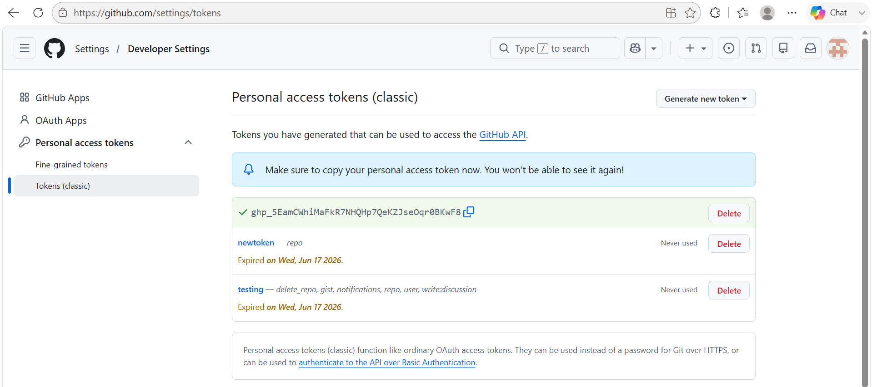
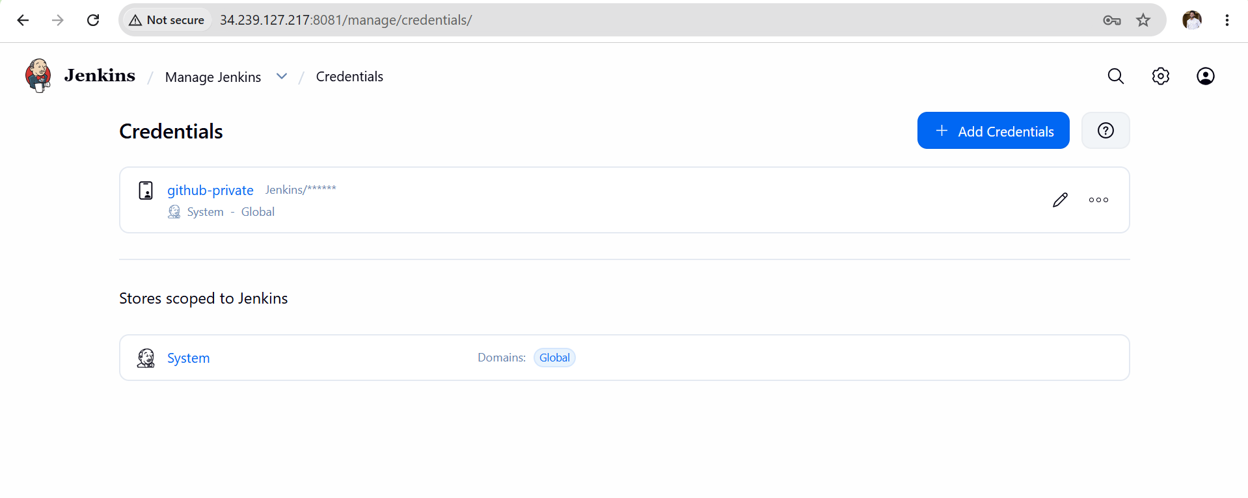 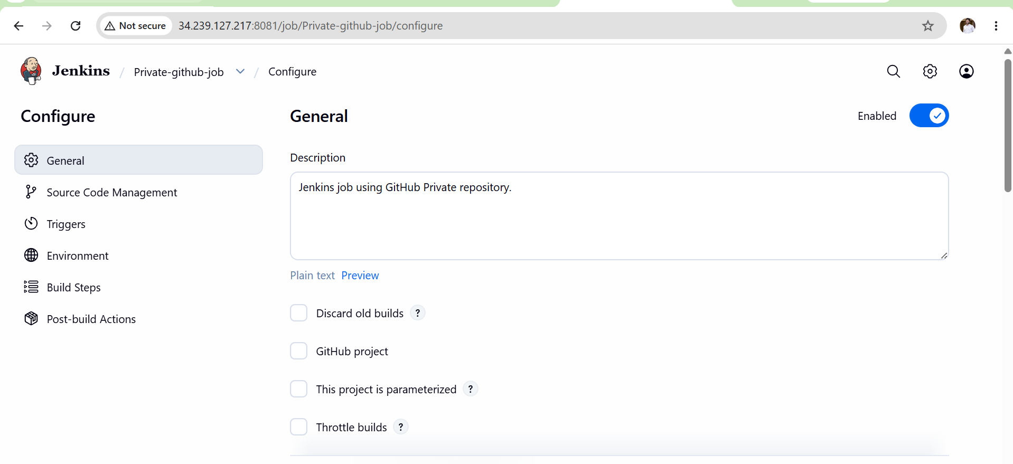 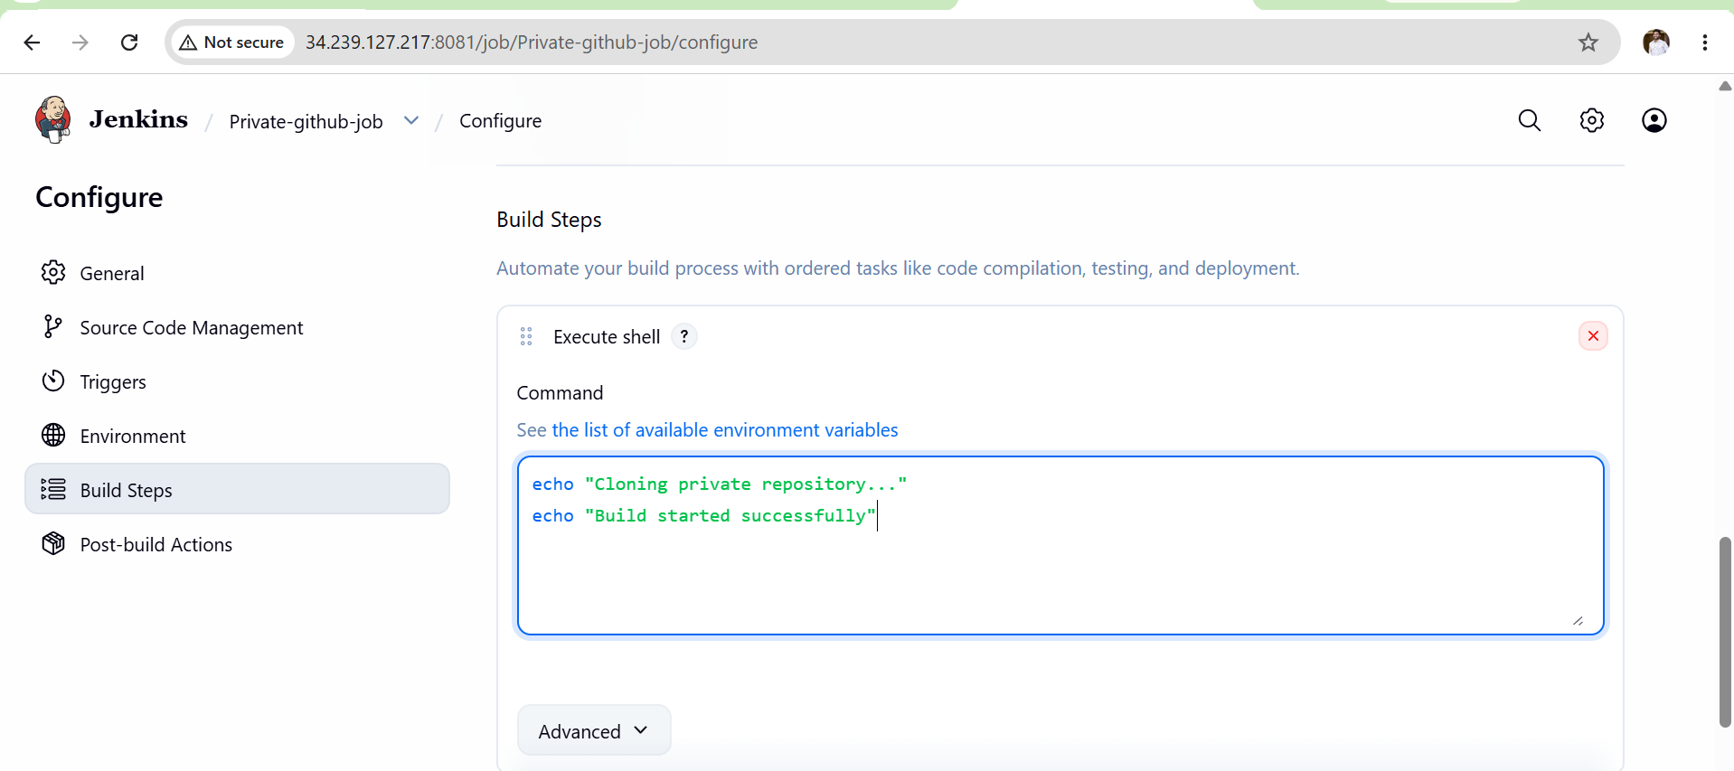
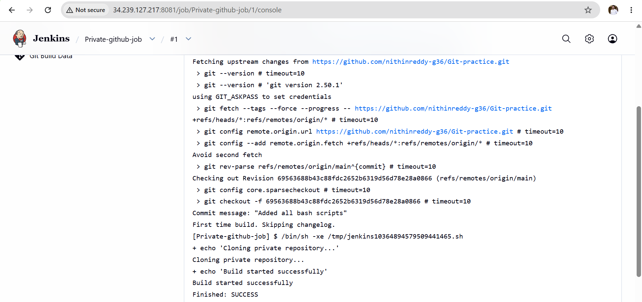
Validation Checks
Verify:
✅ Job Created
✅ Private Repository URL Configured
✅ Jenkins Credential Configured
✅ Repository Cloned Successfully
✅ Build Status = SUCCESS

Common Errors and Solutions

Error 1
Authentication failed
Cause
Wrong GitHub Token.
Solution
Generate new PAT.
Update Jenkins Credentials.

Error 2
Repository not found
Cause
Incorrect repository URL.
Solution
Copy URL directly from GitHub Code button.
Verify repository exists.

Error 3
Failed to connect to repository
Cause
Network issue.
Solution
Verify Jenkins server internet access.
Test:
git ls-remote https://github.com/username/repository.git

Error 4
Couldn't find any revision to build
Cause
Wrong branch name.
Solution
Check repository branch:
main
or
master
Update Jenkins job configuration.

Error 5
Credentials not found
Cause
Credential not added or selected.
Solution
Go:
Manage Jenkins
→ Credentials
Verify credential exists and is selected in the job.

Error 6
Permission denied
Cause
PAT lacks required permissions.
Solution
Generate PAT with:
repo
workflow
read:org
permissions.

