Task 1: Configure 2 Slave Machines (Agents) in Jenkins Master
Objective
Configure two Jenkins Agent (Slave) machines and connect them to the Jenkins Master so jobs can run on remote nodes instead of the Jenkins controller.

Architecture
Jenkins Master (EC2-1)
|
-----------------------
| |
Agent-1 Agent-2
(devops) (testing)

Expected Outcome
✅ Jenkins Master connected to 2 agents
✅ Both agents show Online status
✅ Jobs can run on Agent-1 and Agent-2
✅ Labels configured for each agent

Prerequisites
Existing Resources
You should already have:
- Jenkins Master EC2 running
- Jenkins running on Port 8081
- Admin access to Jenkins
Additional Resources Required
Launch 2 new EC2 instances:
Server | Purpose
Agent-1 | DevOps Agent
Agent-2 | Testing Agent
Implementation Steps
- Launch two EC2 instances named Agent-1 and Agent-2.
- Connect to both agents using SSH.
- Install Java 21 on Agent-1.
- Install Java 21 on Agent-2.
- Verify Java installation using java -version.
- Create Jenkins workspace directory on Agent-1.
- Create Jenkins workspace directory on Agent-2.
- Verify SSH service is running on both agents.
- Login to Jenkins Master.
- Navigate to Manage Jenkins → Nodes.
- Click New Node and create Agent-1.
- Select Permanent Agent option.
- Configure Remote Root Directory.
- Assign label devops to Agent-1.
- Select Launch agents via SSH.
- Configure Agent-1 public IP address.
- Add SSH credentials using AWS PEM key.
- Save Agent-1 configuration.
- Launch Agent-1 from Jenkins.
- Verify Agent-1 status changes to Online.
- Create Agent-2 node in Jenkins.
- Select Permanent Agent option.
- Configure Remote Root Directory.
- Assign label testing to Agent-2.
- Select Launch agents via SSH.
- Configure Agent-2 public IP address.
- Add SSH credentials using AWS PEM key.
- Save Agent-2 configuration.
- Launch Agent-2 from Jenkins.
- Verify Agent-2 status changes to Online.
- Create a sample job for Agent-1 using label restriction.
- Execute the job and verify it runs on Agent-1.
- Create a sample job for Agent-2 using label restriction.
- Execute the job and verify it runs on Agent-2.
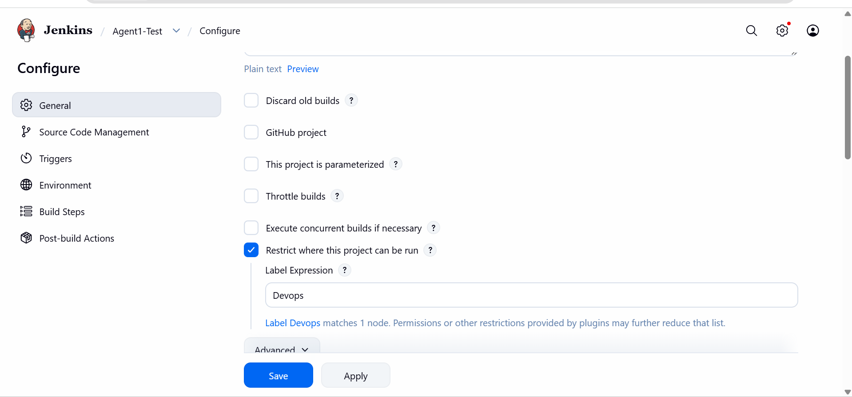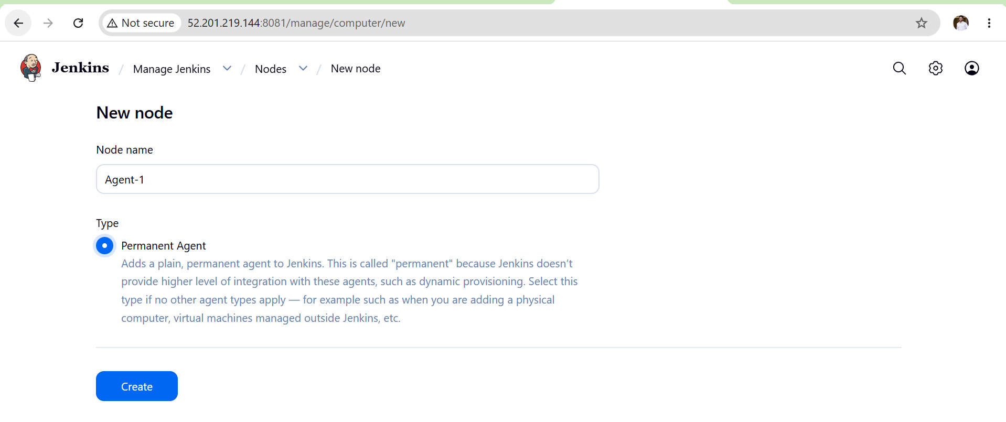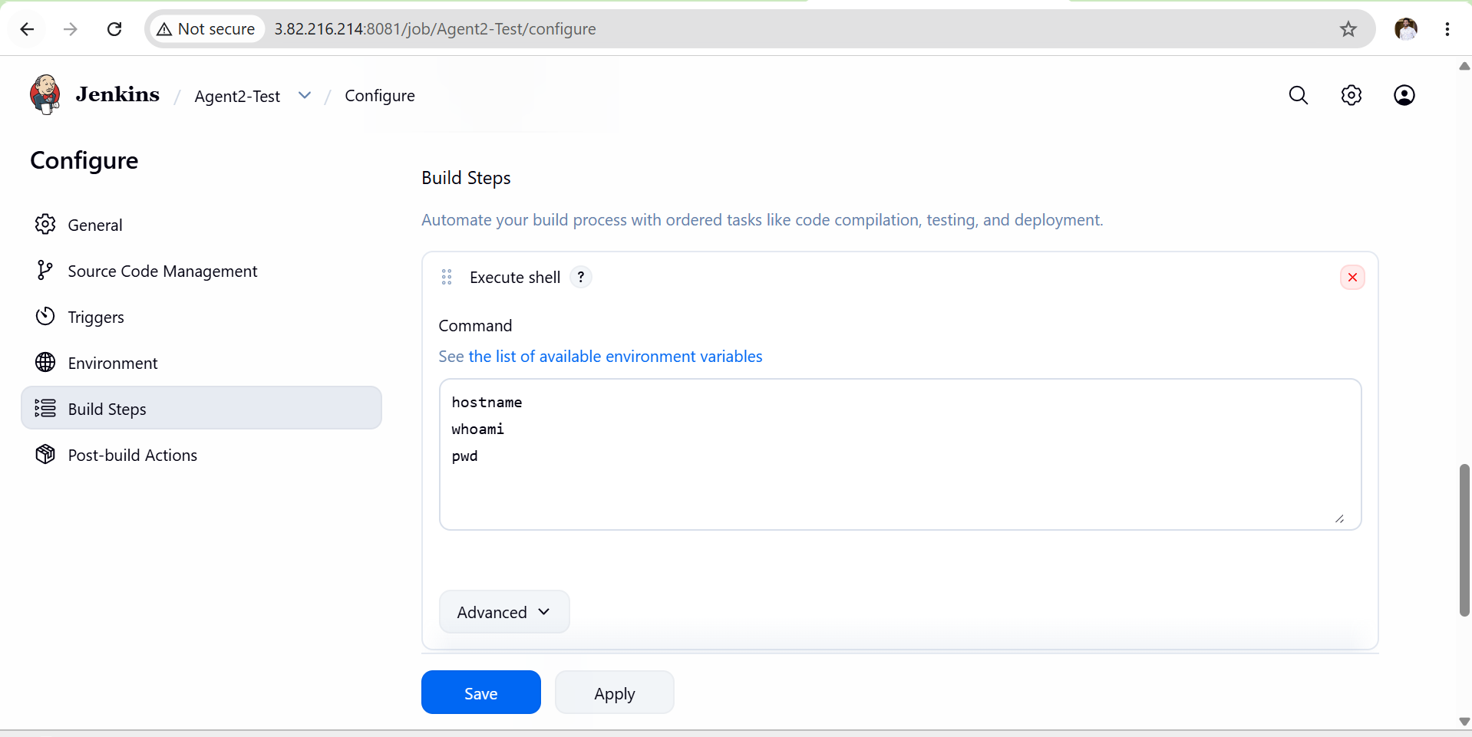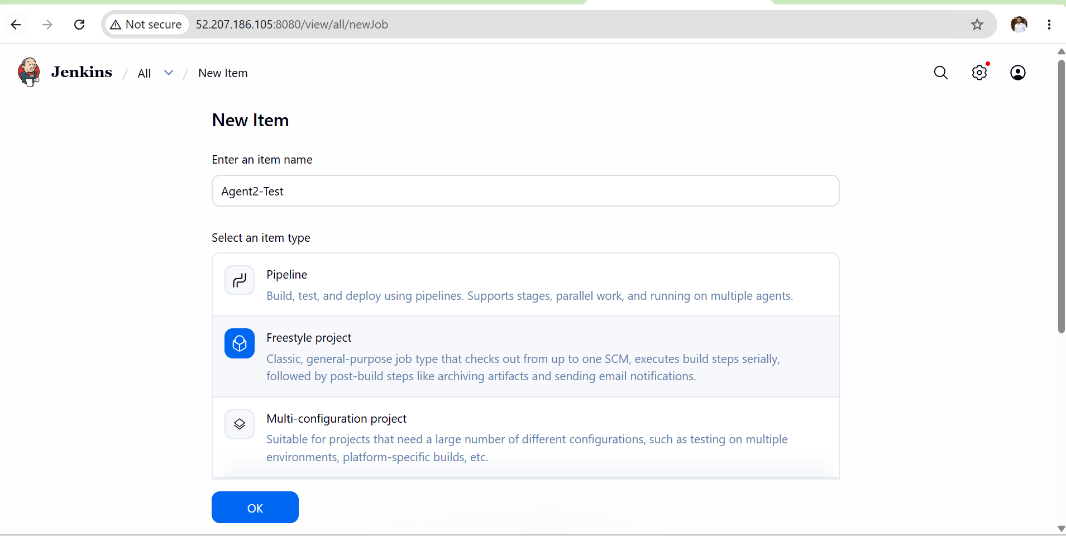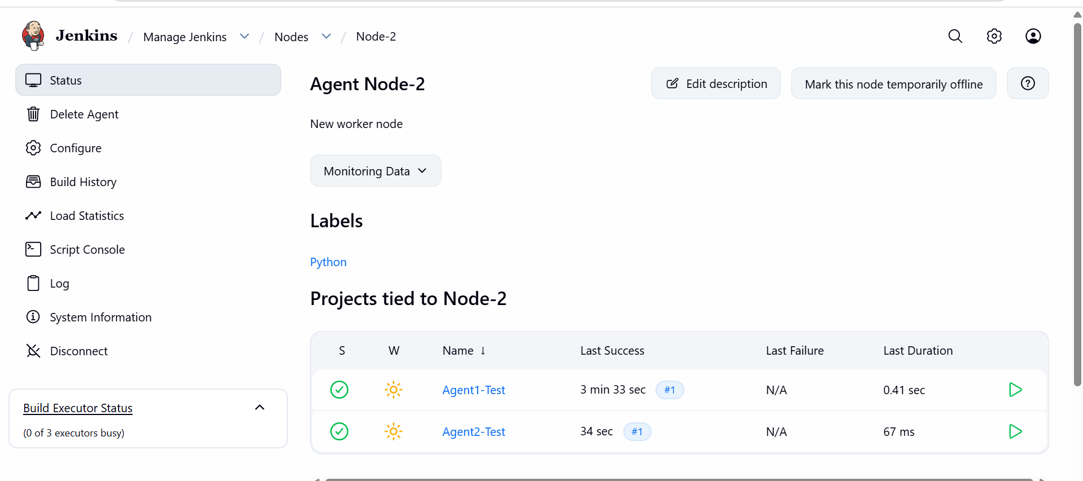

Validation Points
- Verify Agent-1 is visible under Jenkins Nodes.
- Verify Agent-2 is visible under Jenkins Nodes.
- Verify Agent-1 status shows Online.
- Verify Agent-2 status shows Online.
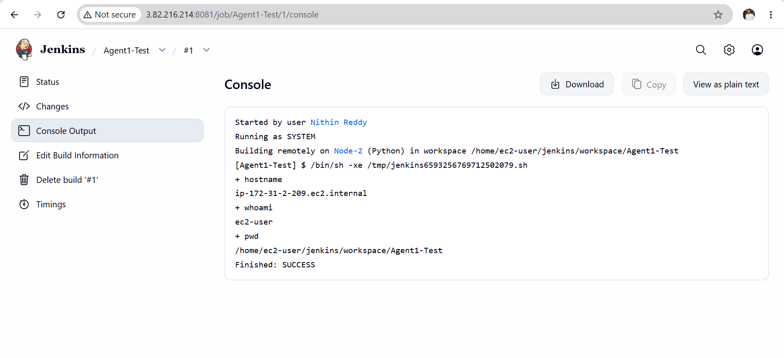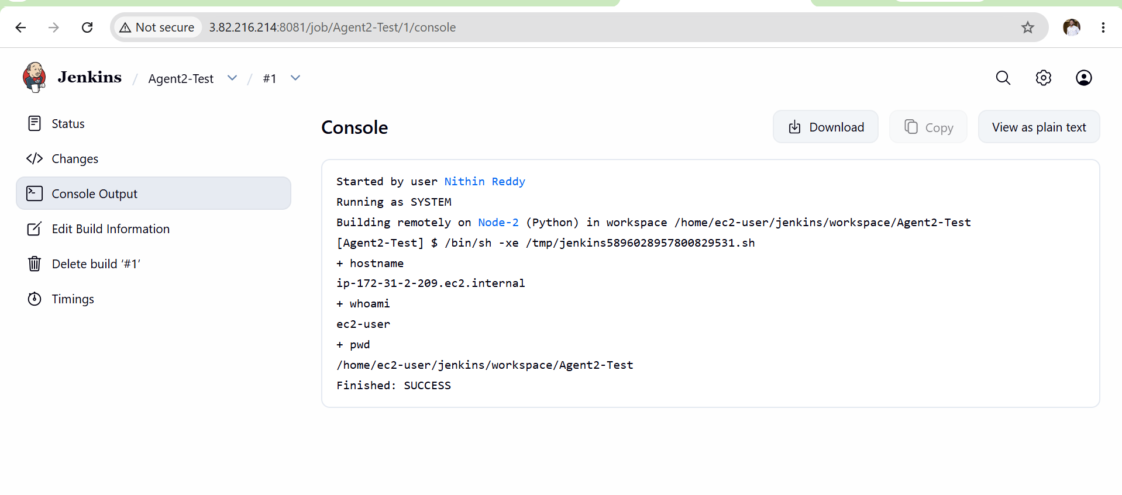

Task 2: Configure Webhooks to the Jenkins Job
Objective
Configure GitHub Webhooks so that whenever code is pushed to GitHub, Jenkins automatically triggers a build.

Expected Outcome
✅ GitHub repository connected to Jenkins
✅ Webhook configured successfully
✅ Pushing code to GitHub automatically triggers Jenkins build
✅ No manual Build Now required

Prerequisites
- Jenkins Server running on port 8081
- Existing Jenkins job available (Example: Clone-Code or Devops-job)
- GitHub repository access
- Public IP or Public DNS of Jenkins server
- GitHub Plugin installed in Jenkins
- Git Plugin installed in Jenkins

Implementation Steps
- Login to Jenkins as Administrator.
- Verify the Jenkins job builds successfully using Build Now.
- Open the Jenkins job and click Configure.
- Verify the correct GitHub repository URL is configured.
- Verify the correct branch name (*/main or */master) is configured.
- Navigate to the Build Triggers section.
- Enable GitHub hook trigger for GITScm polling.
- Click Save.
- Navigate to Manage Jenkins → Plugins.
- Verify Git Plugin is installed.
- Verify GitHub Plugin is installed.
- Verify GitHub Integration Plugin is installed.
- Open Manage Jenkins → System.
- Verify the Jenkins URL is configured correctly.
- Open the GitHub repository.
- Navigate to Settings → Webhooks.
- Click Add Webhook.
- Enter the Payload URL as:
http://<JENKINS_PUBLIC_IP>:8081/github-webhook/
- Select application/json as Content Type.
- Leave Secret field empty.
- Select Just the push event.
- Click Add Webhook.
- Verify the webhook is created successfully.
- Edit any file in the GitHub repository (for example README.md).
- Commit and push the changes.
- Open Jenkins Dashboard.
- Verify a new build is triggered automatically.
- Open Console Output of the latest build.
- Verify the message Started by GitHub push is displayed.
Validation Points
- Verify Jenkins job builds successfully manually.
- Verify GitHub repository URL is correct.
- Verify the correct branch is configured.
- Verify GitHub hook trigger is enabled.

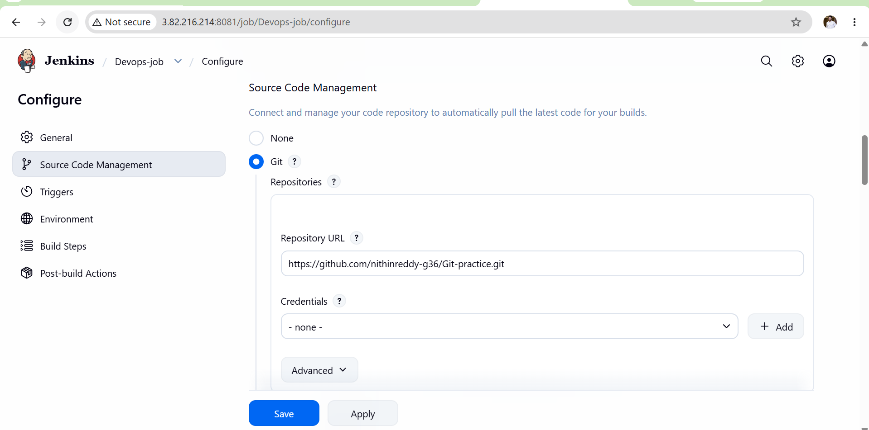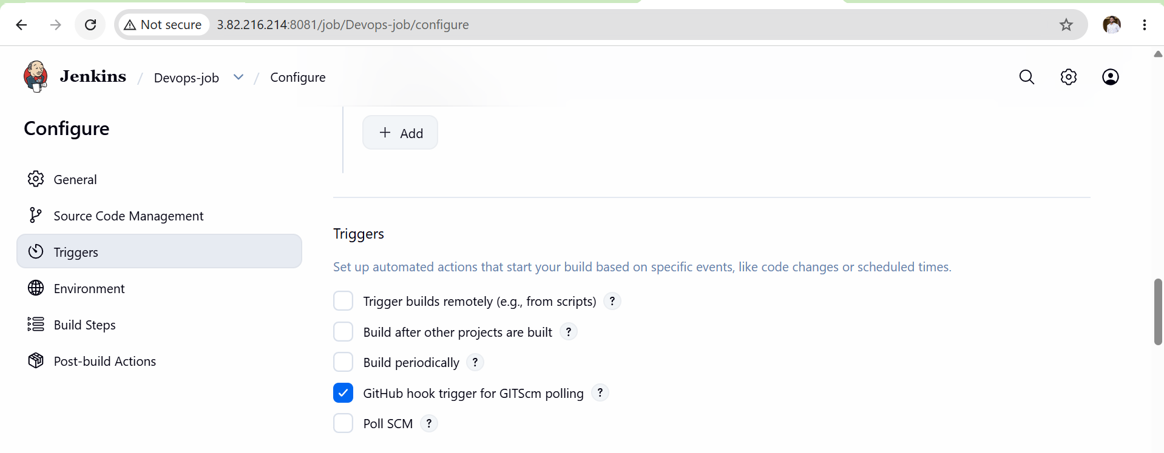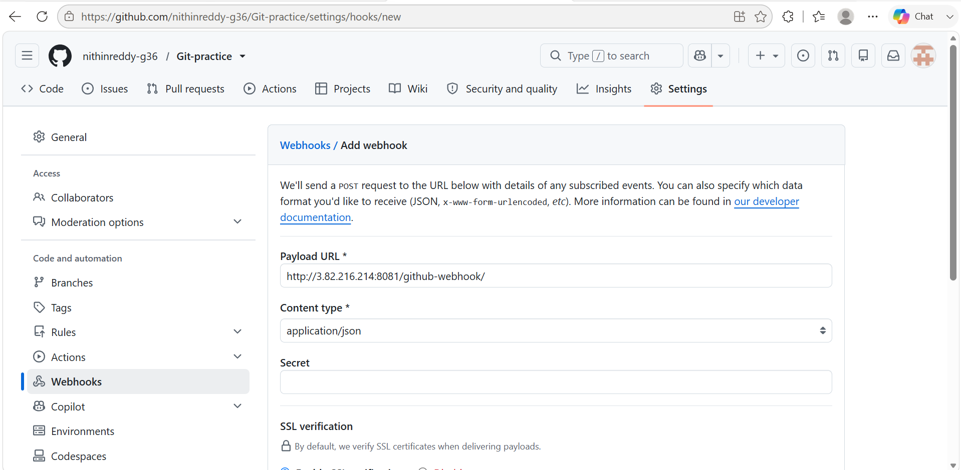
Verify GitHub webhook is created successfully.
Verify webhook delivery status shows 200 OK.
- Verify GitHub push event is received by Jenkins.
- Verify Jenkins automatically triggers a build after code push.
- Verify no manual Build Now action is required.
- Verify Build History shows a new build after push.
- Verify Console Output contains:
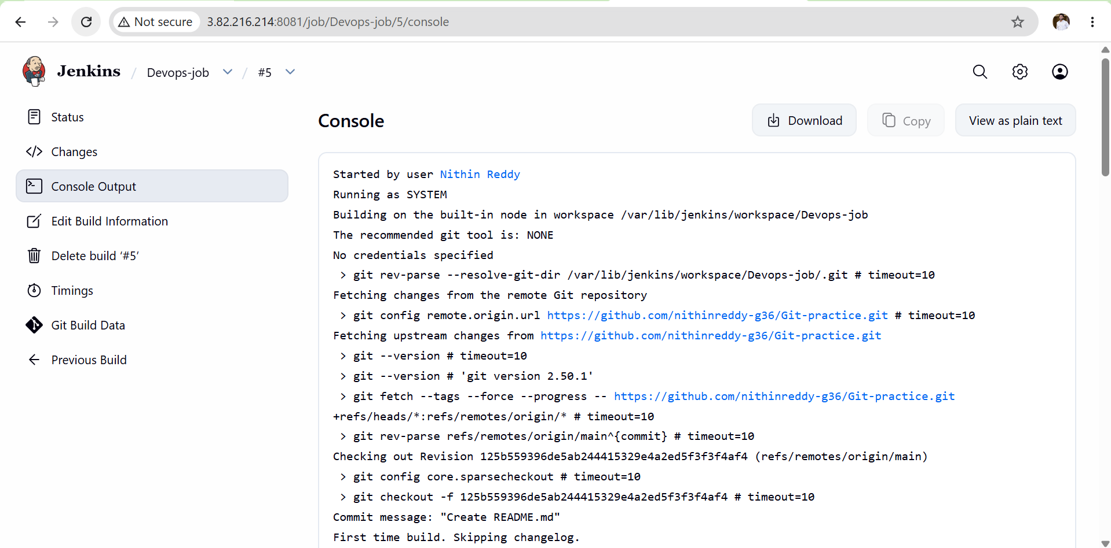
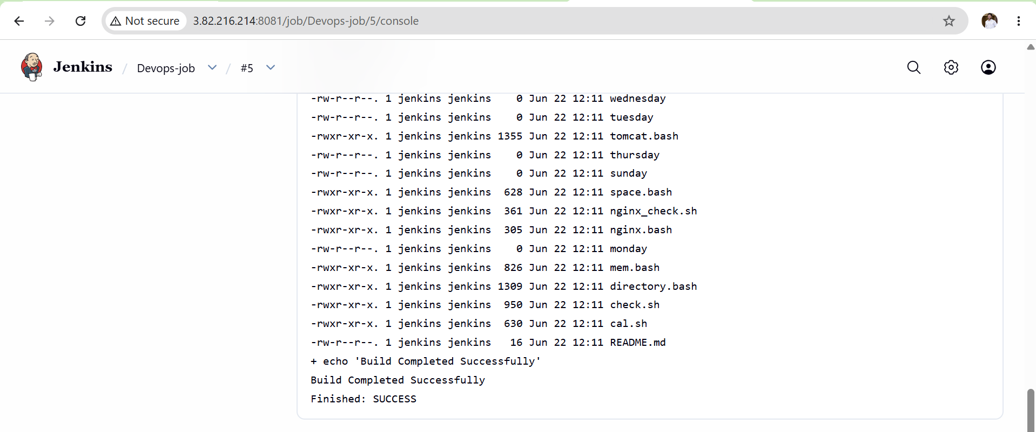

Task 3: Configure Poll SCM and Build Periodically in Jenkins Job
Objective
Configure a Jenkins job to:
- Poll SCM – Jenkins checks the Git repository at scheduled intervals and triggers a build only if changes are detected.
- Build Periodically – Jenkins triggers builds at fixed times regardless of whether code changes exist.

Difference Between Poll SCM and Build Periodically
Poll SCM
- Jenkins checks GitHub periodically.
- Build runs only if code changes are detected.
Example:
Every 5 minutes check GitHub.
If code changed → Build.
If no change → No Build.
Build Periodically
- Jenkins runs builds at scheduled times.
- Build runs even if no code changes exist.
Example:
Every 5 minutes run build.

Prerequisites
- Jenkins Server running.
- Git Plugin installed.
- Jenkins job already created (Devops-job).
- GitHub repository configured correctly.
- Job builds successfully using Build Now.
- Correct branch configured (main or master).
Part A: Poll SCM Configuration Steps
- Login to Jenkins.
- Open the Jenkins job (Devops-job).
- Click Configure.
- Navigate to the Build Triggers section.
- Enable Poll SCM.
- Enter the schedule:
* * * * *
- Click Save.
- Modify any file in the GitHub repository.
- Commit and push the changes to GitHub.
- Wait for Jenkins to poll the repository.
- Verify Jenkins detects the changes.
- Verify a new build starts automatically.
- Open Build History.
- Verify a new build is created.
- Open Console Output.

Part B: Build Periodically Configuration Steps
- Open the Jenkins job (Devops-job).
- Click Configure.
- Navigate to the Build Triggers section.
- Enable Build Periodically.
- Enter the schedule:
*/2 * * * *
- Click Save.
- Wait for the scheduled time.
- Verify Jenkins automatically starts a build.
- Open Build History.
- Verify new builds are generated automatically.
- Open Console Output.
- Verify the message:

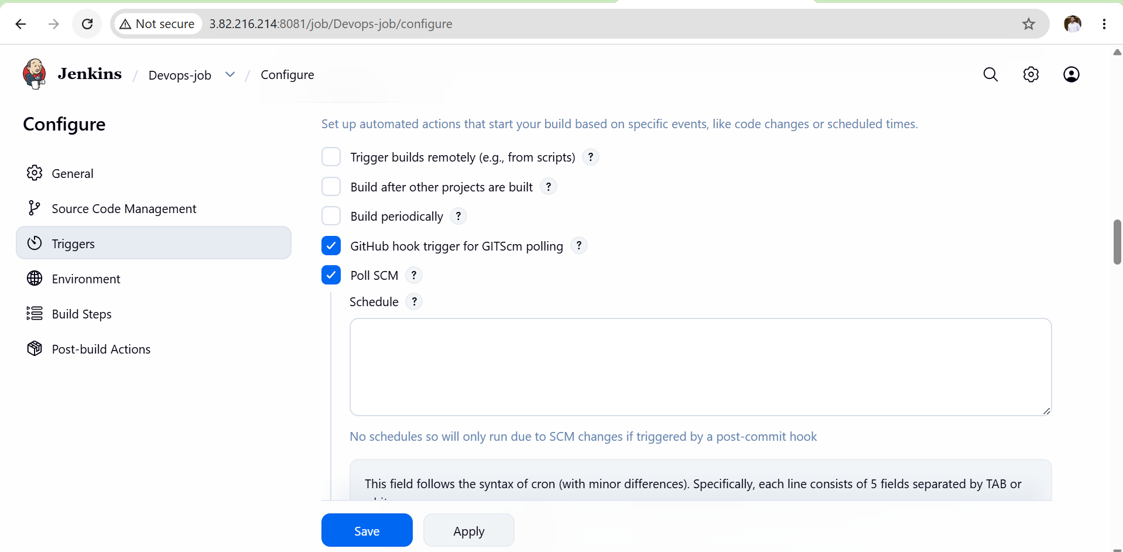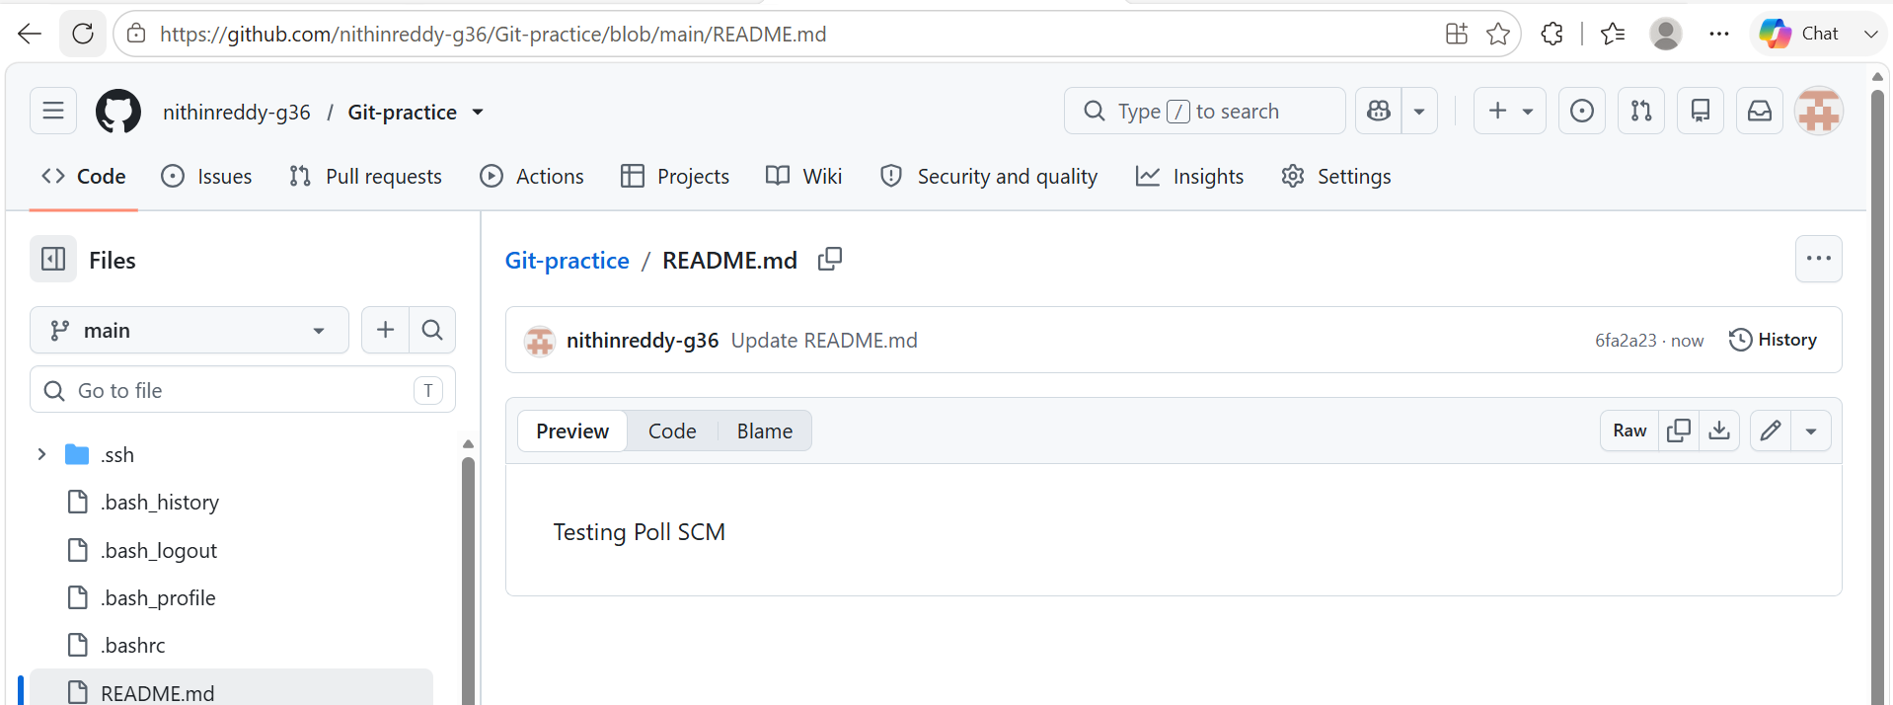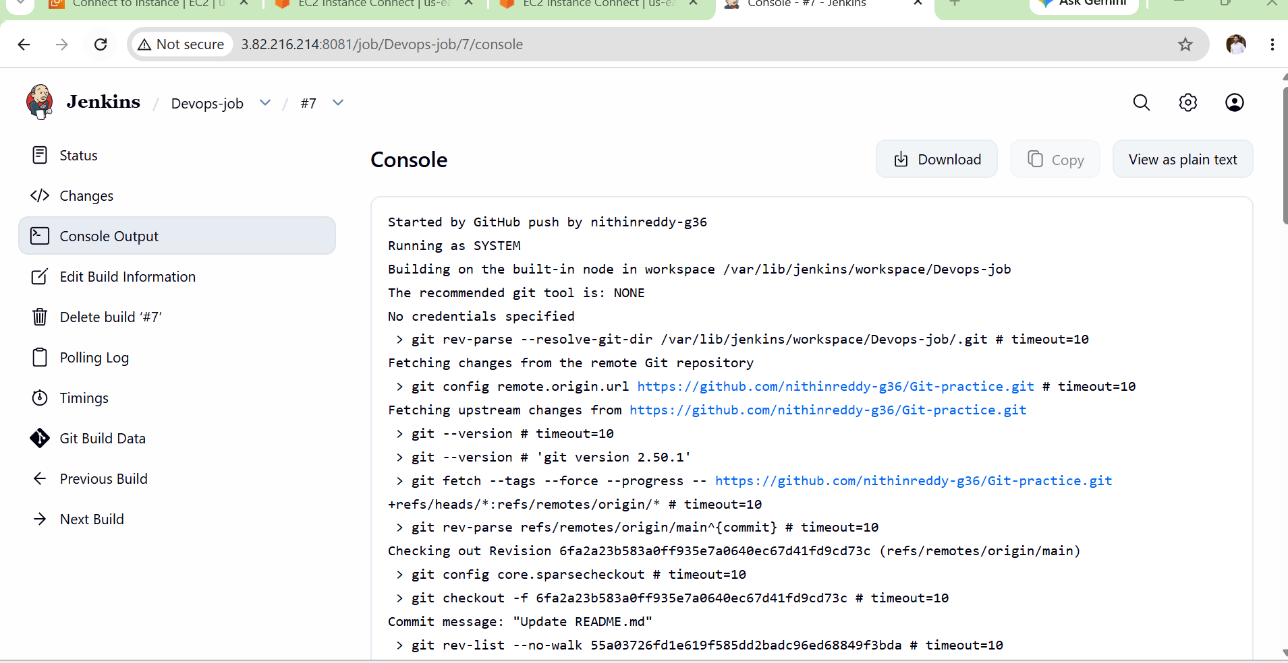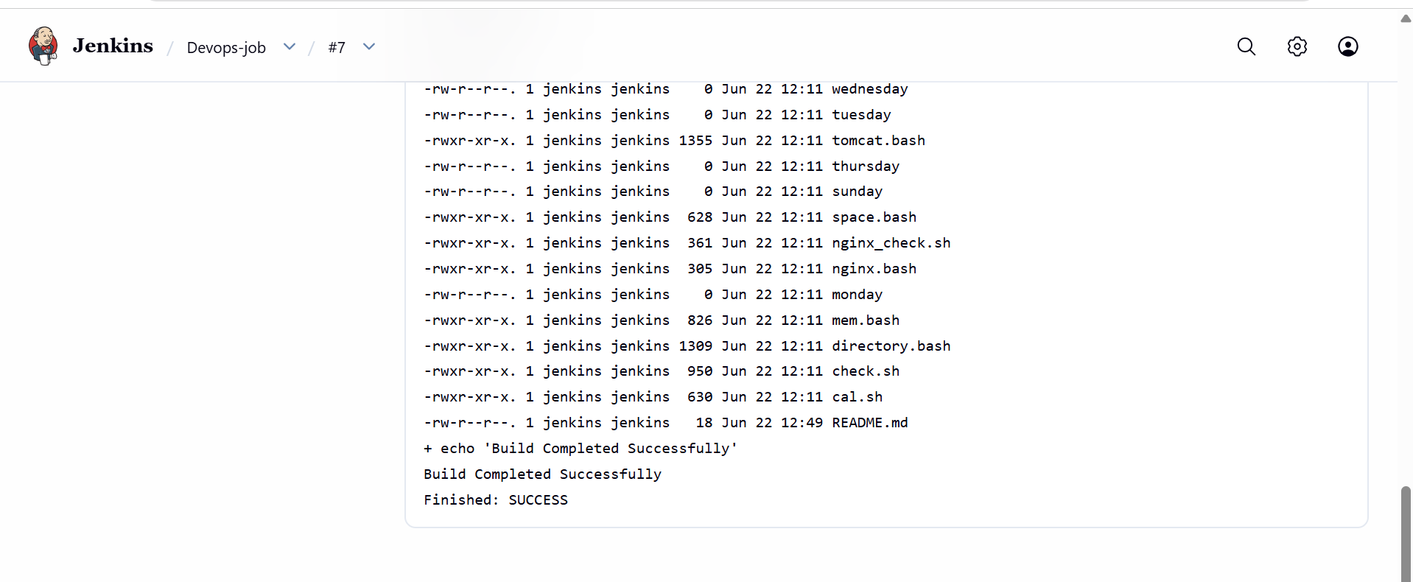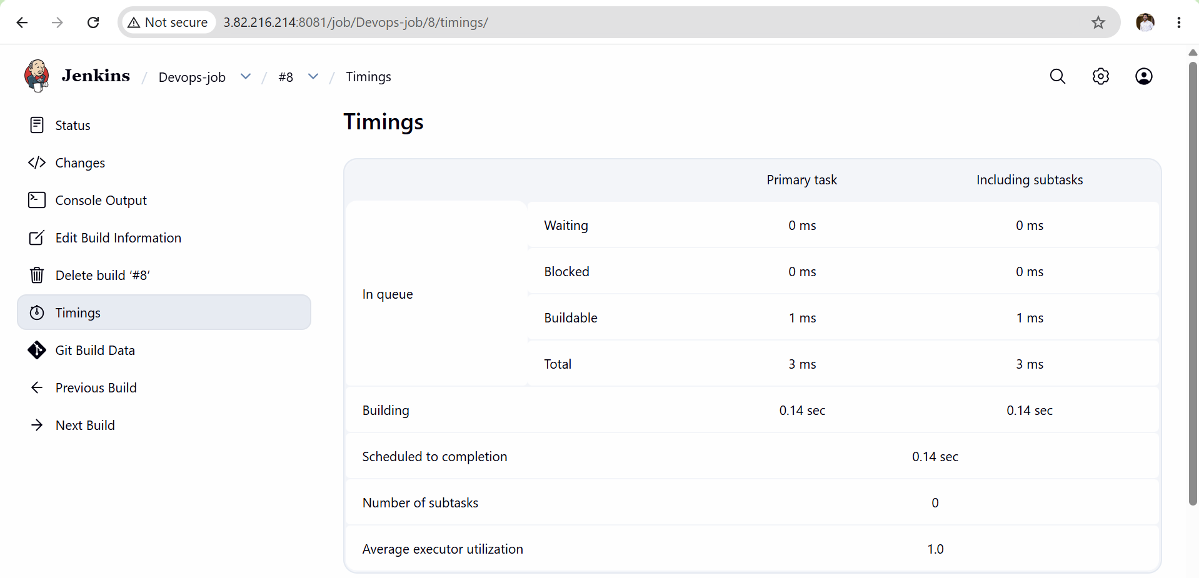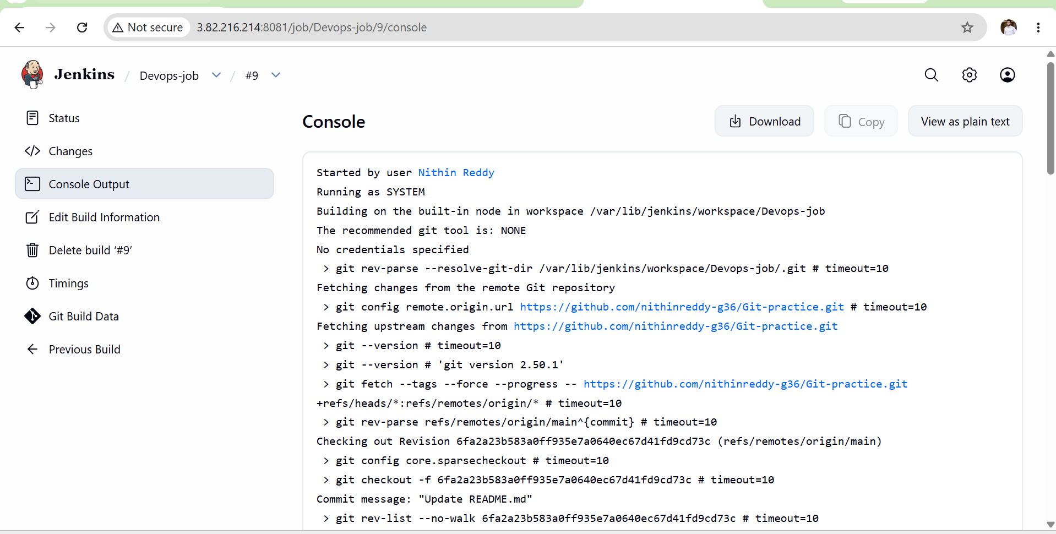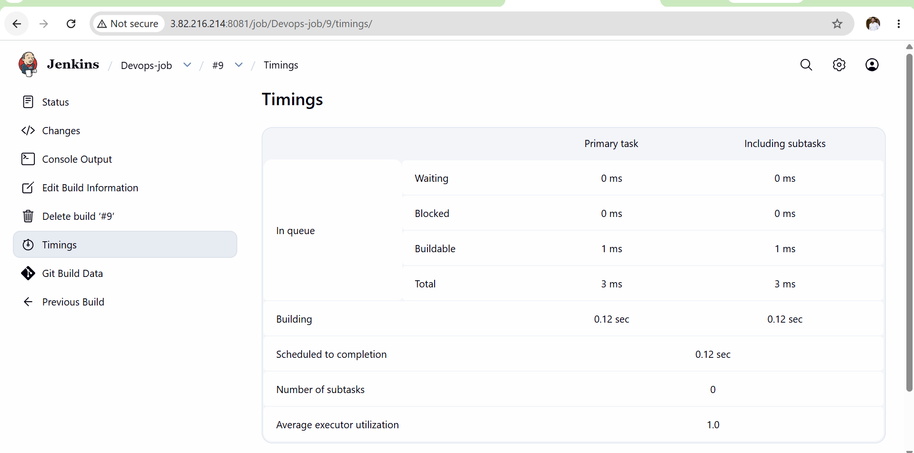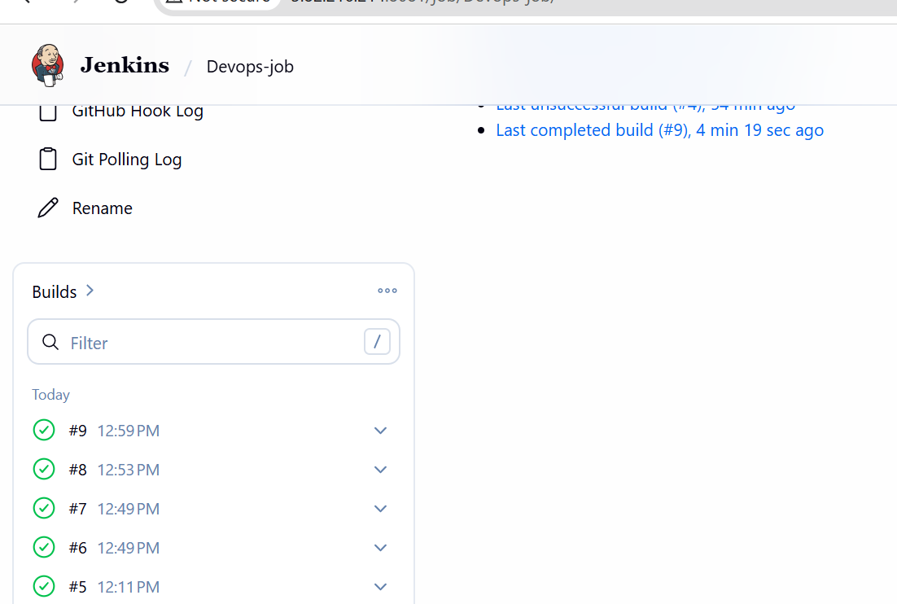

Task 4: Take a Backup of the Jenkins Server Using a Bash Script
Objective
Create a Bash script that automatically takes a backup of Jenkins configuration, jobs, plugins, users, credentials, and other important Jenkins data.

Expected Outcome
✅ Bash script created successfully
✅ Jenkins backup generated successfully
✅ Backup stored in a dedicated directory
✅ Backup file compressed as .tar.gz
✅ Backup available for restore in Task 6

Prerequisites
- Jenkins Master EC2 is running.
- Jenkins service is installed.
- Administrator access to the Jenkins server.
- Sufficient disk space available.
- SSH access to Jenkins server.
- Jenkins home directory available.
Implementation Steps
- Login to the Jenkins Master server using SSH.
- Verify Jenkins service is running using:
sudo systemctl status jenkins
- Verify Jenkins home directory exists:
sudo ls /var/lib/jenkins
- Create a backup directory:
sudo mkdir -p /opt/jenkins-backup
- Create a backup script file:
sudo vi /opt/jenkins-backup/jenkins_backup.sh
- Add the Bash script content to backup /var/lib/jenkins.
- Save and exit the script file.
- Assign execute permission to the script:
sudo chmod +x /opt/jenkins-backup/jenkins_backup.sh
- Verify execute permission is assigned successfully.
- Run the backup script:
sudo /opt/jenkins-backup/jenkins_backup.sh
- Wait for the backup process to complete.
- Verify a .tar.gz backup file is created in /opt/jenkins-backup.
- Check backup file details:
ls -lh /opt/jenkins-backup
- Verify the backup file size is greater than 0 KB.
- Verify backup contents:
tar -tvf /opt/jenkins-backup/jenkins-backup-*.tar.gz | head
- Confirm Jenkins jobs, plugins, users, and configuration files are included.
- Verify Jenkins service is still running after backup:
sudo systemctl status jenkins
- Save the backup file location for future restoration.
- Keep the backup file for Task 6 restoration.
- Document the backup file name and backup path.

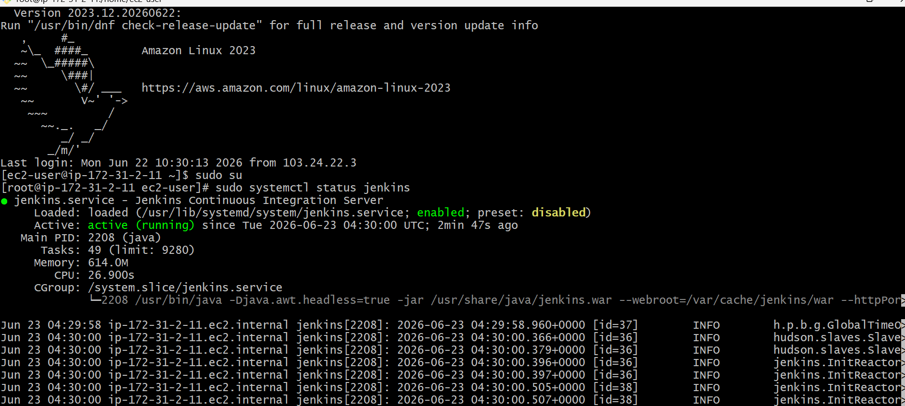
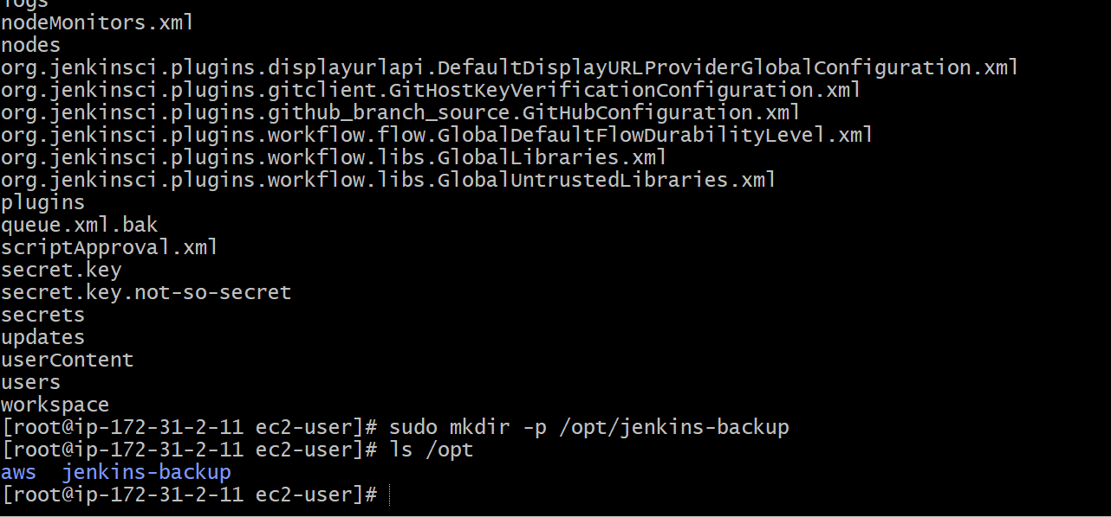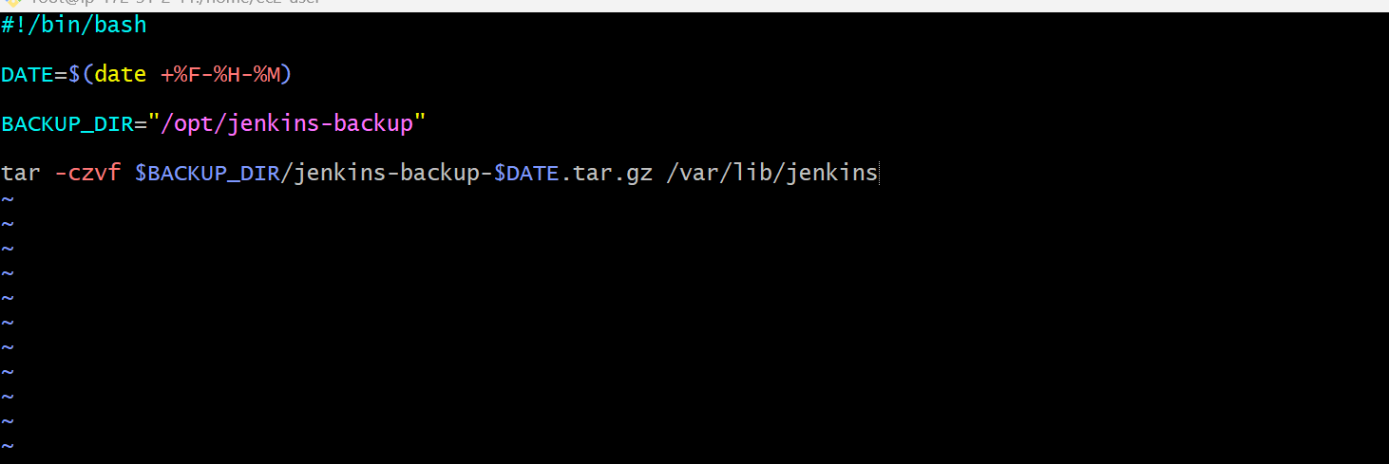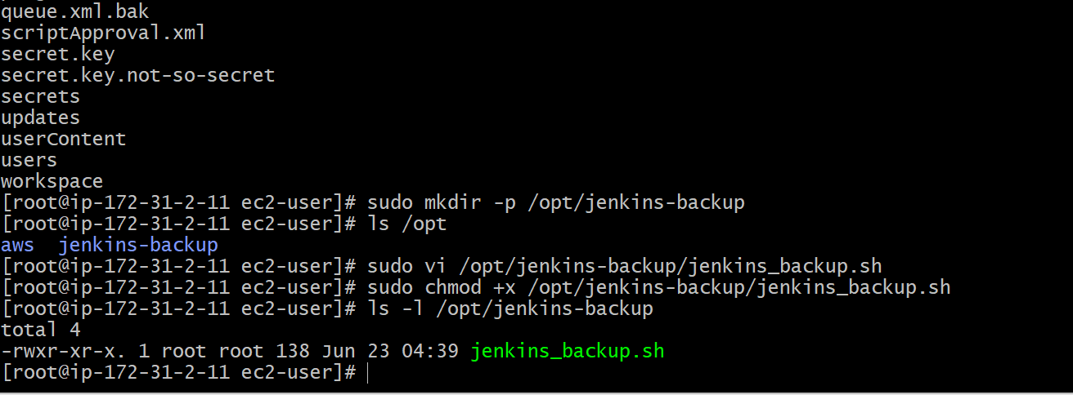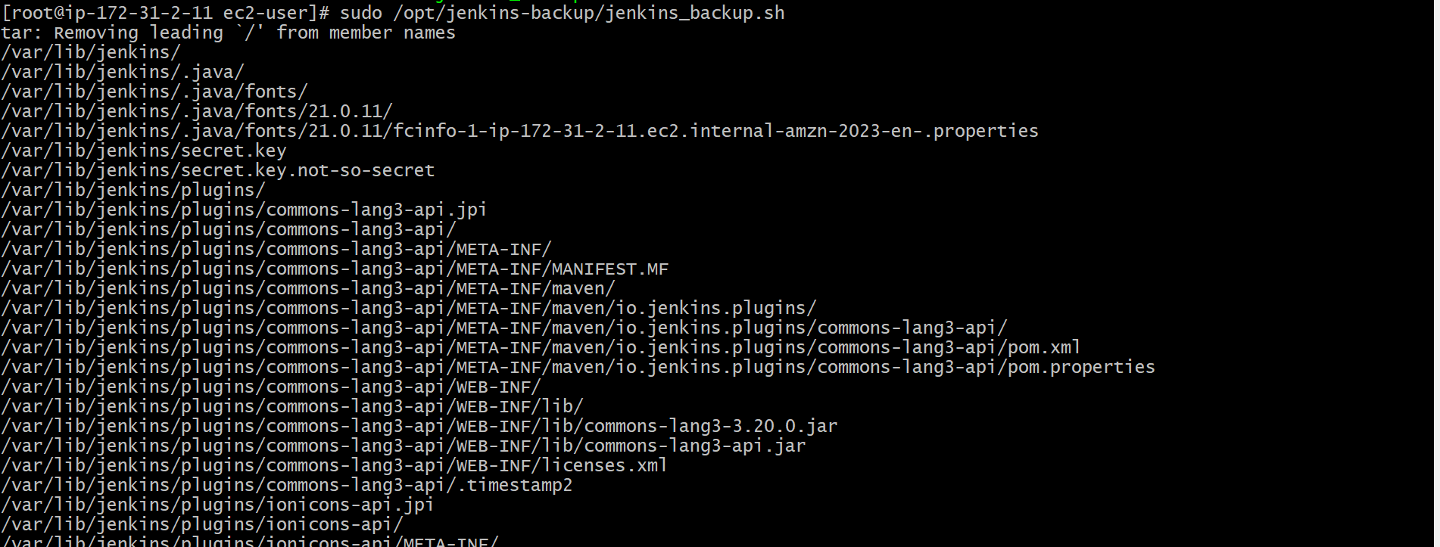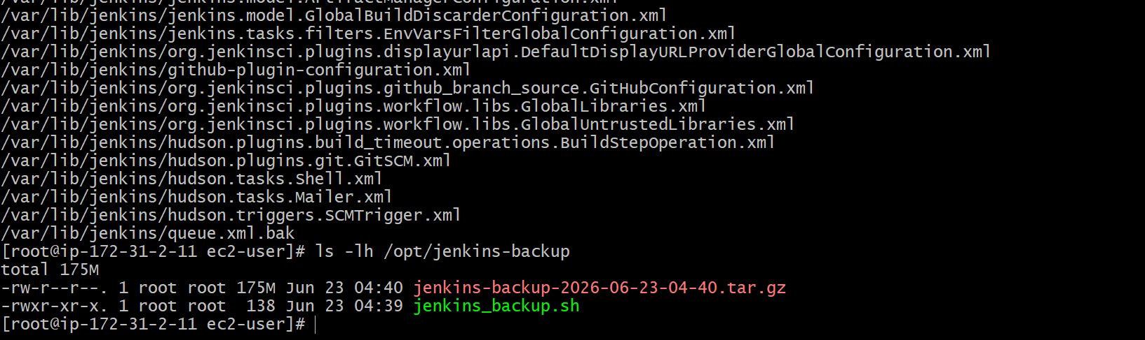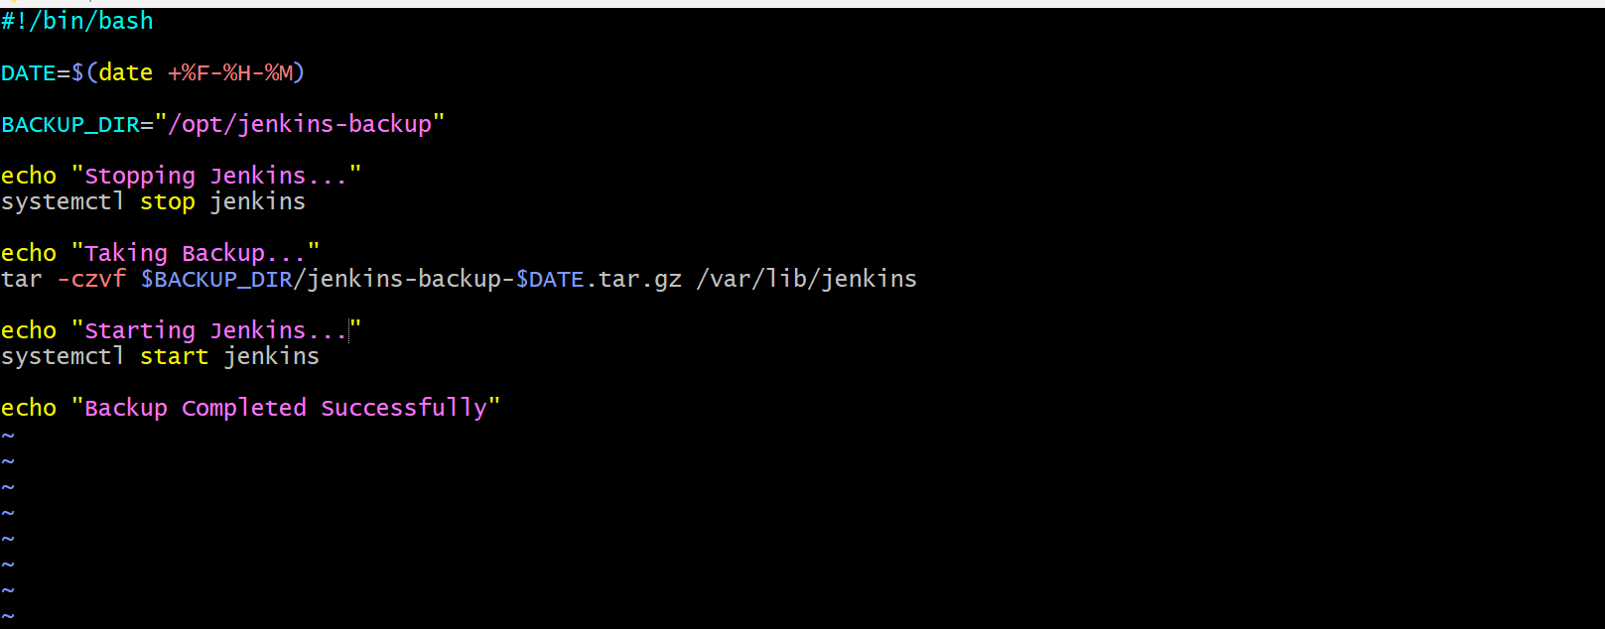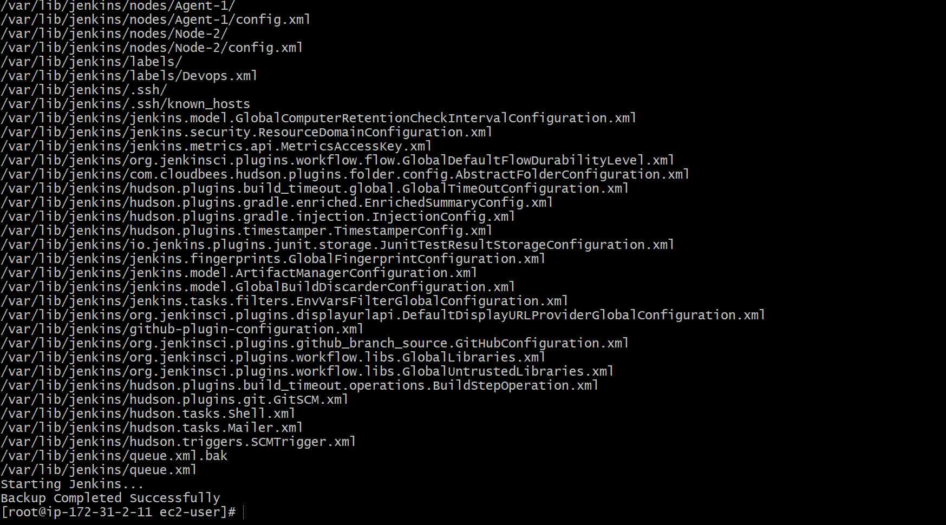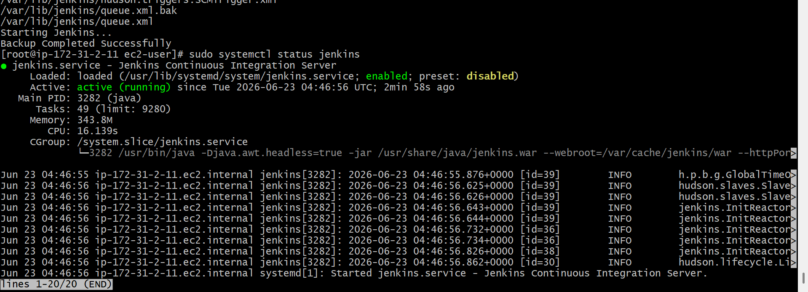
Expected Outcome
- Jenkins backup script is created successfully.
- Jenkins home directory is backed up successfully.
- Backup file is stored in /opt/jenkins-backup.
- Backup file is compressed in .tar.gz format.
- Backup is ready to be restored in Task 6. 🚀

Task 5: Take a Backup of Jenkins Using ThinBackup Plugin
Objective
Install and configure the ThinBackup plugin in Jenkins to create backups of jobs, users, plugins, credentials, and Jenkins configuration through the Jenkins UI.

Expected Outcome
✅ ThinBackup plugin installed
✅ Backup directory configured
✅ Jenkins backup created successfully
✅ Backup available for restore
✅ Ready for Task 6

Prerequisites
- Jenkins Master EC2 is running.
- Jenkins Administrator access available.
- Internet connectivity available.
- Jenkins service running successfully.
- Sufficient disk space available.
- Previous tasks completed.

Implementation Steps
- Login to Jenkins as Administrator.
- Navigate to Manage Jenkins → Plugins.
- Open the Available Plugins tab.
- Search for ThinBackup plugin.
- Select the ThinBackup Plugin.
- Click Install.
- Wait for the installation to complete.
- Restart Jenkins if required.
- Verify ThinBackup plugin is installed under Installed Plugins.
- Login to the Jenkins server using SSH.
- Create a backup directory:
sudo mkdir -p /opt/thinbackup
- Assign permissions to the backup directory:
sudo chmod 777 /opt/thinbackup
- Navigate to Manage Jenkins → ThinBackup → Settings.
- Configure the backup directory:
/opt/thinbackup
- Enable Backup Build Results.
- Enable Backup User Contents.
- Enable Backup Next Build Number File.
- Enable Backup Plugin Archives.
- Enable Backup Additional Files.
- Click Save.
- Navigate to Manage Jenkins → ThinBackup.
- Click Backup Now.
- Wait for the backup process to complete.
- Login to the Jenkins server using SSH.
- Verify backup files are created:
ls -lh /opt/thinbackup
- Verify jobs directory exists in backup.
- Verify plugins directory exists in backup.
- Verify users directory exists in backup.
- Verify secrets directory exists in backup.
- Verify backup completed successfully.
- Document the backup path for future restoration.
- Save the backup directory information for Task 6.

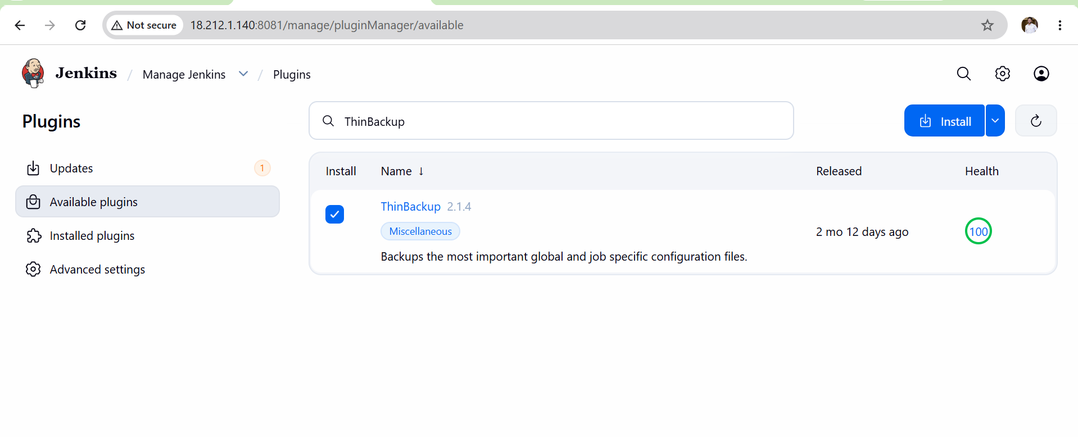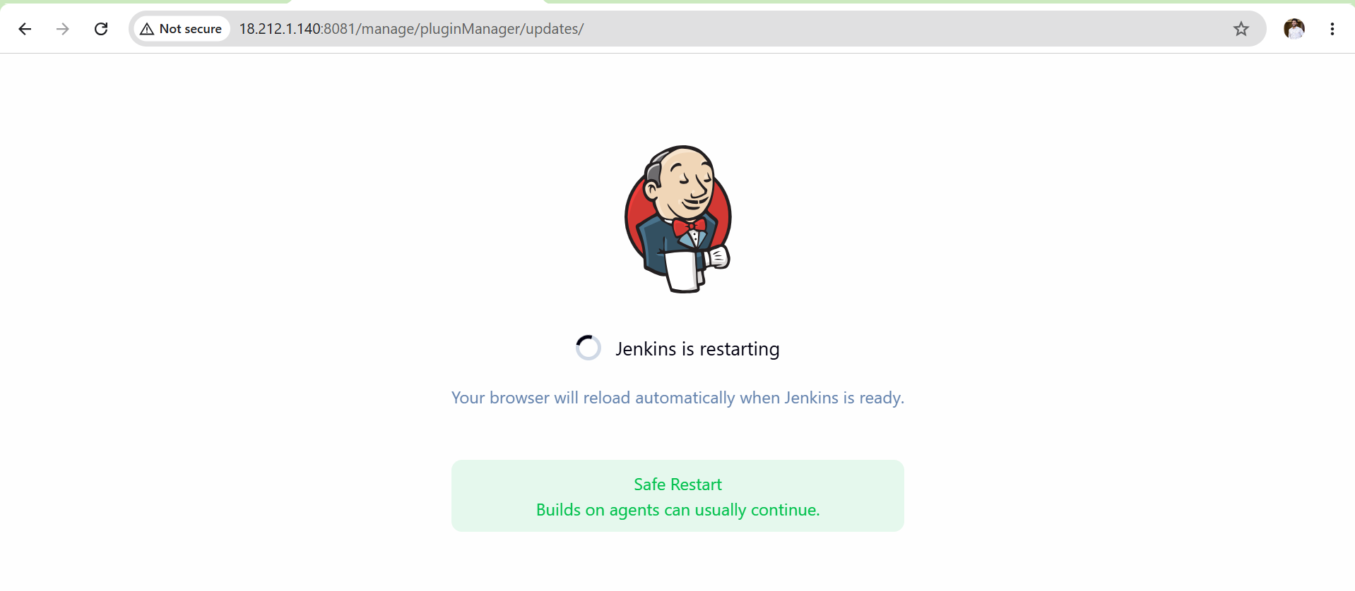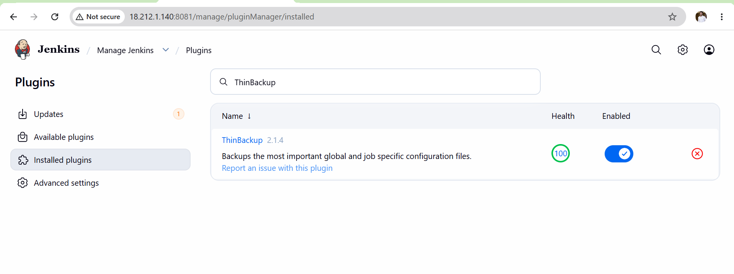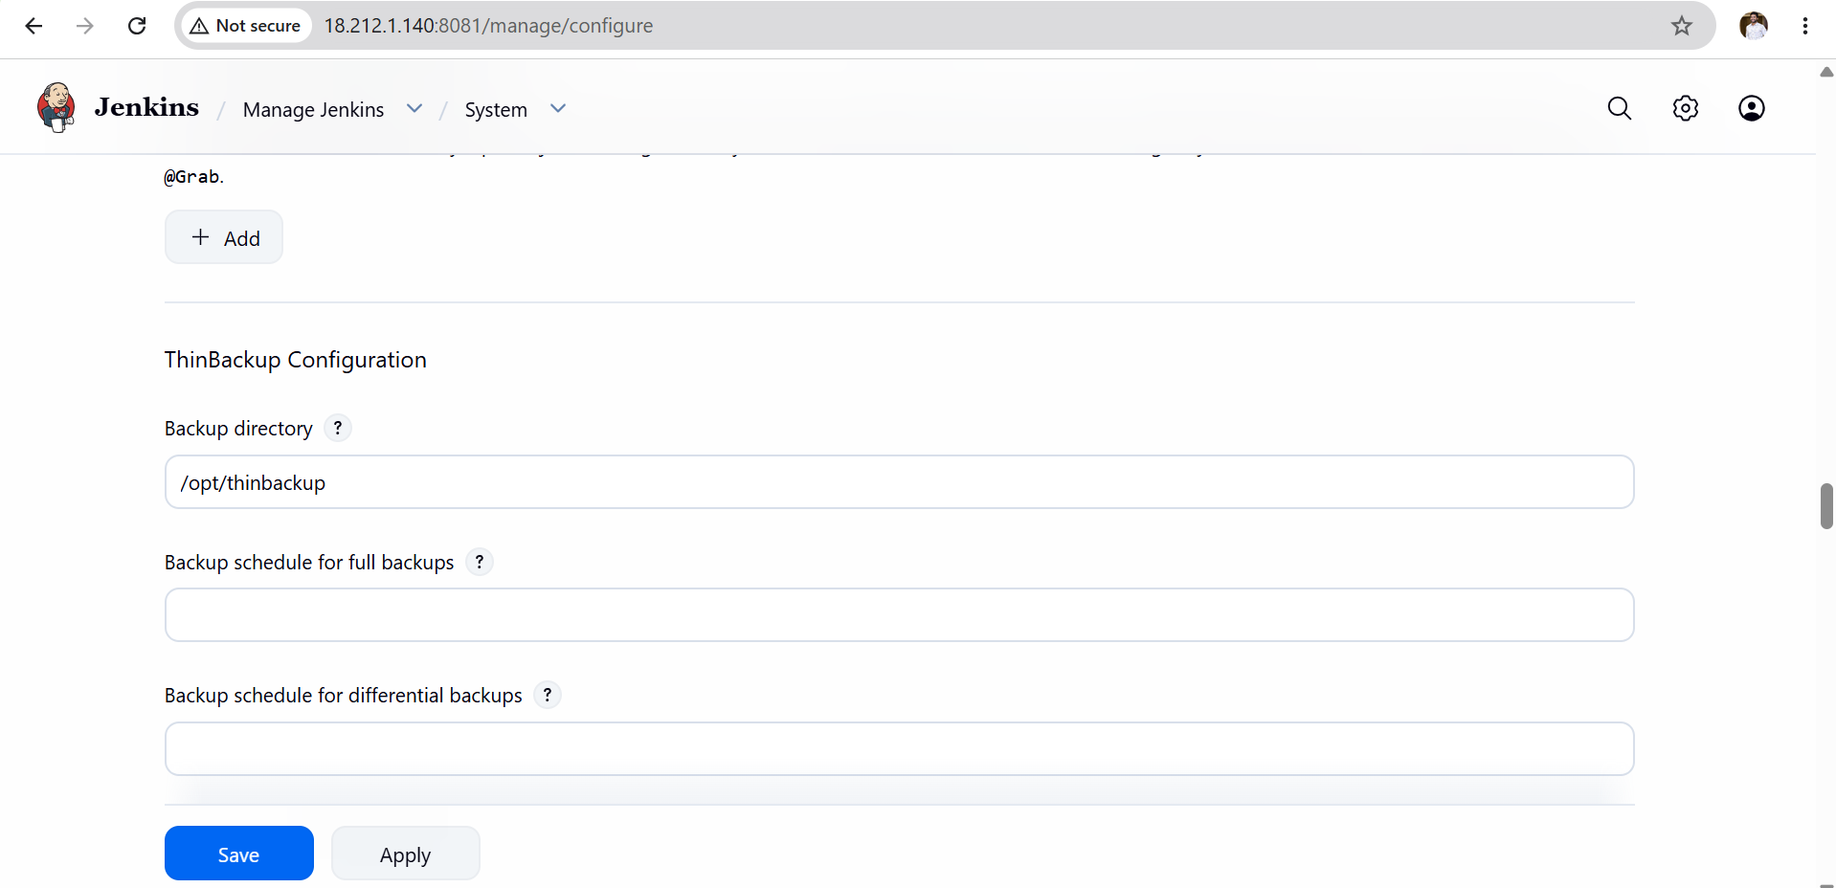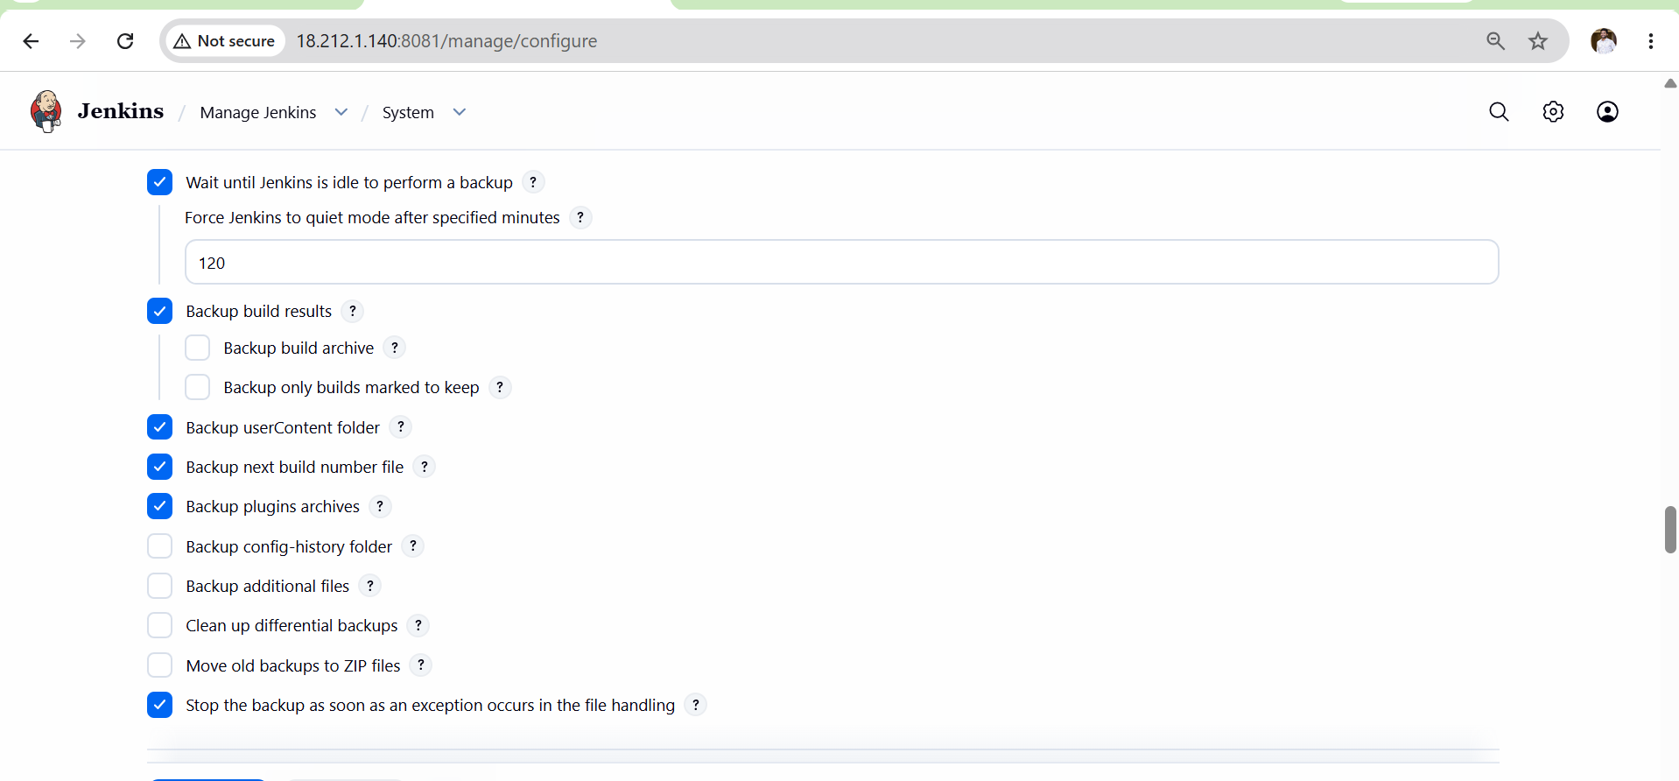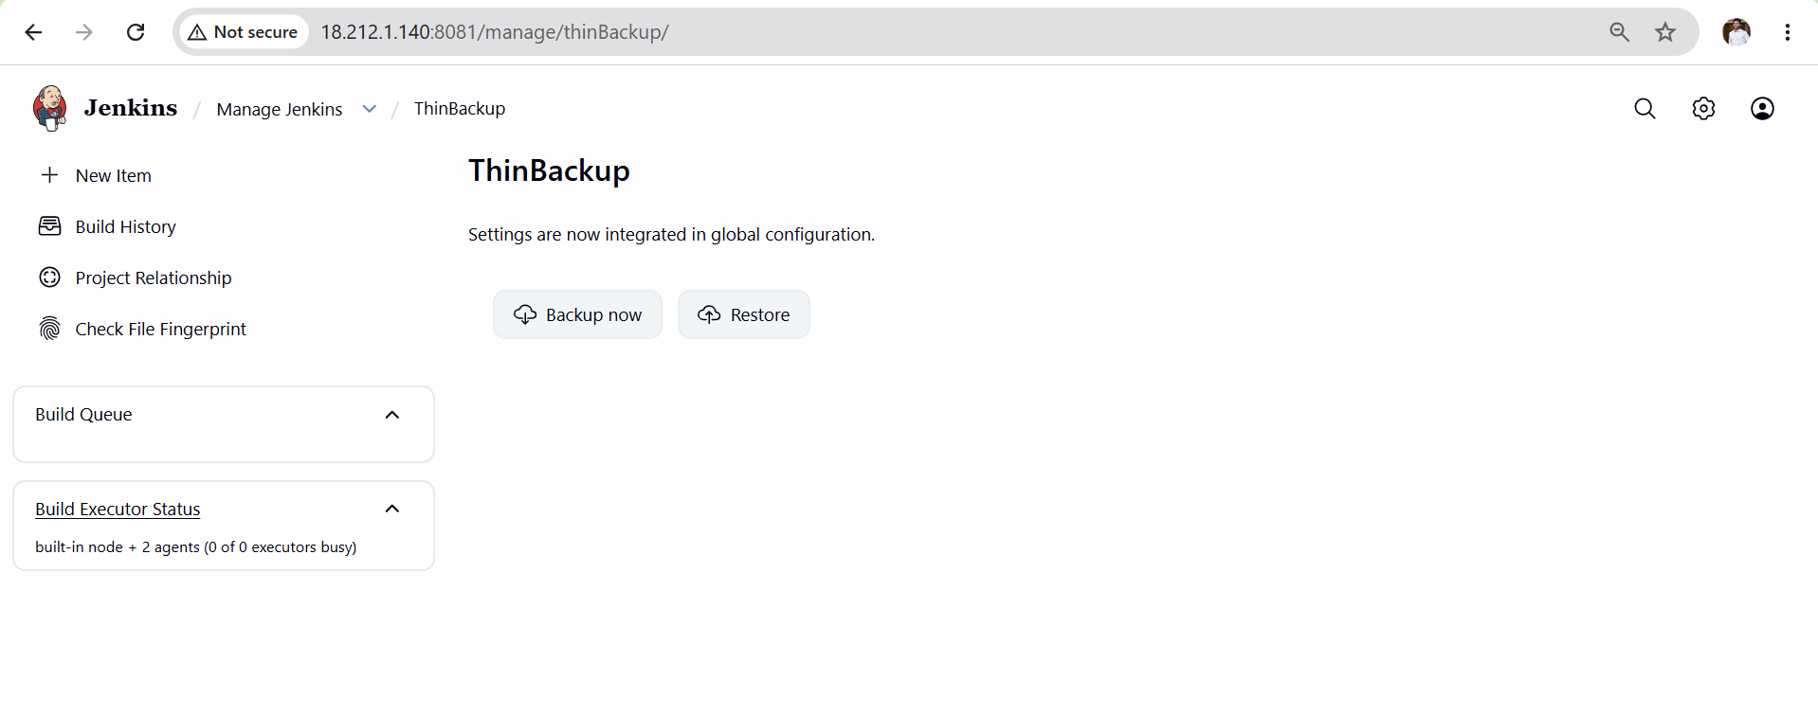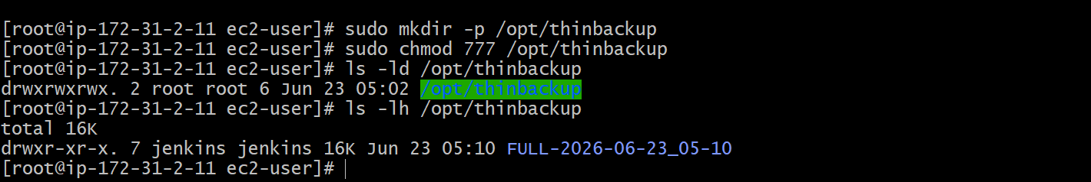
Validation Points
- Verify ThinBackup plugin is installed successfully.
- Verify ThinBackup menu appears under Manage Jenkins.
- Verify backup directory is created.
- Verify backup directory permissions are configured.
- Verify ThinBackup settings are saved successfully.
- Verify Backup Now executes without errors.
- Verify backup files are generated.
- Verify jobs are included in backup.
- Verify plugins are included in backup.
- Verify users are included in backup.
- Verify credentials and secrets are included in backup.
- Verify backup directory contains Jenkins data.
- Verify backup is available for restoration.
- Verify backup process completes successfully.

Expected Outcome
- ThinBackup plugin installed successfully.
- Jenkins backup created successfully.
- Backup stored in /opt/thinbackup.
- Jenkins jobs, plugins, users, credentials, and configurations are backed up.
Task 6: Set Up a New Jenkins Server and Restore the Backup Taken in Task 4
Objective
Create a brand-new Jenkins server and restore the backup created using the Bash Script from Task 4, ensuring all jobs, users, plugins, nodes, and configurations are recovered.
Architecture
Old Jenkins Server
|
| Backup File (.tar.gz)
|
V
New Jenkins Server
|
| Restore
|
V
Jobs + Plugins + Users + Credentials Restored
Prerequisites
- Backup file from Task 4 available.
- Jenkins Master EC2 still available (old server).
- AWS account access.
- New EC2 instance creation permission.
- Security Group with ports 22 and 8081 open.
- Java 21 installation access.
- Internet access.
Implementation Steps
- Launch a new EC2 instance for Jenkins restoration.
- Connect to the new EC2 instance using SSH.
- Update the server packages.
- Install Java 21 on the new server.
- Install Jenkins on the new server.
- Configure Jenkins to run on port 8081.
- Reload systemd configuration.
- Enable Jenkins service.
- Stop Jenkins service before restoration.
- Verify the backup file exists on the old Jenkins server.
- Copy the backup file from the old server to the local machine.
- Upload the backup file to the new Jenkins server.
- Verify the backup file is available in /tmp.
- Remove the default Jenkins data from /var/lib/jenkins.
- Extract the backup file to the root (/) directory.
- Verify Jenkins data is restored under /var/lib/jenkins.
- Verify jobs directory is restored.
- Verify plugins directory is restored.
- Verify users directory is restored.
- Verify nodes directory is restored.
- Verify secrets directory is restored.
- Change ownership of Jenkins files:
sudo chown -R jenkins:jenkins /var/lib/jenkins
- Verify correct ownership is assigned.
- Start Jenkins service.
- Verify Jenkins service is running successfully.
- Verify Jenkins is listening on port 8081.
- Open Jenkins in a web browser.
- Login using the restored Jenkins credentials.
- Verify all Jenkins jobs are restored.
- Verify all Jenkins users are restored.
- Verify installed plugins are restored.
- Verify Jenkins node configurations are restored.
- Run a sample job using Build Now.
- Verify the build completes successfully.
- Document the restoration results and server details.

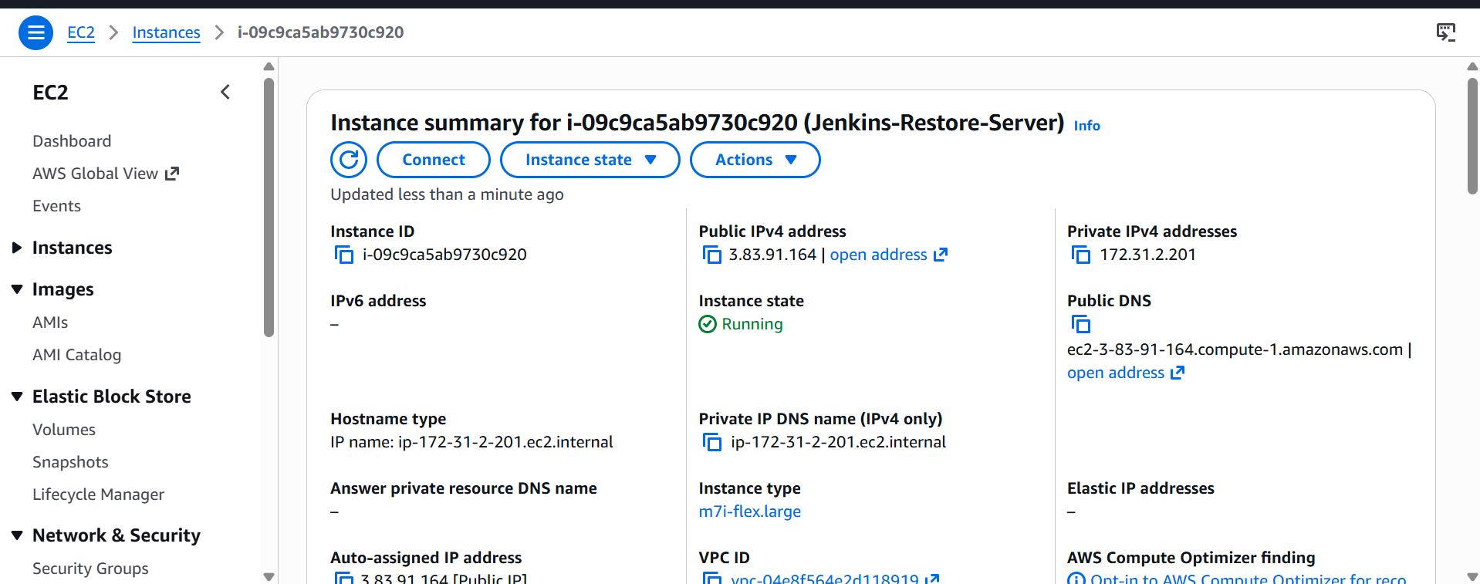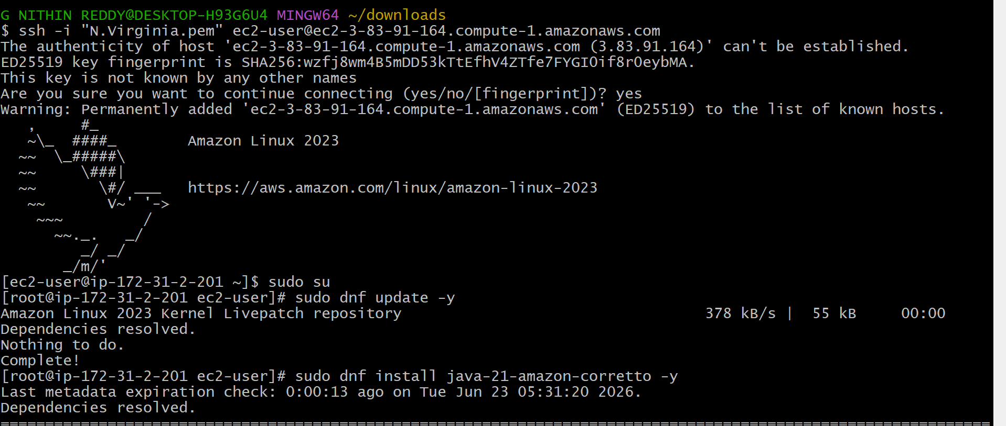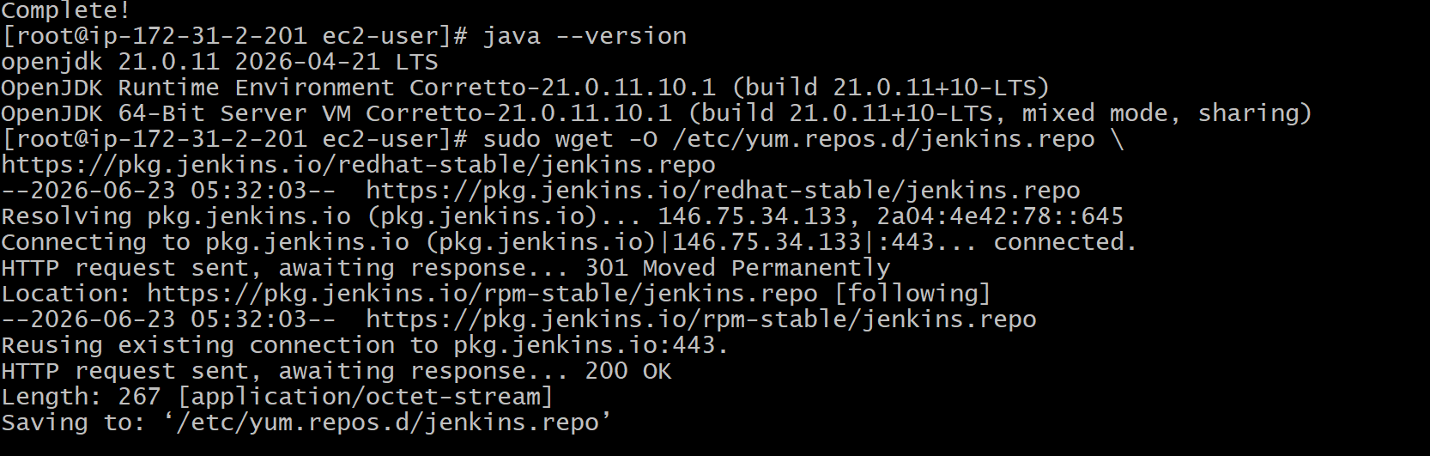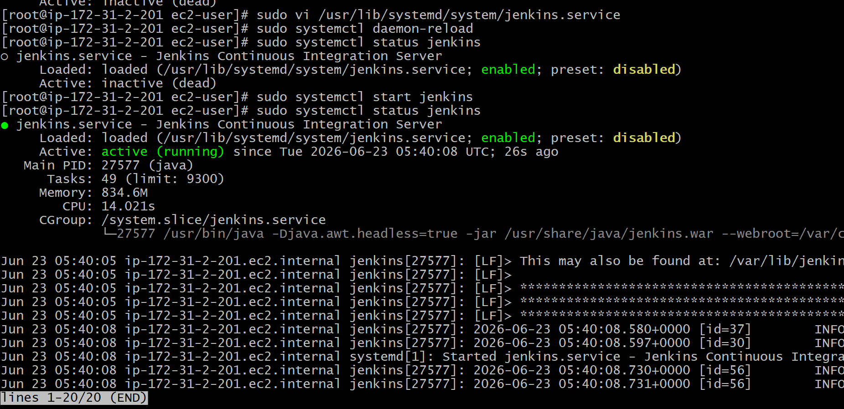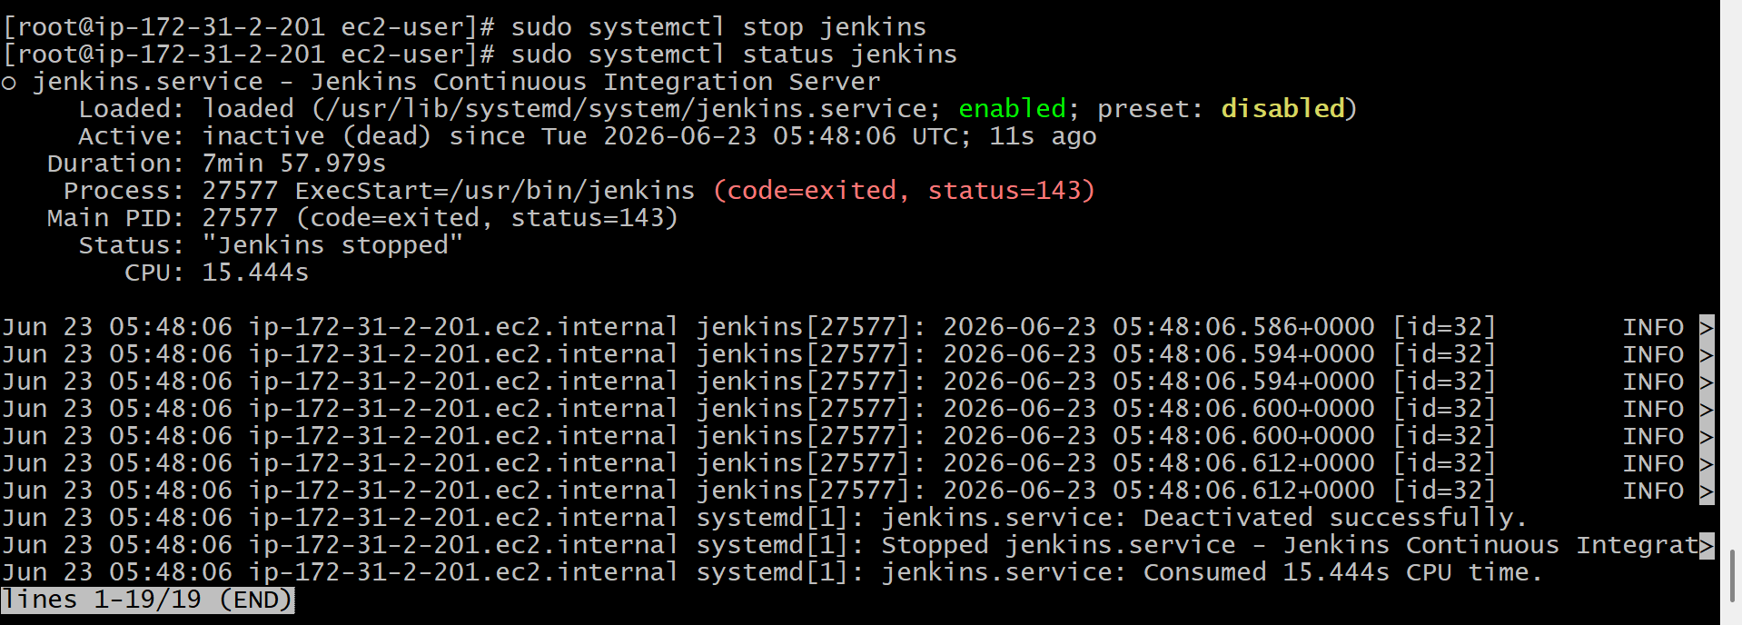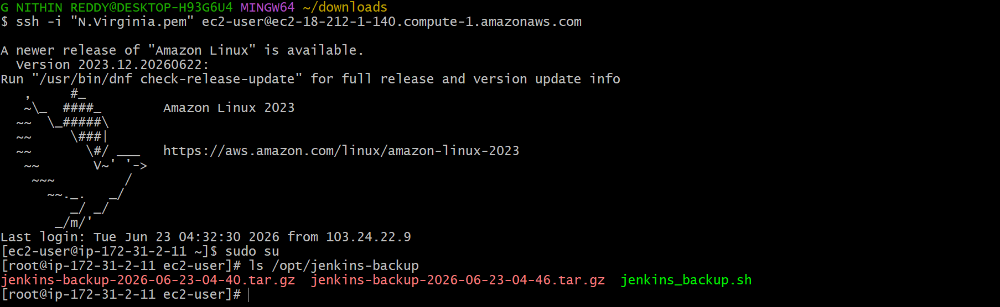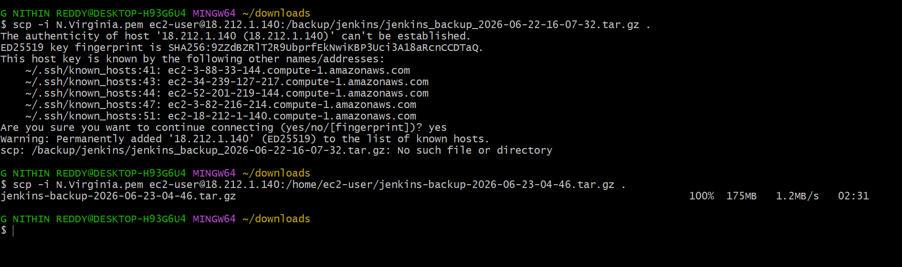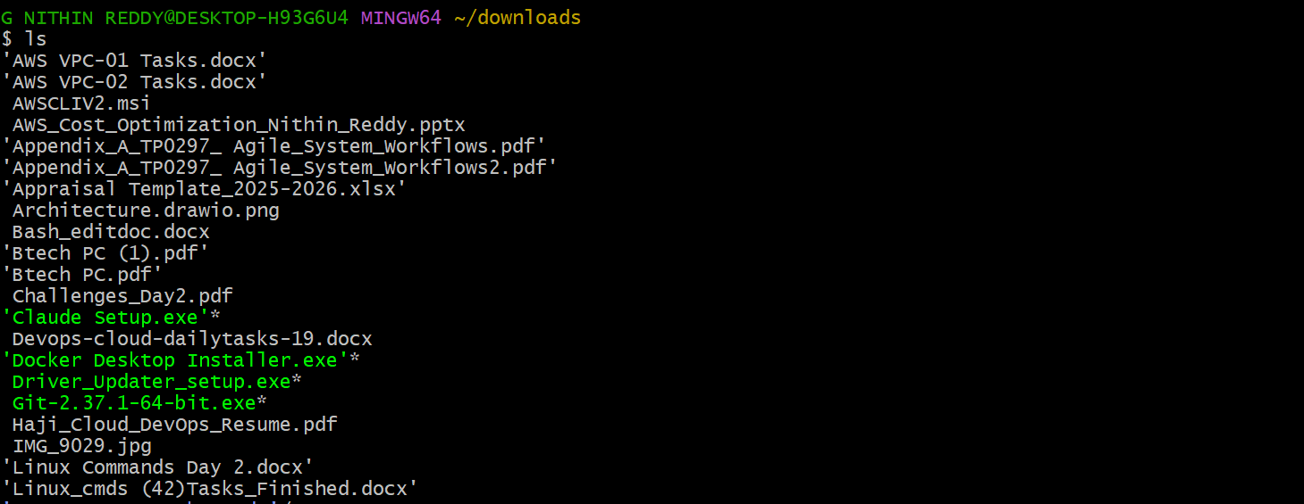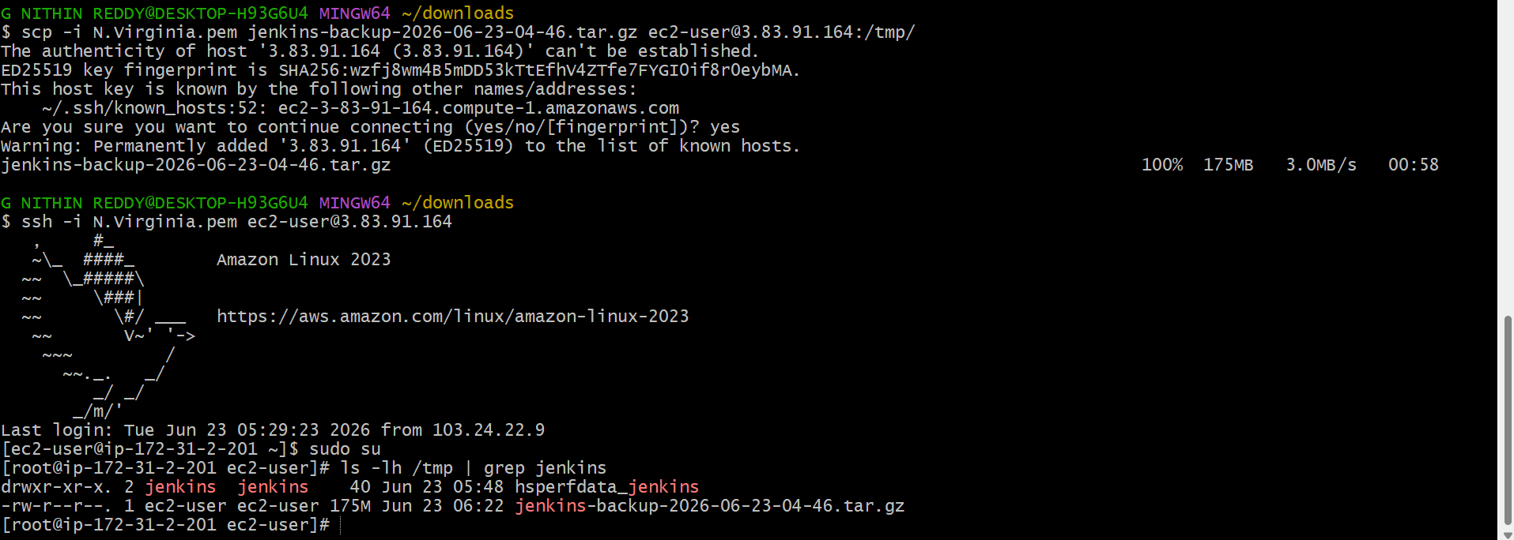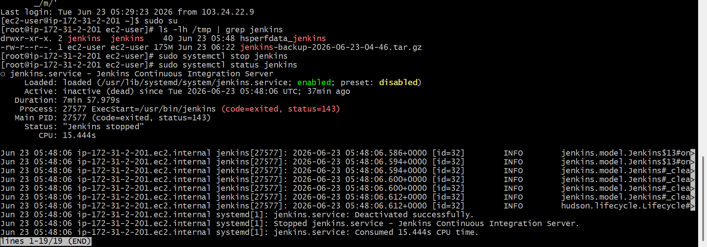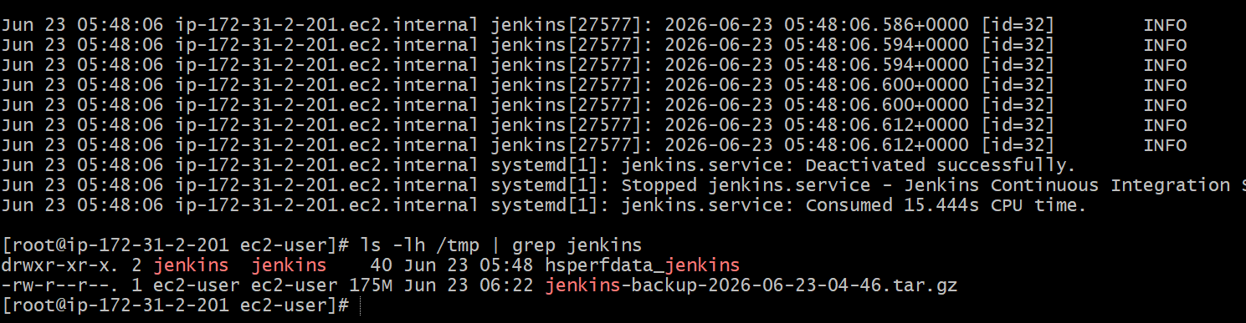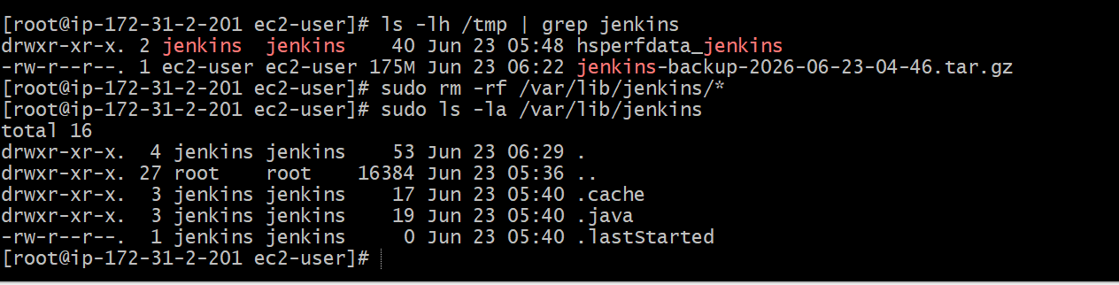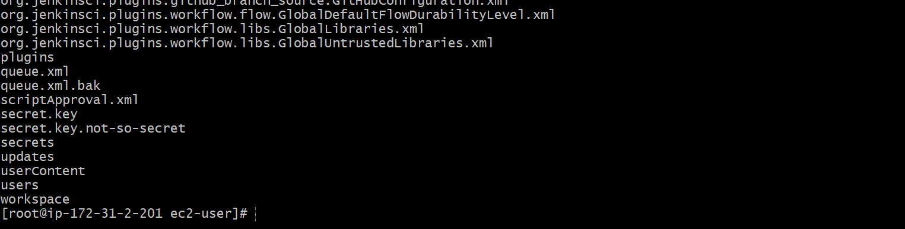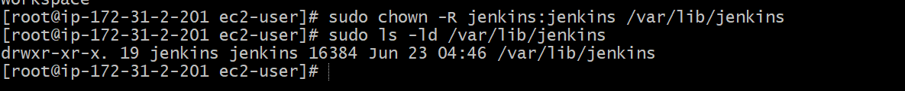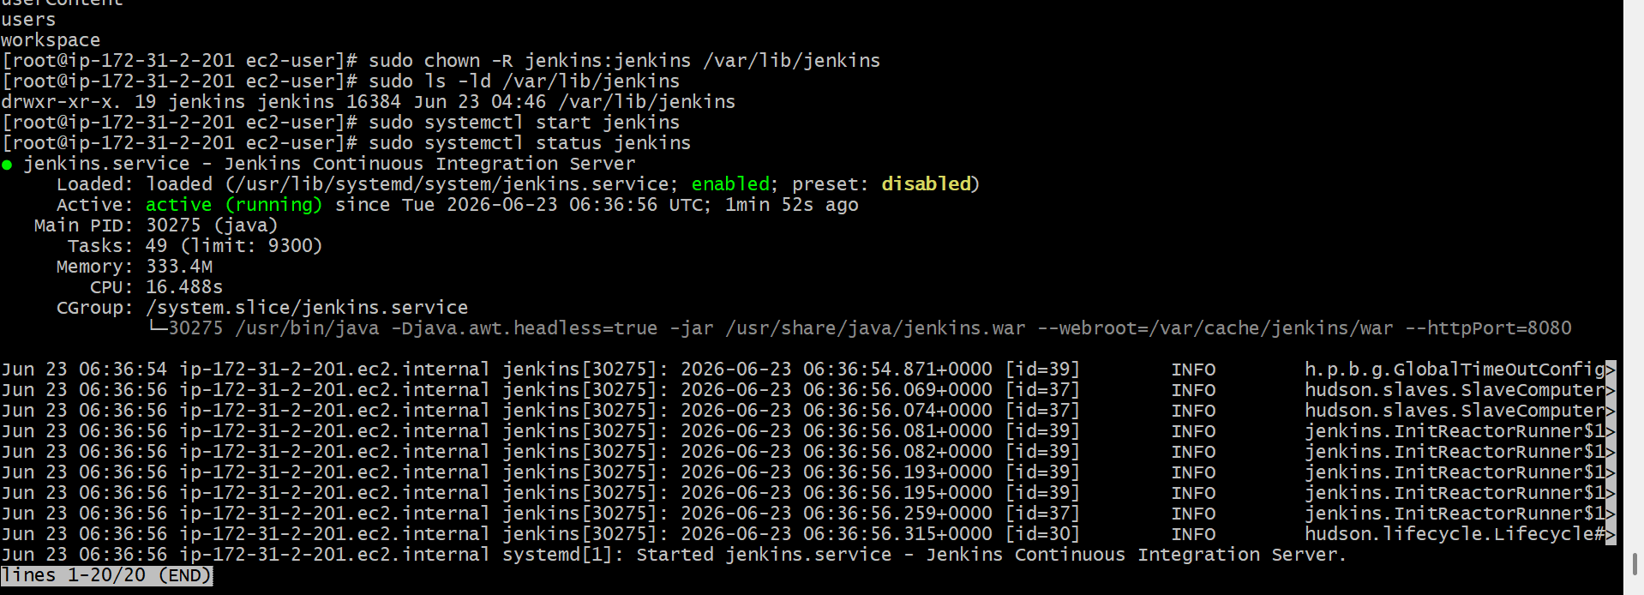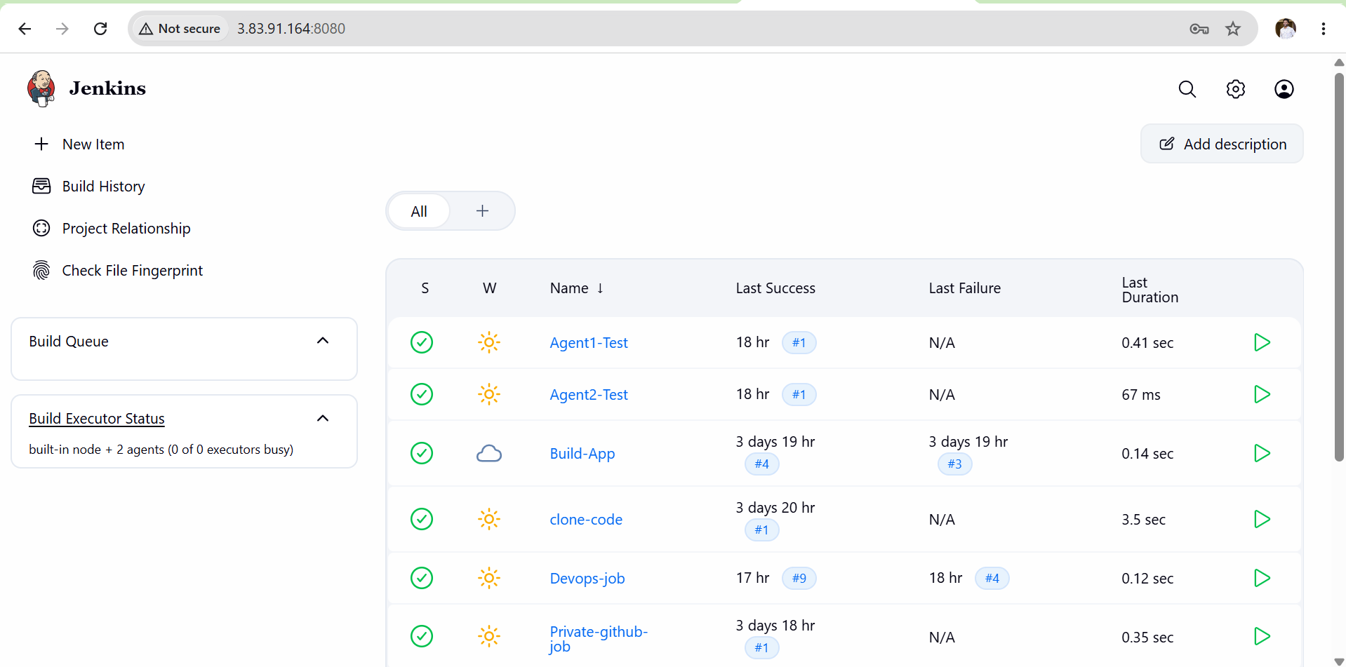
Expected Outcome
- New Jenkins server created successfully.
- Jenkins backup restored successfully.
- Jobs, plugins, users, credentials, and configurations recovered.
- Jenkins environment is fully operational on the new server.
- Backup and restore process completed successfully.

