ARGOCD
TASK-1
Setup ArgoCD
Objective
Install ArgoCD in the Kubernetes cluster and access the ArgoCD UI successfully for GitOps-based application deployment.
Prerequisites
- Kubernetes cluster is running.
- kubectl is configured.
- Internet access is available.
- At least 2 CPU and 2 GB RAM free.
- Jenkins and Docker are already installed (not required for this task but available for later tasks).
Implementation Steps
1. Verify EKS Cluster
kubectl get nodes
kubectl get ns

2. Create ArgoCD Namespace
kubectl create namespace argocd

3. Install ArgoCD
kubectl apply -n argocd -f https://raw.githubusercontent.com/argoproj/argo-cd/stable/manifests/install.yaml

4. Verify ArgoCD Pods
kubectl get pods -n argocd
Wait until all pods are in Running state.

5. Expose ArgoCD Server
kubectl patch svc argocd-server -n argocd \
-p '{"spec":{"type":"LoadBalancer"}}'

6. Verify Service
kubectl get svc -n argocd
Wait until the EXTERNAL-IP or LoadBalancer DNS is assigned.

7. Get ArgoCD Admin Password
kubectl -n argocd get secret argocd-initial-admin-secret \
-o jsonpath="{.data.password}" | base64 -d
echo

8. Access ArgoCD UI
Open:
https://<LoadBalancer-DNS>
Example:
https://a5ede130213c1491d998343d2232b3e1-229407392.us-east-1.elb.amazonaws.com
If Chrome shows Your connection is not private, click:
Advanced → Proceed to the site
This is expected because ArgoCD uses a self-signed certificate by default.

9. Login to ArgoCD
Username:
admin
Password:
(Output from Step 7)

10. Verify Installation
kubectl get all -n argocd

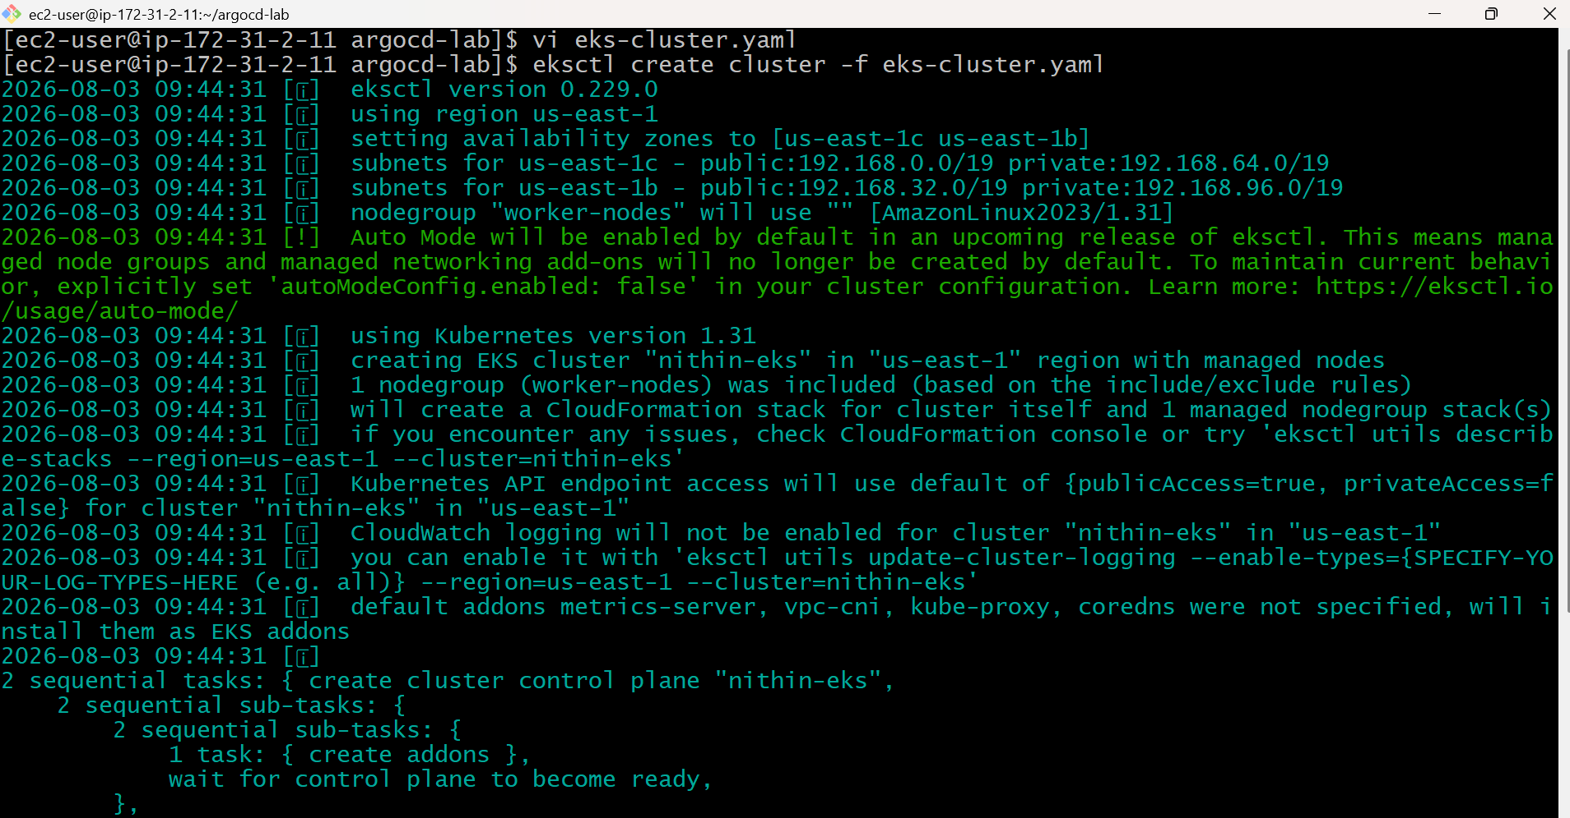
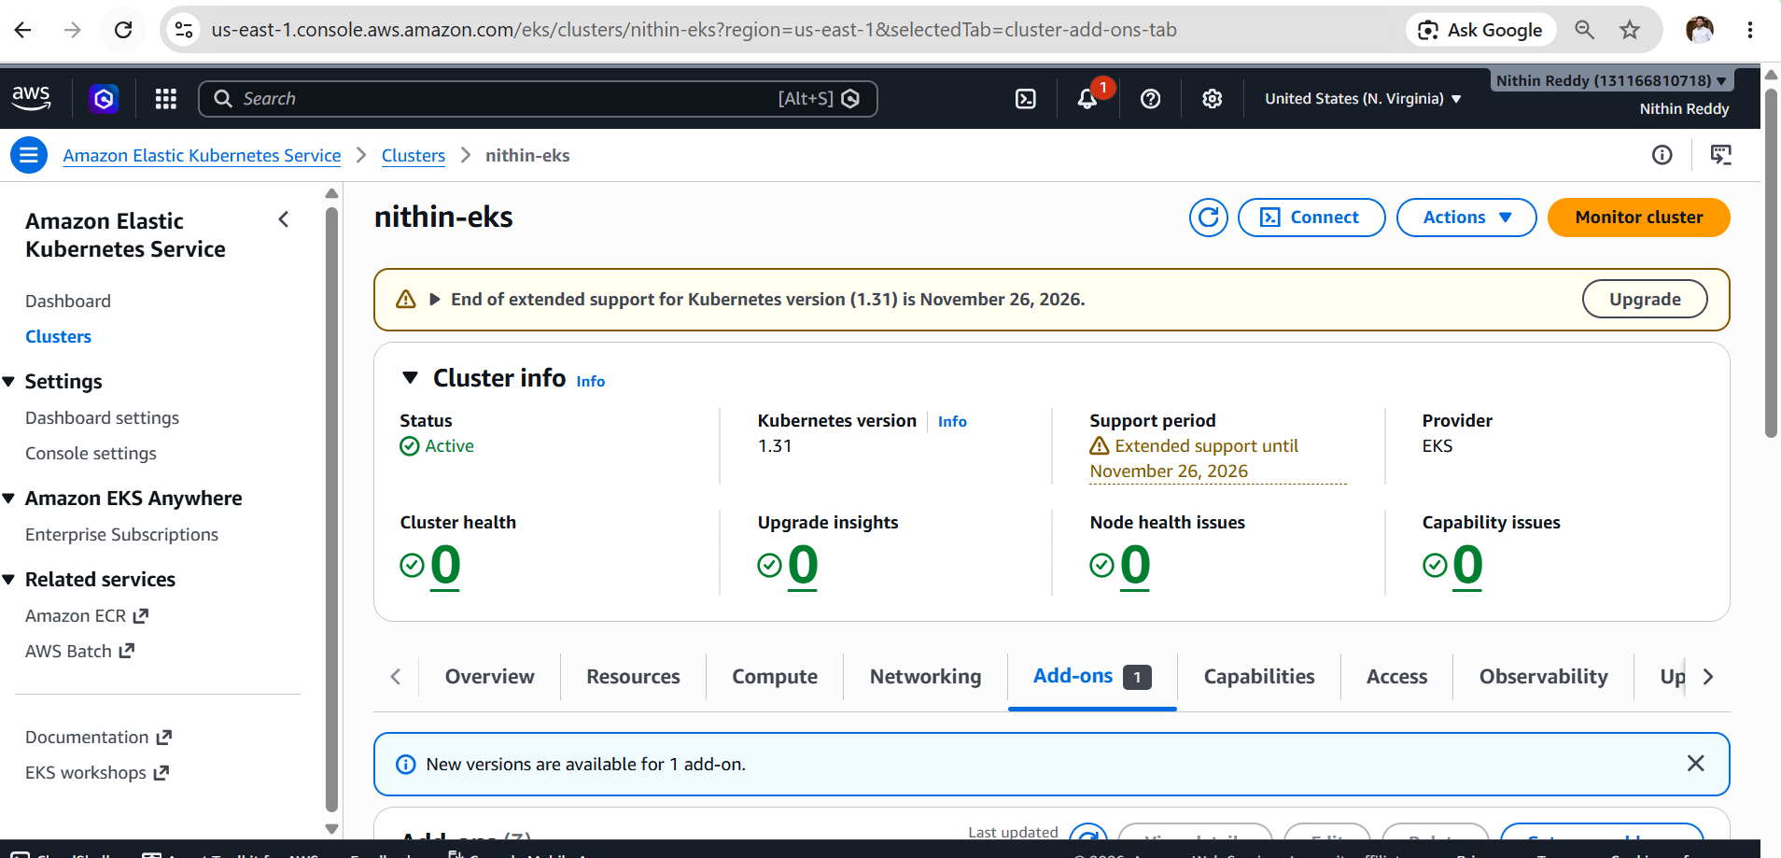
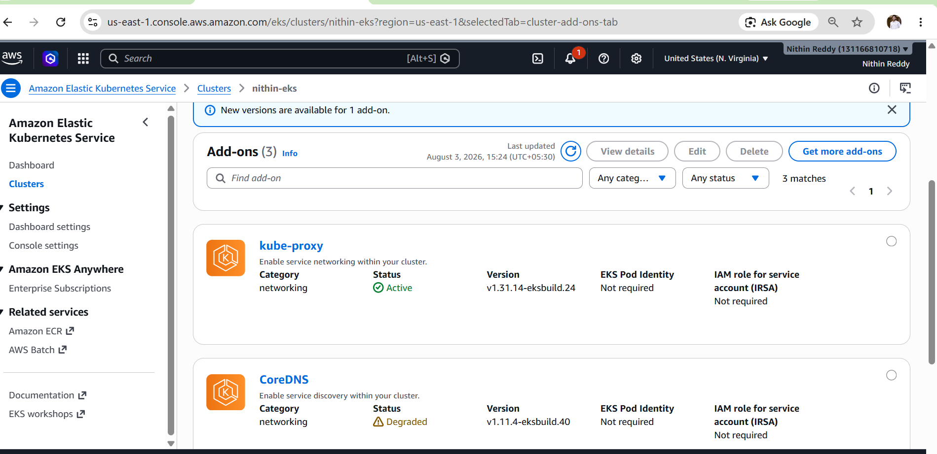
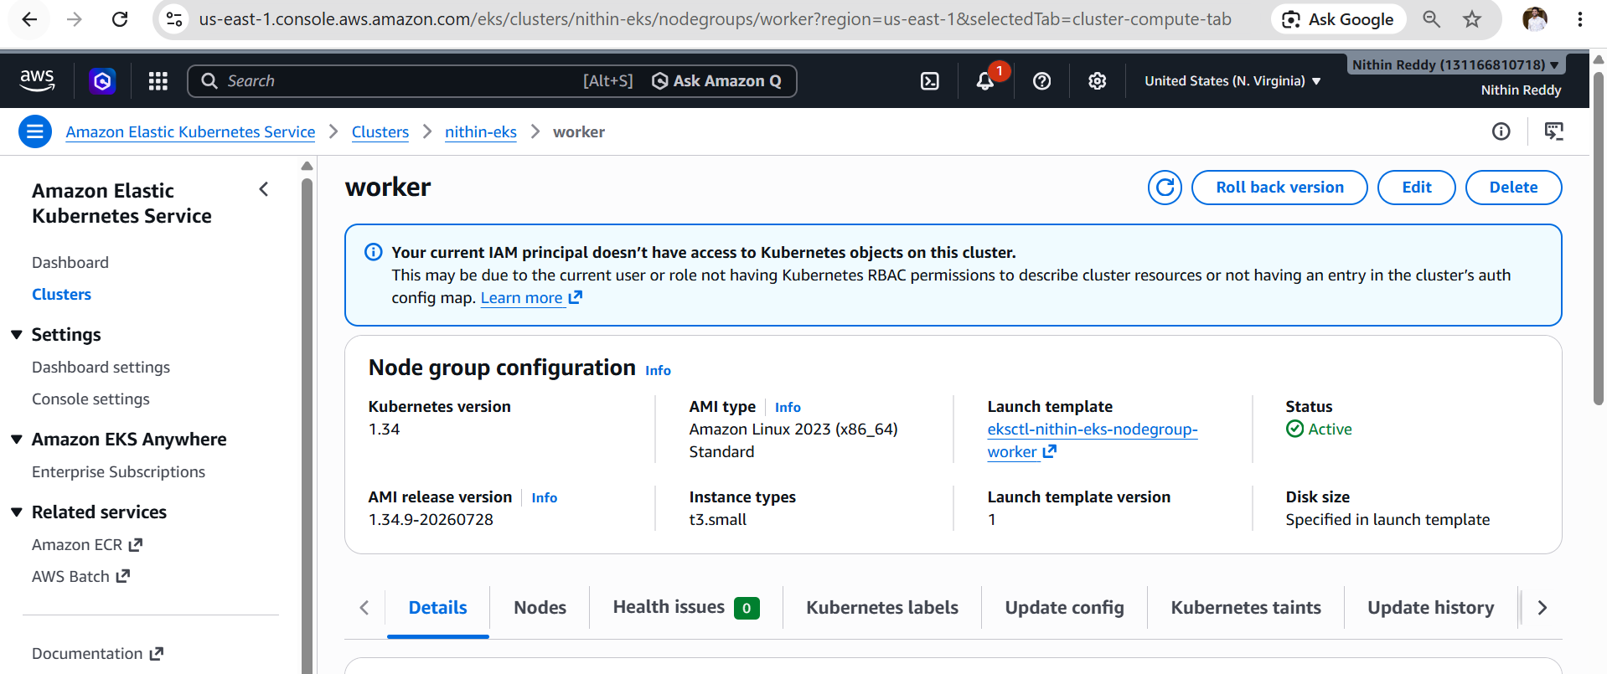
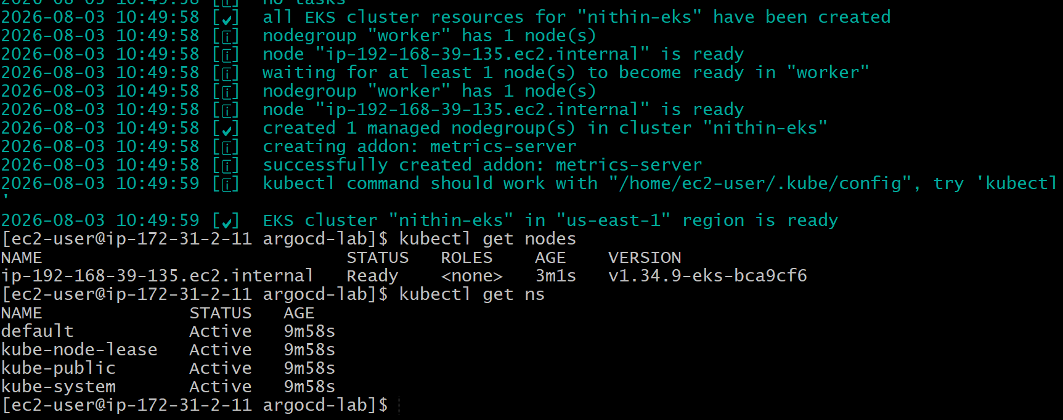
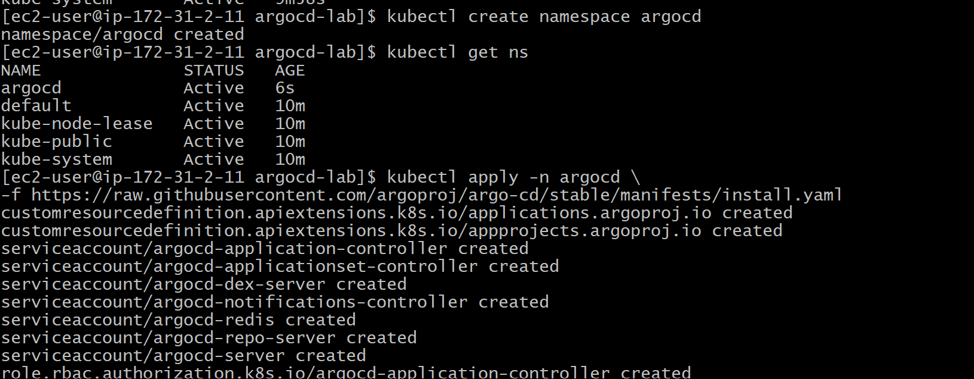
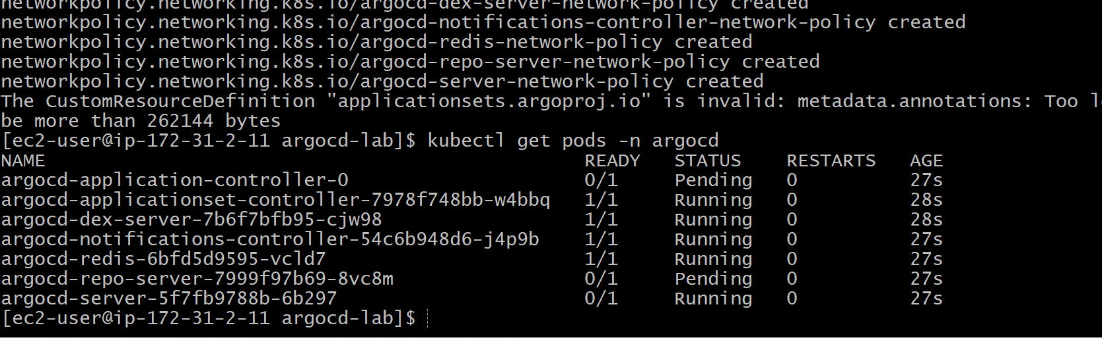
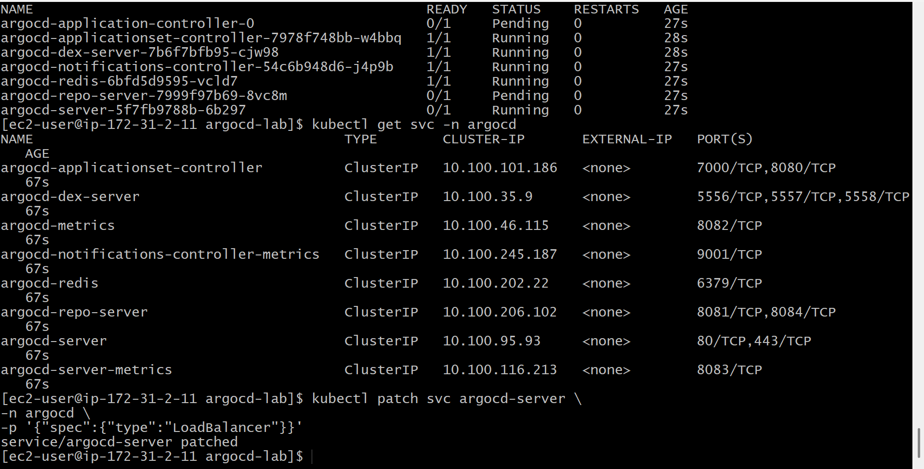
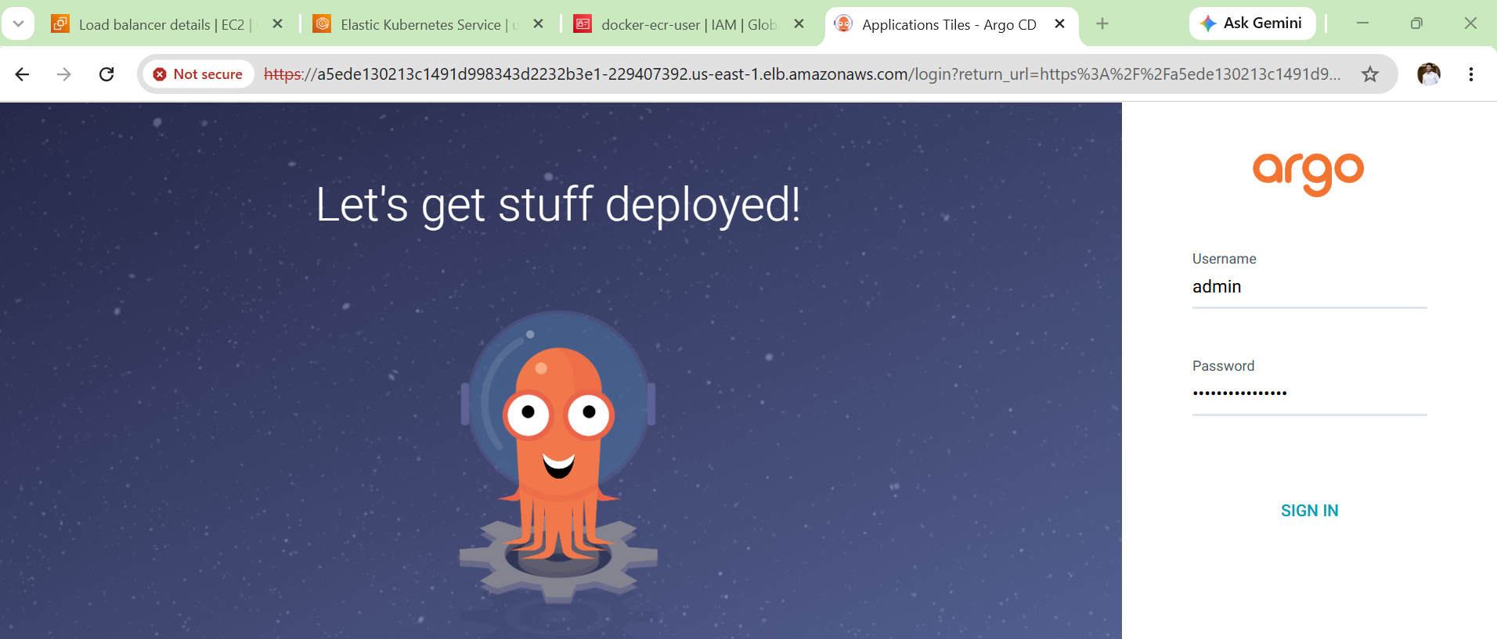
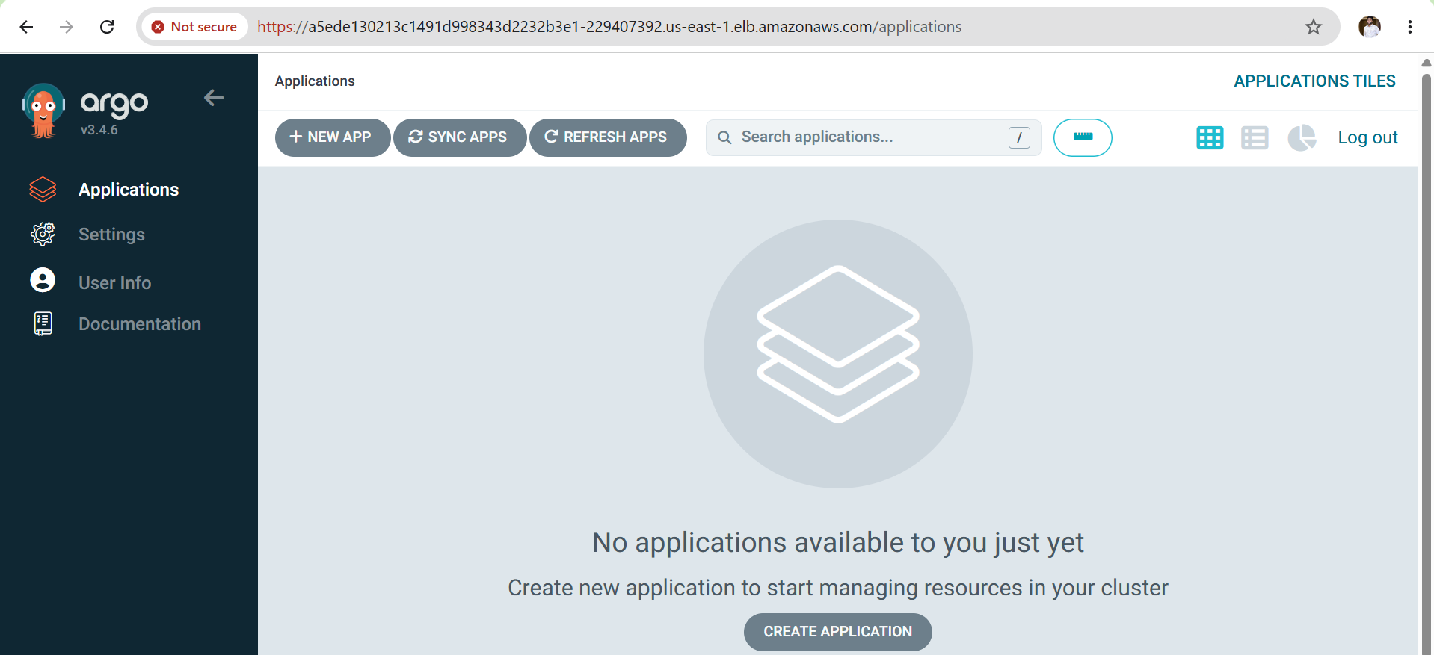
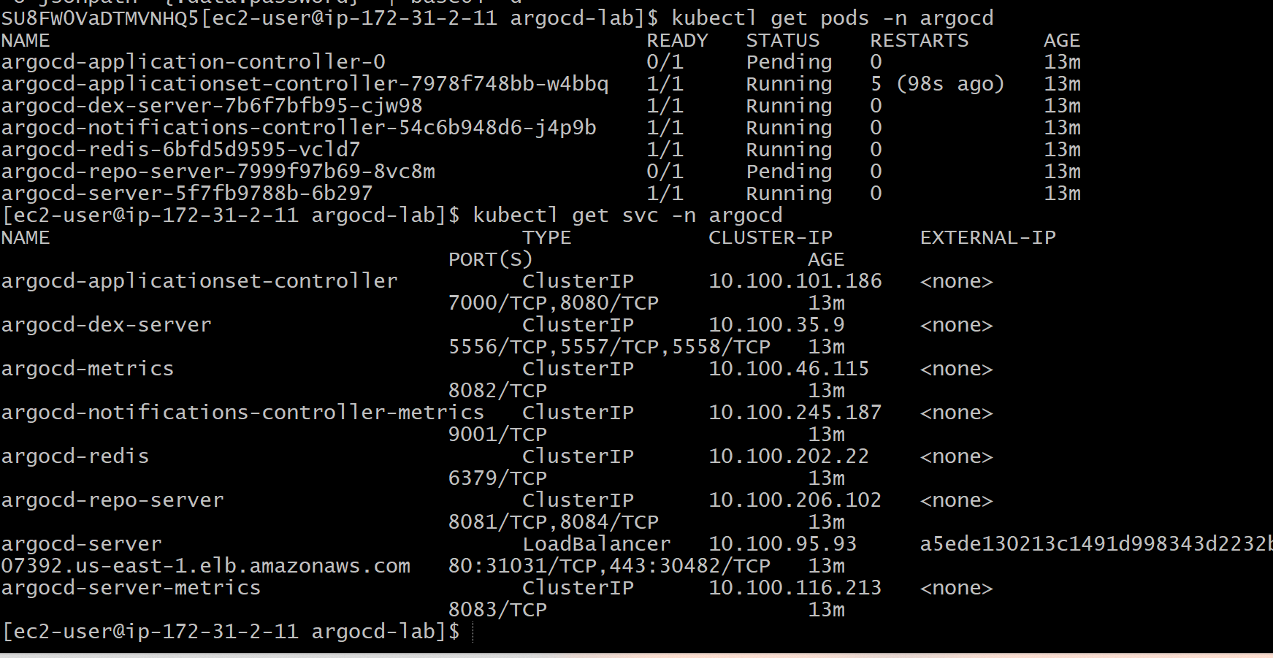
Outcome
- Amazon EKS cluster created successfully.
- Argo CD installed on the cluster.
- Argo CD server exposed using an AWS LoadBalancer.
- Argo CD web UI accessible.
- Successfully logged in using the admin account.
- GitOps platform is ready for application deployments.

Task 2: Create Jenkins Job for CI
Objective
- Integrate Jenkins with GitHub.
- Pull source code from GitHub.
- Build the application using Maven.
- Verify that the application builds successfully.

Prerequisites
- Jenkins Server Running
- Java 21 Installed
- Git Installed
- Maven Installed
- GitHub Repository
- Jenkins Plugins Installed:
  - Git Plugin
  - Pipeline Plugin
  - Maven Integration Plugin
Steps
- Created a new Freestyle Jenkins job named CI-Build.
- Configured the GitHub repository URL in Source Code Management.
- Selected the required Git branch (main).
- Configured Maven as the build tool.
- Added the Maven goal clean package.
- Saved the job configuration.
- Triggered the Jenkins build manually.
- Verified source code checkout from GitHub.
- Verified Maven build execution.
- Reviewed the Console Output for build status.

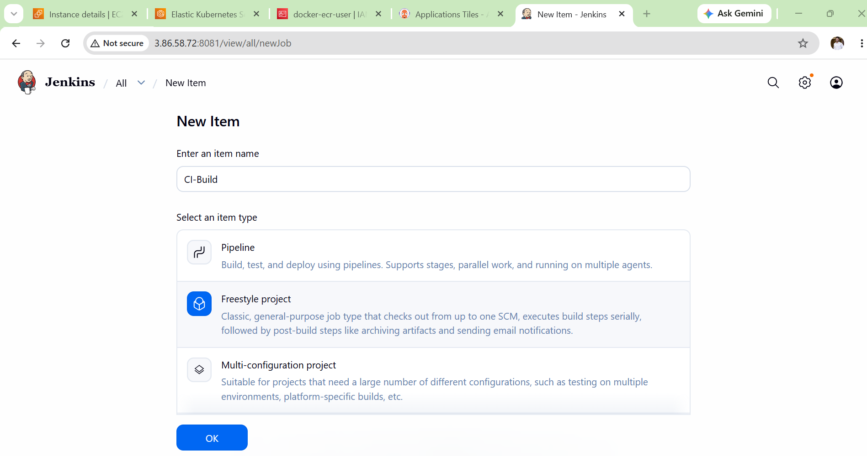
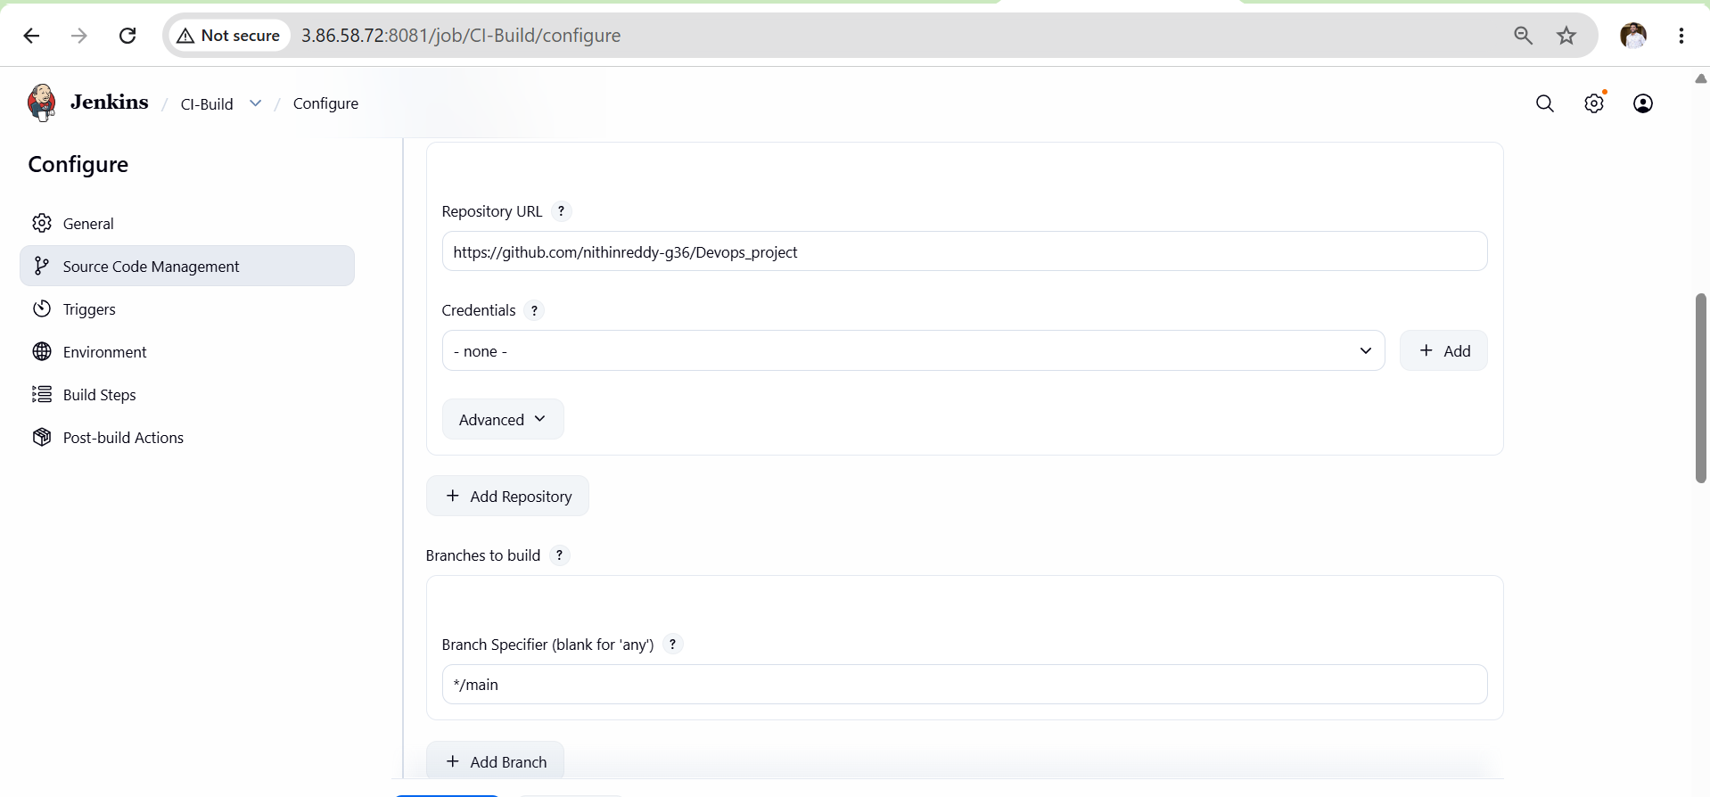
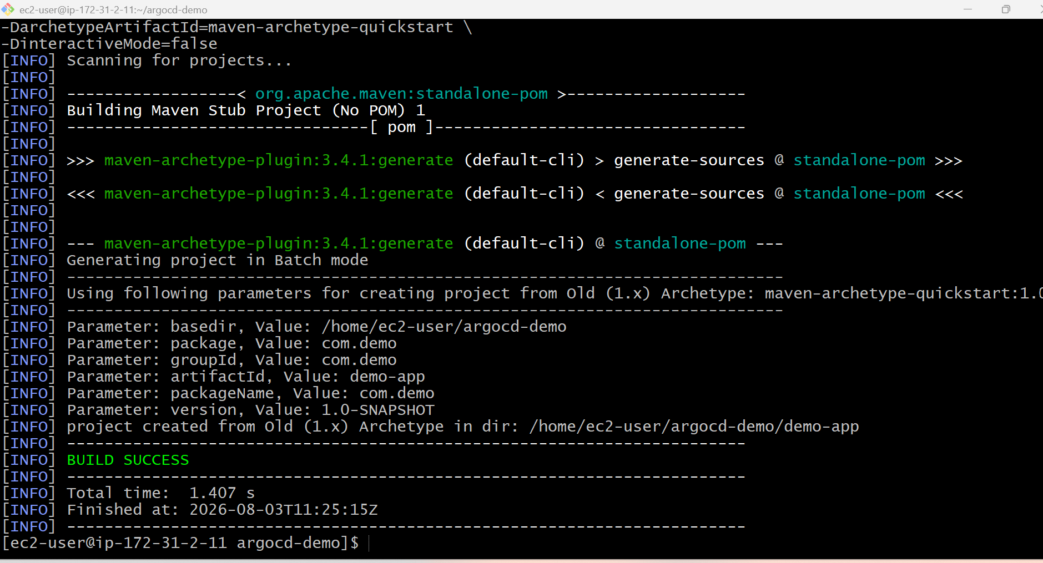
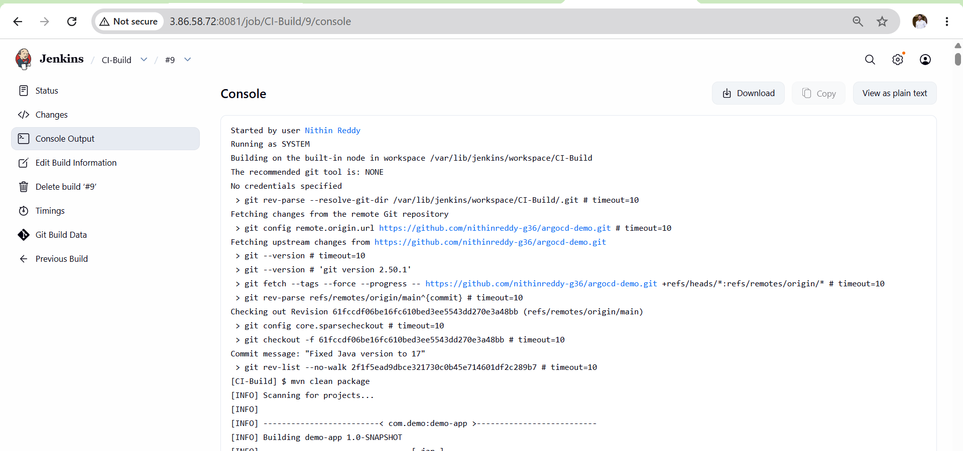
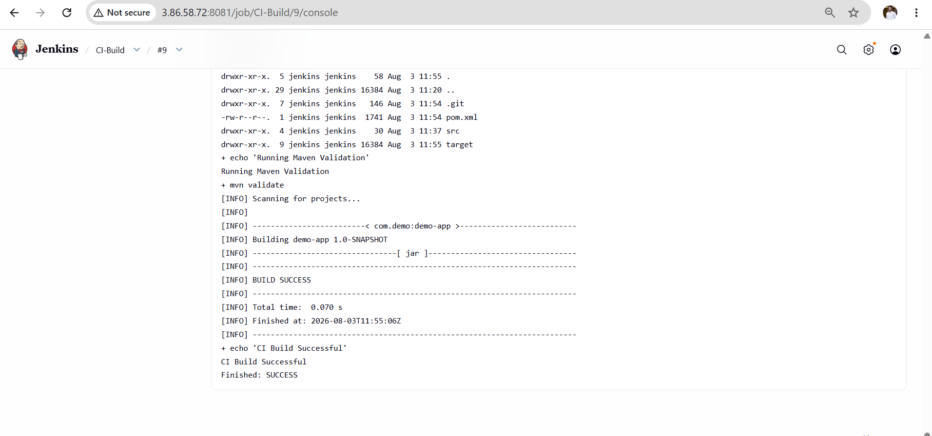
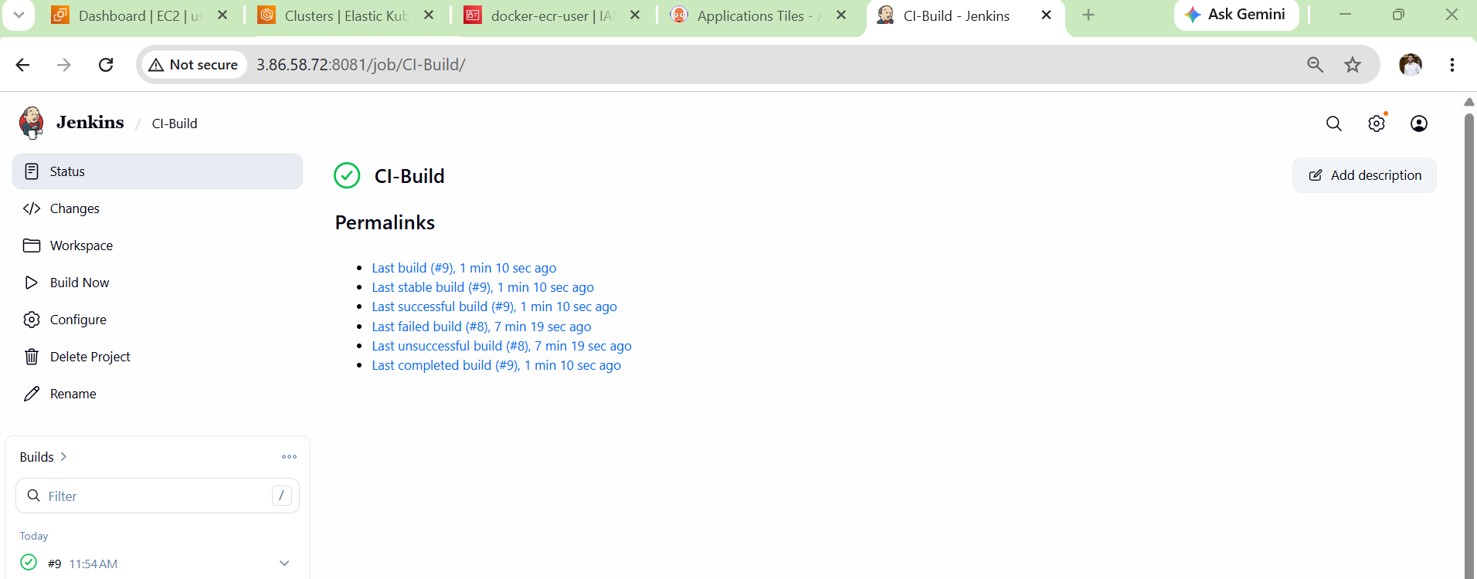
Validation
- Jenkins successfully cloned the GitHub repository.
- Maven executed the configured build command.
- Console Output displayed all build stages.
- Build status changed to SUCCESS (or FAILURE during troubleshooting).
- Workspace was created under /var/lib/jenkins/workspace/CI-Build.
Outcome
- Jenkins CI job was successfully created.
- Source code was automatically fetched from GitHub.
- CI workflow was validated using Jenkins and Maven.
- The CI job is ready for integration with Docker image creation in the next task.

Task 3: Create Jenkins Job to Build Docker Image
Architecture
GitHub
│
▼
Jenkins
│
▼
Clone Source Code
│
▼
Docker Build
│
▼
Docker Image
│
▼
Push to Amazon ECR
Steps
- Created an Amazon ECR repository.
- Logged in to Amazon ECR using AWS CLI.
- Created a Dockerfile for the application.
- Pushed the Dockerfile to the GitHub repository.
- Created a Jenkins Freestyle job named Docker-Build.
- Configured GitHub repository in Jenkins.
- Built the Docker image using Jenkins.
- Tagged the Docker image with the Amazon ECR repository URI.
- Pushed the Docker image to Amazon ECR.
- Verified the image was successfully uploaded to ECR.

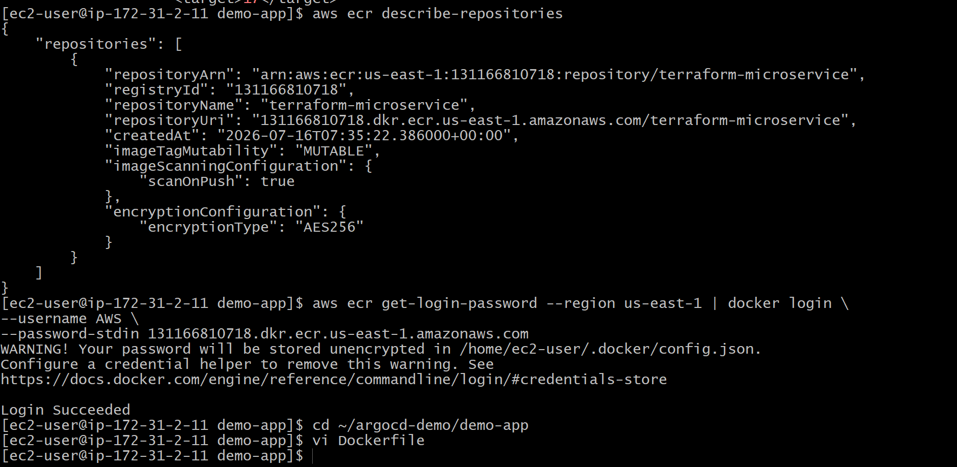

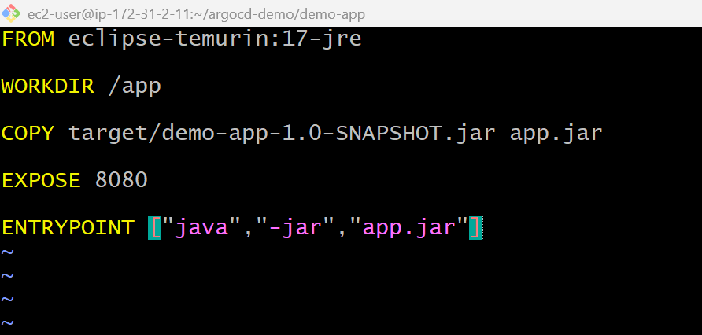
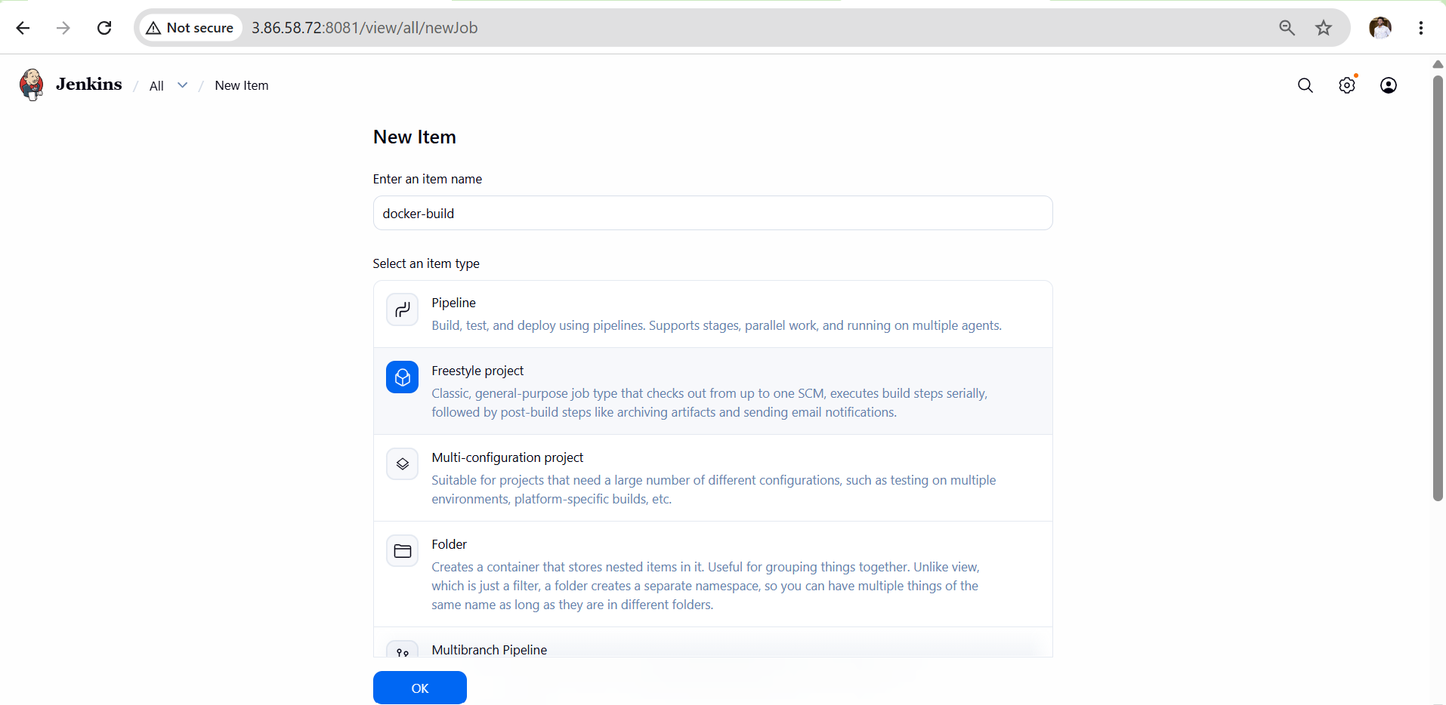
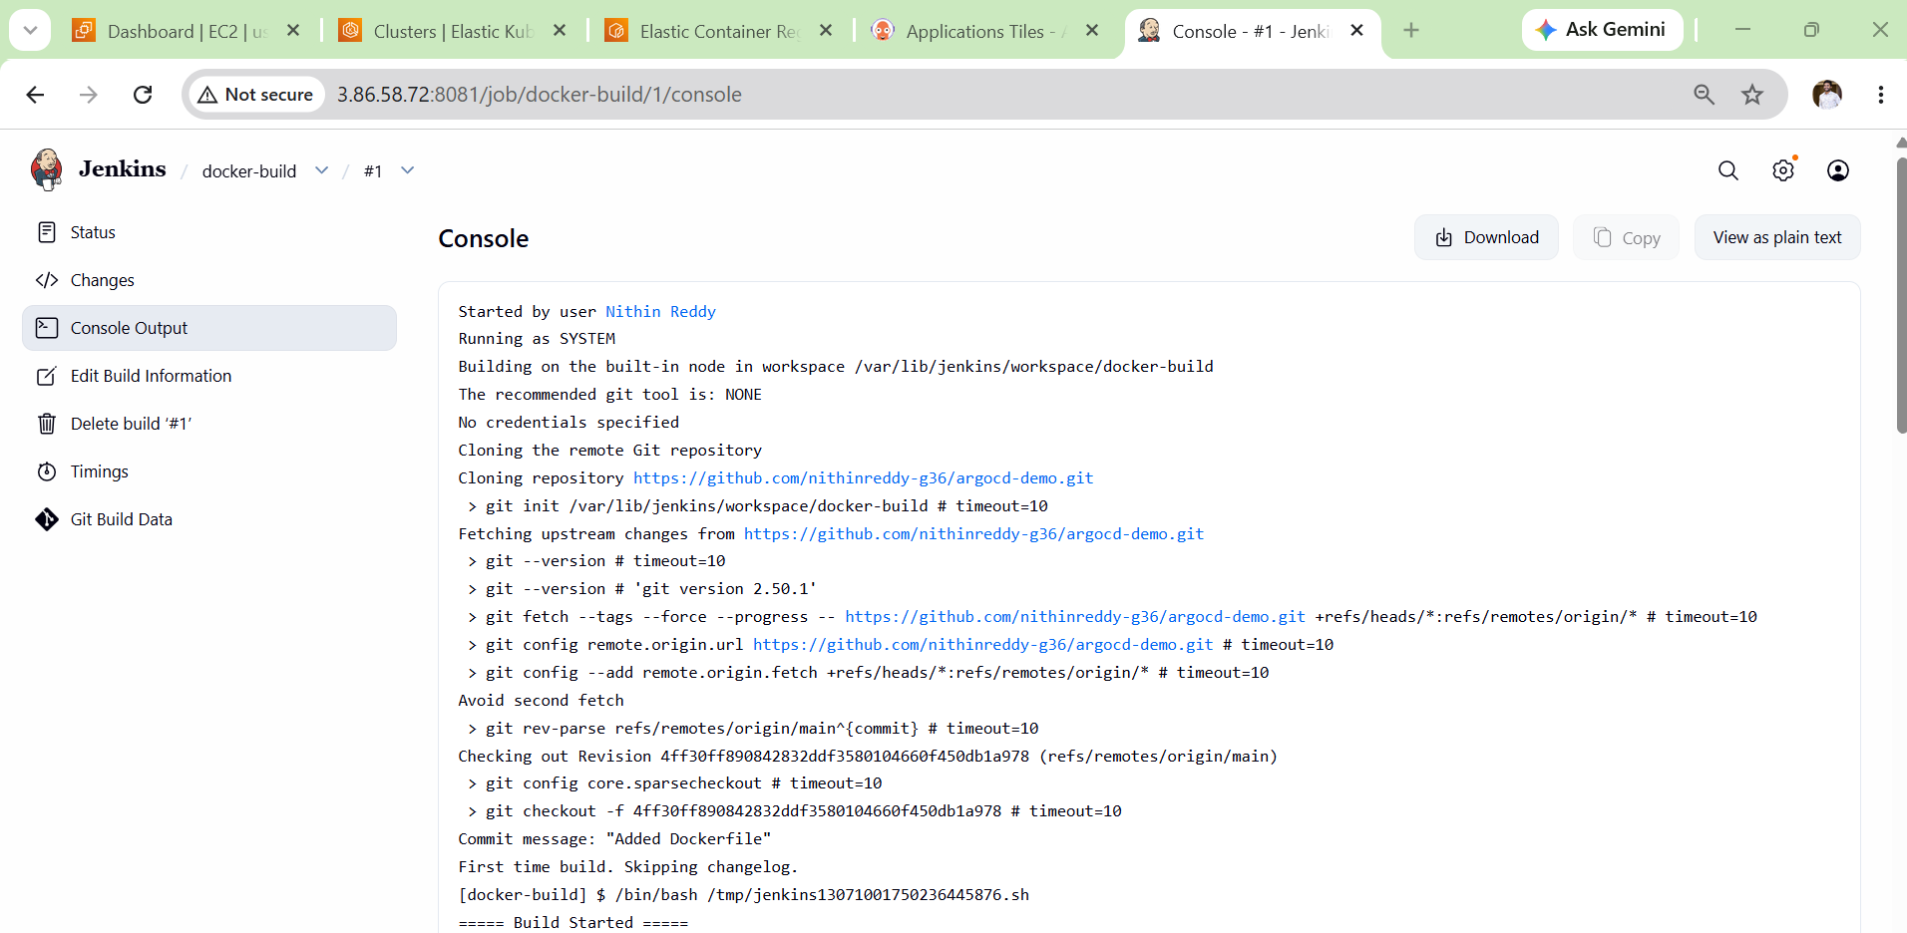
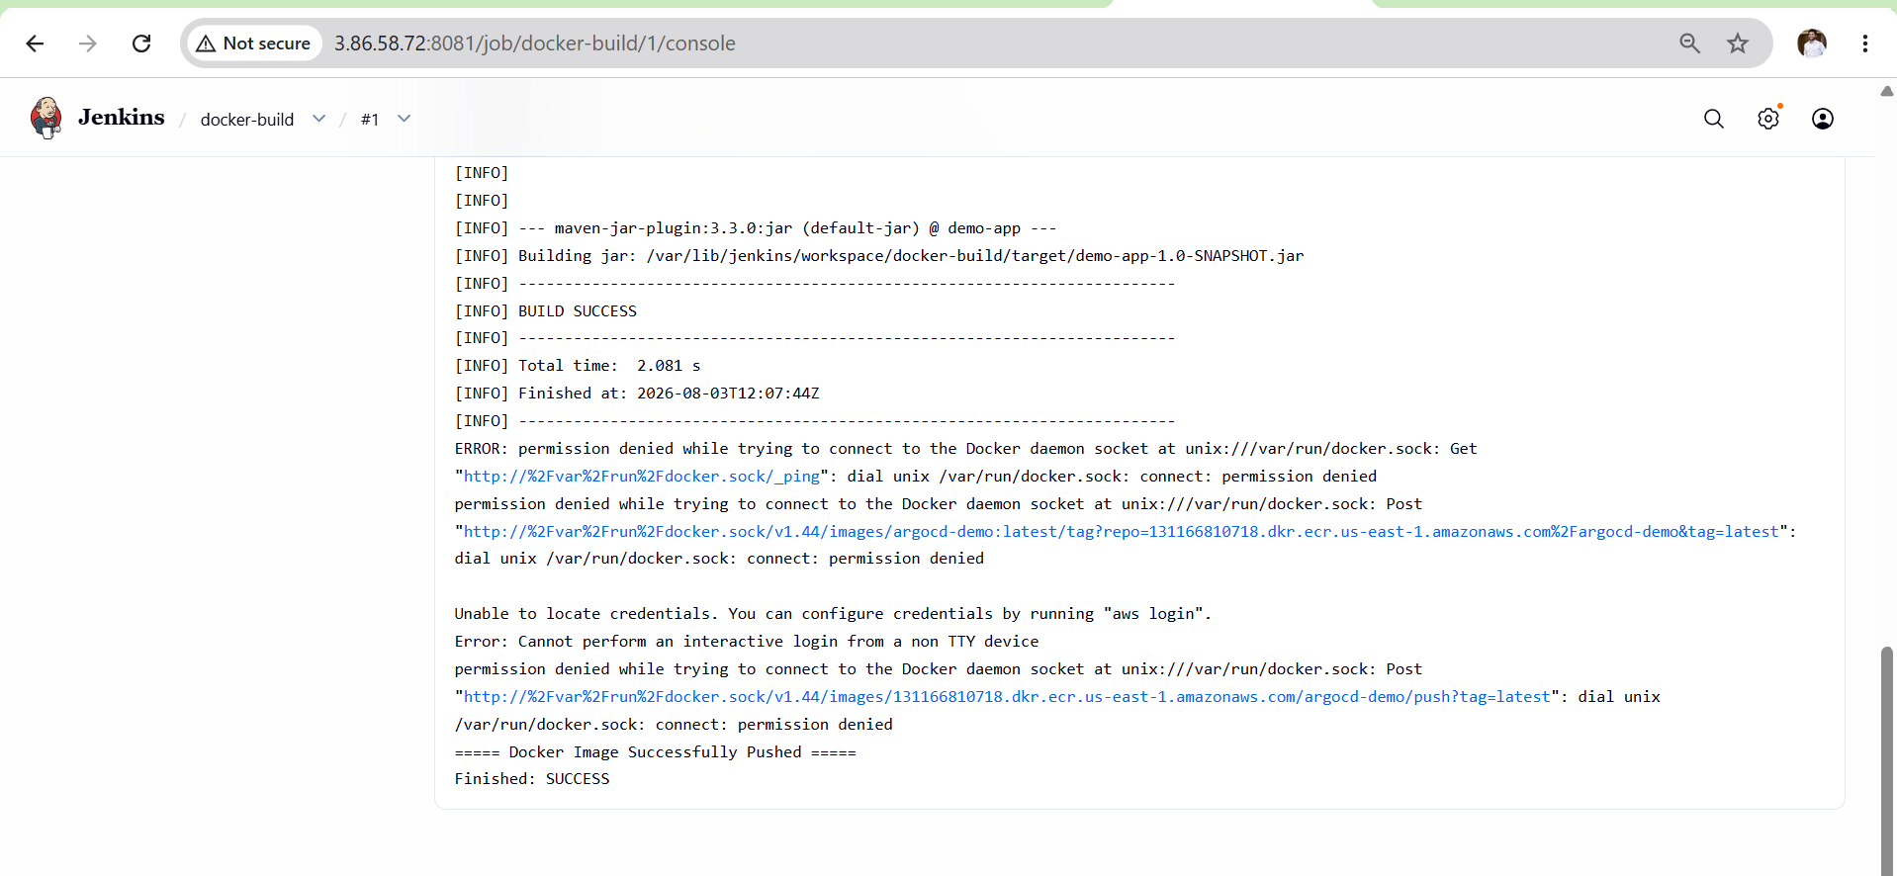

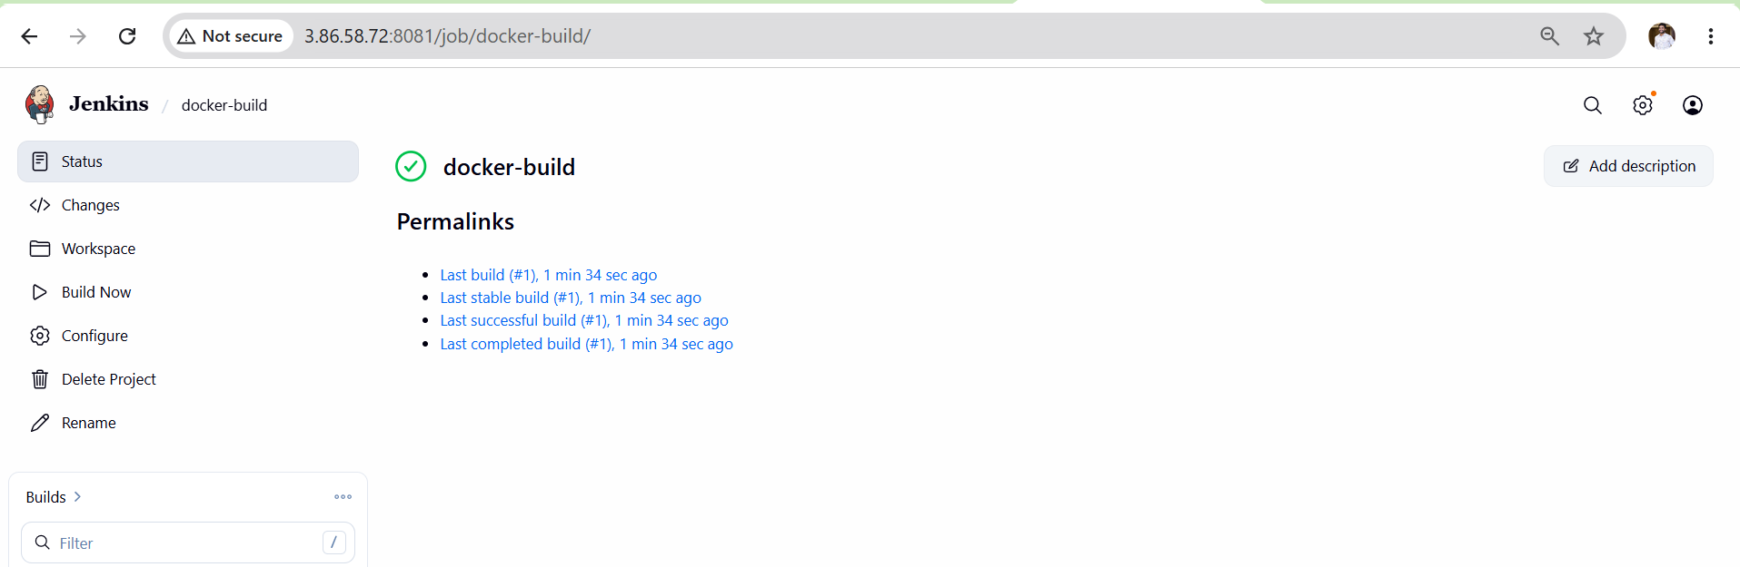

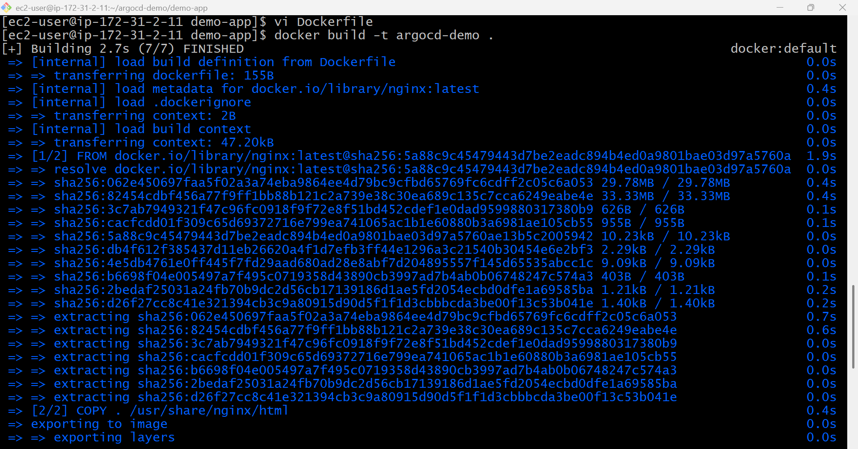
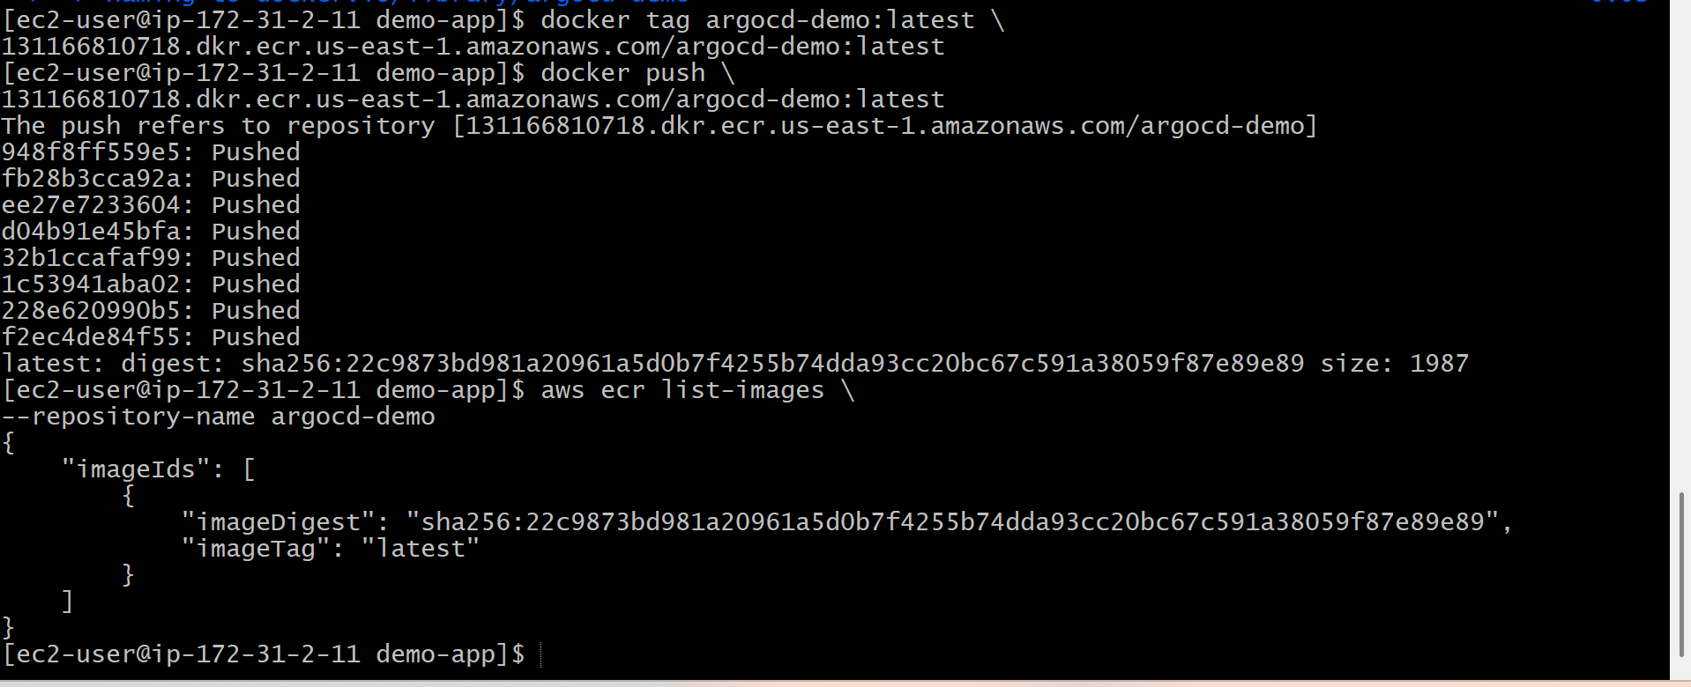
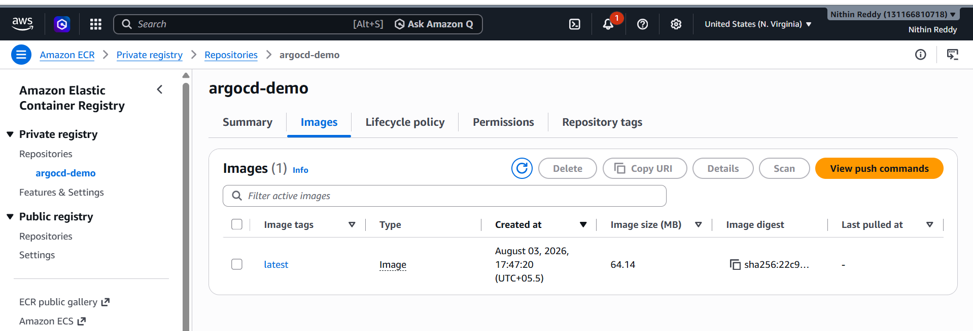
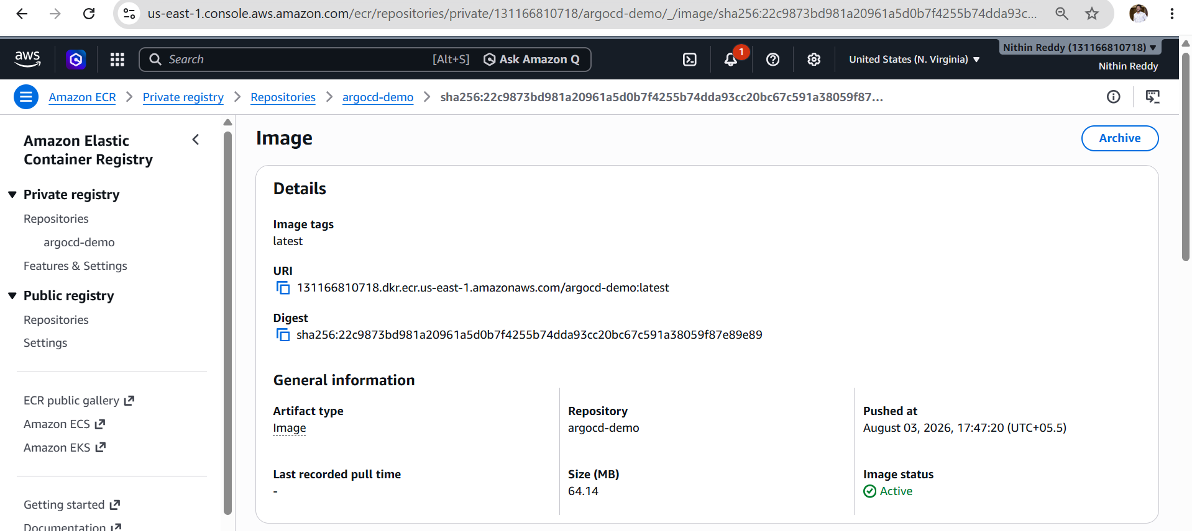
Validation
- ECR repository was created successfully.
- Docker login to ECR completed successfully.
- Docker image built without errors.
- Docker image was tagged correctly.
- Docker image was successfully pushed to Amazon ECR.
- Image was visible in the ECR repository with the latest tag.
Outcome
- Docker image creation and storage were automated using Jenkins and Amazon ECR.
- The application image is available in Amazon ECR.
- The Docker image is ready to be deployed to the EKS cluster using ArgoCD in Task 4.
Task 4 : Create ArgoCD job to deploy on ek8s cluster.
Objective:
Deployed containerized application to EKS cluster using ArgoCD GitOps deployment.
Implementation:
- Installed ArgoCD on EKS cluster.
- Configured ArgoCD components.
- Created Kubernetes deployment and service manifests.
- Stored manifests in GitHub repository.
- Connected GitHub repository with ArgoCD.
- Created ArgoCD application.
- Enabled automatic synchronization.
- Deployed application into EKS cluster using ECR Docker image.

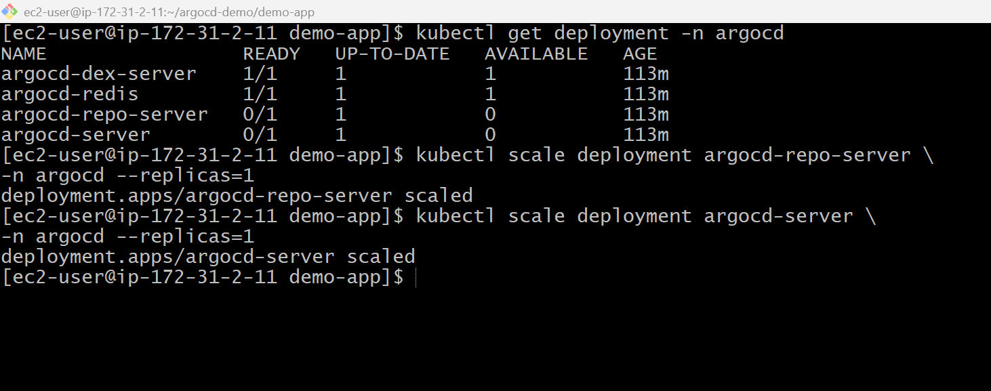
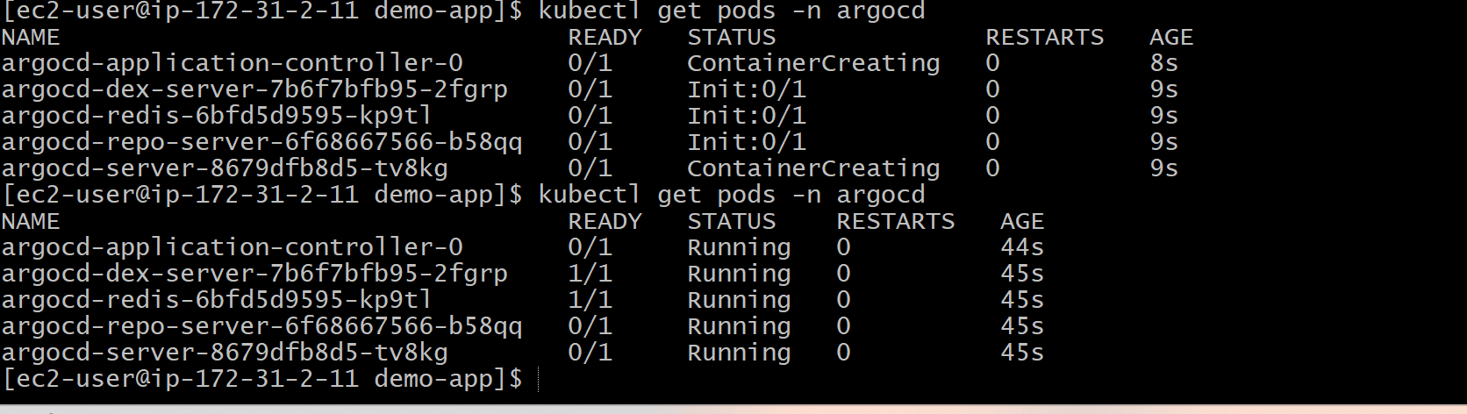
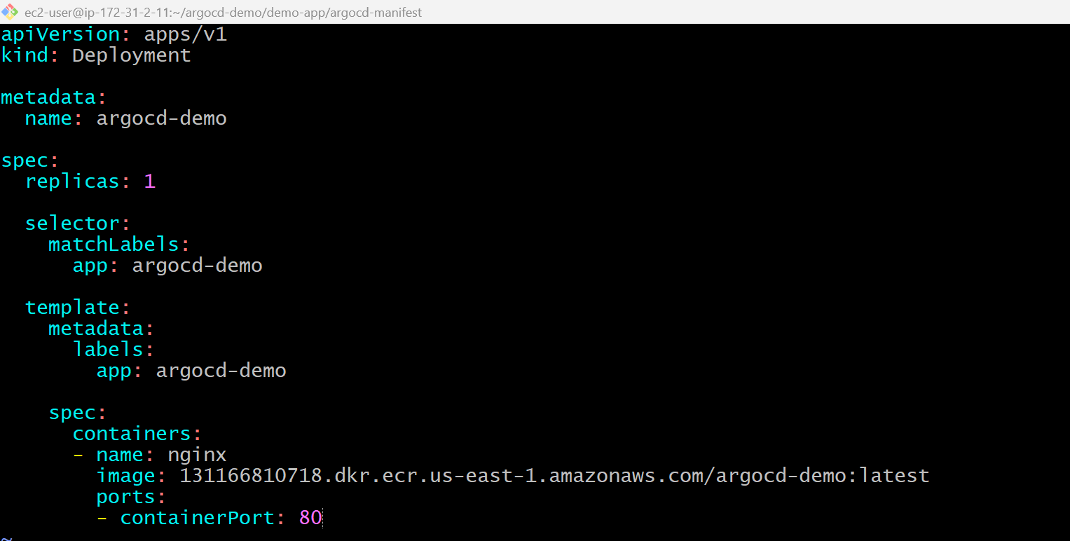
vi service.yaml
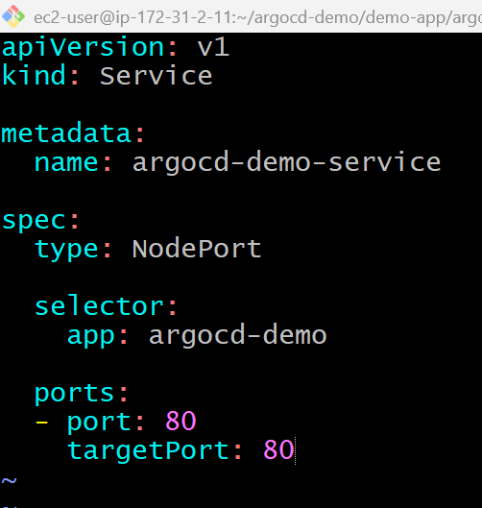
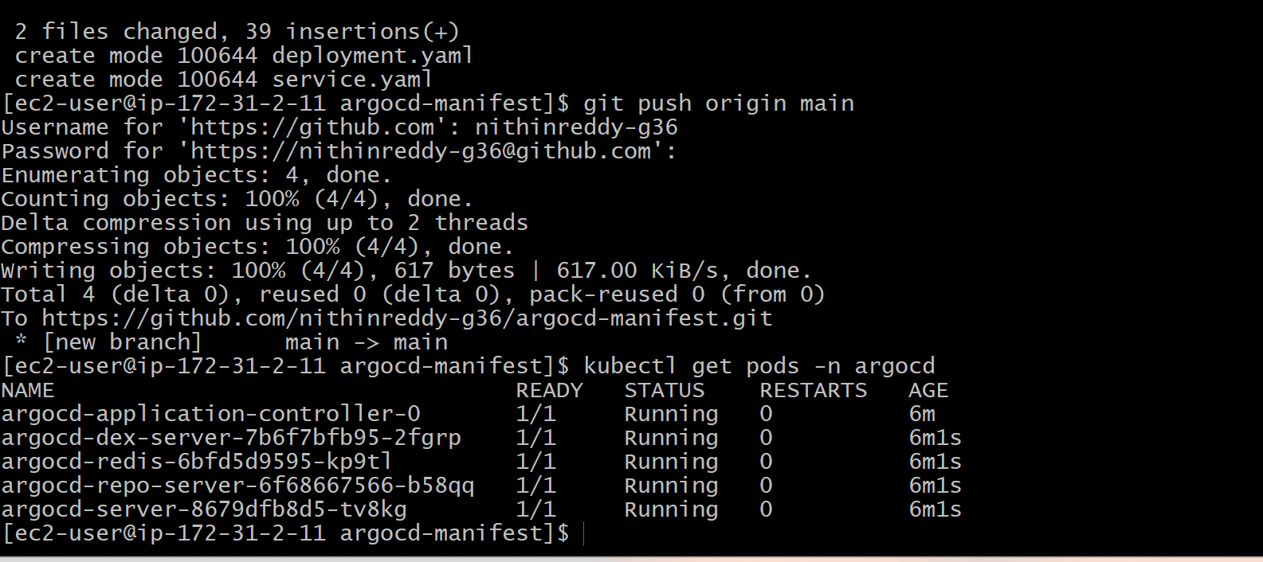
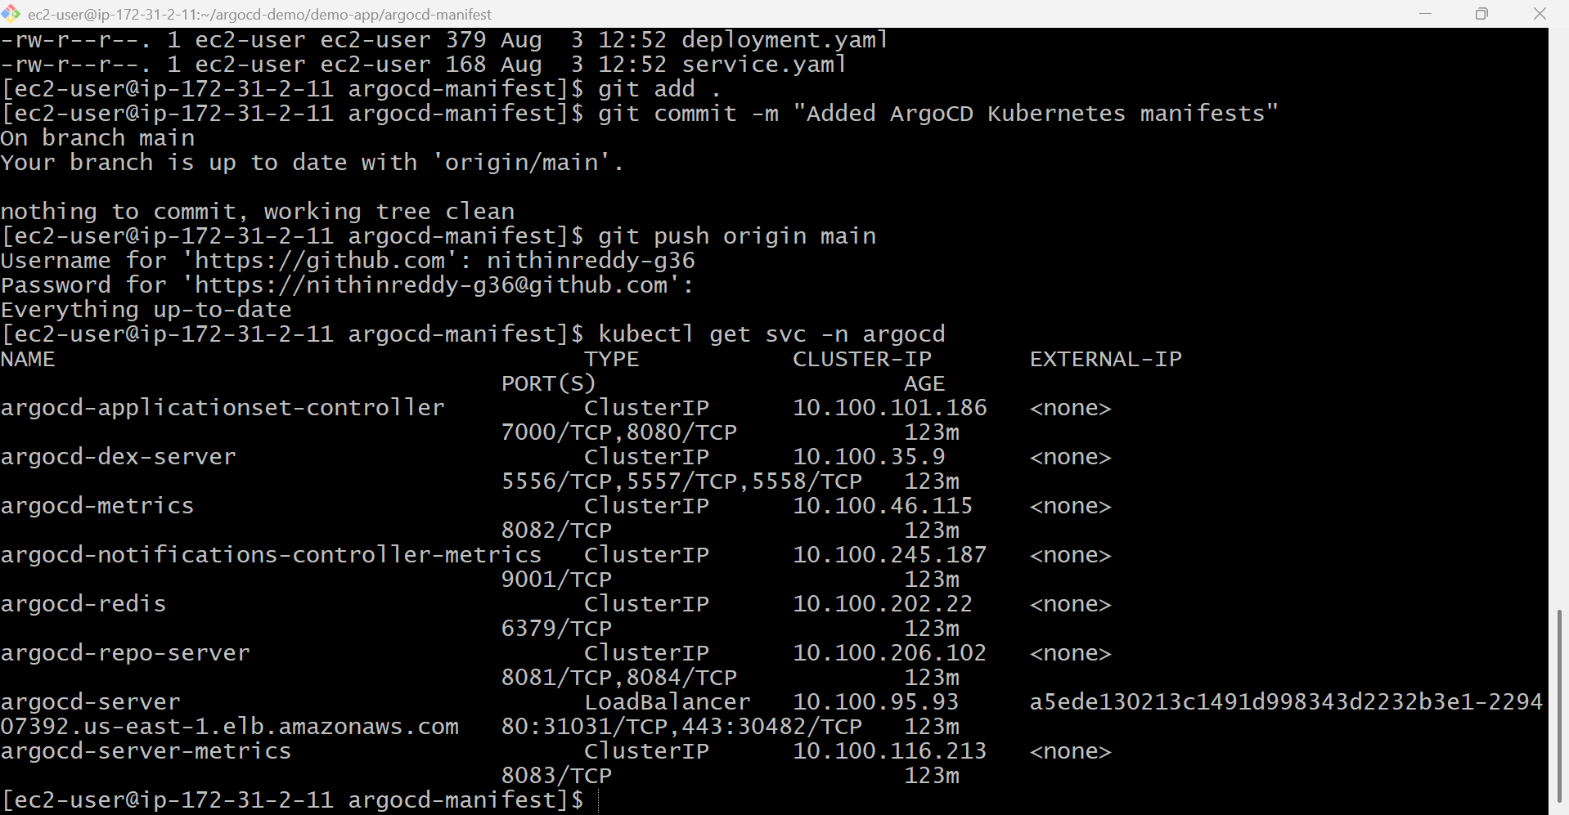
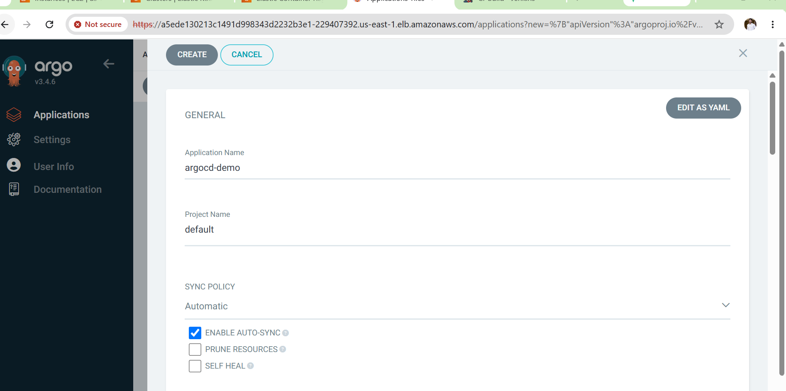
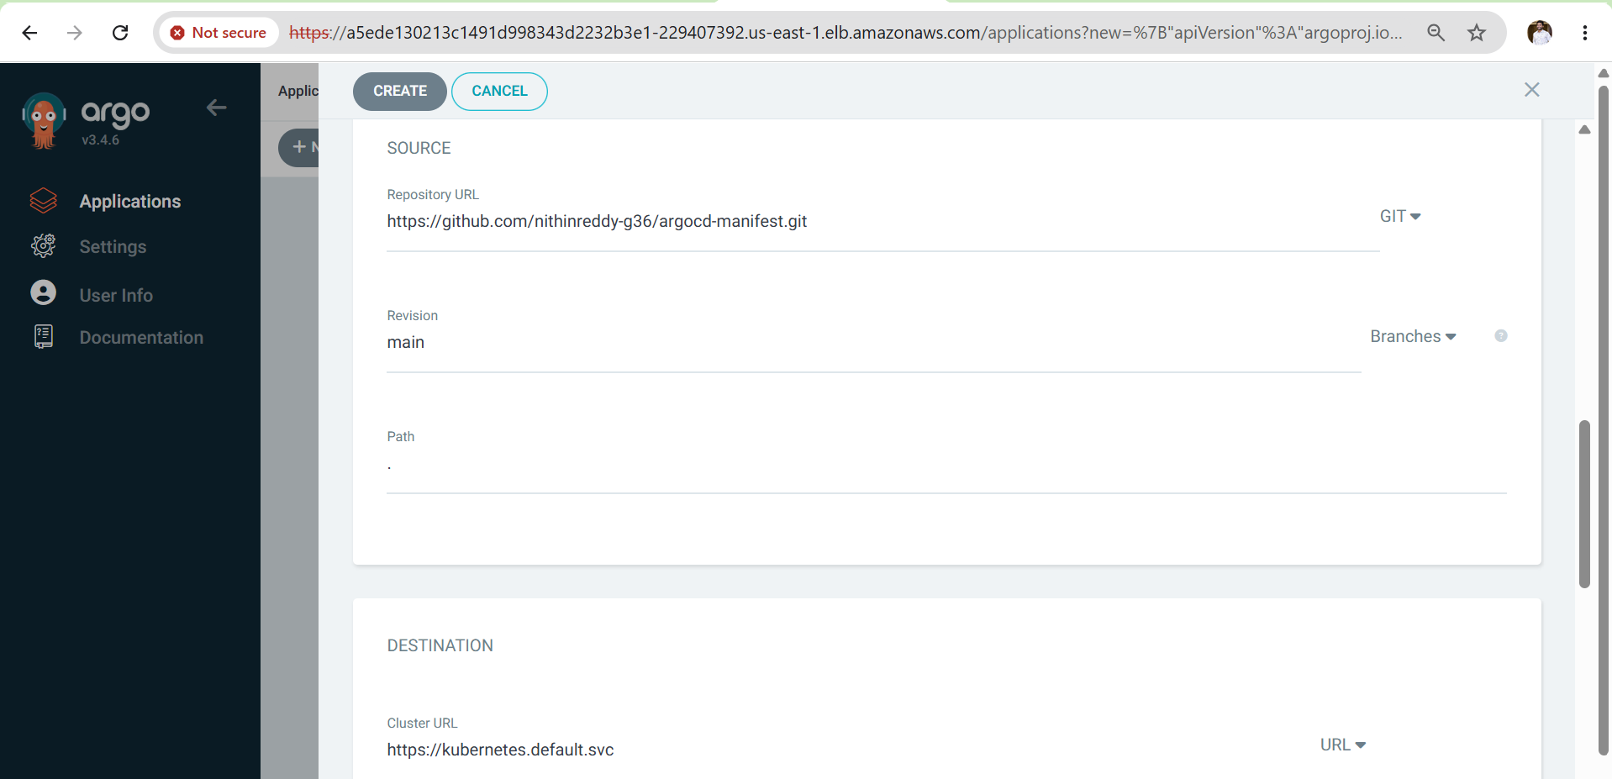
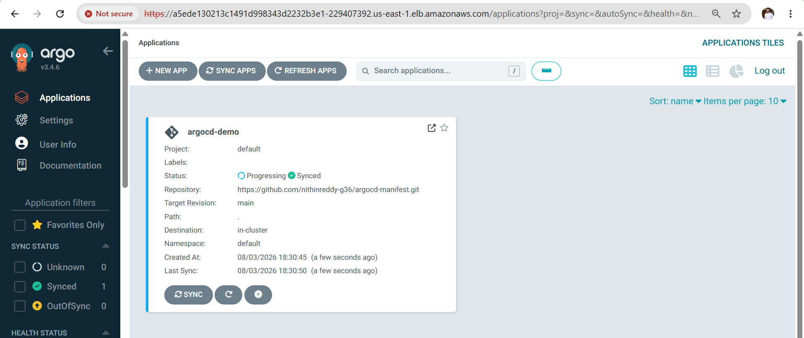
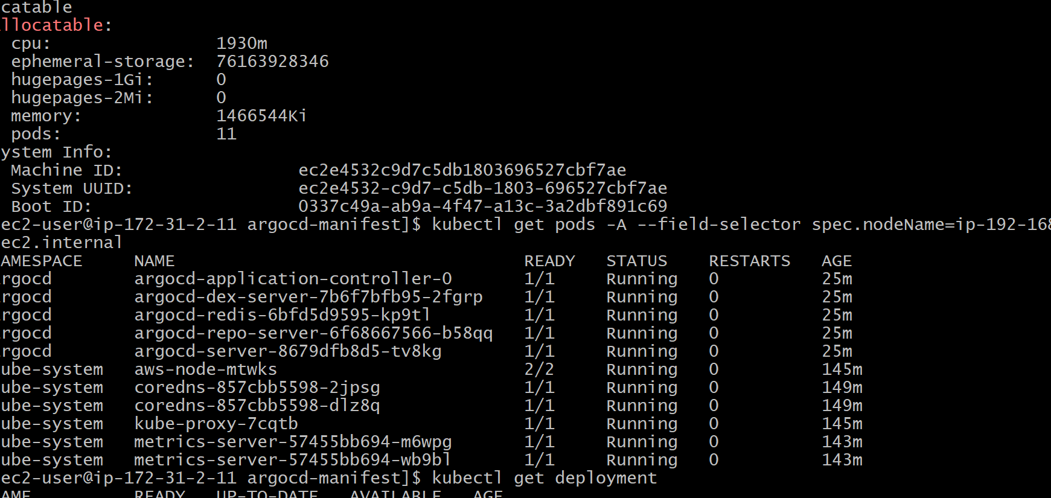
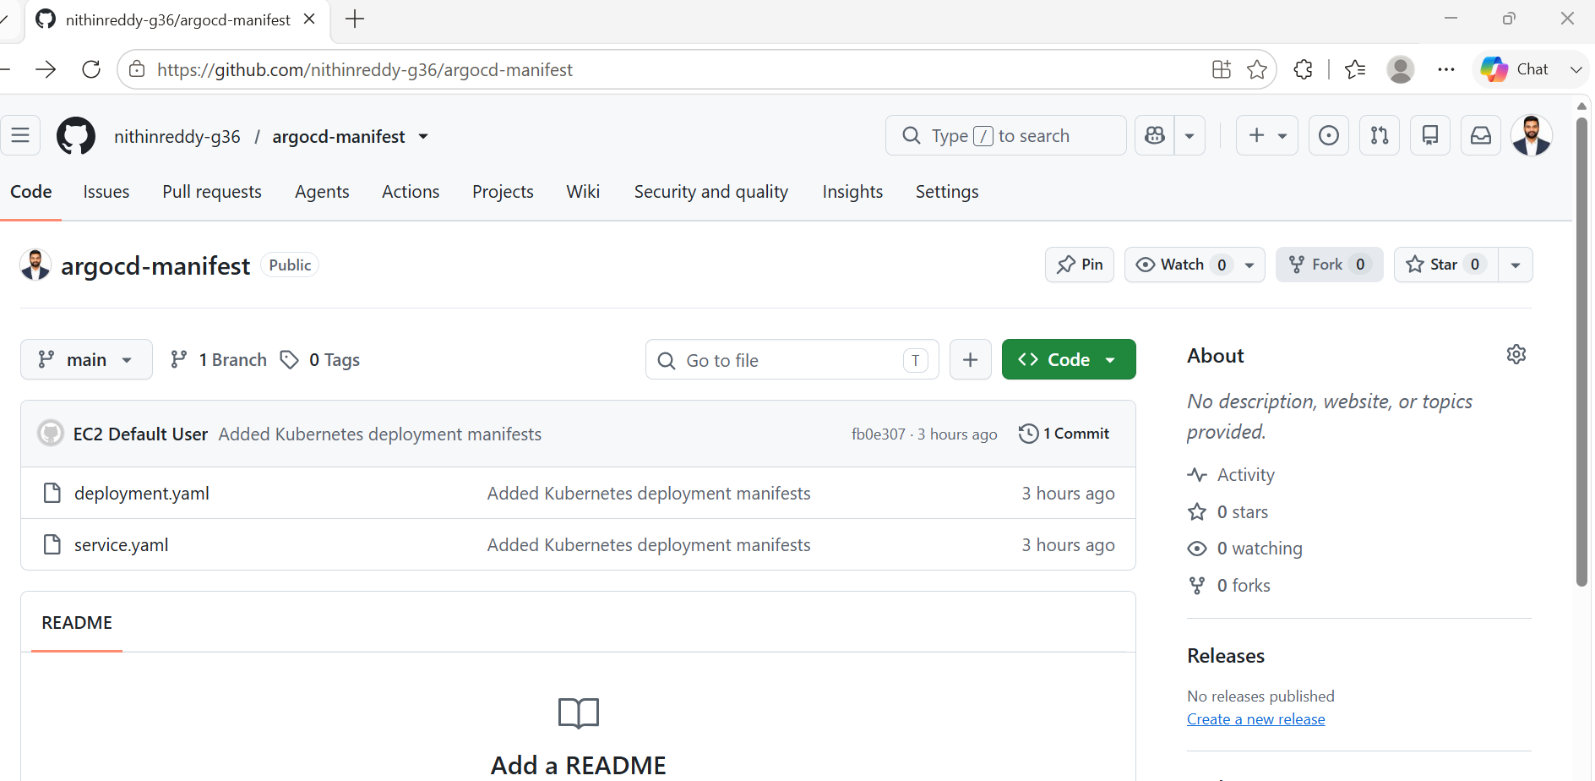
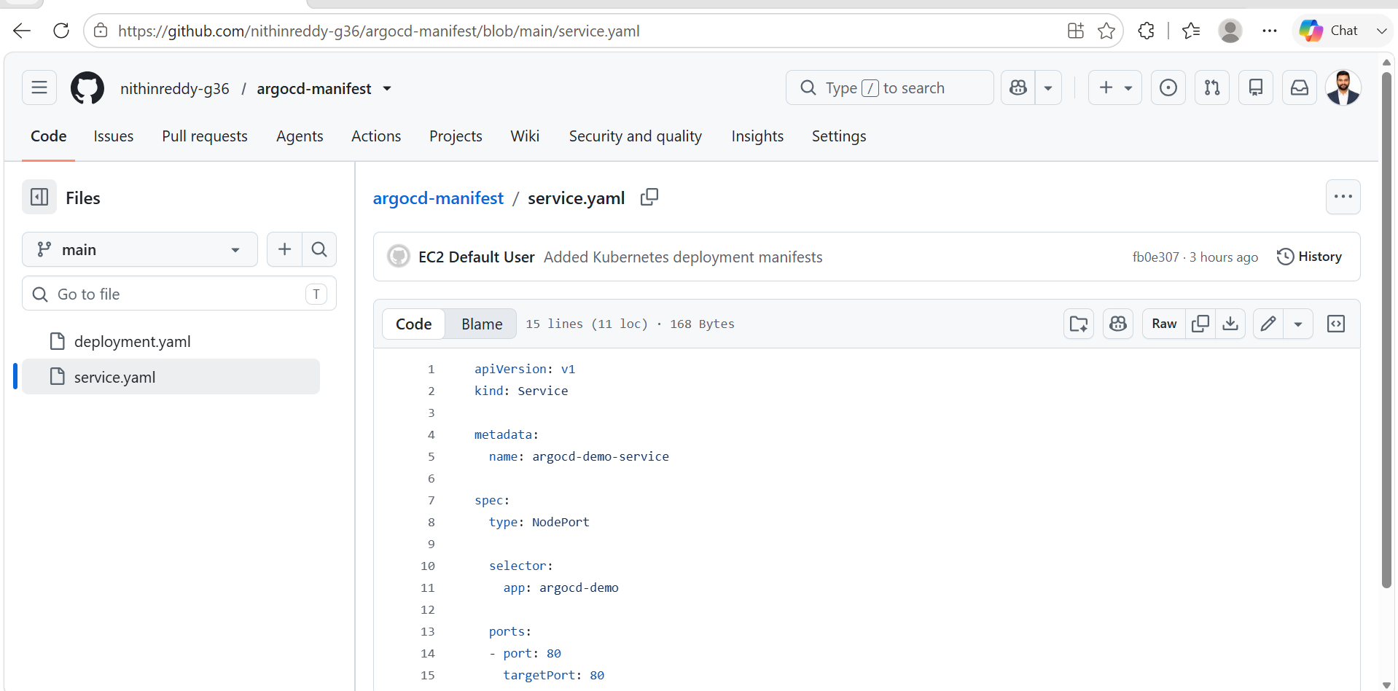

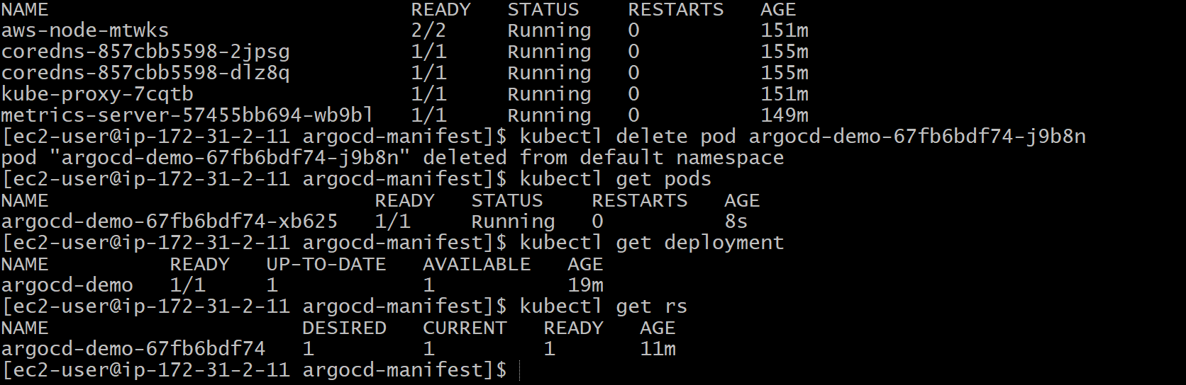
Outcome
- Successfully deployed an application on Amazon EKS cluster using ArgoCD GitOps workflow.
- Integrated Git repository with ArgoCD for automated Kubernetes deployments.
- Verified automatic synchronization between Git changes and EKS resources.
- Learned ArgoCD application management, sync process, health monitoring, and rollback functionality.
- Implemented a GitOps-based CI/CD deployment approach for Kubernetes workloads.
- Improved understanding of managing Kubernetes deployments in a production-like EKS environment.

