- Install git.
Outcome: Git is successfully installed and version is confirmed via terminal.
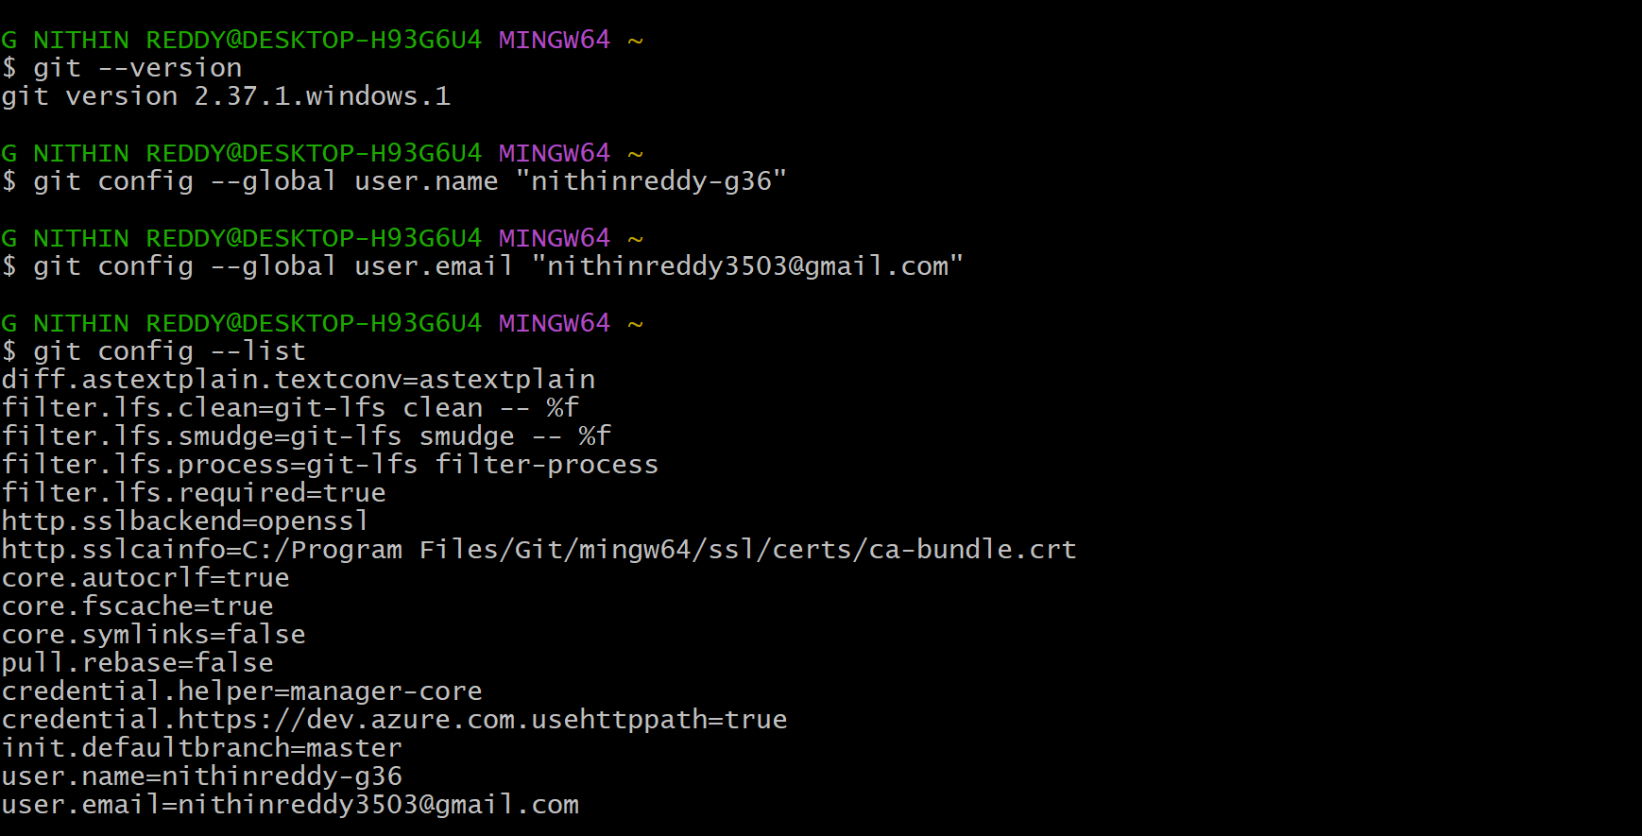
Objective : To set up Git version control system on local machine for source code management.
Prerequisites:
- Windows/Mac/Linux machine
- Admin/sudo privileges
Step-by-Step Implementation:
- Step 1: Download & Install
- Step 2: Verify Installation
- Validation: git version displayed in terminal
Explanation: Git is a distributed version control system that tracks changes in source code. It is the foundation for collaborative development and CI/CD pipelines.
Common Errors:
- Error | - Cause | - Resolution
- git not recognized | - PATH not set | - Restart terminal or add Git to PATH

- Create a repo in github with README.md and .ignore file
Outcome : A new GitHub repository is created with README.md and . gitignore files initialized.
Objective: To create a remote central repository where code will be stored and collaborated on.
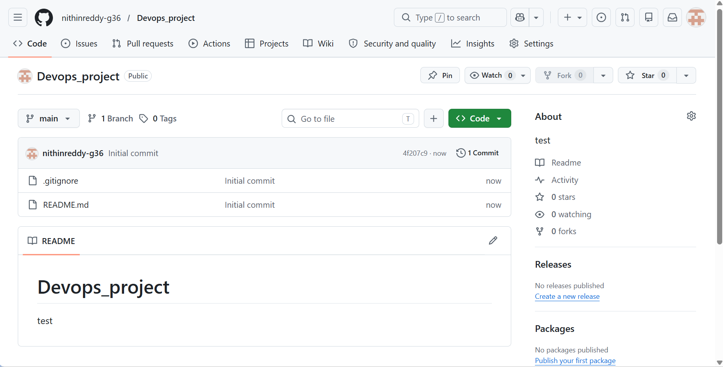
Explanation
I have successfully created a new repository named Devops_project on GitHub. During creation, I initialized it with a README.md file and selected a. gitignore template. Both files are now visible in the repository. I have also copied the HTTPS URL of the repo which will be used in the next task to clone it to my local machine."
Prerequisites:
- GitHub account
- Browser access
Step-by-Step Implementation:
- Step 1: Open GitHub
- Login to github.com → Click "+" icon → Select "New Repository"
- Step 2: Configure Repo
- Parameter | - Value
- Repository Name | - my-project
- Visibility | - Public/Private
- Initialize README | - ✅ Checked
- Add .gitignore | - Select template (e.g., Python/Node)
- Step 3: Create
- Click "Create Repository"
Common Errors:
- Error | - Cause | - Resolution
- Repo name taken | - Already exists | - Choose a different name

- Clone the created repo to local.
Outcome: Remote GitHub repository is cloned and available as a local folder.
Objective : To download the remote repository to local machine for development work.
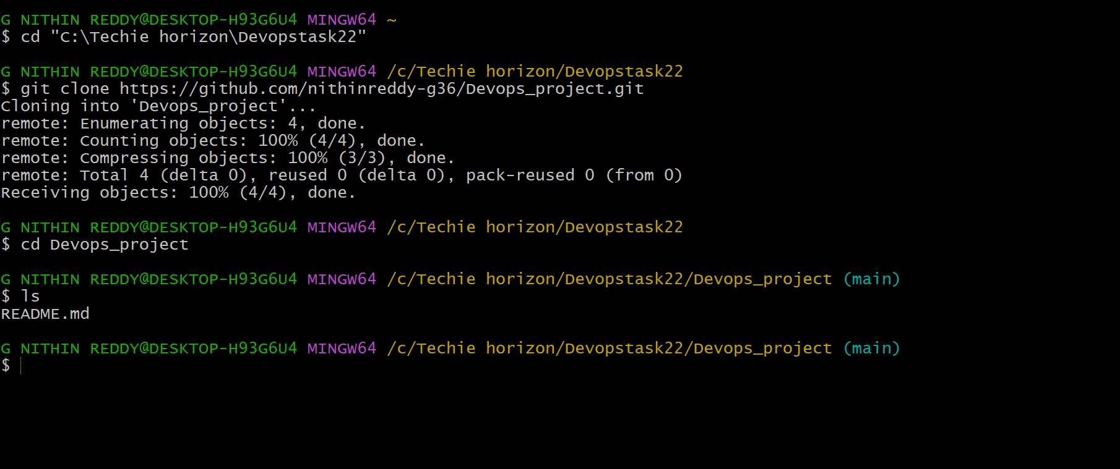
Explanation
I have successfully cloned the remote repository Devops_project from GitHub to my local machine using the git clone command. After cloning, I navigated into the folder and verified that README.md and .gitignore files were downloaded correctly. I also ran git remote -v which confirmed that origin is pointing to my GitHub repository URL. The local repo is now ready to work on.
Prerequisites:
- Git installed
- Repository URL from GitHub
Step-by-Step Implementation:
Step 1: Copy Repo URL
GitHub Repo → Click "Code" button → Copy HTTPS URL
Step 2: Clone
git clone https://github.com/username/my-project.git
cd my-project
Validation:
Folder "my-project" created locally with README.md and .gitignore present.
Common Errors:
Error | Cause | Resolution
Repository not found | Wrong URL | Copy exact URL from GitHub
Permission denied | Private repo, no auth | Configure credentials or SSH

- Create two files in local repo.
Outcome : Two new files created inside the local repository folder.
Objective
To simulate real development by adding new files to the local project.
Prerequisites:
- Cloned repository on local machine
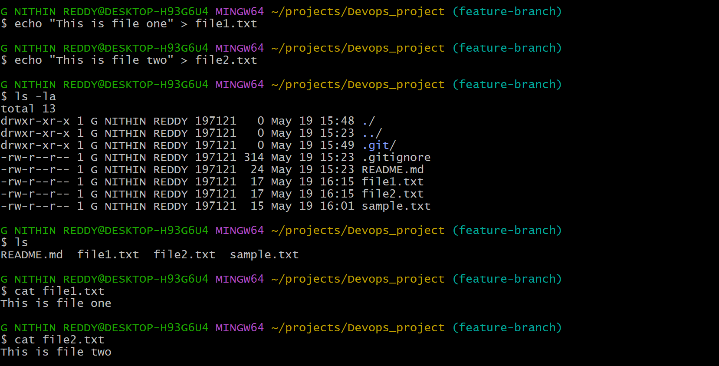
Explanation
I have successfully created two new files — file1.txt and file2.txt — inside the local Devops_project repository using the echo command. I verified the files using ls -la and read their contents using cat. I also ran git status which shows both files as untracked, meaning Git can see them but has not started tracking them yet. They are ready to be staged and committed in the next task.
Step-by-Step Implementation:
Step 1: Navigate to Repo
cd my-project
Step 2: Create Files
touch file1.txt file2.txt
echo "This is file 1" > file1.txt
echo "This is file 2" > file2.txt
Validation:
ls shows file1.txt and file2.txt inside the project folder.

- Commit two files and push to central Repository.
Outcome:
Both files are committed and pushed to the GitHub remote repository.
Objective:
To save changes permanently in version history and sync with the central repository.
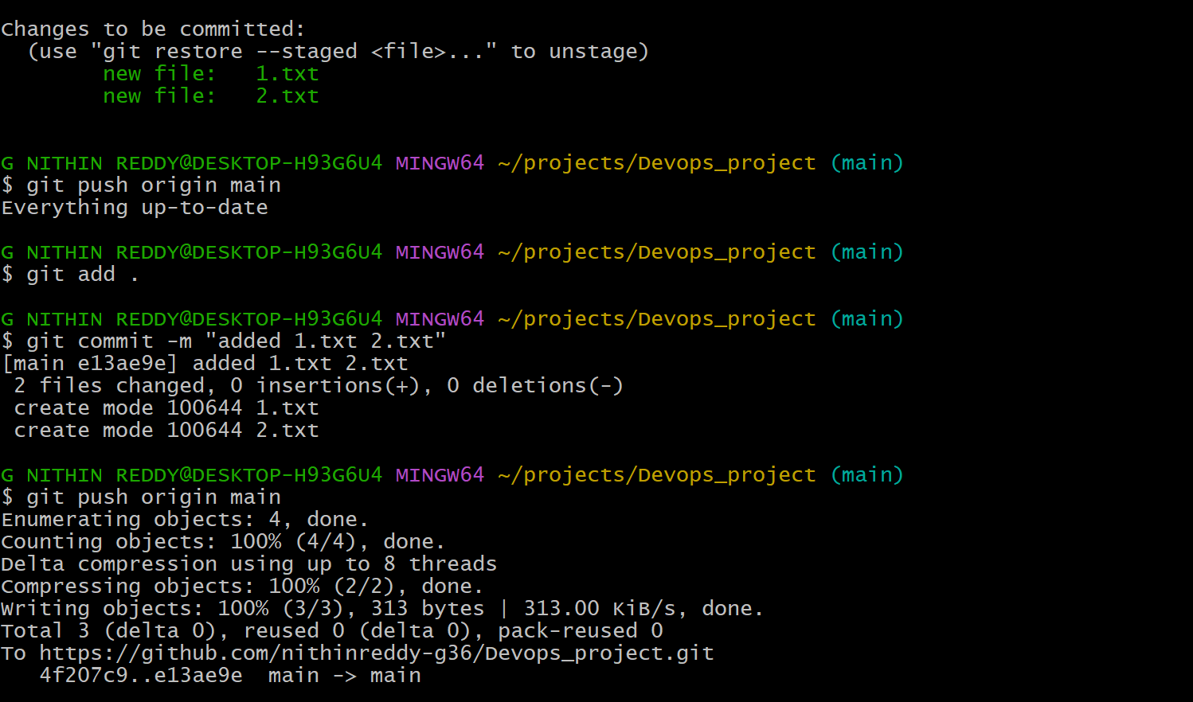
Explanation
Successfully staged both file1.txt and file2.txt using git add, committed them with a meaningful message using git commit, and pushed the commit to the remote GitHub repository using git push. Git now tracks these files, and they are visible in your GitHub repo under the main/master branch.
Prerequisites:
- Files created in local repo
- Git configured with username and email
Step-by-Step Implementation:
Step 1: Configure Git (First Time)
git config --global user.name "Your Name"
git config --global user.email "you@email.com"
Step 2: Stage Files
git add file1.txt file2.txt
Step 3: Commit
git commit -m "Add file1 and file2"
Step 4: Push
git push origin main
Validation:
GitHub repo shows file1.txt and file2.txt with the commit message.
Common Errors:
Error | Cause | Resolution
rejected (non-fast-forward) | Remote has newer commits | git pull origin main first
Nothing to commit | Files not staged | Run git add before commit

- Create a branch in local and create a sample file and push to central.
Outcome:
A new branch is created locally, a file added, and the branch pushed to GitHub.
Objective:
To isolate feature development from the main branch following Git branching strategy.
Prerequisites:
Local repository with at least one commit
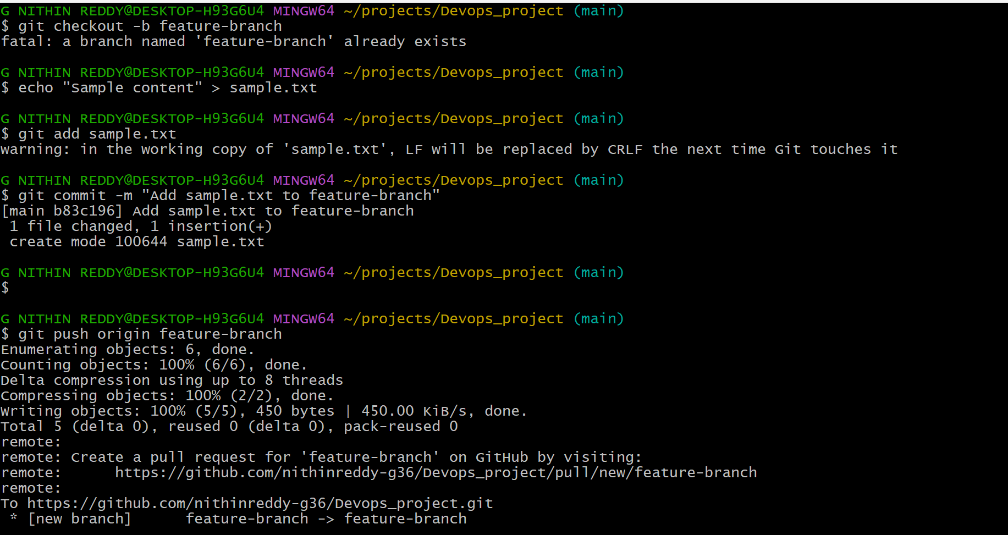
Explanation
Created a new local branch called feature-branch using git checkout -b, created sample.txt inside it, committed the file, and pushed the branch to the remote GitHub repository. The branch is now visible in GitHub under the Branches tab.
Step-by-Step Implementation:
Step 1: Create & Switch to Branch
git checkout -b feature-branch
Step 2: Create a File
touch feature.txt
echo "Feature work" > feature.txt
Step 3: Commit & Push
git add feature.txt
git commit -m "Add feature file"
git push origin feature-branch
Validation:
GitHub shows "feature-branch" branch with feature.txt file.

- Create a branch in github and clone that to local.
Outcome:
A branch created on GitHub is fetched and checked out on local machine.
Objective:
To work on a branch created remotely by a teammate or via GitHub UI.
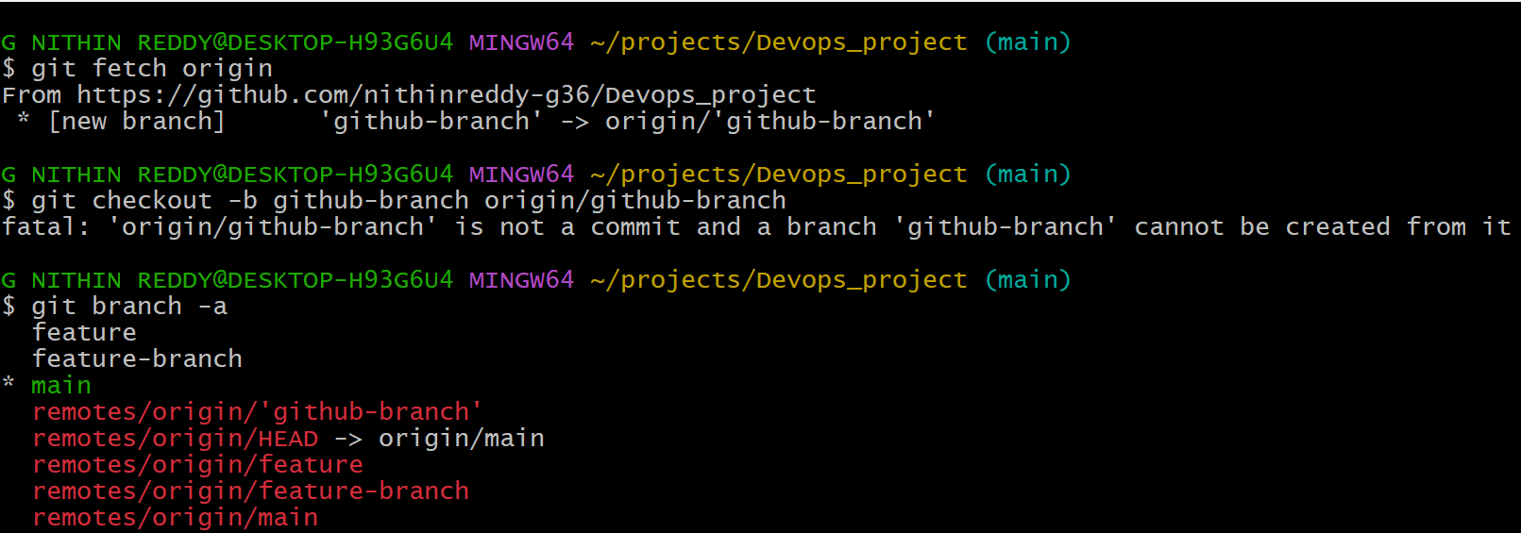
Explanation
GitHub repo, created a new branch called github-branch from the GitHub UI. Then you fetched all remote branches locally using git fetch, and switched to that branch using git checkout. Your local repo now has the github-branch tracking the remote.
Prerequisites:
- GitHub repository
- Branch created on GitHub UI
Step-by-Step Implementation:
Step 1: Create Branch on GitHub
GitHub Repo → Branches dropdown → Type new branch name → Click "Create branch"
Step 2: Fetch and Checkout Locally
git fetch origin
git checkout github-branch
Validation:
git branch shows github-branch as active.

- Merge the created branch with master in git local.
Outcome:
Feature branch changes are merged into the main branch in local repository.
Objective:
To integrate completed feature work into the main codebase locally before pushing
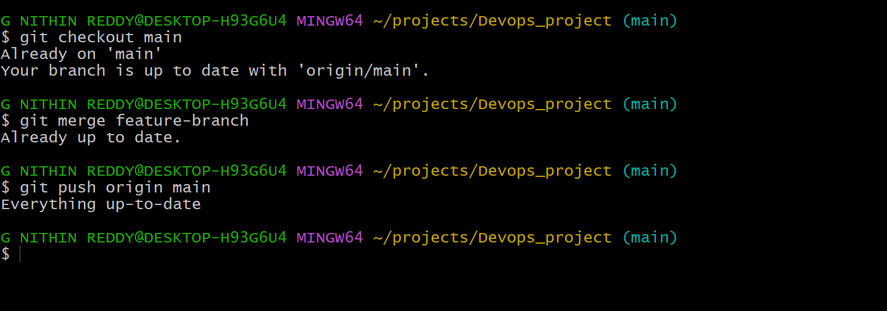
Explanation
I switched back to the main branch, then merged feature-branch into main using git merge. Git combined both histories. The commit from feature-branch (sample.txt) is now part of the main branch locally. You can then push this merged main to remote.
Prerequisites:
- Feature branch with commits
- Clean working directory
Step-by-Step Implementation:
Step 1: Switch to Main
git checkout main
Step 2: Merge Branch
git merge feature-branch
Step 3: Push Merged Main
git push origin main
Validation:
git log shows feature-branch commits merged into main history.

- Merge the created branch with master in github by sending a pull request.
Outcome:
A Pull Request is created and merged on GitHub, integrating the branch into main.
Objective:
To follow the industry-standard code review process before merging code to production branch.
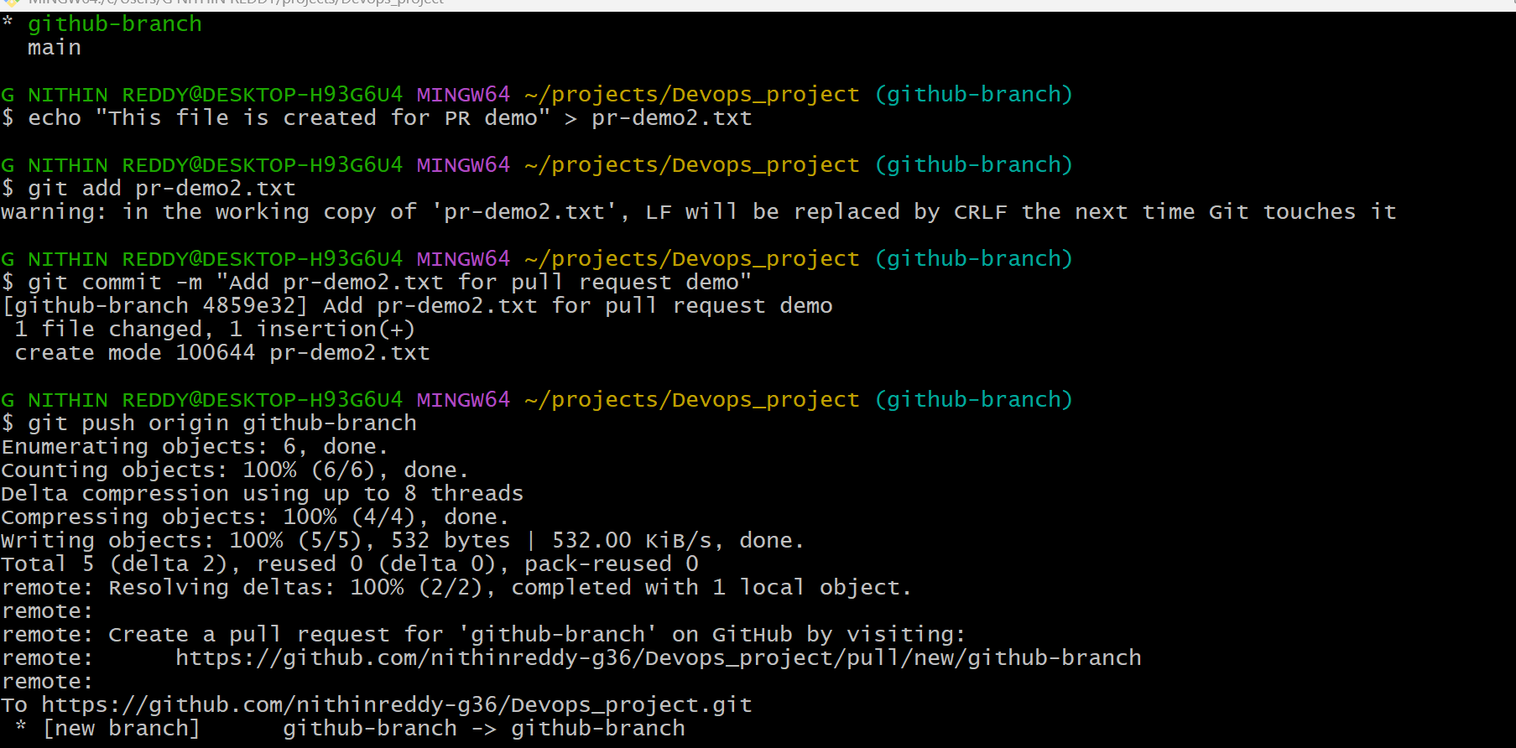
Prerequisites:
- Branch pushed to GitHub with changes
Step-by-Step Implementation:
Step 1: Open Pull Request
GitHub Repo → "Pull Requests" tab → Click "New Pull Request"
→ Base: main ← Compare: feature-branch
Step 2: Add Details
Add Title and Description → Click "Create Pull Request"
Step 3: Merge
Review changes → Click "Merge Pull Request" → Confirm Merge
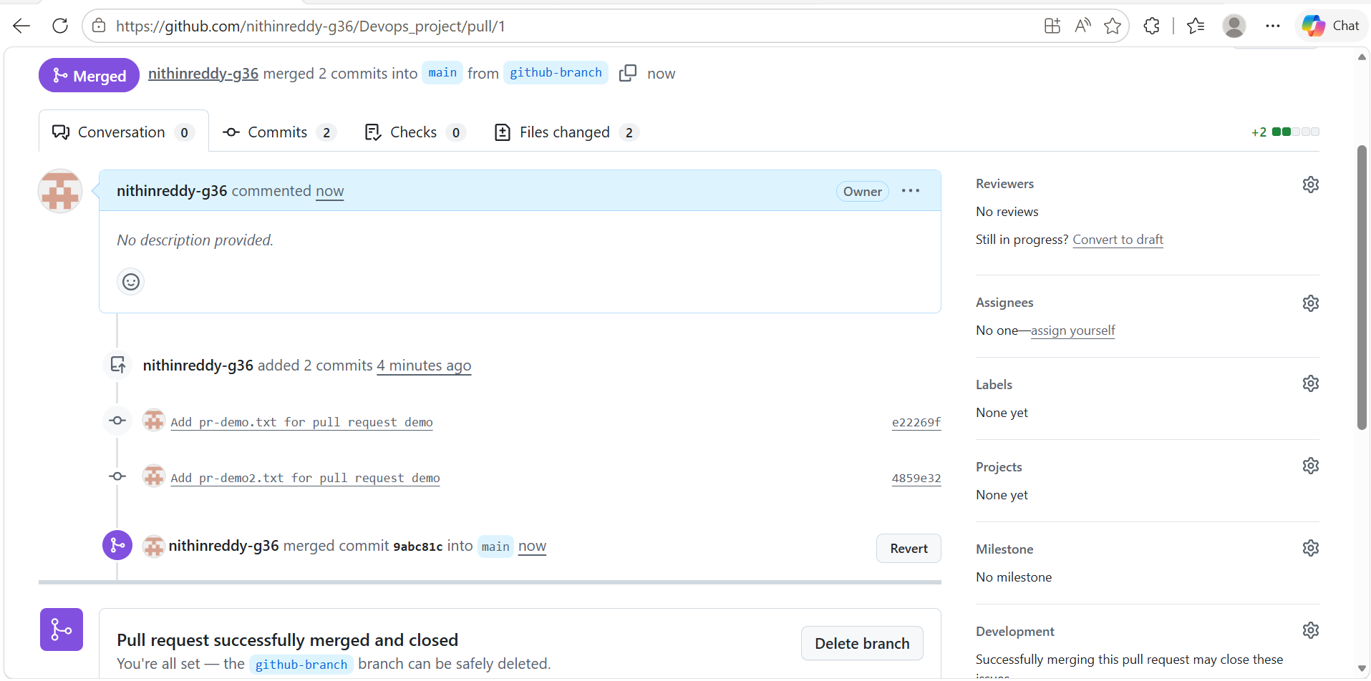
* GitHub, opened a Pull Request (PR) from github-branch into main, added a title and description, and clicked Merge Pull Request. GitHub merged the branch into main. This is the standard team workflow for code review and merging.
Validation:
PR shows "Merged" status. main branch now contains feature-branch commits.
- Create a file in local and send that to branch in github.
Outcome:
A locally created file is committed and pushed to a specific remote branch (not main).
Objective:
To send changes to a particular remote branch for isolated testing or feature work.
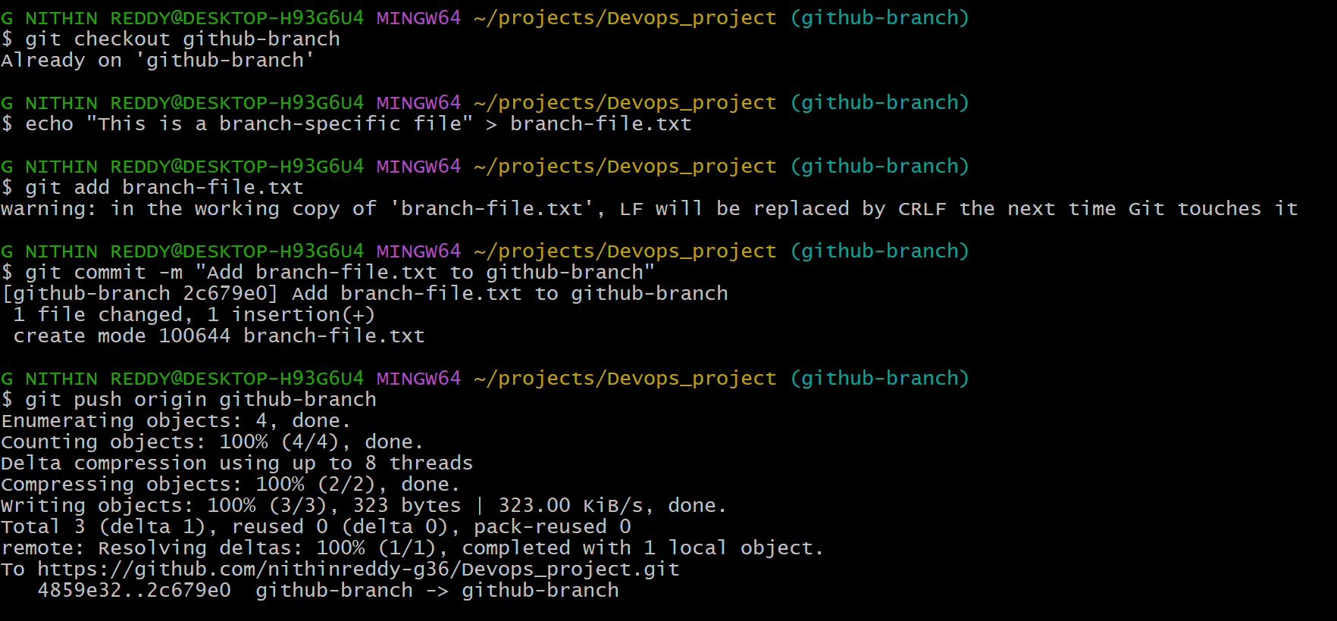
Explanation
I switched to github-branch locally, created a new file called branch-file.txt, staged and committed it, then pushed only that branch to the remote. The file appears in GitHub under the github-branch branch, not in main.
Prerequisites:
- Remote branch already exists on GitHub
Step-by-Step Implementation:
Step 1: Switch to Target Branch
git checkout feature-branch
Step 2: Create File and Commit
touch newfile.txt
git add newfile.txt
git commit -m "Add newfile to feature-branch"
Step 3: Push to Specific Branch
git push origin feature-branch
Validation:
GitHub shows newfile.txt inside feature-branch only, not in main.

- Clone only a branch from github to local.
Outcome:
Only one specific branch is cloned locally instead of the full repository.
Objective:
To save bandwidth and time when only a specific branch is needed for work.
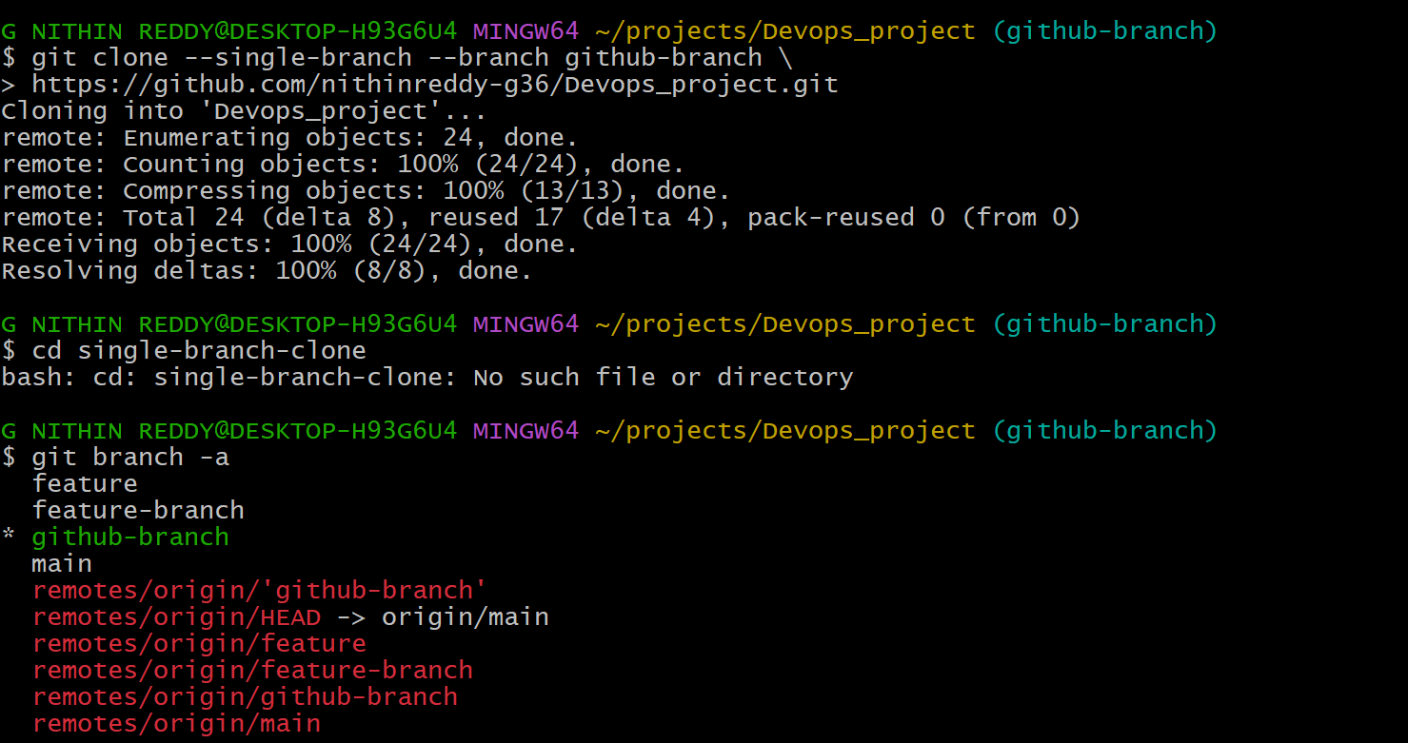
Explanation
I cloned only the github-branch from GitHub into a new local folder called single-branch-clone using the --single-branch and --branch flags. This is useful when a repo is large and you only need one branch. Only that branch's history is downloaded.
Prerequisites:
- Repository with multiple branches on GitHub
Step-by-Step Implementation:
Step 1: Clone Single Branch
git clone --single-branch --branch feature-branch https://github.com/username/my-project.git
Validation:
git branch shows only "feature-branch". Other branches not present locally.

- Create a file with all passwords and make that untrackable with git.
Outcome:
A passwords file is created but Git does not track or push it to remote.
Objective:
To prevent sensitive credentials from being accidentally committed to version control.
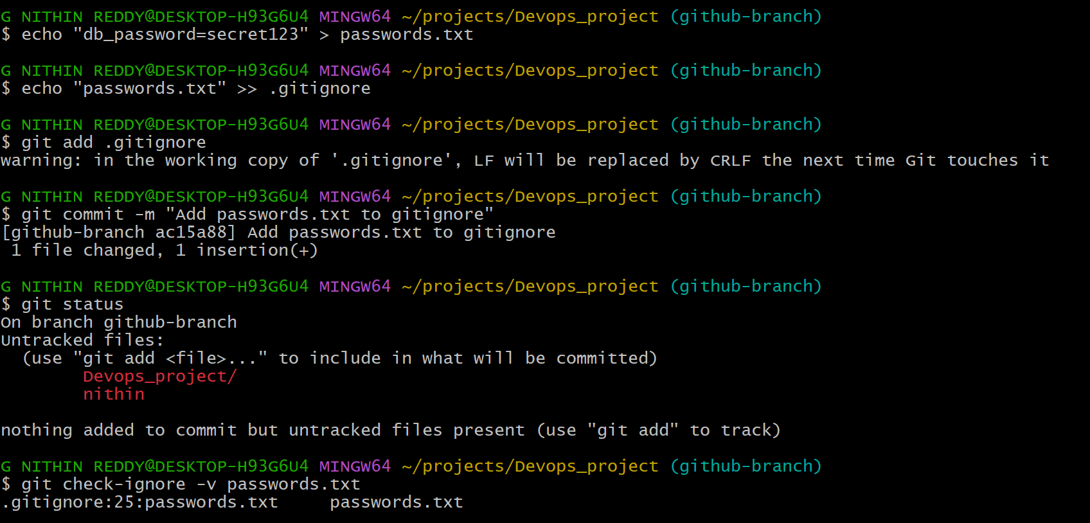
Explanation
I created a file called passwords.txt with sensitive data, then added it to the .gitignore file so Git will never track or commit it. Even after running git add ., passwords.txt will not be staged. This is the correct security practice for secrets and credentials.
Prerequisites:
- Local Git repository
Step-by-Step Implementation:
Step 1: Create Sensitive File
touch passwords.txt
echo "DB_PASS=secret123" > passwords.txt
Step 2: Add to .gitignore
echo "passwords.txt" >> .gitignore
Step 3: Verify Ignored
git status
(passwords.txt should NOT appear in untracked files)
Step 4: Commit .gitignore
git add .gitignore
git commit -m "Add passwords.txt to gitignore"
git push origin main
Validation:
git status does not show passwords.txt. File exists locally but never pushed to GitHub.

- Make a commit and make that commit reset without savings changes.
Outcome:
A commit is undone completely, with all changes removed from working directory.
Objective:
To discard a bad commit and all its changes as if it never happened.
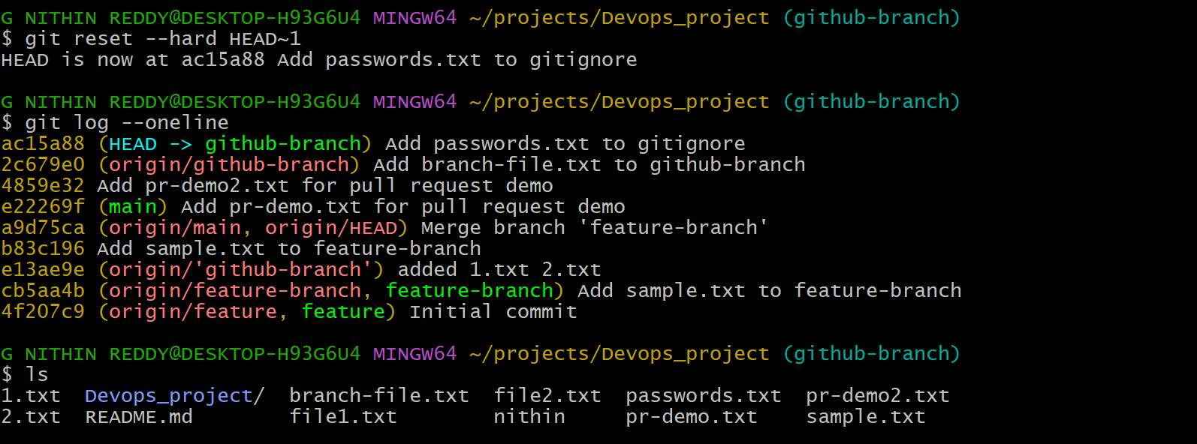
Explanation
I created a test commit, then used git reset --hard HEAD~1 to completely undo it. The --hard flag removes both the commit from history AND discards all file changes. The working directory is clean as if the commit never happened. Use with caution — changes are permanently lost.
Prerequisites:
- A commit made locally
Step-by-Step Implementation:
Step 1: Make a Test Commit
echo "bad code" > bad.txt
git add bad.txt
git commit -m "Bad commit"
Step 2: Hard Reset
git reset --hard HEAD~1
Validation:
git log no longer shows "Bad commit". bad.txt no longer exists in working directory.
Explanation: --hard resets staging area and working directory. All changes are permanently discarded. Use carefully — data cannot be recovered.
Real-Time Use Case:
Developers hard reset when they commit broken code locally that should never have existed.
Common Errors:
Error | Cause | Resolution
Lost important changes | Wrong reset type | Use --soft or --mixed to keep changes

- Revert a commited commit to the older version.
Outcome:
A previous commit is reversed by creating a new "revert" commit, preserving history.
Objective:
To safely undo a pushed commit without rewriting history, keeping the audit trail intact.
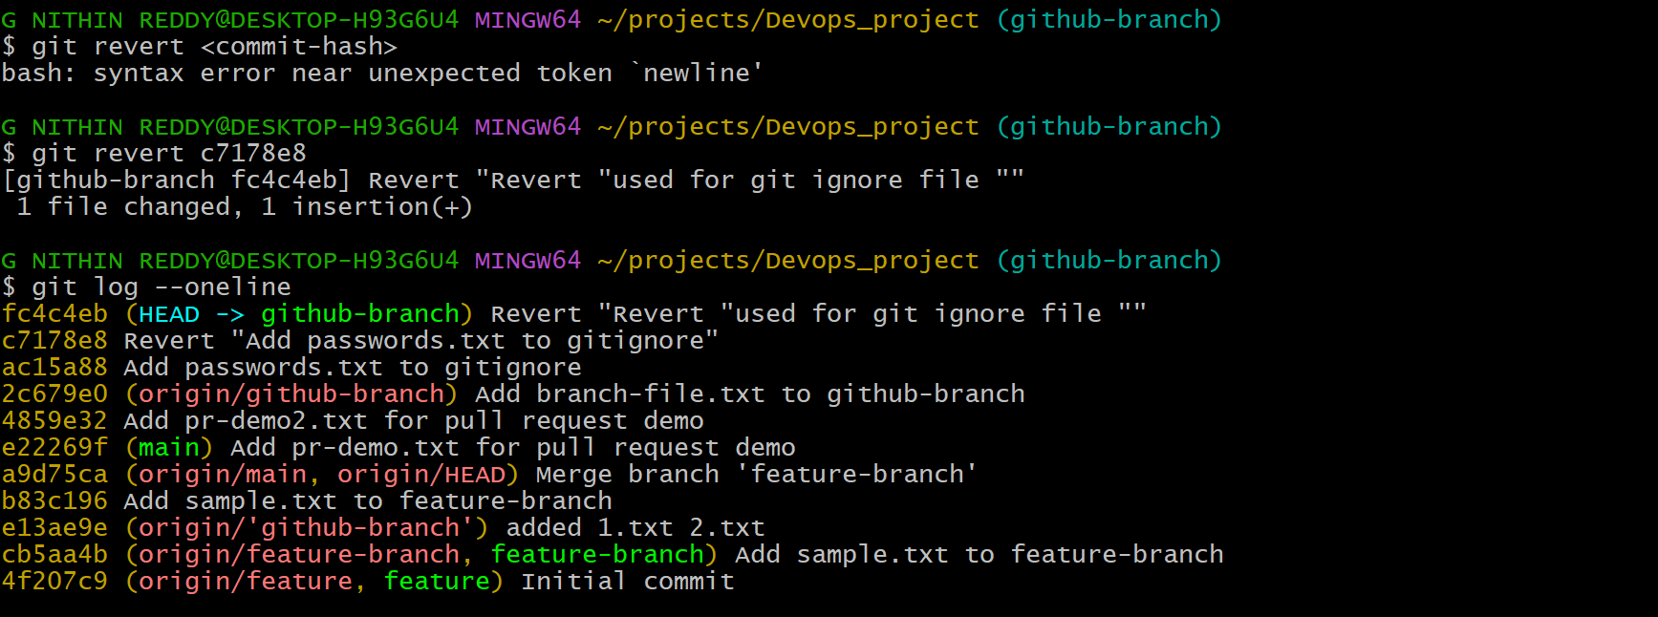
Explanation
used git revert to safely undo a specific commit by creating a new 'undo' commit. Unlike reset, revert is safe for shared/remote branches because it preserves history. Git creates a new commit that reverses the changes of the target commit.
Prerequisites:
- Commit already pushed to remote
Step-by-Step Implementation:
Step 1: Find Commit Hash
git log --oneline
Step 2: Revert Commit
git revert <commit-hash>
Step 3: Push Revert
git push origin main
Validation:
git log shows a new "Revert" commit. Original commit still visible in history.
Real-Time Use Case:
When a bug is introduced in production via a commit, teams use git revert to roll back safely without losing commit history.
Common Errors:
Error | Cause | Resolution
Conflict during revert | Complex changes | Resolve conflicts manually and commit

- Push a file to stash without savings the changes and work on another file.
Outcome:
Uncommitted work is saved to stash and working directory is cleaned for other work.
Objective:
To temporarily shelve work-in-progress changes and switch tasks without committing incomplete code.
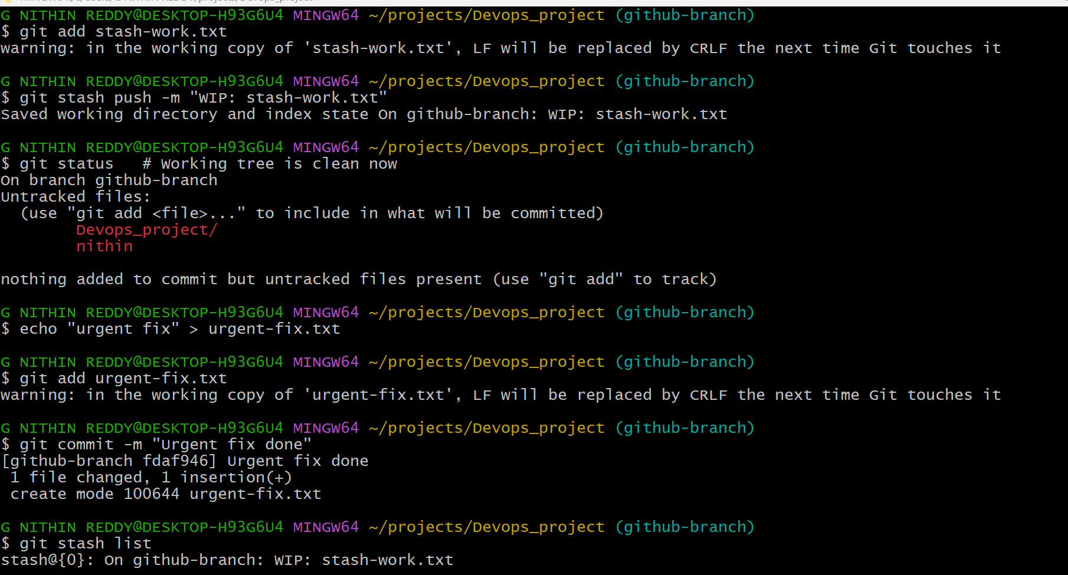
Explanation
I worked on stash-work.txt but needed to switch context. You used git stash to temporarily save those uncommitted changes away (off your working directory). Then you created and committed another file (urgent-fix.txt) without interference. Your stashed work is safely stored.
Prerequisites:
- Uncommitted changes in working directory
Step-by-Step Implementation:
Step 1: Make Some Changes
echo "WIP code" > wip.txt
git add wip.txt
Step 2: Stash Changes
git stash
Step 3: Work on Another File
touch urgent.txt
git add urgent.txt
git commit -m "Urgent fix"
Validation:
git status is clean. git stash list shows "stash@{0}".
Real-Time Use Case:
A developer stashes ongoing work when an urgent production bug needs to be fixed immediately on the same branch.

- Undo the stash file and start working on that again
Outcome:
Stashed changes are restored to working directory and development continues.
Objective:
To resume previous work after completing the interrupting task.
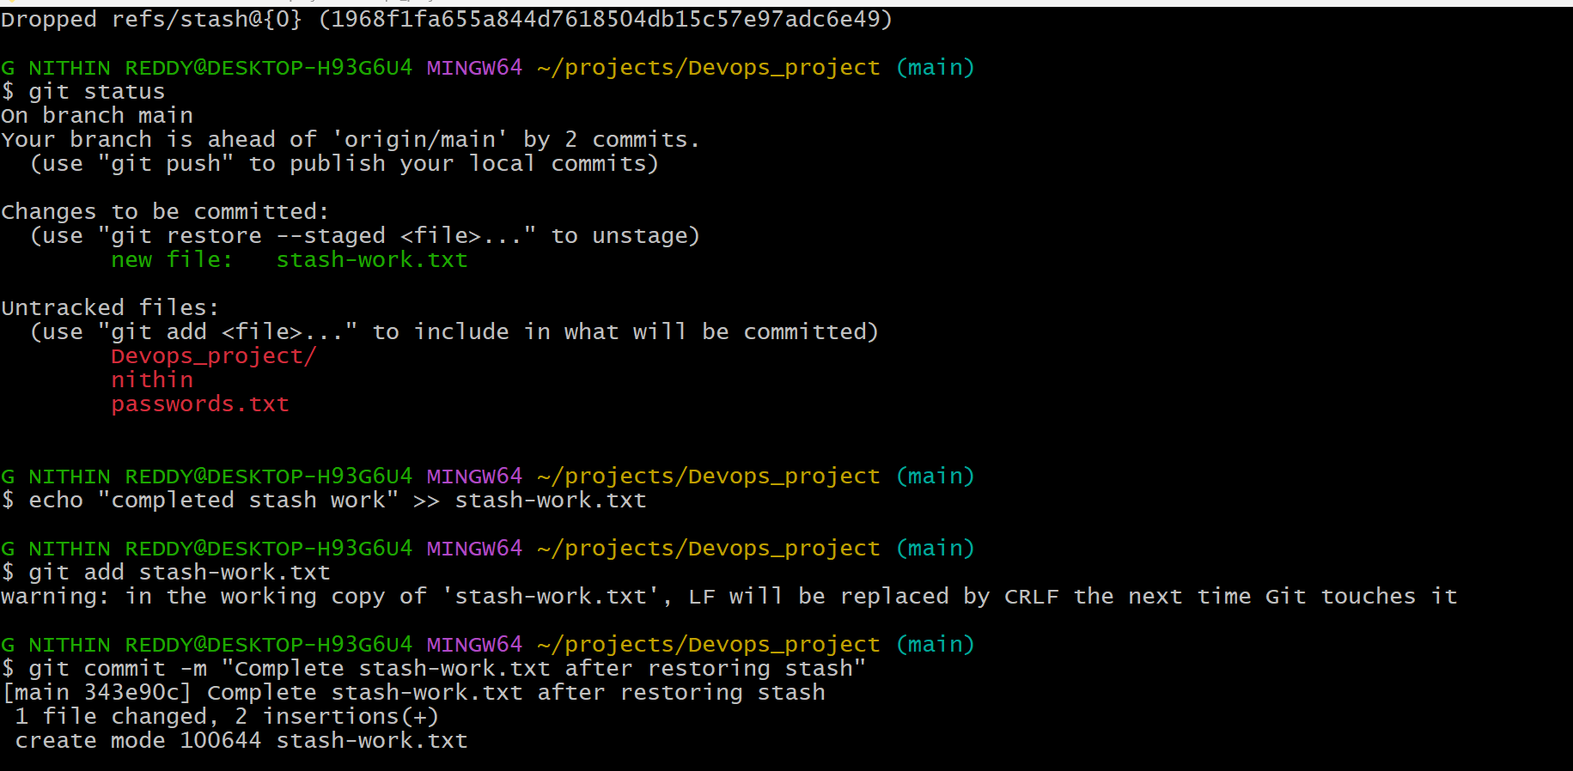
Explanation
I used git stash pop to bring back your stashed changes (stash-work.txt). The file and its staged state are restored to your working directory exactly as you left them. You can now continue editing, then stage and commit as normal. git stash pop removes it from the stash list.
Prerequisites:
- Stash exists (git stash list not empty)
Step-by-Step Implementation:
Step 1: View Stash List
git stash list
Step 2: Apply Stash
git stash pop
Validation:
wip.txt reappears in working directory with original changes. git stash list is now empty.
Real-Time Use Case:
After fixing the urgent bug, a developer pops the stash to resume their feature development seamlessly.
Common Errors:
Error | Cause | Resolution
Conflict on pop | Branch changed since stash | Resolve conflicts manually

- Generate a ssh-keygen and configure into github.
Outcome:
SSH key pair generated and public key added to GitHub for passwordless authentication.
Objective:
To enable secure, password-free Git operations using SSH key authentication.
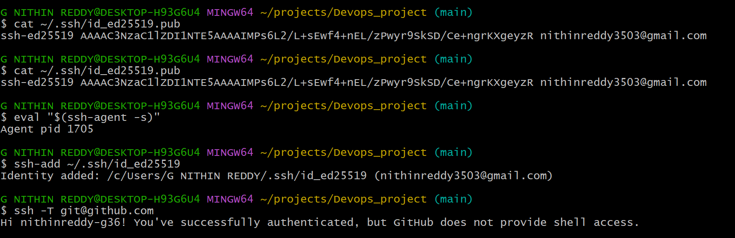
Explanation
I generated an SSH key pair using ssh-keygen. The private key stays on your machine; the public key was added to GitHub under Settings → SSH and GPG Keys. You tested the connection with ssh -T git@github.com. Now you can push/pull without entering your password every time.
Prerequisites:
- Git installed
- GitHub account
Step-by-Step Implementation:
Step 1: Generate SSH Key
ssh-keygen -t ed25519 -C "you@email.com"
(Press Enter for all prompts)
Step 2: Copy Public Key
cat ~/.ssh/id_ed25519.pub
(Copy the output)
Step 3: Add to GitHub
GitHub → Settings → SSH and GPG Keys → New SSH Key
→ Paste key → Click "Add SSH Key"
Step 4: Test Connection
ssh -T git@github.com
Validation:
Terminal shows: "Hi username! You've successfully authenticated."
Real-Time Use Case:
DevOps engineers configure SSH keys on build servers and CI/CD agents so automated pipelines can push/pull without passwords.
Common Errors:
Error | Cause | Resolution
Permission denied (publickey) | Key not added to GitHub | Re-add key or check SSH agent

- Configure webhooks to github.
Outcome:
A webhook is configured on GitHub to send HTTP POST notifications on repository events.
Objective:
To automate triggering of external services (CI/CD, Slack, Jenkins) when code changes occur.
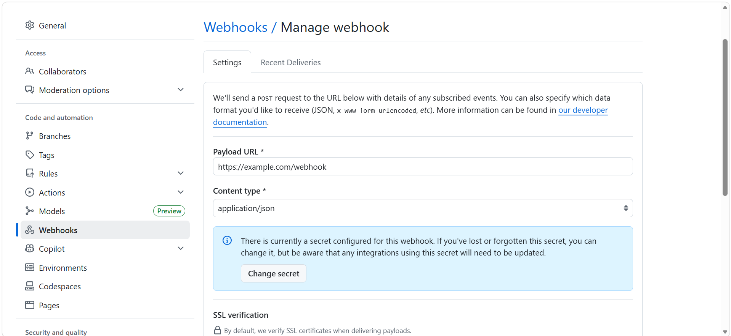
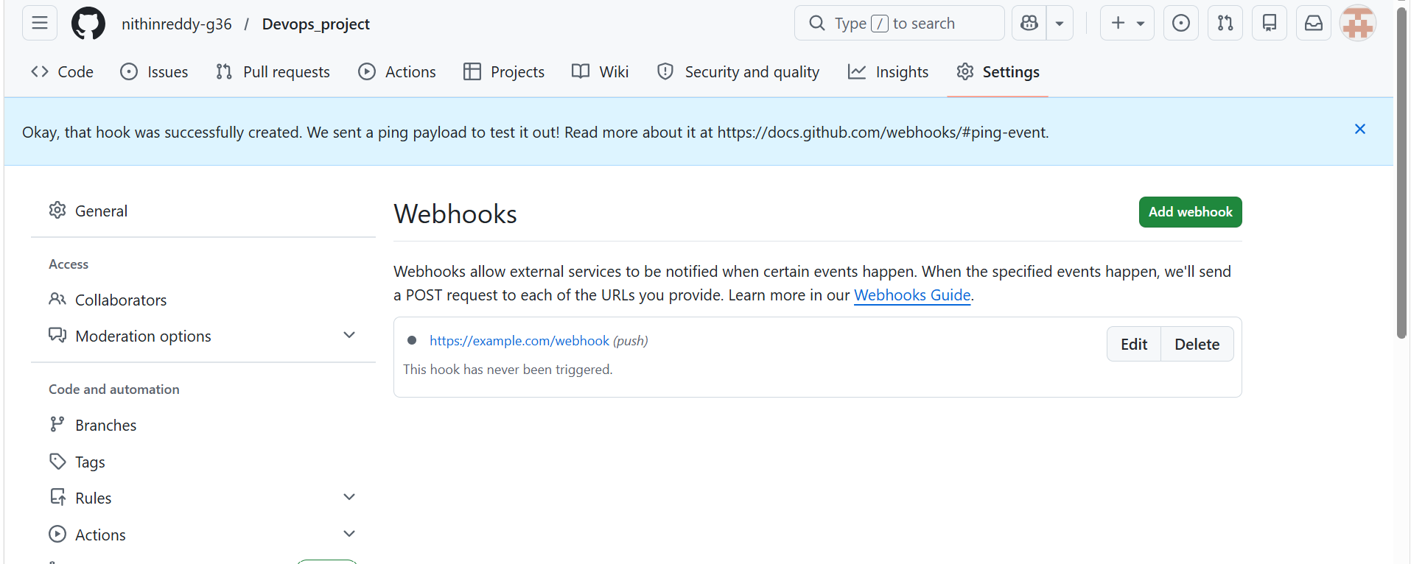
Explanation
I configured a webhook in your GitHub repository so that GitHub sends an HTTP POST request to your server URL whenever specific events (like a push) happen. This is used for CI/CD, notifications, or deployment automation. You set the payload URL, content type, and selected events.
Prerequisites:
- GitHub repository
- A server/endpoint URL to receive webhook (e.g., Jenkins, RequestBin)
Step-by-Step Implementation:
Step 1: Open Webhook Settings
GitHub Repo → Settings → Webhooks → Add Webhook
Step 2: Configure Webhook
Parameter | Value
Payload URL | https://your-server.com/webhook
Content Type | application/json
Events | Just the push event / All events
Active | ✅ Checked
Step 3: Save
Click "Add Webhook"
Validation:
Webhook appears in list with green checkmark after first delivery test.
Real-Time Use Case:
Organizations configure webhooks to trigger Jenkins pipelines, Slack alerts, or deployment scripts automatically on every code push.
Common Errors:
Error | Cause | Resolution
Delivery failed | Server not reachable | Check URL and firewall/port settings

- Basic understanding of .git file.
Outcome:
The structure and purpose of the .git directory is understood and explored.
Objective:
To understand how Git internally stores commits, branches, configs, and history.
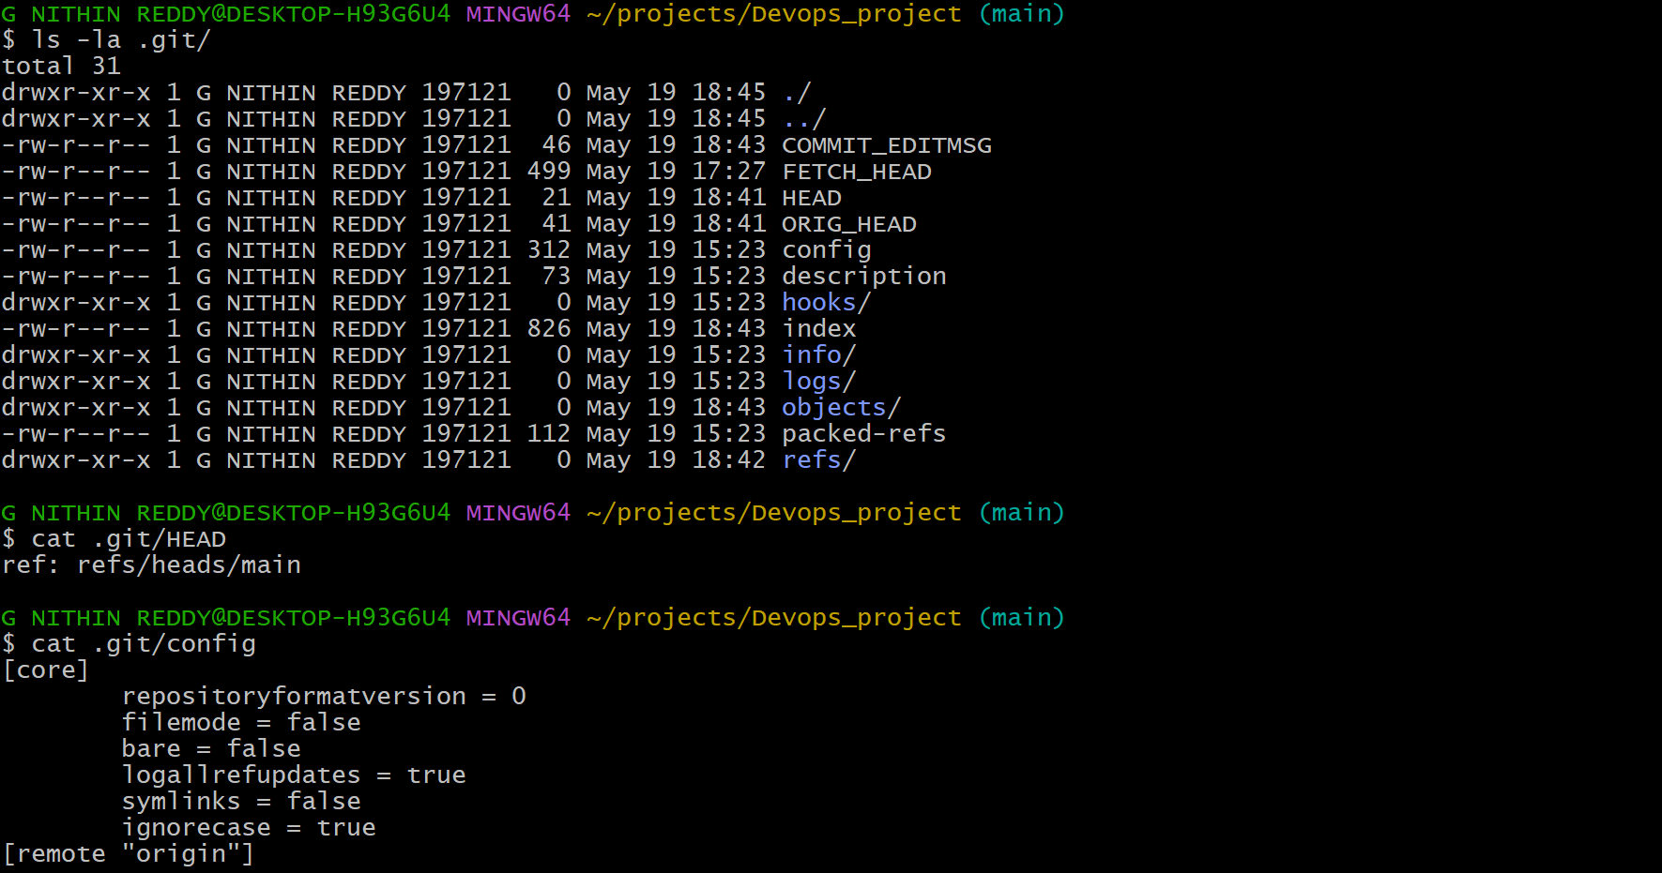
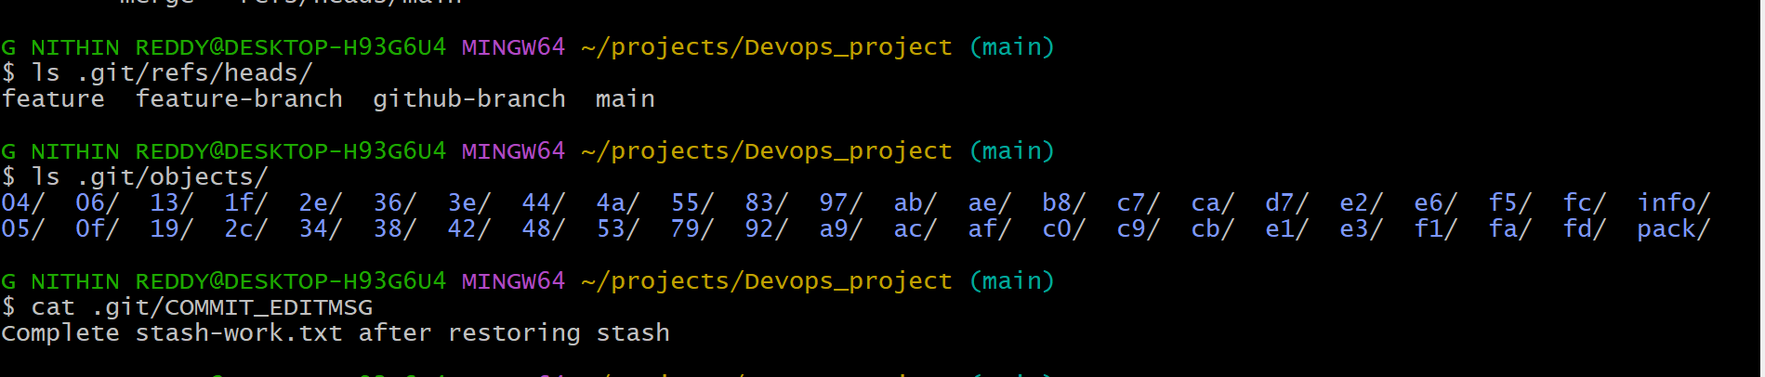
Explanation
I explored the hidden .git folder inside your repository. This folder is Git's brain — it stores all commit history, branch references, config, staging index, and objects. Understanding it helps you know what happens under the hood when you run any git command.
Prerequisites:
- A local Git repository
Step-by-Step Implementation:
Step 1: View .git Folder
ls -la .git/
Step 2: Explore Key Files
File/Folder | Purpose
HEAD | Points to current branch
config | Local repo configuration
objects/ | All file content (blobs, trees, commits)
refs/heads/ | Local branch pointers
refs/remotes/ | Remote branch pointers
COMMIT_EDITMSG | Last commit message
index | Staging area snapshot
Step 3: Read HEAD
cat .git/HEAD
→ ref: refs/heads/main
Validation:
All key files and directories are visible and readable inside .git/

- Check all the logs of git.
Outcome:
Complete commit history and detailed logs are viewed using various git log commands.
Objective:
To review project history, audit changes, and trace when and by whom changes were made.
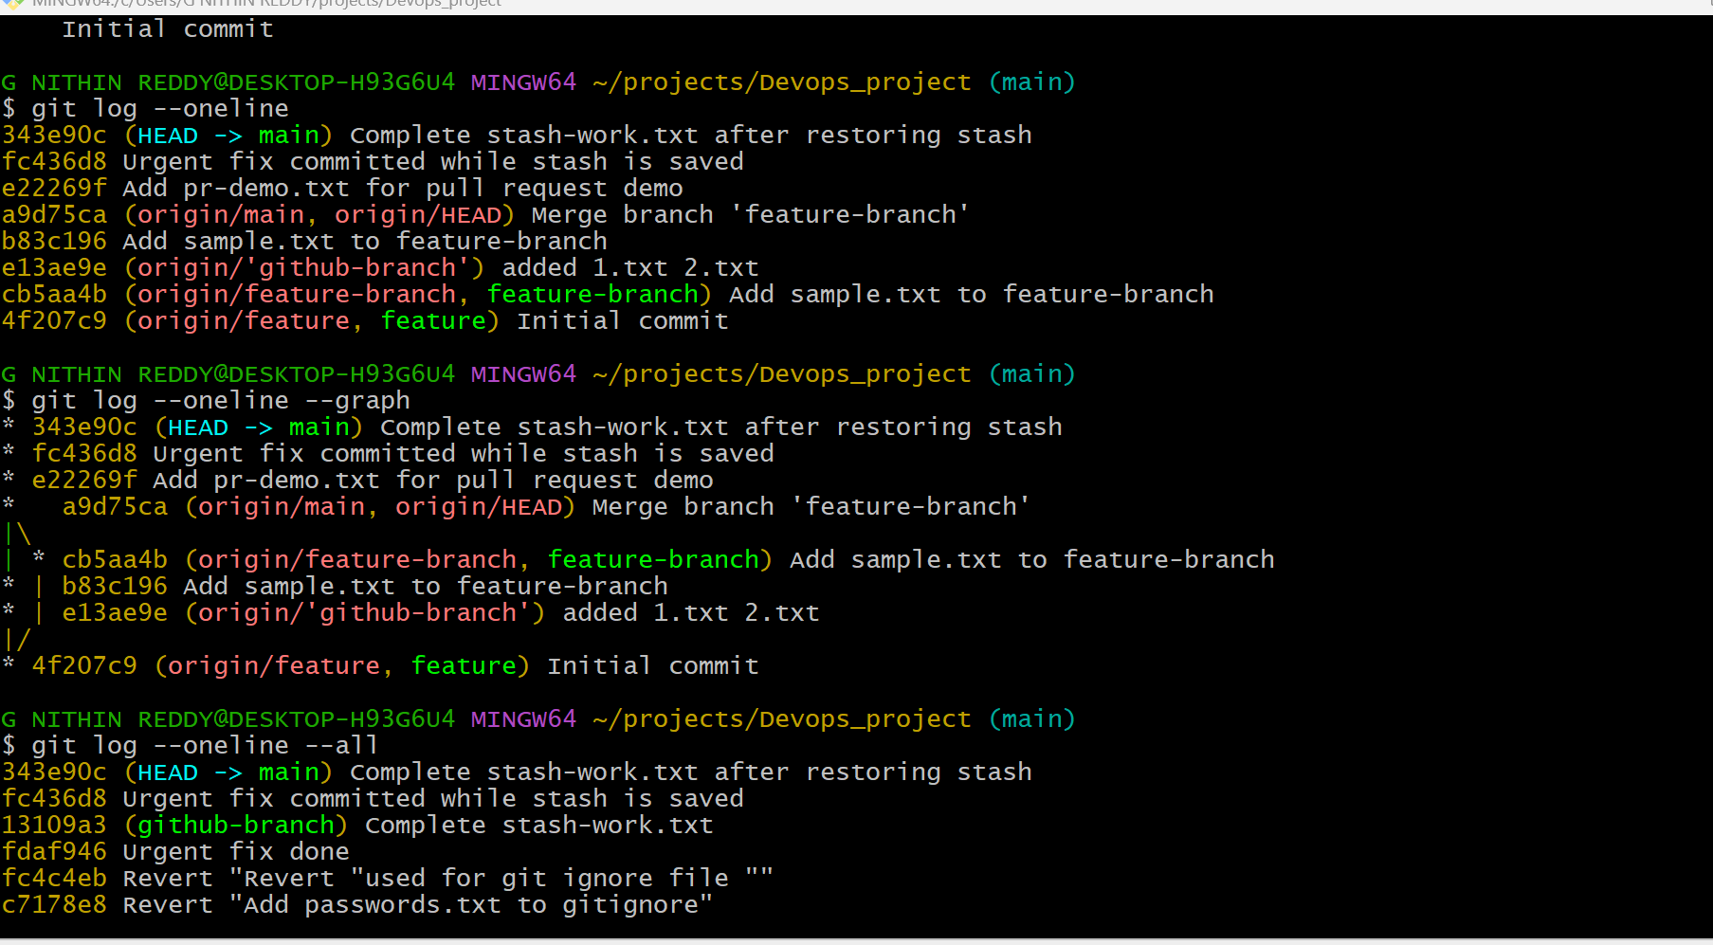
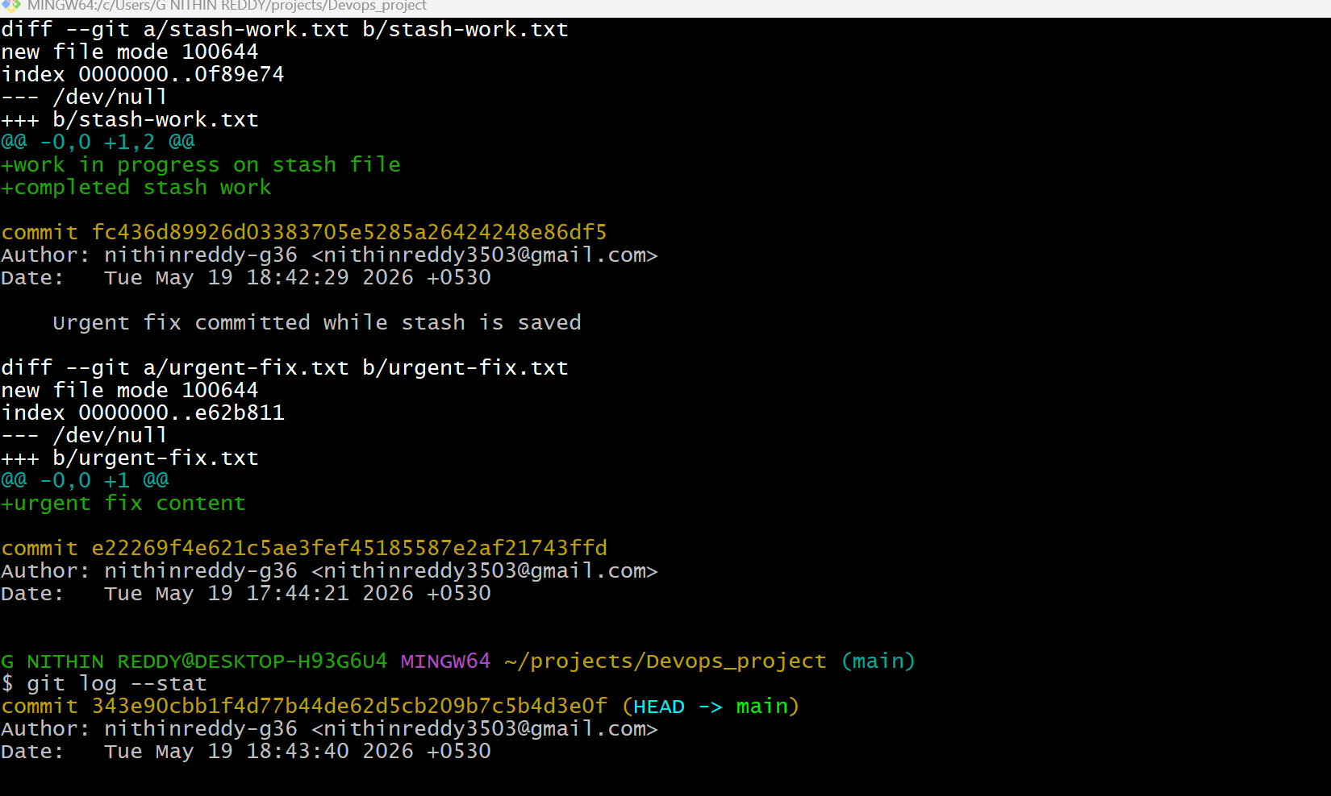
Explanation
I used various forms of git log to view commit history. git log --oneline shows a compact view. --graph shows branch merges visually. --author filters by person. --since filters by date. These are essential for auditing changes and understanding project history.
Prerequisites:
- Repository with multiple commits
Step-by-Step Implementation:
Step 1: Basic Log
git log
Step 2: One-line Compact Log
git log --oneline
Step 3: Graph View
git log --oneline --graph --all
Step 4: Log for a Specific File
git log -- file1.txt
Step 5: Log by Author
git log --author="Your Name"
Validation:
All commits displayed with hash, author, date, and message.

- Rename the commit message.
Outcome:
The most recent commit message is corrected to a new message.

Objective:
To fix typos or improve clarity of commit messages before or after pushing (for local commits).
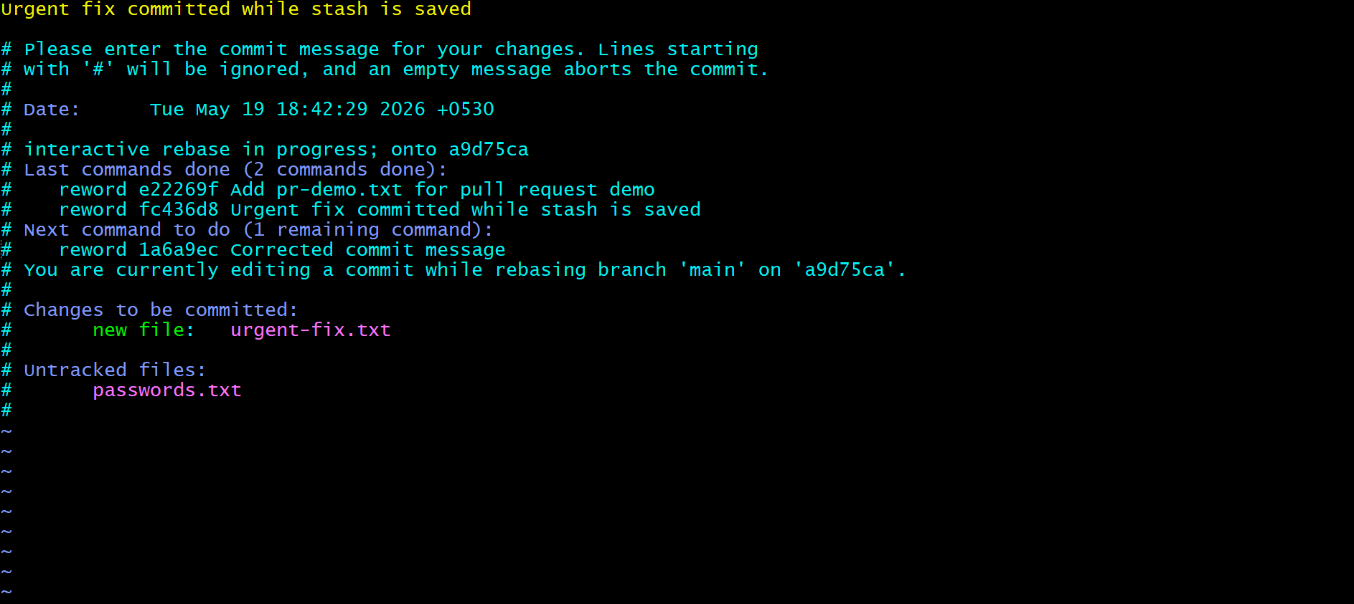
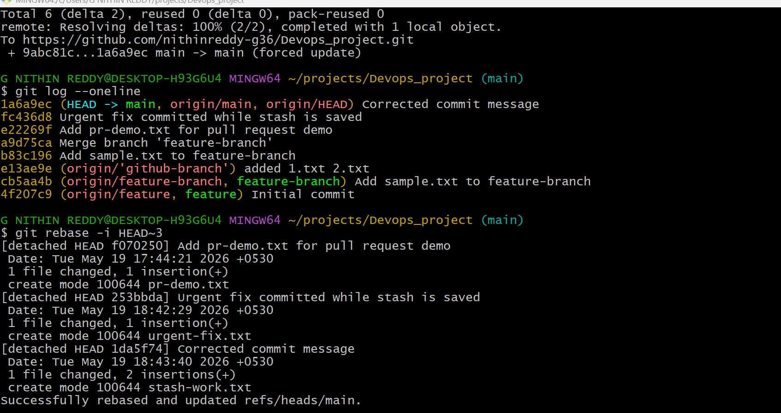
Explanation
I renamed the most recent commit message using git commit --amend. This replaces the last commit with a new one with the corrected message. For older commits, you used interactive rebase. Note: if already pushed, you must force push with caution.
Prerequisites:
- At least one commit in history
Step-by-Step Implementation:
Step 1: Amend Last Commit Message
git commit --amend -m "Corrected commit message"
Step 2: Force Push (if already pushed)
git push origin main --force
Validation:
git log --oneline shows updated commit message.
Real-Time Use Case:
Developers amend commit messages to follow team naming conventions like "feat:", "fix:", "chore:" before code review.
Common Errors:
Error | Cause | Resolution
Rejected on push | History rewritten | Use --force-with-lease for safer force push

- merge multiple commits into single commit
Outcome:
Multiple commits are squashed into one clean commit in the branch history.
Objective:
To create a clean, readable commit history before merging a feature branch into main.
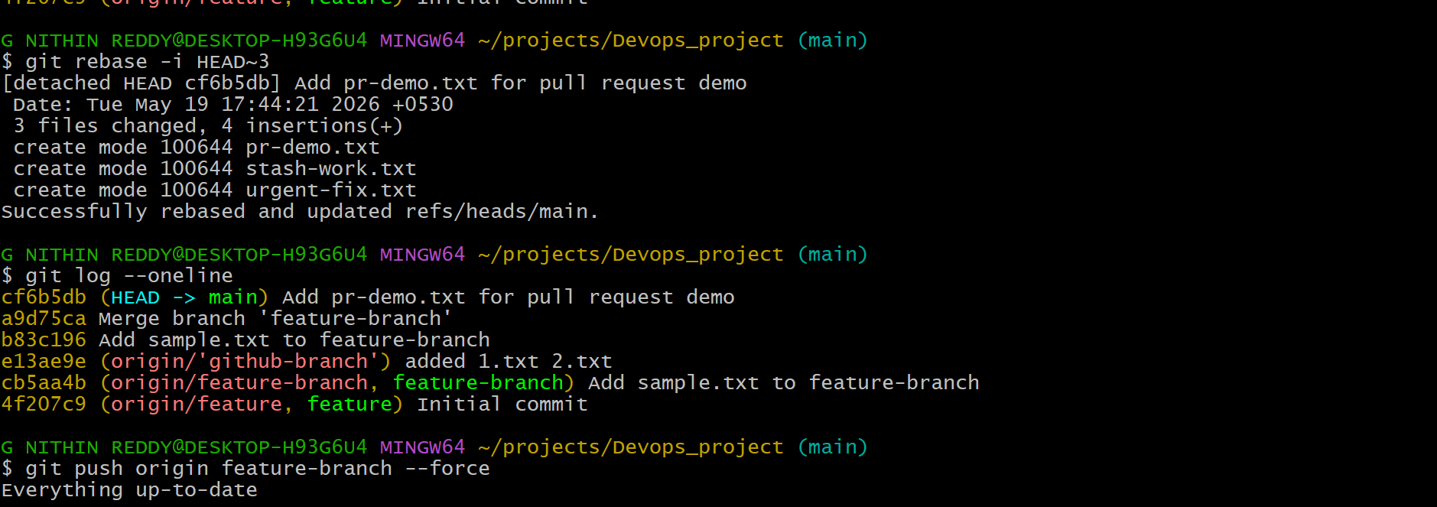
Explanation
I used interactive rebase to squash the last 3 commits into one clean commit. This is common before merging a feature branch — it keeps the main branch history clean and readable. Each 'squash' commit gets folded into the one above it, and you write a single combined commit message.
Prerequisites:
- Branch with multiple commits
Step-by-Step Implementation:
Step 1: Interactive Rebase (last 3 commits)
git rebase -i HEAD~3
Step 2: Edit the Rebase File
In the editor that opens:
- First commit: keep as "pick"
- Others: change "pick" to "squash" (or "s")
Save and close.
Step 3: Edit Final Commit Message
Combined message editor opens → Write clean final message → Save
Step 4: Push
git push origin feature-branch --force
Validation:
git log --oneline shows all previous commits replaced by a single clean commit.
Real-Time Use Case:
Before merging a PR, developers squash 10+ WIP commits into one meaningful commit like "feat: Add user authentication module" to keep main branch history clean.
Common Errors:
Error | Cause | Resolution
Rebase conflict | File changed in multiple commits | Resolve each conflict, then git rebase --continue
Push rejected | History rewritten | Use --force or --force-with-lease

