Docker-02
Task 1: Create a Tomcat Container on Port 8080 and Deploy a Sample Application.
Objective
To create and run an Apache Tomcat Docker container on port 8080, deploy a sample web application (WAR file) inside the Tomcat server, and verify that the application is accessible through a web browser.
What is Apache Tomcat?
Apache Tomcat is an open-source Java Servlet container and web server used to deploy Java web applications (WAR files).
In Docker, Tomcat runs inside a container, eliminating the need to install Tomcat directly on the operating system.
What is a WAR File?
A WAR (Web Application Archive) file is a packaged Java web application that contains:
- HTML
- JSP pages
- Servlets
- Java classes
- Configuration files
- Libraries
Tomcat deploys .war files automatically when they are placed in the webapps directory.

Prerequisites
Before starting this task, ensure:
- Docker is installed and running.
- Tomcat Docker image is available locally.
- Internet connection is available.
- Port 8080 is free.
- If using EC2, TCP Port 8080 is allowed in the Security Group.
Implementation Steps
- Connected to the Ubuntu EC2 instance using SSH.
- Verified whether the Tomcat Docker image was available using docker images.
- Pulled the Tomcat Docker image from Docker Hub using docker pull tomcat (if not available locally).
- Stopped the Jenkins container temporarily to free up port 8080 using docker stop jenkins.
- Created and started the Tomcat container on port 8080 using docker run -d --name tomcat-container -p 8080:8080 tomcat.
- Verified that the Tomcat container was running successfully using docker ps.
- Checked the Tomcat container logs using docker logs tomcat-container and confirmed the server started successfully.
- Downloaded the sample WAR application file to the EC2 instance.
- Copied the sample WAR file into the Tomcat container's webapps directory using docker cp.
- Allowed Tomcat to automatically deploy the WAR file.
- Verified the deployment by checking the webapps directory inside the container using docker exec.
- Accessed the sample application through the browser using http://<EC2-Public-IP>:8080/<application-name>/.
- Confirmed that the sample application was successfully deployed and accessible through the Tomcat web server.
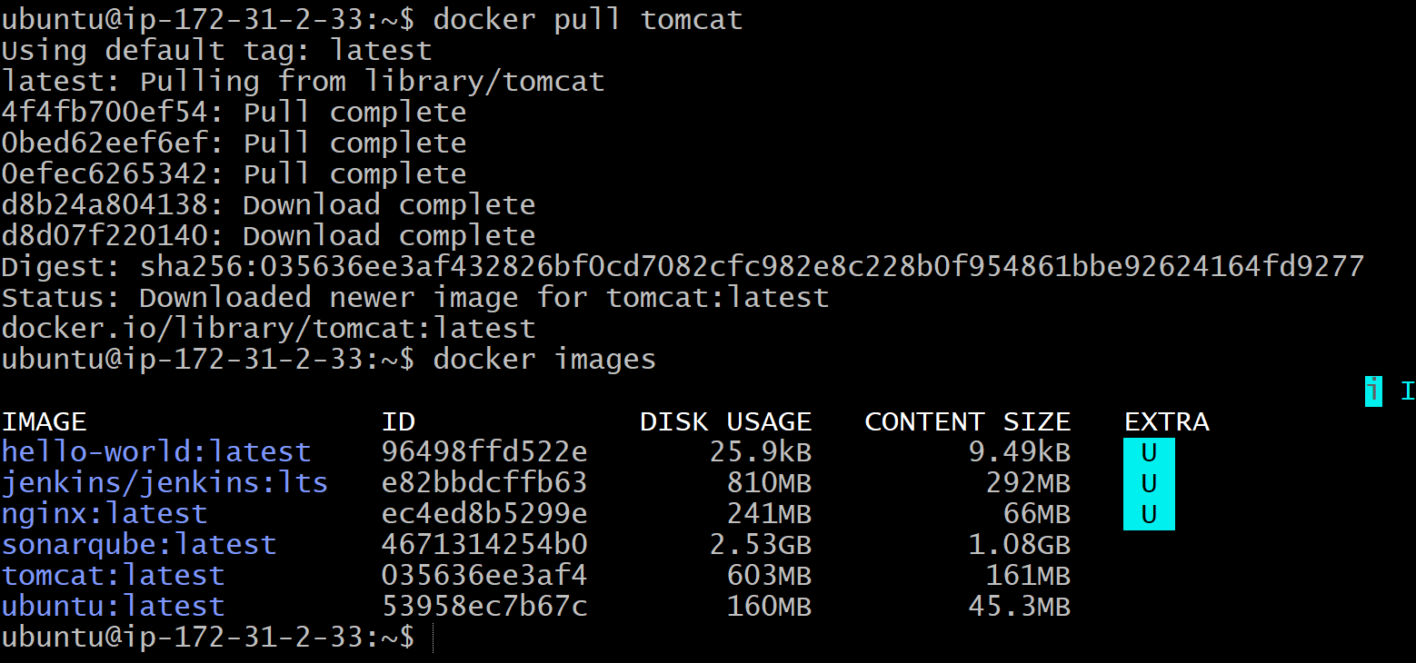

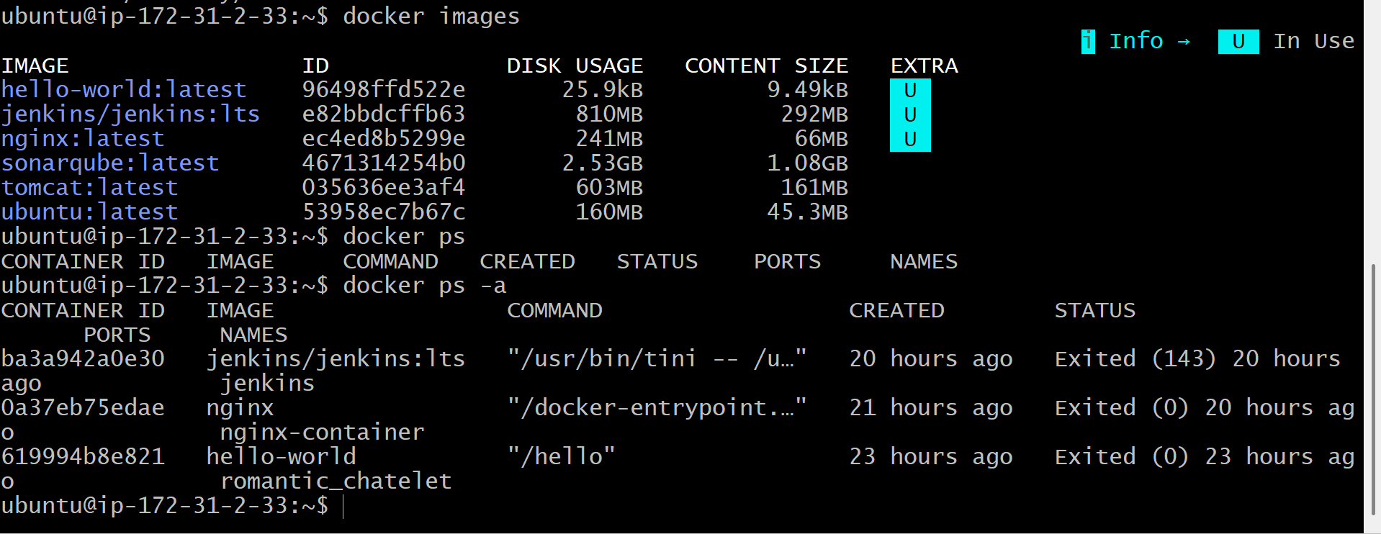
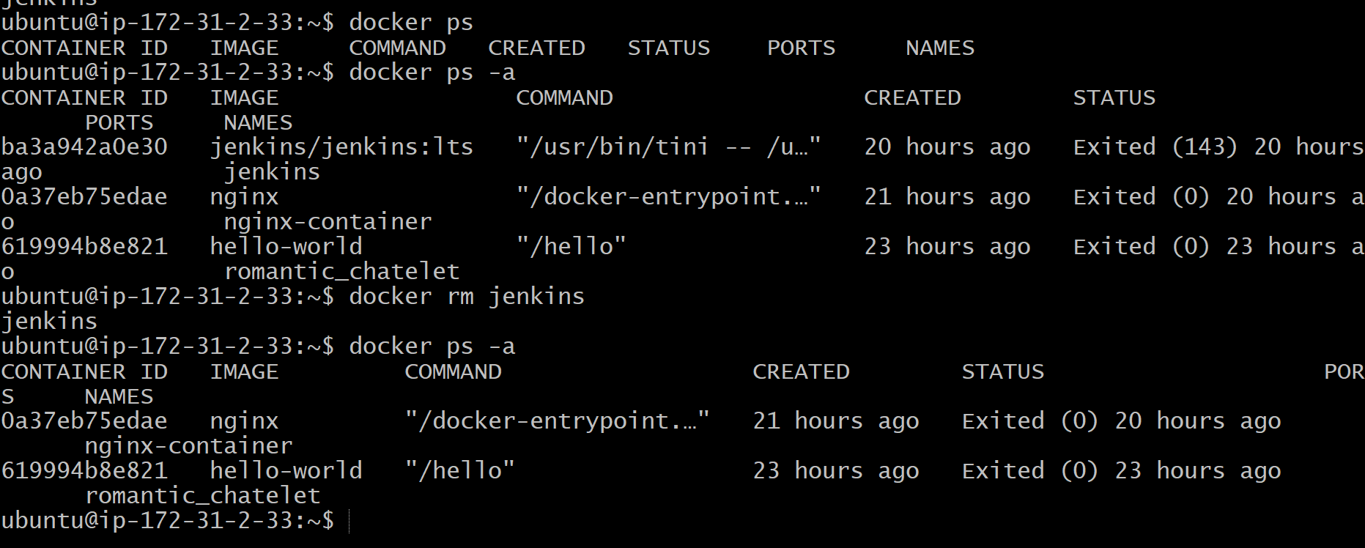

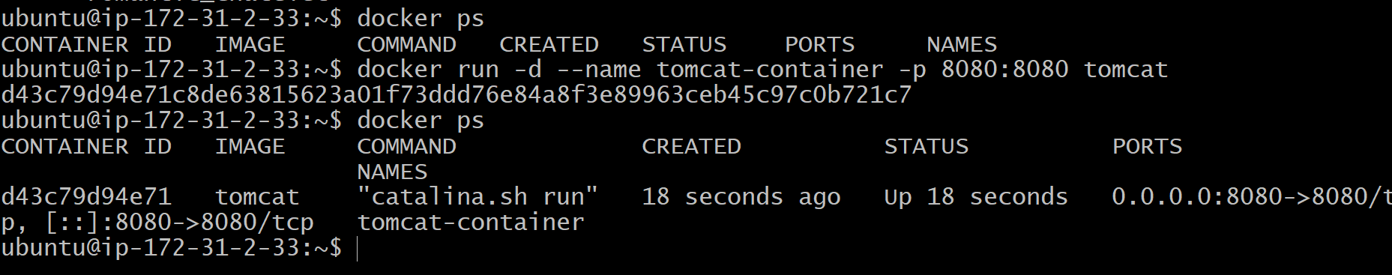
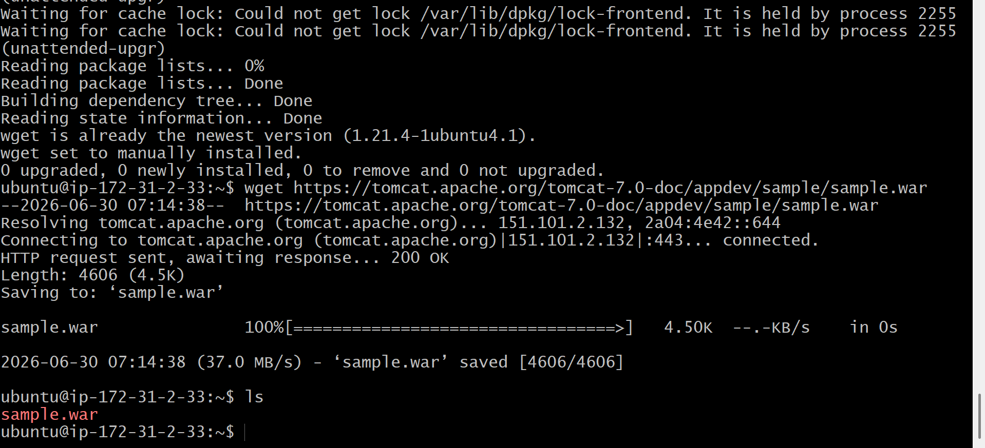
Validation Points
- Tomcat image is available locally.
- Tomcat container is created successfully.
- Container is running on port 8080.
- Tomcat home page is accessible in the browser.
- Sample WAR file is copied successfully.
- Tomcat automatically deploys the WAR file.
- Sample application is accessible through the browser.

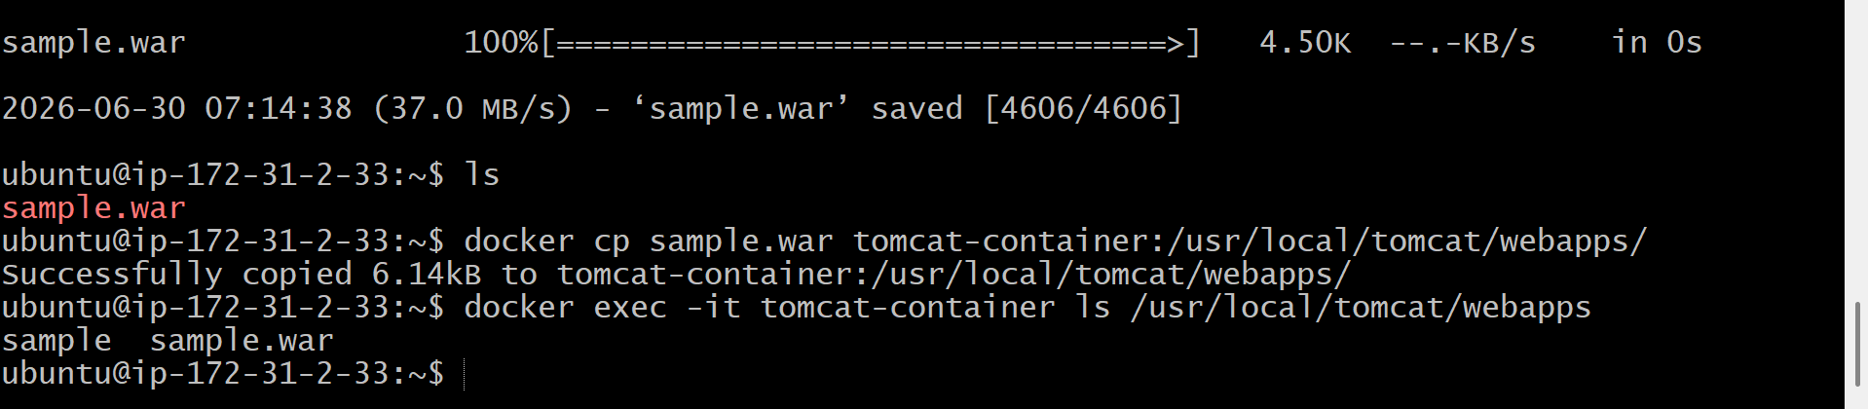
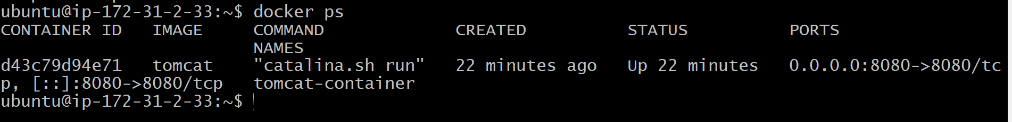
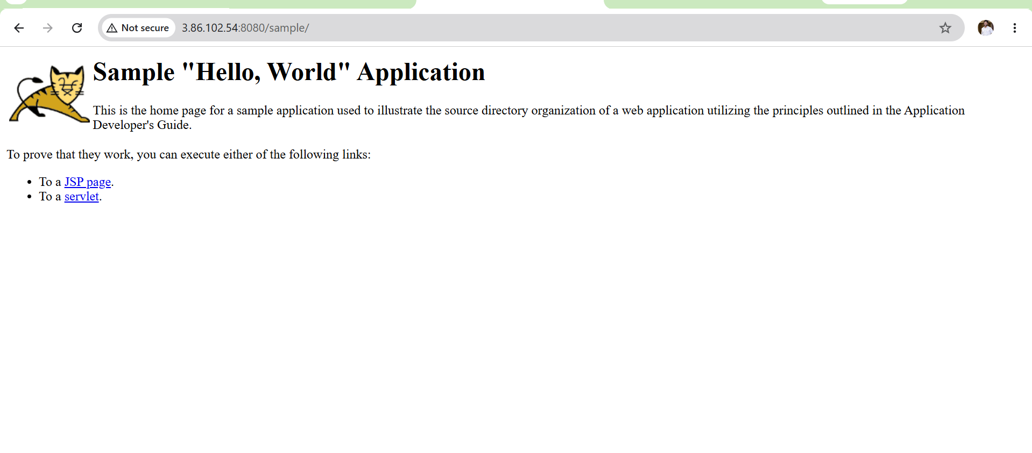
Outcome
After completing Task 1:
- Successfully created an Apache Tomcat Docker container.
- Exposed Tomcat on port 8080.
- Deployed a sample Java web application (WAR file).
- Verified that the application is accessible through the browser.
- Confirmed that the Tomcat container is functioning correctly.
Task 2: Create a Docker Volume and Deploy a Tomcat Container on Port 8081
Objective
To create a Docker volume for persistent storage and deploy an Apache Tomcat container on port 8081 by mounting the volume to the Tomcat webapps directory. This ensures that application data persists even if the container is removed.
What is a Docker Volume?
A Docker volume is a persistent storage mechanism managed by Docker. Unlike container storage, volumes are not deleted when a container is removed.
Benefits of Docker Volumes
- Persist data beyond the life of a container.
- Share data between multiple containers.
- Store application files independently of the container.
- Commonly used for databases, logs, and application deployments.
Prerequisites
- Ubuntu EC2 instance is running.
- Docker is installed and running.
- Tomcat Docker image is available.
- Port 8081 is available.
Implementation Steps
- Connected to the Ubuntu EC2 instance using SSH.
- Verified the existing Docker volumes using docker volume ls.
- Created a new Docker volume named tomcat-data using docker volume create tomcat-data.
- Verified that the Docker volume was created successfully using docker volume ls.
- Inspected the Docker volume details using docker volume inspect tomcat-data.
- Created and started a new Tomcat container on port 8081 using docker run -d --name tomcat-volume -p 8081:8080 -v tomcat-data:/usr/local/tomcat/webapps tomcat.
- Verified that the Tomcat container was running successfully using docker ps.
- Confirmed that the Docker volume was mounted to the Tomcat container by inspecting the container using docker inspect tomcat-volume.
- Created a sample file inside the mounted volume to verify persistent storage using docker exec.
- Verified that the sample file was successfully stored in the Docker volume.
- Confirmed that the Tomcat container was accessible on port 8081 and that the Docker volume was functioning correctly.

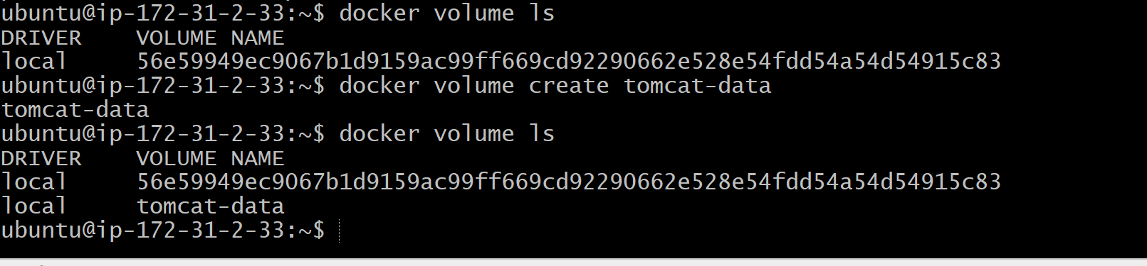
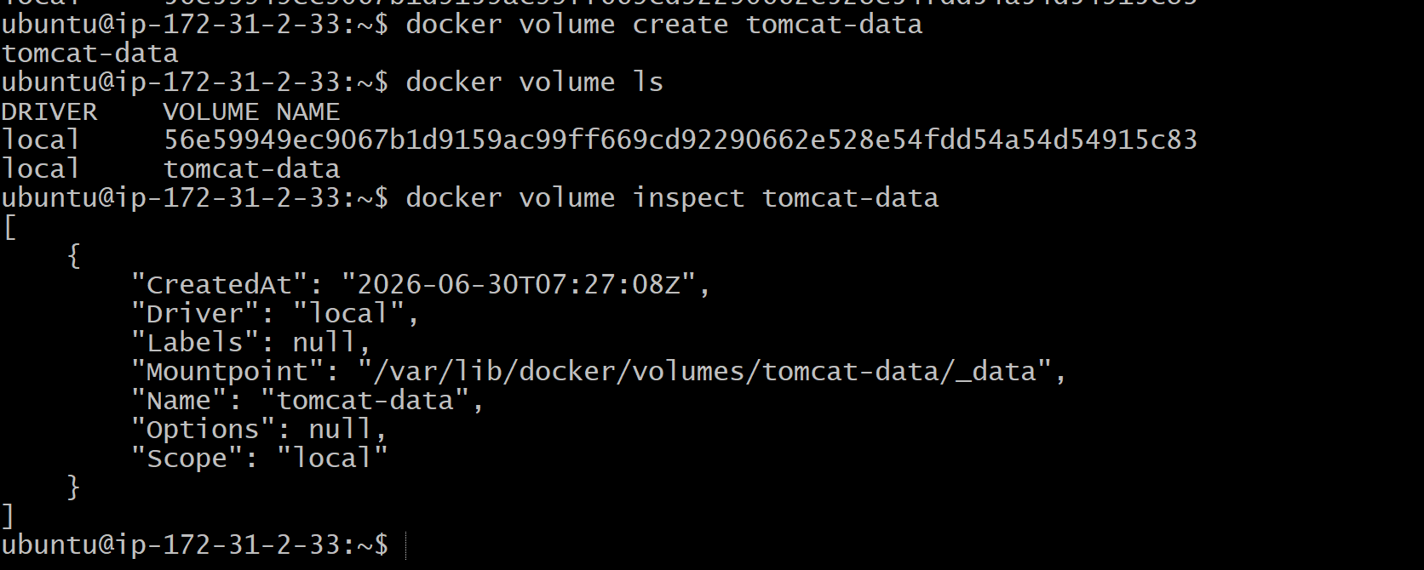
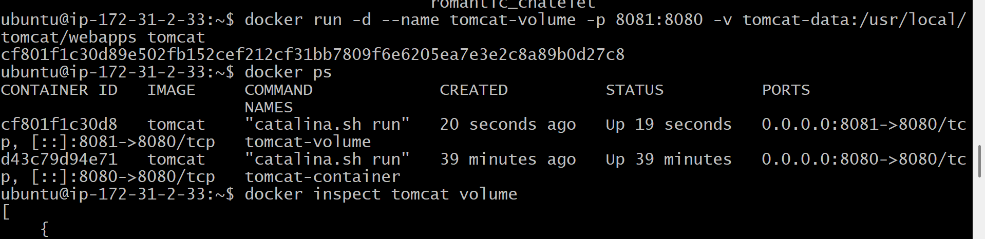
Validation Points
- Docker volume tomcat-data created successfully.
- Volume is visible in docker volume ls.
- Tomcat container deployed on port 8081.
- Docker volume successfully mounted to /usr/local/tomcat/webapps.
- Volume attachment verified using docker inspect.
- Data stored in the volume remains available even after recreating the container.

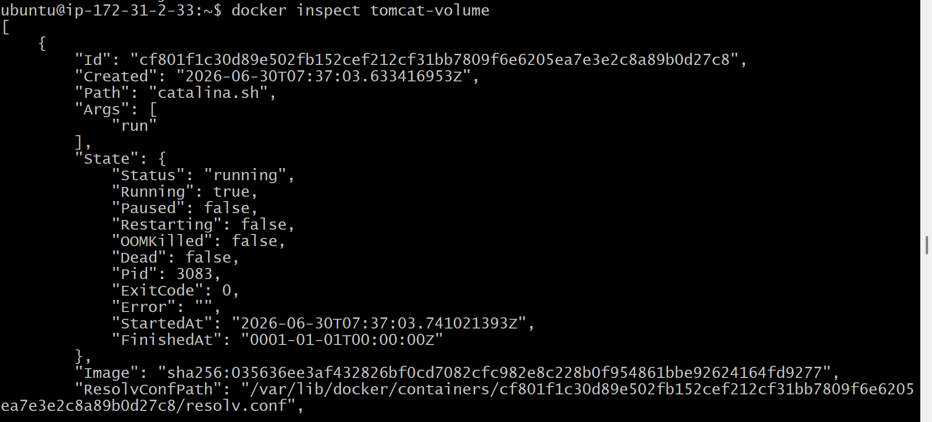
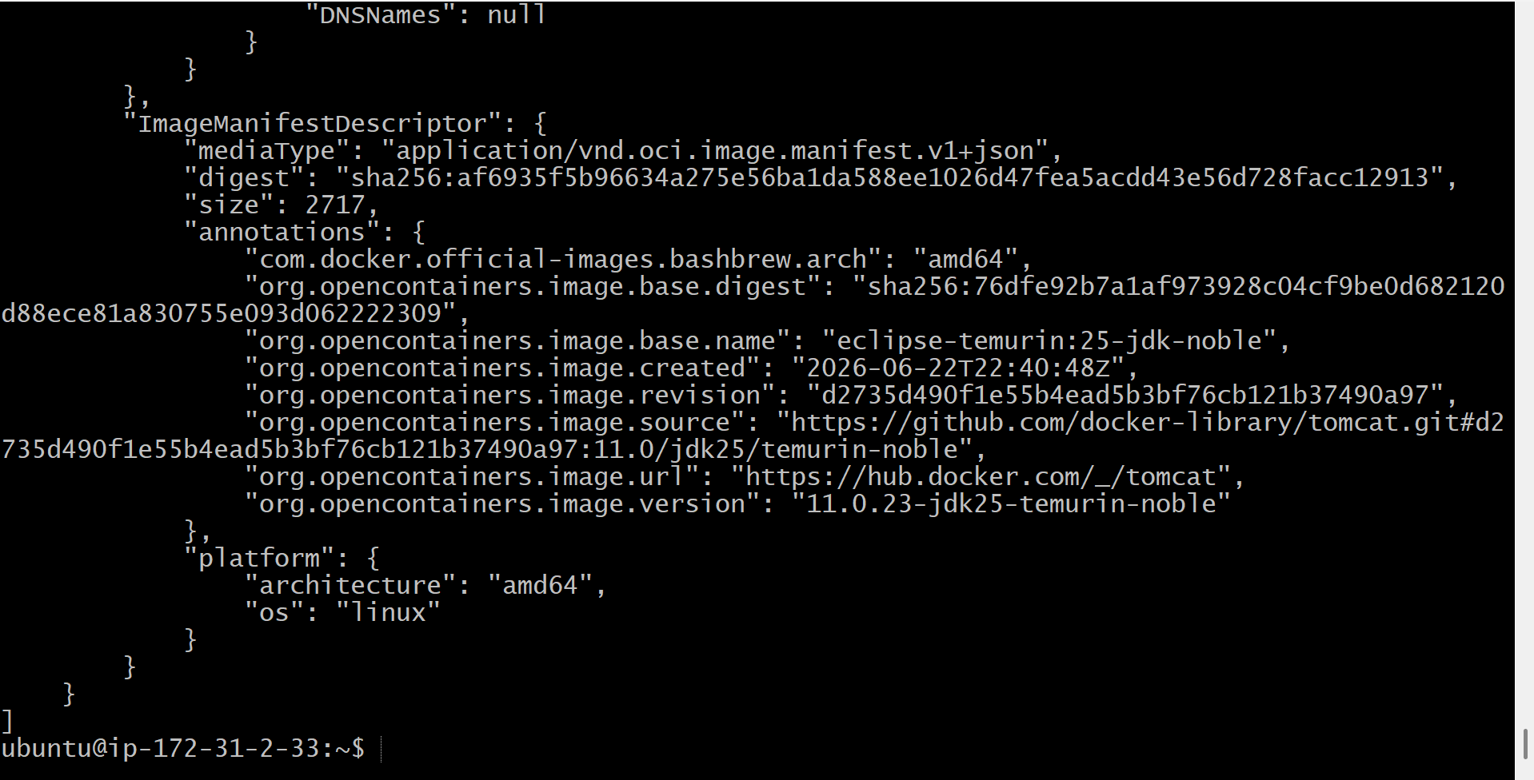
Outcome
After completing Task 2:
- Successfully created a Docker volume for persistent storage.
- Deployed a Tomcat container on port 8081 using the volume.
- Verified that the volume was mounted correctly.
- Demonstrated that application data persisted independently of the container lifecycle

Task 3: Limit the Nginx Container to 500 MB
Objective
To create and run an Nginx Docker container with a maximum memory limit of 500 MB using Docker's resource management options. This prevents the container from consuming more than the allocated memory.
What is Resource Limiting?
Docker allows you to control the resources allocated to a container, such as:
- Memory (RAM)
- CPU
- Storage
- Processes
Resource limits help prevent one container from consuming all the host system resources.
What is the --memory Option?
The --memory (or -m) option limits the maximum RAM a container can use.
Syntax:
docker run -d --memory=<size> <image>
Example:
docker run -d --memory=500m nginx
Here:
- 500m = 500 Megabytes
- If the container exceeds 500 MB, Docker may terminate it due to the memory limit.
Prerequisites
- Ubuntu EC2 instance is running.
- Docker is installed and running.
- Nginx Docker image is available locally.
- Port 80 (or another available host port) is free.
Implementation Steps
- Connected to the Ubuntu EC2 instance using SSH.
- Verified that the Nginx Docker image was available using docker images.
- Checked for any existing Nginx containers using docker ps -a.
- Removed the existing Nginx container (if present) to avoid container name conflicts.
- Created and started a new Nginx container with a 500 MB memory limit using the --memory=500m option.
- Mapped the Nginx container to an available host port (e.g., 8082) using the -p option.
- Verified that the Nginx container was running successfully using docker ps.
- Inspected the container using docker inspect --format='{{.HostConfig.Memory}}' nginx-limit to verify that the 500 MB memory limit was applied.
- Accessed the Nginx web server through the browser and confirmed that the Welcome to nginx! page was displayed successfully.

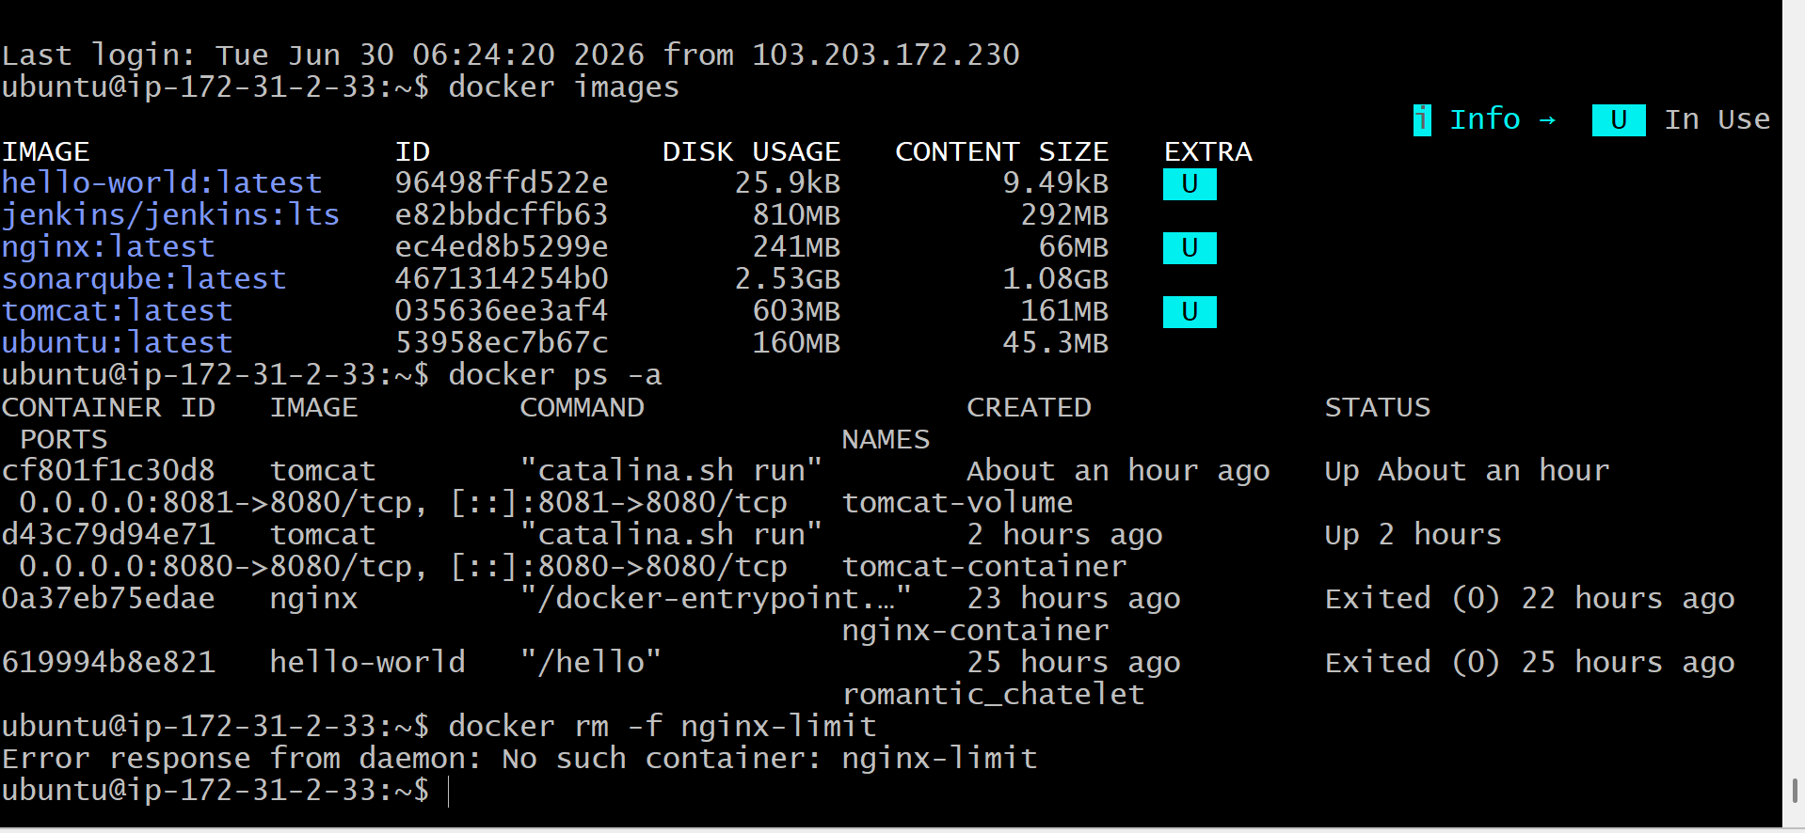
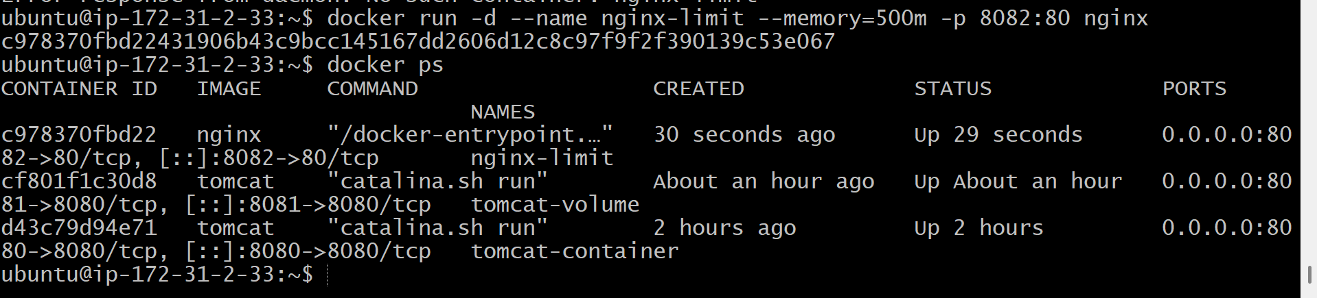
Validation Points
- Verified that the Nginx image was available.
- Successfully created an Nginx container.
- Applied a 500 MB memory limit using the --memory option.
- Verified the memory limit using docker inspect.
- Confirmed that the Nginx container was running successfully.
- Verified that the Nginx welcome page was accessible in the browser.

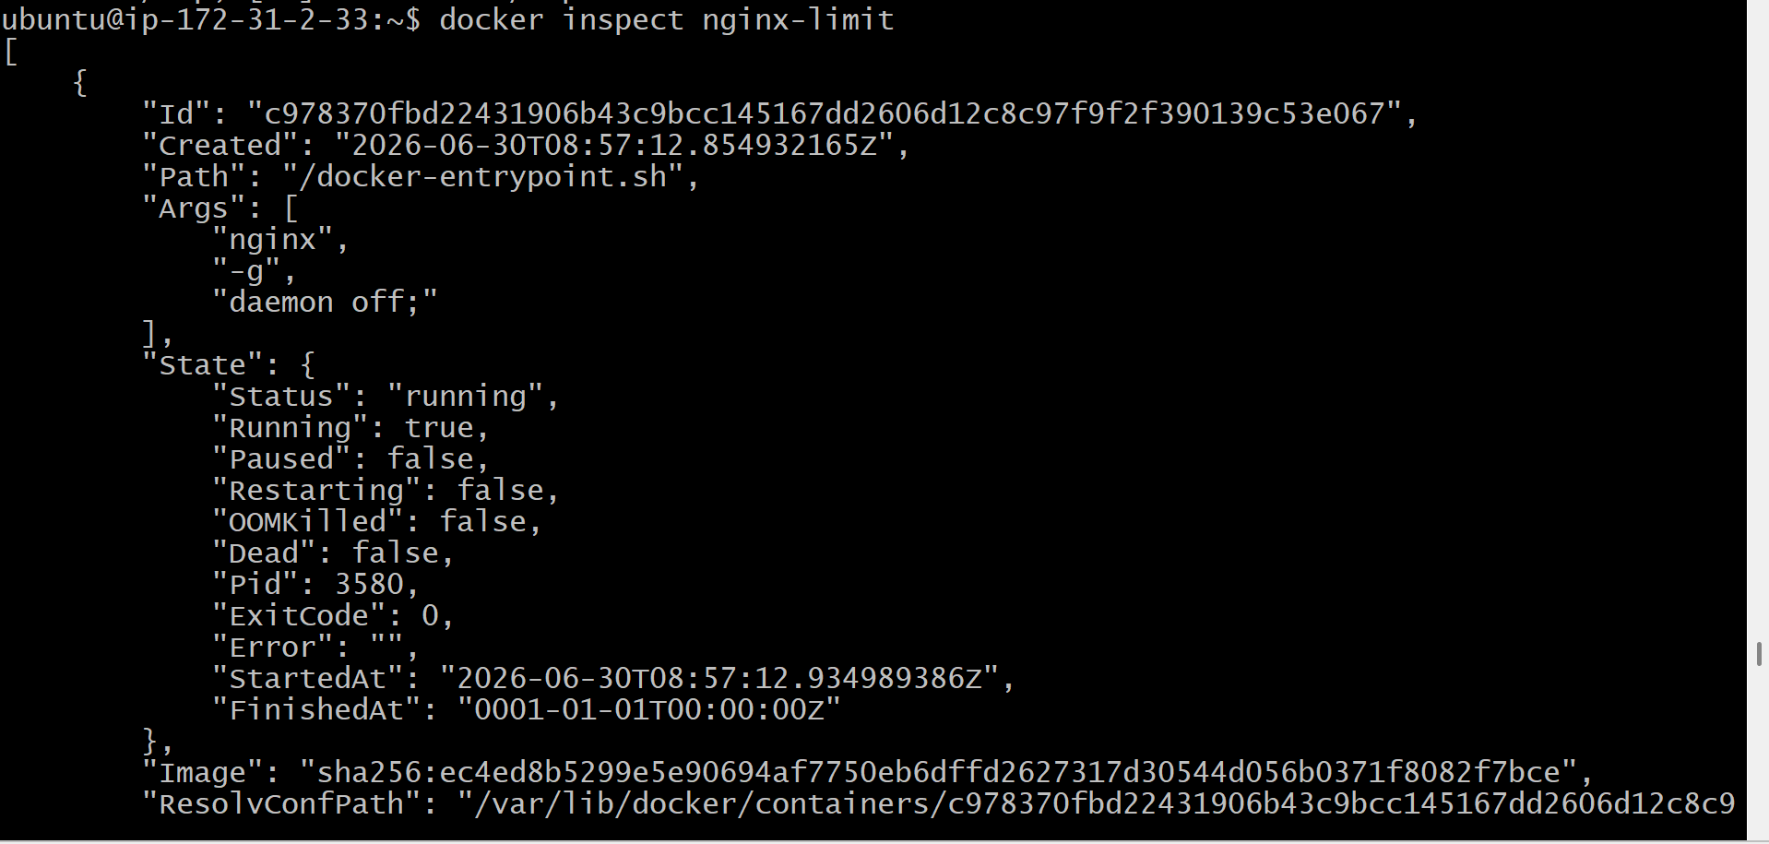
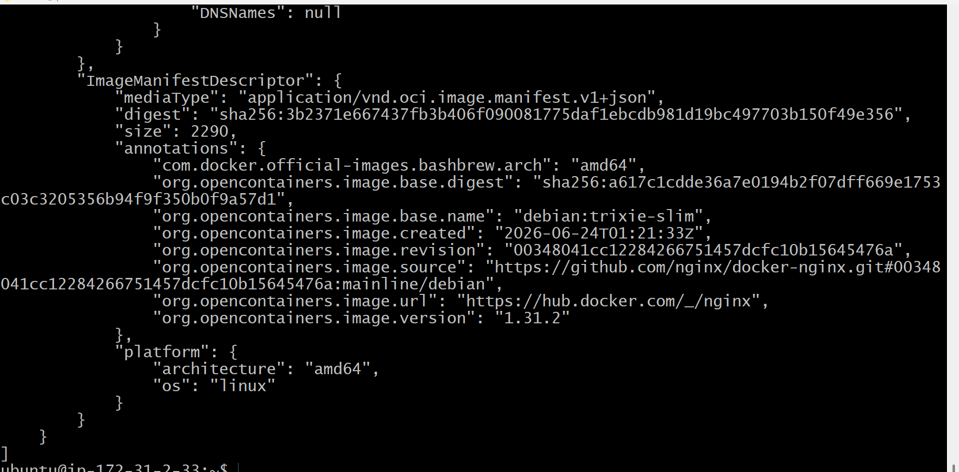
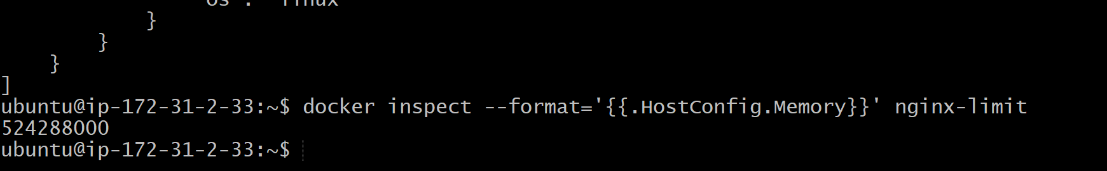

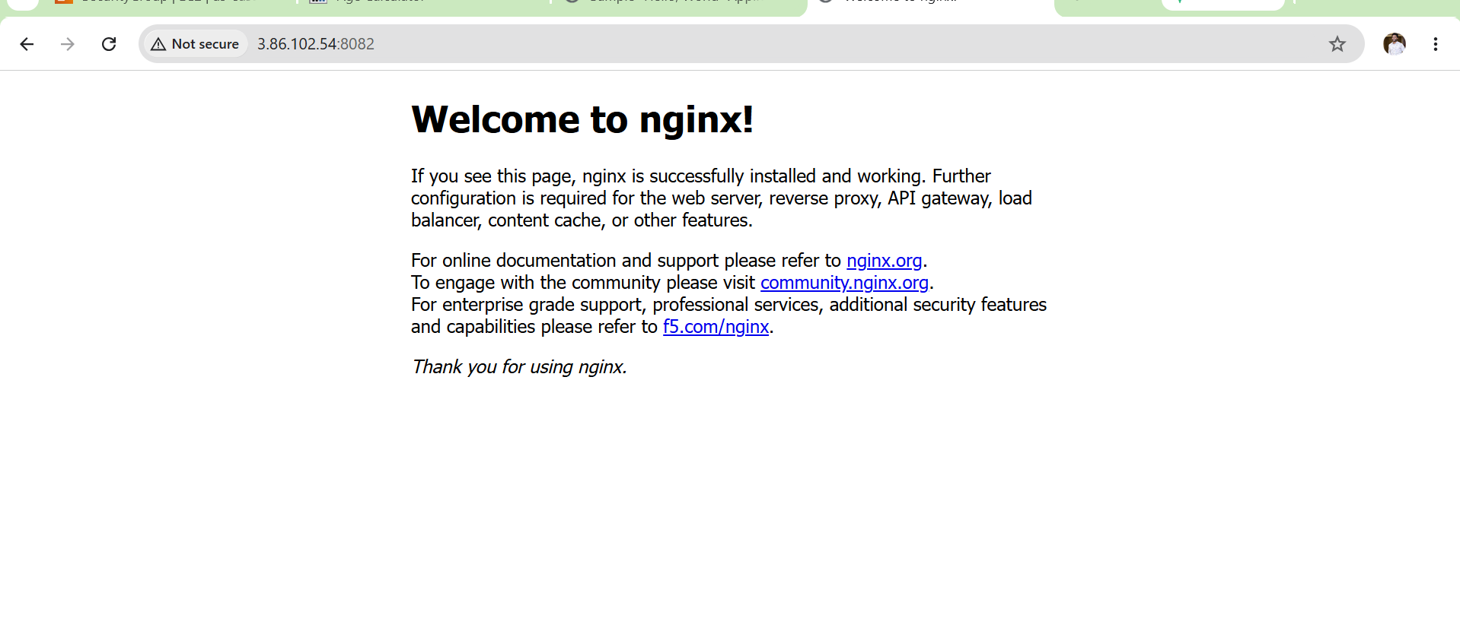
Outcome
After completing Task 3:
- Successfully created an Nginx Docker container with a 500 MB memory limit.
- Verified that Docker applied the memory restriction.
- Confirmed that the container was running and accessible.
- Learned how to control container resource allocation using Docker runtime options.

Task 4. Create a custom Docker image using a Docker file with the following requirements.
Objective
- Base image: amazonlinux:latest
- Maintainer: Nithin Reddy
- Install Nginx
- Copy an index.html file into the image
- Expose port 80
- Start the Nginx service when the container starts
Implementation Steps
- Created a project directory named docker-nginx to store Dockerfile and application files.
- Created an index.html file with sample HTML content to deploy through Nginx.
- Created a Dockerfile with the required instructions:
  - Used amazonlinux:latest as the base image.
  - Added maintainer information using LABEL.
  - Installed Nginx using dnf.
  - Copied index.html into the Nginx web root directory.
  - Exposed port 80.
  - Added the command to start the Nginx service when the container starts.
- Verified the Dockerfile and index.html files were present in the project directory.
- Built the custom Docker image using the docker build command with image name my-nginx-image:v1.
- Verified that the Docker image was created successfully using docker images.
- Created and started a container from the custom image using docker run.
- Mapped the container port 80 to host port 8083 to access the Nginx application.
- Verified that the container was running successfully using docker ps.
- Checked the Nginx container logs to confirm the service started successfully.
- Accessed the Nginx application through the browser using the EC2 public IP and port 8083.
- Verified that the custom index.html page was displayed successfully.

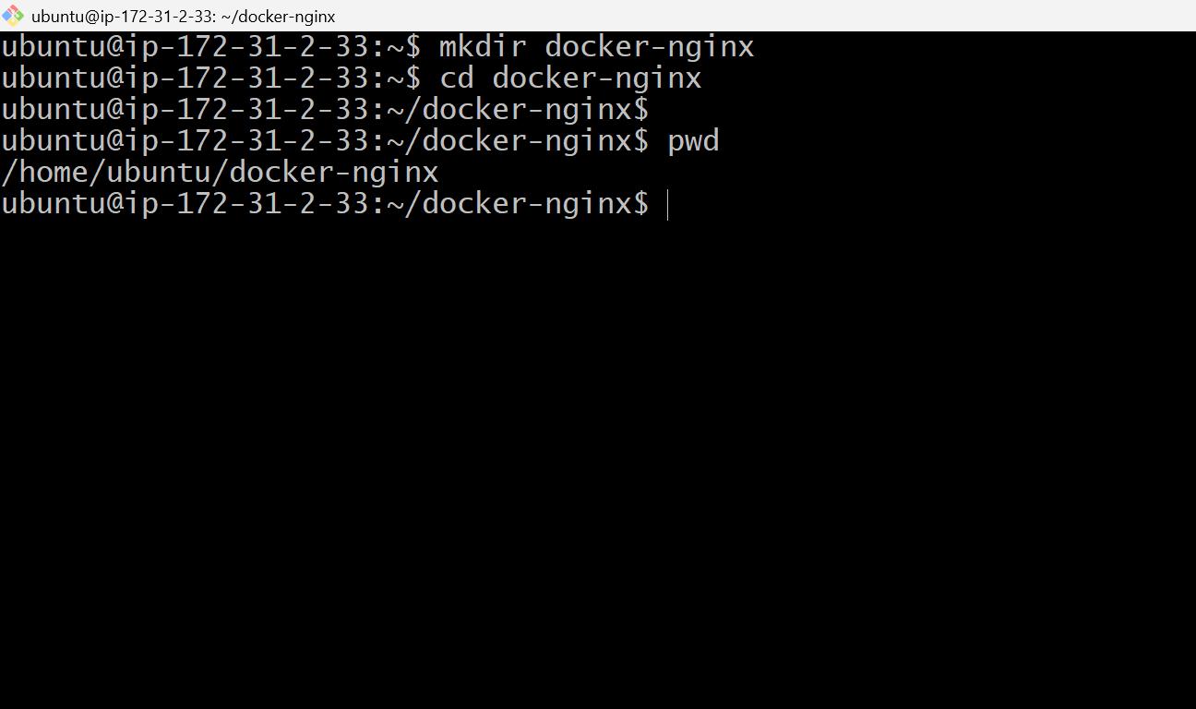
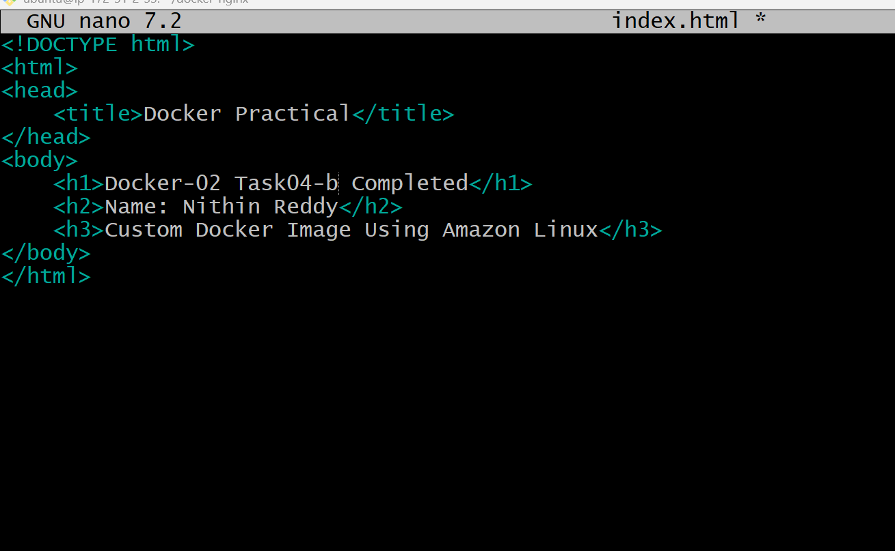
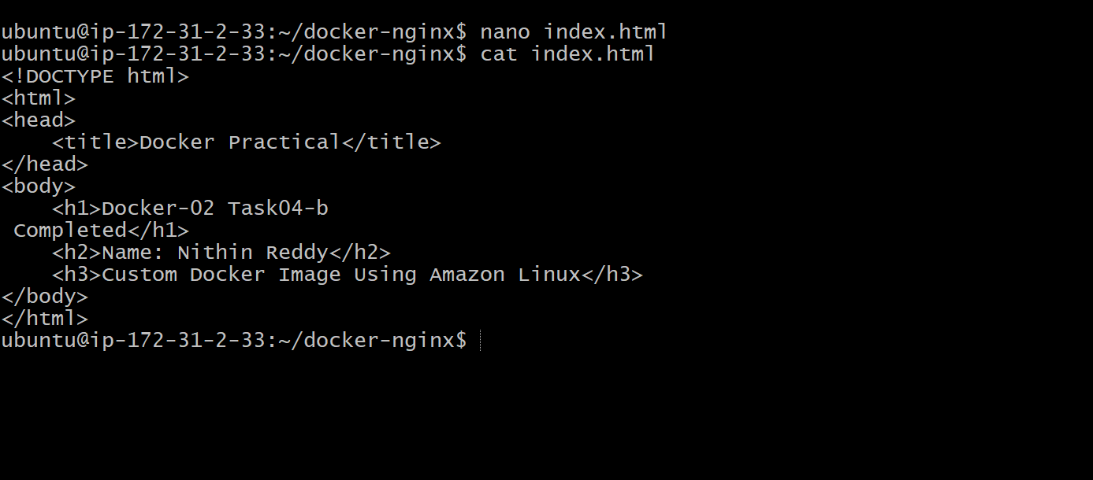

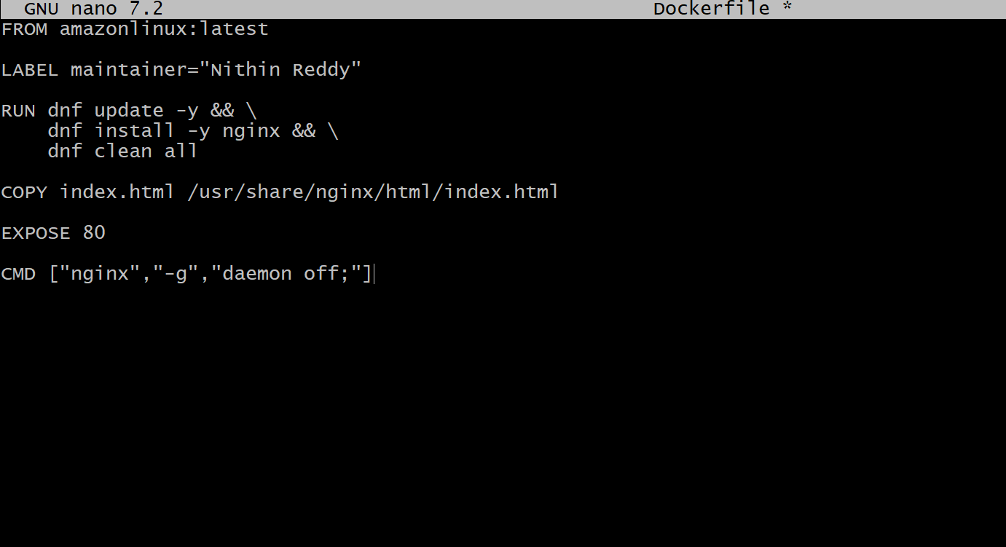
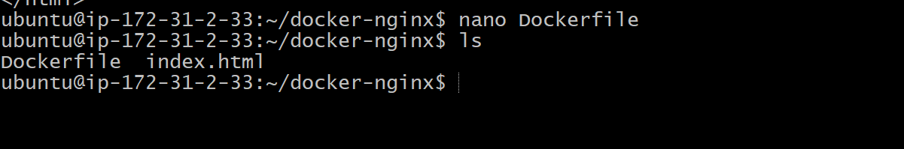
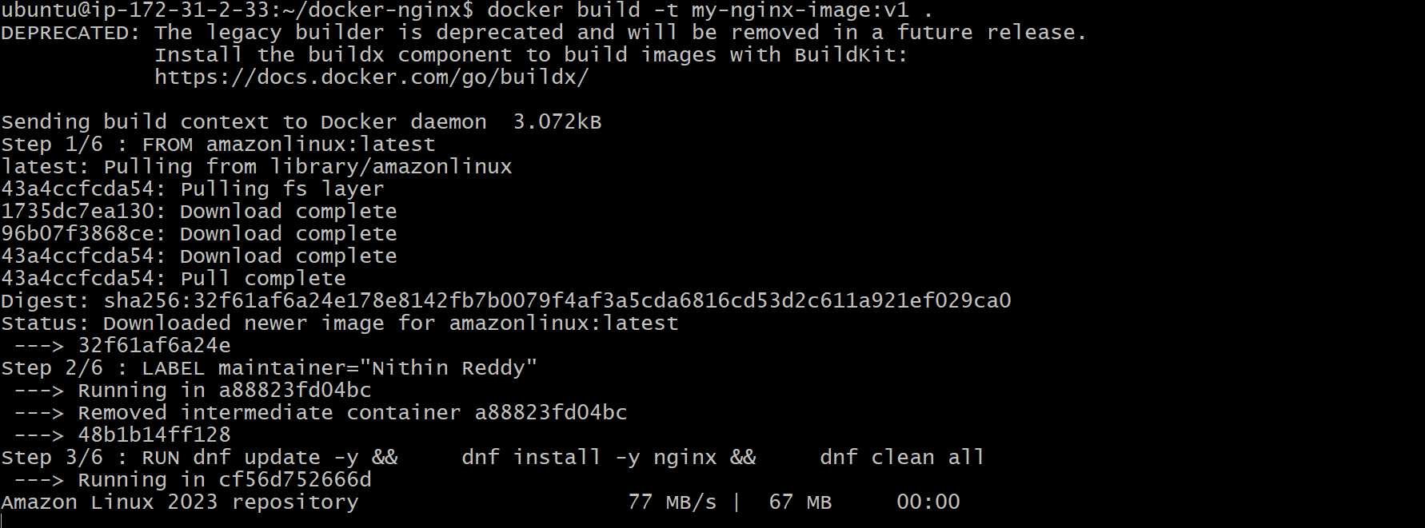
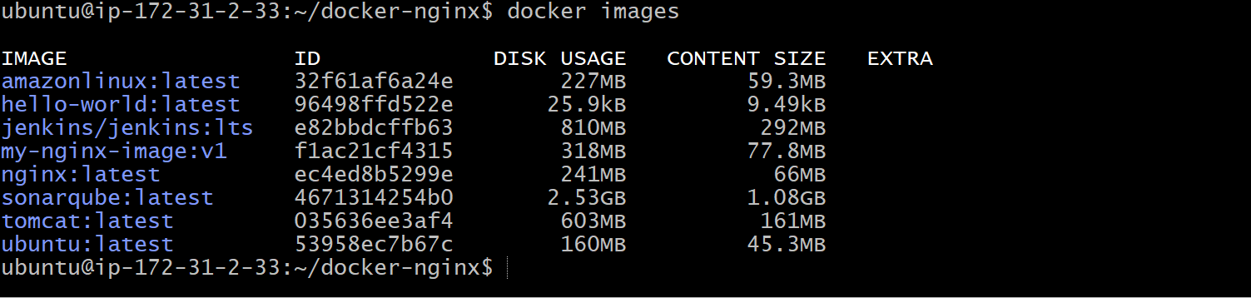
Validation Points
- Created a project directory.
- Created index.html.
- Created a Dockerfile.
- Used amazonlinux:latest as the base image.
- Added the maintainer label.
- Installed Nginx using dnf.
- Copied index.html into the Nginx web root.
- Exposed port 80.
- Built the Docker image successfully.
- Ran the Docker container successfully.
- Verified the custom web page in the browser.
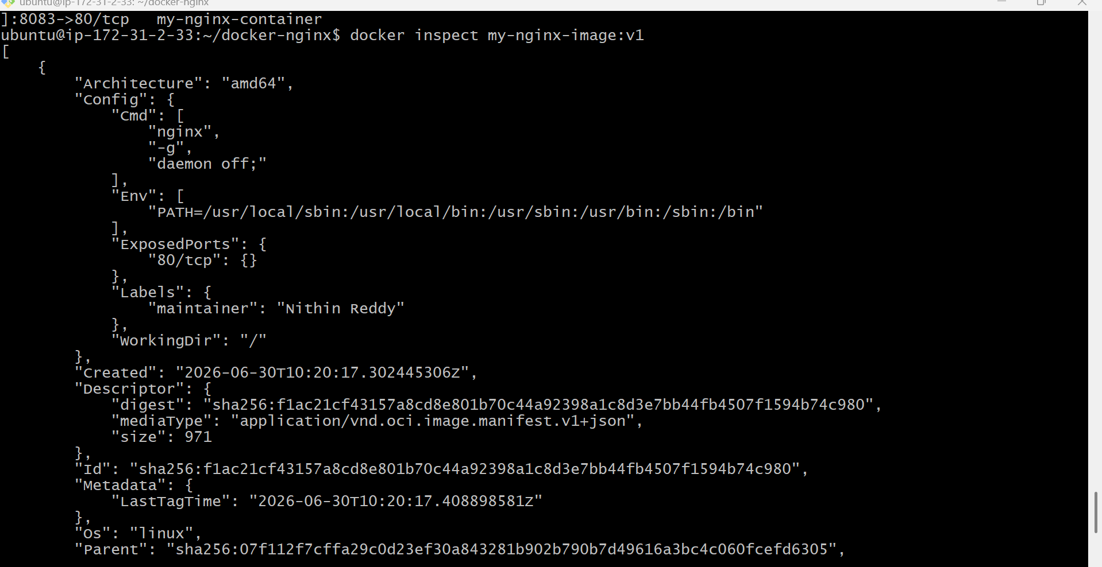
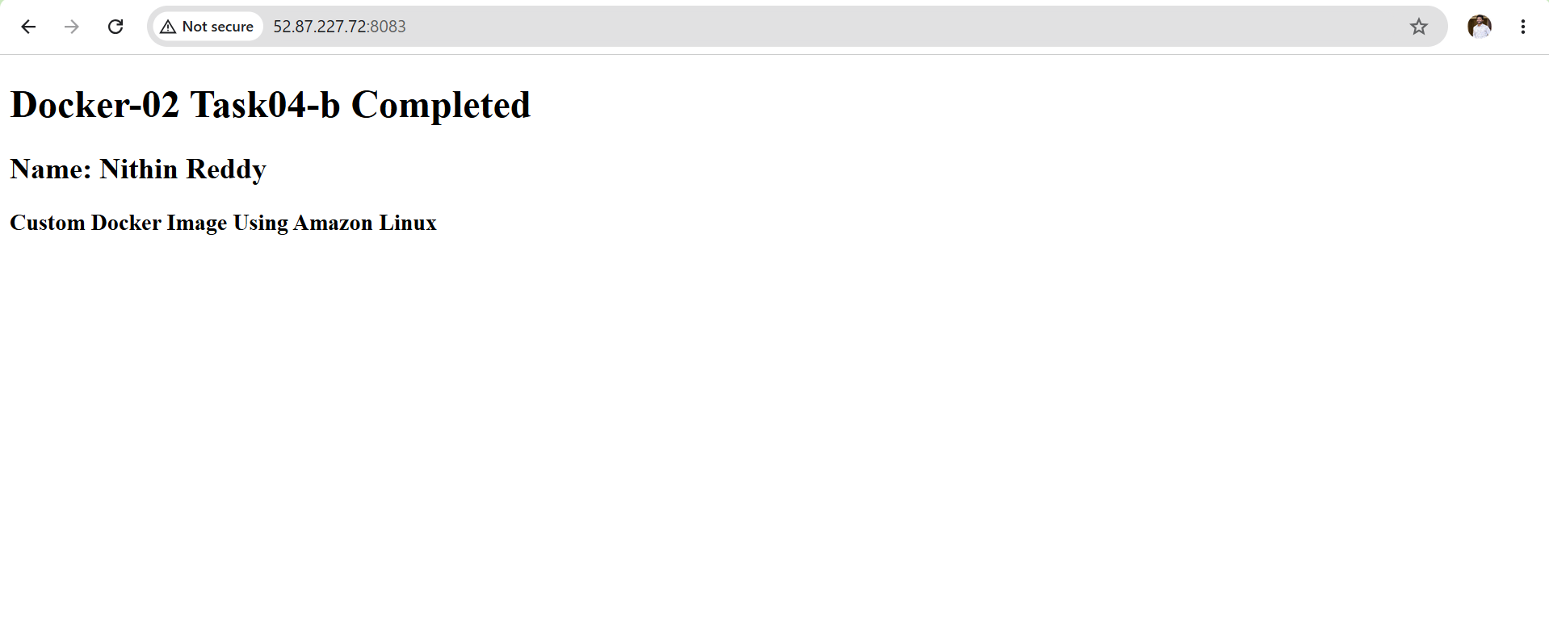
Outcome
After completing Task 4:
- Successfully created a custom Docker image using a Dockerfile.
- Used Amazon Linux as the base image.
- Installed Nginx inside the image.
- Copied a custom HTML page into the image.
- Exposed port 80.
- Started Nginx automatically when the container launched.
- Verified the custom web page through the browser.
Task 5: Push Image to Docker Hub
I already completed Task 4 and have this local image:
my-nginx-image:v1
Now I will push this image to Docker Hub.
Objective
Upload the custom Docker image created in Task 4 to Docker Hub so that the image can be stored in a public/private registry and pulled from anywhere.
Prerequisites
Before starting:
- Docker is installed and running.
- Docker Hub account is created.
- Task 4 image exists locally:
docker images
You should see:
REPOSITORY TAG
my-nginx-image v1
Implementation Steps
- Verified the custom Docker image created in Task 4 using docker images.
- Confirmed the image available locally as my-nginx-image:v1.
- Logged into Docker Hub using the docker login command.
- Tagged the local Docker image with Docker Hub username and repository name using the docker tag command.
- Verified the newly created Docker Hub image tag using docker images.
- Pushed the tagged image to Docker Hub using the docker push command.
- Verified that the image upload was completed successfully.
- Logged into Docker Hub web console and confirmed that the my-nginx-image repository and v1 tag were available.
- Tested the uploaded image by pulling it from Docker Hub to verify image availability.

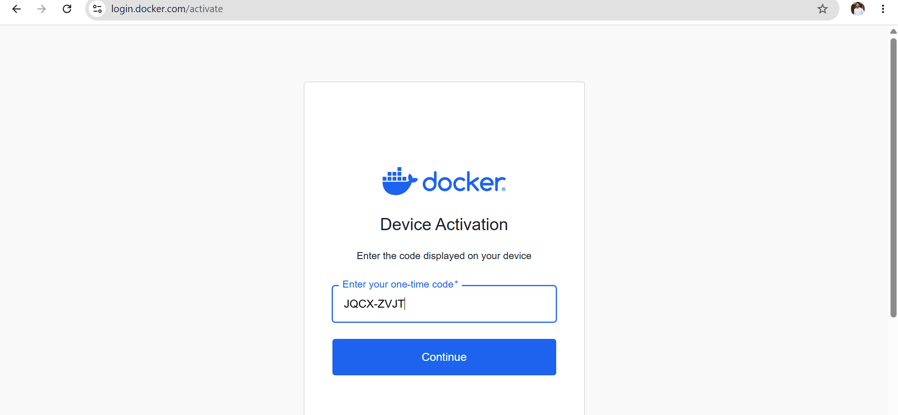
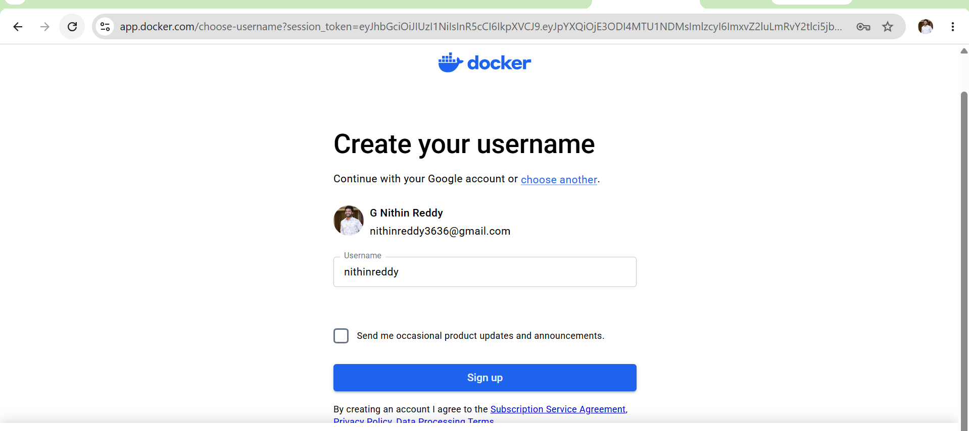
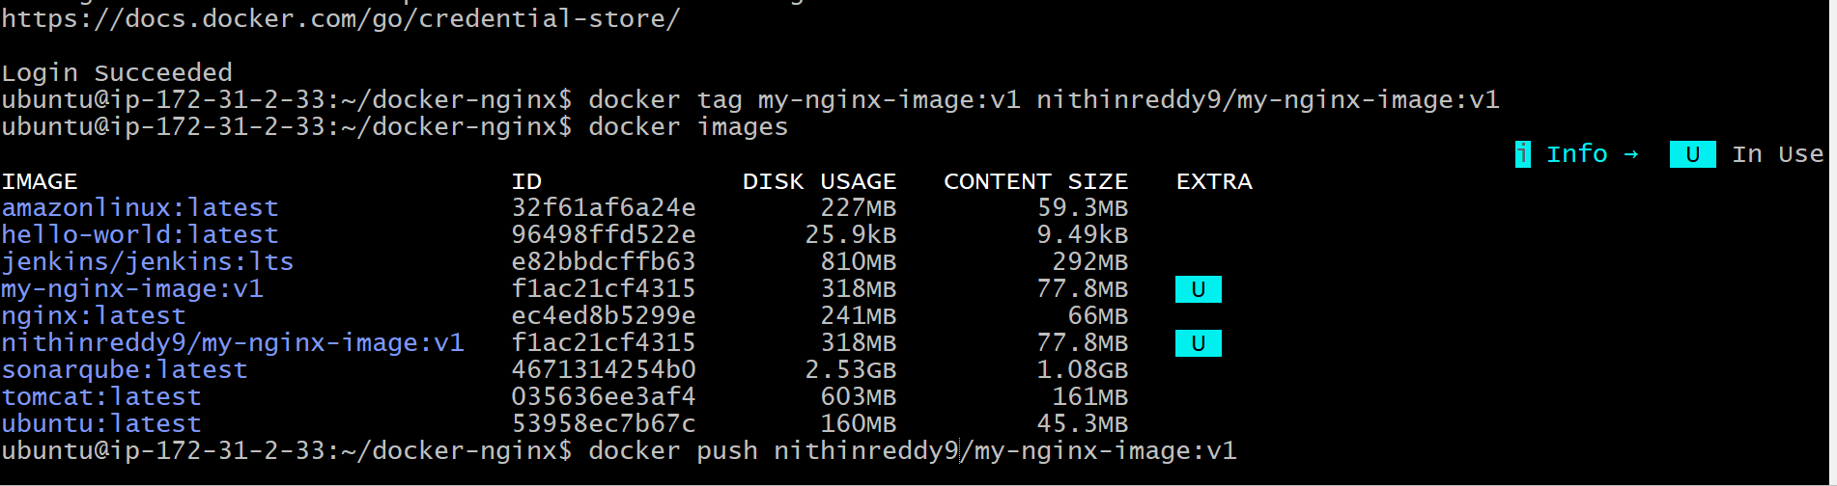
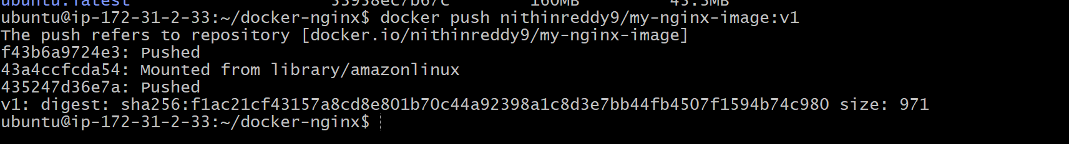
Validation Points
- Logged into Docker Hub successfully.
- Tagged the custom image with Docker Hub username.
- Verified Docker Hub image tag.
- Successfully pushed image to Docker Hub.
- Verified repository and image tag in Docker Hub.

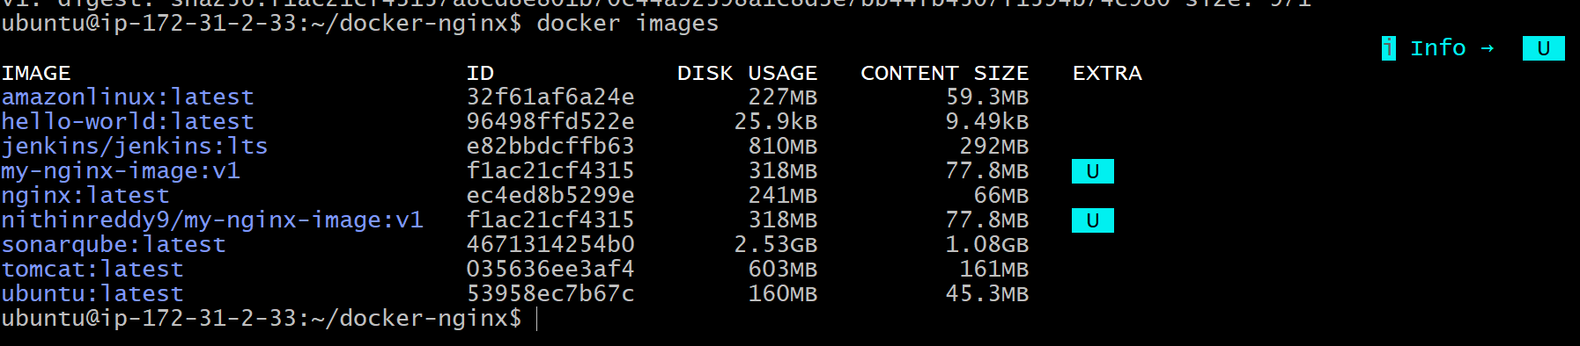
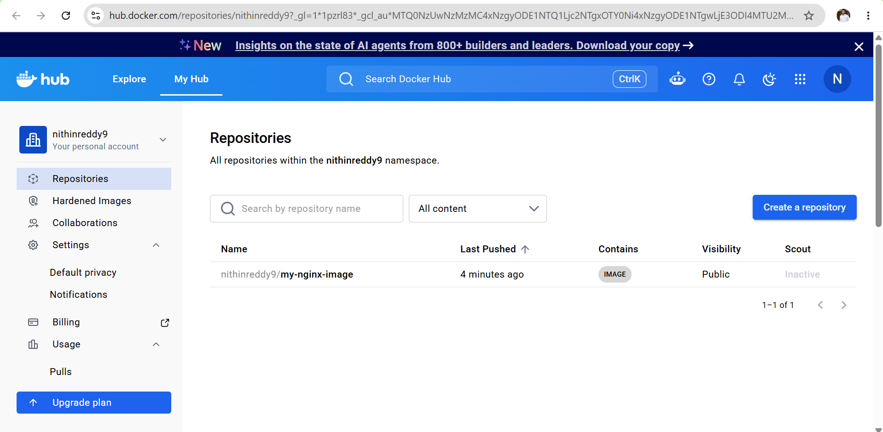

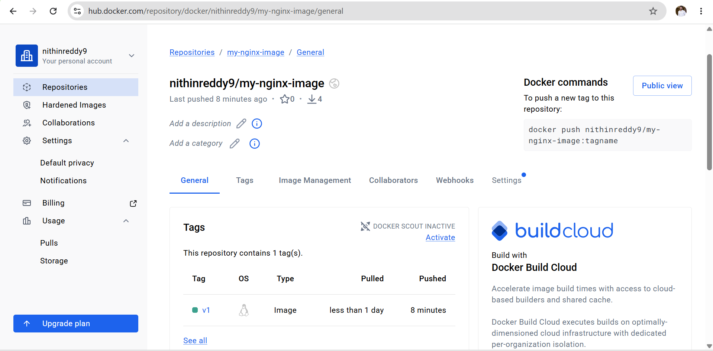
Outcome
Successfully uploaded the custom Nginx Docker image created in Task 4 to Docker Hub and made it available for future deployments.
Task 6: Push Docker Image to AWS ECR
I will push the same image created in Task 4:
my-nginx-image:v1
to Amazon Elastic Container Registry (ECR).
Objective
Upload the custom Docker image to AWS ECR so that the image can be stored in a private AWS container registry and used for deployments.
Prerequisites
Before starting:
- AWS CLI installed.
- IAM permissions for ECR.
- Docker service running.
- Task 4 image available:
Check:
docker images
You should have:
my-nginx-image:v1
Implementation Steps
- Installed AWS CLI on the Ubuntu EC2 instance using the official AWS CLI installer.
- Verified the AWS CLI installation using the aws --version command.
- Created an IAM user with programmatic access and attached the required ECR permissions.
- Configured AWS CLI using aws configure with the IAM Access Key, Secret Access Key, region (us-east-1), and JSON output format.
- Verified the AWS account configuration using aws sts get-caller-identity.
- Created a new Amazon ECR repository named my-nginx-image.
- Logged in to Amazon ECR using the AWS CLI and Docker login command.
- Tagged the local Docker image with the Amazon ECR repository URI.
- Verified the new ECR image tag using docker images.
- Pushed the tagged Docker image to the Amazon ECR repository using docker push.
- Verified that the image was successfully uploaded by checking the ECR repository in the AWS Management Console.

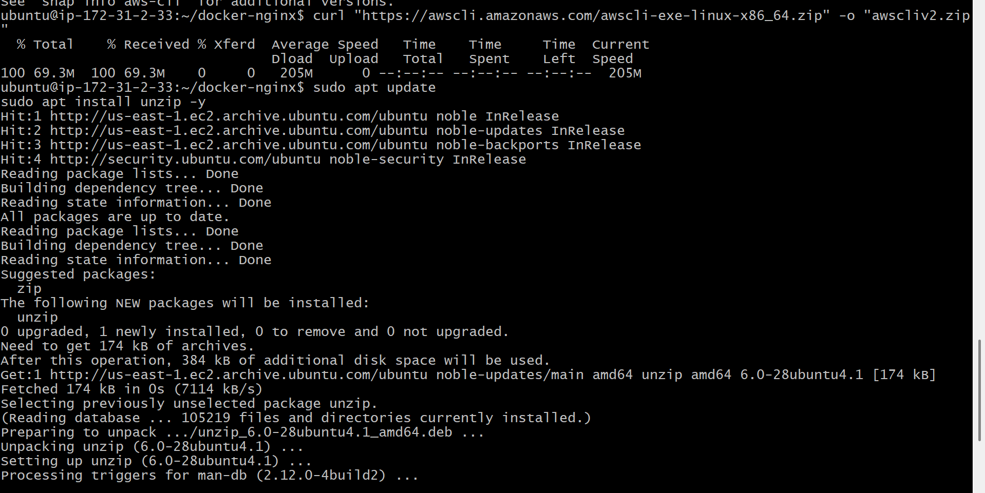
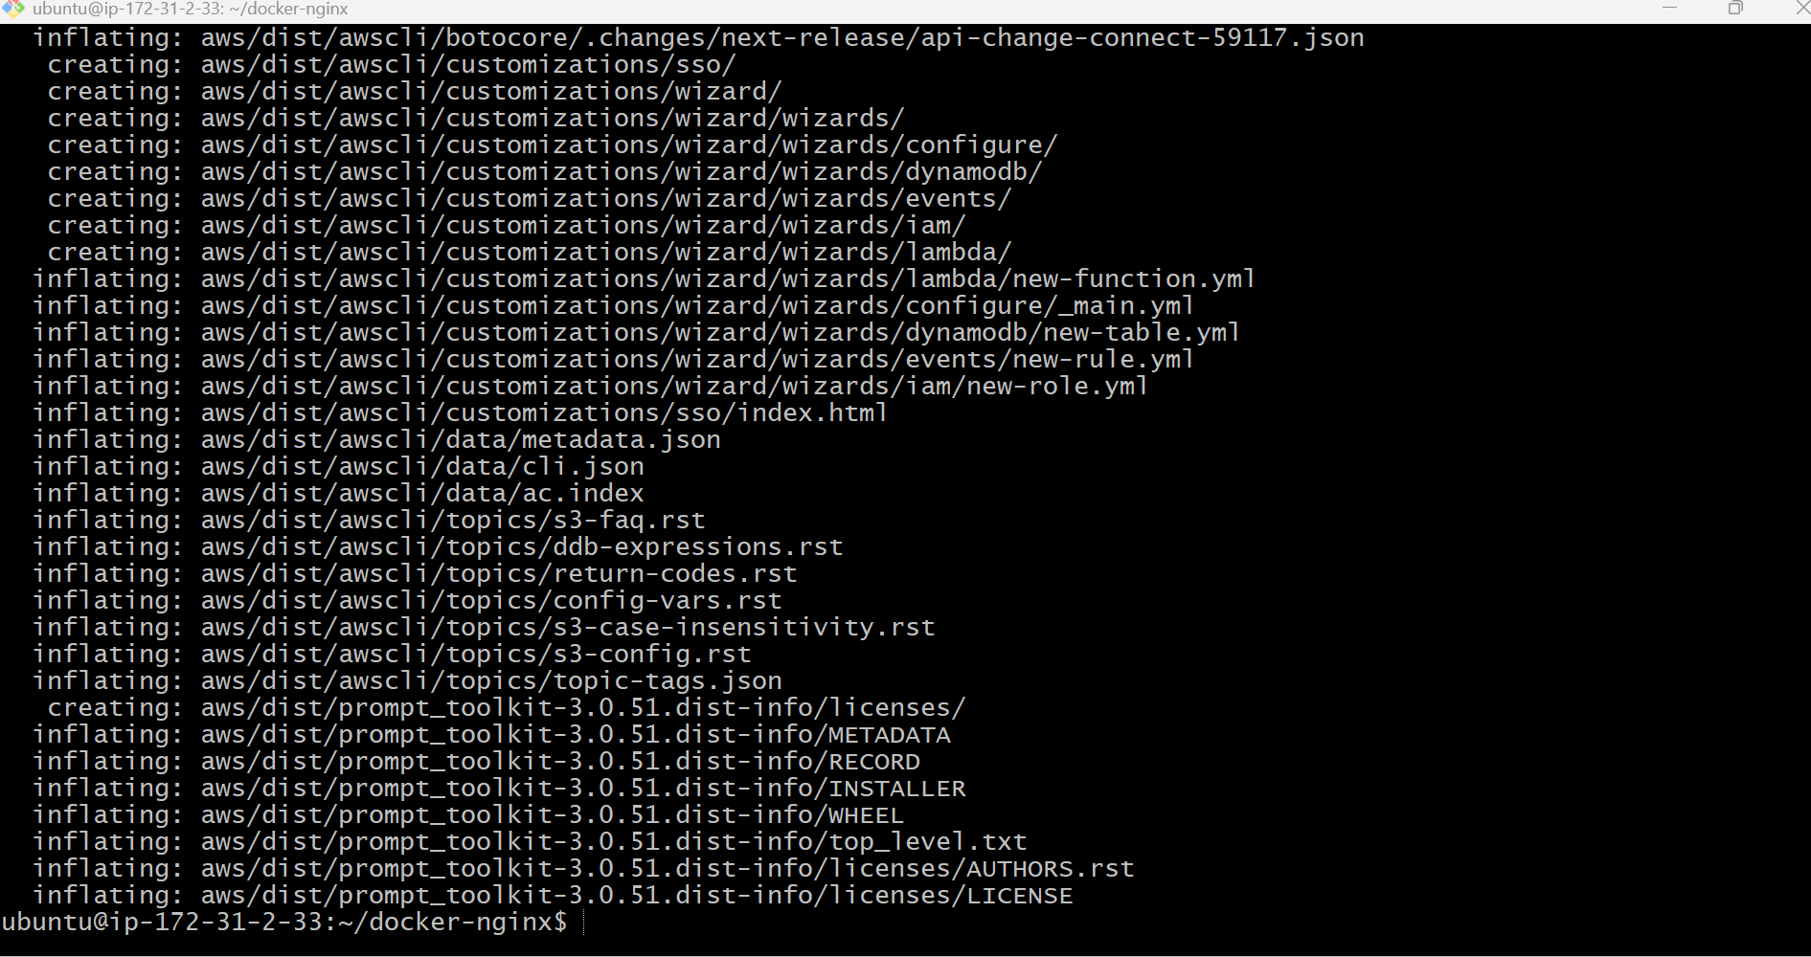
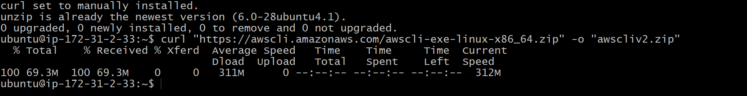
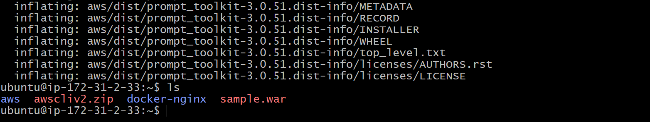
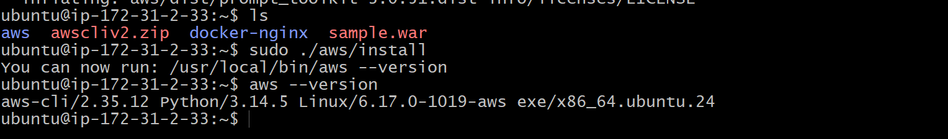
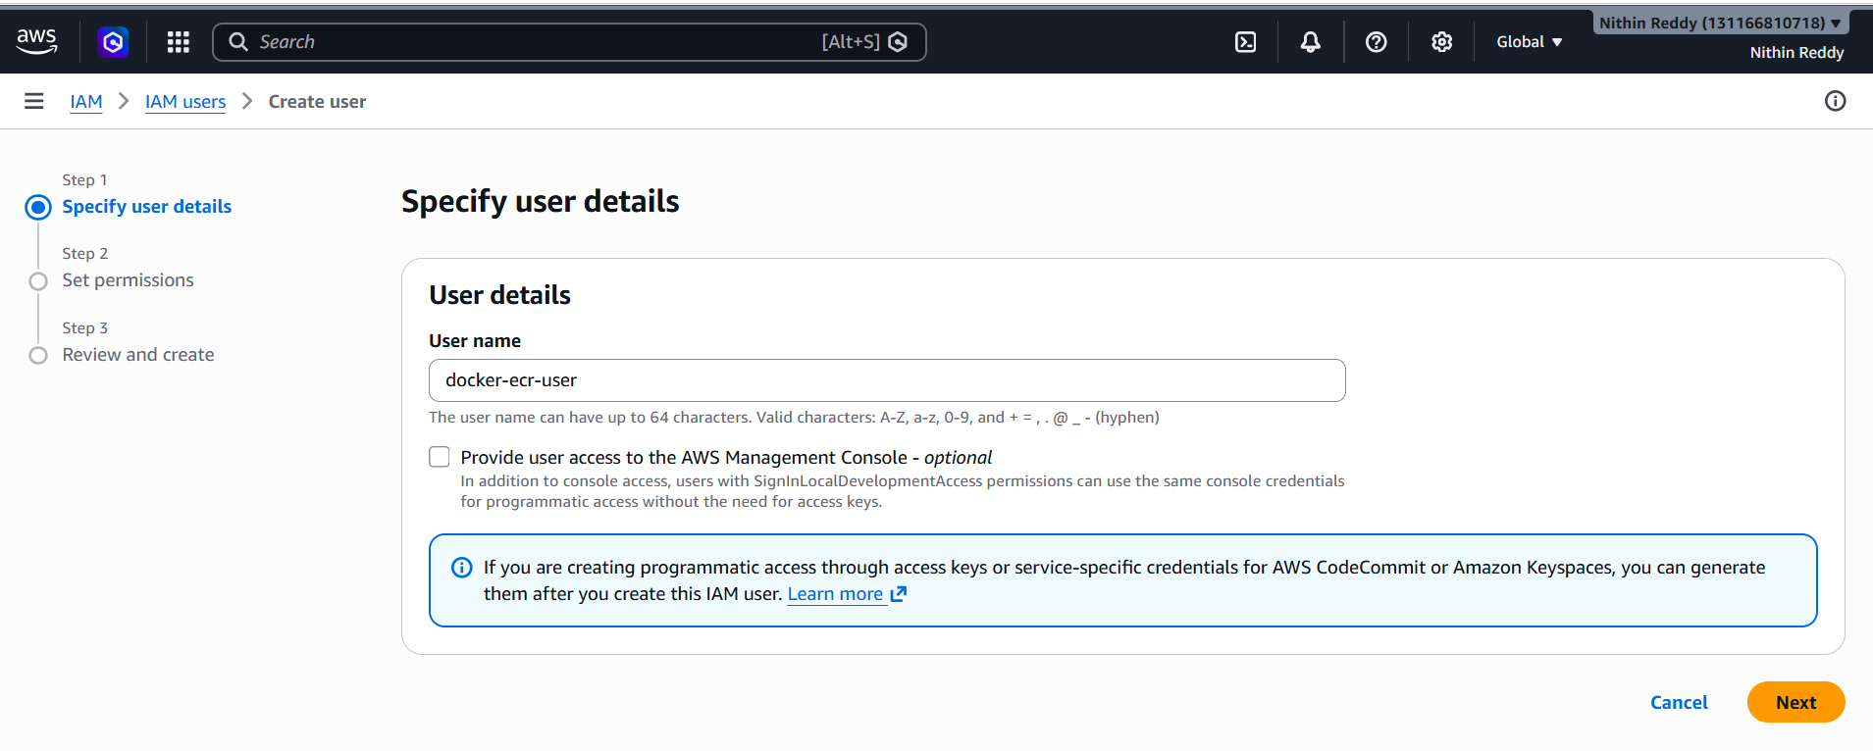
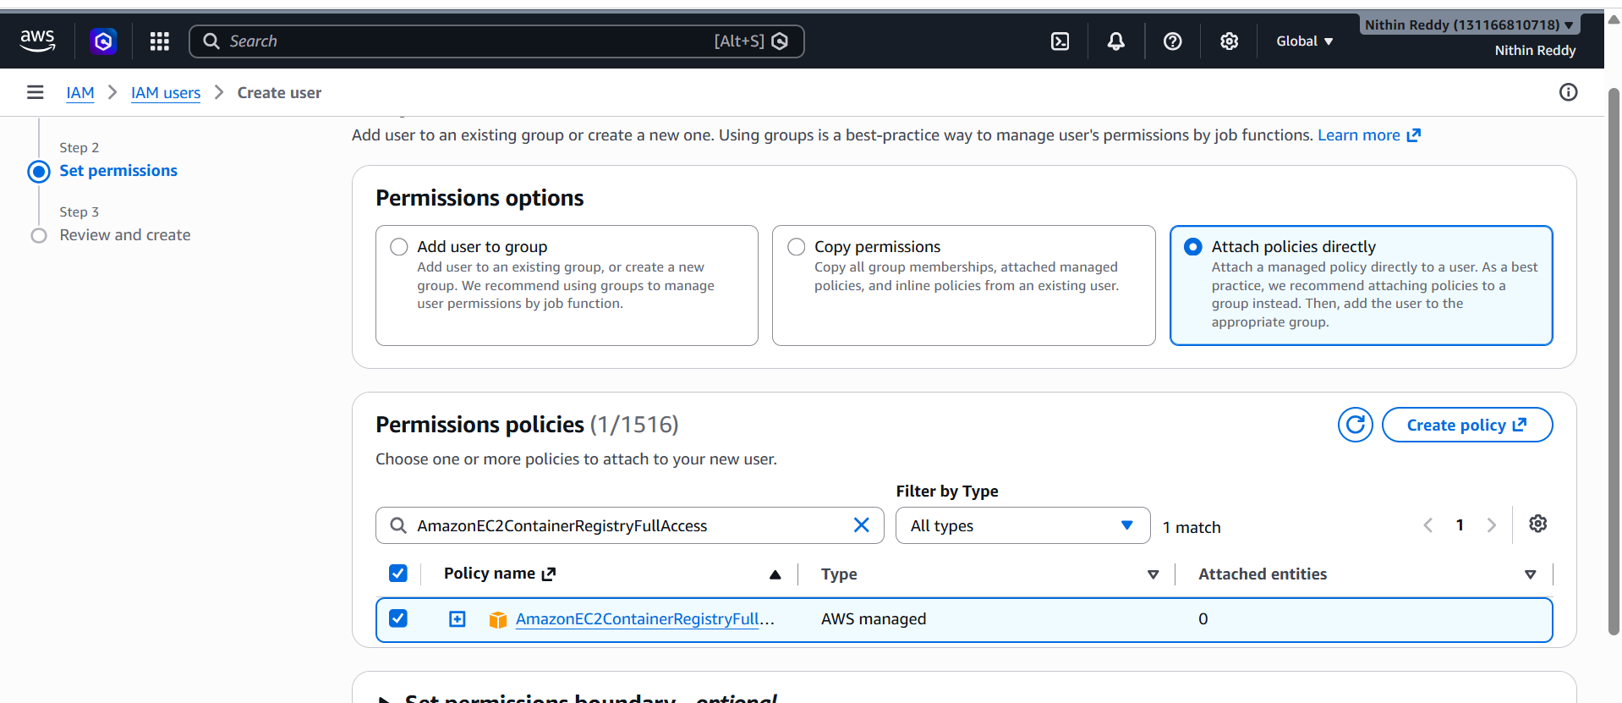
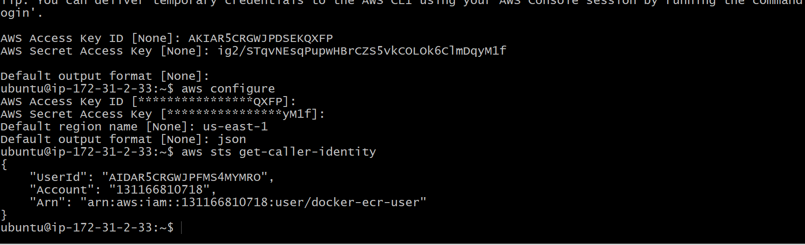
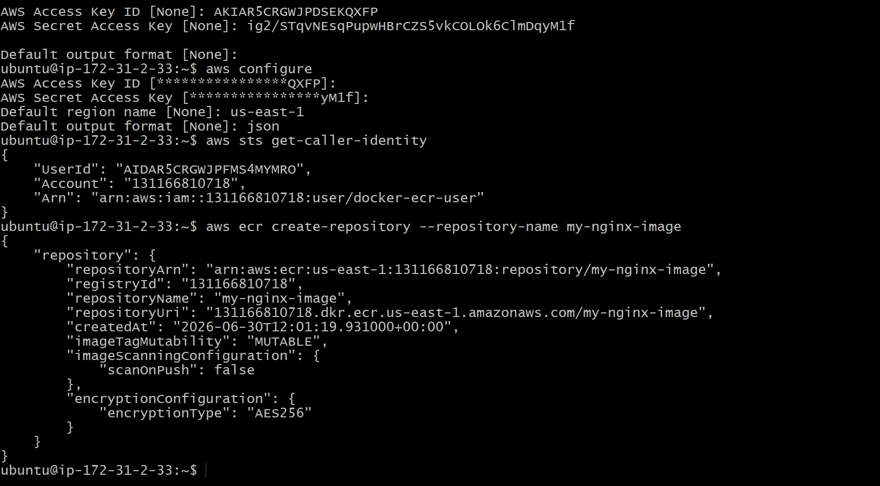
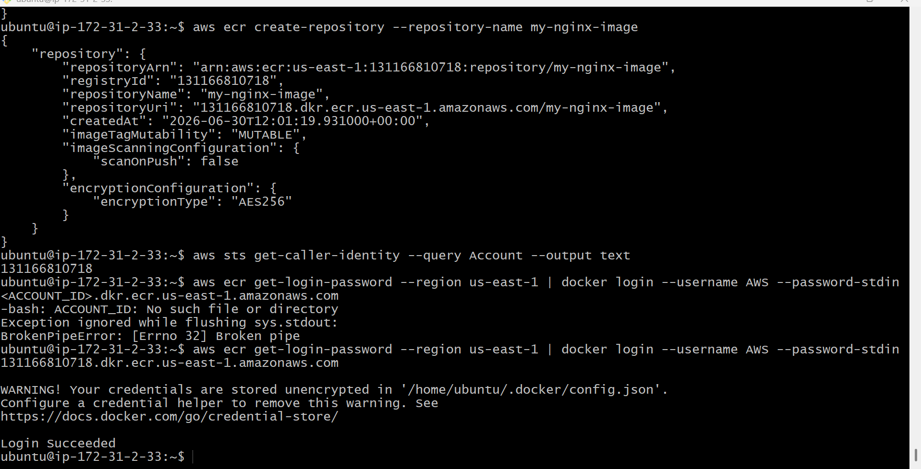
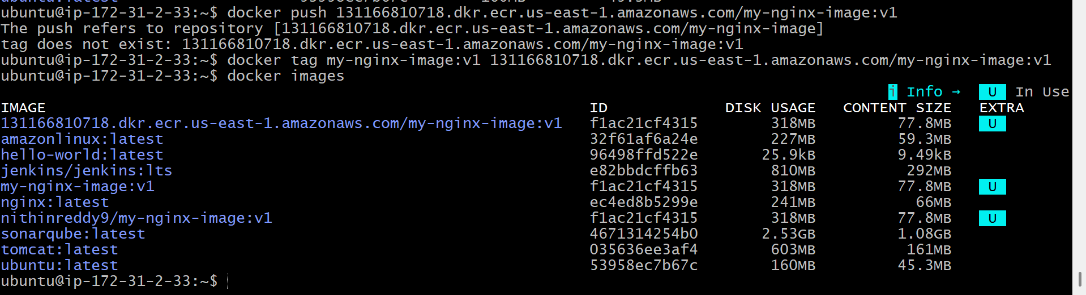
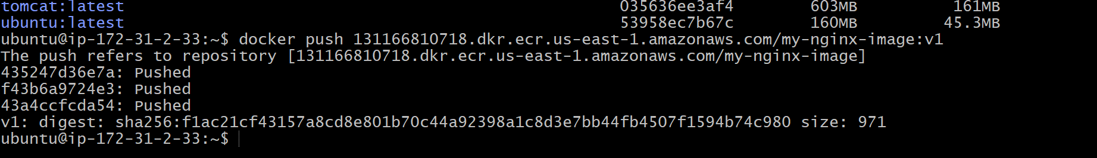
Validation Points
- AWS CLI installed and configured successfully.
- IAM authentication verified using aws sts get-caller-identity.
- Amazon ECR repository created successfully.
- Docker authenticated with Amazon ECR.
- Docker image tagged with the correct ECR repository URI.
- Image pushed to Amazon ECR successfully.
- Image visible in the ECR repository with the v1 tag.

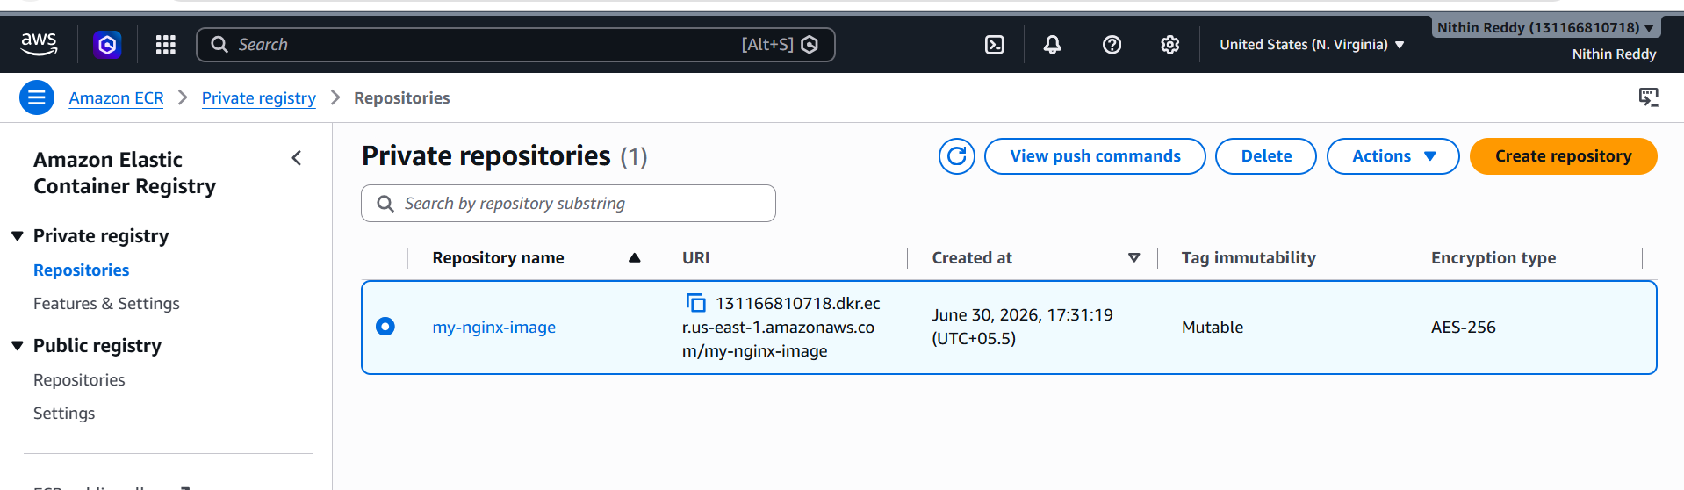
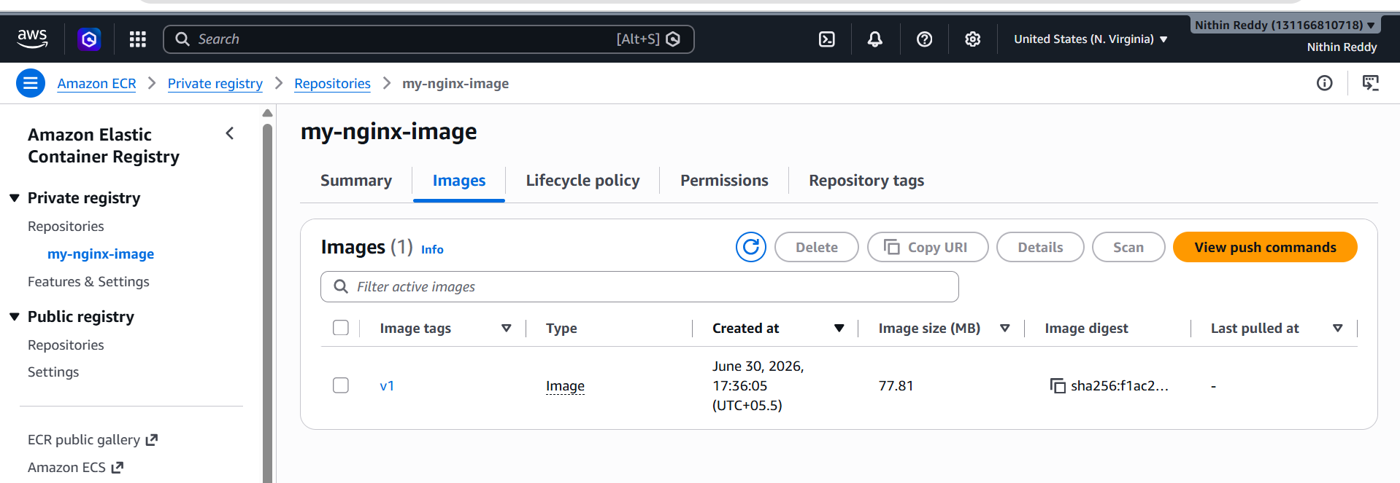
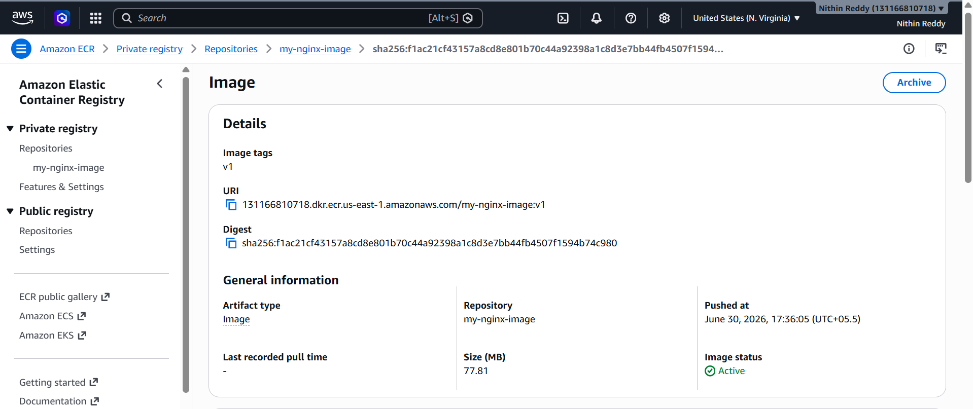
Outcome
Successfully configured AWS CLI, authenticated Docker with Amazon ECR, and pushed the custom Nginx Docker image to the private Amazon Elastic Container Registry (ECR). The image is now securely stored in AWS and can be pulled and deployed from the ECR repository whenever required.

