Terraform-02
Execute all the templates shown in the video.
AWS Provider Example
Install Terraform on EC2 (Amazon Linux)
Objective
Create an AWS EC2 instance named terraform using Terraform and manage it through the complete Terraform lifecycle:
- terraform init
- terraform fmt
- terraform validate
- terraform plan
- terraform apply
- terraform destroy
Prerequisites
Ensure the following are ready:
- Terraform installed (terraform version works)
- AWS account
- AWS IAM User with programmatic access
- AWS CLI installed
- Git Bash installed
- VS Code installed
- AWS Access Key and Secret Key
Step 1: Configure AWS CLI
Open Git Bash.
Check AWS CLI:
aws --version
Configure AWS:
aws configure
Enter:
AWS Access Key ID : XXXXXXXXXXXXX
AWS Secret Access Key : XXXXXXXXXXXXX
Default region : us-east-1
Default output : json
Verify:
aws sts get-caller-identity
You should see your AWS account details.
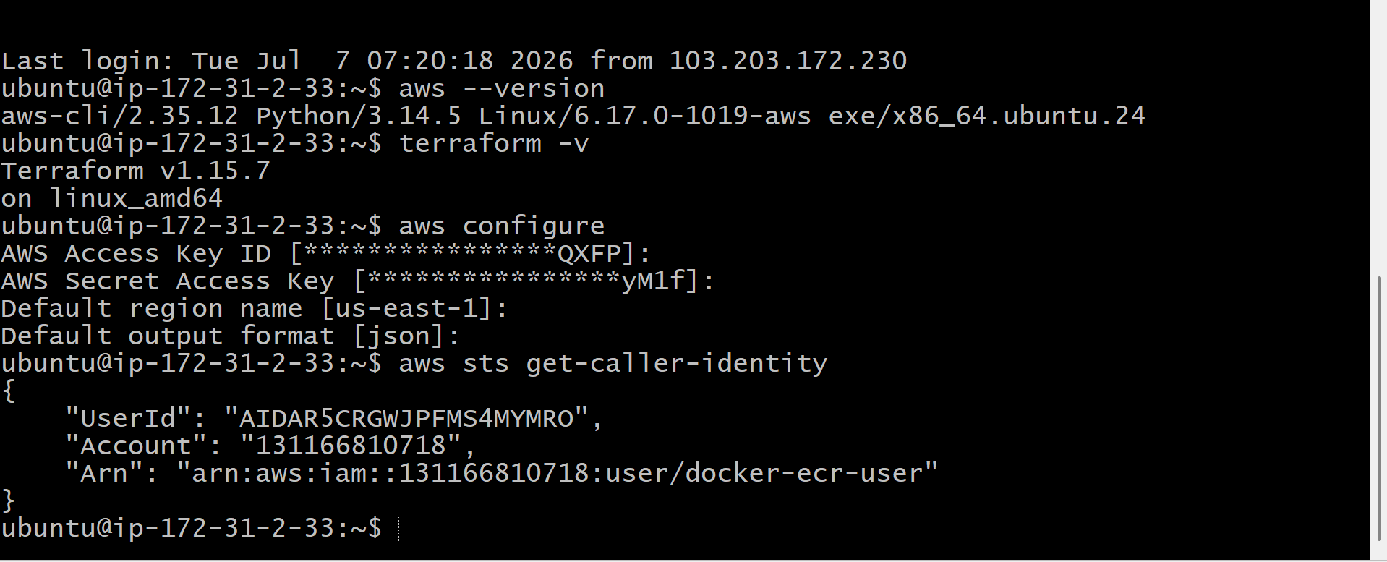
Step 2: Create Project Folder
mkdir terraform-ec2
cd terraform-ec2
Verify:
pwd

Step 3: Create main.tf
Create a file named:
vi main.tf
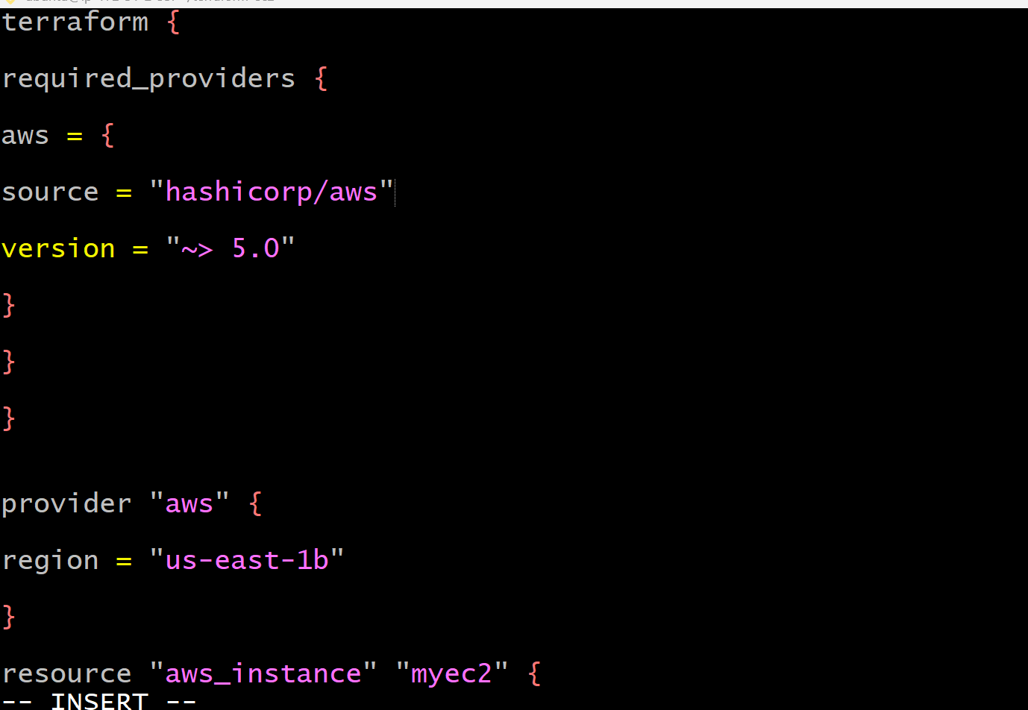
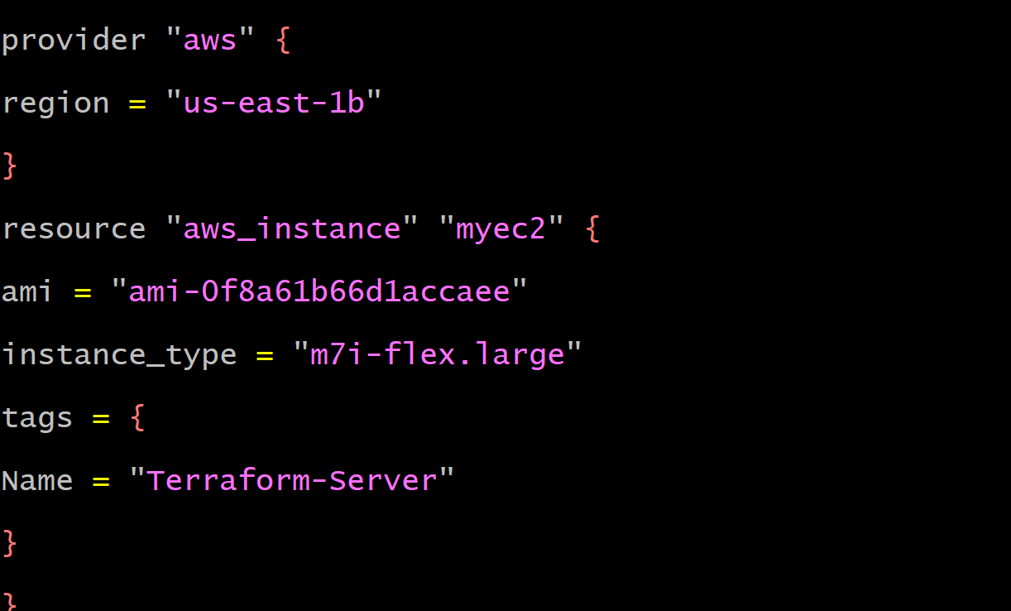
Step 5: Initialize Terraform
terraform init
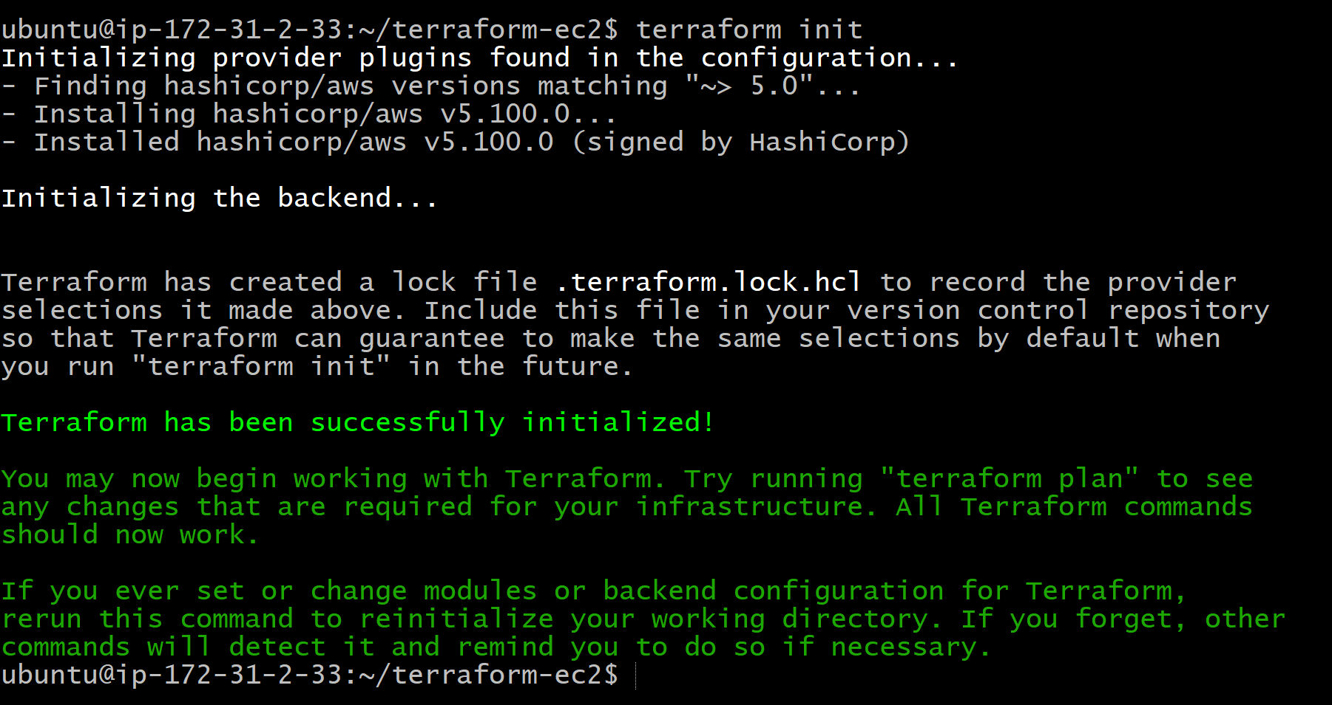
Step 6
Terraform validate
Terraform will automatically create:
terraform-provider-demo/
├── main.tf
├ ── .terraform/
├── .terraform.lock.hcl
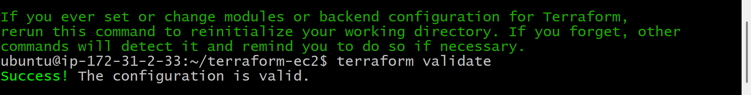
Step 9: Create the EC2 Instance
terraform apply
When prompted:
Enter a value:
Type: yes
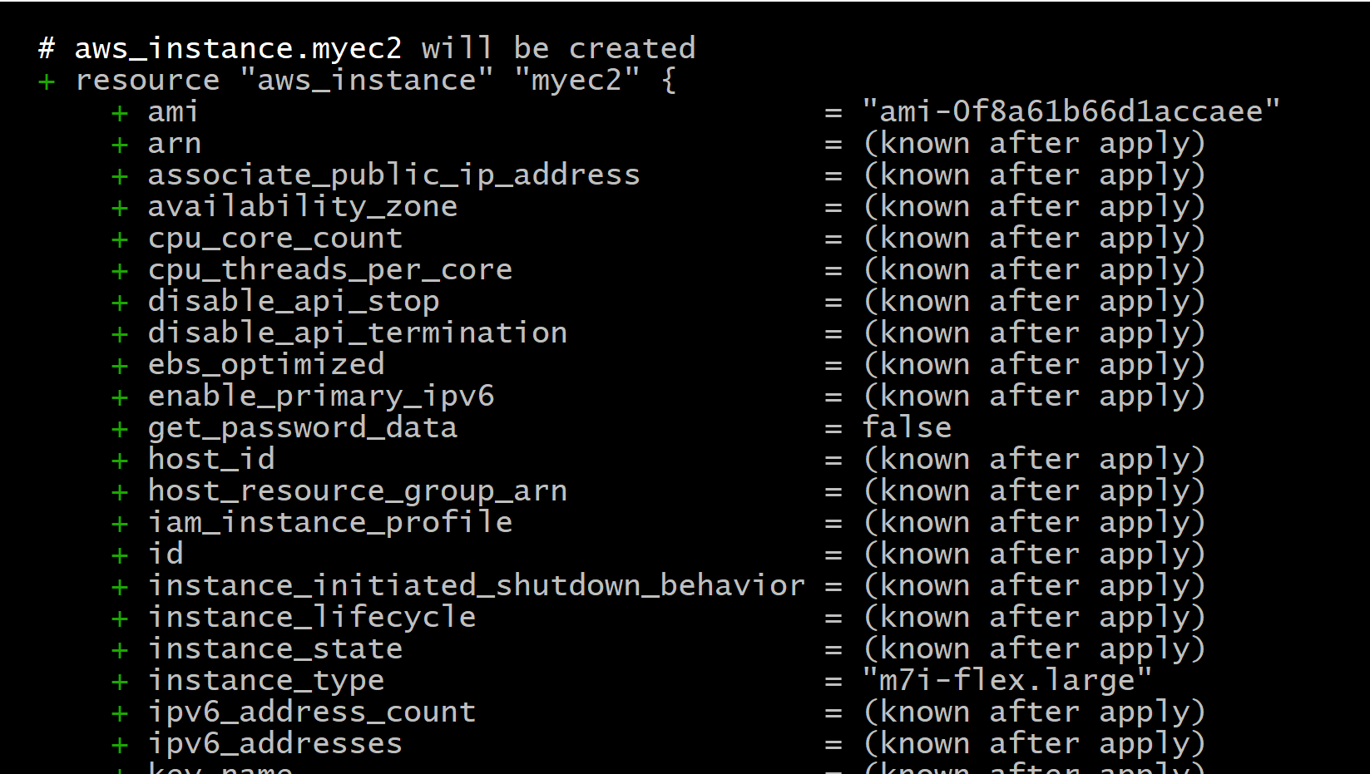

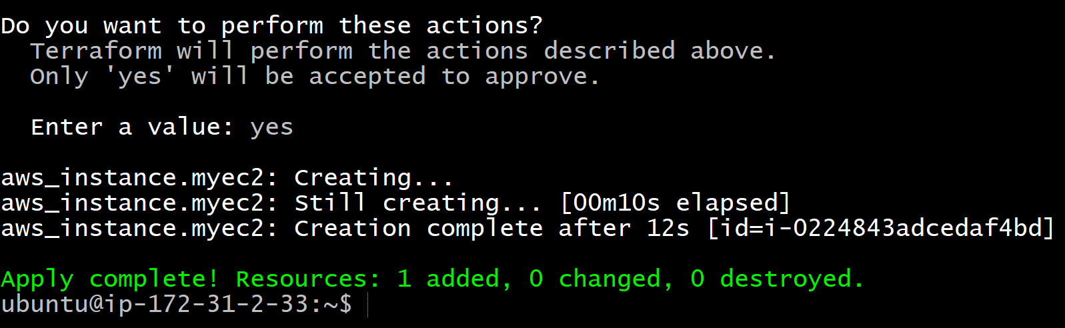
Step 10: Verify in AWS
Go to:
AWS Console → EC2 → Instances
Verify:
- Instance is Running
- M-7 large
- Name : terraform

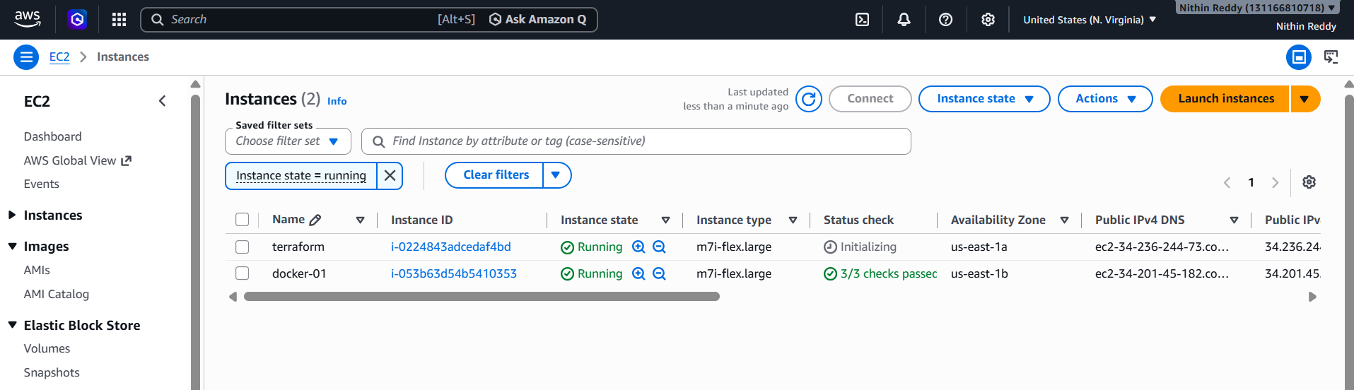
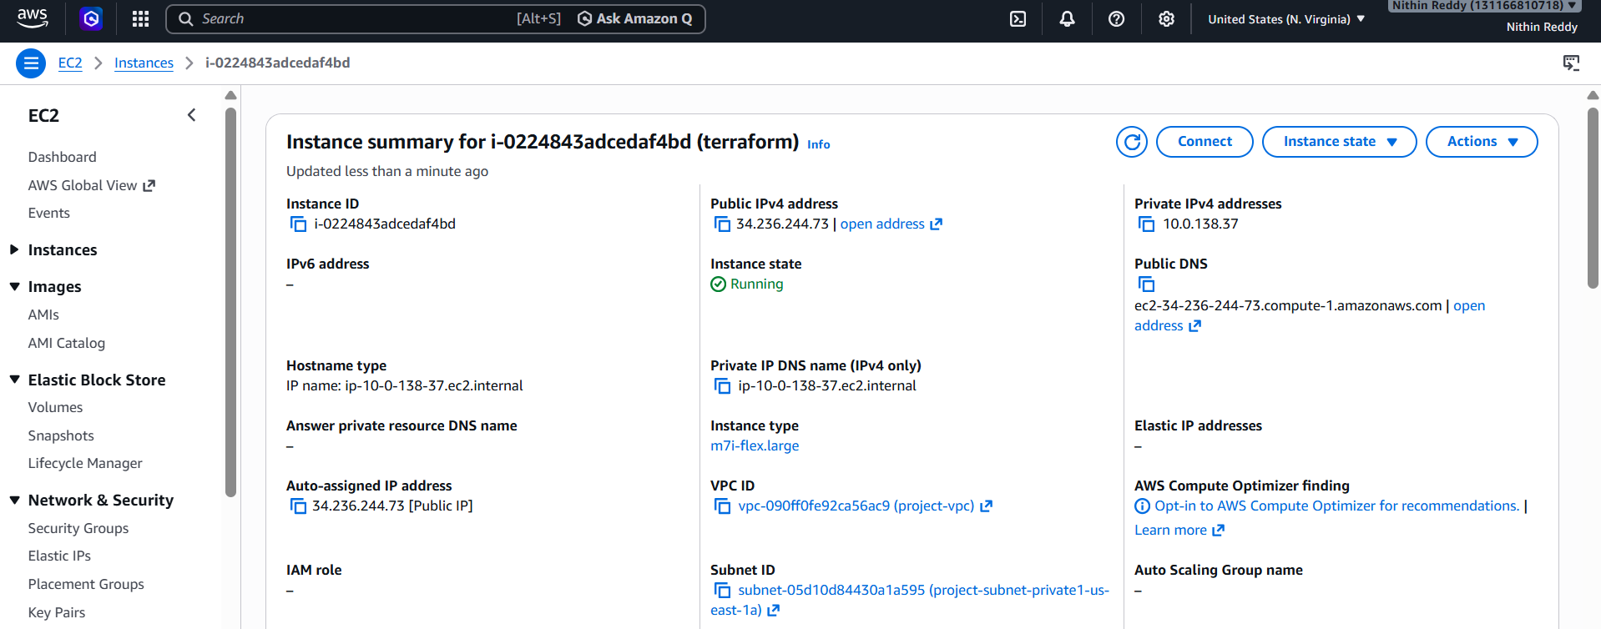
Step 11: Destroy the EC2 Instance
terraform destroy
When prompted:
Enter a value:
Type:
yes

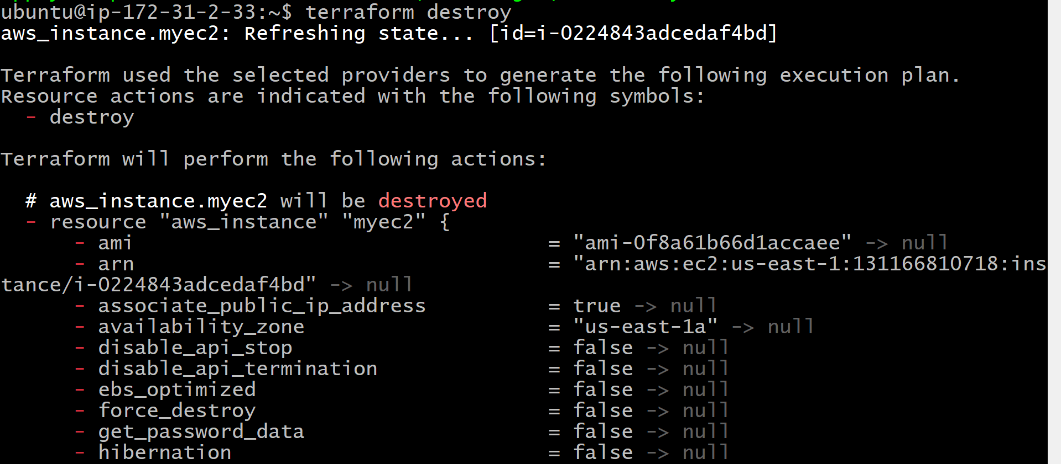

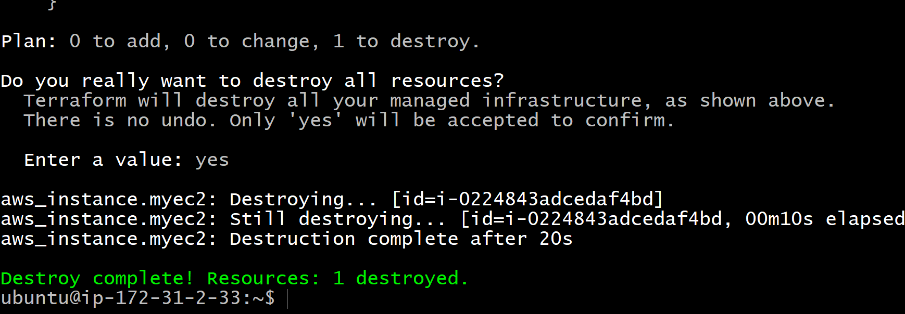

Validation
- Terraform initialized successfully.
- AWS provider downloaded.
- Configuration formatted successfully.
- Configuration validated successfully.
- Execution plan reviewed.
- EC2 instance created.
- Instance visible in AWS Console.
- State file generated.
- EC2 instance destroyed successfully.

Outcome
After completing this task:
- Terraform successfully provisions an EC2 instance named terraform.
- The full Terraform lifecycle (init, fmt, validate, plan, apply, show, state list, and destroy) is demonstrated.
- Infrastructure is created and removed using Infrastructure as Code (IaC), without manual actions in the AWS Console.

Task: Integrate Terraform in Jenkins using the Terraform Plugin
Objective
The objective of this task is to integrate Terraform with Jenkins using the Terraform Plugin. This integration allows Jenkins to execute Terraform commands (init, plan, apply, and destroy) through a CI/CD pipeline, enabling automated infrastructure provisioning and management using Infrastructure as Code (IaC).
What is the Terraform Plugin?
The Terraform Plugin is a Jenkins plugin that integrates Terraform with Jenkins. It allows Jenkins jobs and pipelines to use Terraform installations configured in Jenkins without manually specifying the Terraform executable path.
Benefits
- Integrates Terraform with Jenkins
- Supports multiple Terraform versions
- Simplifies pipeline configuration
- Uses centrally managed Terraform installations
- Automates Infrastructure as Code deployments
Prerequisites
Before starting, ensure the following requirements are met:
System Requirements
- Ubuntu/Linux Jenkins Server
- Jenkins installed and running
- Java installed
- Git installed
- Terraform installed
- Internet connection
Jenkins Requirements
- Administrator access
- Pipeline Plugin
- Git Plugin
- Terraform Plugin
- Credentials Plugin
Cloud Requirements
- AWS Account (if deploying AWS resources)
- AWS CLI configured (optional)
- IAM User with required permissions
Implementation Steps
Step 1: Verify Jenkins is Running
Open Jenkins in your browser.
http://<Jenkins-IP>:8080
Login using administrator credentials.
Step 2: Install Terraform Plugin
Navigate to
Manage Jenkins
↓
Plugins
↓
Available Plugins
Search
Terraform
Select
Terraform
Click
Install without restart
Wait until installation completes.
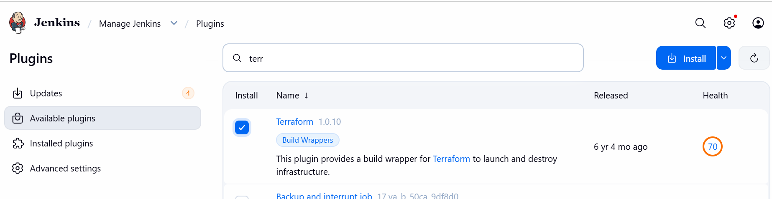
Step 3: Verify Plugin Installation
Go to
Manage Jenkins
↓
Plugins
↓
Installed Plugins
Verify that
Terraform Plugin
appears in the installed plugin list.
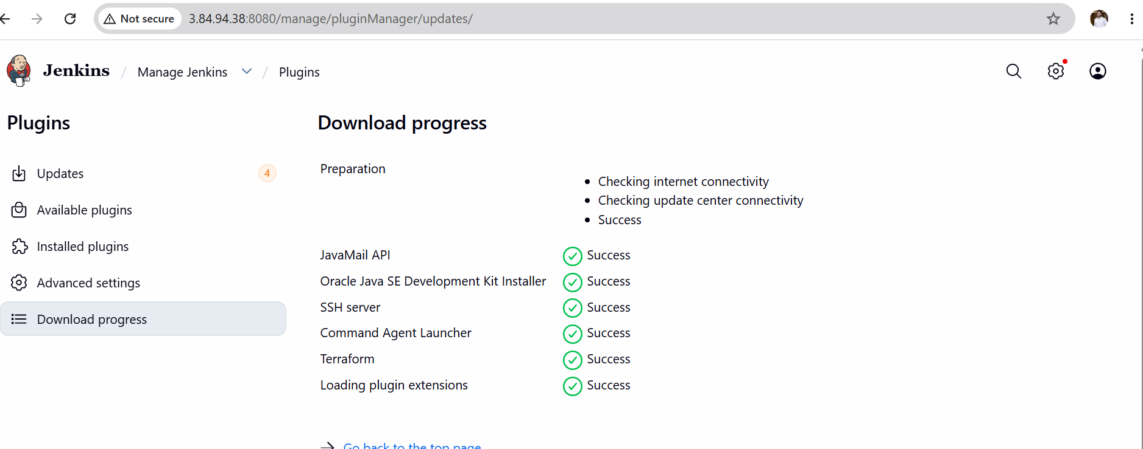
Step 4: Configure Terraform Installation
Navigate to
Manage Jenkins
↓
Tools
(or Global Tool Configuration, depending on the Jenkins version)
Scroll down to
Terraform Installations
Click
Add Terraform
Configure:
Name
Terraform-1.15.7
Uncheck
Install automatically
Enter the installation directory.
Example
/usr/local/bin/terraform
or
/usr/bin/terraform
(Use the output of which terraform on your Jenkins server.)
Click
Save
Step 5: Verify Terraform Path
Run on Jenkins server
which terraform
Example output
/usr/local/bin/terraform
Also verify
terraform version
Expected output
Terraform v1.15.7
Step 6: Create Pipeline Job
Dashboard
↓
New Item
Project Name
Terraform-Plugin-Demo
Select
Pipeline
Click
OK
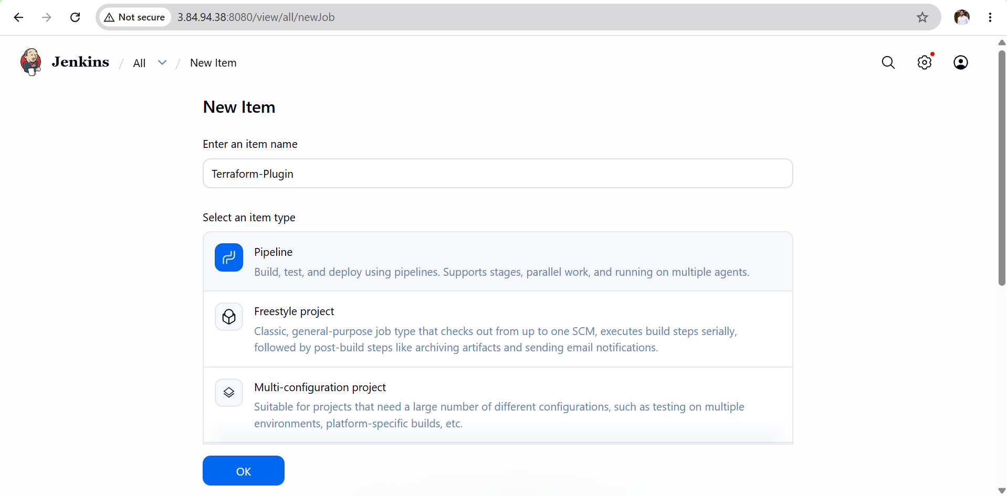
Declarative script
pipeline {
agent any

stages {

stage('Terraform Version') {
steps {
sh 'terraform version'
}
}

stage('Terraform Init') {
steps {
sh 'terraform init'
}
}

stage('Terraform Validate') {
steps {
sh 'terraform validate'
}
}
}
}
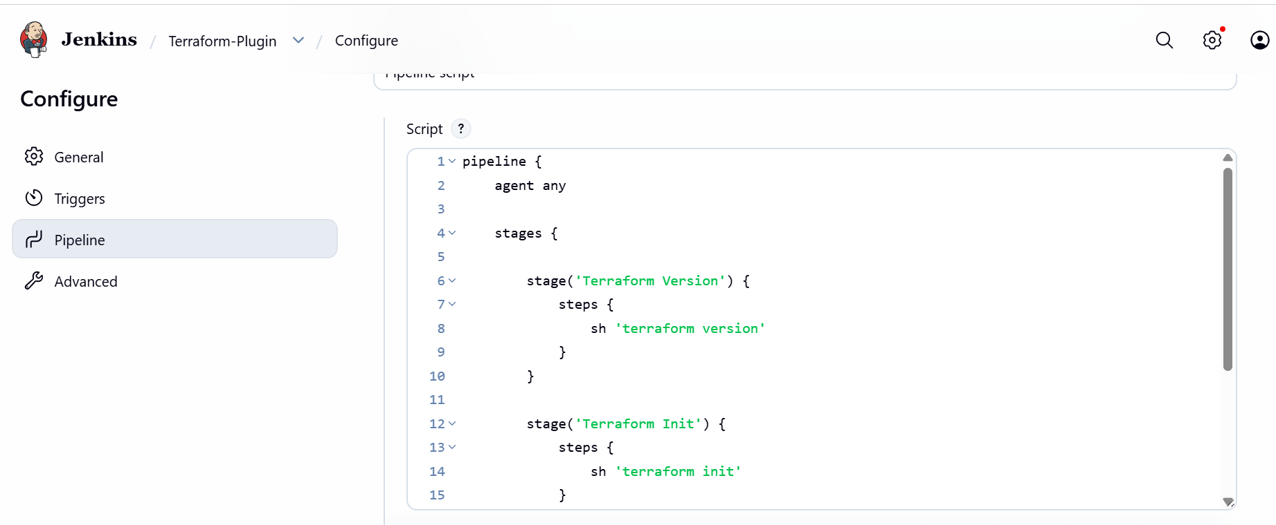
Step 8: Save Pipeline
Click
Save

Step 9: Build Pipeline
Click
Build Now
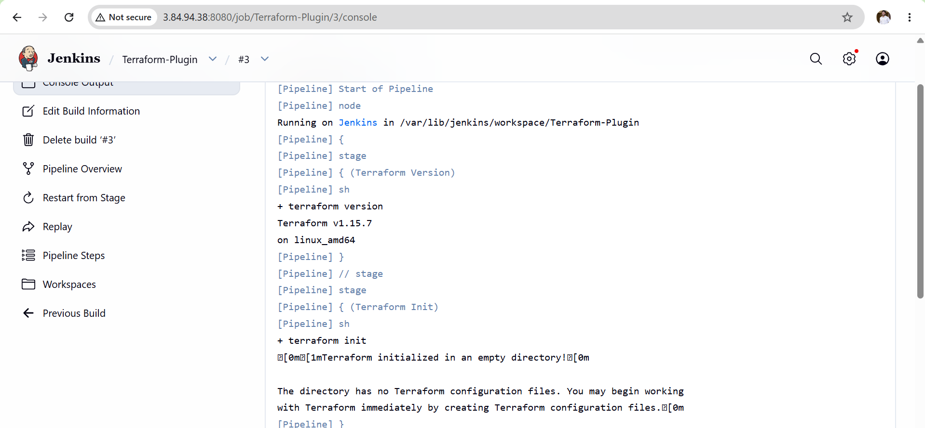
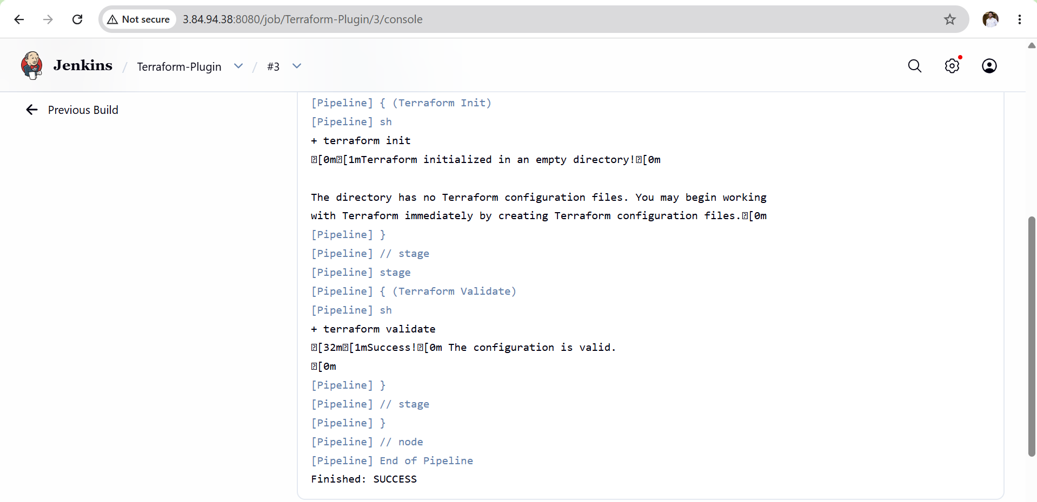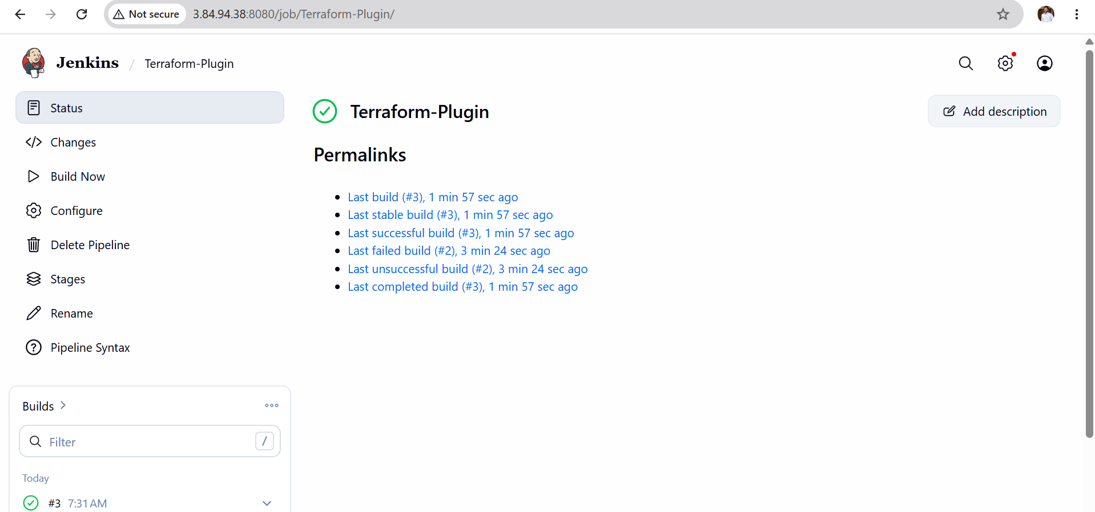
Validation Checklist
- Jenkins server is running.
- Terraform Plugin is installed.
- Terraform installation is configured in Jenkins.
- Terraform version is detected successfully.
- Pipeline executes without errors.
- Console output displays Terraform commands.
- Build completes with SUCCESS status.

Outcome
After completing this task:
- Terraform Plugin is successfully installed in Jenkins.
- Terraform is configured as a global tool.
- Jenkins can access the configured Terraform installation.
- A pipeline can execute Terraform commands without specifying the executable path manually.
- Infrastructure automation through Jenkins and Terraform is ready for future deployments.

