Kubernetes-07
Task: Taint a Node and Schedule a Tolerant Pod
Objective
- Taint a worker node with special=true: NoSchedule.
- Create a Pod with a matching toleration.
- Verify that the Pod is scheduled successfully on the tainted node.

What is a Taint?
A taint is applied to a Node to prevent Pods from being scheduled on it unless the Pod has a matching toleration.
Think of it like this:
- Taint = "Do not schedule Pods here."
- Toleration = "This Pod has permission to run here."

Architecture
Worker Node
special=true:NoSchedule
(Taint Applied)
│
┌───────────────┴───────────────┐
│ │
Pod without Toleration Pod with Toleration
❌ Rejected ✅ Scheduled

Implementation Steps (Documentation)
- Identified the target worker node.
- Applied a NoSchedule taint to the node.
- Verified the taint configuration.
- Created a Pod manifest with a matching toleration.
- Deployed the Pod.
- Verified the Pod scheduling and toleration details.

Kubectl get nodes
kubectl taint nodes k8s-worker1 special=true:NoSchedule
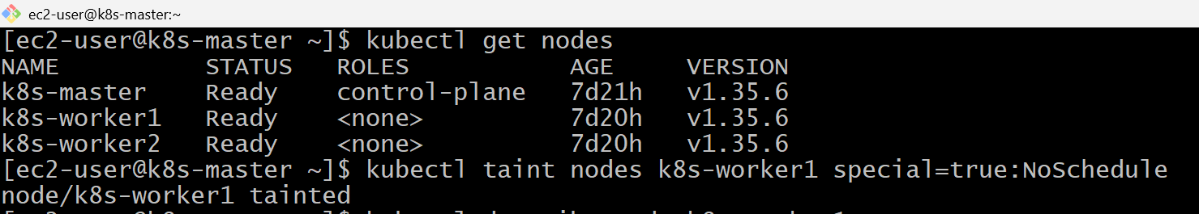
kubectl describe node k8s-worker1
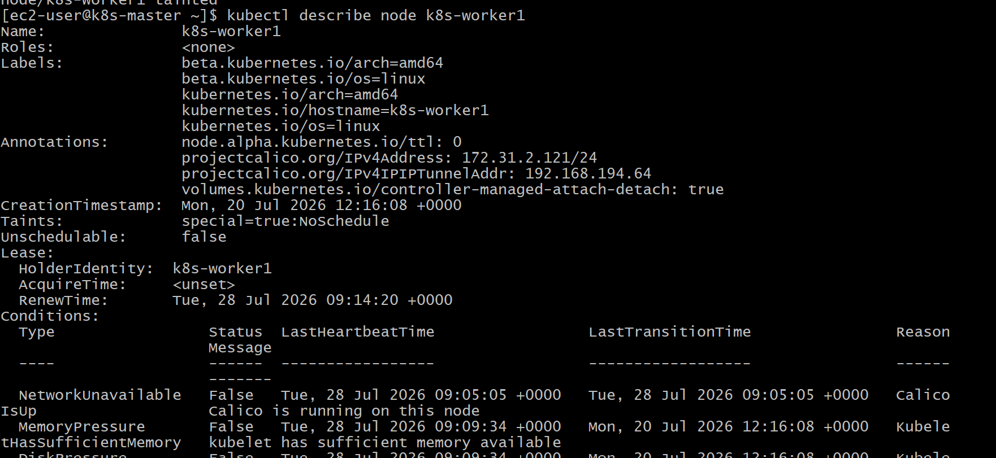

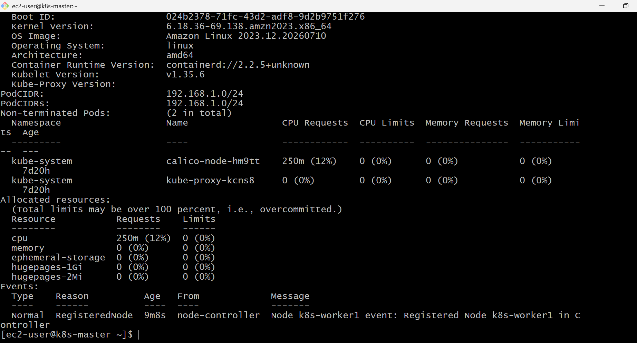
vi tolerant-pod.yaml
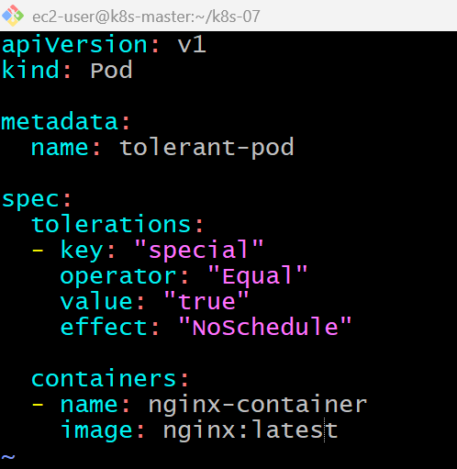

kubectl describe node k8s-worker1 | grep Taints
vi tolerant-pod.yaml
kubectl apply -f tolerant-pod.yaml
kubectl get pods -o wide
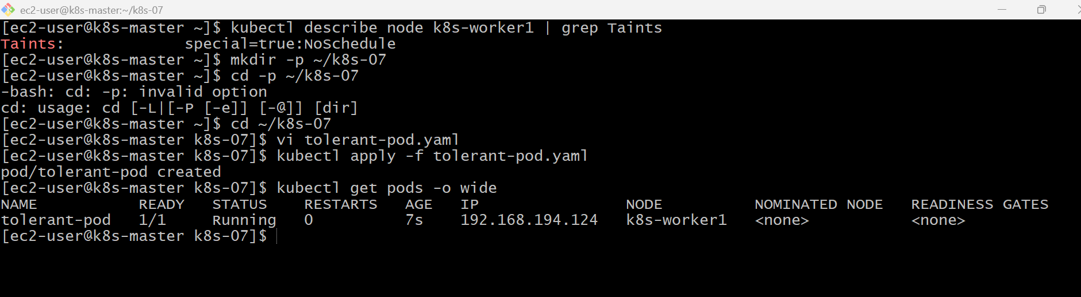
kubectl describe pod tolerant-pod
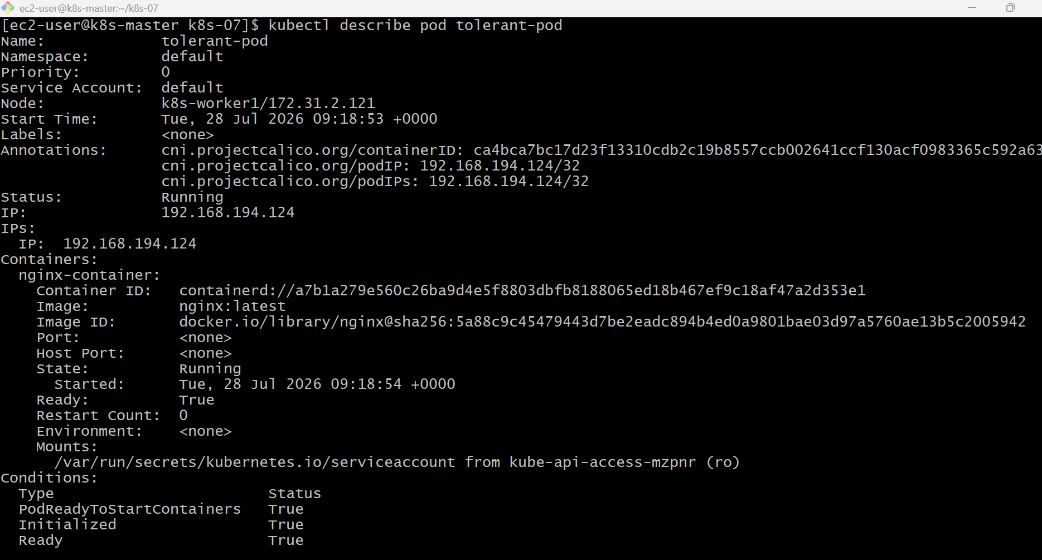
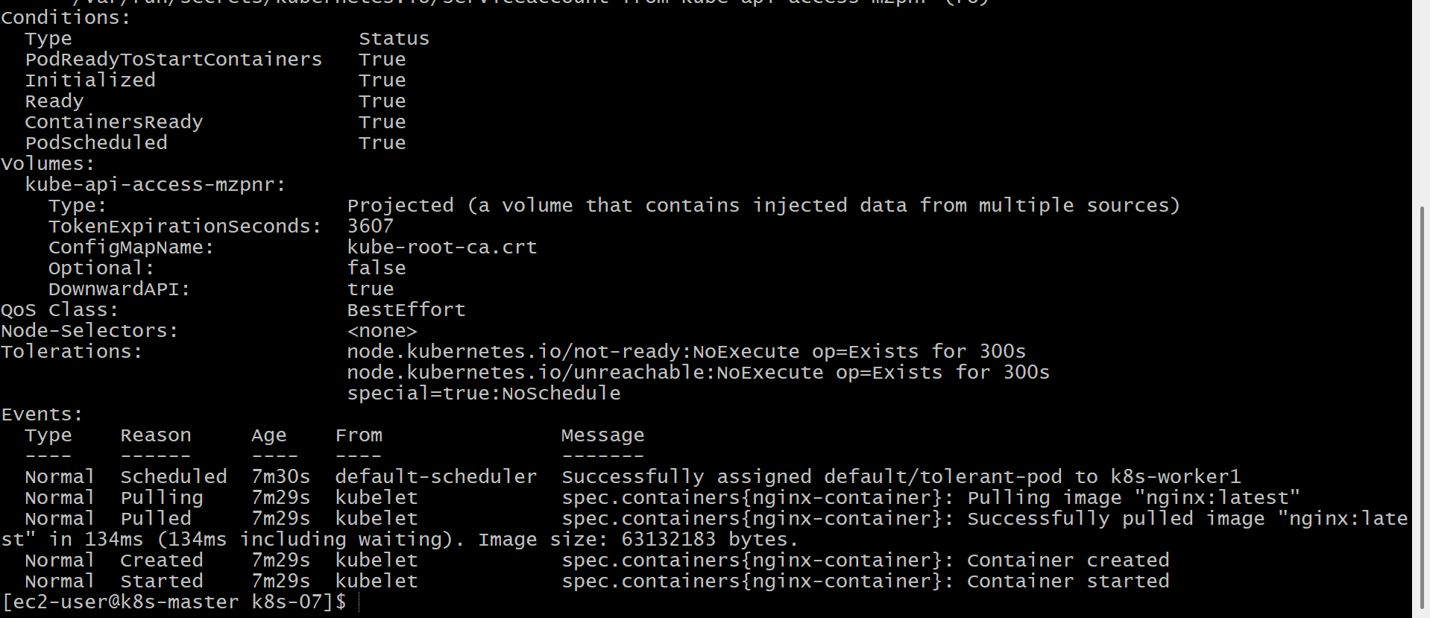
kubectl describe pod tolerant-pod
kubectl get pod tolerant-pod -o wide
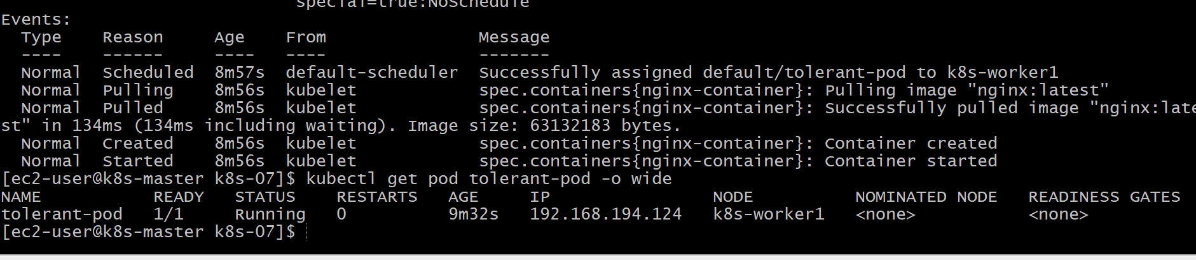
Validation Points
- Applied a NoSchedule taint to a worker node.
- Verified the taint on the node.
- Created a Pod with a matching toleration.
- Deployed the Pod successfully. Verified the Pod's tolerations.
- Confirmed the Pod could be scheduled despite the taint.
Outcome
- Successfully configured a tainted node.
- Created a Pod with a matching toleration.
- Verified that the Pod can run on a node with a matching taint.
- Learned how taints and tolerations help control workload placement in Kubernetes
Task 3: Use Node Selector to Schedule a Pod on a Specific Node
Objective
- Label a node with env=dev.
- Create a Pod using node Selector.
- Verify that the Pod is scheduled only on the node with the env=dev label.
What is Node Selector?
Node Selector is the simplest way to schedule a Pod on a specific node.
- Node Label = Identity of a node.
- Node Selector = Pod requests a node with a specific label.
If the label doesn't exist, the Pod remains in the Pending state.

Architecture
Worker-1
env=dev Label
│
│
nodeSelector=env:dev
│
▼
Pod Scheduled

Implementation Steps (Documentation)
- Listed the available Kubernetes nodes.
- Added the env=dev label to k8s-worker1.
- Verified the node label.
- Created a Pod manifest with a nodeSelector.
- Deployed the Pod.
- Verified the Pod was scheduled on the labeled node.
- Tested scheduling behavior by removing and restoring the label.

Kubectl get nodes
kubectl label node k8s-worker1 env=dev
kubectl describe node k8s-worker1
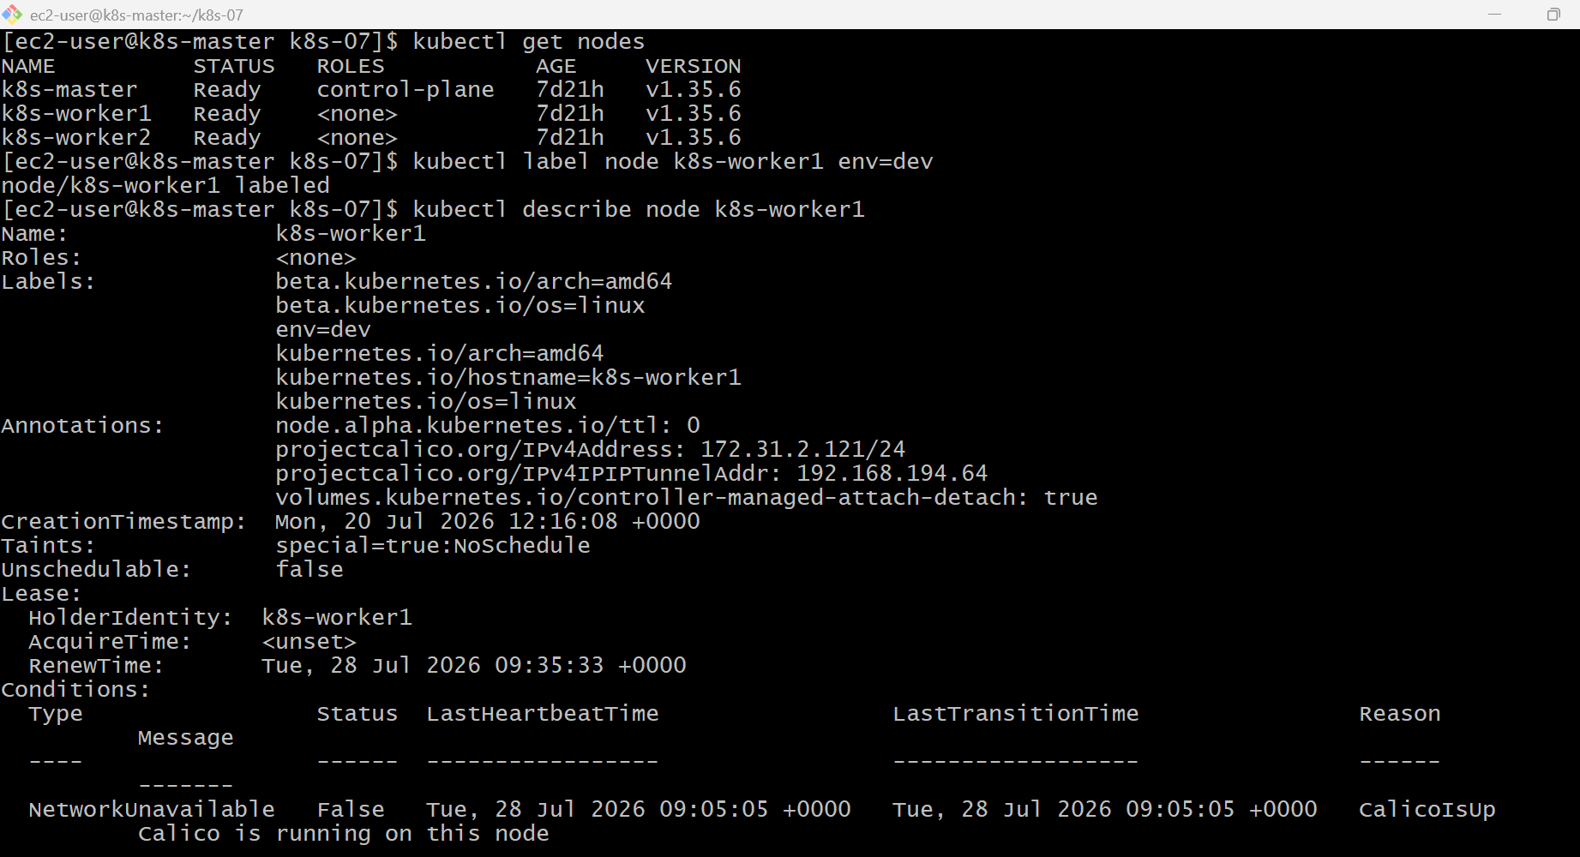

vi nodeselector-pod.yaml
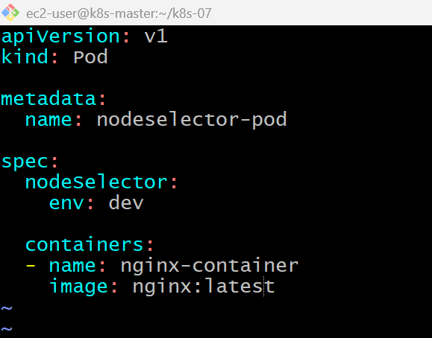
kubectl apply -f nodeselector-pod.yaml
kubectl get pods -o wide
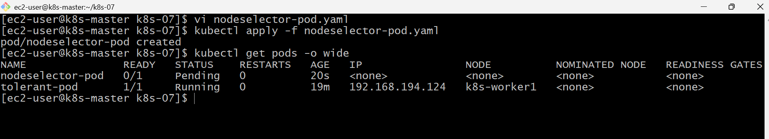
kubectl describe node k8s-worker1
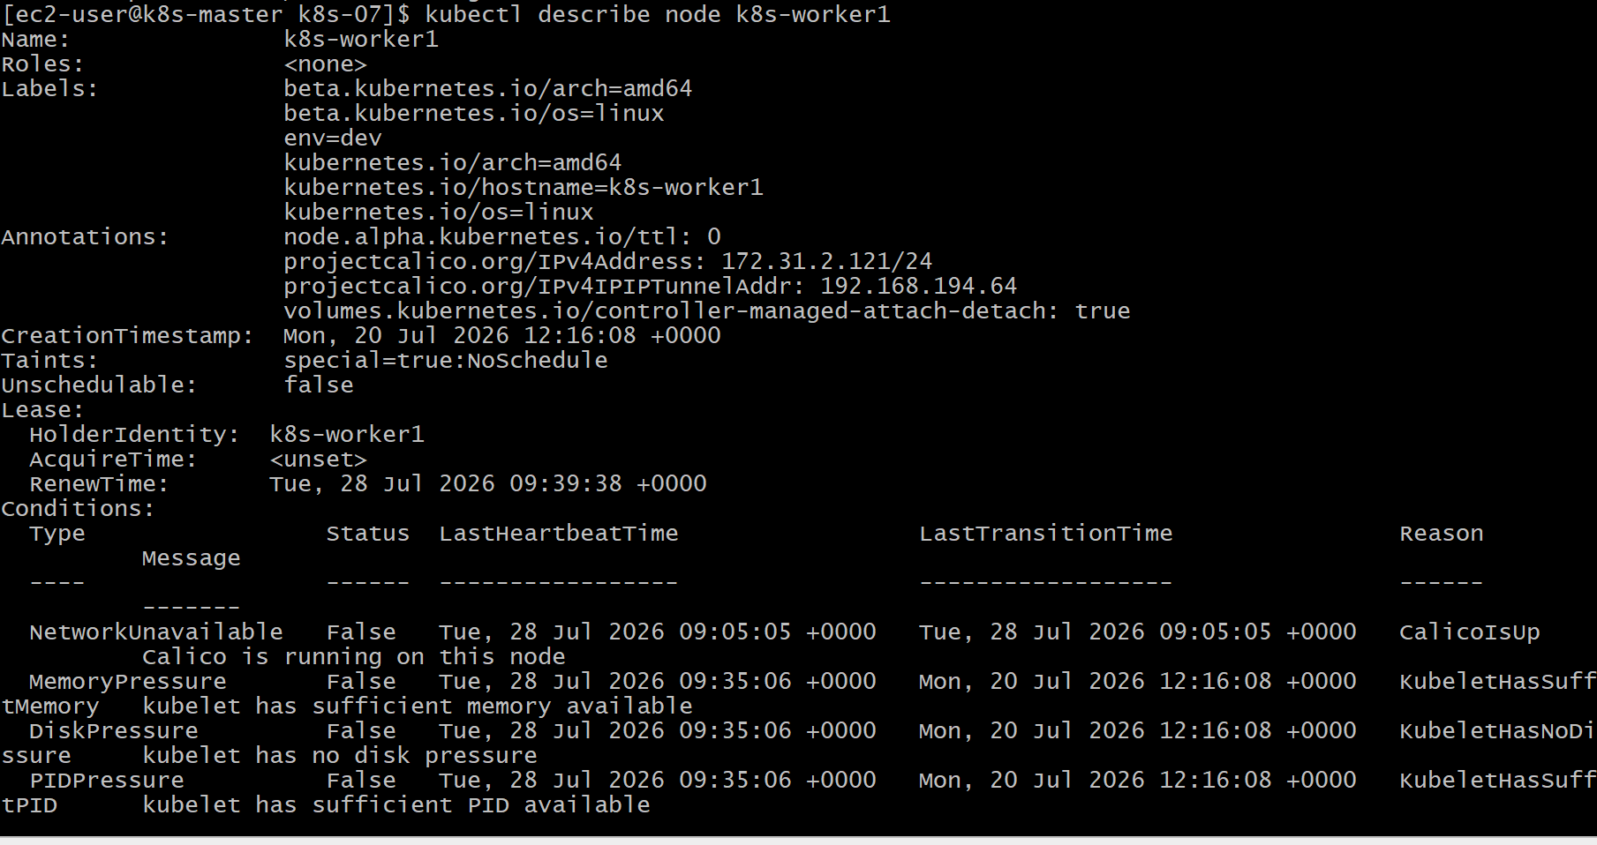
Validation Points
- Verified available cluster nodes.
- Applied the env=dev label to a worker node.
- Verified the node label.
- Created a Pod using nodeSelector.
- Successfully scheduled the Pod on the labeled node.
- Confirmed scheduling behavior when the label was removed.

Outcome
- Successfully used nodeSelector to schedule a Pod on a specific node.
- Verified that Pods are scheduled only on nodes with matching labels.
- Learned how Kubernetes uses labels and selectors for basic workload placement.

Task 4: Use Node Affinity with Soft Scheduling
Objective
- Label a node with env=test.
- Create a Pod using Preferred During Scheduling Ignored During Execution (Soft Affinity).
- Verify the Pod prefers the labeled node.
- Remove the label and verify the Pod continues running.
What is Node Affinity?
Node Affinity is an advanced version of nodeSelector.
There are two types:
- PreferredDuringSchedulingIgnoredDuringExecution (Soft Affinity)
  - Kubernetes tries to schedule the Pod on the preferred node.
  - If unavailable, it schedules the Pod on another suitable node.
- RequiredDuringSchedulingIgnoredDuringExecution (Hard Affinity)
  - Kubernetes must find a matching node.
  - Otherwise, the Pod stays in Pending.
In this task, we'll use Soft Affinity.
Architecture
Worker-1 Worker-2
env=test No Label
│
│ (Preferred)
▼
Kubernetes Scheduler
│
▼
Pod
Implementation Steps (Documentation)
- Identified a worker node.
- Added the env=test label.
- Verified the label.
- Created a Pod manifest with preferred node affinity.
- Deployed the Pod.
- Verified scheduling on the preferred node.
- Removed the node label.
- Confirmed the Pod continued running.

kubectl get nodes --show-labels
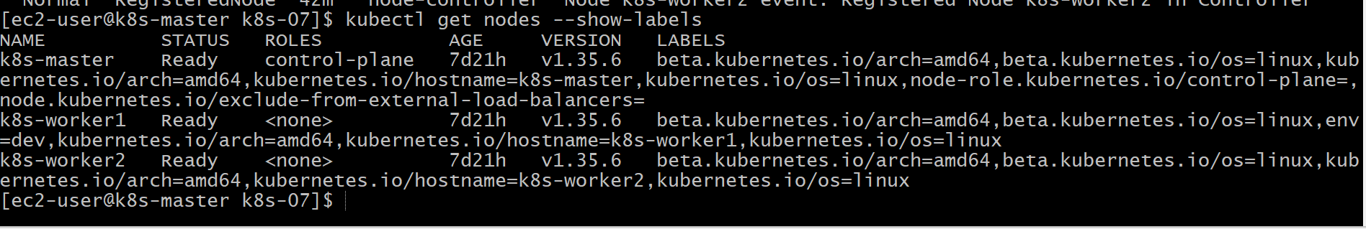

vi preferred-affinity-pod.yaml
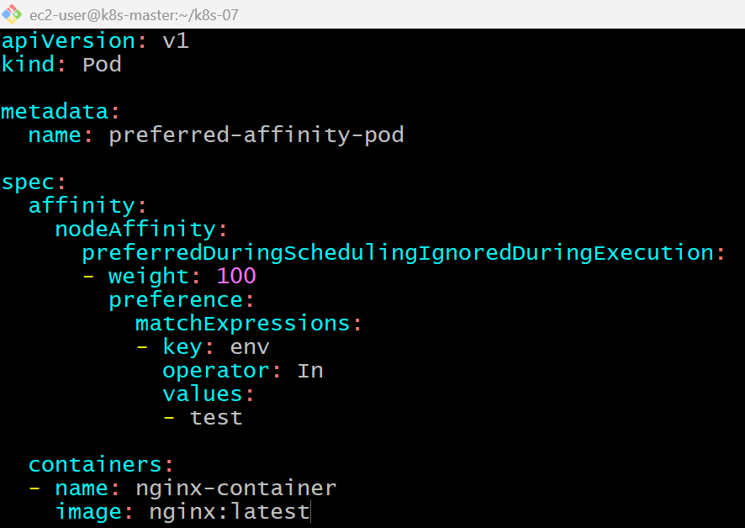
kubectl apply -f preferred-affinity-pod.yaml
kubectl get pods -o wide
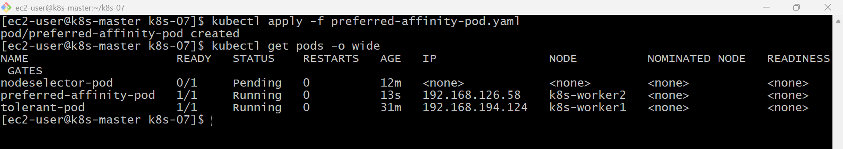
kubectl describe pod preferred-affinity-pod
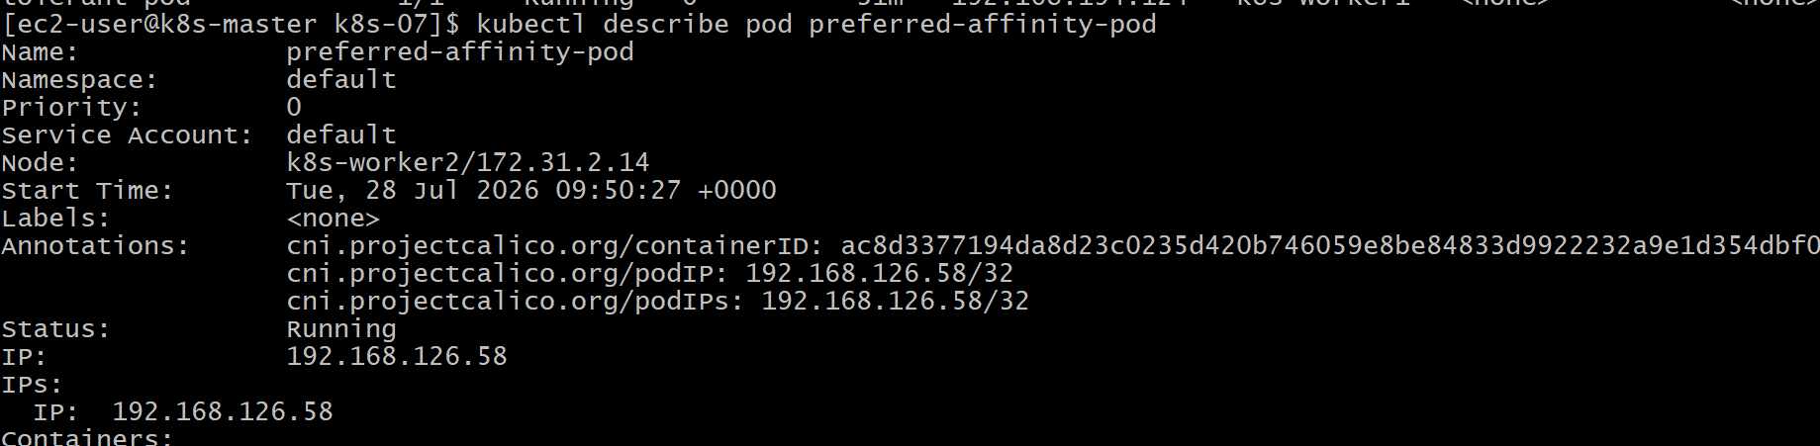

kubectl label node k8s-worker2 env-
kubectl get nodes --show-labels
kubectl get pods -o wide
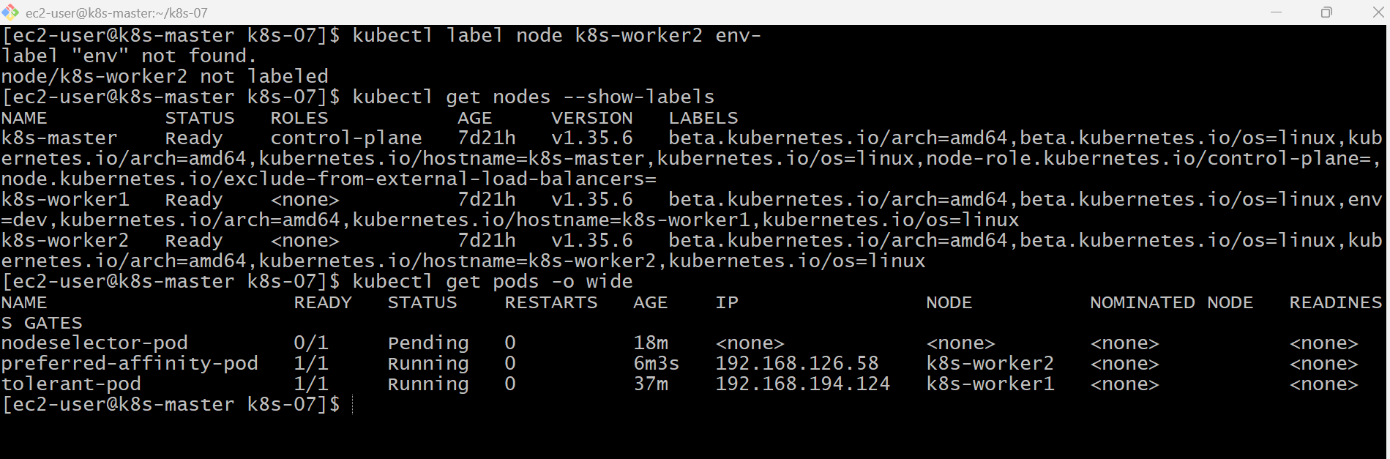
Validation Points
- Applied the env=test label to a worker node.
- Created a Pod using soft node affinity.
- Verified the Pod preferred the labeled node.
- Removed the node label.
- Confirmed the running Pod was not evicted.
- Verified the scheduler's behavior with preferred node affinity.

Outcome
- Successfully configured soft node affinity using preferredDuringSchedulingIgnoredDuringExecution.
- Verified that the scheduler prefers matching nodes but does not require them.
- Confirmed that removing the node label after scheduling does not affect a running Pod.

Task 5: Implement Node Affinity with Hard Scheduling
Objective
- Create a Pod with RequiredDuringSchedulingIgnoredDuringExecution node affinity.
- Ensure it can only be scheduled on a node labeled env=prod.
- Verify that the Pod remains Pending if no node has the env=prod label.

What is Hard Node Affinity?
Hard Node Affinity means:
The Pod must be scheduled only on nodes matching the specified label.
If no matching node exists:
- ❌ The Pod is not scheduled.
- ❌ It stays in the Pending state.

Soft vs Hard Affinity
Soft Affinity | Hard Affinity
Preferred | Mandatory
Scheduler tries | Scheduler must
Pod can run elsewhere | Pod stays Pending

Architecture
Worker-1 Worker-2
env=dev env=test
│ │
└──────────────┐
│
Required env=prod
│
▼
❌ No Matching Node
│
▼
Pod = Pending
Implementation Steps (Documentation)
- Verified node labels.
- Created a Pod with requiredDuringSchedulingIgnoredDuringExecution.
- Deployed the Pod.
- Observed the Pod in the Pending state.
- Labeled a worker node with env=prod.
- Verified the Pod was scheduled automatically.
- Removed the node label.
- Confirmed the running Pod continued without interruption.

vi required-affinity-pod.yaml
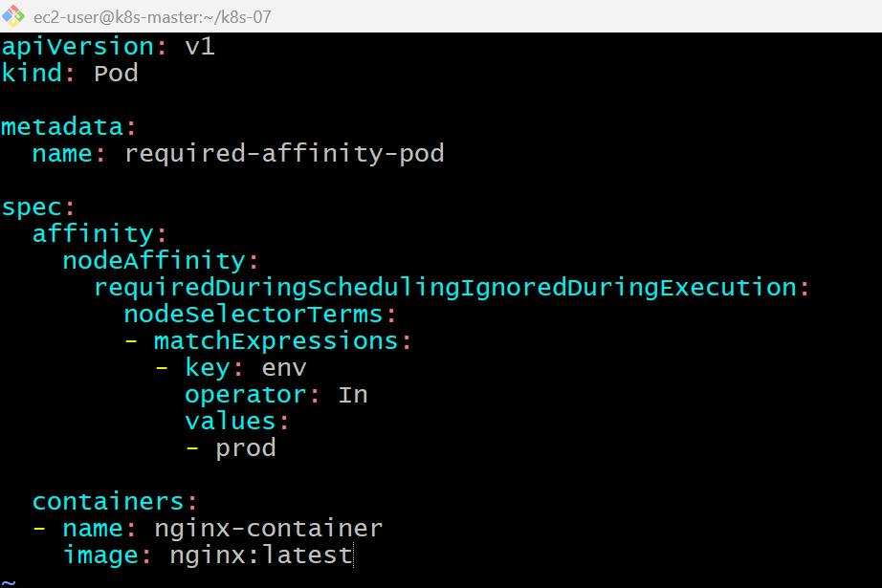
kubectl apply -f required-affinity-pod.yaml
kubectl label node k8s-worker2 env=prod
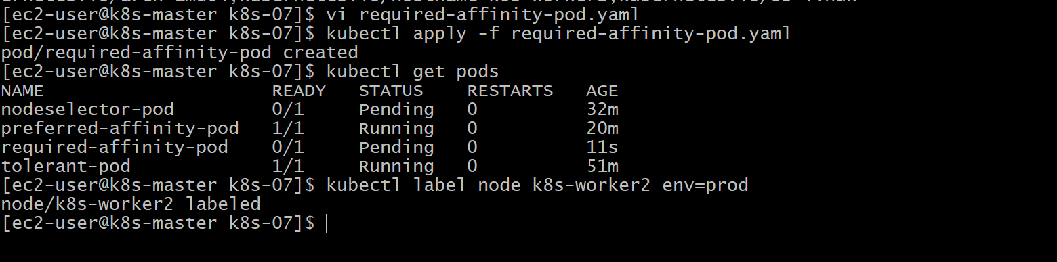
kubectl get nodes --show-labels
kubectl get pods -o wide
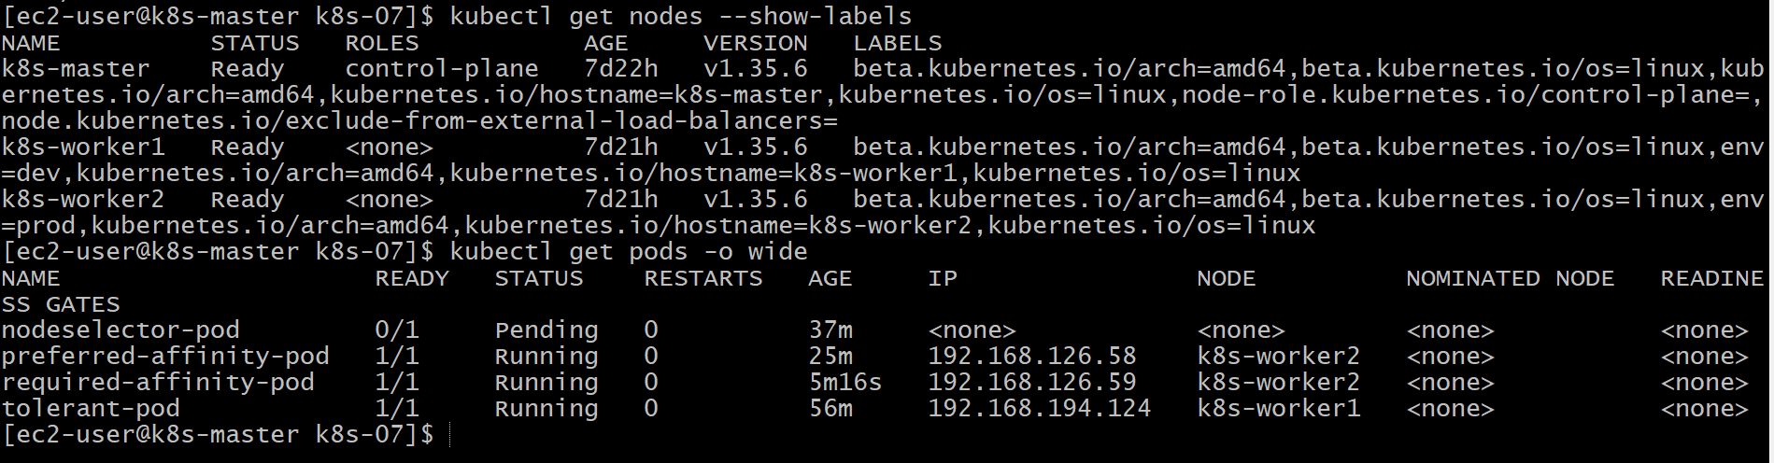
kubectl describe pod required-affinity-pod
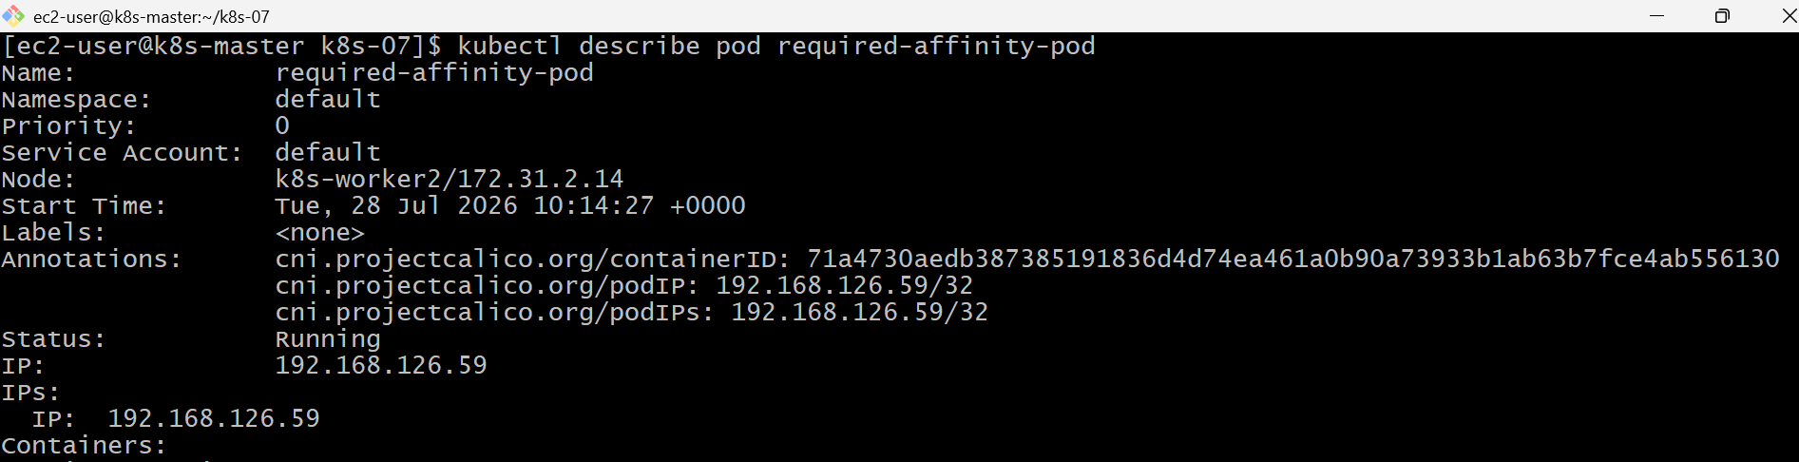

Validation
kubectl get nodes --show-labels
kubectl get pods -o wide
kubectl describe pod required-affinity-pod

Outcome
- Successfully implemented Hard Node Affinity.
- Verified that Pods remain Pending when no node matches the required affinity.
- Confirmed that adding the required node label allows Kubernetes to schedule the Pod automatically.

Task 6: Taint a Node and Use NoExecute with tolerationSeconds
Objective
- Taint a node with special=true:NoExecute.
- Create a Pod with a matching toleration and tolerationSeconds: 60.
- Observe that the Pod is evicted after approximately 60 seconds.
What is NoExecute?
There are three taint effects:
Effect | Description
NoSchedule | Prevents new Pods from being scheduled on the node. Existing Pods continue running.
PreferNoSchedule | Scheduler tries to avoid the node but may still use it.
NoExecute | Prevents new Pods from scheduling and evicts existing Pods that don't tolerate the taint.
With tolerationSeconds, the Pod is allowed to stay only for the specified duration.
Architecture
k8s-worker2
special=true:NoExecute
│
│
Pod has toleration
│
tolerationSeconds=60
│
Runs for ~60 seconds
│
▼
Automatically Evicted

Implementation Steps (Documentation)
- Applied the special=true:NoExecute taint to k8s-worker2.
- Added a temporary node label for scheduling.
- Created a Pod with a matching NoExecute toleration.
- Configured tolerationSeconds: 60.
- Deployed the Pod.
- Verified the Pod started on the tainted node.
- Observed the Pod being automatically evicted after approximately 60 seconds.
- Removed the taint and temporary label.

kubectl get nodes
kubectl taint nodes k8s-worker2 special=true:NoExecute
kubectl get nodes --show-labels
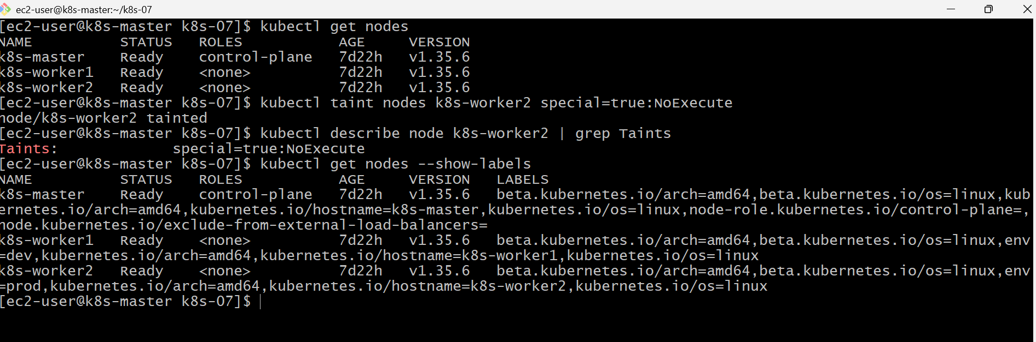

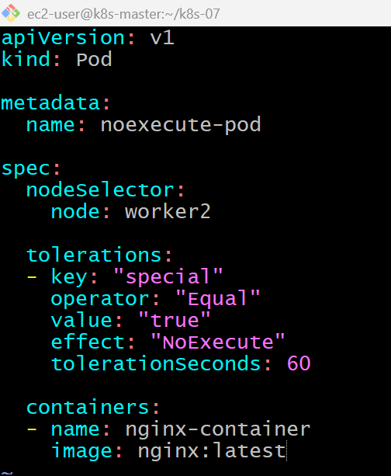
kubectl apply -f noexecute-pod.yaml
kubectl get pods -o wide
kubectl get pods
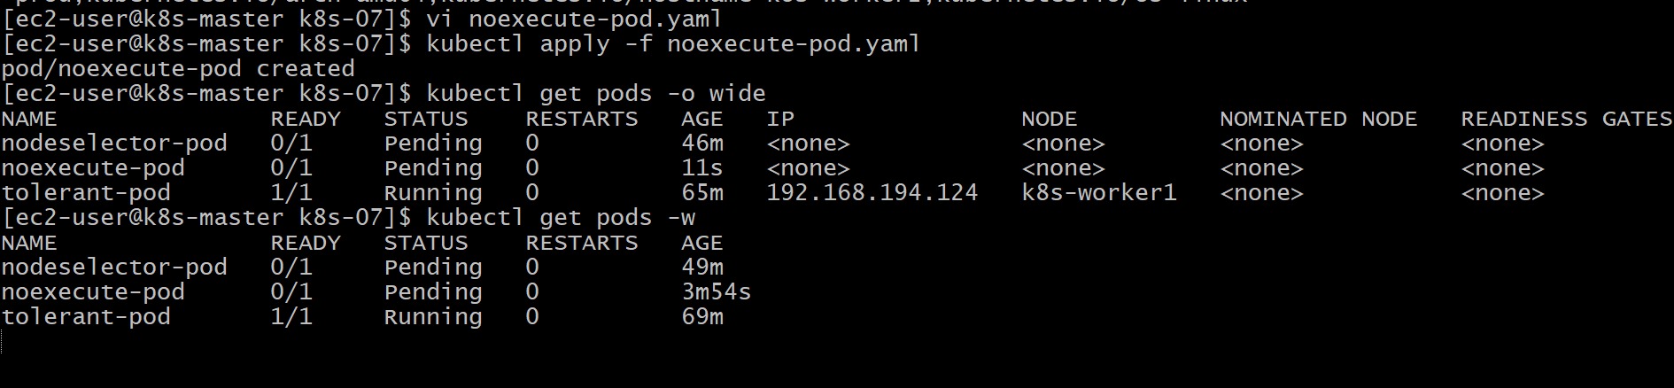
Validation Commands
kubectl get nodes
kubectl describe node k8s-worker2 | grep Taints
kubectl get pods -o wide
kubectl get pods -w
Validation Points
- Successfully applied a NoExecute taint.
- Created a Pod with a matching toleration.
- Verified the Pod ran on the tainted node.
- Observed automatic eviction after the configured toleration period.
- Removed the taint to restore normal scheduling.

Outcome
- Successfully demonstrated NoExecute taints with tolerationSeconds.
- Verified that Kubernetes allows the Pod to remain temporarily and then evicts it automatically.
- Understood the behavioral differences between NoSchedule, PreferNoSchedule, and NoExecute.

