TASK 1 — Create an S3 Bucket and Upload Objects
Objective
Learn how to create and manage S3 storage.
Why are we doing this?
S3 buckets are the foundation of object storage in AWS. Before performing advanced operations, we must create a bucket and store files.
Expected Outcome
- New bucket created
- Files uploaded successfully
- Objects visible inside bucket

Step 1: Create Bucket
Login AWS Console
Navigate:
S3
→ Create Bucket
Bucket Name:
nithin-s3-demo-2026
(Use a unique name if already taken)
Region:
ap-south-1 (Mumbai)
Leave everything else default.
Click:
Create Bucket
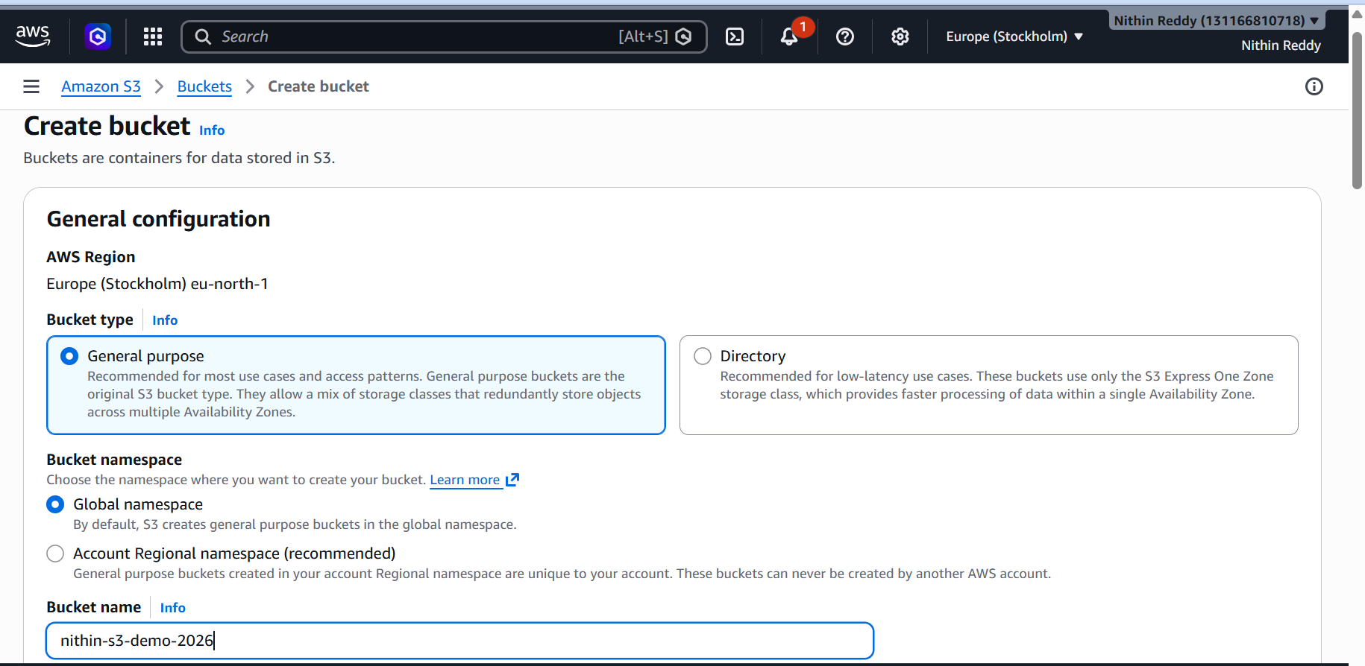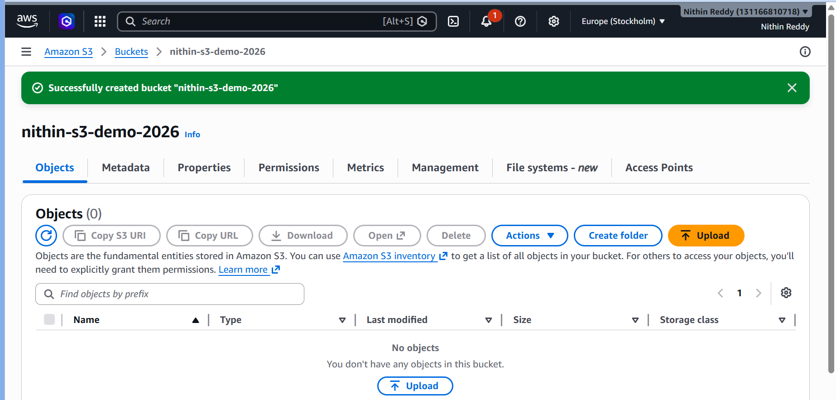
Step 2: Upload Files
Open bucket.
Click:
Upload
Upload:
sample1.txt
sample2.jpg
sample3.pdf
Click:
Upload
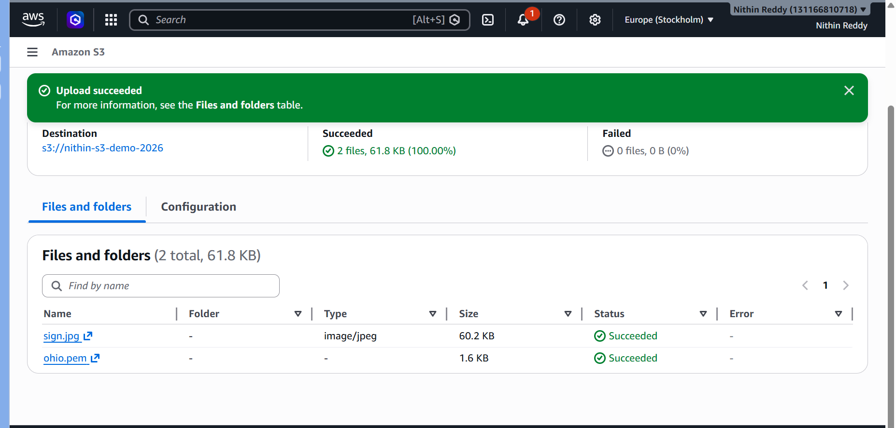
Validation
You should see:
sample1.txt
sample2.jpg
sample3.pdf
inside bucket.

Common Errors
Error
Bucket name already exists
Fix
Use:
nithin-s3-demo-2026-001
or
nithin-s3-demo-2026-yourinitials

Error
Upload button disabled
Fix
Verify:
You are inside bucket
not on S3 home page.

TASK 2 — Deploy a Static Website in S3
Objective
Host a static website directly from an S3 bucket and access it using the S3 website endpoint.

Why Are We Doing This?
Amazon S3 can serve HTML, CSS, JavaScript, images, and other static content without needing a web server such as Apache or Nginx.
This demonstrates:
- Static website hosting
- Public content delivery
- Website endpoint configuration
- S3 web hosting capabilities

Expected Outcome
You should be able to:
- Open a URL in the browser
- See a webpage hosted from S3
- Access website files stored in the bucket

Implementation Steps
- Created an HTML file named index.html containing the website content for GNR International Import Export.
- Logged in to the AWS Management Console.
- Navigated to Amazon S3 service.
- Opened the previously created S3 bucket.
- Uploaded the index.html file to the bucket.
- Opened the Properties tab of the bucket.
- Enabled Static Website Hosting.
- Specified:
- Index document: index.html
- Error document: index.html
- Saved the configuration.
- Opened the Permissions tab.
- Disabled Block Public Access settings required for website hosting.
- Configured a bucket policy to allow public read access for website files.
- Copied the generated S3 Website Endpoint URL.
- Opened the endpoint URL in a web browser.
- Verified successful website hosting.

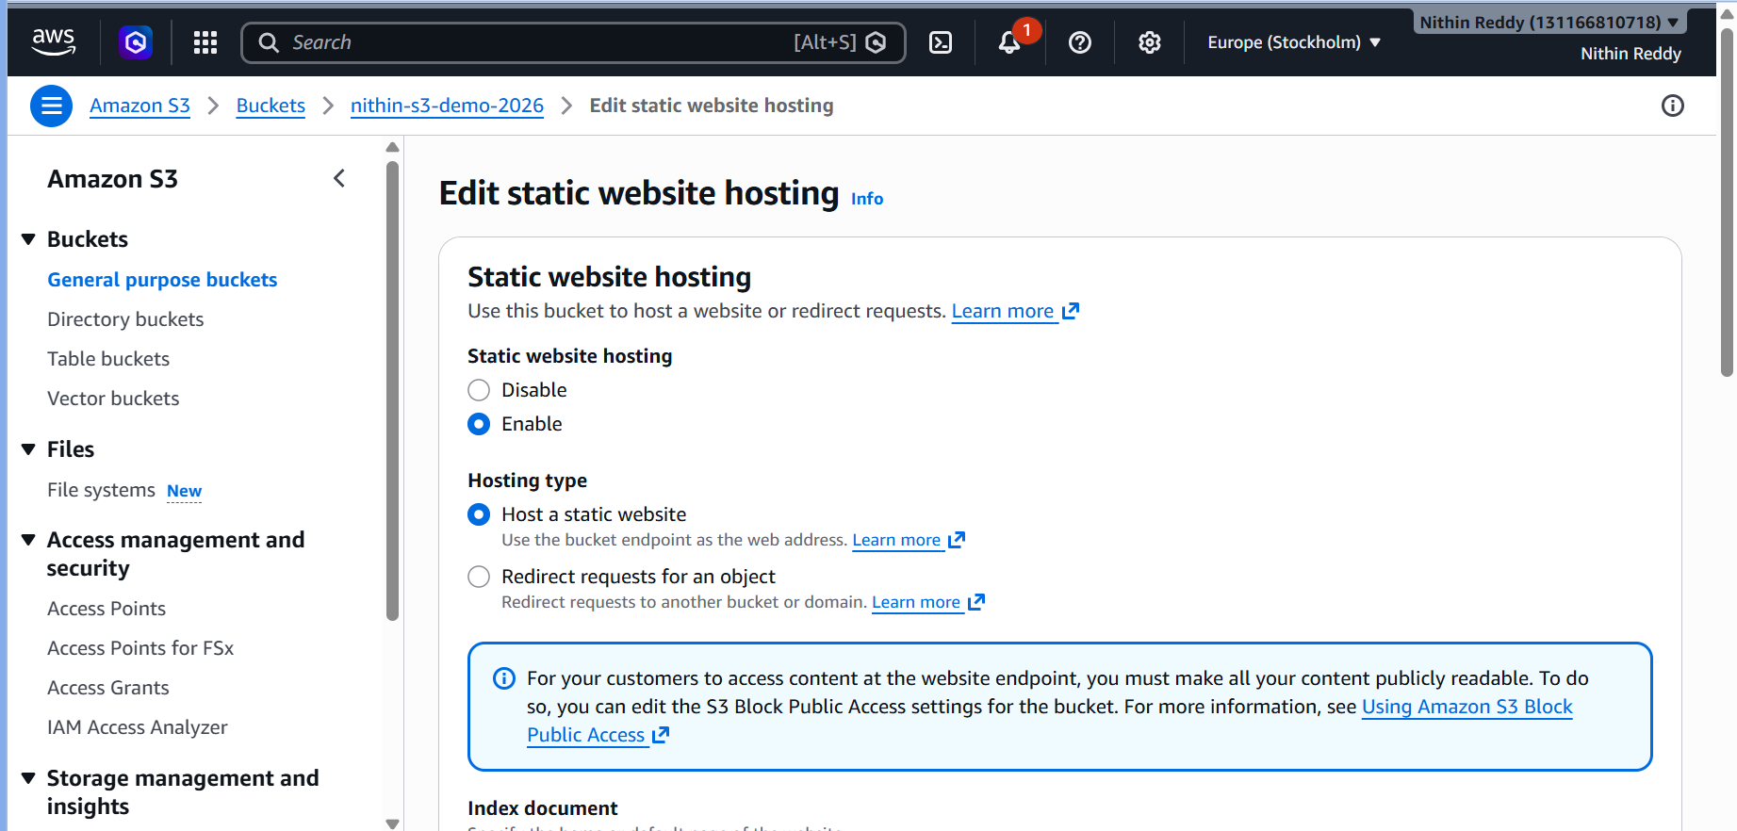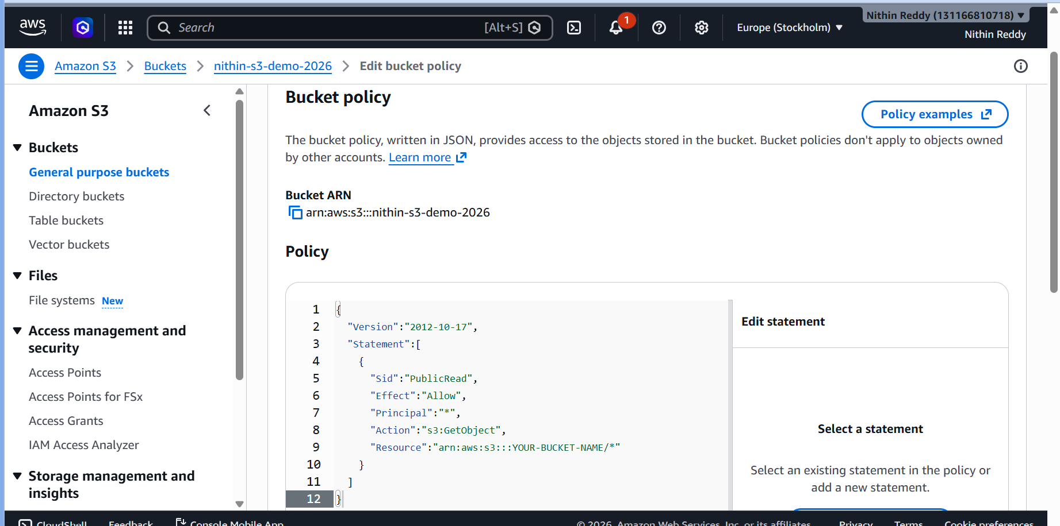
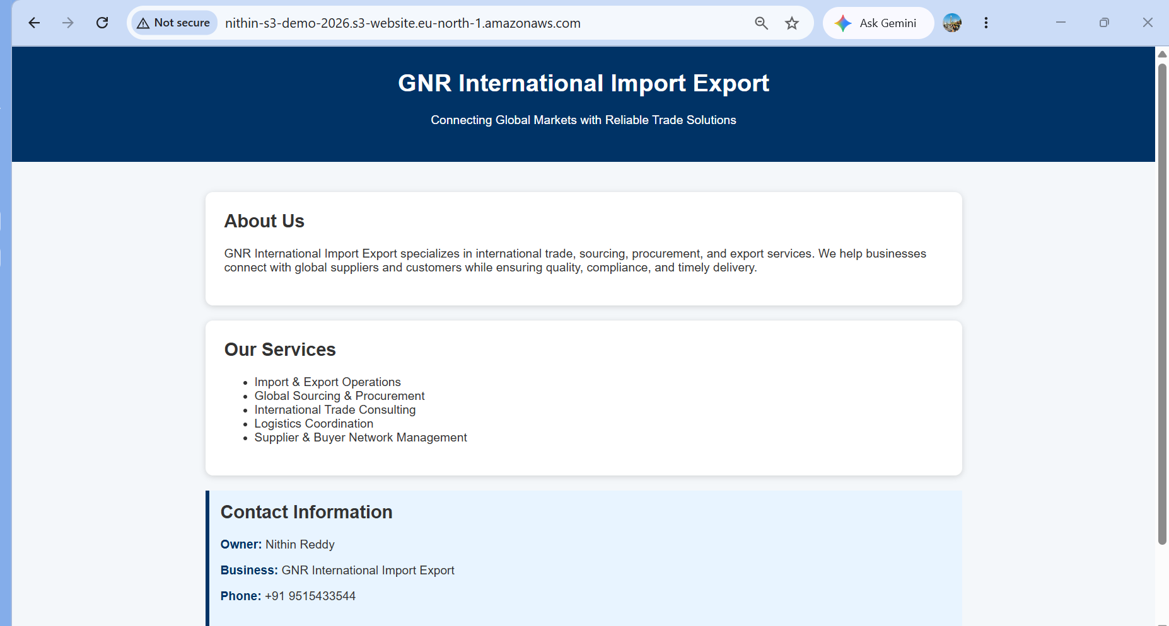
Validation Performed
- Verified Static Website Hosting status as Enabled.
- Verified index.html was uploaded successfully.
- Verified website endpoint URL was generated.
- Verified website loaded successfully in a browser.
- Verified website content displayed correctly.
- Evidence Collected
- Screenshot of uploaded website files.
- Screenshot showing Static Website Hosting enabled.
- Screenshot of bucket policy.
- Screenshot of website successfully opened in browser.
- Common Errors and Resolution
- Error | - Cause | - Resolution
- Access Denied | - Bucket policy not configured | - Updated bucket policy with public read permissions
- 403 Forbidden | - Public access blocked | - Disabled Block Public Access settings
- 404 Not Found | - Missing index.html | - Uploaded index.html and updated hosting configuration
- Website Not Loading | - Incorrect endpoint used | - Used S3 Website Endpoint URL instead of object URL
- Outcome
Successfully deployed a static website using Amazon S3 Static Website Hosting and verified accessibility through the generated website endpoint URL.

Task 3: Enable Cross-Region Replication on S3 Buckets
Objective
Configure Amazon S3 Cross-Region Replication (CRR) to automatically replicate objects from a source bucket to a destination bucket located in another AWS Region.
Outcome
Successfully configured Amazon S3 Cross-Region Replication and validated automatic replication of objects between AWS Regions.
Why Are We Doing This?
Cross-Region Replication provides:
- Disaster recovery
- High availability
- Compliance requirements
- Backup across AWS Regions
- Data redundancy
When an object is uploaded to the source bucket, AWS automatically copies it to the destination bucket.

Prerequisites
Before starting, ensure:
✅ Source bucket exists
✅ Objects are present in source bucket
✅ AWS Console access
✅ Permission to create buckets and IAM roles

Architecture
Example:
Source Bucket
Mumbai (ap-south-1)
│
▼
Destination Bucket
Singapore (ap-southeast-1)
Implementation Steps
- Created a destination S3 bucket in a different AWS Region.
- Opened the source bucket and enabled Versioning.
- Opened the destination bucket and enabled Versioning.
- Navigated to Source Bucket → Management → Replication Rules.
- Created a new replication rule.
- Configured replication for all objects in the bucket.
- Selected the destination bucket located in another AWS Region.
- Allowed AWS to create the required IAM replication role automatically.
- Saved the replication configuration.
- Uploaded a new test file to the source bucket.
- Waited for replication processing.
- Verified the same object was automatically copied to the destination bucket.

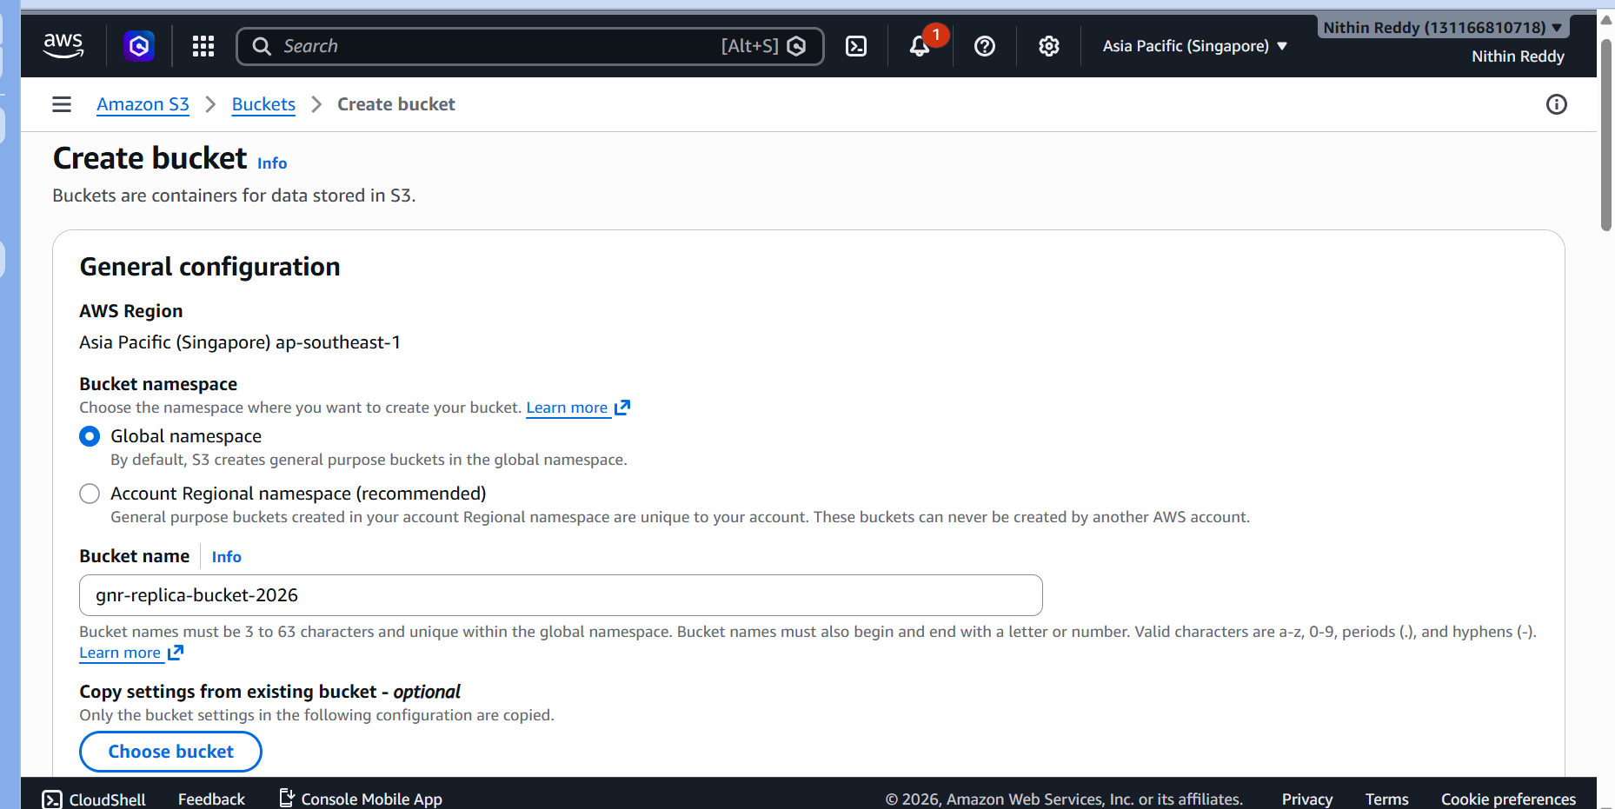
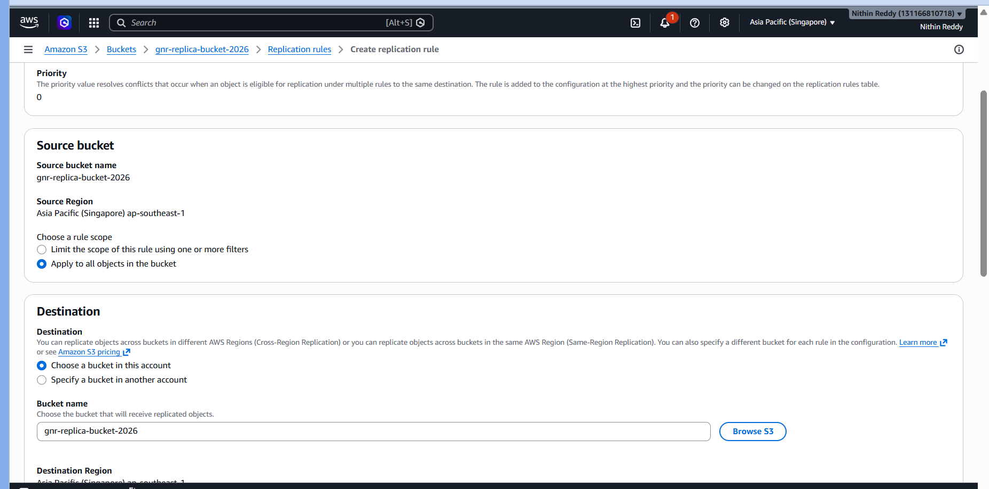
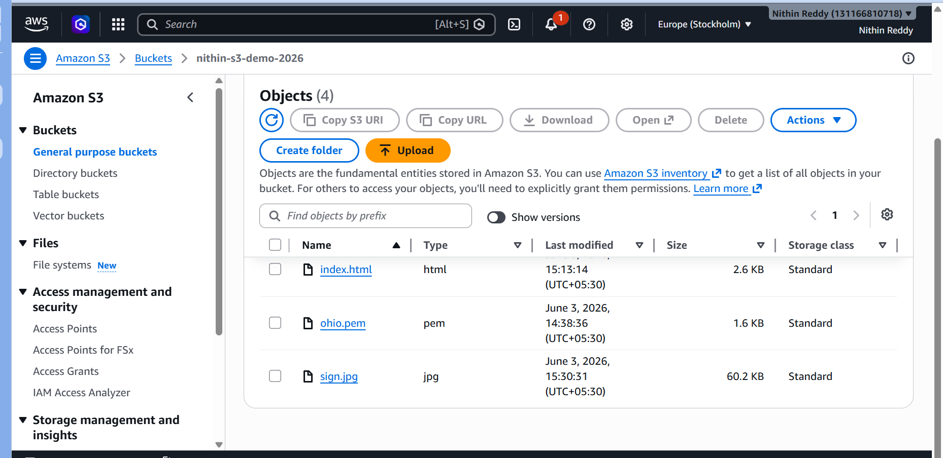
Validation Performed
- Verified versioning enabled on both buckets.
- Verified replication rule created successfully.
- Uploaded test object to source bucket.
- Confirmed automatic replication to destination bucket.
- Verified replicated object in destination region.

Common Errors and Fixes
Error | Cause | Fix
Replication Configuration Failed | Versioning not enabled | Enable versioning on both buckets
Access Denied | IAM role missing permissions | Use AWS auto-created replication role
Objects Not Replicating | Existing files don't replicate automatically | Upload a NEW file after enabling replication
Replication Delayed | AWS processing delay | Wait 5-15 minutes

Task 4 Configure a bucket policy so only the admin user can see the objects of the S3 bucket
Objective
Restrict access to bucket objects so that only the Admin IAM User can list and view bucket contents.
Outcome
Successfully configured bucket access restrictions allowing only the designated Admin IAM User to list and view bucket objects.

Why Are We Doing This?
This demonstrates:
- S3 security controls
- IAM-based access management
- Least privilege principle
- Bucket policy implementation

Prerequisites
- Existing S3 bucket
- IAM Admin User available
- Permission to modify bucket policies
Implementation Steps
- Navigated to Amazon S3 bucket nithin-s3-demo-2026.
- Opened the Permissions tab.
- Edited the bucket policy.
- Added permissions allowing the IAM user Devops to list bucket contents and read objects.
- Saved the bucket policy.
- Validated object visibility using the authorized IAM user.
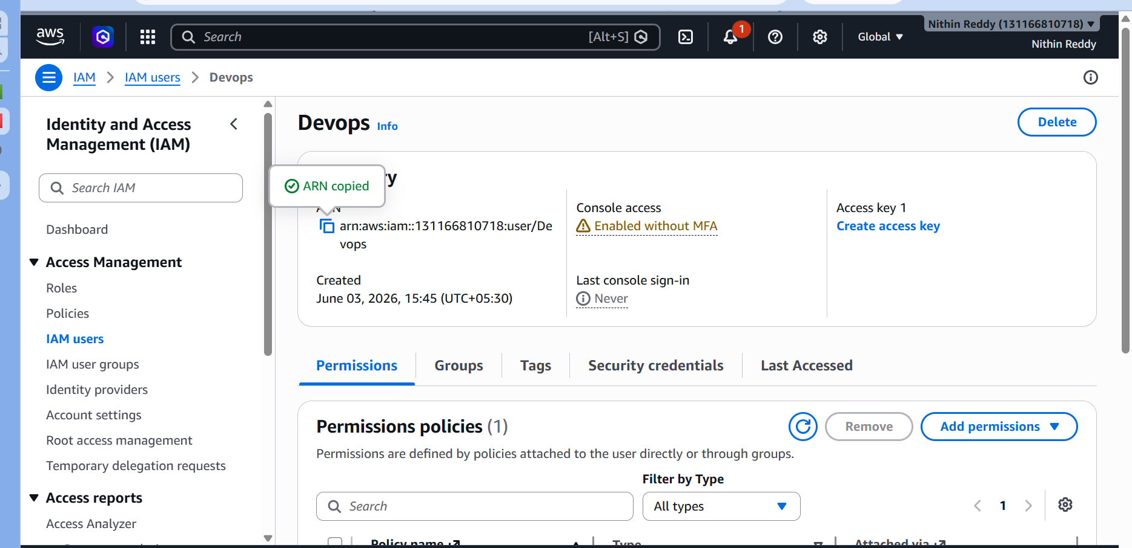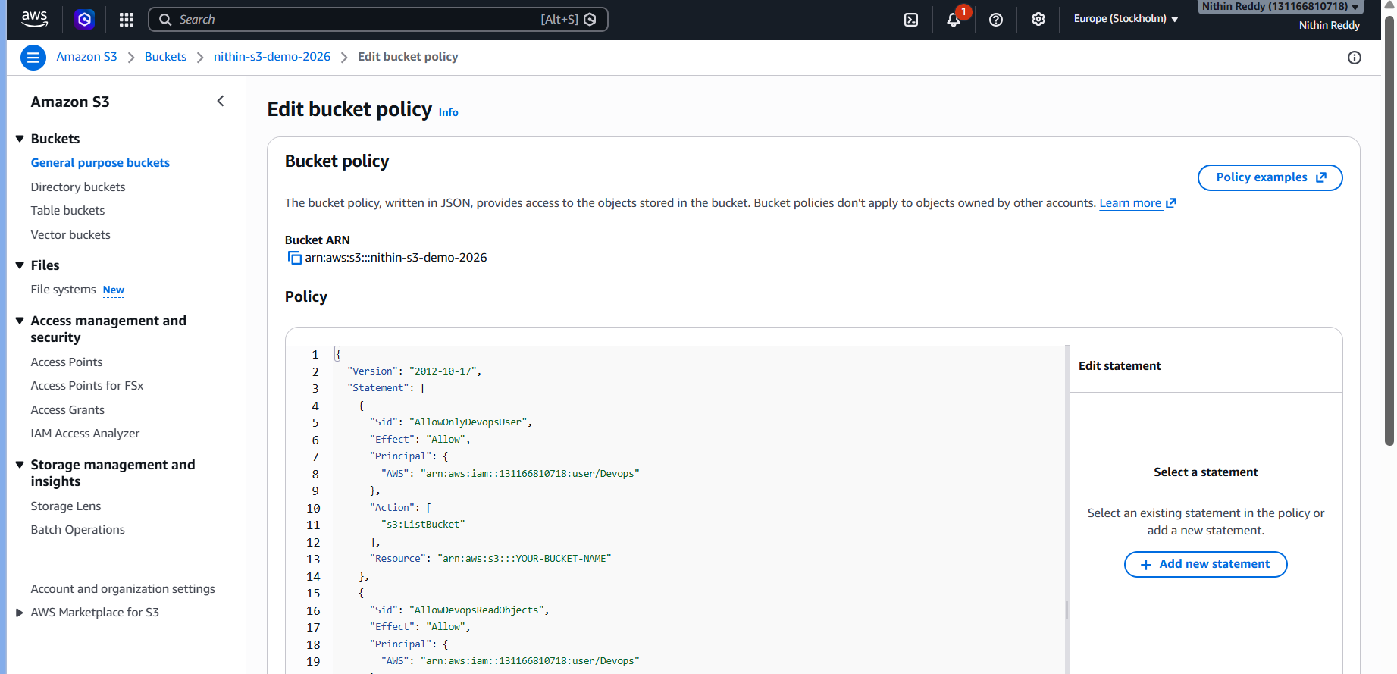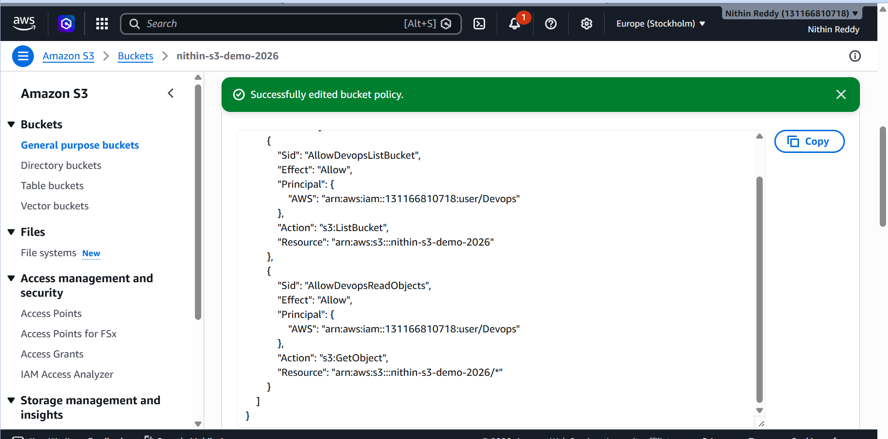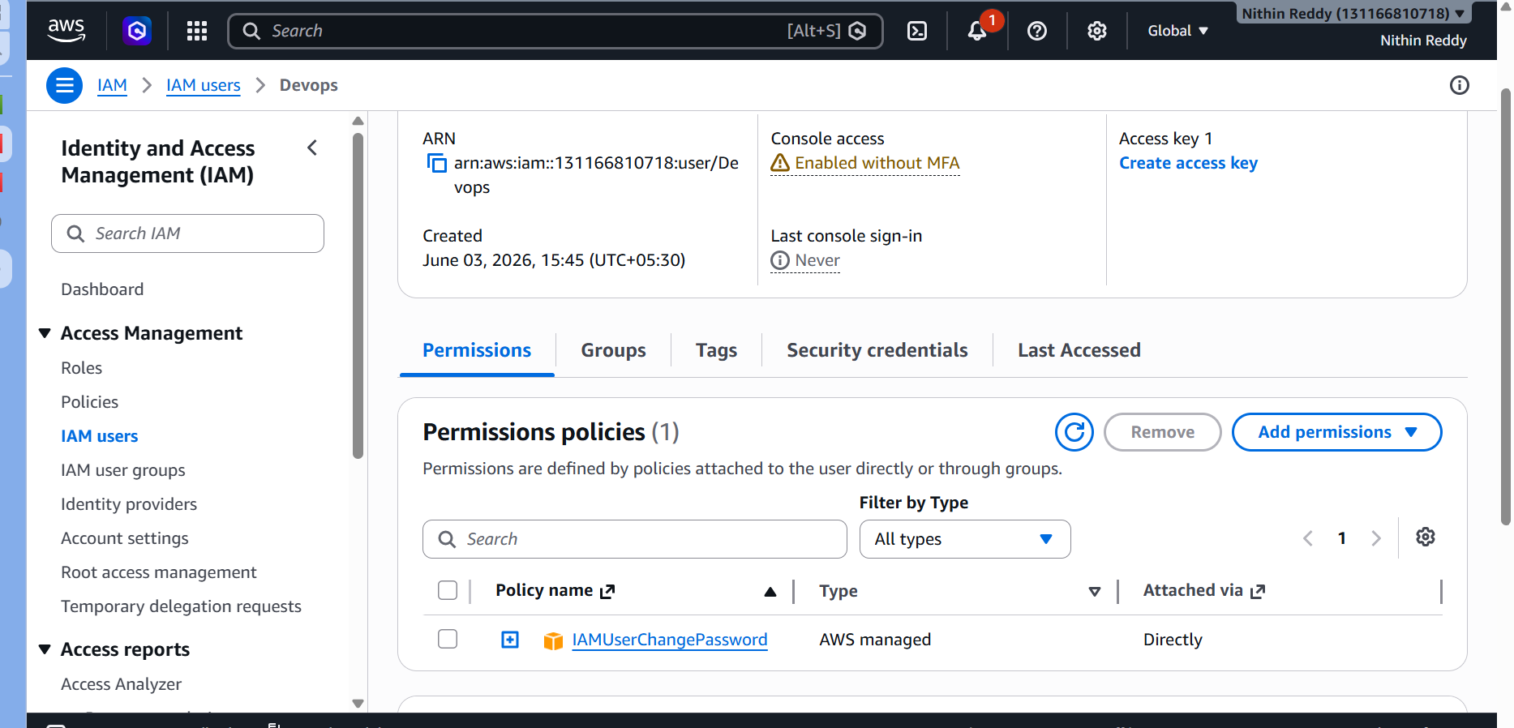

Validation
- Verified policy saved successfully.
- Verified IAM user Devops can access bucket objects.
- Verified bucket contents are visible.

Common Errors
Error | Cause | Fix
Invalid Principal | Wrong ARN | Copy exact IAM User ARN
Access Denied | Incorrect bucket name in policy | Verify bucket ARN
Policy Save Failed | JSON syntax issue | Validate commas and brackets
Locked Out | Wrong principal configured | Use Root/Admin account to fix

Task 5: Set Up Lifecycle Policies
Objective
Configure lifecycle rules to automatically manage S3 objects by transitioning or deleting them after a specified period.
Outcome
Successfully configured an S3 Lifecycle Policy to automatically expire objects after 30 days, reducing long-term storage costs and automating storage management.

Why Are We Doing This?
Lifecycle policies help:
- Reduce storage costs
- Automate object management
- Remove unused files
- Optimize storage usage
In real projects, old log files, backups, and temporary files are automatically deleted or archived.

Prerequisites
- Existing S3 bucket
- Objects uploaded in bucket
- Permission to modify bucket management settings

Implementation Steps
- Logged in to the AWS Management Console.
- Navigated to Amazon S3 service.
- Opened the bucket nithin-s3-demo-2026.
- Selected the Management tab.
- Clicked Create Lifecycle Rule.
- Entered rule name:

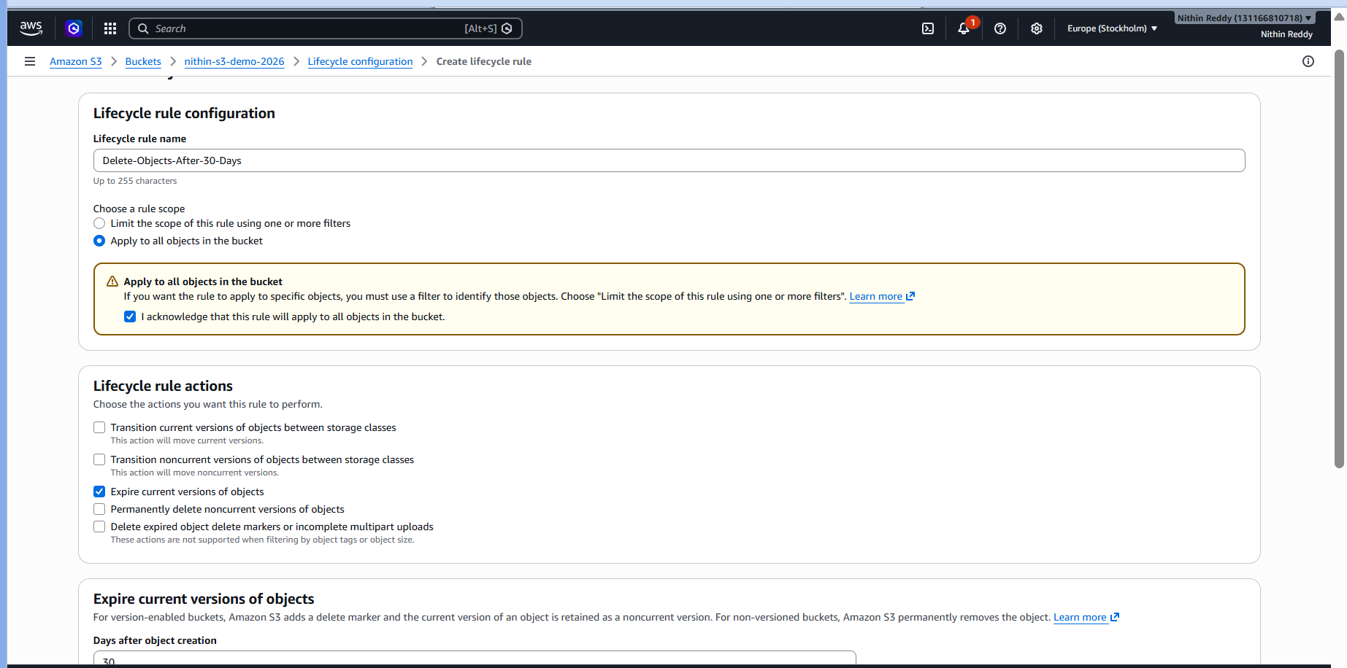
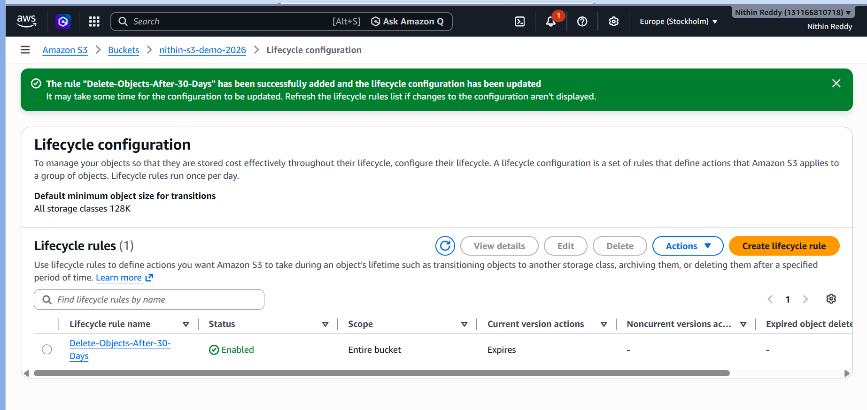
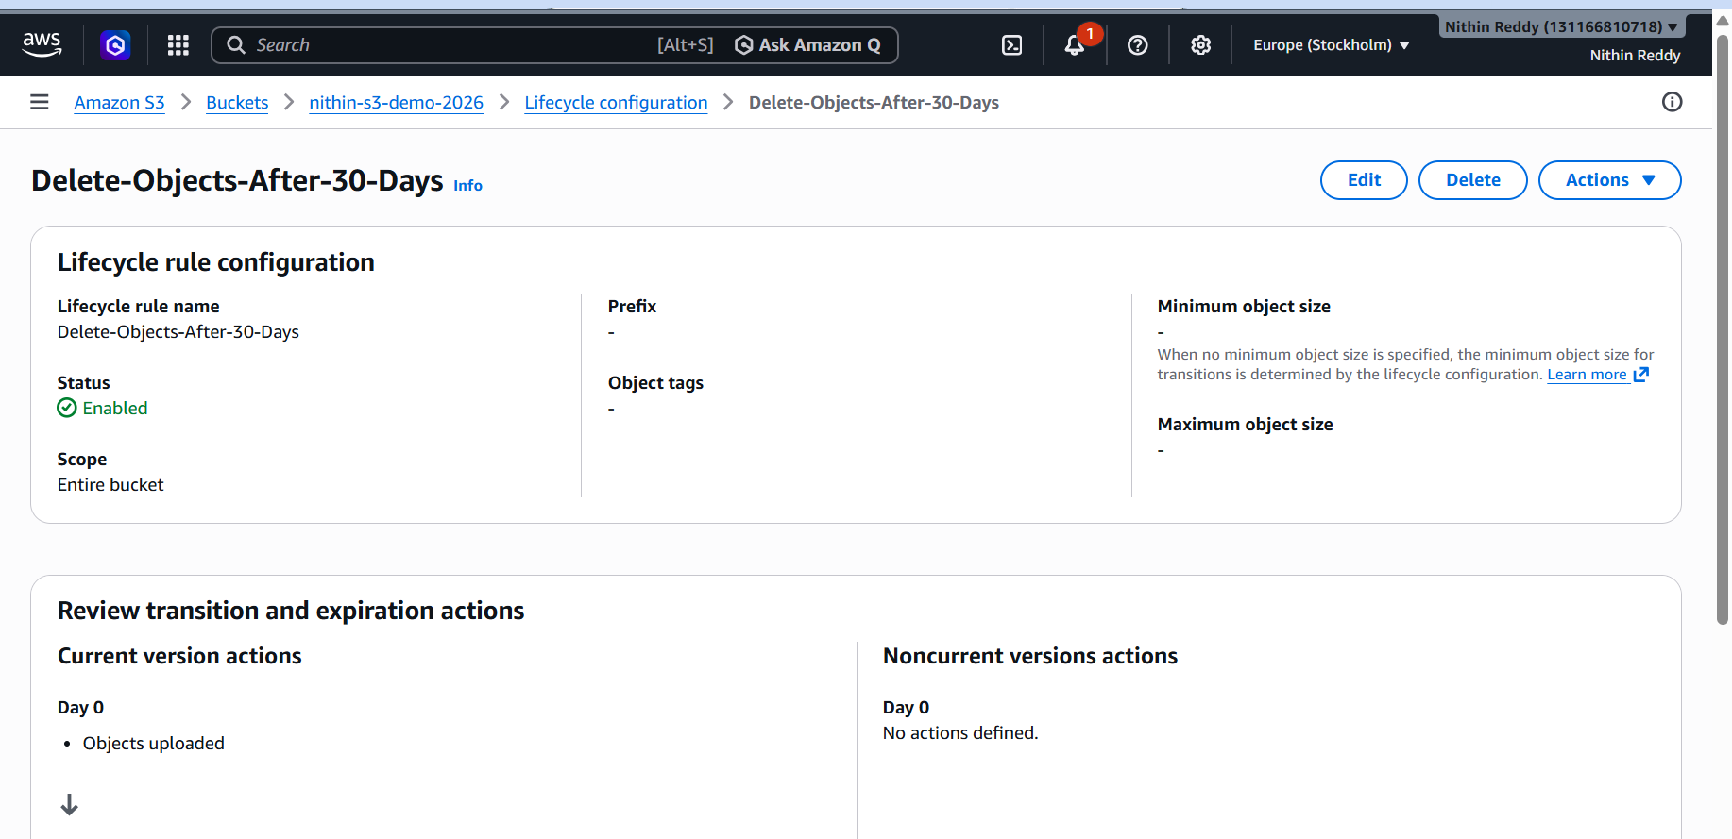

Validation Performed
- Verified lifecycle rule creation.
- Verified rule status as Enabled.
- Verified expiration period configured successfully.
- Verified rule applied to all bucket objects.

Errors Encountered and Resolution
Error | Cause | Resolution
Rule Creation Failed | Missing permissions | Used Devops/Admin account
Rule Disabled | Incorrect selection | Enabled rule during creation
Lifecycle Not Triggering Immediately | Lifecycle jobs run periodically | Waited for AWS scheduled execution

TASK 6 – Push Objects to S3 Using AWS CLI
Objective
Upload files to Amazon S3 using AWS Command Line Interface (CLI).
Outcome
Successfully uploaded objects to Amazon S3 using AWS CLI commands and verified uploads using both CLI and AWS Console.

Why Are We Doing This?
AWS CLI is widely used for:
- Automation
- DevOps operations
- CI/CD pipelines
- Bulk uploads
- Scripting
This task demonstrates command-line interaction with AWS services.

Prerequisites
Verify AWS CLI Installation
Open Command Prompt:

Implementation Steps (For Documentation)
- Created a Bash script named create_s3_bucket.sh.
- Defined bucket name and AWS region variables.
- Used the AWS CLI aws s3api create-bucket command within the script.
- Granted execute permission to the script.
- Executed the script to create the bucket.
- Verified bucket creation using AWS CLI and AWS Console.
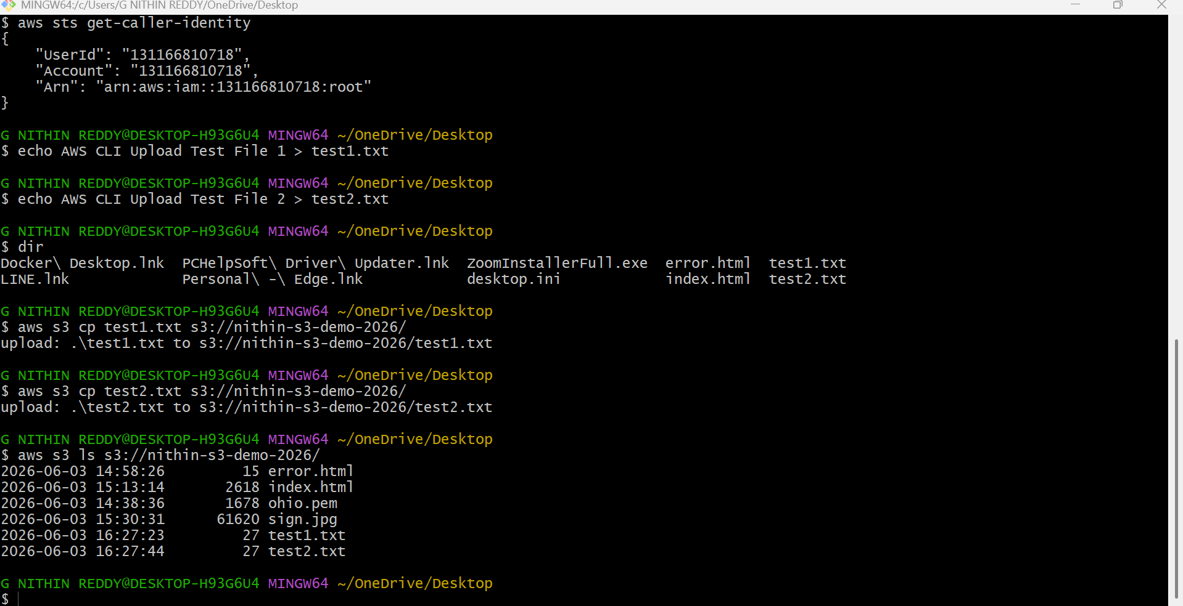
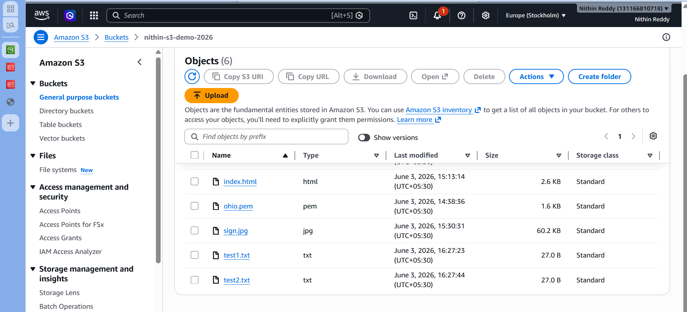
Validation
- Run aws s3 ls and confirm the new bucket appears.
- Verify the bucket is visible in the AWS Console.
Common Errors and Resolution
Error | Resolution
BucketAlreadyExists | Choose a unique bucket name.
PermissionDenied | Ensure the IAM user has s3:CreateBucket permission.
InvalidLocationConstraint | Verify the region value (for example ap-south-1

Task 7 Write a Bash script to create an S3 bucket.
Objective
Automate S3 bucket creation using a Bash script.
Outcome
Successfully automated Amazon S3 bucket creation using a Bash script and validated the created bucket using AWS CLI and AWS Console.

Why Are We Doing This?
This demonstrates:
- Infrastructure Automation
- DevOps Scripting
- AWS CLI Integration
- Repeatable Resource Provisioning

Prerequisites
- AWS CLI Installed
- AWS CLI Configured
- IAM User with S3 Permissions
- Linux Shell, Git Bash, WSL, or CloudShell

Implementation Steps (For Documentation)
- Created a Bash script named create_s3_bucket.sh.
- Defined bucket name and AWS region variables.
- Added AWS CLI command to create an S3 bucket.
- Granted execute permission to the script using chmod +x.
- Executed the script using Git Bash.
- Verified successful bucket creation through AWS CLI.
- Verified bucket visibility in the AWS Management Console.

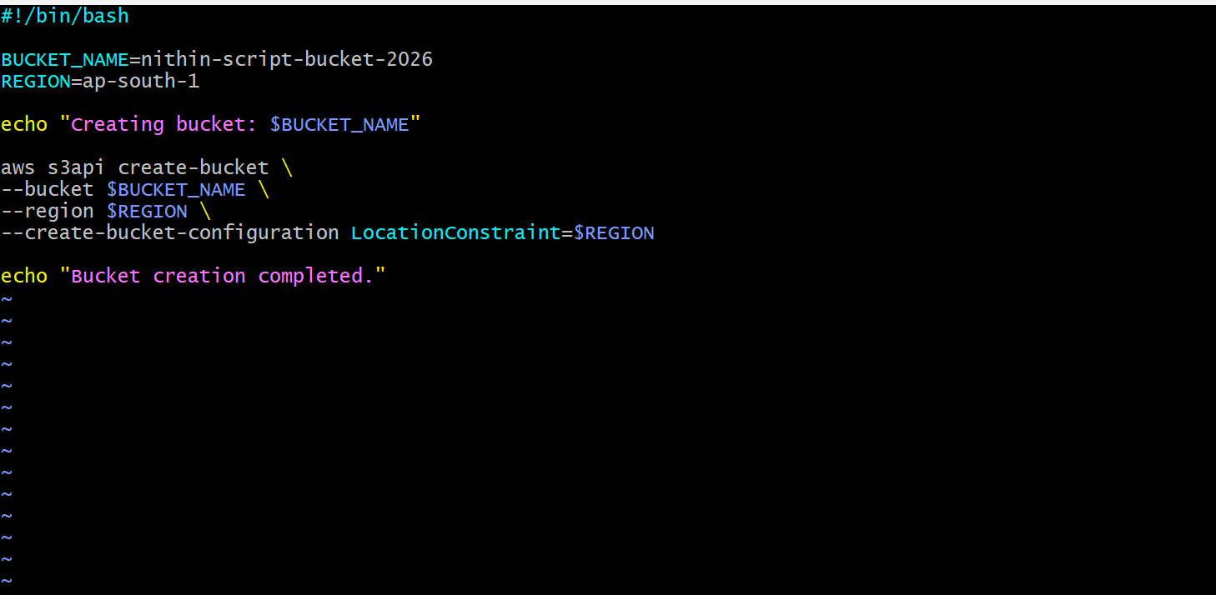
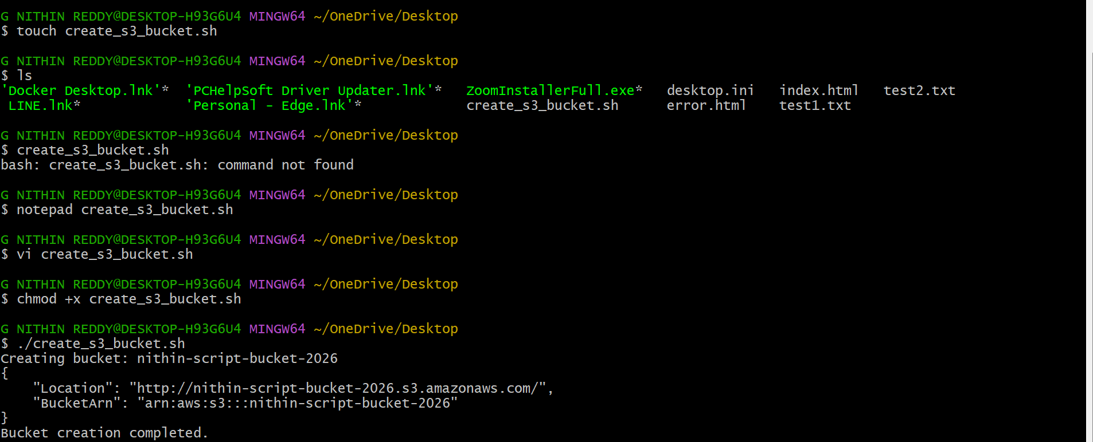
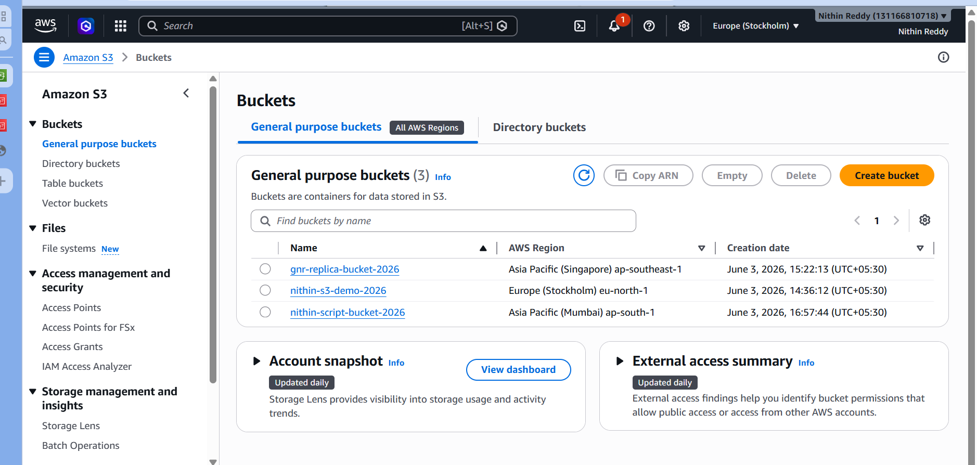
Validation Performed
- Verified script execution completed successfully.
- Verified bucket creation through AWS CLI.
- Verified bucket creation through AWS Console.

Common Errors and Resolution
Error | Cause | Resolution
BucketAlreadyExists | Bucket name not unique | Use timestamp-based bucket name
AccessDenied | Missing permissions | Use Devops IAM user
InvalidLocationConstraint | Wrong region | Use ap-south-1
create-bucket failed | AWS CLI not configured | Run aws configure

Task 8 – Upload a 1 GB File to S3 Using AWS CLI
Objective
Upload a 1 GB file to Amazon S3 using AWS CLI and verify successful upload.
Outcome
Successfully created and uploaded a 1 GB file to Amazon S3 using AWS CLI and validated the upload through both AWS CLI and AWS Console.
Why Are We Doing This?
This demonstrates:
- Large object uploads
- AWS CLI file transfer capability
- S3 object management
- Enterprise-scale storage operations

Prerequisites
- AWS CLI installed and configured
- Existing S3 bucket (nithin-s3-demo-2026)
- Sufficient local disk space (1 GB)
Implementation Steps (For Documentation)
- Created a 1 GB test file on the local machine.
- Verified the file size.
- Used the AWS CLI aws s3 cp command to upload the file to the S3 bucket.
- Monitored upload completion.
- Verified uploaded object using AWS CLI.
- Verified uploaded object in the AWS S3 Console.
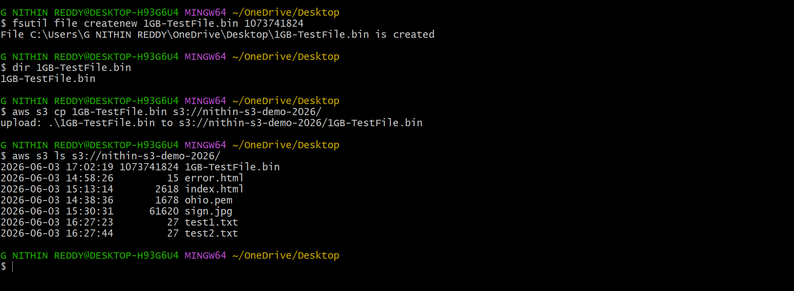
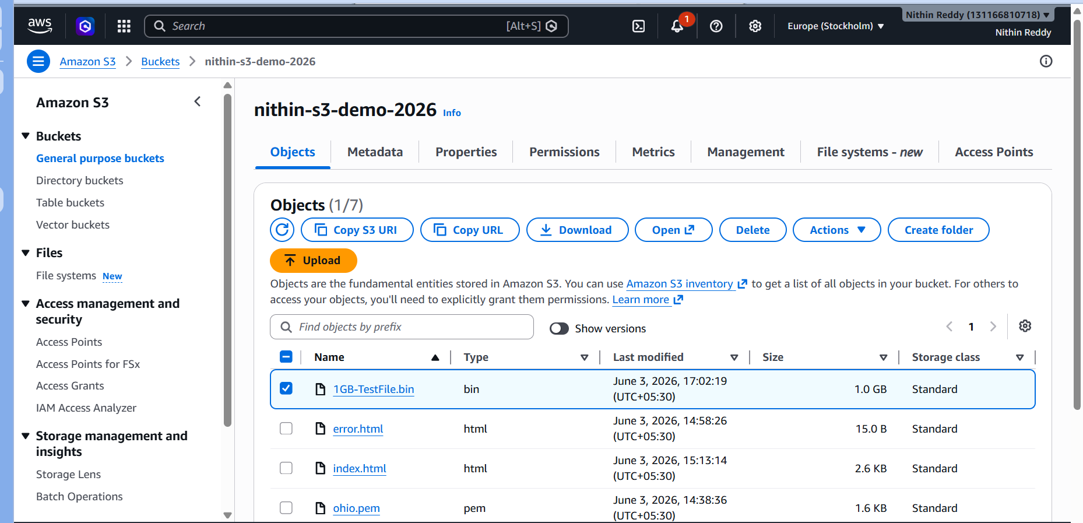
Validation Performed
- Created a 1 GB file locally.
- Uploaded the file using AWS CLI.
- Verified upload completion.
- Verified object presence in S3 bucket.
- Confirmed upload through AWS Console.

Common Errors and Resolution
Error | Cause | Resolution
AccessDenied | Insufficient IAM permissions | Use Devops/Admin credentials
Upload Interrupted | Network issue | Re-run upload command
NoSuchBucket | Incorrect bucket name | Verify bucket name
Insufficient Disk Space | Not enough local storage | Free disk space before creating file

