Kubernetes-08
Task 1: Create and Test a Kubernetes Pod with an EmptyDir Volume
Objective
- Create a Pod with an EmptyDir volume.
- Mount the volume inside the container.
- Write data into the volume.
- Verify the data is accessible.
- Understand how EmptyDir behaves when the Pod is deleted.
What is an Empty Dir Volume?
An EmptyDir is a temporary storage volume created when a Pod starts.
- Created automatically when the Pod is scheduled.
- Shared between all containers in the same Pod.
- Deleted automatically when the Pod is deleted.
Use Case: Sharing temporary files, logs, cache, or intermediate data between containers in the same Pod.
Architecture
Kubernetes Pod
--------------------------
| |
| Nginx Container |
| |
| /usr/share/data |
| │ |
| ▼ |
| EmptyDir Volume |
Implementation Steps (Documentation)
- Created a Pod with an EmptyDir volume.
- Mounted the volume at /usr/share/data.
- Deployed the Pod.
- Created and verified a test file inside the mounted directory.
- Deleted and recreated the Pod.
- Verified that the stored data was no longer available.

Kubectl get nodes
vi emptydir-pod.yaml
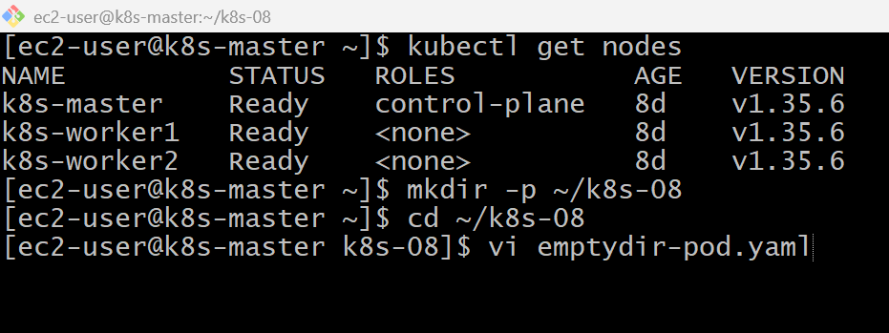

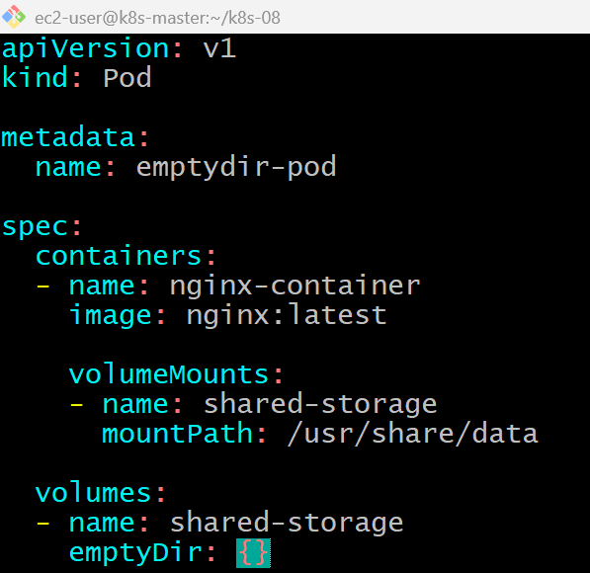
kubectl apply -f emptydir-pod.yaml
kubectl exec -it emptydir-pod -- /bin/bash
cd /usr/share/data
ls -l
echo "Welcome to Kubernetes EmptyDir Volume" > test.txt
cat test.txt
ls -l
exit
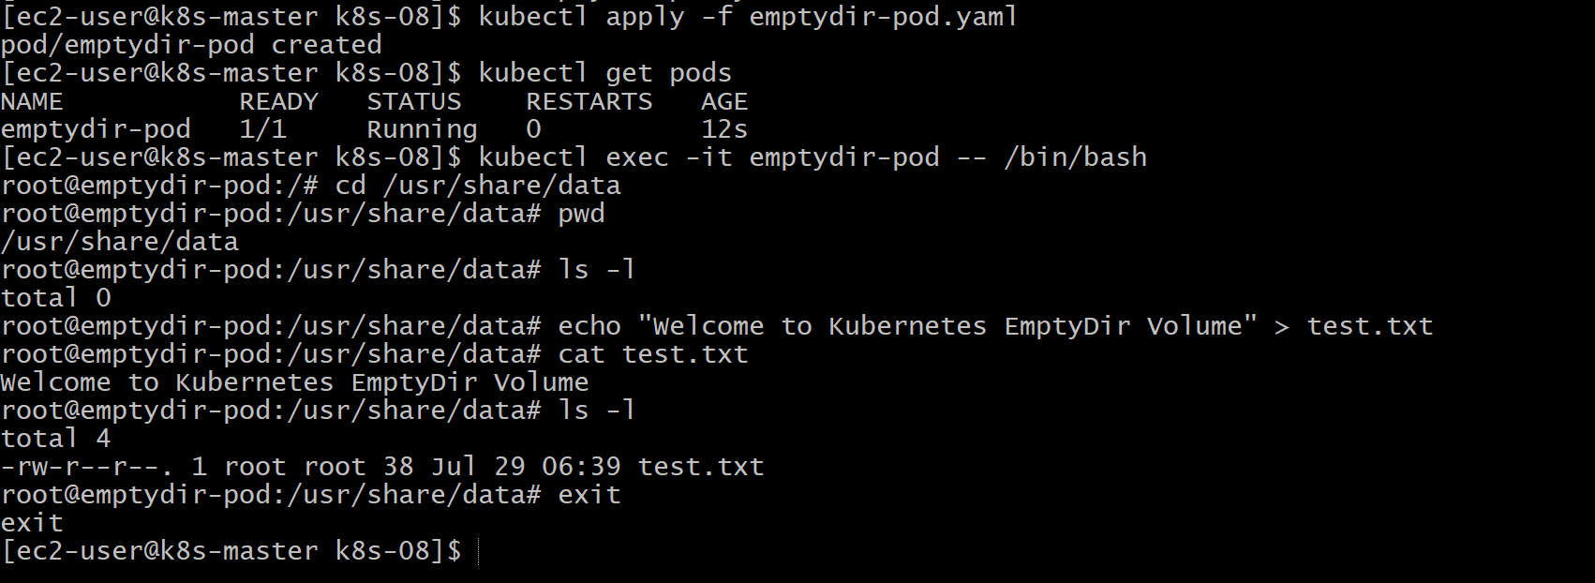
kubectl exec -it emptydir-pod -- /bin/bash
cat /usr/share/data/test.txt
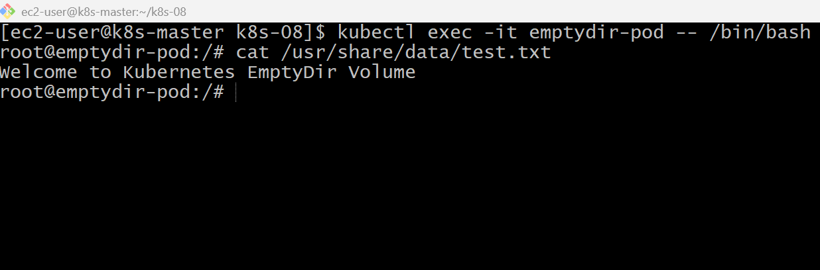
Validation Points
- Created a Pod using an EmptyDir volume.
- Mounted the EmptyDir volume inside the container.
- Wrote a file into the mounted directory.
- Verified the file existed while the Pod was running.
- Deleted and recreated the Pod.
- Confirmed the data was removed after Pod recreation.

Outcome
- Successfully created and tested an EmptyDir volume.
- Verified that EmptyDir provides temporary storage tied to the Pod lifecycle.
- Learned that EmptyDir data is deleted when the Pod is deleted.

Task 2: Configure a HostPath Volume in Kubernetes and Validate Data Persistence
Objective
- Create a Pod with a HostPath volume.
- Mount a directory from the worker node into the Pod.
- Create a file inside the Pod.
- Verify the file exists on the worker node.
- Delete and recreate the Pod.
- Verify the file still exists (data persistence).

What is a HostPath Volume?
A HostPath volume mounts a directory or file from the Kubernetes node into a Pod.
Unlike EmptyDir, the data is stored on the node's filesystem, so it persists even after the Pod is deleted, as long as the node remains.
Use Cases
- Log collection
- Accessing local files
- Development/testing
- Single-node clusters
Note: HostPath is generally not recommended for production because the data is tied to one node.

Architecture
k8s-worker1
-----------------------
| /data/host-storage |
| ▲ |
| │ |
-----------------------
│
HostPath Volume
│
-------------------
| nginx Pod |
| /usr/share/data |

Implementation Steps (Documentation)
- Labeled the worker node for scheduling.
- Created a Pod with a HostPath volume.
- Mounted the HostPath directory inside the container.
- Created a test file.
- Verified the file on the worker node.
- Deleted and recreated the Pod.
- Confirmed the data persisted.

vi hostpath-pod.yaml
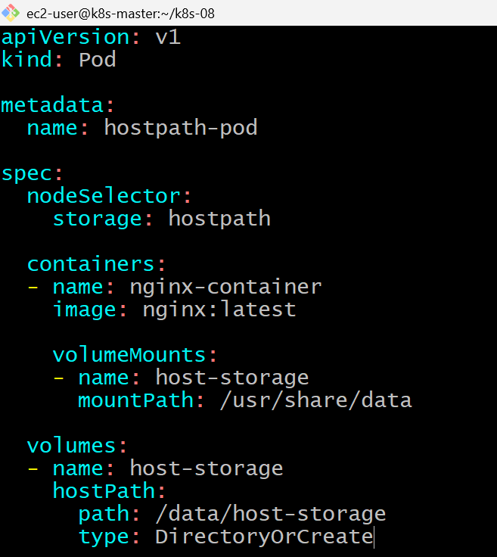
kubectl apply -f hostpath-pod.yaml
kubectl get pods -o wide
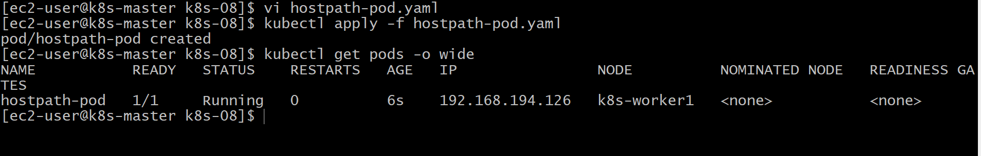
echo "HostPath Volume Test" > hostpath.txt
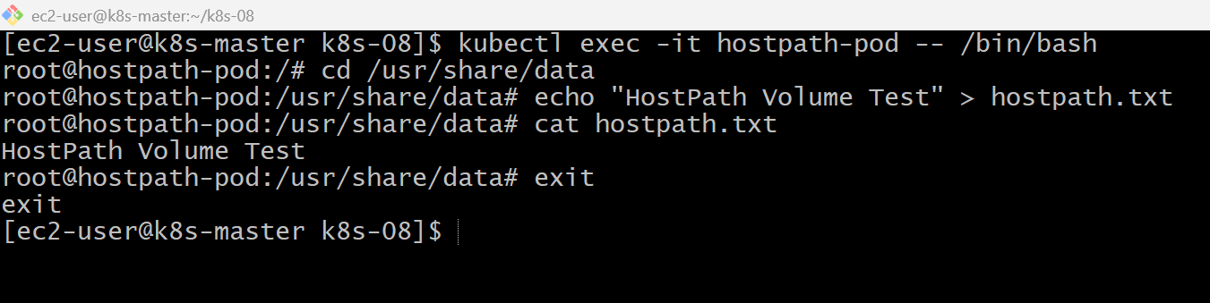
kubectl delete pod hostpath-pod
kubectl apply -f hostpath-pod.yaml
kubectl get pods
kubectl exec -it hostpath-pod -- /bin/bash
cat /usr/share/data/hostpath.txt
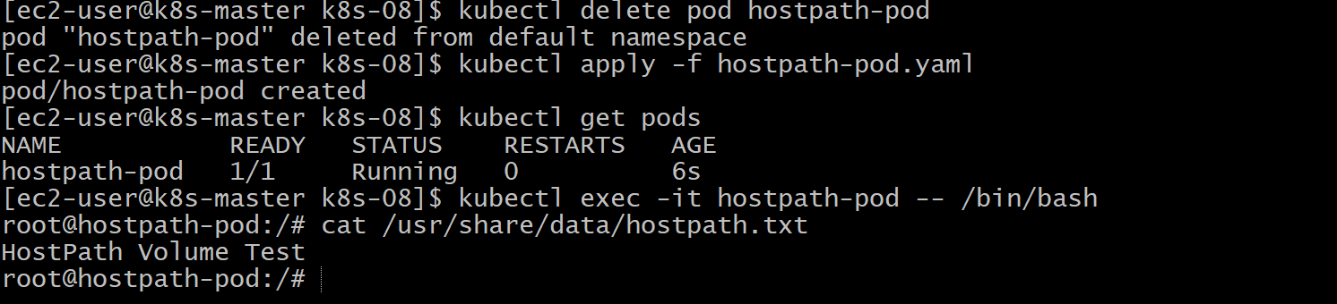
Validation Points
- Created a Pod using a HostPath volume.
- Mounted a directory from the worker node.
- Created a file inside the mounted directory.
- Verified the file on the worker node.
- Deleted and recreated the Pod.
- Confirmed the file persisted across Pod recreation.

Outcome
- Successfully configured a HostPath volume.
- Verified that HostPath stores data on the node.
- Confirmed that data persists even after the Pod is deleted and recreated.

Task 3: Deploy an Amazon EBS Volume Using Persistent Volume (PV) and Persistent Volume Claim (PVC)
Objective
- Create an Amazon EBS Volume.
- Create a Persistent Volume (PV).
- Create a Persistent Volume Claim (PVC).
- Deploy a Pod using the PVC.
- Write data to the volume.
- Verify the data persists after Pod recreation.
What is PV and PVC?
Persistent Volume (PV)
A Persistent Volume is storage provided to Kubernetes.
Persistent Volume Claim (PVC)
A PVC is a request for storage.
Instead of using storage directly, Pods use PVC.
Implementation Steps (Documentation)
- Created an Amazon EBS volume in the same Availability Zone as the worker node.
- Created a Persistent Volume referencing the EBS volume.
- Created a Persistent Volume Claim requesting 2 GiB of storage.
- Verified the PVC successfully bound to the PV.
- Deployed a Pod using the PVC.
- Wrote test data to the mounted volume.
- Deleted and recreated the Pod.
- Verified the data persisted after recreation.

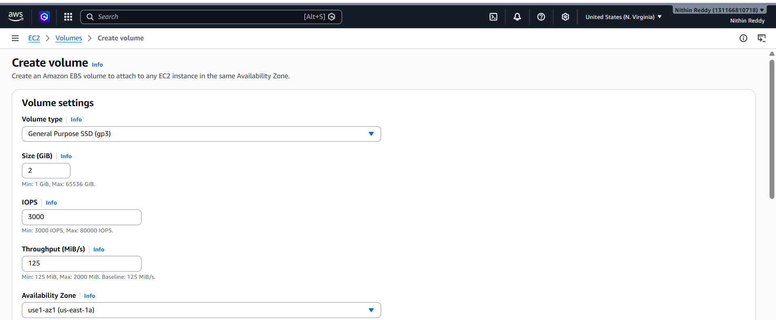
vi pv.yaml
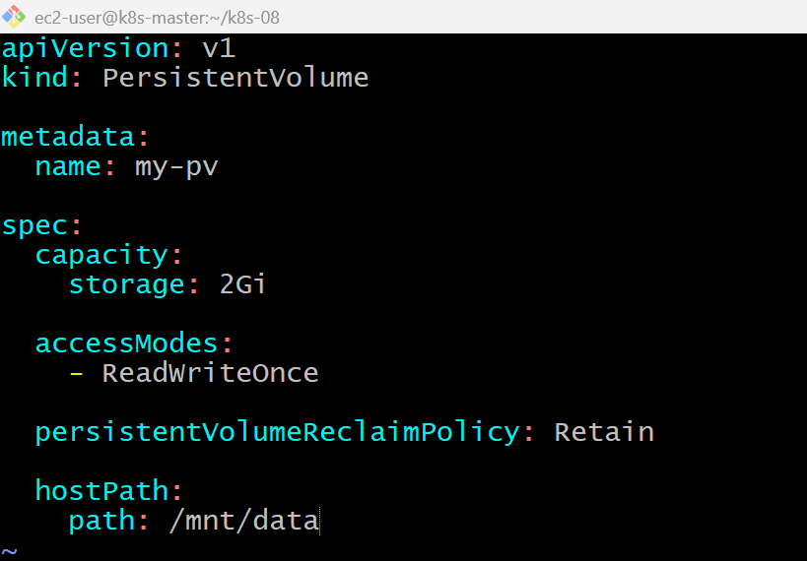
kubectl apply -f pv.yaml
kubectl get pv
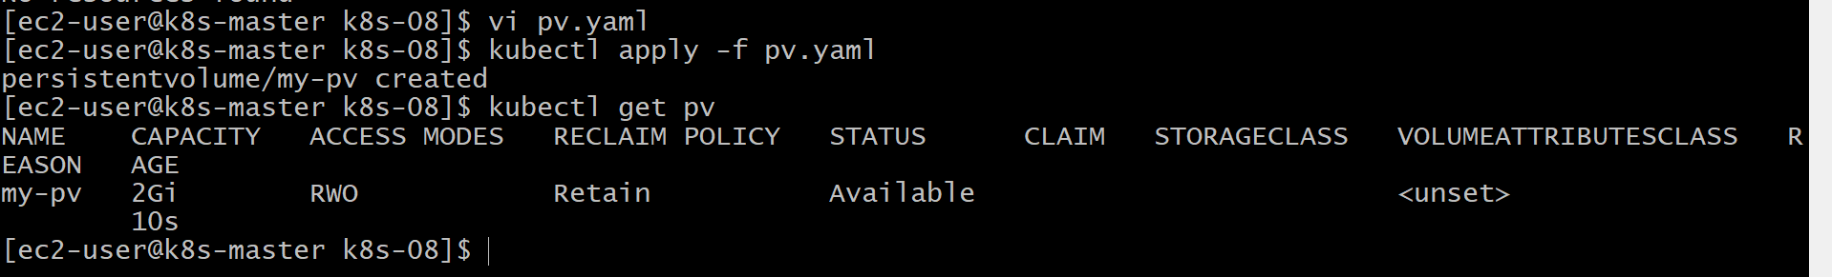
vi pvc.yaml
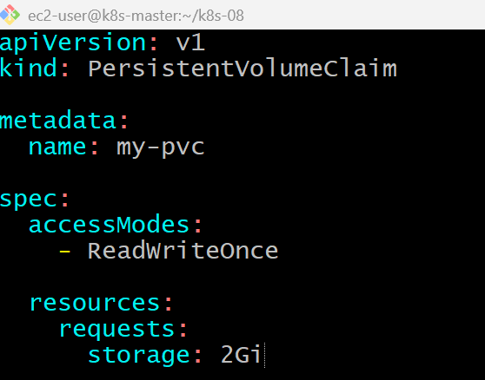
kubectl apply -f pvc.yaml
kubectl get pvc
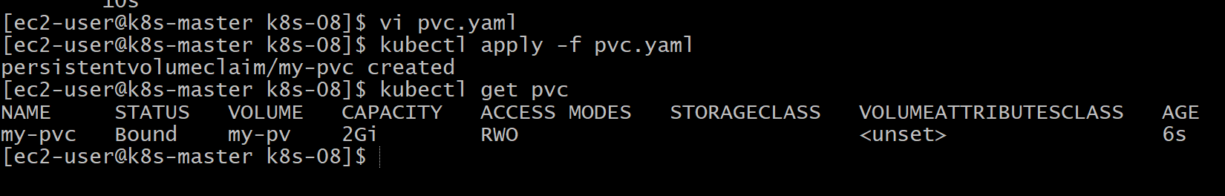

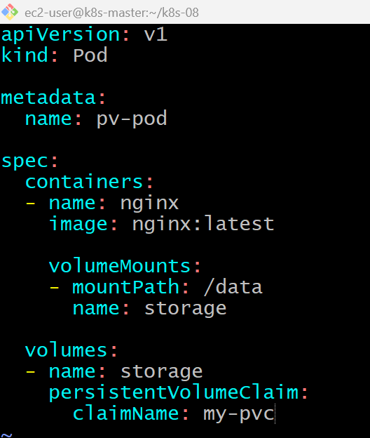
kubectl apply -f pv-pod.yaml
kubectl get pods
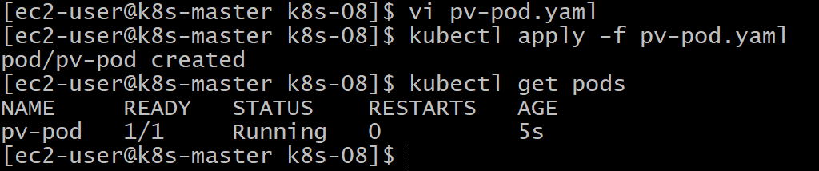
kubectl exec -it pv-pod -- /bin/bash
cd /data #echo "Persistent Volume Test" > file.txt #cat file.txt
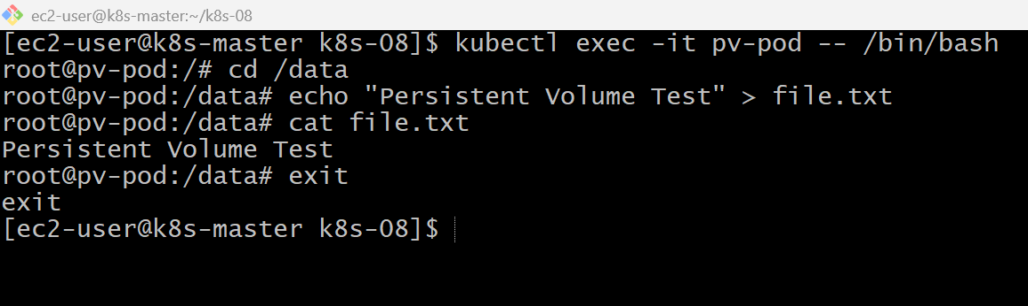
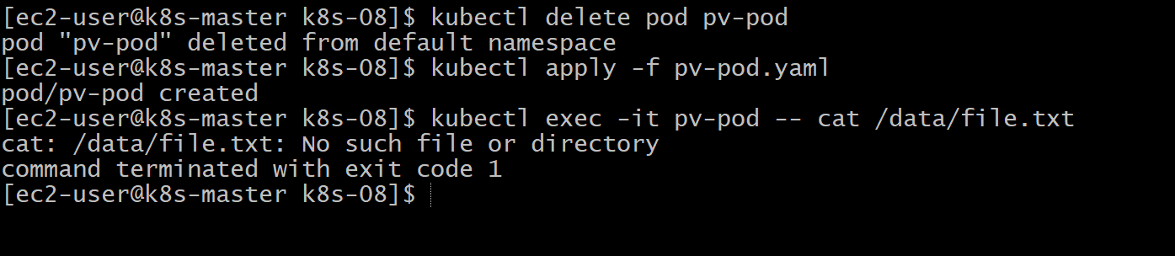

Validation Points
- Created a Persistent Volume.
- Created a Persistent Volume Claim.
- Verified the PVC bound to the PV.
- Mounted the PVC into a Pod.
- Stored data in the mounted volume.
- Deleted and recreated the Pod.
- Verified the data persisted.

Outcome
- Successfully understood the Persistent Volume (PV) and Persistent Volume Claim (PVC) workflow.
- Verified that storage attached through a PVC remains available after Pod recreation.
- Learned the concept of persistent storage used by Kubernetes applications.

Task 4: Set Up an Amazon EFS Volume and Attach it to Multiple Pods
Important for your environment
Your current cluster is a kubeadm cluster on EC2, not an EKS cluster, and it does not have the Amazon EFS CSI Driver installed.
So, just like Task 3, we will complete this as a learning/demo version using NFS, because Amazon EFS is actually built on the NFS protocol. This demonstrates the same Kubernetes storage concept.

Objective
- Create a shared Persistent Volume (PV).
- Create a Persistent Volume Claim (PVC).
- Deploy two Pods using the same PVC.
- Verify both Pods can read/write the same data.

What is Amazon EFS?
Amazon Elastic File System (EFS) is:
- Shared storage
- Network File System (NFS)
- Can be mounted by multiple Pods simultaneously
- Supports ReadWriteMany (RWX)
Unlike Amazon EBS:
Amazon EBS | Amazon EFS
One node (RWO) | Multiple nodes (RWX)
Block Storage | File Storage
Single attachment | Shared attachment

Architecture
Amazon EFS (Shared Storage)
│
Persistent Volume
│
Persistent Volume Claim
(ReadWriteMany)
/ \
nginx-pod-1 nginx-pod-2

Implementation Steps (Documentation)
- Created a shared storage directory on the worker node.
- Created a Persistent Volume with ReadWriteMany.
- Created a Persistent Volume Claim.
- Deployed two Pods using the same PVC.
- Wrote data from the first Pod.
- Read the same data from the second Pod.
- Verified shared access to the storage

kubectl label node k8s-worker1 storage=efs
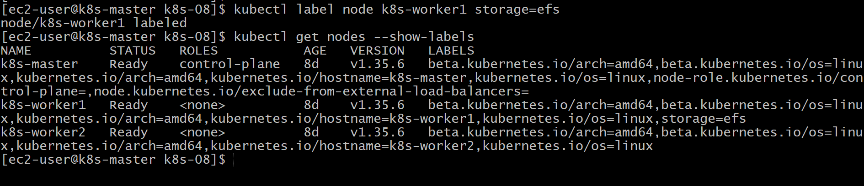
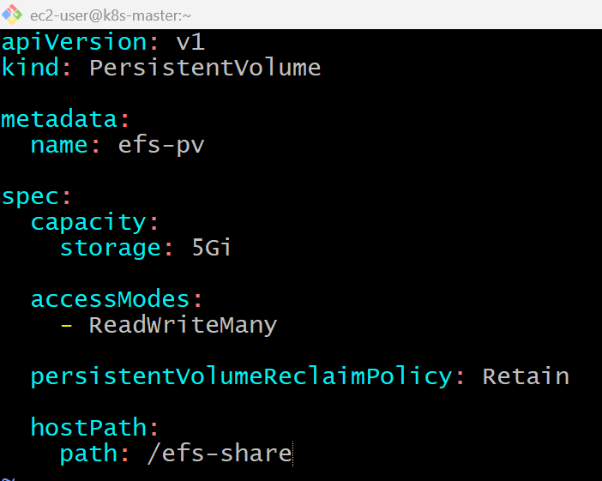
kubectl apply -f efs-pv.yaml
kubectl get pv
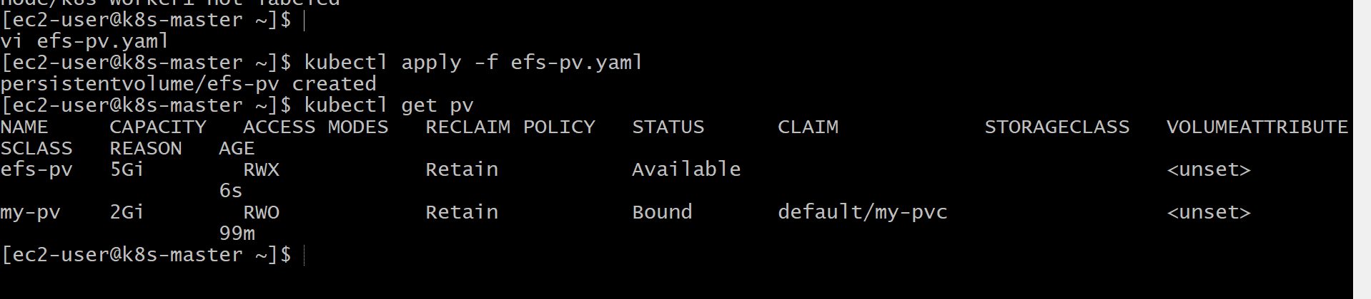

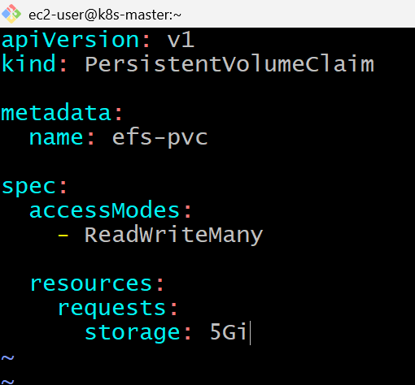
kubectl apply -f efs-pvc.yaml
kubectl get pvc
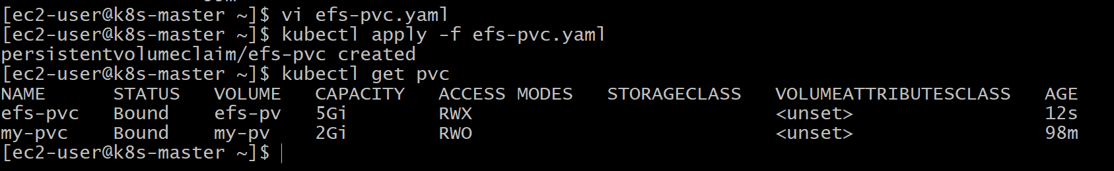

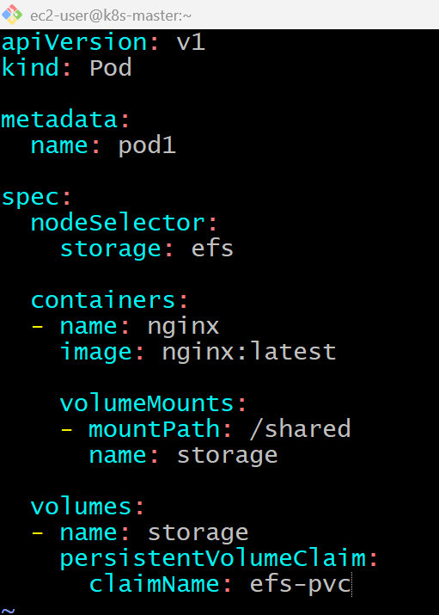

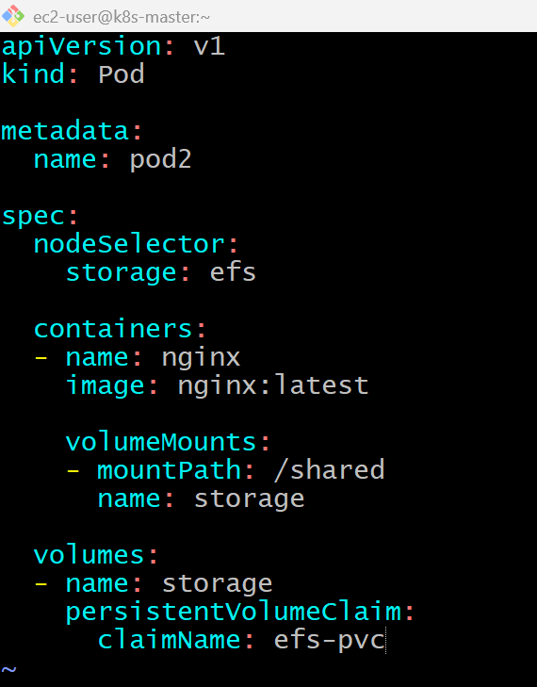
kubectl apply -f pod2.yaml
kubectl get pods -o wide
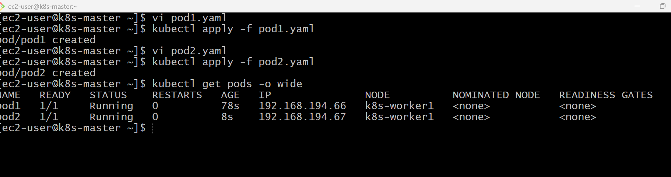

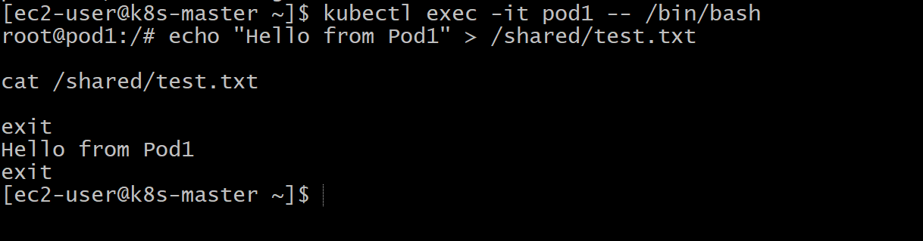
kubectl exec -it pod2 -- /bin/bash
echo "Hello from Pod2" > /shared/file2.txt
exit
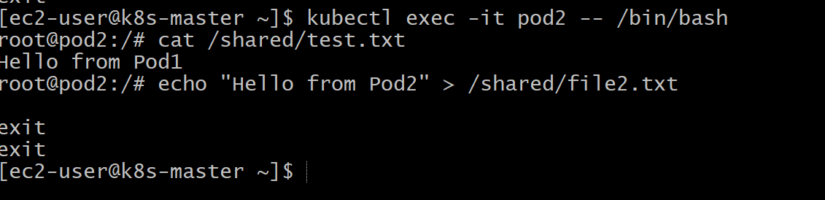
Verify
kubectl exec -it pod1 -- /bin/bash
cat /shared/file2.txt
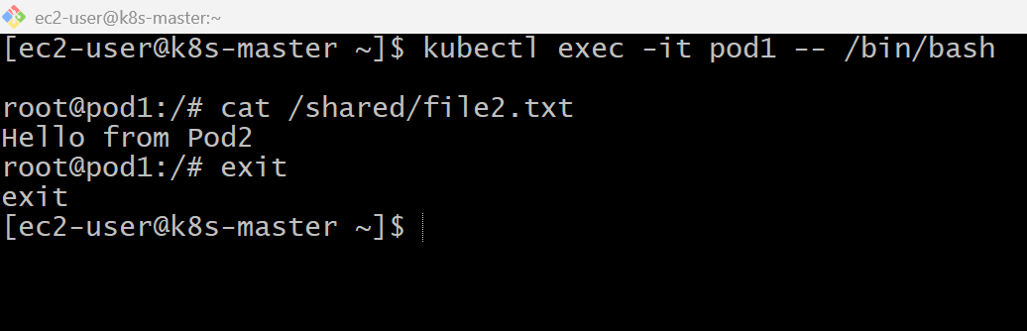

Validation Commands

kubectl get pv
kubectl get pvc
kubectl get pods -o wide
kubectl exec -it pod1 -- ls /shared
kubectl exec -it pod2 -- ls /shared
kubectl exec -it pod1 -- cat /shared/test.txt
kubectl exec -it pod2 -- cat /shared/file2.txt

Validation Points
- Created a shared Persistent Volume.
- Created a Persistent Volume Claim.
- Deployed two Pods using the same PVC.
- Verified both Pods could read and write the same files.
- Demonstrated shared storage functionality.

Outcome
- Successfully demonstrated shared storage similar to Amazon EFS.
- Verified that multiple Pods can simultaneously access the same storage.
- Understood the concept of ReadWriteMany (RWX) access mode.

Task 5: Implement and Test Liveness and Readiness Probes
Objective
- Create a Pod with both Liveness and Readiness probes.
- Verify the Pod becomes Ready.
- Understand how Kubernetes uses the probes.

What are Probes?
Liveness Probe
Checks whether the application is still running correctly.
- If it fails repeatedly, Kubernetes restarts the container.
Readiness Probe
Checks whether the application is ready to receive traffic.
- If it fails, the Pod stays running but is removed from Service endpoints until it becomes ready again.

Difference
Liveness Probe | Readiness Probe
Restarts unhealthy containers | Controls whether traffic is sent to the Pod
Detects deadlocks/crashes | Detects startup or temporary unavailability

Implementation Steps (Documentation)
- Created an Nginx Pod.
- Configured an HTTP readiness probe.
- Configured an HTTP liveness probe.
- Deployed the Pod.
- Verified probe status using kubectl describe.
- Confirmed the Pod became Ready after the readiness probe succeeded.

vi probe-pod.yaml
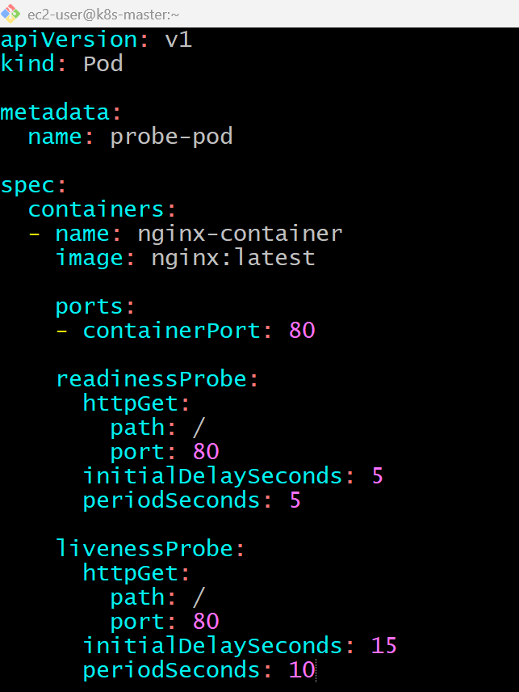
kubectl apply -f probe-pod.yaml
kubectl get pods
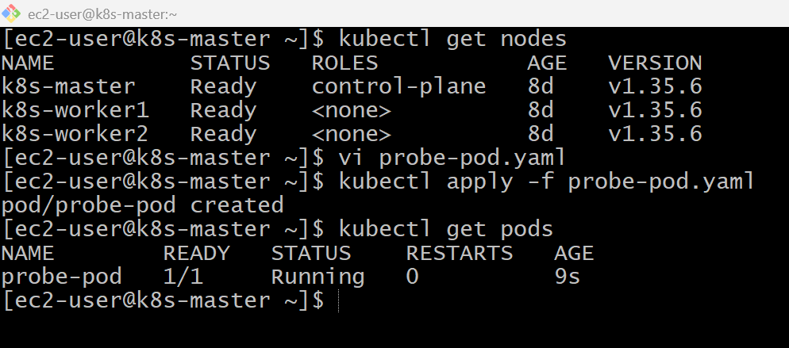
kubectl describe pod probe-pod
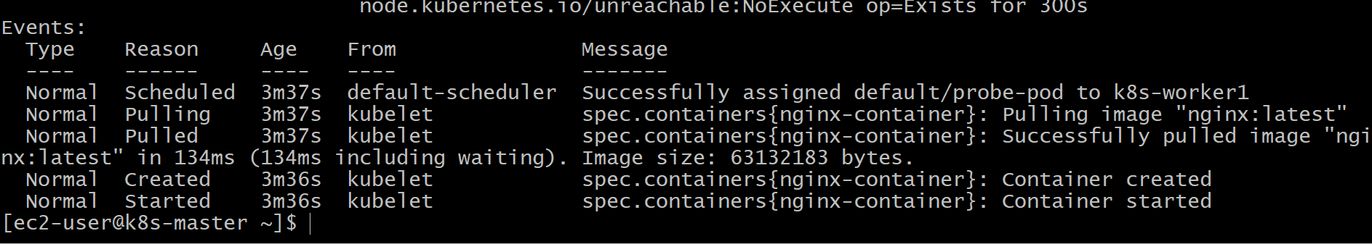
kubectl get pod probe-pod -w
kubectl describe pod probe-pod
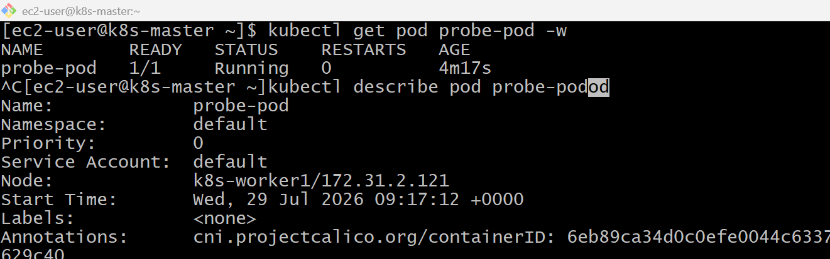
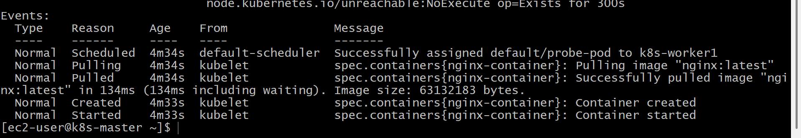

Validation Points
- Created a Pod with liveness and readiness probes.
- Verified the Pod reached the Ready state.
- Confirmed probe configuration using kubectl describe.
- Observed probe behavior through Pod status.

Outcome
- Successfully implemented liveness and readiness probes.
- Learned how Kubernetes monitors application health.
- Understood how readiness controls traffic and liveness controls container restarts.

