Terraform Final Task
Task 1 Create VPC
Objective
- Create a custom Virtual Private Cloud (VPC) using Terraform.
- Define a private network with a custom CIDR block.
- Enable DNS resolution and DNS hostnames within the VPC.
- Build the foundation for all subsequent AWS networking resources.
Prerequisites
- Terraform installed on the local machine.
- AWS account with required permissions.
- AWS CLI configured (aws configure).
- Visual Studio Code installed.
- Terraform project folder created.
- main.tf and outputs.tf files created.
- Internet connection available.
- AWS region selected (e.g., us-east-1).
Implementation Steps
- Create a new Terraform project directory.
- Create the main.tf file.
- Configure the AWS provider.
- Specify the AWS region.
- Create the VPC resource.
- Configure the CIDR block (10.0.0.0/16).
- Enable DNS support.
- Enable DNS hostnames.
- Add a Name tag to the VPC.
- Create the outputs.tf file.
- Add the VPC ID output.
- Run terraform init to initialize Terraform.
- Run terraform fmt to format the configuration.
- Run terraform validate to validate the syntax.
- Run terraform plan to preview the infrastructure.
- Run terraform apply to create the VPC.
- Enter yes to confirm the deployment.
- Verify the VPC in the AWS Management Console.
- Verify the VPC ID using terraform output.
Main.tf
terraform {
required_version = ">=1.5"

required_providers {
aws = {
source = "hashicorp/aws"
version = "~>5.0"
}
}
}

provider "aws" {
region = "us-east-1"
}

resource "aws_vpc" "main_vpc" {

cidr_block = "10.0.0.0/16"

enable_dns_support = true

enable_dns_hostnames = true

tags = {
Name = "Terraform-VPC"
}

}

Output.tf
output "vpc_id" {

value = aws_vpc.main_vpc.id

}

Main.tf
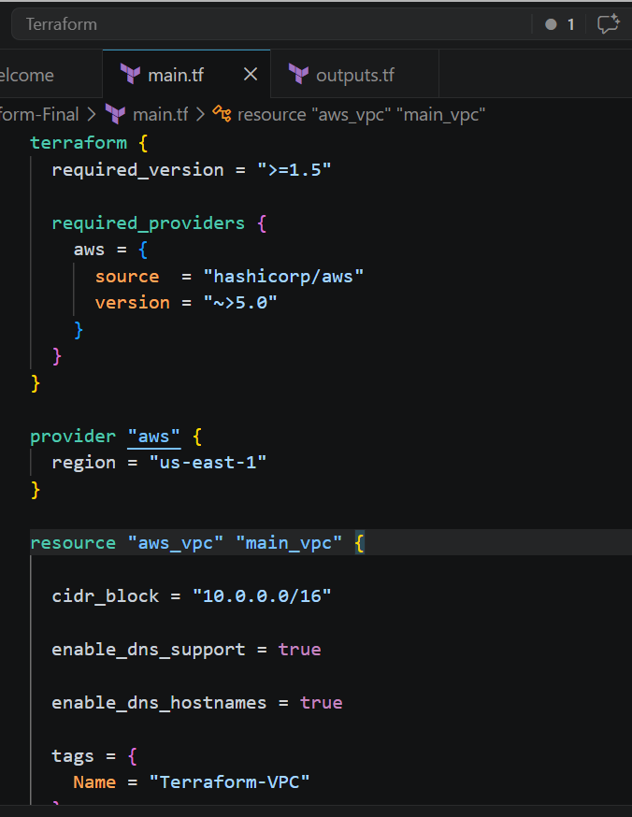
Output.tf
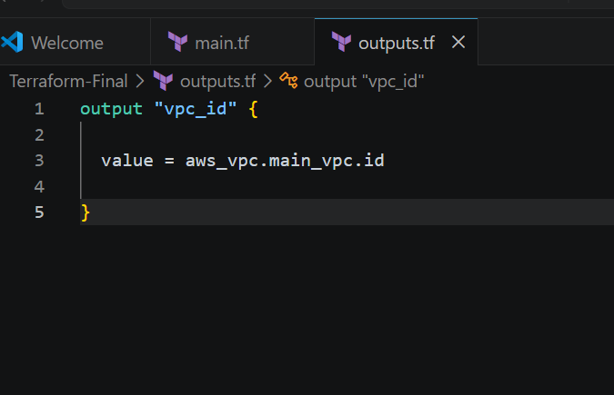
Commands used to run
- terraform init
- terraform fmt
- terraform validate
- terraform plan
- terraform apply

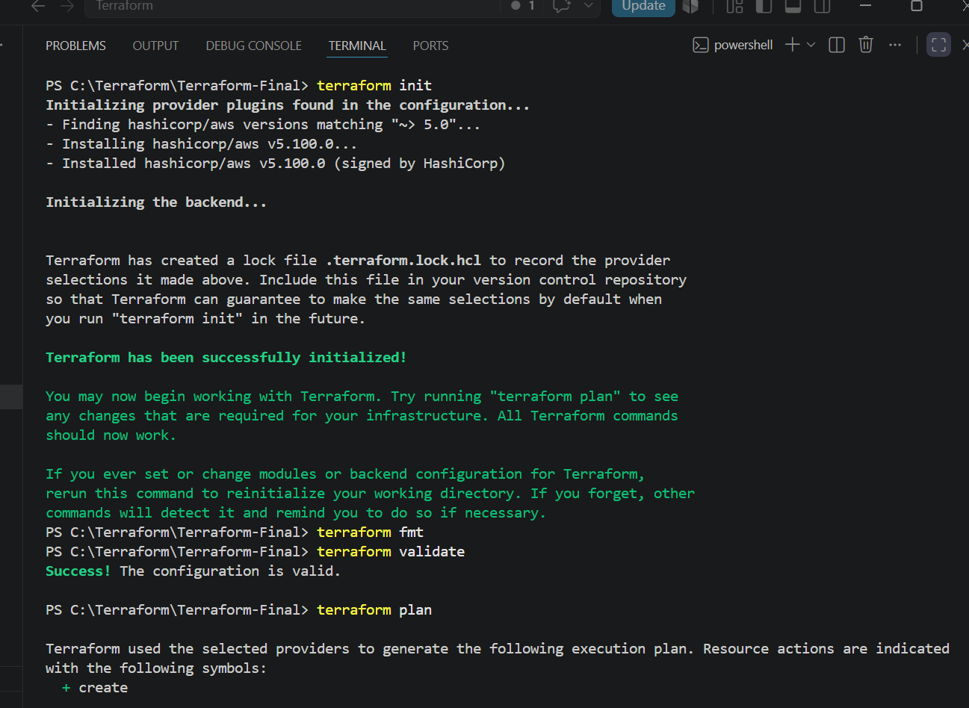

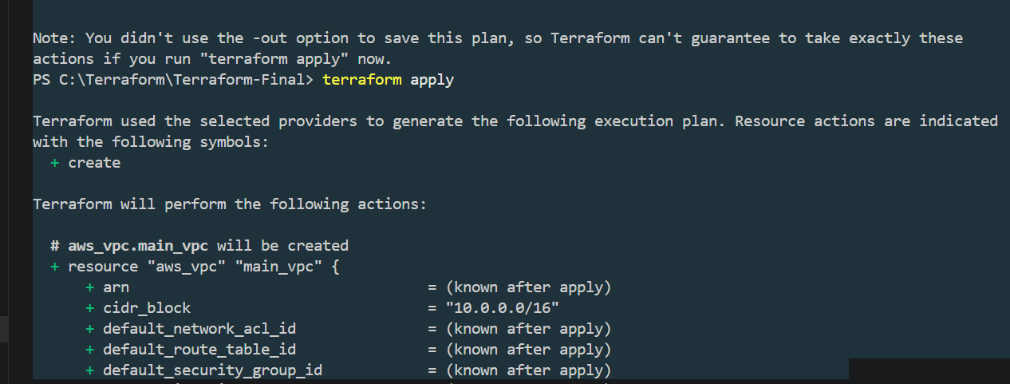

Now automatically VPC created with name “Terraform-VPC”
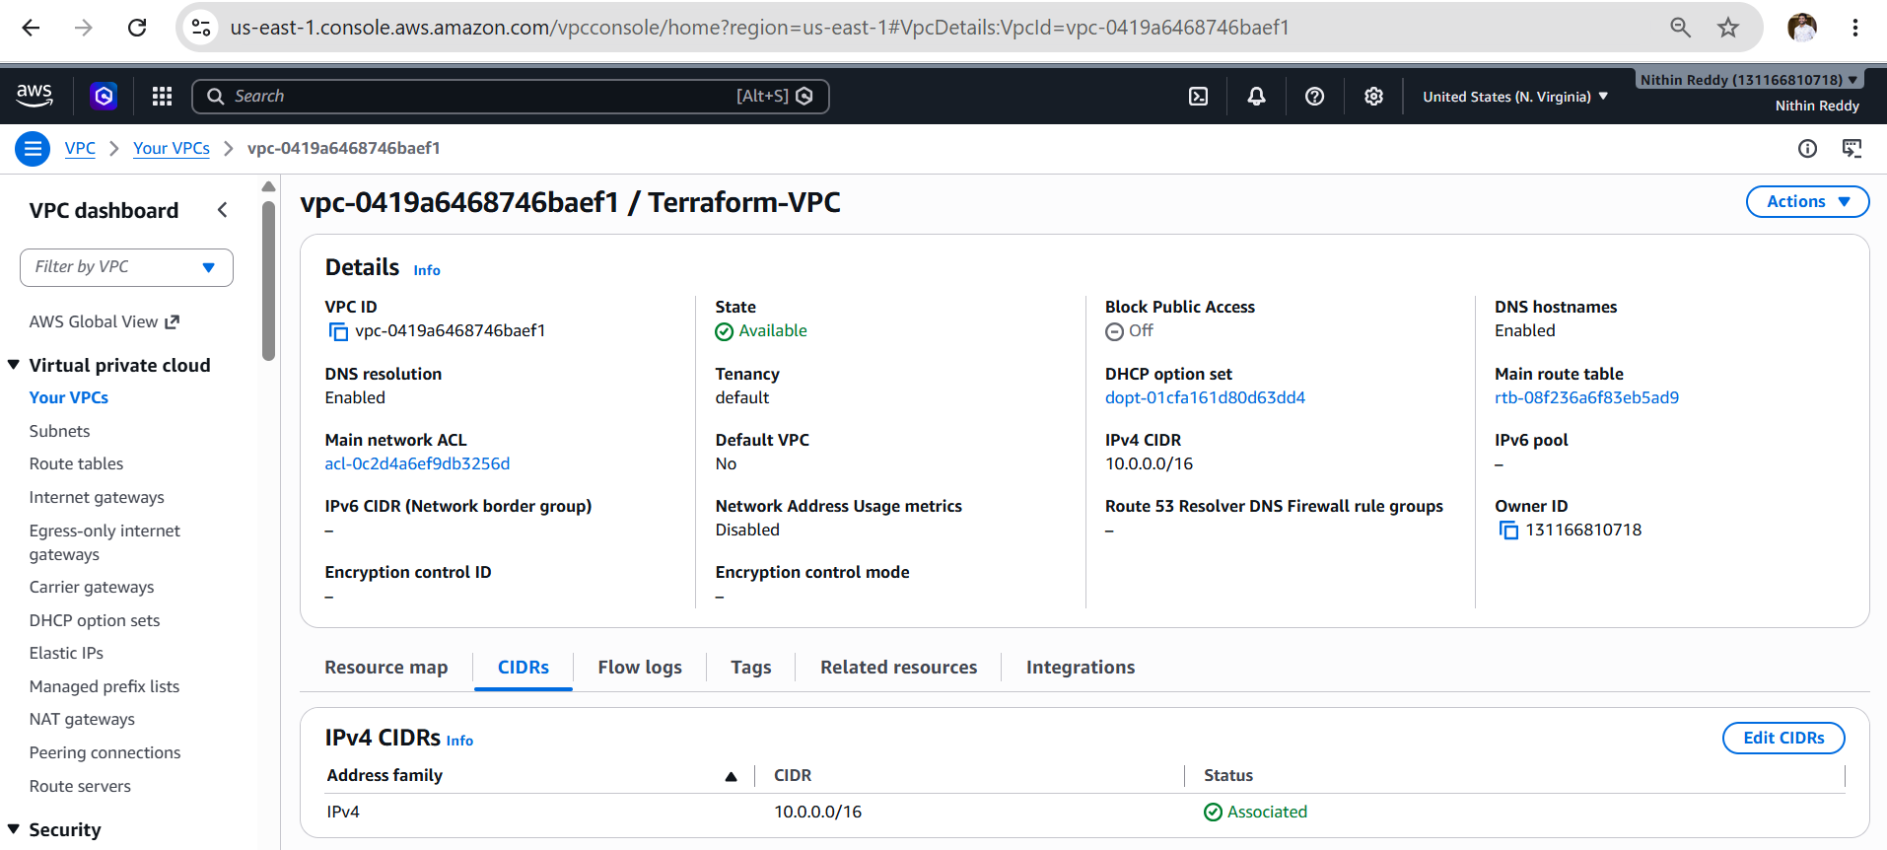

Validation
- Verified Terraform configuration syntax successfully.
- Verified provider initialization.
- Verified execution plan before deployment.
- Verified VPC creation in the AWS Console.
- Verified VPC ID using Terraform outputs.
- Confirmed DNS support and DNS hostnames are enabled.

Outcome
- Successfully created a custom VPC using Terraform.
- Established the base networking infrastructure in AWS.
- Enabled DNS resolution and hostname support within the VPC.
- Verified the VPC creation through Terraform and the AWS Console.
- Prepared the environment for creating the Internet Gateway in Task 2.

Task 2: Create Internet Gateway

Objective
Create an Internet Gateway (IGW) and attach it to the VPC created in Task 1. The Internet Gateway enables resources inside the VPC (such as EC2 instances) to communicate with the internet.

Prerequisites
- Terraform installed.
- AWS CLI configured.
- Task 1 (VPC) completed successfully.
- VPC ID available in the Terraform state.
Implementation Steps
- Open the Terraform project directory.
- Open main.tf.
- Add the Internet Gateway resource.
- Attach the Internet Gateway to the existing VPC.
- Add a Name tag.
- Save the file.
- Format the Terraform configuration using terraform fmt.
- Validate the configuration using terraform validate.
- Review the execution plan using terraform plan.
- Apply the configuration using terraform apply.
- Verify the Internet Gateway in the AWS Console.
- Verify Terraform outputs.

Update main.tf
Add the following code below the VPC resource:

resource "aws_internet_gateway" "main_igw" {

vpc_id = aws_vpc.main_vpc.id

tags = {
Name = "Terraform-IGW"
}

}

Main.tf
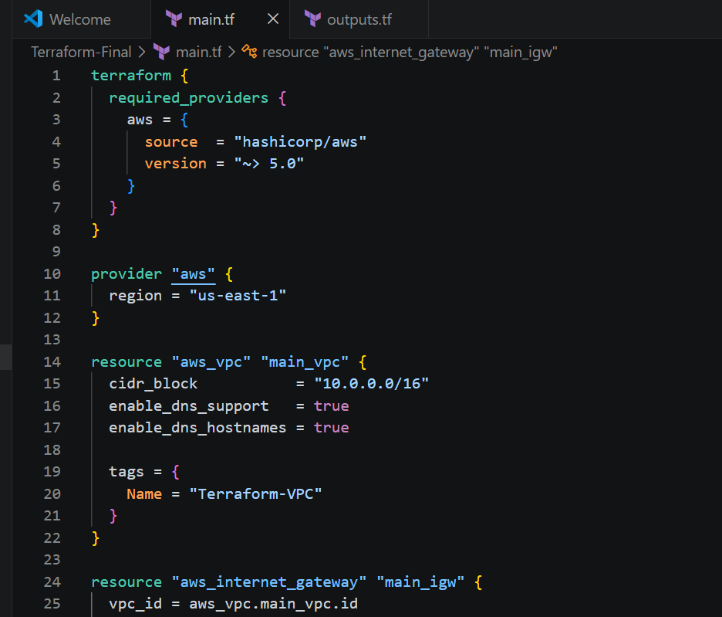
Output.tf
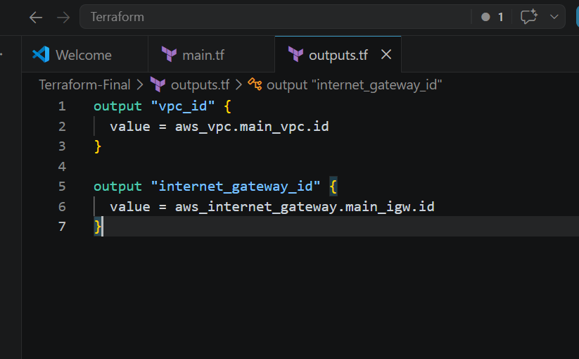

Commands used to run
- terraform init
- terraform validate
- terraform plan
- terraform apply
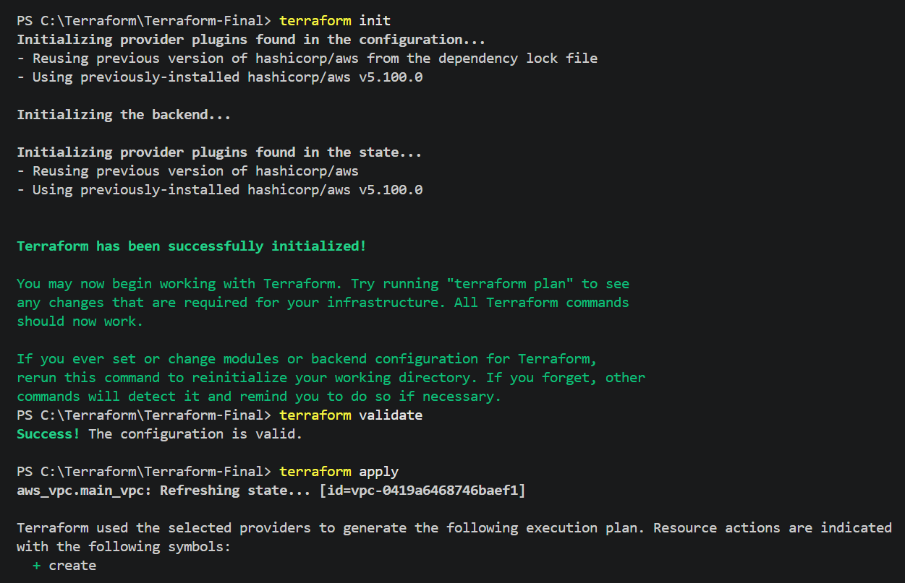
Enter : yes
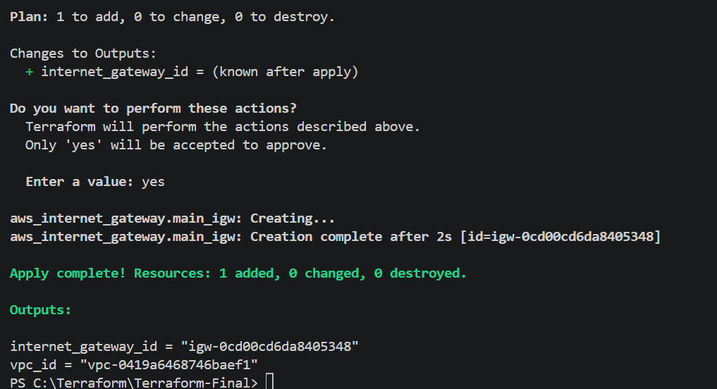

Terraform IGW Created automatically
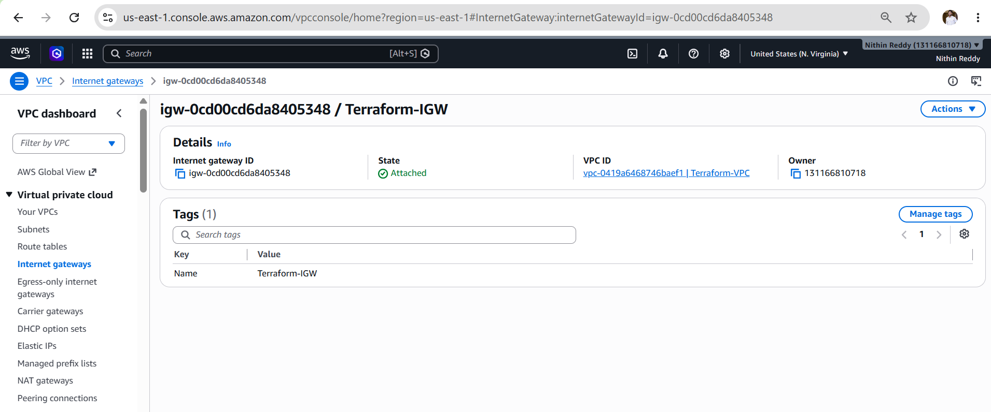

Outcome
- Successfully created an Internet Gateway.
- Attached the Internet Gateway to the VPC.
- Enabled internet connectivity for the VPC (routing will be configured in the next task).
- Infrastructure state updated successfully in Terraform.

Task 3 Create Custom Route Table
Objective: I should not replace my previous resources. Terraform is incremental, so your main.tf should now contain:
- ✅ VPC (Task 1)
- ✅ Internet Gateway (Task 2)
- ✅ Route Table (Task 3)

Implementation Steps
- Open the Terraform project.
- Add the Route Table resource to main.tf.
- Associate the Route Table with the VPC.
- Add a default route (0.0.0.0/0) through the Internet Gateway.
- Apply a Name tag to the Route Table.
- Update outputs.tf with the Route Table ID.
- Run terraform fmt.
- Run terraform validate.
- Run terraform plan.
- Run terraform apply.
- Verify the Route Table and routes in the AWS Console.

Update Main.tf
terraform {
required_version = ">= 1.5"

required_providers {
aws = {
source = "hashicorp/aws"
version = "~> 5.0"
}
}
}

provider "aws" {
region = "us-east-1"
}

# -------------------------
# Task 1 - Create VPC
# -------------------------

resource "aws_vpc" "main_vpc" {

cidr_block = "10.0.0.0/16"
enable_dns_support = true
enable_dns_hostnames = true

tags = {
Name = "Terraform-VPC"
}
}

# -------------------------
# Task 2 - Internet Gateway
# -------------------------

resource "aws_internet_gateway" "main_igw" {

vpc_id = aws_vpc.main_vpc.id

tags = {
Name = "Terraform-IGW"
}
}

# -------------------------
# Task 3 - Custom Route Table
# -------------------------

resource "aws_route_table" "main_rt" {

vpc_id = aws_vpc.main_vpc.id

route {

cidr_block = "0.0.0.0/0"

gateway_id = aws_internet_gateway.main_igw.id

}

tags = {

Name = "Terraform-RouteTable"

}

}

Output.tf
output "vpc_id" {
description = "VPC ID"
value = aws_vpc.main_vpc.id
}

output "internet_gateway_id" {
description = "Internet Gateway ID"
value = aws_internet_gateway.main_igw.id
}

output "route_table_id" {
description = "Route Table ID"
value = aws_route_table.main_rt.id
}

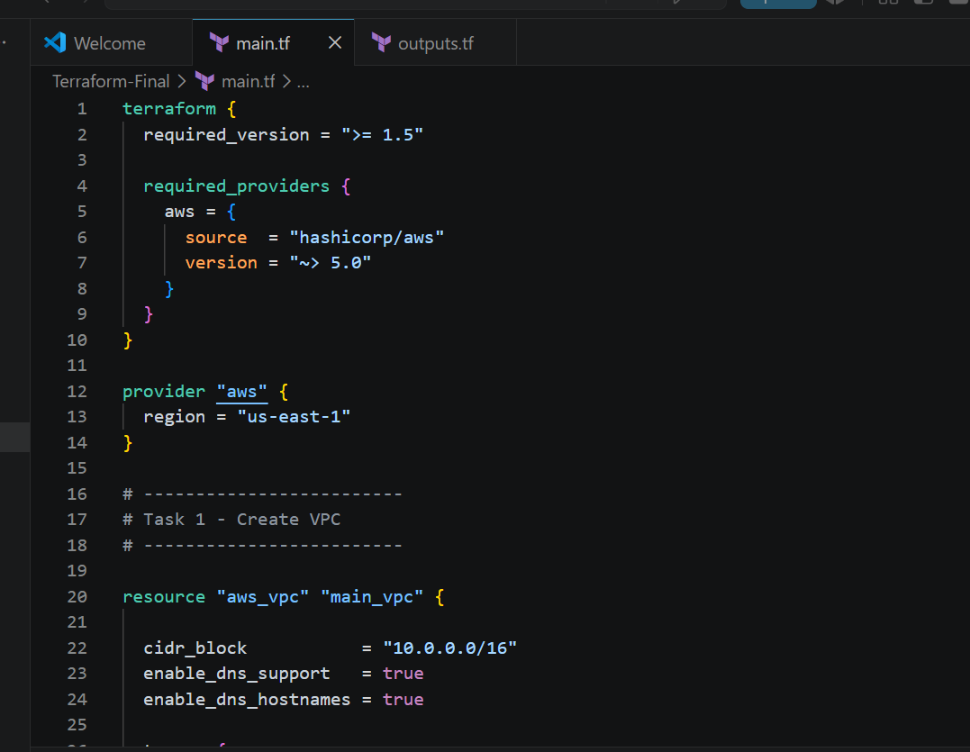
Output.tf
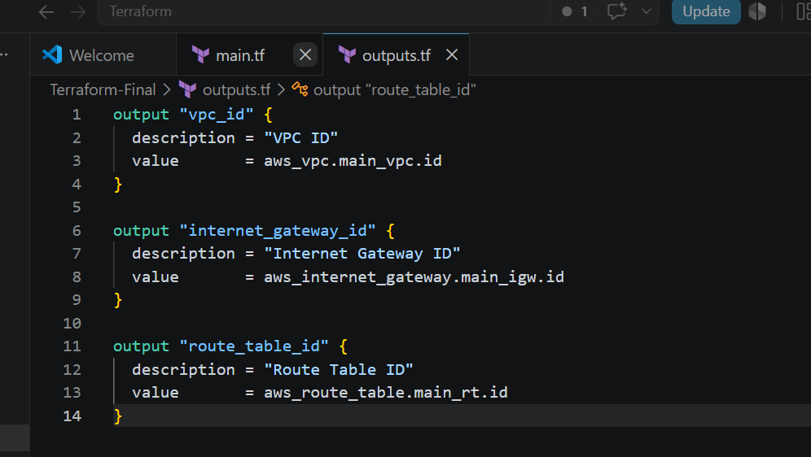

Commands used to run
- terraform init
- terraform fmt
- terraform validate
- terraform plan
- terraform apply
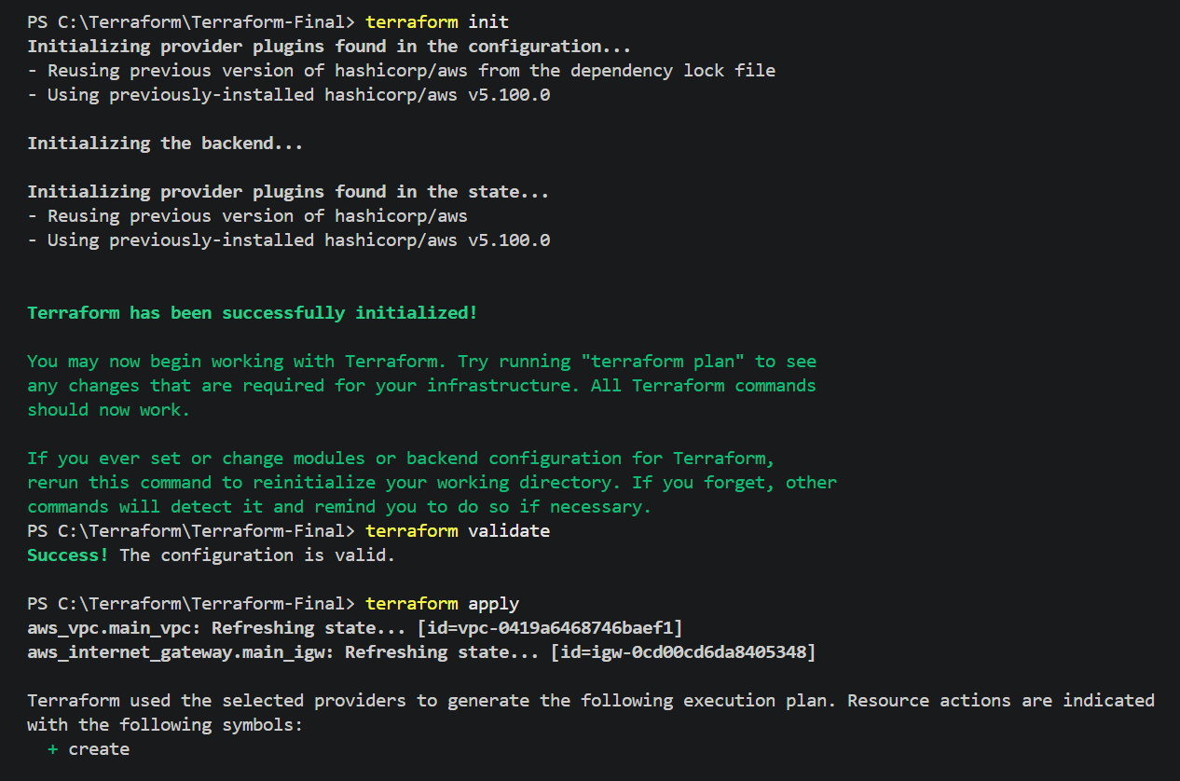
Terraform apply
Enter : yes
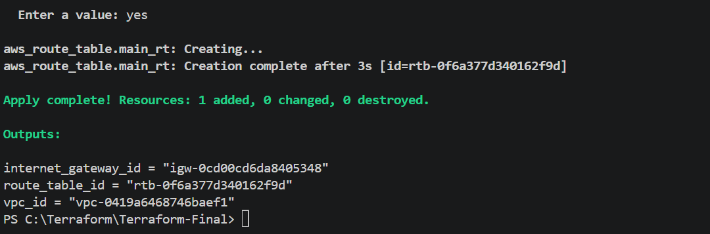

Terraform Route-table created automatically after terraform apply
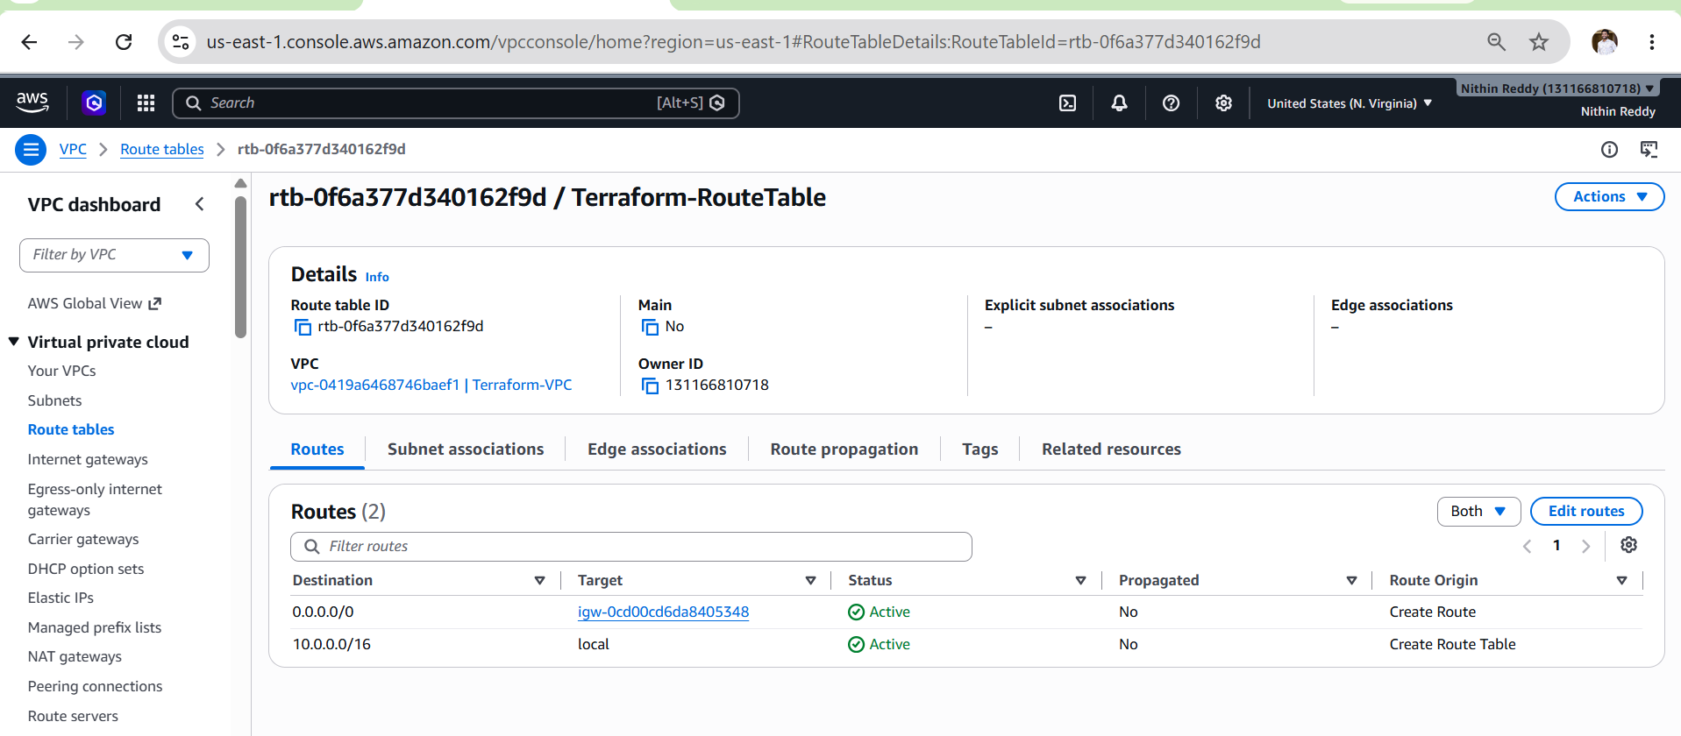

Outcome
- Successfully created a custom Route Table.
- Configured internet routing through the Internet Gateway.
- Prepared the networking infrastructure for subnet association in Task 4 (Create Subnet).

Task 4: Create a Subnet

Objective
Create a subnet inside the VPC to host AWS resources such as EC2 instances. Configure the subnet in a specific Availability Zone and enable automatic public IP assignment.

Prerequisites
- Task 1 (VPC) completed.
- Task 2 (Internet Gateway) completed.
- Task 3 (Custom Route Table) completed.
- Terraform installed.
- AWS CLI configured.
- AWS account with required permissions.
Implementation Steps
- Open the Terraform project in Visual Studio Code.
- Open the main.tf file.
- Add the aws_subnet resource.
- Specify the VPC ID using the Terraform VPC resource reference.
- Configure the subnet CIDR block (10.0.1.0/24).
- Specify the Availability Zone (us-east-1a).
- Enable automatic public IP assignment (map_public_ip_on_launch = true).
- Add a Name tag (Terraform-Subnet).
- Save the configuration.
- Update outputs.tf to include the subnet ID.
- Run terraform fmt to format the code.
- Run terraform validate to validate the configuration.
- Run terraform plan to review the execution plan.
- Run terraform apply to create the subnet.
- Type yes to confirm the deployment.
- Verify the subnet in the AWS Management Console.
- Verify the subnet ID using terraform output.

Main.tf
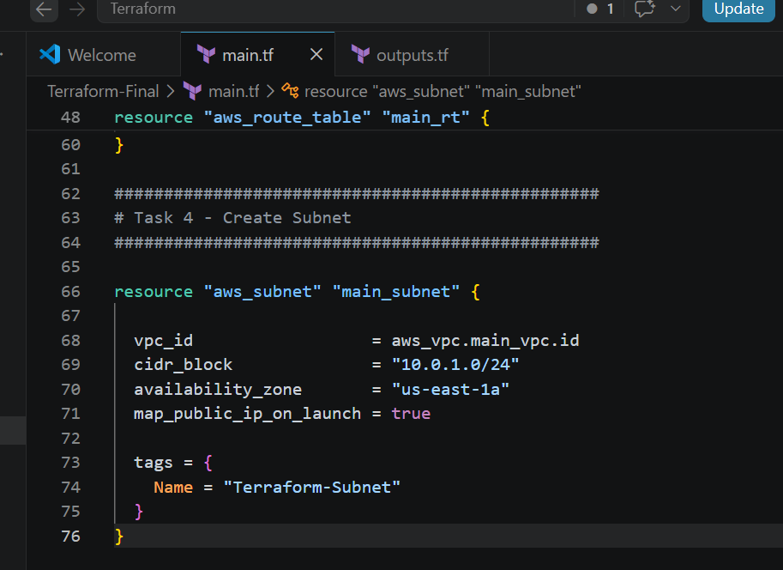

Output.tf
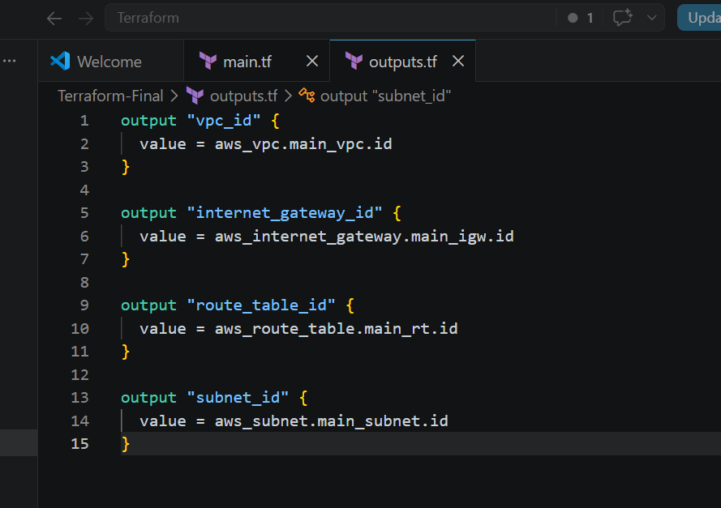

Commands used to run
- terraform init
- terraform fmt
- terraform validate
- terraform plan
- terraform apply
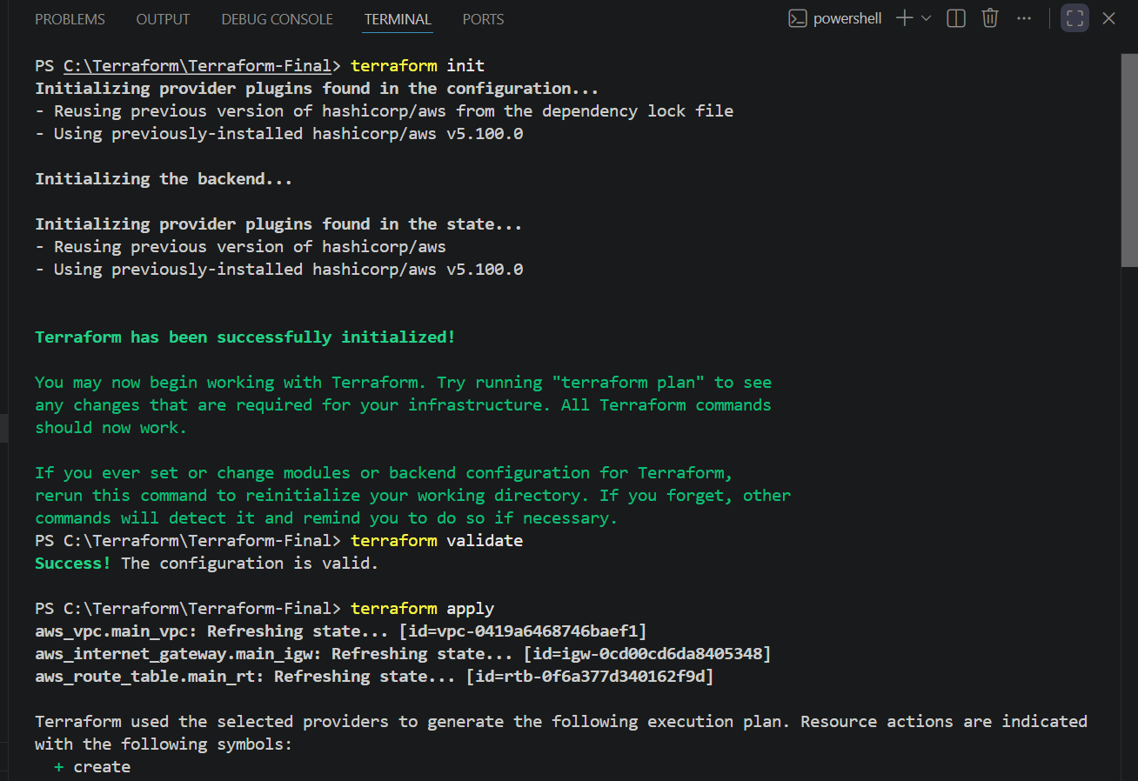
Terraform apply
enter : yes
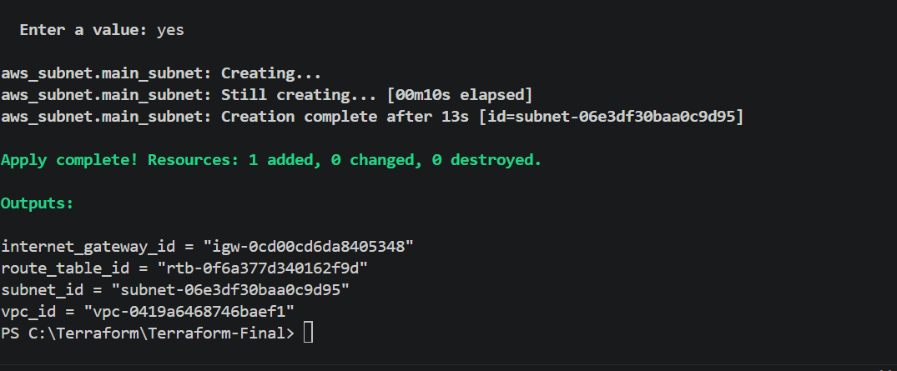

Terraform subnets created automatically
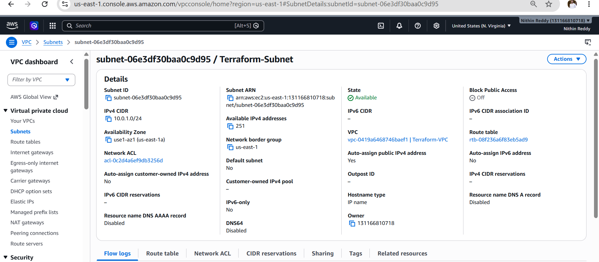
Validation
- Verified the Terraform configuration without errors.
- Verified the subnet was created successfully.
- Verified the subnet belongs to the correct VPC.
- Verified the subnet CIDR block is 10.0.1.0/24.
- Verified the Availability Zone is us-east-1a.
- Verified automatic public IP assignment is enabled.
- Verified the subnet ID using terraform output.

Outcome
- Successfully created a subnet inside the custom VPC using Terraform.
- Configured the subnet with the required CIDR block and Availability Zone.
- Enabled automatic public IP assignment for resources launched in the subnet.
- Verified the subnet deployment through Terraform and the AWS Management Console.
- Prepared the infrastructure for Task 5: Associate the Subnet with the Custom Route Table.

Task 5: Associate Subnet with Route Table
Objective
Associate the subnet with the custom route table so that all resources deployed in the subnet use the routing rules defined in the custom route table.

Prerequisites
- Task 1: VPC created.
- Task 2: Internet Gateway created.
- Task 3: Custom Route Table created.
- Task 4: Subnet created.
- Terraform installed and configured.
- AWS CLI configured.
Implementation Steps
- Open the Terraform project.
- Open the main.tf file.
- Add the Route Table Association resource.
- Reference the subnet ID created in Task 4.
- Reference the Route Table ID created in Task 3.
- Save the configuration.
- Update outputs.tf with the Route Table Association ID.
- Run terraform fmt.
- Run terraform validate.
- Run terraform plan.
- Run terraform apply.
- Verify the association in the AWS Management Console.
- Verify the output using terraform output.

Main.tf
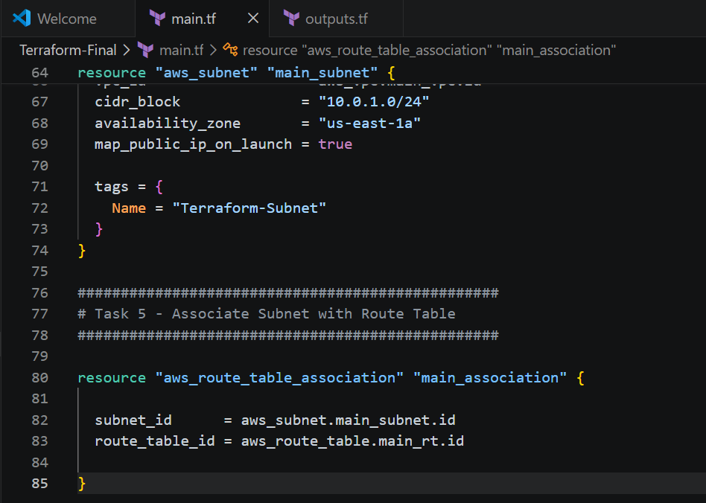
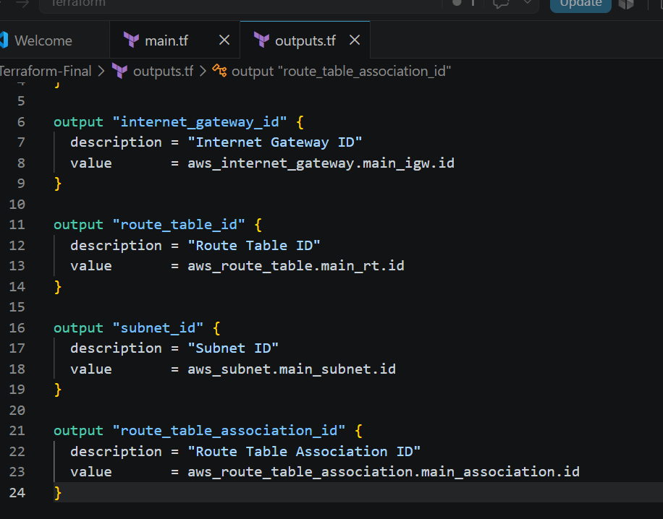

Commands used to run
- terraform init
- terraform fmt
- terraform validate
- terraform plan
- terraform apply
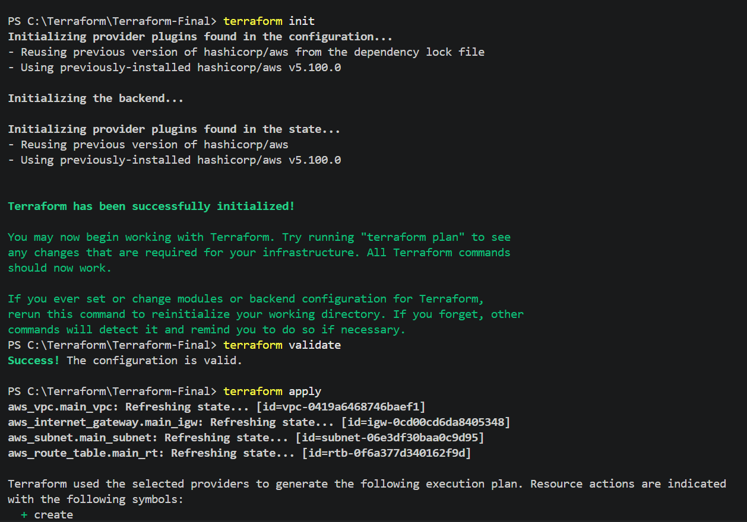

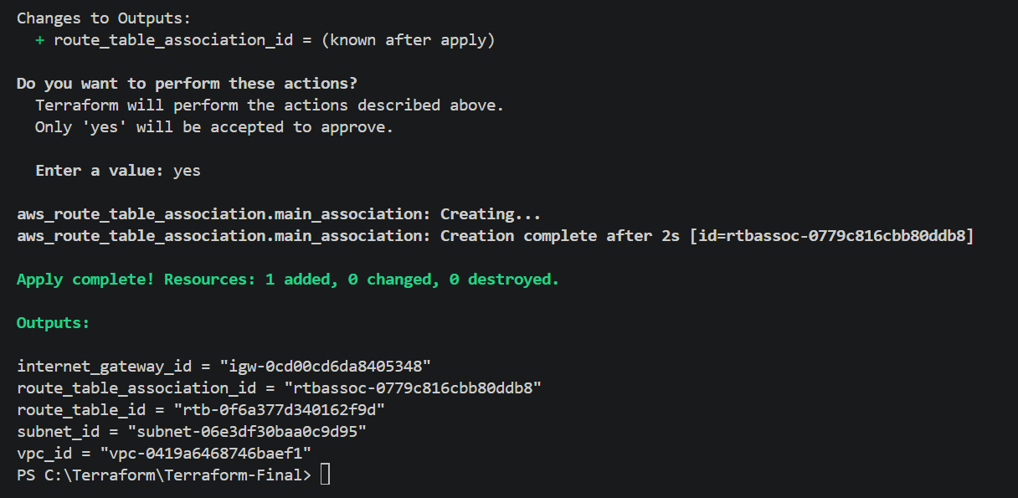
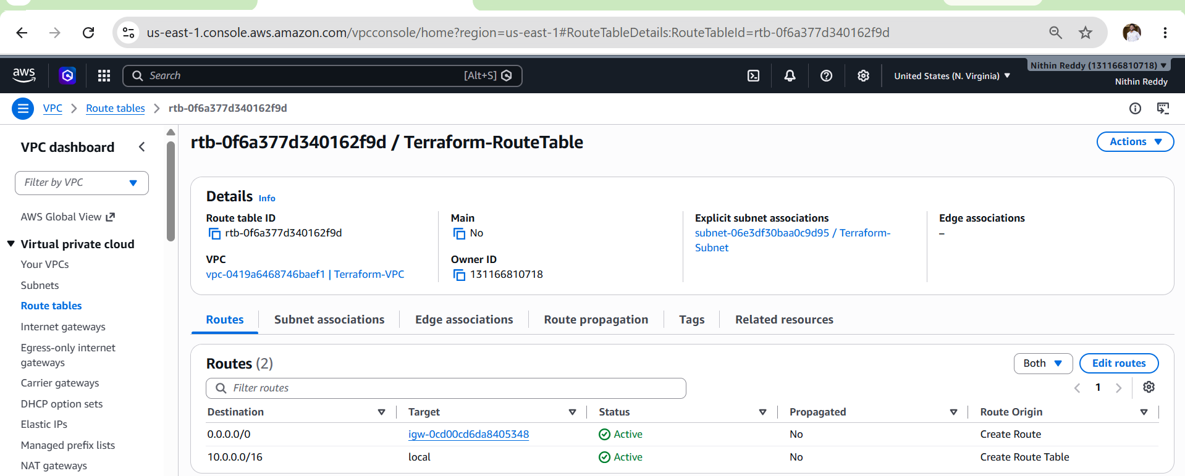
Subnet association created
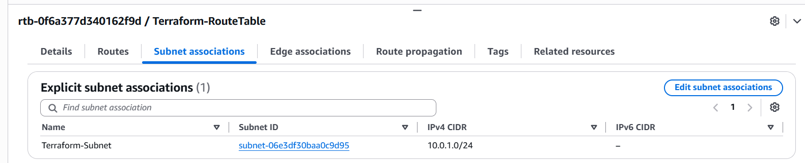

Validation in AWS
Go to:
AWS Console → VPC → Route Tables
- Select Terraform-RouteTable.
- Open the Subnet Associations tab.
- Verify that Terraform-Subnet is listed.
Alternatively:
Go to VPC → Subnets.

Outcome
- Successfully associated the subnet with the custom Route Table.
- Enabled the subnet to use the routing rules defined in the Route Table.
- Verified the Route Table Association through Terraform and the AWS Console.
- Prepared the network for deploying resources with internet connectivity.

Task 6: Create Security Group Allow Ports 22, 80, 443

Objective
Create a Security Group within the custom VPC that allows:
- SSH (Port 22)
- HTTP (Port 80)
- HTTPS (Port 443)
This Security Group will later be attached to the EC2 instance in Task 9.

Prerequisites
- ✅ Task 1 – VPC Created
- ✅ Task 2 – Internet Gateway Created
- ✅ Task 3 – Route Table Created
- ✅ Task 4 – Subnet Created
- ✅ Task 5 – Route Table Association Completed
- Terraform Installed
- AWS CLI Configured

Implementation Steps
- Open the Terraform project.
- Open main.tf.
- Add the Security Group resource.
- Associate it with the custom VPC.
- Configure inbound rules for SSH (22), HTTP (80), and HTTPS (443).
- Configure an outbound rule to allow all traffic.
- Add a Name tag to the Security Group.
- Save the configuration.
- Update outputs.tf with the Security Group ID.
- Run terraform fmt.
- Run terraform validate.
- Run terraform plan.
- Run terraform apply.
- Verify the Security Group in the AWS Management Console.
- Verify the Security Group ID using terraform output.

Main.tf
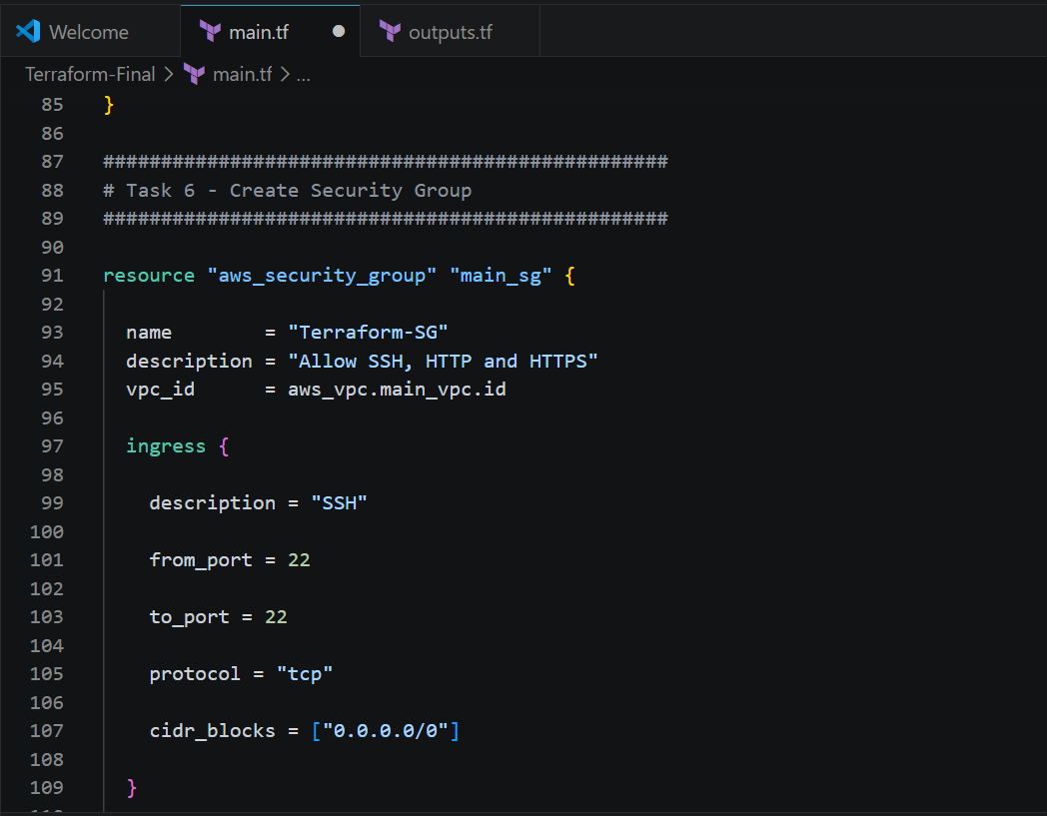
Outcome.tf
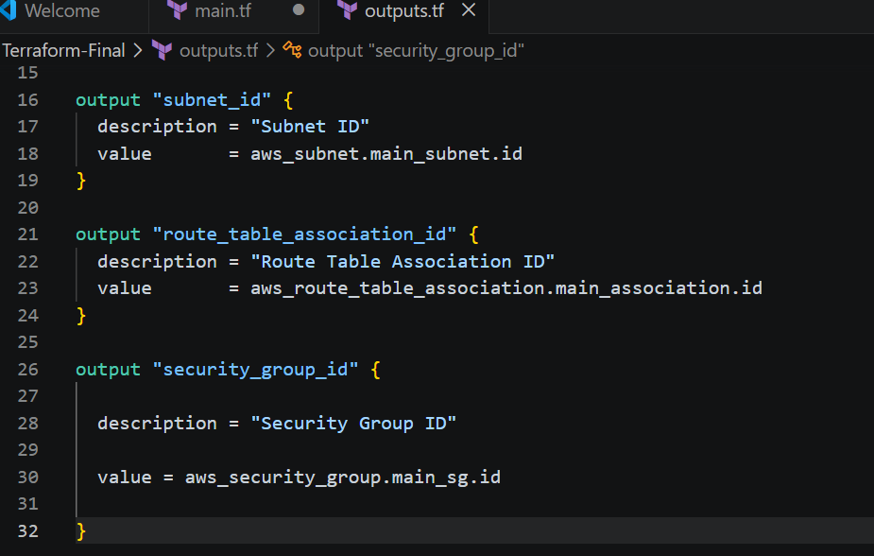

Commands used to run
- terraform init
- terraform fmt
- terraform validate
- terraform plan
- terraform apply
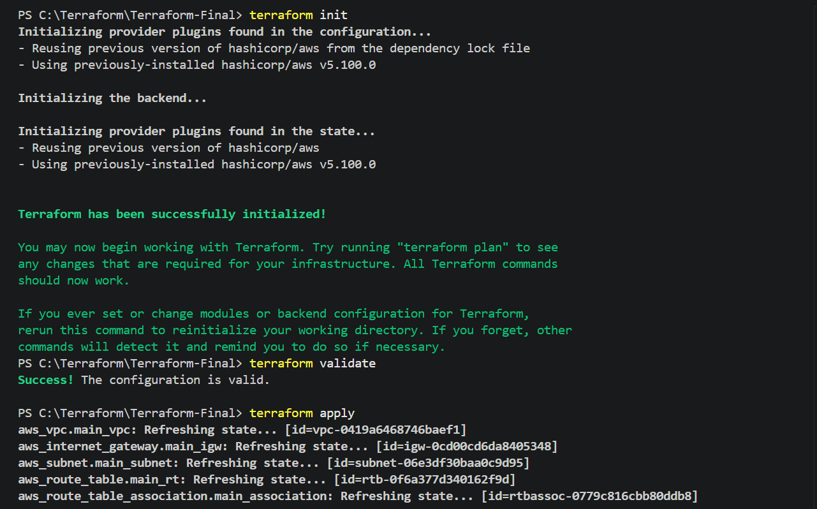
Enter : yes
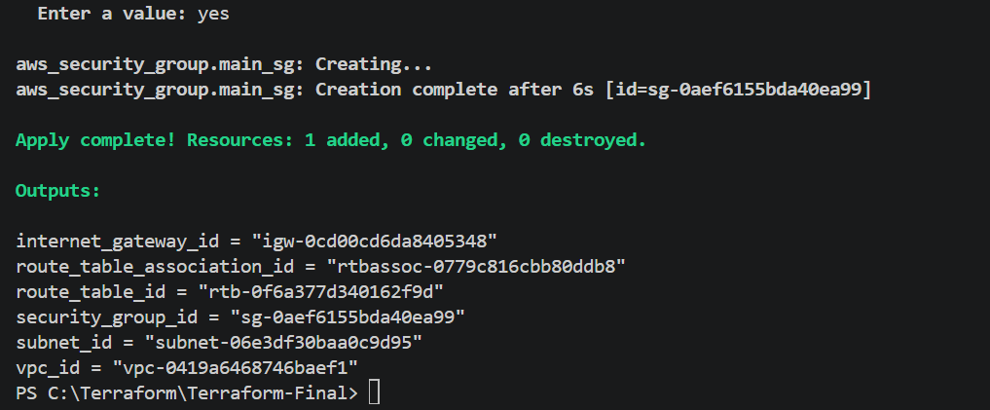

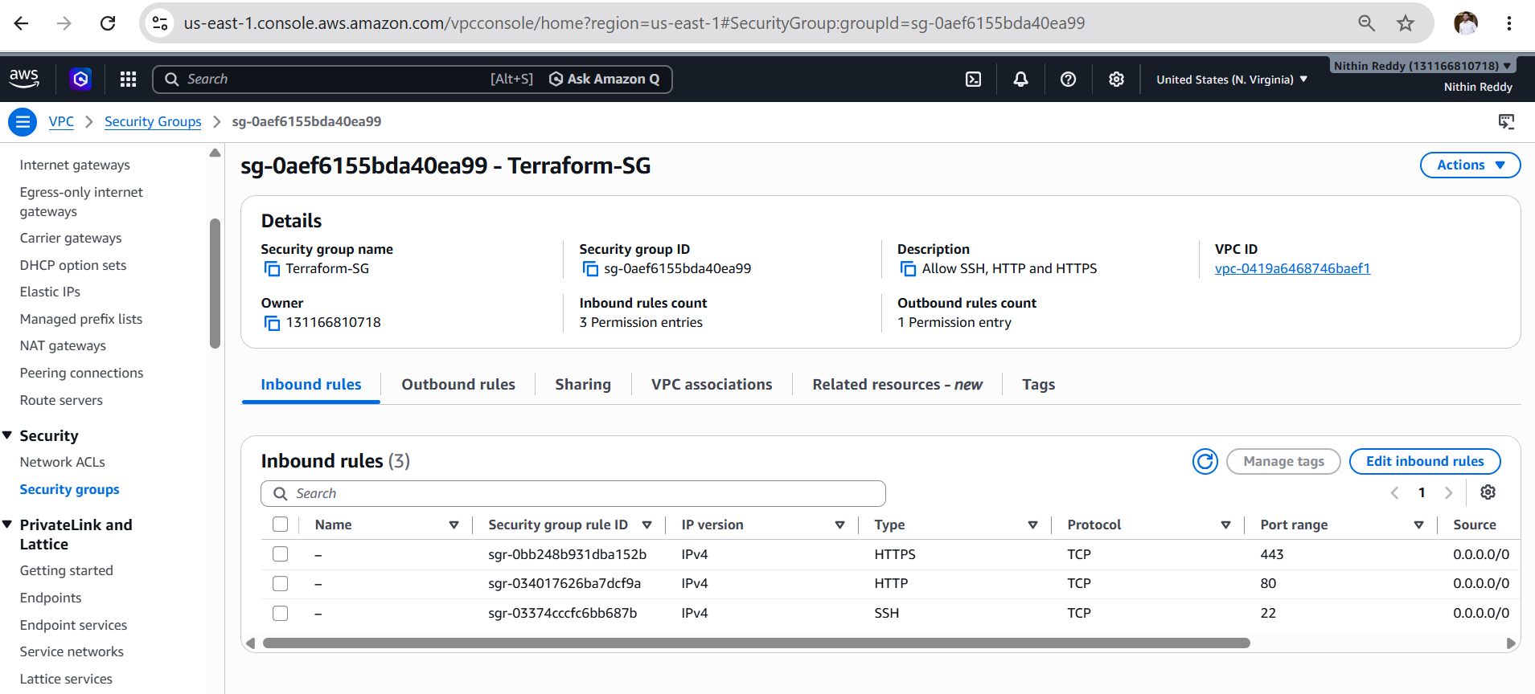
AWS Validation
Go to:
AWS Console → EC2 → Security Groups
Verify:
- Name: Terraform-SecurityGroup
- VPC: Terraform-VPC
Inbound Rules
Type | Port | Source
SSH | 22 | 0.0.0.0/0
HTTP | 80 | 0.0.0.0/0
HTTPS | 443 | 0.0.0.0/0

Outcome
- Successfully created a Security Group using Terraform.
- Configured inbound access for SSH (22), HTTP (80), and HTTPS (443).
- Configured outbound access to allow all traffic.
- Verified the Security Group through Terraform and the AWS Management Console.

Task 7 - Create Network Interface

Objective
- Create an Elastic Network Interface (ENI).
- Attach it to the subnet created in Task 4.
- Associate the Security Group created in Task 6.
- Assign a static private IP address.

Prerequisites
- ✅ Task 1 – VPC Created
- ✅ Task 2 – Internet Gateway Created
- ✅ Task 3 – Route Table Created
- ✅ Task 4 – Subnet Created
- ✅ Task 5 – Route Table Association Created
- ✅ Task 6 – Security Group Created
- Terraform Installed
- AWS CLI Configured

Implementation Steps
- Open the Terraform project.
- Open main.tf.
- Add the Network Interface resource.
- Reference the subnet created in Task 4.
- Configure the private IP address (10.0.1.50).
- Associate the Security Group created in Task 6.
- Add a Name tag.
- Save the configuration.
- Update outputs.tf with the Network Interface ID and private IP.
- Run terraform fmt.
- Run terraform validate.
- Run terraform plan.
- Run terraform apply.
- Verify the Network Interface in the AWS Console.
- Verify the outputs using terraform output.

Main.tf
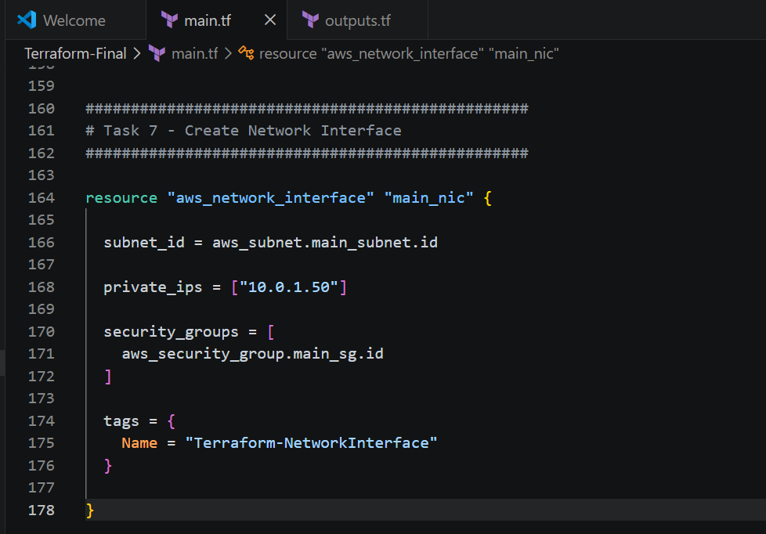
Output.tf
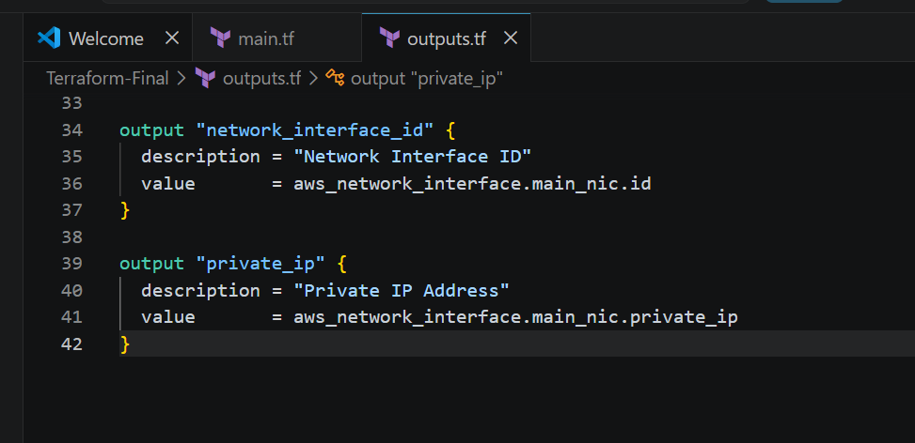
Commands used to run
- terraform init
- terraform validate
- terraform apply

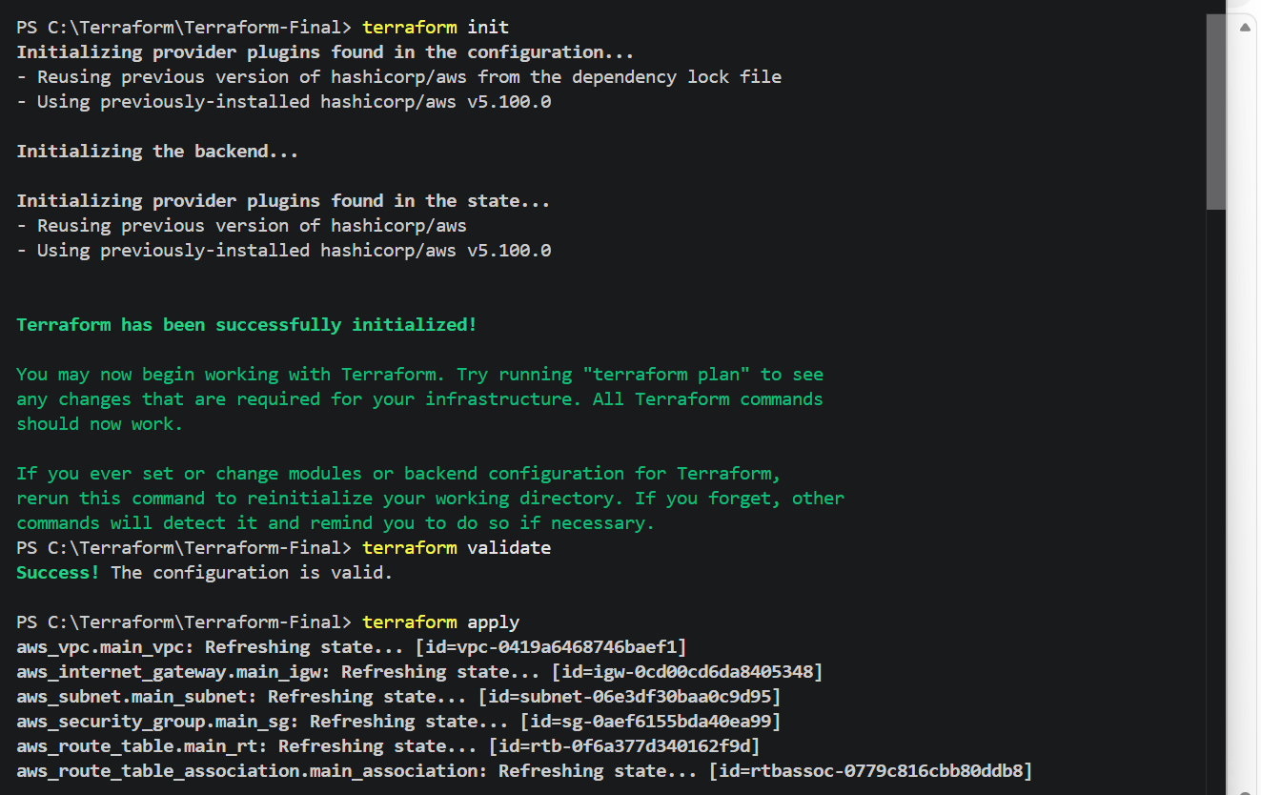
Enter : yes
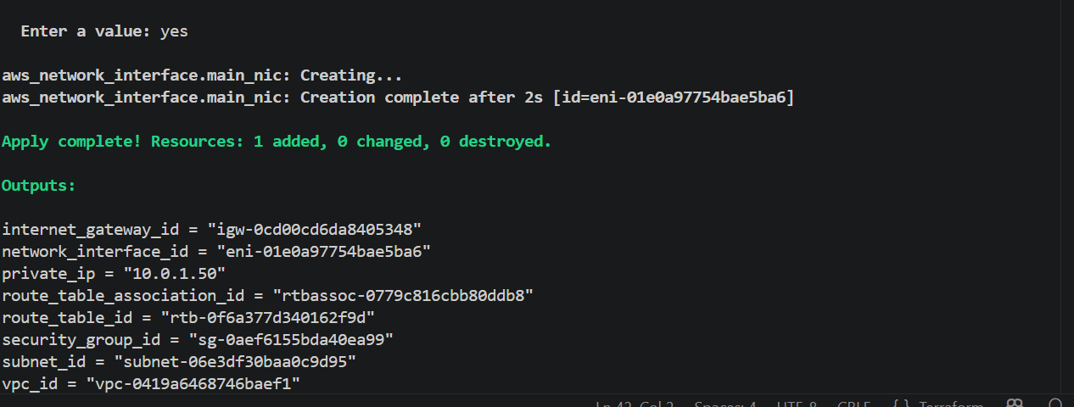
AWS Validation
Go to:
AWS Console → EC2 → Network Interfaces
Verify:
- Name: Terraform-NetworkInterface
- Subnet: Terraform-Subnet
- Private IP: 10.0.1.50
- Status: Available
- Security Group: Terraform-SecurityGroup

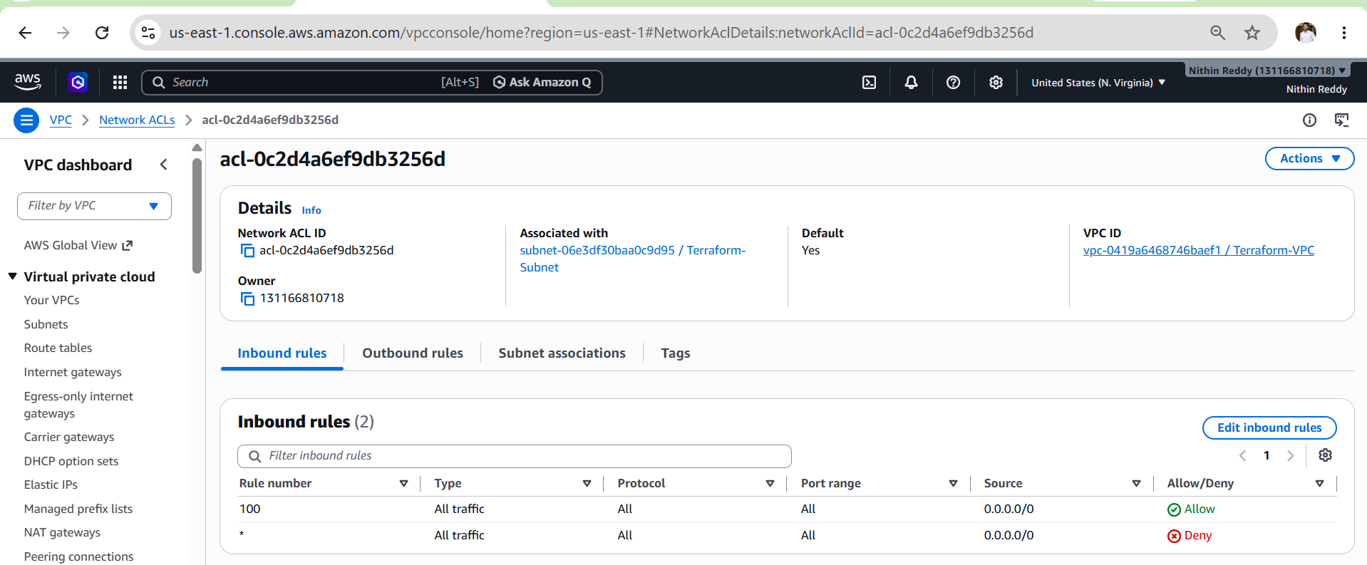
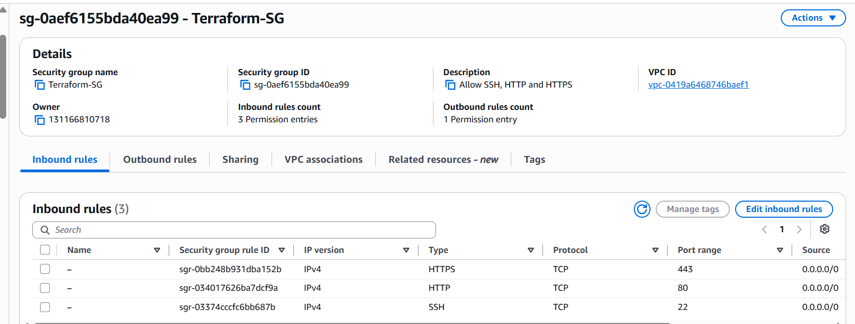
Outcome
- Successfully created an Elastic Network Interface (ENI) using Terraform.
- Assigned a static private IP address (10.0.1.50) to the network interface.
- Associated the network interface with the custom subnet and Security Group.
- Verified the ENI through Terraform and the AWS Management Console.

Task 8 – Assign Elastic IP to Network Interface

Objective
- Allocate a new Elastic IP (EIP).
- Associate the Elastic IP with the Network Interface created in Task 7.
- Enable internet access using a static public IP.

Prerequisites
- ✅ Task 1 – VPC Created
- ✅ Task 2 – Internet Gateway Created
- ✅ Task 3 – Route Table Created
- ✅ Task 4 – Subnet Created
- ✅ Task 5 – Route Table Association Completed
- ✅ Task 6 – Security Group Created
- ✅ Task 7 – Network Interface Created
- Terraform Installed
- AWS CLI Configured

Implementation Steps
- Open the Terraform project.
- Open main.tf.
- Add the Elastic IP resource.
- Set domain = "vpc".
- Reference the Network Interface created in Task 7.
- Associate the Elastic IP with the private IP 10.0.1.50.
- Add a Name tag (Terraform-EIP).
- Save the configuration.
- Update outputs.tf with the Elastic IP and Allocation ID outputs.
- Run terraform fmt.
- Run terraform validate.
- Run terraform plan.
- Run terraform apply.
- Verify the Elastic IP in the AWS Console.
- Verify the output using terraform output

Main.tf
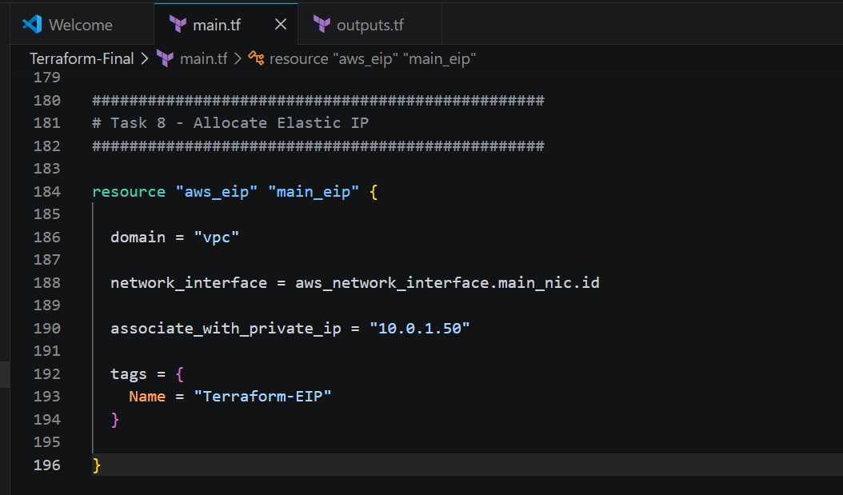
Output.tf
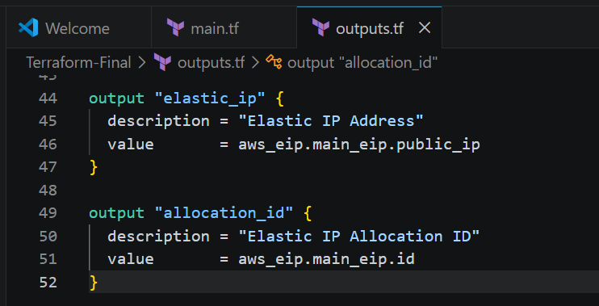

Commands used to run
- terraform init
- terraform validate
- terraform apply

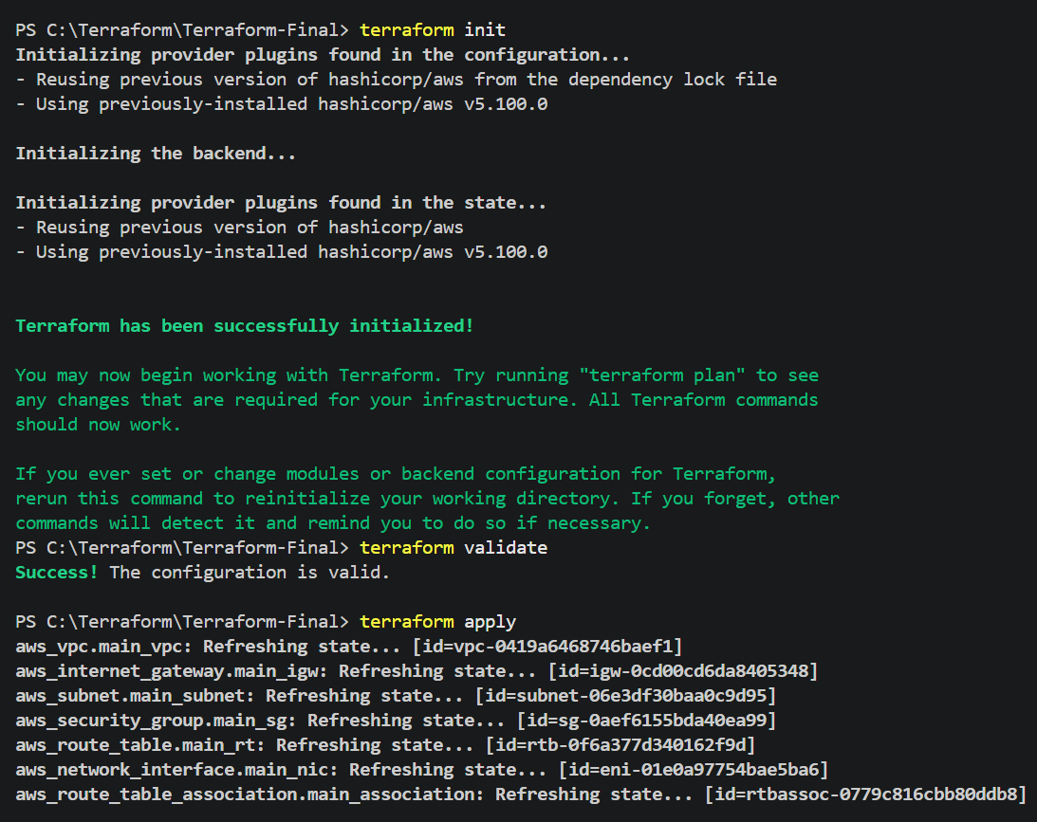
Enter : yes
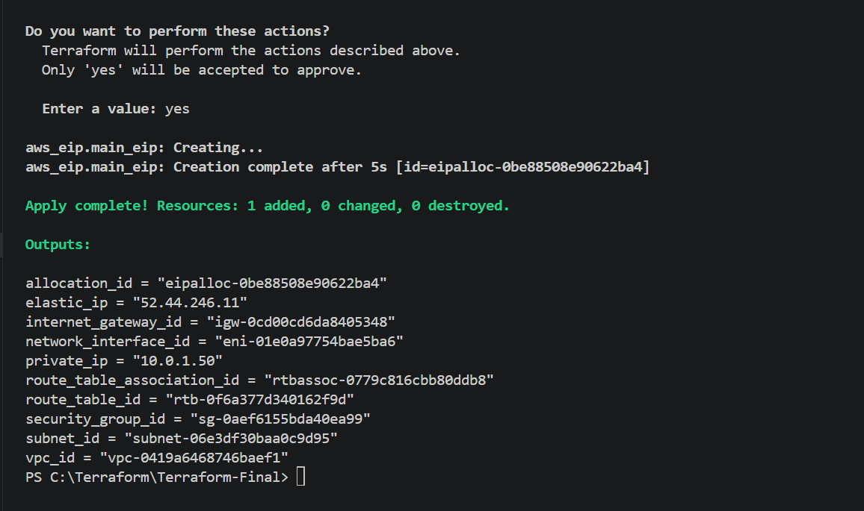

Elastic ip released
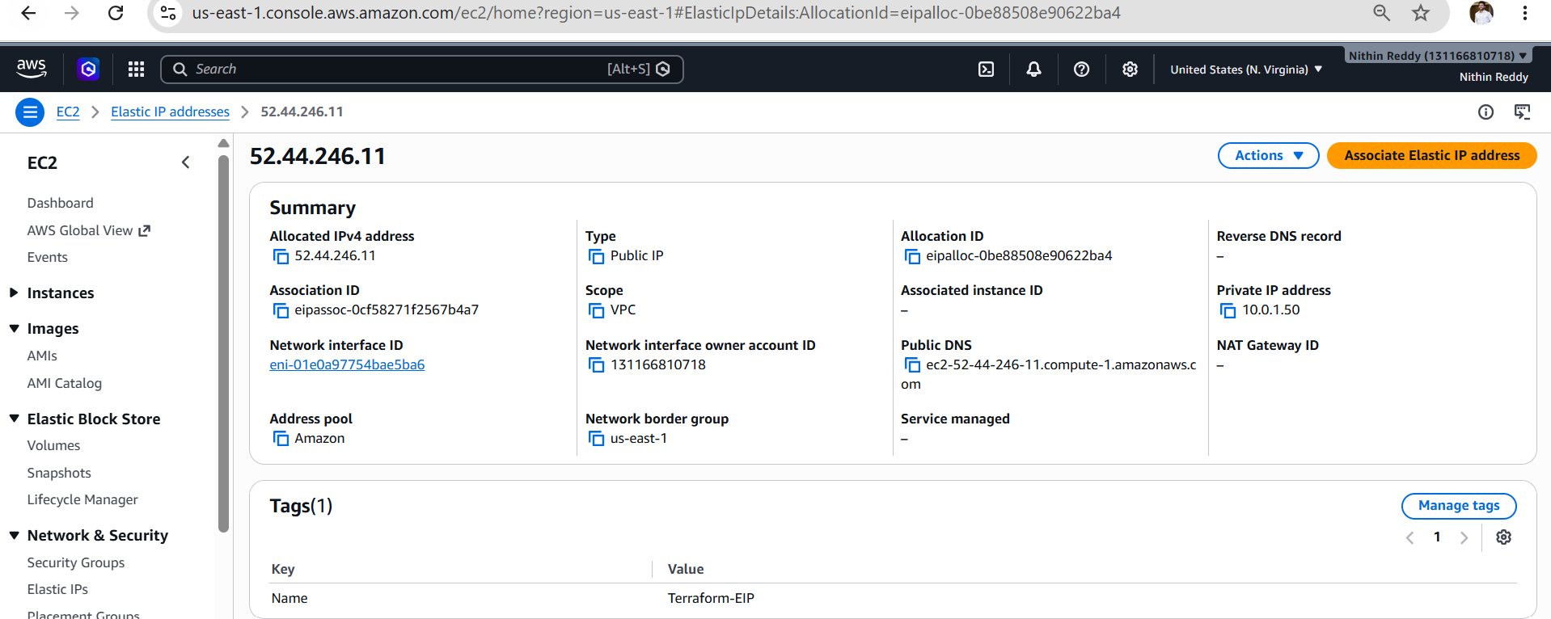

Validation in AWS Console
Go to:
AWS Console → EC2 → Elastic IPs
Verify:
- Name: Terraform-EIP
- Public IPv4 Address: Allocated
- Association: Attached
- Network Interface: Terraform-NetworkInterface

Outcome
- Successfully allocated an Elastic IP using Terraform.
- Associated the Elastic IP with the Network Interface.
- Assigned a static public IP address for internet access.
- Verified the Elastic IP association through Terraform and the AWS Management Console.

Task 9 – Create Ubuntu EC2 Instance and Install Apache2

Objective
- Launch an Ubuntu EC2 instance.
- Attach the existing Network Interface created in Task 7.
- Automatically install and enable Apache2 using a User Data script.
- Verify the Apache web page through the Elastic IP.

Prerequisites
- ✅ Task 1 – VPC Created
- ✅ Task 2 – Internet Gateway Created
- ✅ Task 3 – Route Table Created
- ✅ Task 4 – Subnet Created
- ✅ Task 5 – Route Table Association Completed
- ✅ Task 6 – Security Group Created
- ✅ Task 7 – Network Interface Created
- ✅ Task 8 – Elastic IP Associated
- Terraform Installed
- AWS CLI Configured
- Ubuntu Key Pair available in AWS

Implementation Steps
- Open the Terraform project.
- Add the EC2 resource to main.tf.
- Specify the Ubuntu AMI ID.
- Set the instance type to t3.micro.
- Specify the EC2 Key Pair.
- Attach the existing Network Interface.
- Add the User Data script to install Apache2.
- Configure Apache2 to start automatically.
- Create a custom index.html page.
- Save the configuration.
- Update outputs.tf with the EC2 outputs.
- Run terraform fmt.
- Run terraform validate.
- Run terraform plan.
- Run terraform apply.
- Verify the instance in the AWS Console.
- Verify Apache using the Elastic IP.
- Verify the Apache service through SSH.

Main.tf
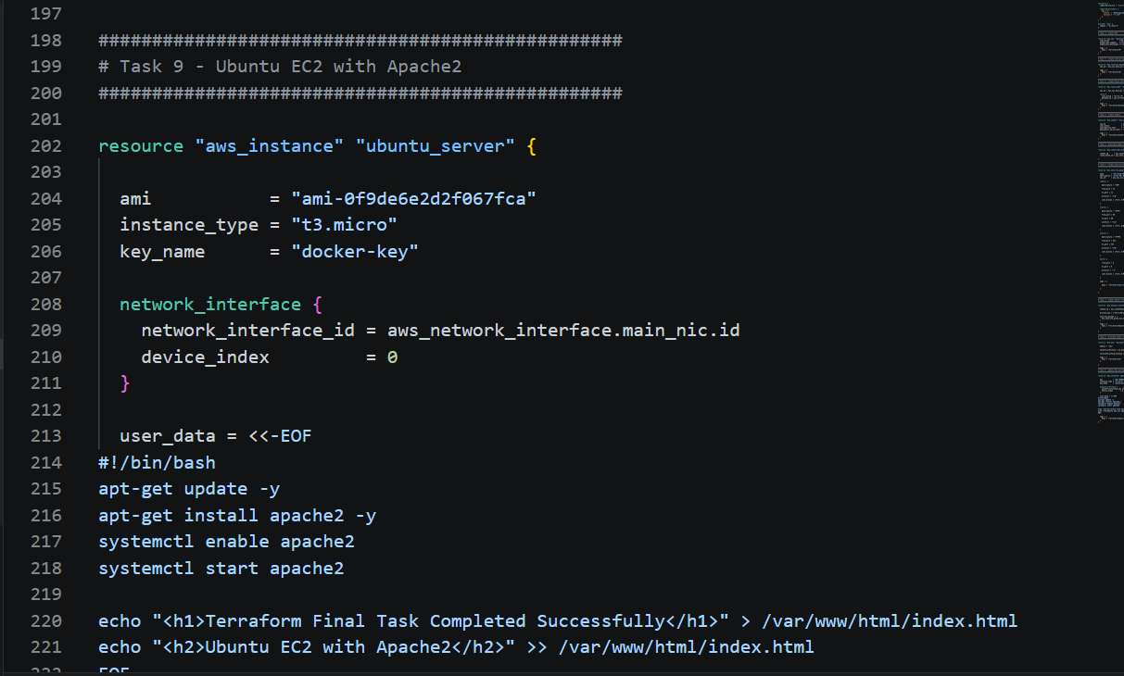

Output.tf
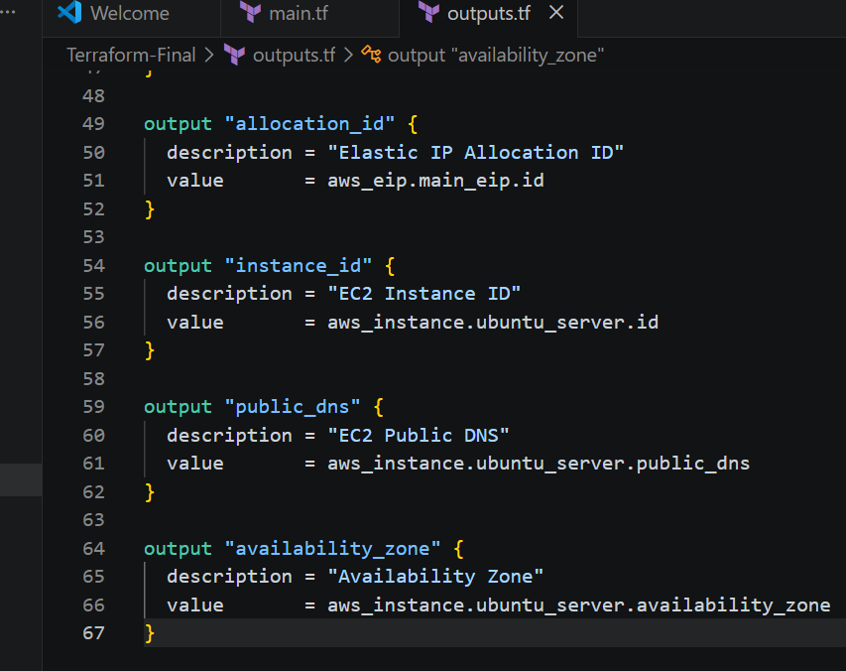

Commands used to run
- terraform init
- terraform validate
- terraform apply

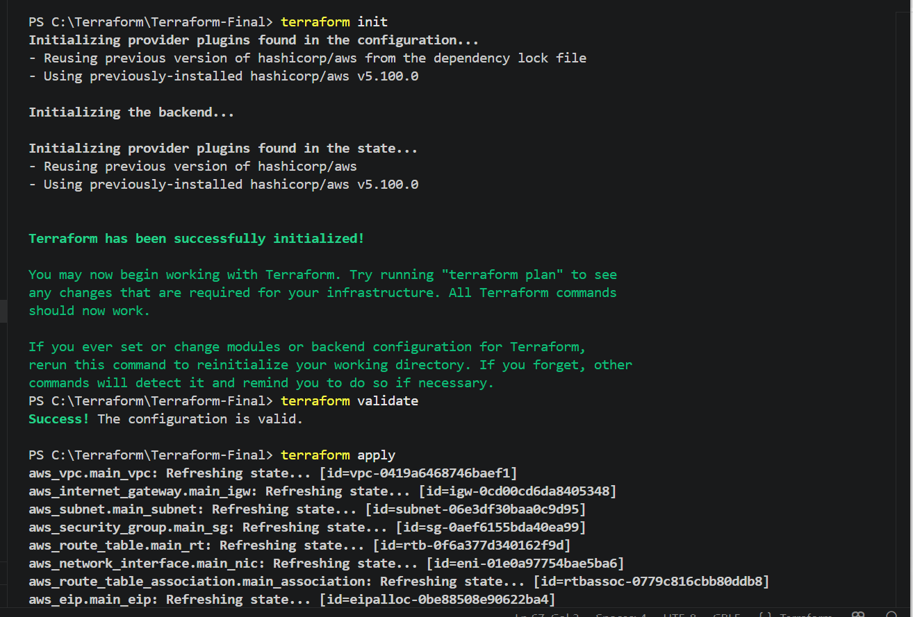
Terraform output
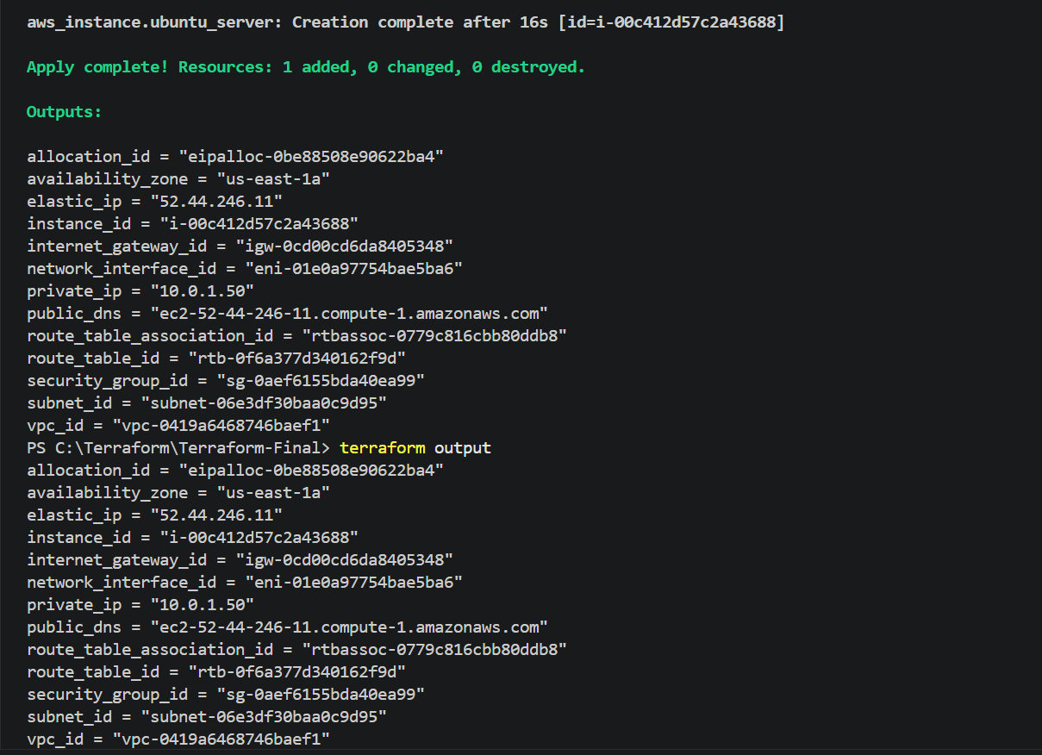

Terraform final output
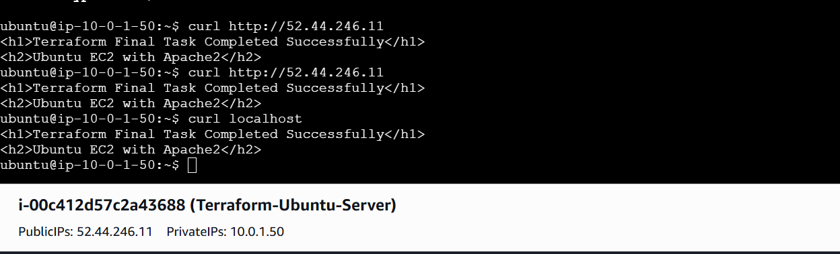

Running http://52.44.246.11

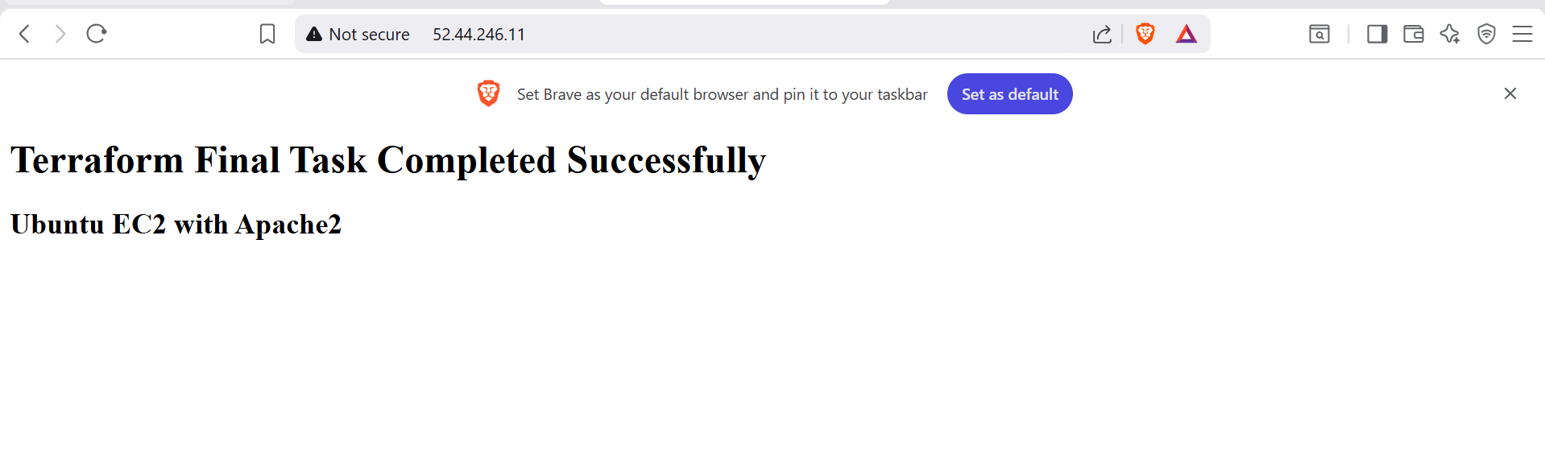

All 9 Task’s done now i destroyed everything
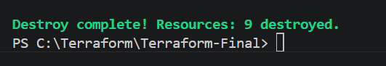

Outcome
- Successfully launched an Ubuntu EC2 instance using Terraform.
- Attached the existing Network Interface to the instance.
- Installed and enabled Apache2 automatically using User Data.
- Verified the Apache web server through the Elastic IP.
- Successfully completed the entire Terraform Final Task, including VPC, Internet Gateway, Route Table, Subnet, Route Table Association, Security Group, Network Interface, Elastic IP, and Ubuntu EC2 deployment.

