Ansible-01

Task-01: Setup One Master and Two Worker Nodes
Objective
- Set up one Ansible Master and two Worker nodes with passwordless SSH authentication to enable Ansible management.
Prerequisites
- AWS account with permission to create EC2 instances.
- One VPC with Internet Gateway configured.
- One Security Group allowing SSH (Port 22).
- One Key Pair (.pem file).
- Three EC2 instances (Amazon Linux 2023/2 or Ubuntu).
- Internet connectivity for package installation.
- Sudo privileges on all instances.
Steps (Single-Line Points for Documentation)
EC2 Setup
- Launch one EC2 instance named ansible-master.
- Launch two EC2 instances named ansible-worker1 and ansible-worker2.
- Attach the same Security Group to all three instances.
- Attach the same Key Pair to all three instances.
- Verify all instances are in the Running state.
- Note the private IP addresses of both worker nodes.

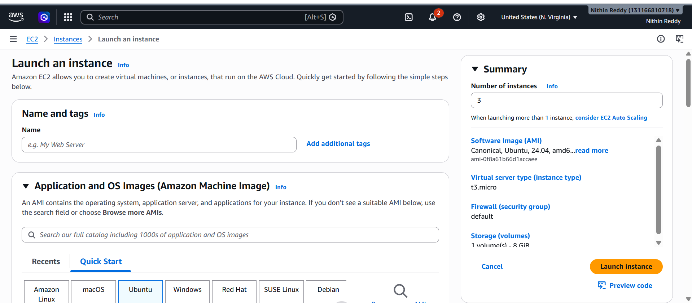
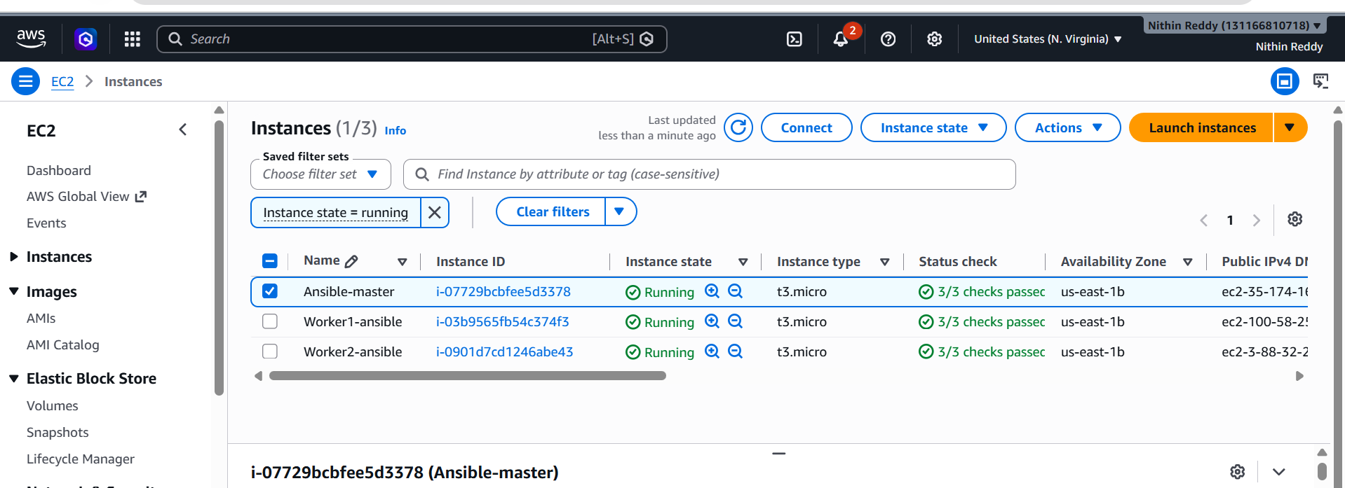

Install Ansible on Master
- Connect to the Ansible Master using SSH.
- Update the operating system packages.
- Install Ansible.
- Verify the installed Ansible version.
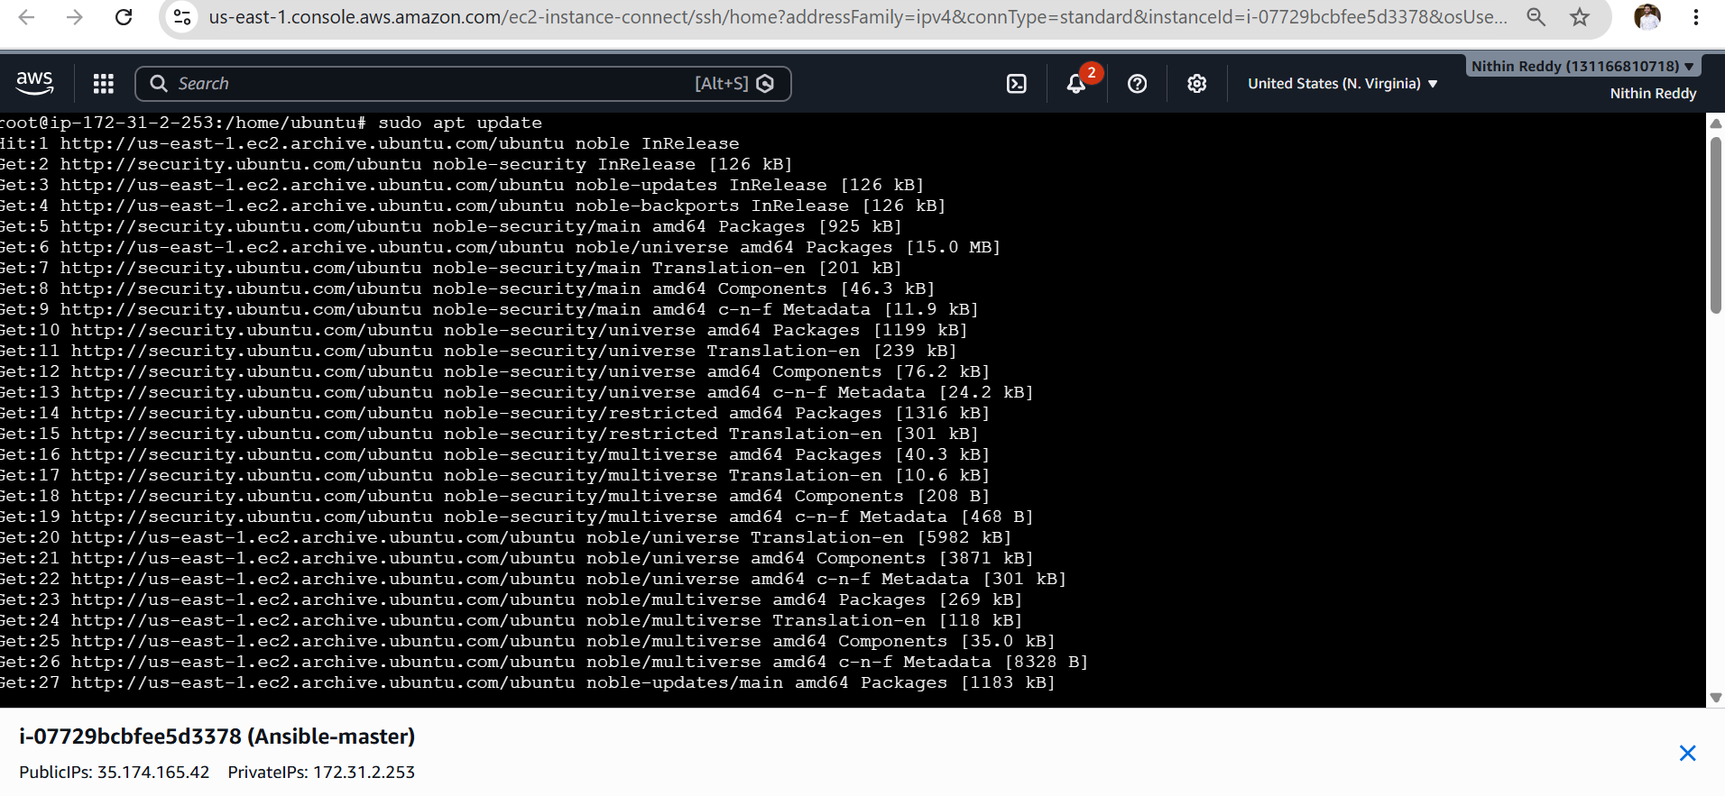
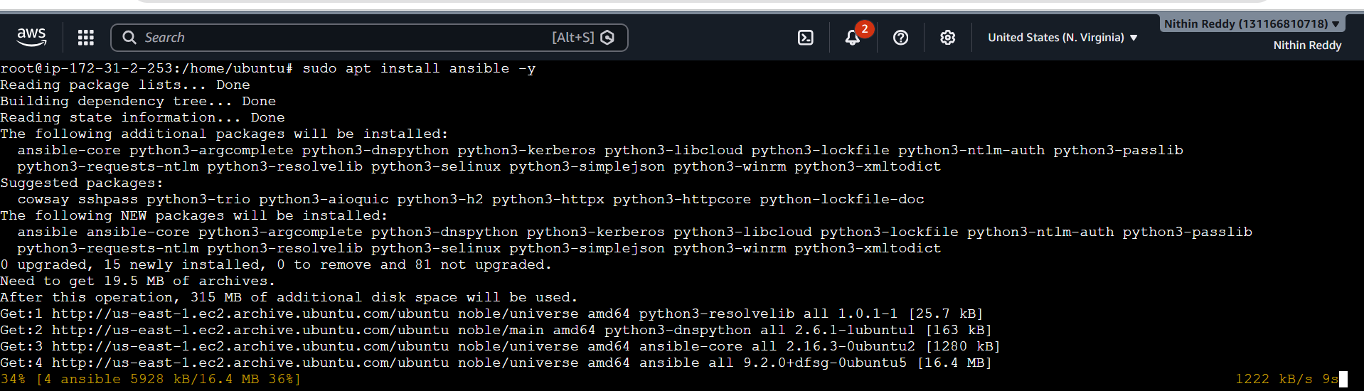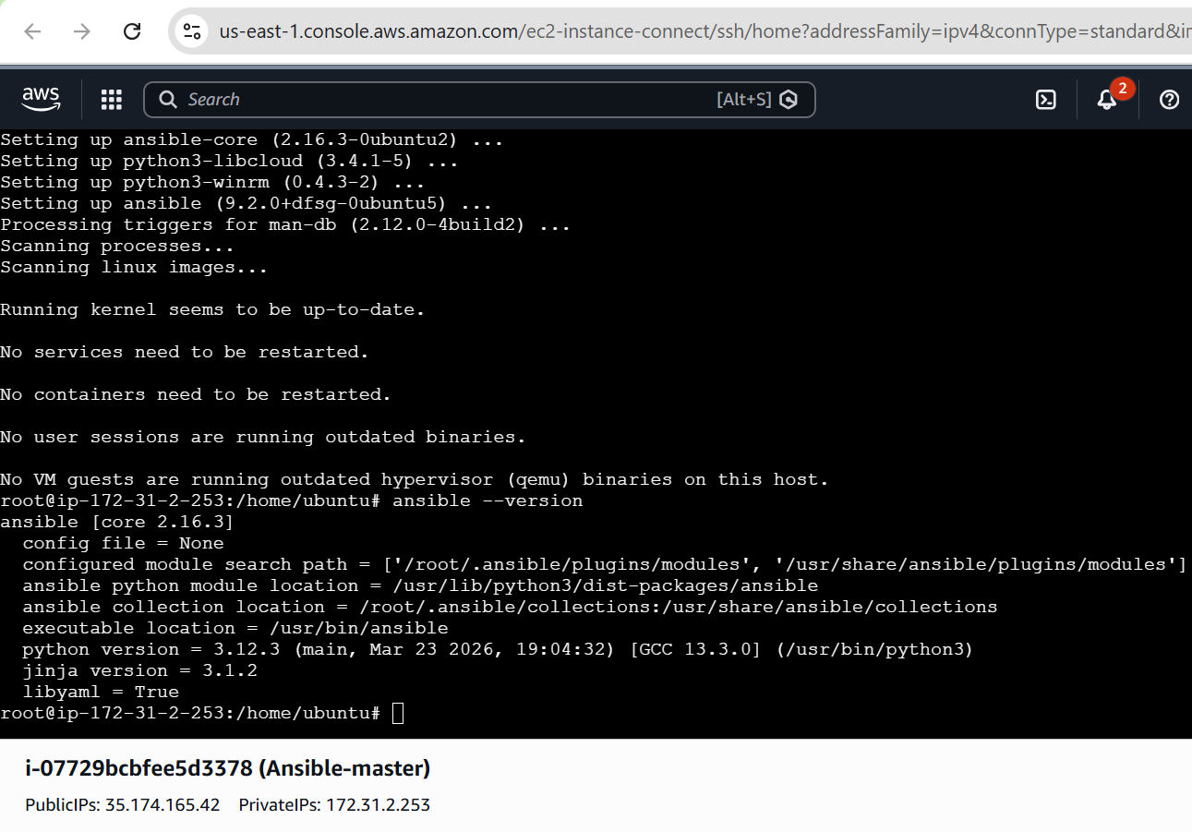

Create Login User (if required)
- Create the Ansible administration user (ansadm) on the Master.
- Create the same user (ansadm) on both Worker nodes.
- Assign sudo privileges to the user.
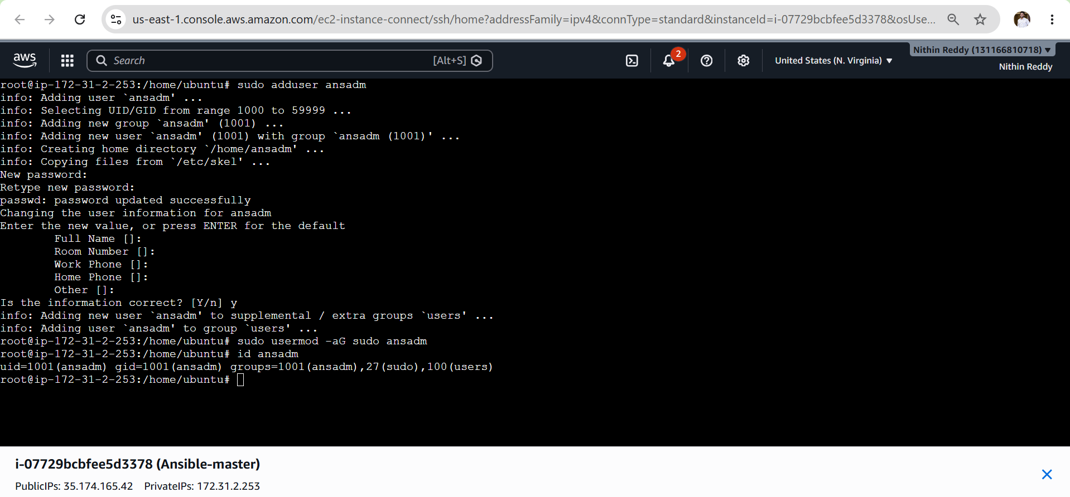
Configure Passwordless SSH
- Login as the Ansible user on the Master.
- Generate an RSA SSH key pair using ssh-keygen.
- Display the generated public key.
- Login to Worker-1.
- Create the .ssh directory for the Ansible user.
- Set the correct ownership of the .ssh directory.
- Set appropriate permissions on the .ssh directory.
- Create the authorized_keys file.
- Paste the Master's public key into authorized_keys.
- Set the correct permissions on authorized_keys.
- Repeat the same steps on Worker-2.
- Test SSH connectivity from Master to Worker-1.
- Test SSH connectivity from Master to Worker-2.
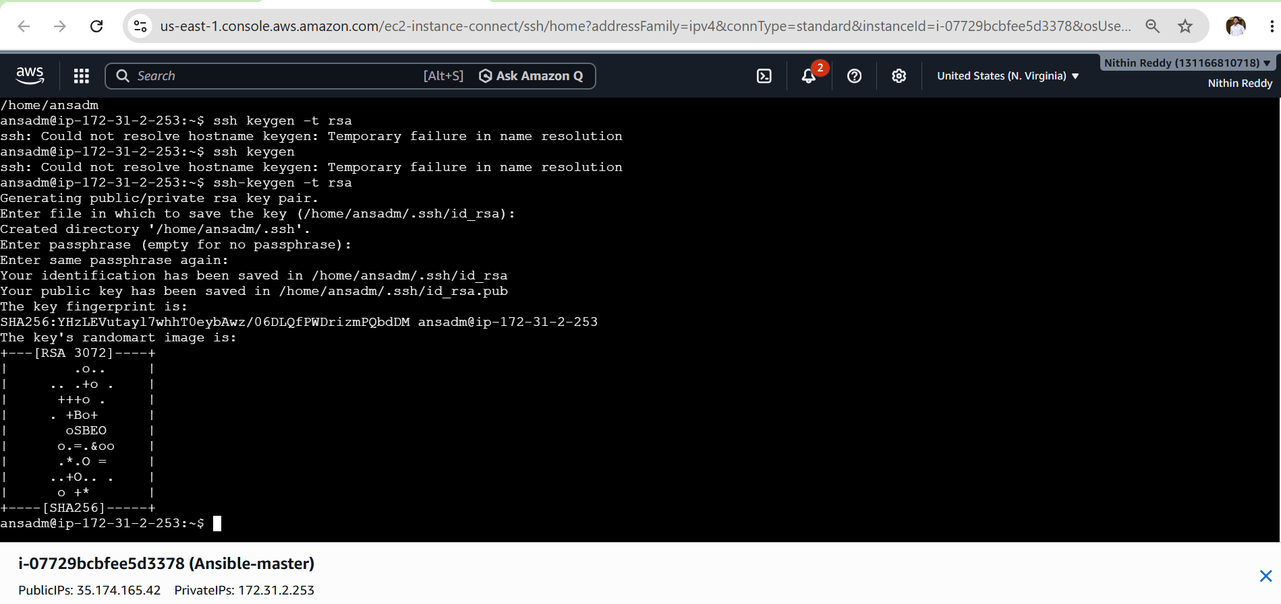
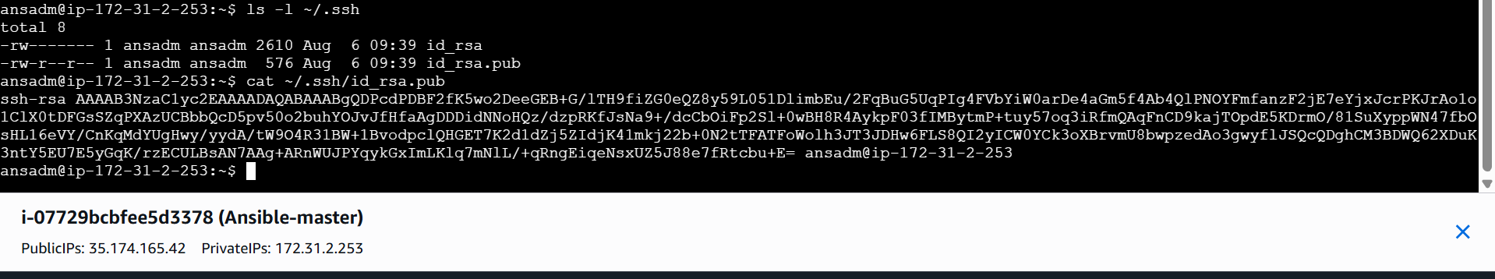Now go to worker-01 and paste key
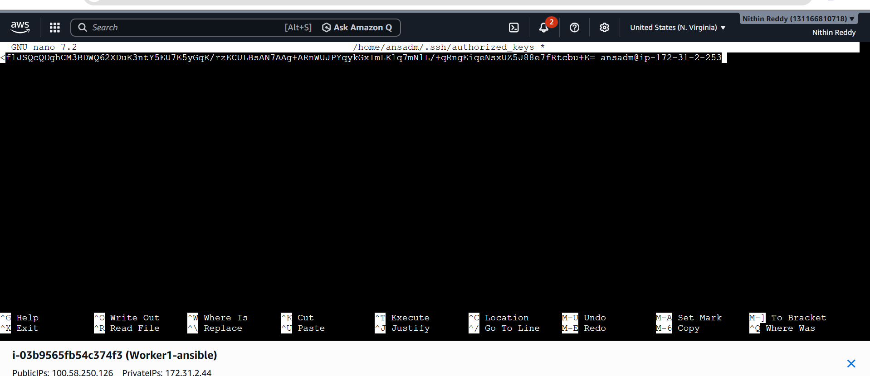
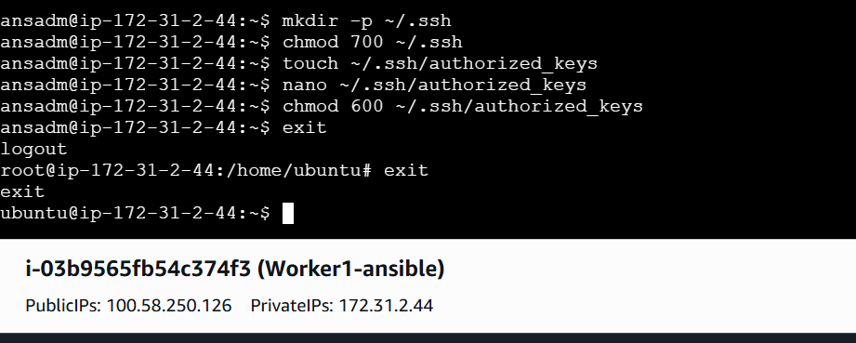
Repeat same in Worker-02
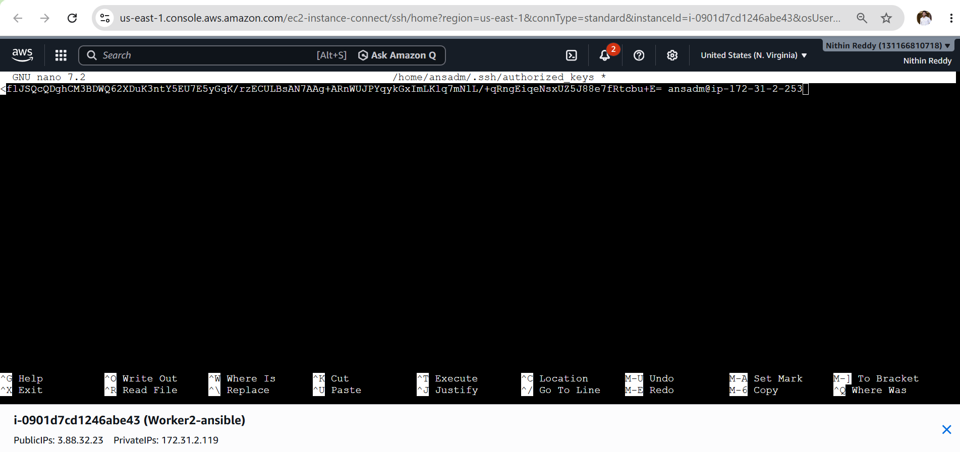
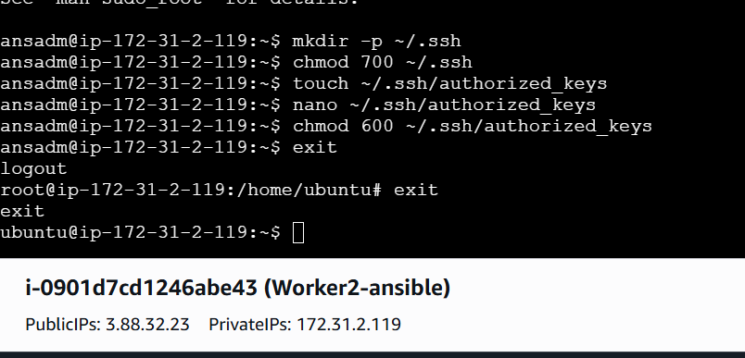

Test Passwordless SSH
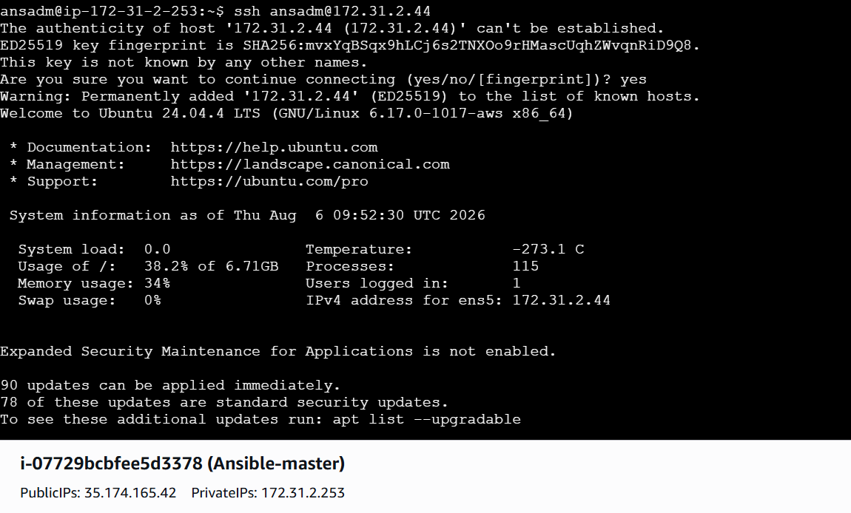
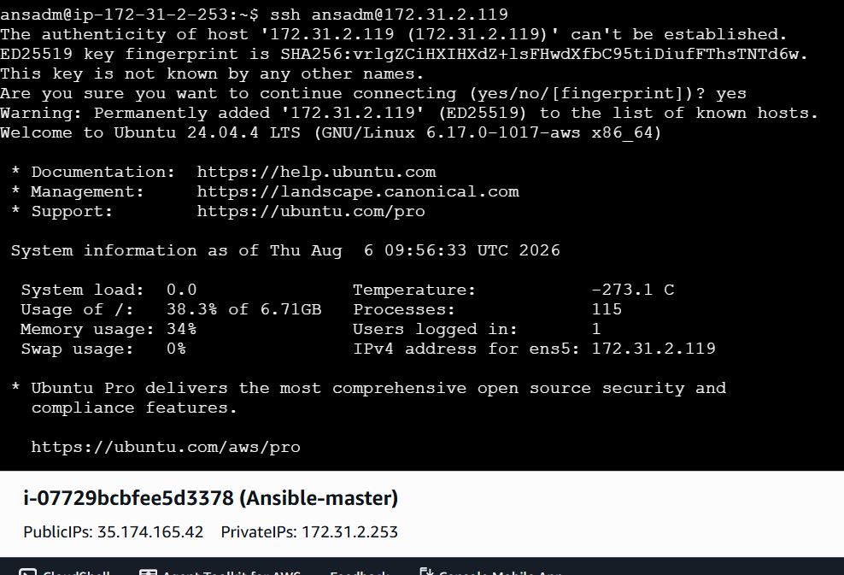

Configure Inventory
- Create an Ansible inventory file.
- Add Worker-1 private IP address.
- Add Worker-2 private IP address.
- Specify the SSH user for both hosts.
- Save the inventory configuration.
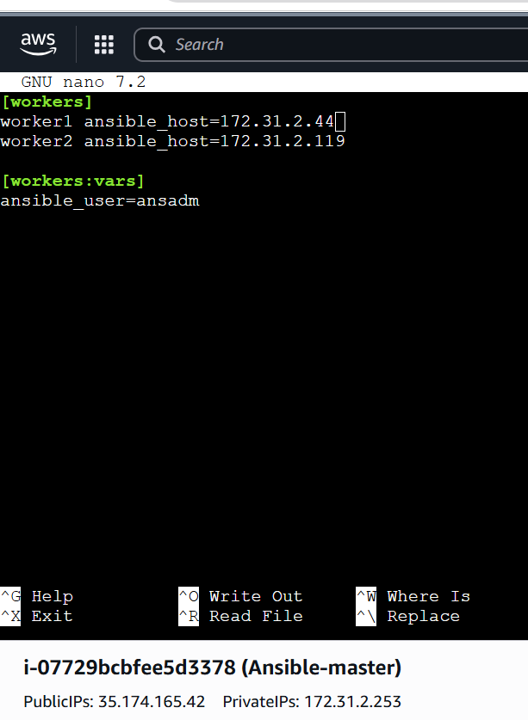
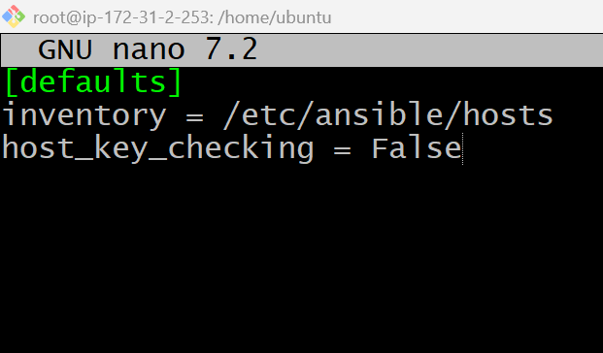
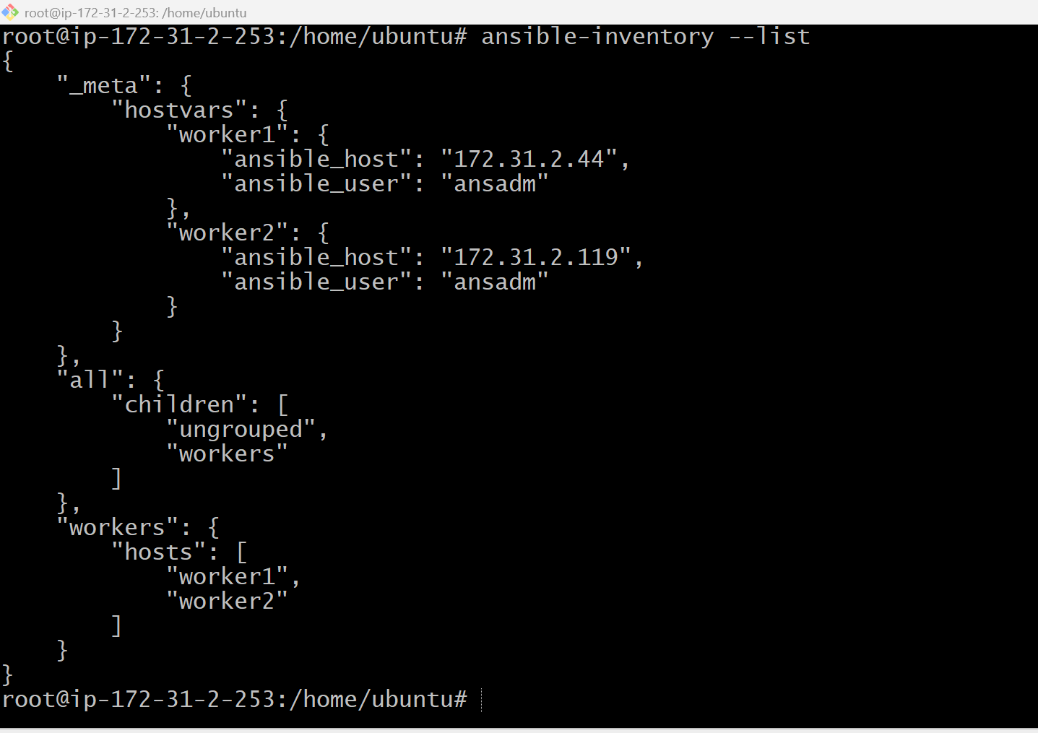
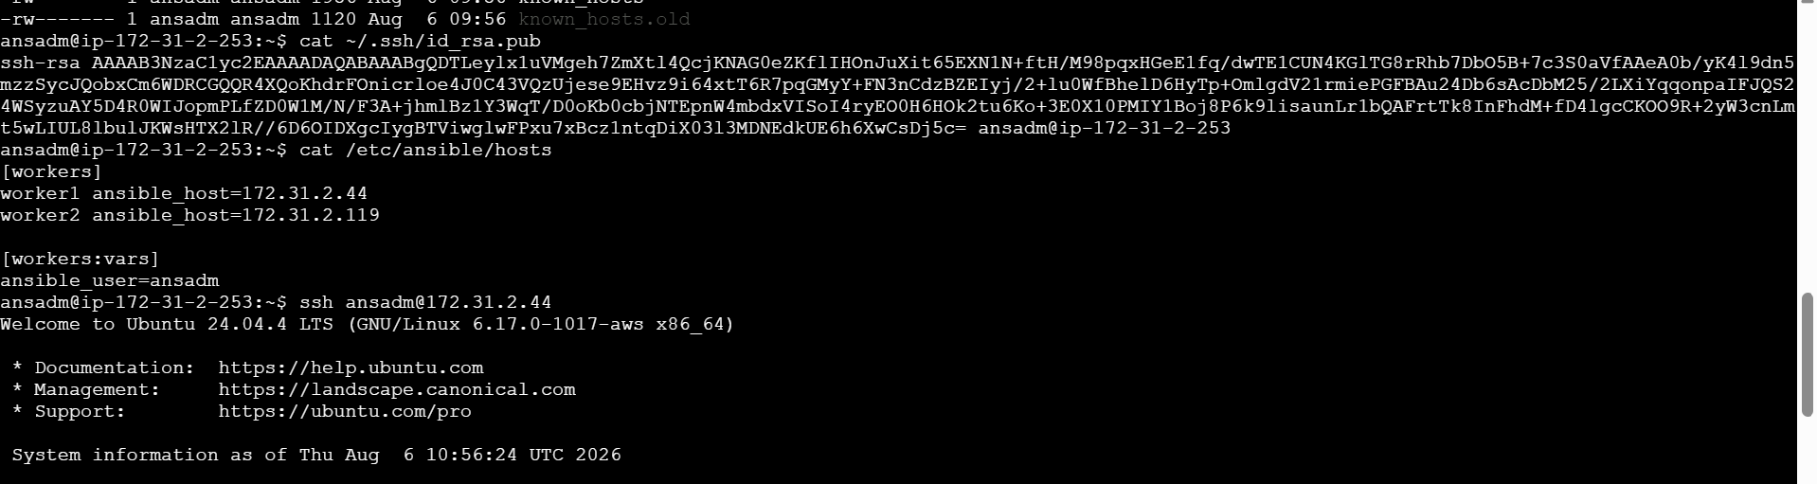


Important Points
- Use private IP addresses for communication between Master and Workers.
- Passwordless SSH is mandatory for smooth Ansible execution.
- Ensure the .ssh directory permission is 700.
- Ensure the authorized_keys permission is 600.
- Verify the inventory file contains the correct IP addresses.
- Security Group must allow SSH (Port 22).
- The Ansible package is required only on the Master node.
- Workers only require SSH access and Python (usually pre-installed).
Validation
- Verify all three EC2 instances (1 Master and 2 Workers) are in the Running state.
- Verify Ansible is installed successfully on the Master using ansible --version.
- Verify the ansadm user is created on the Master and both Worker nodes.
- Verify passwordless SSH authentication from the Master to Worker-1.
- Verify passwordless SSH authentication from the Master to Worker-2.
- Verify the Ansible inventory file (/etc/ansible/hosts) is configured with both Worker private IP addresses.
- Verify the inventory is detected using ansible-inventory --list.
- Verify successful communication between the Master and Worker nodes using ansible all -m ping.
- Verify both Worker nodes return SUCCESS with "ping": "pong".
Outcome
- One Ubuntu EC2 instance is successfully configured as the Ansible Master.
- Two Ubuntu EC2 instances are successfully configured as Ansible Worker nodes.
- Ansible is installed and operational on the Master node.
- Passwordless SSH authentication is established between the Master and both Worker nodes.
- The Ansible inventory is configured with the Worker nodes.
- The Master node can successfully communicate with both Worker nodes using Ansible Ad-Hoc commands.
- The Ansible environment is fully configured and ready to execute Task-2 (Ad-Hoc Commands).

Task-2: Execute Ansible Ad-Hoc Commands
Objective
Execute various Ansible Ad-Hoc commands to perform remote administration tasks on all managed worker nodes without creating Ansible Playbooks.
Prerequisites
- Task-1 completed successfully.
- Ansible installed on the Master node.
- Passwordless SSH configured.
- Inventory file (/etc/ansible/hosts) configured.
- Worker nodes are reachable.
- ansible all -m ping returns pong.

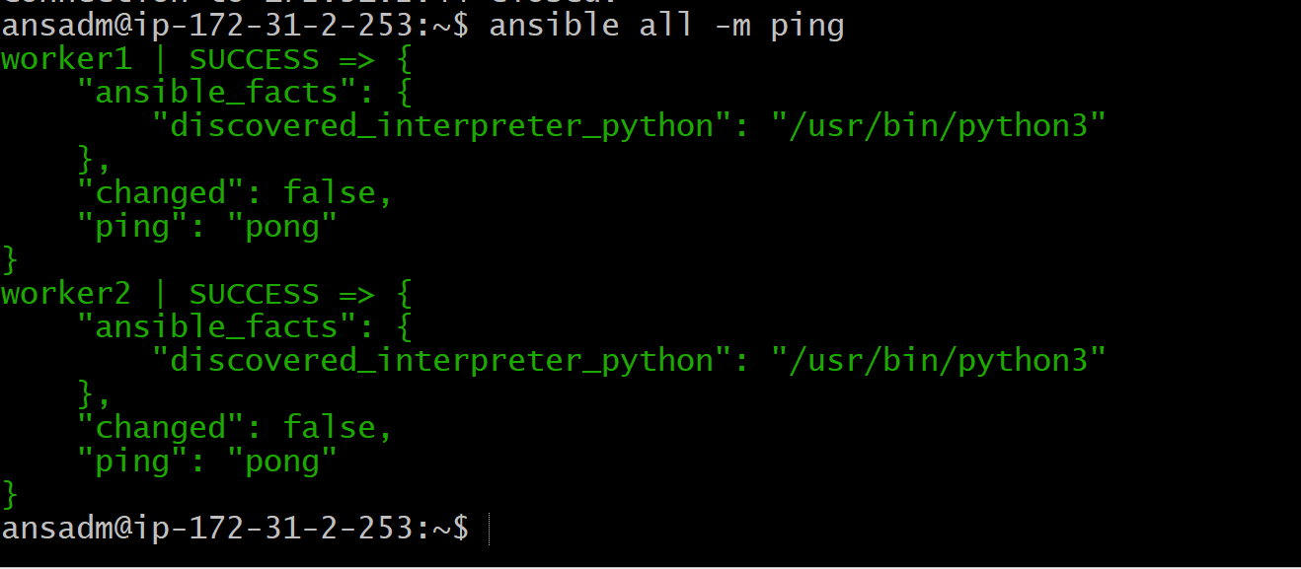

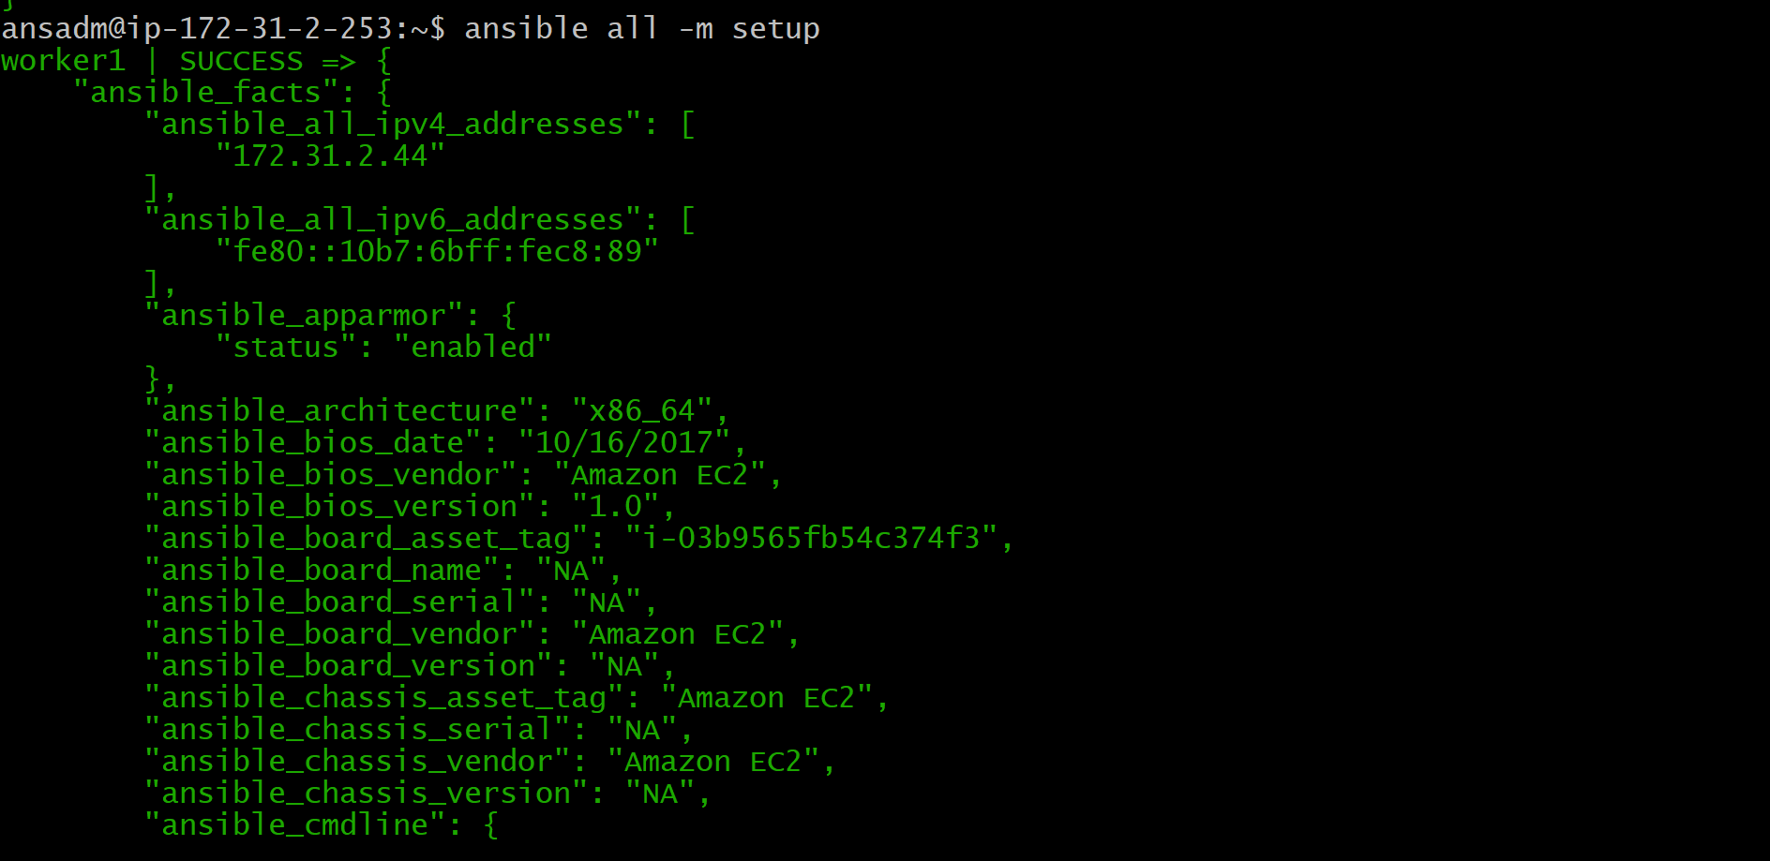
ansible all -a "uptime"
ansible all -a "free -m"
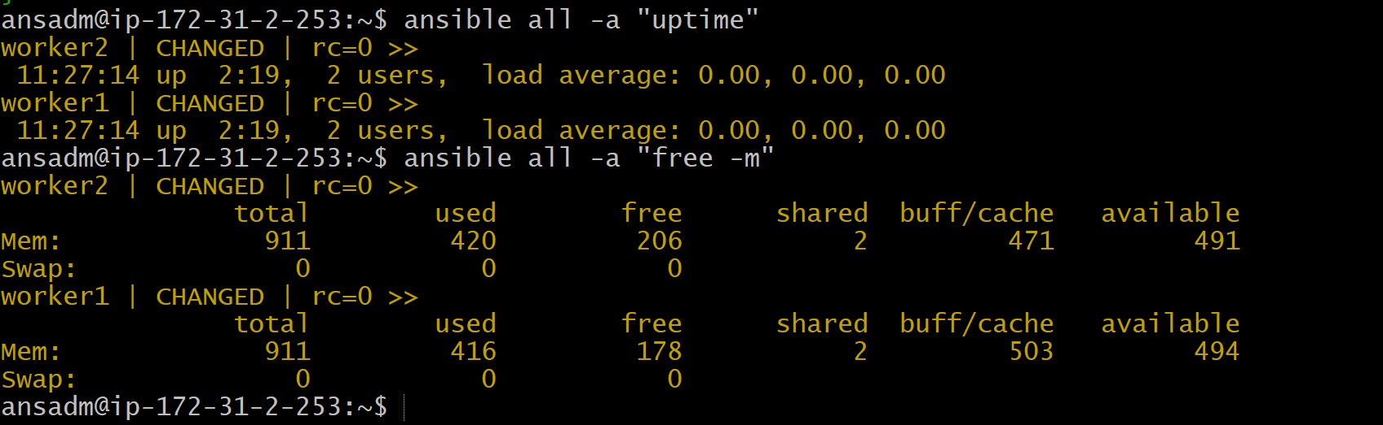

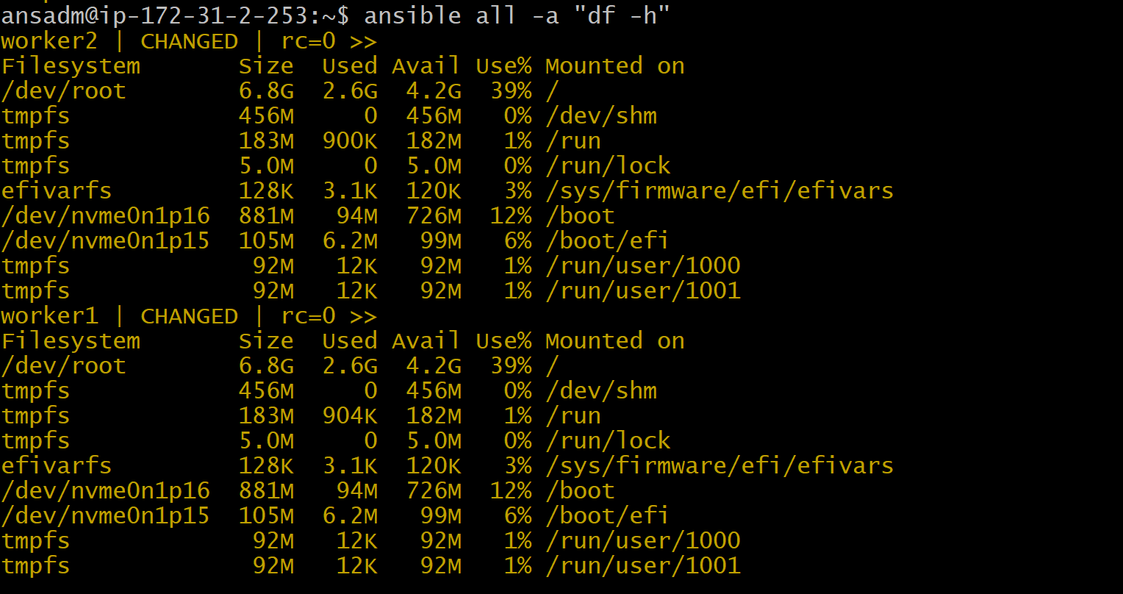
ansible all -a "hostname"

ansible all -a "date"
ansible all -a "whoami"
ansible all -a "uname -r"
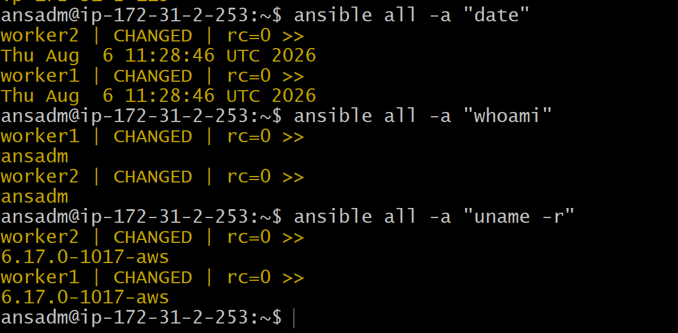

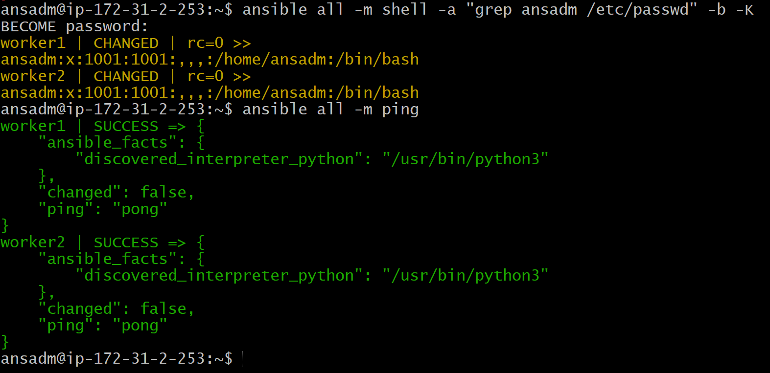
Validation
- Verify all Ad-Hoc commands execute successfully on both Worker nodes.
- Verify system facts are collected correctly.
- Verify uptime, memory, disk, and hostname information is retrieved.
- Verify the directory, group, user, and file are created successfully.
- Verify file ownership changes to the specified user and group.
- Verify Apache is installed successfully on both Worker nodes.
- Verify all commands return a SUCCESS status without errors.
Expected Outcome
- The Master node successfully executes Ansible Ad-Hoc commands on both Worker nodes.
- System administration tasks are performed remotely without logging into individual servers.
- Files, directories, users, and groups are managed centrally using Ansible.
- Apache is installed and managed remotely on all Worker nodes.

