CHALLENGE 1: Launch EC2 Instance (Amazon Linux 2023)
Steps Performed:
- Logged into AWS Console → EC2 → Launch Instance
- Selected Amazon Linux 2023 as the AMI
- Chose t2.medium instance type (2 vCPU, 4GB RAM)
- Configured Security Group with inbound rules for ports: 22, 80, 8080, 8081, 8090
- Created/selected a key pair (.pem file)
- Launched the instance and connected via SSH:
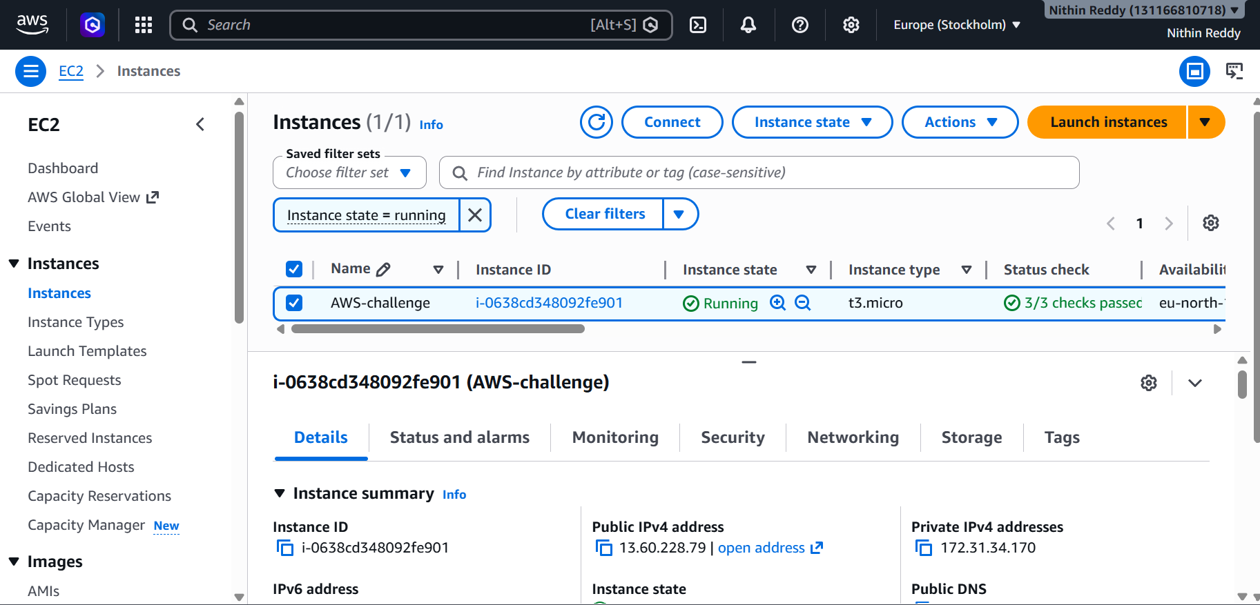
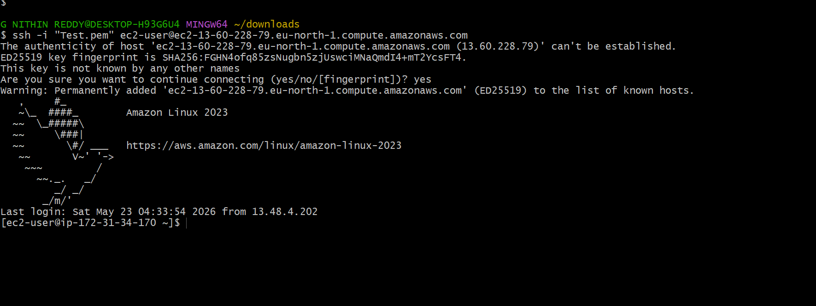
Outcome:
- EC2 instance launched successfully in Running state
- SSH connection established to the instance
- Instance IP: 13.60.228.79 (private), accessible via public IP
CHALLENGE 2: Install Docker
Steps Performed:
bash
sudo yum update -y
sudo yum install docker -y
sudo systemctl start docker
sudo systemctl enable docker
sudo usermod -aG docker ec2-user
docker --version

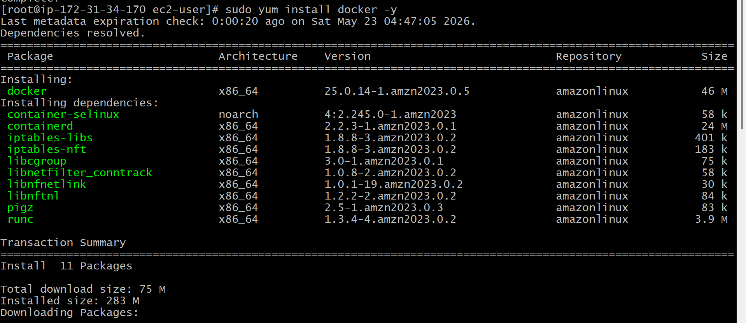
Outcome:
- Docker installed successfully
- Docker service started and enabled to auto-start on reboot
- Verified with docker --version showing installed version
- docker ps returns empty container list (ready to use)
Why Docker: Docker is a containerization platform that allows applications to run in isolated environments called containers, ensuring consistency across environments.
Output:
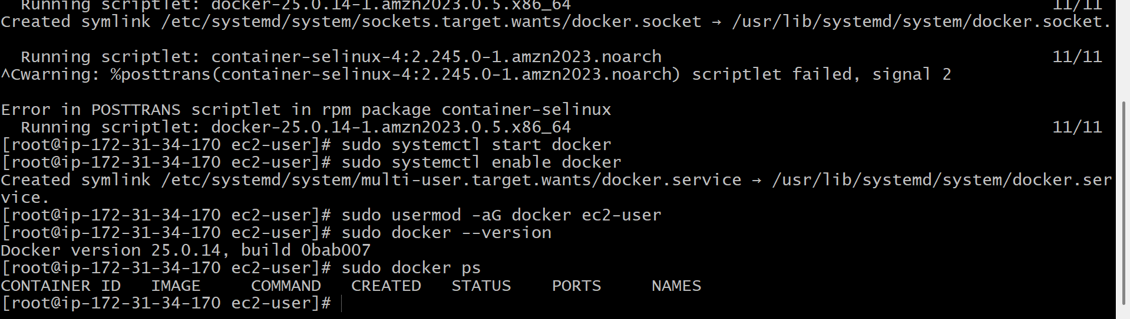
CHALLENGE 3: Install Jenkins (Port 8080)
Steps Performed:
bash
# Added Jenkins repository
sudo wget -O /etc/yum.repos.d/jenkins.repo https://pkg.jenkins.io/rpm-stable/jenkins.repo
sudo rpm --import https://pkg.jenkins.io/rpm-stable/jenkins.io-2023.key

# Installed Java 21 (Jenkins dependency)
sudo yum install java-21-amazon-corretto -y

# Installed Jenkins
sudo yum install jenkins -y

# Started Jenkins using Java WAR directly (due to Java version compatibility)
sudo java -jar /opt/jenkins/jenkins.war --httpPort=8080 &
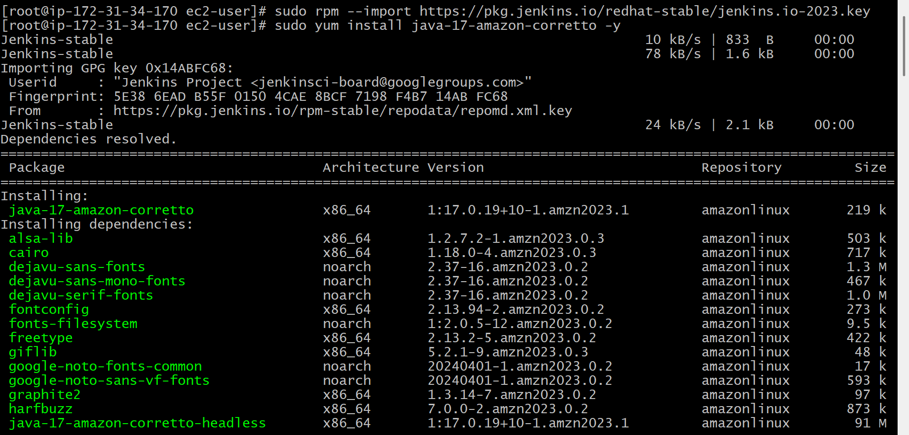
Troubleshooting Done:
- Java 22 was not supported by Jenkins (supports only 17 and 21)
- Switched back to Java 21 using sudo alternatives --set java
- Downloaded fresh jenkins.war from get.jenkins.io
- Ran Jenkins directly via java -jar command
Outcome:
- Jenkins started successfully on port 8080
- Accessed via browser: http:// 13.60.228.79>:8080
- Initial admin password retrieved
Jenkins UI loaded with "Getting Started" setup wizard
- Status confirmed: Jenkins is fully up and running
- Why Jenkins: Jenkins is an open-source CI/CD automation server used to build, test, and deploy software automatically.

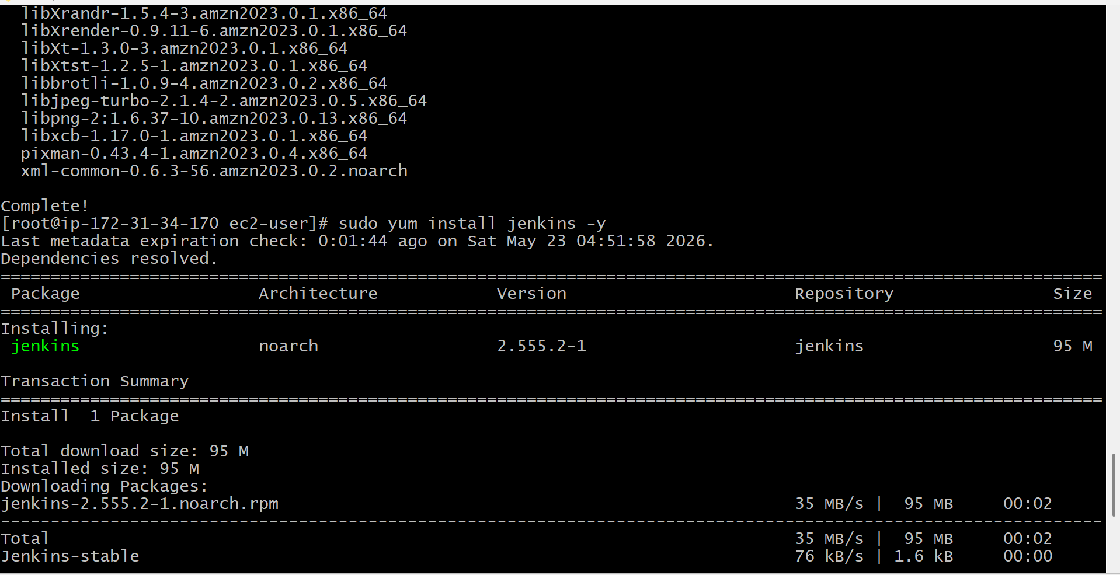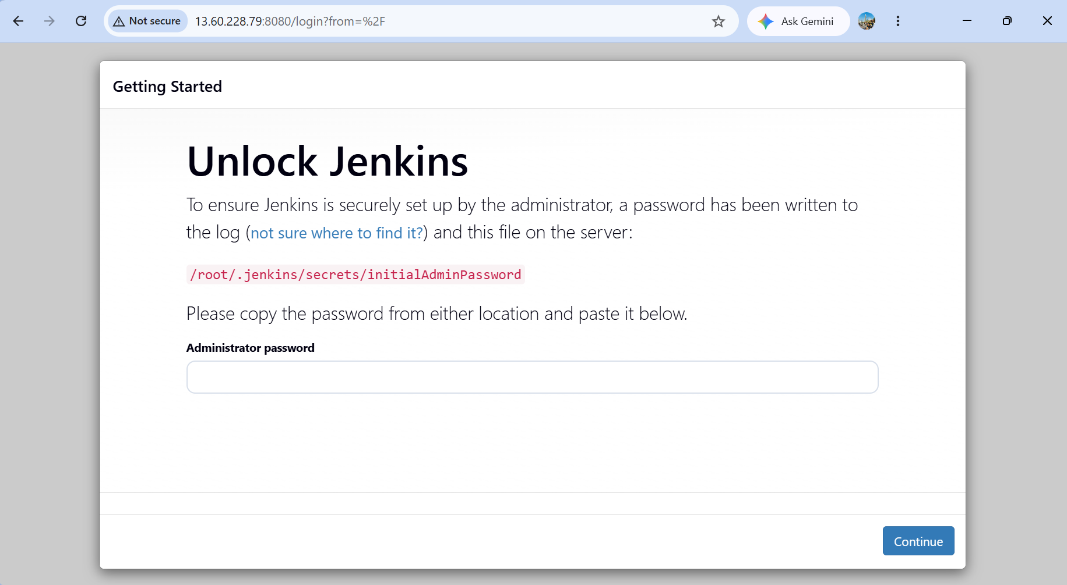

CHALLENGE 4: Install Apache HTTPD (Port 80)
Steps Performed:
bash
sudo yum install httpd -y
sudo systemctl start httpd
sudo systemctl enable httpd
sudo systemctl status httpd
curl http://localhost:80
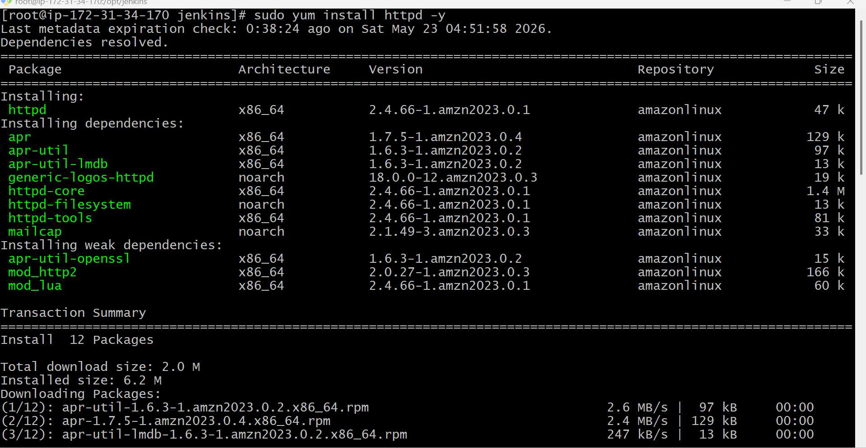
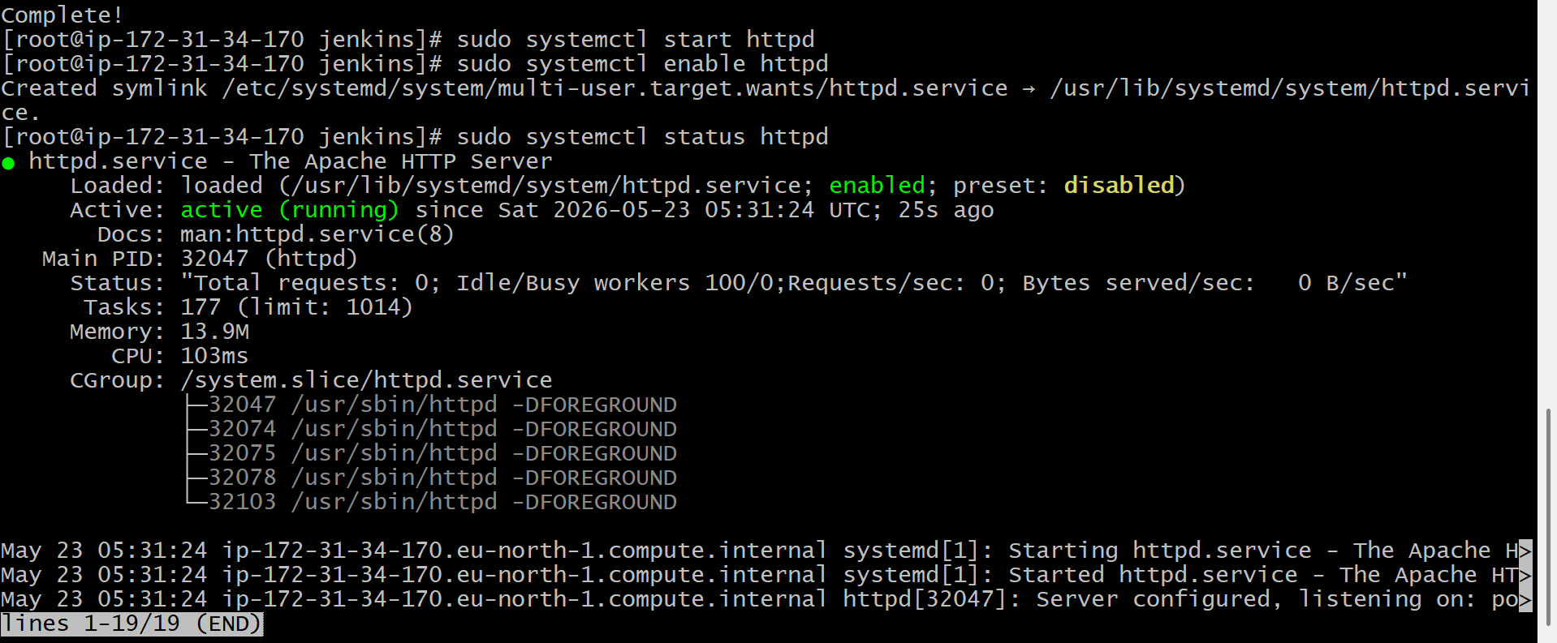
Outcome:
- Apache HTTPD installed and started successfully on port 80
- Service enabled to auto-start on reboot
- systemctl status httpd shows: active (running)
- curl http://localhost returns Apache test page HTML
- Accessible via browser: http://<EC2-IP 13.60.228.79>:80
Why Apache HTTPD: Apache HTTP Server is one of the most widely used web servers in the world, used to serve static and dynamic web content over HTTP/HTTPS.
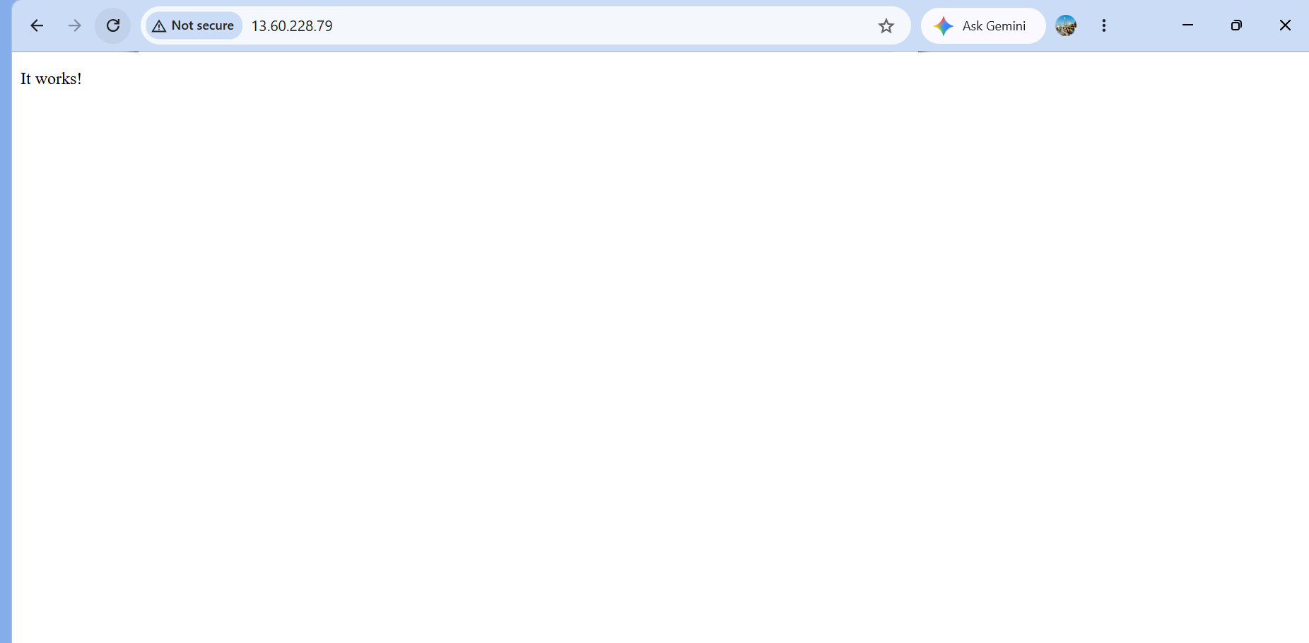
CHALLENGE 5: Install Nginx (Port 8081)
Steps Performed:
bash
# Installed Nginx (using yum on Amazon Linux 2023)
sudo yum install nginx -y

# Changed default port from 80 to 8081 to avoid conflict with Apache
sudo sed -i 's/listen 80;/listen 8081;/g' /etc/nginx/nginx.conf
sudo sed -i 's/listen \[::\]:80;/listen [::]:8081;/g' /etc/nginx/nginx.conf

sudo systemctl start nginx
sudo systemctl enable nginx
sudo systemctl status nginx
curl http://localhost:8081
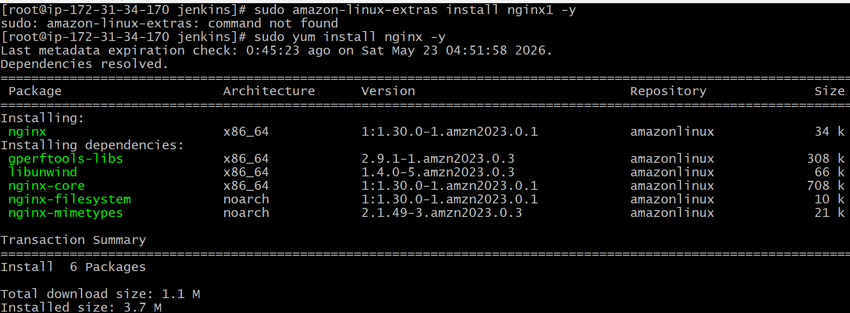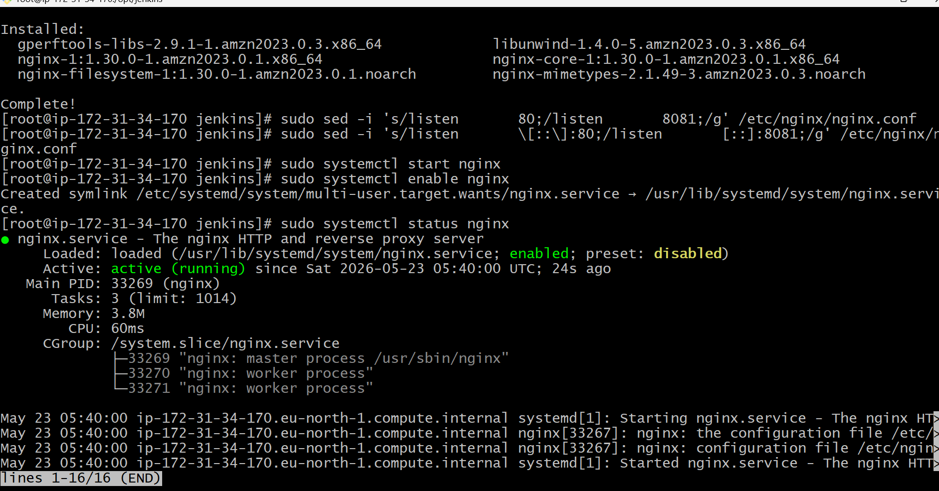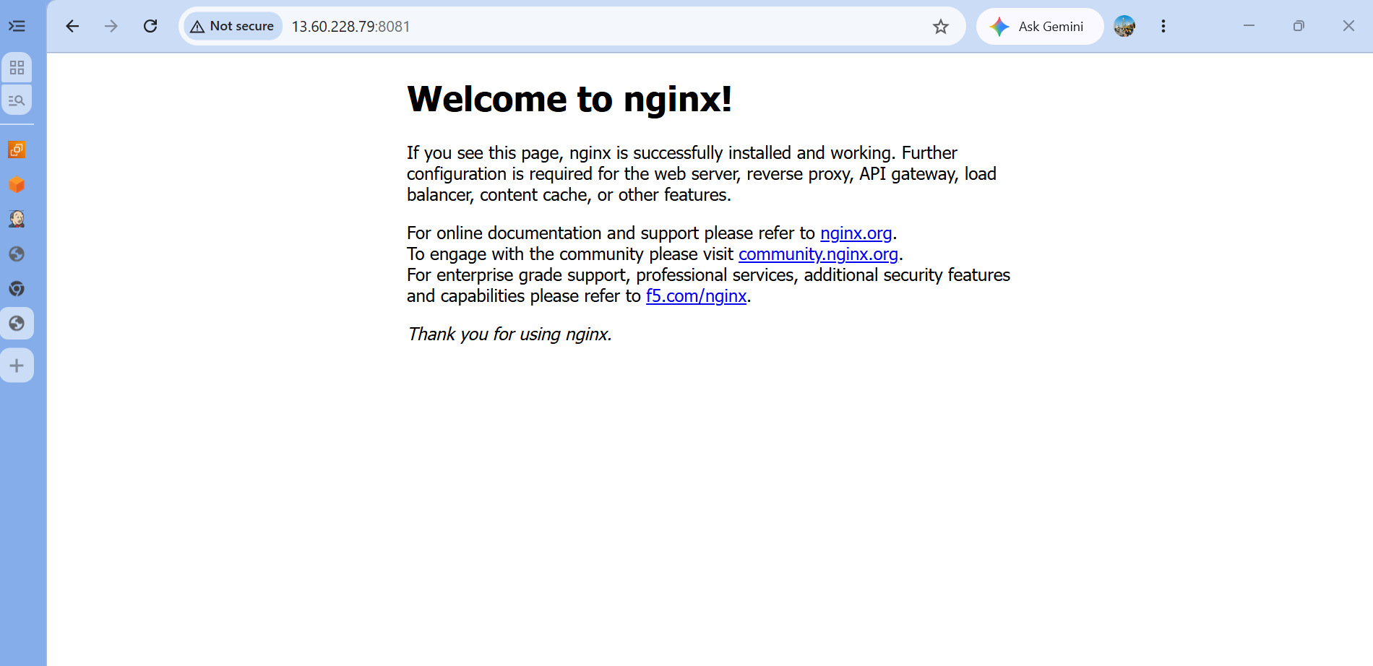
Troubleshooting Done:
- amazon-linux-extras command not available on Amazon Linux 2023
- Used sudo yum install nginx directly instead
- Changed port to 8081 to avoid conflict with Apache running on port 80
Outcome:
- Nginx installed and running successfully on port 8081
- Service enabled for auto-start on reboot
- systemctl status nginx shows: active (running)
- curl http://localhost:8081 returns Nginx welcome page HTML
- Accessible via browser: http://<EC2-IP>:8081
Why Nginx: Nginx is a high-performance web server and reverse proxy known for handling high concurrency with low memory usage. Commonly used alongside Apache.

CHALLENGE 6: Install Apache Tomcat (Port 8090)
Steps Performed:
bash
# Downloaded Tomcat
cd /opt
sudo wget https://archive.apache.org/dist/tomcat/tomcat-10/v10.1.33/bin/apache-tomcat-10.1.33.tar.gz

# Extracted and set up
sudo tar -xvf apache-tomcat-10.1.33.tar.gz
sudo mv apache-tomcat-10.1.33 tomcat

# Changed port from 8080 to 8090 (avoid conflict with Jenkins)
sudo sed -i 's/port="8080"/port="8090"/' /opt/tomcat/conf/server.xml

# Started Tomcat
sudo /opt/tomcat/bin/startup.sh
sleep 5
curl http://localhost:8090
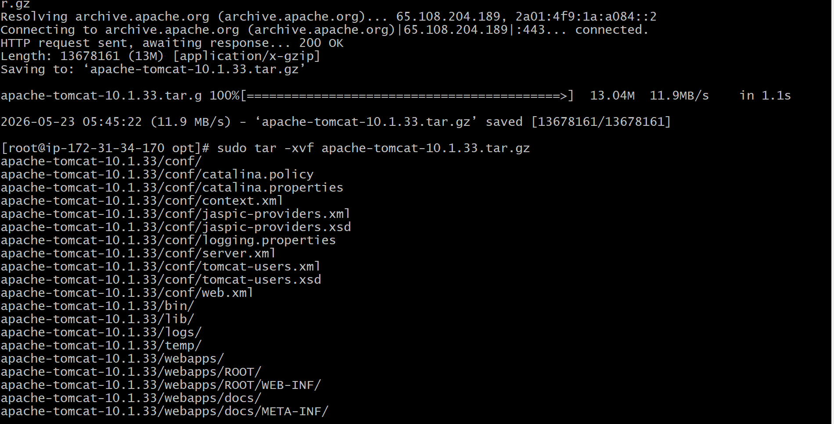
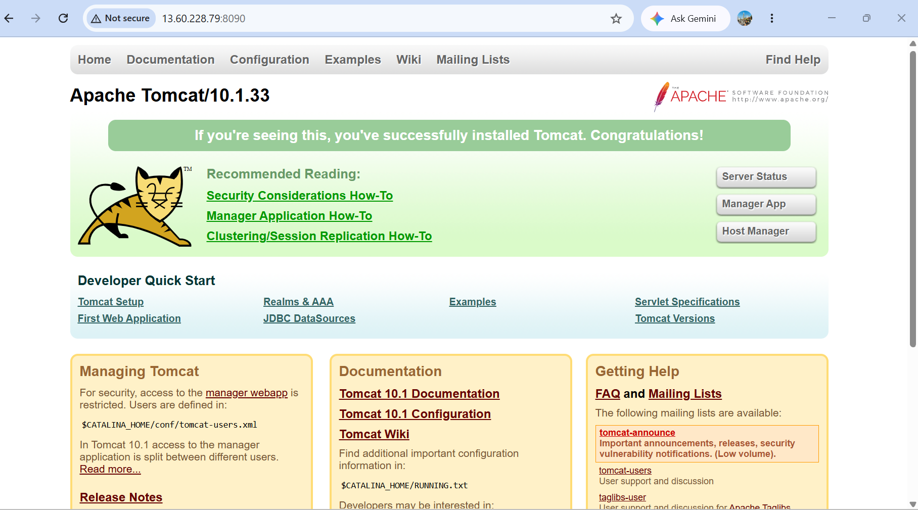
Troubleshooting Done:
- Version 10.1.40 returned 404 — not yet available on Apache mirrors
- Used 10.1.33 from archive.apache.org which worked
- Changed port to 8090 to avoid conflict with Jenkins on 8080
Outcome:
- Tomcat downloaded, extracted and started successfully on port 8090
- startup.sh shows: Tomcat started
- curl http://localhost:8090 returns Tomcat homepage HTML
- Accessible via browser: http://<EC2-IP>:8090
Why Apache Tomcat: Apache Tomcat is a Java-based web application server used to deploy and run Java Servlets and JSP applications. Widely used in enterprise Java development.

📊 Final Summary Table
Challenge | Service | Port | Method | Status
1 | EC2 Instance | - | AWS Console | ✅ Running
2 | Docker | - | yum install | ✅ Running
3 | Jenkins | 8080 | java -jar WAR | ✅ Running
4 | Apache HTTPD | 80 | yum install | ✅ Running
5 | Nginx | 8081 | yum install | ✅ Running
6 | Apache Tomcat | 8090 | tar.gz manual | ✅ Running

🔑 Key Learnings
- Port conflict management — Multiple services on one EC2 requires careful port planning
- Java version compatibility — Jenkins 2.x supports only Java 17 and 21, not 22
- Amazon Linux 2023 vs AL2 — amazon-linux-extras doesn't exist on AL2023; use yum directly
- Mirror availability — Apache download mirrors may not have the latest version; use archive.apache.org as fallback
- systemd vs direct run — When systemd service fails, running via java -jar directly is a valid workaround

