Terraform-04
Task 1 Execute the script shown in the video.
STEP 1 — Create Project Folder
Visual Studio / Git Bash:
mkdir terraform-local-demo
Go inside folder:
cd terraform-local-demo

terraform {
required_providers {
local = {
source = "hashicorp/local"
version = "2.3.0"
}
}
}
resource "local_file" "my-pet" {
filename = "pets.txt"
content = "I love cats!"
}

Explanation of Code
terraform block
Defines:
- Required providers
- Provider version
terraform {
required_providers {
local provider
Uses HashiCorp local provider.
source = "hashicorp/local"
resource block
Creates infrastructure resource.
resource "local_file" "my-pet"
Where:
- local_file → resource type
- my-pet → resource name
filename
Creates:
pets.txt
content
Writes inside file:
I love cats!
### Commands
Bash
terraform init
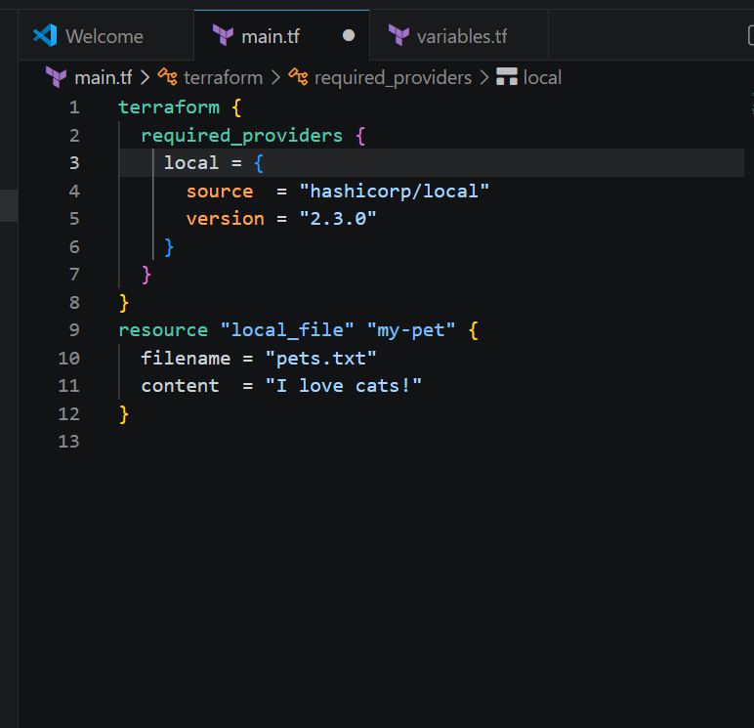
Now terraform init
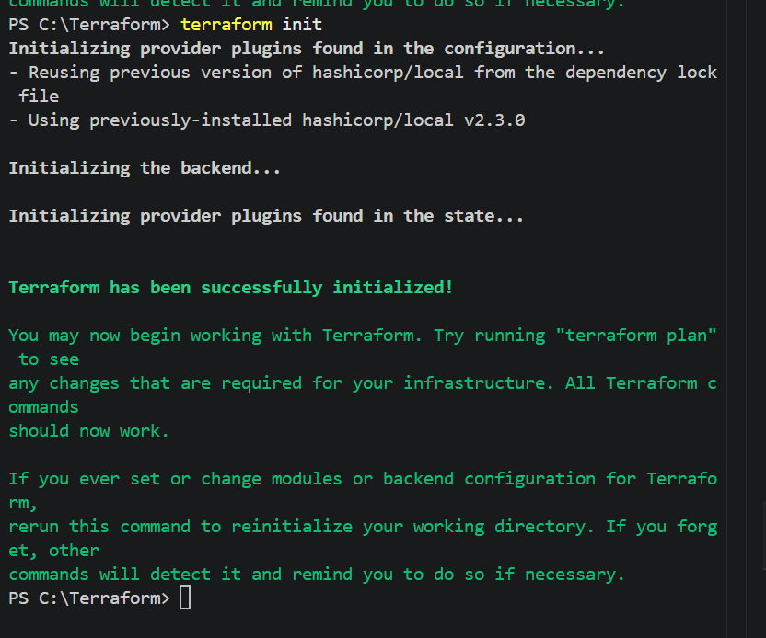
Terraform plan
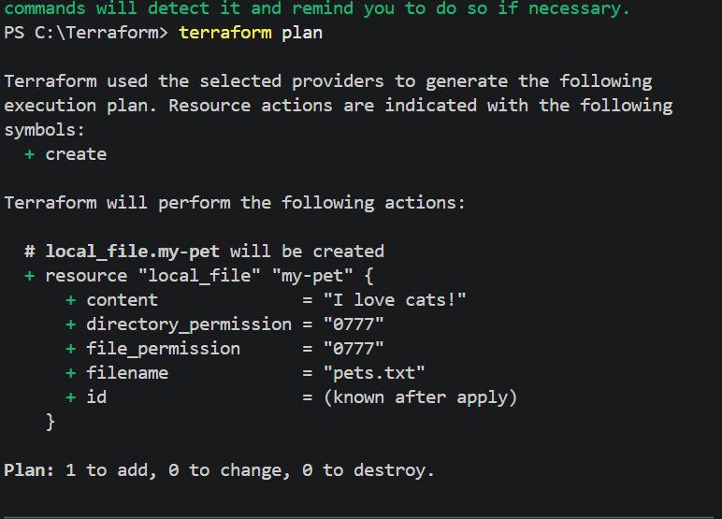
Terraform apply
Enter value : Yes
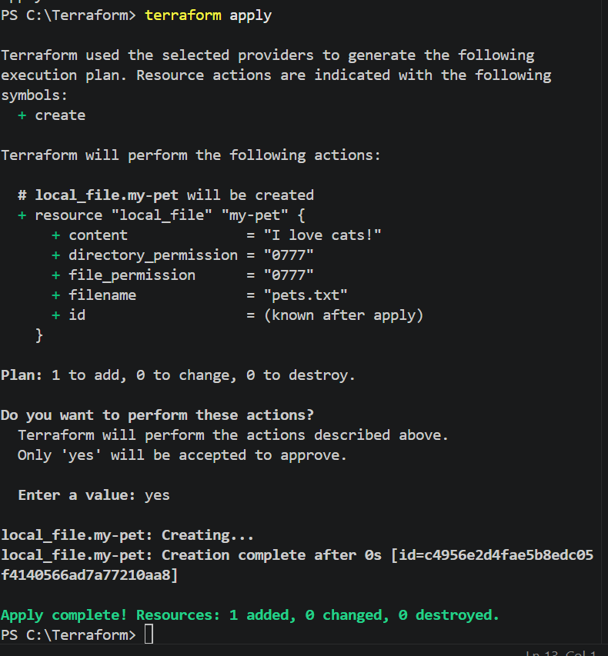
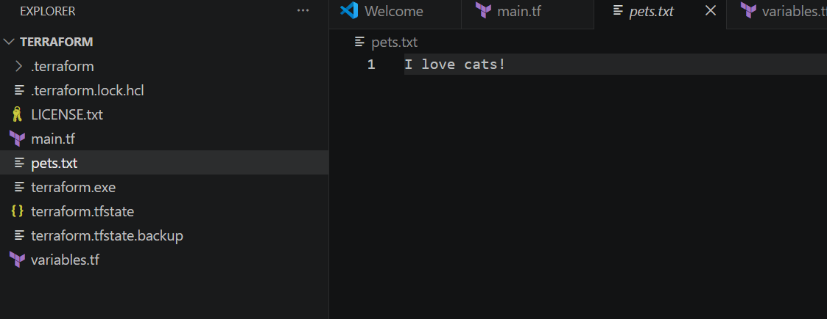

Terraform Variables Example
Now we will use:
- variables.tf
- List variables
- Multiple file creation using Terraform
Objective
Terraform will create:
pets.txt
cats.txt
dogs.txt
automatically.
Project Structure
terraform-variable-demo/
│
├── main.tf
├── variables.tf
└── terraform.tfvars (optional)
STEP 1 — Create Project Folder
mkdir terraform-variable-demo
Go inside:
cd terraform-variable-demo
STEP 2 — Create variables.tf
Create file:
vi variables.tf
Paste:
hcl
variable "filename" {
default = [
"pets.txt",
"cats.txt",
"dogs.txt"
]
}
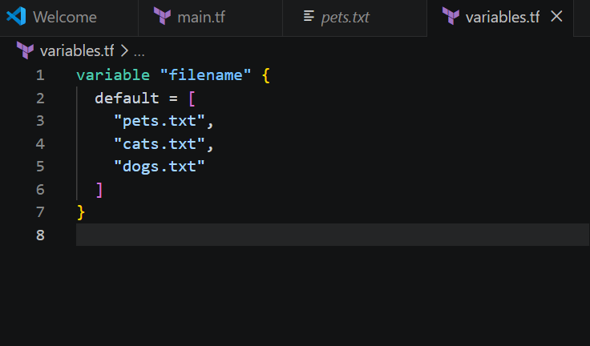
Terraform init
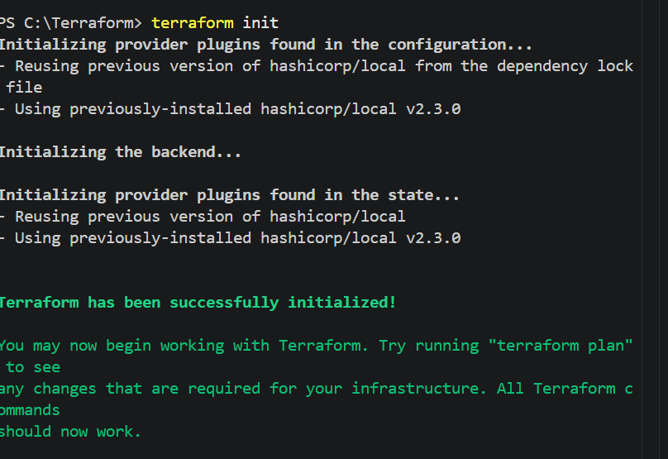
Terraform plan
NO change
Now Terraform apply
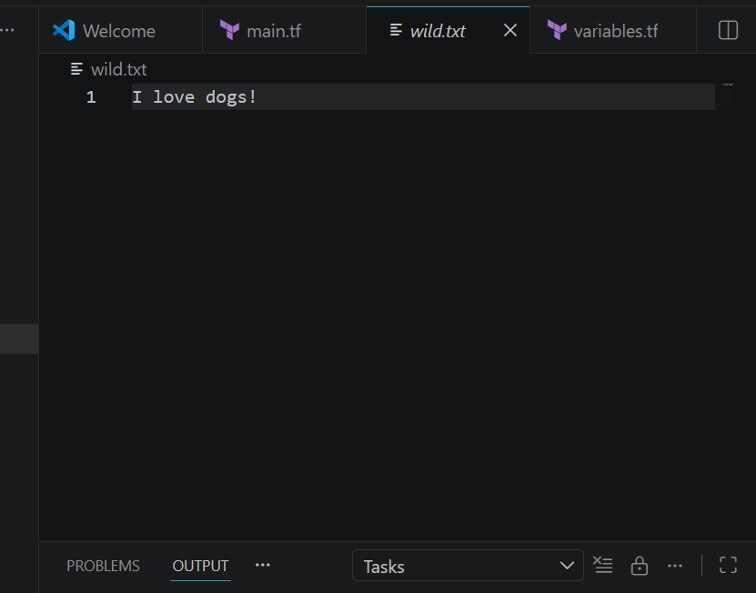
Terraform AWS IAM User Example
## Prerequisites
Install and configure AWS CLI:
Bash
aws configure
Provide:
* AWS Access Key
* AWS Secret Key
* Region
Output format
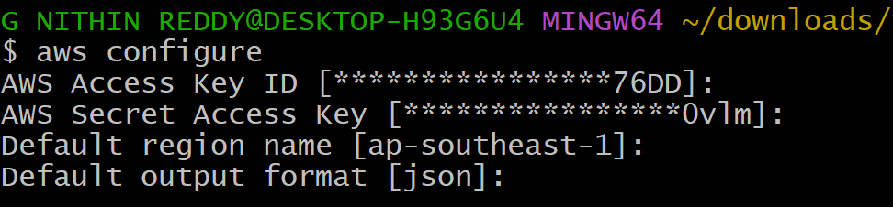
Now create IAM user
resource "aws_iam_user" "Admin-user" {
name = "Nithin Reddy"
tags = {
"Description" = "IT"
}
}
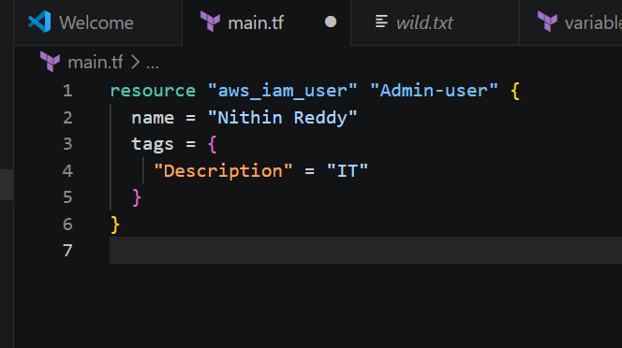
Terraform init now
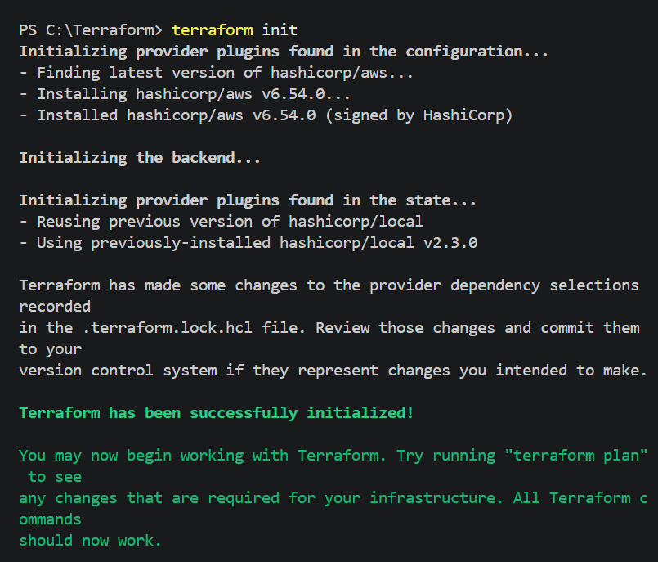
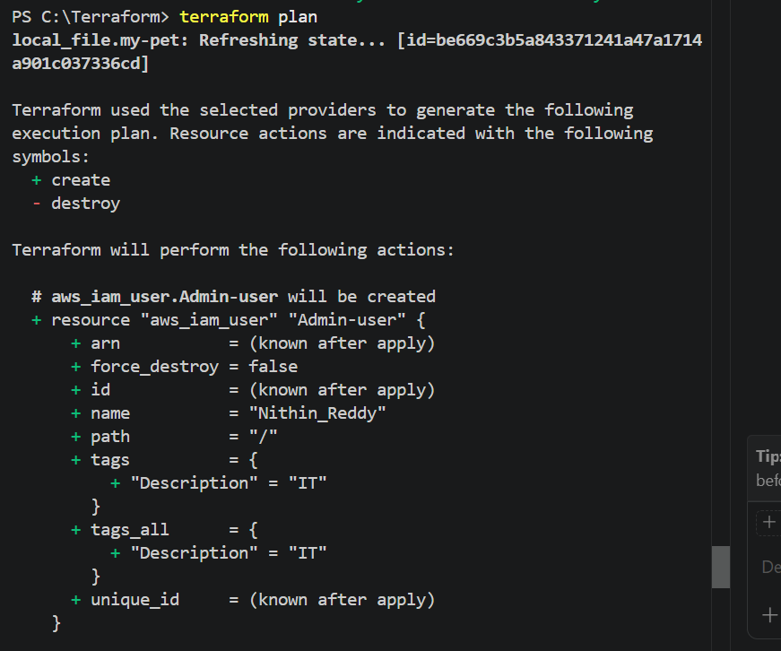
Terraform Apply
Enter: Yes
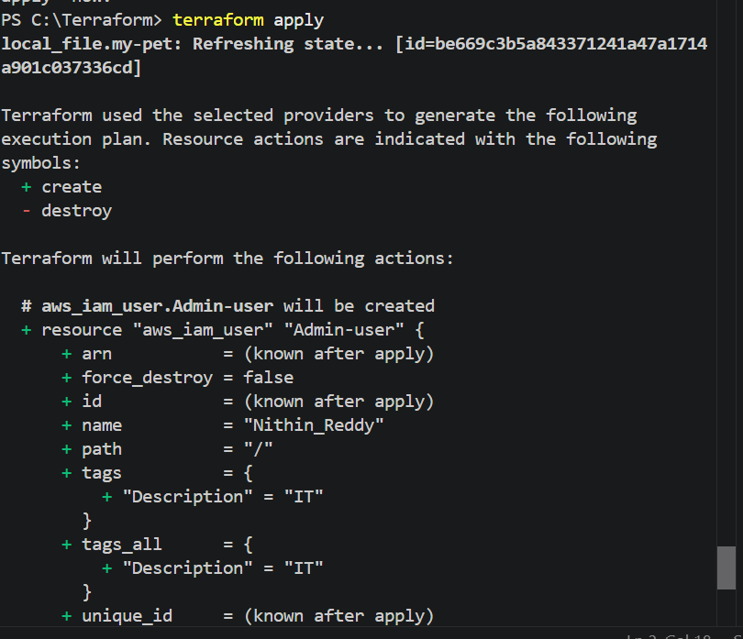
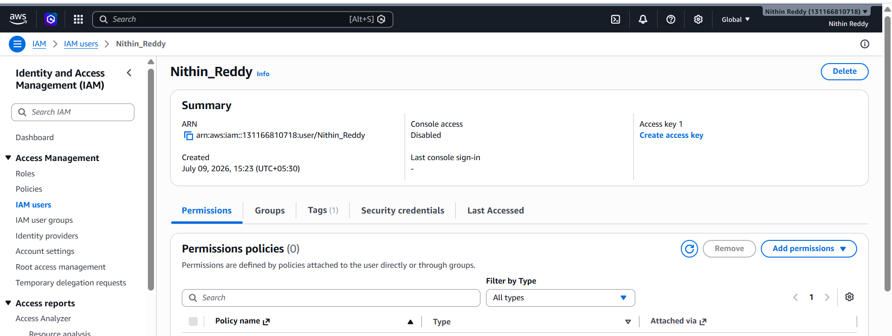

Create IAM Policy and Attach Policy
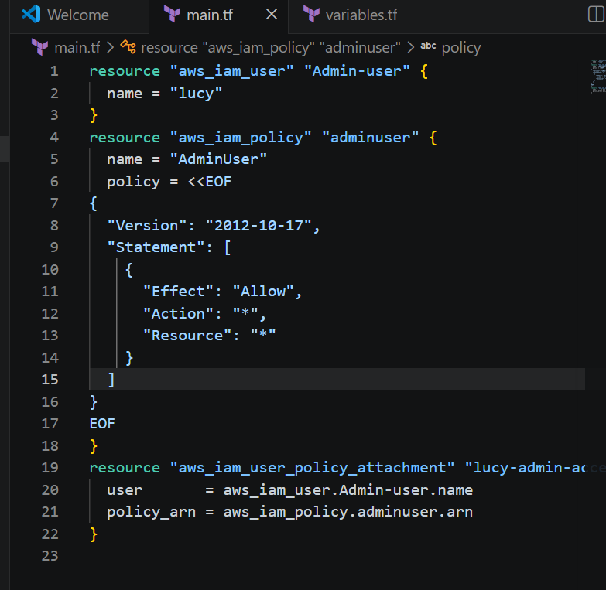
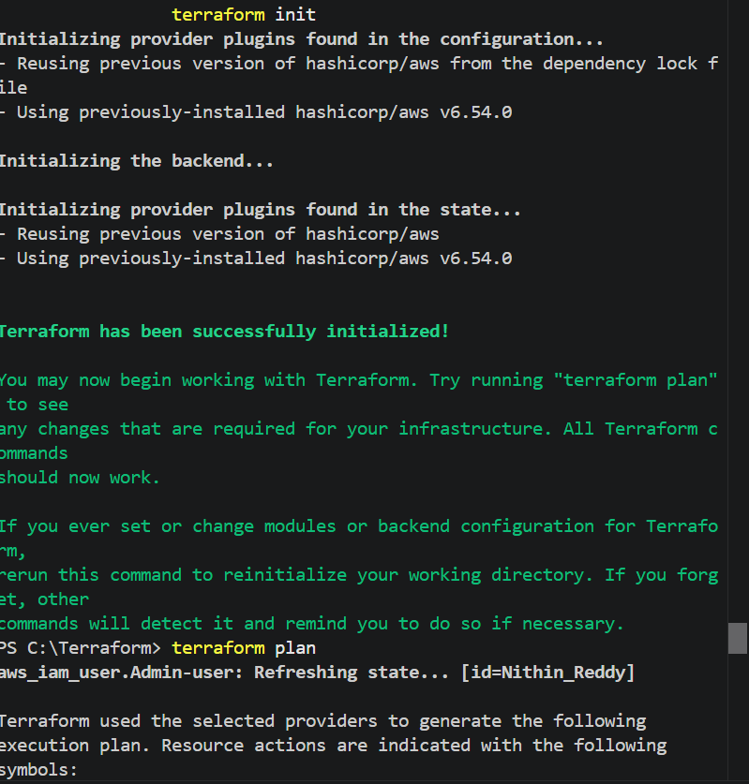
Terraform plan
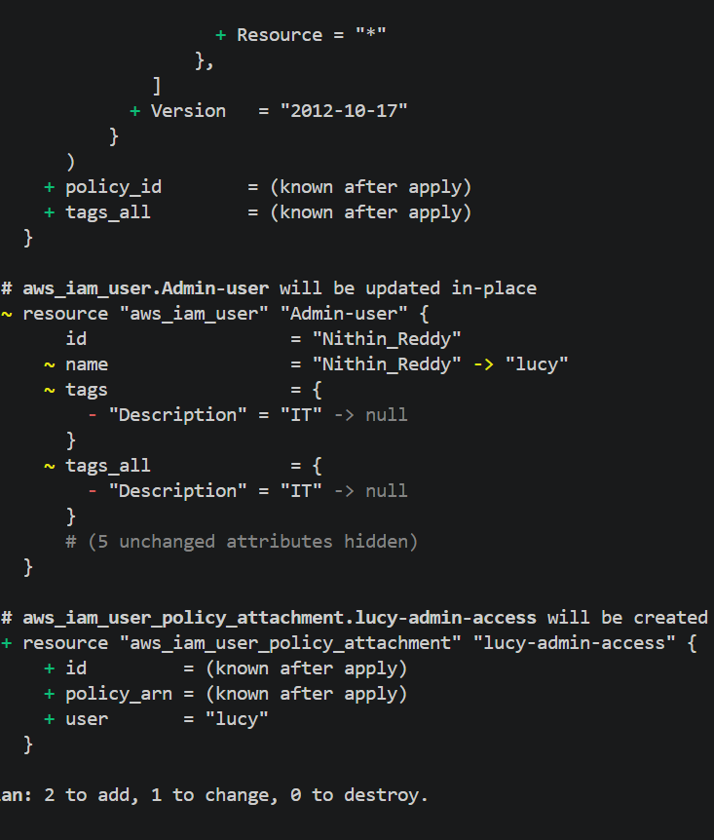
Terraform apply
enter : yes
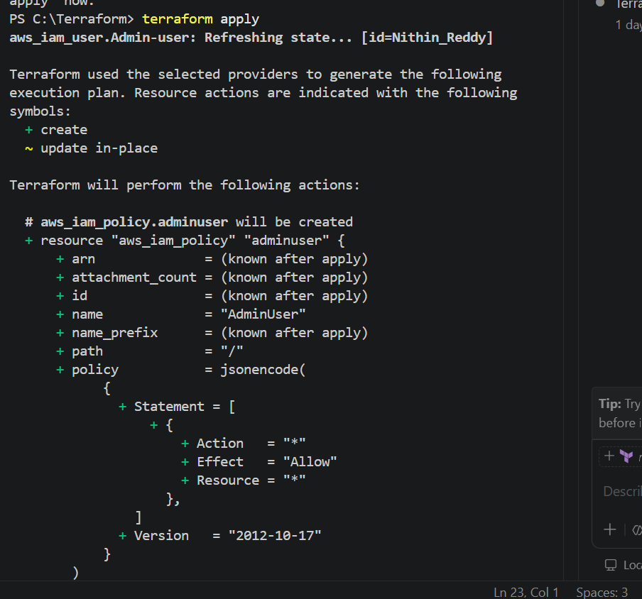
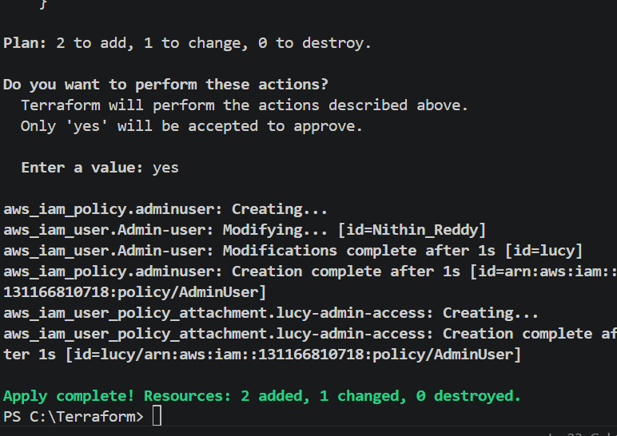
Attached policy
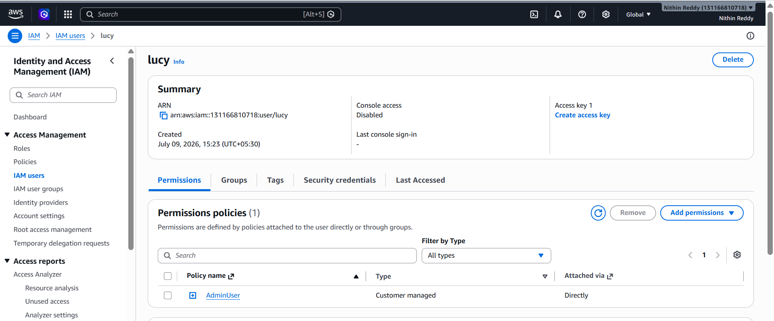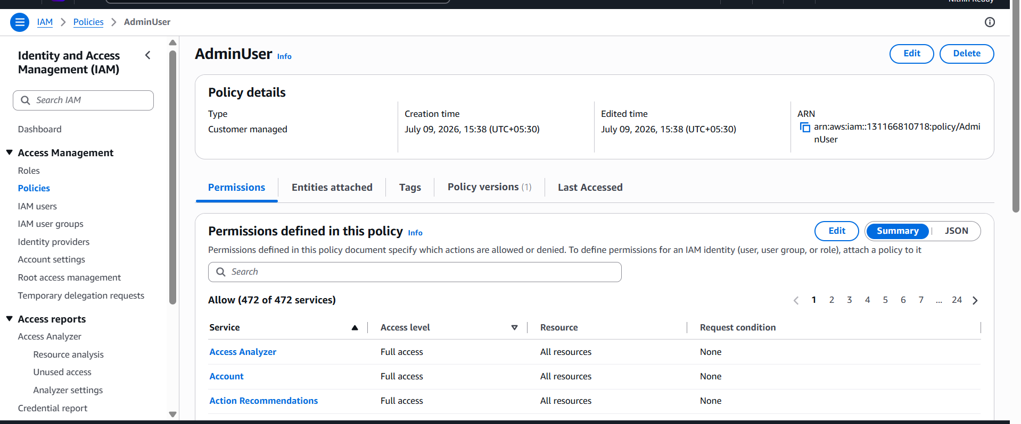
Terraform Destroy
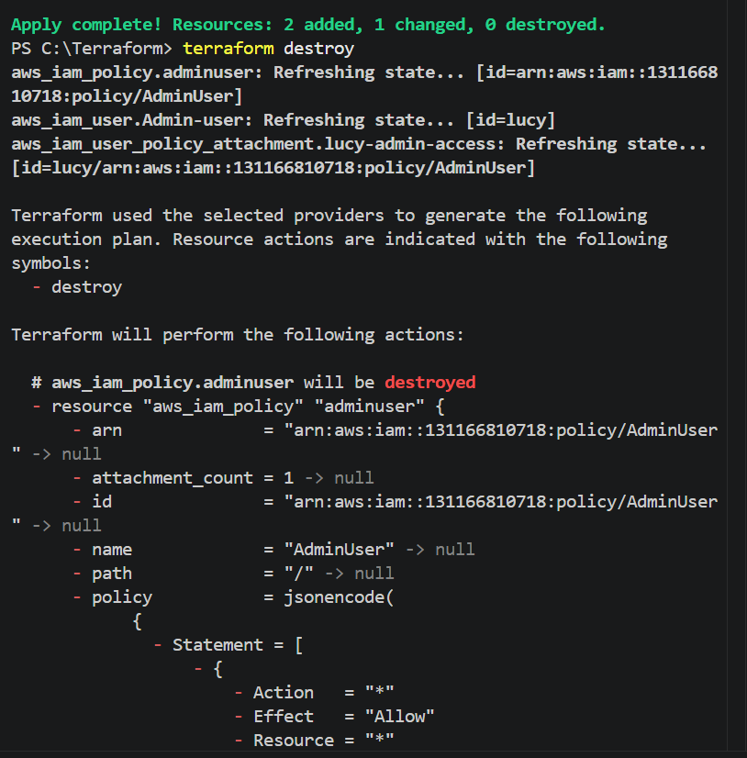

Task 2: Integrate Terraform in Jenkins using the Terraform Plugin
Objective
The objective of this task is to integrate Terraform with Jenkins using the Terraform Plugin. This integration allows Jenkins to execute Terraform commands (init, plan, apply, and destroy) through a CI/CD pipeline, enabling automated infrastructure provisioning and management using Infrastructure as Code (IaC).
What is the Terraform Plugin?
The Terraform Plugin is a Jenkins plugin that integrates Terraform with Jenkins. It allows Jenkins jobs and pipelines to use Terraform installations configured in Jenkins without manually specifying the Terraform executable path.
Benefits
- Integrates Terraform with Jenkins
- Supports multiple Terraform versions
- Simplifies pipeline configuration
- Uses centrally managed Terraform installations
- Automates Infrastructure as Code deployments
Prerequisites
Before starting, ensure the following requirements are met:
System Requirements
- Ubuntu/Linux Jenkins Server
- Jenkins installed and running
- Java installed
- Git installed
- Terraform installed
- Internet connection
Jenkins Requirements
- Administrator access
- Pipeline Plugin
- Git Plugin
- Terraform Plugin
- Credentials Plugin
Cloud Requirements
- AWS Account (if deploying AWS resources)
- AWS CLI configured (optional)
- IAM User with required permissions
Implementation Steps
Step 1: Verify Jenkins is Running
Open Jenkins in your browser.
http://<Jenkins-IP>:8080
Login using administrator credentials.
Step 2: Install Terraform Plugin
Navigate to
Manage Jenkins
↓
Plugins
↓
Available Plugins
Search
Terraform
Select
Terraform
Click
Install without restart
Wait until installation completes.
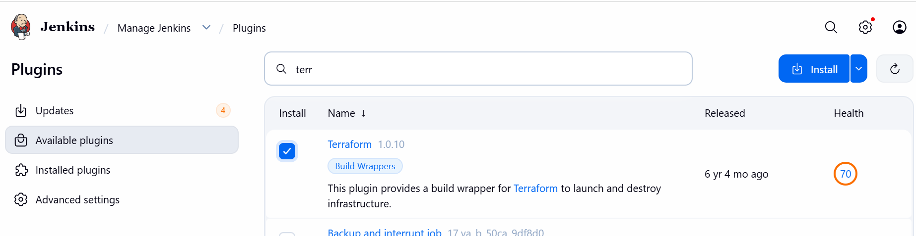
Step 3: Verify Plugin Installation
Go to
Manage Jenkins
↓
Plugins
↓
Installed Plugins
Verify that
Terraform Plugin
appears in the installed plugin list.
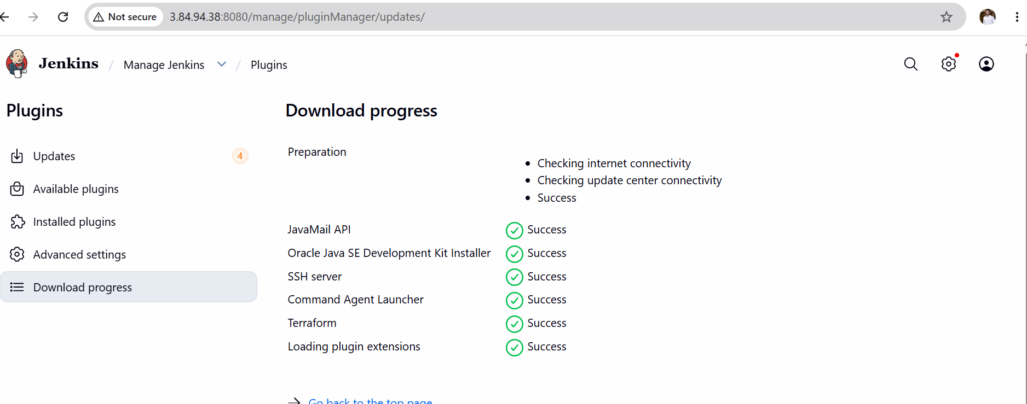
Step 4: Configure Terraform Installation
Navigate to
Manage Jenkins
↓
Tools
(or Global Tool Configuration, depending on the Jenkins version)
Scroll down to
Terraform Installations
Click
Add Terraform
Configure:
Name
Terraform-1.15.7
Uncheck
Install automatically
Enter the installation directory.
Example
/usr/local/bin/terraform
or
/usr/bin/terraform
(Use the output of which terraform on your Jenkins server.)
Click
Save
Step 5: Verify Terraform Path
Run on Jenkins server
which terraform
Example output
/usr/local/bin/terraform
Also verify
terraform version
Expected output
Terraform v1.15.7
Step 6: Create Pipeline Job
Dashboard
↓
New Item
Project Name
Terraform-Plugin-Demo
Select
Pipeline
Click
OK
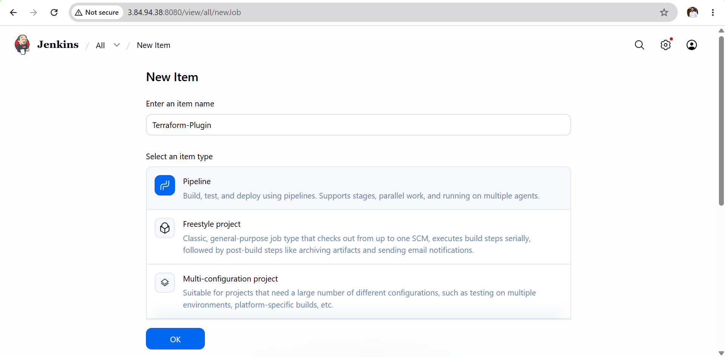
Declarative script
pipeline {
agent any

stages {

stage('Terraform Version') {
steps {
sh 'terraform version'
}
}

stage('Terraform Init') {
steps {
sh 'terraform init'
}
}

stage('Terraform Validate') {
steps {
sh 'terraform validate'
}
}
}
}
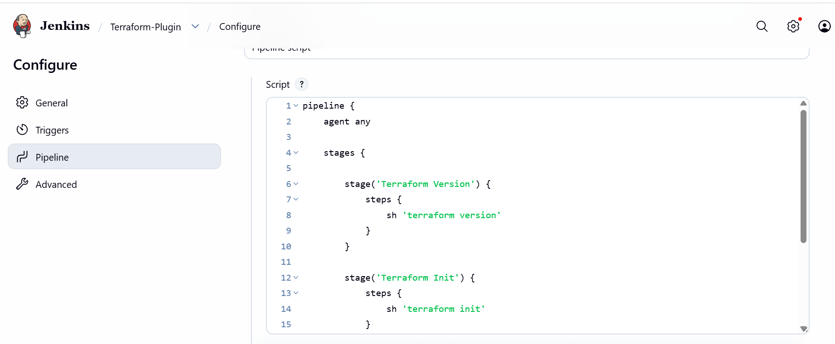
Step 8: Save Pipeline
Click
Save

Step 9: Build Pipeline
Click
Build Now
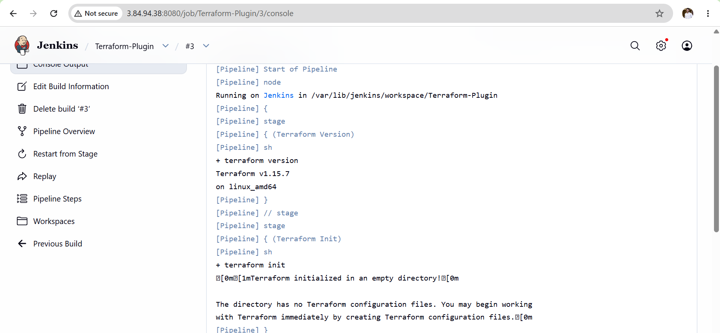
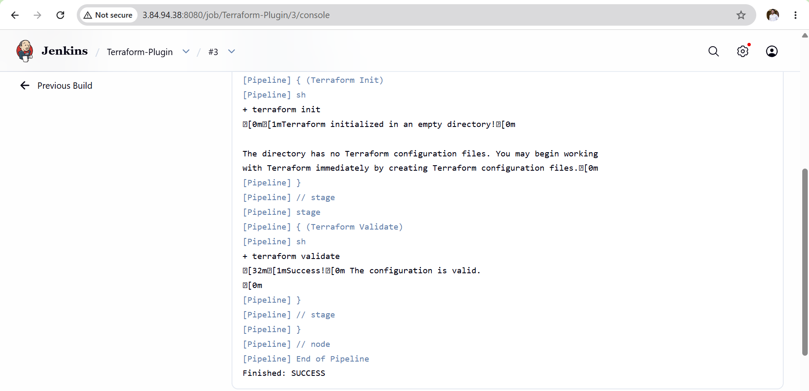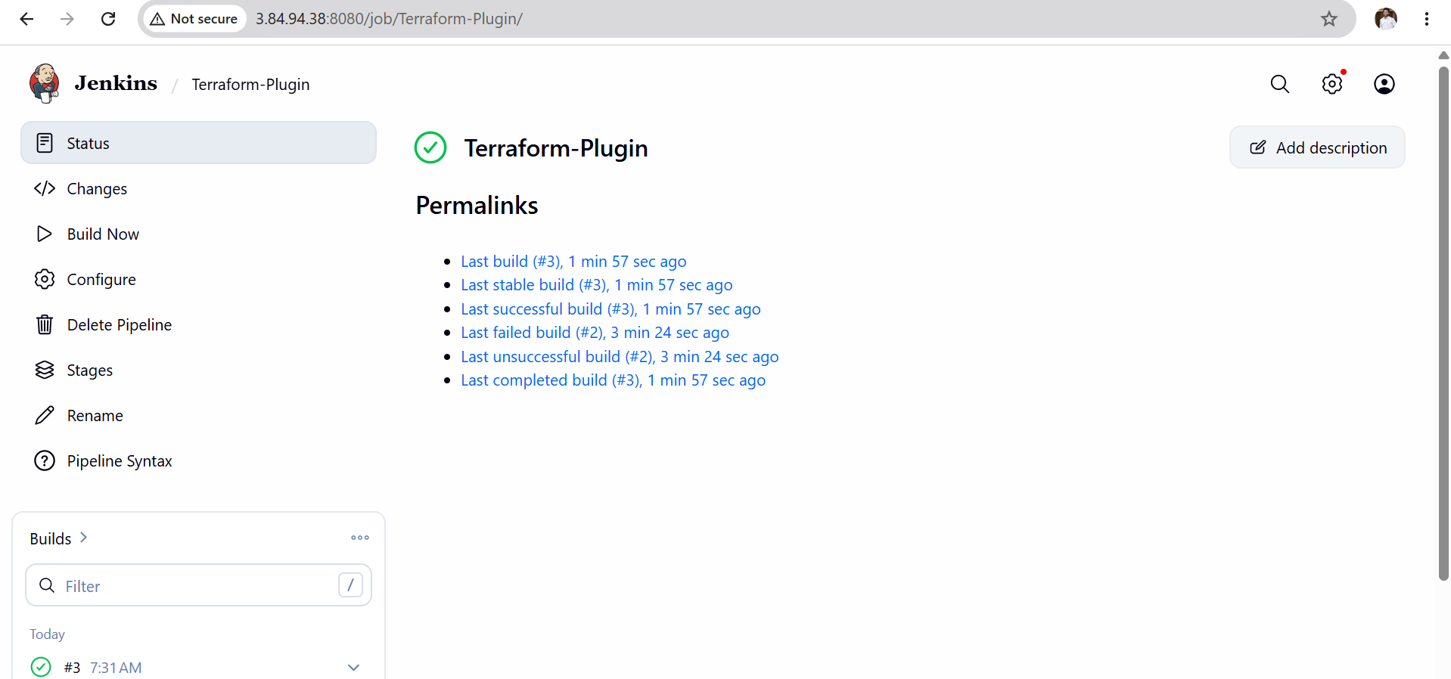
Validation Checklist
- Jenkins server is running.
- Terraform Plugin is installed.
- Terraform installation is configured in Jenkins.
- Terraform version is detected successfully.
- Pipeline executes without errors.
- Console output displays Terraform commands.
- Build completes with SUCCESS status.

Outcome
After completing this task:
- Terraform Plugin is successfully installed in Jenkins.
- Terraform is configured as a global tool.
- Jenkins can access the configured Terraform installation.
- A pipeline can execute Terraform commands without specifying the executable path manually.
- Infrastructure automation through Jenkins and Terraform is ready for future deployments.

Task 3: Create a CI/CD Pipeline for a Node.js Application
Repository:
https://github.com/betawins/Trading-UI.git

Objective
The objective of this task is to create a Continuous Integration and Continuous Deployment (CI/CD) pipeline in Jenkins for a Node.js application. The pipeline will automatically clone the source code from GitHub, install Node.js dependencies, build the application, and verify that the build completes successfully. This automation reduces manual effort and ensures consistent application builds.
CI/CD Workflow
Developer
│
▼
GitHub Repository
│
▼
Jenkins Pipeline
│
├── Stage 1 : Git Clone
│
├── Stage 2 : Install Dependencies (npm install)
│
├── Stage 3 : Build Application (npm run build)
│
└── Stage 4 : Build Success

Prerequisites
Before starting this task, ensure the following:
- Jenkins is installed and running.
- Git is installed on the Jenkins server.
- Node.js and npm are installed.
- Jenkins has internet access.
- GitHub repository is accessible.
- Pipeline plugin is installed.
- NodeJS plugin (optional but recommended) is installed.
- Node.js is configured under Manage Jenkins → Tools (if using the NodeJS plugin).
Implementation Steps
Step 1: Verify Node.js Installation
On the Jenkins server, run:
node -v
Verify npm:
npm -v
Both commands should display installed versions.
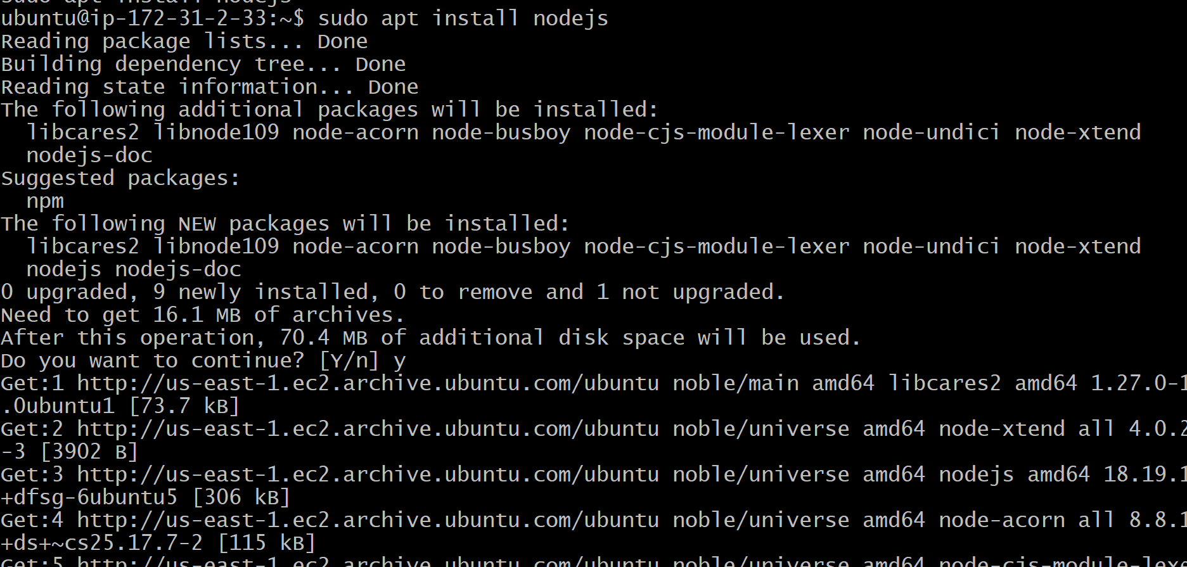
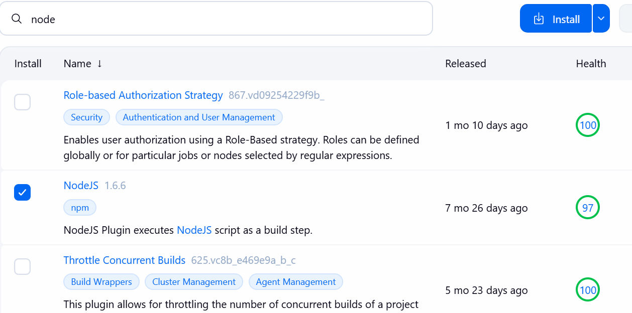
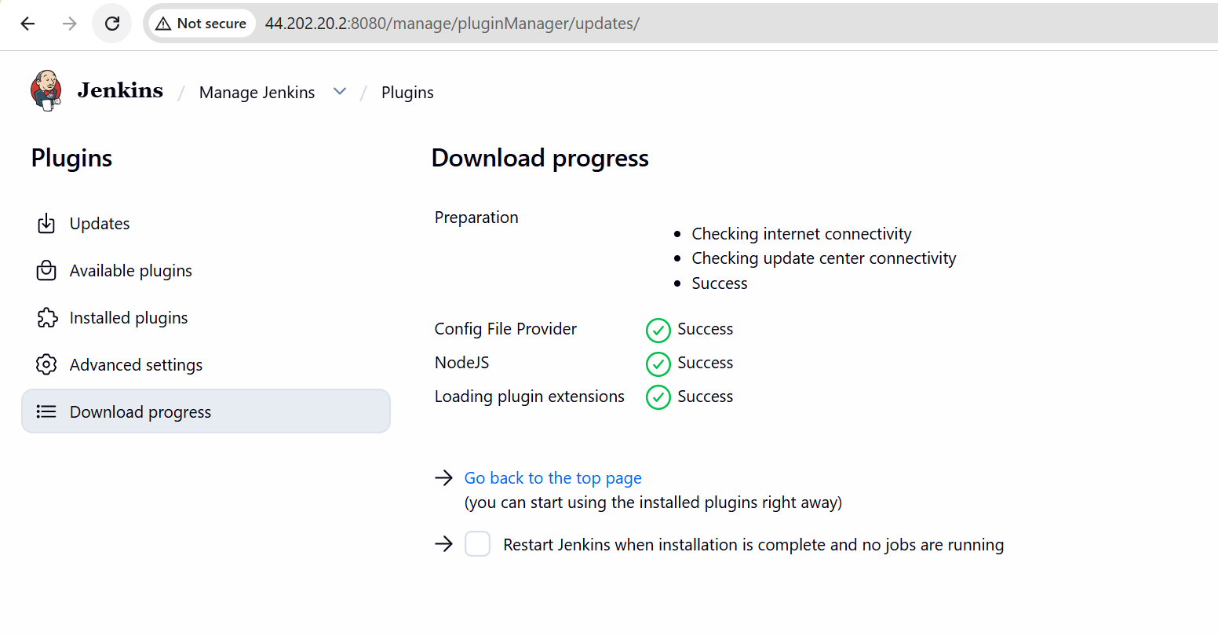
Step 2: Create a New Pipeline Job
- Open Jenkins Dashboard.
- Click New Item.
- Enter the job name.
Example:
Trading-UI-CICD
- Select Pipeline.
- Click OK.
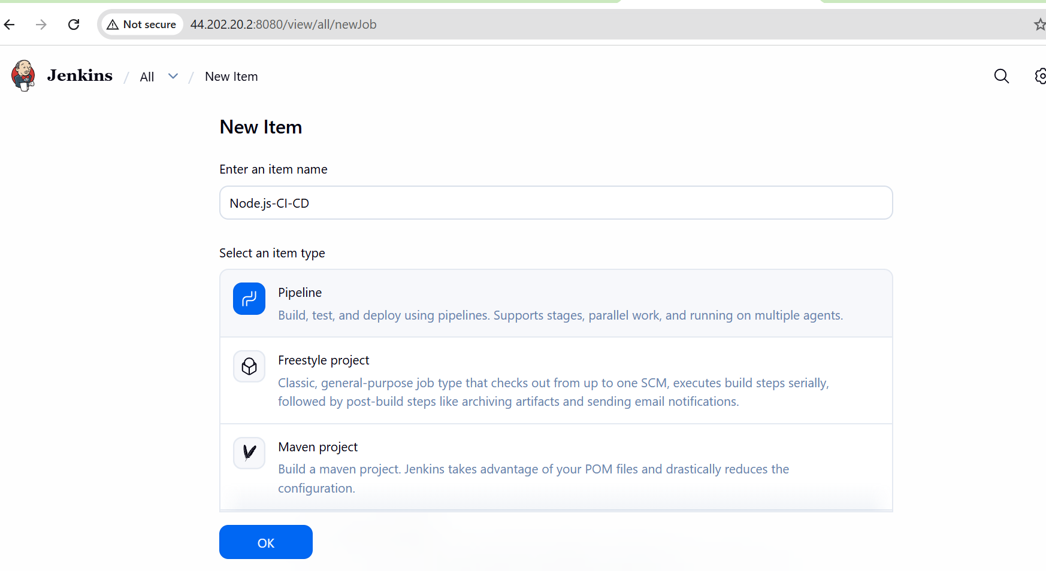
Step 3: Configure Pipeline
Scroll to Pipeline.
Choose:
Pipeline script
pipeline {
agent any

stages {

stage('Git Clone') {
steps {
git branch: 'main',
url: 'https://github.com/betawins/Trading-UI.git'
}
}

stage('Install Dependencies') {
steps {
sh 'npm install'
}
}

stage('Build Application') {
steps {
sh 'npm run build'
}
}

}
}
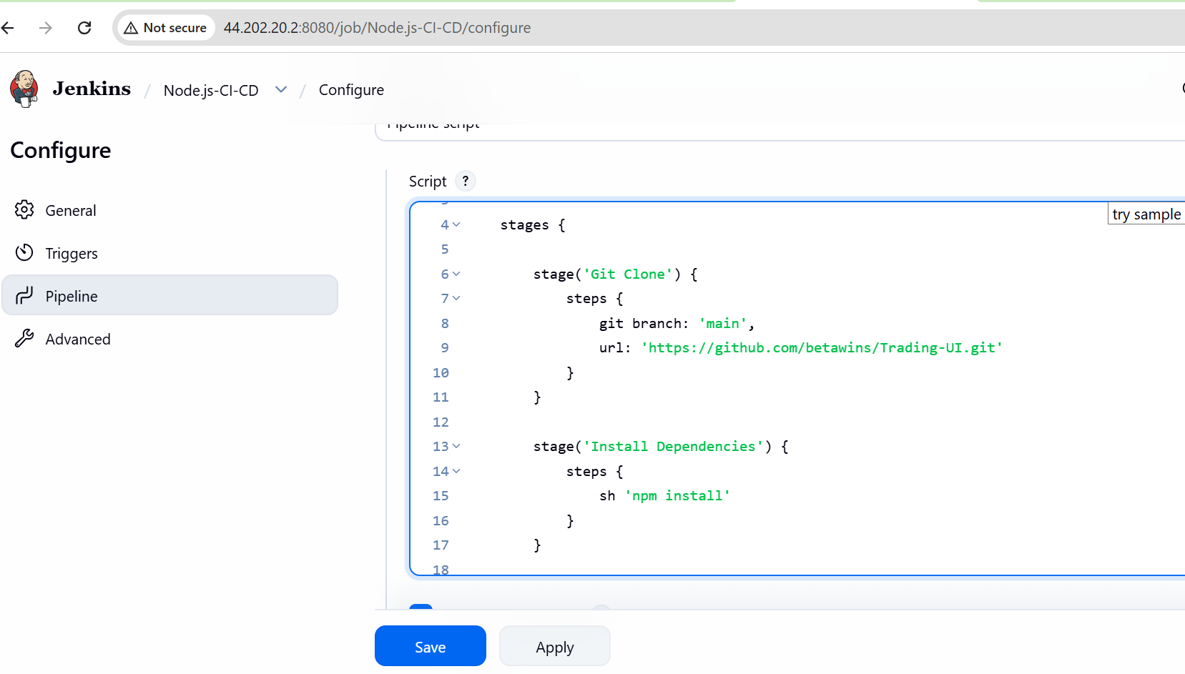
Validation
Verify the following:
- Jenkins pipeline is created successfully.
- GitHub repository is cloned.
- Node.js dependencies are installed.
- Application builds without errors.
- Jenkins displays SUCCESS.
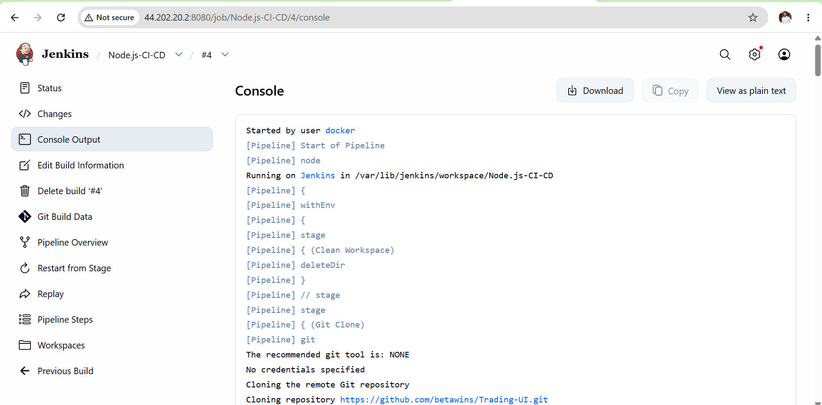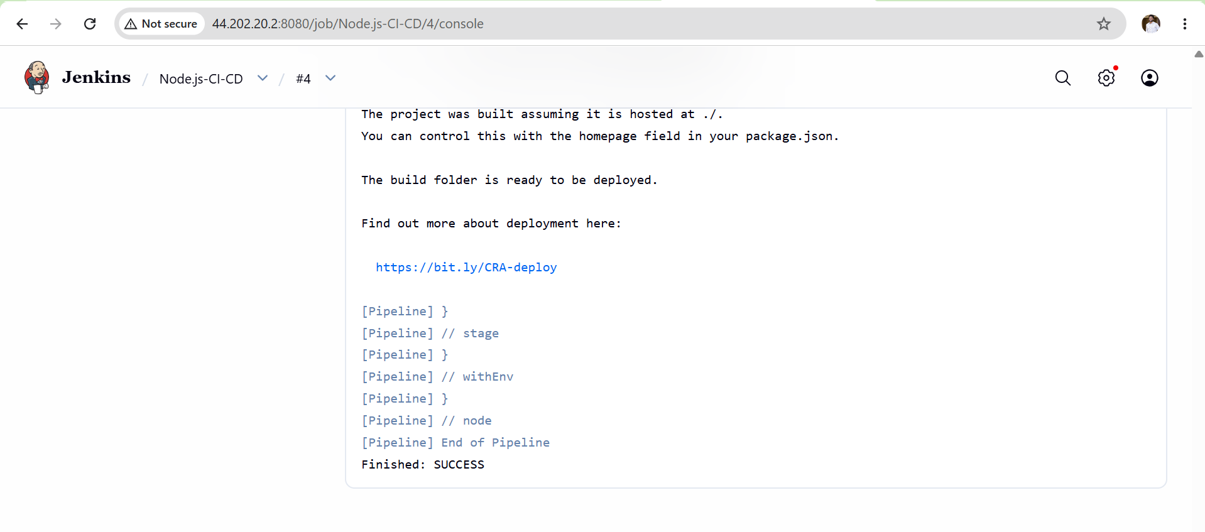
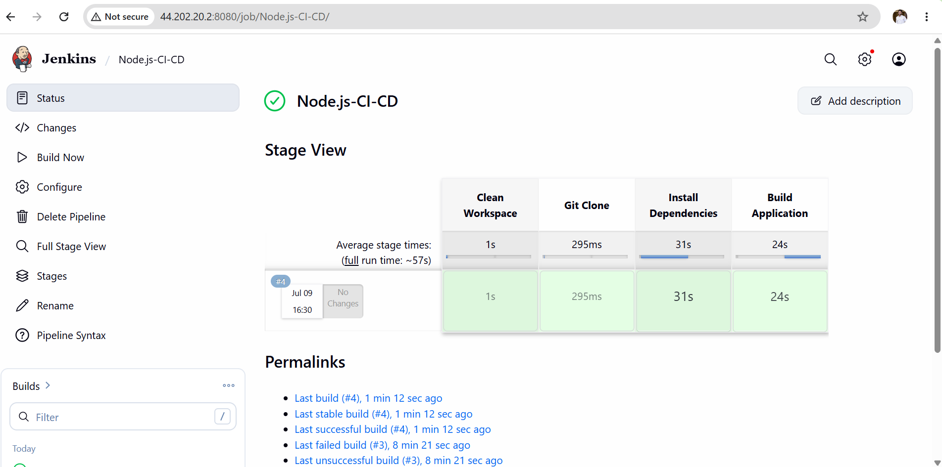
Outcome
After completing this task:
- Jenkins automatically clones the Node.js application from GitHub.
- Required npm dependencies are installed.
- The application is built successfully.
- The CI/CD pipeline executes all stages automatically.
Build status is displayed in Jenkins.

Task 5: Explain 10 Maven Commands
Objective
The objective of this task is to understand the most commonly used Maven commands that automate the build lifecycle of Java applications. These commands are used for cleaning old builds, compiling source code, running tests, packaging applications, installing artifacts, and deploying them to repositories.
What is Maven?
Apache Maven is a Build Automation and Project Management Tool used primarily for Java applications. It manages project dependencies, compiles source code, runs tests, packages applications (JAR/WAR), and automates the software build process using the pom.xml configuration file.
Maven Build Lifecycle
validate
↓
compile
↓
test
↓
package
↓
verify
↓
install
↓
deploy
1. mvn clean
Purpose
Deletes all files generated from the previous build.
Syntax
mvn clean
What it does
- Deletes the target/ directory.
- Removes old compiled classes and build artifacts.
- Starts the next build from a clean state.
Example Output
Deleting target directory...
BUILD SUCCESS

2. mvn compile
Purpose
Compiles the Java source code.
Syntax
mvn compile
What it does
- Compiles files from the src/main/java directory.
- Stores compiled .class files in the target/classes directory.
- Does not create a JAR or WAR file.
Example Output
Compiling Java source files...
BUILD SUCCESS
3. mvn test
Purpose
Runs unit tests.
Syntax
mvn test
What it does
- Executes test cases located in src/test/java.
- Uses testing frameworks such as JUnit or TestNG.
- Displays pass or fail results.
Example Output
Running Tests...
Tests run: 10
Failures: 0
BUILD SUCCESS
4. mvn package
Purpose
Creates a deployable application package.
Syntax
mvn package
What it does
- Compiles the code.
- Runs tests.
- Packages the application.
- Creates a JAR or WAR file inside the target/ directory.
Example Output
Building WAR...
target/project.war
BUILD SUCCESS
5. mvn install
Purpose
Installs the application into the local Maven repository.
Syntax
mvn install
What it does
- Performs clean, compile, test, and package.
- Copies the generated artifact to the local Maven repository (~/.m2/repository).
- Makes the artifact available for other local Maven projects.
Example Output
Installing to ~/.m2/repository
BUILD SUCCESS
6. mvn deploy
Purpose
Uploads the application to a remote repository.
Syntax
mvn deploy
What it does
- Builds the application.
- Uploads the generated artifact to a remote repository such as Nexus or Artifactory.
- Commonly used in CI/CD pipelines.
Example Output
Uploading artifact to Nexus...
BUILD SUCCESS
7. mvn validate
Purpose
Validates the project configuration.
Syntax
mvn validate
What it does
- Checks whether the project structure is correct.
- Verifies that the pom.xml file is valid.
- Ensures required information is present before the build starts.
Example Output
Project validation successful.
BUILD SUCCESS
8. mvn verify
Purpose
Performs project verification after packaging.
Syntax
mvn verify
What it does
- Executes all build phases up to verify.
- Runs integration tests.
- Ensures the packaged application is valid.
Example Output
Verification completed.
BUILD SUCCESS
9. mvn dependency:tree
Purpose
Displays all project dependencies.
Syntax
mvn dependency:tree
What it does
- Shows direct and transitive dependencies.
- Helps identify dependency conflicts and versions.
Example Output
Project
├── spring-core
├── spring-web
└── log4j
10. mvn site
Purpose
Generates project documentation.
Syntax
mvn site
What it does
- Creates HTML documentation for the project.
- Includes reports such as test results, project information, and dependency reports.
- Stores the generated site under target/site.
Example Output
Generating project site...
BUILD SUCCESS
Outcome
After completing this task:
- I understand the purpose of the most commonly used Maven commands.
- I can use Maven to clean, compile, test, package, install, and deploy Java applications.
- I understand how these commands fit into the Maven build lifecycle and are used in Jenkins CI/CD pipelines.

