Prometheus & Grafana-01

What is Prometheus?
Prometheus is an open-source monitoring and alerting tool.
Its job is to:
- Collect metrics
- Store metrics as time-series data
- Query metrics using PromQL
- Trigger alerts
- Provide data to Grafana
Think of Prometheus as the brain of monitoring.
Example metrics:
- CPU Usage
- Memory Usage
- Disk Usage
- Network Usage
- Kubernetes Pods
- Docker Containers
- EC2 Server Health
How Prometheus Works
Prometheus does not wait for servers to send data.
Instead,
Prometheus pulls (scrapes) metrics every few seconds.
Example:
Every 15 seconds

Prometheus
|
|
HTTP GET
|
http://server:9100/metrics
|
Node Exporter
|
Returns thousands of metrics
Prometheus stores them inside its own database.
What is Grafana?
Grafana is a visualization tool.
It does not collect metrics.
Instead,
It connects to Prometheus and displays beautiful dashboards.
Example:
Prometheus stores
CPU = 32%

Memory = 61%

Disk = 48%
Grafana converts this into
CPU Graph
██████████
Memory Graph
██████
Disk Graph
████
Think of Grafana as the dashboard.

Task 1
Install Prometheus on a Server and Configure prometheus.yml
Objective
Install Prometheus on an EC2 instance and configure it to collect its own metrics using the prometheus.yml configuration file.
Prerequisites
- AWS EC2 instance (Amazon Linux 2023 recommended)
- t2.medium or larger (recommended)
- Security Group:
  - SSH (22) from your IP
  - TCP 9090 (Prometheus Web UI)
- Internet access
- Sudo privileges
Steps
Documentation
- Launched a new Amazon Linux 2023 EC2 instance with port 9090 open.
- Updated the server packages using dnf.
- Created a dedicated prometheus system user.
- Created Prometheus configuration and data directories.
- Downloaded and installed the Prometheus binaries.
- Copied console templates and libraries to /etc/prometheus.
- Configured prometheus.yml with a self-scrape job.
- Assigned appropriate ownership to Prometheus files and directories.
- Started Prometheus manually and verified the web UI on port 9090.
- Validated the configuration and confirmed the Prometheus target status was UP.

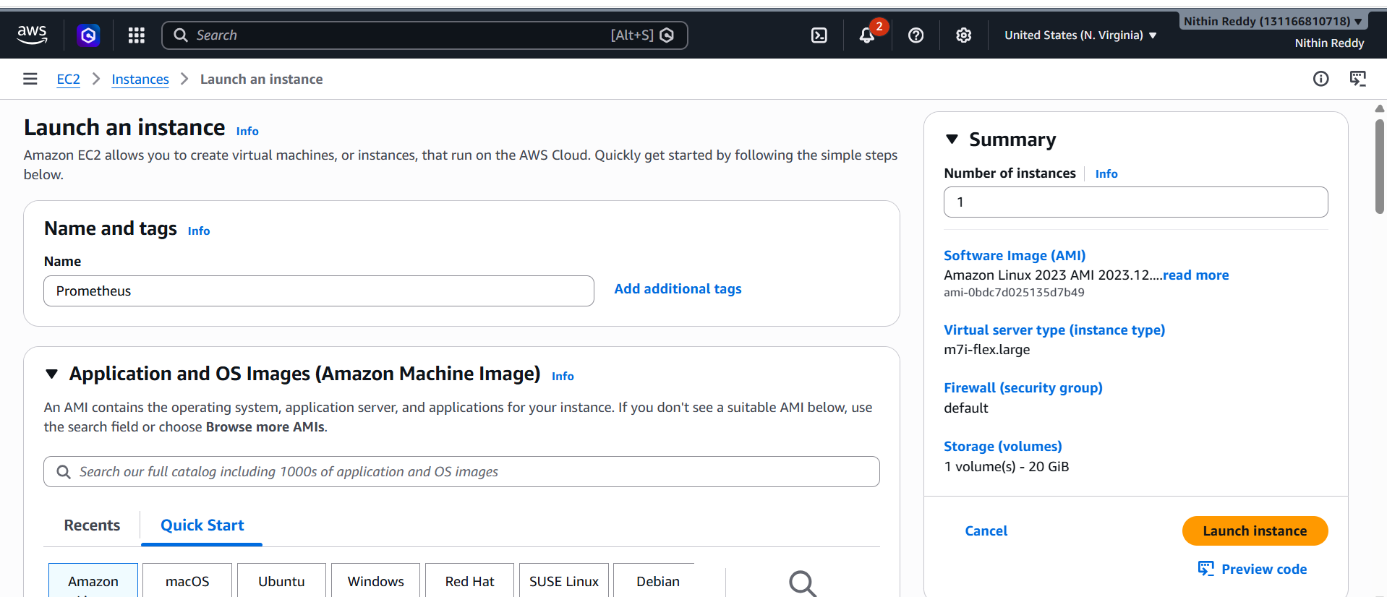
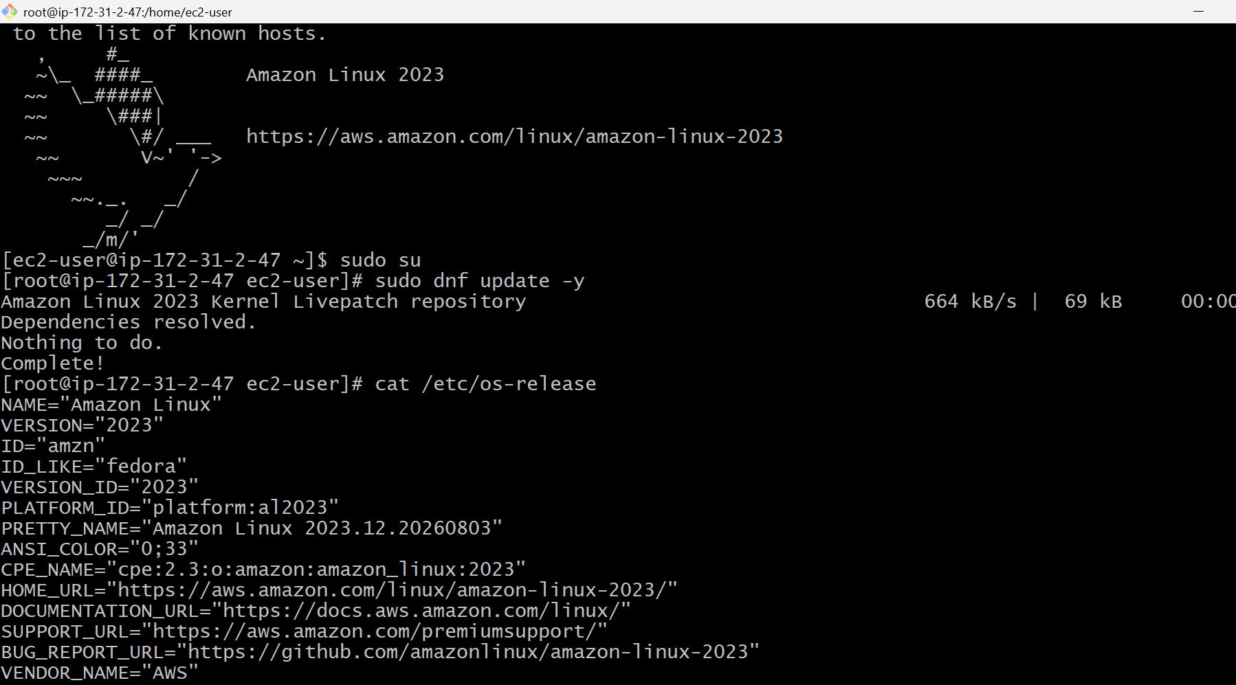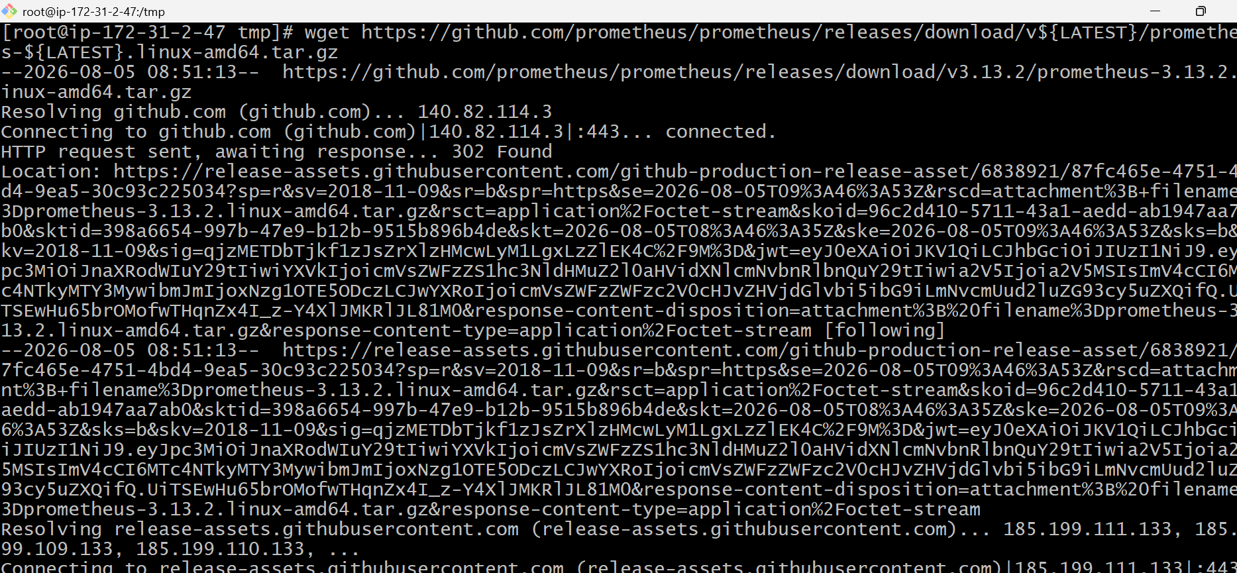

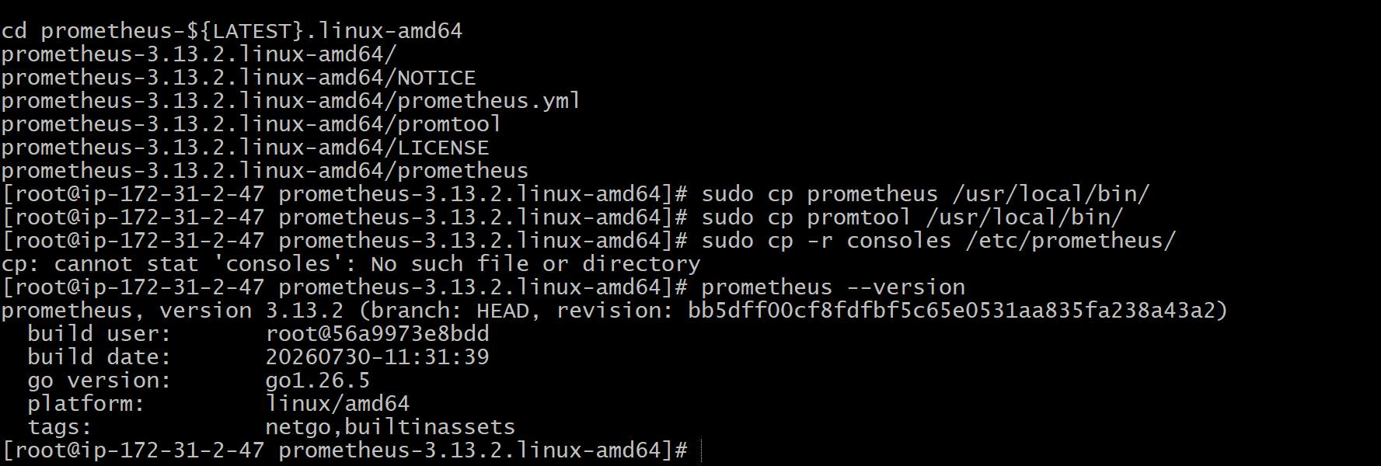
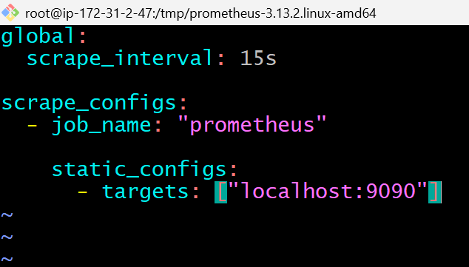
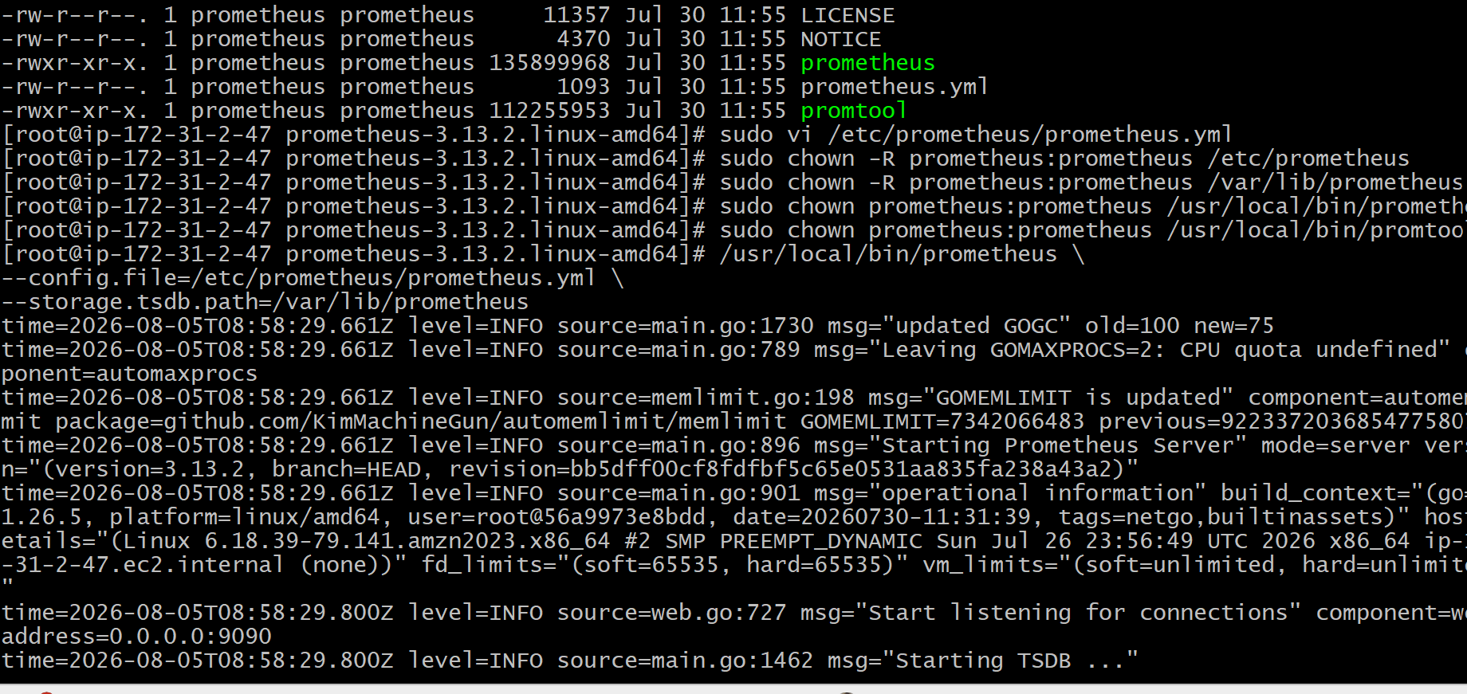
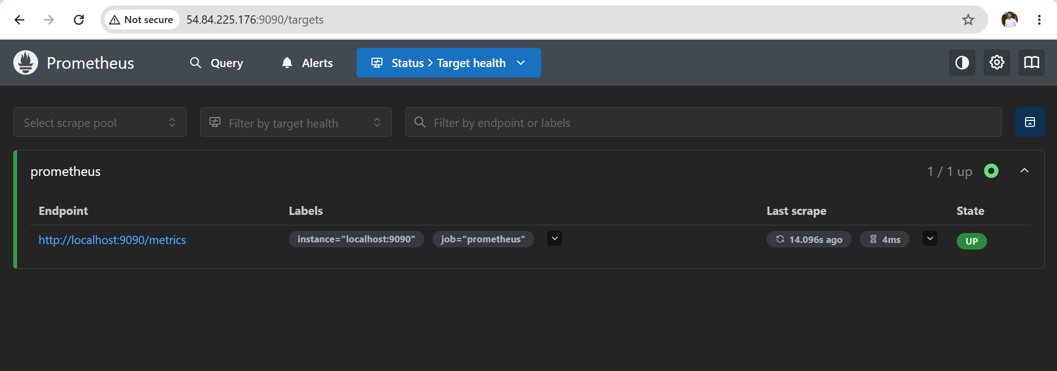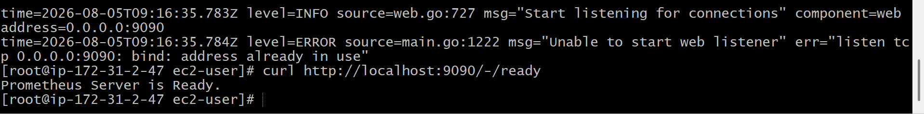

Outcome
After completing Task 1, you will have:
- Installed Prometheus.
- Created a dedicated Prometheus user.
- Configured prometheus.yml.
- Started Prometheus manually.
- Verified that Prometheus is scraping its own metrics.

Task 2: Install and Configure Node Exporter for System Monitoring
Objective
Install Node Exporter on the EC2 instance and configure Prometheus to scrape system metrics such as CPU, memory, disk, filesystem, network, and load average.
What is Node Exporter?
Node Exporter is an agent developed by the Prometheus community that collects hardware and operating system metrics from Linux systems.
Think of it like this:
Linux Server
│
│ Collects CPU, RAM, Disk, Network...
▼
Node Exporter (Port 9100)
│
│ HTTP GET /metrics
▼
Prometheus (Port 9090)
│
▼
Grafana Dashboard
Without Node Exporter:
- Prometheus knows only about itself.
With Node Exporter:
- Prometheus knows everything about your Linux server.

Steps
- Created a dedicated node_exporter system user.
- Downloaded and installed the latest Node Exporter binary.
- Configured Node Exporter as a systemd service.
- Enabled and started the Node Exporter service.
- Verified Node Exporter was listening on port 9100.
- Updated prometheus.yml to scrape Node Exporter metrics.
- Restarted Prometheus to apply the new scrape configuration.
- Verified both Prometheus and Node Exporter targets were in the UP state.
- Queried CPU, memory, disk, and network metrics successfully from Prometheus.

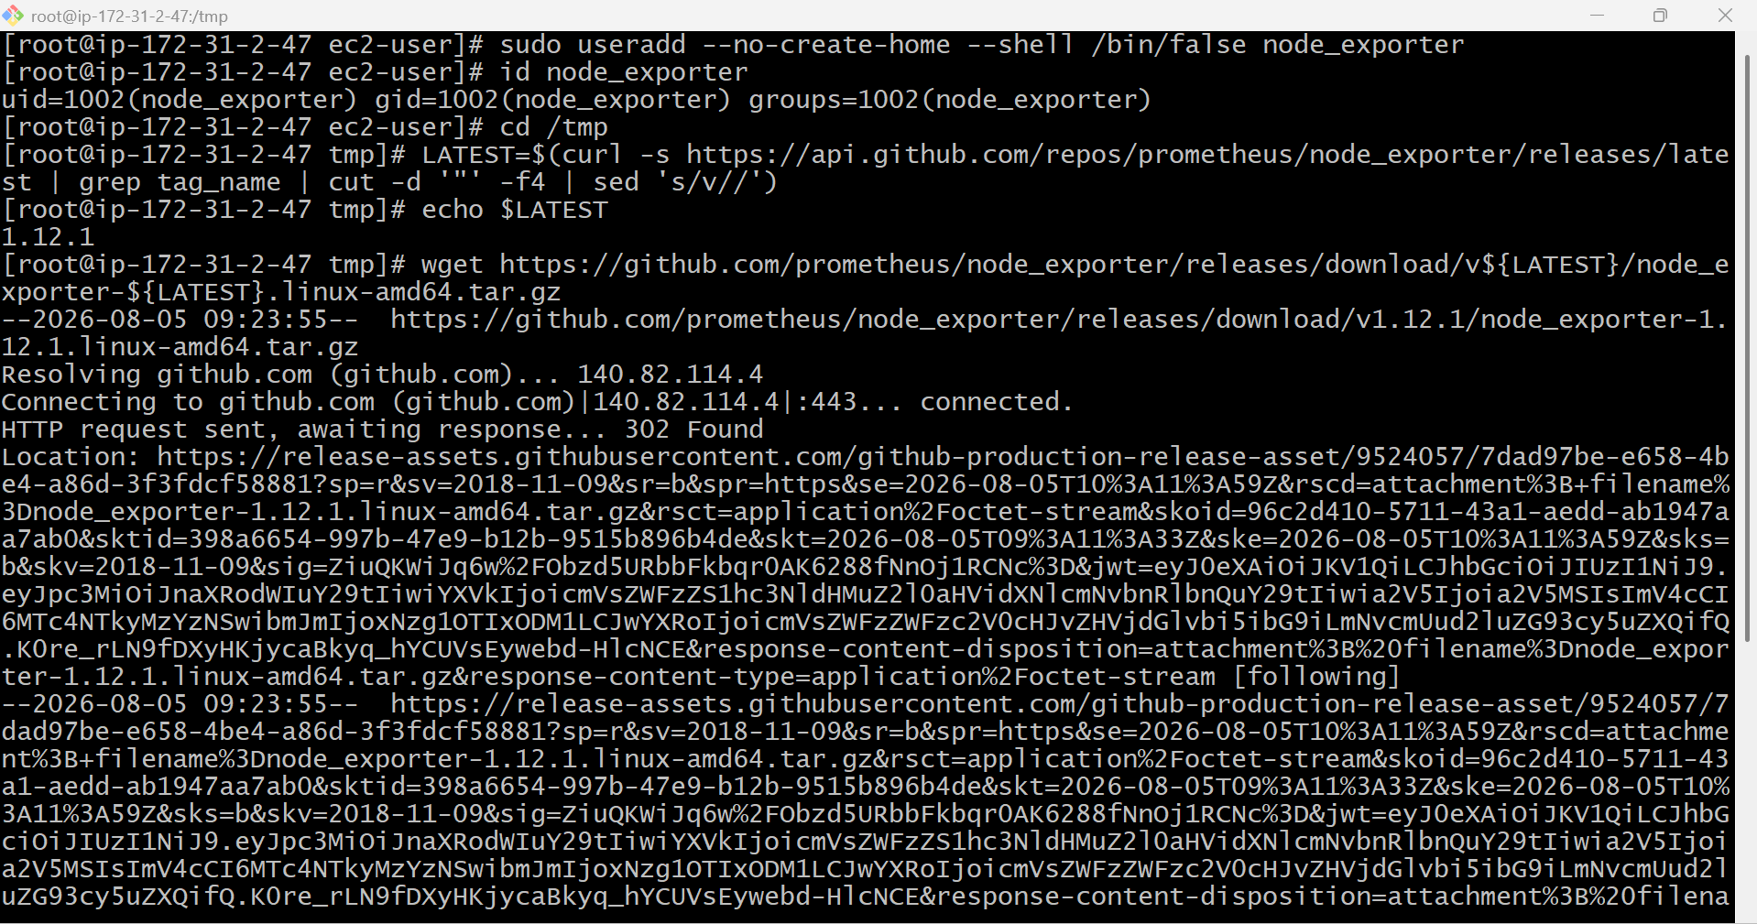
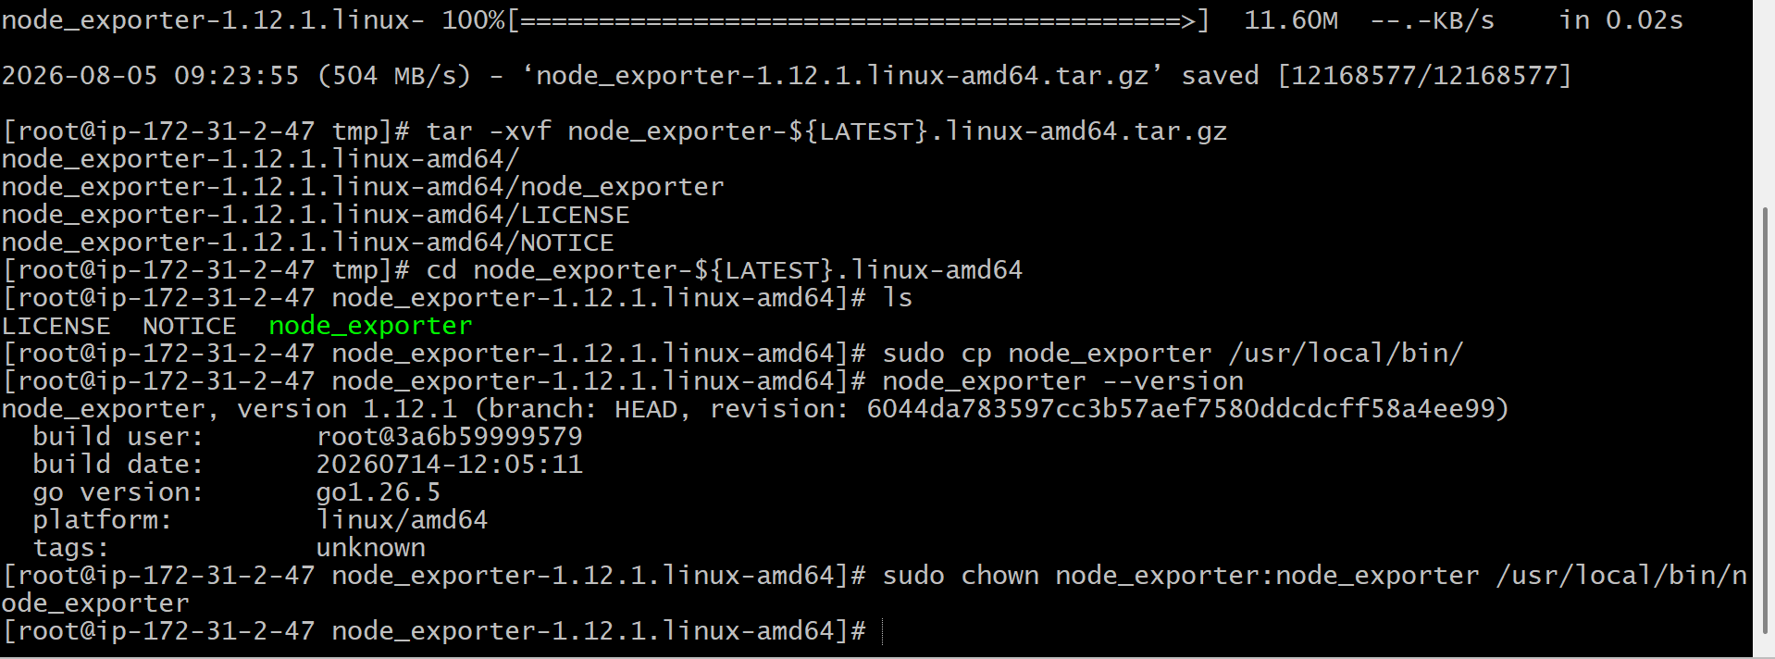
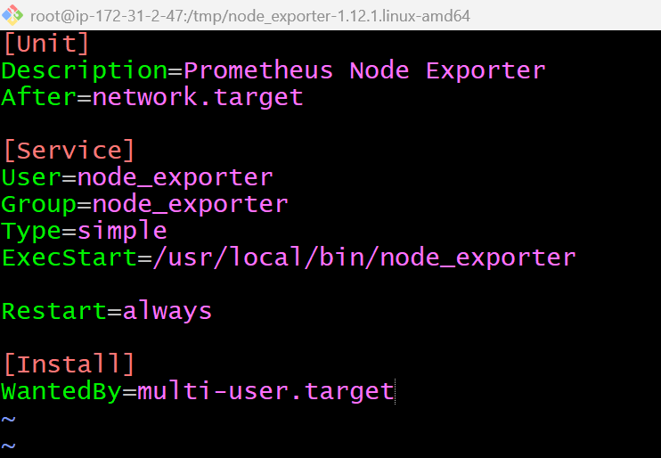
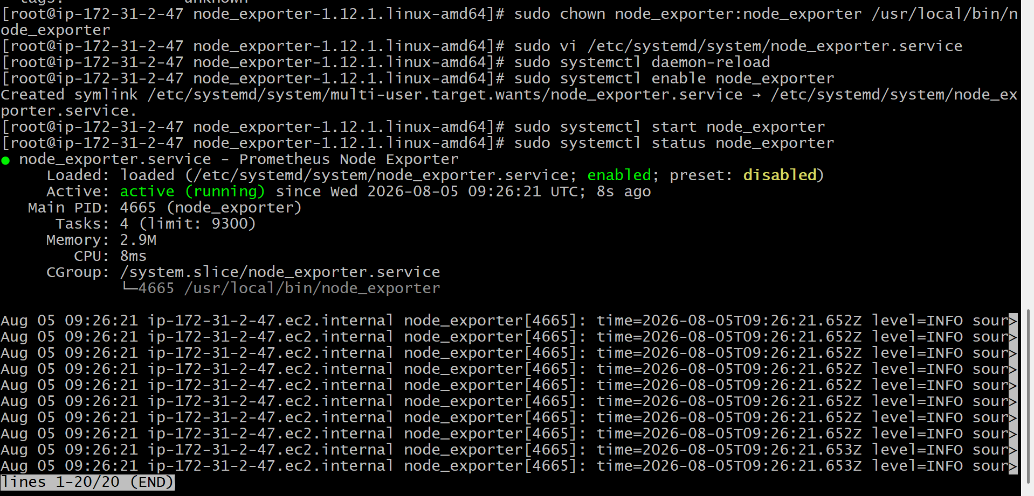
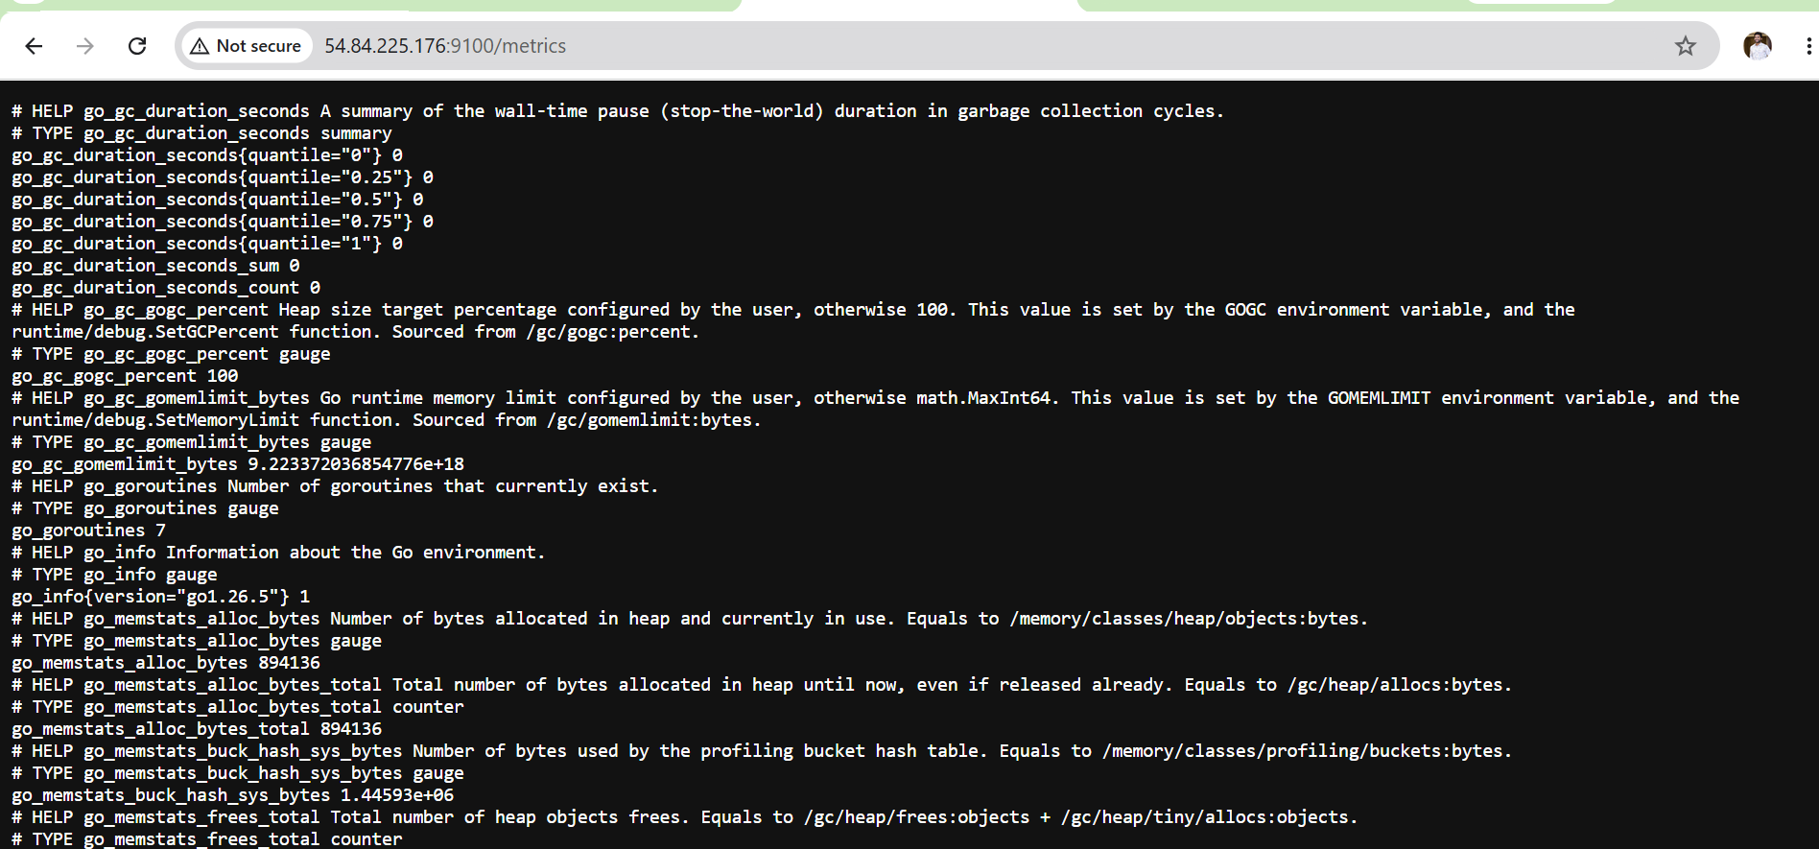
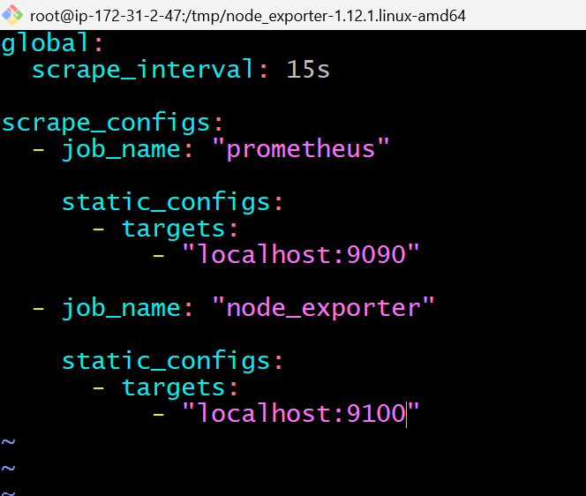
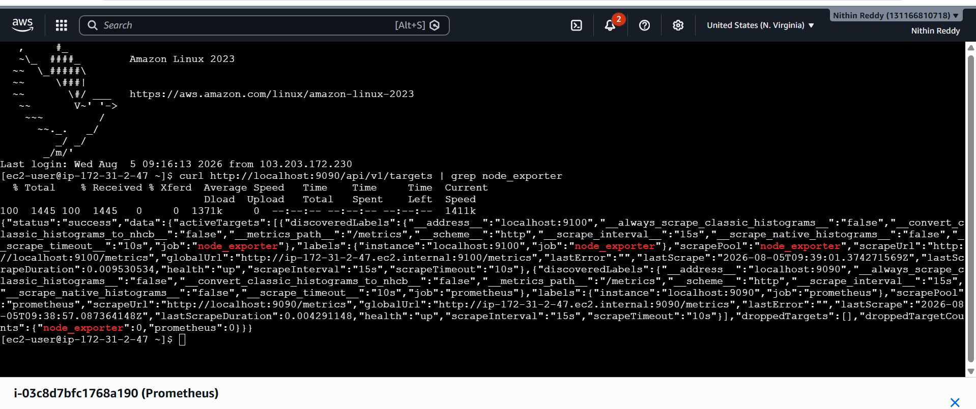
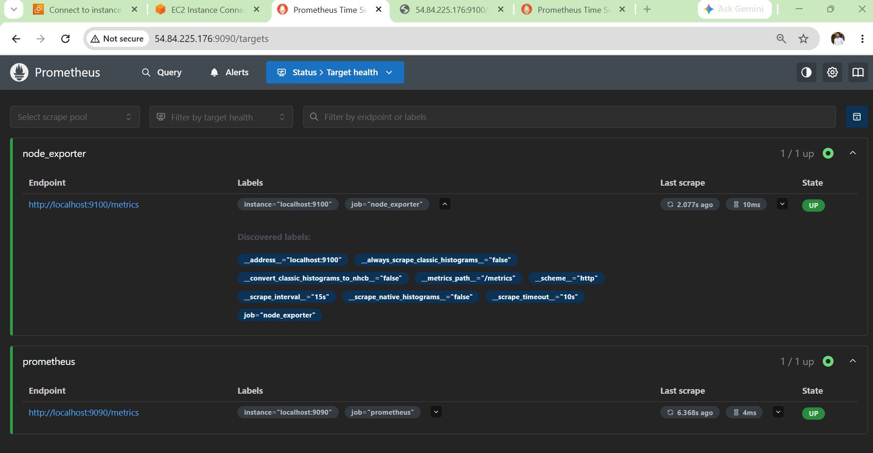
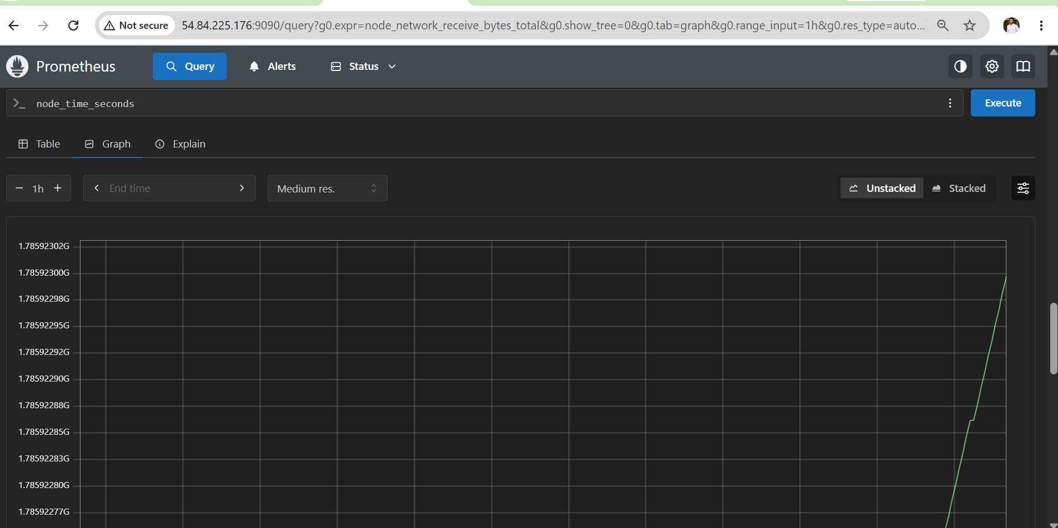

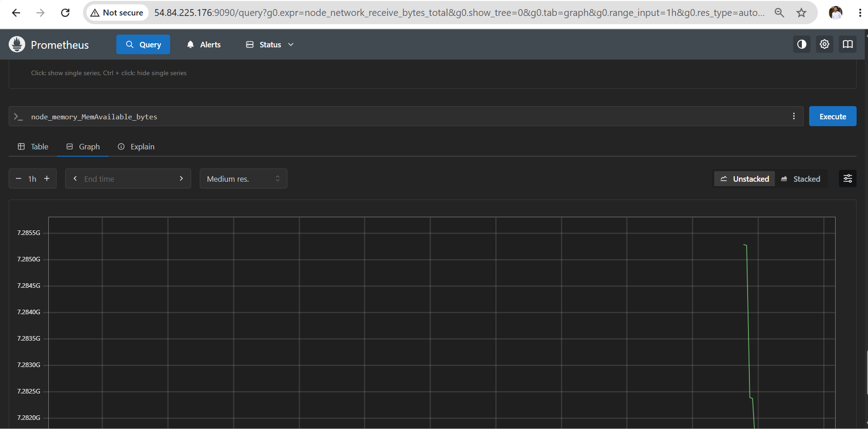

Outcome
After Task 2:
- Node Exporter is installed.
- It runs as a systemd service.
- Prometheus scrapes Linux system metrics every 15 seconds.
- CPU, memory, disk, network, and filesystem metrics are available for querying.
- The server is ready to be visualized in Grafana.

Task 3: Install and Configure SNMP Exporter to Monitor Network Devices
Objective
Install and configure SNMP Exporter on the Prometheus server so that Prometheus can collect metrics from SNMP-enabled network devices such as routers, switches, firewalls, load balancers, printers, UPS devices, and storage appliances.
What is SNMP?
SNMP (Simple Network Management Protocol) is a standard protocol used to monitor and manage network devices.
Instead of installing an agent like Node Exporter, network devices expose information using SNMP.
Examples of devices:
- Cisco Router
- Cisco Switch
- Fortinet Firewall
- Palo Alto Firewall
- MikroTik Router
- HP Printer
- APC UPS
- NAS Storage
Steps
- Created a dedicated snmp_exporter system user.
- Downloaded and installed the latest SNMP Exporter binary.
- Copied the default snmp.yml configuration.
- Configured SNMP Exporter as a systemd service.
- Enabled and started the SNMP Exporter service.
- Verified SNMP Exporter was listening on port 9116.
- Updated Prometheus to scrape SNMP metrics.
- Validated the SNMP Exporter endpoint and Prometheus target.

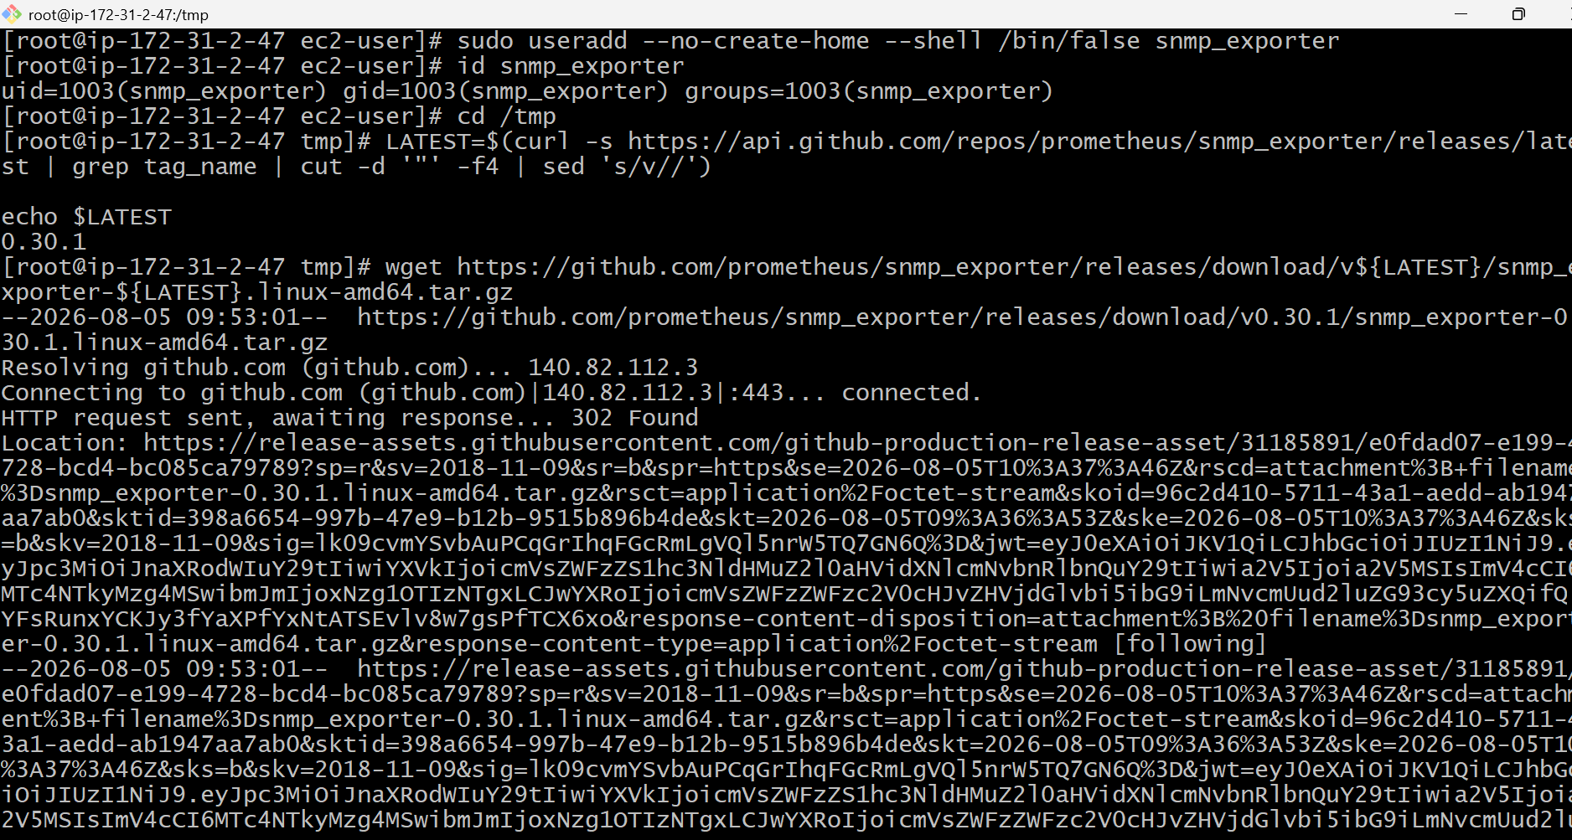
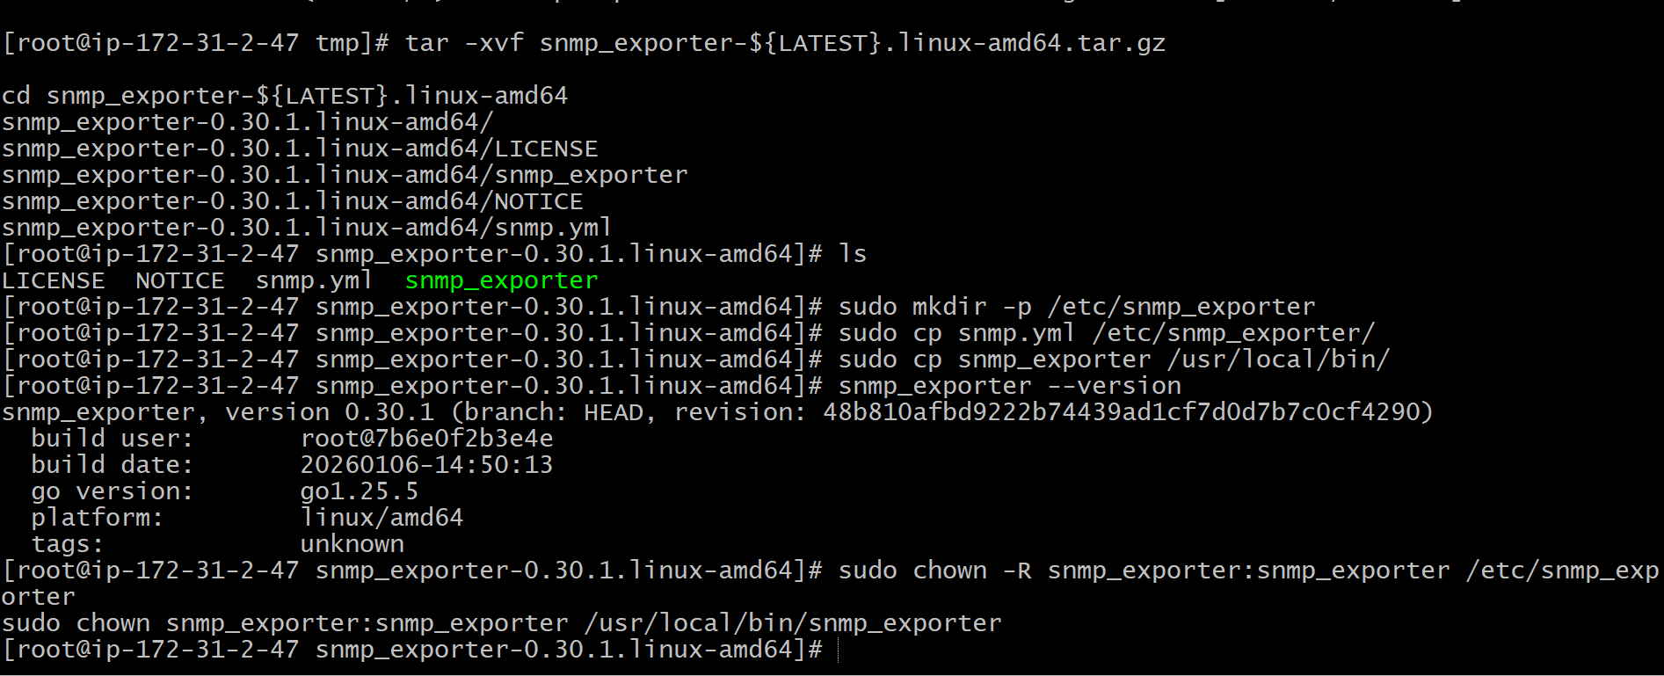
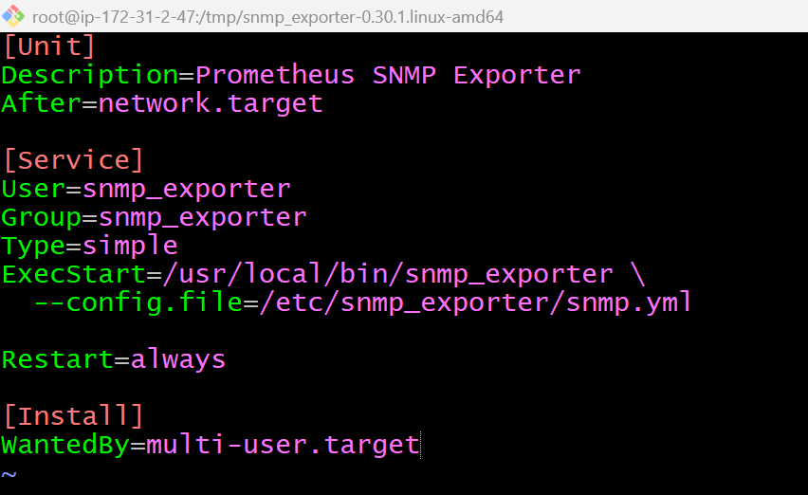
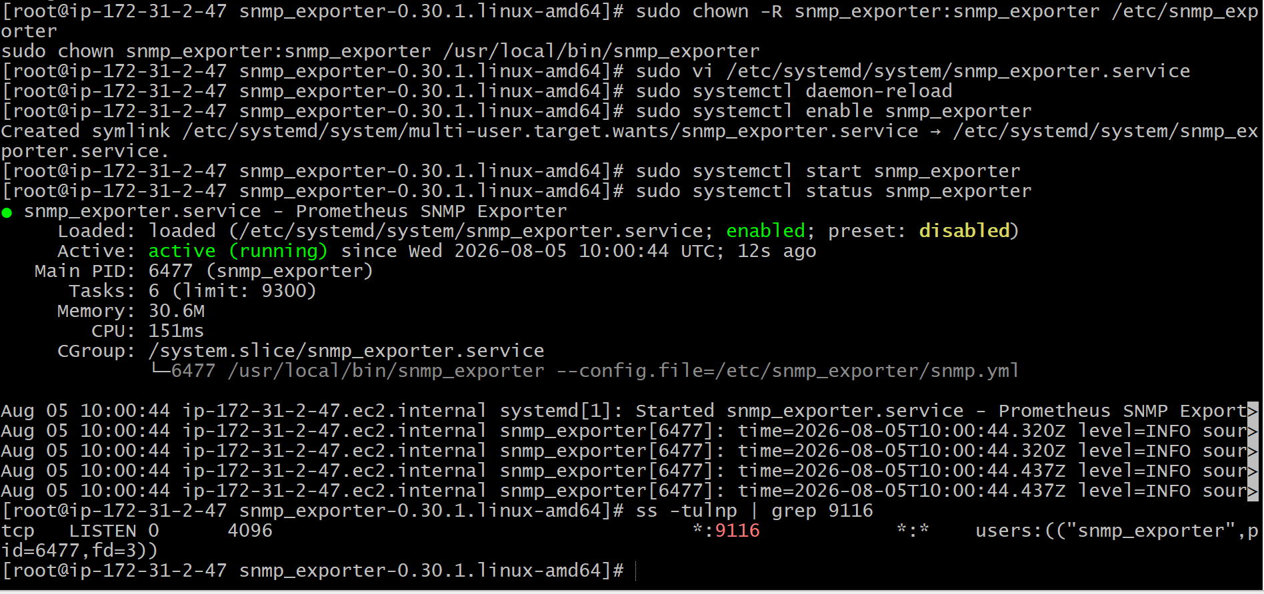

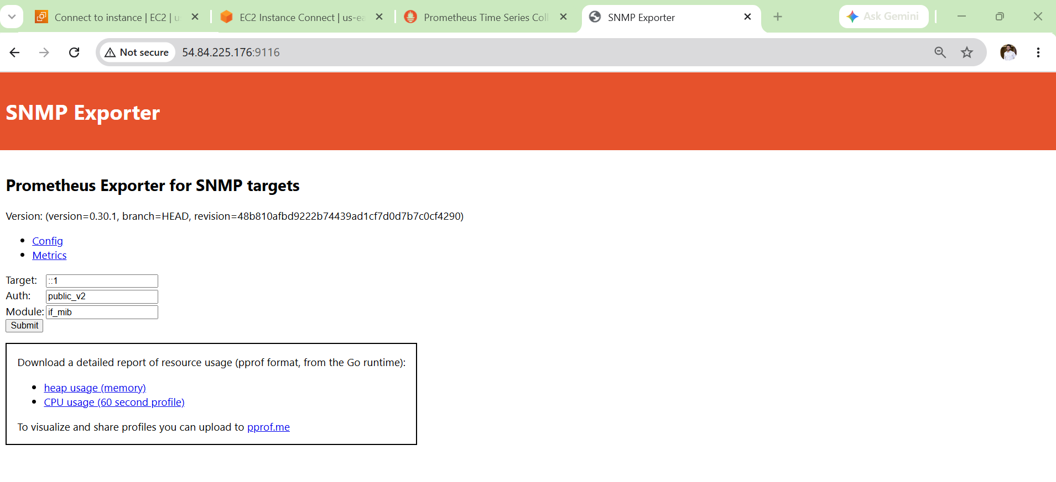
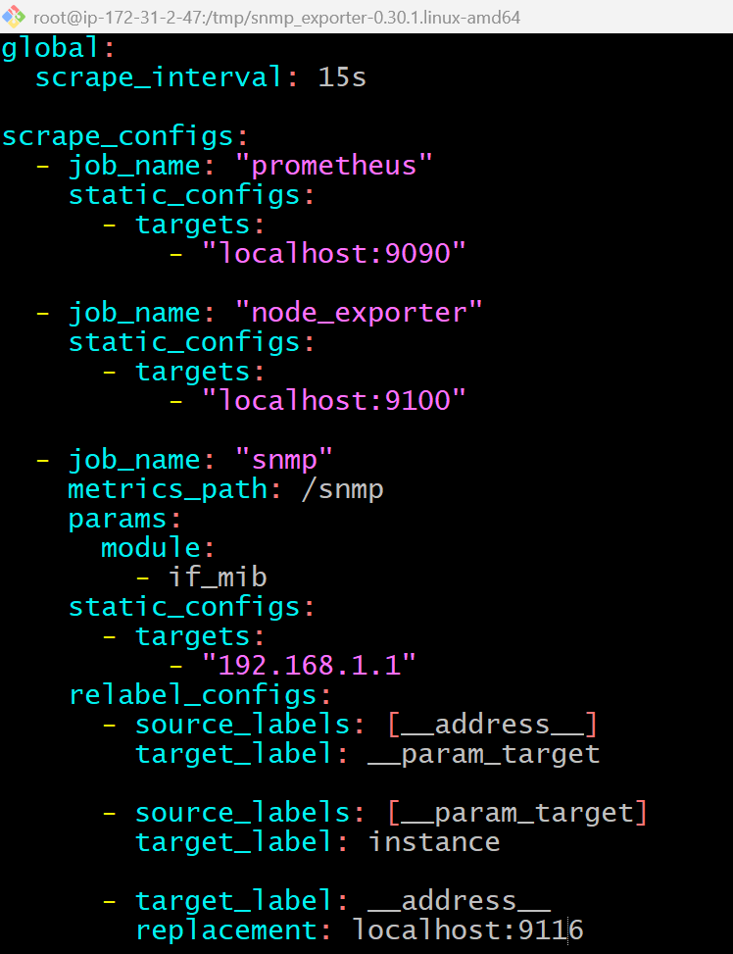
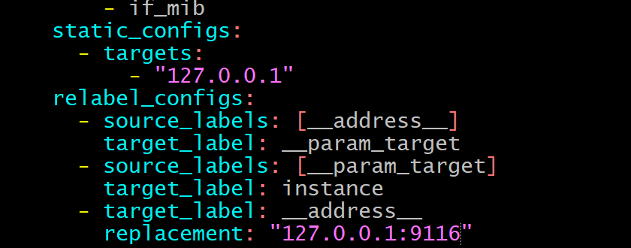

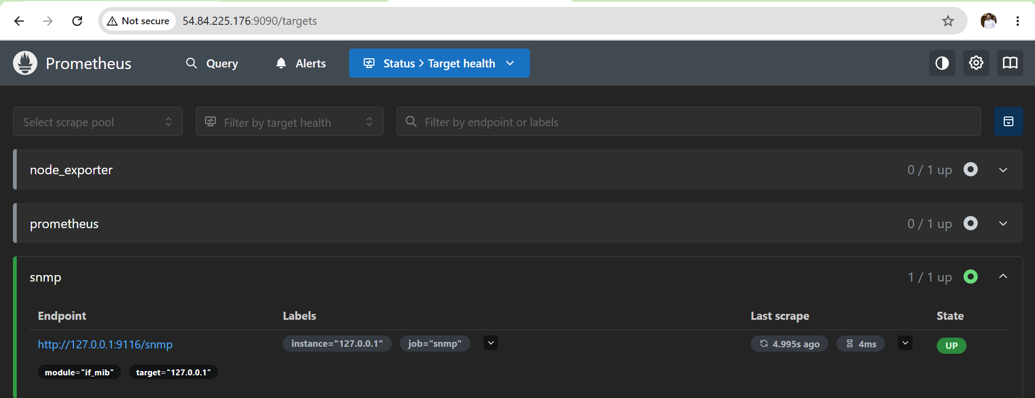
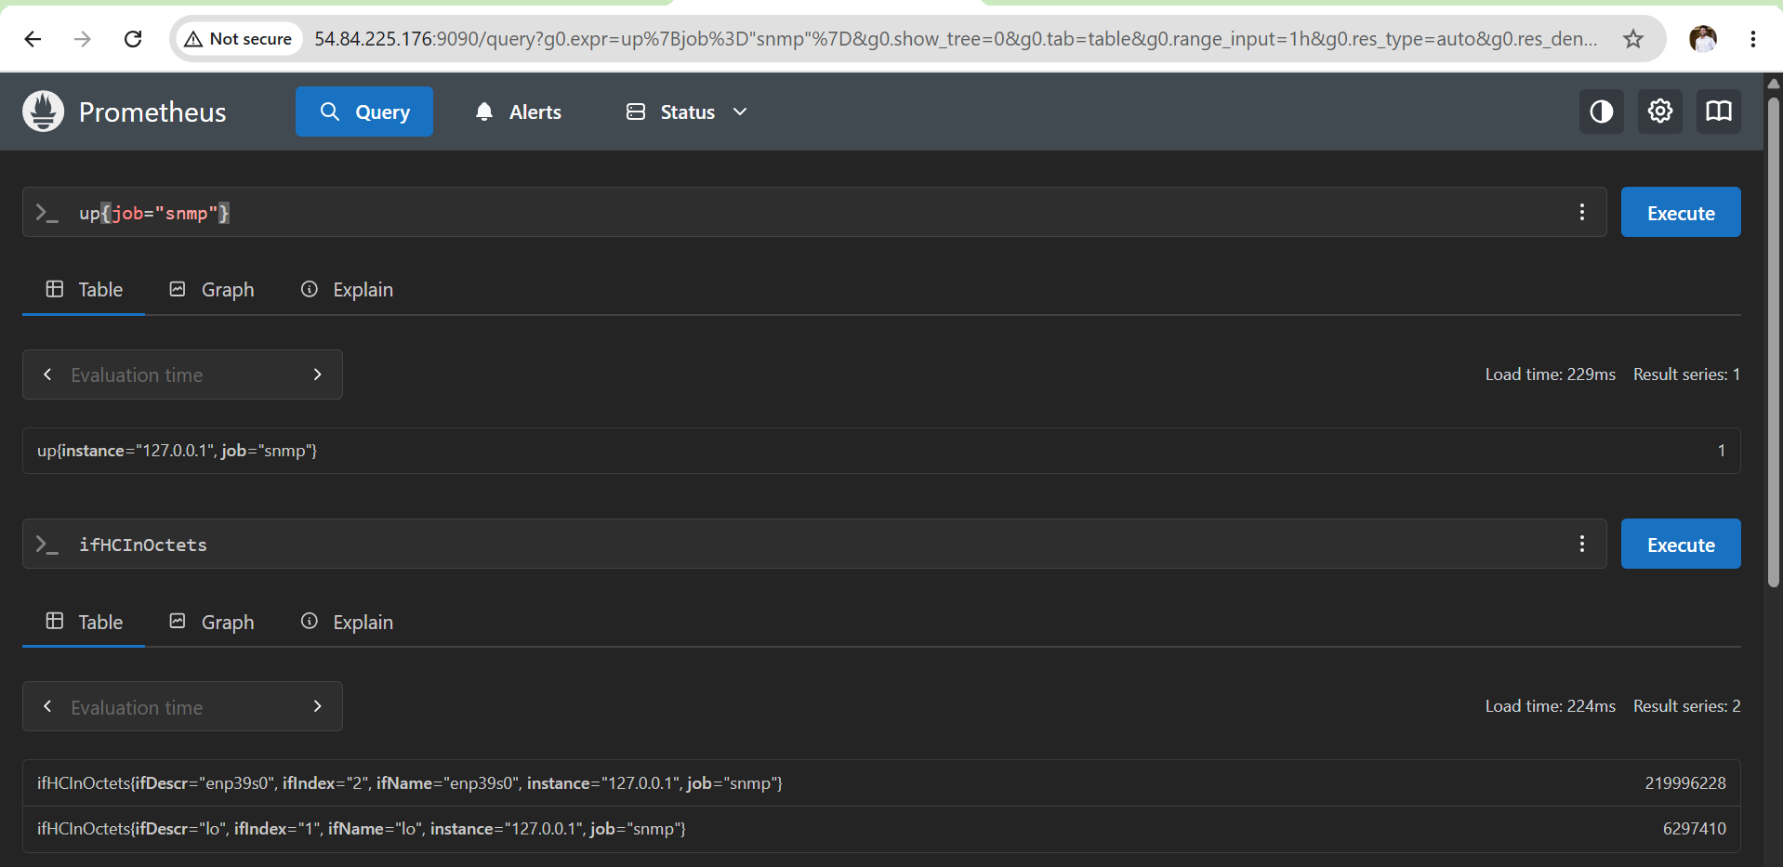
Outcome
After completing Task 3:
- SNMP Exporter is installed.
- It runs as a systemd service.
- Prometheus can scrape SNMP metrics.
- Network devices can be monitored through Prometheus.
- The monitoring stack is ready for switches, routers, firewalls, UPS devices, and printers.

Task 4: Configure Prometheus as a systemd Service
Objective
Configure Prometheus as a systemd service so it starts automatically when the server boots, can be managed using systemctl, and runs in the background like a production service.
What is systemd?
systemd is the default service manager in Linux.
Instead of starting Prometheus manually:
/usr/local/bin/prometheus \
--config.file=/etc/prometheus/prometheus.yml \
--storage.tsdb.path=/var/lib/prometheus
You will use:
sudo systemctl start prometheus
Benefits:
- Automatically starts after server reboot
- Easier service management
- Automatic restart on failure
- Centralized logging using journalctl
- Production-ready approach
Steps for Documentation (Single-Line Points)
- Created a systemd service for Prometheus.
- Configured Prometheus to use the existing configuration and data directories.
- Enabled the service for automatic startup on boot.
- Started and validated the Prometheus service.
- Verified Prometheus health endpoint and listening port.
- Confirmed service status and automatic startup configuration.
- Accessed the Prometheus web UI and verified monitoring targets.

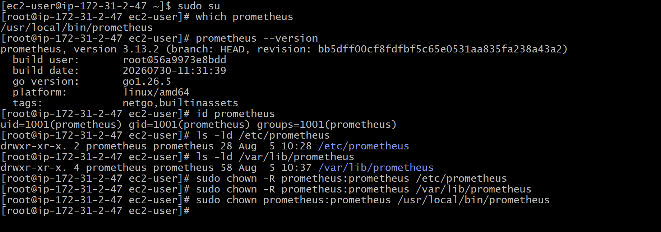
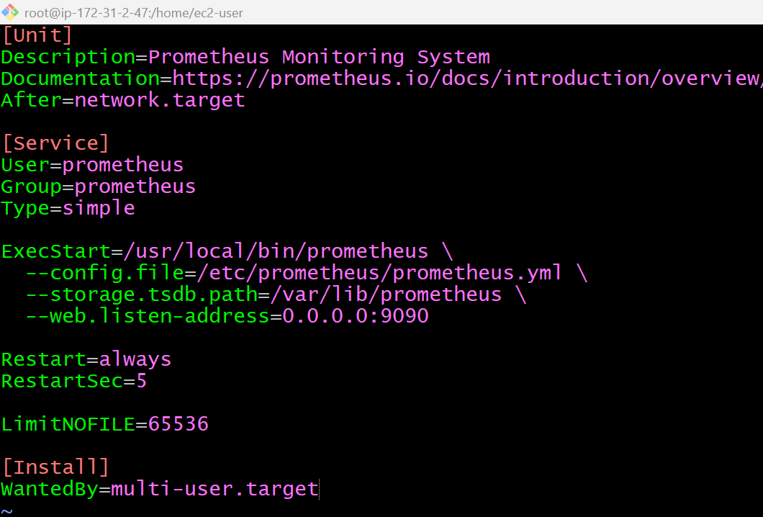
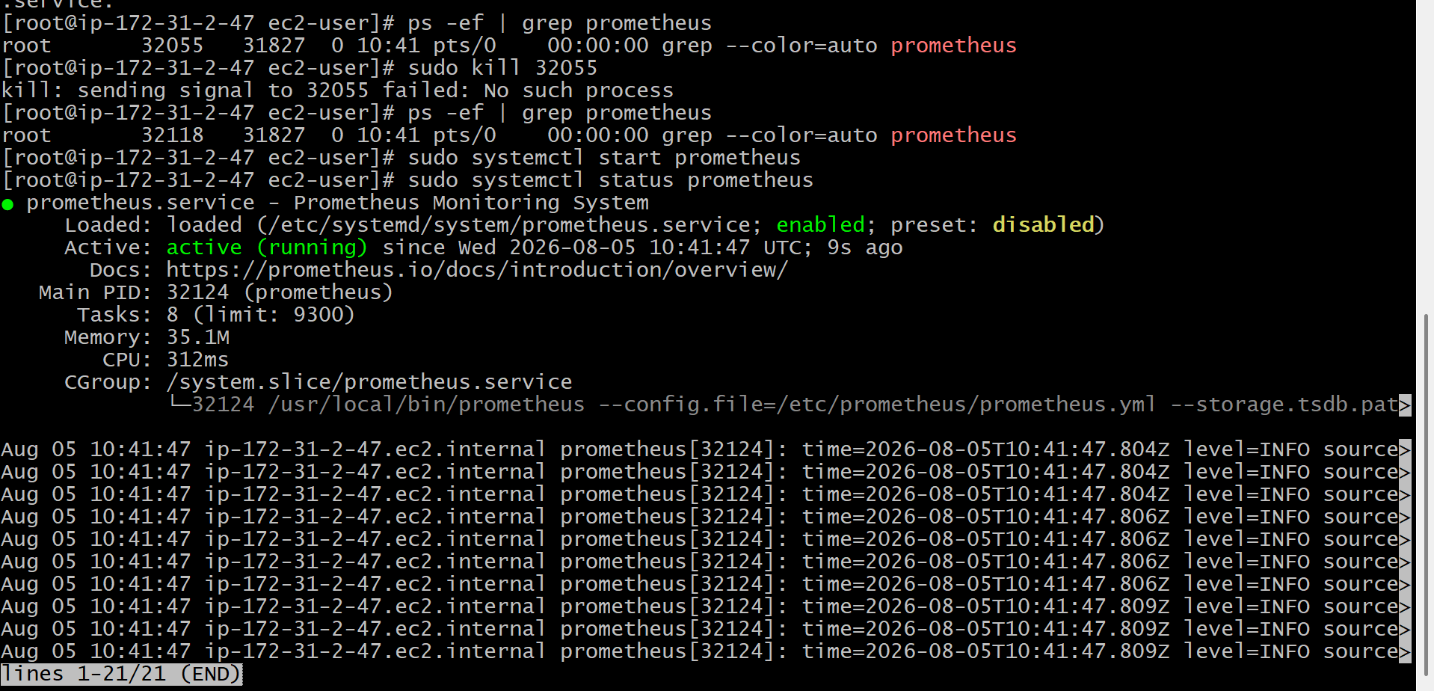
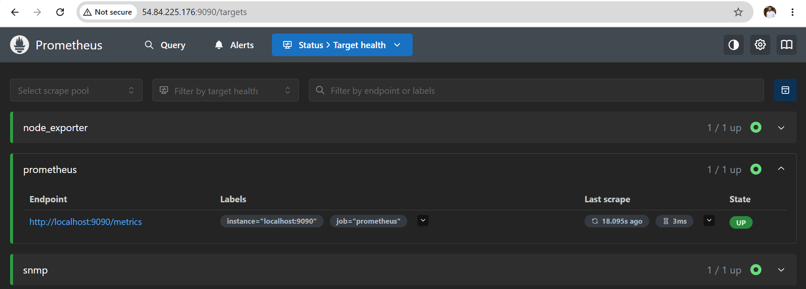
Outcome
After completing this task:
- Prometheus runs as a systemd service.
- Prometheus starts automatically after every reboot.
- Service can be managed using systemctl.
- Logs are available through journalctl.
- Manual start commands are no longer required.
- The setup follows production best practices.

Task 5: Install Alert manager and Configure an Email Alert
Objective
Install Alert manager, configure it as a systemd service, integrate it with Prometheus, and send email notifications whenever an alert is triggered.
What is Alert manager?
Alert manager is a component of the Prometheus ecosystem that receives alerts from Prometheus and sends notifications through different channels.
Supported notification channels include:
- Email
- Slack
- Microsoft Teams
- PagerDuty
- Discord
- Telegram
- Webhooks
Stpes for Documentation (Single-Line Points)
- Installed Alertmanager binaries and configuration files.
- Created a dedicated alertmanager system user.
- Configured Alertmanager as a systemd service.
- Enabled and started the Alertmanager service.
- Configured SMTP email notifications.
- Integrated Prometheus with Alertmanager.
- Validated Alertmanager health and configuration.

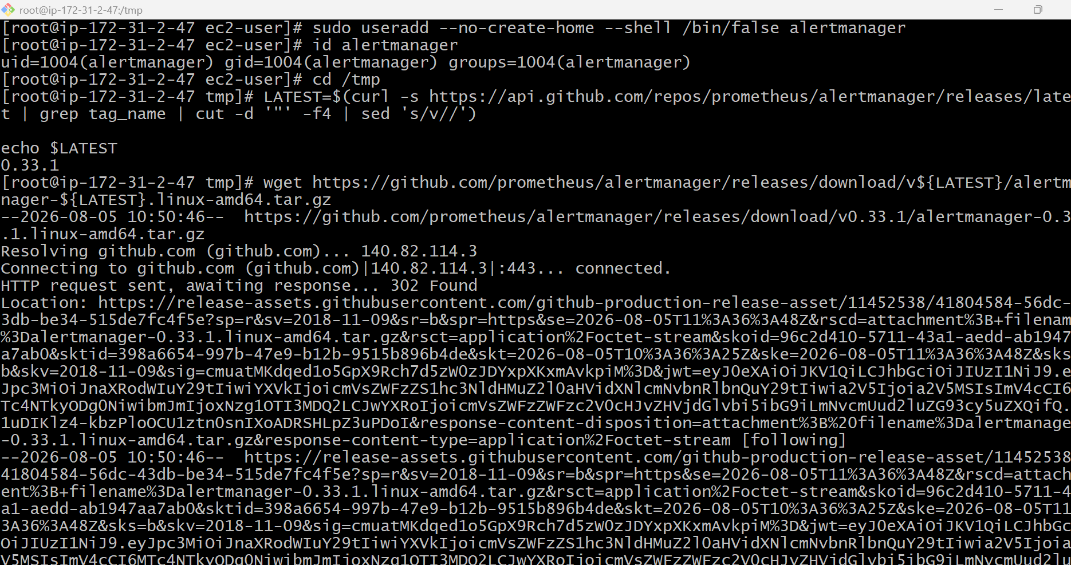
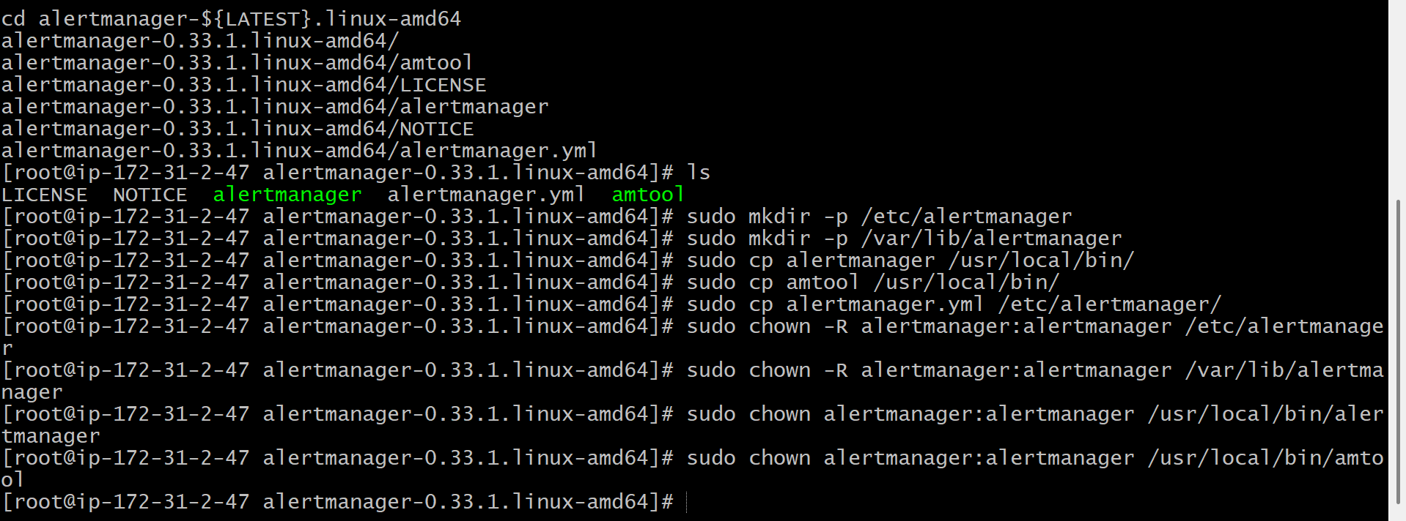
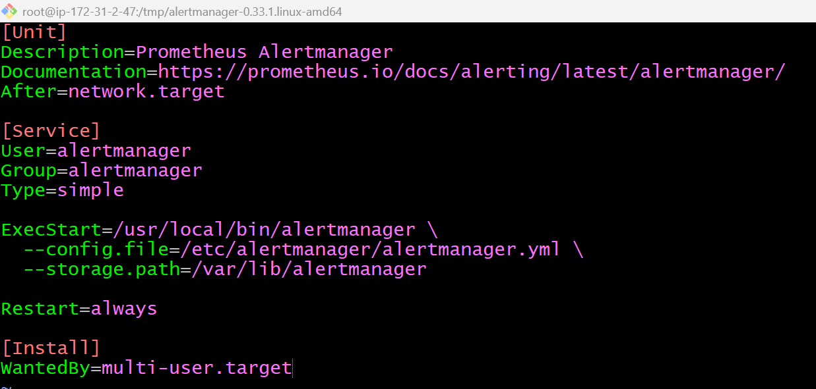
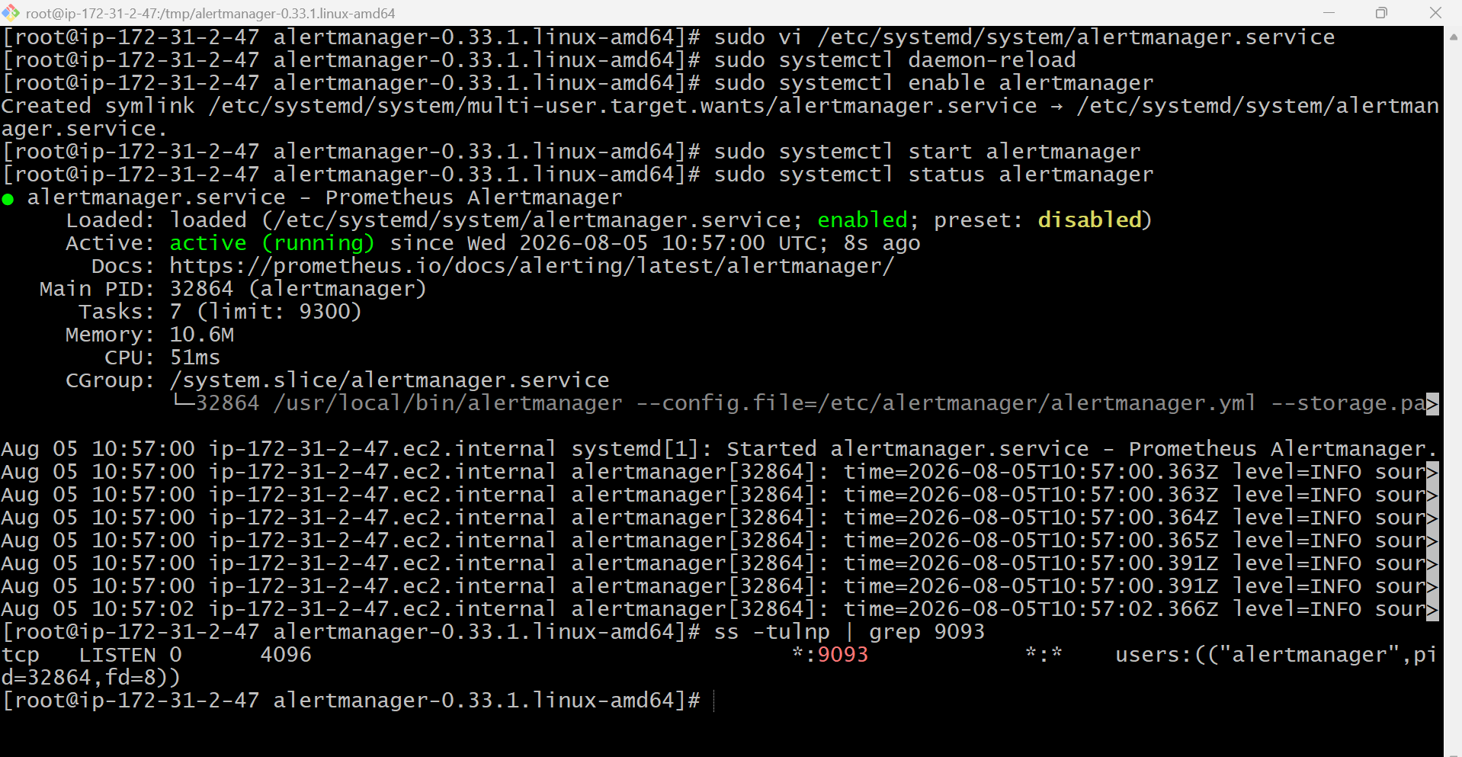
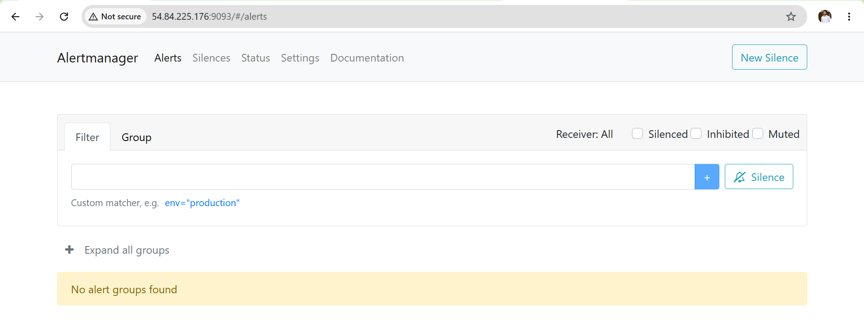
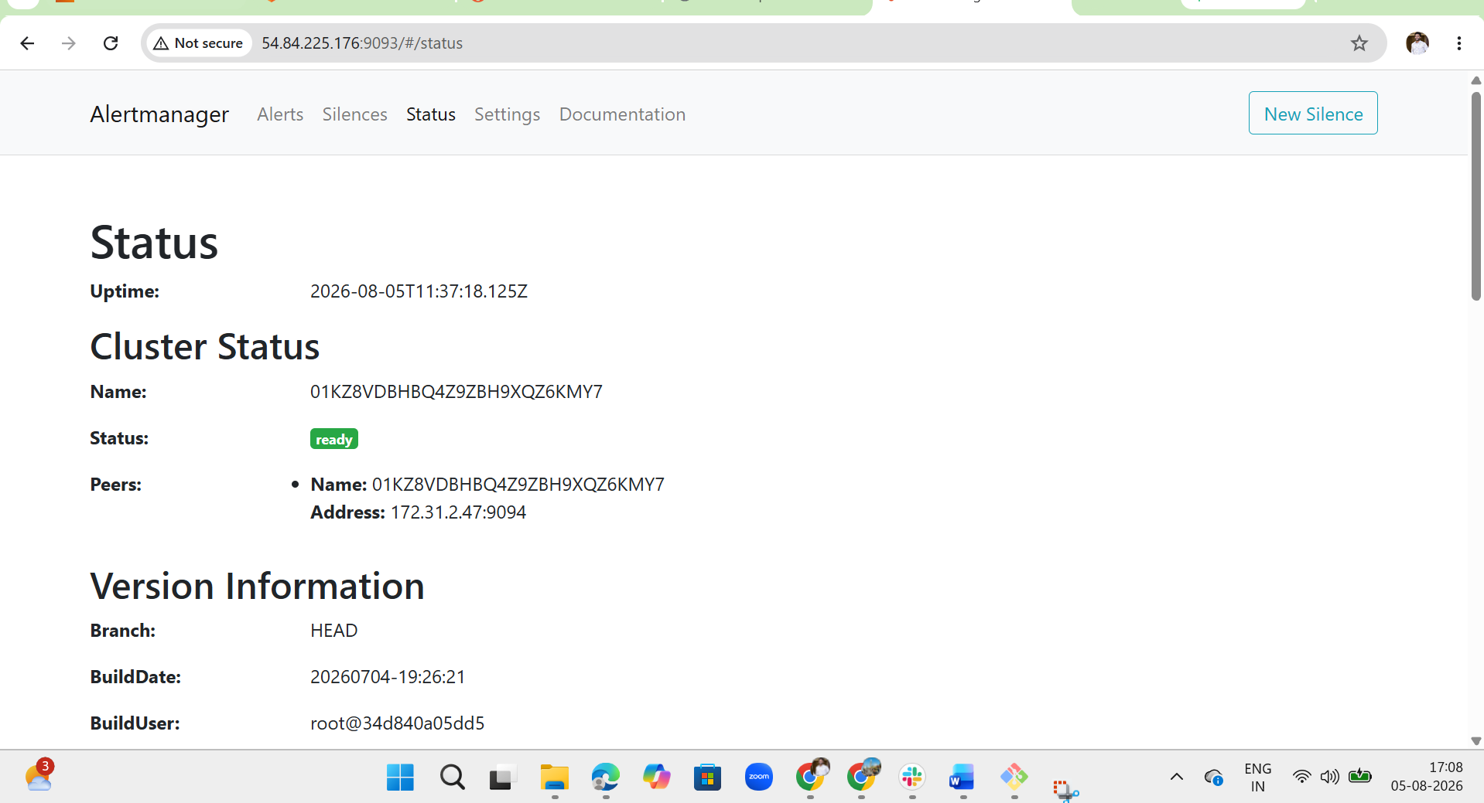
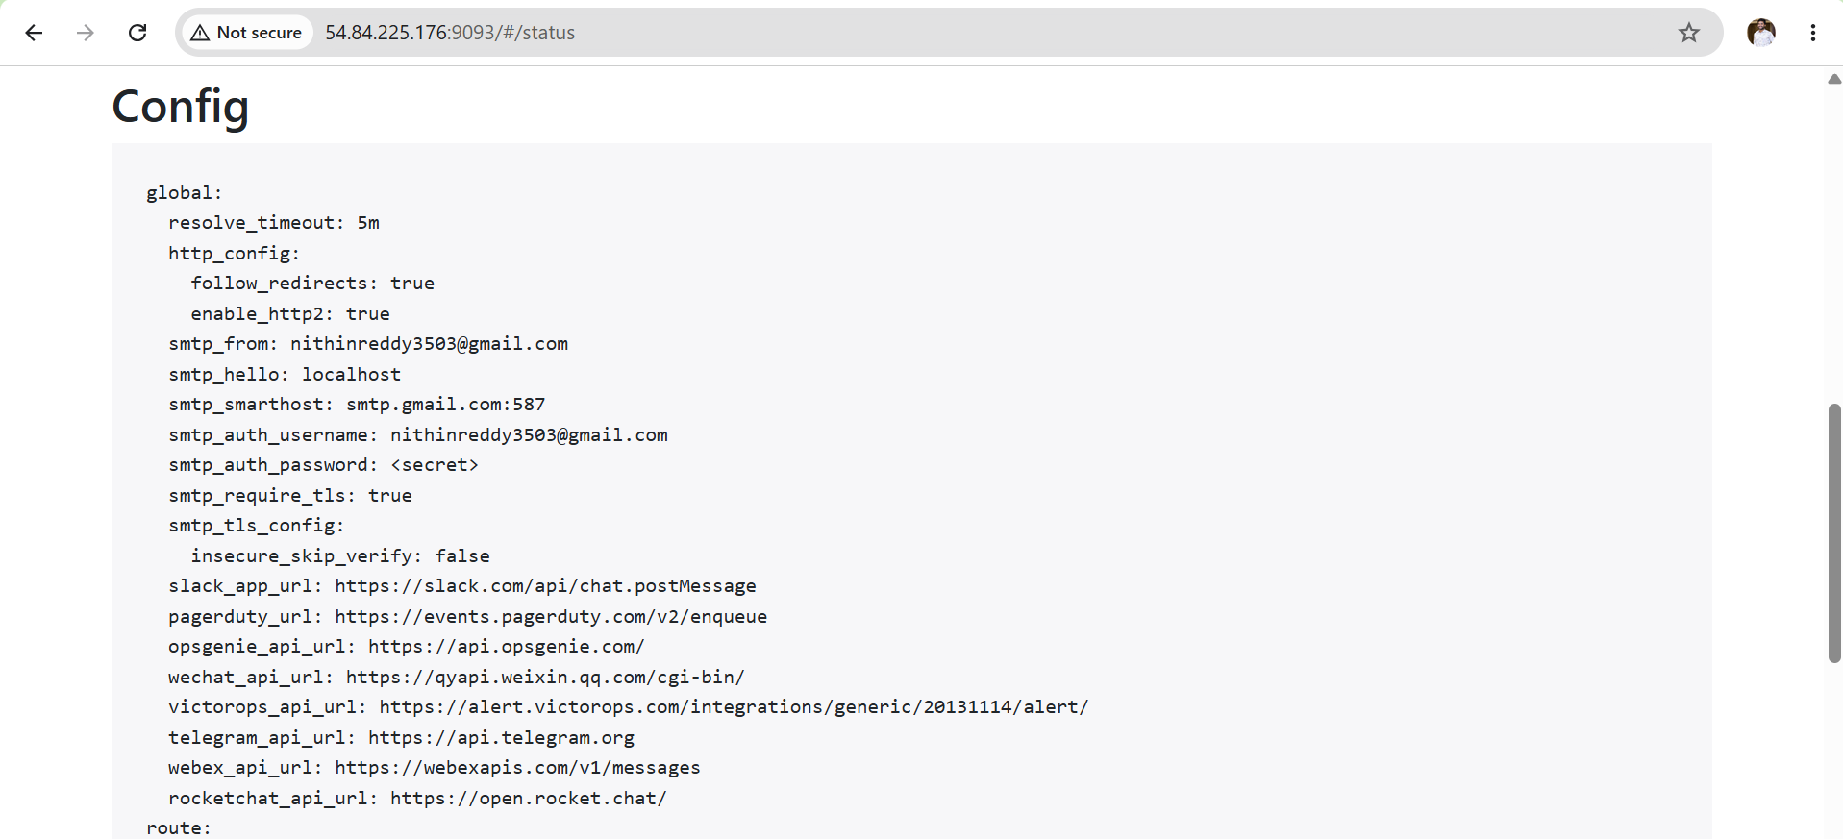
Outcome
After completing this task:
- Alertmanager is installed.
- It runs as a systemd service.
- Prometheus is configured to send alerts to Alertmanager.
- Email notification settings are configured.
- The Alertmanager web interface is accessible.

Task 6: Install Grafana and Add Prometheus as a Data Source
Objective
Install Grafana, configure it as a systemd service, access the Grafana web UI, change the default password, and connect it to Prometheus as the primary data source for creating dashboards.
What is Grafana?
Grafana is an open-source visualization and monitoring platform used to display metrics collected by monitoring systems like Prometheus.
It helps convert raw metrics into:
- Interactive Dashboards
- Graphs
- Gauges
- Heatmaps
- Tables
- Alerts
Prerequisites
- Prometheus installed and running
- Node Exporter configured
- Internet access
- Root/Sudo privileges
- EC2 Security Group allows TCP Port 3000
Steps for Documentation (Single-Line Points)
- Installed Grafana using the official repository.
- Enabled and started the Grafana service.
- Verified Grafana service status and port 3000.
- Accessed the Grafana web interface and changed the default password.
- Added Prometheus as a data source.
- Verified connectivity using Save & Test.
- Queried Prometheus metrics from Grafana.
- Imported the Node Exporter Full dashboard (ID: 1860) to visualize system metrics.

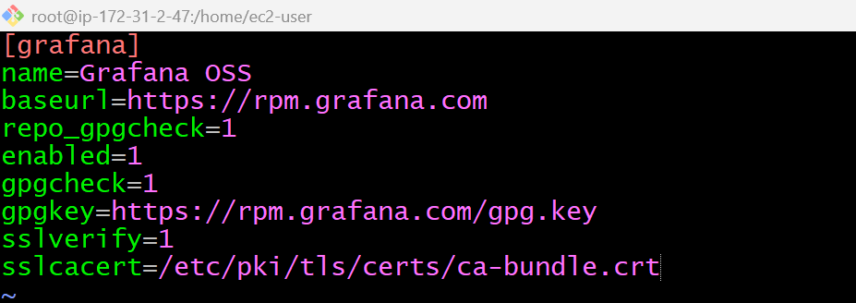
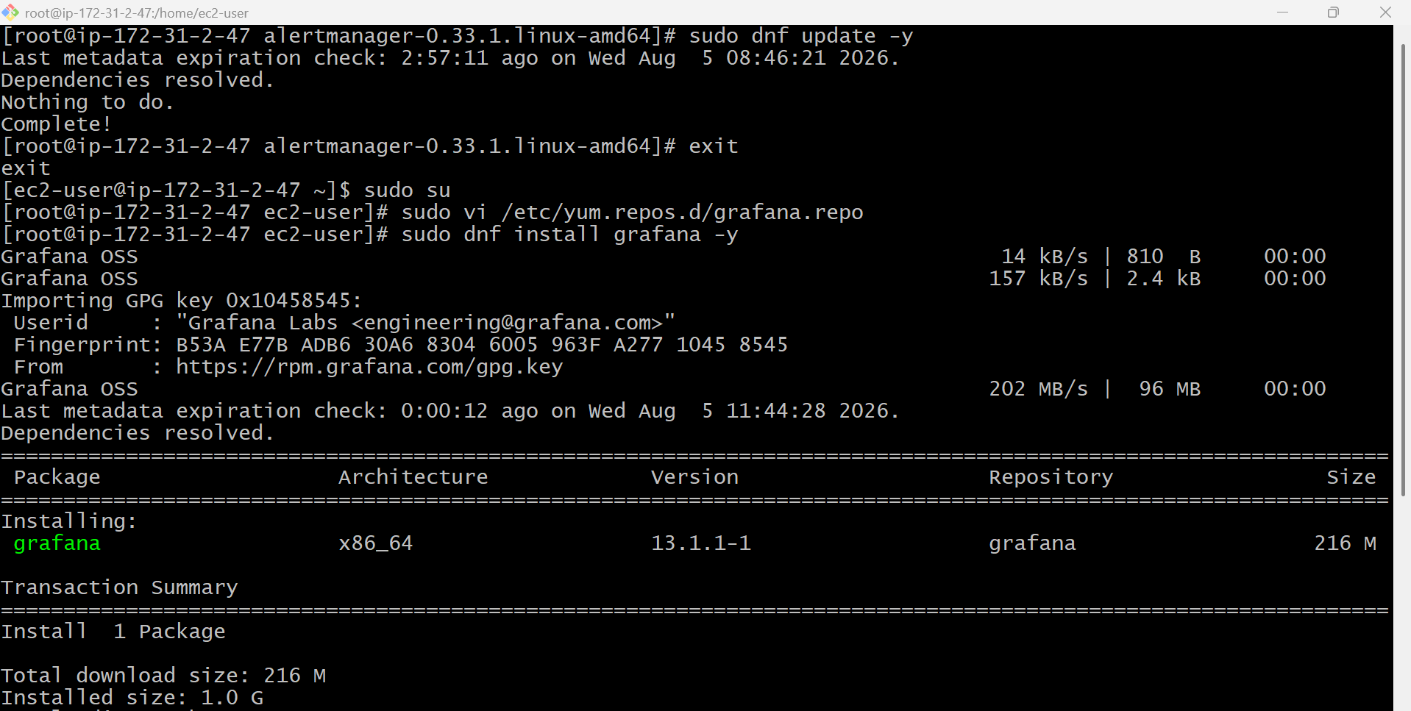
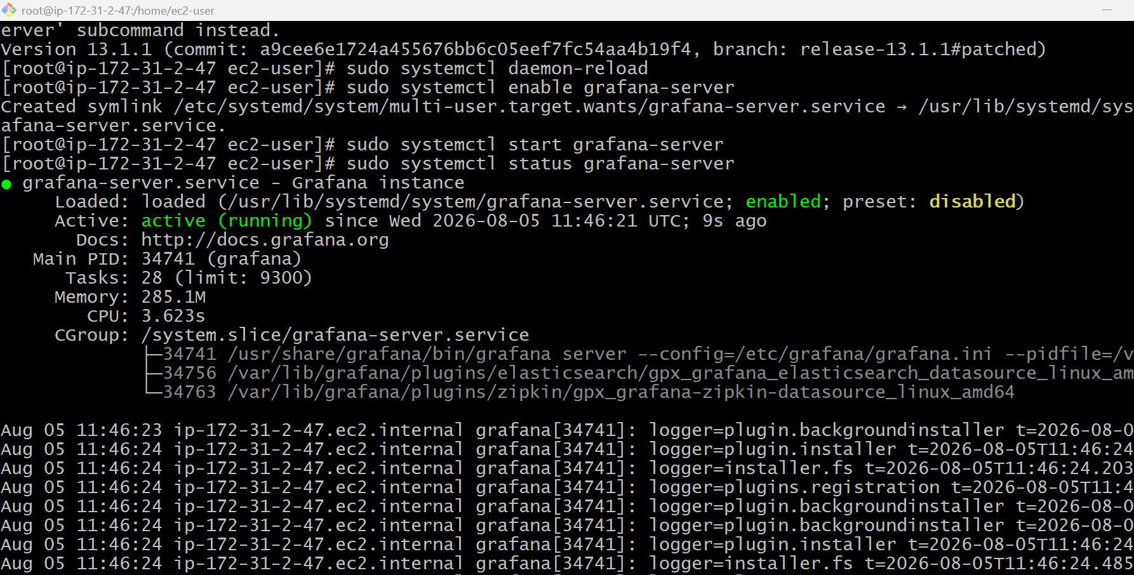
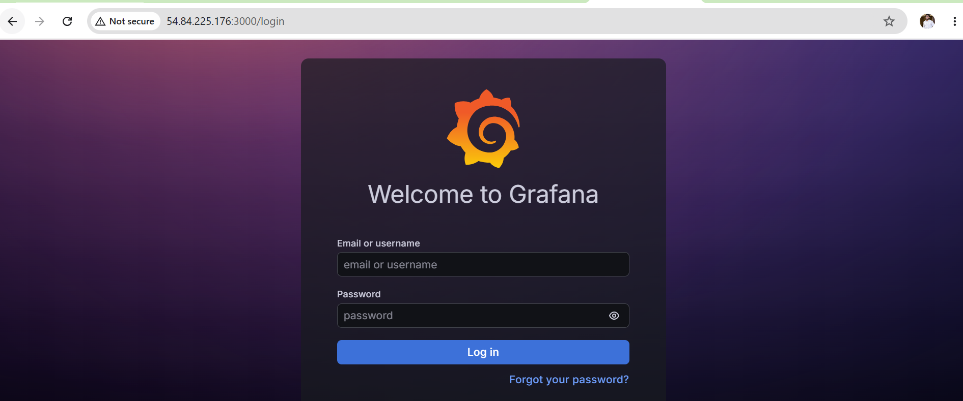
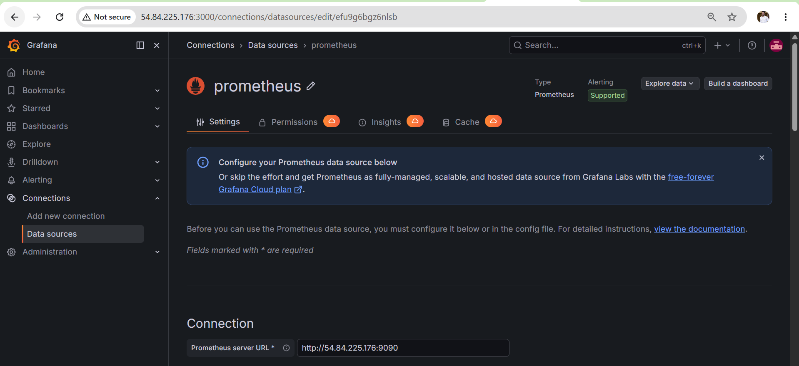
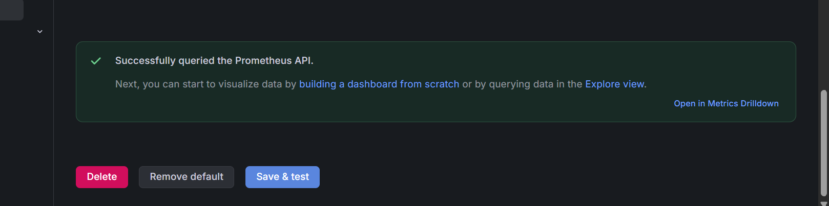
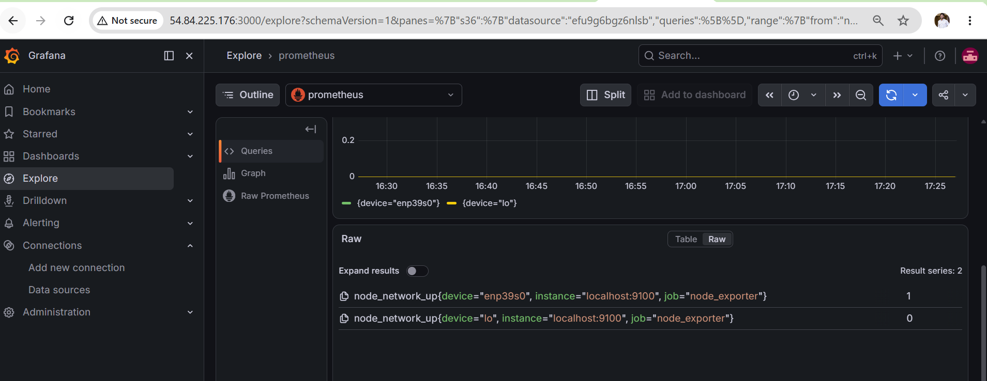
Outcome
After completing this task:
- Grafana is installed and running as a systemd service.
- Grafana starts automatically on system boot.
- Prometheus is configured as a data source.
- Grafana successfully retrieves metrics from Prometheus.
- A Node Exporter dashboard is imported and displays system metrics.

Task 7: Configure Prometheus for Service Discovery of Dynamic Targets

Objective
Configure Prometheus Service Discovery so it can automatically discover new targets (servers, containers, Kubernetes pods, EC2 instances, etc.) without manually updating prometheus.yml.

What is Service Discovery?
Normally, Prometheus monitors targets defined manually:
targets:
- localhost:9090
- localhost:9100
If a new server is added, you must edit prometheus.yml and restart Prometheus.
With Service Discovery, Prometheus automatically finds new targets.

Why Service Discovery?
Without Service Discovery:
Server1 Added → Edit prometheus.yml → Restart Prometheus
With Service Discovery:
Server1 Added
│
▼
Prometheus Automatically Detects
│
▼
Monitoring Starts
No manual changes are required.

Types of Service Discovery
Prometheus supports many discovery mechanisms:
- Static Configuration
- File-Based Service Discovery
- Kubernetes Service Discovery
- EC2 Service Discovery
- Consul
- DNS Service Discovery
- Docker Swarm
- Azure
- GCE (Google Cloud)
- OpenStack
Steps for Documentation (Single-Line Points)
- Created a directory for file-based service discovery.
- Configured a JSON file containing dynamic monitoring targets.
- Updated prometheus.yml to use file_sd_configs.
- Validated the Prometheus configuration using promtool.
- Restarted the Prometheus service.
- Verified automatic discovery of dynamic targets in the Prometheus Targets page.
- Confirmed dynamically discovered metrics were available in Grafana.

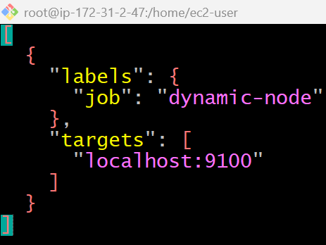
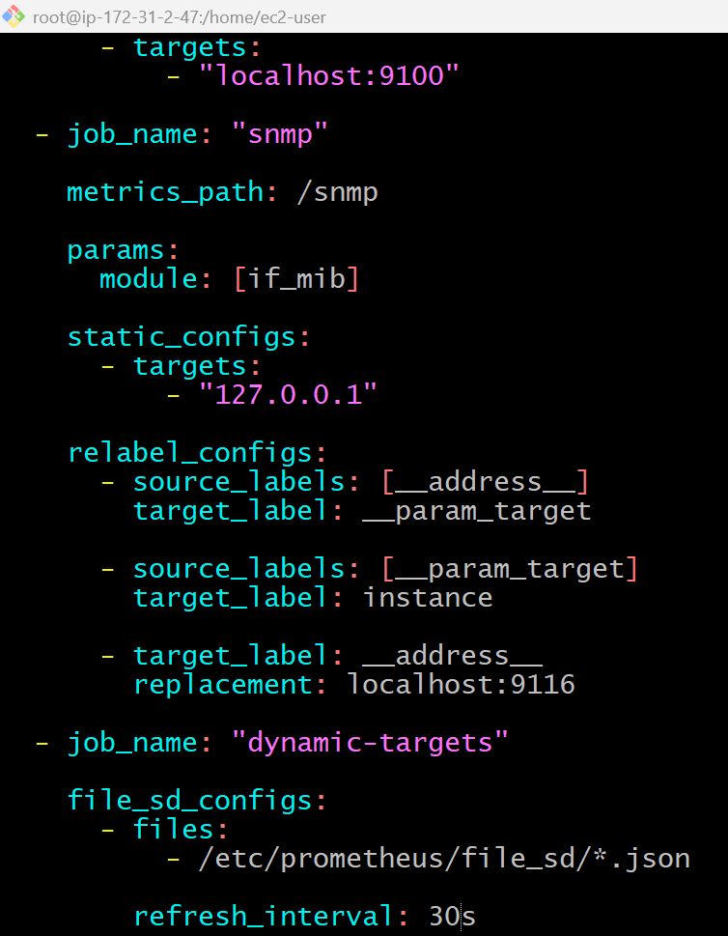

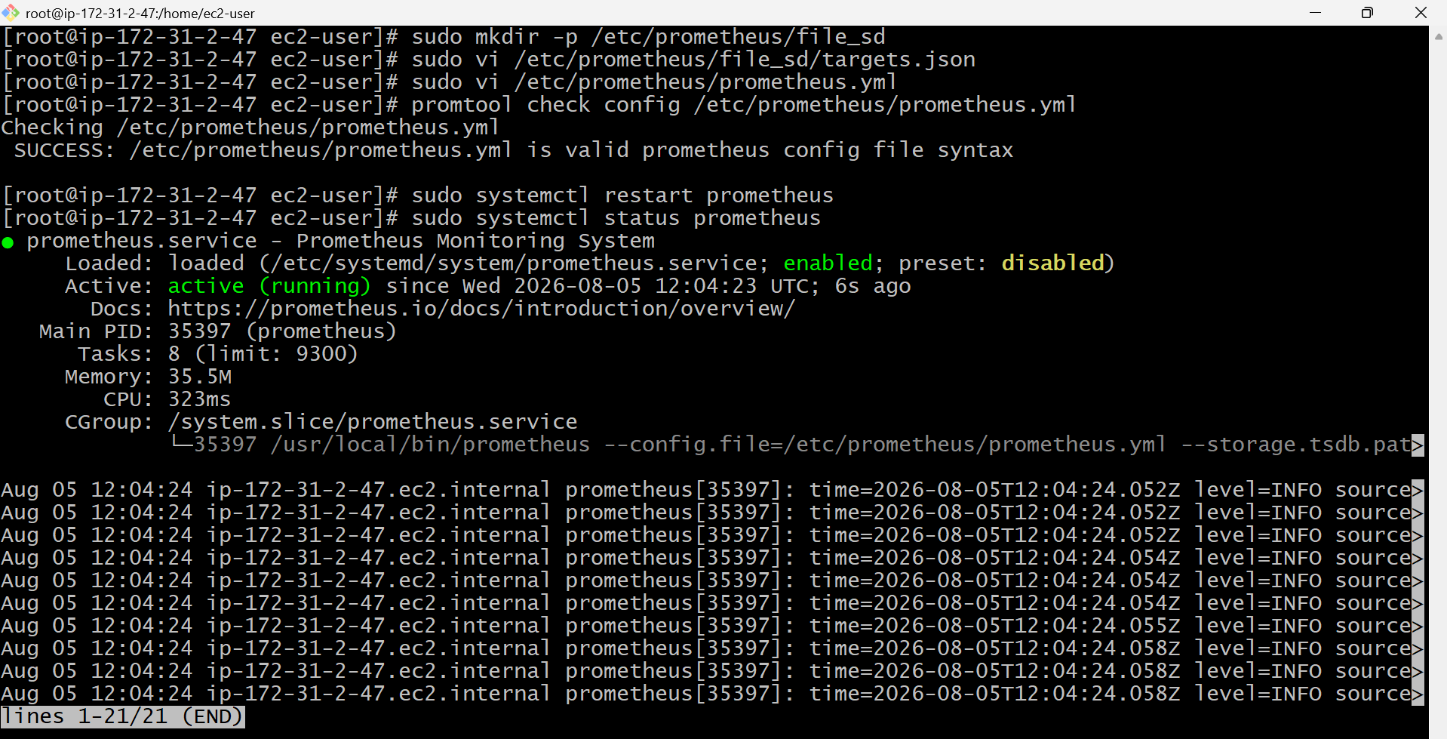
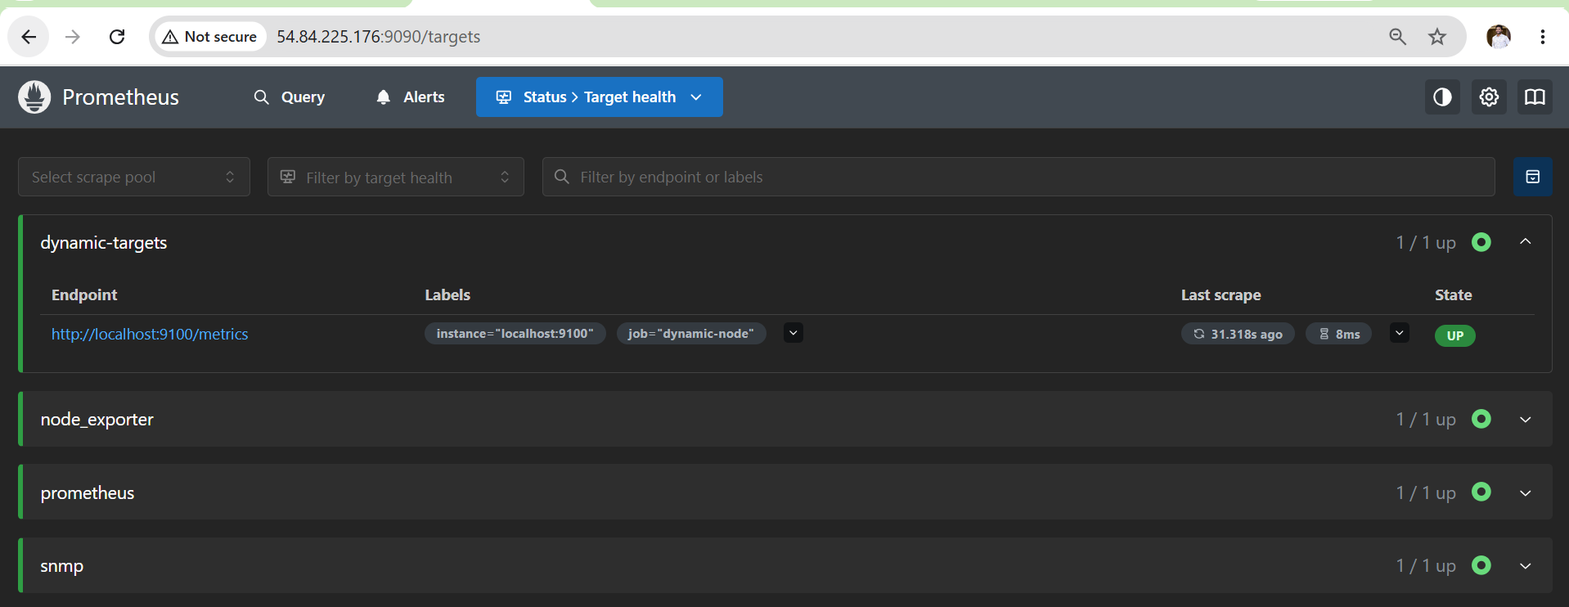
Again edit
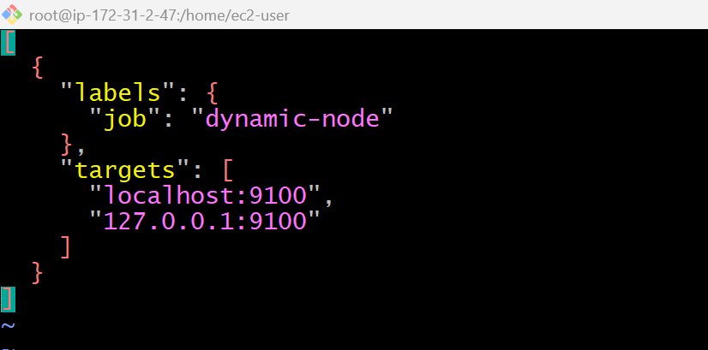

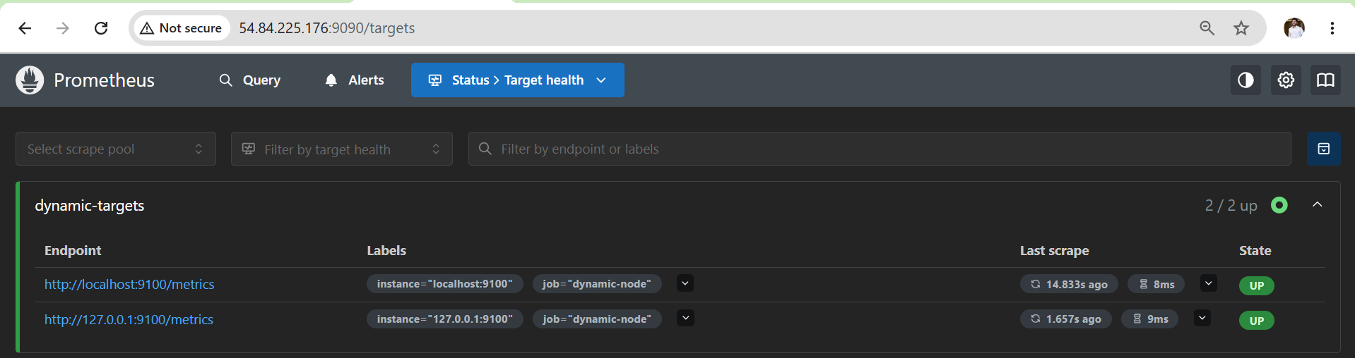
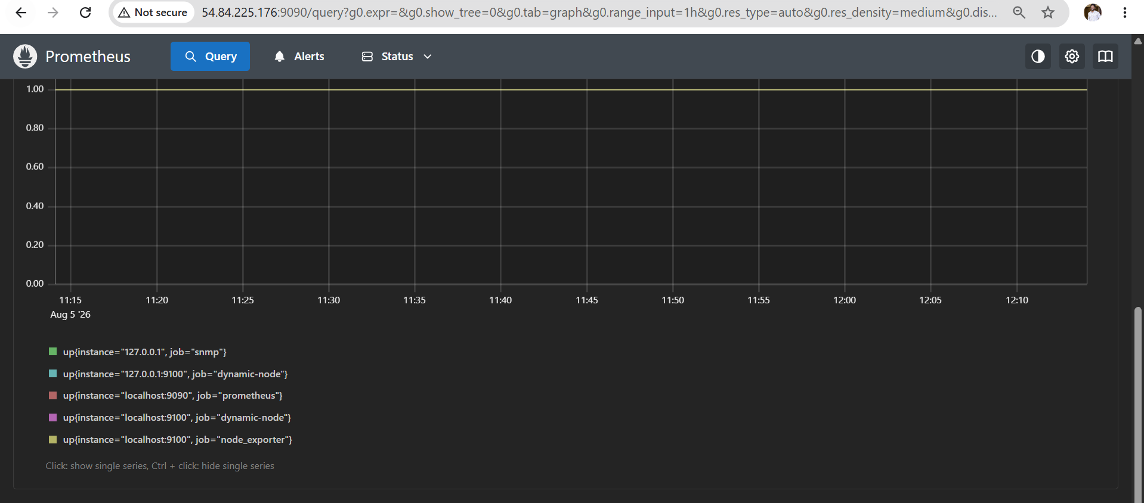
Outcome
After completing this task:
- Prometheus reads targets from a JSON file.
- New targets are discovered automatically without editing prometheus.yml.
- Dynamic targets appear in the Prometheus Targets page.
- Grafana can query metrics from dynamically discovered targets.

Task 8: Create Alerting Rules for Monitoring Disk Space

Objective
Create a Prometheus alert rule that monitors disk space usage using Node Exporter metrics. When available disk space falls below a specified threshold, Prometheus will trigger an alert and send it to Alertmanager, which can then send an email notification.
Prerequisites
- ✅ Prometheus installed
- ✅ Node Exporter installed
- ✅ Alertmanager configured
- ✅ Grafana installed
- ✅ Prometheus service running
- ✅ Node Exporter metrics available
Documentation (Single-Line Points)
- Created a custom Prometheus alert rule for disk space monitoring.
- Configured Prometheus to load rule files.
- Validated the Prometheus configuration and alert rules using promtool.
- Restarted Prometheus to apply the new configuration.
- Verified the alert in the Prometheus Rules and Alerts pages.
- Tested the alert by temporarily increasing the threshold and confirmed it entered the Firing state.
- Restored the production threshold after successful testing.

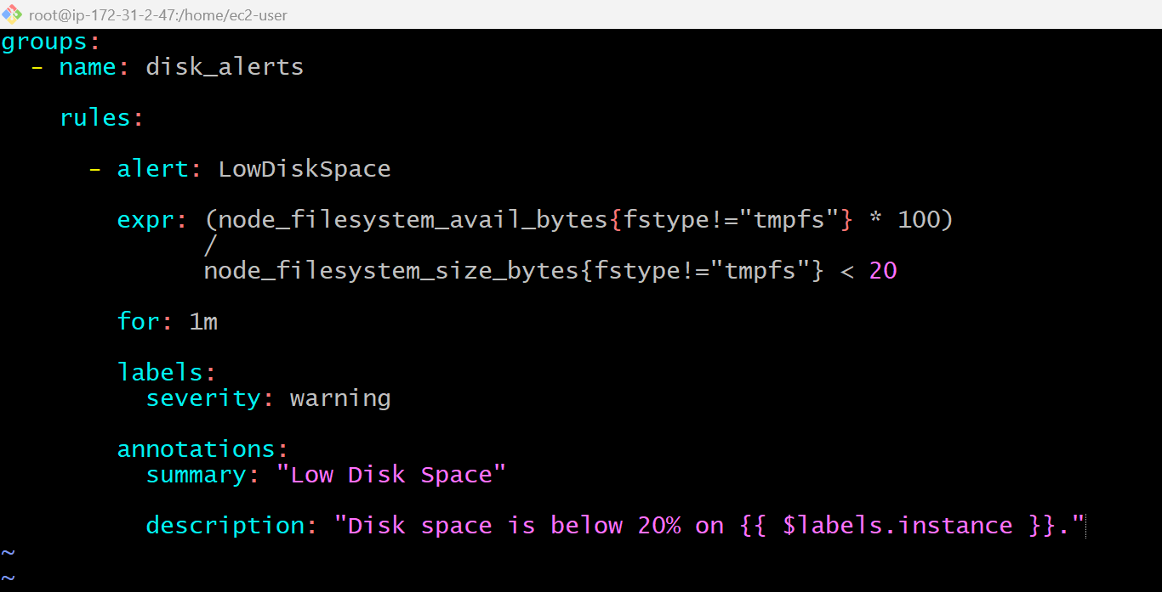
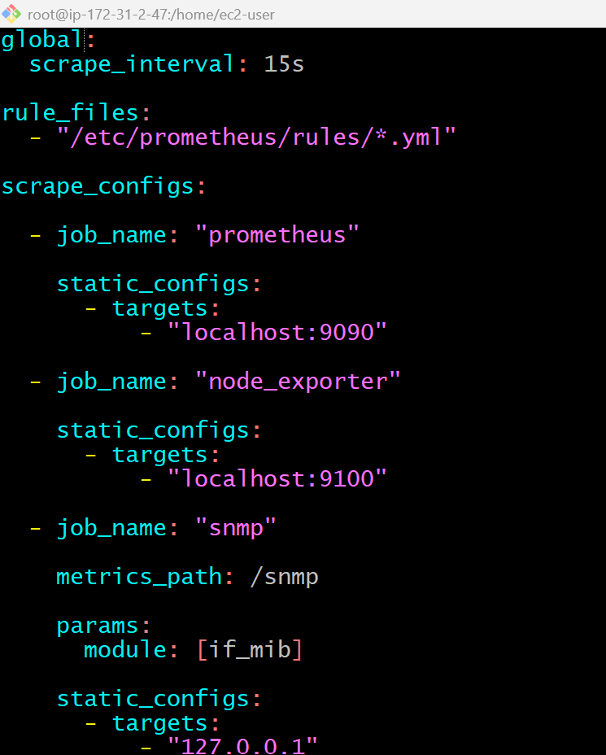
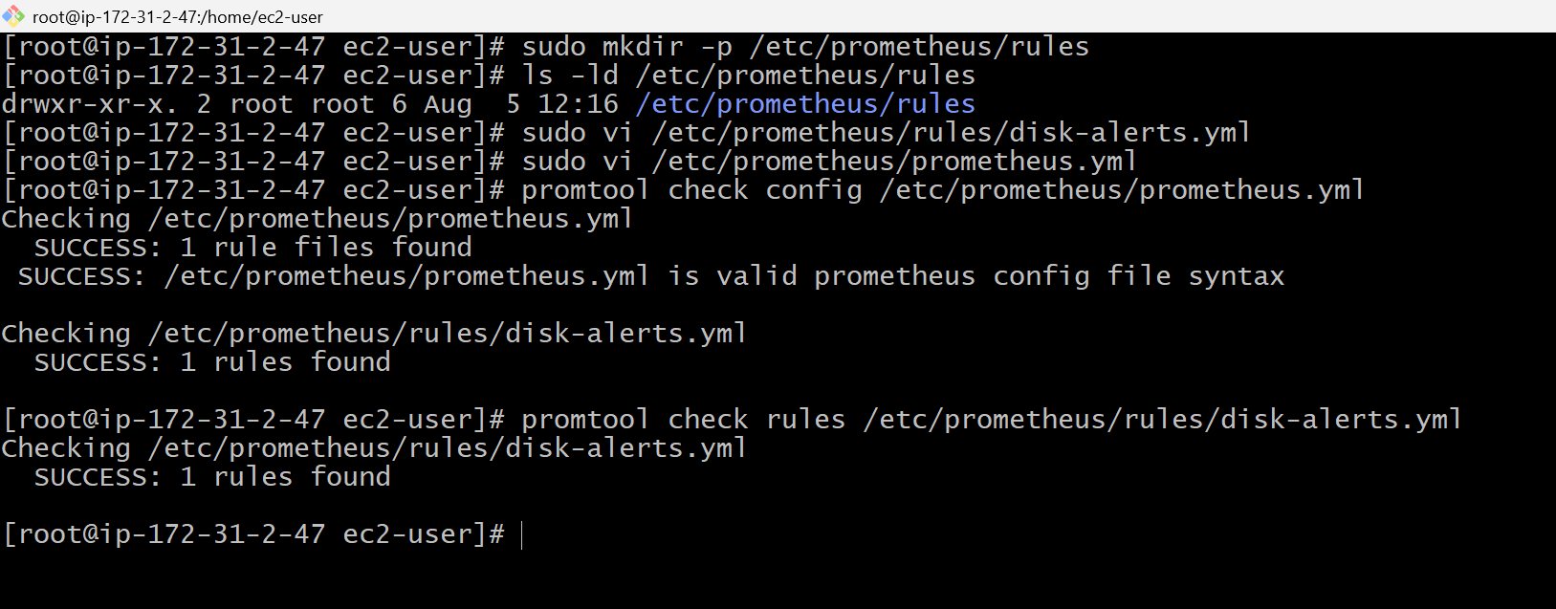

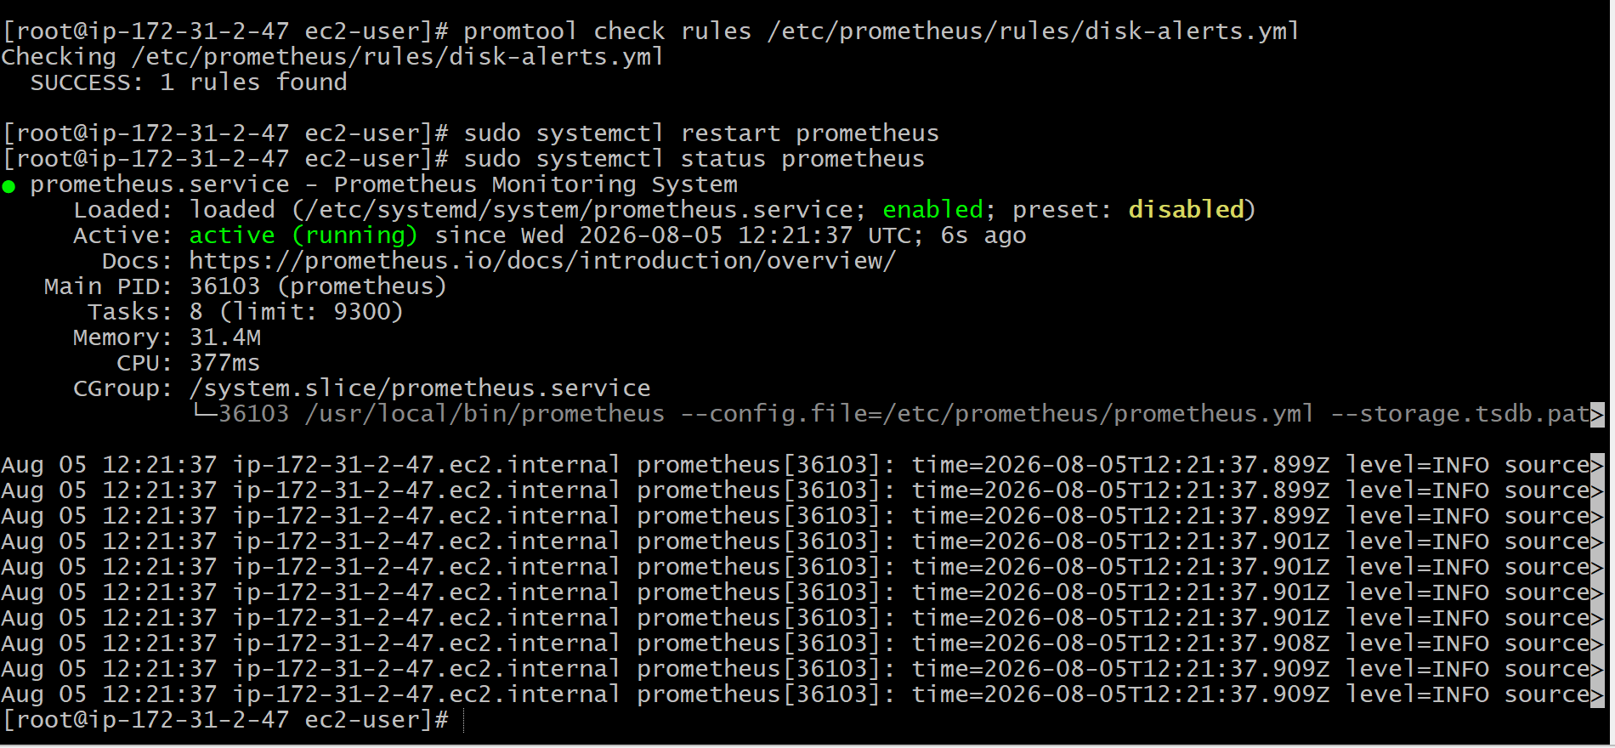
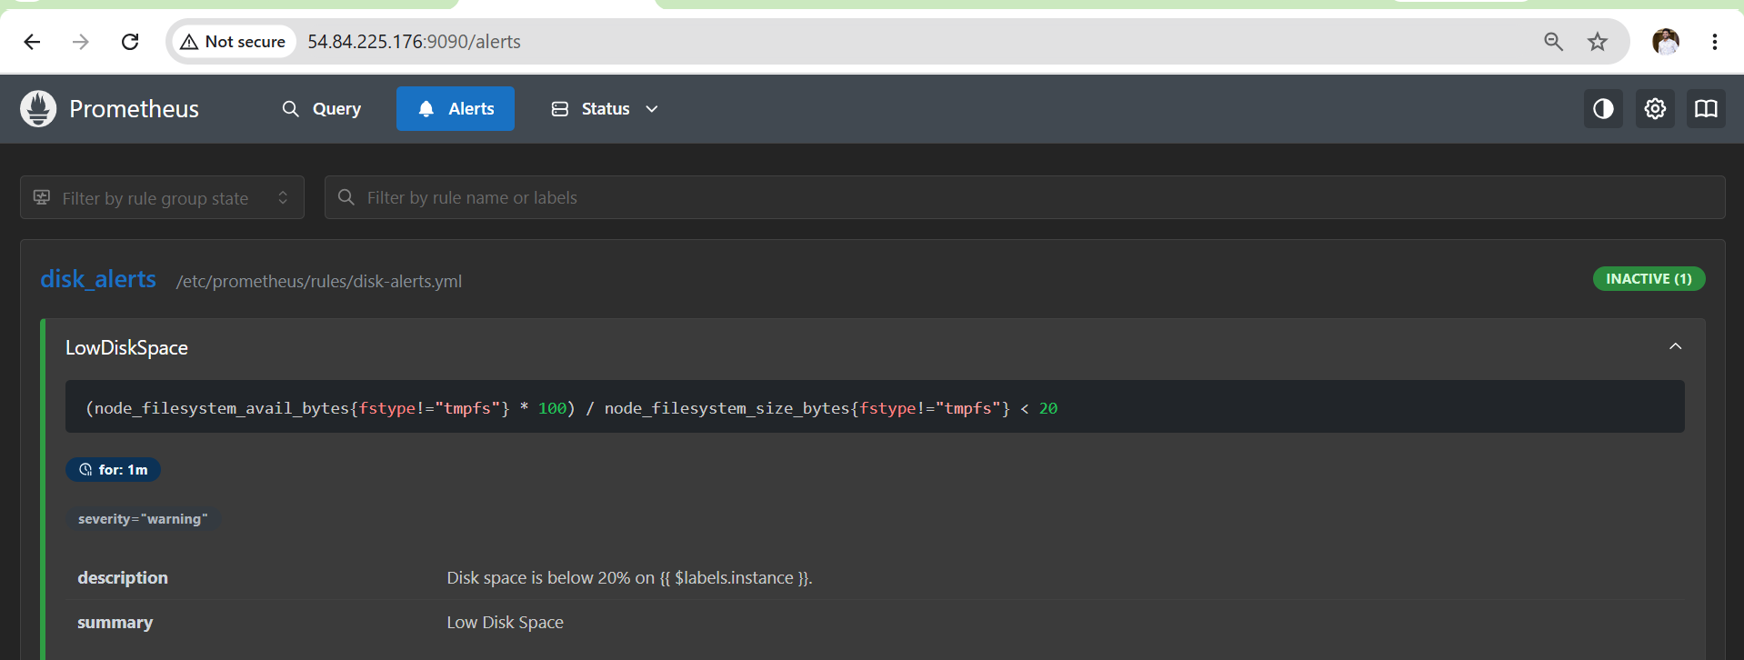
Outcome
After completing this task:
- Prometheus loads a custom alert rule.
- Disk space is continuously monitored using Node Exporter metrics.
- Alerts are triggered when available disk space falls below the configured threshold.
- Alertmanager can forward the alert to your configured email.
- You understand how to create, validate, test, and restore Prometheus alert rules.

Task 9: Create a Custom Grafana Dashboard Using Prometheus Metrics

Objective
Create a custom Grafana dashboard that visualizes real-time system metrics collected by Prometheus through Node Exporter. The dashboard will display CPU, Memory, Disk, Network, and System Uptime metrics.

What is a Grafana Dashboard?
A Grafana Dashboard is a collection of panels that display data from one or more data sources. Each panel represents a visualization such as a graph, gauge, stat, or table.
Example:
Prerequisites
- Grafana installed
- Prometheus added as Data Source
- Node Exporter running
- Prometheus Targets UP
Documentation (Single-Line Points)
- Created a custom Grafana dashboard.
- Added Prometheus as the dashboard data source.
- Configured panels for CPU, memory, disk, uptime, network, and filesystem metrics.
- Applied appropriate visualizations and units for each metric.
- Saved the dashboard for continuous monitoring.
- Verified that live Prometheus metrics were displayed correctly.
- Tested the dashboard by generating system load and observing real-time updates.
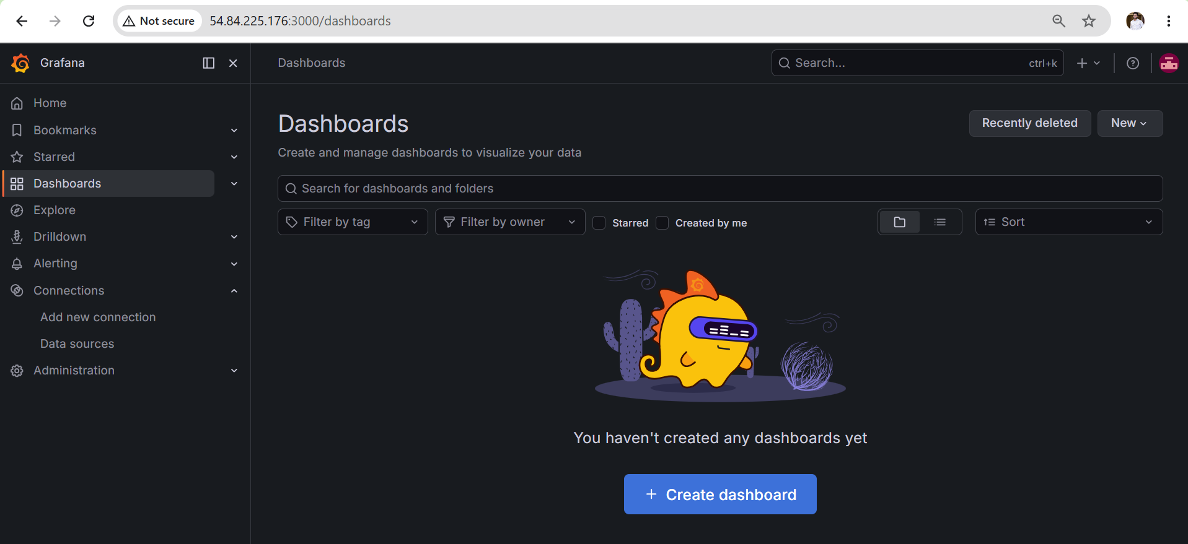
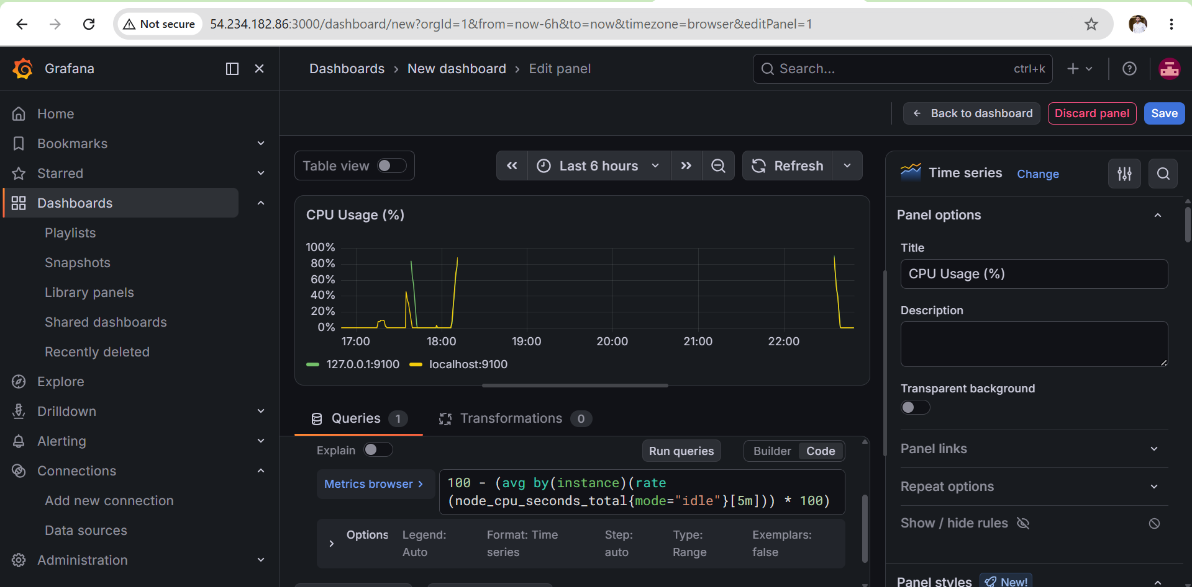
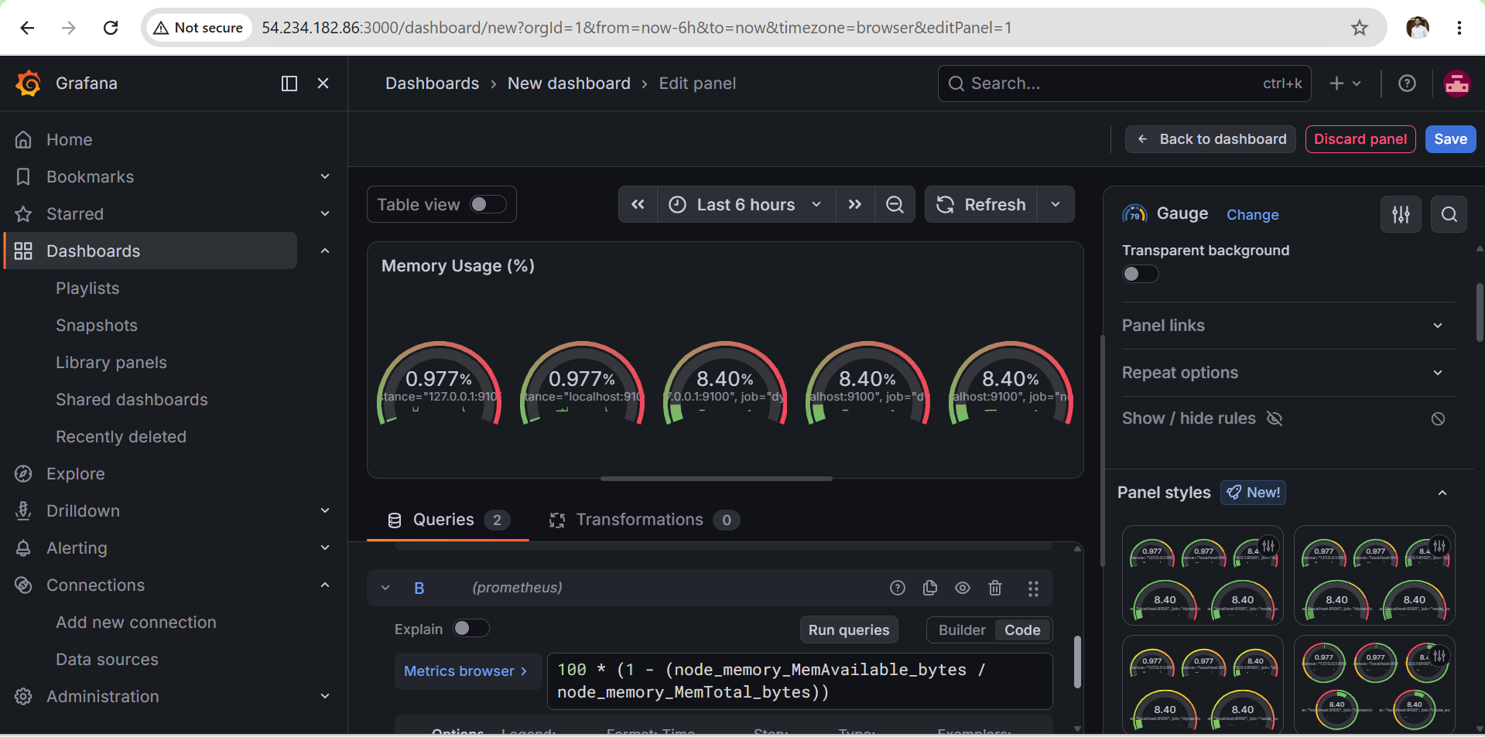
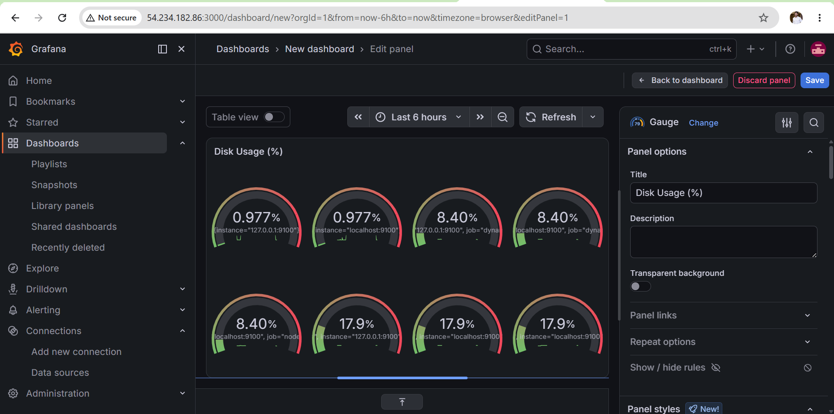
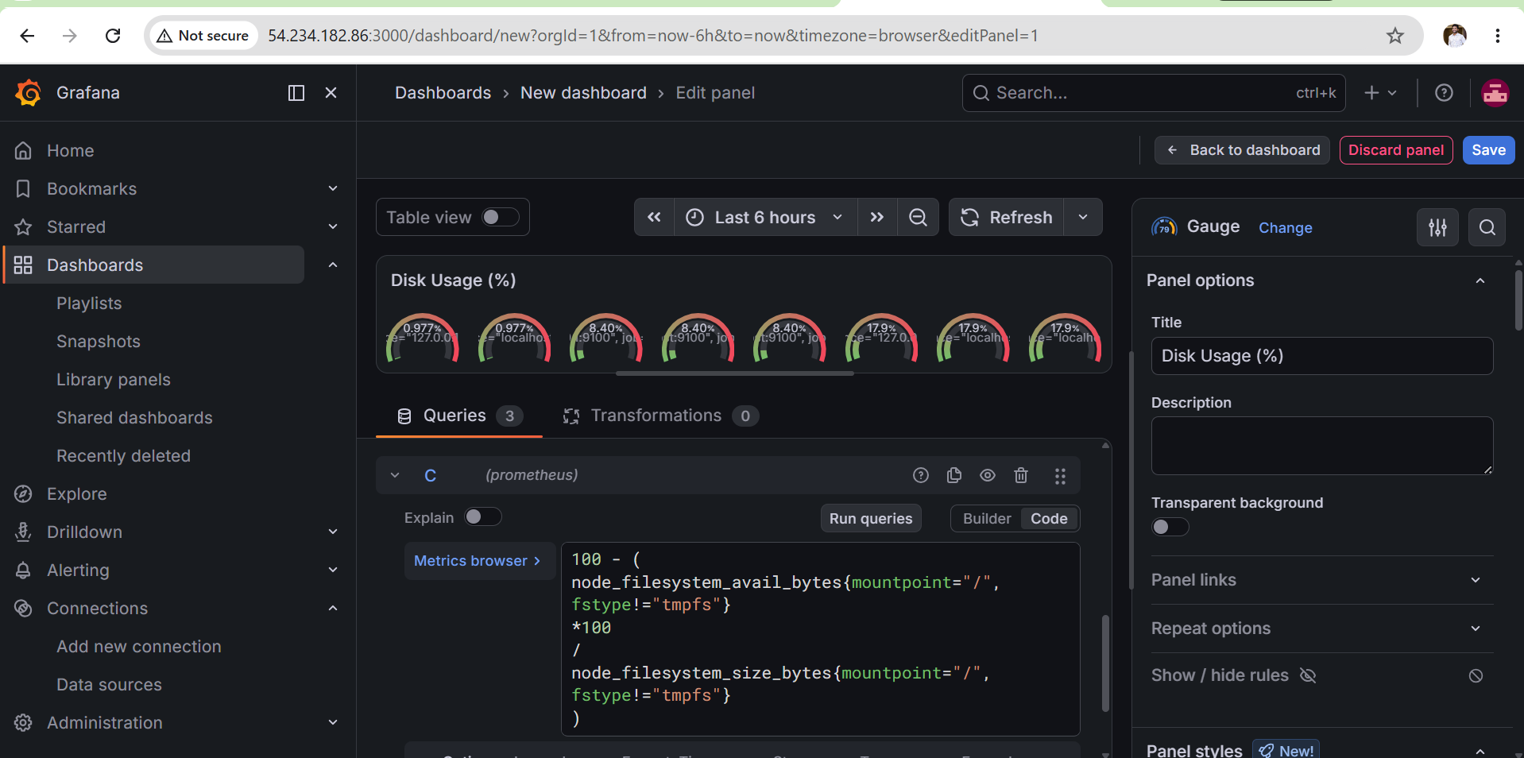
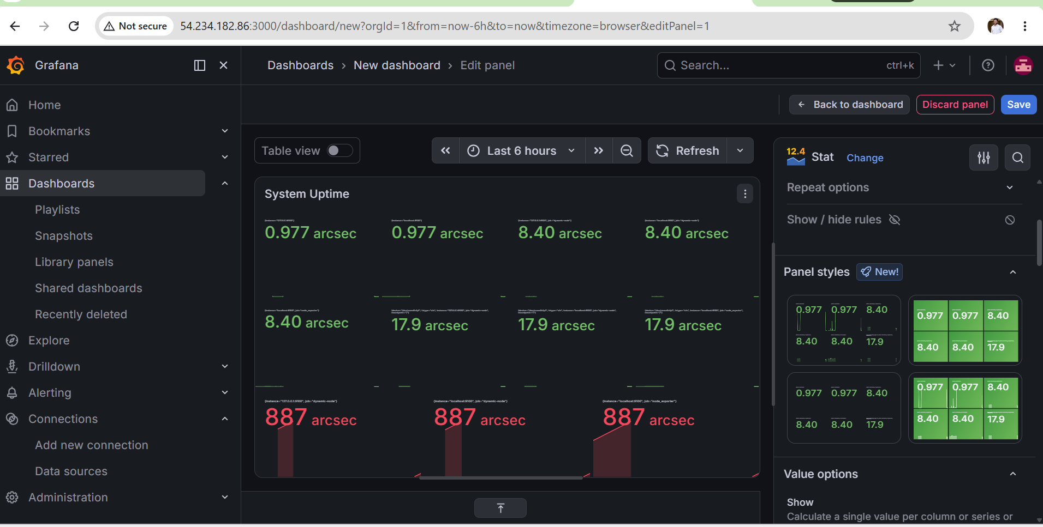
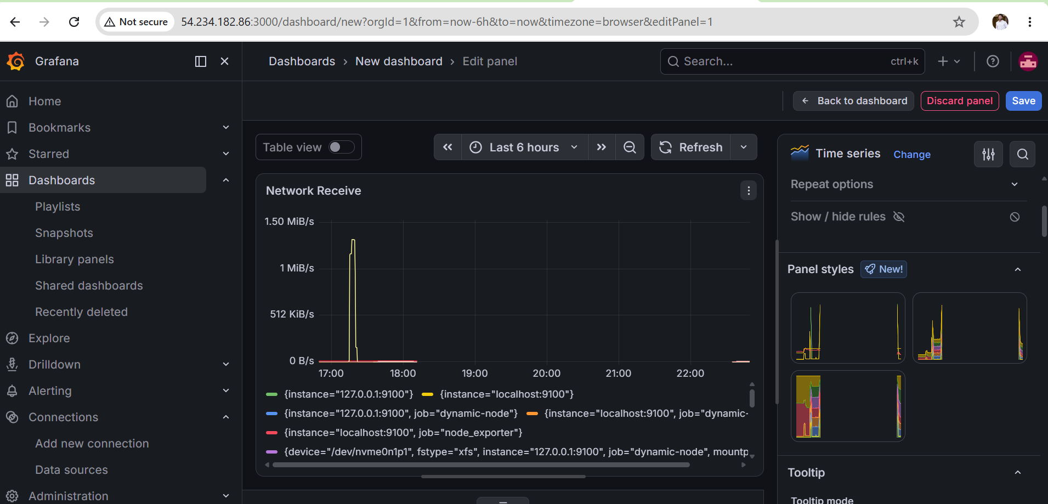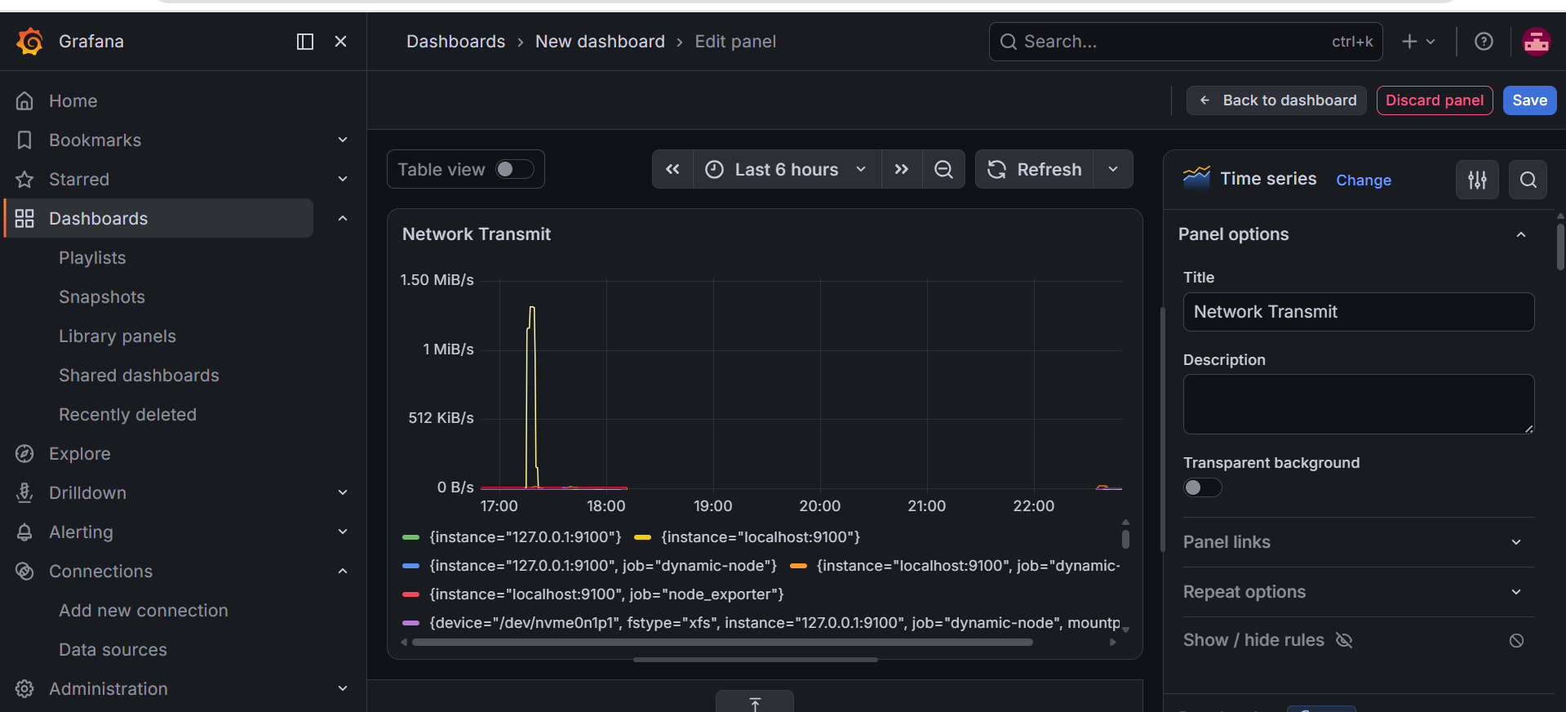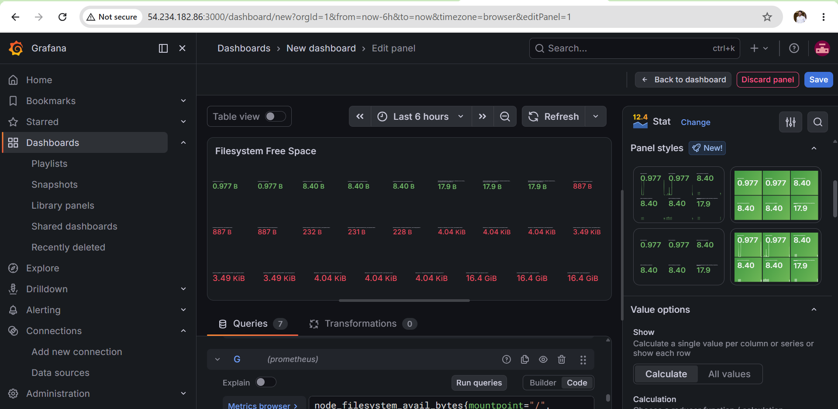
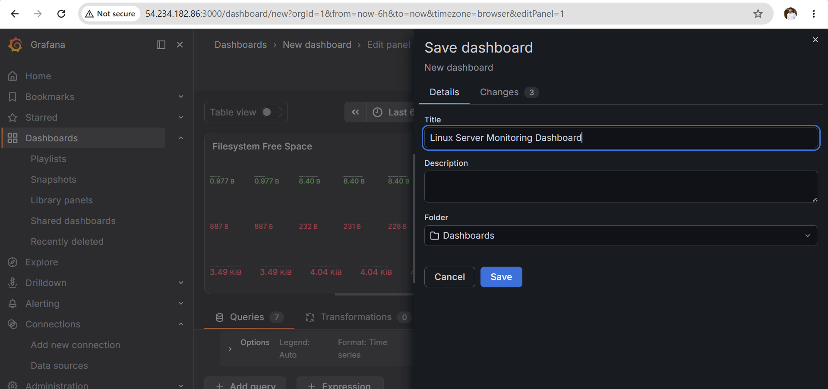
Validation
Verify the dashboard shows live values for:
- CPU Usage, Memory Usage
- Disk Usage
- System Uptime
- Network Receive
- Network Transmit
- Filesystem Free Space
Ensure the panels refresh automatically as metrics change.
Outcome
After completing this task:
- Grafana displays a custom monitoring dashboard.
- Prometheus provides real-time metrics to Grafana.
- The dashboard visualizes CPU, memory, disk, network, uptime, and filesystem usage.
- The dashboard updates automatically as system metrics change.
- Administrators can monitor server health from a single interface.

