Kubernetes-09

Task 1 : Execute all the steps shown in video.
Nginx with Ingress
Objective
- Deploy an NGINX application on the Kubernetes cluster.
- Expose the application using a Kubernetes Service.
- Configure an NGINX Ingress Controller.
- Create an Ingress resource to route external traffic to the NGINX application.
- Access and verify the NGINX welcome page through the browser.
Steps
- Created a Kubernetes Deployment with two NGINX replicas.
- Applied the Deployment and verified that both NGINX Pods were in Running state.
- Created a ClusterIP Service to expose the NGINX Pods internally.
- Installed the NGINX Ingress Controller in the ingress-nginx namespace.
- Verified that the Ingress Controller Pod was running successfully.
- Created an Ingress resource with path / and configured it to forward traffic to the NGINX Service on port 80.
- Verified the Ingress configuration and backend Service.
- Identified the Ingress Controller NodePort.
- Allowed the required NodePort in the AWS EC2 Security Group.
- Accessed the application using the worker node public IP and NodePort from a web browser.
vi nginx-deployment.yaml
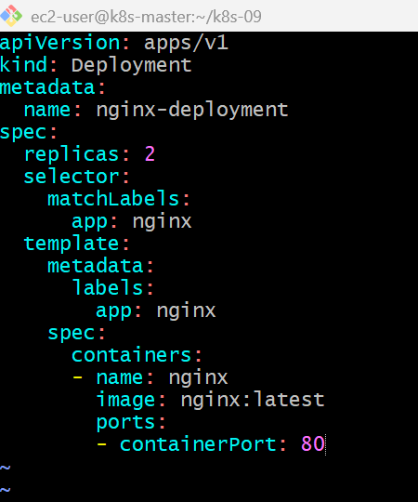
kubectl apply -f nginx-deployment.yaml
kubectl get pods
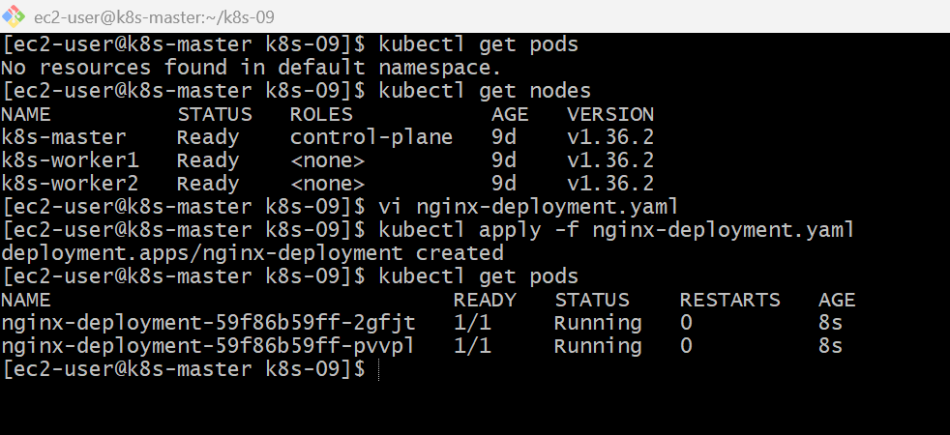

vi nginx-service.yaml
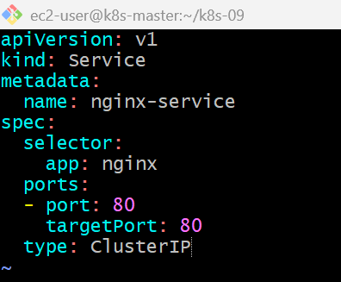
kubectl apply -f nginx-service.yaml
kubectl get svc
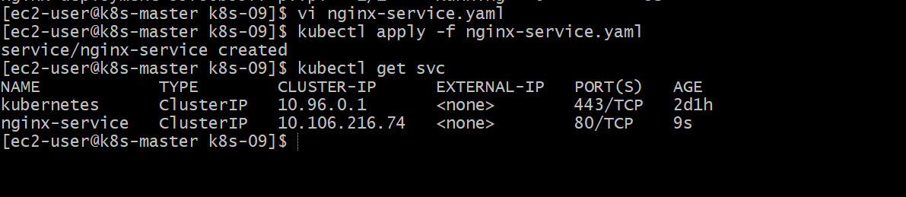
kubectl apply -f nginx-service.yaml
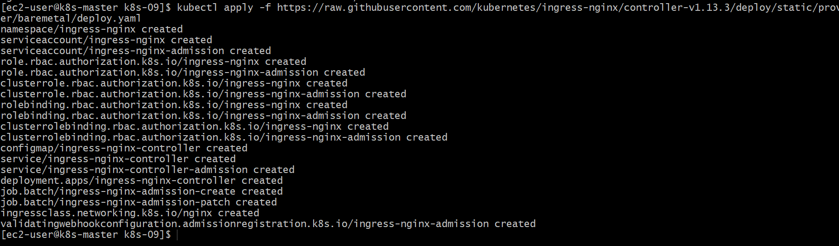
kubectl get pods -n ingress-nginx
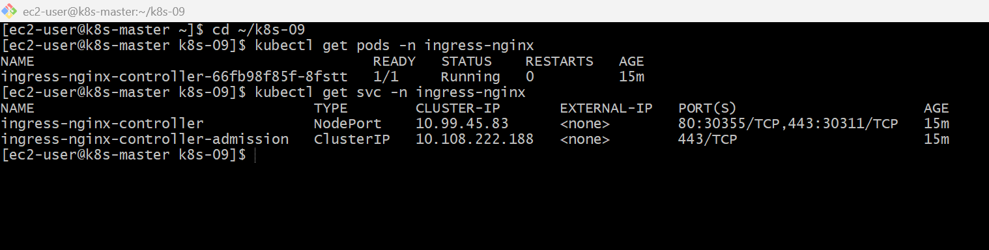
vi nginx-ingress.yaml
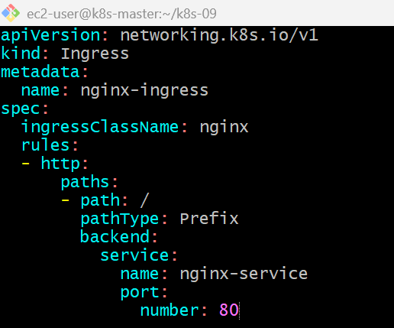
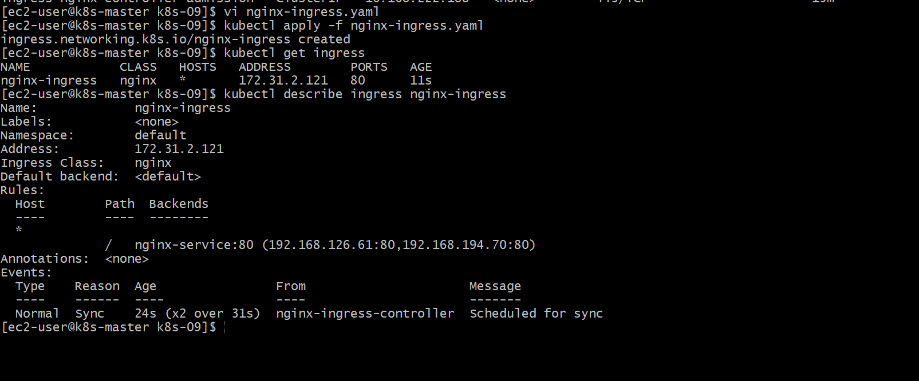
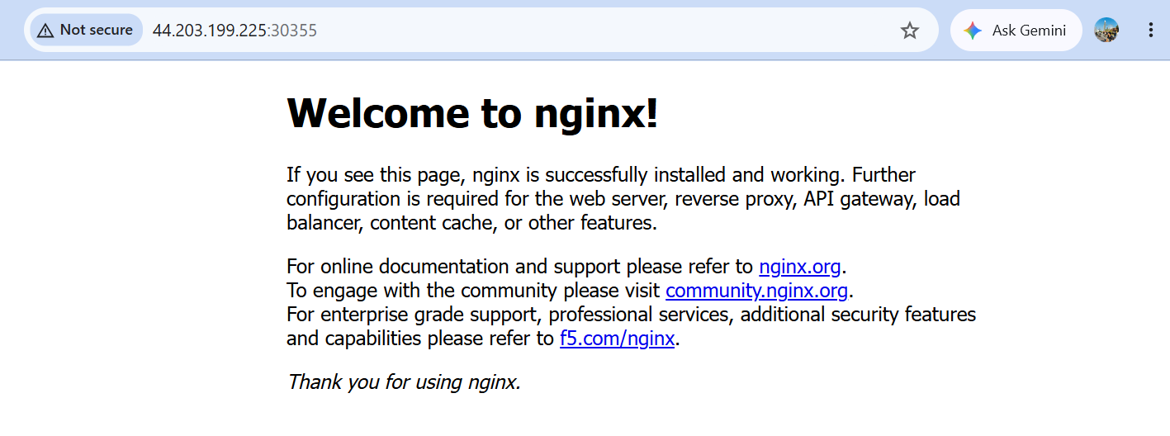

Update your Ingress YAML with hostname nithinreddy.local
On the master:
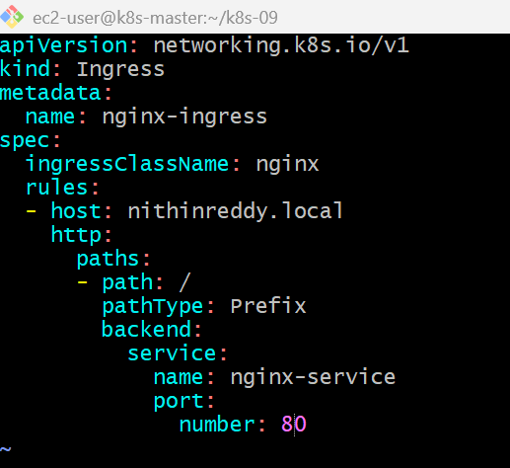
kubectl apply -f nginx-ingress.yaml
kubectl get ingress
kubectl describe ingress nginx-ingress
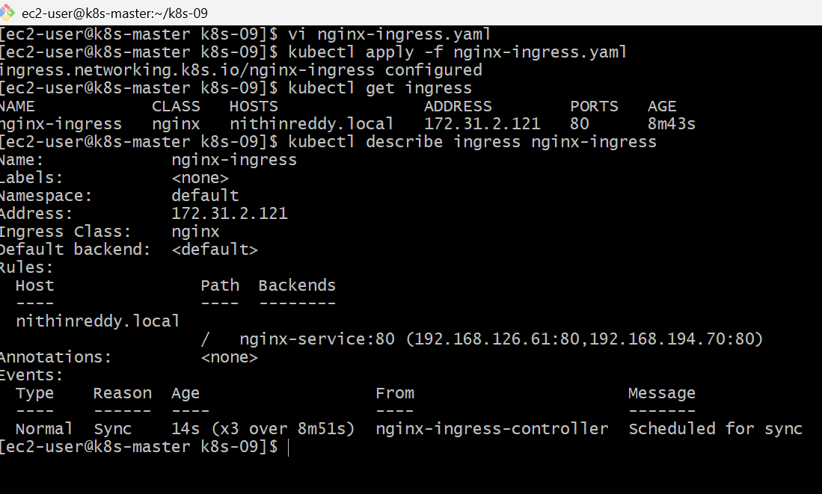

curl -H "Host: nithinreddy.local" http://172.31.2.121:30355
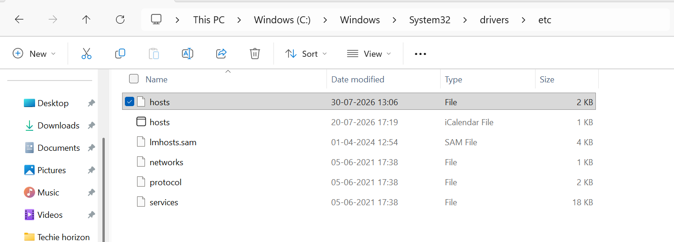

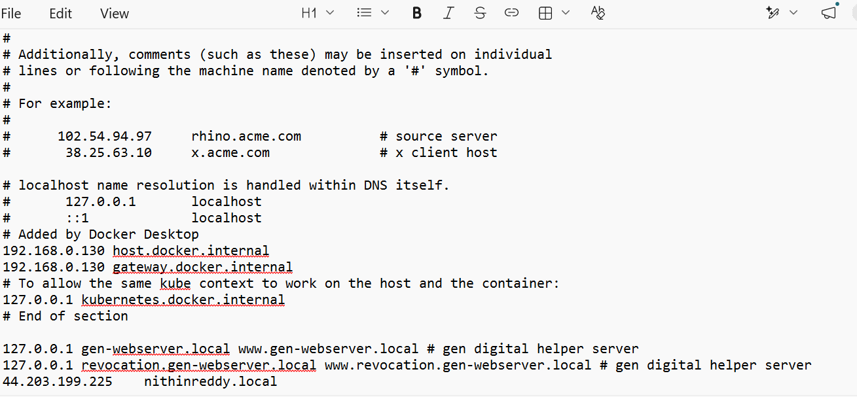
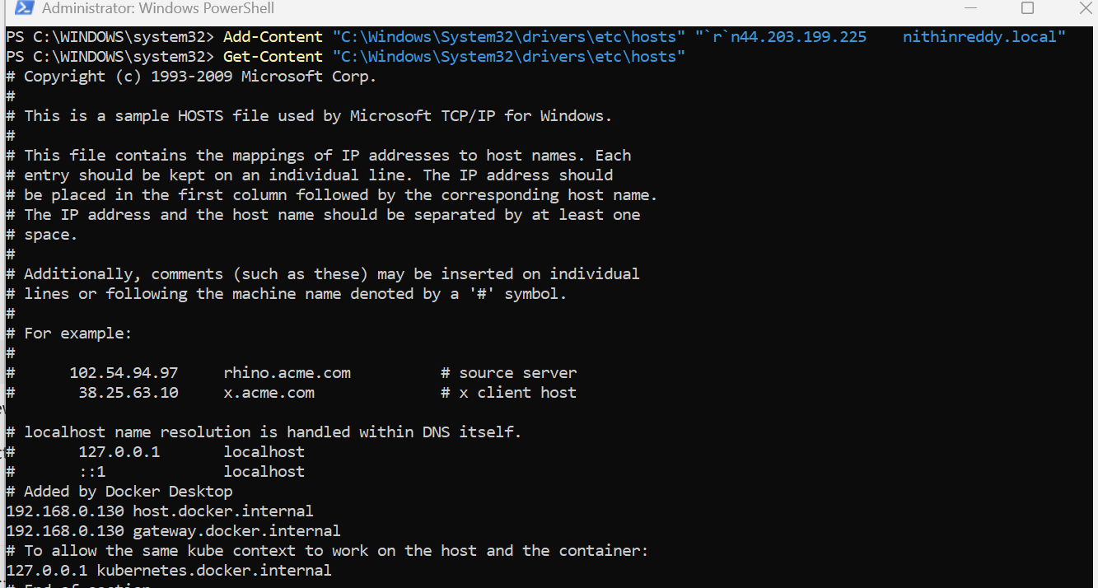
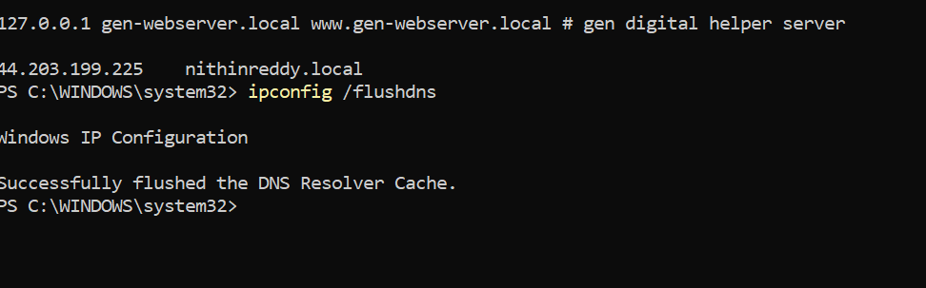
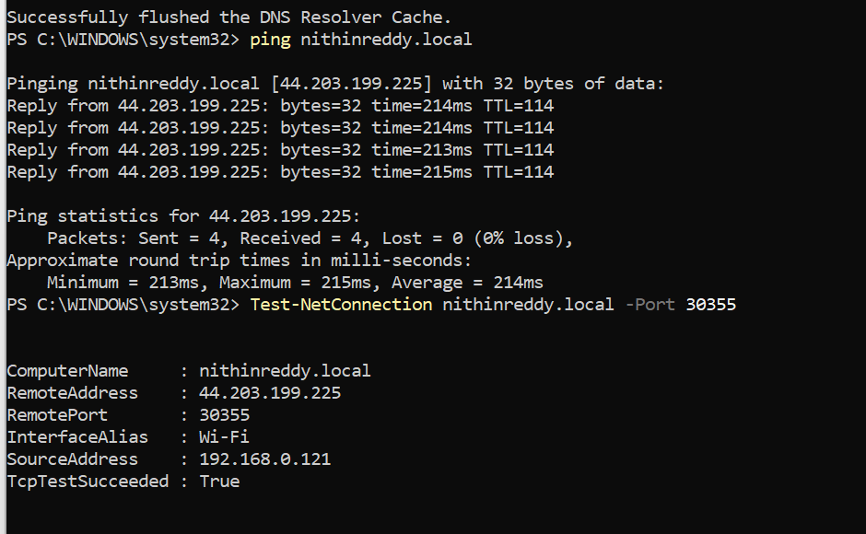
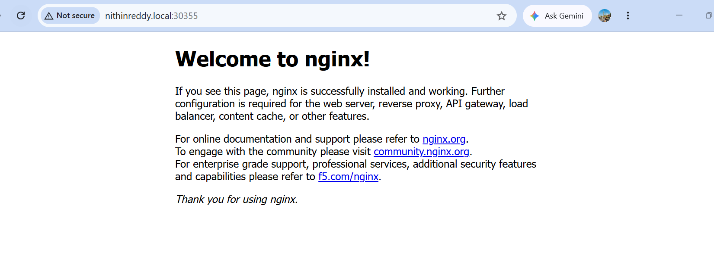

Validation
- Verified all NGINX Pods were in Running state.
- Verified the NGINX Service was successfully created and exposed the application on port 80.
- Verified the NGINX Ingress Controller was running in the ingress-nginx namespace.
- Verified the Ingress resource was created with the hostname nithinreddy.local.
- Verified Ingress routing from nithinreddy.local to nginx-service:80.
- Verified NodePort 30355 was accessible from the worker node.
- Tested Ingress routing using curl and received the NGINX Welcome Page.
- Configured the Windows hosts file to resolve nithinreddy.local to the worker node public IP 44.203.199.225.
- Verified nithinreddy.local:30355 successfully opened the NGINX Welcome Page in the browser.
Outcome
Successfully deployed an NGINX application with Kubernetes Ingress, configured host-based routing using nithinreddy.local, and verified that the application was accessible through the browser using the custom hostname.

Task 2 : Upgrade k8s cluster from 1.26 to 1.28 Version. Note: Document to upgrade cluster.https://devopscube.com/upgrade-kubernetes-cluster-kubeadm/
Objective
Upgrade the Kubernetes cluster from version 1.26 to version 1.28
using kubeadm while maintaining cluster availability and validating
all control-plane and worker nodes after the upgrade.
Implementation
1. Checked the existing Kubernetes cluster version and node status.
2. Created an etcd backup before starting the upgrade.
3. Upgraded kubeadm on the control-plane node.
4. Verified the upgrade using kubeadm upgrade plan.
5. Upgraded the Kubernetes control plane to version 1.28.
6. Upgraded kubelet and kubectl on the control-plane node.
7. Drained worker nodes one at a time.
8. Upgraded kubeadm, kubelet and kubectl on each worker node.
9. Uncordoned the worker nodes after successful upgrades.
10. Verified that all nodes returned to Ready state.
11. Verified Kubernetes system Pods after the upgrade.

— Backup Kubernetes configuration
Run:
sudo cp -r /etc/kubernetes /root/kubernetes-backup
Verify:
sudo ls /root/kubernetes-backup

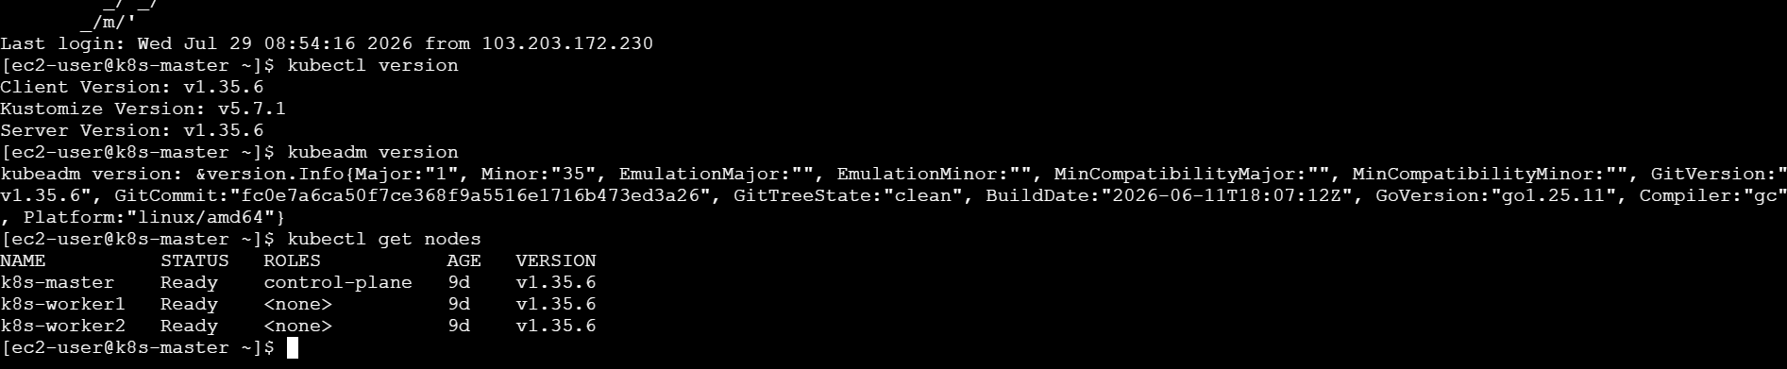
sudo cp -r /etc/kubernetes /root/kubernetes-backup
kubectl get all -A -o yaml > ~/k8s-resources-backup.yaml
ls -lh ~/k8s-resources-backup.yaml
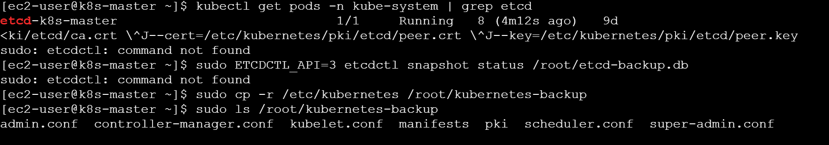
sudo du -sh /root/kubernetes-backup
ls -lh ~/k8s-resources-backup.yaml
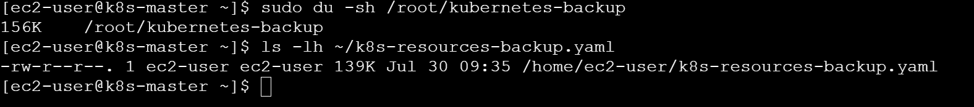

kubeadm version
kubelet –version
kubectl version –client
kubectl get nodes
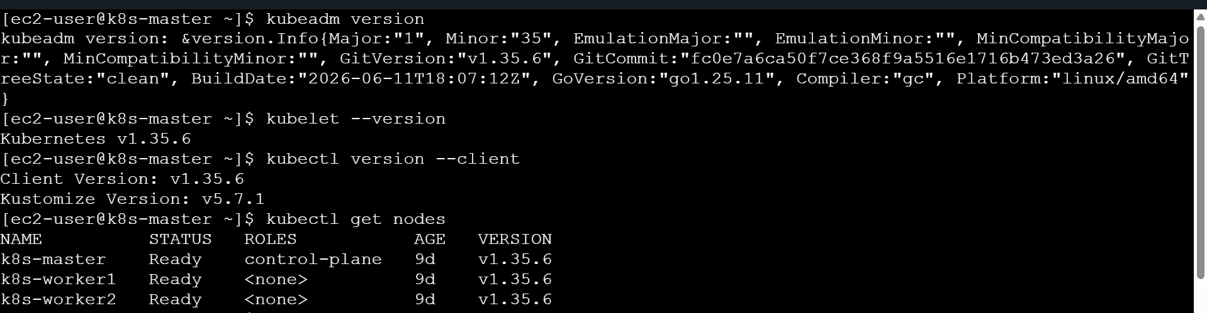
kubectl get pods -A
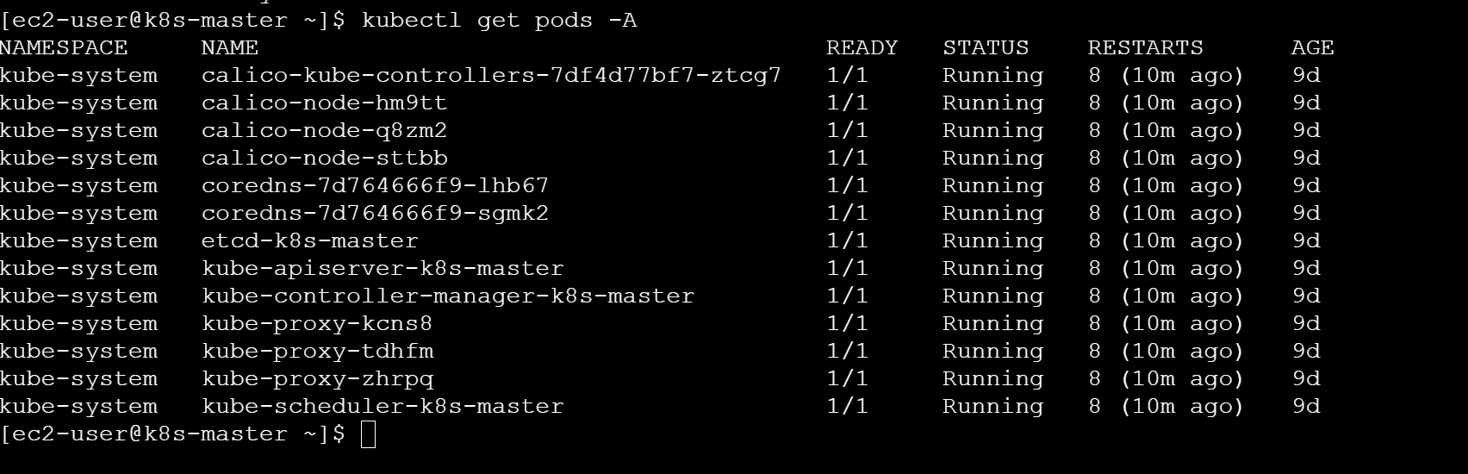
Kubernetes Cluster Upgrade I already have 1.35.6 so im updating 1.36.2
Objective
Upgrade the Kubernetes cluster from version 1.35.6 to Kubernetes 1.36.2 using kubeadm.
1. Backup Cluster
- Verified that all Kubernetes nodes were in Ready state.
- Backed up /etc/kubernetes configuration and certificates.
- Exported Kubernetes resources to a YAML backup file.
- Verified the cluster health before starting the upgrade
I already have 1.35 v so upgrading to 1.36
sudo vi /etc/yum.repos.d/kubernetes.repo
cat /etc/yum.repos.d/kubernetes.repo
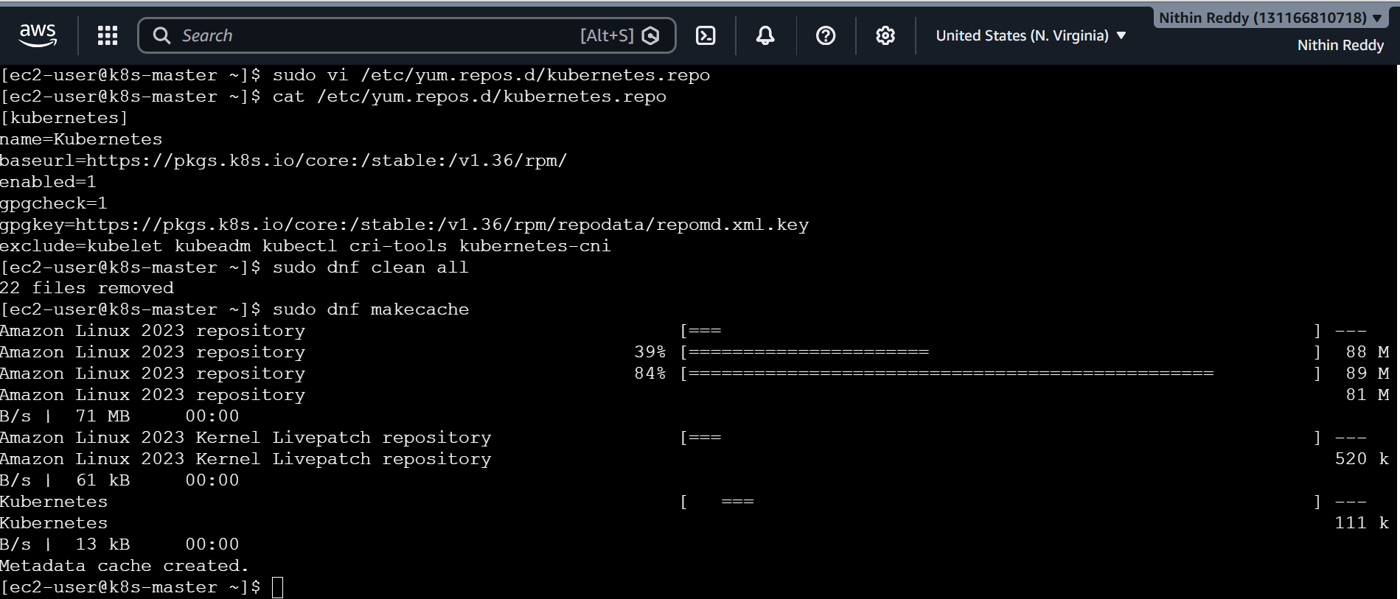
sudo dnf list --showduplicates kubeadm
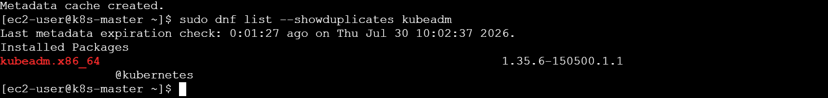

2. Upgrade Control Plane
- Changed the Kubernetes package repository from v1.35 to v1.36.
- Installed the required v1.36.x version of kubeadm.
- Verified the kubeadm upgrade plan.
- Upgraded the control plane using kubeadm upgrade apply.
- Upgraded kubelet and kubectl on the master node.
- Restarted the kubelet service.
- Verified the control-plane node status.

3. Upgrade Worker Nodes
- Drained worker node 1 before upgrading.
- Changed the Kubernetes repository to v1.36.
- Upgraded kubeadm and executed kubeadm upgrade node.
- Upgraded kubelet and kubectl.
- Restarted kubelet and uncordoned worker node 1.
- Repeated the same procedure for worker node 2.
sudo dnf install -y kubeadm-1.36.2 --setopt=disable_excludes=kubernetes
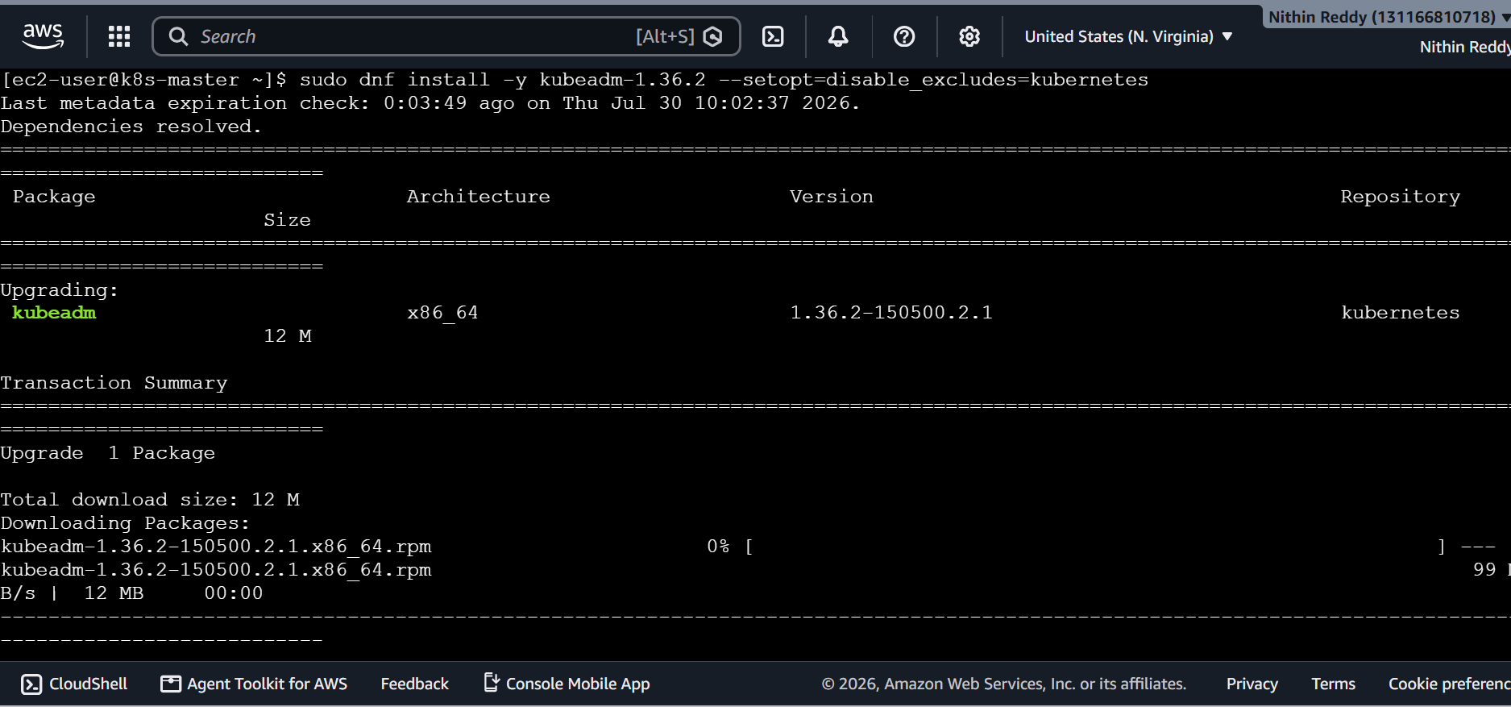
kubeadm version
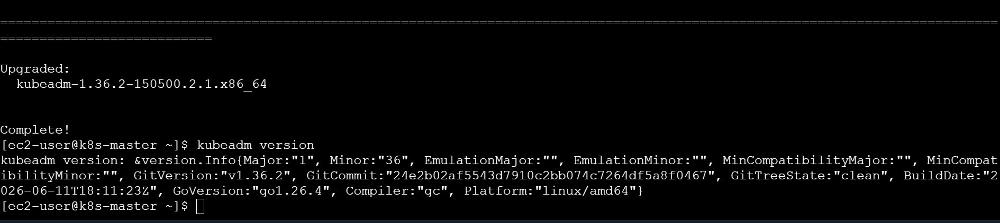

sudo kubeadm upgrade plan
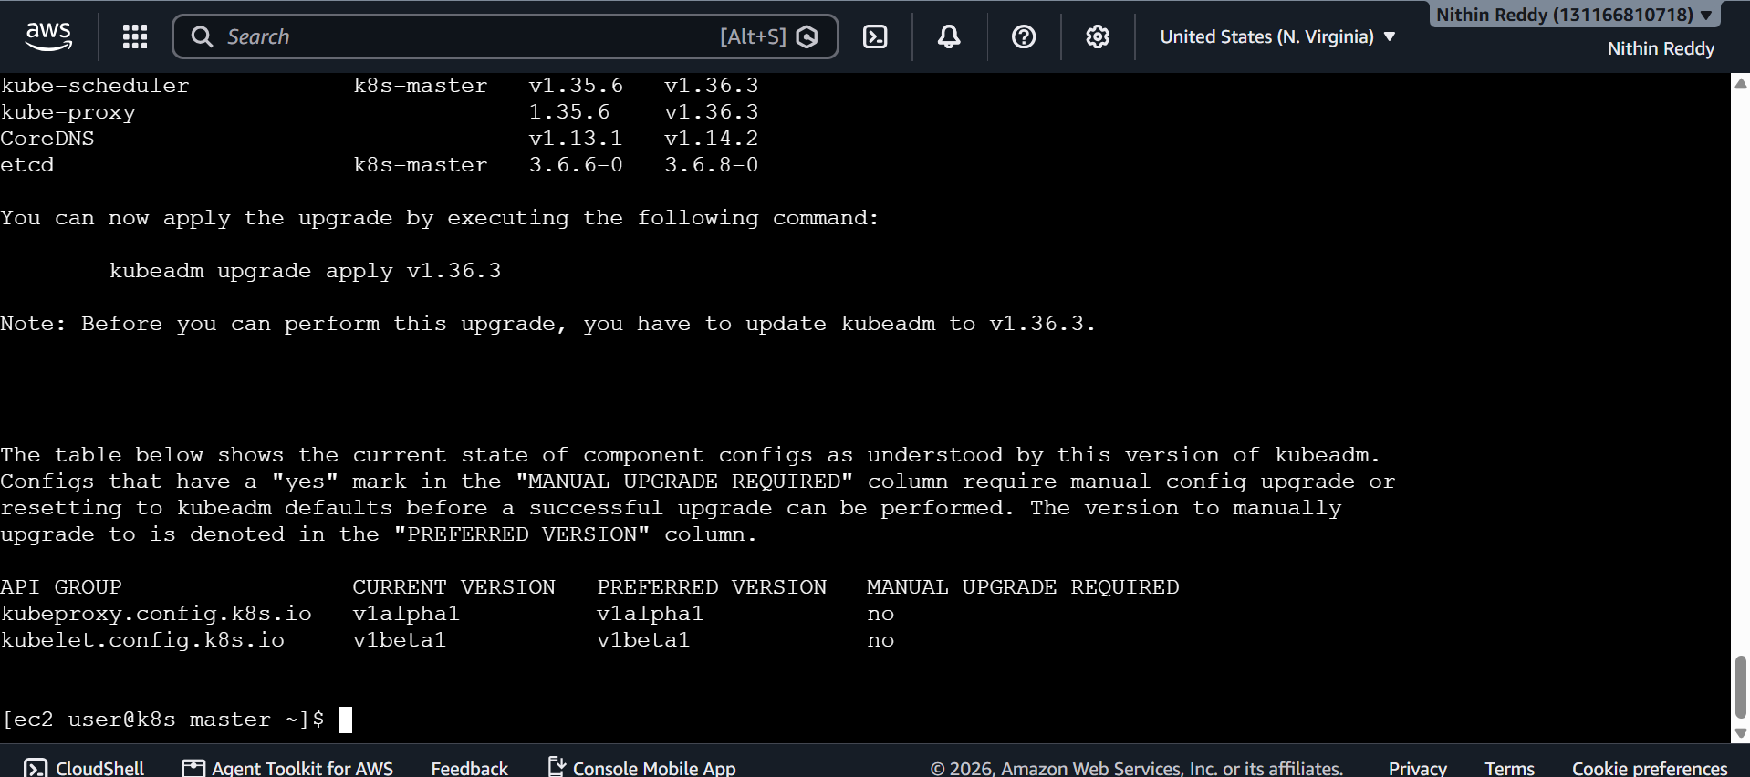
Installed kubectl and kubelet
sudo dnf install -y kubelet-1.36.2 kubectl-1.36.2 --setopt=disable_excludes=kubernetes
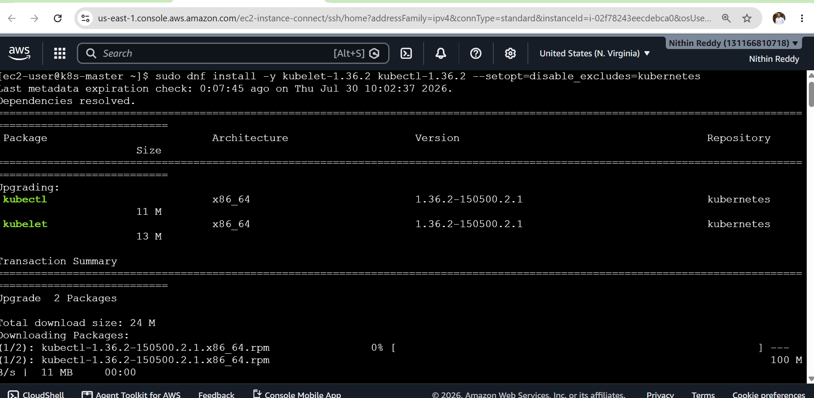

sudo systemctl daemon-reload
sudo systemctl restart kubelet
kubelet –version
kubectl version --client
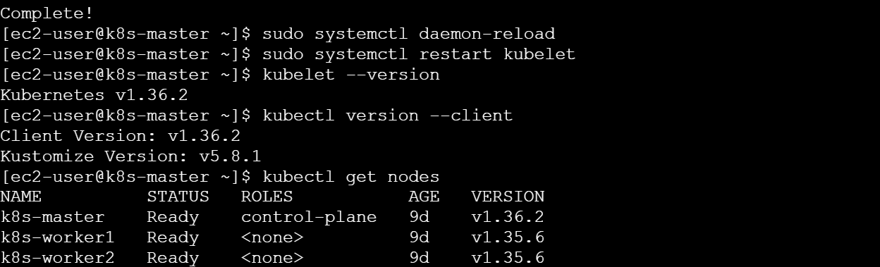
kubectl get pods -A
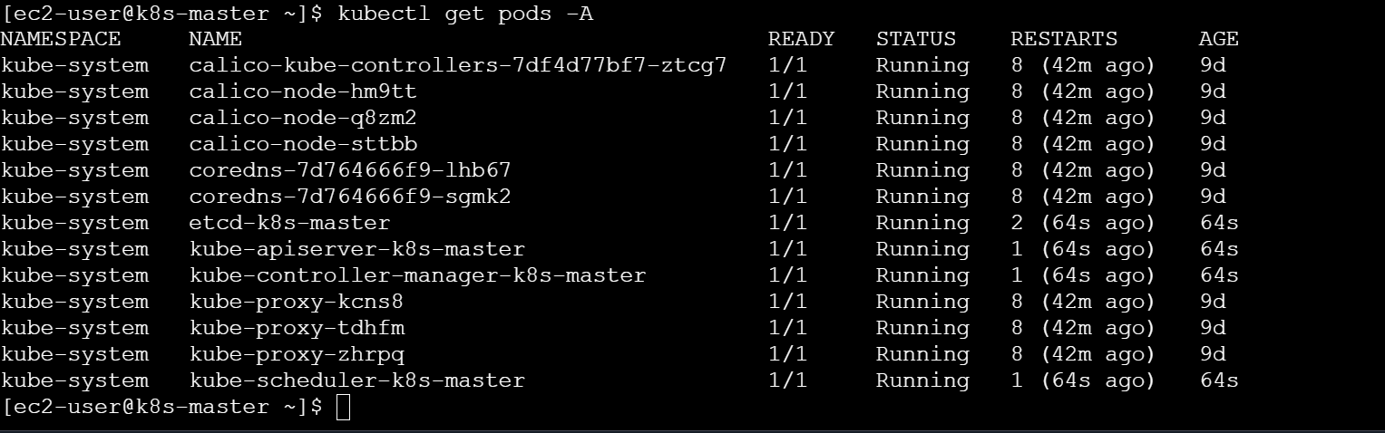

Upgrade WORKER 1
Everything below is done in order.
On MASTER
Drain worker1:
kubectl drain k8s-worker1 --ignore-daemonsets
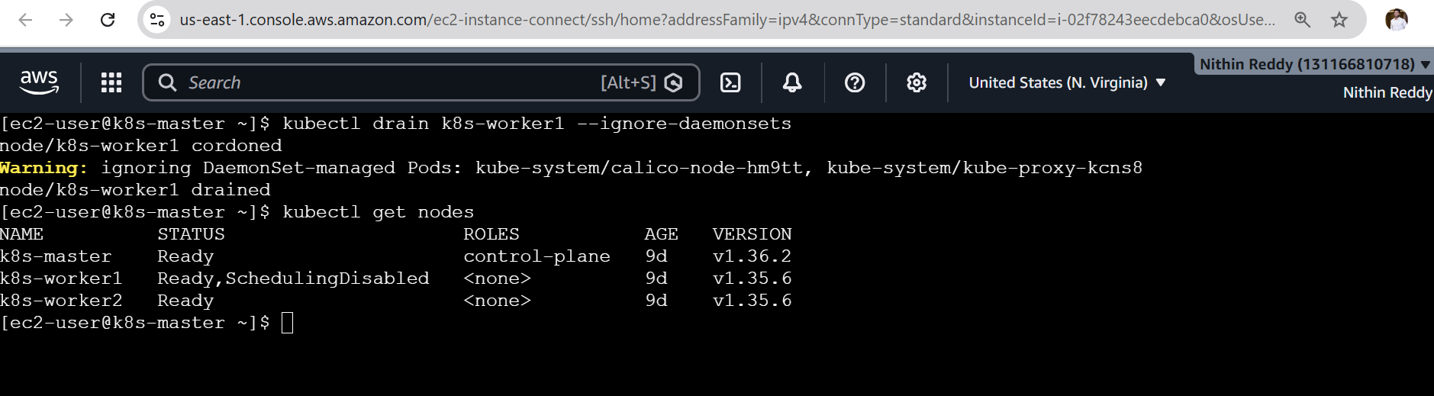
kubectl uncordon k8s-worker1
kubectl get nodes
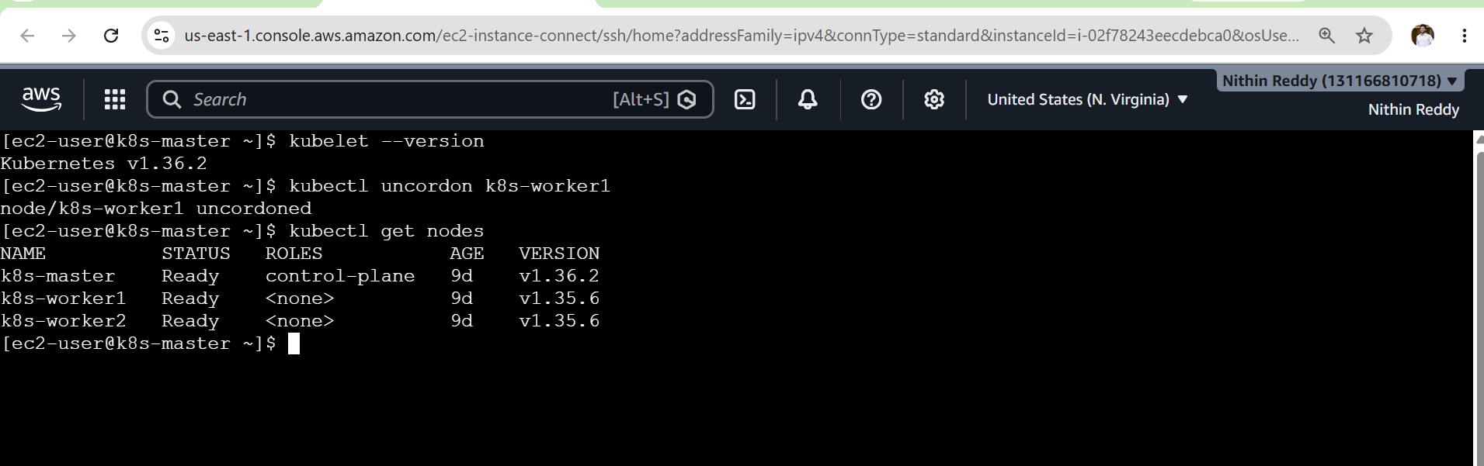
Same repeat on k8s-worker1
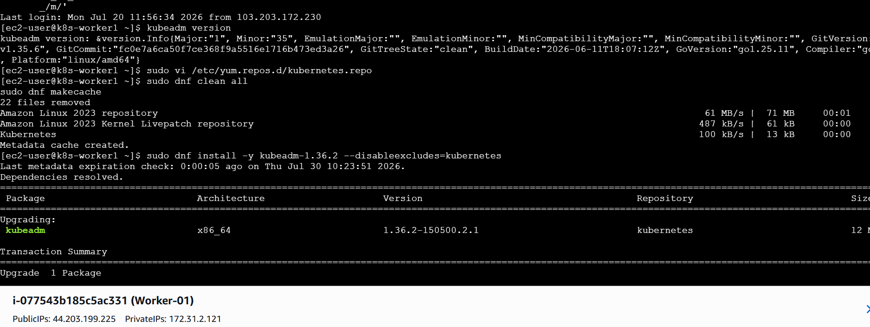

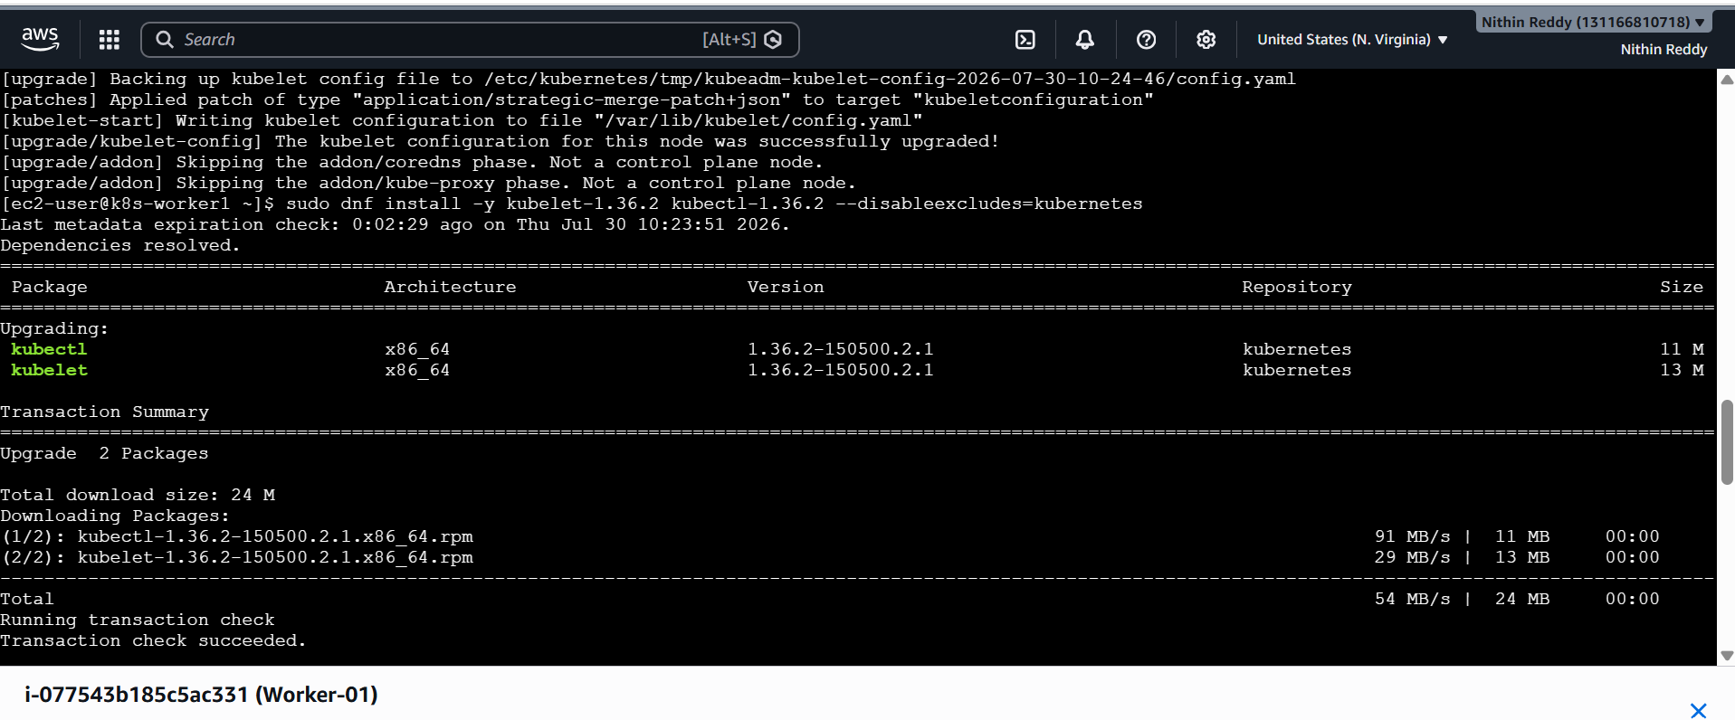
Now Drain worker 2 from master
kubectl drain k8s-worker2 --ignore-daemonsets
kubectl get nodes
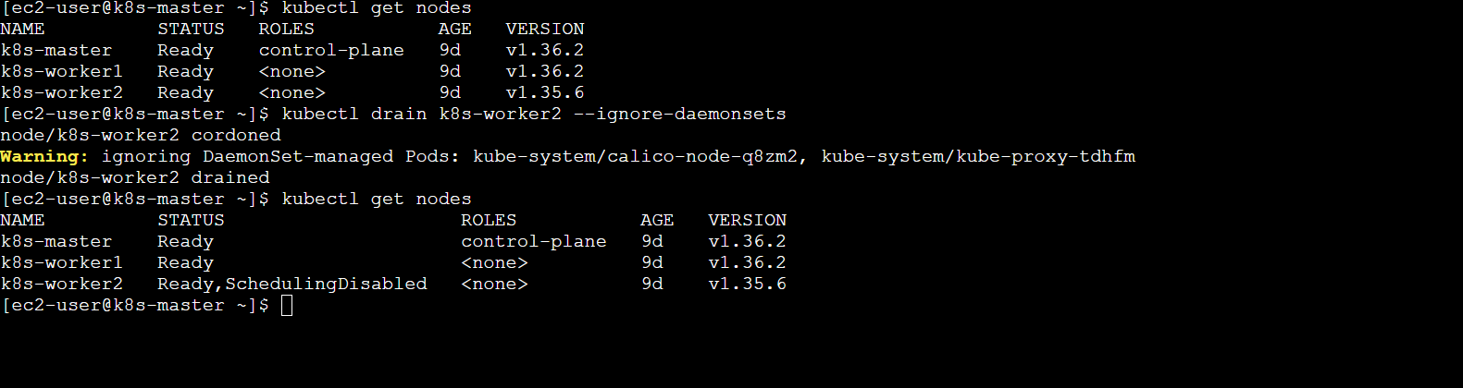
Update in worker-2
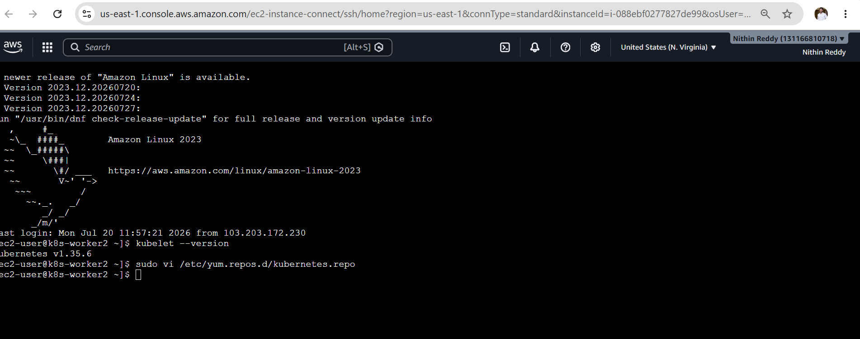

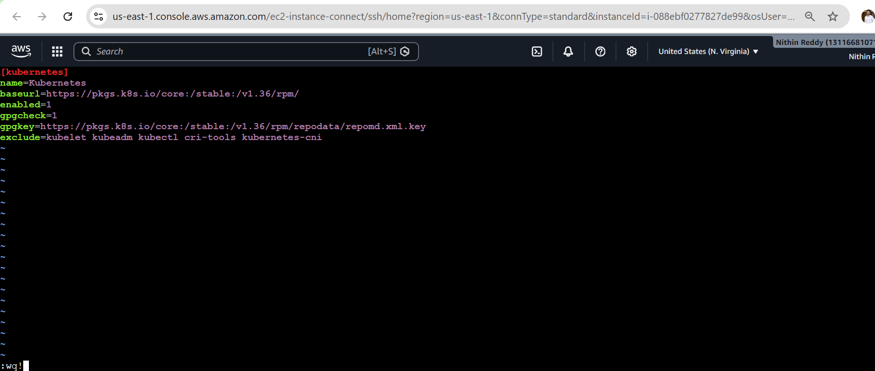
Installed kubeadm
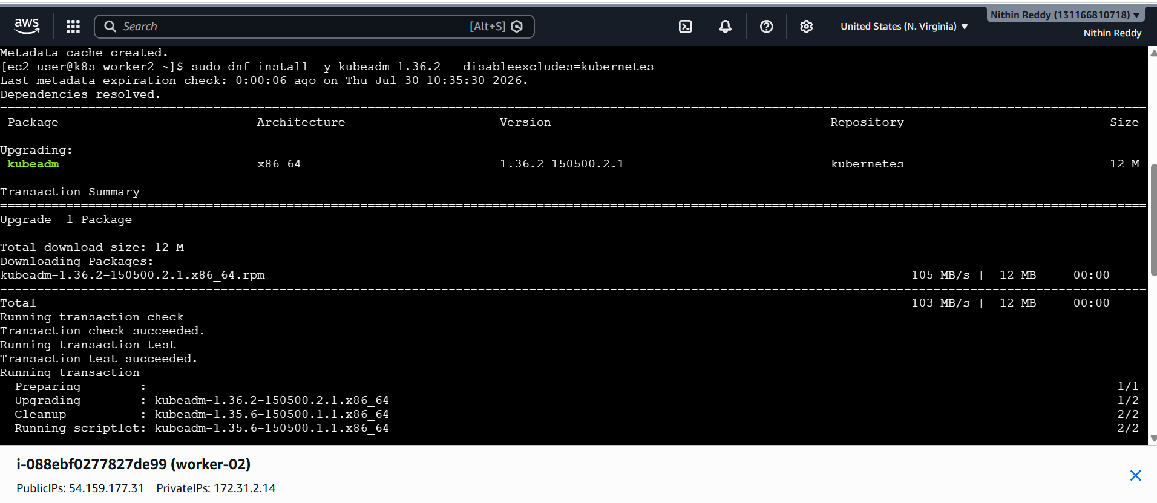
sudo dnf install -y kubelet-1.36.2 kubectl-1.36.2 --disableexcludes=kubernetes
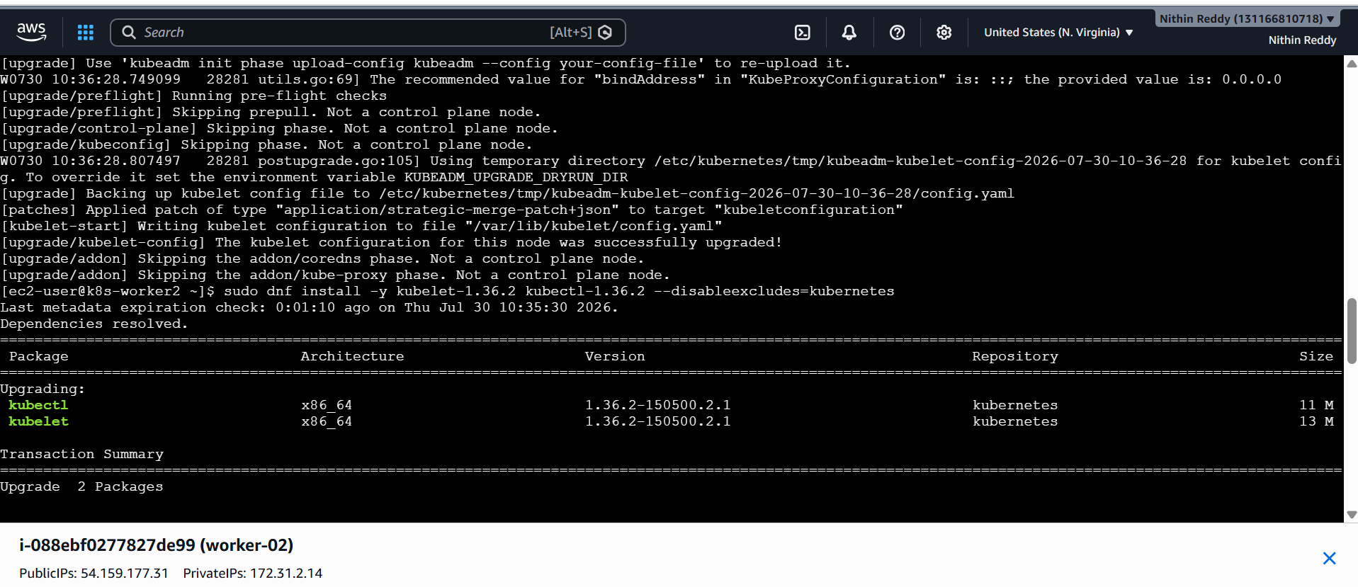
sudo systemctl daemon-reload
sudo systemctl restart kubelet
kubelet –version
exit
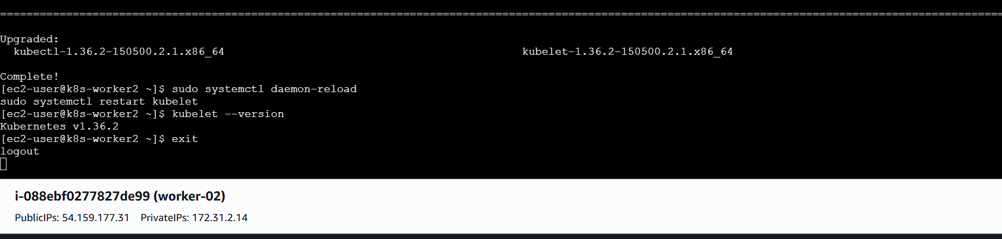
Now back to k8s-master node
kubectl uncordon k8s-worker2
kubectl get nodes
kubectl get pods -A
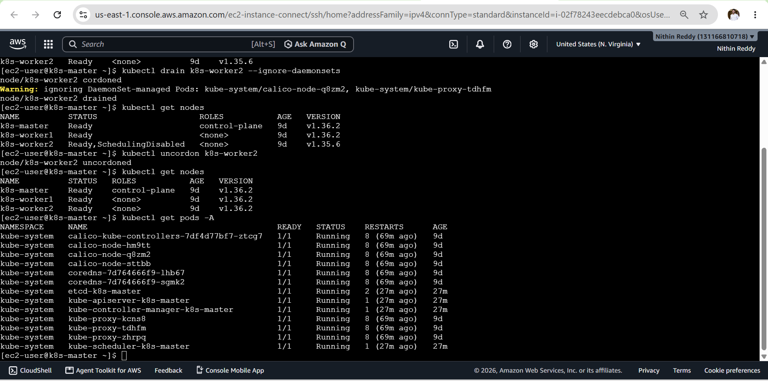
Validation
- Verified all three nodes are in Ready state.
- Verified all nodes are running Kubernetes v1.36.x.
- Verified Kubernetes system Pods are running.
- Verified kubeadm, kubelet and kubectl versions.
- Verified that the worker nodes are schedulable again.
- Control-plane node: Ready
- Worker node 1: Ready
- Worker node 2: Read
- Kubernetes version: 1.28.x
- kubeadm version: 1.28.x
- kubelet version: 1.28.x
- System Pods: Running

Outcome
- Successfully upgraded the Kubernetes cluster from v1.26 to v1.28
using kubeadm and verified the health and version of the control-plane
and worker nodes.
- Successfully upgraded the three-node kubeadm Kubernetes cluster from v1.35.6 to v1.36.x and validated the health and availability of the cluster after the upgrade.

