Kubernetes-03
Task 1: Create a ClusterIP Service for an Apache Web Server Pod
Objective
- Create an Apache (httpd) Pod.
- Expose it using a ClusterIP Service.
- Verify the Service.
- Access the Apache page from inside the cluster.
Architecture
ClusterIP Service
│
▼
Apache Pod (httpd)
Create a Working Directory
mkdir -p ~/k8s-03
cd ~/k8s-03
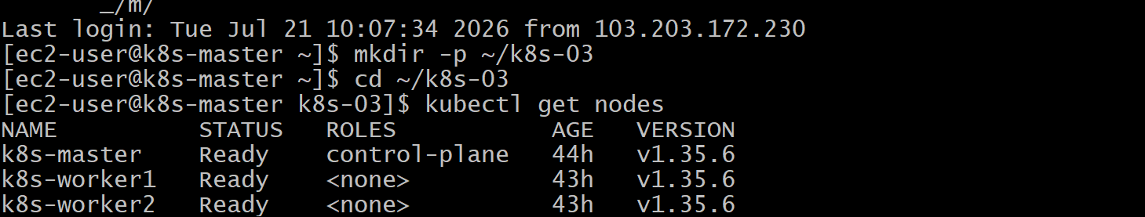
Implementation Steps (for your documentation)
- Created an Apache Pod YAML.
- Deployed the Pod.
- Verified the Pod status.
- Created a ClusterIP Service YAML.
- Applied the Service.
- Verified the Service and endpoints.
- Tested connectivity using a temporary BusyBox Pod.

vi apache-pod.yaml
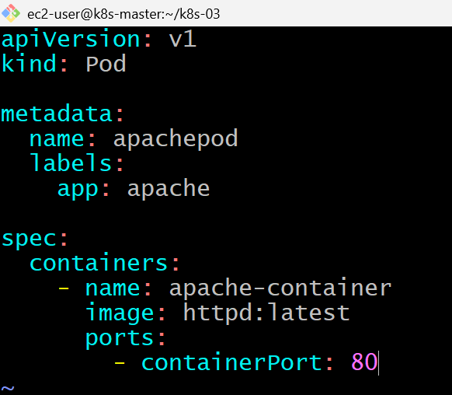
Cat apache-pod.yaml
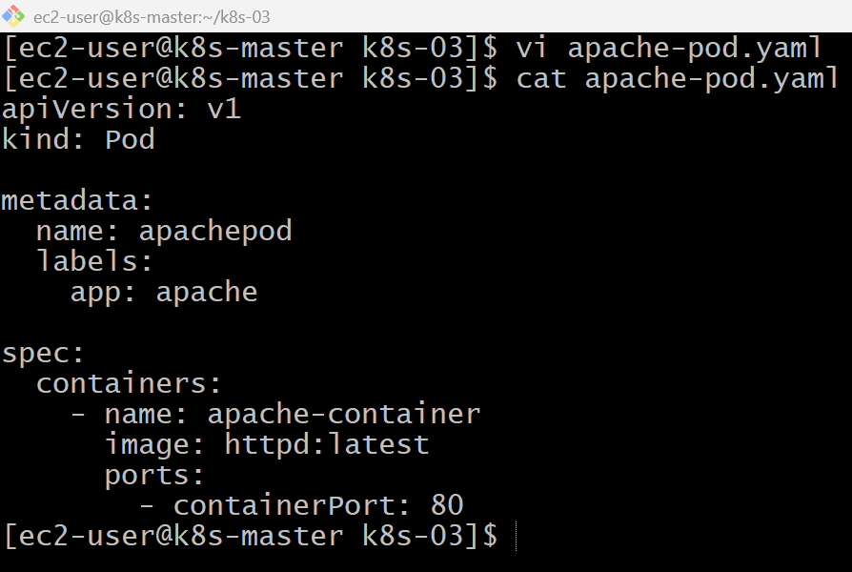
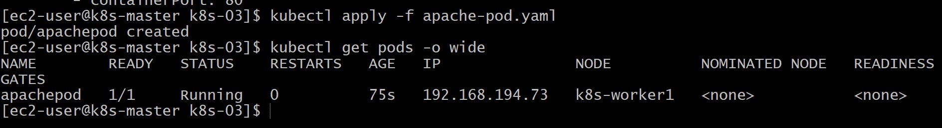
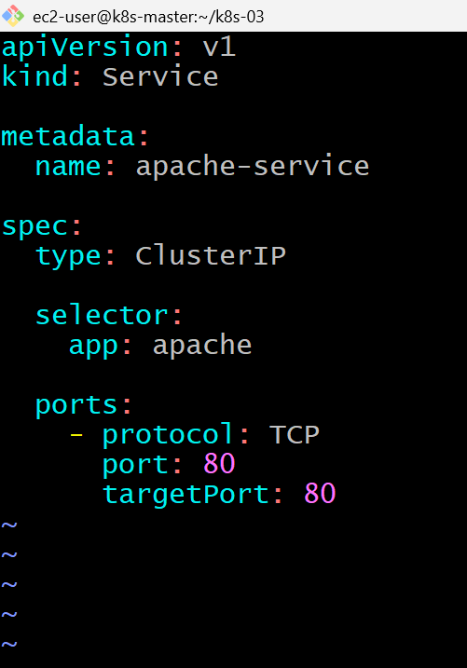
kubectl get svc
kubectl get endpoints apache-service
kubectl run testpod --image=busybox --restart=Never -it --rm – sh
wget -qO- http://apache-service
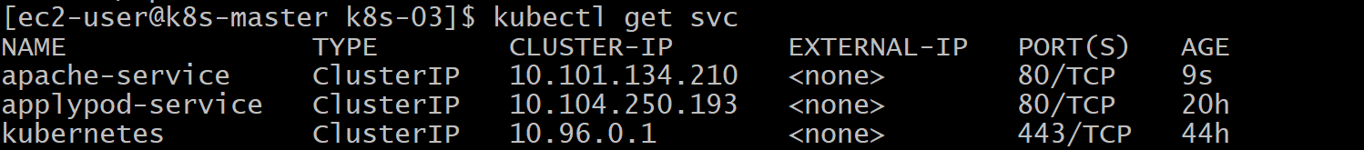
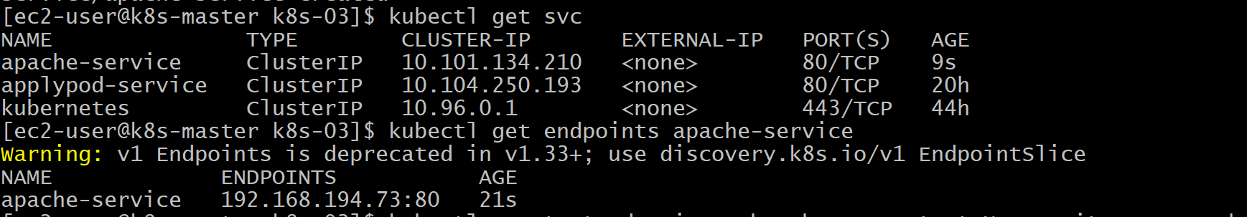

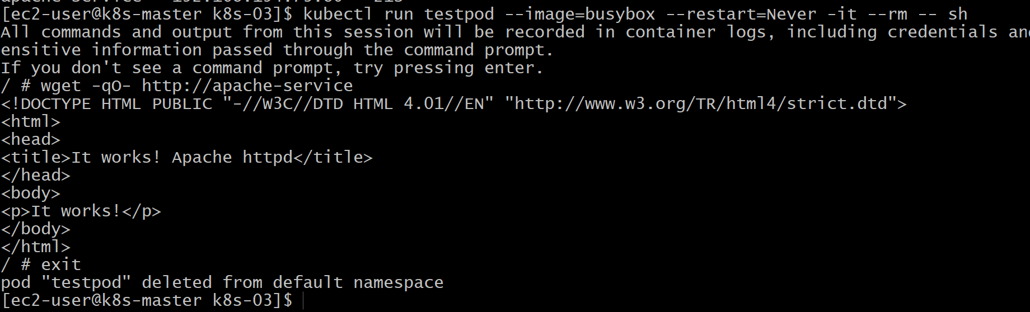
Validation
- Verified the Apache Pod was running.
- Created a ClusterIP Service.
- Verified the Service using kubectl get svc.
- Verified the Service endpoints using kubectl describe svc.
- Successfully accessed the Apache application using the Service name from another Pod.

Outcome
- Successfully deployed an Apache web server Pod.
- Exposed it internally using a ClusterIP Service.
- Verified communication within the Kubernetes cluster.

Task 2: Expose an Nginx Pod Externally Using a NodePort Service
Objective
- Create an Nginx Pod.
- Expose it using a NodePort Service.
- Access the application from a browser.

Architecture
Internet
│
▼
Worker1 Public IP:NodePort
│
▼
Kubernetes Service
Type = NodePort
│
▼
Nginx Pod
Implementation Steps (for your documentation)
- Created an Nginx Pod YAML file.
- Deployed the Pod.
- Verified the Pod status.
- Created a NodePort Service YAML file.
- Configured the Service to expose port 80 using NodePort 30080.
- Applied the Service.
- Verified the Service and endpoints.
- Allowed the NodePort in the AWS Security Group.
- Accessed the application through the worker node's public IP and NodePort
vi nginx-pod.yaml
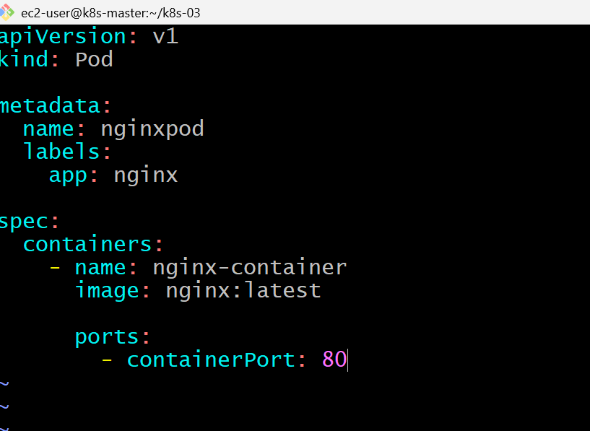
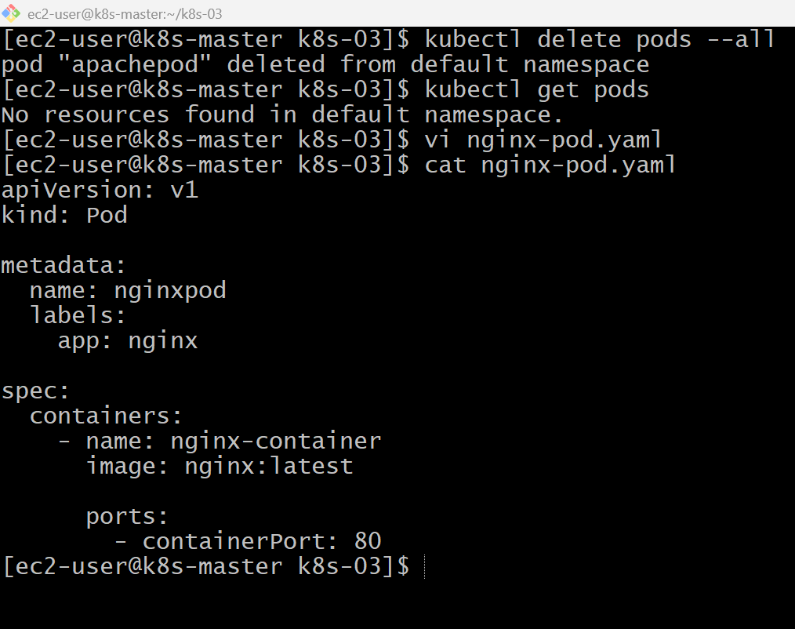
kubectl apply -f nginx-pod.yaml
kubectl get pods -o wide
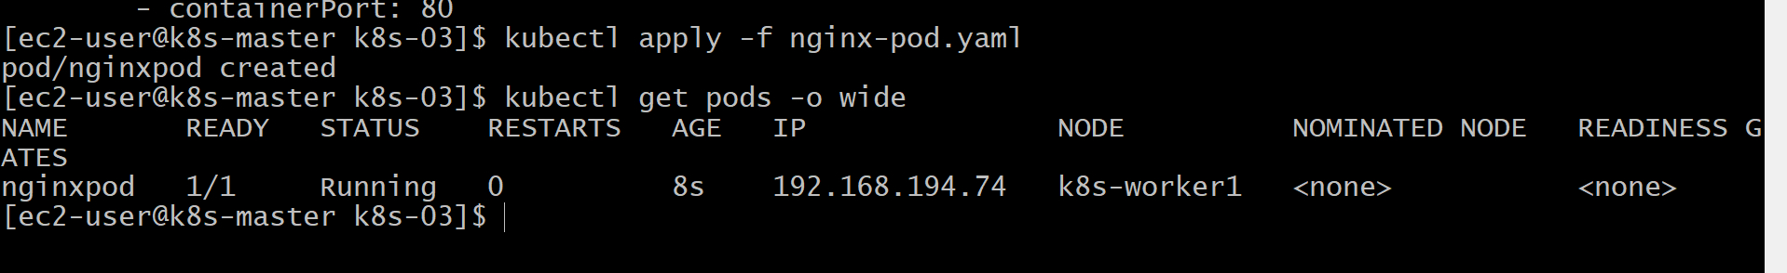
kubectl exec -it nginxpod -- /bin/bash
inside nginx -v
curl localhost
and
exit
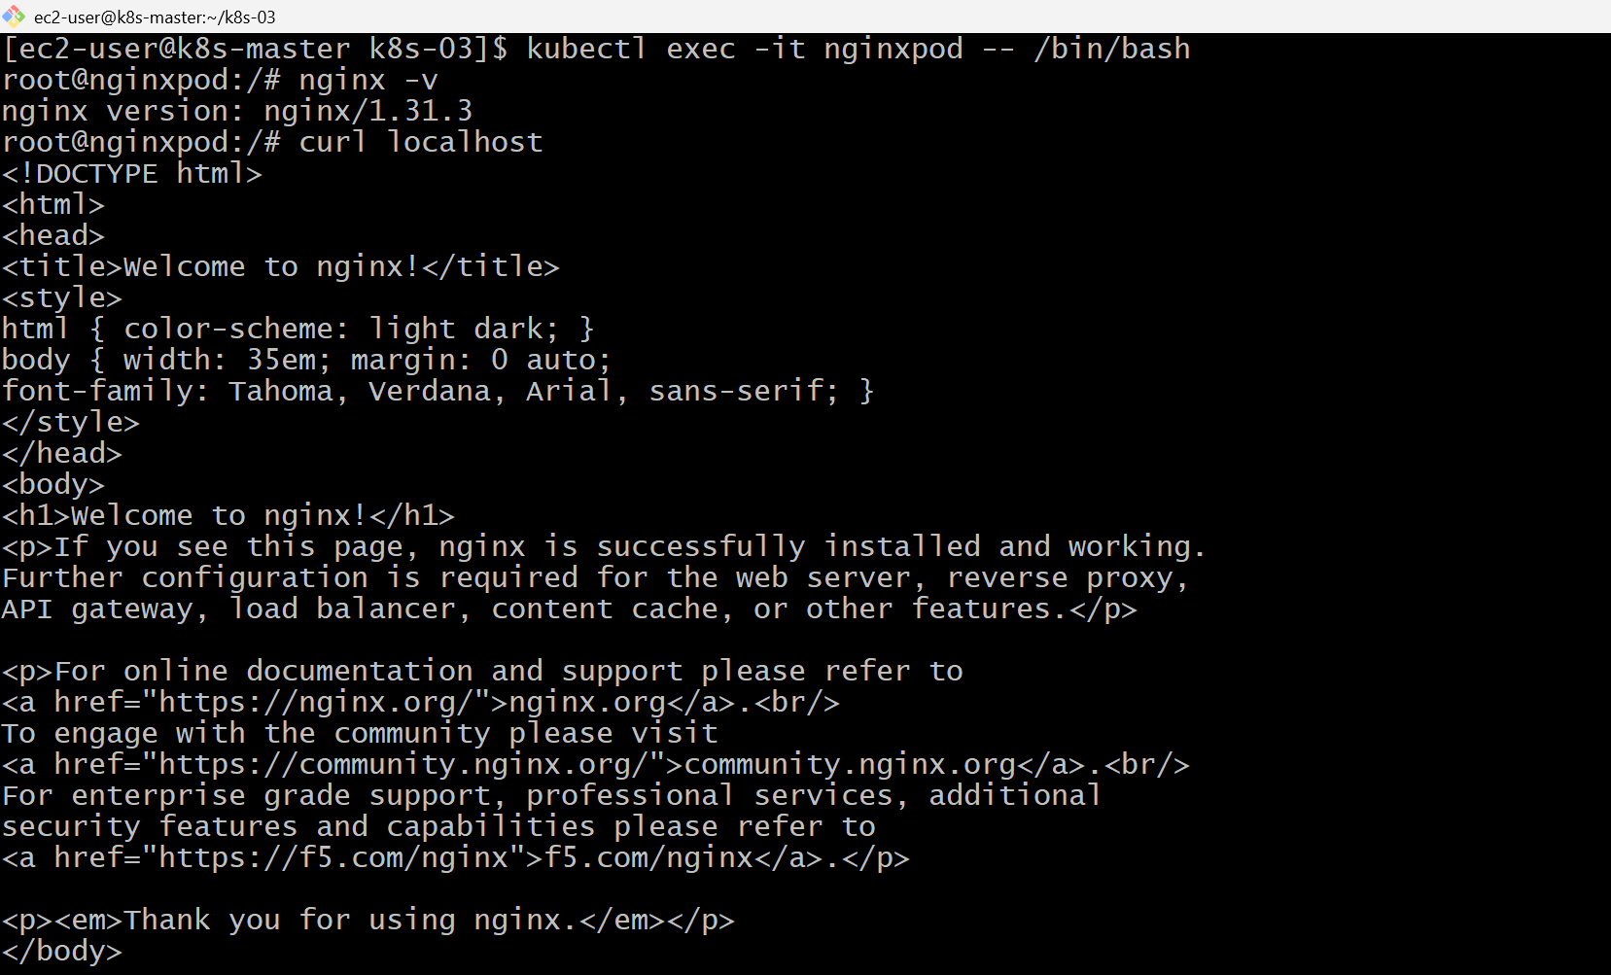
vi nginx-nodeport.yaml
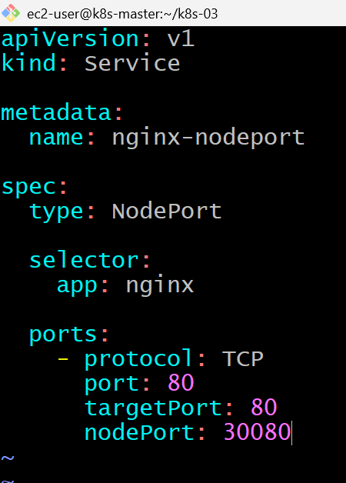

kubectl apply -f nginx-nodeport.yaml
kubectl get svc
kubectl describe svc nginx-nodeport
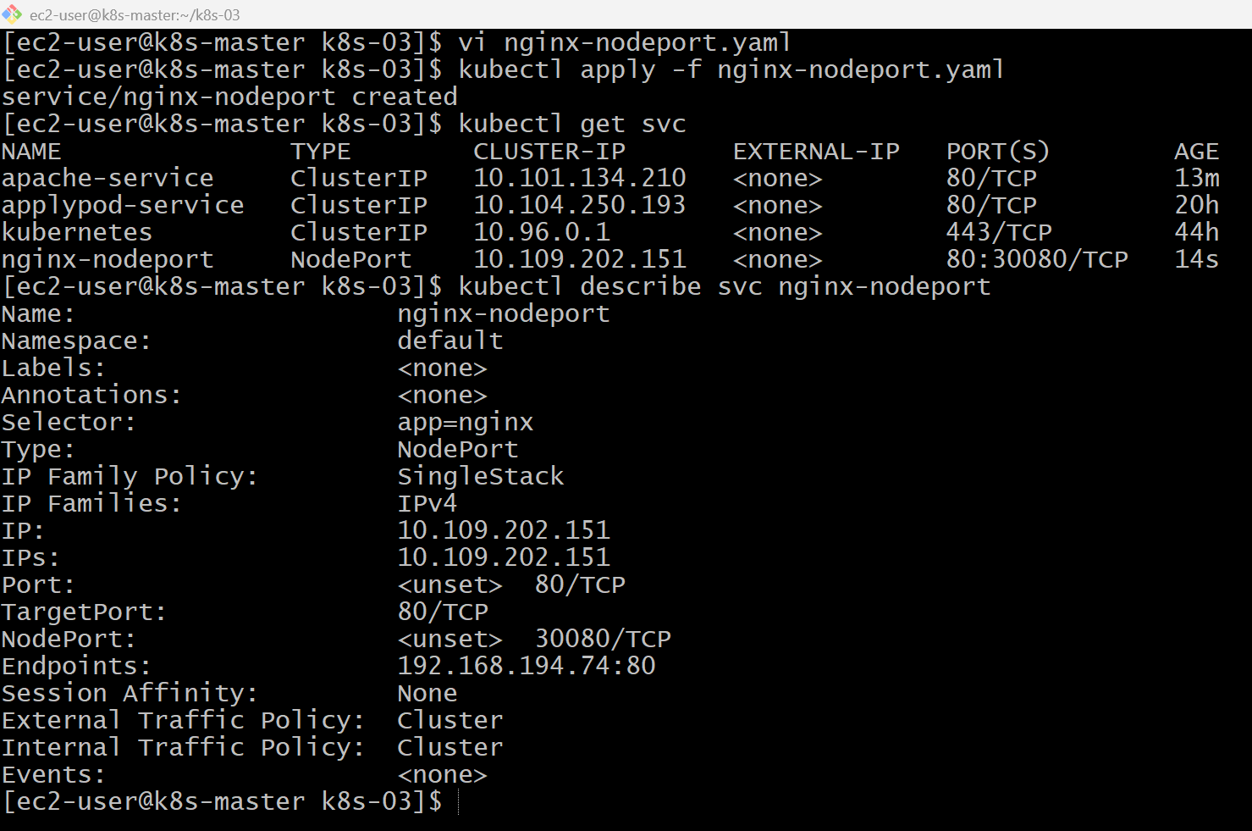
kubectl get pods -o wide

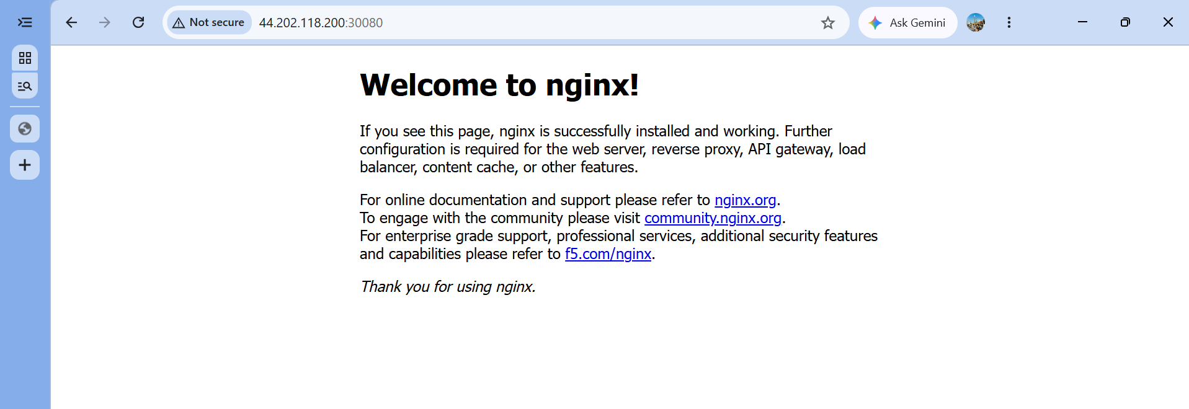

Validation
- Created the Nginx Pod.
- Verified the Pod is in the Running state.
- Created a NodePort Service.
- Verified the Service using kubectl get svc.
- Verified the Service endpoints using kubectl describe svc.
- Accessed the Nginx application using the worker node's public IP and the NodePort.

Outcome
- Successfully exposed an Nginx Pod externally using a NodePort Service.
- Verified that external users can access the application through the worker node's IP address and NodePort.
- Understood how Kubernetes Services route traffic from external clients to Pods.

Task 3: Deploy a Replication Controller to Maintain 3 Replicas of an Nginx Pod
Objective
- Create a ReplicationController.
- Maintain 3 Nginx Pods.
- Verify that exactly 3 Pods are running.
- Test the self-healing feature by deleting one Pod.

What is a Replication Controller?
A ReplicationController ensures that a specified number of identical Pods are always running.
Implementation Steps (for your documentation)
- Created a ReplicationController YAML file.
- Defined the desired replica count as 3.
- Added selectors and Pod labels.
- Configured the Nginx container in the Pod template.
- Applied the YAML using kubectl apply.
- Verified the ReplicationController status.
- Verified that 3 Pods were running.
- Deleted one Pod to test self-healing.
- Confirmed that Kubernetes automatically recreated the missing Pod.

vi nginx-rc.yaml
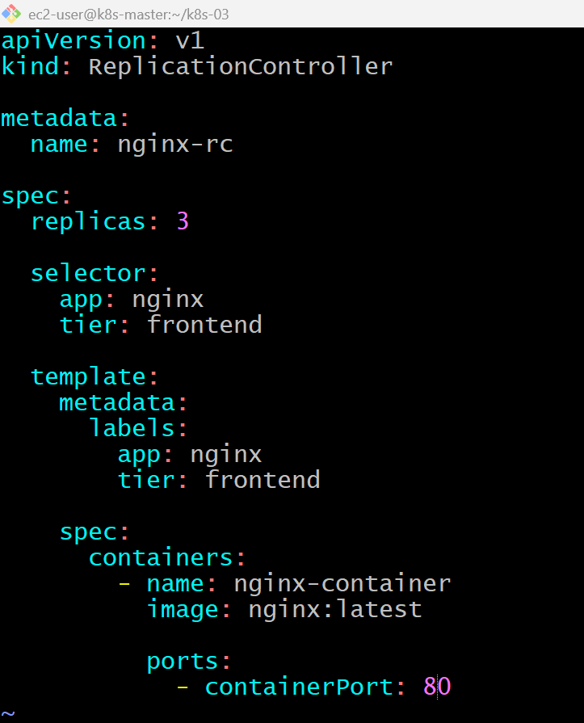
kubectl apply -f nginx-rc.yaml
kubectl get rc
kubectl get pods -o wide

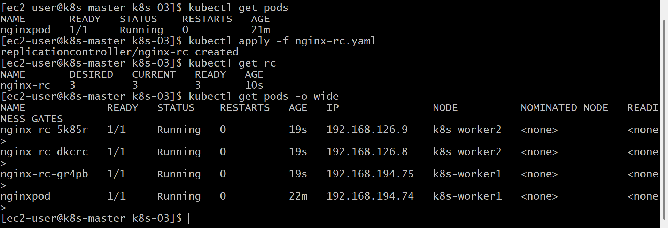
kubectl describe rc nginx-rc
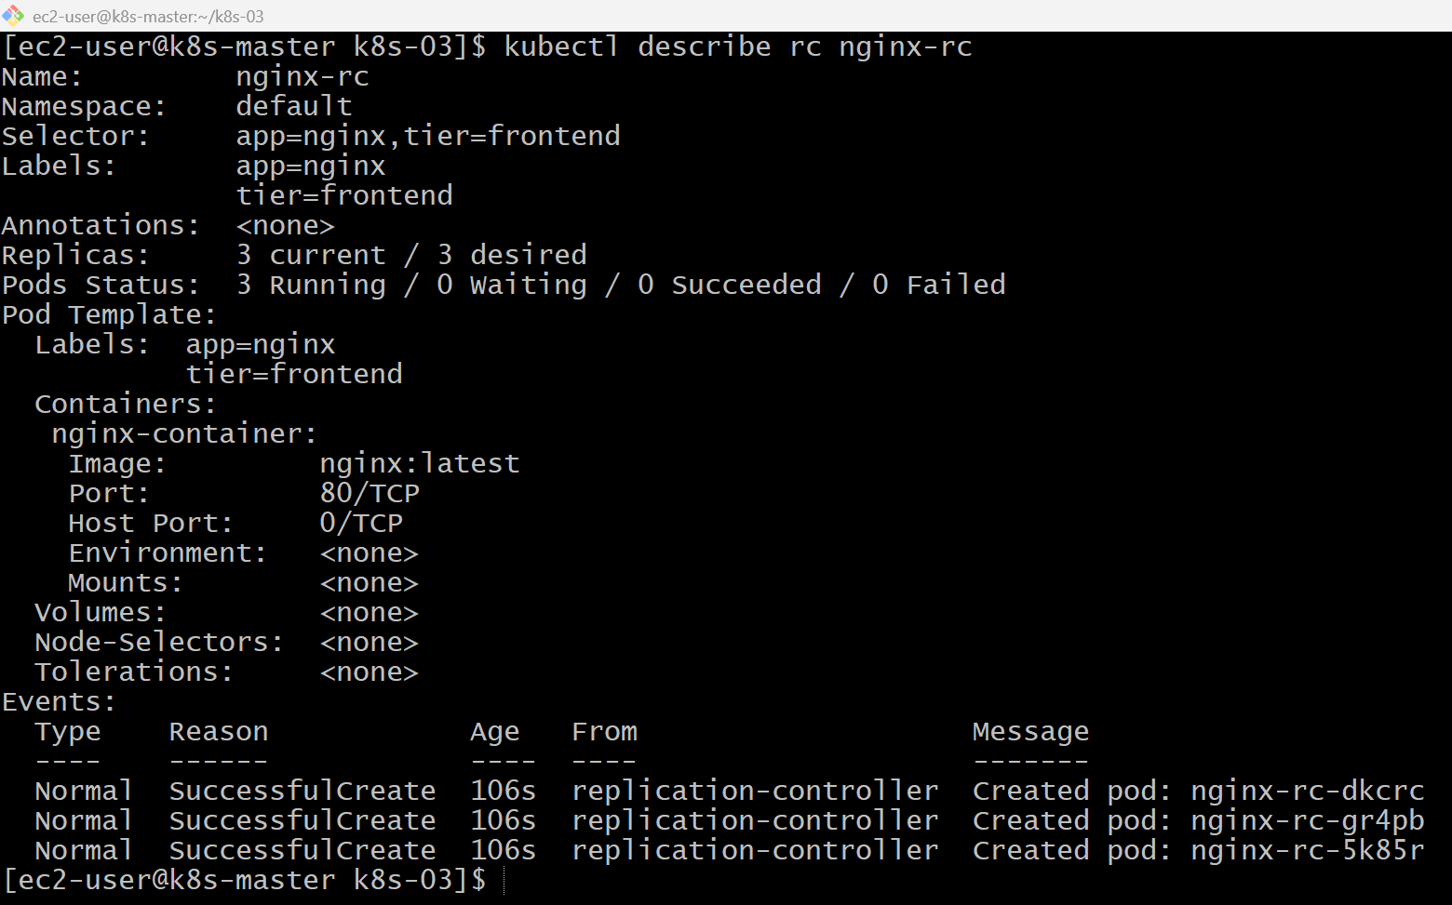
kubectl get rc
kubectl delete pod nginx-rc-5k85r
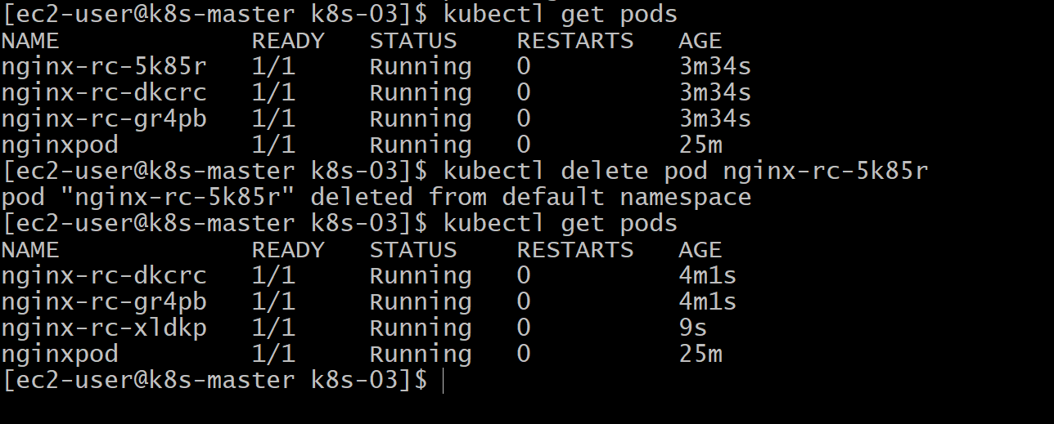
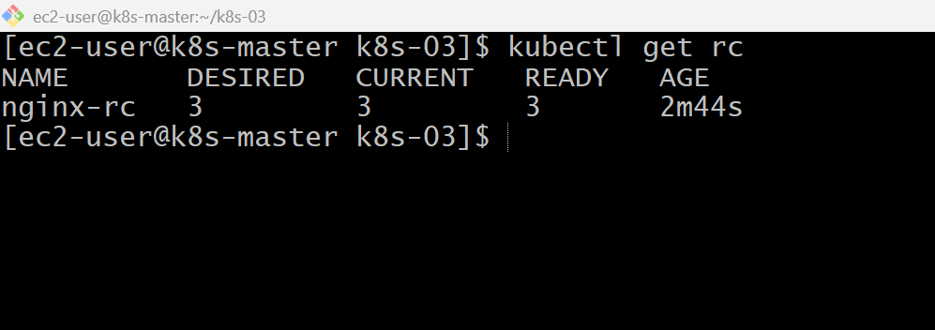
Validation Points
- Created a Replication Controller. Configured 3 desired replicas. Verified the RC using kubectl get rc.
- Verified that 3 Pods were running, Deleted one Pod.
- Confirmed that the ReplicationController automatically created a replacement Pod. Verified the RC maintained the desired replica count.
Outcome
- Successfully deployed a ReplicationController managing 3 Nginx Pods.
- Learned how a ReplicationController ensures high availability by maintaining the desired number of replicas.
- Verified Kubernetes' self-healing capability through automatic Pod recreation.
Task 4: Scale the Replication Controller from 3 Replicas to 5 Replicas
Objective
- Scale the existing Replication Controller.
- Increase the replicas from 3 to 5.
- Verify that Kubernetes creates two additional Pods.
- Understand manual scaling.
What is Scaling?
Scaling means changing the number of Pod replicas.
Implementation Steps (for your documentation)
- Verified the existing ReplicationController.
- Checked the current replica count.
- Scaled the ReplicationController to 5 replicas using the kubectl scale command.
- Verified the updated replica count using kubectl get rc.
- Verified that five Pods were in the Running state.
- Described the ReplicationController to confirm the updated desired and current replicas.
- (Optional) Deleted a Pod to verify self-healing.

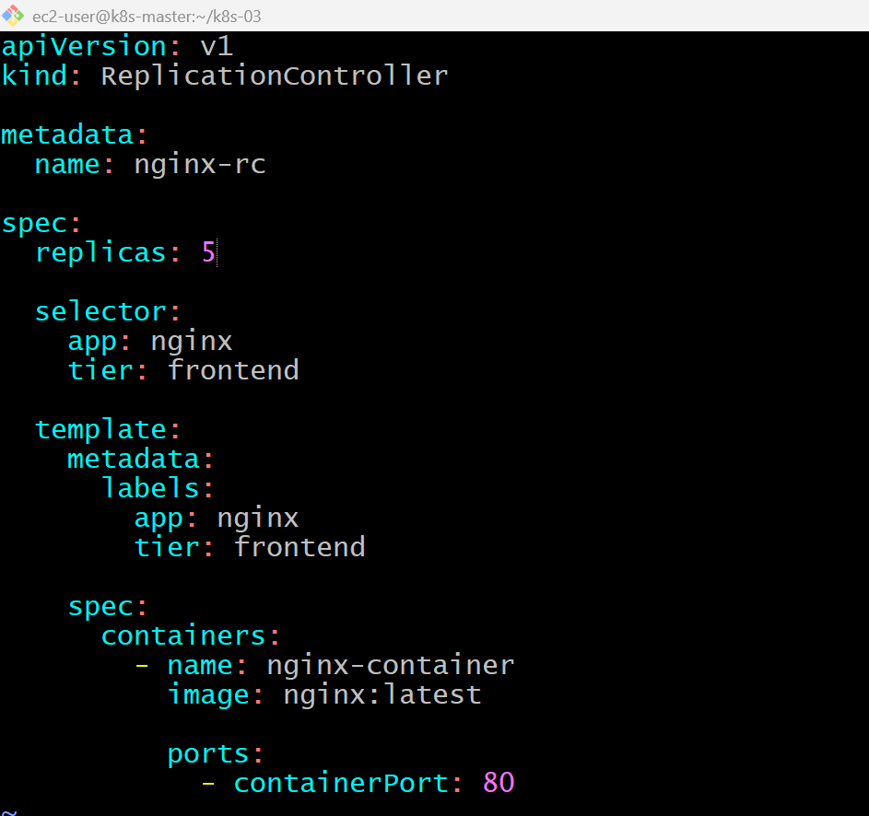
kubectl get rc
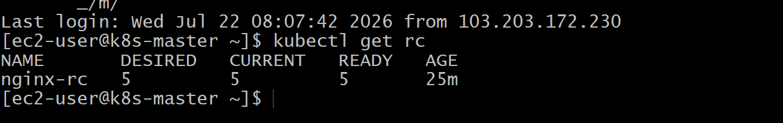

kubectl scale rc nginx-rc --replicas=5
kubectl get pods -o wide
kubectl get rc
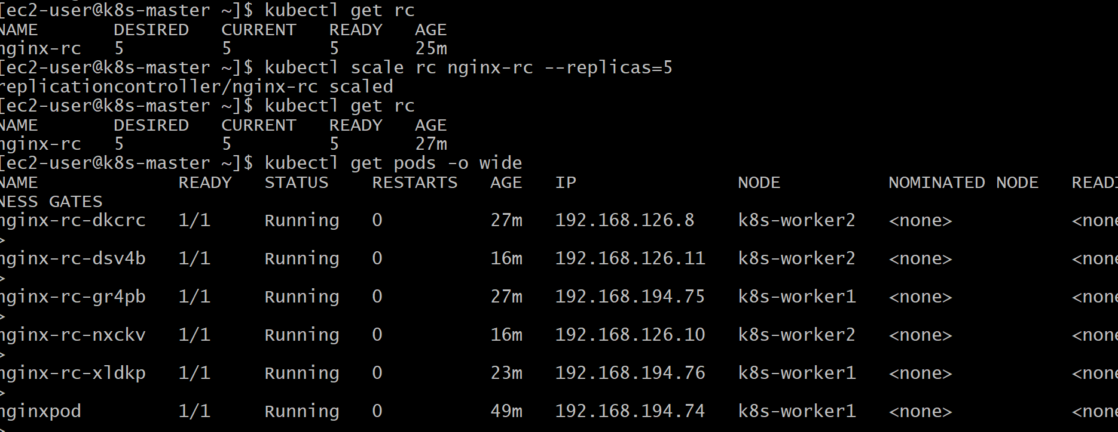
kubectl describe rc nginx-rc
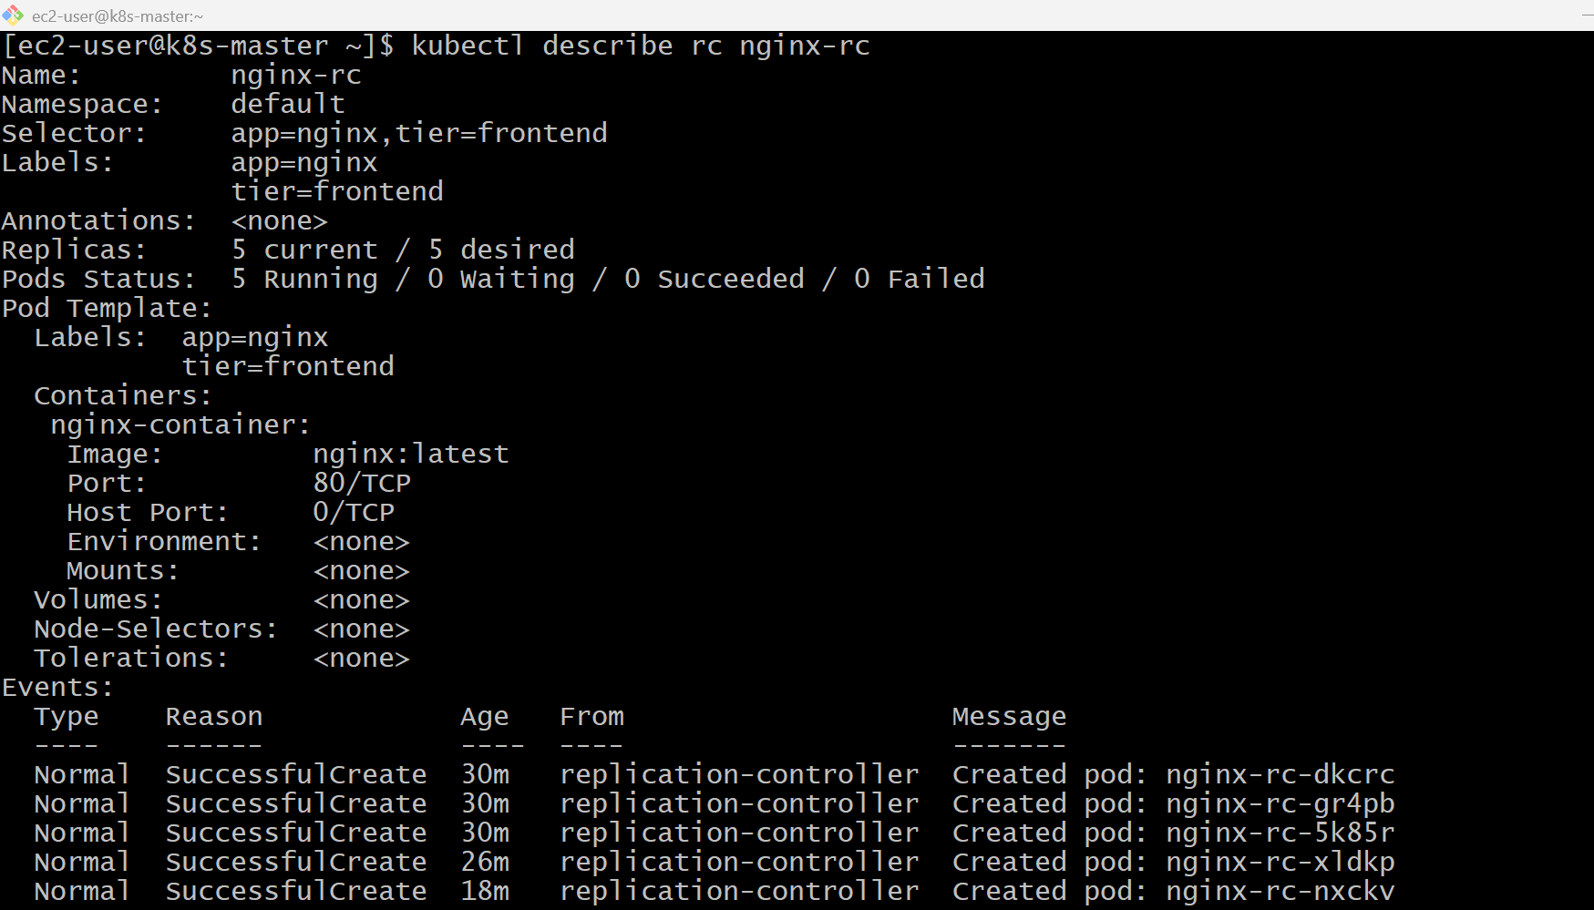

kubectl scale rc nginx-rc --replicas=2
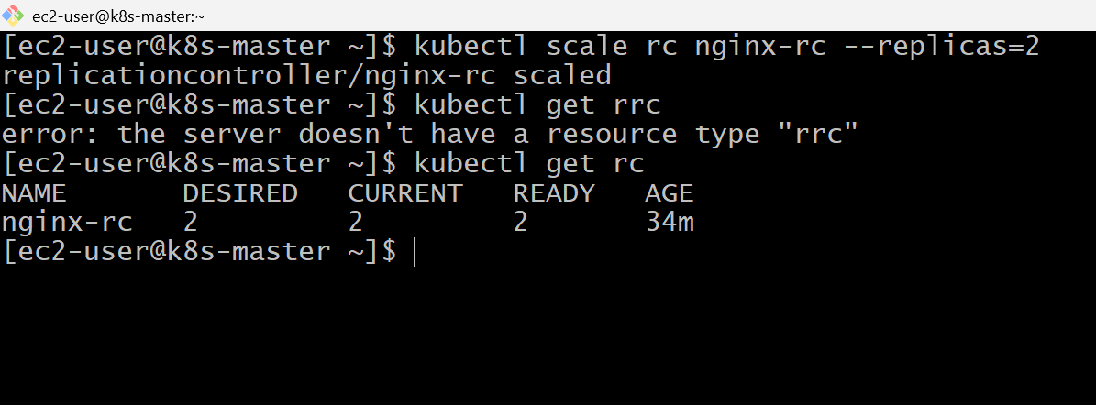

Validation Points
- Verified the ReplicationController before scaling.
- Scaled the ReplicationController from 3 to 5 replicas.
- Verified the ReplicationController using kubectl get rc.
- Verified that five Pods were running.
- Confirmed the additional Pods were created automatically.
- Verified the updated replica count using kubectl describe rc.

Outcome
- Successfully scaled a ReplicationController from 3 to 5 replicas.
- Learned how Kubernetes performs manual scaling.
- Verified that Kubernetes automatically creates additional Pods to meet the desired state.
- Understood that the ReplicationController continues to maintain the configured replica count.

Task 5: Create a Replica Set to Manage Pods Based on Multiple Labels (prod and test)
Objective
- Create a Replica Set.
- Use multiple labels (app and environment).
- Create 3 Nginx Pods.
- Verify that the Replica Set manages Pods based on multiple labels.
What is a Replica Set?
A Replica Set ensures that a specified number of Pod replicas are always running.
It is an improved version of Replication Controller because it supports set-based selectors in addition to equality-based selectors.
Replication Controller vs Replica Set
Replication Controller | Replica Set
Old controller | Modern controller
Supports only equality selectors | Supports equality and set-based selectors
Rarely used in production | Used by Deployments

What are Multiple Labels?
A Pod can have more than one label.

vi nginx-rs.yaml
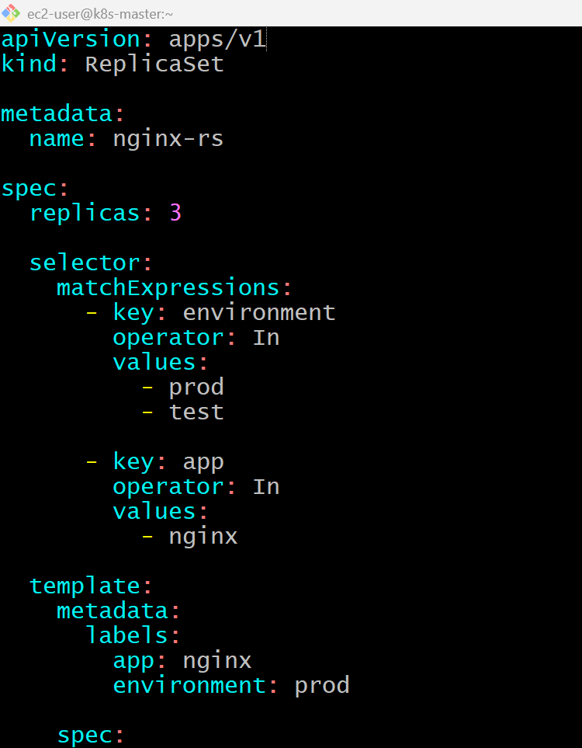

kubectl apply -f nginx-rs.yaml
kubectl get rs
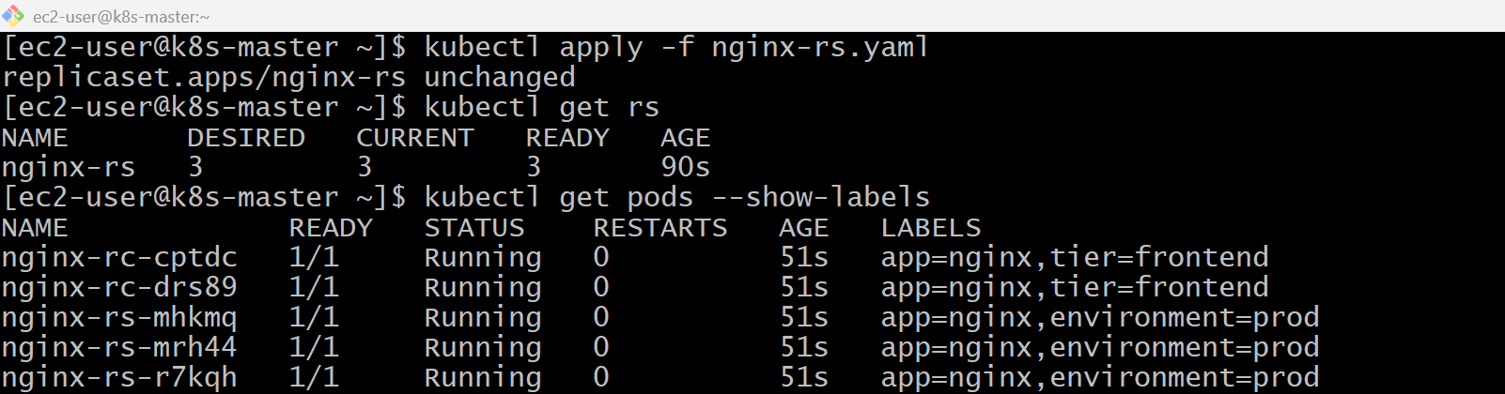
kubectl describe rs nginx-rs
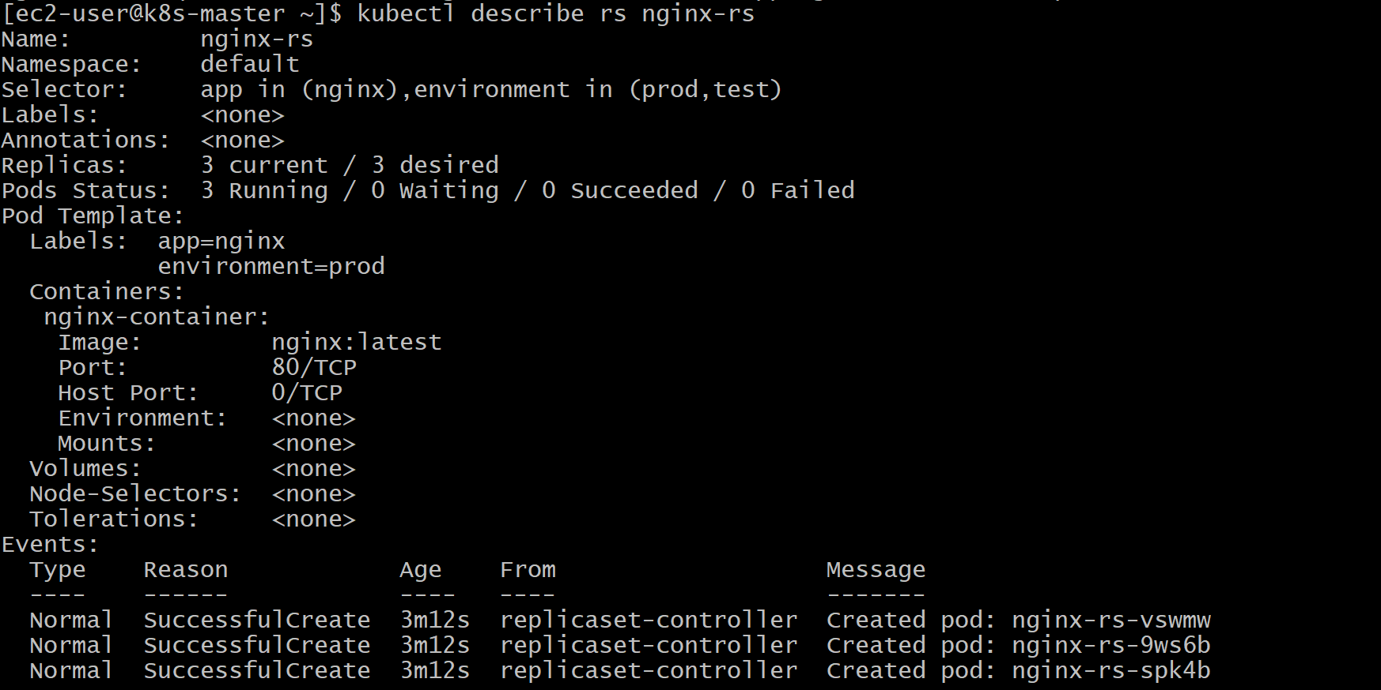
kubectl get pods --show-labels
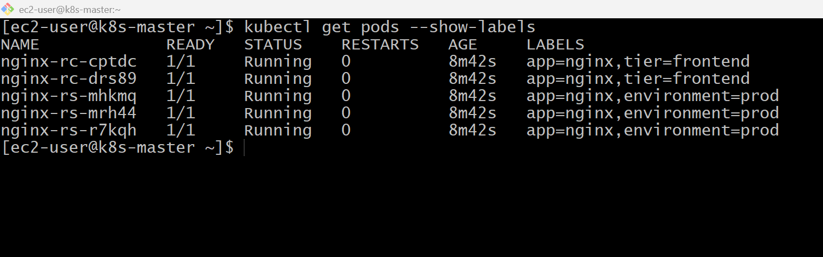

Validation
- Created a ReplicaSet.
- Configured 3 replicas.
- Used multiple labels with set-based selectors.
- Verified the ReplicaSet using kubectl get rs.
- Verified Pods using kubectl get pods --show-labels.
- Verified the selector using kubectl describe rs.
- Confirmed self-healing by deleting a Pod.

Outcome
- Successfully created a ReplicaSet managing Nginx Pods.
- Used multiple labels (app and environment) for Pod selection.
- Learned how ReplicaSets use set-based selectors (In) to manage Pods.
- Verified Kubernetes automatically recreates Pods to maintain the desired replica count.

Task 6: Deploy a ReplicaSet That Excludes Pods with the Label backend
Objective
- Create a ReplicaSet.
- Use a NotIn selector.
- Exclude Pods that have the label backend.
- Verify the selector using kubectl describe.
What is NotIn?
The NotIn operator tells Kubernetes:
Implementation Steps (Documentation)
- Created a ReplicaSet YAML file.
- Set the desired replica count to 3.
- Used matchExpressions with the NotIn operator.
- Assigned the label tier: frontend to the Pod template.
- Applied the YAML using kubectl apply.
- Verified the ReplicaSet using kubectl get rs.
- Verified labels using kubectl get pods --show-labels.
- Deleted a Pod to confirm self-healing.

vi nginx-rs-notin.yaml
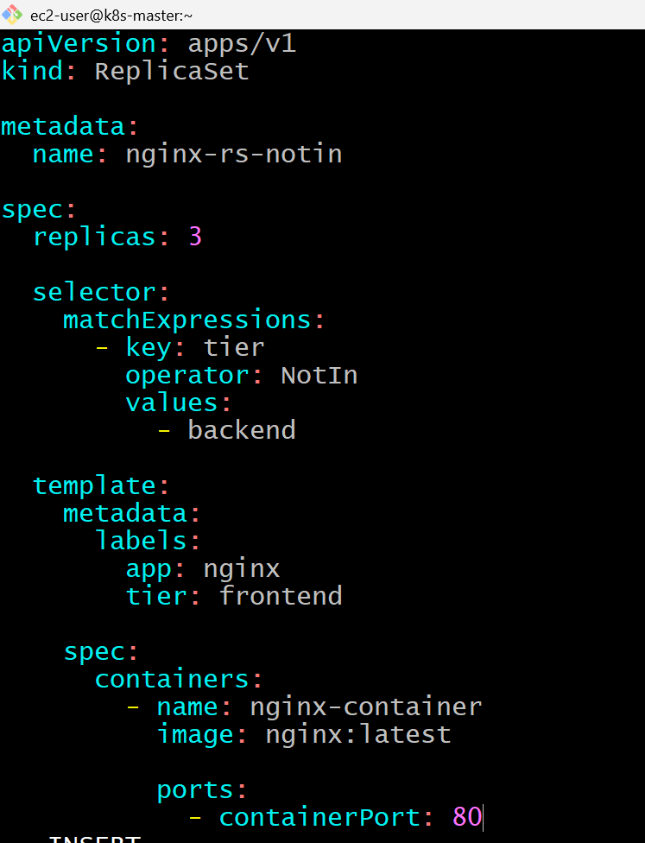

kubectl apply -f nginx-rs-notin.yaml
kubectl get rs
kubectl get pods --show-labels
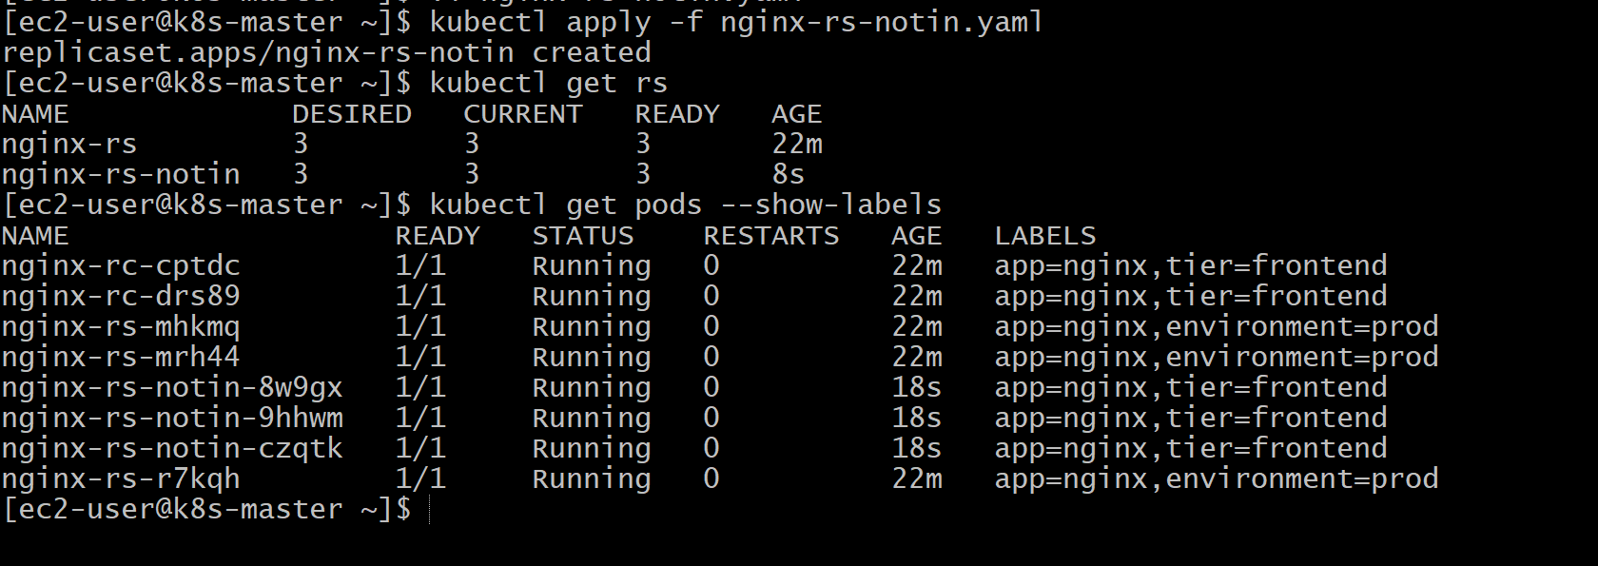
Validation Points
- Created a ReplicaSet using the NotIn operator.
- Configured 3 replicas.
- Excluded Pods with the label tier=backend.
- Verified the ReplicaSet using kubectl get rs.
- Verified Pod labels using kubectl get pods --show-labels.
- Confirmed the selector using kubectl describe rs.
- Tested self-healing by deleting a Pod.

Outcome
- Successfully created a ReplicaSet using a set-based NotIn selector.
- Learned how ReplicaSets can exclude Pods based on labels.
- Verified automatic Pod recreation to maintain the desired number of replicas.
- Understood how label selectors provide flexible Pod management.

Task 7: Test Load Balancing Across Multiple Pods Using a Node Port Service
Objective
- Create multiple Nginx Pods (using the Replica Set from previous tasks).
- Expose them through a Node Port Service.
- Access the Service using the worker or master node IP.
- Verify that requests are load balanced across the Pods.

What is Load Balancing?
Instead of sending traffic to a single Pod, Kubernetes Service distributes requests across all matching Pods.
Example:
User
│
▼
NodePort Service
(Port: 30080)
│
┌───────────┼───────────┐
▼ ▼ ▼
Nginx-1 Nginx-2 Nginx-3
Each new request may be sent to a different Pod.

Prerequisites
Before starting, verify that you have a ReplicaSet with multiple running Pods.
kubectl get rs
kubectl get pods -o wide
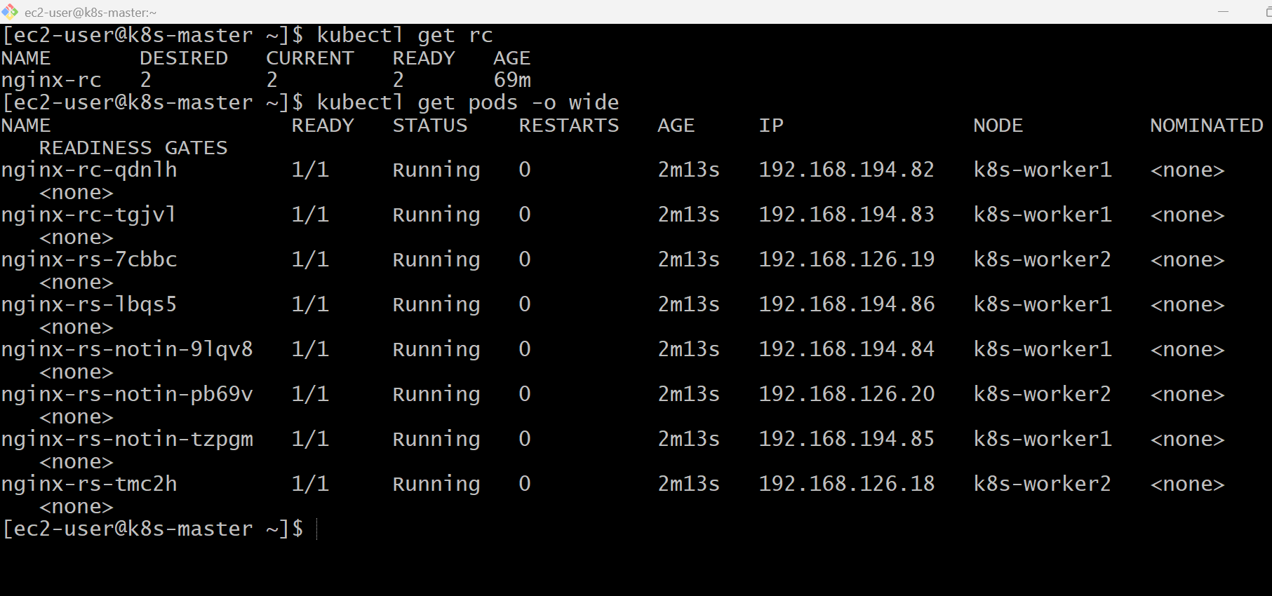
Implementation Steps (Documentation)
- Verified the ReplicaSet and running Pods.
- Created a NodePort Service YAML.
- Configured the selector to target Nginx Pods.
- Exposed port 80 through NodePort 30080.
- Applied the Service configuration.
- Verified the Service using kubectl get svc.
- Verified the endpoints using kubectl get endpoints.
- Accessed the application using the node's public IP and NodePort.

vi nginx-nodeport-service.yaml
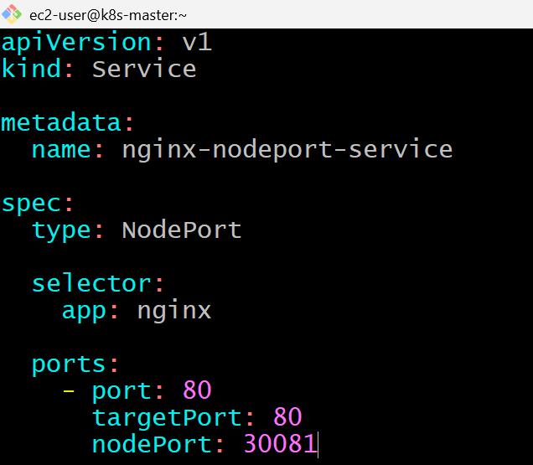
kubectl apply -f nginx-nodeport-service.yaml
kubectl get svc
kubectl get endpoints
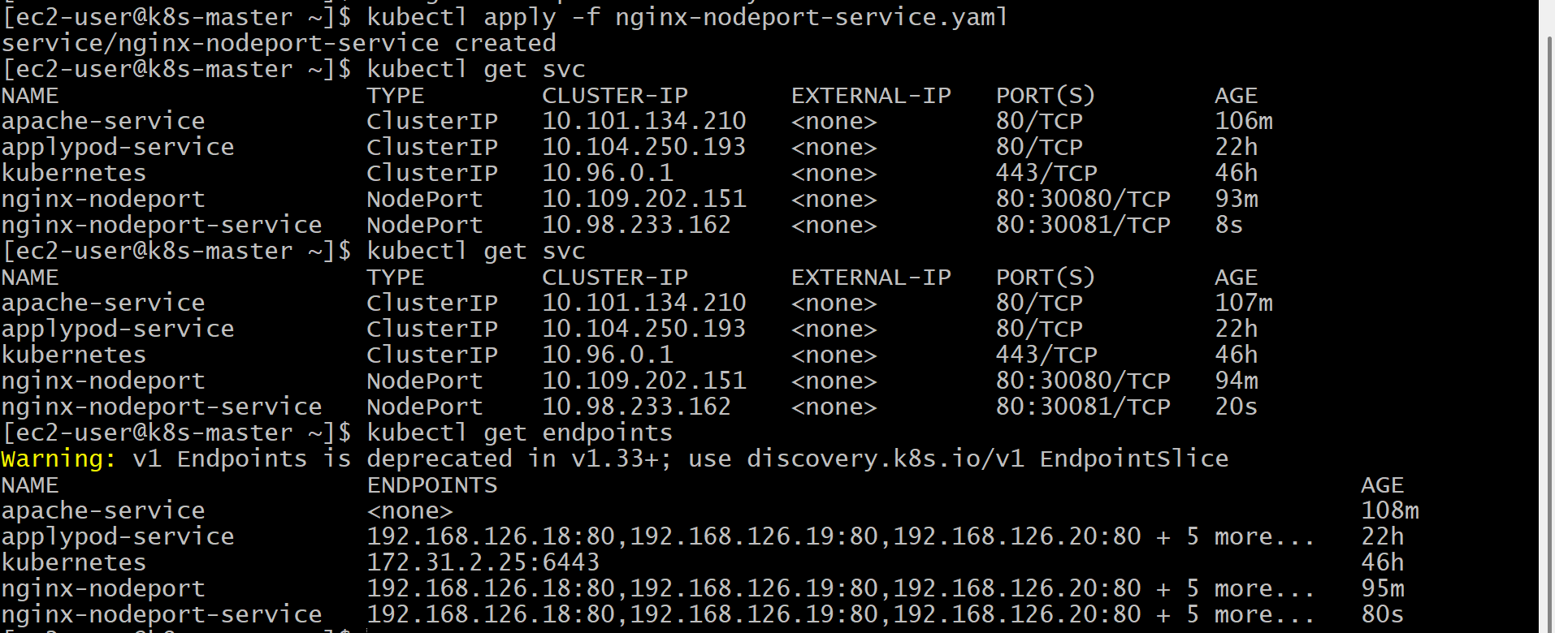

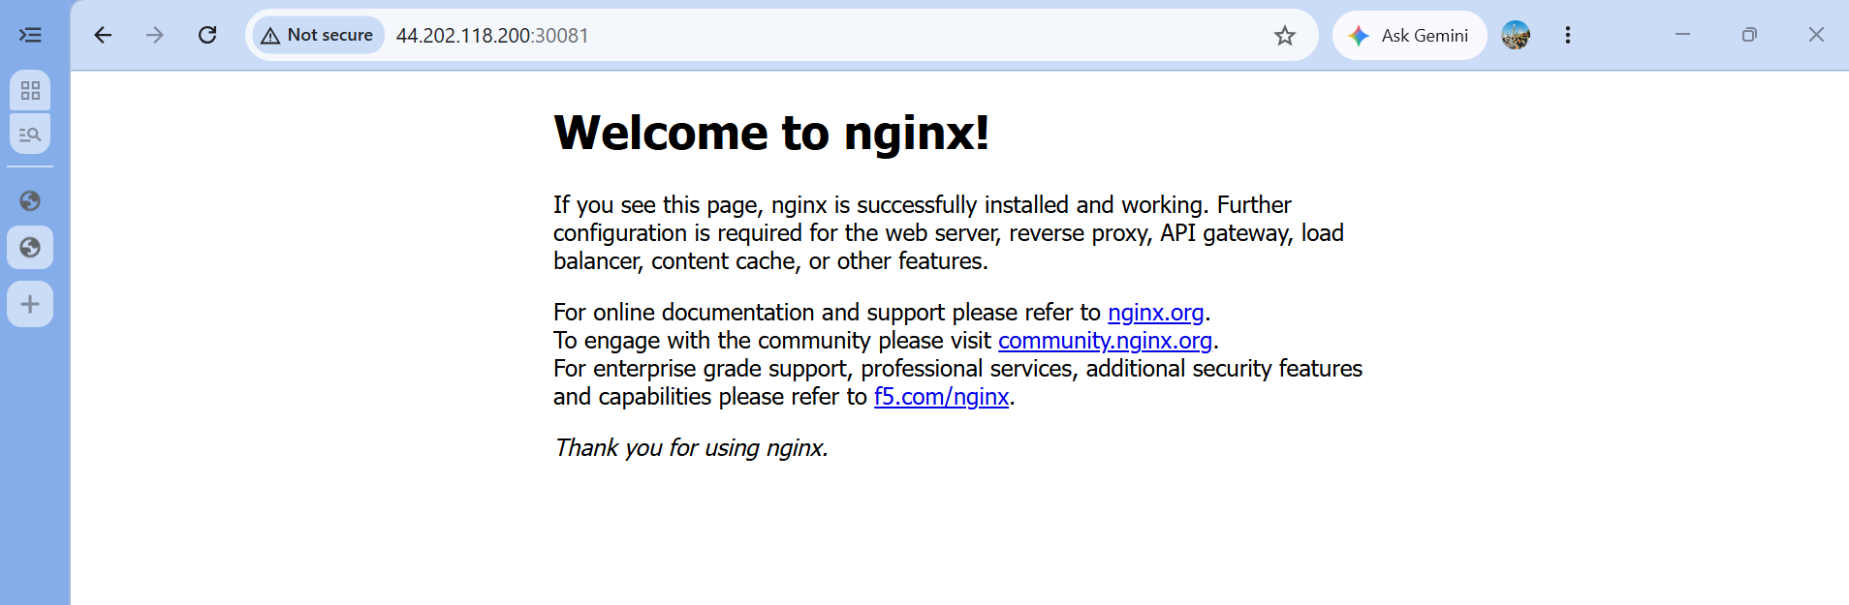
Validation Points
- Created a NodePort Service.
- Exposed multiple Nginx Pods externally.
- Verified the Service using kubectl get svc.
- Verified the endpoints using kubectl get endpoints.
- Accessed the application through the NodePort.
- Confirmed the Service forwards traffic to all matching Pods.

Outcome
- Successfully exposed multiple Nginx Pods using a NodePort Service.
- Learned how Kubernetes Services provide a single access point for multiple Pods.
- Understood that the Service distributes incoming traffic among healthy Pods, providing basic load balancing.

Task 8: Delete a Replication Controller Without Affecting the Running Pods
Objective
- Delete the Replication Controller (RC).
- Keep the Pods running.
- Verify that the Pods continue to run even after the RC is deleted.
Why Use --cascade=orphan?
Normally, if you delete a Replication Controller:
Implementation Steps (Documentation)
- Verified the existing ReplicationController.
- Verified the Pods managed by the ReplicationController.
- Deleted the ReplicationController using kubectl delete rc --cascade=orphan.
- Verified that the ReplicationController was removed.
- Verified that the Pods remained in the Running state.
- Confirmed the Pods were no longer managed by any controller.

kubectl delete rc nginx-rc
kubectl get pods
kubectl delete rc nginx-rc --cascade=orphan
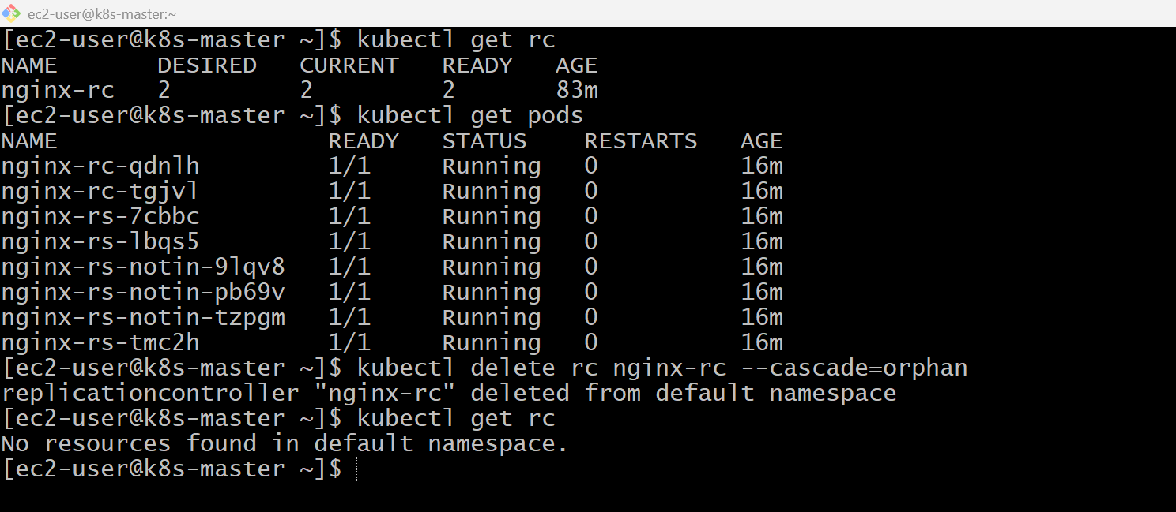
kubectl get pods
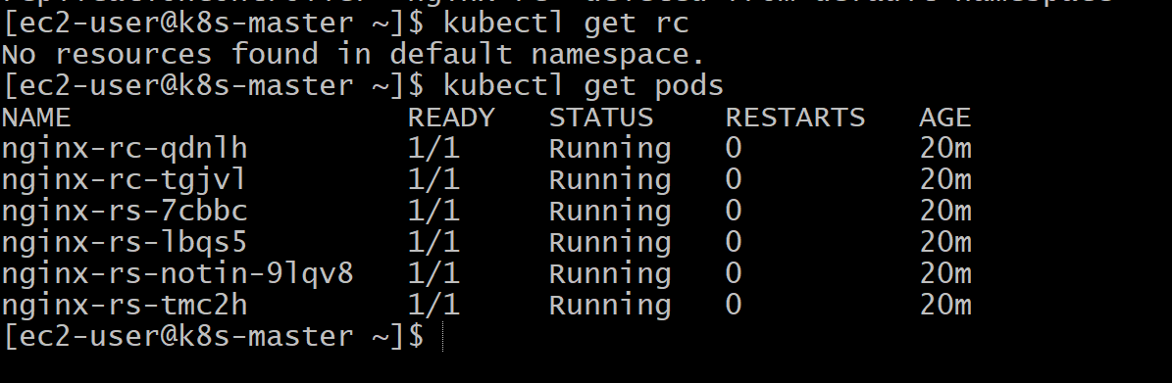
Kubectl delete –all –all
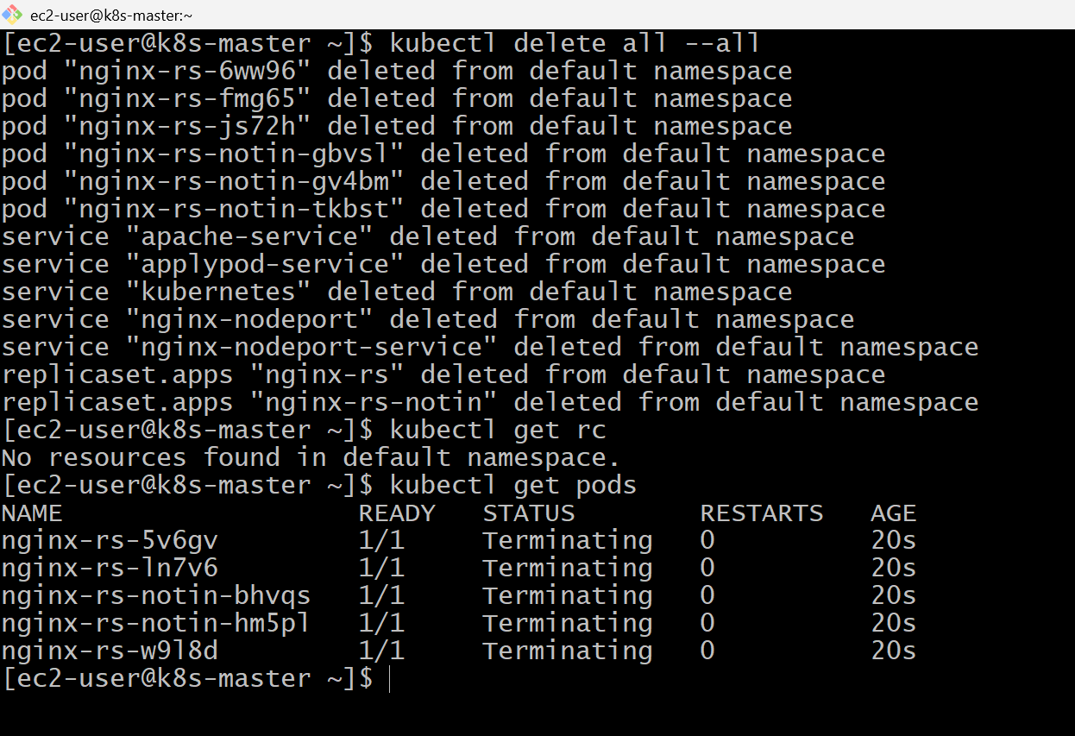
kubectl get pods
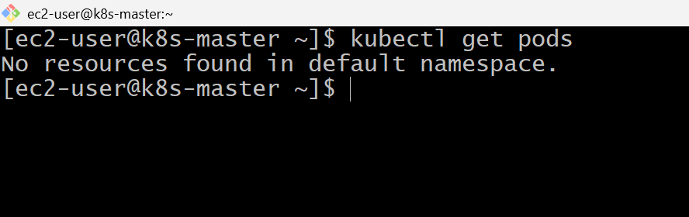

Validation Points
- Verified the ReplicationController before deletion.
- Verified the running Pods.
- Deleted the ReplicationController using --cascade=orphan.
- Confirmed the ReplicationController was removed.
- Verified that all Pods continued running.
- Confirmed the application remained accessible (if exposed through a Service).

Outcome
- Successfully deleted a ReplicationController while preserving the running Pods.
- Learned how the --cascade=orphan option prevents managed Pods from being deleted.
- Understood that orphaned Pods continue running but are no longer self-healing because they are not managed by a controller.

