Terraform-06
Watched the Terraform-06 video
Executed the script shown in the video.
Task 1: Provision EC2, S3, and VPC Using Terraform Modules
Objective
The objective of this task is to provision AWS infrastructure using reusable Terraform modules. Separate modules are created for VPC, S3 Bucket, and EC2 Instance, allowing the infrastructure code to be modular, reusable, maintainable, and scalable.
Prerequisites
- Terraform installed.
- AWS CLI configured (aws configure).
- AWS account with permissions for EC2, VPC, and S3.
- Existing Key Pair (docker-key).
- Valid AMI ID (ami-0f8a61b66d1accaee).
- Visual Studio Code.
Step-by-Step Implementation
Step 1
Create a project folder
Terraform-Modules

Step 2
Inside it create
modules
Step 3
Inside modules create
ec2
s3
vpc
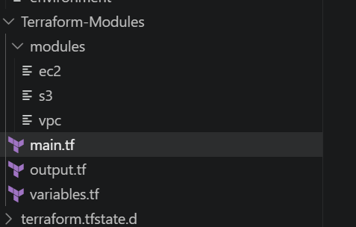
Step 4
Create the required Ec2 / main.tf
Create ec2
resource "aws_instance" "ec2" {

ami = var.ami

instance_type = var.instance_type

subnet_id = var.subnet_id

key_name = var.key_name

associate_public_ip_address = true

tags = {

Name = "Terraform-Module-EC2"

}

}

Main.tf
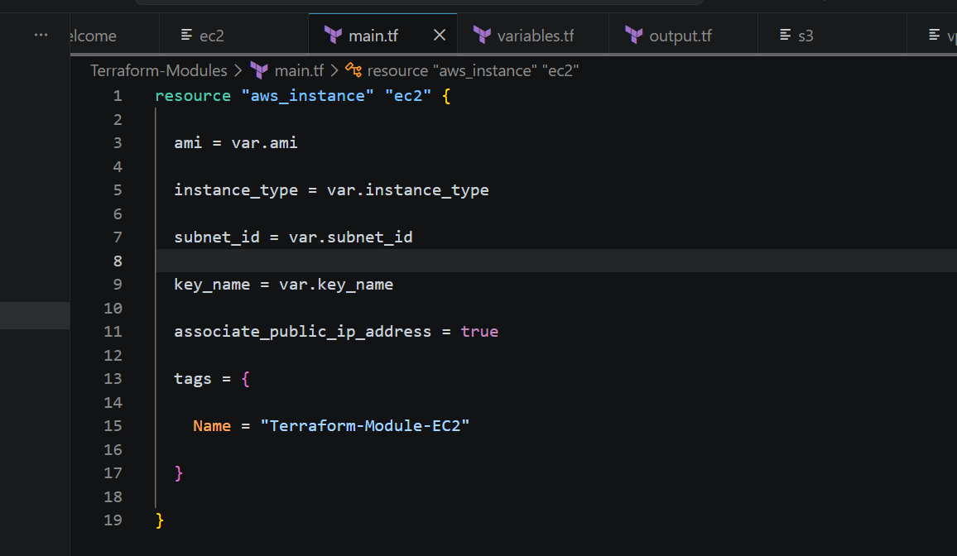
Variables.tf
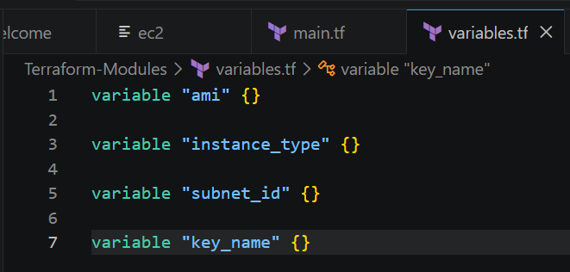
Output.tf
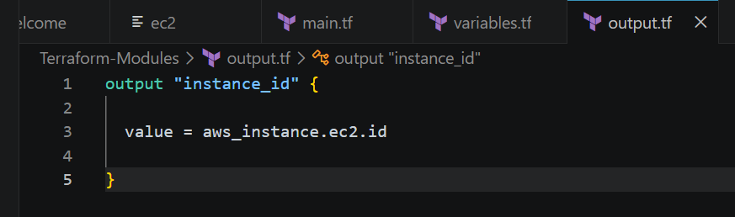
Now commands used
terraform init
terraform validate
terraform plan
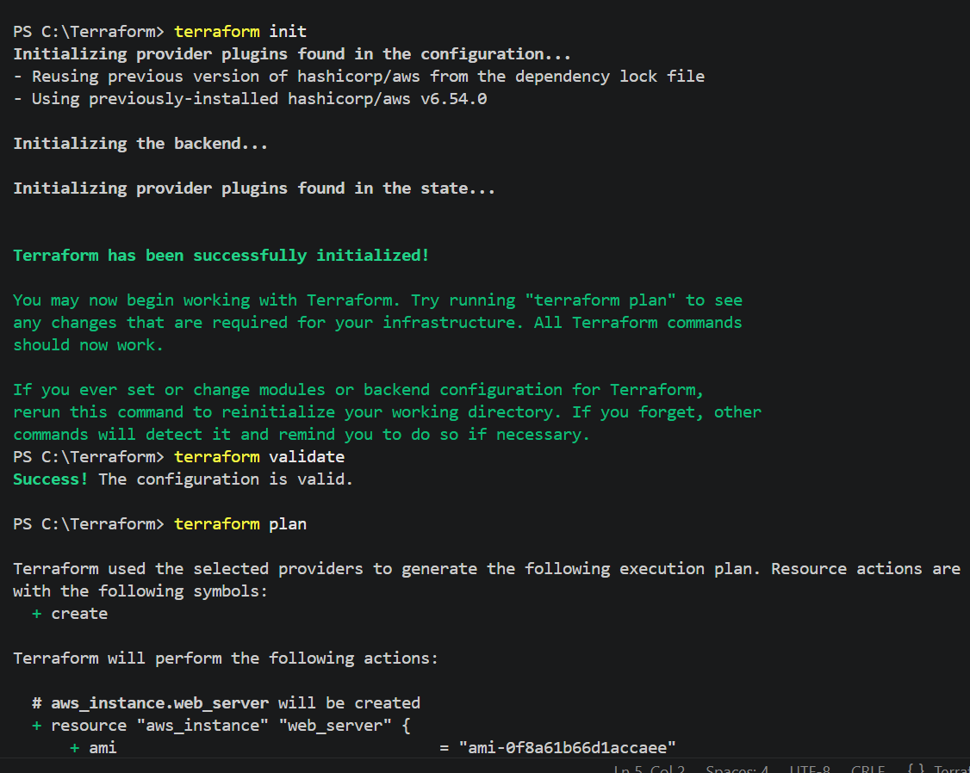
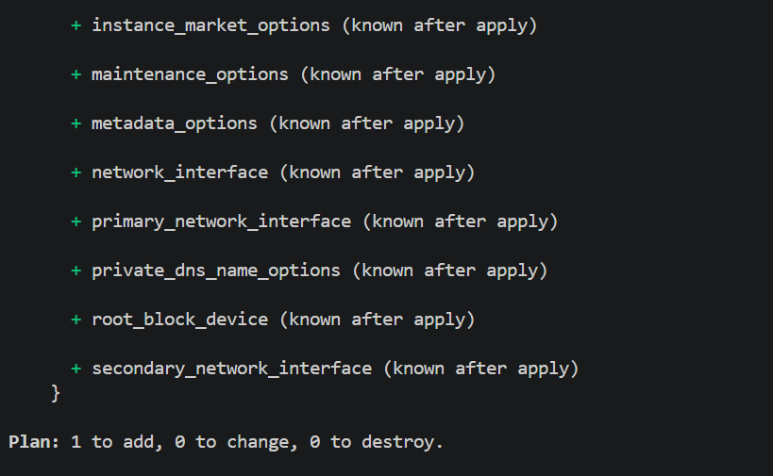
Now terraform apply
Enter : Yes
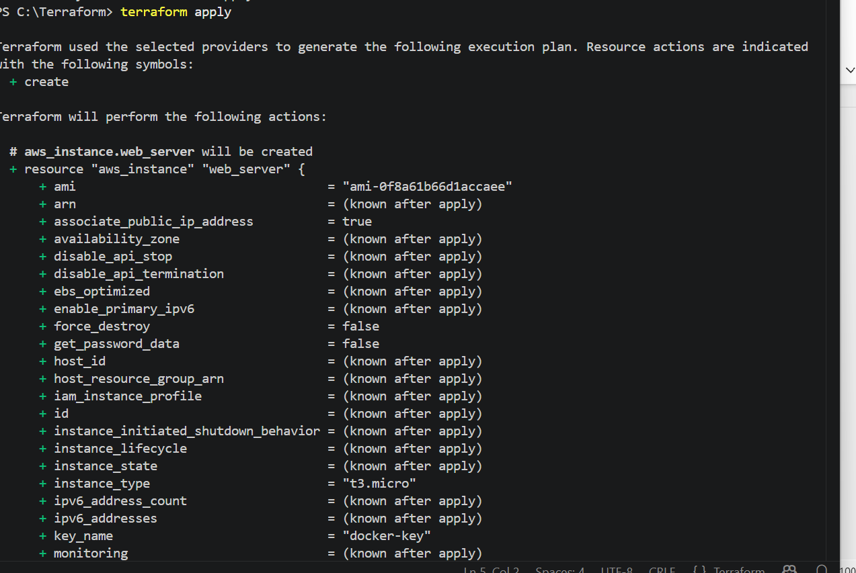
Ec2 instance created automatically
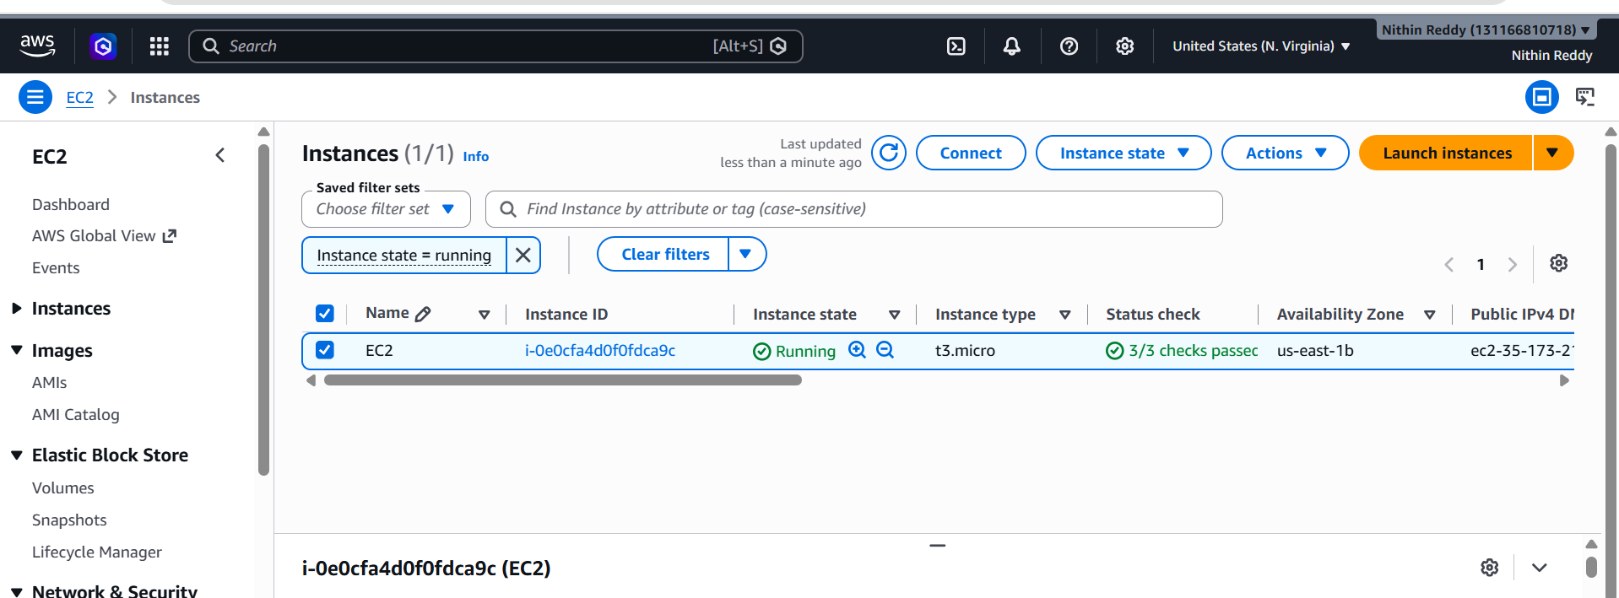
Now create S3
main.tf
terraform {
required_providers {
aws = {
source = "hashicorp/aws"
version = "~>6.54"
}
}
}

provider "aws" {
region = "us-east-1"
}

module "vpc" {
source = "./modules/vpc"

cidr_block = "10.0.0.0/16"
}

module "s3" {
source = "./modules/s3"

bucket_name = "nithinreddy-module-bucket-12345"
}

module "ec2" {

source = "./modules/ec2"

ami = "ami-0f8a61b66d1accaee"
instance_type = "t3.micro"
subnet_id = module.vpc.public_subnet_id
key_name = "docker-key"

}
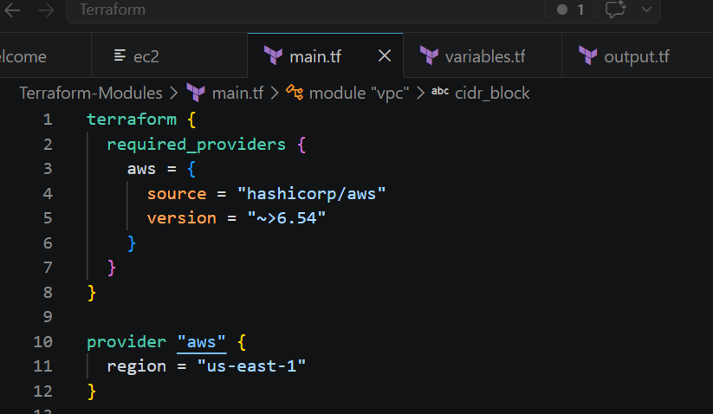

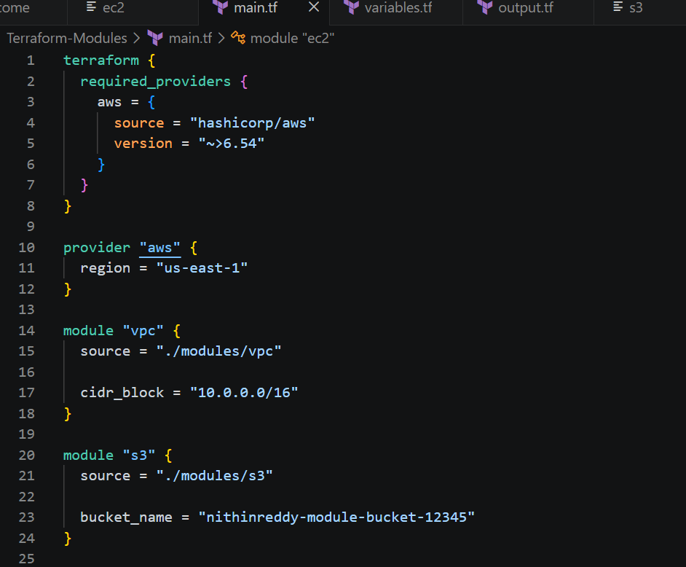

Commands used
terraform init
terraform validate
terraform plan
terraform apply
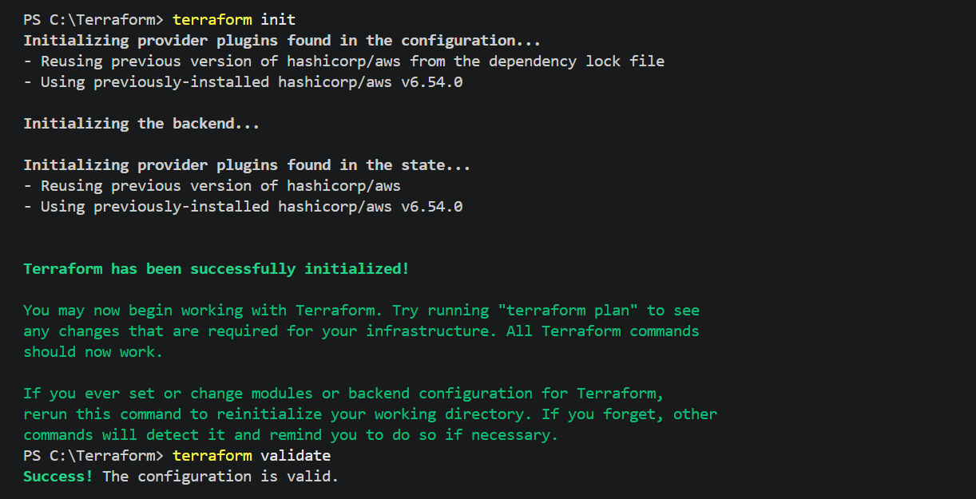
Now terraform apply
Enter : yes
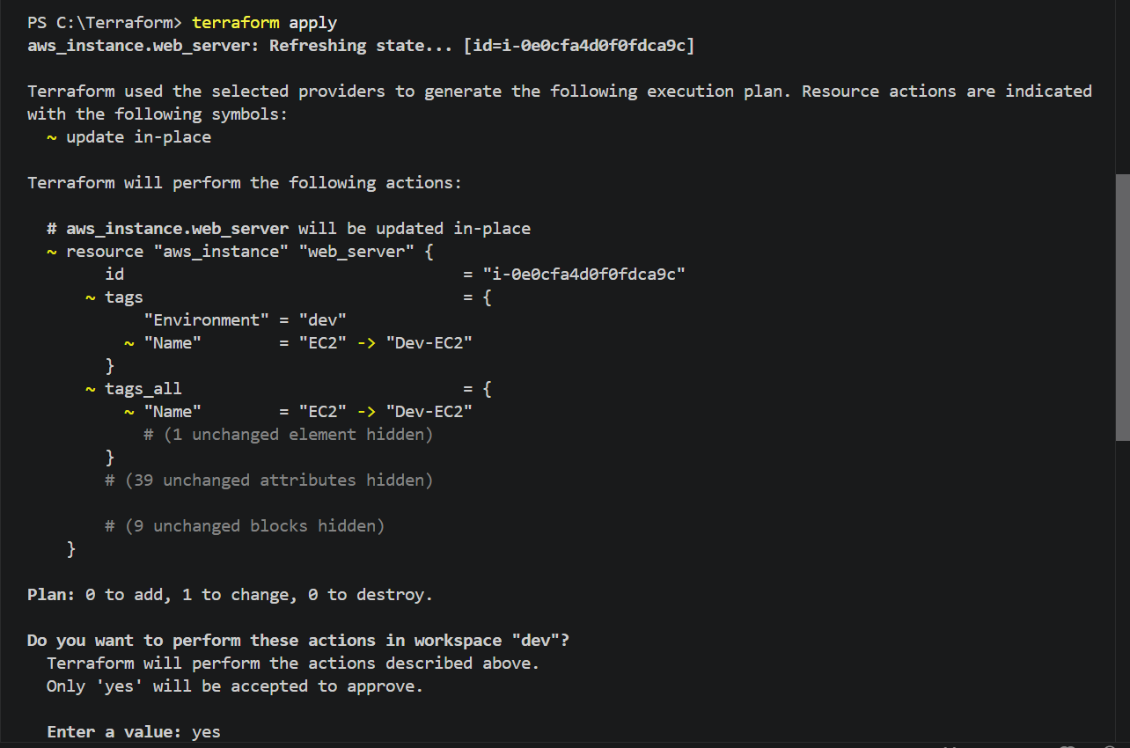
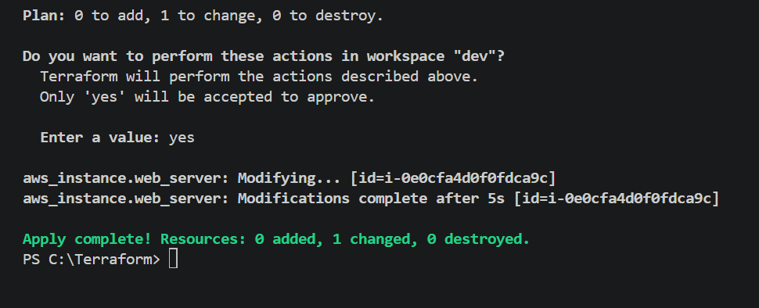
S3 bucket created automatically after terraform apply
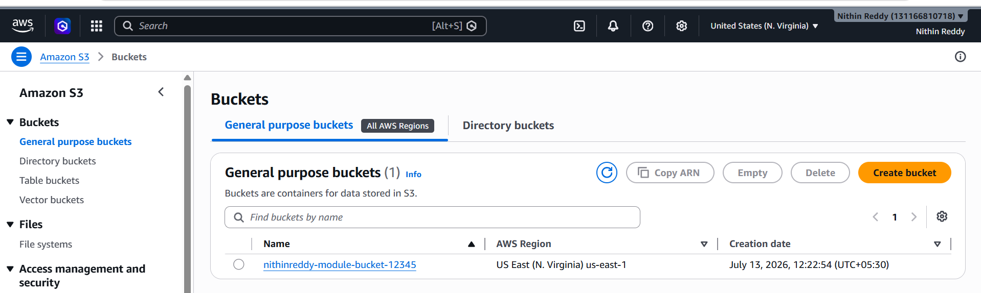
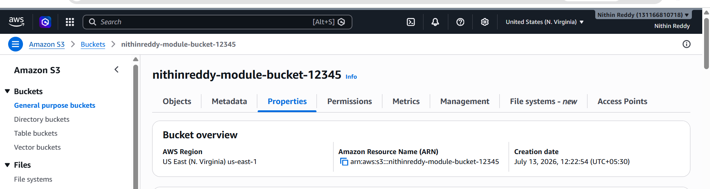

Now create vpc

resource "aws_vpc" "main" {

cidr_block = var.cidr_block

tags = {
Name = "Terraform-VPC"
}

}

resource "aws_subnet" "public" {

vpc_id = aws_vpc.main.id

cidr_block = "10.0.1.0/24"

availability_zone = "us-east-1a"

map_public_ip_on_launch = true

}

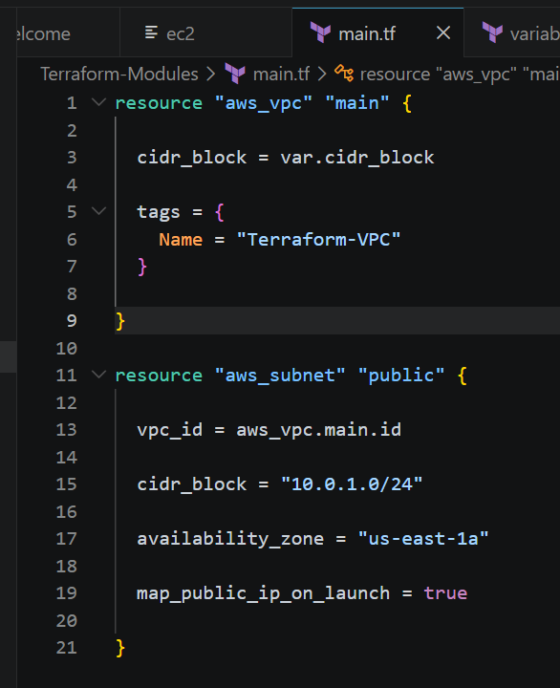
Commands used
terraform init
terraform validate
terraform plan
terraform apply
terraform output
terraform destroy
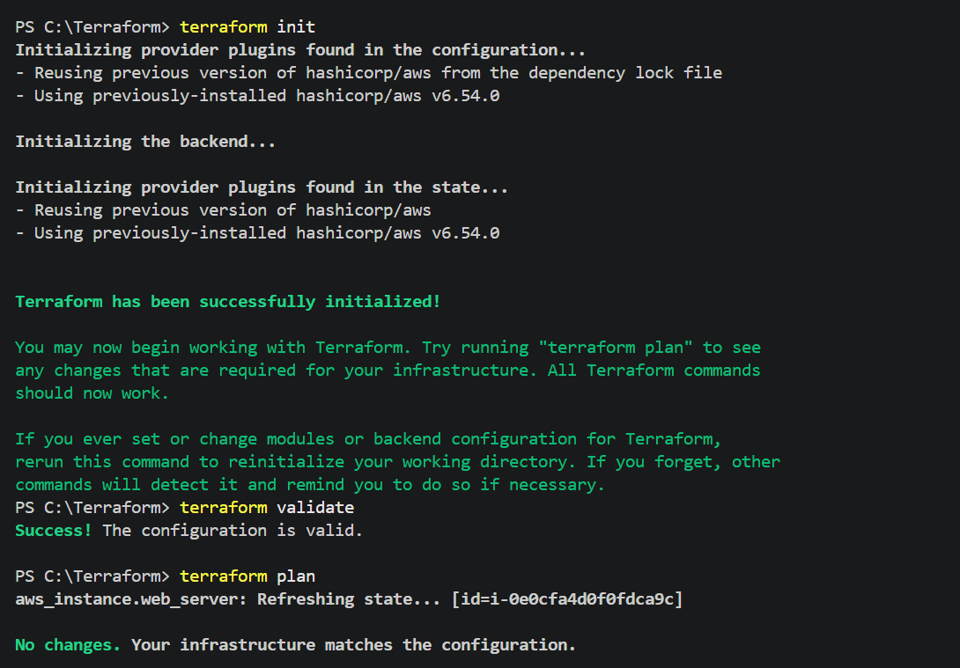
After terraform apply
Enter : yes
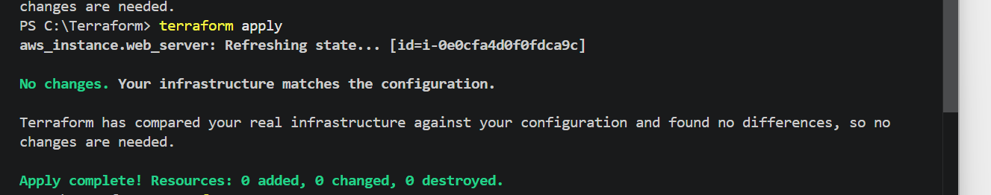
VPC created automatically using terraform apply
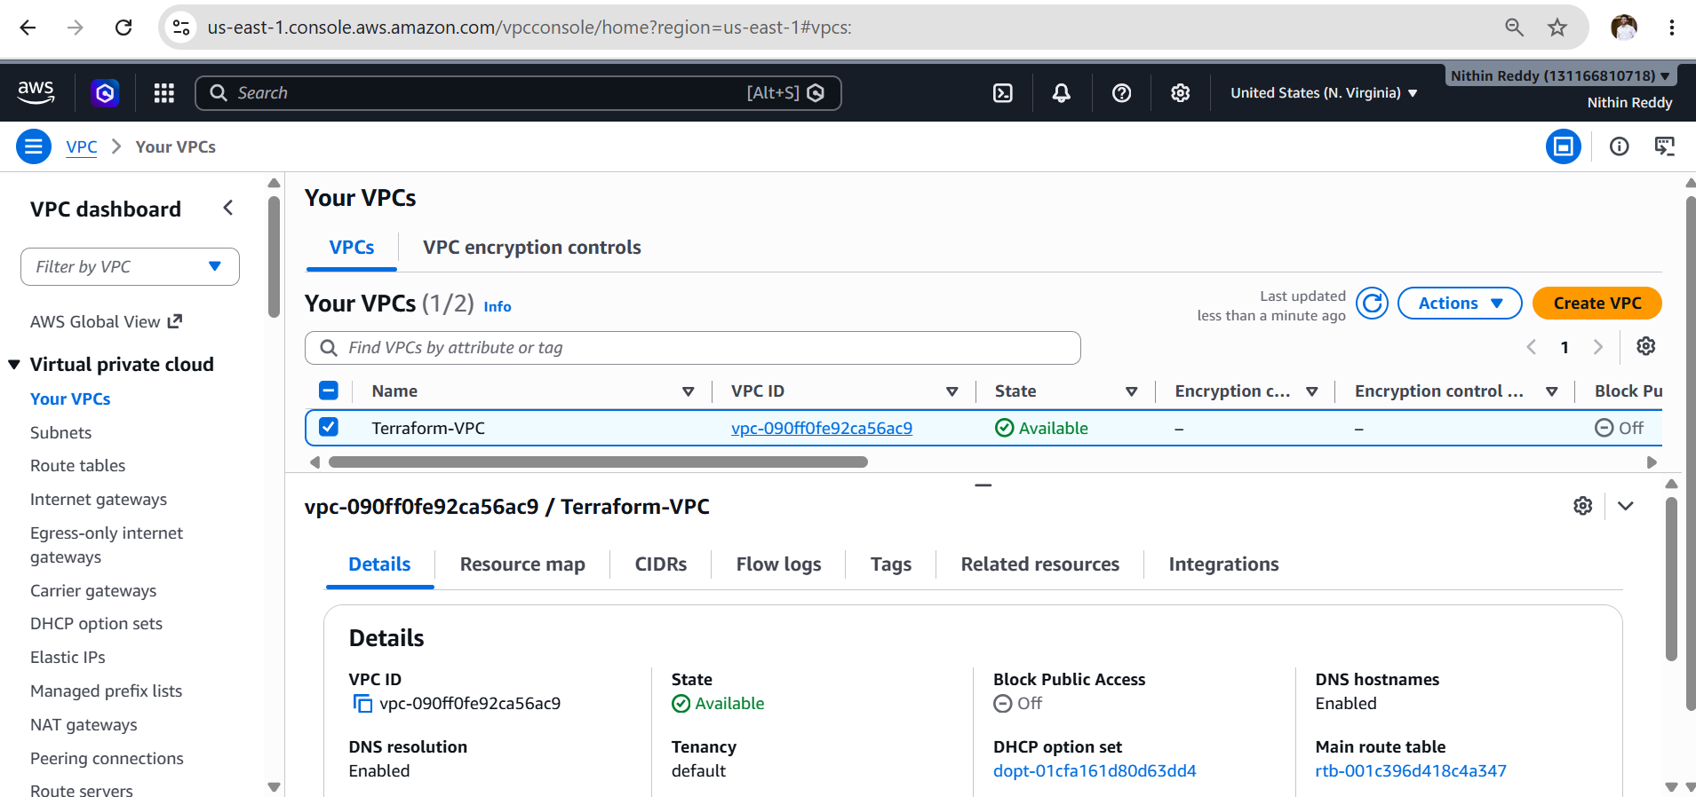
Validation
- Terraform initialized successfully.
- All configuration files validated successfully.
- Execution plan generated without errors.
- New VPC and subnet created.
- EC2 instance launched successfully.
- S3 bucket created successfully.
- Outputs displayed the VPC ID, EC2 Instance ID, and Bucket Name.
- Resources destroyed successfully using terraform destroy.
Expected Outcome
- Infrastructure is provisioned using reusable Terraform modules.
- Separate modules are created for EC2, VPC, and S3.
- Resources are deployed successfully in AWS.
- The module-based structure improves code reusability, maintainability, and scalability.
- Terraform provisions and destroys all resources through a single root module configuration.
Task 2: Provision EC2 for 3 different environments (Dev, Staging, and Prod) using Terraform workspaces
Objective
The objective of this task is to provision separate EC2 instances for Development (Dev), Staging, and Production (Prod) environments using Terraform Workspaces. Terraform Workspaces allow multiple environments to be managed from a single Terraform configuration while maintaining separate state files for each environment.
Prerequisites
- Terraform installed and configured.
- AWS CLI installed and configured (aws configure).
- AWS account with EC2 permissions.
- Valid AWS credentials.
- Existing VPC and Subnet.
- EC2 Key Pair created.
- Suitable AMI ID.
- Internet connectivity.
Implementation Steps
- Install and verify Terraform installation.
- Configure AWS CLI credentials.
- Create a new Terraform project directory.
- Create the main.tf file with AWS provider configuration.
- Define local variables for Dev, Staging, and Prod environments.
- Configure different instance names and instance types for each workspace.
- Create an EC2 resource using terraform.workspace.
- Initialize the Terraform working directory using terraform init.
- Create a new workspace named dev.
- Create a new workspace named staging.
- Create a new workspace named prod.
- List all available workspaces using terraform workspace list.
- Select the dev workspace.
- Validate the Terraform configuration using terraform validate.
- Review the execution plan using terraform plan.
- Provision the Dev EC2 instance using terraform apply.
- Switch to the staging workspace.
- Review the execution plan.
- Provision the Staging EC2 instance.
- Switch to the prod workspace.
- Review the execution plan.
- Provision the Production EC2 instance.
- Verify that three separate EC2 instances are created in the AWS EC2 Console.
- Verify each instance has the correct Environment and Name tags.
- Verify the active workspace using terraform workspace show.
- Destroy resources separately from each workspace when the
- task is completed.
Create Main.tf
terraform {
required_version = ">= 1.0"

required_providers {
aws = {
source = "hashicorp/aws"
version = "~> 6.54"
}
}
}

provider "aws" {
region = "us-east-1"
}

locals {

env_config = {

dev = {
instance_type = "t3.micro"
name = "Dev-EC2"
}

staging = {
instance_type = "t3.micro"
name = "Staging-EC2"
}

prod = {
instance_type = "t3.micro"
name = "Prod-EC2"
}

}

current_env = terraform.workspace
}

resource "aws_instance" "web_server" {

ami = "ami-0f8a61b66d1accaee"
instance_type = local.env_config[local.current_env].instance_type
key_name = "docker-key"
subnet_id = "subnet-0435eed3acba8cc3b"
associate_public_ip_address = true

tags = {
Name = local.env_config[local.current_env].name
Environment = local.current_env
}

}

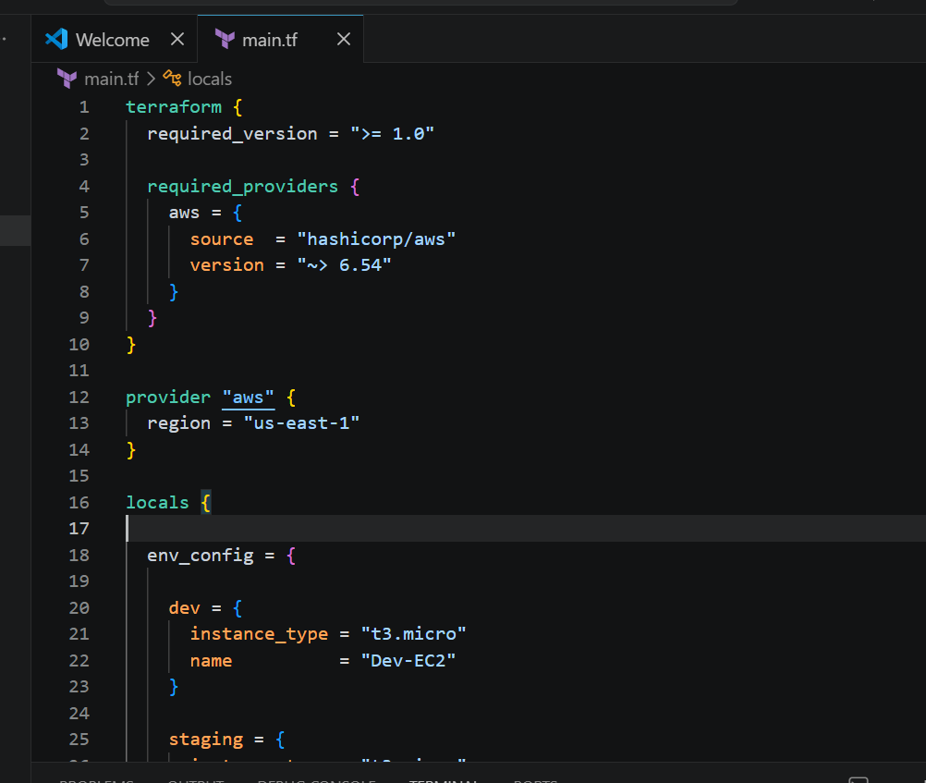
Terraform init -reconfigure
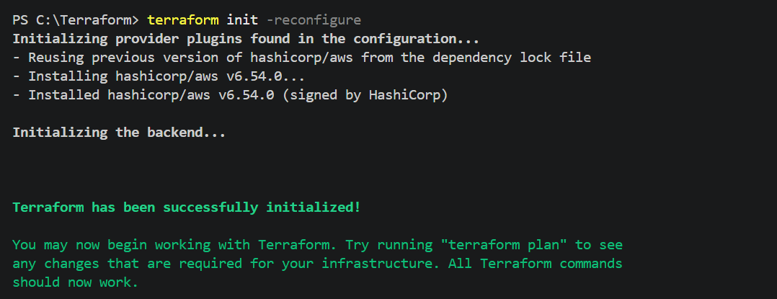

Commands used
terraform workspace new dev
terraform workspace new staging
terraform workspace new prod
terraform workspace list
terraform workspace show
terraform workspace select dev
terraform validate
terraform plan
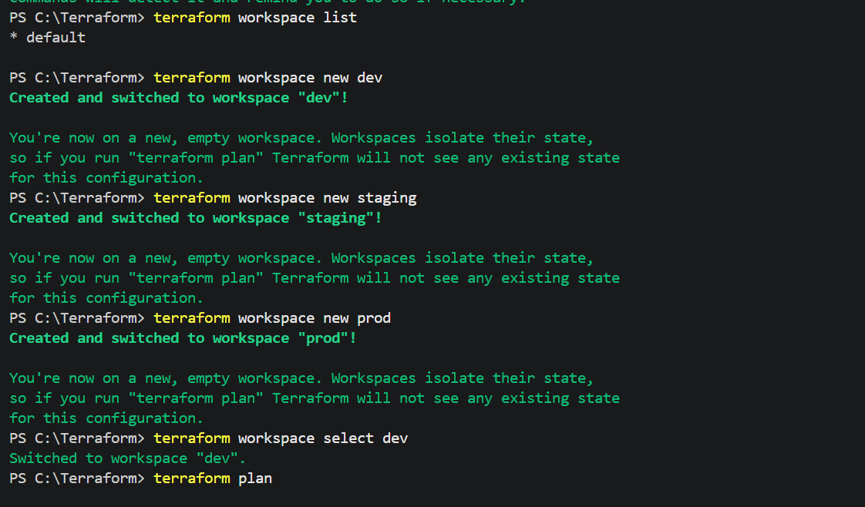
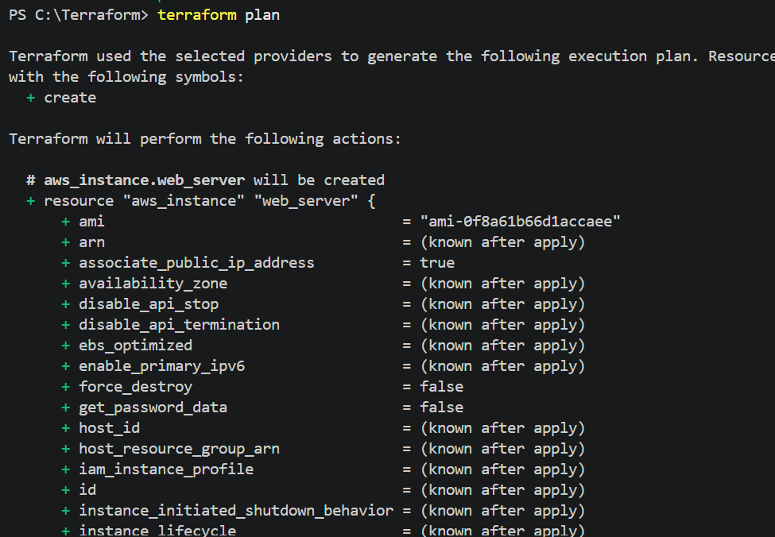
Now terraform apply |
enter: yes
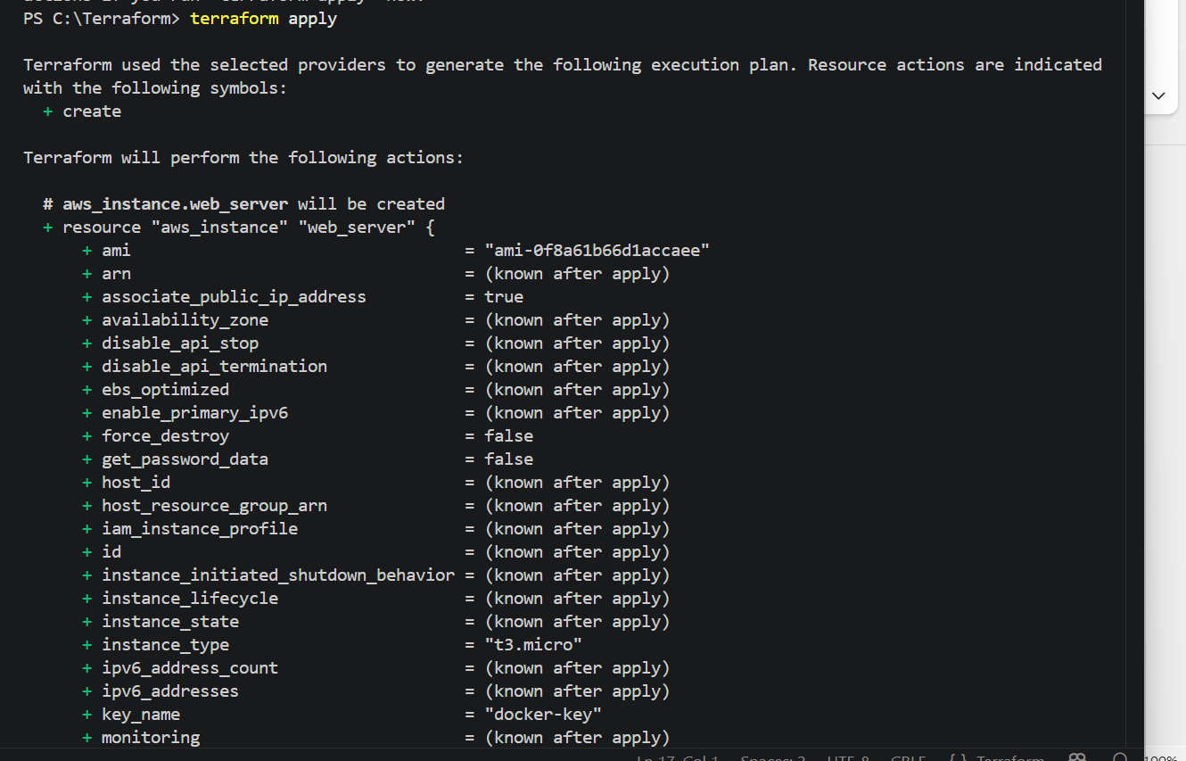

Dev-Ec2 instance created
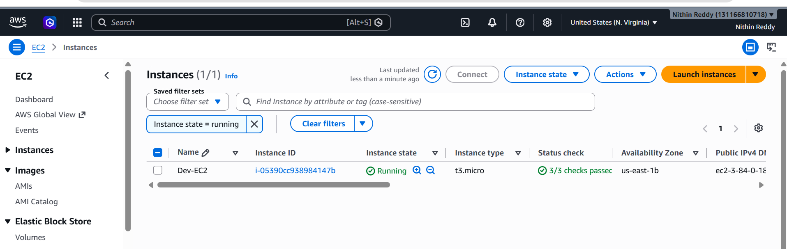

Created Staging EC2
terraform workspace select staging terraform apply -auto-approve
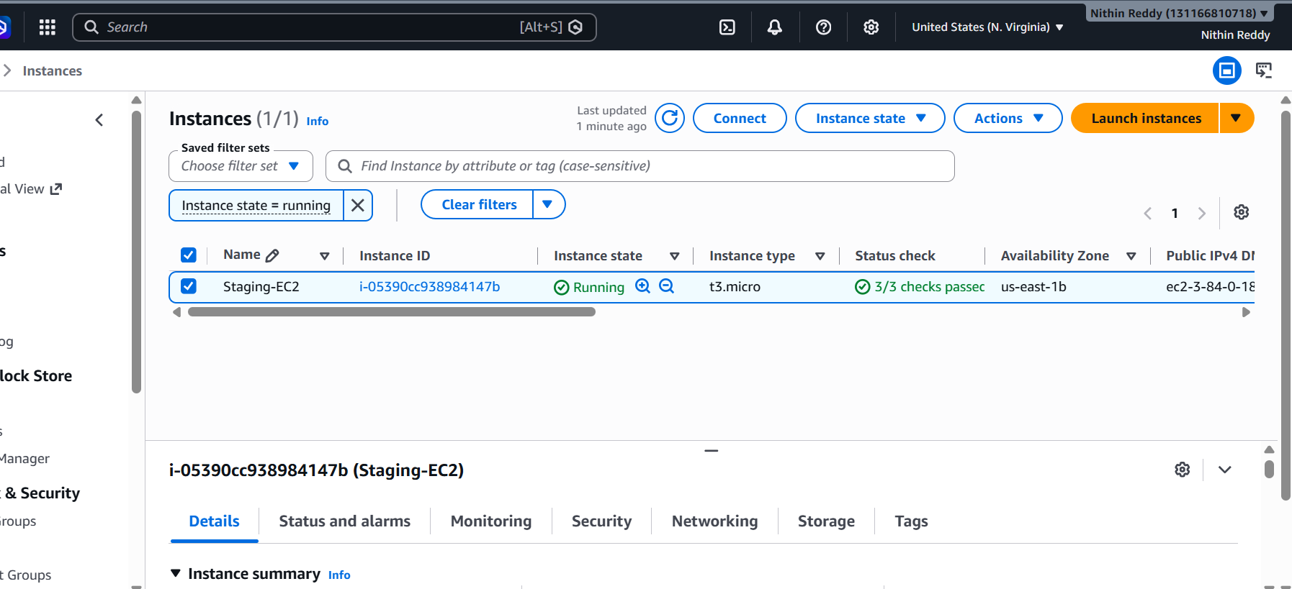
Created Prod-ec2
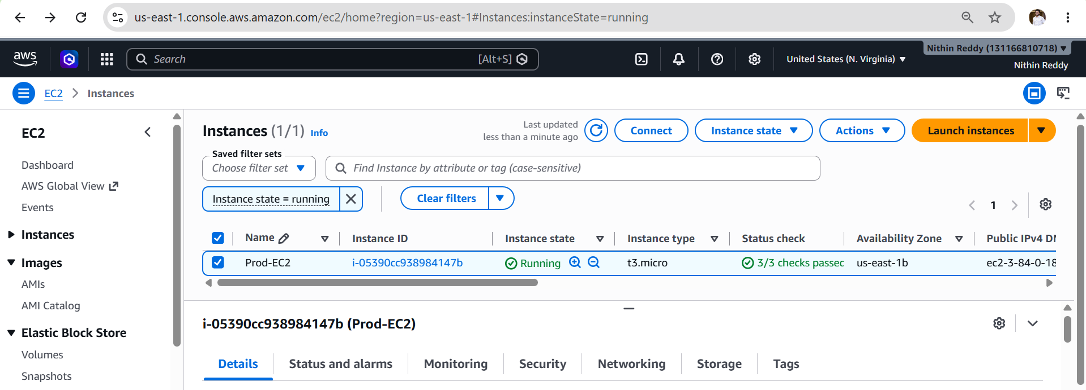
Terminated using “terraform destroy”
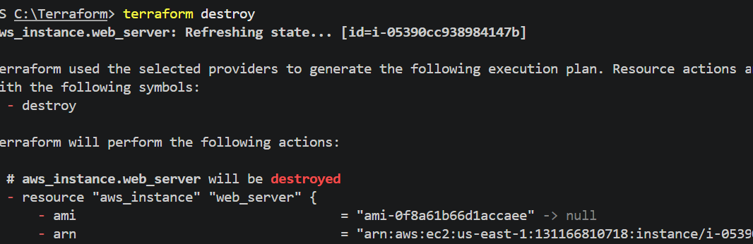

Validation

Validate the task using the following checks:
- Terraform configuration is successfully initialized.
- Terraform validation completes without errors.
- Three workspaces (dev, staging, and prod) are created successfully.
- Each workspace maintains a separate Terraform state.
- One EC2 instance is created for each workspace.
- Instance tags correctly display:
  - Dev-EC2
  - Staging-EC2
  - Prod-EC2
- The active workspace changes successfully using terraform workspace select.
- AWS EC2 Console displays three separate EC2 instances for the three environments.

Expected Outcome

After successful completion of this task:
- Terraform Workspaces are configured successfully.
- Three independent environments (Dev, Staging, and Prod) are managed from a single Terraform configuration.
- Separate Terraform state is maintained for each environment.
- Three EC2 instances are provisioned with appropriate environment-specific tags.
- Environment switching becomes simple using Terraform Workspaces.
- Infrastructure management becomes more organized, scalable, and reusable.

