Kubernetes-06

Task 1: Create a Config Map from a Directory Containing Multiple Files and Inject the Variables into a Pod as Environment Variables
Objective
- Create a directory with multiple configuration files.
- Create a Config Map from the directory.
- Create a Pod that loads the Config Map as environment variables.
- Verify the environment variables inside the Pod.
What is a Config Map?
A Config Map stores non-sensitive configuration data such as:
- Application name
- Environment (Dev, QA, Prod)
- URLs
- Port numbers
- Log levels
Instead of hardcoding these values in your application, you store them in a ConfigMap.
Architecture
ConfigMap
(Application Config)
│
┌─────────────┼─────────────┐
│ │ │
app.env db.env config.env
│ │ │
└─────────────┼─────────────┘
│
Kubernetes Pod
│
Environment Variables
│
Application Reads
Implementation Steps (Documentation)
- Created a directory containing configuration files.
- Added application configuration values to multiple files.
- Created a ConfigMap from the directory.
- Created a Pod referencing the ConfigMap.
- Deployed the Pod.
- Verified the ConfigMap.
- Verified the environment variables inside the Pod.

Prerequisites
Kubectl get nodes
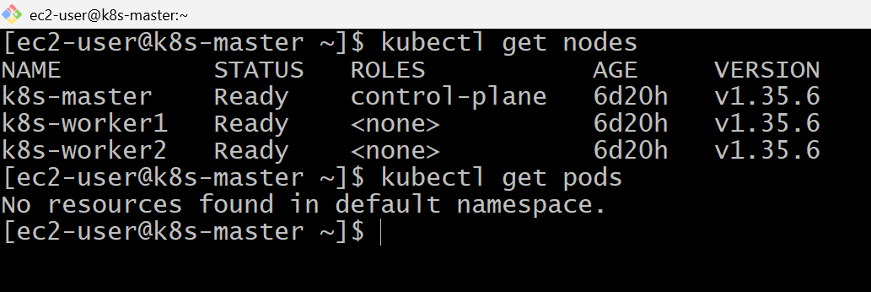
Vi app.env
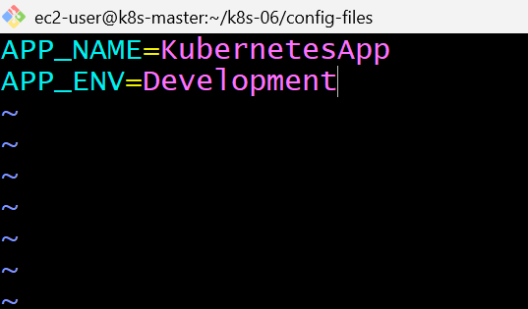
Vi db.env
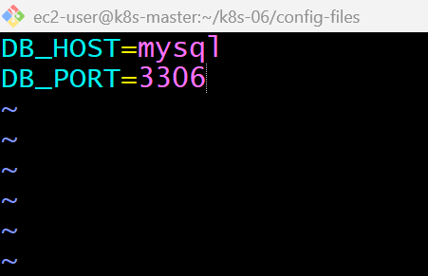
Vi config.env
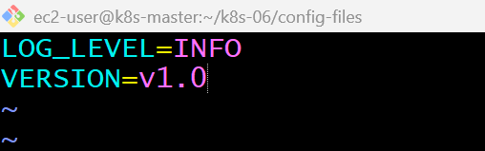
Ls

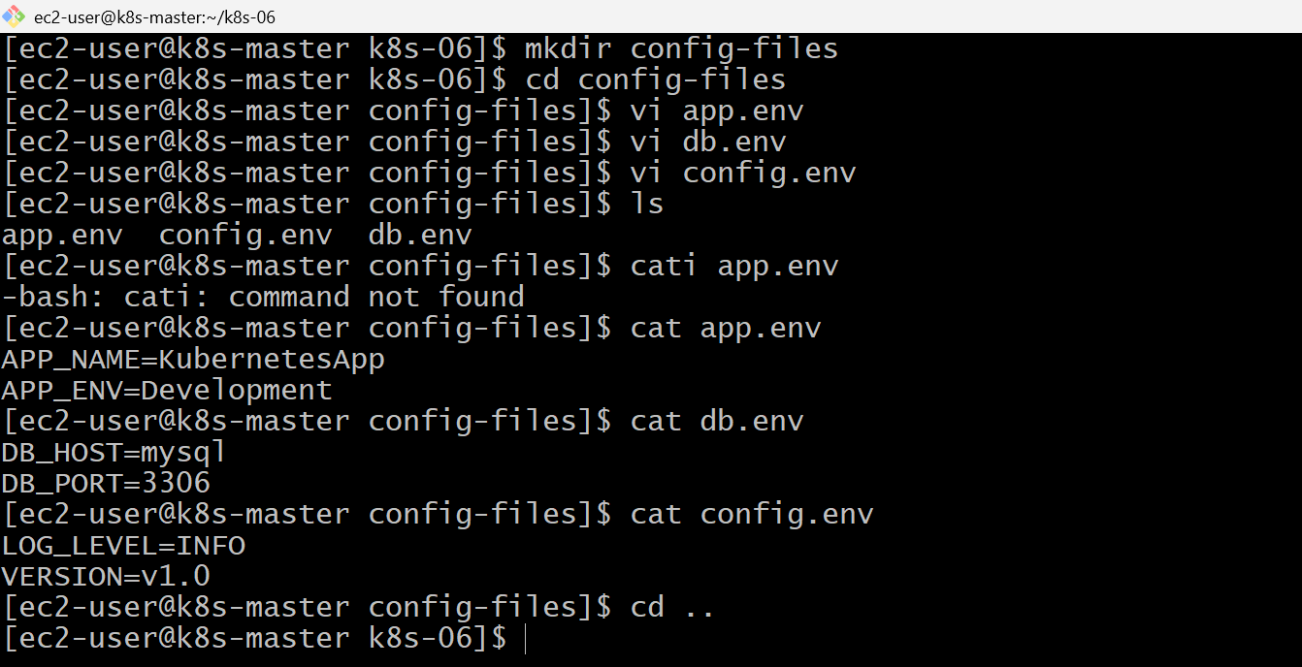
kubectl create configmap app-config --from-file=config-files/
kubectl get configmap
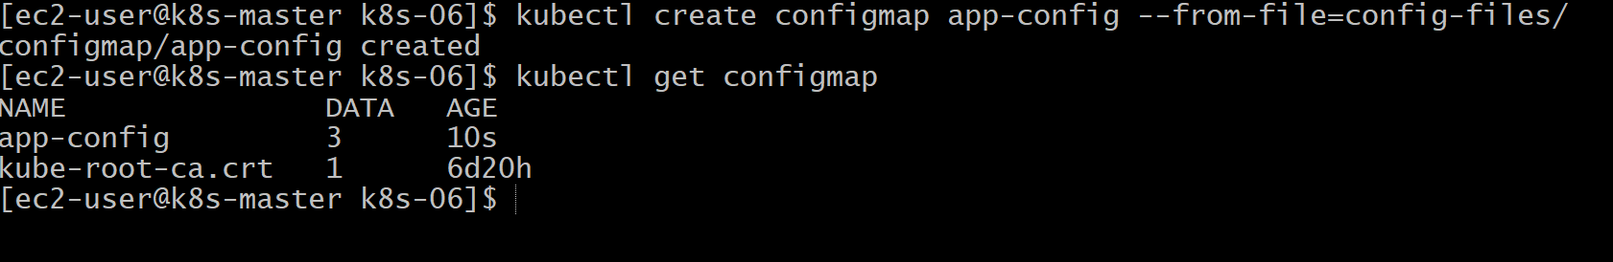

kubectl describe configmap app-config
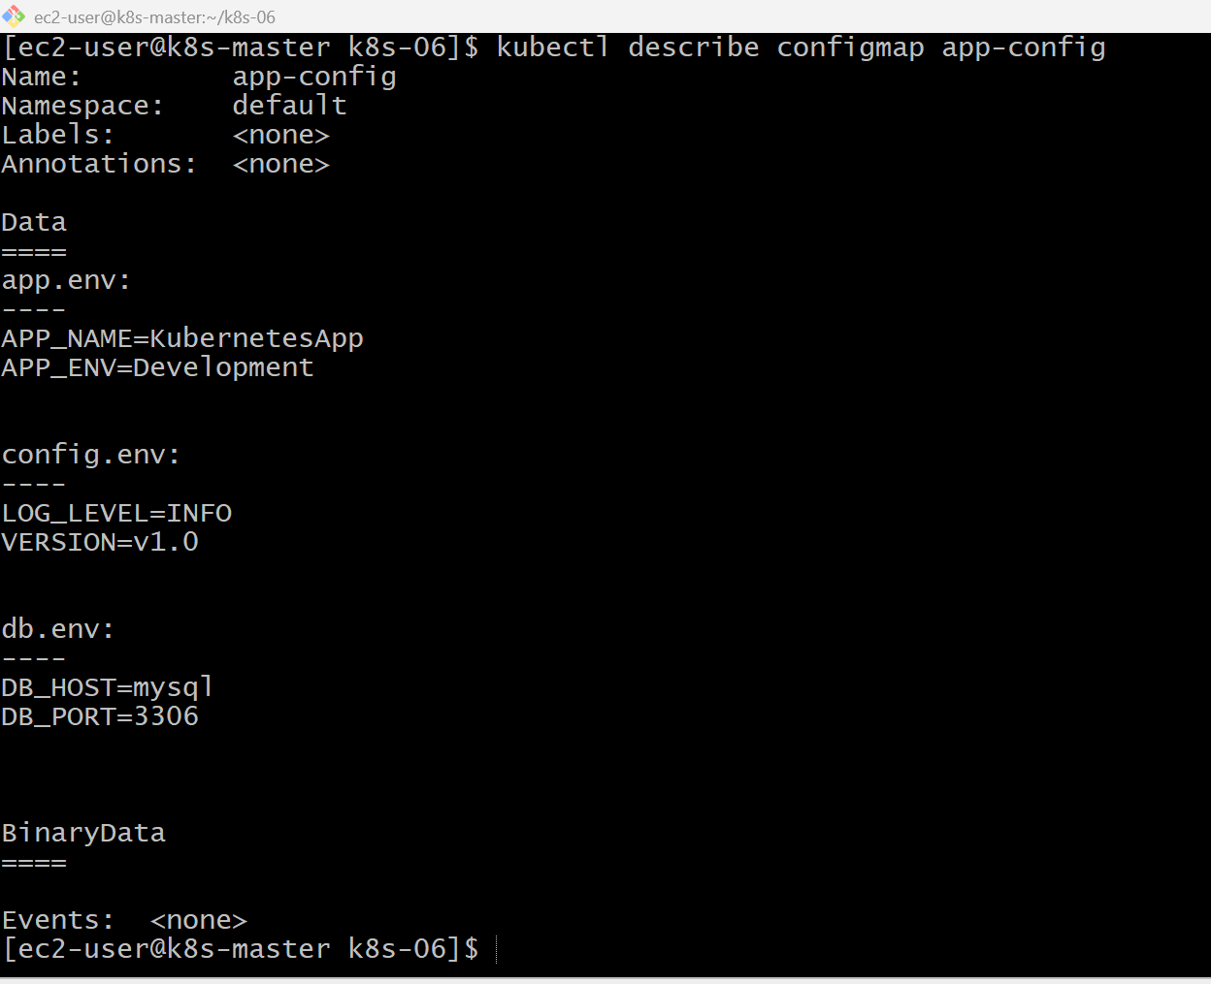
vi configmap-pod.yaml
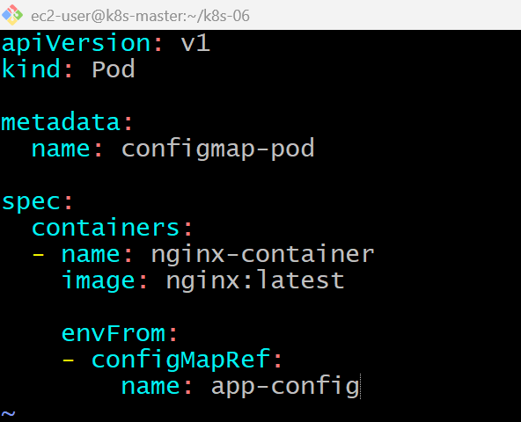
kubectl apply -f configmap-pod.yaml
kubectl get pods
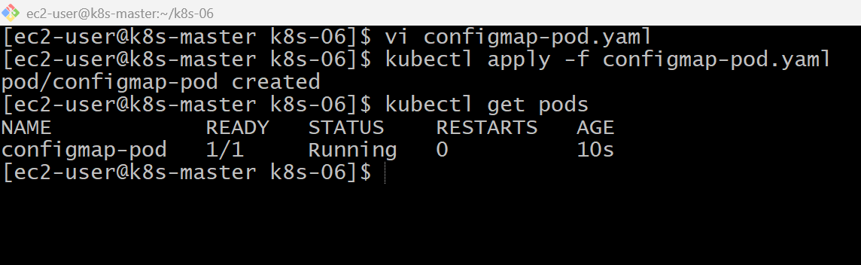
kubectl exec -it configmap-pod -- /bin/bash
run: env
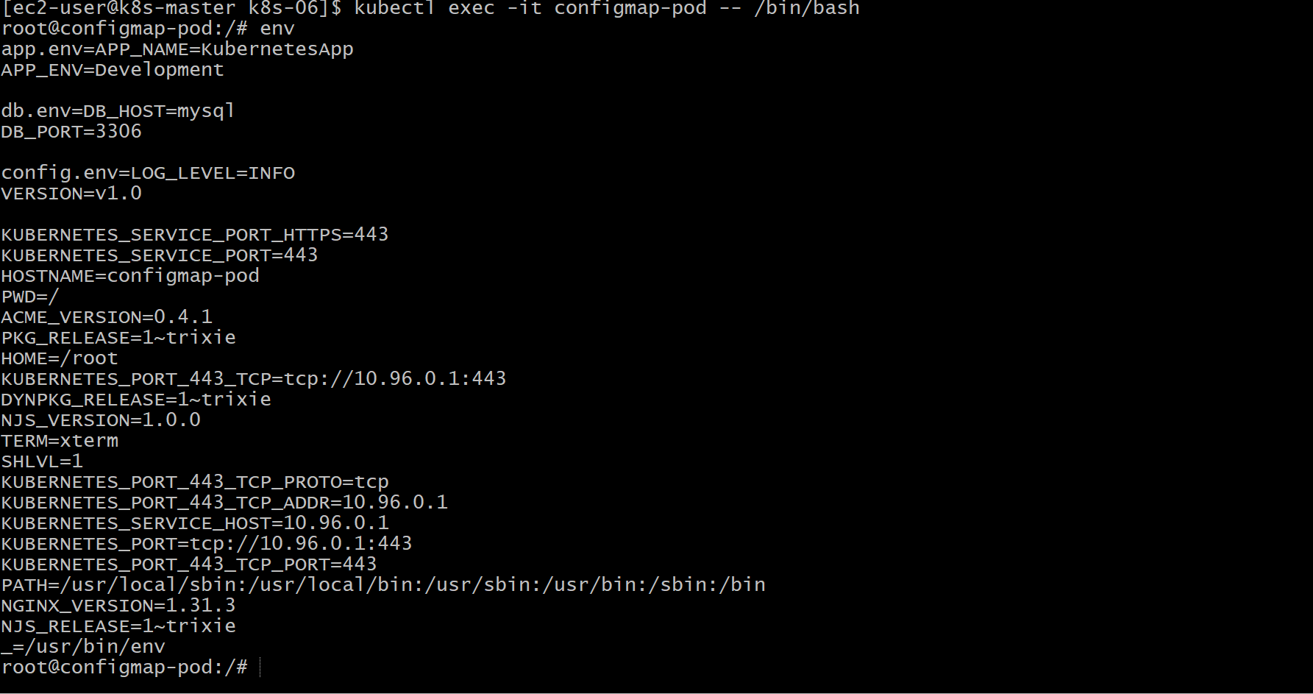

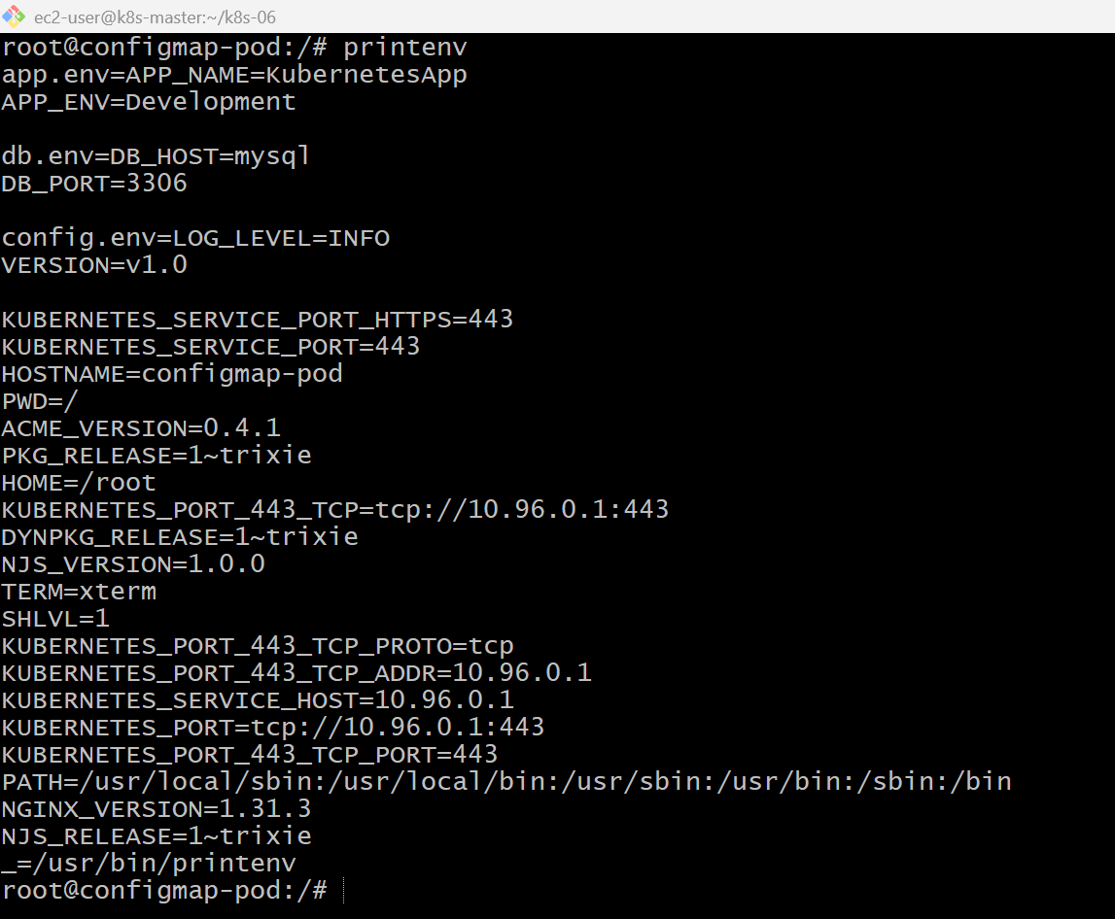
kubectl delete configmap app-config
kubectl create configmap app-config --from-file=config-files/
kubectl delete pod configmap-pod
kubectl apply -f configmap-pod.yaml
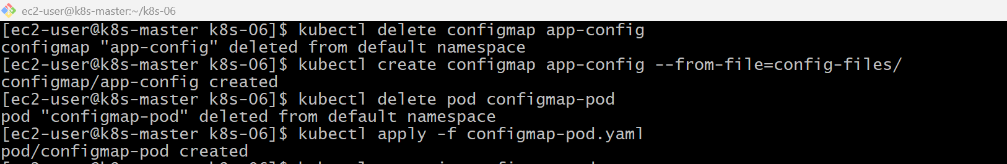

kubectl exec -it configmap-pod – env
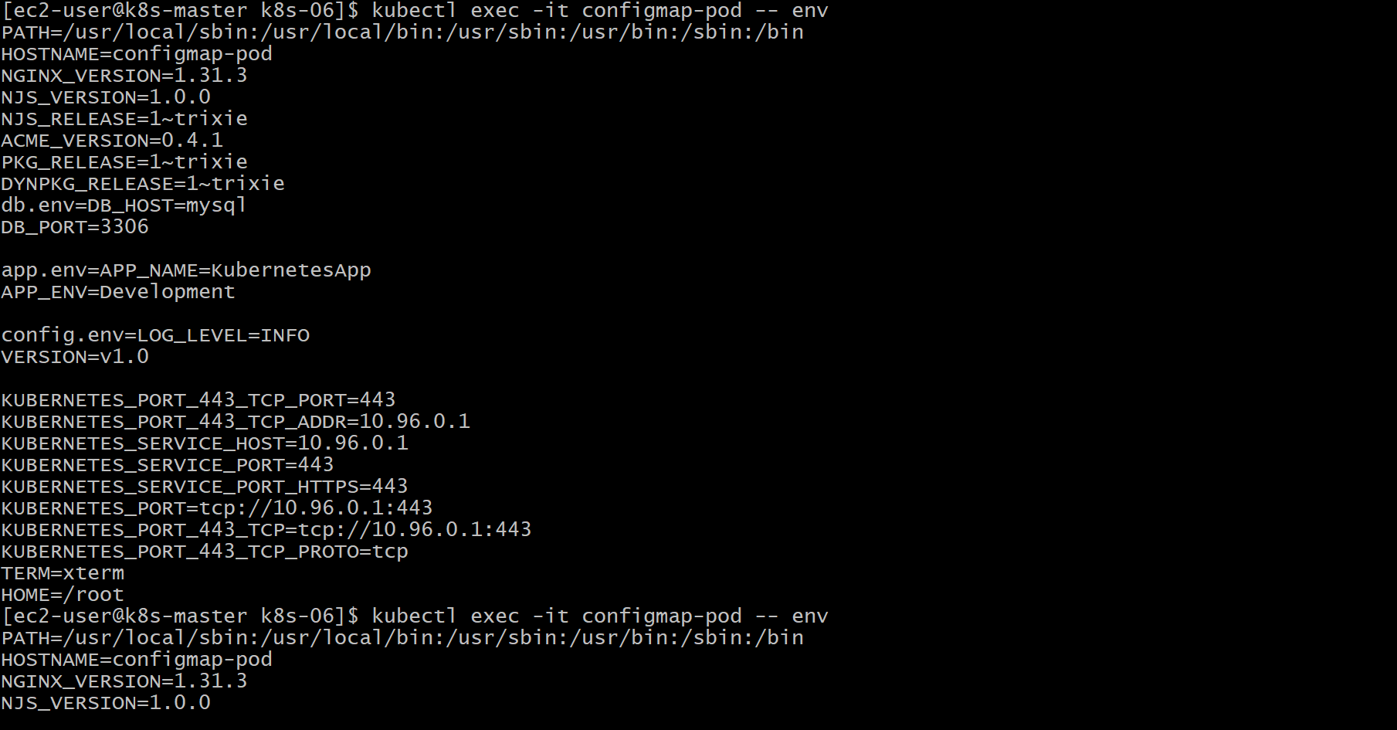
Validation Points
- Created a directory containing multiple configuration files.
- Created a ConfigMap from the directory.
- Created a Pod that references the ConfigMap.
- Verified the ConfigMap.
- Verified the environment variables inside the Pod.
Outcome
- Successfully created a Config Map from a directory.
- Injected configuration values into a Pod as environment variables.
- Verified that the application could access configuration without hardcoding values.
- Understood how Config Maps separate configuration from application code.

Task 2: Create a Config Map from a File and Mount It as a Volume Inside a Pod
Objective
- Create a Config Map from a configuration file.
- Mount the Config Map as a volume inside a Pod.
- Verify the configuration file is available inside the Pod.
What l Learned
Instead of injecting configuration as environment variables, Kubernetes mounts the Config Map as files inside the container.
This approach is commonly used for:
- Nginx configuration
- Apache configuration
- Spring Boot properties
- Application YAML files
- Database configuration
Architecture
ConfigMap
│
app-config.conf
│
│
Mounted as Volume
│
▼
/etc/config/app-config.conf
│
Pod reads file
Implementation Steps (Documentation)
- Created a configuration file containing application settings.
- Created a ConfigMap from the file.
- Verified the ConfigMap contents.
- Created a Pod with a ConfigMap volume.
- Mounted the ConfigMap at /etc/config.
- Deployed the Pod.
- Verified the mounted configuration file inside the container.

vi app-config.conf
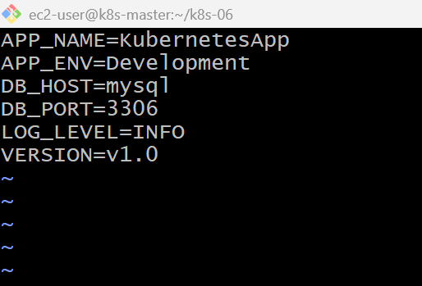

kubectl create configmap file-config --from-file=app-config.conf
kubectl get configmap
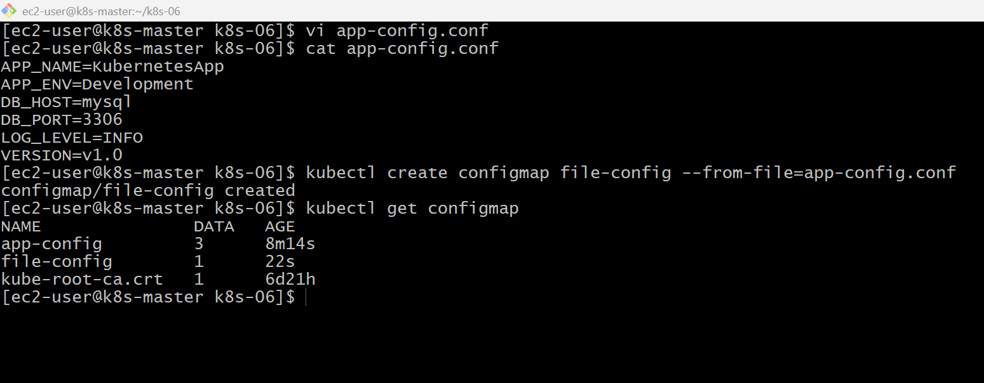
kubectl describe configmap file-config
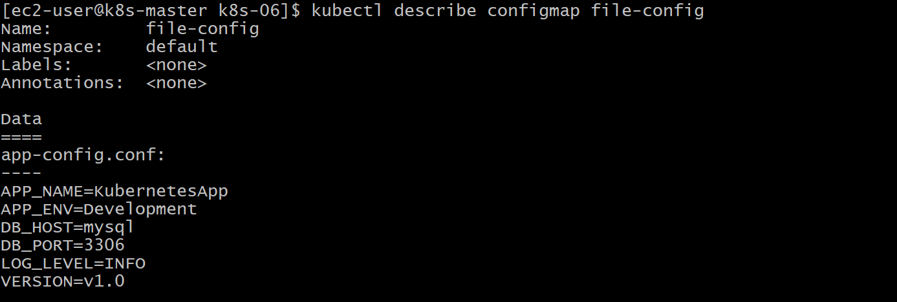

vi configmap-volume-pod.yaml
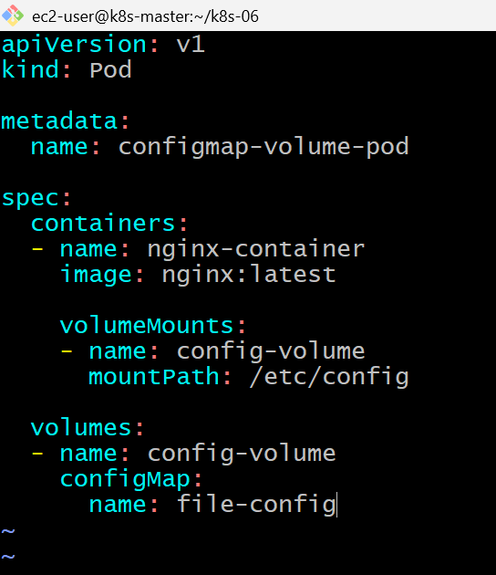

kubectl apply -f configmap-volume-pod.yaml
kubectl get pods
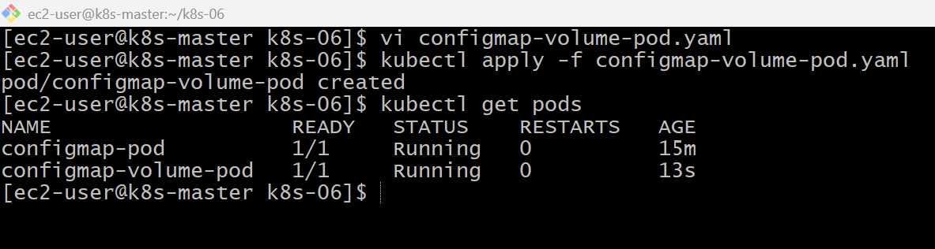

kubectl exec -it configmap-volume-pod -- /bin/bash
run: cd /etc/config
#cat app-config.conf
#exit
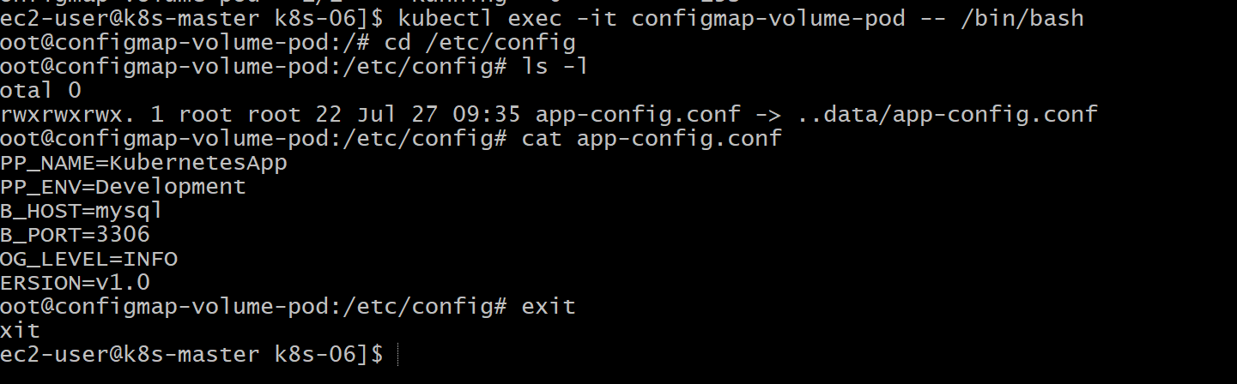
Validation Points
- Created a configuration file.
- Created a ConfigMap from the file.
- Verified the ConfigMap.
- Created a Pod with a ConfigMap volume.
- Mounted the ConfigMap under /etc/config.
- Verified the configuration file inside the Pod.
- Confirmed the application configuration is available as a mounted file.
Outcome
- Successfully created a ConfigMap from a file.
- Mounted the ConfigMap as a volume in a Pod.
- Verified that the configuration file was accessible inside the container.
- Learned how applications can consume configuration files without embedding them in the container image.
Task 3: Create a Secret with Username and Password and Inject It into a Pod as Environment Variables

Objective
- Create a Secret containing a username and password.
- Verify the Secret.
- Inject the Secret into a Pod as environment variables.
- Verify the Secret values inside the Pod.

What is a Secret?
A Secret stores sensitive data such as:
- Username
- Password
- API Keys
- SSH Keys
- TLS Certificates
- Tokens
Difference:
- Config Map → Non-sensitive data.
- Secret → Sensitive data (stored in Base64 format by Kubernetes).

Architecture
Secret
(username,password)
│
▼
Kubernetes Secret
│
▼
Pod
│
Environment Variables
│
USERNAME PASSWORD

Implementation Steps (Documentation)
- Created a Secret using kubectl create secret generic.
- Stored username and password as Secret data.
- Verified the Secret.
- Created a Pod referencing the Secret.
- Injected the Secret values as environment variables.
- Deployed the Pod.
- Verified the Secret values inside the container.

kubectl create secret generic app-secret \
--from-literal=username=admin \
--from-literal=password=Welcome@123
kubectl get secrets
kubectl describe secret app-secret
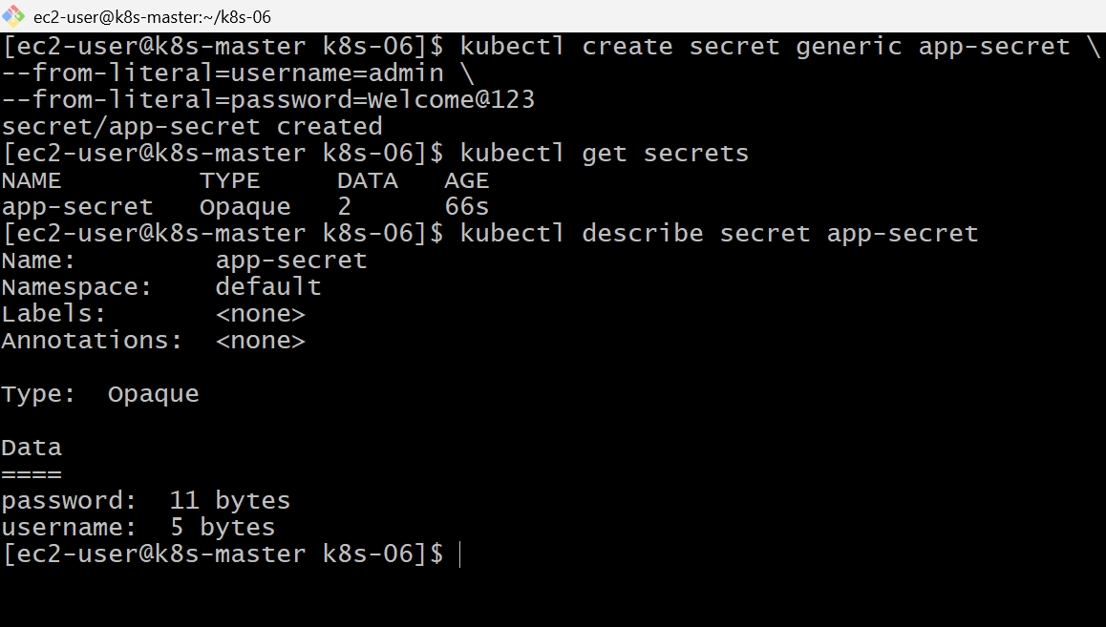

vi secret-pod.yaml
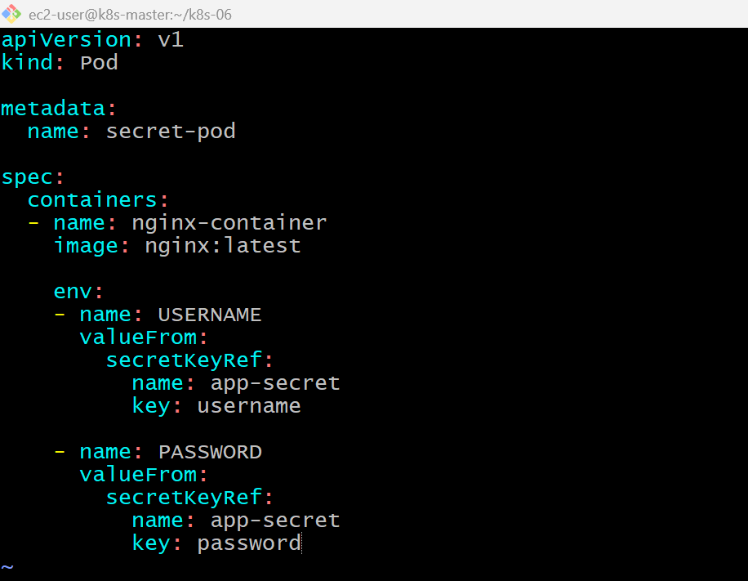
kubectl apply -f secret-pod.yaml
kubectl get pods
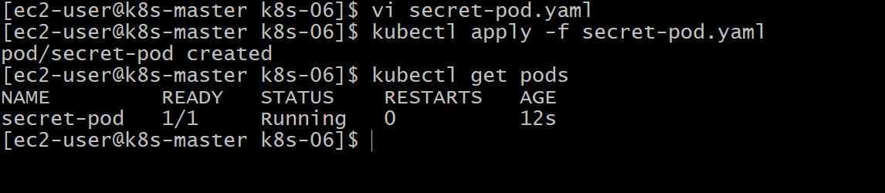

kubectl exec -it secret-pod -- /bin/bash
#echo $USERNAME
#echo $PASSWORD
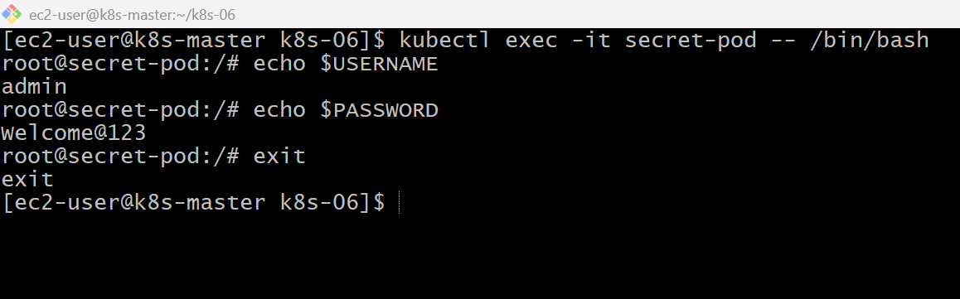
Validation Points
- Created a Secret with username and password.
- Verified the Secret.
- Created a Pod using the Secret.
- Injected Secret values as environment variables.
- Verified the Secret values inside the Pod.
Outcome
- Successfully created a Kubernetes Secret.
- Injected sensitive information into a Pod as environment variables.
- Verified that the application can securely access credentials without hardcoding them in the container image.
- Learned the difference between ConfigMaps (non-sensitive data) and Secrets (sensitive data).

Task 4: Create a Secret Using a YAML File, Mount It as a Volume in a Pod, and Verify the Secret Values are Available as Files
Objective
- Create a Secret using a YAML file.
- Mount the Secret as a volume inside a Pod.
- Verify that the Secret values are available as files.

Architecture
Secret YAML
│
▼
Kubernetes Secret
│
▼
Mounted as Volume
│
▼
/etc/secret-data
├── username
└── password

Implementation Steps (Documentation)
- Encoded the username and password using Base64.
- Created a Secret YAML manifest.
- Applied the Secret to the Kubernetes cluster.
- Created a Pod that mounts the Secret as a volume.
- Mounted the Secret at /etc/secret-data.
- Verified the mounted Secret files inside the Pod.
- Confirmed the Secret values by reading the files.

echo -n "admin" | base64
echo -n "Welcome@123" | base64
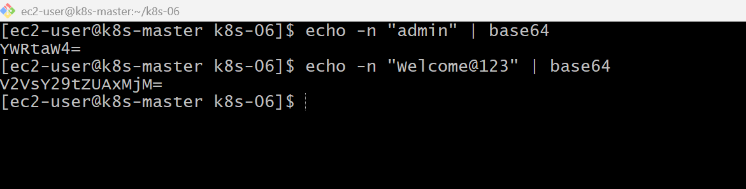

vi secret-volume.yaml
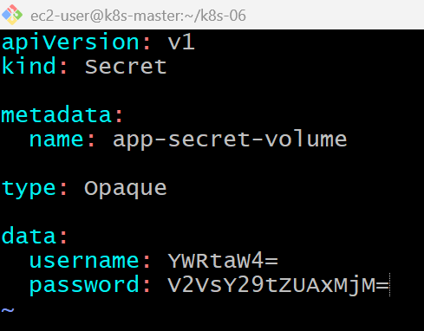

kubectl apply -f secret-volume.yaml
kubectl get secrets
kubectl describe secret app-secret-volume
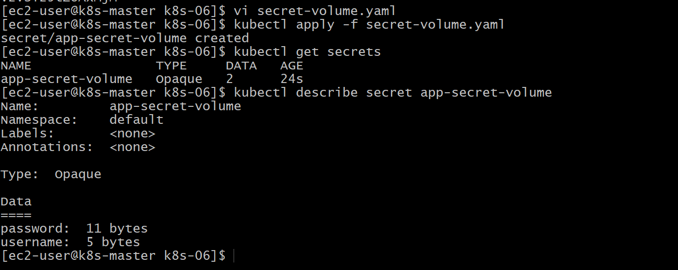

vi secret-volume-pod.yaml
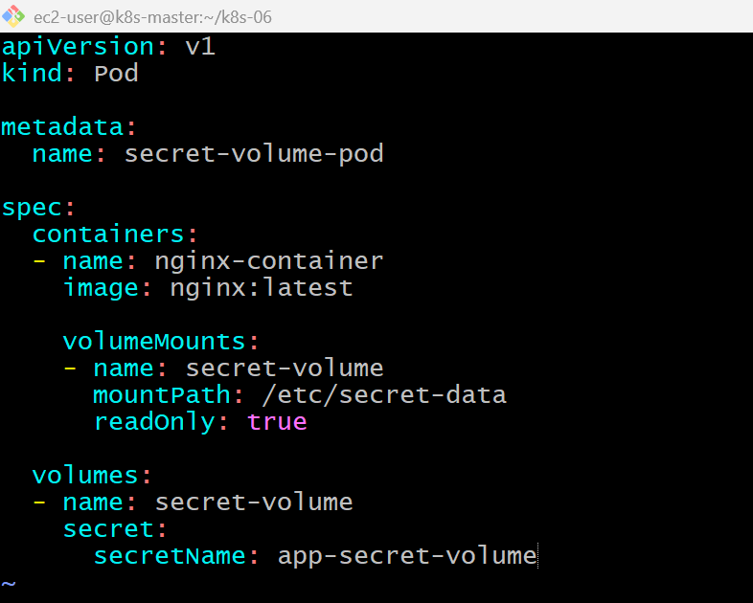

kubectl apply -f secret-volume-pod.yaml
kubectl get pods
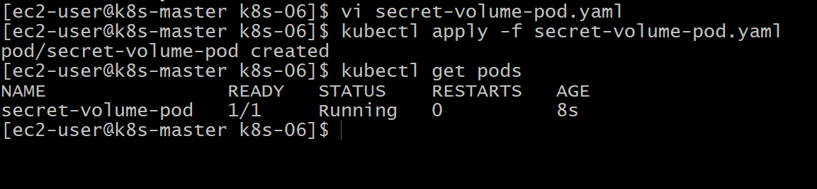

kubectl exec -it secret-volume-pod -- /bin/bash
cd /etc/secret-data
#cat username
#cat password
#exit
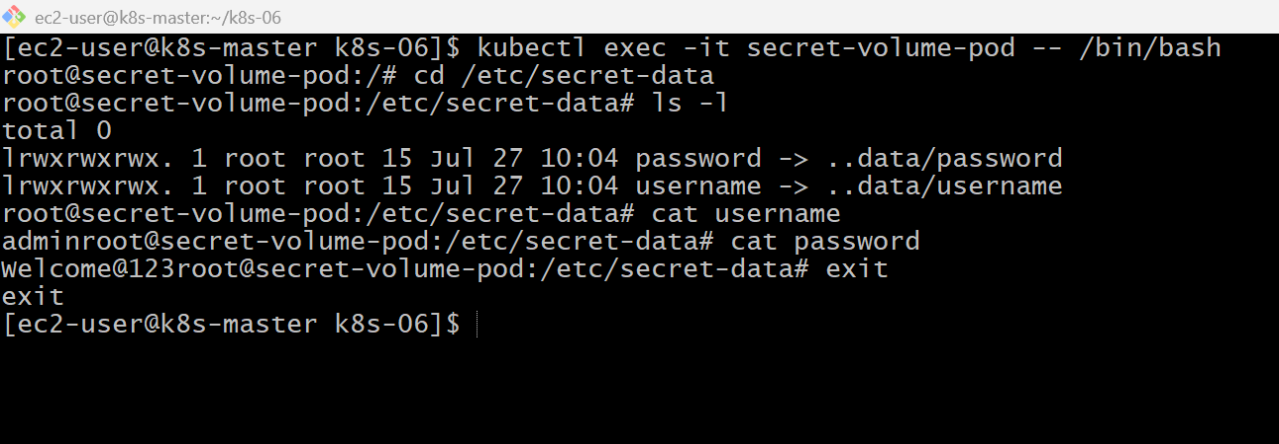
Validation Points
- Created a Secret using a YAML manifest.
- Stored Base64-encoded username and password in the Secret.
- Applied the Secret to the cluster.
- Created a Pod that mounts the Secret as a volume.
- Verified the Secret files inside the Pod.
- Read the Secret values from the mounted files.

Outcome
- Successfully created a Secret using a YAML file.
- Mounted the Secret as a read-only volume in a Pod.
- Verified that each Secret key appears as a separate file.
- Learned how applications can securely consume credentials from mounted files instead of environment variables.
Task 5: Inject a ConfigMap as Environment Variables and a Secret as Files into the Same Pod
Objective
- Create a Pod.
- Inject a ConfigMap as environment variables.
- Mount a Secret as a volume.
- Verify that both are accessible inside the Pod.

Real-Time Use Case
Suppose you're deploying an application.
- ConfigMap stores:
  - Application Name
  - Environment
  - Database Host
  - Log Level
- Secret stores:
  - Database Username
  - Database Password
The application reads:
- Configuration from environment variables.
- Credentials from files.

Architecture
ConfigMap Secret
(Application Config) (Username, Password)
│ │
│ │
Environment Variables Mounted as Volume
│ │
└──────────────┬───────────┘
│
Kubernetes Pod
│
printenv /etc/secret-data

Prerequisites
Ensure these already exist:
kubectl get configmap
kubectl get secrets
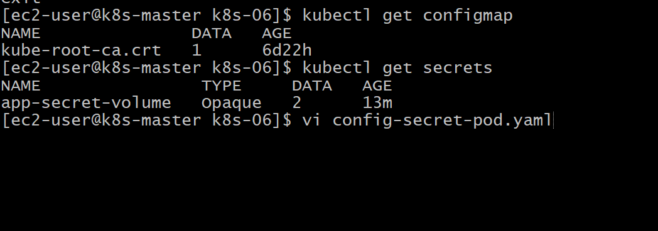

vi config-secret-pod.yaml
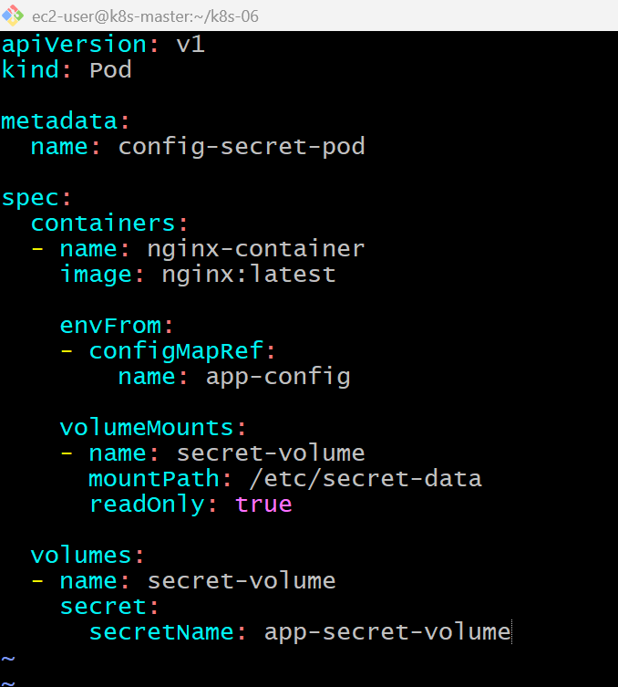

kubectl apply -f config-secret-pod.yaml
kubectl get pods
kubectl exec -it config-secret-pod -- /bin/bash
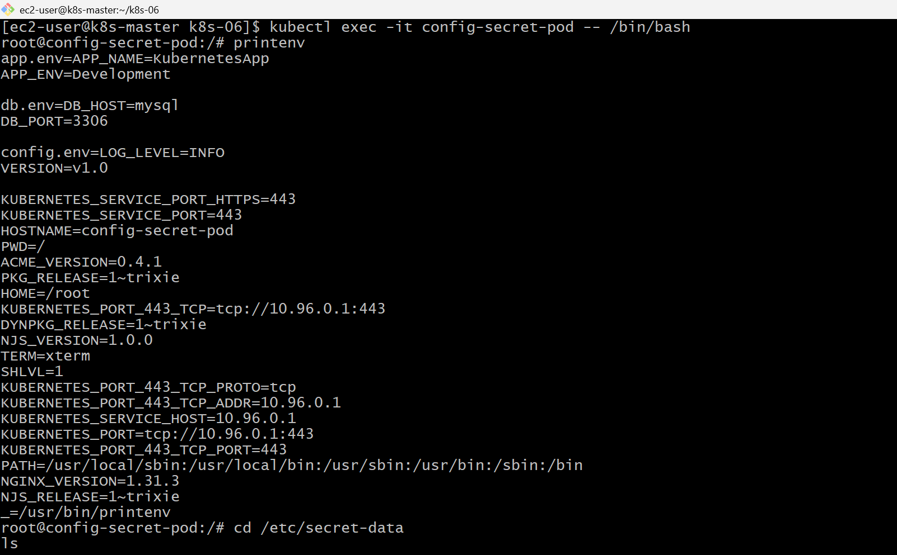
cd /etc/secret-data
ls
cat username
cat password
exit

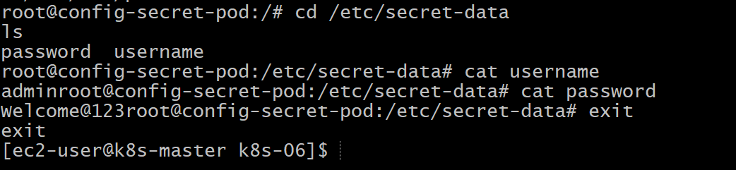

Validation Points
- Created a Pod using both a ConfigMap and a Secret.
- Injected the ConfigMap as environment variables.
- Mounted the Secret as a read-only volume.
- Verified the environment variables inside the Pod.
- Verified the Secret files inside the mounted directory.
- Confirmed both configuration data and sensitive credentials are available to the application.

Outcome
- Successfully combined a ConfigMap and a Secret in the same Pod.
- Verified that ConfigMap values are accessible as environment variables.
- Verified that Secret values are accessible as mounted files.
- Understood a common production pattern for separating application configuration from sensitive credentials.

