Kubernetes-10

K8S-10 Task 1: Setup EKS Cluster using eksctl
Objective
Create an Amazon EKS cluster using the eksctl CLI tool and verify that the cluster is running successfully.
Prerequisites
You need:
- AWS CLI installed
- eksctl installed
- kubectl installed
- IAM user with AdministratorAccess
- AWS credentials configured
- Region: us-east-1
Implementation Steps
- Verified AWS CLI, eksctl, and kubectl installations.
- Configured AWS CLI with IAM user credentials and selected the us-east-1 region.
- Created an EKS cluster configuration YAML file.
- Defined the cluster name, Kubernetes version, region, and managed node group details.
- Executed the eksctl create cluster command to provision the EKS cluster.
- Waited for the EKS control plane, VPC, IAM roles, security groups, and worker nodes to be created automatically.
- Verified the EKS cluster status using eksctl get cluster.
- Verified worker nodes successfully joined the cluster using kubectl get nodes.
- Confirmed all Kubernetes system pods were in the Running state.
- Validated the EKS cluster, managed node group, and EC2 worker nodes from the AWS Management Console.

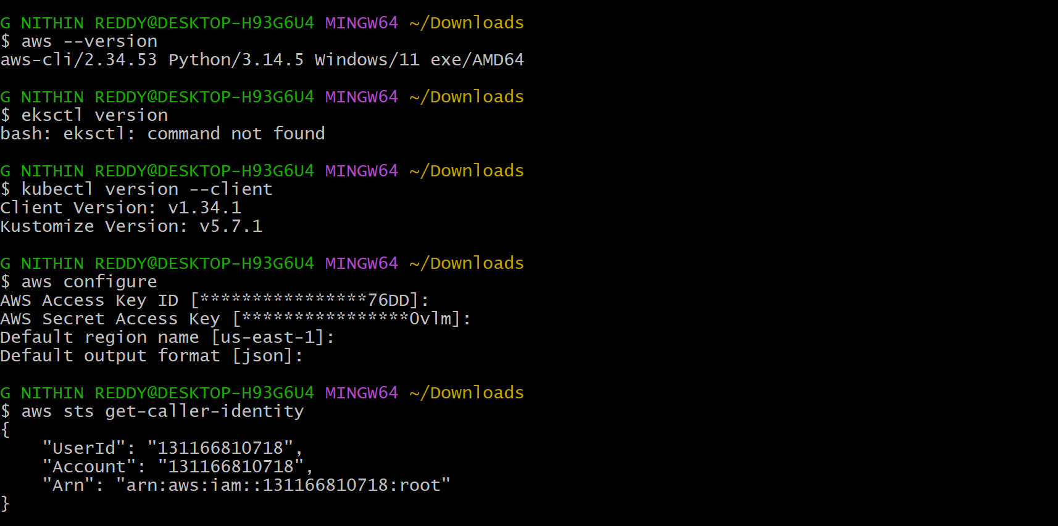
vi eks-cluster.yaml
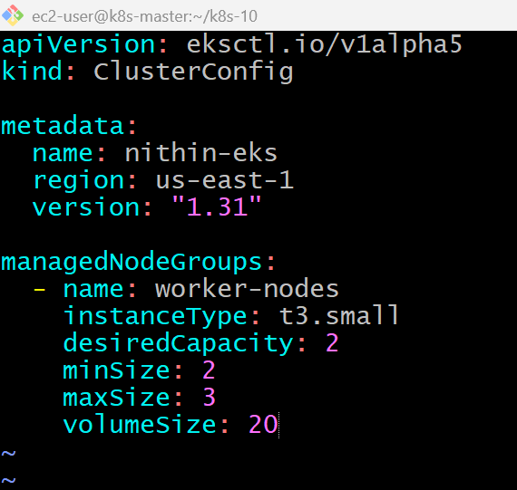
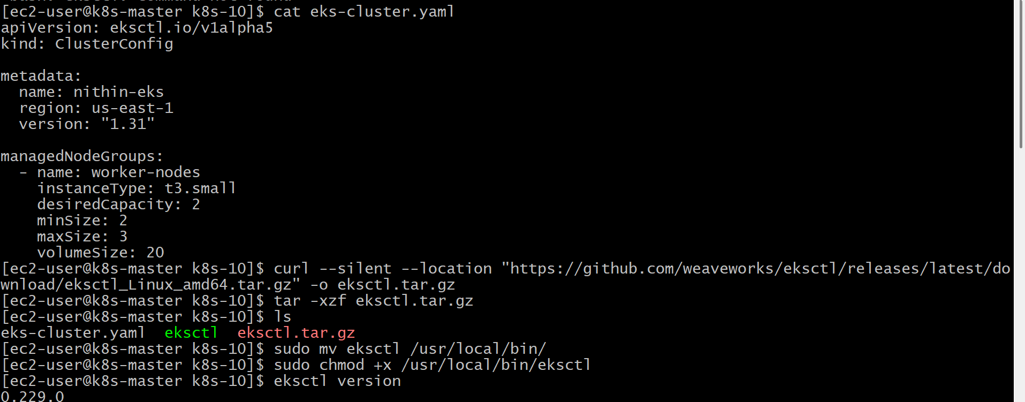
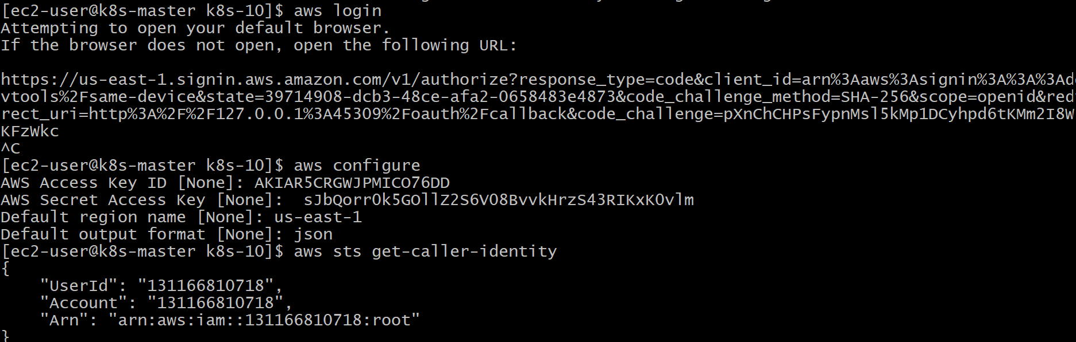
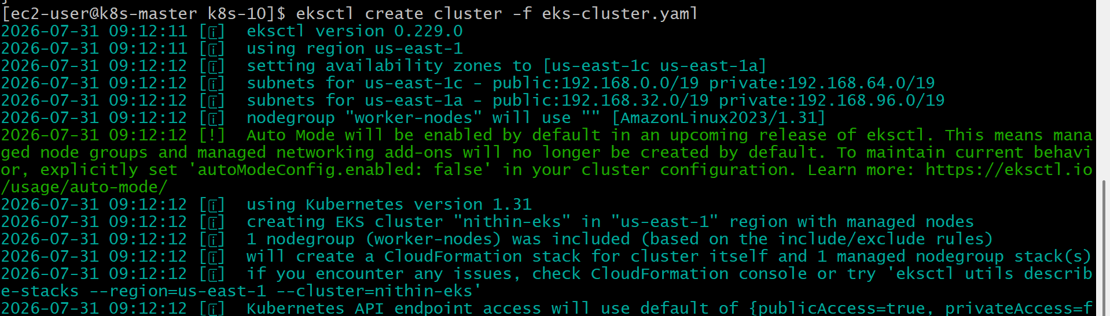
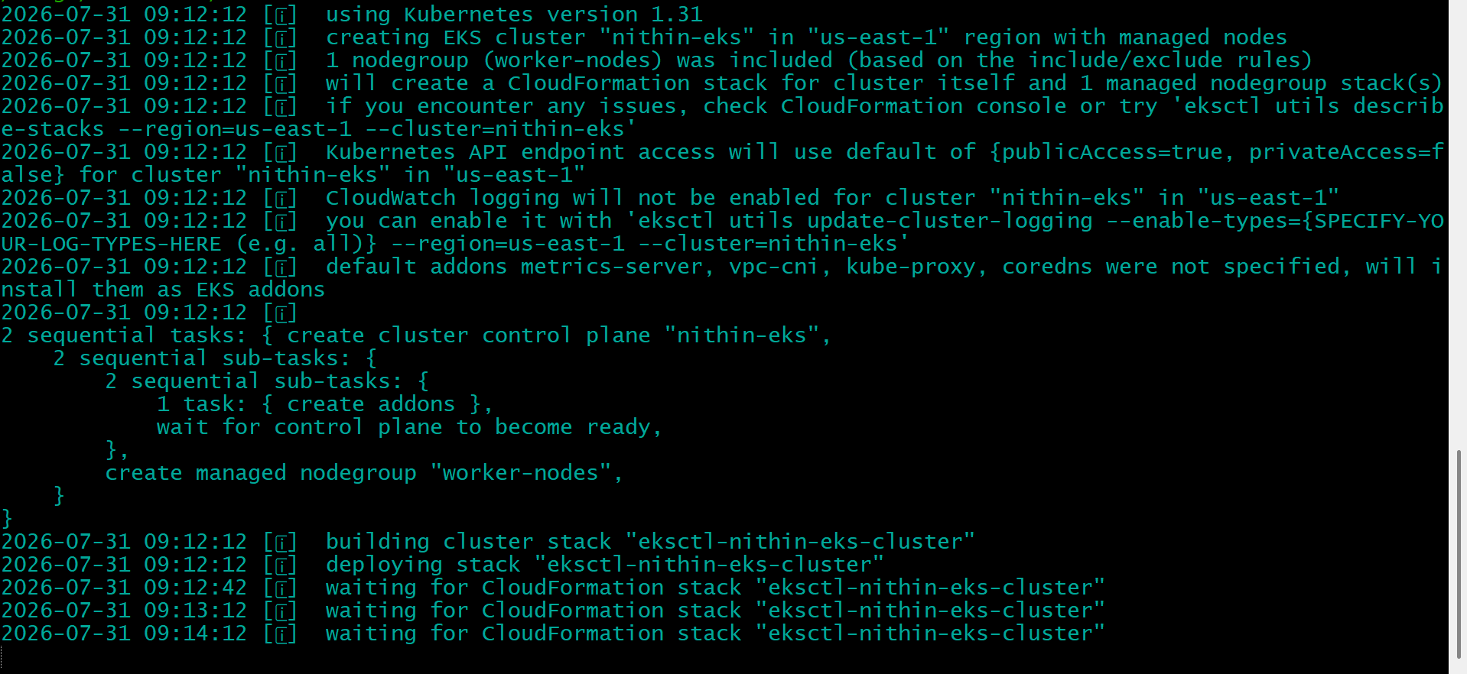
Eks creating automatically
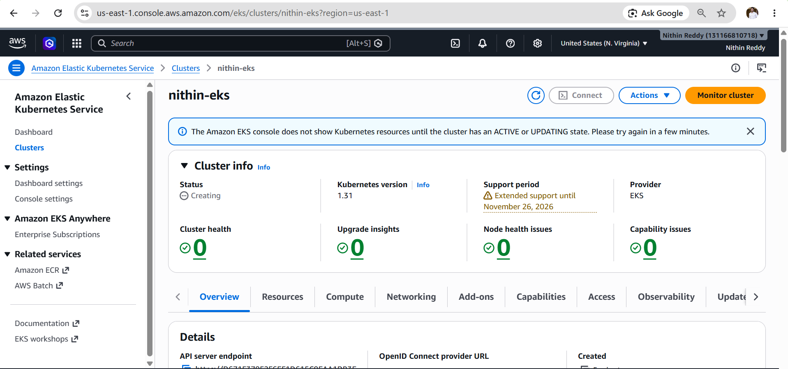
Status active
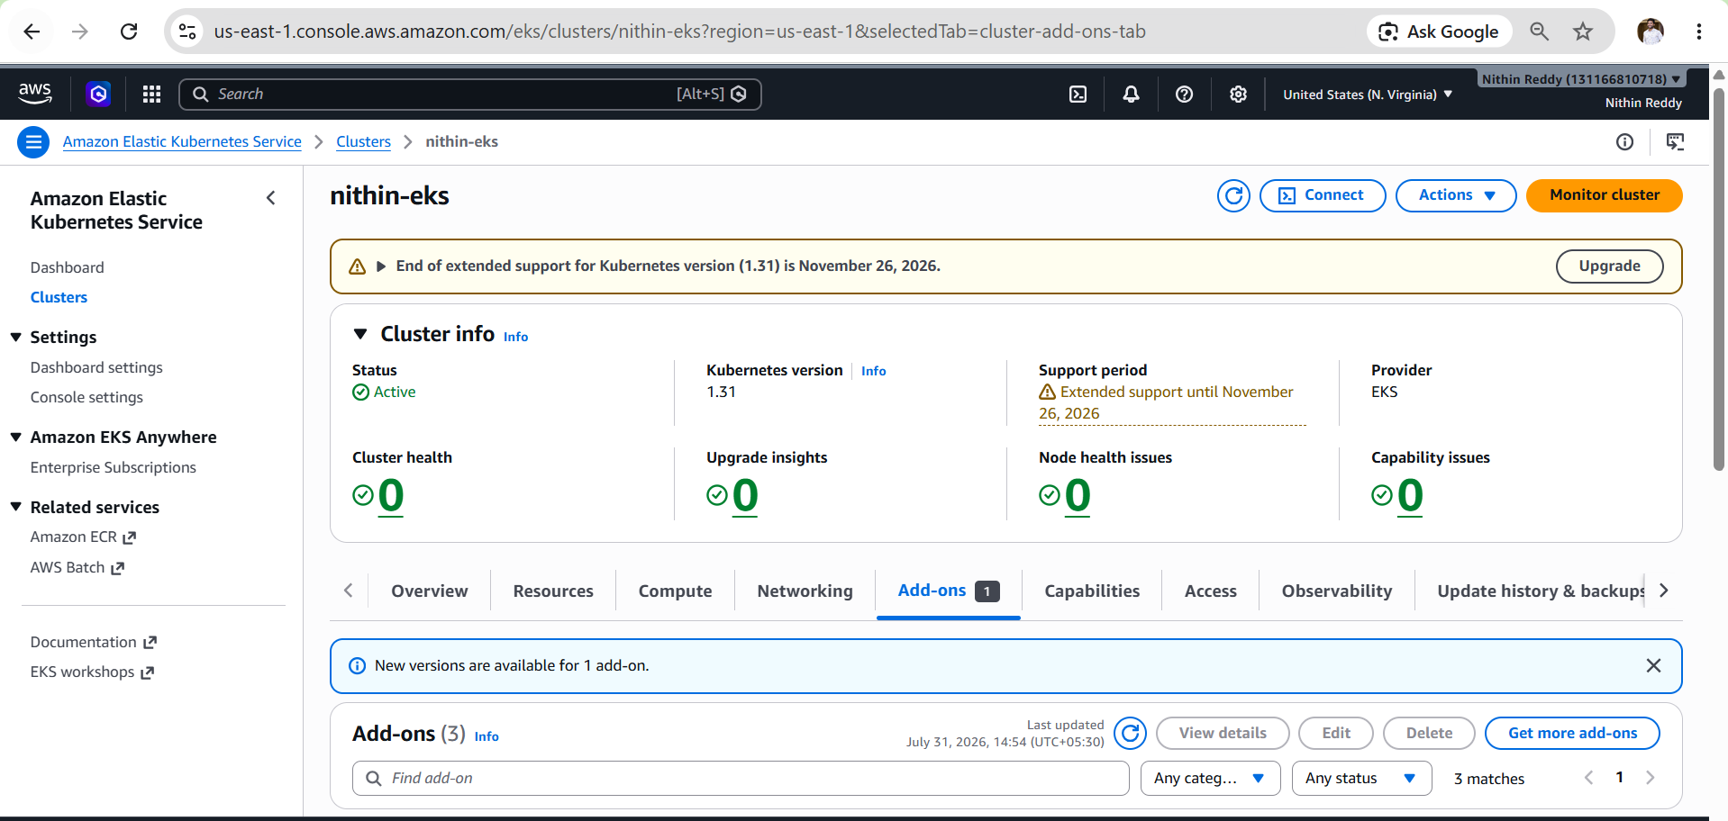
Running
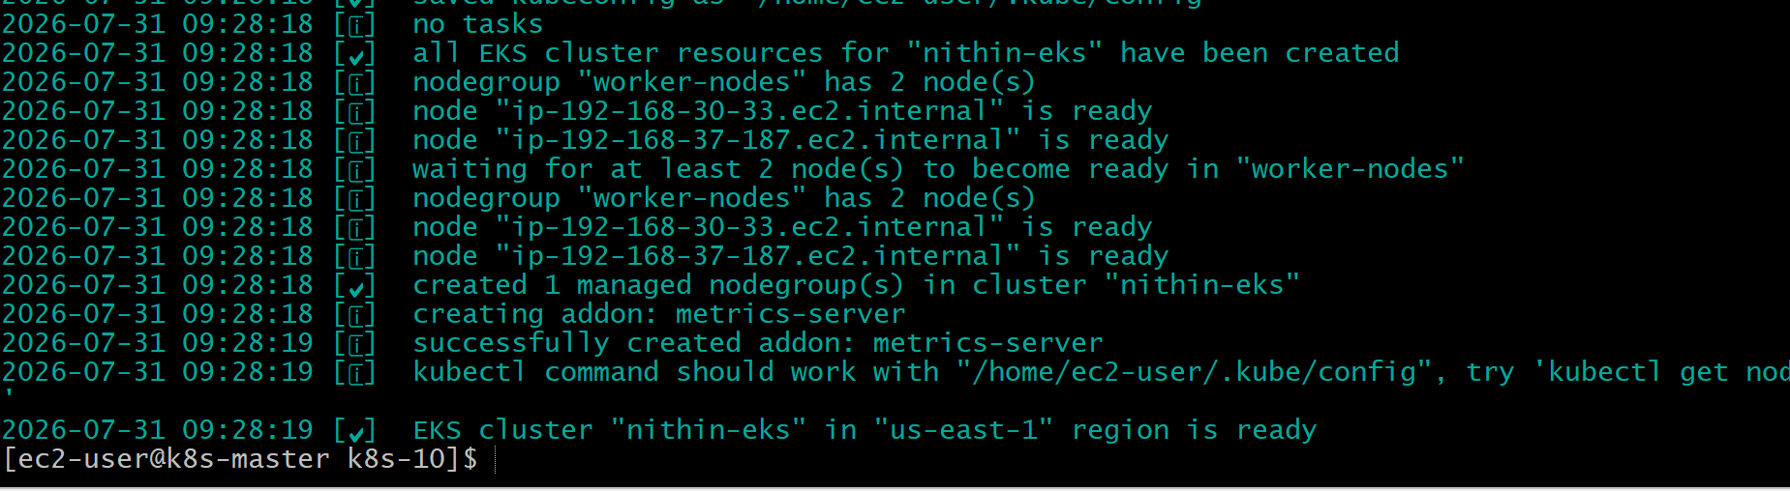

eksctl get cluster
eksctl get nodegroup --cluster nithin-eks
kubectl get nodes
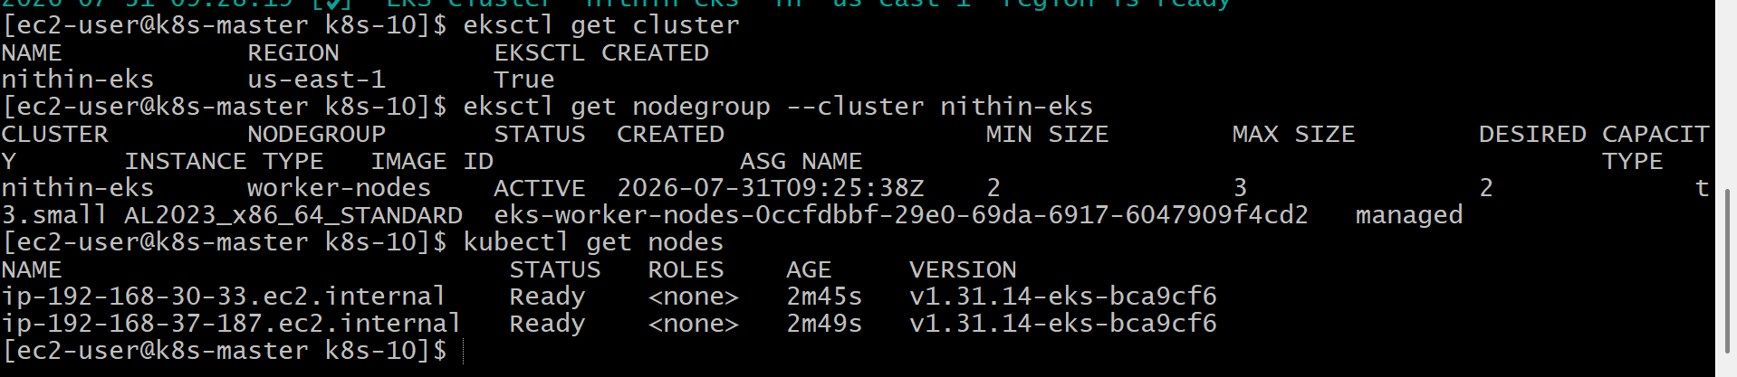
kubectl get pods -A
aws eks list-clusters
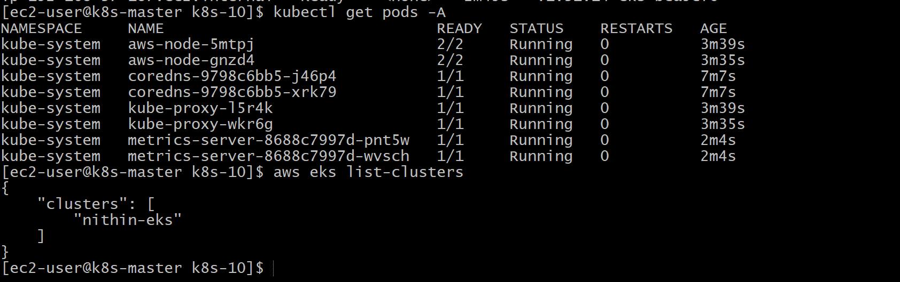
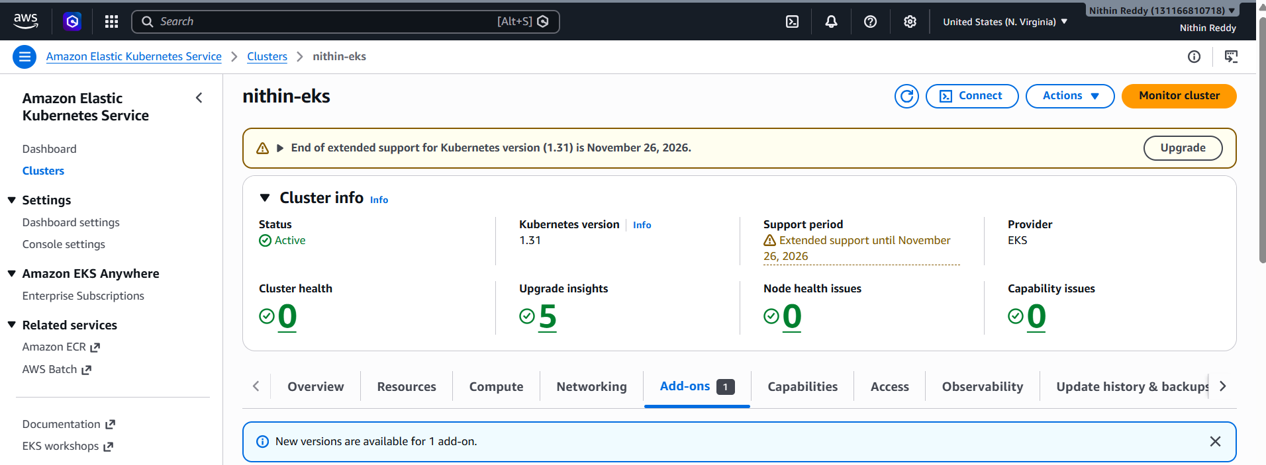
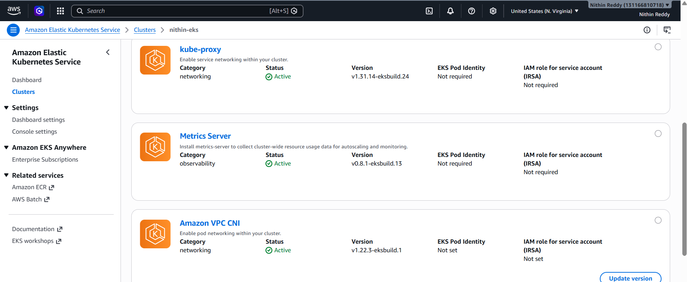
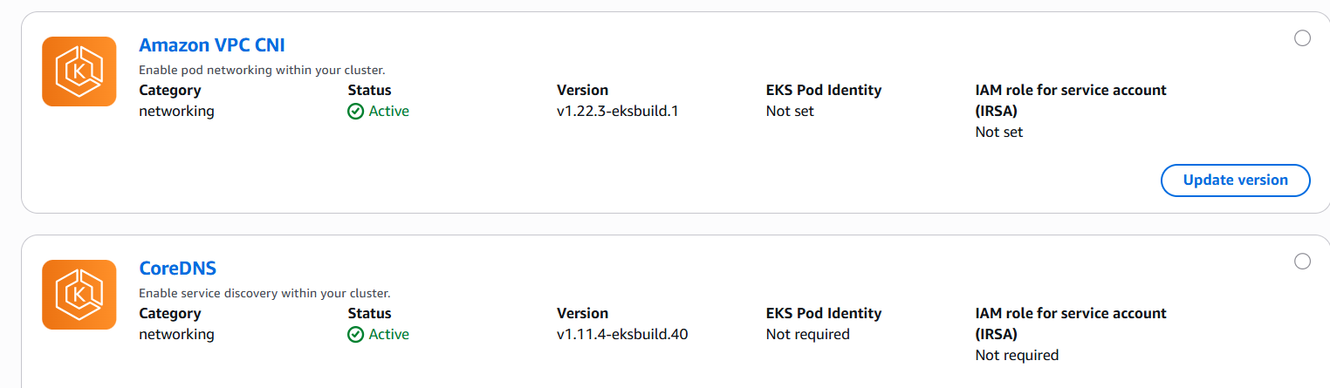
Validation
- Verified EKS cluster creation.
- Verified managed node group status as ACTIVE.
- Confirmed worker nodes joined the cluster.
- Verified all Kubernetes system pods were in Running state.
- Confirmed the cluster was accessible through kubectl and AWS CLI.
Outcome
- Successfully created an Amazon EKS cluster using eksctl.
- Managed node group with two worker nodes was provisioned.
- Kubernetes system components were deployed successfully.
- The cluster is ready to deploy containerized applications and proceed with advanced Kubernetes tasks such as HPA, Cluster Autoscaler, Jobs, CronJobs, Secrets, and Add-ons.
Task 2: Set Up EKS Cluster Using AWS Console
Objective
Create an Amazon EKS cluster using the AWS Management Console, create a managed node group, connect to the cluster using kubectl, and verify that the worker nodes join the cluster successfully.
Implementation Steps
- Open AWS Console → Amazon EKS.
- Click Create Cluster.
- Enter cluster details:
  - Cluster Name: nithin-console-eks
  - Kubernetes Version: 1.31
  - Cluster IAM Role: EKSClusterRole
- Select the Default VPC (or your custom VPC).
- Select at least 2 Public Subnets in different Availability Zones.
- Choose the Default Security Group.
- Set API Endpoint Access = Public.
- Leave the remaining settings as default and click Create Cluster.
- Wait until the cluster status changes to ACTIVE.
- Open the Compute tab and click Add Node Group.
- Configure the node group:
  - Name: worker-nodes
  - IAM Role: EKSNodeRole
  - AMI: Amazon Linux 2023
  - Instance Type: t3.small
  - Disk Size: 20 GB
- Configure Auto Scaling:
  - Desired Capacity: 2
  - Minimum Size: 2
  - Maximum Size: 3
- Select the same VPC and Public Subnets.
- Click Create Node Group.
- Wait until the node group status becomes ACTIVE.
- Connect the cluster to kubectl:

Create iam role
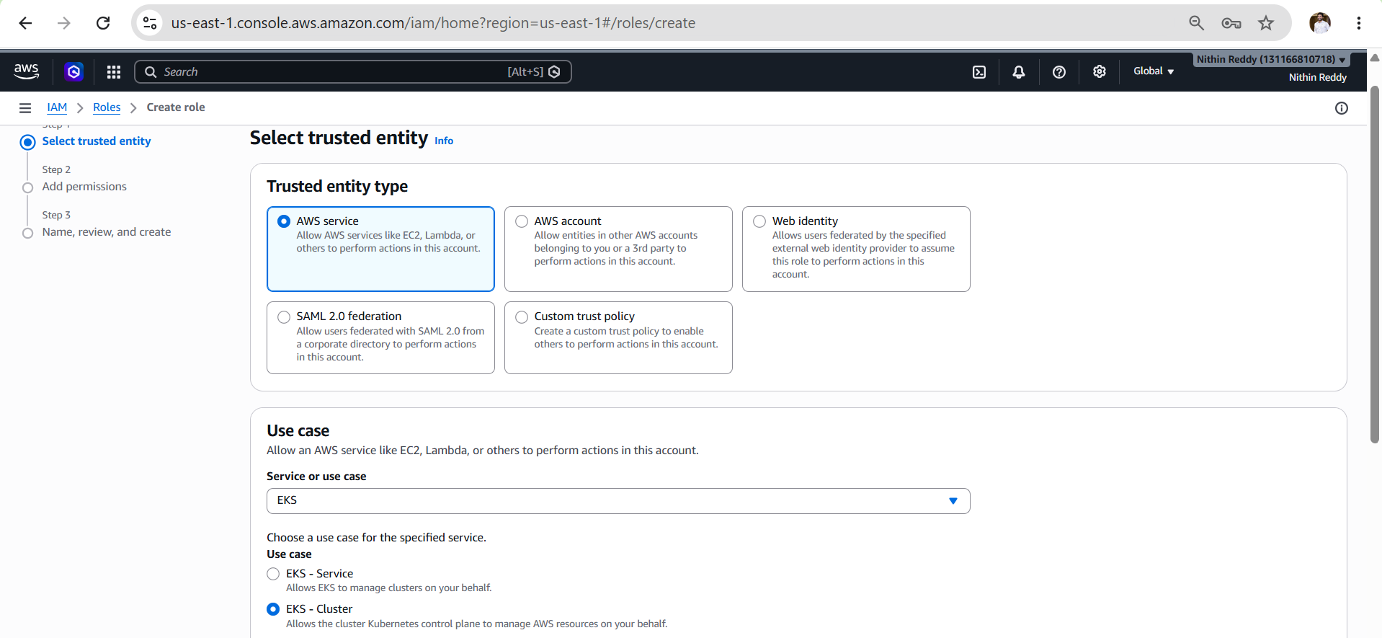
AmazonEKSClusterPolicy
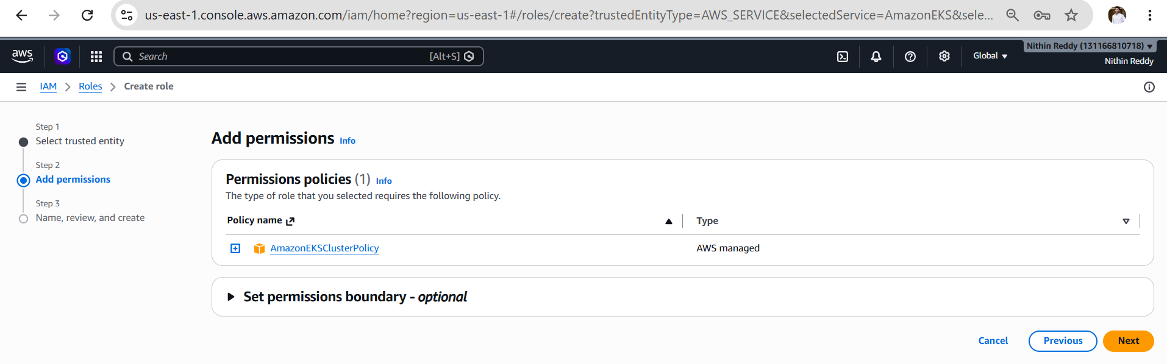

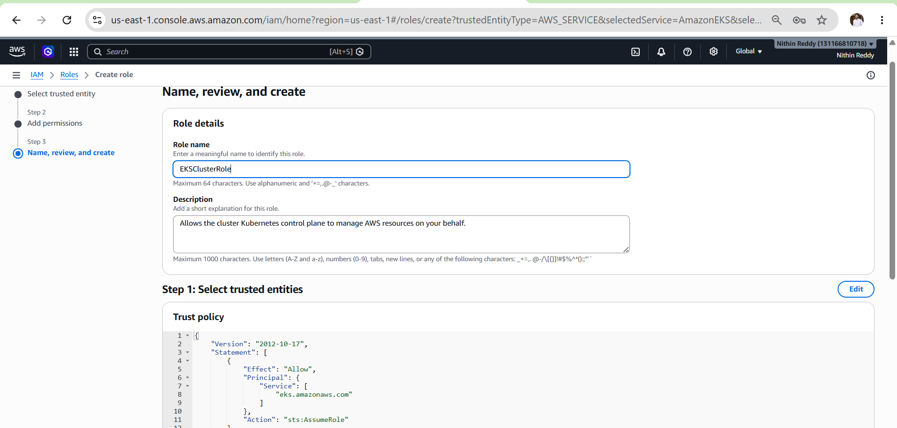
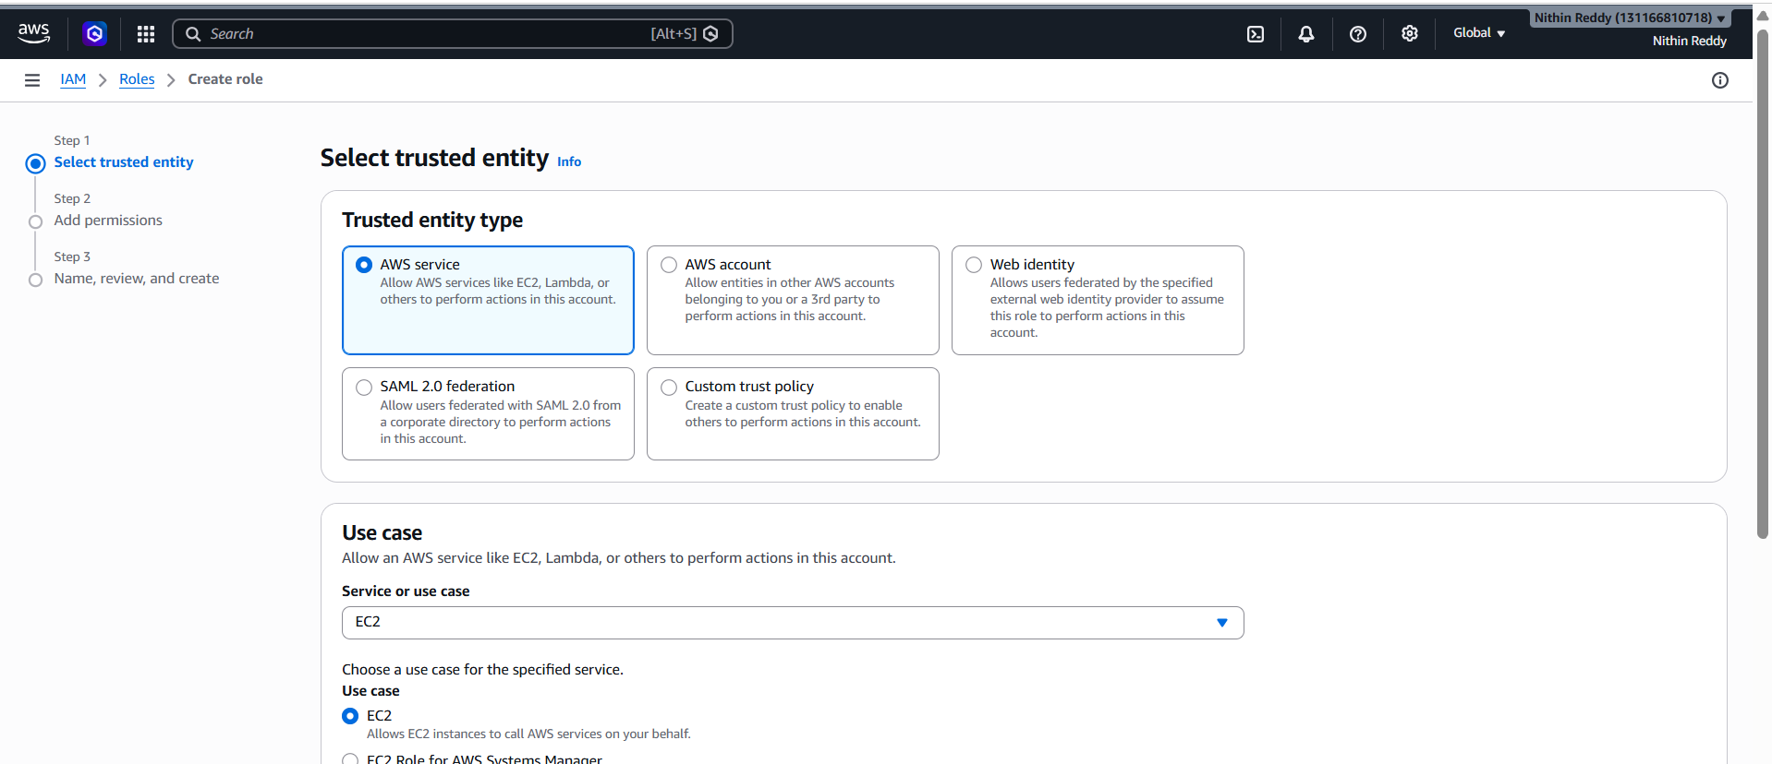
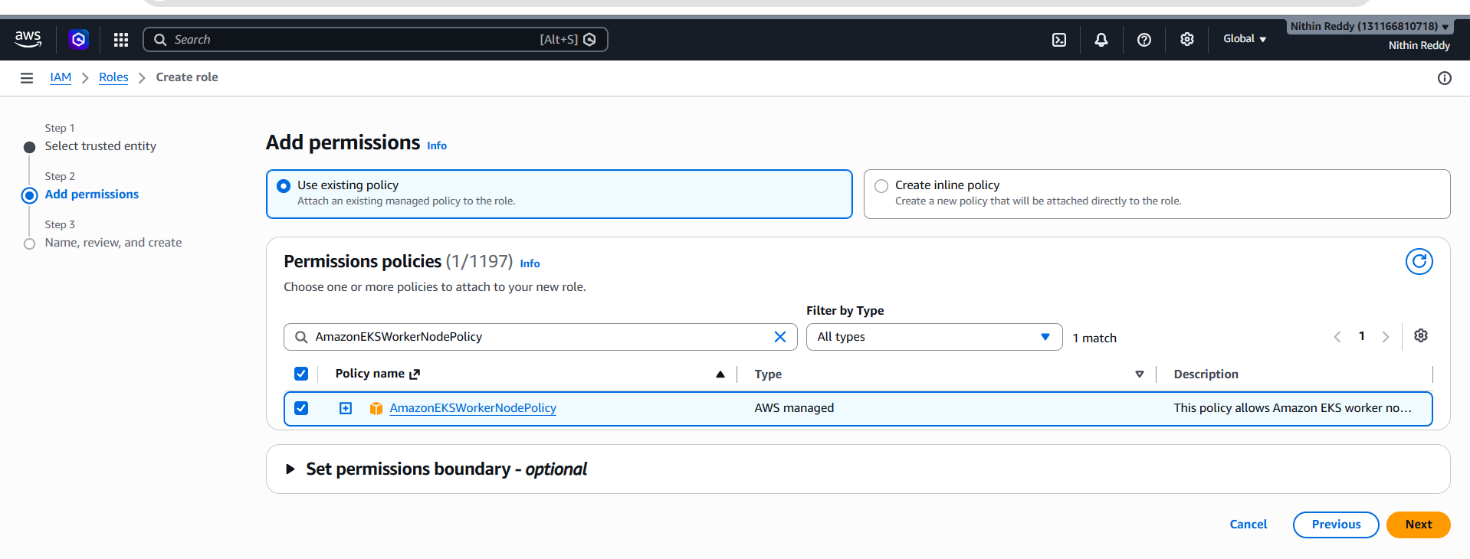
Also attached
AmazonEC2ContainerRegistryPullOnly
AmazonEKS_CNI_Policy
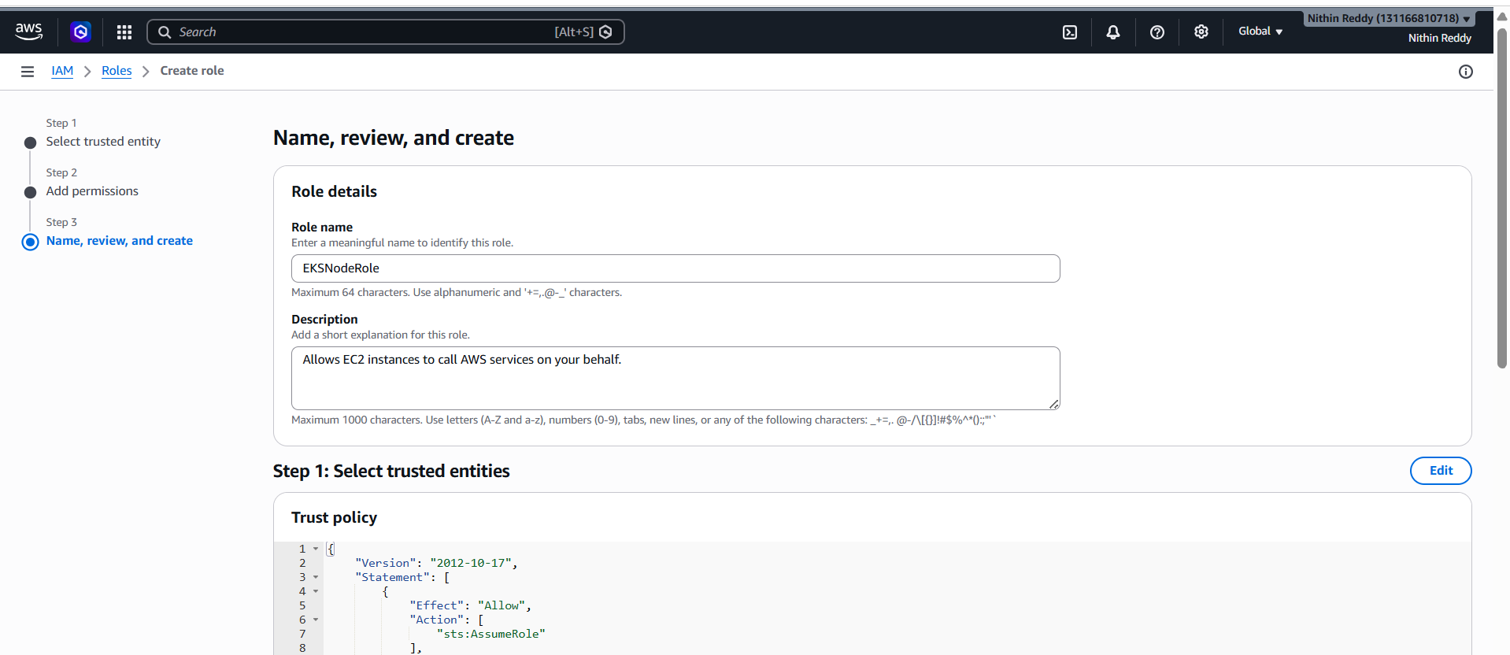
Creating EKS Cluster
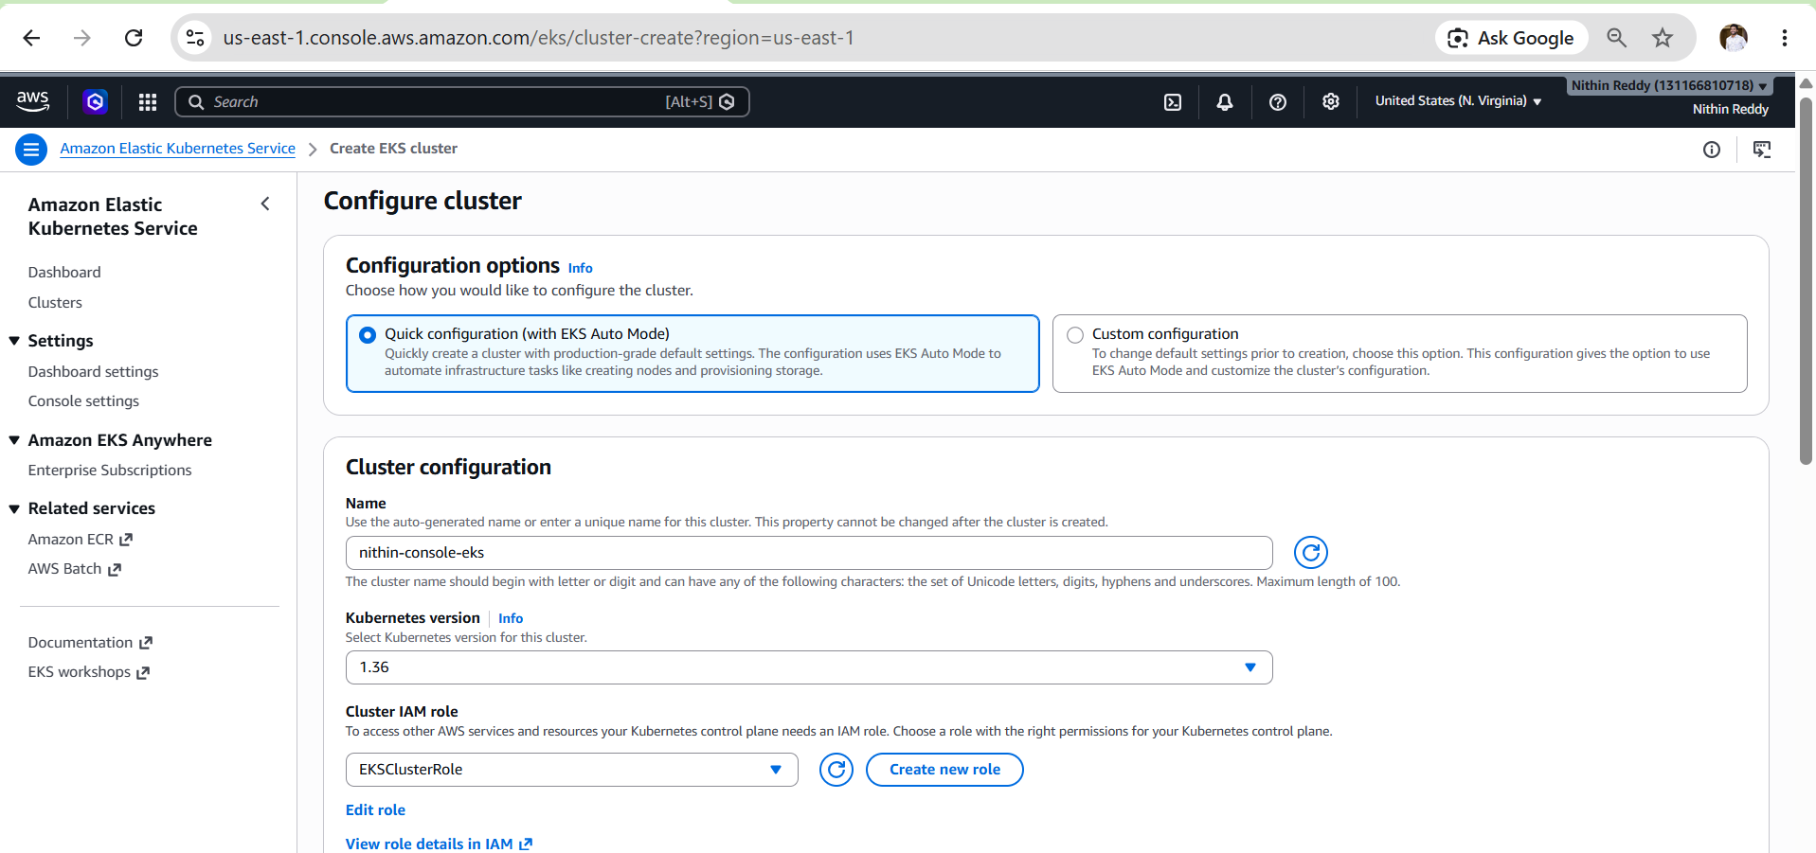
Creating cluster status is “creating”
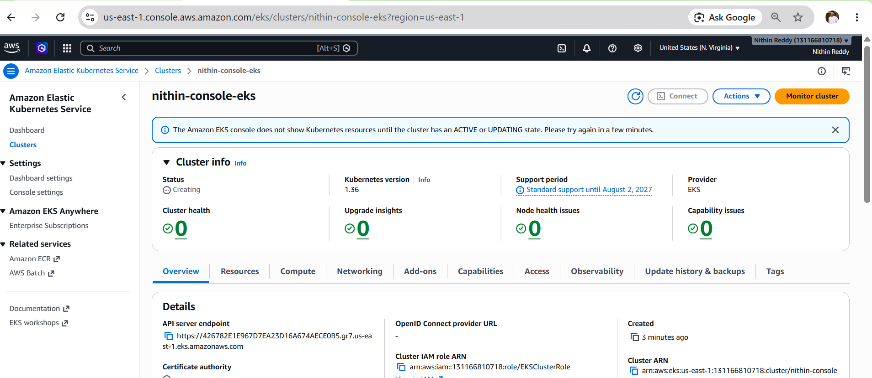
Now status active
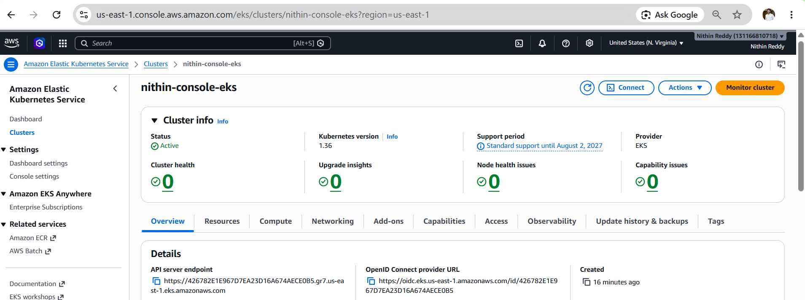

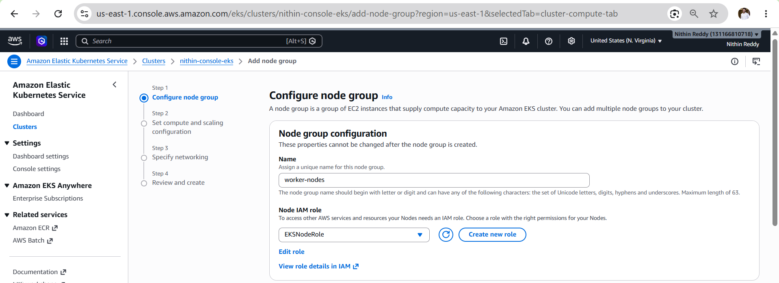
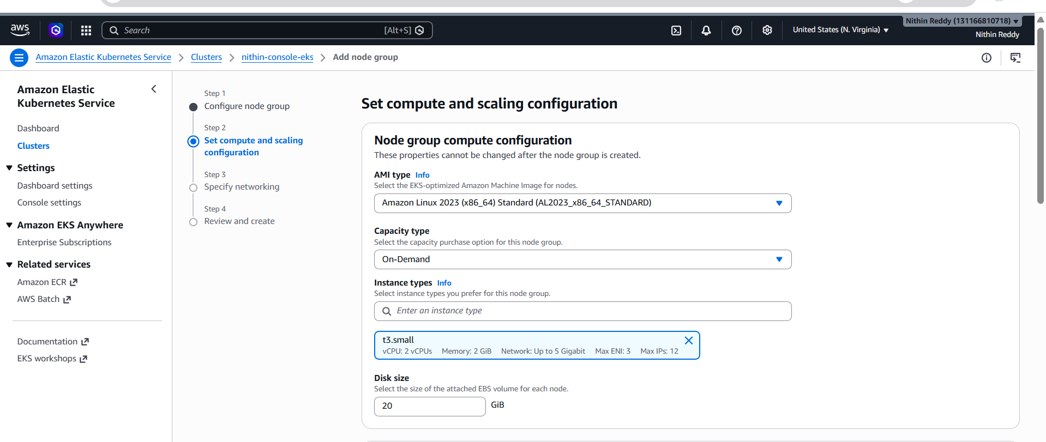

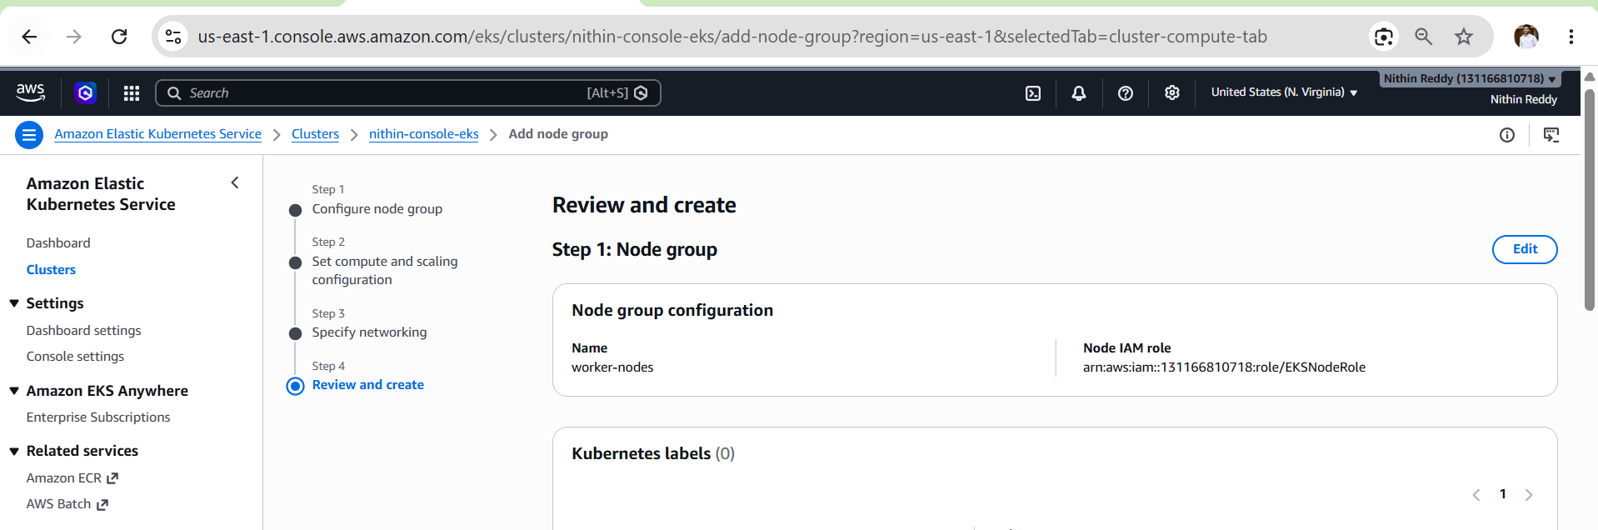
Creating status creating
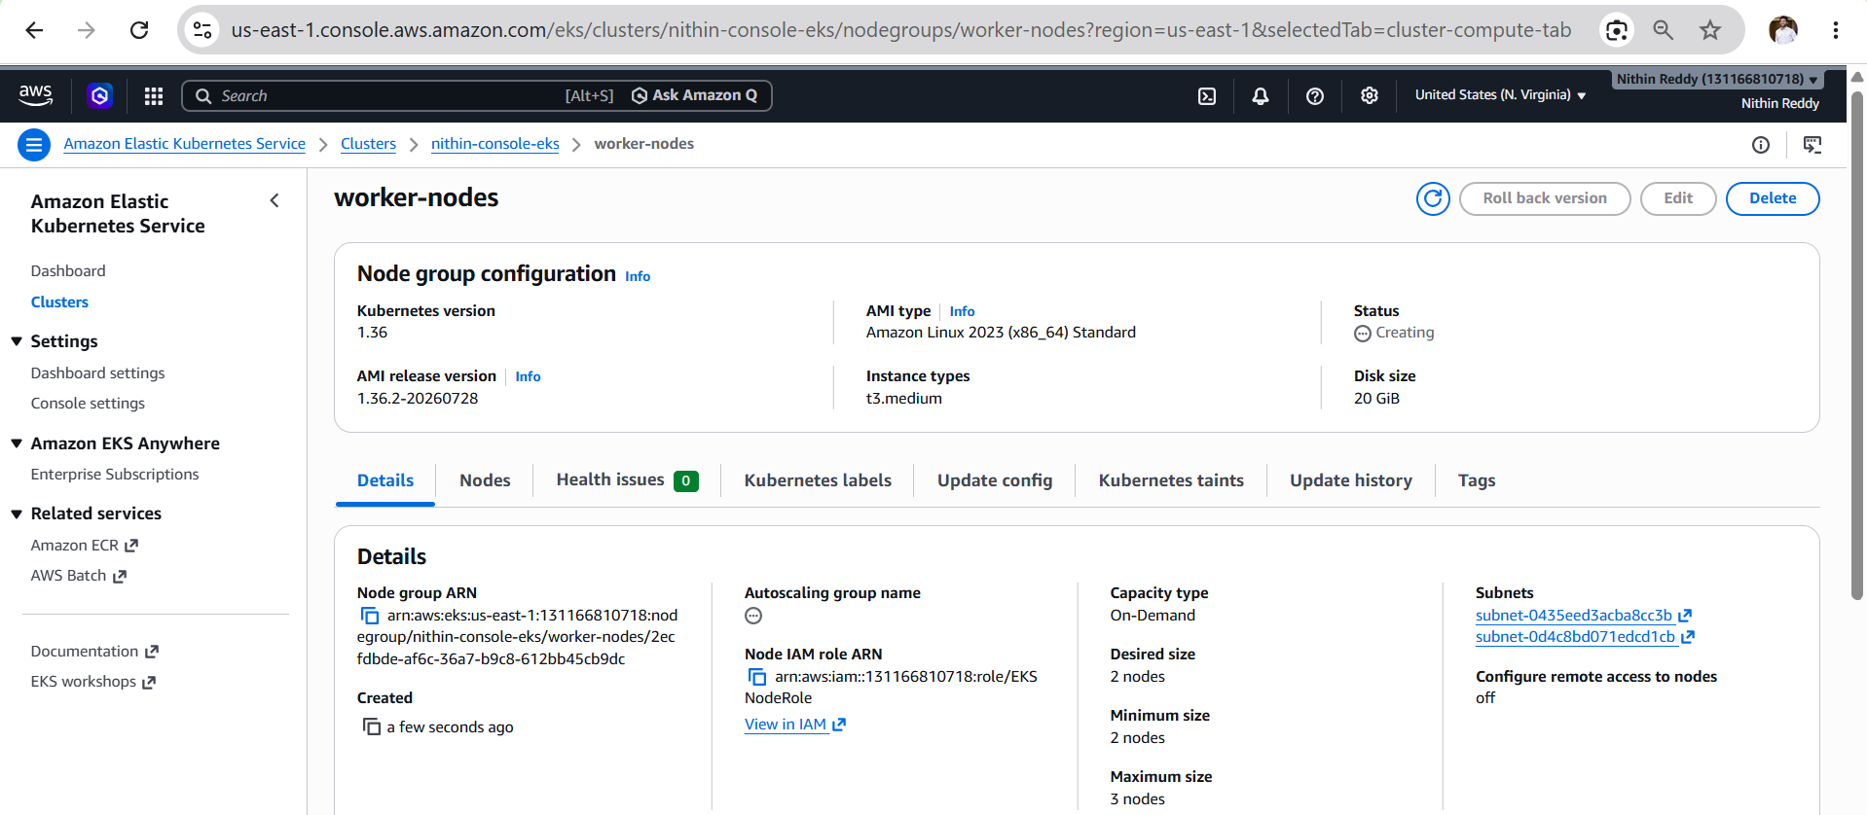
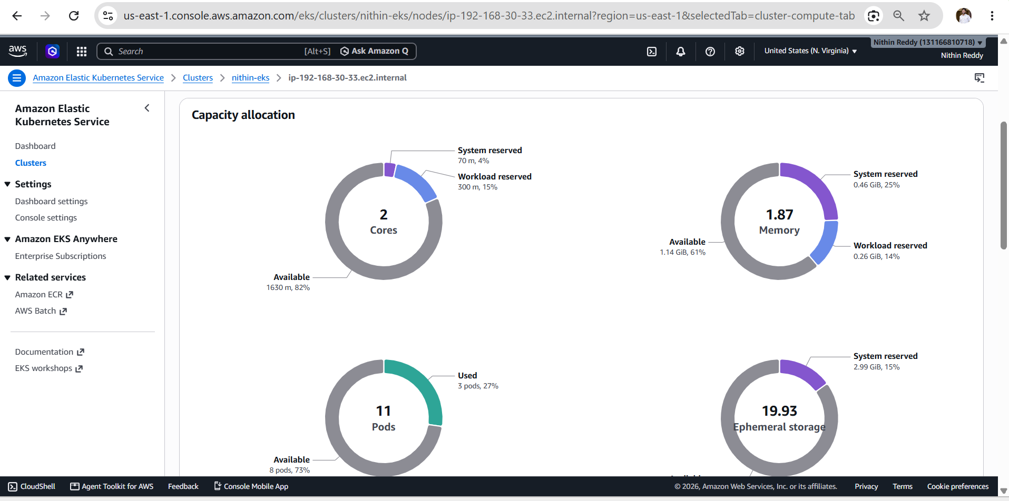

Validation
- ✅ EKS cluster created successfully using the AWS Console.
- ✅ Cluster status changed to ACTIVE.
- ✅ Managed node group created successfully.
- ✅ Two worker nodes joined the cluster.
- ✅ Kubernetes system pods are in the Running state.
- ✅ kubectl successfully connected to the EKS cluster.
- ✅ AWS CLI listed the newly created cluster.

Outcome
- Successfully created an Amazon EKS cluster using the AWS Management Console.
- Configured a managed node group with two worker nodes.
- Connected to the cluster using kubectl.
- Verified that the cluster, worker nodes, and system pods were functioning correctly.
- The EKS cluster is ready for deploying Kubernetes workloads
Task 3: Setup Horizontal Pod Autoscaler (HPA)
Objective
Deploy an Nginx application on Amazon EKS, expose it using a Kubernetes Service, configure a Horizontal Pod Autoscaler (HPA), generate load, and verify that the number of pods scales automatically based on CPU utilization.
Implementation Steps (For Document)
- Verified Metrics Server was running in the EKS cluster.
- Created an Nginx Deployment with CPU resource requests and limits.
- Exposed the Deployment using a ClusterIP Service.
- Configured a Horizontal Pod Autoscaler (HPA) with a CPU utilization target of 50%.
- Generated application load using a BusyBox pod.
- Observed automatic scaling of pods based on CPU utilization.
- Stopped the load and verified automatic scale-down to the minimum replica count.

kubectl get pods -n kube-system | grep metrics
kubectl top nodes
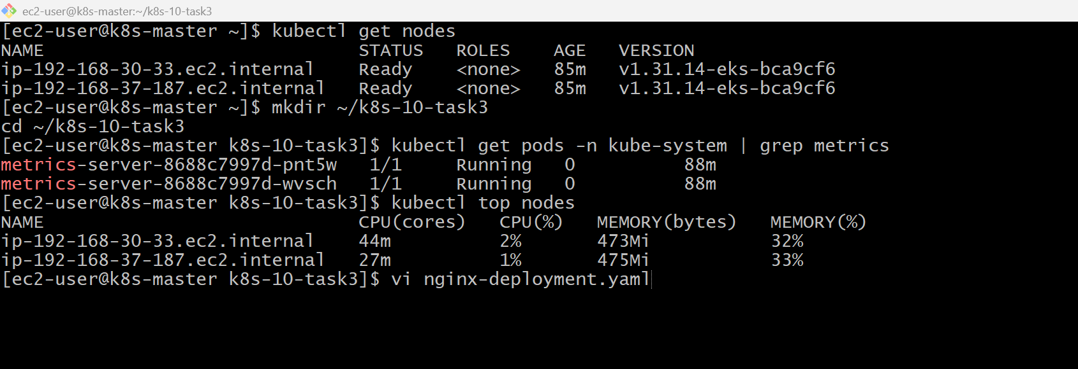

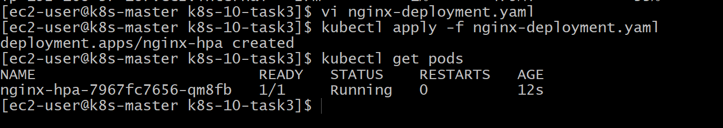
vi nginx-service.yaml
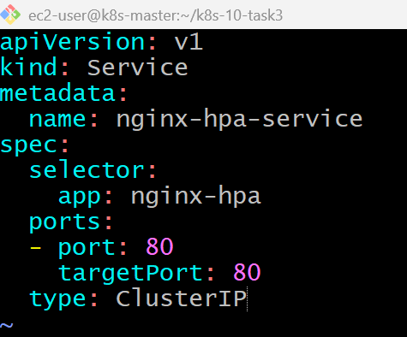
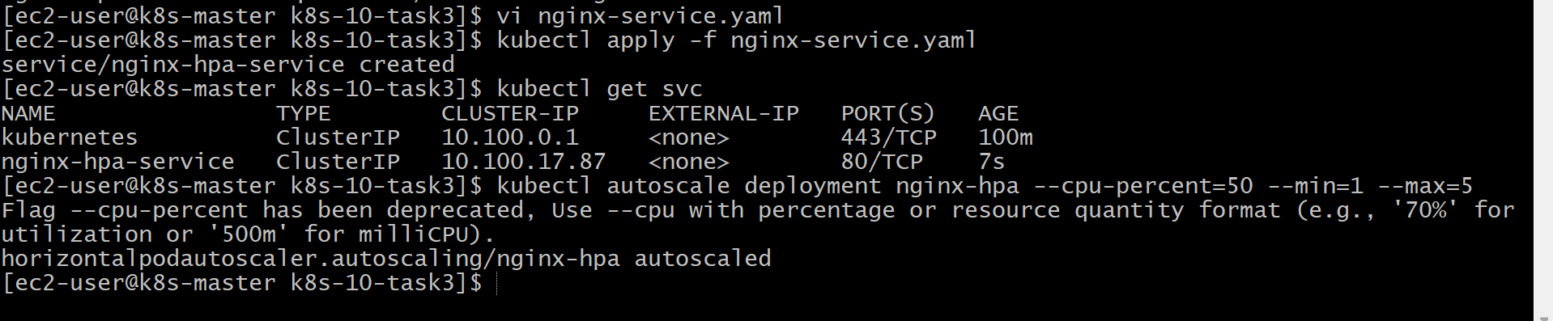
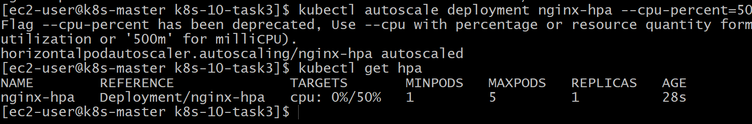
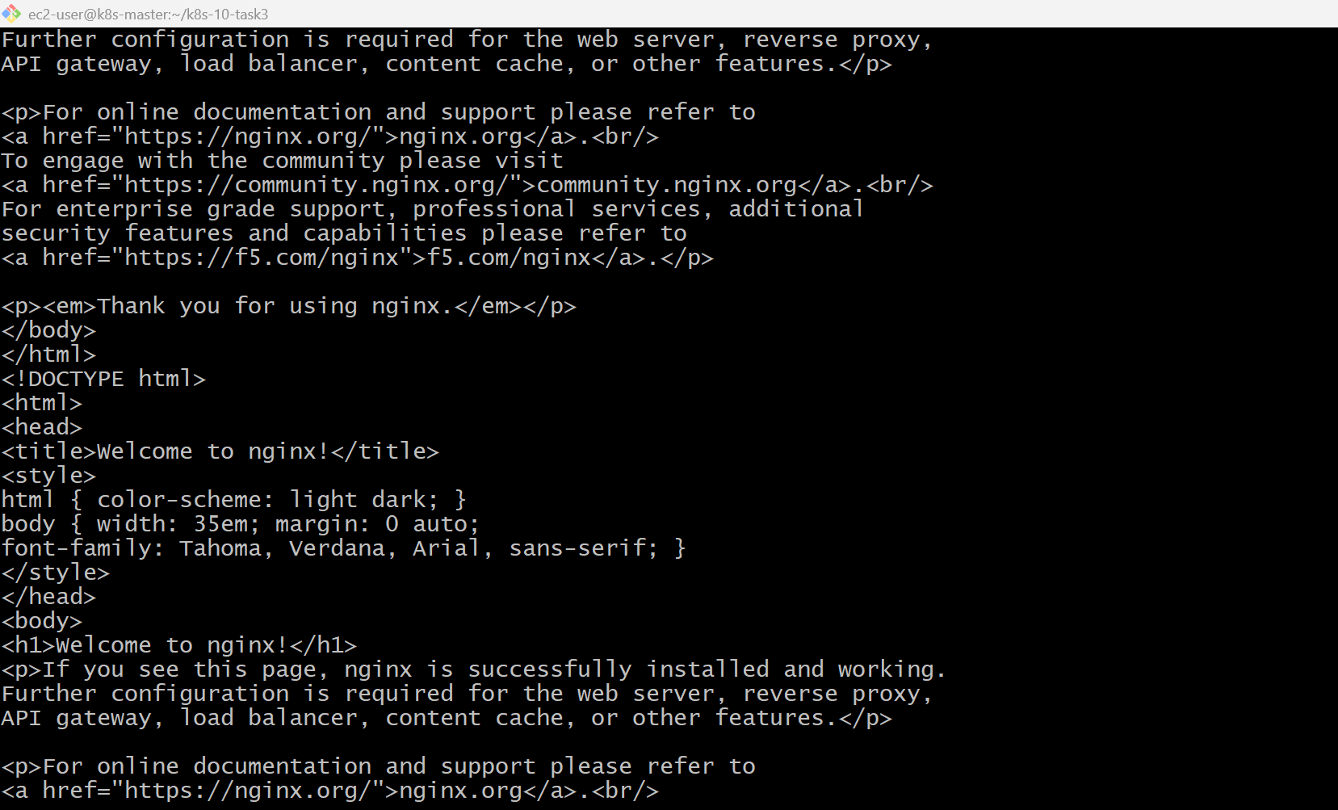
Run on other terminal
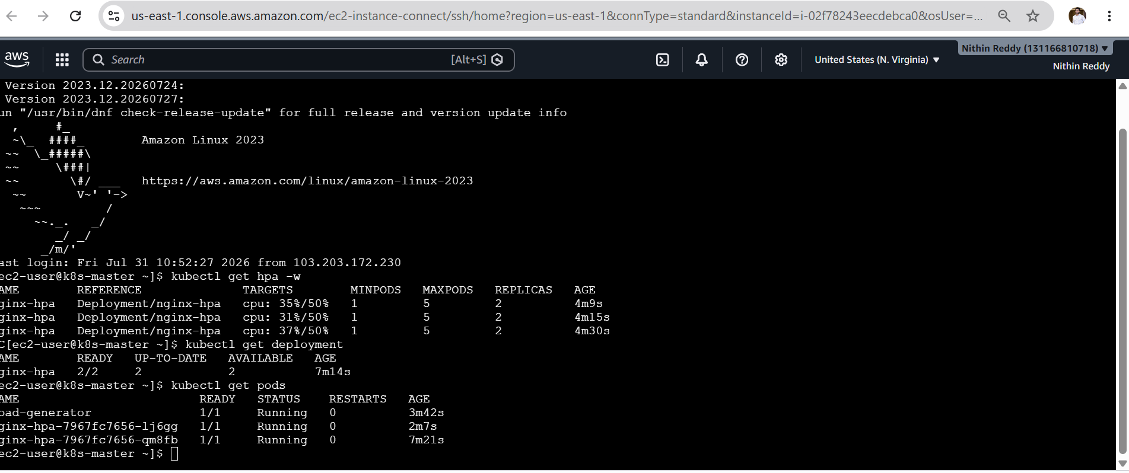
kubectl delete pod load-generator
kubectl get hpa
kubectl get pods
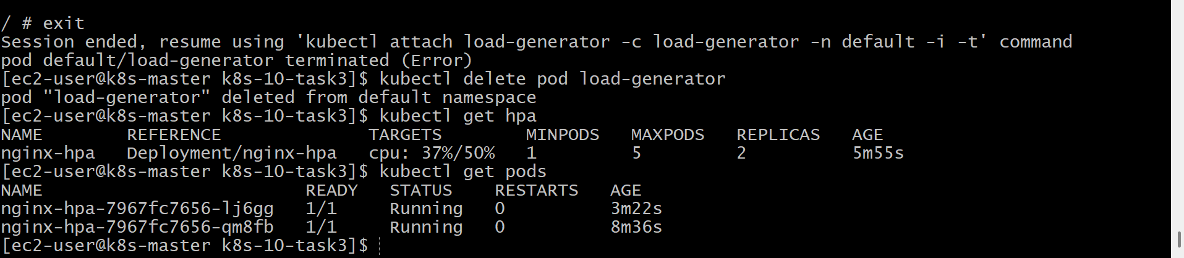
Validation
- Deployment created successfully.
- Service created successfully.
- HPA created successfully.
- Metrics Server collected CPU metrics.
- Pods scaled up automatically when CPU usage increased.
- Pods scaled down automatically after the load was removed.

Outcome
Successfully configured a Horizontal Pod Autoscaler (HPA) on an Amazon EKS cluster. The application automatically scaled between 1 and 5 replicas based on CPU utilization, demonstrating Kubernetes' ability to dynamically adjust application capacity according to workload demand.

Task 4: Setup Cluster Autoscaler
Objective
Install Kubernetes Cluster Autoscaler on the EKS cluster and understand how it automatically increases or decreases the number of worker nodes based on pending pods.
Implementation Steps (For Documentation)
- Verified the EKS cluster and managed node group.
- Created the Cluster Autoscaler namespace.
- Deployed the Cluster Autoscaler manifest.
- Verified the Cluster Autoscaler deployment and pod.
- Reviewed the managed node group's minimum, maximum, and desired capacity.
- Understood how Cluster Autoscaler automatically adds and removes worker nodes based on workload.
cd ~/k8s-10
kubectl get nodes
eksctl get nodegroup --cluster nithin-eks
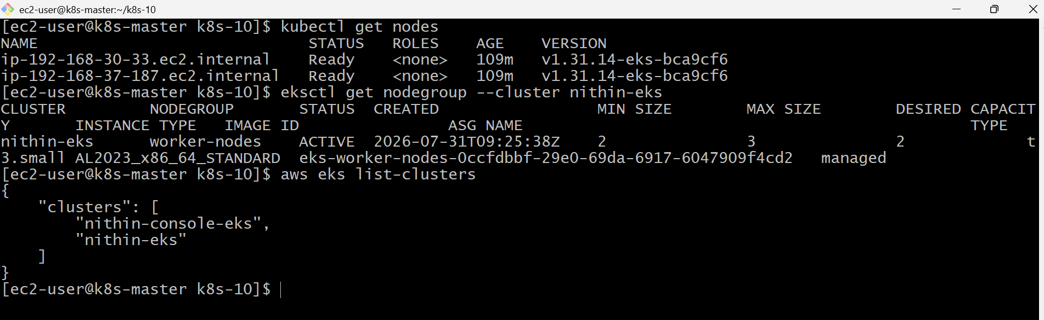

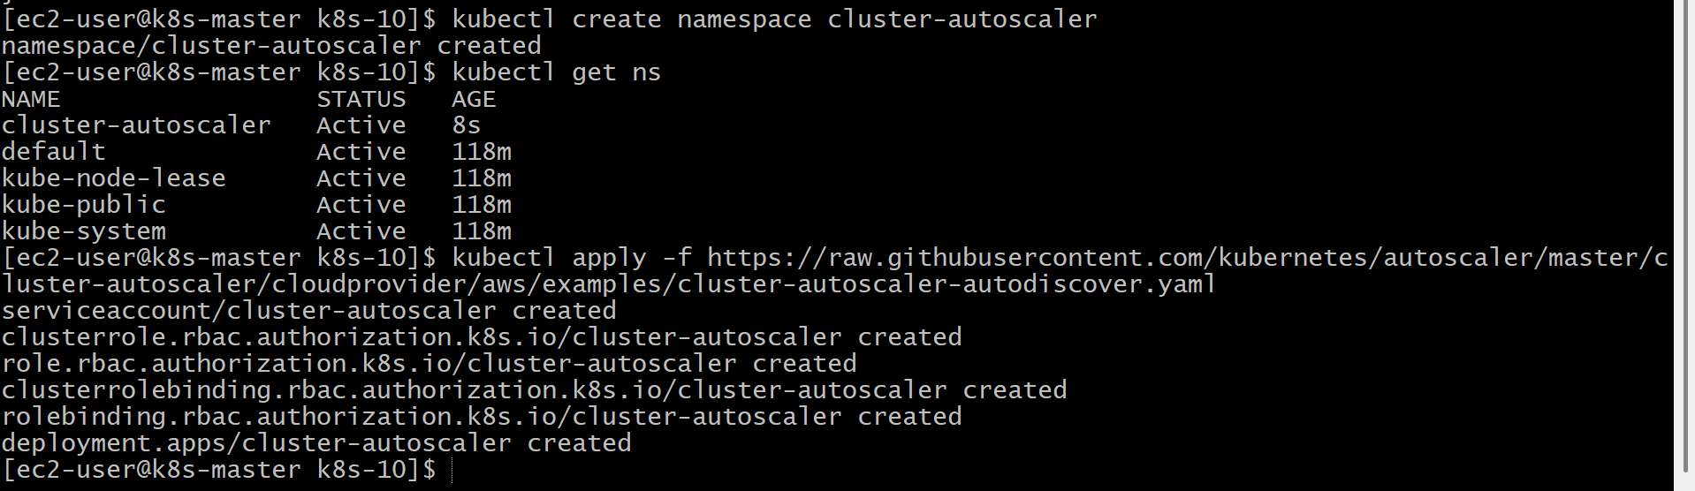

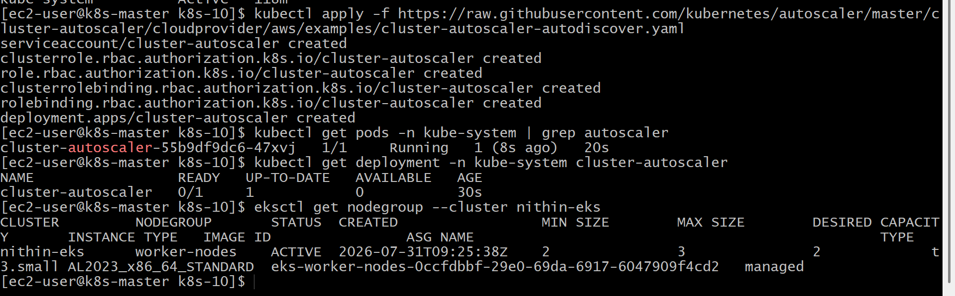
Validation
- Managed node group verified successfully.
- Cluster Autoscaler deployment created.
- Cluster Autoscaler pod deployed.
- Auto Scaling configuration confirmed (Min = 2, Max = 3).
- Worker nodes remained healthy.

Outcome
Successfully deployed and verified the Cluster Autoscaler on the Amazon EKS cluster. Understood how Kubernetes can automatically scale worker nodes by interacting with the EC2 Auto Scaling Group when application workloads increase or decrease.

Task 5: Setup Job and CronJob
Objective
Create and execute a Kubernetes Job to perform a one-time task and a CronJob to execute a task automatically at scheduled intervals.
Implementation Steps (For Documentation)
- Created a Kubernetes Job YAML file.
- Deployed the Job to execute a one-time task.
- Verified Job completion and viewed execution logs.
- Created a Kubernetes CronJob YAML file.
- Configured the CronJob to execute every minute.
- Verified automatic Job creation by the CronJob.
- Viewed CronJob execution logs.
- Deleted Job and CronJob resources after validation

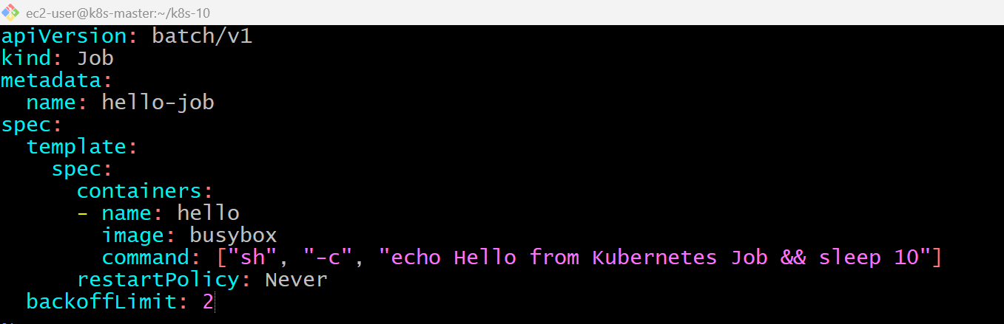
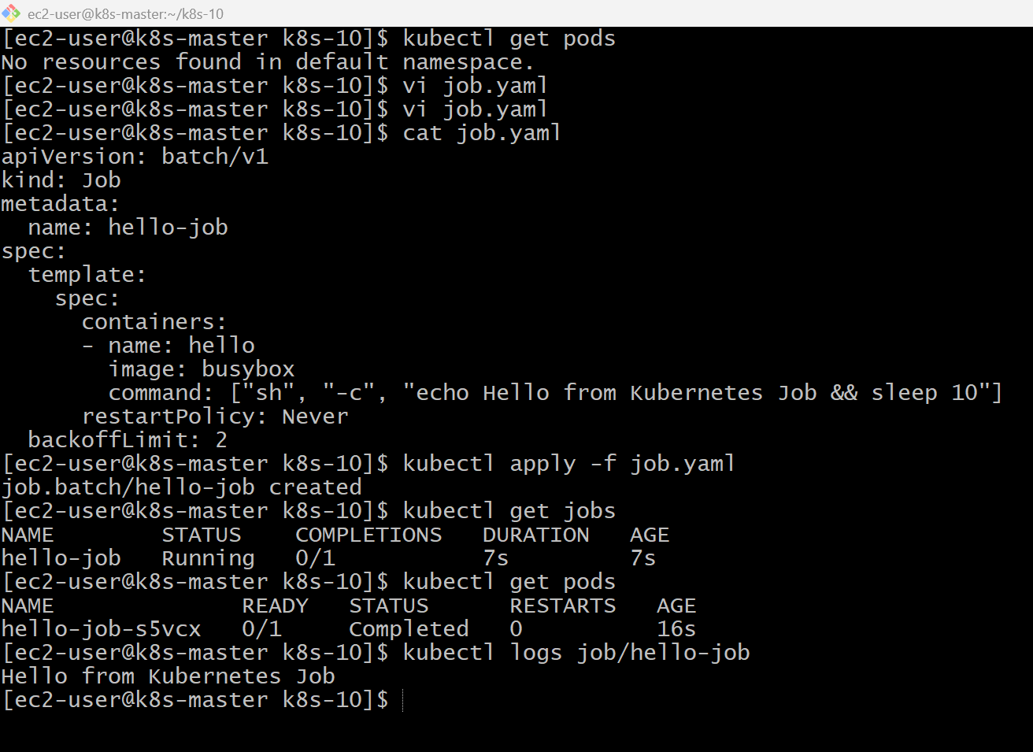
vi cronjob.yaml
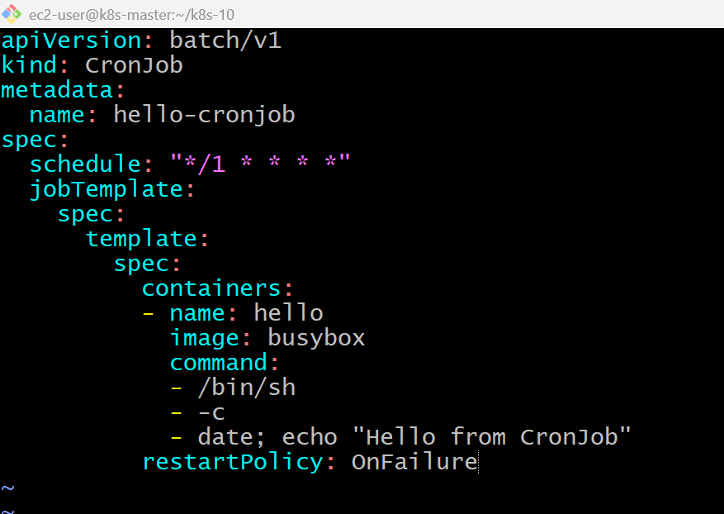
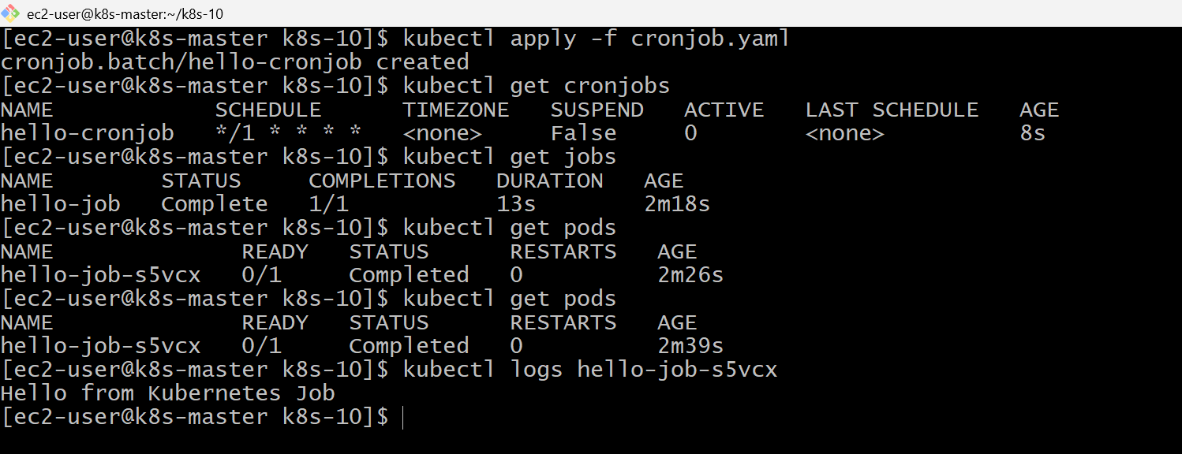
Validation
- Job created successfully.
- Job executed once and completed successfully.
- CronJob created successfully.
- CronJob automatically created Jobs at the scheduled interval.
- Logs confirmed successful execution of both Job and CronJob.

Outcome
Successfully implemented a Kubernetes Job to execute a one-time task and a CronJob to schedule recurring tasks. Verified successful execution, monitored logs, and cleaned up all resources after completion.

Task 6: Create Secret and Inject Inside Pod
Objective
Create a Kubernetes Secret, inject it into a Pod as environment variables, and verify that the application can securely access the secret values.
Implementation Steps (For Documentation)
- Created a Kubernetes Secret using literal values.
- Verified the Secret creation.
- Created a Pod YAML that references the Secret.
- Injected Secret values as environment variables.
- Deployed the Pod.
- Verified that the Secret values were available inside the container.
- Cleaned up all resources after validation.

kubectl create secret generic app-secret \
--from-literal=username=admin \
--from-literal=password=DevOps@123
kubectl get secrets
kubectl describe secret app-secret
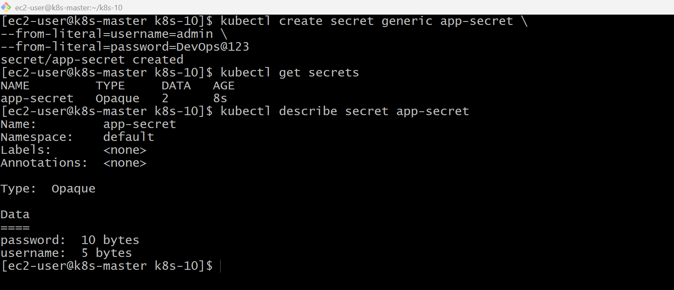
vi secret-pod.yaml
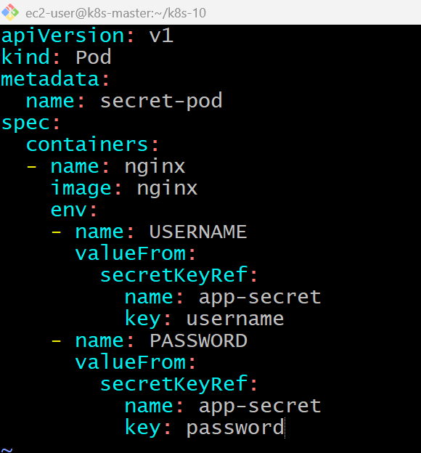
kubectl apply -f secret-pod.yaml
kubectl get pods
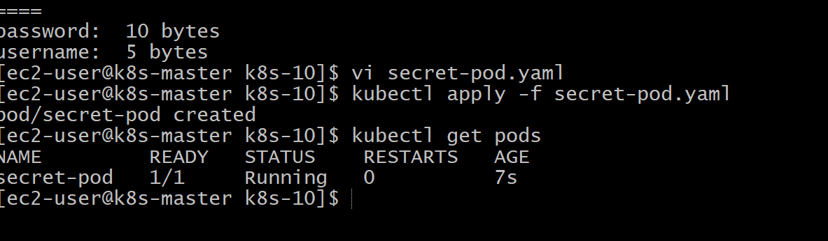
kubectl exec -it secret-pod -- printenv | grep USERNAME
kubectl get secret app-secret -o yaml
echo "YWRtaW4=" | base64 -d
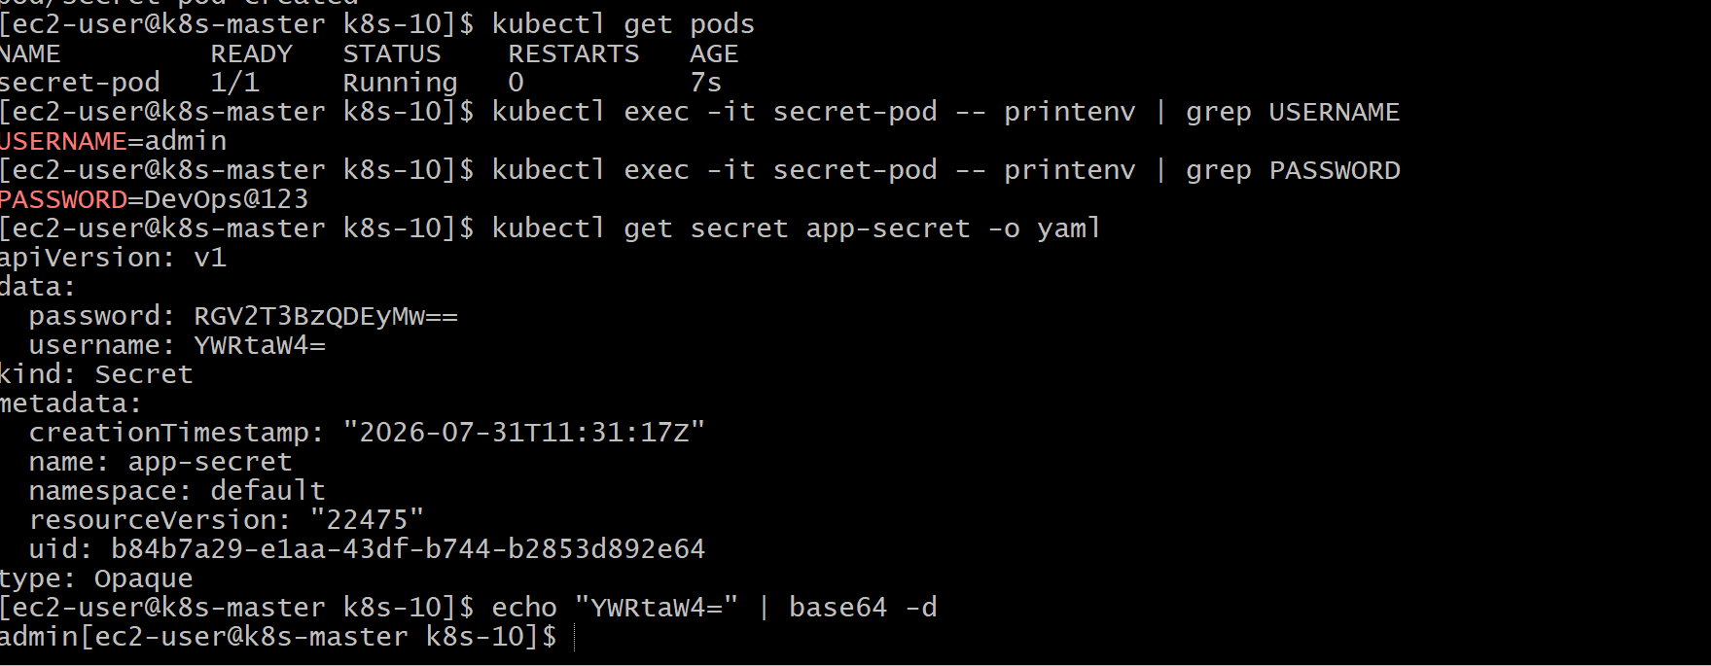
Validation Commands
kubectl get secrets
kubectl describe secret app-secret
kubectl get pods
kubectl exec -it secret-pod -- printenv
kubectl get secret app-secret -o yaml
Validation
- Secret created successfully.
- Pod deployed successfully.
- Secret values injected as environment variables.
- Verified environment variables inside the running container.
- Secret data stored in Base64 format.

Outcome
Successfully created a Kubernetes Secret and securely injected it into a Pod as environment variables. Verified that the application could access the secret values without exposing sensitive information directly in the Pod specification.

Task 7: Check Different Add-ons Available on EKS
Objective
View the installed Amazon EKS add-ons, understand their purpose, and verify their status using both the AWS CLI and Kubernetes commands.
Implementation Steps (For Documentation)
- Verified the Amazon EKS cluster and worker nodes.
- Listed all installed EKS add-ons using the AWS CLI.
- Described each add-on to verify its status and version.
- Verified the corresponding system pods in the kube-system namespace.
- Checked available versions for CoreDNS using the AWS CLI.
- Understood the purpose of commonly used EKS add-ons.

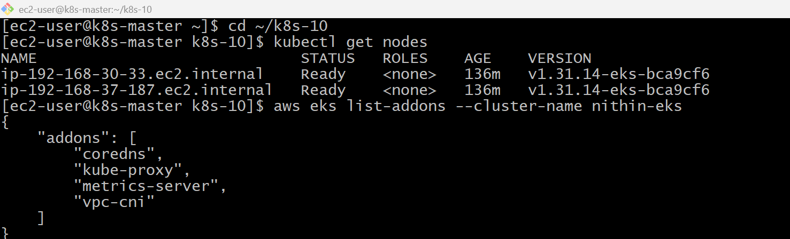
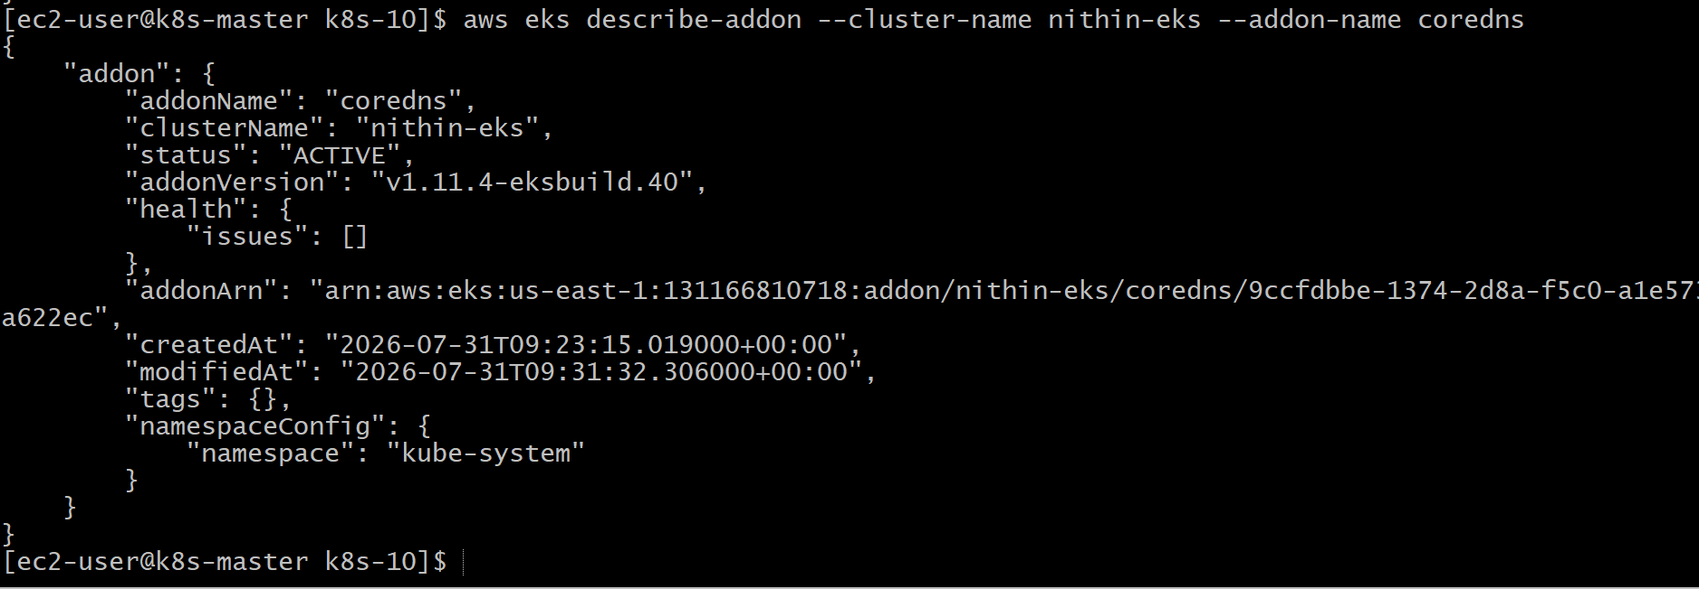

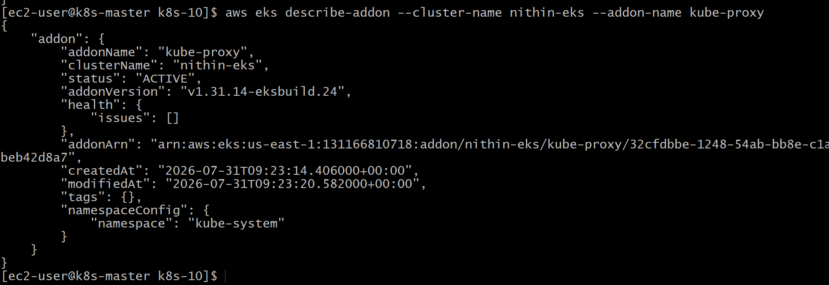
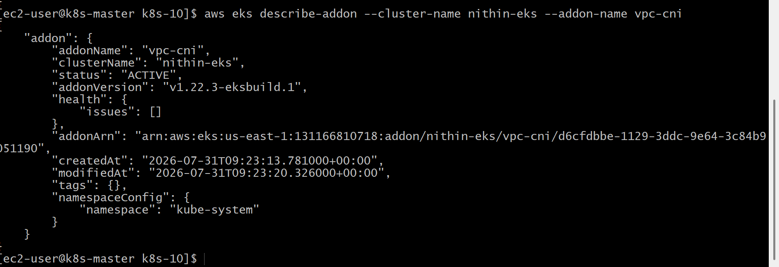
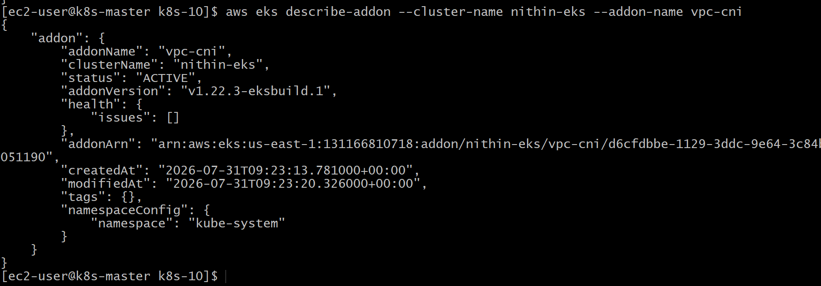
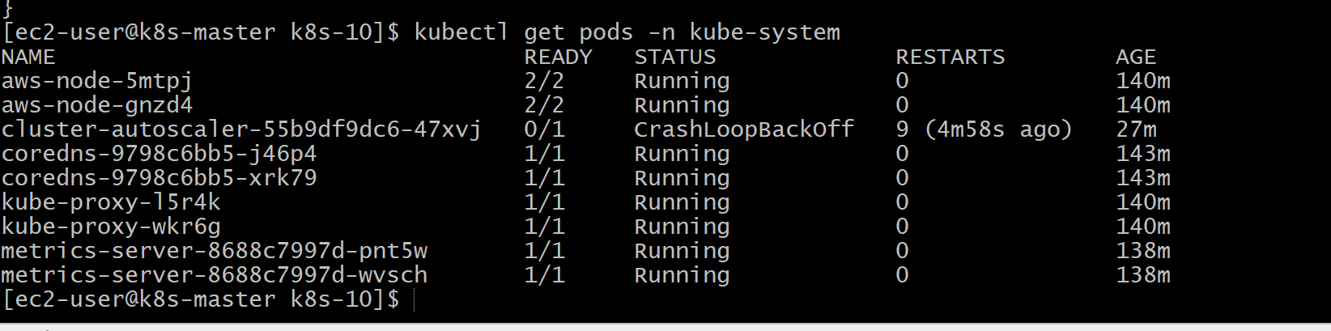

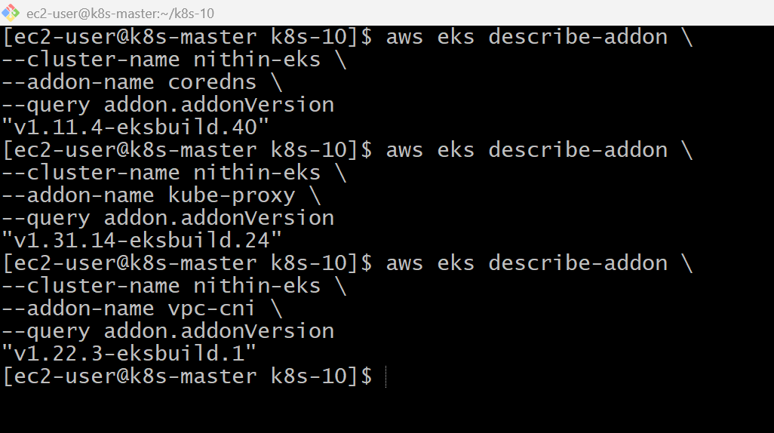
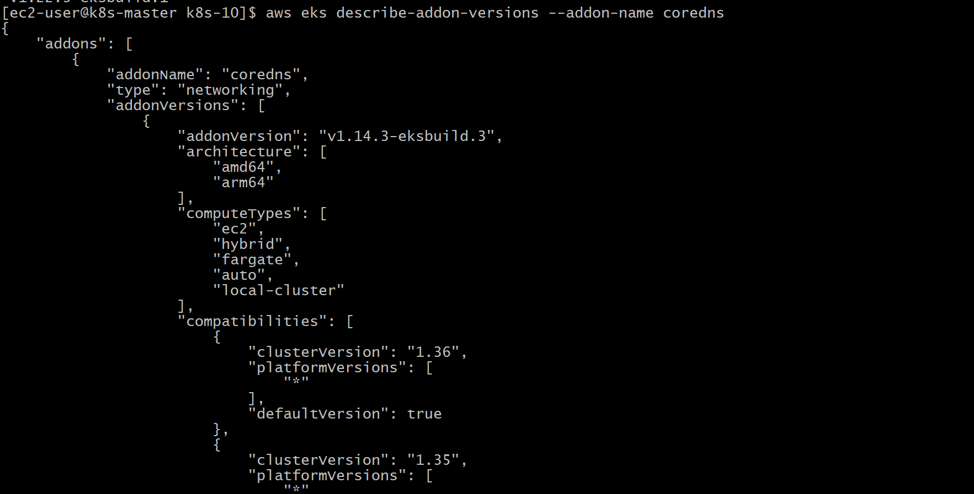

Validation
- Successfully listed all installed EKS add-ons.
- Verified add-on status as ACTIVE.
- Verified add-on pods were running in the kube-system namespace.
- Retrieved add-on versions successfully.
- Confirmed the cluster was functioning correctly with the required add-ons.

Outcome
Successfully explored and verified the Amazon EKS managed add-ons. Confirmed that essential components such as CoreDNS, kube-proxy, and Amazon VPC CNI were installed and operational, ensuring proper networking, DNS resolution, and cluster functionality.

Task 8: Upgrade Amazon EKS Cluster
Since this is for learning purposes, a minor version upgrade. Your cluster is currently 1.31, so we'll upgrade it to 1.32 (or to the next version available in your AWS account).
Note: If AWS does not yet offer version 1.32 in your account, simply upgrade to the next available version shown in the EKS console.
Objective
Upgrade the Amazon EKS control plane and managed node group to a newer Kubernetes version and verify that the cluster is healthy after the upgrade.
Implementation Steps (For Documentation)
- Verified the current EKS cluster version.
- Checked the available Kubernetes upgrade versions.
- Upgraded the EKS control plane to the next supported version.
- Monitored the upgrade until the cluster became ACTIVE.
- Upgraded the managed node group to match the control plane version.
- Verified that worker nodes rejoined the cluster successfully.
- Confirmed all system pods were in the Running state after the upgrade.

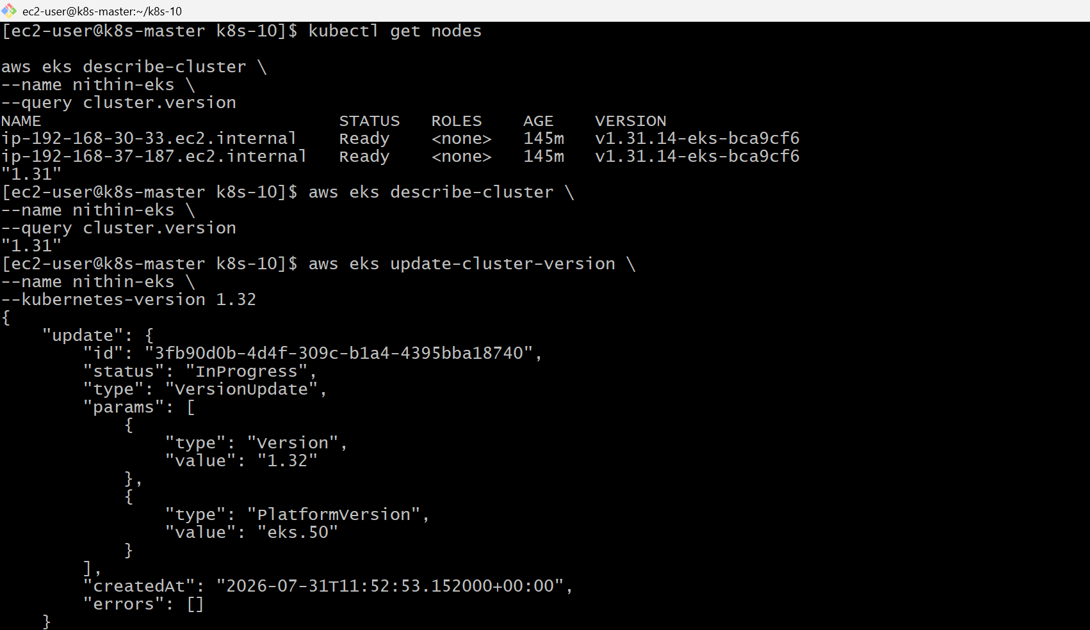
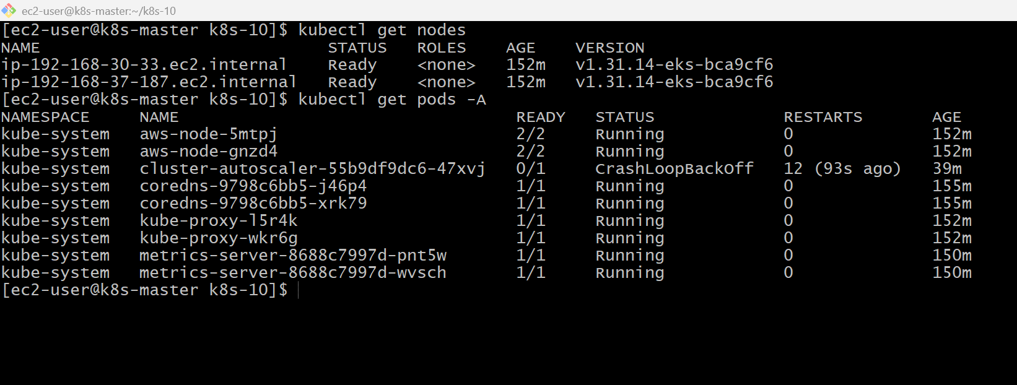
Validation
- Control plane upgraded successfully.
- Managed node group upgraded successfully.
- Worker nodes were in the Ready state.
- System pods were Running.
- Cluster version reflected the upgraded Kubernetes version.

Outcome
Successfully upgraded the Amazon EKS control plane and managed node group to a newer Kubernetes version. Verified cluster health, node readiness, and system pod status, ensuring the cluster remained operational after the upgrade.

