Challenge 6
Architecture
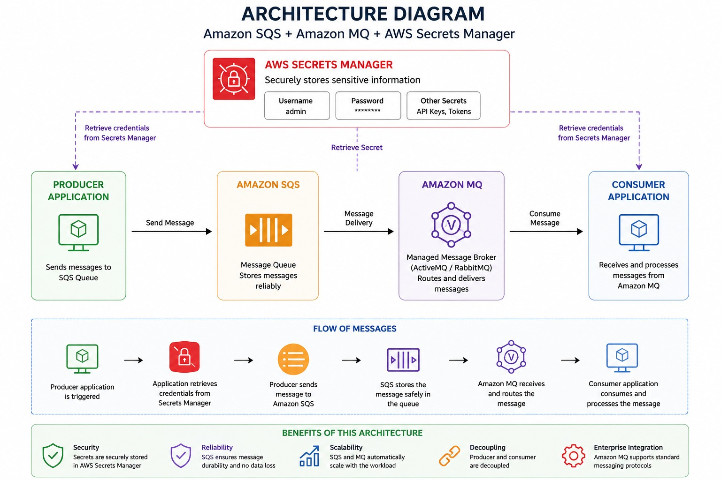
Architecture Explanation
- AWS Secrets Manager securely stores application credentials such as usernames, passwords, and API keys.
- Producer Application retrieves credentials from Secrets Manager before sending messages.
- Amazon SQS receives and stores messages reliably in a queue.
- Amazon MQ acts as a managed message broker and routes messages between applications.
- Consumer Application receives messages from Amazon MQ and processes them.
- SQS ensures message durability and prevents message loss.
- Amazon MQ supports enterprise messaging protocols such as AMQP, MQTT, JMS, and STOMP.
- Secrets Manager improves security by avoiding hardcoded credentials.
- The architecture is scalable and loosely coupled, allowing applications to work independently.
- The complete message flow is: Secrets Manager → Producer → SQS → Amazon MQ → Consumer.

Project Title
Secure Message Queue System using AWS SQS, Amazon MQ, and AWS Secrets Manager
TASK 1 – Amazon Simple Queue Service AWS-SQS
Objective
Create a queue and send/receive messages.
Expected Outcome
- Create queue
- Send message
- Receive message
- Delete message

Architecture
Producer
|
v
AWS SQS
|
v
Consumer

Prerequisites
- AWS Account
- IAM User

Implementation Steps
Step 1
Open
SQS

Step 2
Create Queue
Type:
Standard Queue
Name:
demo-queue
Create Queue.
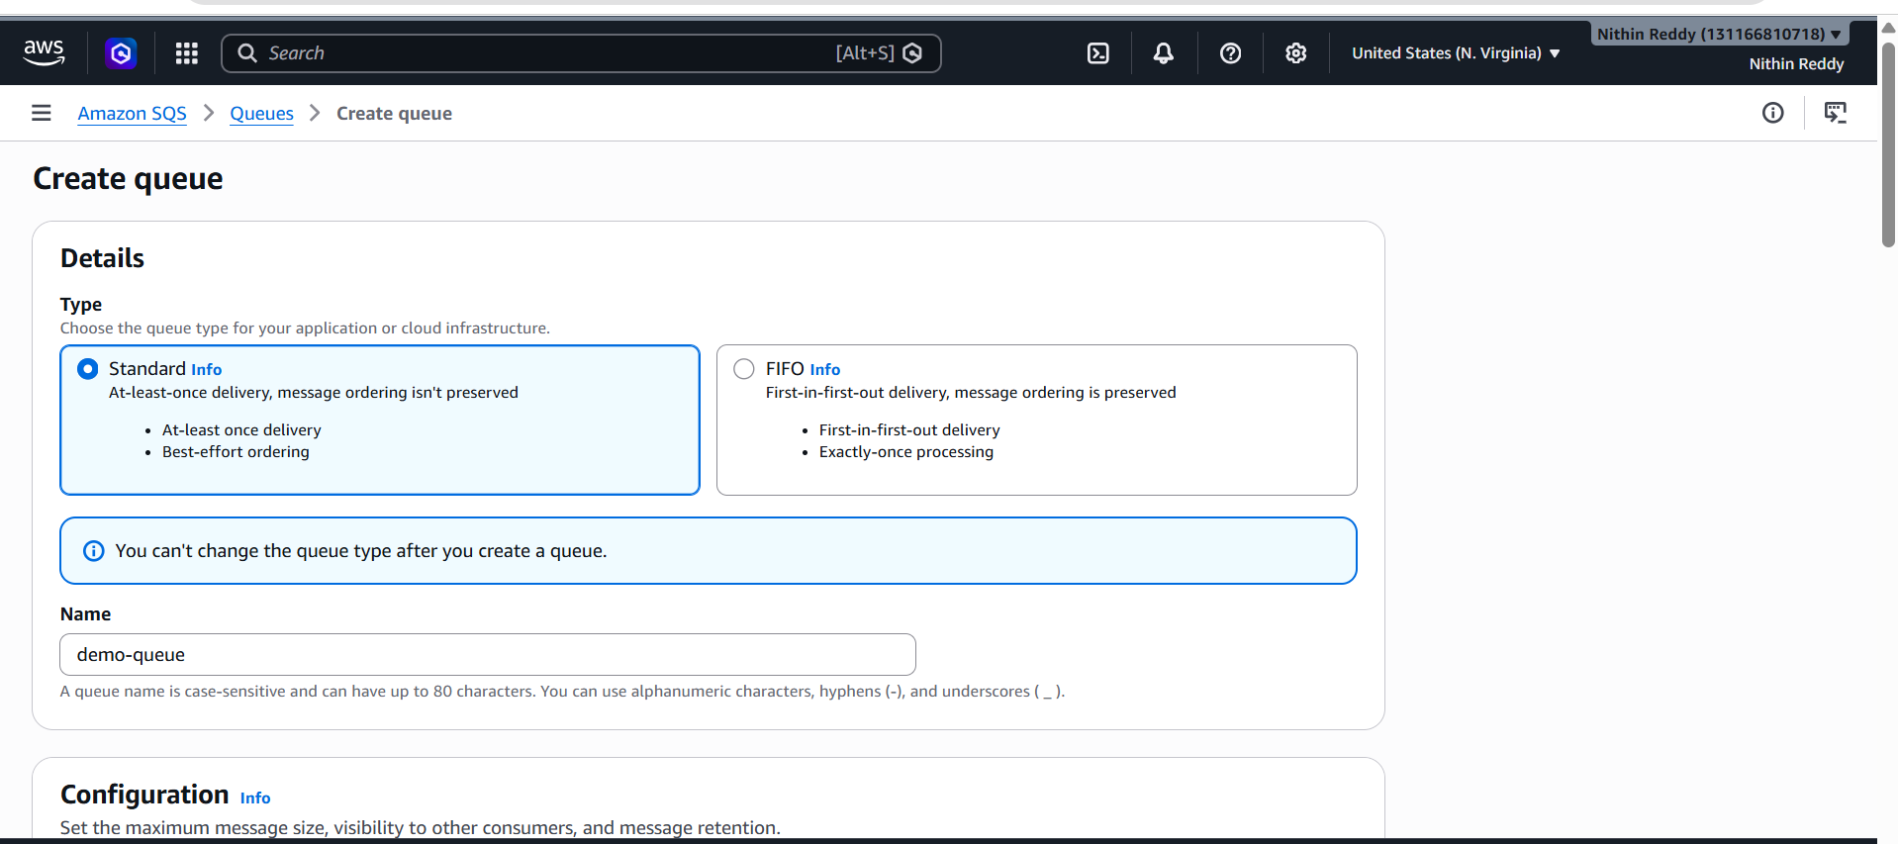

Step 3
Open queue
Click
Send and receive messages

Step 4
Message Body
Hello SQS
Send Message.
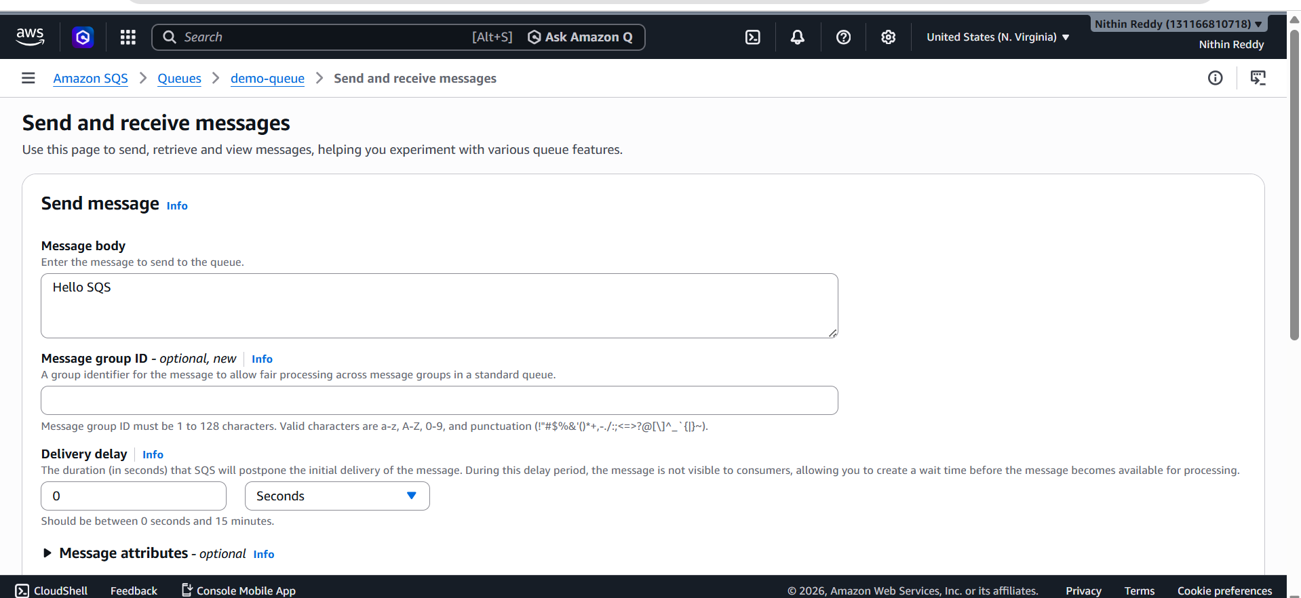
Step 5
Receive Messages
Click
Poll for messages
Message should appear.
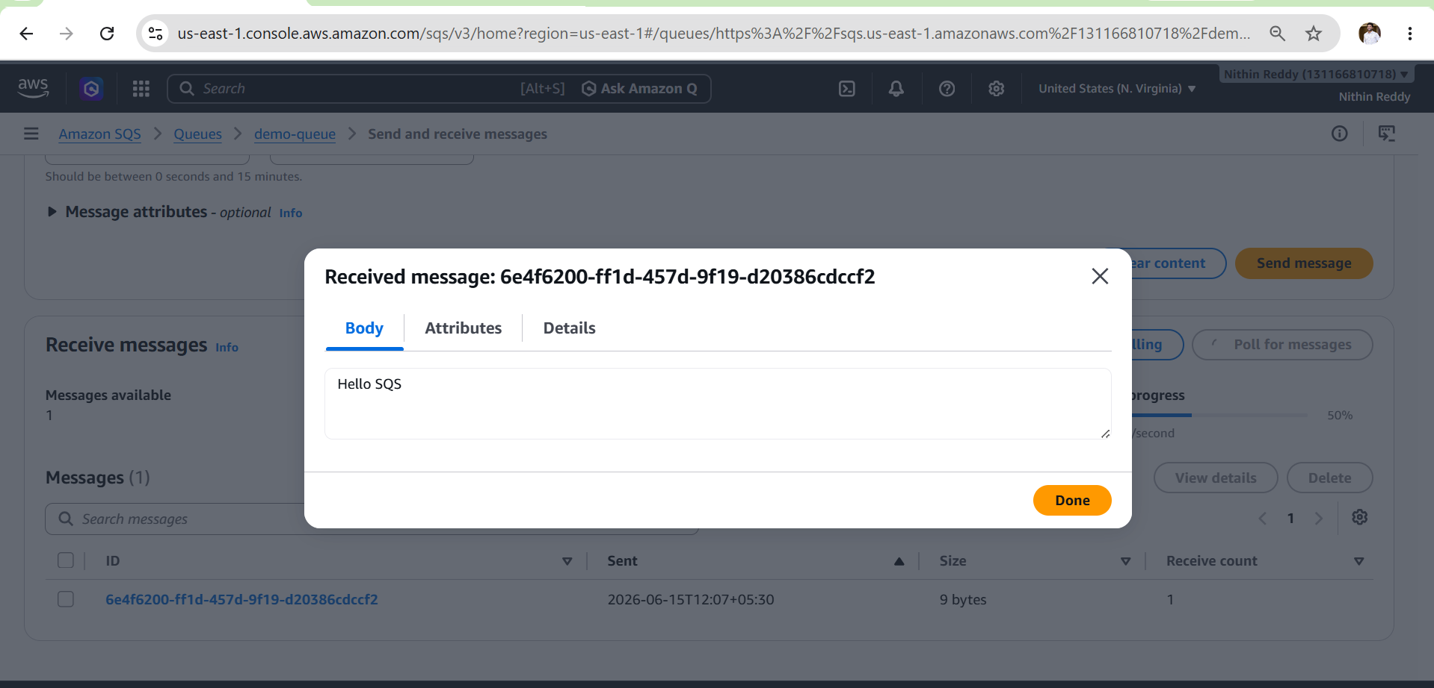
Validation
Verify:
Messages Available = 1
After polling:
Message Received Successfully

Common Errors
Access Denied
Cause:
Missing IAM permissions
Fix:
Attach AmazonSQSFullAccess

Queue Not Found

TASK 2 – AWS Secrets Manager
Objective
Store database credentials securely.

Expected Outcome
- Create Secret
- Retrieve Secret
- Understand secure credential storage

Architecture
Application
|
v
Secrets Manager
|
v
Username / Password

Prerequisites
- AWS Account

Implementation Steps
Step 1
Open
Secrets Manager

Step 2
Choose
Store a New Secret
Step 3
Select
Other Type of Secret

Step 4
Add:
username=admin
password=admin123
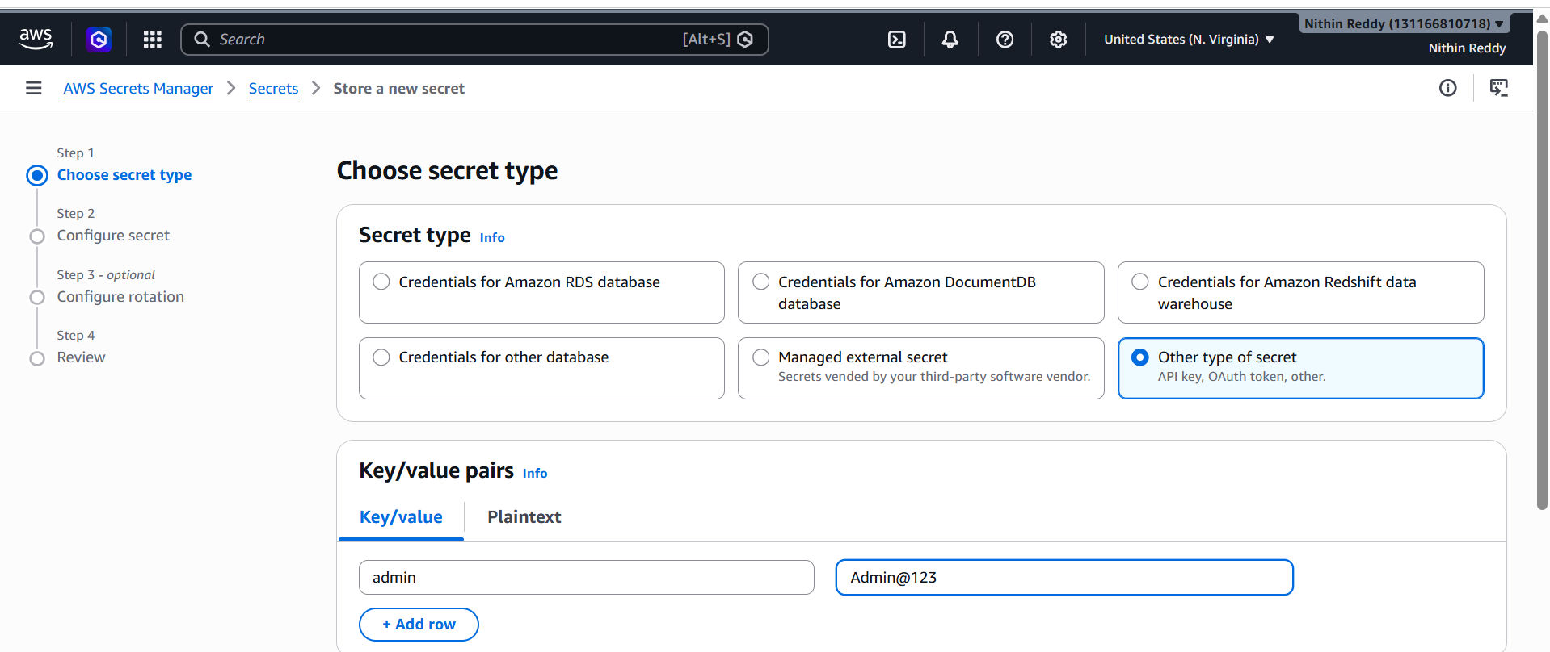
Step 5
Secret Name
demo-secret
Create Secret.
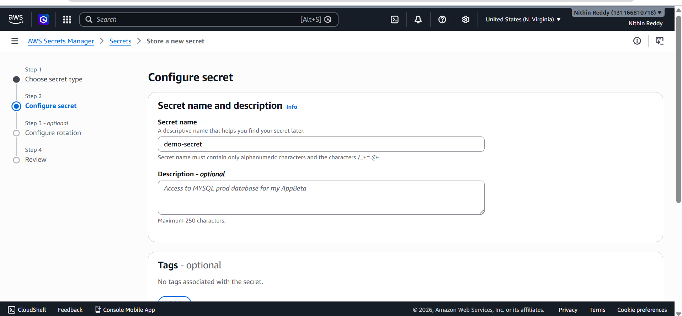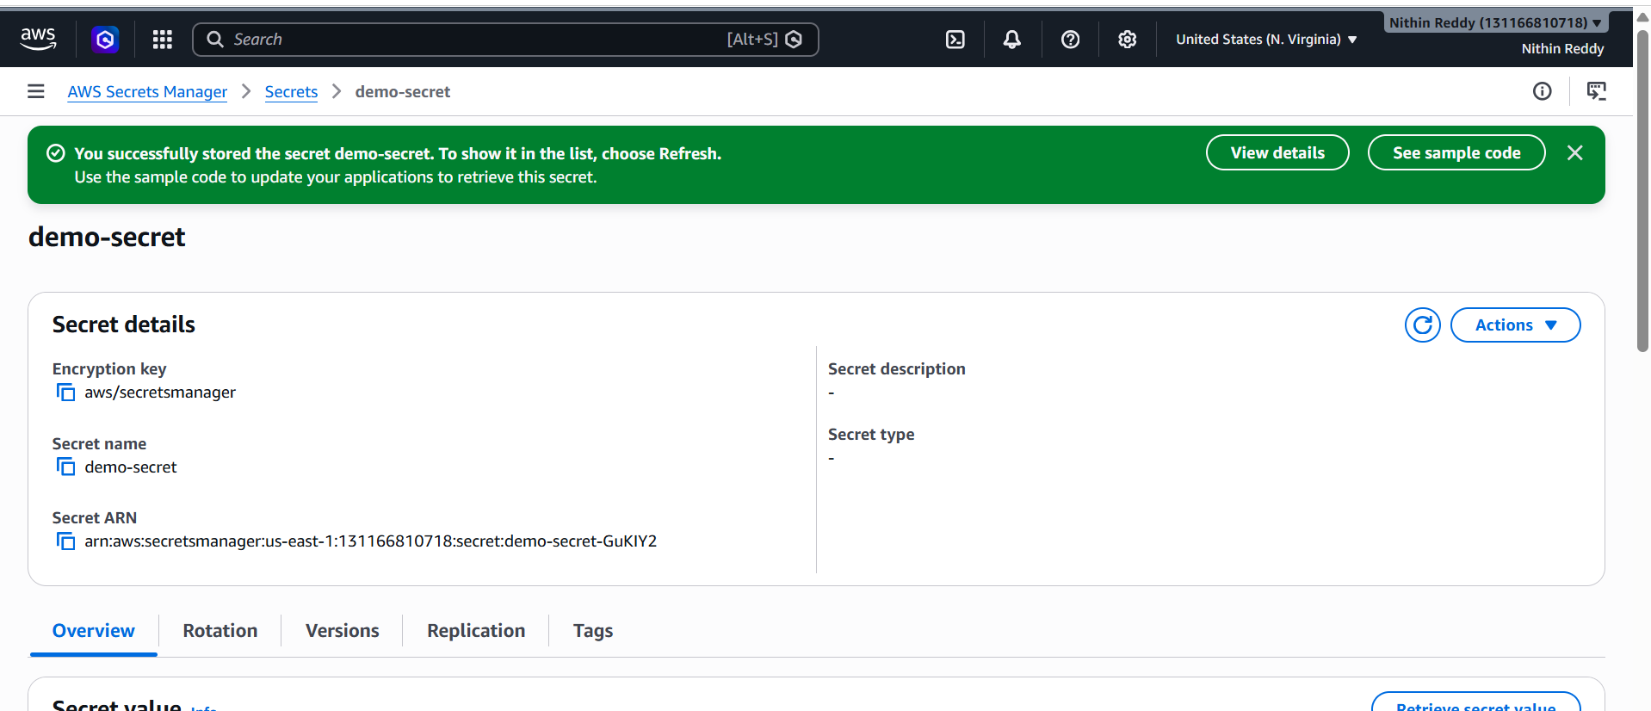
Validation
Open secret.
Click
Retrieve Secret Value
Verify:
username=admin
password=Admin@123
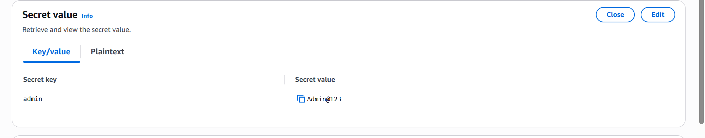
Common Errors
Access Denied
Cause:
No Secrets Manager permission
Fix:
Attach SecretsManagerReadWrite

Secret Not Found
Cause:
Wrong Secret Name
Fix:
Verify Secret Name

Observation
Secrets Manager securely stores credentials and avoids hardcoding passwords in applications.

TASK 3 – Amazon MQ
Objective
Create a message broker and understand enterprise messaging.

Expected Outcome
- Create Broker
- Understand Producer/Consumer communication
- Learn ActiveMQ

Architecture
Producer
|
v
Amazon MQ
|
v
Consumer

Prerequisites
- AWS Account
- Amazon MQ permissions

Step-by-Step Implementation
Step 1: Open Amazon MQ
- Login to AWS Console.
- Search for Amazon MQ.
- Open the Amazon MQ dashboard.
Screenshot 1: Amazon MQ dashboard.
Step 2: Create a Broker
Click:
You will see broker configuration options.
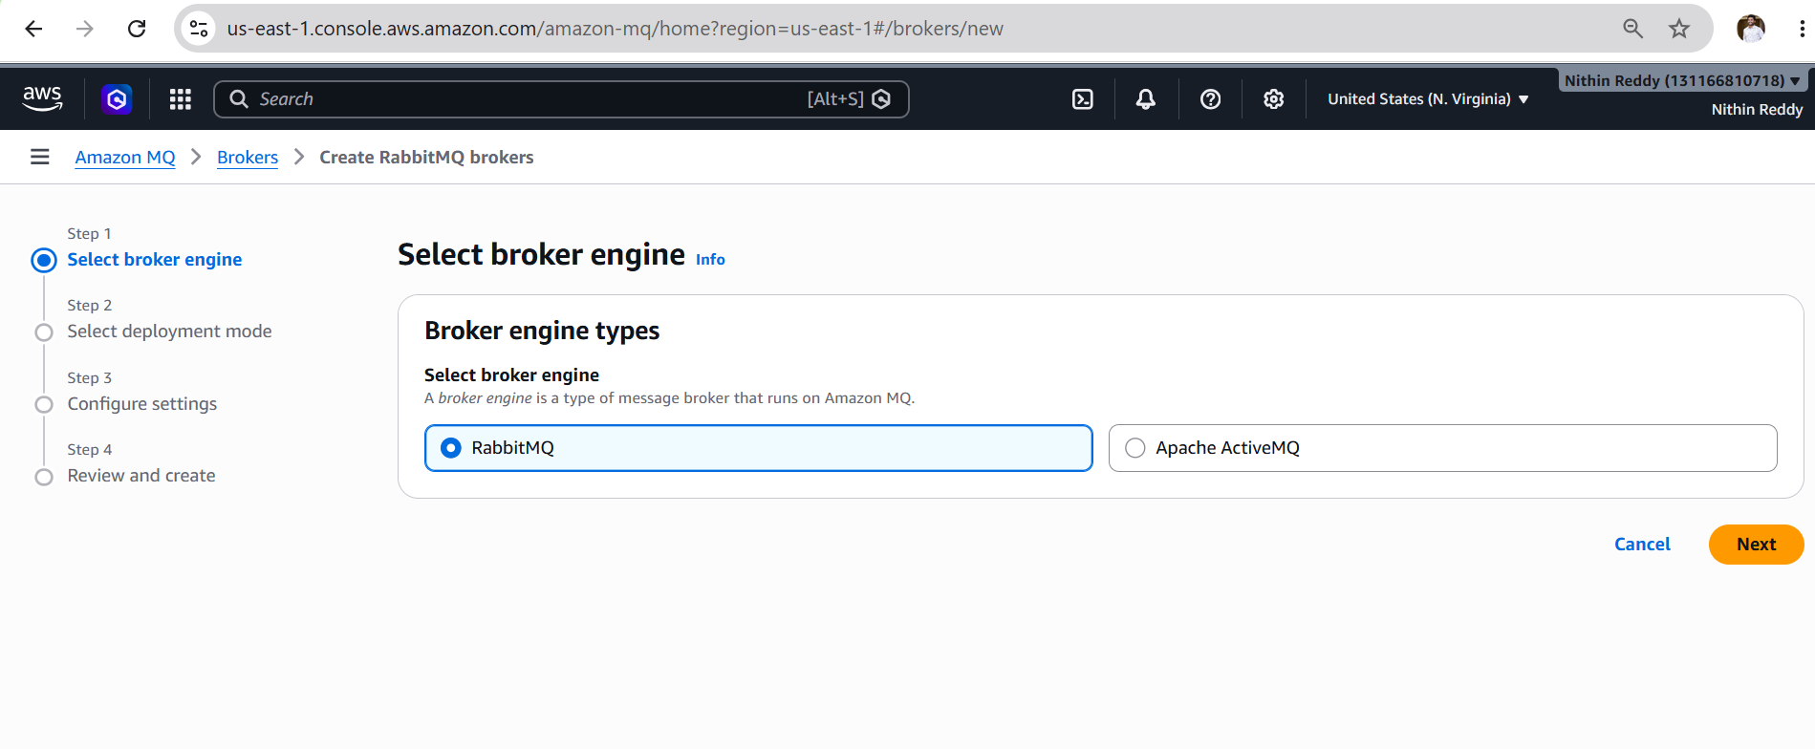
Step 3: Choose Broker Engine
Select:
- Broker engine: ActiveMQ
- Engine version: Keep default
Why ActiveMQ? It is simple and widely used for learning and enterprise messaging.Screenshot 2: Broker engine selection.

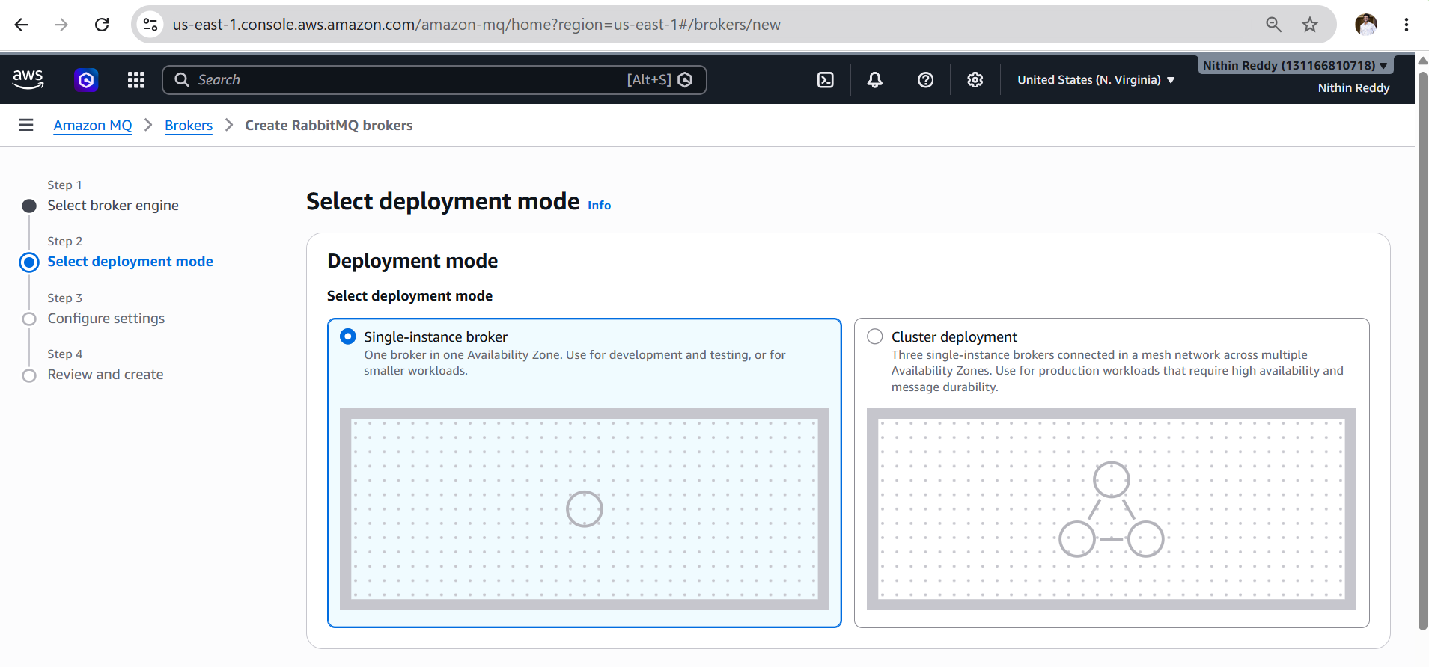
Step 4: Configure Deployment
Choose:
- Deployment mode: Single-instance broker (cheapest option for demo)
- Broker name: demo-broker
Screenshot 3: Deployment configuration.
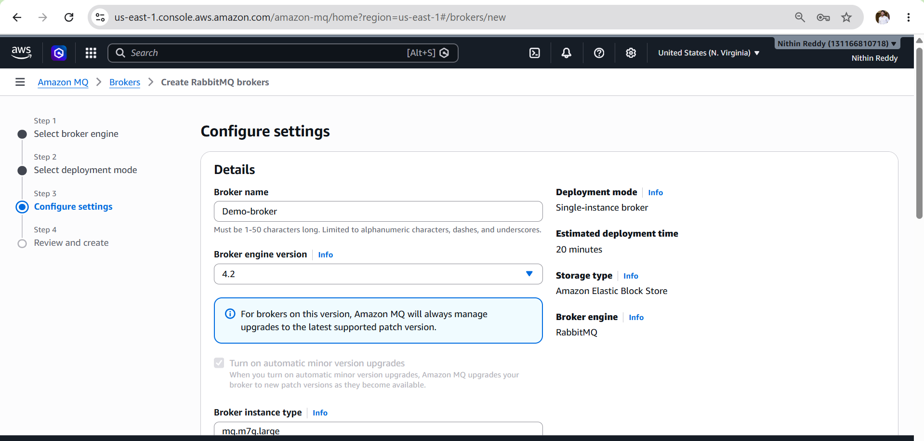

Step 5: Configure Credentials
Enter:
Field | Value
Username | admin
Password | Admin@12345
Use a strong password. AWS requires a secure password for the broker user.Screenshot 4: Broker username and password configuration.
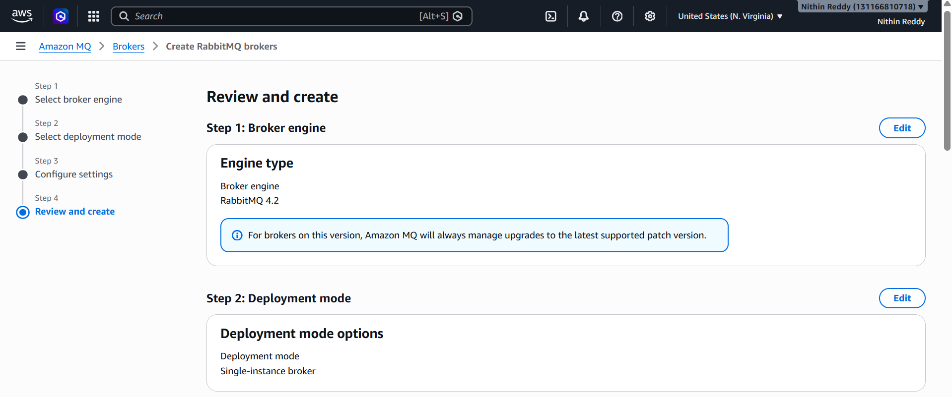
Step 6: Network Configuration
Keep the default settings:
- VPC: Default VPC
- Subnets: Default subnets
- Security Group: Create new or use default
This is sufficient for a demo setup.Screenshot 5: Network configuration.

Step 7: Review and Create
- Review all settings.
- Click Create broker.
Broker creation takes 5–15 minutes.Screenshot 6: Broker creation in progress.
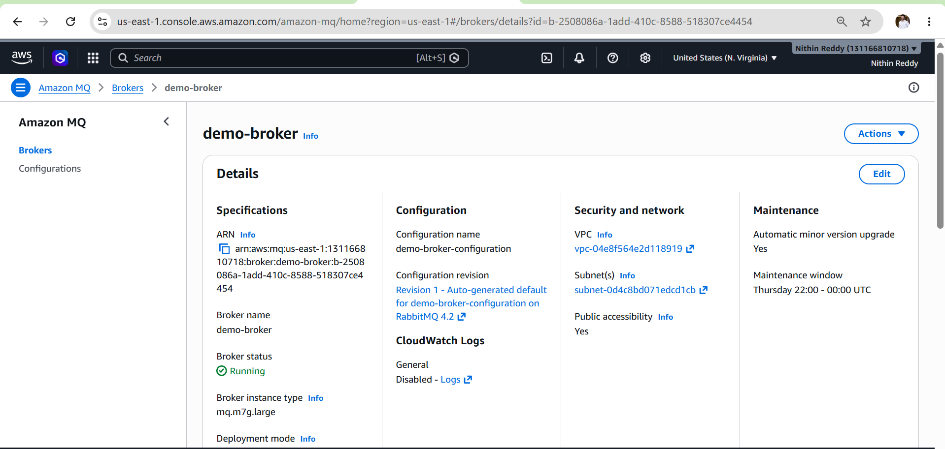
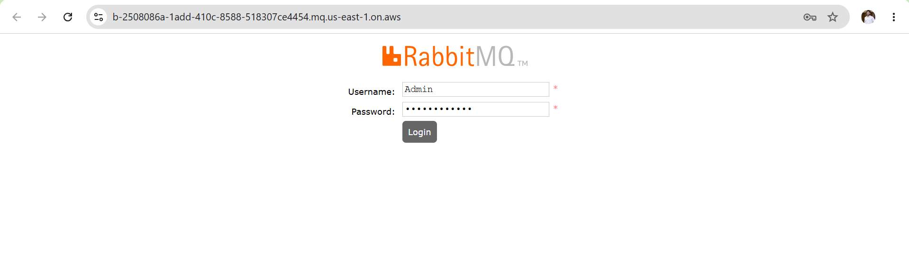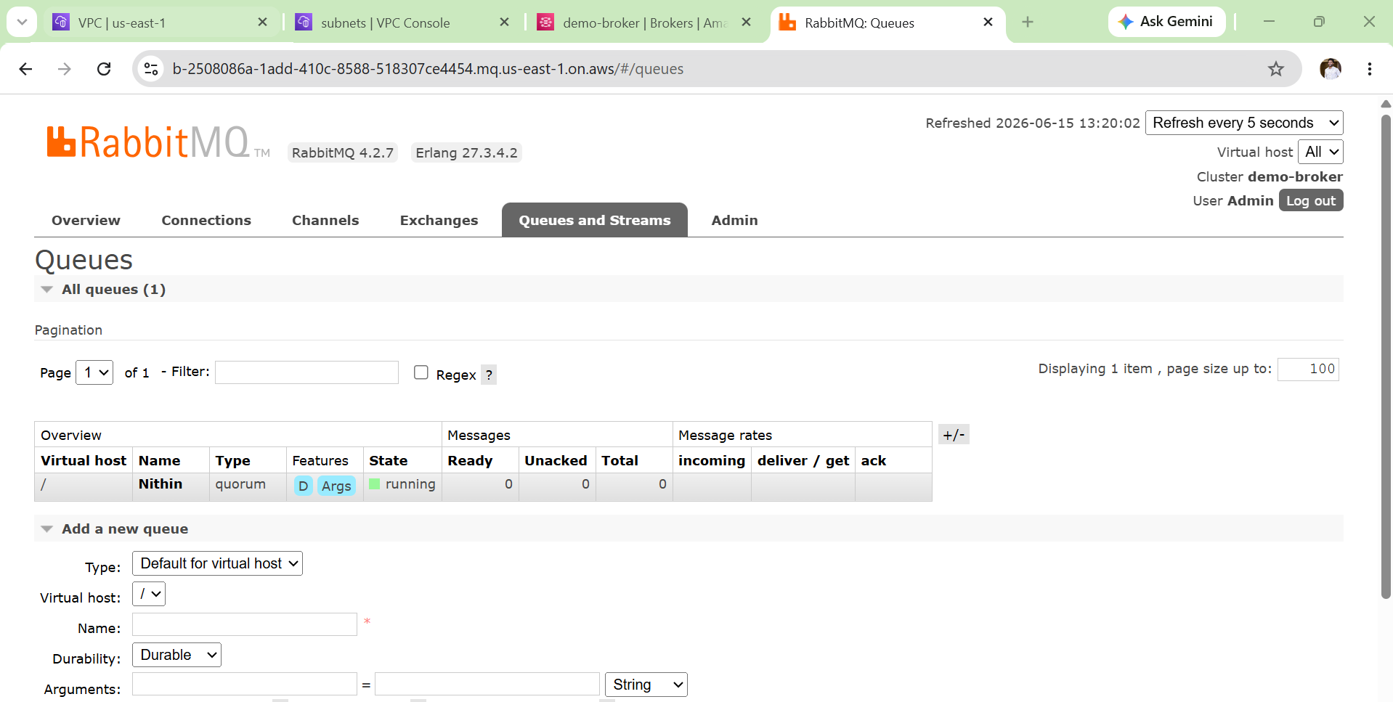
Validation
After a few minutes:
- Open the broker demo-broker.
- Check the Status.
You should see:
This confirms the broker was created successfully.Screenshot 7 (Most Important): Broker status = Running.

