Terraform-05
Task 1: Watched the Terraform-05 video.
Task 2 Execute the script shown in the video
Task 3: Create an EC2 Instance with Apache HTTP Server (httpd) Installed Using Terraform
Objective
The objective of this task is to use Terraform Infrastructure as Code (IaC) to automatically provision an Amazon EC2 instance and install the Apache HTTP Server (httpd) during instance launch using a User Data script. This demonstrates how Terraform can automate infrastructure provisioning and software installation in a single deployment.
Prerequisites
Before starting this task, ensure the following:
- AWS account with an active Free Tier subscription.
- Ubuntu EC2 instance (Terraform server) or local machine with Terraform installed.
- AWS CLI installed and configured (aws configure).
- Terraform installed and verified (terraform version).
- IAM user with EC2, VPC, and Security Group permissions.
- Existing VPC and Subnet.
- Existing EC2 Key Pair.
- Security Group allowing:
  - SSH (Port 22)
  - HTTP (Port 80)
Architecture
Terraform
│
▼
AWS Provider
│
▼
EC2 Instance
│
▼
User Data Script
│
▼
Apache (httpd) Installed
│
▼
Web Page Accessible via Public IP

Project Structure
terraform-httpd/
│
├── main.tf
├── variables.tf
├── outputs.tf
└── terraform.tfvars
Implementation Steps
- Install Terraform on the system and verify the installation using:
terraform version
- Configure AWS CLI credentials using:
aws configure

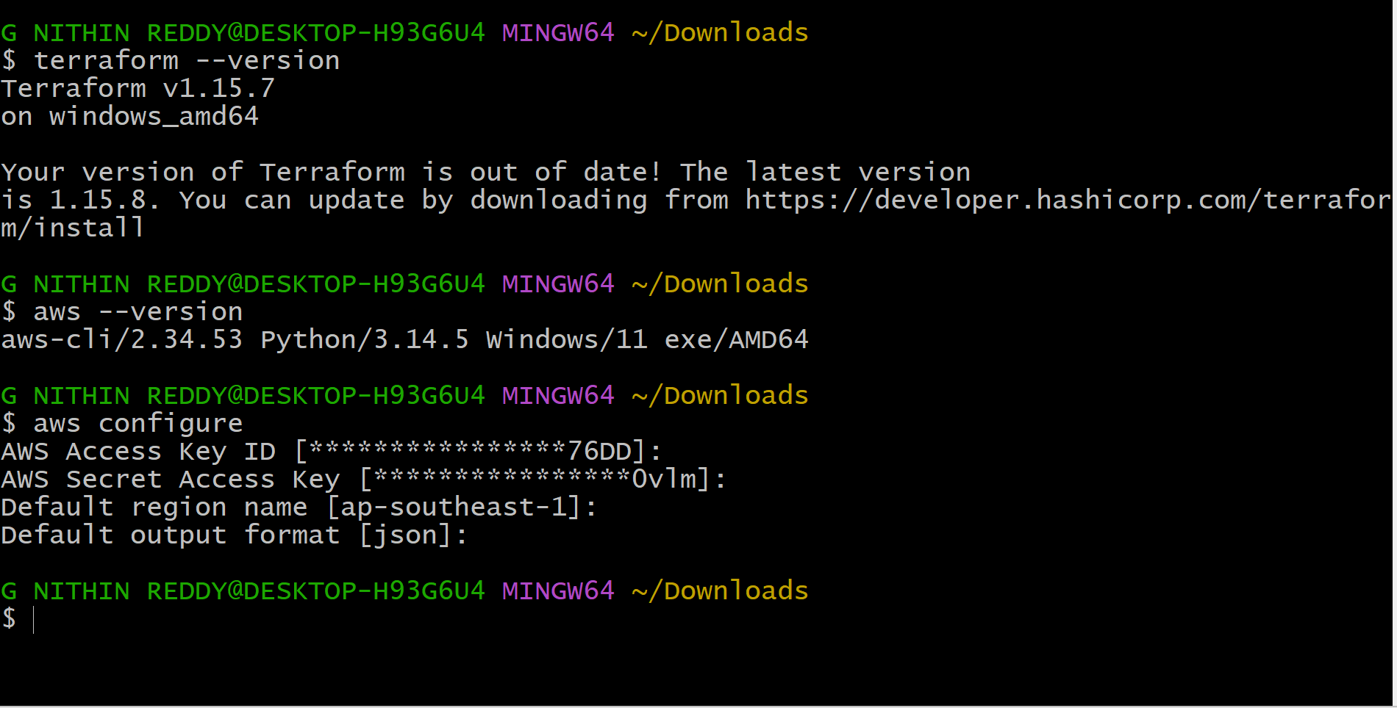
Step 4 Create a main.tf file and configure:
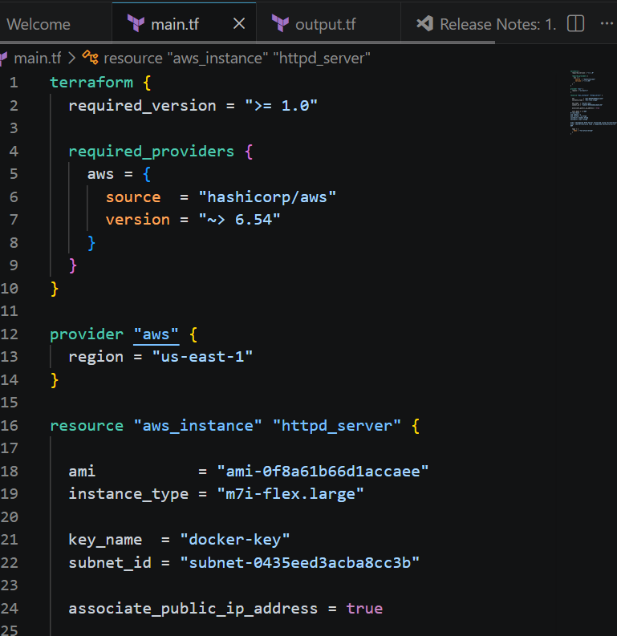
Step 5: output.tf
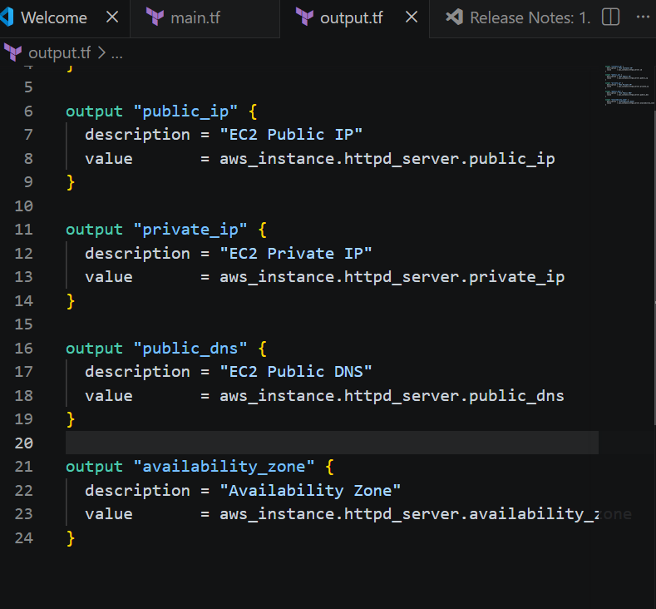
Now terraform init
terraform validate
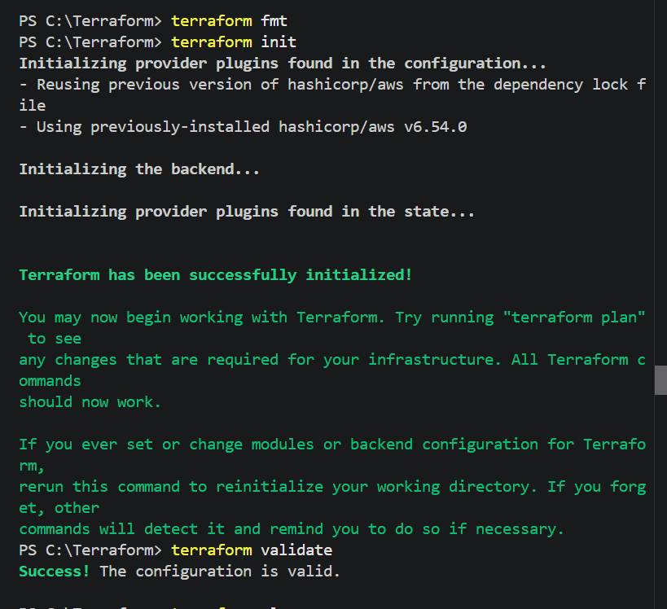
Terraform plan
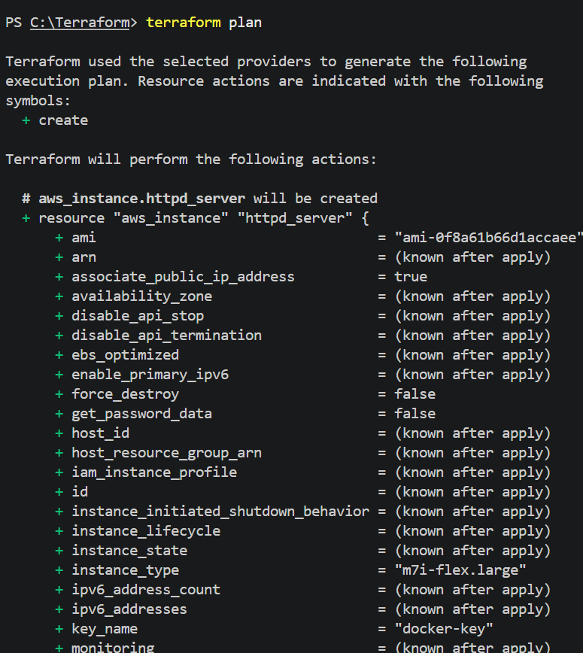
Terraform apply
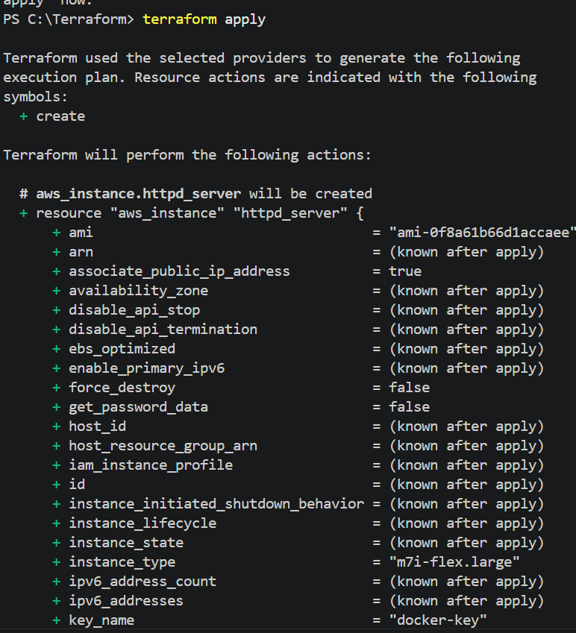
Enter : Yes
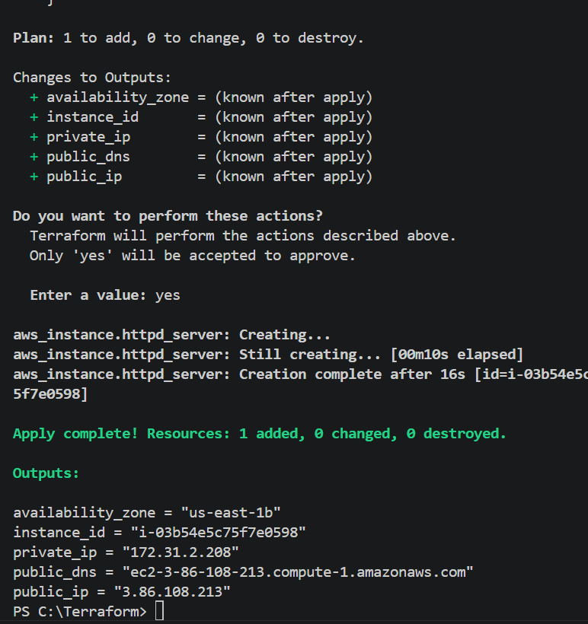
Ec2 instance created automatically after terraform apply
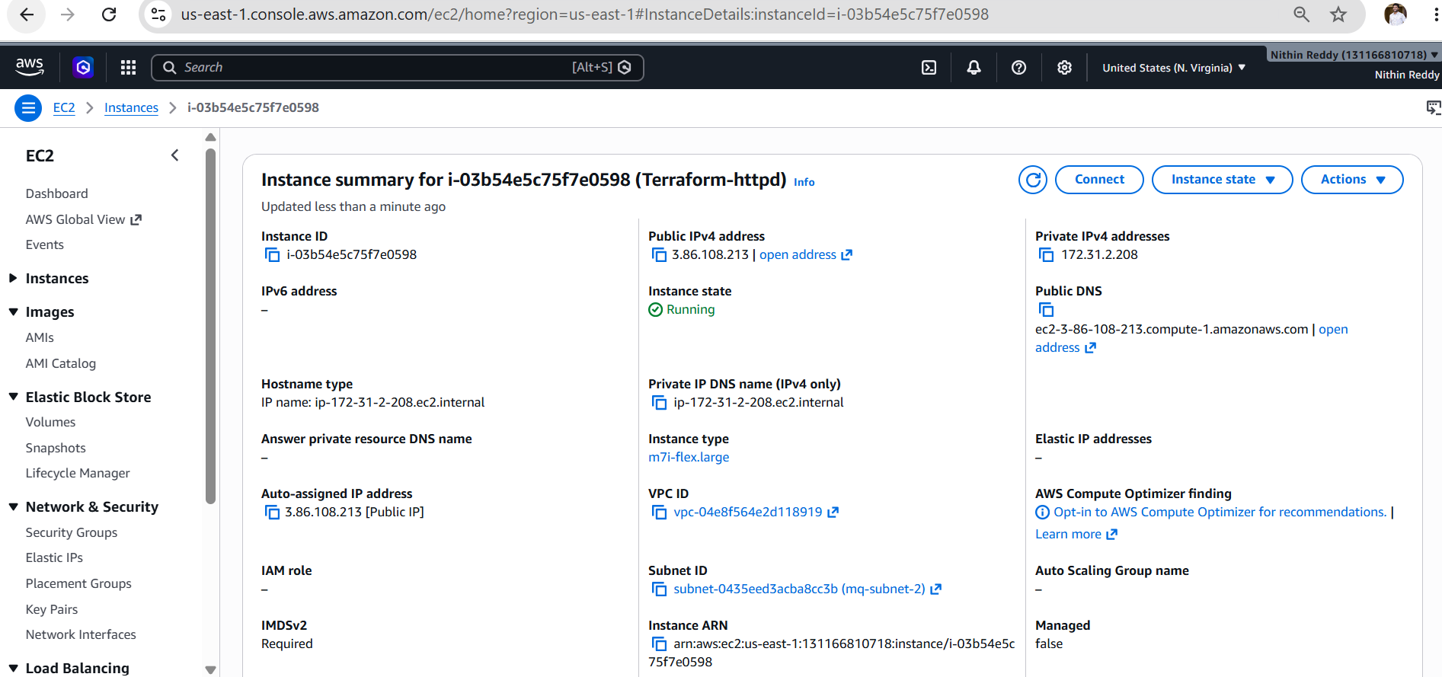
Validation
Verify the following:
- Terraform initializes successfully.
- Configuration validation passes.
- Execution plan displays one EC2 instance to be created.
- EC2 instance is created successfully.
- Apache (httpd) is installed automatically.
- The Apache service is running.
- The web page is accessible using the instance's public IP.
- Terraform destroys the resources successfully when no longer needed.

Terraform output
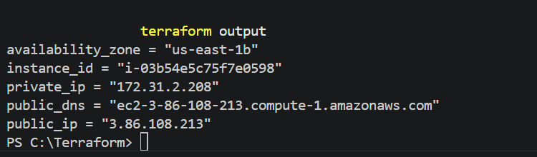
Final output
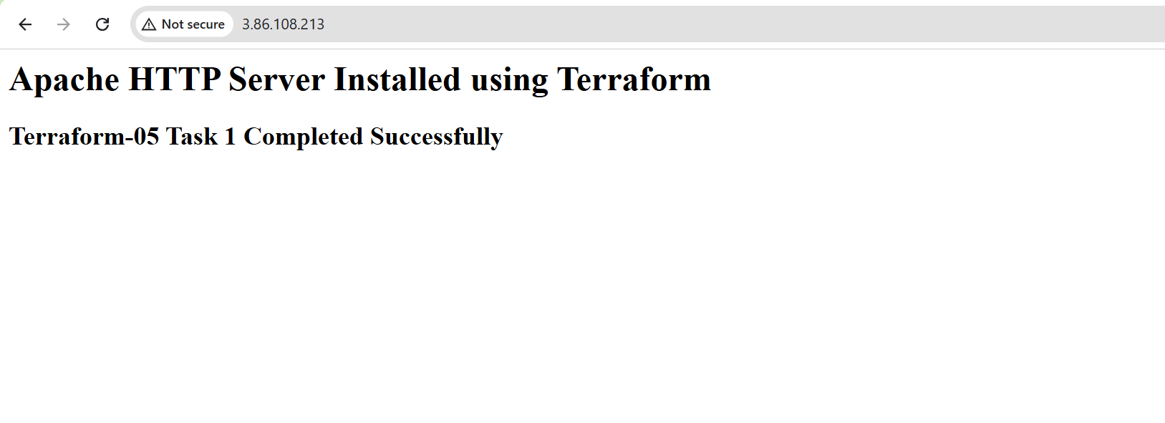
Outcome
After completing this task:
- Terraform provisions an EC2 instance automatically.
- Apache HTTP Server is installed using a User Data script.
- The web server starts automatically during boot.
- A default web page is accessible from the browser.
- Infrastructure can be created and destroyed using Terraform commands.

Task 4: Set Up Amazon S3 as a Remote Backend for Task 3
Objective
The objective of this task is to configure Amazon S3 as the remote backend for the Terraform project created in Task 3. Storing the Terraform state file remotely in S3 provides centralized state management, improves collaboration among team members, and ensures the infrastructure state is securely stored.
Prerequisites
Before starting this task, ensure the following:
- Task 3 completed successfully.
- Terraform installed and verified.
- AWS CLI configured (aws configure).
- AWS account with permissions for S3.
- Existing Terraform project (main.tf and output.tf).
- Region: us-east-1
Architecture
Terraform
│
▼
Amazon S3 Backend
│
▼
terraform.tfstate
│
▼
AWS Infrastructure (EC2 + Apache)
Step 1: Create an S3 Bucket
Open AWS Console:
AWS Console
→ S3
→ Create Bucket
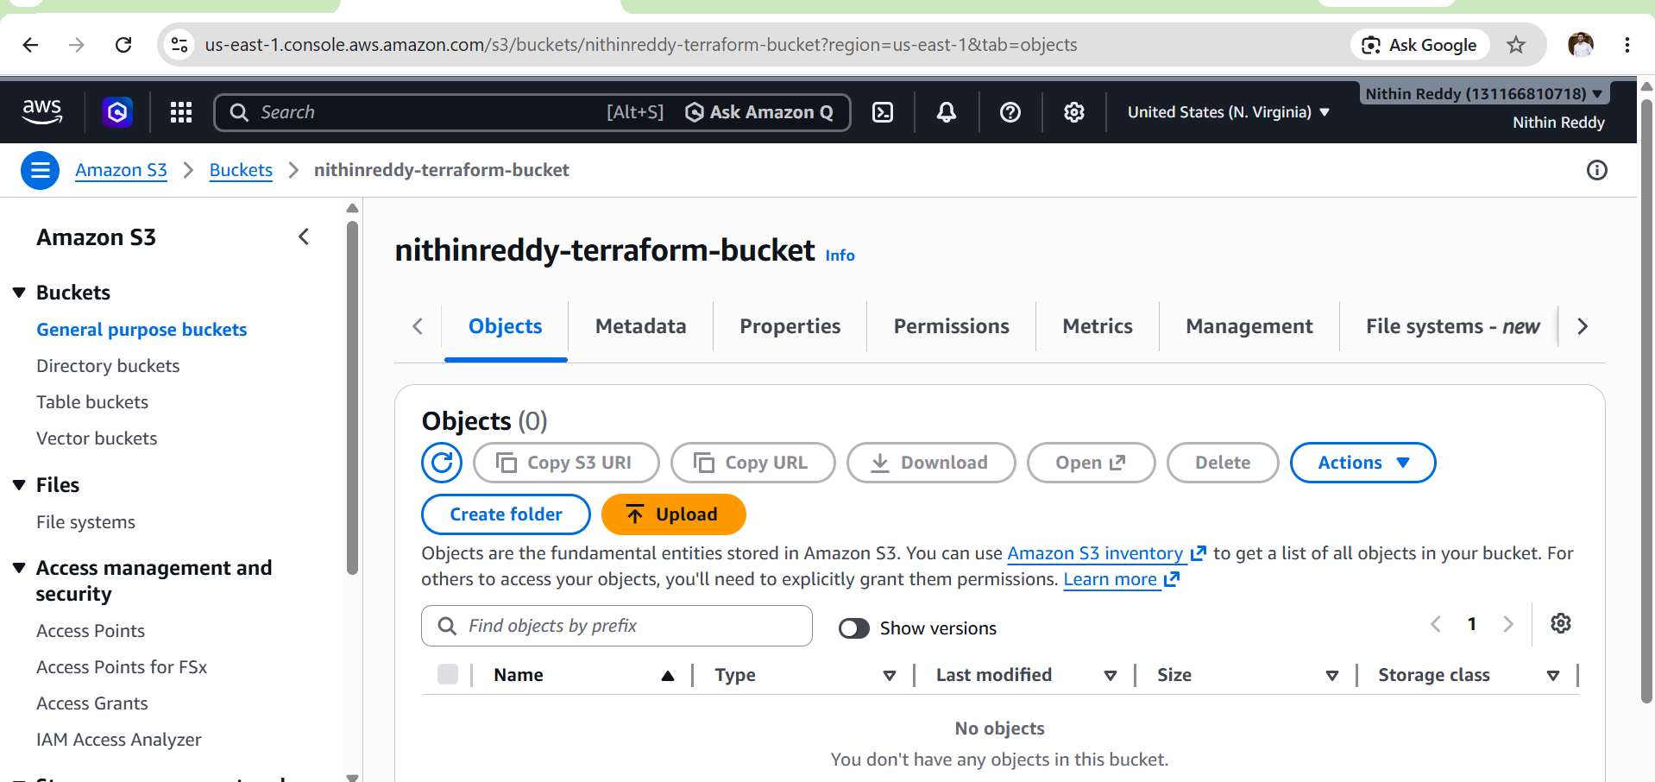

Step 2: Update main.tf
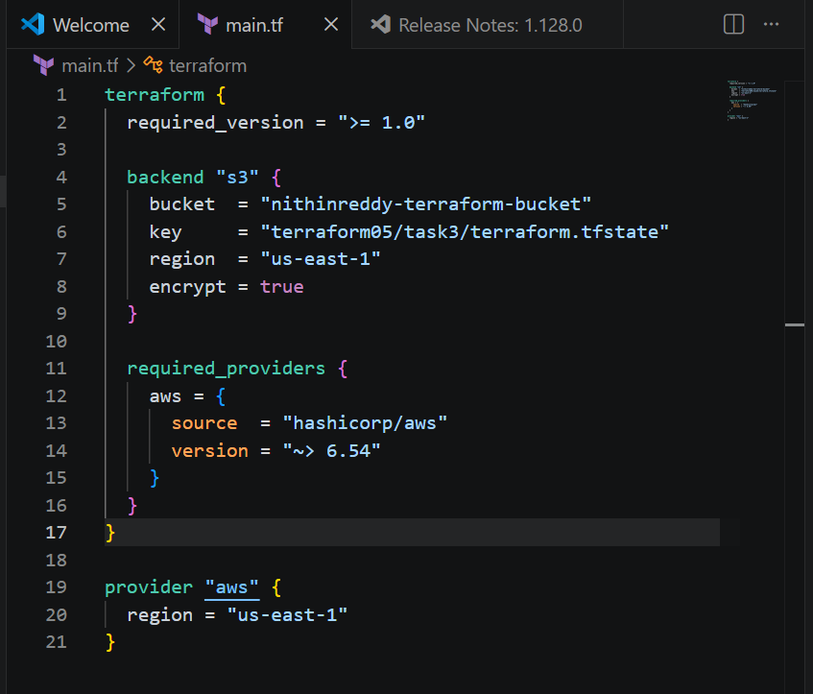
Step 3 : Terraform init
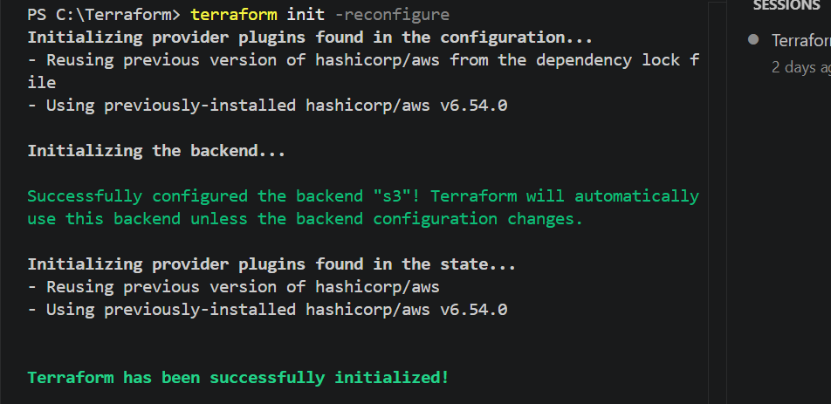

Step 4 : Terraform Validate
Step 5 : Terraform plan
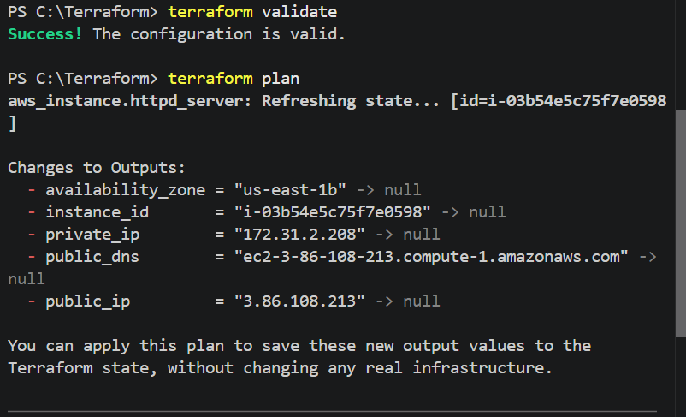
Step 6 : Terraform apply
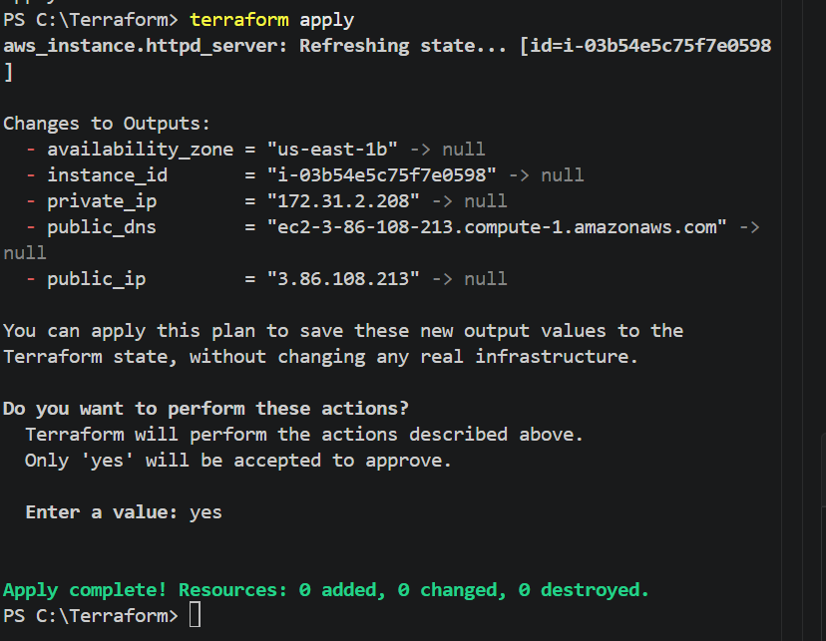

Step 7: Verify the State File
Open:
AWS Console
→ S3
→ terraform-httpd-state-nithin
→ terraform05
→ task3
You should see:
terraform.tfstate
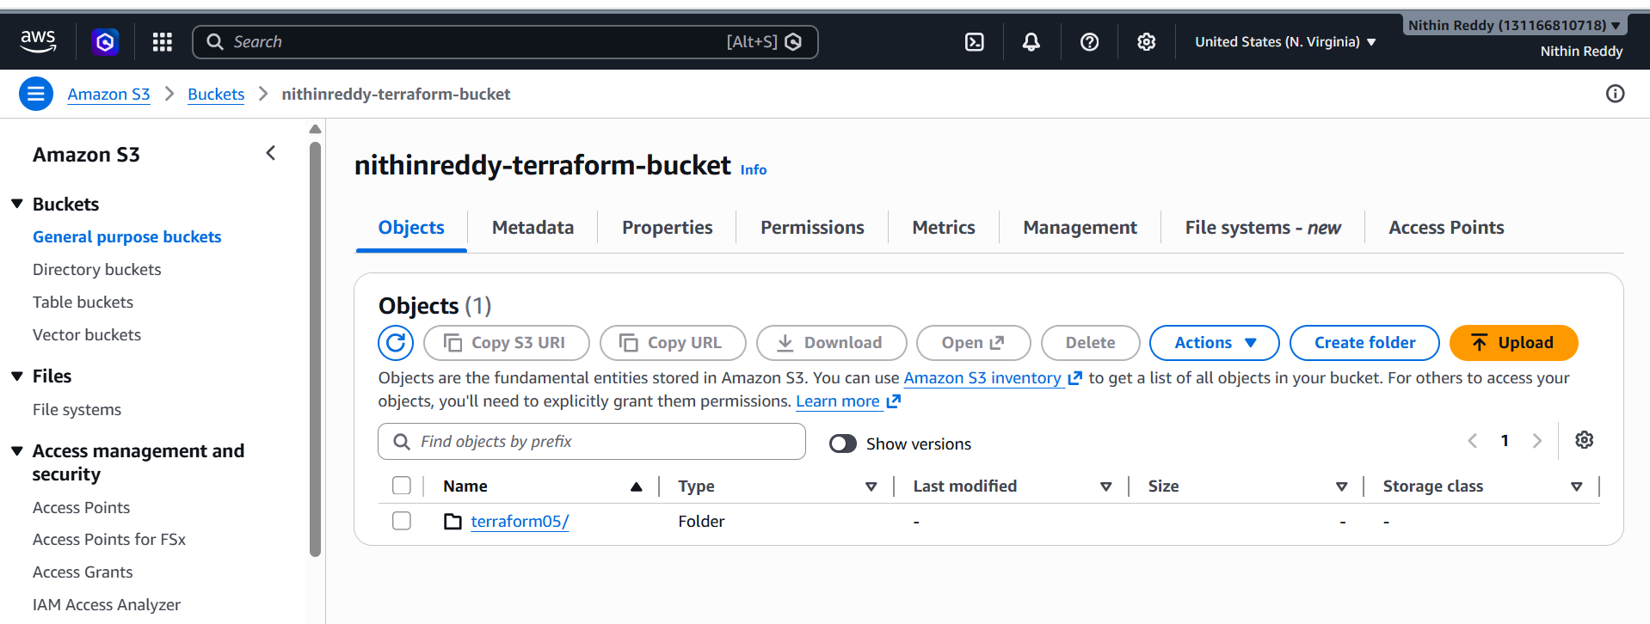
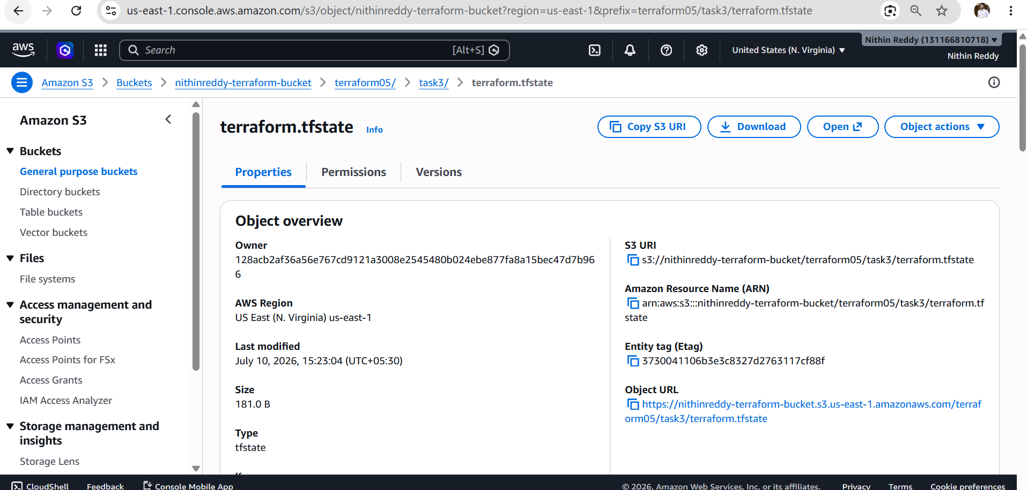

Validation
Verify the following:
- S3 bucket created successfully.
- Bucket versioning enabled.
- Public access blocked.
- Backend configured in main.tf.
- terraform init -reconfigure completed successfully.
- Terraform state file uploaded to the S3 bucket.
- Infrastructure state is now stored remotely.
Expected Outcome
After completing this task:
- Terraform state is stored securely in Amazon S3.
- The local terraform.tfstate file is replaced by the remote backend.
- Team members can share a centralized Terraform state.
- The infrastructure remains manageable across multiple systems.

Task 5: Set Up DynamoDB State Locking for Task 3
Objective
The objective of this task is to configure Amazon DynamoDB for Terraform state locking. State locking prevents multiple users from modifying the same Terraform state file simultaneously, avoiding conflicts and ensuring safe infrastructure deployments.
Prerequisites
- Task 3 completed successfully.
- Task 4 (S3 backend) completed successfully.
- Terraform installed.
- AWS CLI configured.
- S3 backend configured.
- AWS account with DynamoDB permissions.
- Region: us-east-1
Architecture
Terraform
│
▼
Amazon S3 (terraform.tfstate)
│
▼
Amazon DynamoDB (State Lock)
│
▼
AWS Infrastructure

Implementation Steps
Step 1: Create a DynamoDB Table
AWS Console
AWS Console
→ DynamoDB
→ Create Table
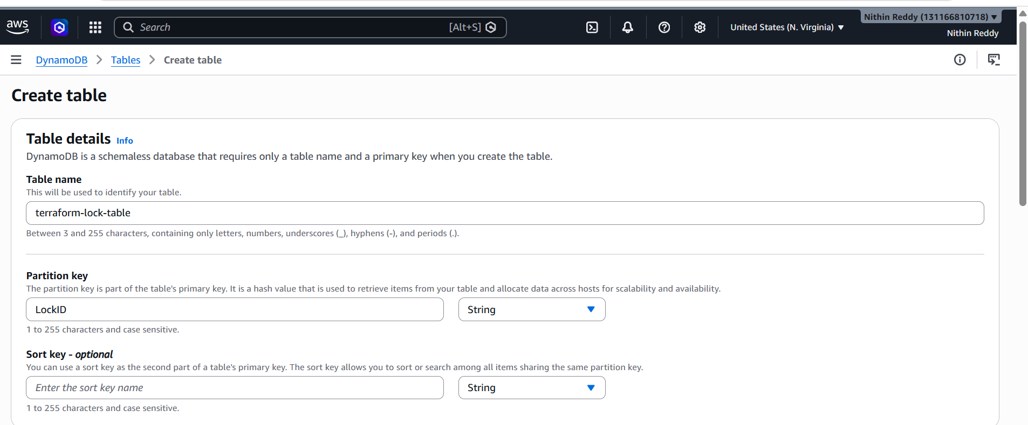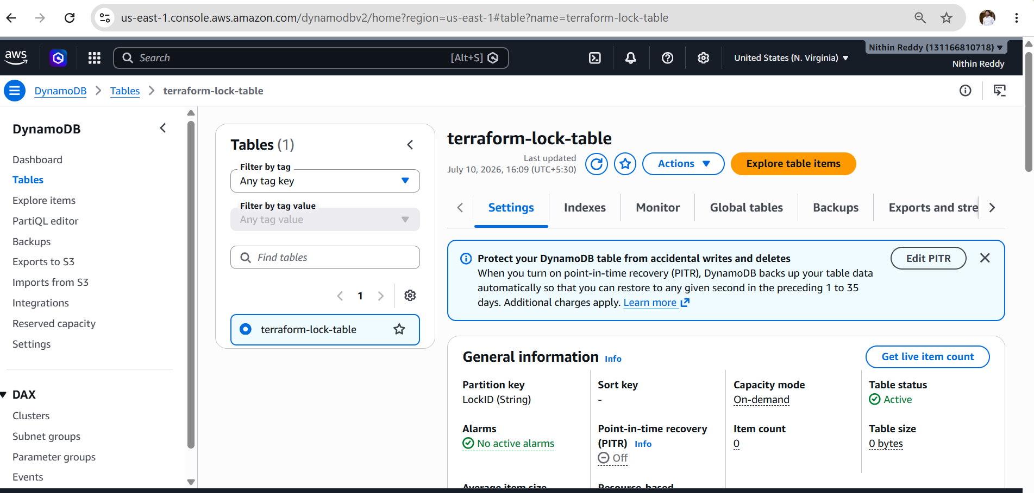
Step 3: Update main.tf
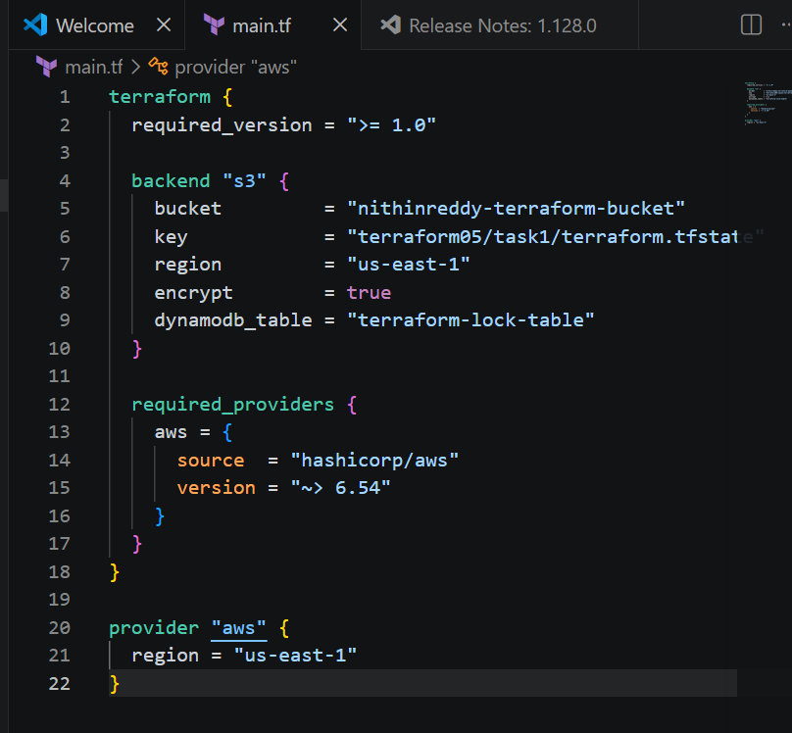
Step 4 : Terraform init
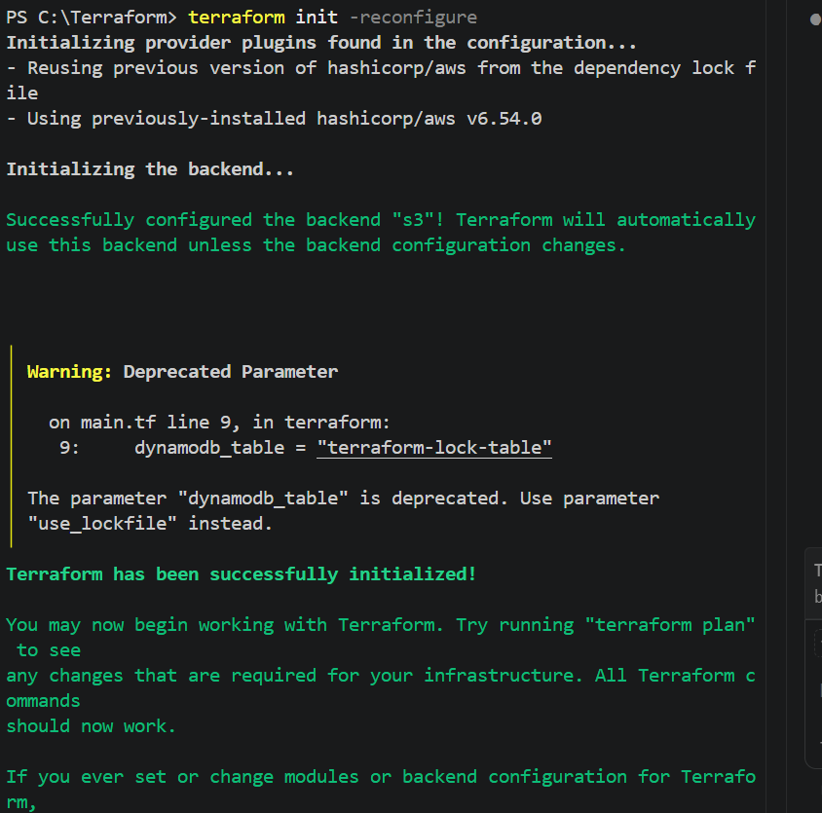
Step 5 : Terraform validate
Step 6 : Terraform plan
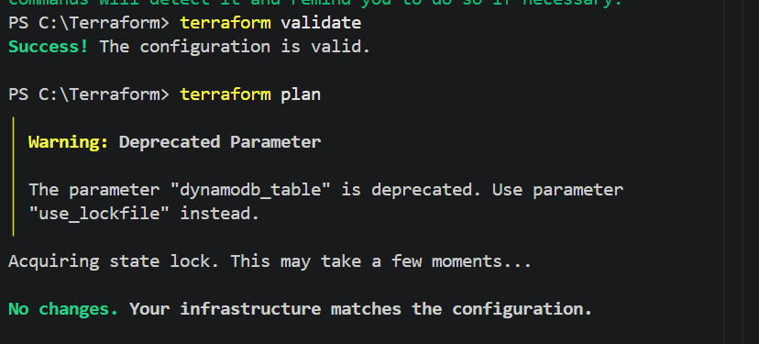
Step 7 : Terraform apply
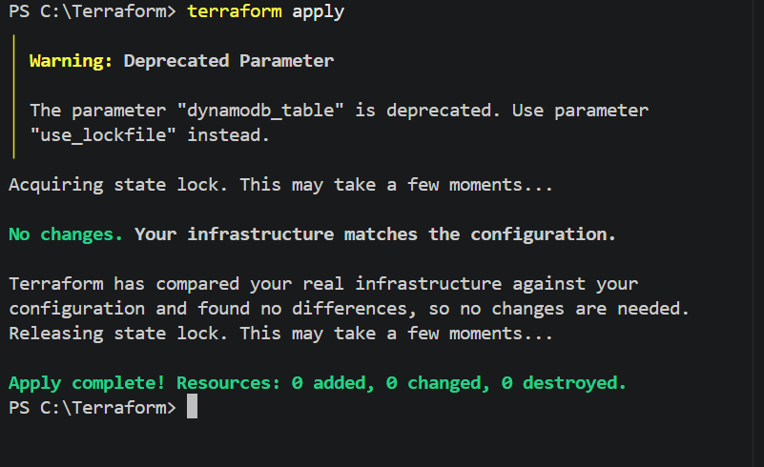
Final output
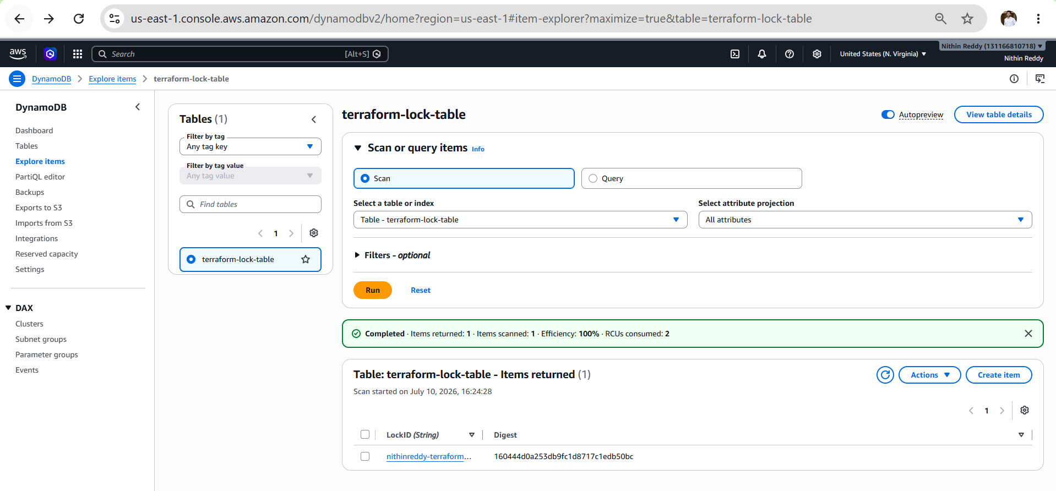
Now Terraform destroy
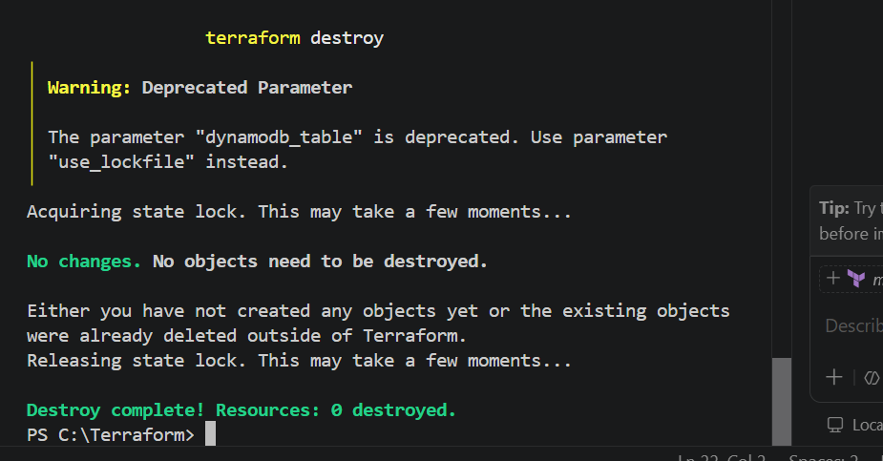
Validation
Verify the following:
- DynamoDB table created successfully.
- Partition key is LockID (String).
- Backend configuration includes the DynamoDB table.
- terraform init -reconfigure completes successfully.
- Terraform reads the remote state from S3.
- Terraform acquires and releases the lock during operations.
Expected Outcome
After completing this task:
- Terraform stores its state file in the S3 bucket.
- DynamoDB manages state locking.
- Concurrent Terraform operations are prevented.
- Infrastructure changes are protected from simultaneous modifications.
- Remote state management is more reliable for team environments.

