- Launched AWS instance successfully running
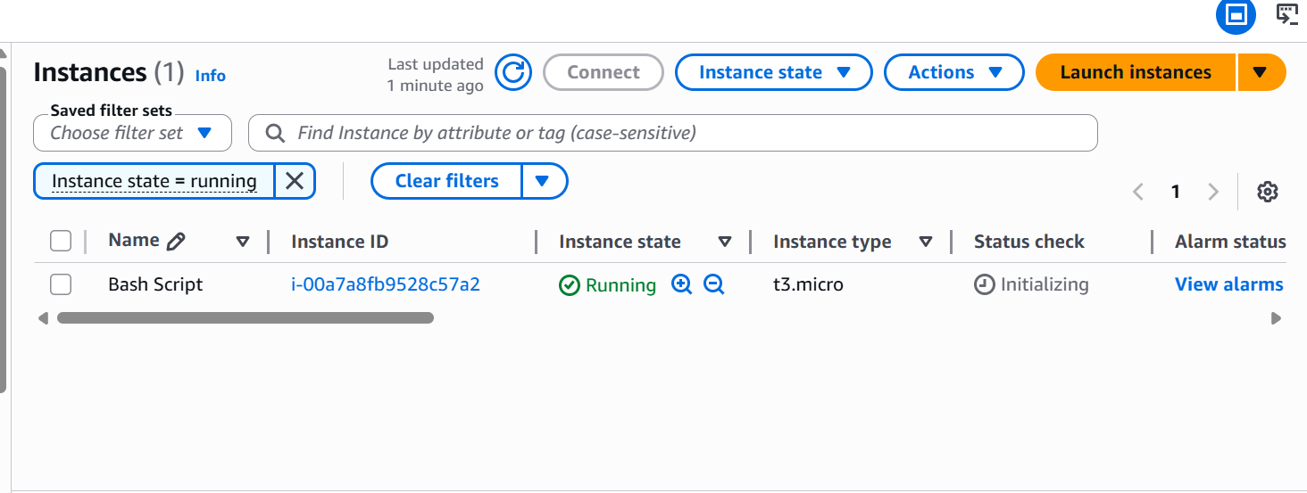
now login back to gitbash to finish the task
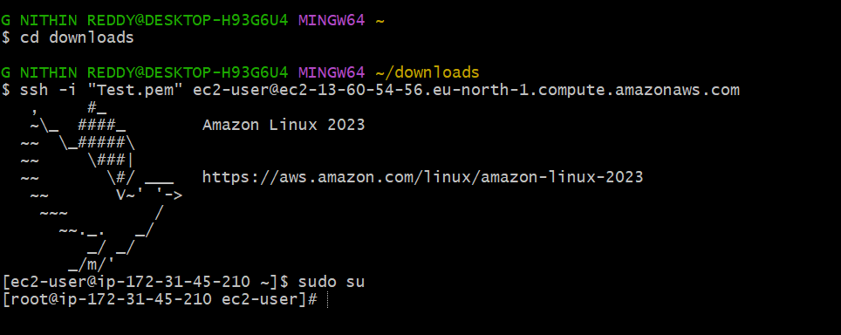
Started with the shells and made a directory
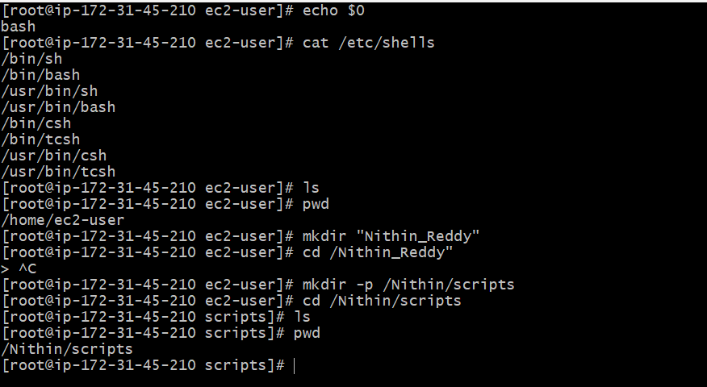
Finding Current Shell and Available Shells
Outcome: - Successfully identified current shell, available shells, and user assigned shell in
Linux.
Objective: - To learn how to identify shells configured in Linux systems.
Prerequisites: - Linux terminal access
Step-by-Step Implementation
Step 1: Check Current Shell
Command Used echo $0
Expected Output -bash
Explanation
Explanation Displays all installed shells available in the system.
Explanation Displays all users and their assigned shells.

Now using vi created Hello world, and gave simple bash scripting and using chmod 755 gave permission.
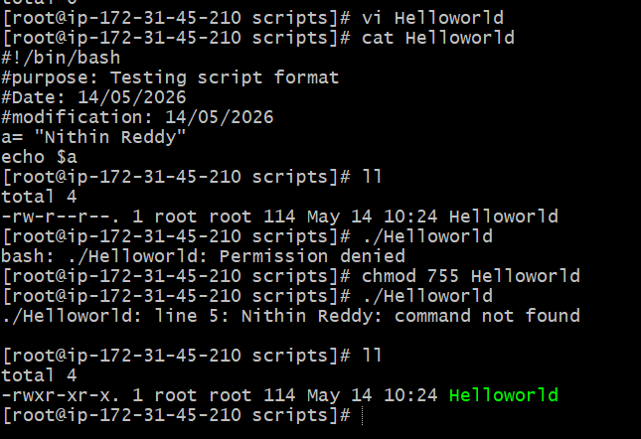

Task 2: Create a Basic Shell Script
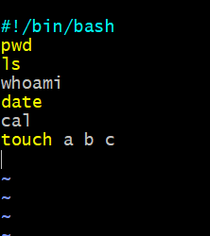
I have used same basic shell scripts created in same directory Helloworld.bash
Outcome: - Successfully created and executed a basic shell script that prints “Hello World”
output.
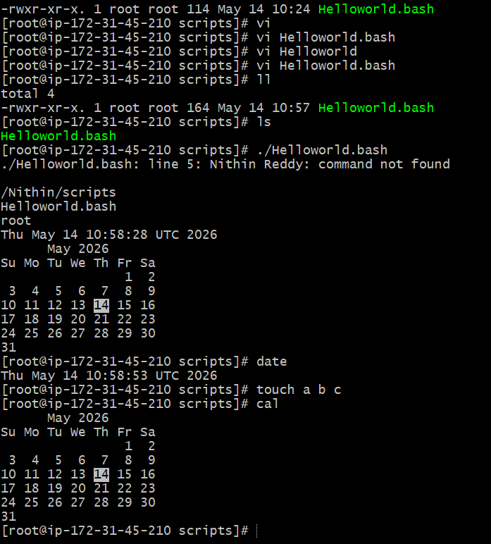
Objective:- The objective of this task is to understand the basic structure of a shell script and
learn how to execute commands using Bash scripting.
Prerequisites:- Before starting this task, the following requirements were needed:
- Linux system access
- Bash shell availability
- Basic knowledge of terminal commands
- Text editor such as vi
Step-by-Step Implementation:-
In this task, a basic shell script was created using the Bash shell. First, a new file named
helloworld.bash was created using a text editor. Inside the script, the shebang line #!/bin/bash
was added to define the shell interpreter. Then the echo command was used to print the
message “Hello World”.
Script Used
#!/bin/bash
echo "Hello World"
After saving the file, executable permissions were assigned using the chmod command.
Permission Command
chmod 755 hello.sh
The script was then executed using the following command:
./helloworld.bash

The output displayed the message “Hello World!” successfully.
Validation Steps:- The script execution was validated by checking whether the output
displayed the expected “Hello World!” message without any errors.
Explanation
This task demonstrated the basic syntax of shell scripting. The echo command is used to print
output on the terminal, while the shebang (#!/bin/bash) specifies that the script should be
executed using the Bash interpreter.
Shell scripting is commonly used to automate repetitive administrative and operational tasks
in Linux systems.
Real-Time Use Case
In real-time environments, basic shell scripts are used to automate startup tasks, health
checks, log generation, and deployment activities.

Task3: Basic Administration Tasks
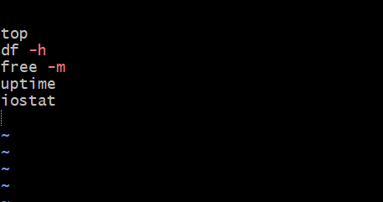
Used top command and gave permissions using chmod 755
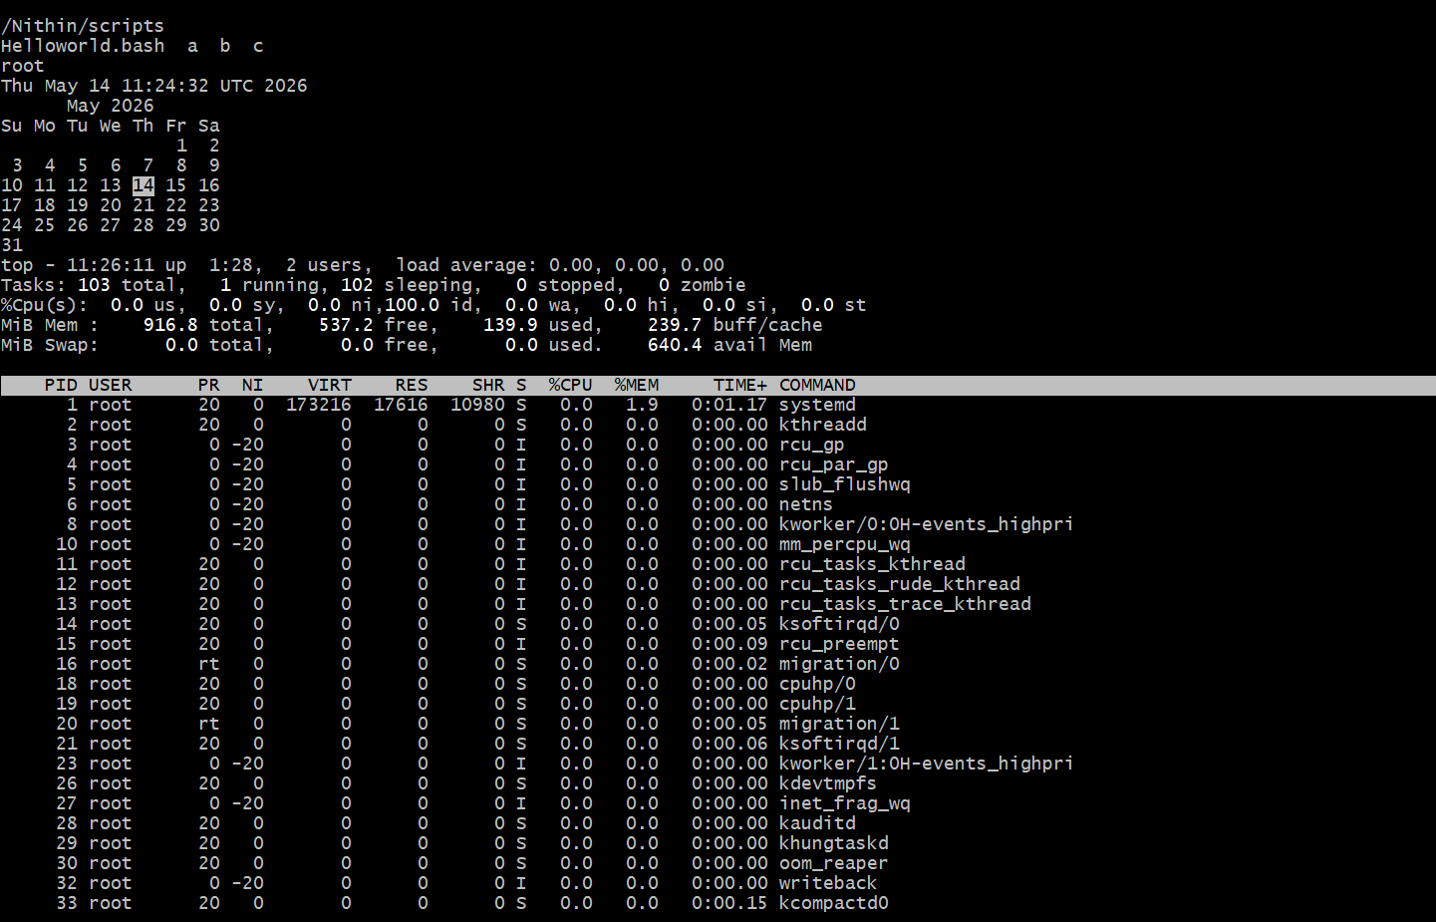
Created Basic second Script.

Outcome:- Successfully created and executed a shell script that displays system information
and creates files.

Objective:- The objective of this task is to understand how multiple Linux commands can be
combined inside a shell script to automate system-related operations.
Step-by-Step Implementation:-
In this task, a shell script was created to execute multiple Linux commands sequentially. A file
named basic.sh was created and edited using a text editor. The Bash interpreter line was
added at the top of the script.
The script included commands such as:
- pwd to display the present working directory
- ls to list files and directories
- whoami to display current logged-in user
- date to show current date and time
- cal to display calendar
- touch to create empty files
Script Used
#!/bin/bash
pwd
ls
whoami
date
cal
touch a b c

Validation Steps:-
Validation was performed by:
- Checking command outputs
- Verifying file creation using ls

Task 4 Defining Variables in Bash Script
Created variables
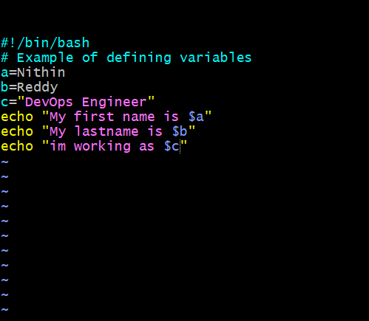
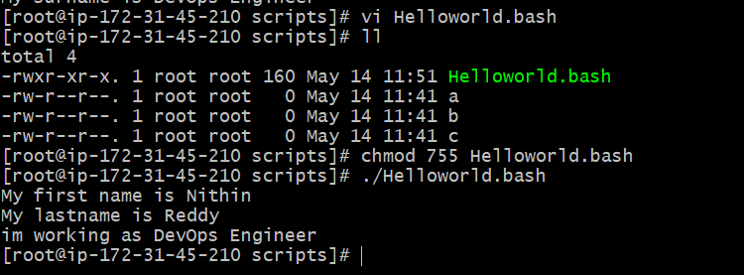
* After creating variables given permission using chmod and the output delivered.
Outcome:- Successfully created and executed a shell script using variables.
Objective:- The objective of this task is to understand how variables are declared and used in
Bash scripting.

Step-by-Step Implementation:-
In this task, variables were defined inside a shell script to store Linux commands. A script file
was created and variables were assigned values such as pwd, ls, whoami, date, and cal.
The variables were later executed using the $ symbol.
The script was saved and executed after assigning execute permissions.
Validation Steps:- Validation was performed by checking whether all commands stored in
variables executed successfully.
Explanation
Variables are used to store values temporarily inside scripts. In Bash scripting, variables can
store strings, commands, numbers, or user input. The $ symbol is used to access variable
values.

Task 5: Input and Output Shell Script Using read and echo
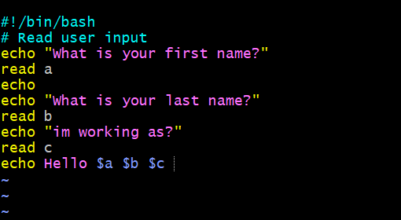
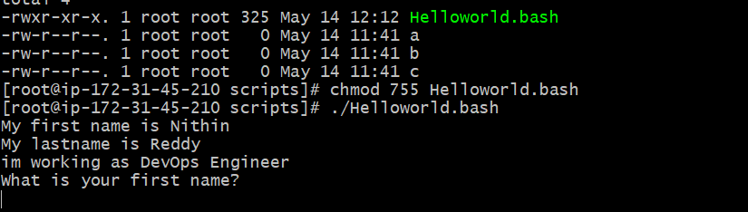
Outcome:- Successfully created interactive shell scripts that accept user input and display
dynamic output.
Objective:- The objective of this task is to understand how to interact with users in shell
scripting using read and echo commands.
Step-by-Step Implementation:-
In this task, interactive shell scripts were created using read and echo. The echo command
was used to print output on the terminal, while the read command accepted user input
dynamically.
The first script asked the user to enter their name and displayed a greeting message.
Both scripts were executed successfully after assigning execute permissions.
Validation Steps:- Validation was completed by:
Entering user input successfully
Verifying dynamic greeting output
Checking hostname display
Explanation
The read command pauses script execution and waits for user input. The echo command
displays output messages. Backticks ( ` ` ) are used for command substitution, meaning
command output is stored inside a variable.

