DOWNLOADED THE GIT AND RUNNED IT SUCCESFULLY
Install git {sudo yum install git -y}
Started by {git init}
Checked status by {git status}
Checked version {git -version}
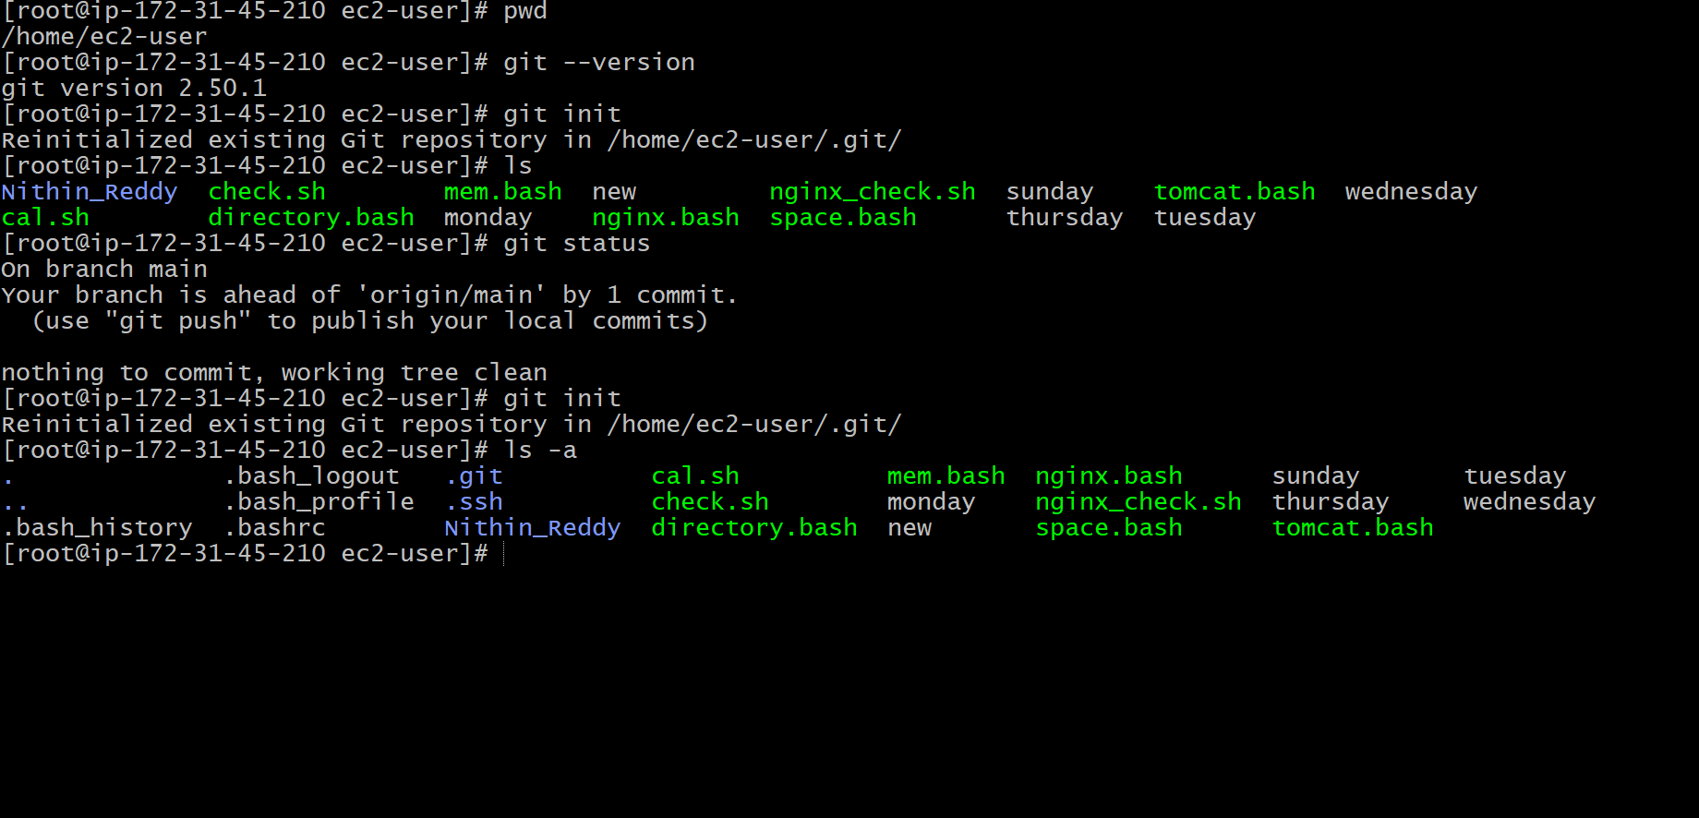
* Checked Git Version Navigation in Git Bash and Check Current Directory

Now configure the username and email address of GitHub account in git bash
List the configuration
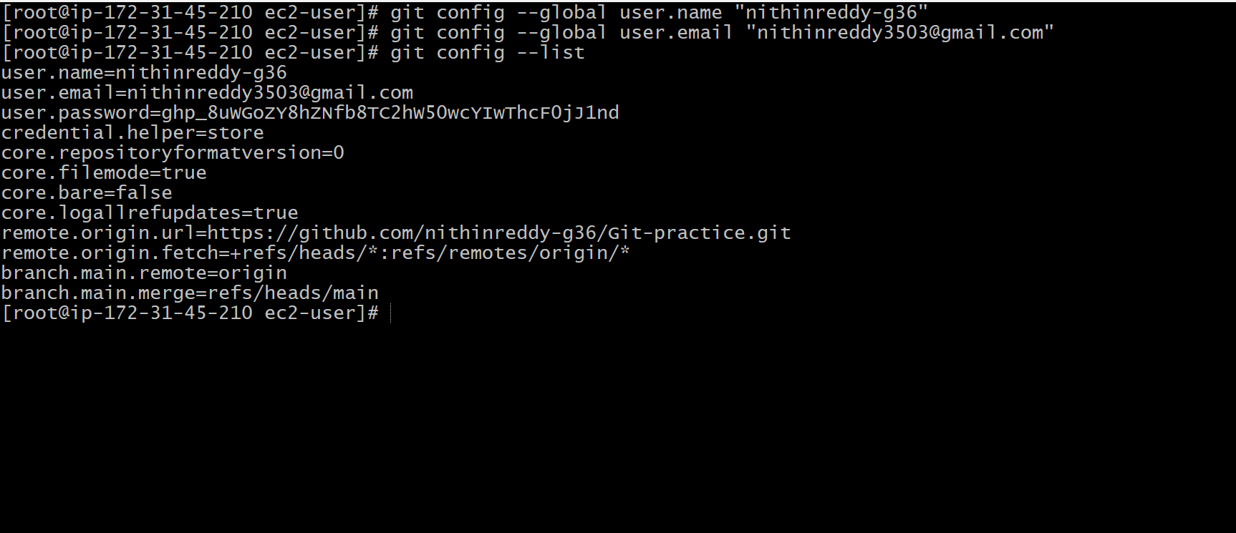
checked my files
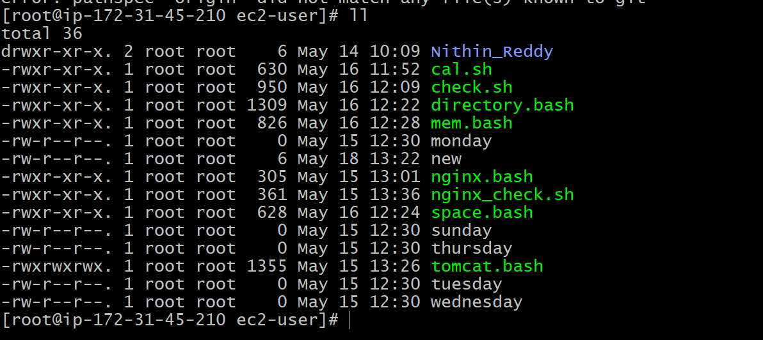

Created files in Github
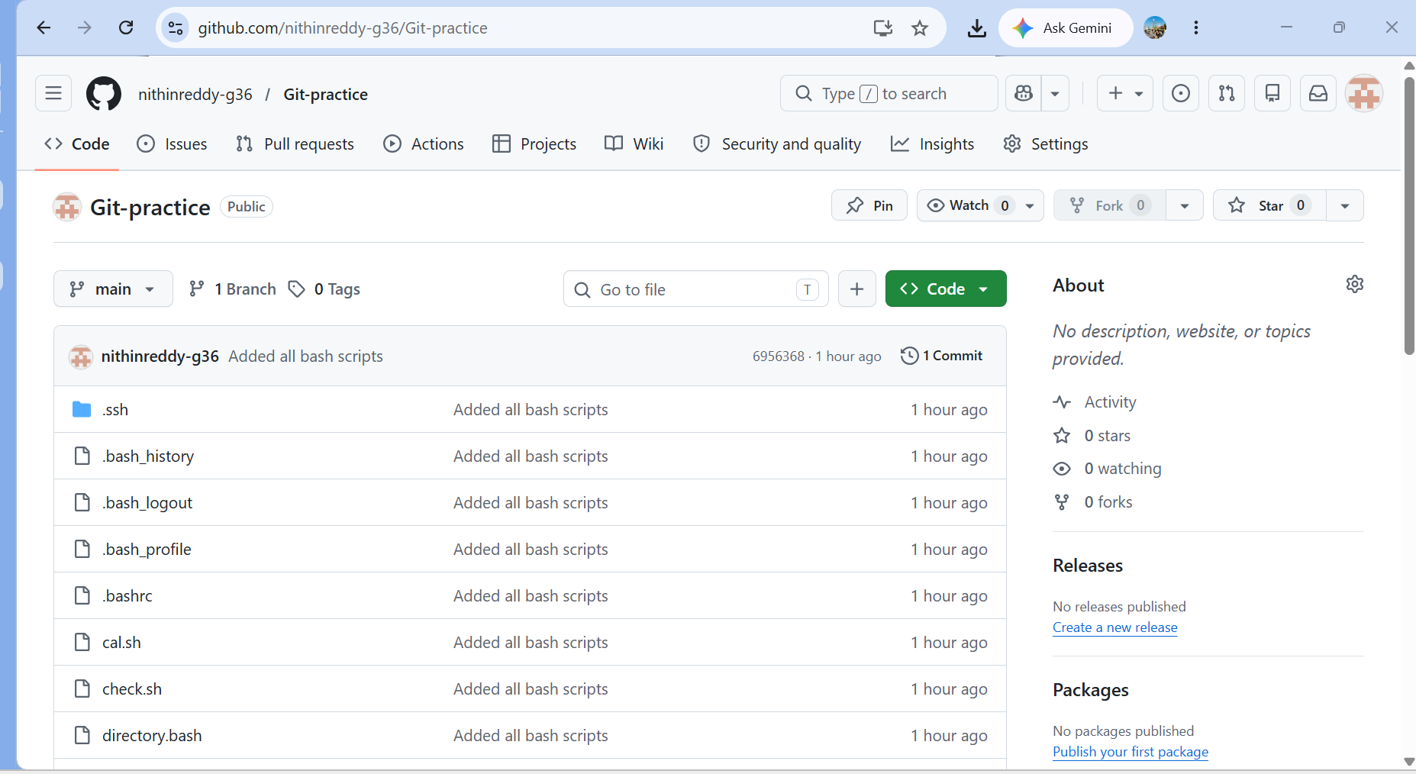
Two factor authentication done
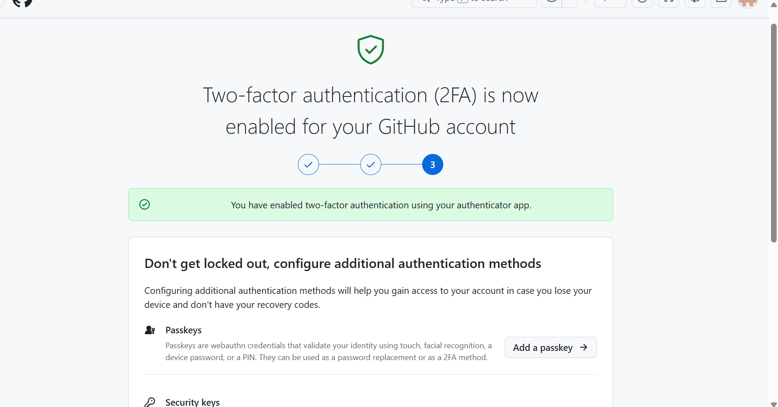
Important Git Commands Practiced
Command Purpose
git init Initialize repository
git status Check repository
status
git add . Stage all files
git commit -m Commit changes
git log View commit history
git remote add origin Add remote
repository
git push -u origin
master
Push code to GitHub
git pull Pull latest changes
git clone Clone repository
git revert Revert a commit
git reset Unstage files

