- Install git.
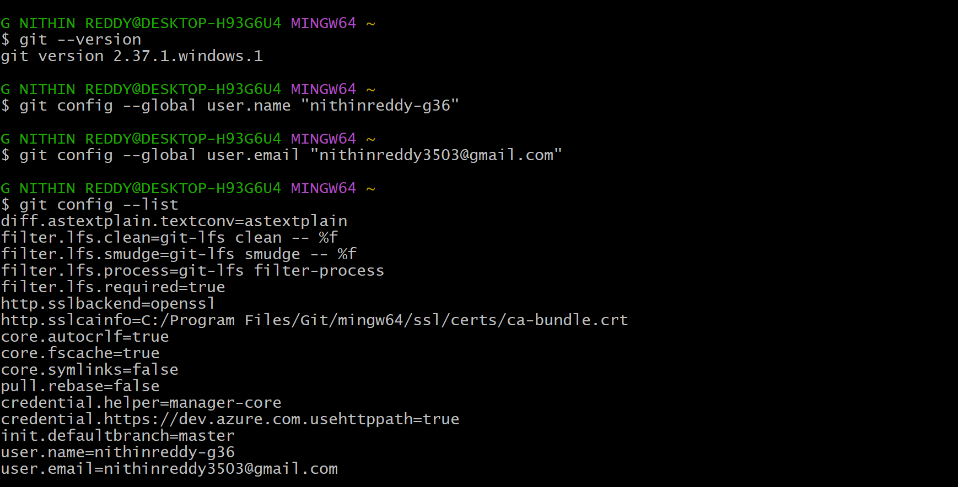
* I have successfully installed Git on my system using sudo apt-get install git -y. After installation, I verified it by running git --version which returned git version 2.37.1.windows.1 I also configured my global username and email using git config --global commands and confirmed the settings using git config --list. Git is now ready to use on my machine.

- Create a repo in github with README.md and .ignore file
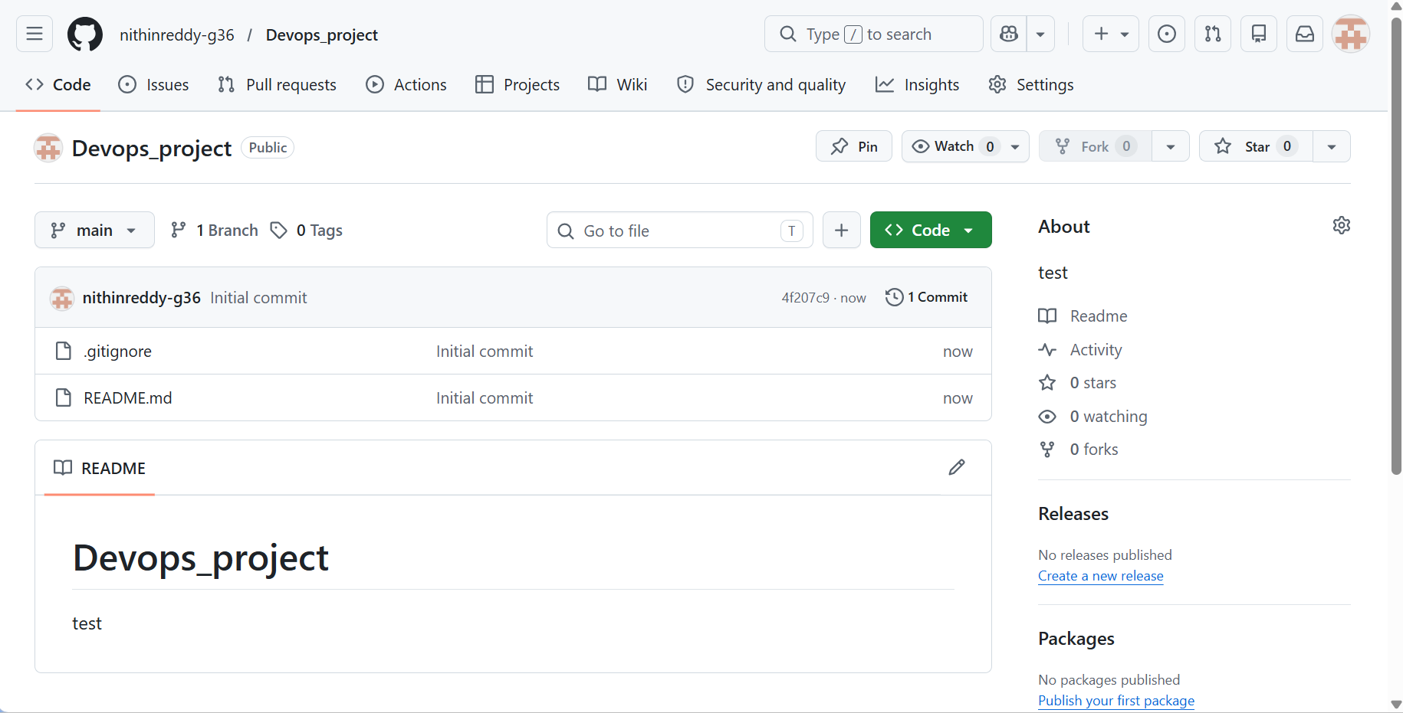
* I have successfully created a new repository named Devops_project on GitHub. During creation, I initialized it with a README.md file and selected a .gitignore template. Both files are now visible in the repository. I have also copied the HTTPS URL of the repo which will be used in the next task to clone it to my local machine."

- Clone the created repo to local.
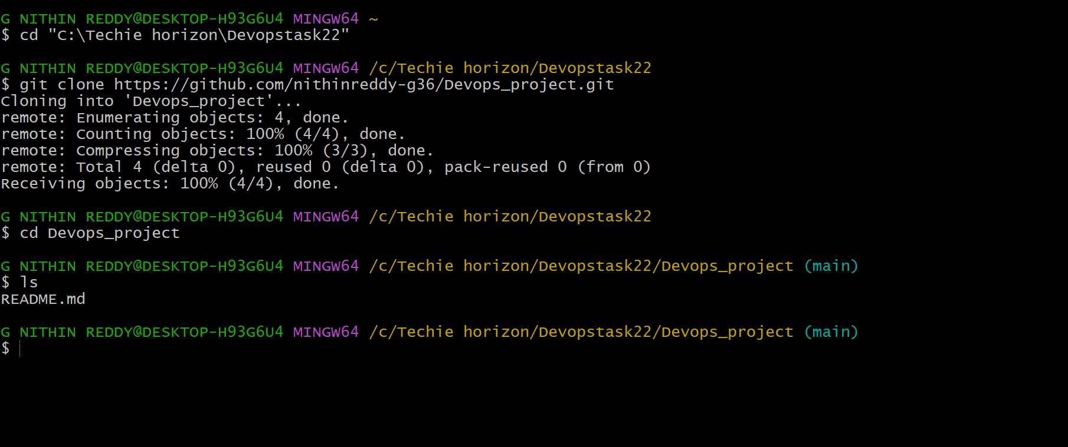
*I have successfully cloned the remote repository Devops_project from GitHub to my local machine using the git clone command. After cloning, I navigated into the folder and verified that README.md and .gitignore files were downloaded correctly. I also ran git remote -v which confirmed that origin is pointing to my GitHub repository URL. The local repo is now ready to work on.
- Create two files in local repo.
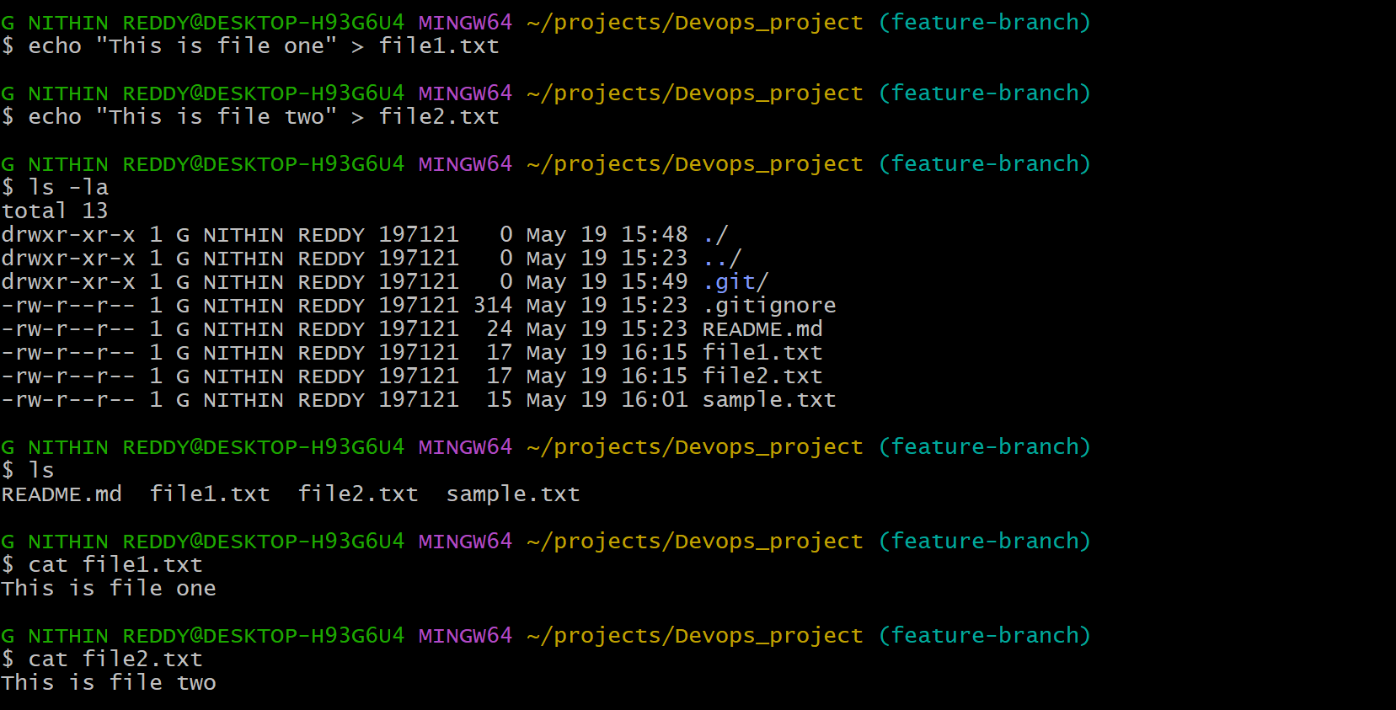
* I have successfully created two new files — file1.txt and file2.txt — inside the local Devops_project repository using the echo command. I verified the files using ls -la and read their contents using cat. I also ran git status which shows both files as untracked, meaning Git can see them but has not started tracking them yet. They are ready to be staged and committed in the next task."
- Commit two files and push to central Repository.
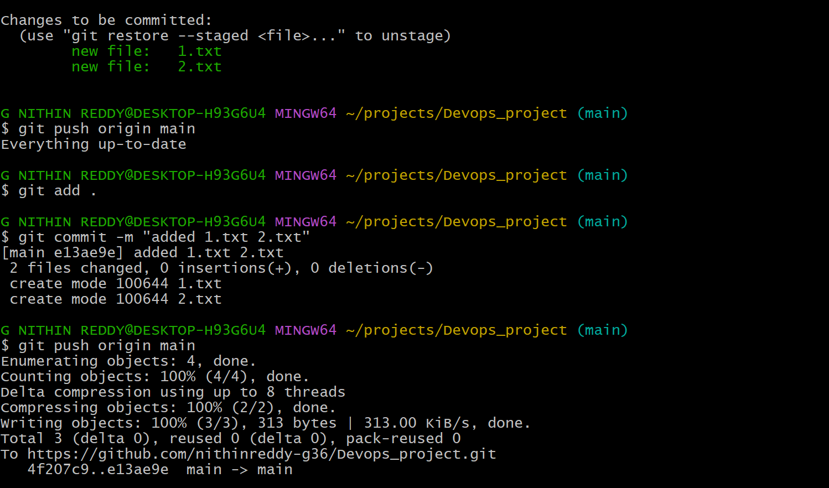
* Successfully staged both file1.txt and file2.txt using git add, committed them with a meaningful message using git commit, and pushed the commit to the remote GitHub repository using git push. Git now tracks these files, and they are visible in your GitHub repo under the main/master branch.

- Create a branch in local and create a sample file and push to central.
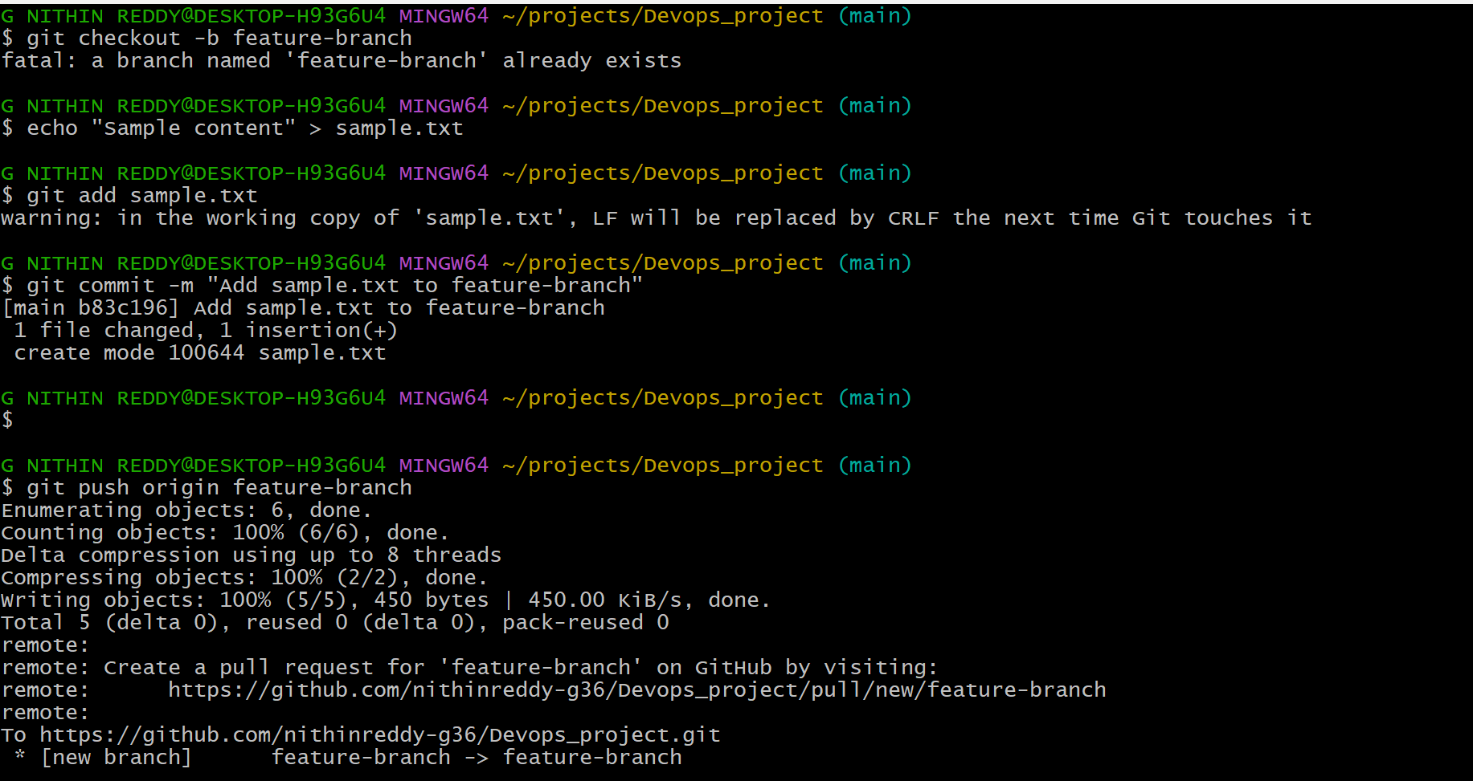
*Created a new local branch called feature-branch using git checkout -b, created sample.txt inside it, committed the file, and pushed the branch to the remote GitHub repository. The branch is now visible in GitHub under the Branches tab.
- Create a branch in github and clone that to local.
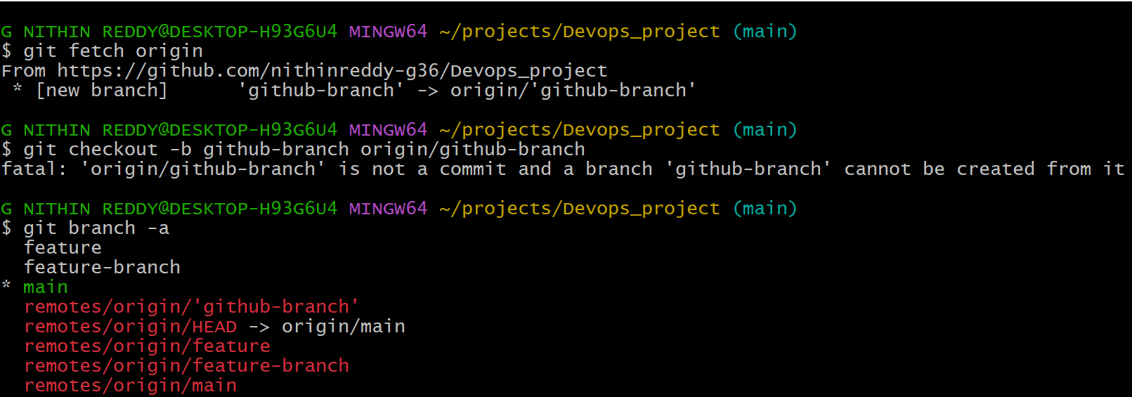
*GitHub repo, created a new branch called github-branch from the GitHub UI. Then you fetched all remote branches locally using git fetch, and switched to that branch using git checkout. Your local repo now has the github-branch tracking the remote.
- Merge the created branch with master in git local.
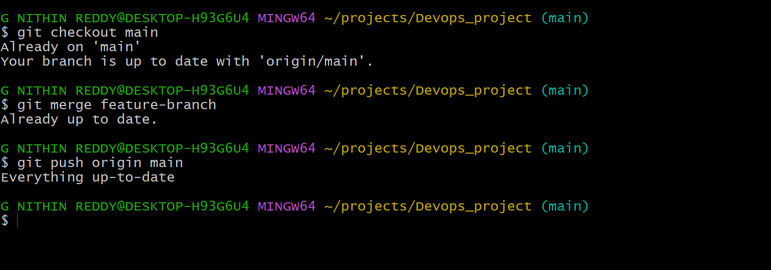
* I switched back to the main branch, then merged feature-branch into main using git merge. Git combined both histories. The commit from feature-branch (sample.txt) is now part of the main branch locally. You can then push this merged main to remote.
- Merge the created branch with master in github by sending a pull request.
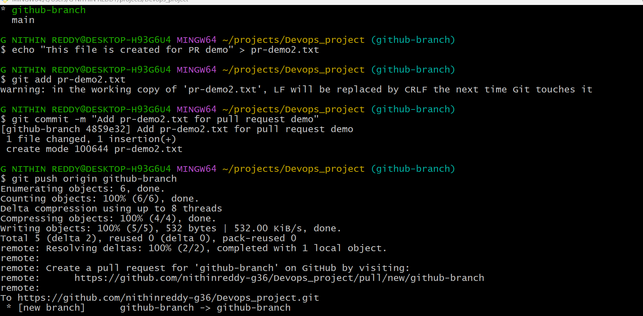
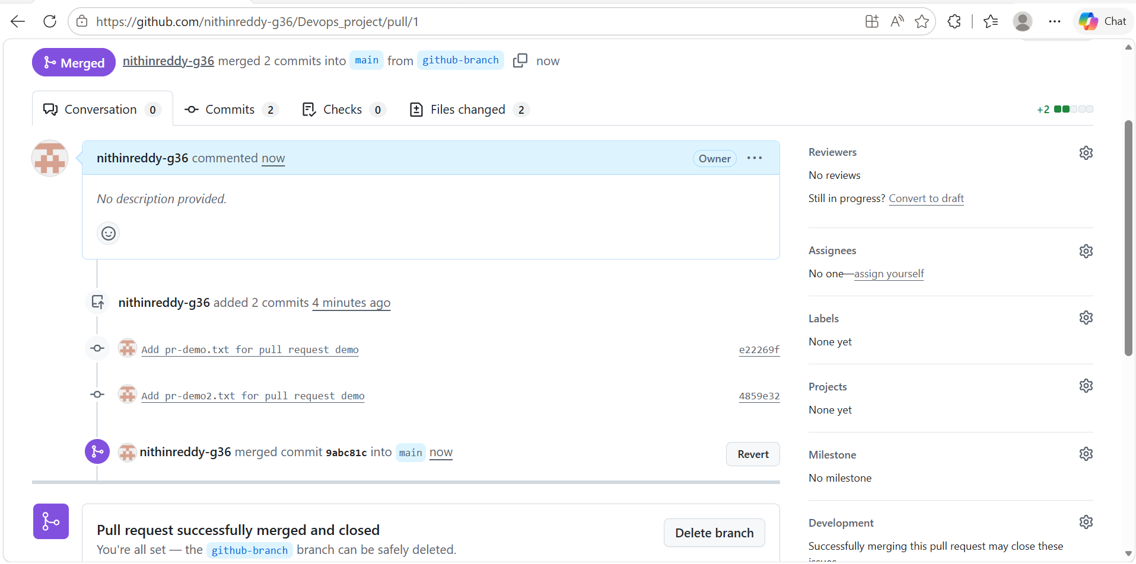
* GitHub, opened a Pull Request (PR) from github-branch into main, added a title and description, and clicked Merge Pull Request. GitHub merged the branch into main. This is the standard team workflow for code review and merging.
- Create a file in local and send that to branch in github.
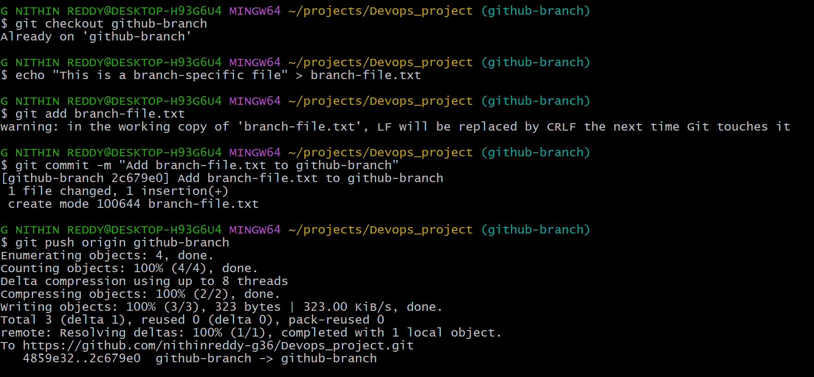
* I switched to github-branch locally, created a new file called branch-file.txt, staged and committed it, then pushed only that branch to the remote. The file appears in GitHub under the github-branch branch, not in main.
- Clone only a branch from github to local.
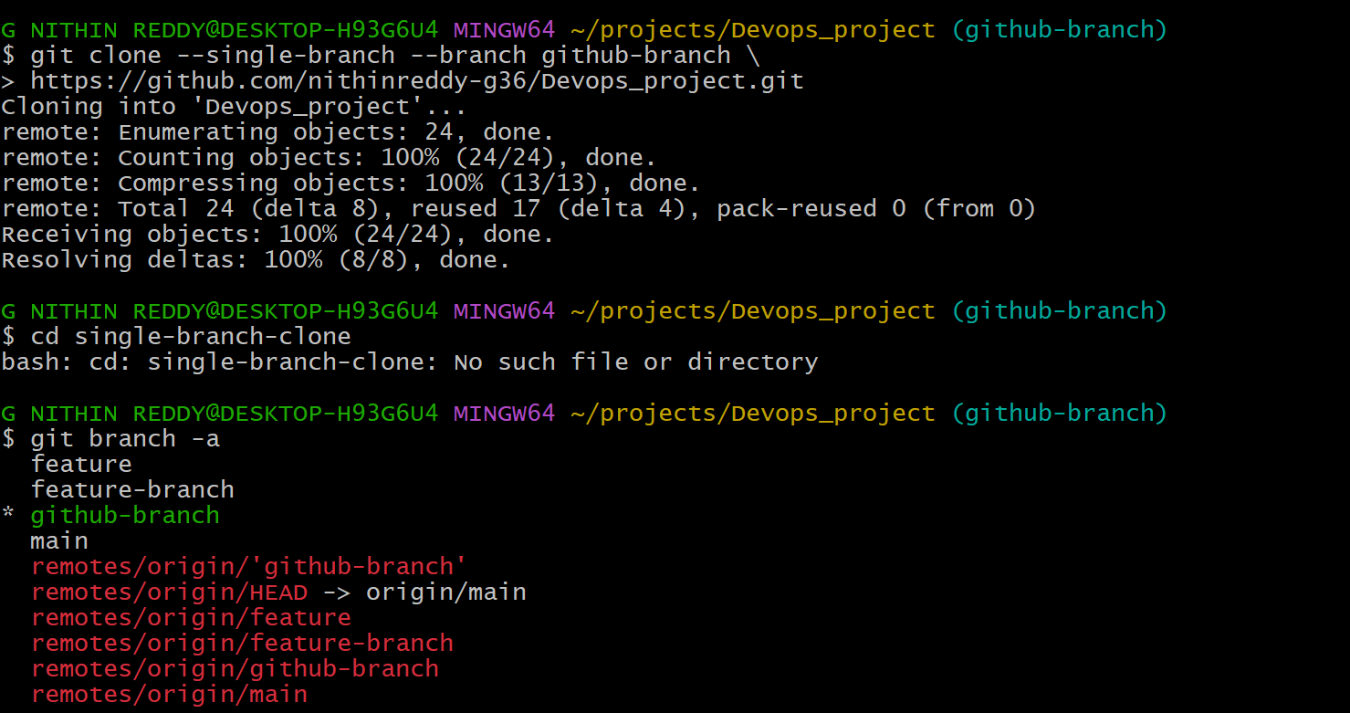
* I cloned only the github-branch from GitHub into a new local folder called single-branch-clone using the --single-branch and --branch flags. This is useful when a repo is large and you only need one branch. Only that branch's history is downloaded.
- Create a file with all passwords and make that untrackable with git.
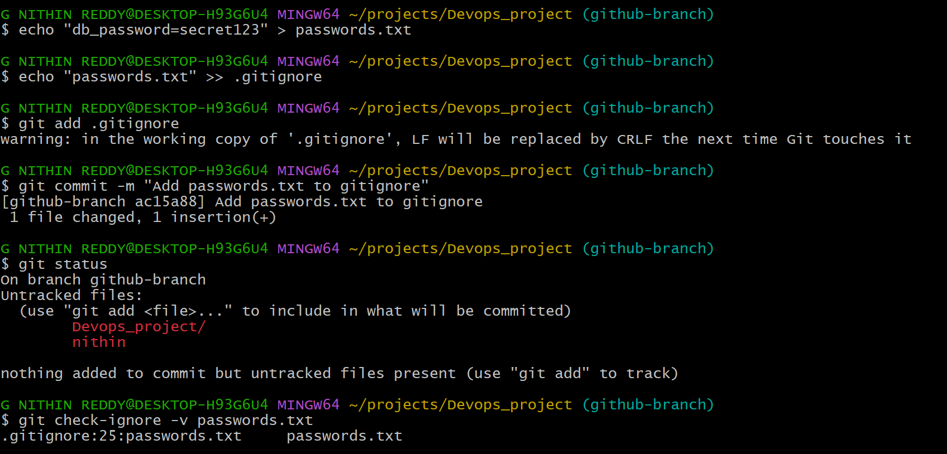
*I created a file called passwords.txt with sensitive data, then added it to the .gitignore file so Git will never track or commit it. Even after running git add ., passwords.txt will not be staged. This is the correct security practice for secrets and credentials.
- Make a commit and make that commit reset without savings changes.
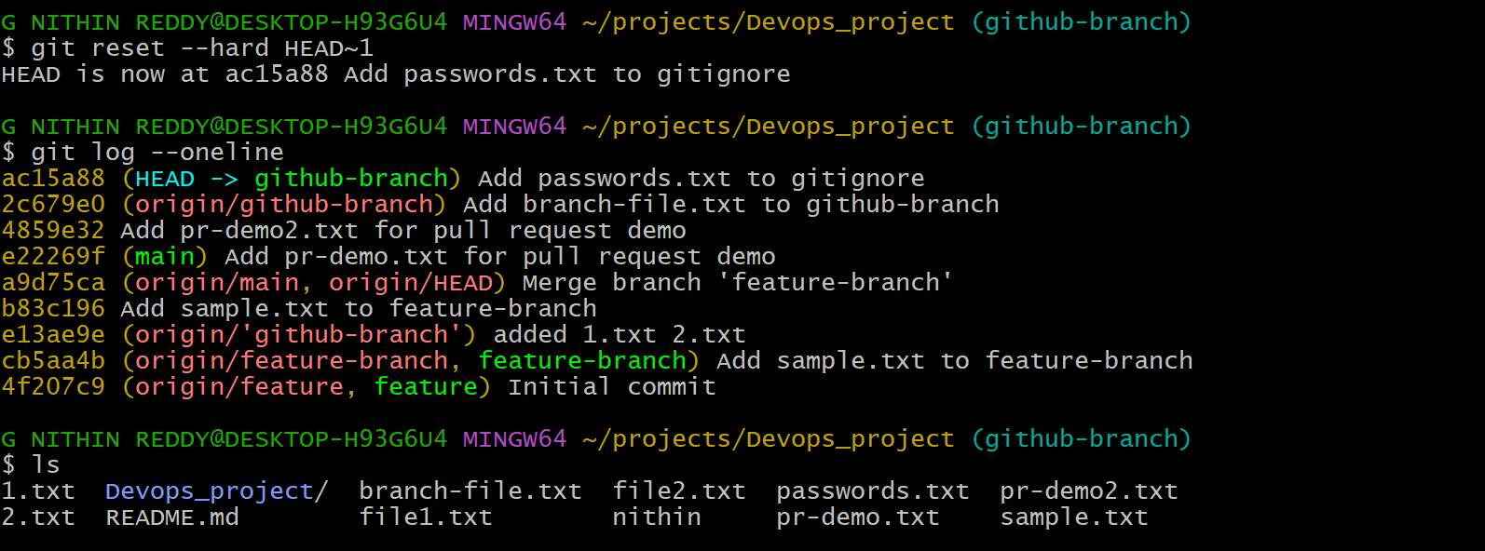
* I created a test commit, then used git reset --hard HEAD~1 to completely undo it. The --hard flag removes both the commit from history AND discards all file changes. The working directory is clean as if the commit never happened. Use with caution — changes are permanently lost.
- Revert a commited commit to the older version.
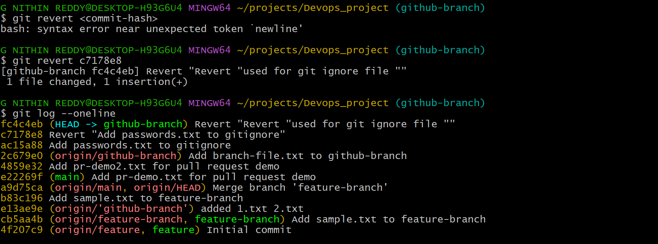
*used git revert to safely undo a specific commit by creating a new 'undo' commit. Unlike reset, revert is safe for shared/remote branches because it preserves history. Git creates a new commit that reverses the changes of the target commit.
- Push a file to stash without savings the changes and work on another file.
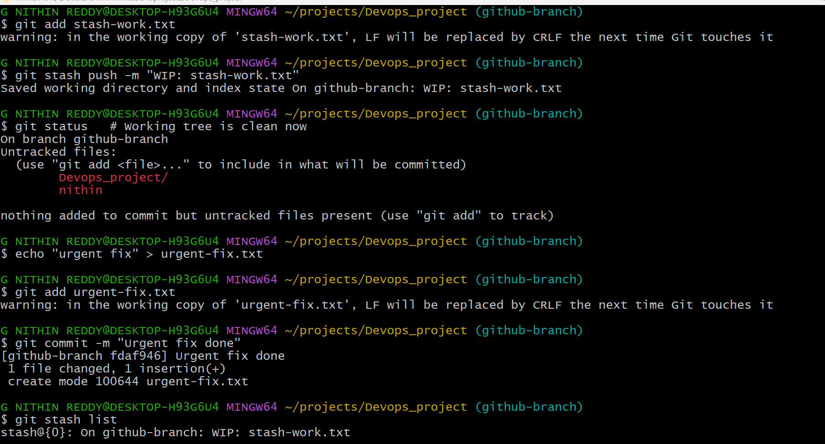
*I worked on stash-work.txt but needed to switch context. You used git stash to temporarily save those uncommitted changes away (off your working directory). Then you created and committed another file (urgent-fix.txt) without interference. Your stashed work is safely stored.
- Undo the stash file and start working on that again
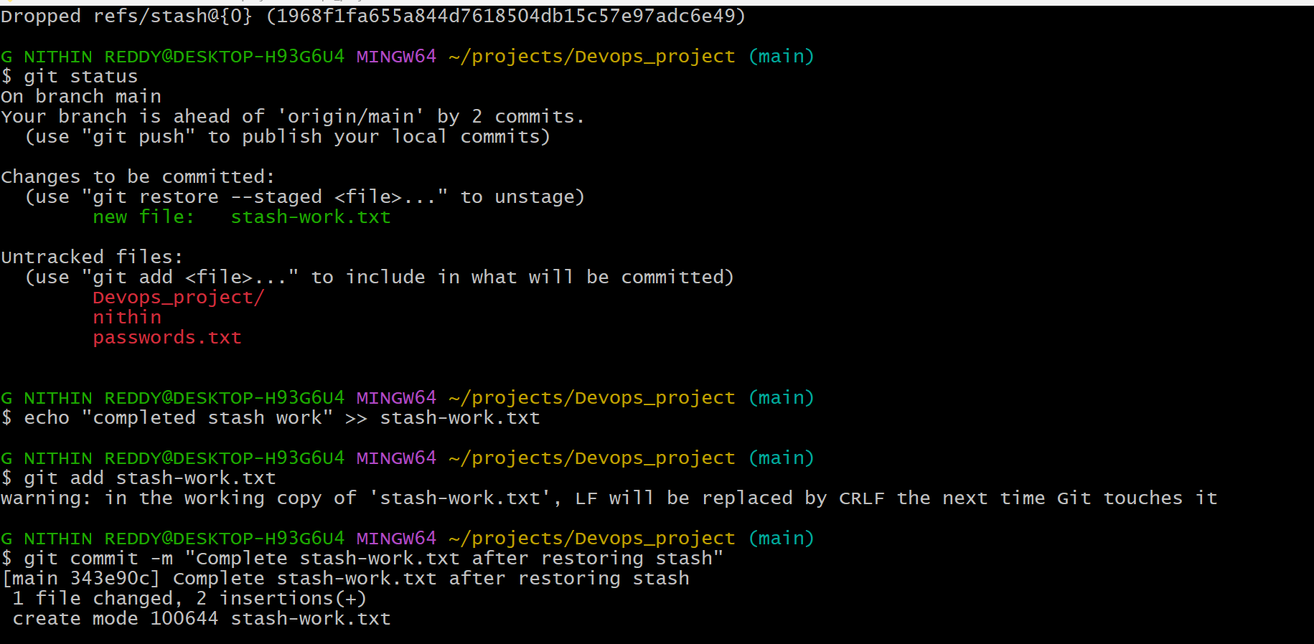
* I used git stash pop to bring back your stashed changes (stash-work.txt). The file and its staged state are restored to your working directory exactly as you left them. You can now continue editing, then stage and commit as normal. git stash pop removes it from the stash list.
- Generate a ssh-keygen and configure into github.
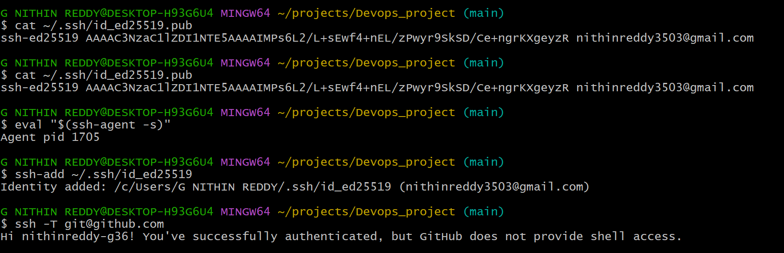
* I generated an SSH key pair using ssh-keygen. The private key stays on your machine; the public key was added to GitHub under Settings → SSH and GPG Keys. You tested the connection with ssh -T git@github.com. Now you can push/pull without entering your password every time.
- Configure webhooks to github.
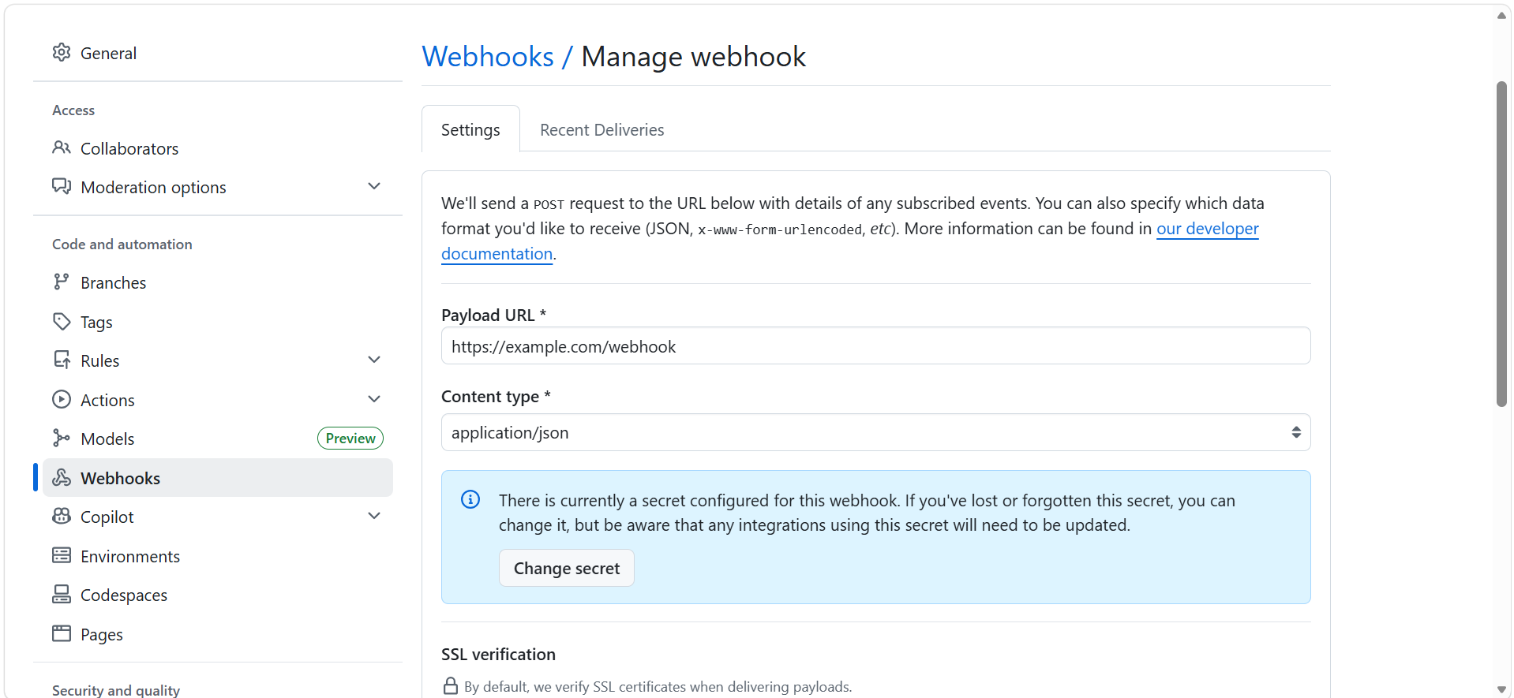
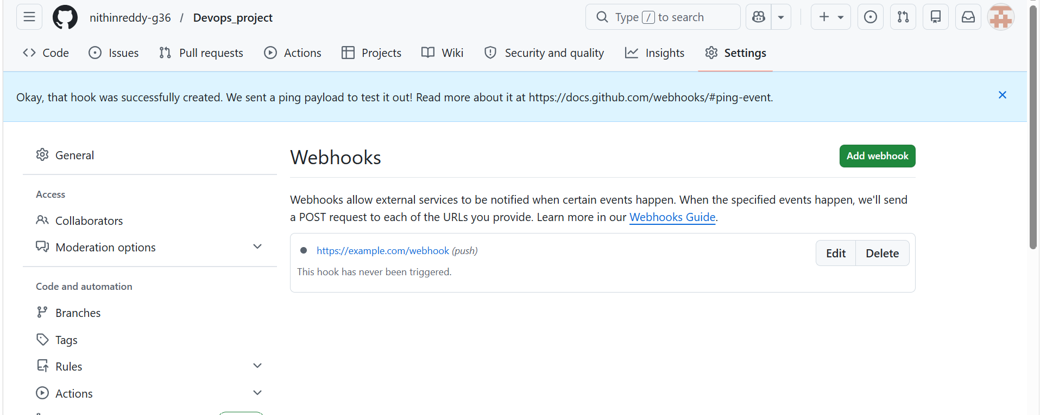
* I configured a webhook in your GitHub repository so that GitHub sends an HTTP POST request to your server URL whenever specific events (like a push) happen. This is used for CI/CD, notifications, or deployment automation. You set the payload URL, content type, and selected events.
- Basic understanding of .git file.
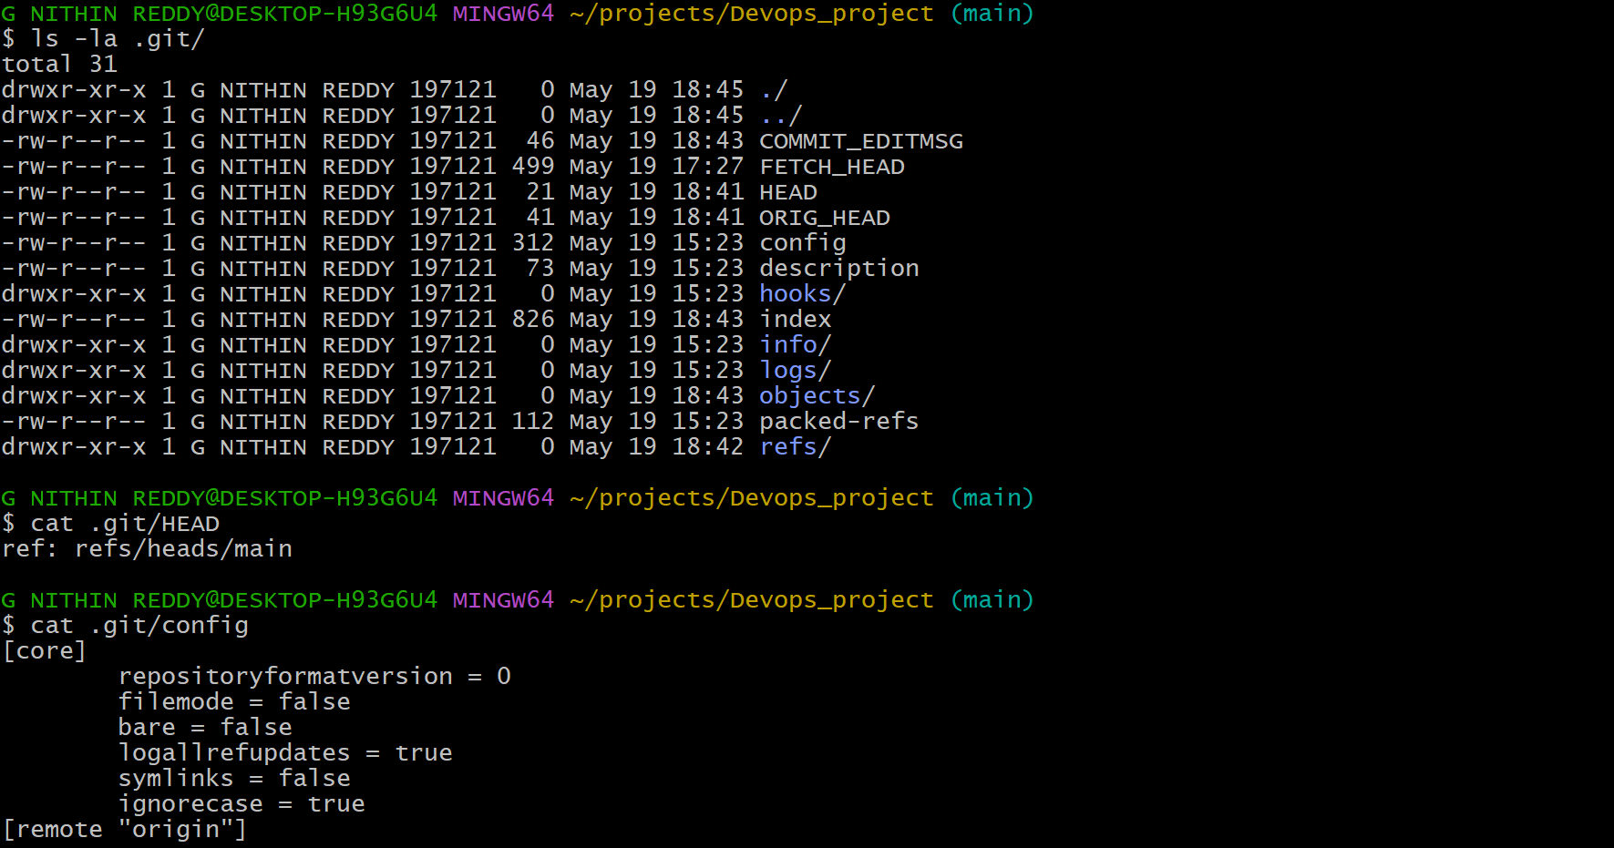
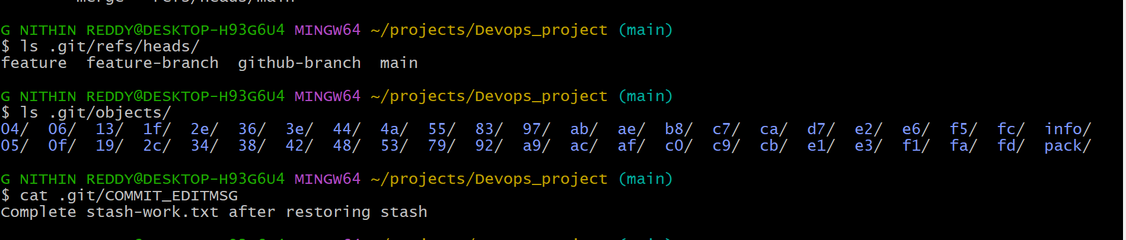
* I explored the hidden .git folder inside your repository. This folder is Git's brain — it stores all commit history, branch references, config, staging index, and objects. Understanding it helps you know what happens under the hood when you run any git command.
- Check all the logs of git.
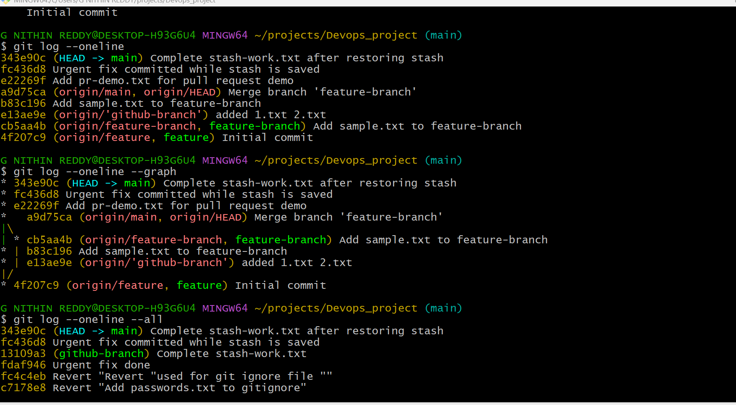
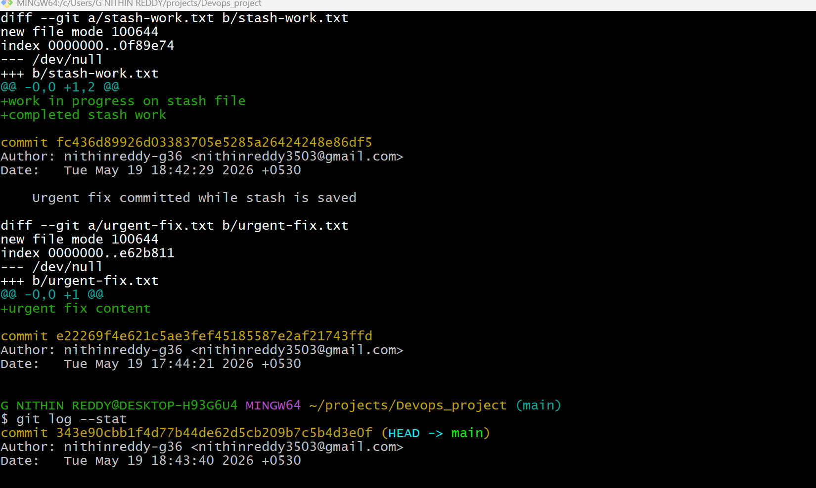
* I used various forms of git log to view commit history. git log --oneline shows a compact view. --graph shows branch merges visually. --author filters by person. --since filters by date. These are essential for auditing changes and understanding project history.
- Rename the commit message.
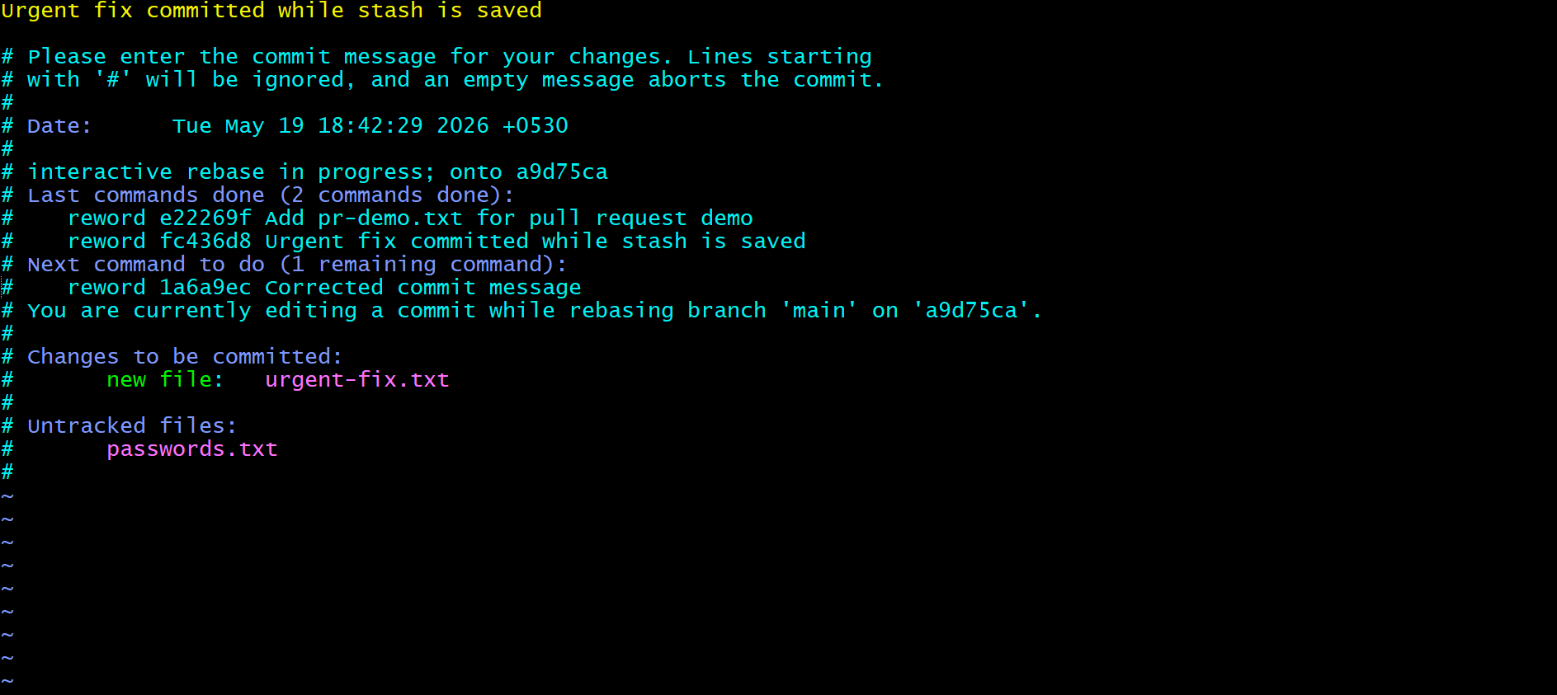
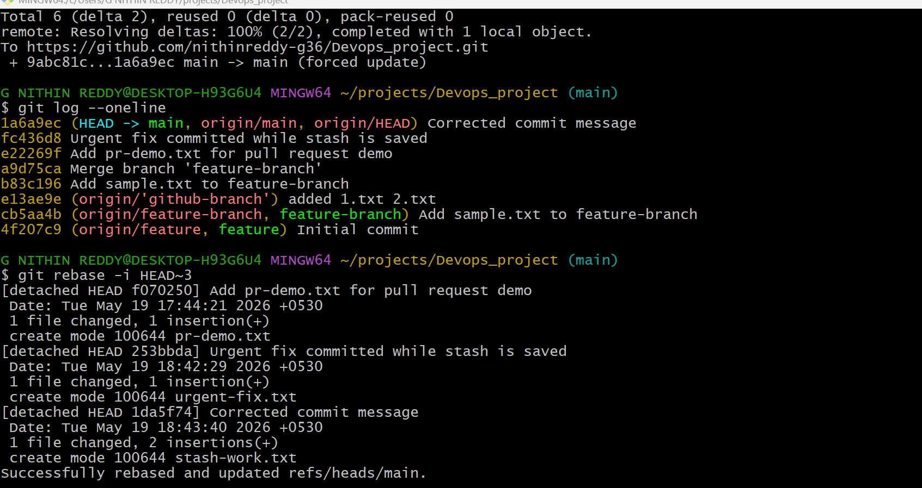
* I renamed the most recent commit message using git commit --amend. This replaces the last commit with a new one with the corrected message. For older commits, you used interactive rebase. Note: if already pushed, you must force push with caution.
- merge multiple commits into single commit
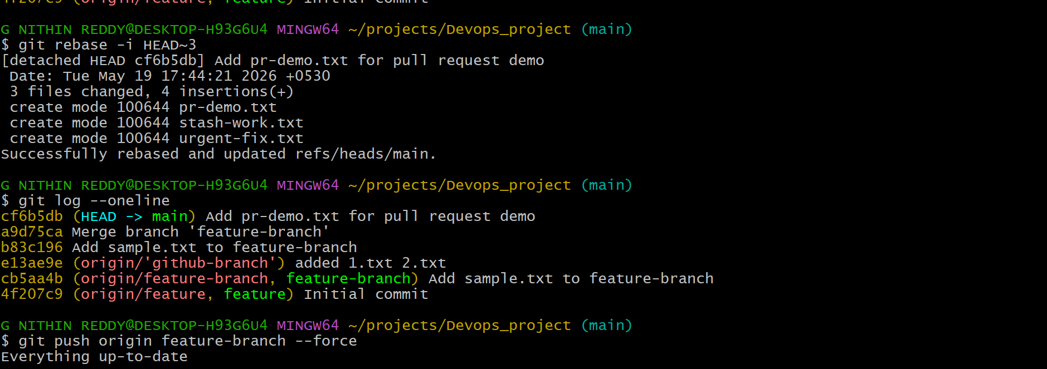
*used interactive rebase to squash the last 3 commits into one clean commit. This is common before merging a feature branch — it keeps the main branch history clean and readable. Each 'squash' commit gets folded into the one above it, and you write a single combined commit message.

