**ASSIGNMENT-11.2**

1. Using table team and importing the table into HDFS

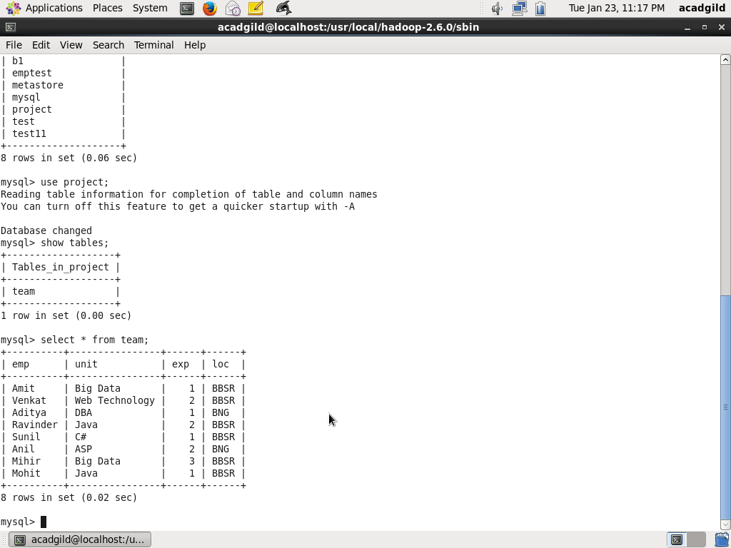

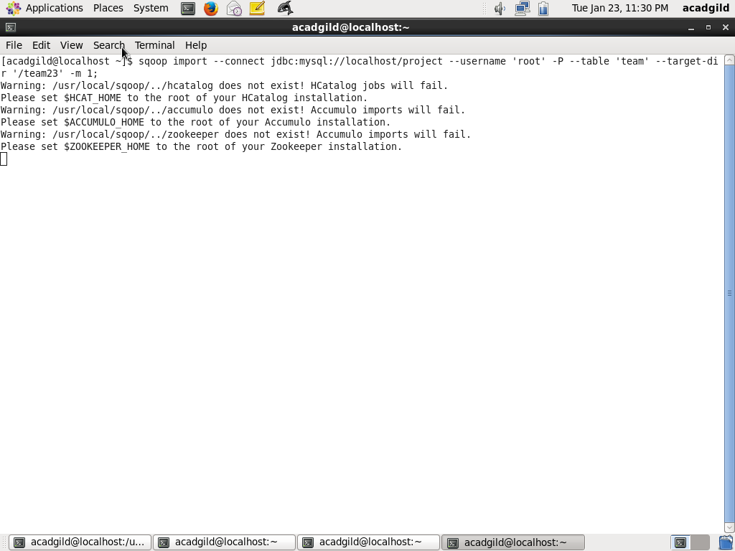

1. Checking the listings of the table imported

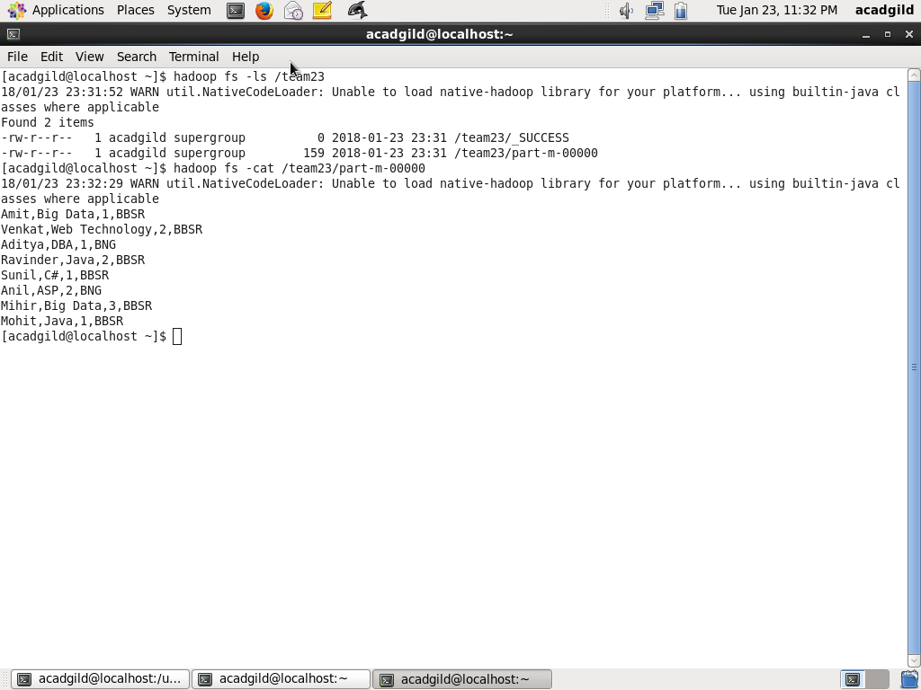

**INCREMENTAL LOAD**

**Inserting new records into sql table**

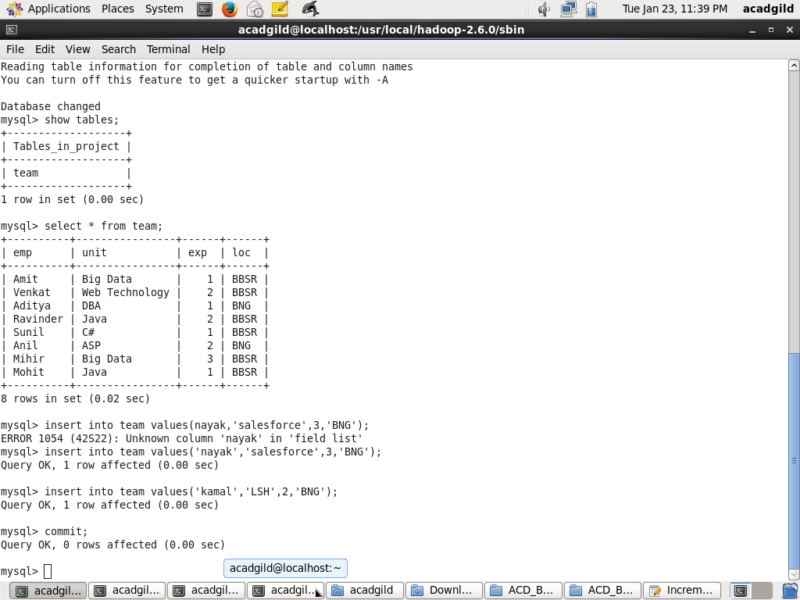

Sqoop incremental append command

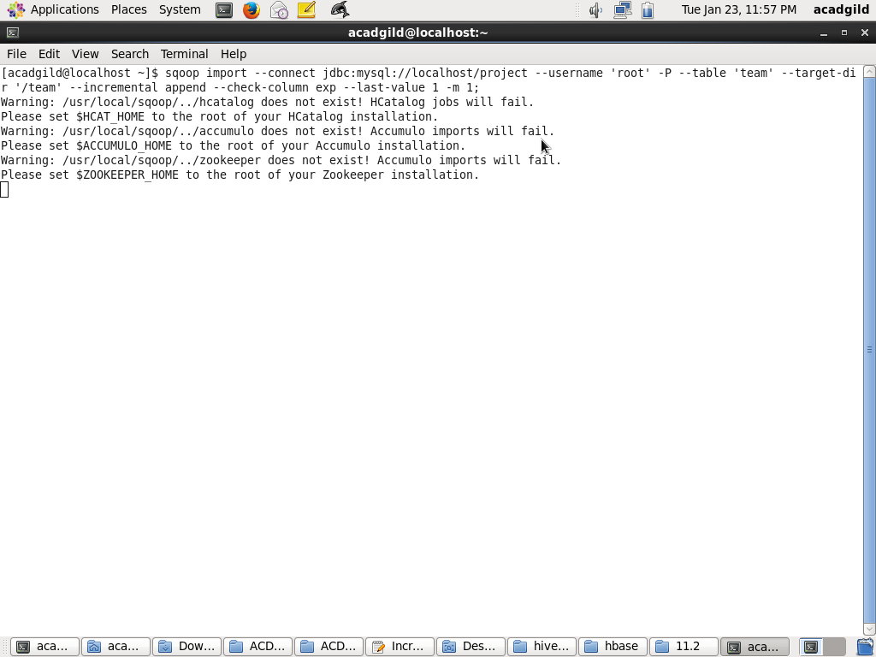

**List of the data which got appended**

