**ASSIGNMENT-11.3**

Navigate to create new Application page and enter the required detaiils

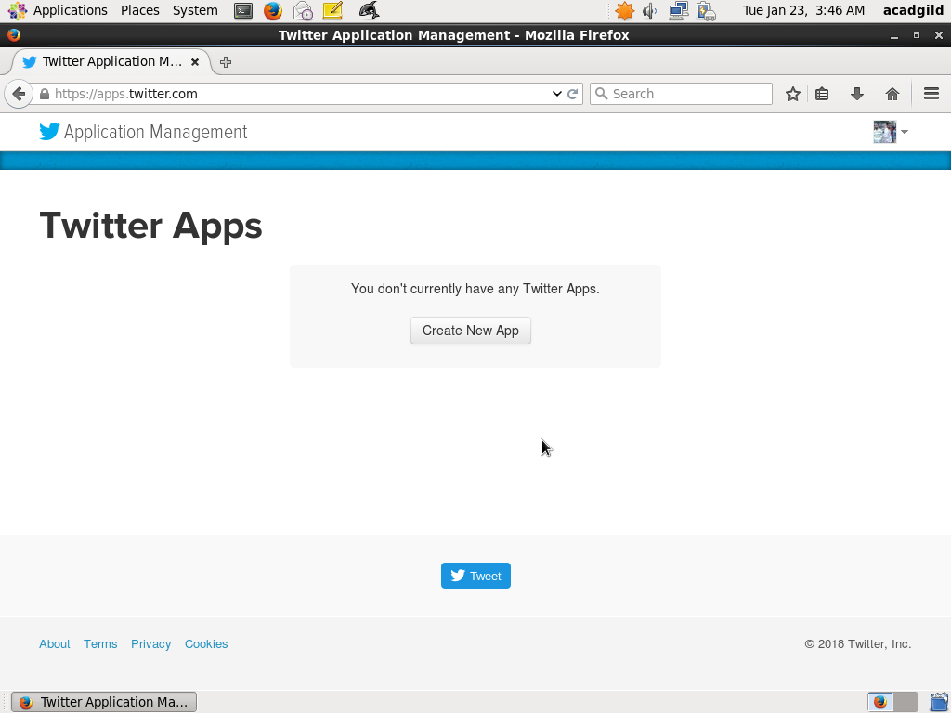

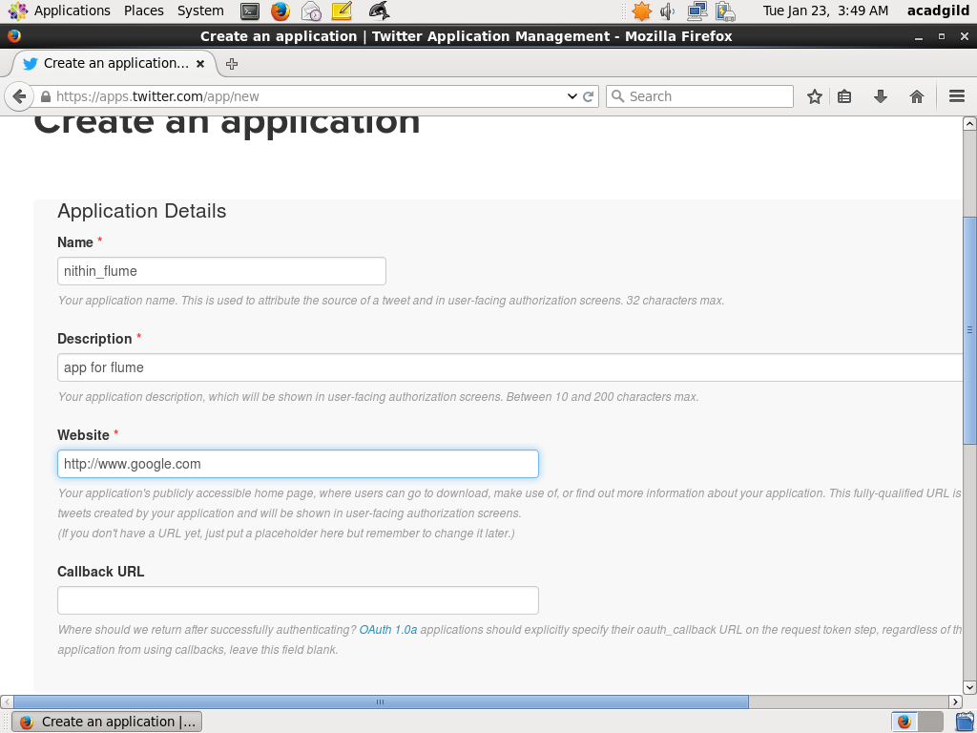

Accept the developer agreement and select the ‘create your Twitter application’ button.

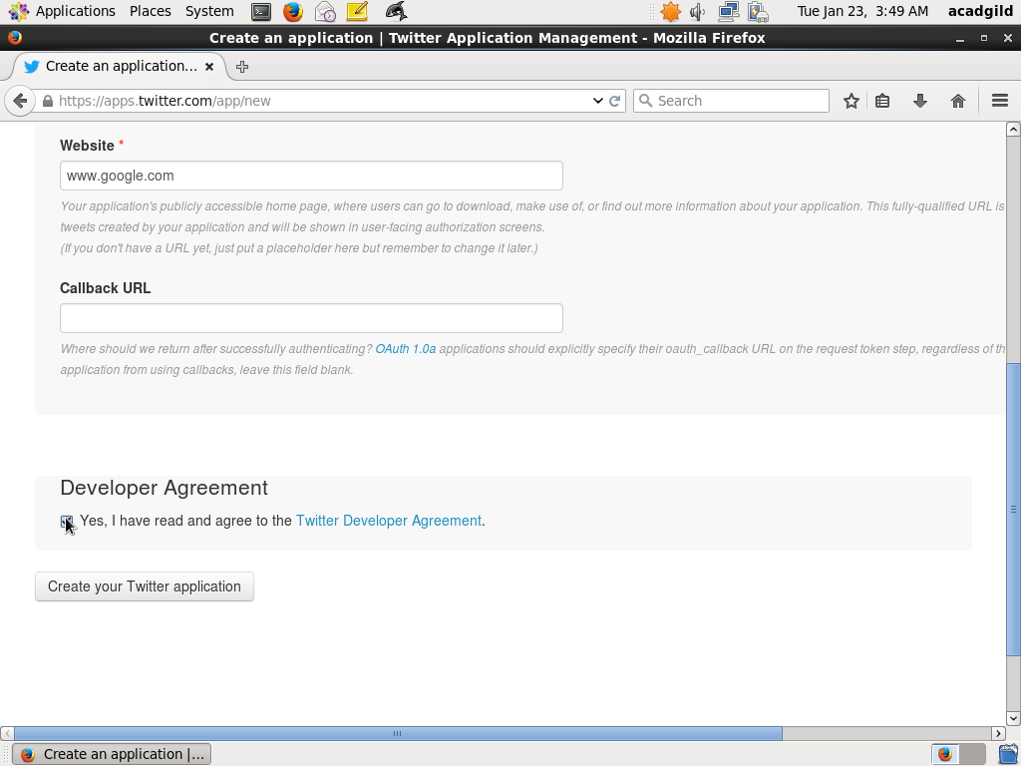

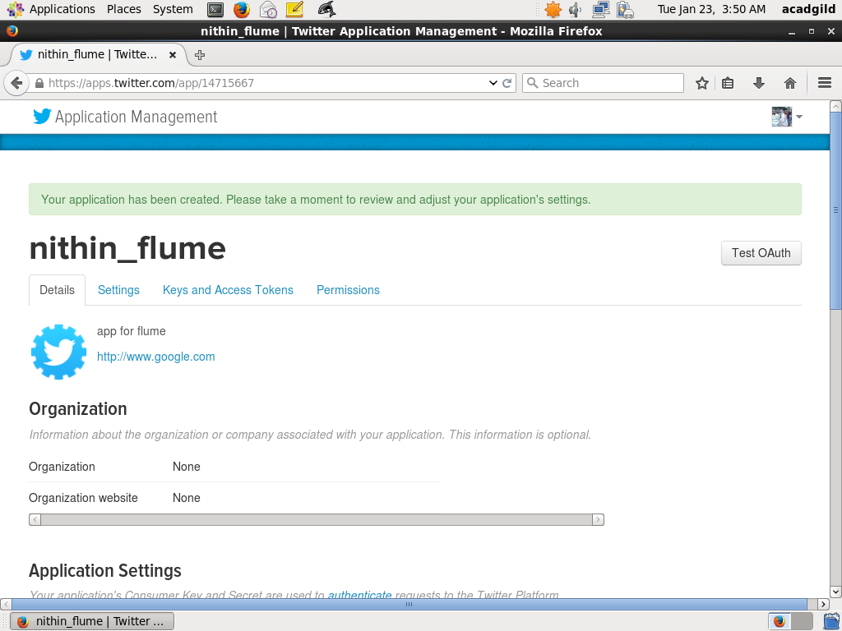

**Generate Access Token**

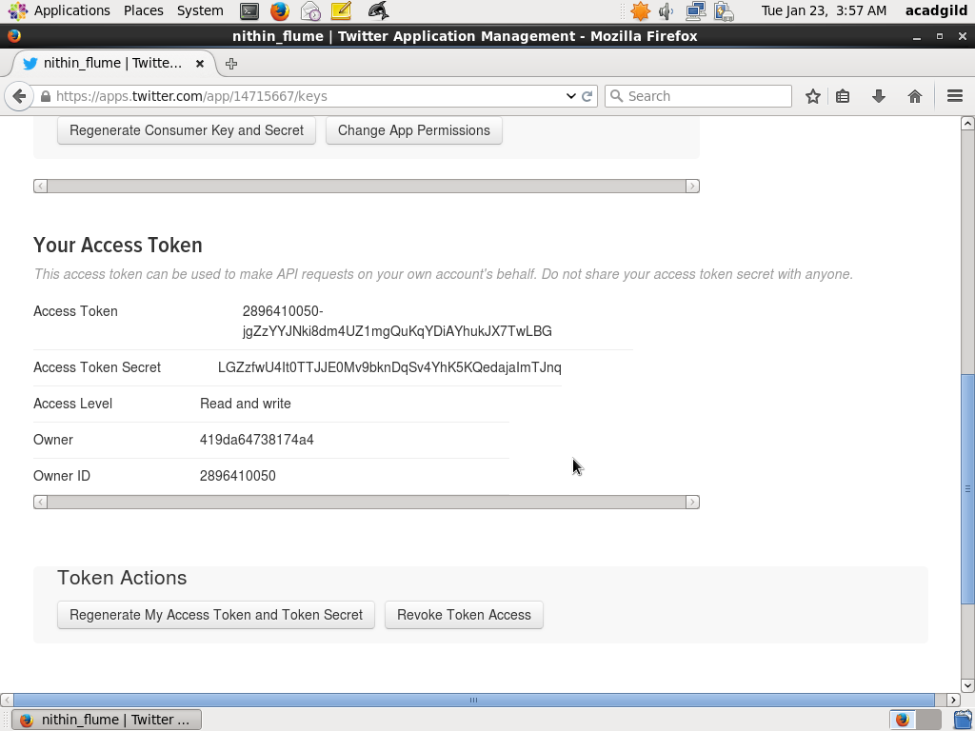

**Download Flume from the specified path, extract and edit the .bashrc file to point to the new downloaded flume agent and Change the twitter api keys with the keys generated**

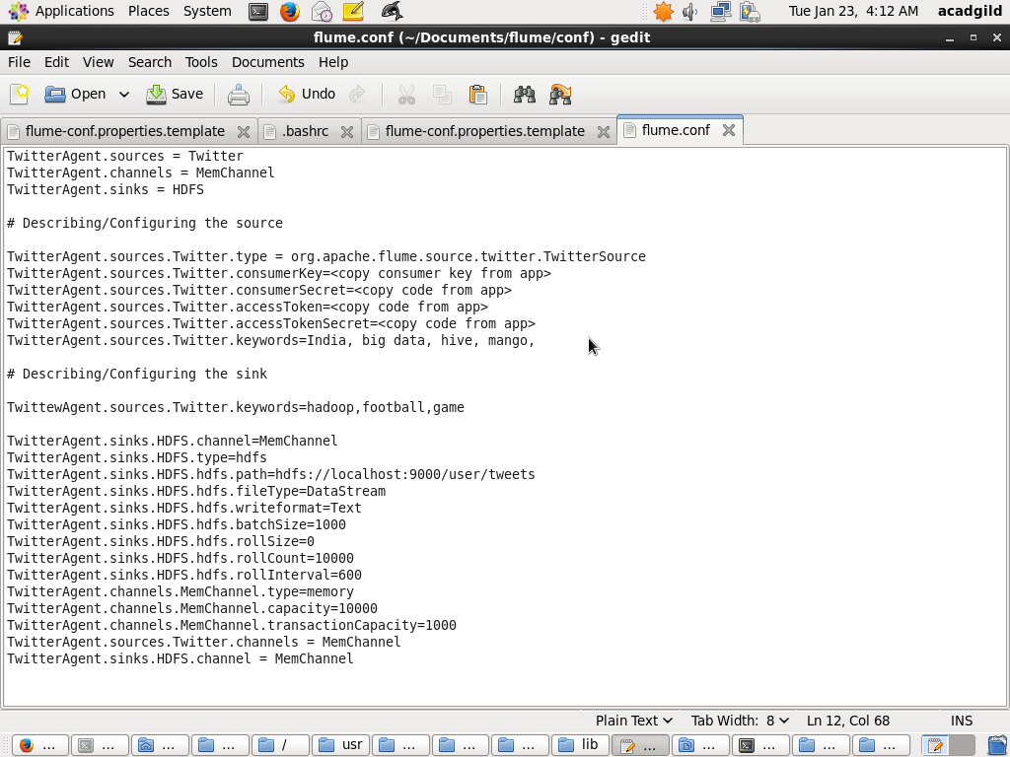

**Created a new directory inside HDFS path, where the Twitter tweet data should be stored.**

**Hadoop dfs –mkdir –p /user/flume/tweets**

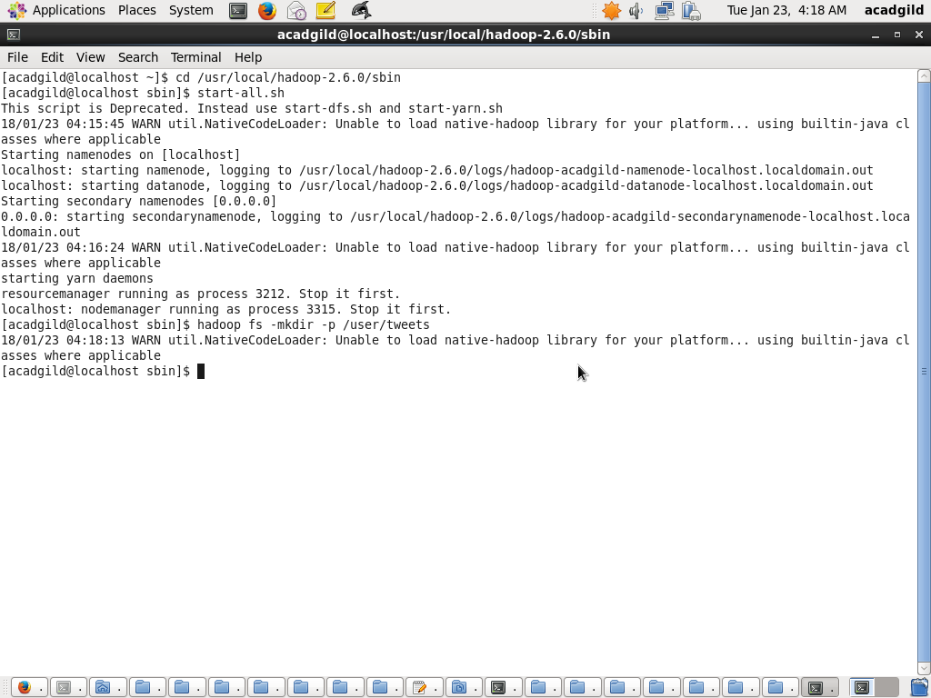

**Command to start flume agent, point to flume_conf path**

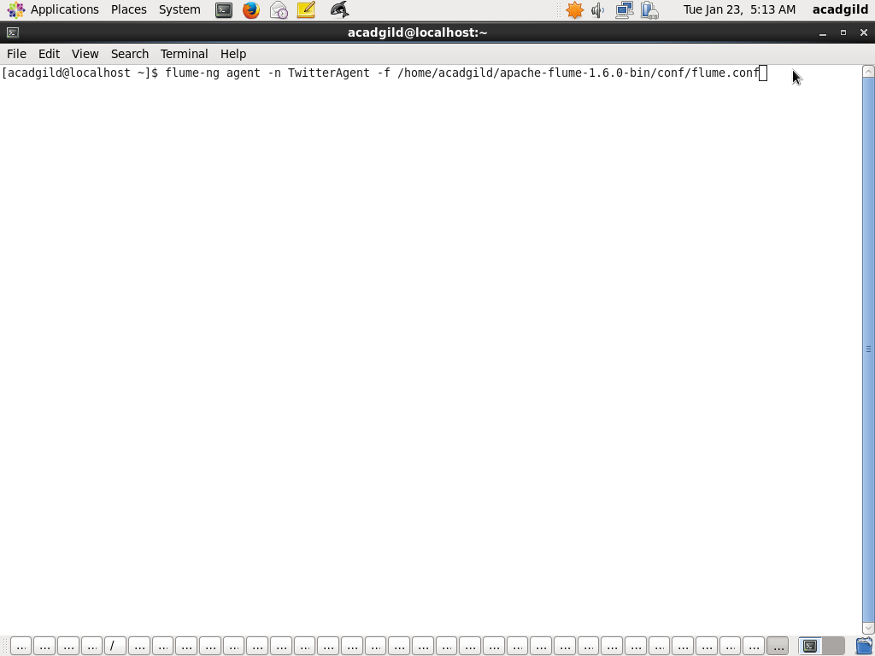

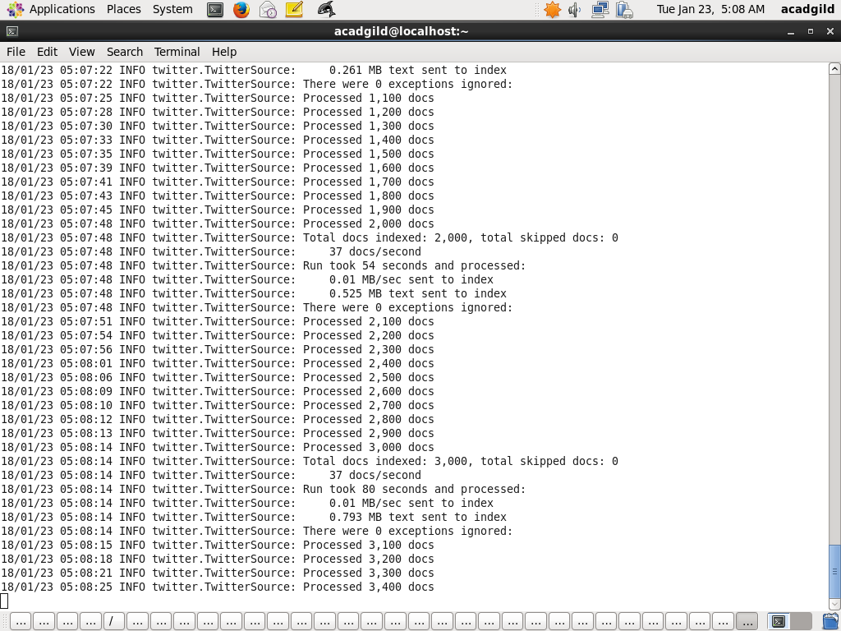

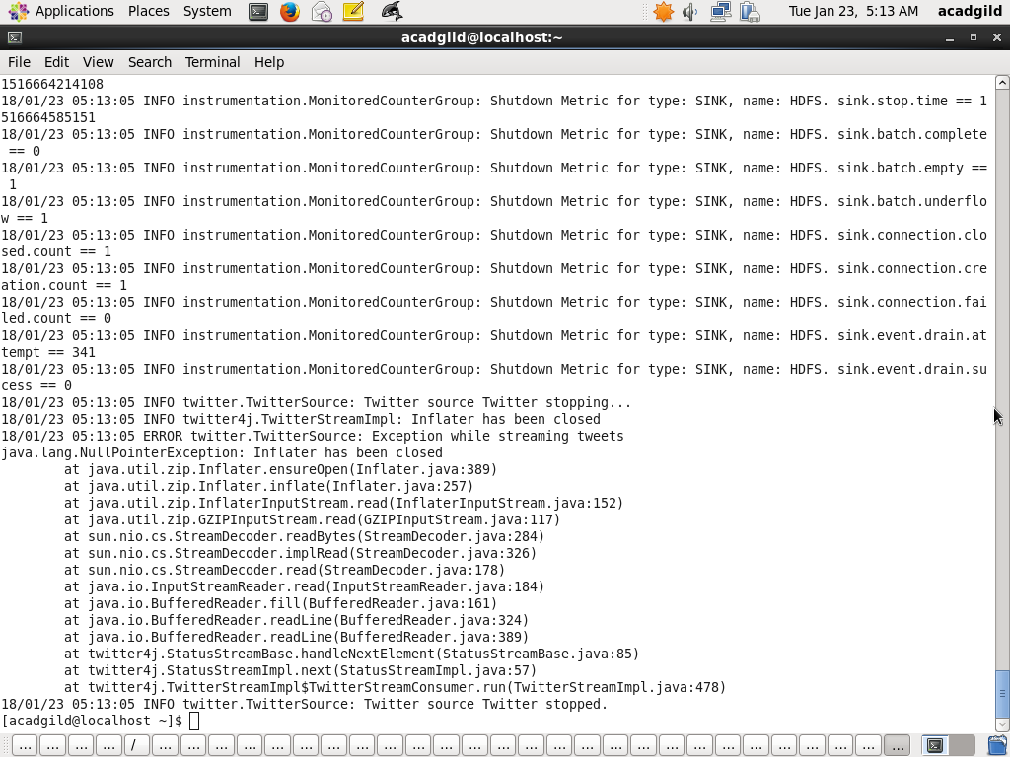

**Cat command to view the files**

