**ASSIGNMENT-12.2**

1. find count of all strings with length 4 in the List - List[String] (“alpha”, “gamma”, “omega”, “zeta”, “beta”)

**Code:**

object Ass12_2_1 extends App{  
  
 val *maths*:List[String] = *List*("alpha","gamma","omega","zeta","beta")  
 val *i*=0;  
  
 *println*("Count of strings with length 4:")  
 for (i <- 0 to (*maths*.length-1)) {  
 if (*maths*(i).length == 4)  
 *println*(*maths*(i))  
  
 }  
}

**Output1** : Count of strings with length 4:

Zeta

beta

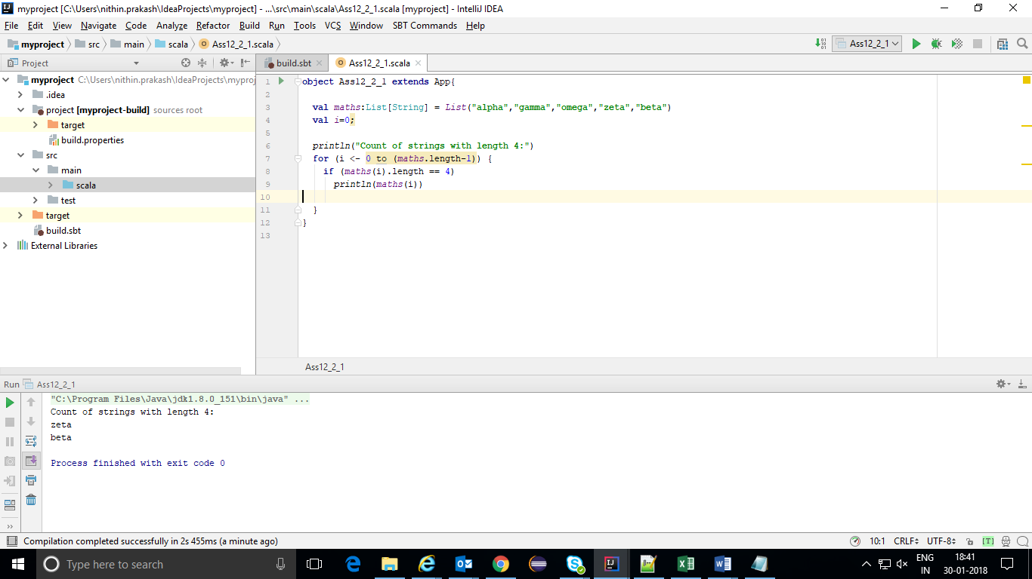

1. convert the list of string to a list of integers, where each string is mapped to its corresponding length - List[String] (“alpha”, “gamma”, “omega”, “zeta”, “beta”)

**CODE:**

import scala.collection.mutable.ListBuffer  
  
object Ass12_2_2 extends App {  
  
 var *maths*: List[String] = *List*("alpha", "gamma", "omega", "zeta", "beta")  
 val *temp* = new ListBuffer[String]()  
 *println*("String length: ")  
  
  
 for (i <- 0 to (*maths*.length-1)){  
 *temp* += *maths*(i).length.toString  
 }  
 *maths* = *temp*.toList  
 *println*("new List is "+ *maths*)  
 *maths* = *List*("alpha","gamma","omega","zeta","beta");  
}

**Output2** : String length:

new List is List(5, 5, 5, 4, 4)

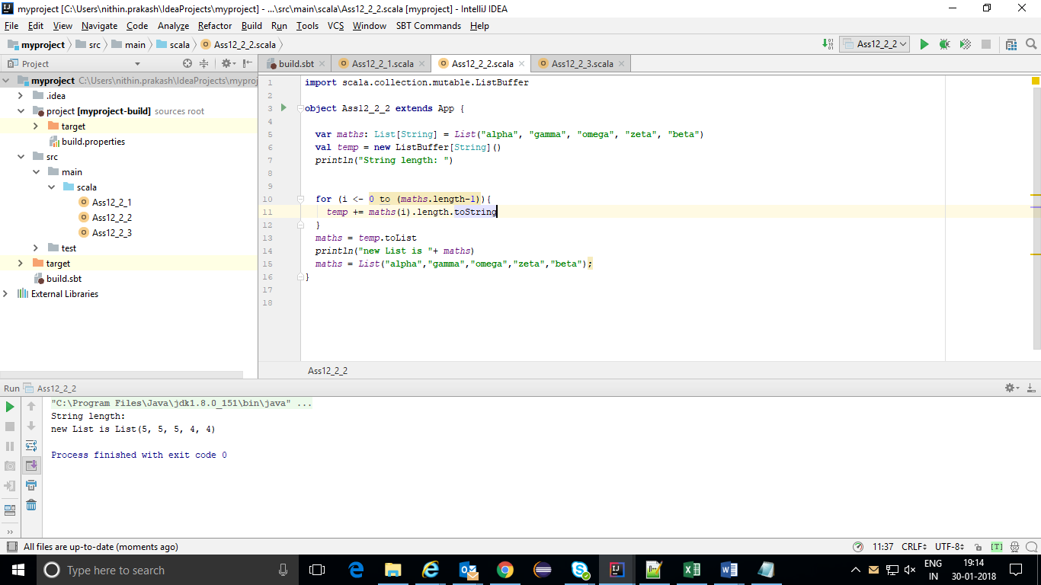

**3.** find count of all strings which contain alphabet ‘m’

object Ass12_2_3 extends App {

var maths: List[String] = List("alpha", "gamma", "omega", "zeta", "beta")

val newStrings = maths.filter(_.contains("m"))

println("count of strings with m:" + newStrings.length)

}

**Output3: count of strings with m:2**

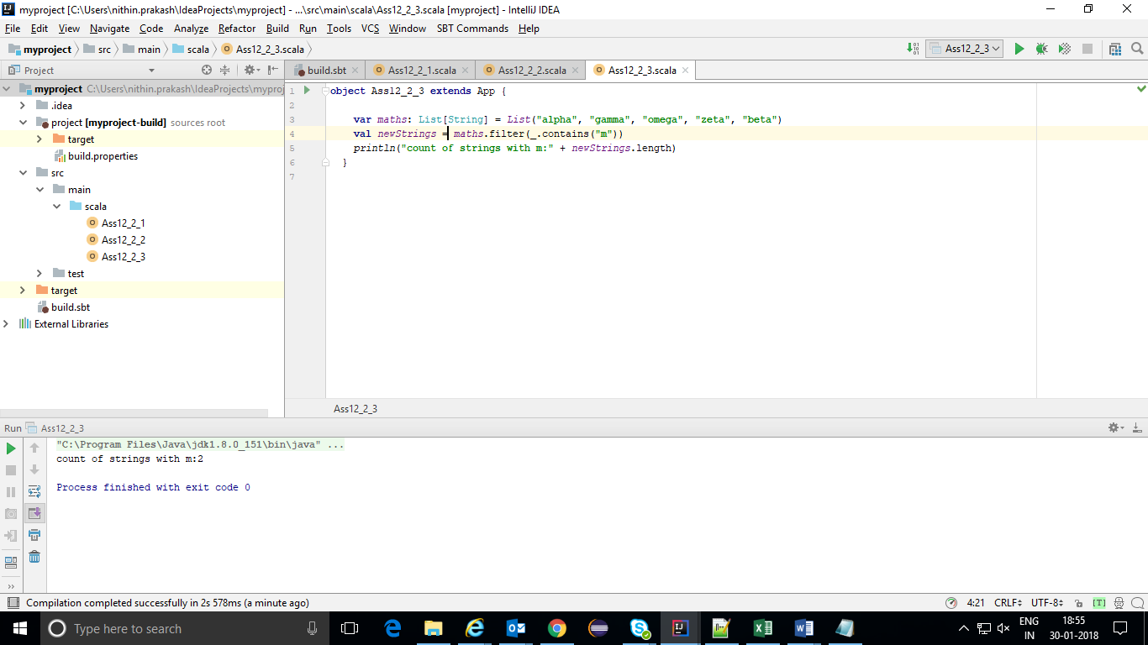

4. find the count of all strings which start with the alphabet ‘a’

**CODE:**

object Ass12_2_3 extends App {

val maths:List[String] = List("alpha", "gamma", "omega", "zeta", "beta")

val newStrings = maths.filter(_.startsWith("a"))

println("Count of strings starting with a: " +newStrings.length)

}

**Output 4 : Count of strings starting with a: 1**

