**ASSIGNMENT-10.2**

**Copying the file to HDFS which will be further loaded into HBase.**

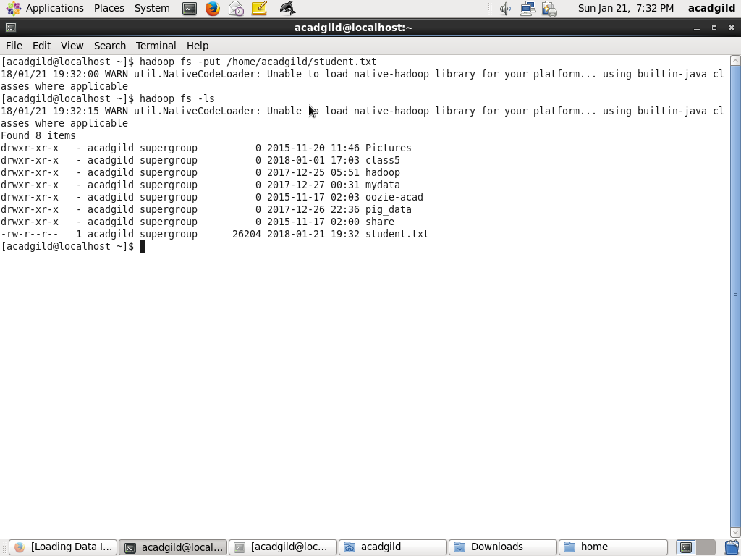

**Set jars HBase to the Pig classpath**

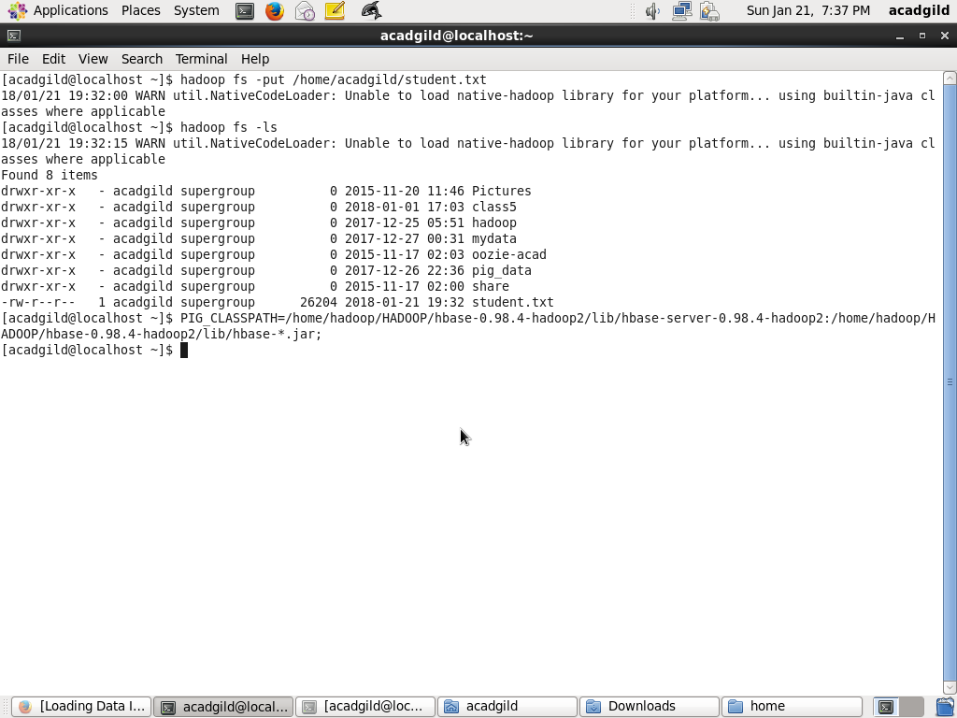

**start HBase shell and create a table.**

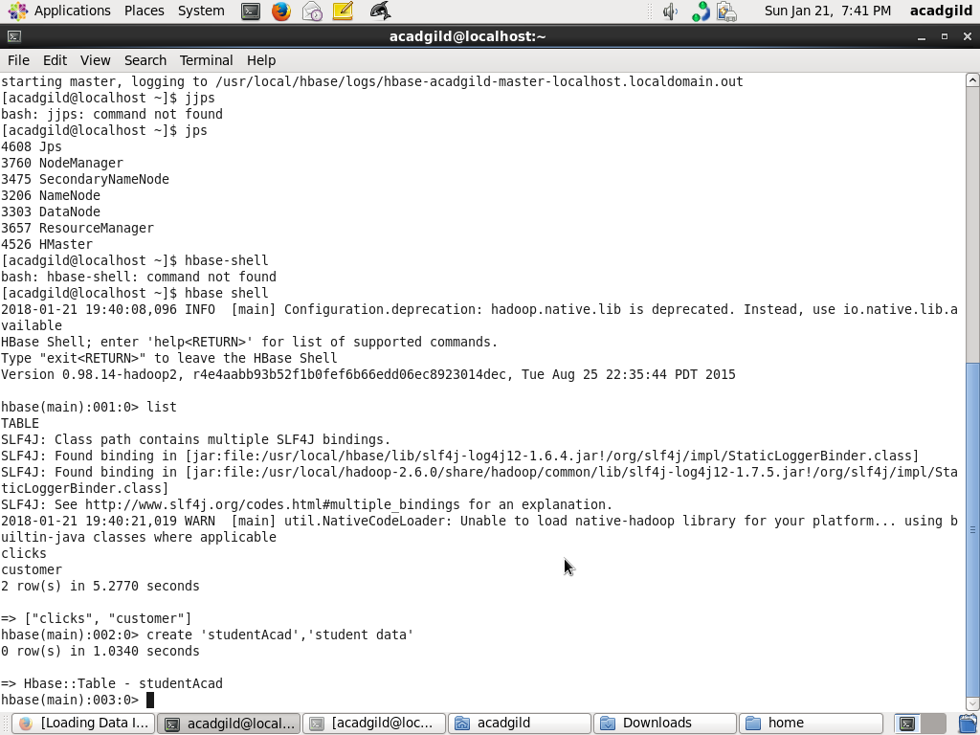

**Start Pig to load the data from hbase using Pig Scripts and Load the data from file system**

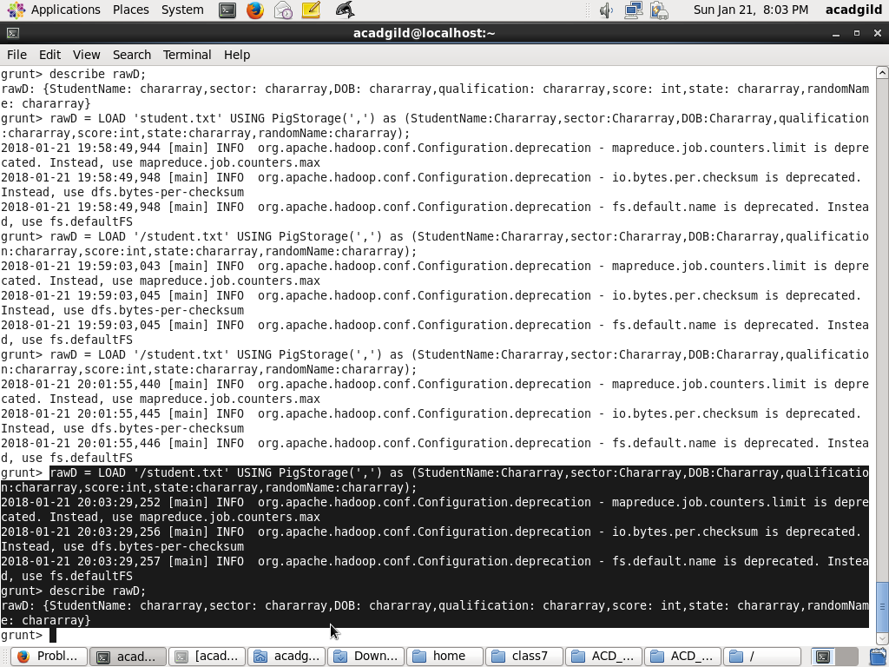

**transfer the data inside HBase by STORE command.**

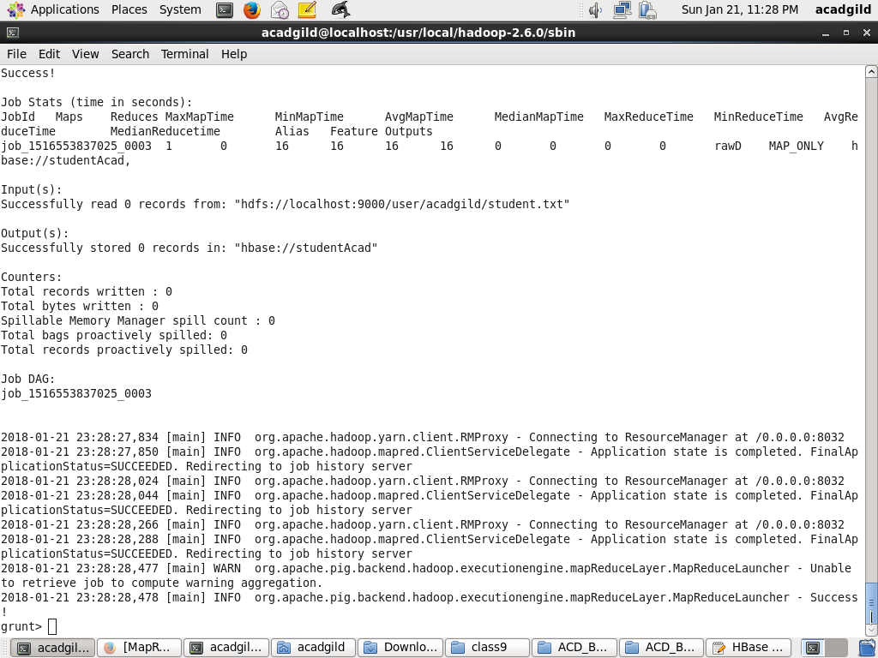

**Scan table command and results**

