1. Write a Hive program to find the number of medals won by each country in swimming.

**select country,SUM(total) from olympic where sport = “Swimming” group by country;**

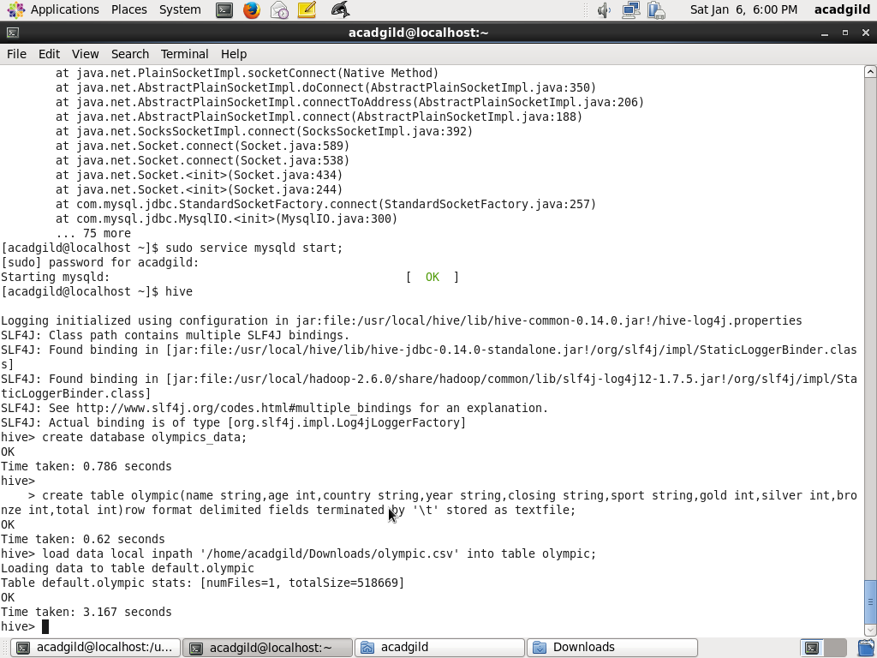

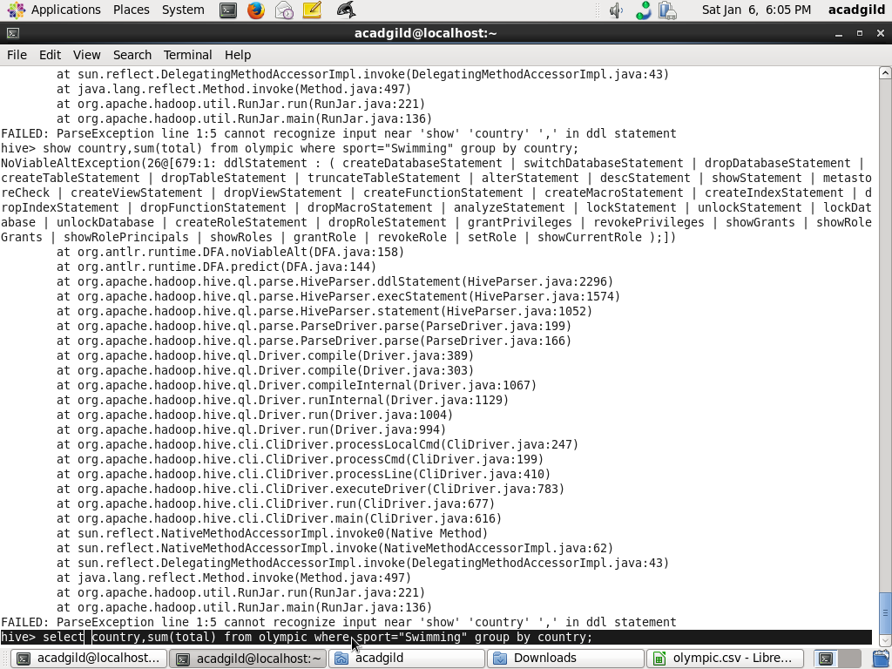

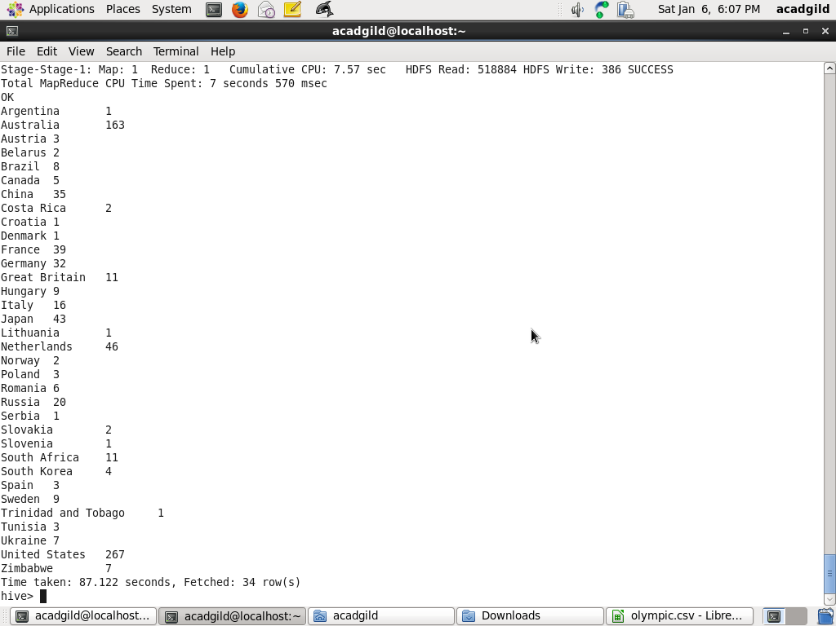

1. Write a Hive program to find the number of medals that India won year wise.

**select year,SUM(total) from olympic where country = “India” group by year;**

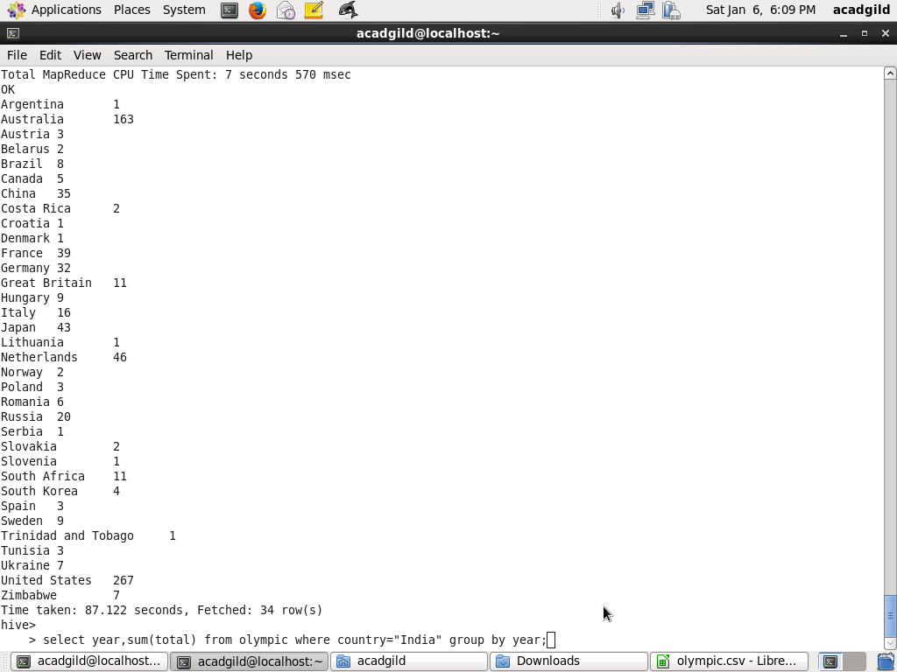

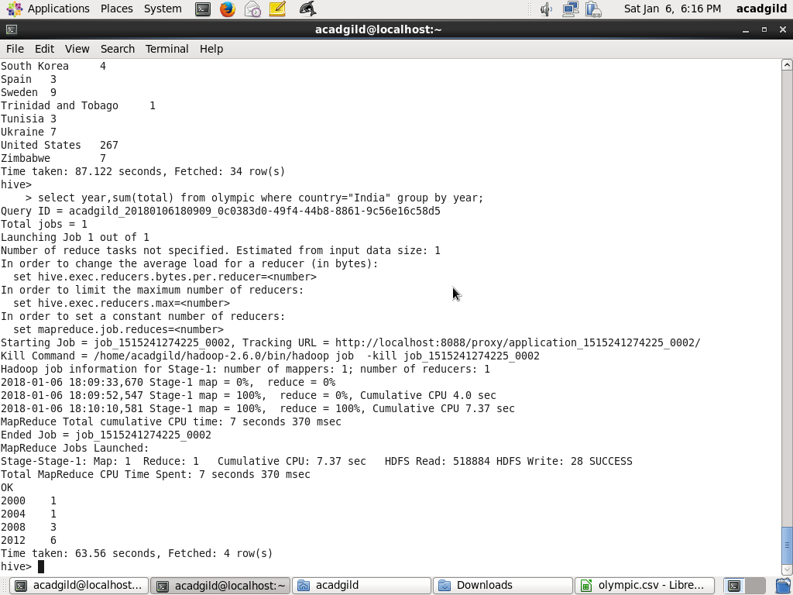

1. Write a Hive Program to find the total number of medals each country won.

**select country,SUM(total) from olympic group by country;**

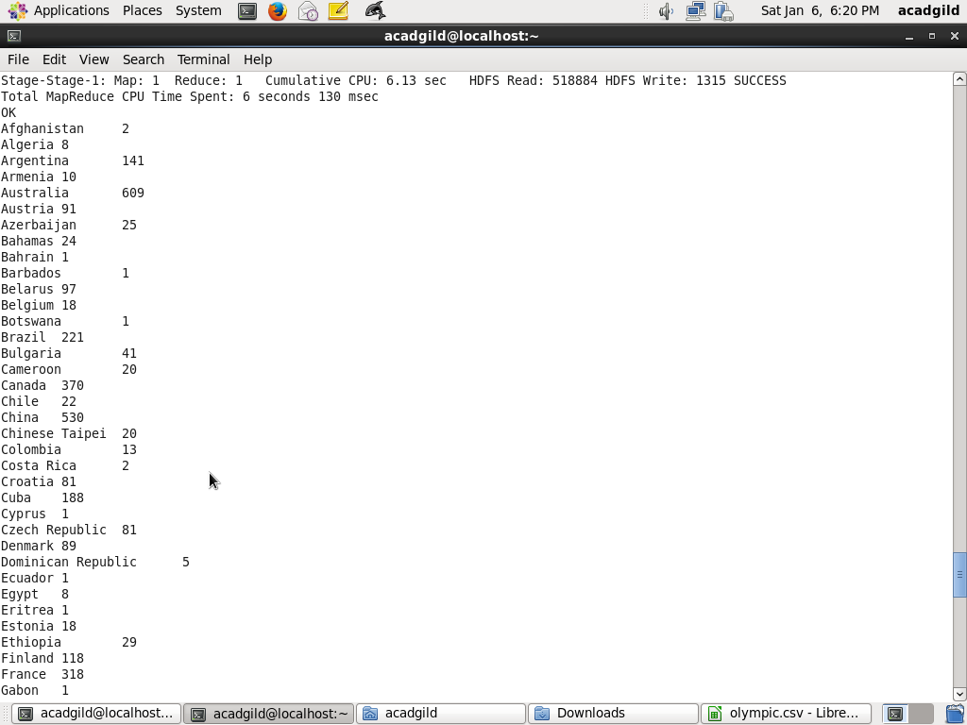



1. Write a Hive program to find the number of gold medals each country won.

**select country,SUM(gold) from olympic GROUP BY country;**

